Man's influence on the environment · items under 80% correct
Multiple-choice practice
Name: ________________________ Class: ____________
No classroom item analysis matched this topic reliably. Items below are those predicted to be answered correctly by fewer than 80% of students. Choose the one best answer.
Part A — HKCEE level (Longman)
1. This method of waste treatment is a means of conservation. Which of the following support this statement?
(1)The dried waste is used as fertilisers to grow crops.
(2)The gas collected is burnt to release heat energy for cooking.
(3)The solid waste is used in landfill.
A.(1) and (2) only B. (1) and (3) only C. (2) and (3) only D. (1), (2) and (3)
Directions: Questions 51 and 52 refer to the diagram below which shows a component part of a sewage treatment plant.
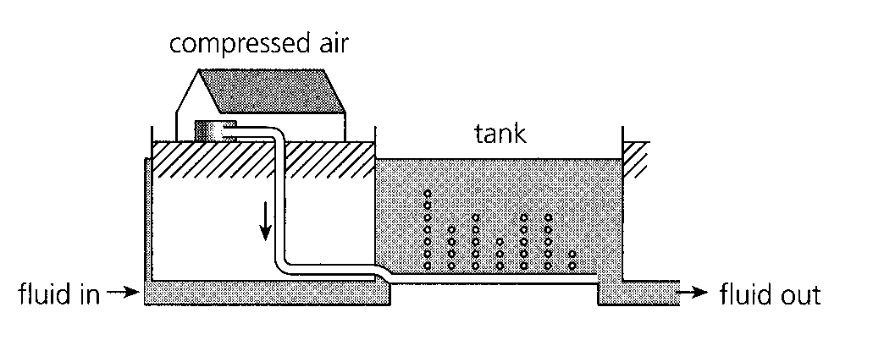
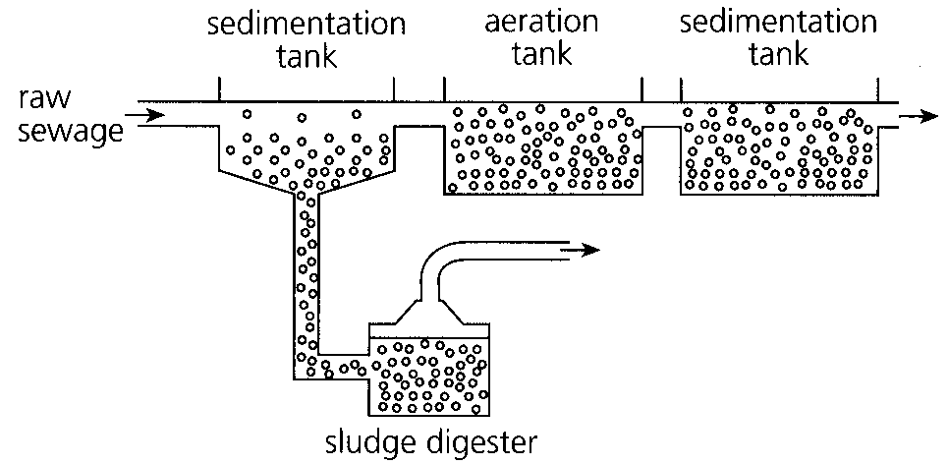
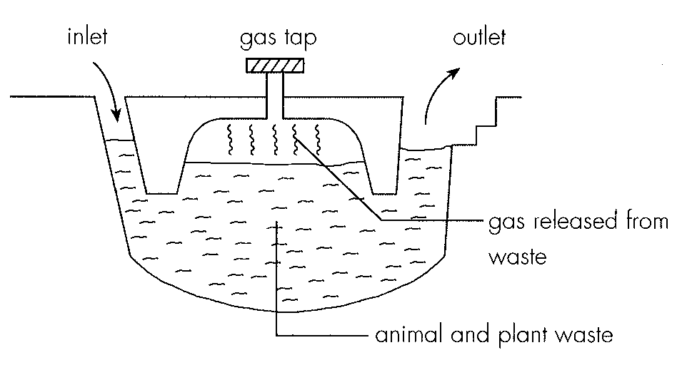
2. Which of the following methods can be used to separate the solid materials from the liquid? (1) Sedimentation (2) Filtration (3) Aeration
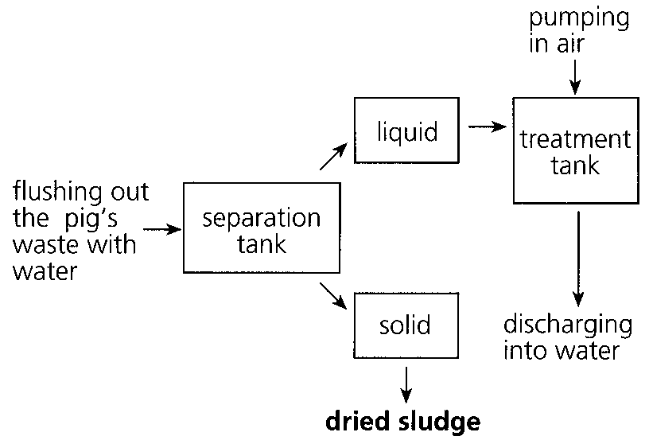
A. (1) and (2) only
B. (1) and (3) only
C. (2) and (3) only
D. (1), (2) and (3)
3. Which of the following are possible uses for the dried sludge? (1) Materials for reclamation of land (2) Fuel for cooking (3) Fertilizer for crops
A. (1) and (2) only
B. (1) and (3) only
C. (2) and (3) only
D. (1), (2) and (3)
4. Which of the following biological processes are taking place in the treatment tank? (1) Fermentation (2) Decomposition (3) Nitrification
A. (1) and (2) only
B. (1) and (3) only
C. (2) and (3) only
D. (1), (2) and (3)
5. Lichens are sensitive to air pollution. The graph below shows the number of species of lichens on different substrates at different distance from the city centre. The graph indicates that B.lichens are completely absent in the city centre. C.more lichen species can survive on walls when the air is unpolluted. D.there are no trees in the city centre.
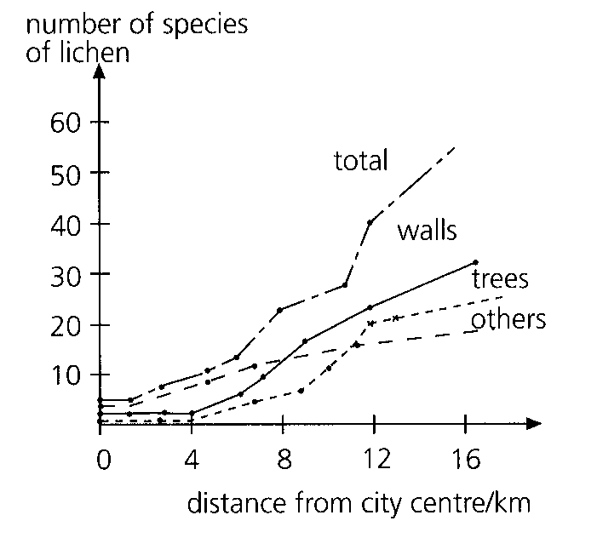
A. the city centre has the cleanest air.
B. lichens are completely absent in the city centre.
C. more lichen species can survive on walls when the air is unpolluted.
D. there are no trees in the city centre.
6. When a large amount of manure is discharged into a river, which of the following graphs shows the most likely changes in the populations of bacteria and algae along the river?
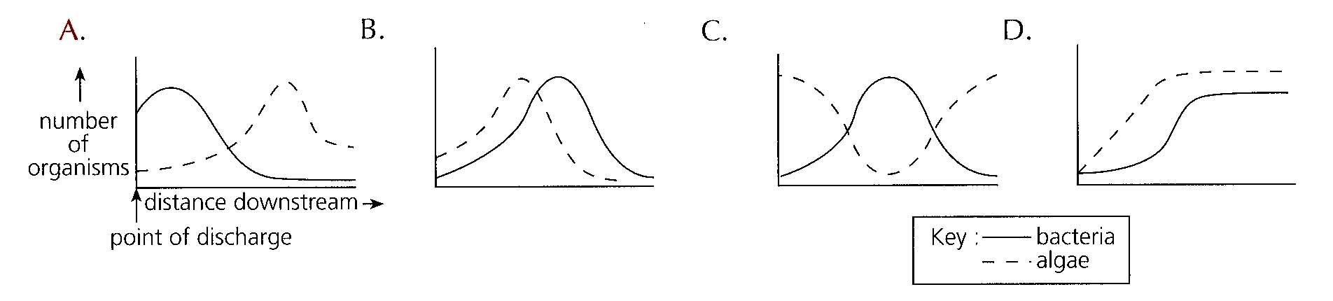
7. If inorganic fertilizer is discharged into the river instead of manure, which of the graphs in No. 30 shows the most likely changes in the populations of bacteria and algae along the river?
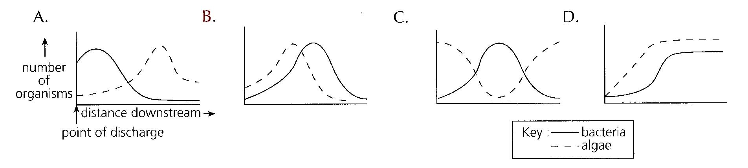
8. Which of the graphs below correctly shows the effect of discharging untreated sewage into a river?
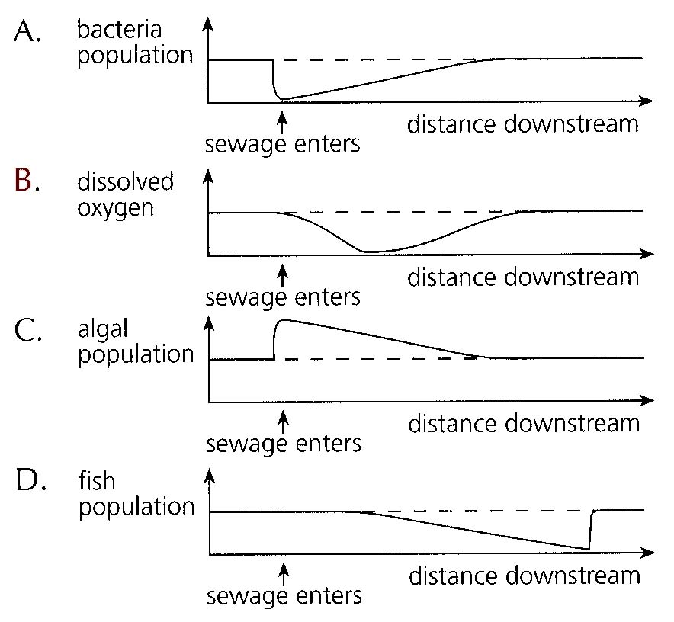
9. Which of the following processes adds most nitrogen compounds to the water in a reservoir?
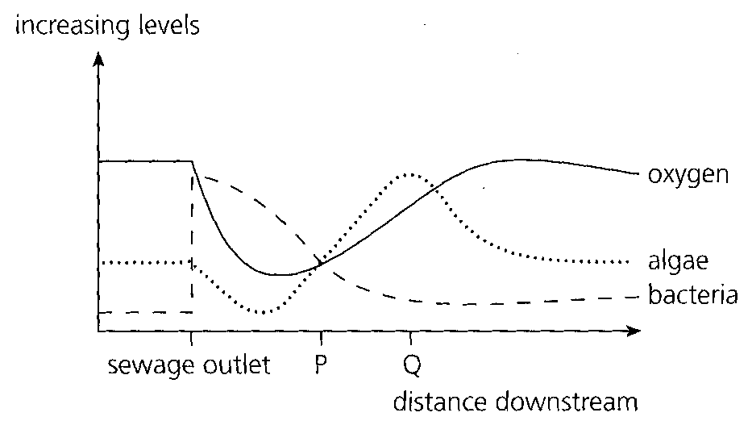
A. Burning of coal in power stations B. Combustion of petrol in motor vehicles
C. Use of fertilizers in farming D. Lightning Directions: Questions 37 and 38 refer to the graph below which shows the effect of sewage on oxygen level, bacterial population and algal population.
10. Deforestation results in (1) destruction of natural habitats. (2) an increase in oxygen level in atmosphere. (3) soil erosion. A. (1) and (2) only
A. (1) and (2) only
B. (1) and (3) only
C. (2) and (3) only
D. (1), (2) and (3)
11. Monoculture may lead to (1) an increase in pest population. (2) the destruction of ecosystem.(3) soil erosion.
A. (1) and (2) only
B. (1) and (3) only
C. (2) and (3) only
D. (1), (2) and (3)
12. Which of the following are related to the practice of monoculture? (1) Loss of species(2) Reduction in soil fertility (3) Destruction of ecosystems
A. (1) and (2) only
B. (1) and (3) only
C. (2) and (3) only
D. (1), (2) and (3)
13. Which of the following practices may help to prevent soil erosion? (1) Planting trees (2) Terracing slopes (3) Harvesting crops
A. (1) and (2) only
B. (1) and (3) only
C. (2) and (3) only
D. (1), (2) and (3)
14. Ozone depletion may lead to (1) increased incidence of skin cancer. (2) increased mutation rate of living organisms. (3) changes in climates.
A. (1) only
B. (1) and (2) only
C. (2) and (3) only
D. (1), (2) and (3)
15. Which of the following pollutants contribute to acid rains? (1) Carbon dioxide (2) Sulphur dioxide(3) Hydrocarbons
A. (1) and (2) only
B. (1) and (3) only
C. (2) and (3) only
D. (1), (2) and (3)
16. Which of the following are harmful effects of acid rain? (1) It damages buildings. (2) It damages plants. (3) It reduces soil fertility.
A. (1) and (2) only
B. (1) and (3) only
C. (2) and (3) only
D. (1), (2) and (3)
17. The problem of acid rain can be lessened by (1) controlling the sulphur content of fuel. (2) limiting the emission of exhaust gases from motor vehicles. (3) the introduction of unleaded petrol.
A. (1) and (2) only
B. (1) and (3) only
C. (2) and (3) only
D. (1), (2) and (3)
18. Which of the following water pollutants may reduce the level of dissolved oxygen? (1) Hot water from cooling towers (2) Oil from oil tanker leakage (3) Pig and chicken wastes from farms
A. (1) and (2) only
B. (1) and (3) only
C. (2) and (3) only
D. (1), (2) and (3)
19. Which of the following may make the pollution problem more serious at a harbour? (1) The dumping of a huge amount of sewage into the water. (2) The lack of oceanic currents. (3) Strong wave action.
A. (1) and (2) only
B. (1) and (3) only
C. (2) and (3) only
D. (1), (2) and (3)

Answers
Answers are printed in red.
1. A
Predicted class correct ≈ 57% (no classroom match)
2. A. (1) and (2) only
Predicted class correct ≈ 57% (no classroom match)
3. B. (1) and (3) only
Predicted class correct ≈ 57% (no classroom match)
4. C. (2) and (3) only
Predicted class correct ≈ 57% (no classroom match)
5. C. more lichen species can survive on walls when the air is unpolluted.
Predicted class correct ≈ 61% (no classroom match)
6. ?
Predicted class correct ≈ 61% (no classroom match)
7. ?
Predicted class correct ≈ 61% (no classroom match)
8. ?
Predicted class correct ≈ 61% (no classroom match)
9. ?
Predicted class correct ≈ 61% (no classroom match)
10. B. (1) and (3) only
Predicted class correct ≈ 62% (no classroom match)
11. D. (1), (2) and (3)
Predicted class correct ≈ 62% (no classroom match)
12. D. (1), (2) and (3)
Predicted class correct ≈ 62% (no classroom match)
13. A. (1) and (2) only
Predicted class correct ≈ 62% (no classroom match)
14. D. (1), (2) and (3)
Predicted class correct ≈ 62% (no classroom match)
15. A. (1) and (2) only
Predicted class correct ≈ 62% (no classroom match)
16. D. (1), (2) and (3)
Predicted class correct ≈ 62% (no classroom match)
17. A. (1) and (2) only
Predicted class correct ≈ 62% (no classroom match)
18. D. (1), (2) and (3)
Predicted class correct ≈ 62% (no classroom match)
19. A. (1) and (2) only
Predicted class correct ≈ 62% (no classroom match)

Class percentage correct
Matched to this paper by question wording in the source bank and the form answer key, not by a shifted paper number.
Q | Answer | % correct | n | Usual slip
1 | A | 57.0% | pred | —
2 | A | 57.0% | pred | —
3 | B | 57.0% | pred | —
4 | C | 57.0% | pred | —
5 | C | 61.0% | pred | —
6 | ? | 61.0% | pred | —
7 | ? | 61.0% | pred | —
8 | ? | 61.0% | pred | —
9 | ? | 61.0% | pred | —
10 | B | 62.0% | pred | —
11 | D | 62.0% | pred | —
12 | D | 62.0% | pred | —
13 | A | 62.0% | pred | —
14 | D | 62.0% | pred | —
15 | A | 62.0% | pred | —
16 | D | 62.0% | pred | —
17 | A | 62.0% | pred | —
18 | D | 62.0% | pred | —
19 | A | 62.0% | pred | —

