Movement of substances across the cell membrane
Multiple-choice practice
Name: ________________________ Class: ____________
There are 141 questions compiled from Longman HKCEE and/or YKTo papers. Choose the one best answer.
Part A — HKCEE level (Longman)
1. Which of the following indicate the importance of water to life?
(1) As a major cell constituent (2) As a metabolite
(3) As a solvent (4) As a medium of transportation and chemical reaction
A. (1), (2) and (3) only B. (1), (3) and (4) only . (2), (3) and (4) only D. (1), (2), (3) and (4)
2. Which of the following is/are not the importance of water in flowering plants? (1) As the reactant in photosynthesis (2) As the product in respiration (3) As the main constituent in vacuole
A. (1) only
B. (2) only
C. (3) only
D. (2) and (3) only
3. When placed in 1.5% saline solution, red blood cells will
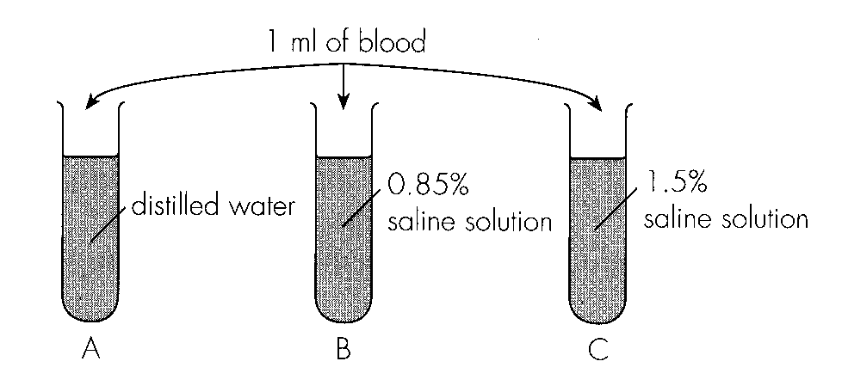
A. remain the same. B. plasmolyse. C. become crenate.D. become turgid. Directions: Questions 4 to 6 refer to the following experiment.
4. How should the blood be treated before the experiment? A.The blood should be sterilized first. C.The blood should be filtered first.
A. The blood should be sterilized first.
B. The blood should be citrated first.
C. The blood should be filtered first.
D. The blood should be spun with a centrifuge first.
5. The result in tube A can be explained by (1)osmosis. (2) the absence of cell wall in red blood cells. (3)the dissolution of haemoglobin in water.
A. (1) only
B. (1) and (2) only
C. (2) and (3) only
D. (1), (2) and (3)
6. Which of the following graphs correctly shows the changes in mass of a red blood cell during its immersion in distilled water and 2% saline solution successively?
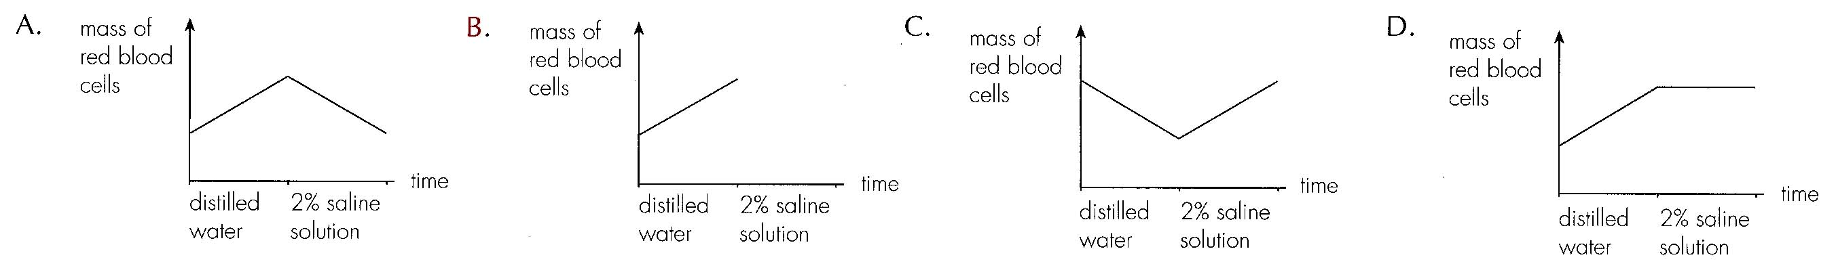
7. Which of the following is/are the functions) of kidneys? (1) Regulation of the amount of salts in relation to that of water in blood (2) Removal of excess glucose (3) Removal of excess urea (4) Removal of excess amino acids
A. (1) and (2) only
B. (1) and (3) only
C. (2), (3) and (4) only
D. (1), (2), (3) and (4)
8. The list below shows some of the body fluids in a human body. (1) Intercellular fluid (2) Tear (3) Lymph (4) Blood Which of the fluids above have steady water potential?
A. (1) and (2) only
B. (1) and (4) only
C. (3) and (4) only
D. (1), (3) and (4) only
9. Drinking a large quantity of isotonic drink like ' Pocari' or 'Striker' will produce
A. a larger volume of isotonic urine.
B. same volume of isotonic urine.
C. a smaller volume of hypotonic urine.
D. a larger volume of hypertonic urine.
10. The change in urine production in Question 10 is probably due to (1) an increase in water potential of blood. (2) an increase in blood volume. (3) an increase in blood pressure.
A. (1) and (2) only
B. (1) and (3) only
C. (2) and (3) only
D. (1), (2) and (3)
11. Which of the following correctly predicts the amount of water lost via sweat and urine in winter as compared with that in summer?
Directions: Questions 13 and 14 refer to the effects of drinking distilled water on urine production in a healthy person.
 | Amount of water lost via sweat | Amount of water lost via urine
A. | increasing | decreasing
B. | decreasing | increasing
C. | decreasing | unchanged
D. | unchanged | increasing

12. Which of the following correctly describes the urine production after drinking a large quantity of distilled water?
A. A larger volume only B. A larger volume of lower concentration
C. A larger volume of same concentrationD. A larger volume of higher concentration
13. When a filamentous spirogyra is placed in a hypotonic solution, the spirogyra will
A. be killed by a net influx of water.
B. be plasmolysed.
C. become longer.
D. become flaccid.
14. When placed in hypertonic solution, the cells in a plant tissue will (1) be plasmolysed. (2) become flaccid. (3) become crenated.
A. (1) and (2) only
B. (1) and (3) only
C. (2) and (3) only
D. (1), (2) and (3)
15. If some of the cells in a plant tissue has been immersed in hypertonic solution, they showed various degrees of plasmolysis. This suggests that
A.some cells are easier to be plasmolysed than others.
B.some cells have thicker cell wall than others.
C.Cells of the same tissue have different pressure.
D.Cells of the same tissue have different water potential.
Directions: Questions 20 to 23 refer to the four drawings below which were recorded by a student who had immersed Rhoeo discolor in sucrose solutions of different concentrations.
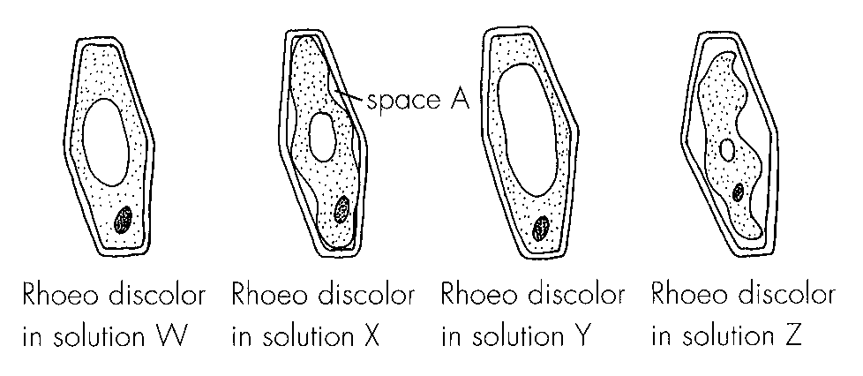
16. Rhoeo discolor is used in this experiment because
A. the epidermis is easily peeled off from the leaf.
B. osmosis occurs more rapidly in it.
C. the cytoplasm is purple in colour.
D. the cell wall is thinner.
17. The four sucrose solutions in increasing order of concentrations are: D. Y →W -→X -→ Z- 22.Space A was probably B. filled up with sucrose solution.C. vacuum. D. filled up with water.
A. W → X -→ Y -→ Z-
B. Z → X -→ Y -→ W-
C. X → Z -→ W -→ Y-
A. filled up with air.
18. Three groups of potato strips were immersed in three sucrose solutions of 0.1 %, 5% and 15% respectively. The probable percentage changes in mass of the three groups of potato strips would be
Directions: Questions 24 to 26 refer to the following graph which shows the changes in mass of a potato strip in an unknown solution.
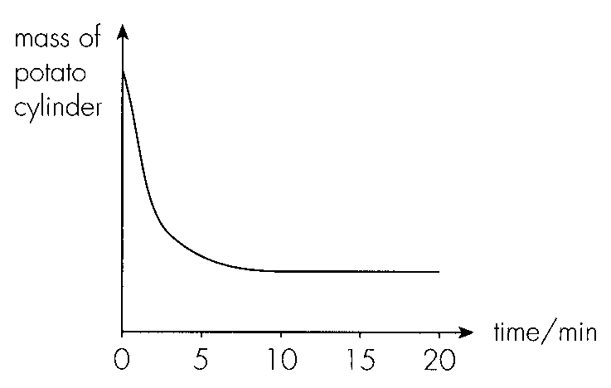
 | 0.1 solution | 5% solution | 15% solution
A. | 9%- | +0.2% | +6%
B. | +0.2% | 9%- | +6%
C. | +6% | +0.2% | 9%-
D. | 9%- | +6% | +0.2%

19. The potato strip loses weight most rapidly between
A. 05 minutes.-
B. 5 10 minutes.-
C. 10 15 minutes.-
D. 15 20 minutes.-
20. The unknown solution was most probably
A. distilled water.
B. dilute glucose solution.
C. dilute sucrose solution.
D. concentrated sucrose solution.
21. Between 15 20 minutes, the potato cells have-
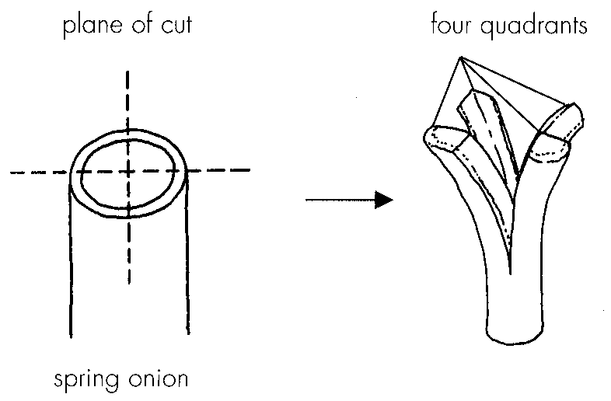
A. no water gain. B. no water loss. C. neither water gain nor water loss. D. no net water movement. Directions: Questions 27 to 29 refer to the decorations using spring onion in Chinese dishes. Leaves of spring onion are cut longitudinally to make flowerlike decorations.-
22. The curvature of quadrants in freshly cut spring onion can be explained by
A. the higher tension in the cortical layer.
B. the higher tension in the epidermal layer.
C. the lower atmospheric pressure outside the spring onion.
D. the higher pressure inside the spring onion.
23. If the cook wants to make the flower like decorations open more, the spring onion should be immersed in-
A. water.
B. syrup.
C. vinegar.
D. boiling water.
24. The answer in Question 28 can be explained by
(1) the impermeability of the epidermal layer.
(2) osmosis. (3) the tension between the epidermal and cortical layers.
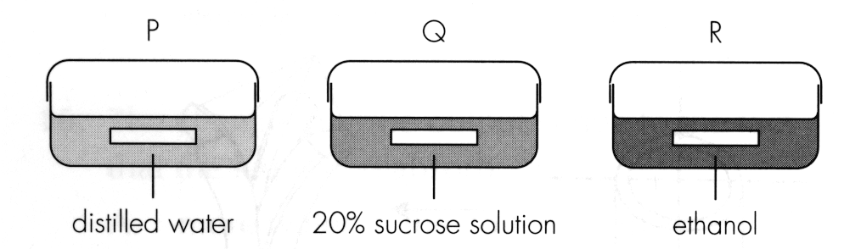
A. (1) and (2) only B. (1) and (3) only C. (2) and (3) only D. (1), (2) and (3) Directions: Questions 30 and 31 refer to the experiment in which three potato strips of the same length were immersed in three solutions respectively as follows.
25. Which of the following correctly describe the change in the length of potato cylinder after 30 minutes?
 | P | Q | R
A. | longer | shorter | longer
B. | longer | shorter | shorter
C. | shorter | longer | longer
D. | shorter | longer | shorter

26. After 30 minutes, the three potato cylinders were then rinsed with tap water and all immersed in distilled water for another 30 minutes. The change in length of P, Q and R would be:
Directions: Questions 32 to 34 refer to the experiment below which attempts to compare the number of stomata on the upper and lower surfaces of a leaf.
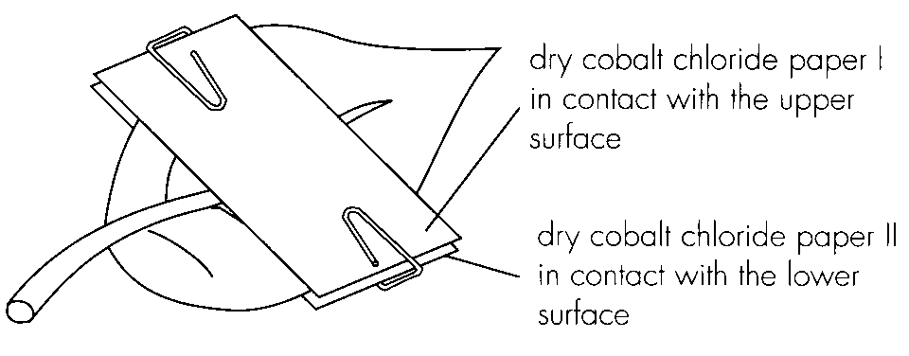
 | P | Q | R
A. | remain unchanged | longer | longer
B. | remain unchanged | longer | remain unchanged
C. | longer | shorter | remain unchanged
D. | shorter | shorter | shorter

27. Which of the following correctly describes the probable colour change in the cobalt chloride paper and its direct indication?
 | Probable colour change | Direct indication
A. | blue to pink | stomata present
B. | pink to blue | stomata absent
C. | blue to pink | water is present
D. | pink to blue | water is absent

28. Which of the following correctly matches the experimental result and its corresponding implication?
 | Experimental results | Corresponding implication
A. | Cobalt chloride papers I and II changed colour at the same speed. | Both surfaces are permeable to water.
B. | Cobalt chloride paper I changed colour first. | Upper surface has fewer stomata.
C. | Cobalt chloride paper II changed colour first. | Lower surface has fewer stomata.
D. | Cobalt chloride papers I and II did not change colour. | Stomata are evenly distributed.

29. This experiment can be used to demonstrate
A. gaseous exchange in leaves.
B. transpiration in leaves.
C. number of stomata in leaves.
D. the distribution of stomata in leaves.
30. The formation of air bubbles can be explained by A.the carbon dioxide production during respiration in the leaf. B.the oxygen production during photosynthesis in the leaf. C.the expansion of air within the leaf upon heating. D.the vaporization of water within the leaf upon heating. Directions: Questions 37 and 38 refer to the experiment on a potted plant below which has been kept in a bell jar for 2 hours. 37. Substance X is A.carbon dioxide. B. oxygen. C. water.D. nitrogen.
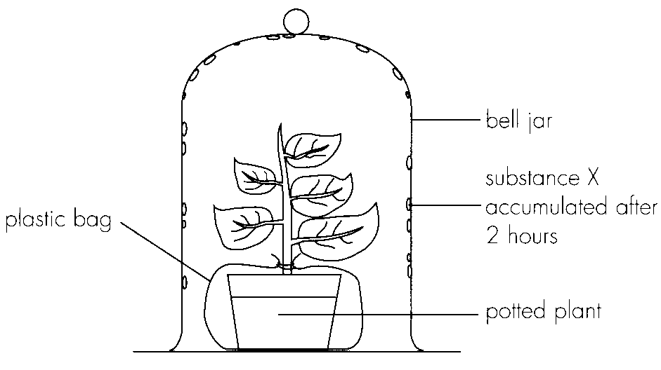
A. the carbon dioxide production during respiration in the leaf.
B. the oxygen production during photosynthesis in the leaf.
C. the expansion of air within the leaf upon heating.
A. carbon dioxide.
31. Which of the following is/are the significance of transpiration in plants? (1) It removes excess water from the plant. (2) It facilitates transport of water within the plant. (3) It induces water absorption by roots. D. (1), (2) and (3) 40.Stomata in the leaves of aquatic plants floating on water are most likely distributed A. on upper surfaces only. B. on lower surfaces only. C. more on upper surfaces. D. evenly on both surfaces.
A. (1) and (2) only
B. (1) and (3) only
C. (2) and (3) only
D. (1), (2) and (3) 40.Stomata in the leaves of aquatic plants floating on water are most likely distributed
32. Leaves of aquatic plants which are totally under water usually have no stomata because
A. those leaves have no cuticle at all.
B. water cannot enter the leaf via stomata.
C. there is no need for transpiration.
D. there is no need for gaseous exchange.
33. The distribution of stomata in the leaves of an aquatic plant A, a terrestrial plant B with horizontally oriented leaves and a terrestrial plant C with vertically oriented leaves would probably be:
Directions: Questions 43 to 45 refer to the potometer below.
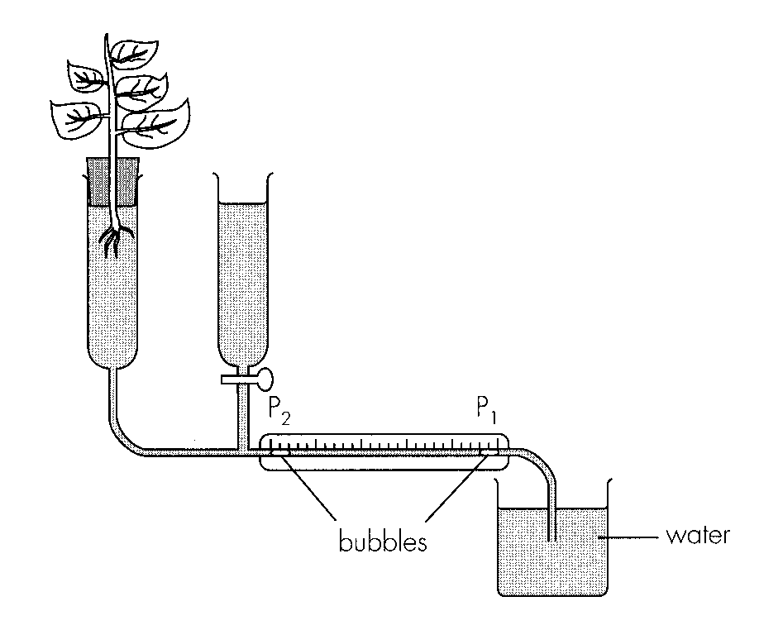
 | Stomata in plant A | Stomata in plant B | Stomata in plant C
A. | absent on both surfaces | present on lower surface | present on both surfaces
B. | absent on both surfaces | present on lower surface only | present on upper surface only
C. | present on both surfaces | absent on lower surface only | absent on upper surface only
D. | present on upper surface only | absent on both surfaces only | present on both surfaces

34. The purpose of including the reservoir in the set up is-
A. to balance the set up.-
B. to supply water to the leafy shoot.
C. to maintain pressure in the set up.-
D. to return the bubble to position P1.
35. What does this potometer measure?
A. The rate of transpiration
B. The rate of water absorption
C. The rate of net water loss
D. The rate of net water uptake
36. What would be the effects of air movement and high relative humidity on the time for the
bubble to travel from PI to P2?
Directions: Questions 46 to 48 refer to the graph below which shows the changes in the rate of transpiration rate during the course of one day.
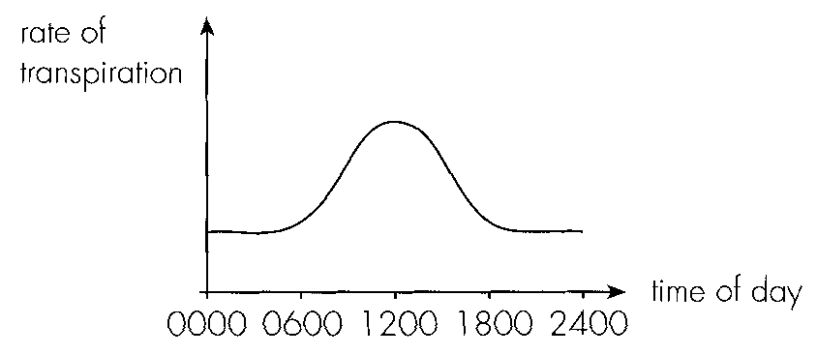
 | Air movement | High relative humidity
A. | shorter | shorter
B. | shorter | longer
C. | longer | shorter
D. | longer | longer

37. The environmental factors affecting the changes in transpiration rate during the course of one day are most likely: (1) Wind(2) Relative humidity (3) Light intensity (4) Temperature
A. (1) and (2) only
B. (2) and (3) only
C. (3) and (4) only
D. (1) and (4) only
38. The rates of transpiration and water absorption can be measured by
Directions: Questions 49 to 51 refer to the potometer below.
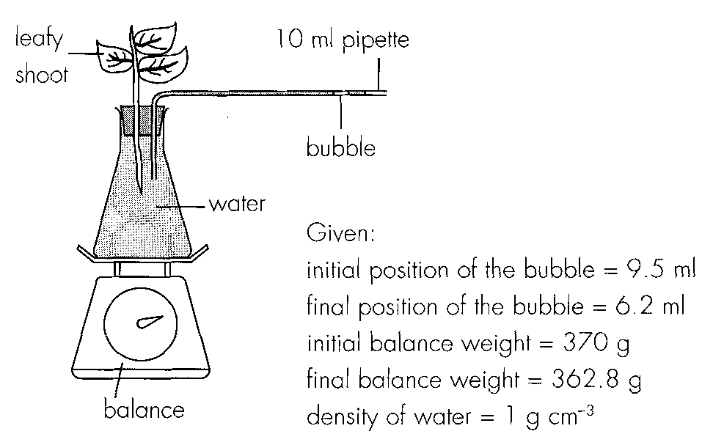
 | Rate of transpiration | Rate of water absorption
A. | bubble potometer | bubble potometer
B. | weight potometer | weight potometer
C. | bubble potometer | weight potometer
D. | weight potometer | bubble potometer

39. The mass of water transpired from the leafy shoot and the mass of water absorbed by the leafy shoot are respectively
 | Mass of water transpired | Mass of water absorbed
A. | 3.3 g | 7.2 g
B. | 7.2 g | 3.3 g
C. | 360.5 g | 356.6 g
D. | 356.6 g | 360.5 g

40. The difference between the mass of water transpired and the mass of water absorbed can be explained by (1) the absence of root system in the leafy shoot. (2) the time lag between water absorption and transpiration. (3) blockage of xylem in the stem.
A. (1) and (2) only
B. (1) and (3) only
C. (2) and (3) only
D. (1), (2) and (3)
41. If the experiment was repeated in bright light, what would the results become?
 | Mass of water transpired | Mass of water absorbed
A. | decrease | decrease
B. | decrease | increase
C. | increase | increase
D. | increase | decrease

42. Leaf fall in winter is a measure to
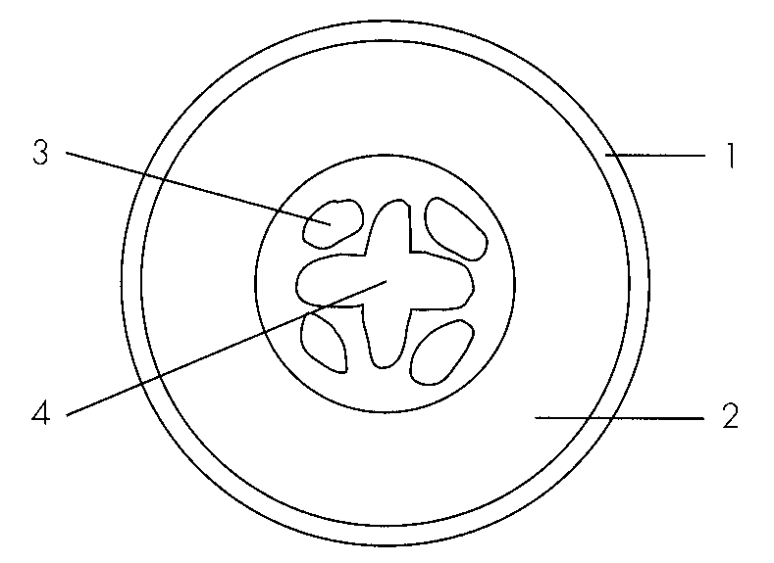
A. return minerals back to the soil. B. reduce heat loss.
C. expose the flowers for pollination. D. reduce water loss. Directions: Questions 53 to 55 refer to the drawing below which shows the transverse section of a plant organ.
43. The plant organ is a
A. stem.
B. leaf.
C. root.
D. fruit.
44. | 3 | 4 |
A. | xylem | phloem | epidermis |
B. | phloem | epidermis | xylem |
C. | epidermis | phloem | phloem |
D. | epidermis | phloem | xylem
45. Which of the following correctly matches the functions of 1, 2 and 4?
46. | 2 | 4 | D. | support | food storage | water transport Directions: Questions 56 to 58 refer to the photomicrograph below which shows the transverse section of a root. 56. Structure 1 is numerous and hair like so that it can - (1) penetrate into the soil for anchorage. (2) facilitate the absorption of water. (3) increase the surface area for gaseous exchange. B. (1) and (3) only C. (2) and (3) only D. (1), (2) and (3)
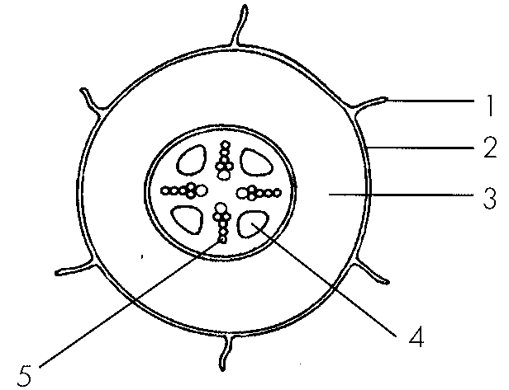
A. | water absorption | transport of organic nutrients | water transport |
B. | absorption of salts | food storage | support |
C. | water absorption | food storage | transport of organic nutrients |
A. (1) and (2) only
47. Food is stored mainly in D. 5. 58.Structure 2 is different from the epidermis in leaf in that structure 2 A. is permeable to water.B. has no chloroplasts. C. is a dead tissue. D. does not allow gases to pass through. Directions: Questions 59 to 61 refer to the diagram below which shows the water relations of a flowering plant.
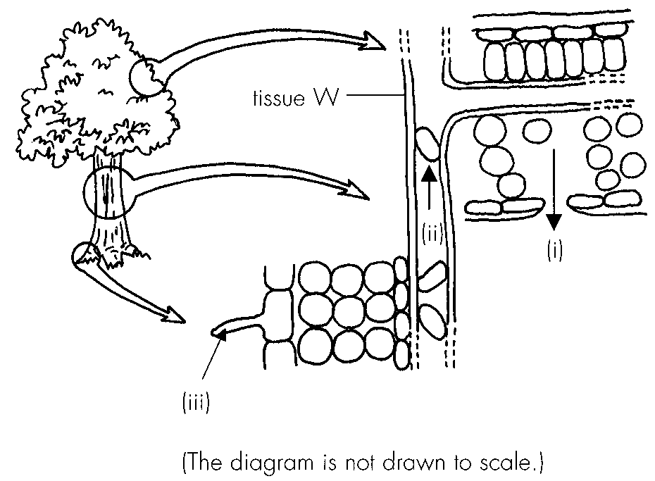
A. 2.
B. 3.
C. 4.
D. 5. 58.Structure 2 is different from the epidermis in leaf in that structure 2
48. The three arrows labelled ( i), (ii) and (iii) represent
 | (i) | (ii) | (III)
A. | evaporation | root pressure | water absorption
B. | transpiration | transpiration pull | water absorption
C. | transpiration | root pressure | osmosis
D. | gaseous exchange | transpiration pull | osmosis

49. The effect of raining on the processes ( i) and (iii) is respectively
 | Effect on (i) | Effect on (iii)
A. | faster | faster
B. | slower | slower
C. | faster | slower
D. | slower | faster

50. The feature(s) of tissue W adapted to process (ii) include: (1) Non living-(2) Hollow (3) Rigid wall
A. (1) and (2) only
B. (1) and (3) only
C. (2) and (3) only
D. (1), (2) and (3)
51. The ascent of water along the stem is mainly caused by
A. water absorption in the roots.
B. pressure exerted by the roots.
C. transpiration in the leaves.
D. capillary action in the xylem vessels.
52. Water absorption in the roots is induced by
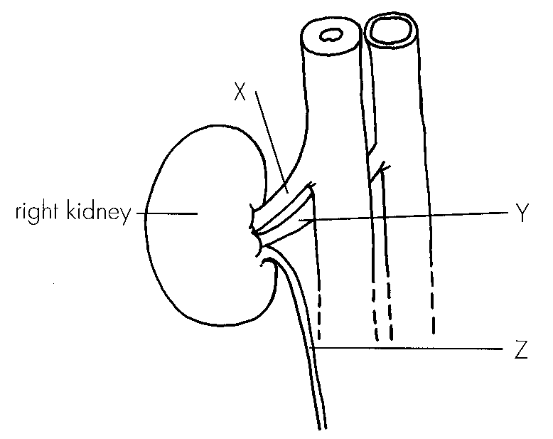
A. evaporation of water from the mesophyll. B. osmosis between root cells and soil water.
C. diffusion of mineral salts into the roots. D. active transport of mineral salts into the mesophyll Directions: Questions 64 and 65 refer to the diagram below.
53. Which of the following about glucose concentration is correct?
 | Glucose concentration in X and Y | Reason
A. | same | Glucose reabsorption is 100%.
B. | same | Glucose is absent in Z.
C. | higher in X | Glucose is forced out of the glomerulus.
D. | higher in X | Glucose is used for respiration by the kidney.

54. The ascending order of urea concentration in X, Y and Z is
A. Y → Z -→ X-
B. Y→ X -→ Z-
C. Z → X -→ Y-
D. Z → Y -→ X-
55. Which of the following are absent in glomerular filtrate but present in blood?
A. Red blood cells and white blood cells.
B. Fibrinogen and white blood cells.
C. Red blood cells and fibrinogen.
D. Red blood cells, white blood cells and fibrinogen.
56. Compared with that in the afferent arteriole, the blood in the efferent arteriole of a nephron has (1) a lower concentration of urea. (2) a lower concentration of glucose. (3) the same concentration of salts.
A. (1) only
B. (2) only
C. (3) only
D. (1) and (2) only
57. The drawing below shows the longitudinal section of a kidney.
The deeper red colour in the cortical region of the kidney can be explained by
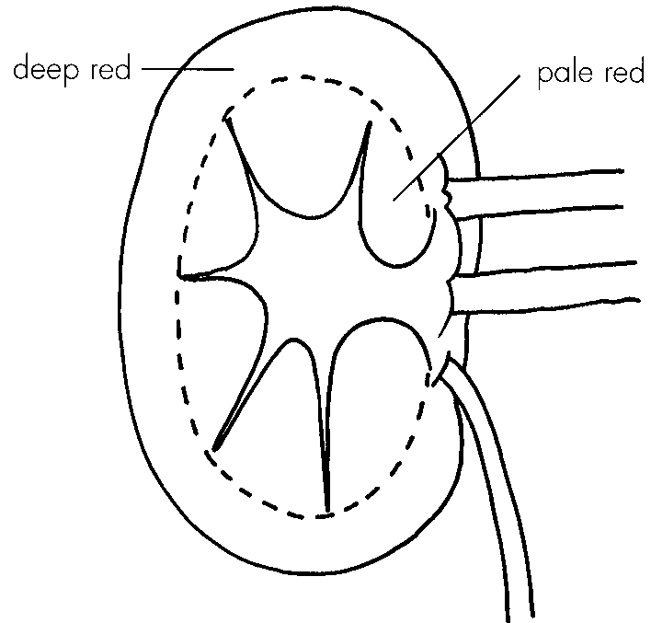
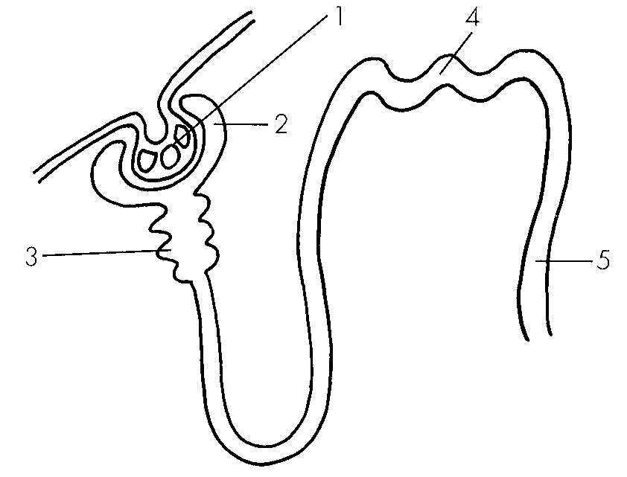
A. the presence of Bowman's capsule. B. the presence of glomeruli.
C. the presence of coiled tubules. D. the presence of collecting ducts. Directions: Questions 69 to 71 refer to the diagram below which shows the functional unit of the kidney.
58. Which of the following shows the correct location of parts 1, 2, 3, 4 and 5 in the kidney?
 | Cortex of the kidney | Medulla of the kidney
A. | 1 and 2 | 3, 4 and 5
B. | 1, 2 and 4 | 3 and 5
C. | 1, 2, 3 and 4 | 5
D. | 4 and 5 | 1, 2 and 3

59. Which region of the functional unit absorbs most water from its content?
A. 2
B. 3
C. 4
D. 5
60. In which regions of the functional unit of a diabetic patient would glucose be detected?
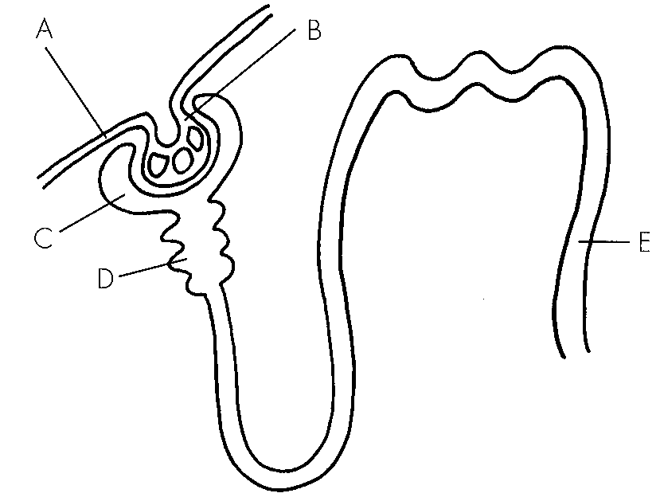
A. 1 and 2 B. 1, 2 and 3 C. 1, 2, 3 and 4 D. 1, 2, 3, 4 and 5 Directions: Questions 72 to 74 refer to the diagram below.
61. Which of the following is incorrect about the formation of glomerular filtrate?
A.The blood pressure in part B is higher than that in part A.
B.The wall of part B is selectively permeable.
C.The wall of part C is one cell thick.-
D.Part B is made of capillaries.
62. Under normal circumstances, which of the following comparisons between the content in D and E is correct?
 | Content in D | Content in E
A. | absence of amino acid | absence of amino acid
B. | higher concentration of sodium | lower concentration of sodium
C. | higher concentration of urea | lower concentration of urea
D. | presence of fibrinogen | absence of fibrinogen

63. By what process is glucose reabsorbed in part D and water reabsorbed in part E respectively?
A. Diffusion and active transport B. Active transport and diffusion
C. Diffusion and osmosis D. Active transport and osmosis
64. Which of the following correctly describes the processes taking place in a nephron?
Directions: Questions 76 and 77 refer to the diagram below which demonstrates the principle of kidney machine.
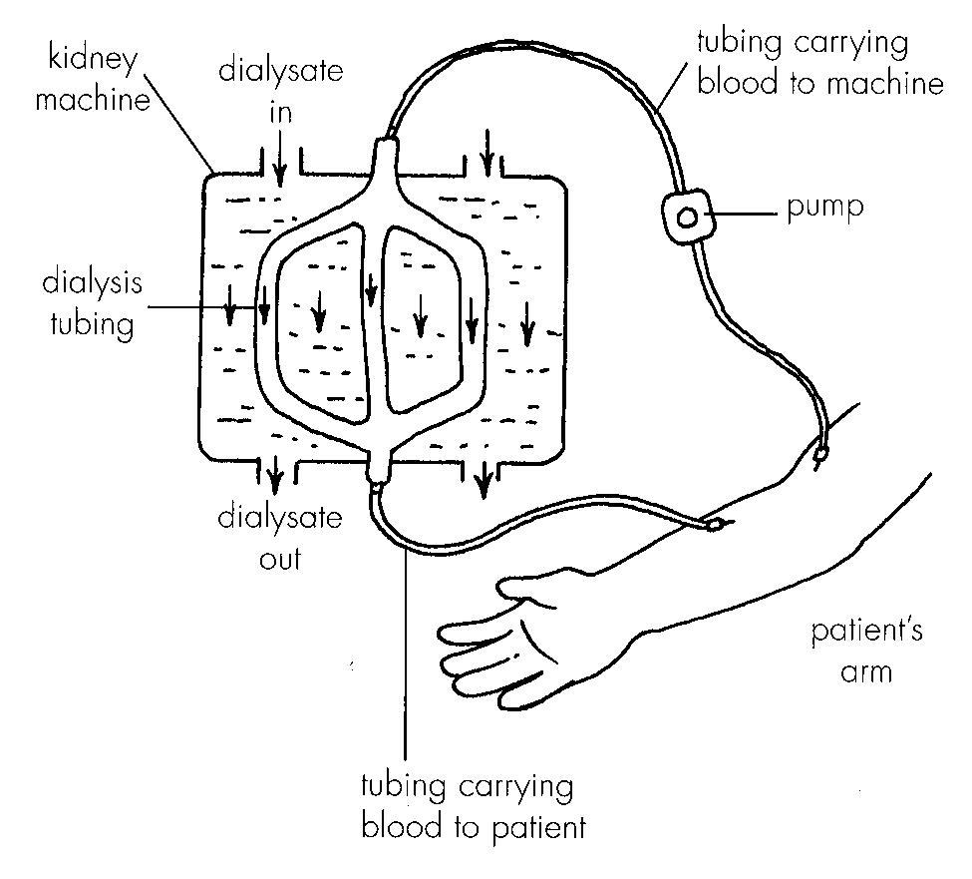
 | Glomerulus | Coiled tubules | Collecting duct
A. | osmosis | ultrafiltration | reabsorption
B. | reabsorption | reabsorption | ultrafiltration
C. | uitrafiltration | osmosis | reabsorption
D. | ultrafiltration | reabsorption | osmosis

65. Only urea, but not useful substances like glucose and mineral salts, can be removed from the patient's blood by kidney machine because
A. the dialysis tubing is impermeable to glucose and mineral salts.
B. the kidney machine can reabsorb glucose and mineral salts back into the patient's blood.
C. the diffusion of glucose and mineral salts is slower than that of urea.
D. dialysate contains the same concentrations of glucose and mineral salts as that of Blood.
66. Which of the following can increase the efficiency of kidney machine? (1) Increase the number of dialysis tubing. (2) Use a more powerful pump. (3) Reverse the direction of dialysate flow. (4) Pierce the dialysis tubing with pores.
A. (1) and (3) only
B. (2) and (4) only
C. (1), (2) and (3) only
D. (2), (3) and (4) only
Part B — HKDSE-style (YKTo)
67. Directions: Questions 1 to 4 refer to the following processes of transport across a membrane : Which of the processes concern with the movement of particles in a random manner?
A. (1) and (2) only
B. (1) and (3) only
C. (2) and (3) only
D. (3) and (4) only
68. Which processes involve the movement of particles in one direction only?
A. (1) and (2) only
B. (2) and (3) only
C. (3) and (4) only
D. (4) and (1) only
69. Which processes need the expenditure of biological energy?
A. (1) and (2) only
B. (2) and (3) only
C. (3) and (4) only
D. (4) and (1) only
70. Which processes need the presence of a living biological membrane?
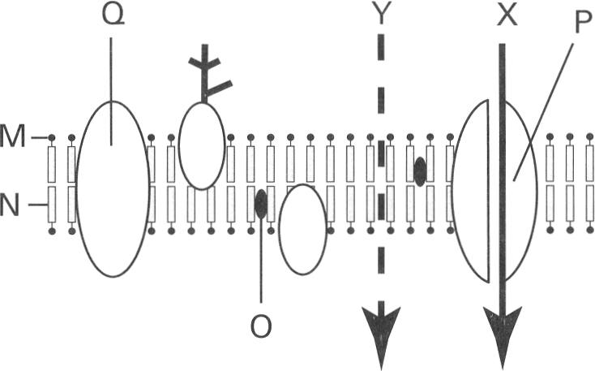
A. (1) and (2) onlyB . (2) and (3) only C. (3) and (4) only D. (2), (3) and (4) only Directions: Questions 5 to 7 refer to the diagram below, which represents the fluid mosaic model of the cell membrane.
71. Which of the following substances can move along pathways X and Y respectively?
 | Pathway X | Pathway Y
A. | Glucose | Oxygen
B. | Alcohol | Water
C. | Oxygen | Glucose
D. | Glucose | Water

72. Which labelled part prevents polar molecules to pass through?
A. M
B. N
C. P
D. Q
73. Which labelled part enhances the passage of molecules against the concentration gradient through the membrane with the expenditure of energy?
A. M
B. N
C. O
D. Q
74. Which of the following combinations TRULY represents the processes by which oxygen, glucose and water pass through the cell membrane into the cell?
(1) Osmosis (2) Diffusion (3) Active transport
 | Water | Oxygen | Glucose
A. | (1) | (2) | (3)
B. | (3) | (2) | (1)
C. | (1) | (3) | (2)
D. | (3) | (1) | (2)

75. Which of the following properties of the selectively permeable membrane of a cell is/are CORRECT? (1) It only permits lipid molecules but not the polar molecules to pass through. (2) It only permits water molecules but not the big soluble molecules to pass through. (3) It only permits certain molecules but prevent others to pass through.
A. (1) only
B. (2) only
C. (3) only
D. (1) and (2) only
76. Which of the following is/are selectively permeable membrane (s)? (1) Cell wall (2) Cell membrane (3) Envelope of chloroplast (4) Nuclear membrane
A. (1) and (2) only
B. (2) and (3) only
C. (1), (3) and (4) only
D. (2), (3) and (4) only
77. The cell sap of beetroot contains a red pigment. Four pieces of beetroot cylinders of equal thickness and length were washed thoroughly and then immersed in distilled water. They were maintained at four different temperatures as shown below:
After 40 minutes the distilled water maintained at 30°C and 40°C remained clear while those maintained at 50°C and 60°C turned red. Which of the following explanation of the result is CORRECT?
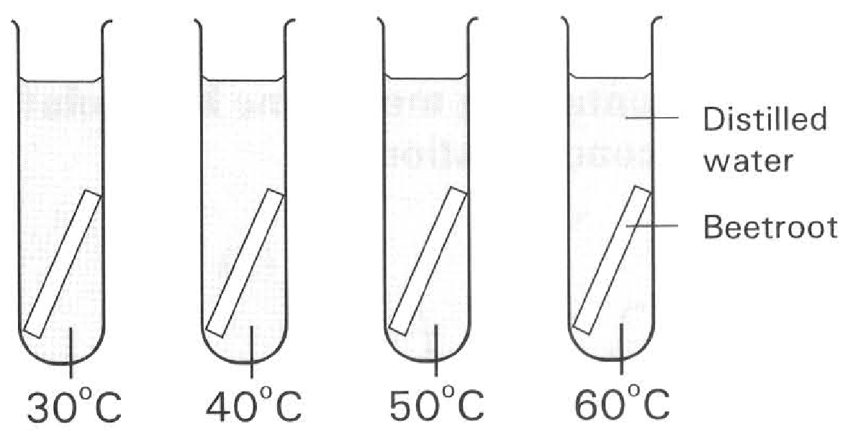
A. Temperature above 50°C destroys the selective permeability of the cytoplasmic membrane of the cell.
B. Increase in temperature increases the kinetic energy of the pigment molecules which vibrate more vigorously at 50°C and 60°C.
C. Temperatures at 30°C and 40°C are too low to catalyse the enzymes responsible for the transport of pigments across the membrane.
D. Osmosis of water occurs at 30°C and 40°C but it fails to occur at 50°C and 60°C.
B. Diffusion
78. Which of the following factors increase the rate of diffusion of particles?
(1) Smaller size of particles
(2) Higher temperature
(3) Smaller surface area for the particles to pass through
(4) Smaller concentration gradient of the particles between two regions
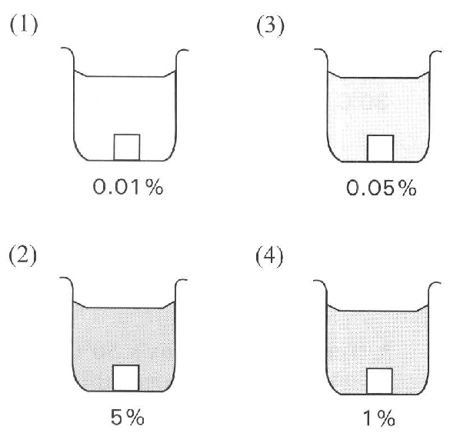
A. (1) and (2) only B. (2) and (3) only
C. (3) and (4) only D. (1), (2) and (3) only Directions: Questions 13 and 14 refer to the diagram below, which shows an experiment in progress. Four potato cubes each of 1 cm long are immersed in four beakers containing methylene blue solution of different concentrations.
79. Which methylene blue solution gives the slowest rate of diffusion into the potato cube?
A. (1)
B. (2)
C. (3)
D. (4)
80. The relative rate of diffusion of the methylene blue solution into the potato cube is found by measuring
A. the total surface area of the potato cube that turns blue.
B. the increase in weight of each potato cube.
C. the decrease in intensity of the solution.
D. the depth of penetration of the blue colour into each potato cube.
81. Which of the following processes involve simple diffusion? (1) Passage of oxygen into the red blood cells in the lungs. (2) Re-absorption of water from the kidney tubules into the blood capillaries surrounding them. (3) Absorption of digested products into the villi of the small intestine. (4) Engulfing the germs by the white blood cells. C. Osmosis
A. (1) and (2) only
B. (1) and (3) only
C. (2) and (4) only
D. (2), (3) and (4) only
82. Which of the following statements or definitions is/are CORRECT? (1) Osmosis is the movement of water molecules from a region of lower water potential to a region of higher water potential. (2) The movement of water molecules from a region of higher water potential to a region of lower water potential is an example of specific diffusion. (3) There is a mixture of urea and protein contained inside a dialysis tubing that only permits urea to pass out. This is an example of osmosis. (4) When osmosis stops, no water molecules will pass through the membrane any more.
A. (1) only
B. (2) only
C. (2) and (3) only
D. (3) and (4) only
83. Which of the following statements concerning the occurrence of osmosis is CORRECT?
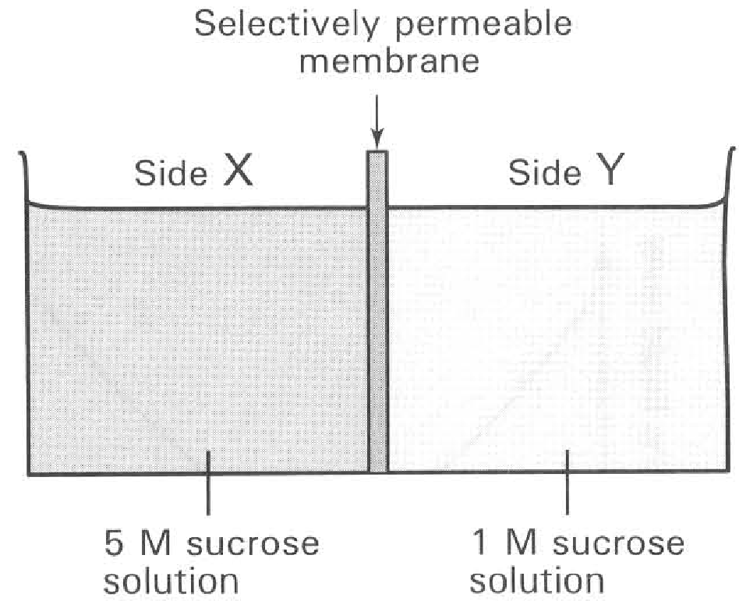
A. Presence of living cell membrane is essential to the process.
B. Biological energy is needed.
C. Movement of water down the water potential gradient.
D. Movement of water in one direction only. Directions: Question 18 refers to the diagram below, which shows the set-up at the beginning of an experiment. The set-up is left at room temperature for 1 hour.
84. Which of the following statements is CORRECT?
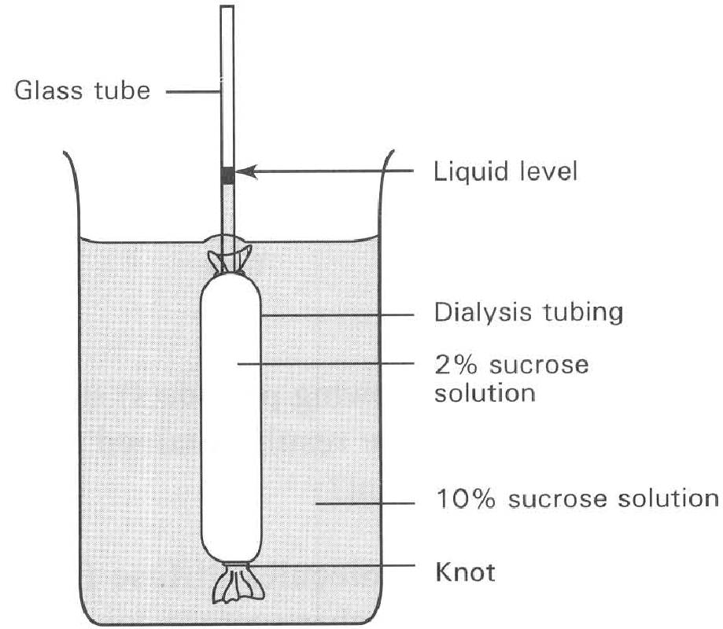
A. The water potential of side X is higher than that of side Y at the beginning of the experiment.
B. Water molecules can only move from side Y to side X throughout the experiment.
C. The water level of side Y will fall one hour after the start of the experiment.
D. The sucrose molecules will move from side X to side Y in the first 20 minutes. Directions: Questions 19 to 22 refer to the diagram below, which shows a dialysis tubing containing 2% sucrose solution. The tubing is immersed in a beaker of 10 % sucrose solution.
85. Which of the following graphs represents the result?
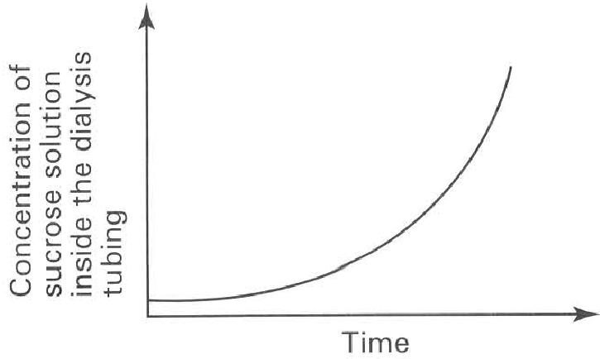
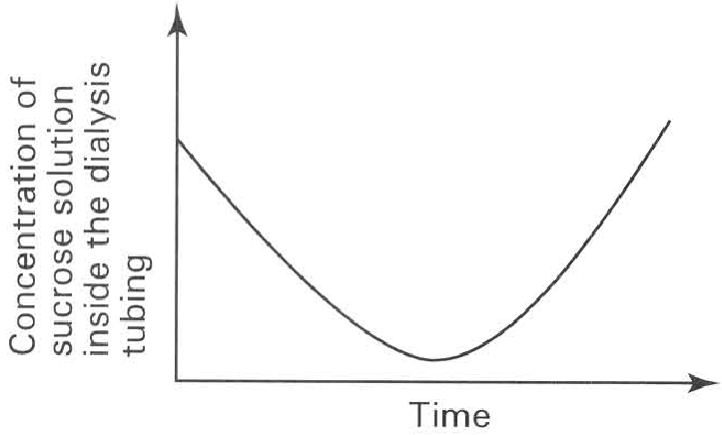
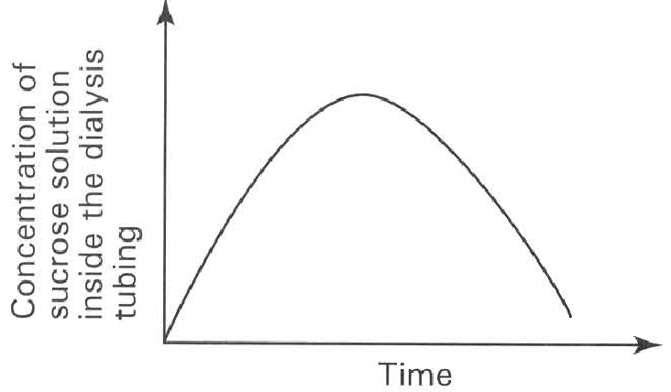
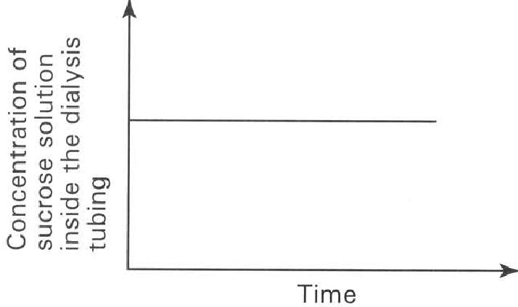
A. | B. | C. | D.

86. Which of the following provide(s) suitable explanation to the result obtained in the previous experiment? (1) Sucrose molecules diffuse from a region of higher sucrose concentration to a region of lower sucrose concentration. (2) Water molecules move from a region of higher water potential through a selectively permeable membrane to a region of lower water potential. (3) The turgor pressure (pressure potential) increases inside the dialysis tubing throughout the whole experiment.
A. (1) only
B. (2) only
C. (3) only
D. (1) and (3) only
87. If the concentration of the sucrose solution inside and outside the dialysis tubing is reversed, which of the diagrams below TRULY represents the change in the liquid level inside the glass tube?
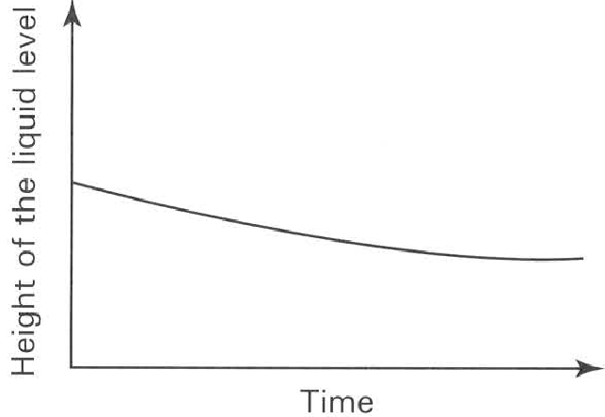
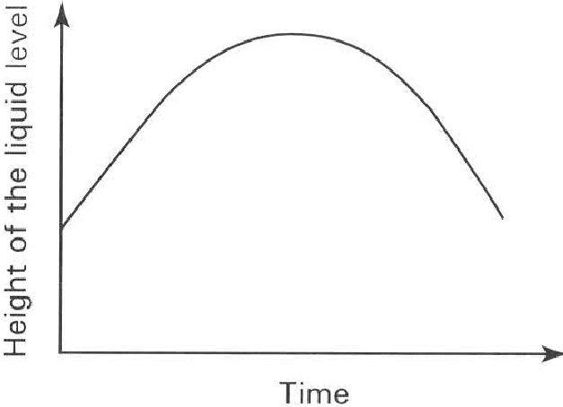
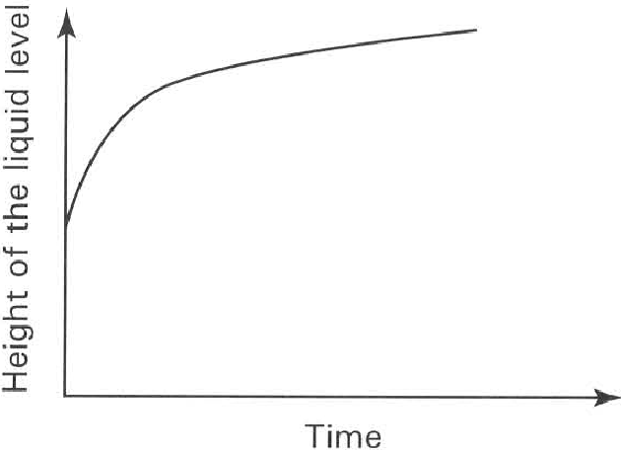
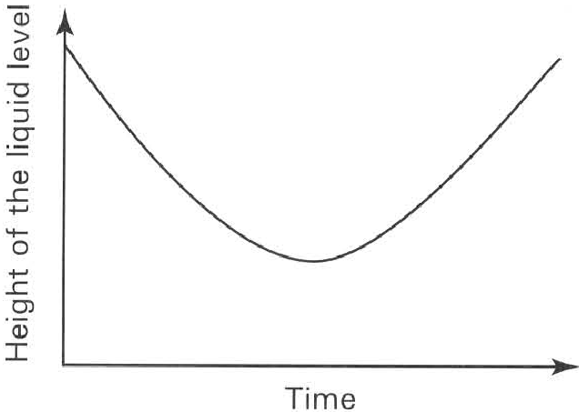
A. | B. | C. | D.

88. At the end of the experiment the liquid level inside the glass tube stops to change any further. The solution inside the dialysis tubing is said to have reached the equilibrium. Which of the following description of the condition of the sucrose solution is CORRECT at this state?
(1) The water potential of the sucrose solution both inside and outside the dialysis tubing is the same.
(2) No more movement of water molecules occurs across the dialysis membrane.
(3) The equilibrium is due to the movement of sucrose molecules from a region of higher concentration to a region of lower concentration.
(4) The concentration of the sucrose solution both inside and outside the dialysis membrane is the same.
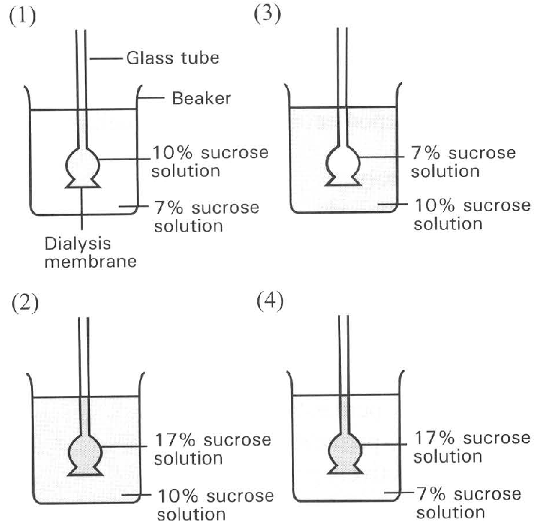
A. (1) only B. (1) and (2) only C. (1) and (4) only D. (2) and (3) only Directions: Questions 23 and 24 refer to the diagram below, which shows the set-up of four osmometers.
89. Which osmometer has the greatest rise in the liquid level inside the glass tube?
A. (1)
B. (2)
C. (3)
D. (4)
90. Which osmometer has a drop in the liquid level inside the glass tube?
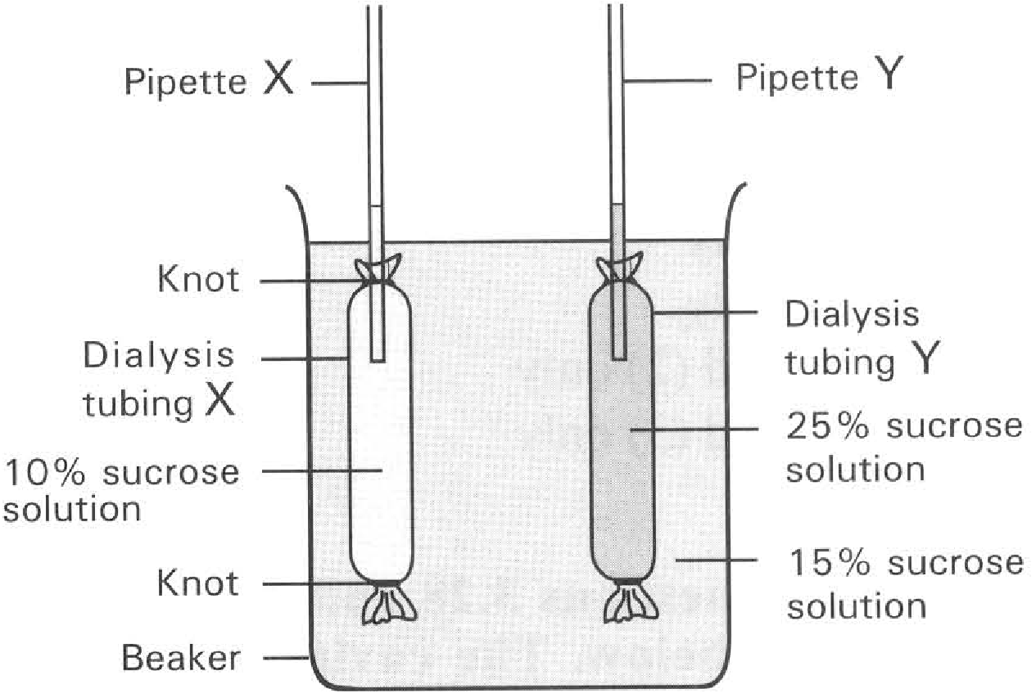
A. (1) B. (2) C. (3) D. (4) Directions: Questions 25 to 27 refer to the diagram below:
91. What result will be expected after one hour?
 | Liquid level in pipette X | Liquid level in pipette Y
A. | Rise | Fall
B. | Fall | Rise
C. | No change | Fall
D. | Rise | No change

92. Which of the following statements is CORRECT?
A. Sucrose molecules pass from the dialysis tubing Y through the 15% sucrose solution in the beaker to the dialysis tubing X.
B. Water molecules move from X to the beaker and then to Y.
C. Water molecules move from Y to the beaker and then to X.
D. Sucrose molecules move from X to the beaker and then to Y.
93. Which of the following procedures can shorten the time of reaching equilibrium in the set-up shown above? (1) Use a bigger beaker with more water to promote the uptake / loss of water by/from the dialysis tubing. (2) Increase the temperature of the solution in the beaker from 25°C to 35°C. (3) Use pipettes of finer bore. D. (2) and (3) only Directions: Questions 28 and 29 refer to the diagram below. The cavity of a boiled potato was filled with 15% sucrose solution and the potato was put in a petri-dish containing distilled water.
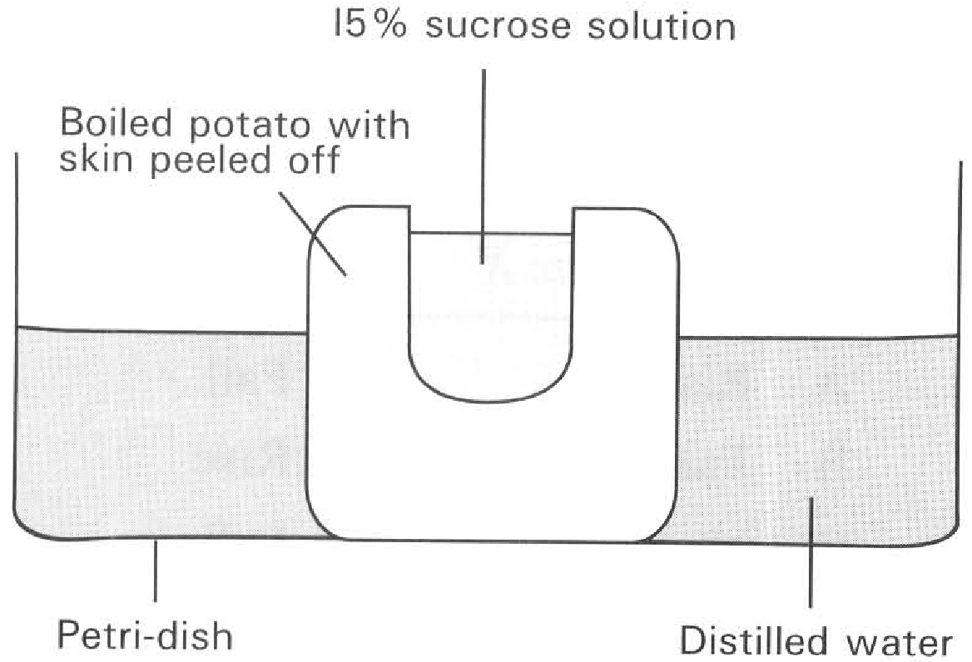
C. (3) Use pipettes of finer bore.
A. (1) only
B. (2) only
C. (1) and (2) only
94. After three hours, the liquid level in the
A. would remain the same.
B. would have risen and overflown.
C. would have fallen below that in the dish.
D. would have fallen to the same level as that in the dish.
95. The result in this experiment is due to the occurrence of
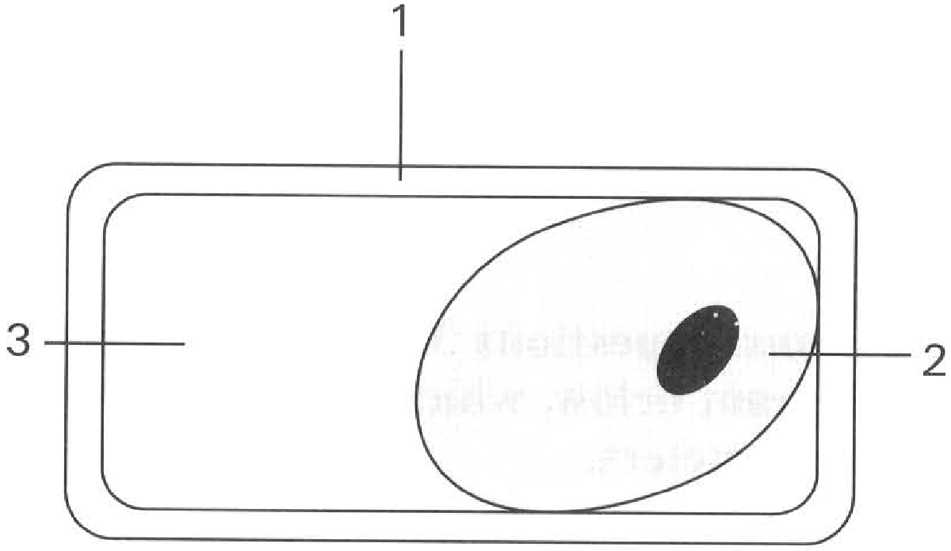
A. osmosis. B. plasmolysis. C. dialysis. D. diffusion. Directions: Questions 30 to 35 refer to the diagram below, which shows the condition of a cell of a strip of epidermis that has been immersed in solution X for 12 hours.
96. The phenomenon shown by the cell is
A. hydrolysis
B. haemolysis
C. dialysis
D. plasmolysis
97. The structure labelled 1 is
A. fully permeable
B. semi-permeable
C. selectively permeable
D. impermeable
98. When the cell shown has reached the state of equilibrium,
A. osmosis stops.
B. water molecules enter and leave the structure labelled 2 at the same rate.
C. structure labelled 1 exerts no wall pressure on the cytoplasm of the cell.
D. all of the above are correct.
99. The space labelled 3 is
A. empty.
B. filled with a solution with the same strength as that bathing the cell.
C. filled with a solution more dilute than that bathing the cell.
D. filled with a solution more concentrated than that bathing the cell.
100. The solution bathing the cell is
A. hypertonic to the cell.
B. isotonic with the cell.
C. hypotonic to the cell.
D. less concentrated than the cell sap.
101. Whenever the cells in the stem of a herbaceous plant are similar to the condition as that in the above diagram, the plant is
A. wilting.
B. turgid.
C. in dormant state.
D. growing.
102. The following diagrams show three closely packed plant cells with different water potential. Which of the following shows the CORRECT movement of water among the cells?
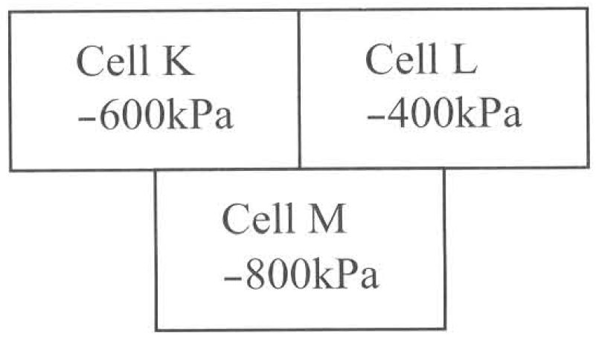
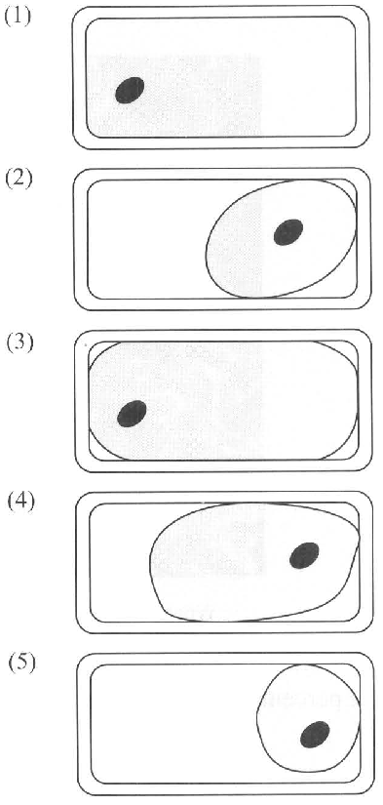
A. Cell K Cell L Cell M
B. Cell M Cell K Cell L
C. Cell L Cell K Cell M
D. Cell L Cell M Cell K
103. A strip of epidermal tissue has reached the plasmolysed condition by immersing it in a hypertonic solution. It is then put back into distilled water. Which of the following is the CORRECT sequence of changes that can be observed?
A. (5), (4), (2), (3), (1)
B. (1), (3), (4),(2), (5)
C. (5), (2), (4), (3), (1)
D. (1),(4), (3),(5), (2) Directions: If the diagrams in the previous question represent the cells of five strips of epidermal tissues that have been immersed in five sucrose solution of different concentrations, answer questions 38 and 39 with reference to these diagrams.
104. Which cell has been immersed in the sucrose solution that has a water potential higher than that of the cell sap?
A. (1)
B. (2)
C. (3)
D. (4)
105. Which cell has been immersed in the sucrose solution that is roughly isotonic to the cell? D. (4) Directions: Questions 40 to 44 refer to the following experiment. A student added 3 drops of citrated mammalian blood to three test tubes, X, Y and Z. Each of these test tubes contained 3 cm3 of saline solution of different concentrations. After 10 minutes he removed a drop of each solution and observed them under the microscope. The red blood cells were found to consist of two forms as shown in the following photomicrographs below: The percentage of red blood cells (RB
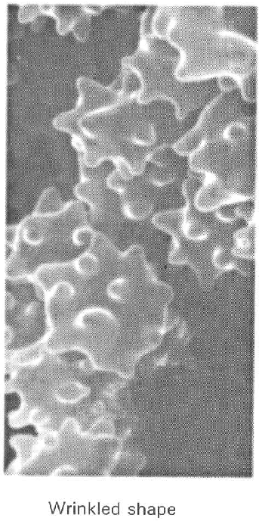
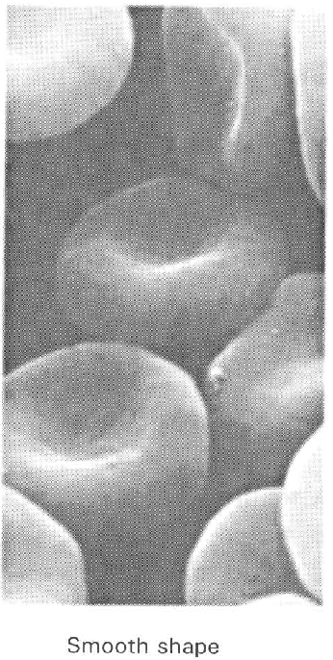
 | Percentage of RBC of
Tubes | Concentration of saline solution | Wrinkled shape | Smooth shape
X | 0.1% | 0 | 0
Y | 0.9% | 55 | 45
Z | 2.0% | 90 | 10

A. (1)
B. (2)
C. (3)
C. of different shapes were recorded as below:
106. Which of the following conclusions are CORRECT? (1) No intact cells observed in solution X because all the RBC burst in hypertonic solution. (2) RBC has different water potential that gives different osmotic response in an isotonic solution. (3) Salt in the concentrated saline solution passes into the RBC to distort the shape of the cells that became wrinkled. (4) Only tube X appears red in colour because of the release of haemoglobin from the burst RBC. (3) and (4) only D. (1) and (4) only
C.
A. (1) and (2) only
B. (2) and (4) only
C. (3) and (4) only
107. Which of the following graphs CORRECTLY represents the change in volume of a red blood cell bathed in solution Z?
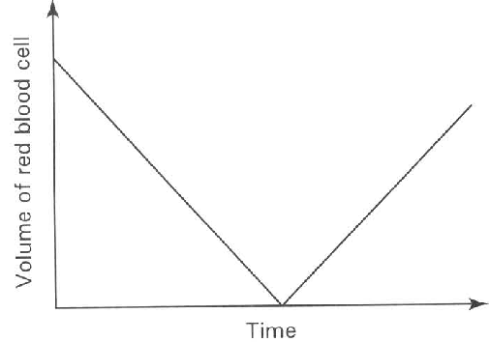
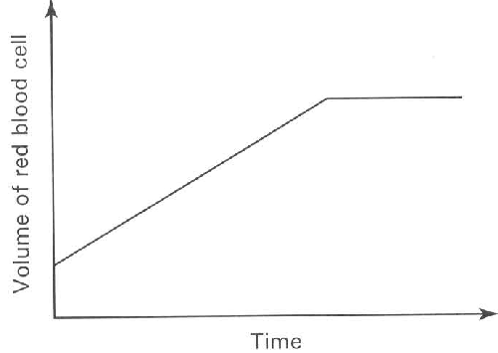
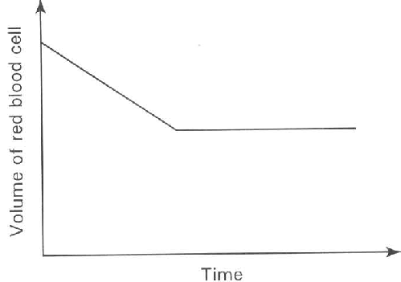
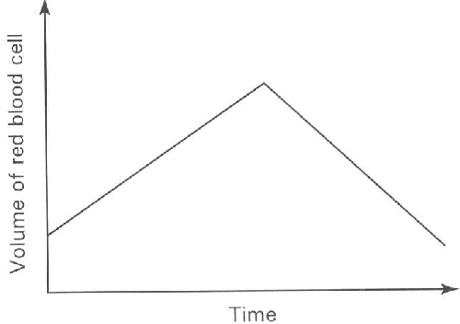
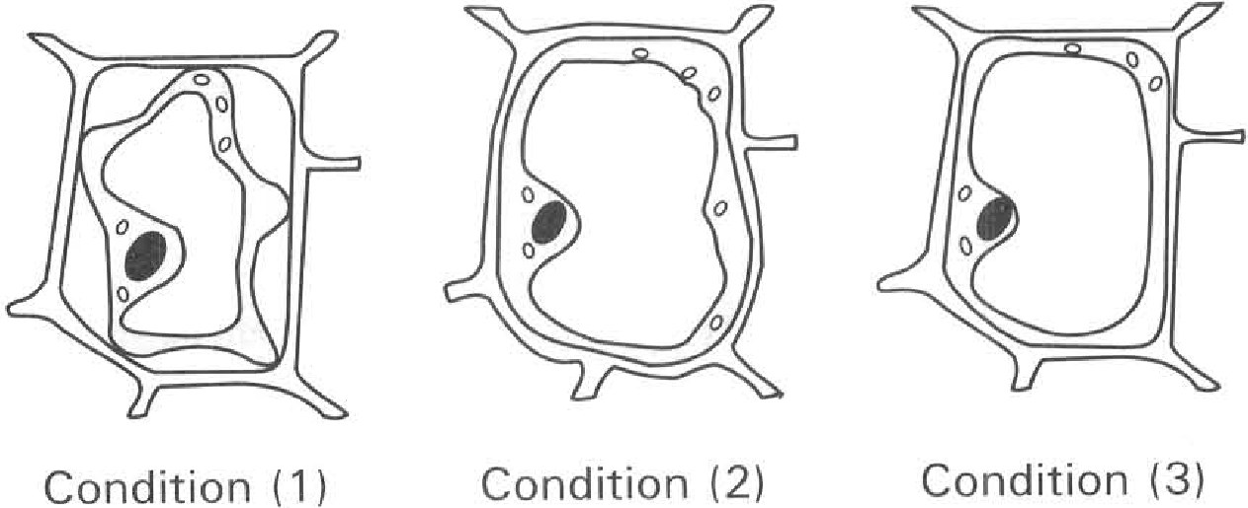
A. | B. | C. | D.

108. If the experiment was repeated by using algal cells with the same water potential of the red blood cells, which of the following diagrams TRULY represent the condition of the algal cells in solution X, Y and Z?
 | Solution X | Solution Y | Solution Z
A. | (3) | (2) | (1)
B. | (1) | (2) | (3)
C. | (3) | (1) | (2)
D. | (2) | (3) | (1)

109. Which of the following is the reason to account for the different results between the red blood cells and algae immersed in solution X?
A. Algal cell has the pigment chlorophyll instead of haemoglobin.
B. Algal cell is bigger than the red blood cell.
C. Algal cell is protected by a rigid cell wall.
D. Algal cell has nucleus while the matured red blood cell has no nucleus.
110. Which of the following TRULY describe the condition or process taking place in the red blood cell and algal cell in solution X and Z respectively?
 | Red blood cell in solution X | Algal cell in solution Z
A. | Plasmolysis | Haemolysis
B. | Haemolysis | Plasmolysis
C. | Fully turgid | Wrinkled
D. | Wrinkled | Fully turgid

111. Which of the following comparisons between plasmolysis and haemolysis is NOT true?
 | Plasmolysis | Haemolysis
(1) | Occurs in hypo-tonic solutions | Occurs in hypertonic solutions
(2) | A phenomenon in plant cells | A phenomenon in red blood cells
(3) | Net effect : water out flux from the cells | Net effect: water influx into the cells

A. (1) only
B. (2) only
C. (3) only
D. (2) and (3) only
112. The following photomicrograph shows the epidermal cells of a plant that has been immersed in a hypertonic sugar solution for hours. Cells of the same tissue show different degree of plasmolysis.
Which of the following is a CORRECT explanation of this phenomenon?
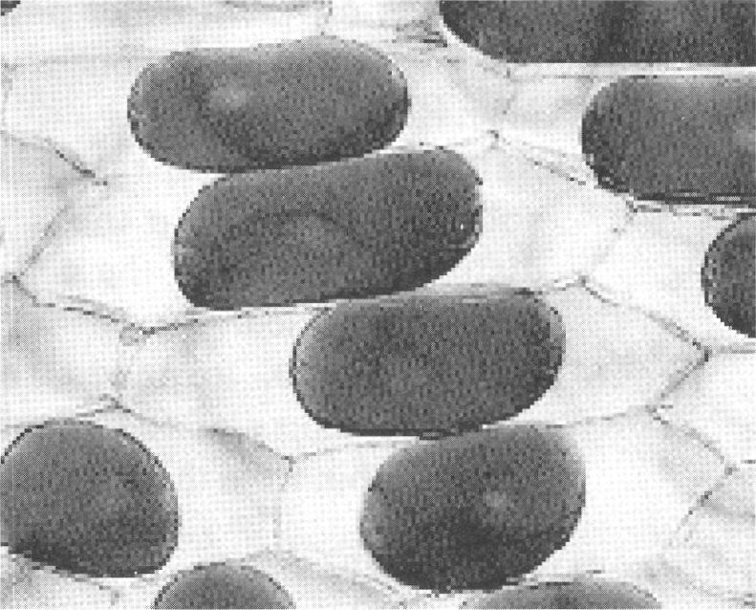
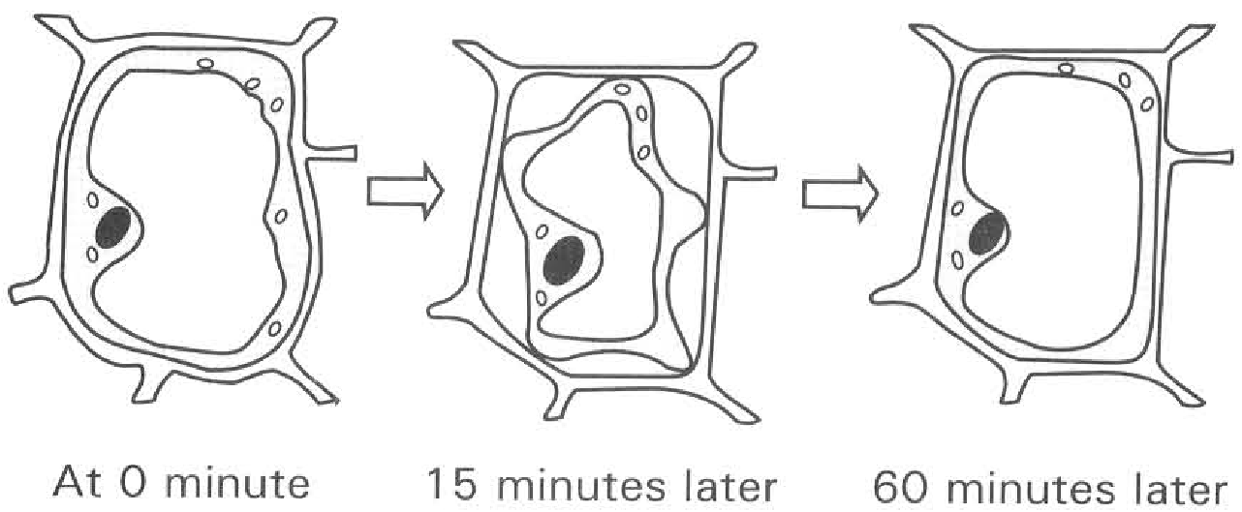
A. Different cells have different water potentials.
B. The cells present at different locations are subjected to different osmotic effect of the external sugar solution.
C. The rate of water loss is affected by the different amount of cytoplasm possessed by individual cells.
D. The osmotic response of the cells is affected by the different thickness of the cell wall. Directions: Questions 47 and 48 refer to the diagrams below, which show the appearance of plant cells at different time after a strip of epidermis has been mounted in 1 M glycerol solution.
113. Which of the following conclusions about the changes from 0 minute to 15 minutes is/are CORRECT? (1) Water moves into the cell by diffusion. (2) The cell has water potential higher than that of the 1M glycerol. (3) The cell is in the state of plasmolysis due to the loss of water by osmosis.
A. (1) only
B. (2) only
C. (1) and (2) only
D. (2) and (3) only
114. Which of the following concerning the changes after 60 minutes is/are CORRECT? (1) Deplasmolysis. (2) Glycerol is an organic solvent that can pass through the lipid portion of the cell membrane into the cell by diffusion until equilibrium is reached. (3) The cell keeps in losing water by osmosis.
A. (1) only
B. (2) only
C. (1) and (2) only
D. (2) and (3) only
115. Three strips of plant tissues with the mean water potential of -600 kPa are put into three sucrose solutions of different water potential.
Which of the following shows the CORRECT state of the epidermal cells?
Solution X- 200 kPa
Solution Y- 600 kPa
Solution Z- 1 000 kPa

 | In solution X | In solution Y | In solution Z
A. | Full turgor | Incipient plasmolysis | Plasmolysis
B. | Incipient plasmolysis | Plasmolysis | Full turgor
C. | Full turgor | Plasmolysis | Incipient plasmolysis
D. | Plasmolysis | Incipient plasmolysis | Full turgor

116. A strip of raw carrot was put into a beaker containing concentrated sucrose solution. After several hours it became limp and soft. Which of the following is the proper explanation for such change?
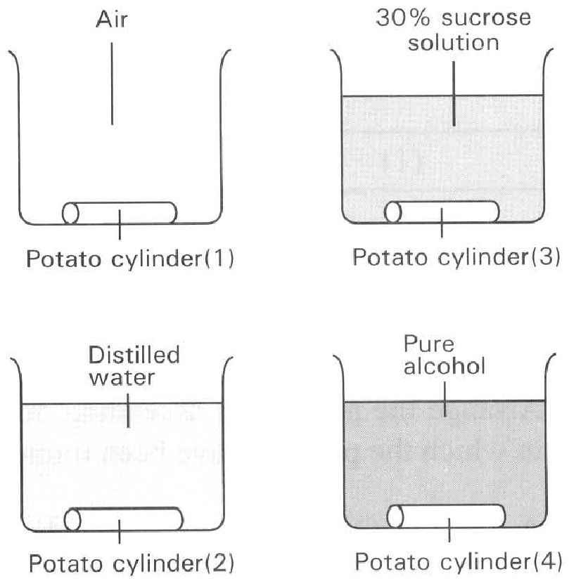
A. The cells were killed by the concentrated sucrose solution.
B. The supporting tissues of the carrot were dissolved by the concentrated sucrose solution.
C. The carrot lost water to the concentrated sucrose solution.
D. The carrot absorbed water from the concentrated sucrose solution. Directions: Questions 51 to 53 refer to the diagrams below, which show four cylinders of potato of equal size treated differently.
117. Which of them will become turgid after 1 hour?
A. (1) only
B. (2) only
C. (3) only
D. (3) and (4)
118. Which of the following CORRECTLY describes the changes in length of the potato cylinders after three hours?
 | Potato cylinder (1) | Potato cylinder (2) | Potato cylinder (3) | Potato cylinder (4)
A. | Decreased | Decreased | Increased | Increased
B. | Decreased | Increased | Decreased | Decreased
C. | Decreased | Increased | Increased | Decreased
D. | Increased | Increased | Decreased | Decreased

119. If the potato cylinders (3) and (4) were removed from the sucrose solution and pure alcohol and washed under tap water. They were then immersed in distilled water together with potato cylinders (1) and (2). Which of the following CORRECTLY describe the change in length of potato cylinders after another three hours?
Directions: Questions 54 to 56 refer to the diagrams below, which show the different appearance of the Coleus petioles that have been split longitudinally into two halves and have immersed in different concentrations of sucrose solution. Diagram (I) represents the appearance of a freshly split petiole.
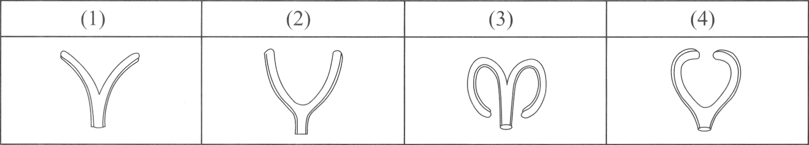
 | Potato cylinder (1) | Potato cylinder (2) | Potato cylinder(3) | Potato cylinder (4)
A. | Increased | Unchanged | Increased | Unchanged
B. | Increased | Increased | Unchanged | Unchanged
C. | Decreased | Decreased | Increased | Increased
D. | Unchanged | Unchanged | Decreased | Decreased

120. Arrange the petioles in ascending order in respect to the concentration of the sucrose solutions in which the petioles have been immersed.
A. (4), (2), (1) and (3)
B. (3), (4), (2) and (1)
C. (4),(3), (1) and (2)
D. (3), (1), (2) and (4)
121. Which of the following is the reason to account for the appearance of petiole (4)?
A. It loses water to the surrounding fluid by dialysis.
B. It gains water from the surrounding fluid by osmosis.
C. The water potential of the petiole cortical cells is lower than the water potential of the surrounding fluid.
D. The water potential of the bathing fluid is lower than that of the petiole cortical cells.
122. What will be the final appearance of the split petiole after it has been immersed in distilled water for two hours?
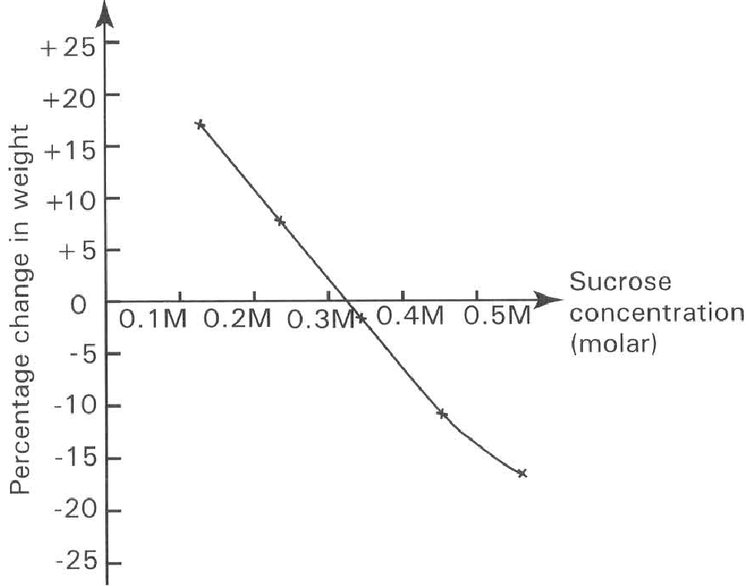
A. (1) B. (2) C. (3) D. (4) Directions: Questions 57 to 59 refer to the graph below.
123. If the average initial weight of each potato strip is 3.2 g, what is the average final weight of the potato strip that has been immersed in the 0.44 M socrose solution?
A. 3.84 g
B. 3.20 g
C. 2.56 g
D. 2.00 g
124. What is the water potential of the potato cell sap in terms of the concentration of the solution?
A. 0.1 M
B. 0.2 M
C. 0.28 M
D. 0.32 M
125. An alternative method of this experiment is to cut each potato strip into equal number of small discs before immersing in the sucrose solution. The purpose of this procedure is to (1) get a more accurate result. (2) increase the rate of diffusion of sucrose molecules into the potato discs. (3) increase the rate of osmosis of the potato discs. (4) shorten the time to achieve the result.
A. (1) and (2) only
B. (3) and (4) only
C. (1) and (3) only
D. (1) and (4) only
126. Three potato strips each of 5 cm long were immersed in three sucrose solutions X, Y and Z. After one hour the final length of these potato strips were recorded as follows: The ascending order of the water potential of these solutions is
X | Y | Z
5.0 cm | 5.2 cm | 4.8 cm

A. X, Y, Z
B. Z, Y, X
C. Y, X, Z
D. Z, X, Y
127. Two bottles with solutions of different concentrations are labelled P and Q. A strip of the epidermis of a leaf is put into each bottle. The cells in solution P undergo plasmolysis and those in Q become very turgid.
Using the above information, it can be concluded that
A. osmosis only takes place in living cells.
B. solution P is hypertonic to the living cells.
C. solution P causes the cytoplasm of the cells to break down into smaller units.
D. the living cells have higher water potential than solution Q.
128. To demonstrate fermentation active yeast cells are put into a solution. If the sucrose solution is very concentrated, the demonstration will fail. Which of the following is the main reason to account for the guick failure of the experiment?
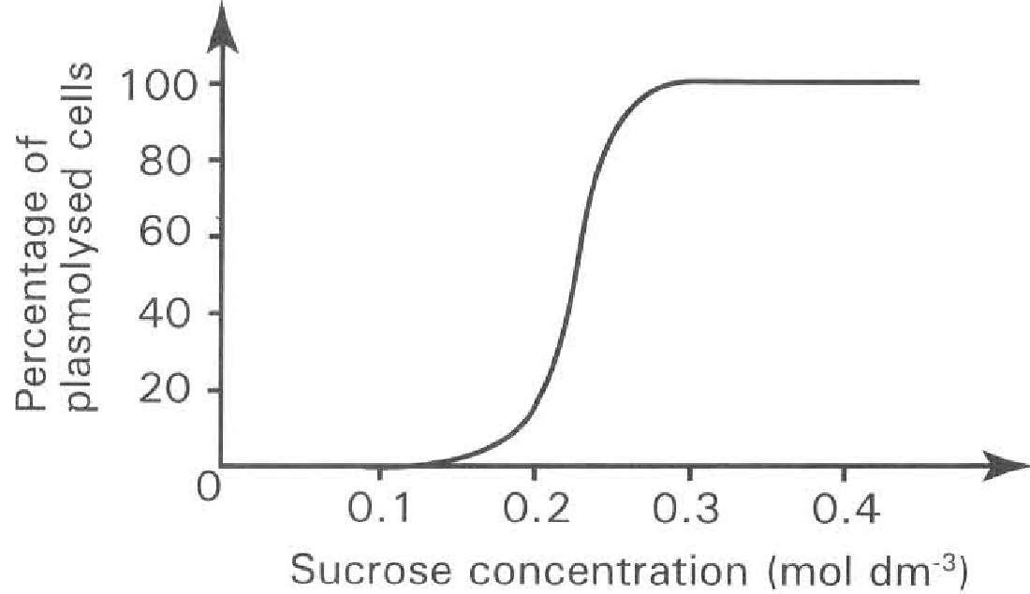
A. The large amount of alcohol produced kills the yeast.
B. The solution is so viscous that it prevents yeast growth.
C. Carbon dioxide is so greatly produced that the yeast is poisoned.
D. Water is drawn out from the yeast by osmosis into the concentrated solution so that the yeast dies due to dehydration. Directions: Questions 63 and 64 refer to the experiment below. Strips of the epidermis of the Zebrina leaf were put into a series of sucrose solution of different concentrations. The percentage of plasmolysed cells at different concentrations of sucrose solution was recorded in the graph below.
129. Which of the following conclusion is CORRECT?
The epidermal cells of the Zebrina leaf
A. have cell walls of different thickness.
B. have different water potential.
C. have different sizes and shapes.
D. have different amount of pigments.
130. Which of the following combinations CORRECTLY matches the condition of most of the epidermal cells at the given concentrations?
E. Active transport
 | 0.05 M | 0.35 M
A. | Burst | Plasmolysed
B. | Flaccid | Turgid
C. | Turgid | Plasmolysed
D. | Plasmolysed | Burst

131. Which of the following processes is/are example(s) of active transport? (1) Absorption of water in the small intestine. (2) Passage of oxygen from alveoli to the blood capillaries covering the alveoli air sacs. (3) Re-absorption of amino acids from the nephrons into the blood capillaries surrounding the nephrons. (4) Absorption of glucose in the small intestine.
A. (1) and (2) only
B. (3) and (4) only
C. (1) and (3) only
D. (2) and (4) only
132. Which of the following processes require the expenditure of energy?
(1) Complete absorption of glucose in the small intestine.
(2) Passage of oxygen through the cell membrane of the red blood cells.
(3) The phagocytosis of germs by white blood cells.
(4) Absorption of water in the small intestine.
(5) The reabsorption of amino acids by the nephrons.
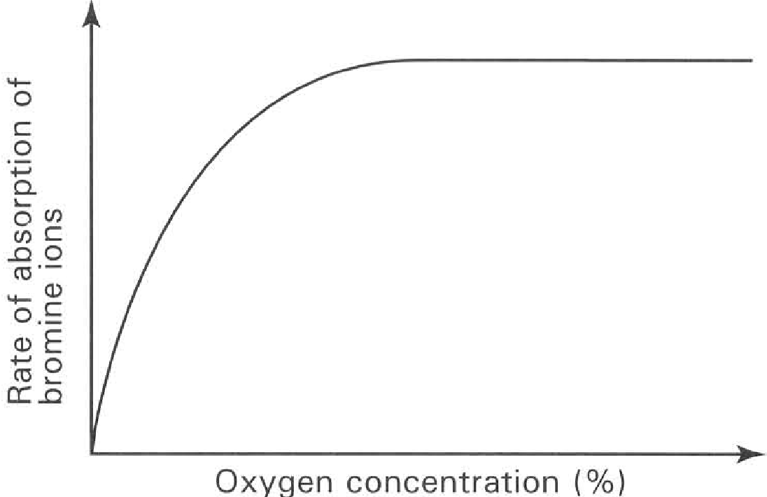
A. (1), (2) and (3) only
B. (2), (4) and (5) only
C. (1), (3) and (5) only
D. (1), (4) and (5) only
133. The following graph shows the effect of oxygen concentration on the rate of absorption of bromine ions in potato tissues.
Which of the following conclusions can be drawn directly from the graph?
A. The rate of absorption of bromine ions depends on aerobic respiration.
B. The rate of absorption of bromine ions depends on enzymatic reactions.
C. The rate of absorption of bromine ions is proportional to the temperature of the surroundings.
D. The rate of absorption of bromine ions is independent of the oxygen concentration.
134. The graph below shows the effect of oxygen on the rate of absorption of potassium ions by cereal root hairs.
Which process(es) is/are responsible for the absorption of potassium ions into the root hair cells when the potassium ion concentration in the solution is within the arbitrary units of 2 to 6?
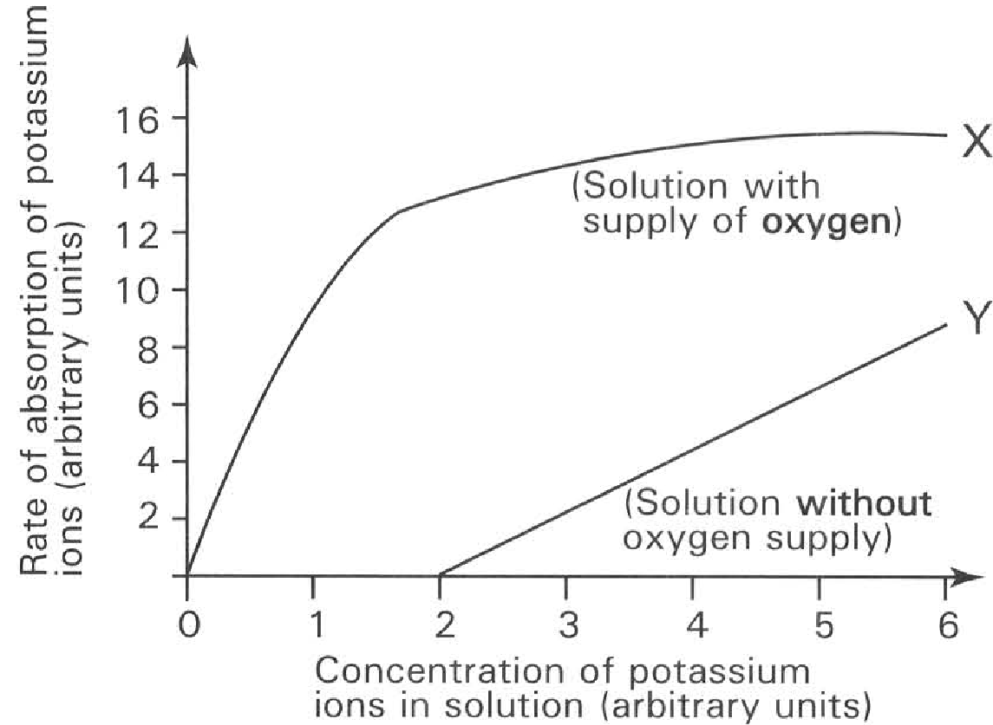
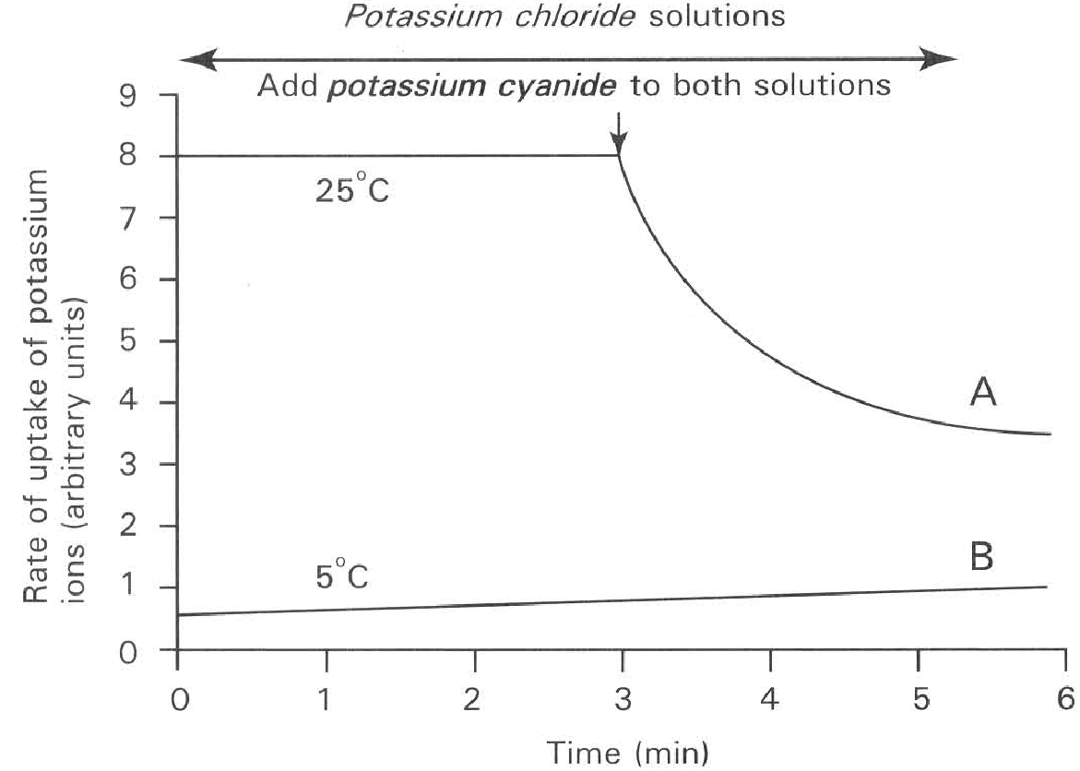
A. Active transport alone
B. Diffusion alone
C. Osmosis alone
D. Diffusion and active transport Directions: Questions 69 to 71 refer to two experiments (A and B), which were set up to find out the uptake of potassium ions by barley root hairs placed in potassium chloride solutions with continuous oxygen supply. One set-up (A) was maintained at 25°C and the other (B) maintained at 5°C. After 30 minutes, potassium cyanide, an inhibitor on respiration, was added to each solution. The result was shown in the graph below:
135. Which of the following statements about these experiments is INACCURATE?
A. At 25°C aerobic respiration can take place to produce enough energy to support the active transport of potassium ions into the root hairs.
B. Potassium cyanide prevents aerobic respiration so that there is insufficient energy to support the active transport of potassium ions into the cells.
C. At low temperature active transport cannot take place and only diffusion occurs for the uptake of potassium ions into the root cells.
D. Active transport is the only means by which potassium ions are absorbed into the root hair cells.
136. Adding potassium cyanide will cause decrease in the rate of uptake of potassium ions into the cells. This suggests that the normal process of absorbing potassium ions into the cells is
A. osmosis.
B. diffusion.
C. active transport.
D. phagocytosis.
137. Which of the following conclusions drawn from these experiments is/are INCORRECT? (1) Potassium cyanide kills the plant. (2) The plant absorbs water by osmosis. (3) The plant absorbs salts by both the active process and the passive process.
A. (1) only
B. (2) only
C. (3) only
D. (1) and (2) only
138. The following table shows the concentration of different ions in the green algae and the pond water bathing them.
Which of the following conclusions can be drawn from the data of the table?
(1) Green algae have different demand for different ions.
(2) Green algae absorb these ions from the surrounding by simple diffusion.
(3) Green algae are very simple plants that do not need vascular system to transport these ions throughout the plant.
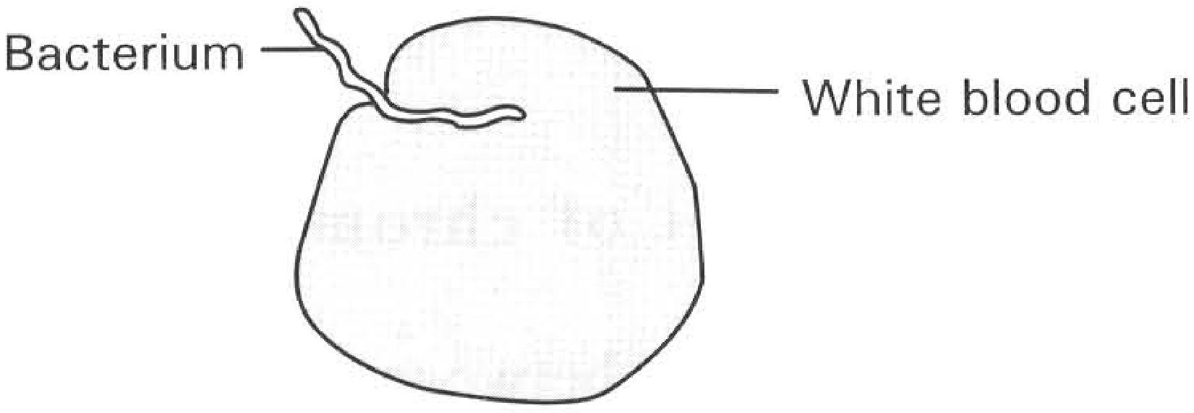
 | Relative concentration of ions (milli-equivalents per litre)
Types of ions | Pond water | Green algae
Calcium ions | 1.3 | 13.0
Magnesium ions | 3.0 | 10.8
Sodium ions | 1.2 | 49.9
Chloride ions | 1.0 | 101.1
Sulphate ions | 0.7 | 13.0

A. (1) only B. (2) onlyC. (3) only D. (2) and (3) only E. Phagocytosis Directions: Questions 73 to 75 refer to the diagram below, which shows a bacterium engulfed by a white blood cell.
139. Which of the following is the CORRECT sequence of events for a white blood cell to engulf a bacterium? (1) The cytoplasmic processes (pseudopodia) surround the bacterium and enclose it to form a food vacuole. (2) Lysosomes discharge digestive enzymes into the vacuole to digest the bacterium. (3) The cell membrane of a white blood cell protrudes out to form two processes (pseudopodia). (4) Lysosomes move towards the food vacuole and fuse with it.
A. (2) (4) (3) (1)
B. (1) (2) (3) (4)
C. (3) (1) (4) (2)
D. (4) (3) (1) (2)
140. Which of the following is the process of transport illustrated by the diagram above?
A. Active transport B. Phagocytosis C. Secretion D. Haemolysis
141. Which TWO organelles below are present in the white blood cells in abundant amount to cope with the process illustrated above? (1) Lysosome (2) Mitochondria (3) Smooth endoplasmic reticulum (4) Nucleoli D. (4) and (1) only Suggested Solutions
A. (1) and (2) only
B. (2) and (3) only
C. (3) and (4) only
D. (4) and (1) only Suggested Solutions

Answers
Answers are printed in red.
1. D

2. B. (2) only
Class: 37.2% correct (n=43) usual slip C
3. C

4. B. The blood should be citrated first.
Class: 62.8% correct (n=43) usual slip D
5. D. (1), (2) and (3)

6. ?

7. B. (1) and (3) only
Class: 75.7% correct (n=74) usual slip A
8. D. (1), (3) and (4) only
Class: 39.5% correct (n=43) usual slip A
9. ?

10. C. (2) and (3) only

11. B
Class: 84.6% correct (n=117) usual slip A
12. B
Class: 69.8% correct (n=149) usual slip C
13. C. become longer.

14. A. (1) and (2) only
Class: 74.7% correct (n=75) usual slip B
15. D

16. C. the cytoplasm is purple in colour.

17. ?

18. C
Class: 51.2% correct (n=43) usual slip A
19. A. 05 minutes.-
Class: 72.1% correct (n=43) usual slip B
20. D. concentrated sucrose solution.
Class: 79.1% correct (n=43) usual slip B
21. D

22. B. the higher tension in the epidermal layer.

23. ?

24. D

25. B

26. B

27. C

28. A

29. D. the distribution of stomata in leaves.
Class: 44.2% correct (n=43) usual slip C
30. C. the expansion of air within the leaf upon heating.

31. ?

32. A. those leaves have no cuticle at all.

33. A

34. D. to return the bubble to position P1.

35. B. The rate of water absorption

36. B

37. C. (3) and (4) only

38. D
Class: 94.7% correct (n=57) usual slip A
39. B
Class: 56.1% correct (n=57) usual slip A
40. D. (1), (2) and (3)

41. C
Class: 94.7% correct (n=57) usual slip A
42. D

43. ?

44. D. | epidermis | phloem | xylem

45. ?

46. ?

47. ?

48. B

49. B

50. C. (2) and (3) only

51. ?

52. A. evaporation of water from the mesophyll. B. osmosis between root cells and soil water.

53. D

54. ?

55. C. Red blood cells and fibrinogen.

56. C. (3) only

57. B

58. C

59. ?

60. D

61. A

62. B

63. D

64. D

65. D. dialysate contains the same concentrations of glucose and mineral salts as that of Blood.

66. A. (1) and (3) only

67. A. (1) and (2) only
Class: 59.0% correct (n=117) usual slip C
68. C. (3) and (4) only
Class: 67.1% correct (n=149) usual slip B
69. C. (3) and (4) only

70. C

71. A
Class: 48.4% correct (n=192) usual slip C
72. B. N
Class: 44.2% correct (n=43) usual slip C
73. D. Q
Class: 95.3% correct (n=43) usual slip B
74. A

75. C. (3) only

76. D. (2), (3) and (4) only
Class: 67.4% correct (n=43) usual slip A
77. A. Temperature above 50°C destroys the selective permeability of the cytoplasmic membrane of the cell.
Class: 30.2% correct (n=43) usual slip C
78. A. (1) and (2) only B. (2) and (3) only
Class: 72.0% correct (n=75) usual slip B
79. A. (1)
Class: 39.5% correct (n=43) usual slip D
80. D. the depth of penetration of the blue colour into each potato cube.
Class: 78.1% correct (n=192) usual slip D
81. B. (1) and (3) only
Class: 75.5% correct (n=192) usual slip C
82. B. (2) only
Class: 55.2% correct (n=192) usual slip B
83. C. Movement of water down the water potential gradient.

84. C. The water level of side Y will fall one hour after the start of the experiment.

85. A

86. B. (2) only

87. C

88. A. (1) only B. (1) and (2) only C. (1) and (4) only D. (2) and (3) only Directions: Questions 23 and 24 refer to the diagram below, which shows the set-up of four osmometers.
Class: 11.6% correct (n=43) usual slip A
89. D. (4)

90. C

91. B

92. B. Water molecules move from X to the beaker and then to Y.

93. B. (2) only

94. D. would have fallen to the same level as that in the dish.

95. D

96. D. plasmolysis

97. A. fully permeable

98. D. all of the above are correct.
Class: 79.1% correct (n=43) usual slip C
99. B. filled with a solution with the same strength as that bathing the cell.
Class: 46.5% correct (n=43) usual slip A
100. A. hypertonic to the cell.
Class: 67.4% correct (n=43) usual slip B
101. A. wilting.

102. C. Cell L Cell K Cell M

103. C. (5), (2), (4), (3), (1)
Class: 34.9% correct (n=43) usual slip A
104. A. (1)

105. C. of different shapes were recorded as below:

106. B. (2) and (4) only

107. C

108. D

109. C. Algal cell is protected by a rigid cell wall.

110. B

111. A. (1) only
Class: 94.7% correct (n=57) usual slip B
112. A. Different cells have different water potentials.

113. D. (2) and (3) only
Class: 89.5% correct (n=57) usual slip A
114. C. (1) and (2) only

115. A

116. C. The carrot lost water to the concentrated sucrose solution.

117. B. (2) only

118. B
Class: 91.2% correct (n=57) usual slip A
119. A

120. D. (3), (1), (2) and (4)
Class: 52.6% correct (n=57) usual slip D
121. D. The water potential of the bathing fluid is lower than that of the petiole cortical cells.

122. C
Class: 40.4% correct (n=57) usual slip B
123. C. 2.56 g

124. D. 0.32 M
Class: 98.2% correct (n=57) usual slip C
125. B. (3) and (4) only

126. D. Z, X, Y

127. B. solution P is hypertonic to the living cells.

128. D. Water is drawn out from the yeast by osmosis into the concentrated solution so that the yeast dies due to dehydration. Directions: Questions 63 and 64 refer to the experiment below. Strips of the epidermis of the Zebrina leaf were put into a series of sucrose solution of different concentrations. The percentage of plasmolysed cells at different concentrations of sucrose solution was recorded in the graph below.

129. B. have different water potential.

130. C

131. B. (3) and (4) only

132. C. (1), (3) and (5) only

133. A. The rate of absorption of bromine ions depends on aerobic respiration.

134. D. Diffusion and active transport Directions: Questions 69 to 71 refer to two experiments (A and B), which were set up to find out the uptake of potassium ions by barley root hairs placed in potassium chloride solutions with continuous oxygen supply. One set-up (A) was maintained at 25°C and the other (B) maintained at 5°C. After 30 minutes, potassium cyanide, an inhibitor on respiration, was added to each solution. The result was shown in the graph below:

135. D. Active transport is the only means by which potassium ions are absorbed into the root hair cells.

136. C. active transport.

137. D. (1) and (2) only

138. A. (1) only B. (2) onlyC. (3) only D. (2) and (3) only E. Phagocytosis Directions: Questions 73 to 75 refer to the diagram below, which shows a bacterium engulfed by a white blood cell.

139. C. (3) (1) (4) (2)

140. B

141. A. (1) and (2) only

