Movement of substances across the cell membrane · items under 80% correct
Multiple-choice practice
Name: ________________________ Class: ____________
These items were answered correctly by fewer than 80% of students in class Google Forms, matched by the wording in the source bank and the form answer key. Choose the one best answer.
Part A — HKCEE level (Longman)
1. Which of the following is/are not the importance of water in flowering plants? (1) As the reactant in photosynthesis (2) As the product in respiration (3) As the main constituent in vacuole
A. (1) only
B. (2) only
C. (3) only
D. (2) and (3) only
2. How should the blood be treated before the experiment? A.The blood should be sterilized first. C.The blood should be filtered first.
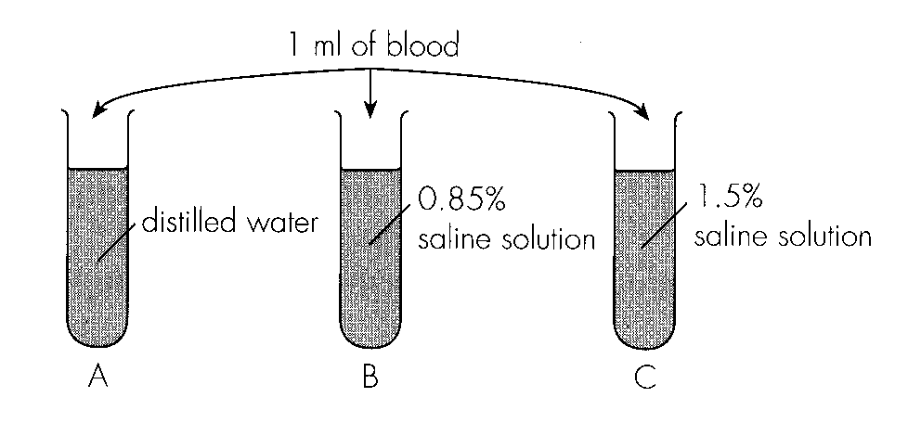
A. The blood should be sterilized first.
B. The blood should be citrated first.
C. The blood should be filtered first.
D. The blood should be spun with a centrifuge first.
3. Which of the following is/are the functions) of kidneys? (1) Regulation of the amount of salts in relation to that of water in blood (2) Removal of excess glucose (3) Removal of excess urea (4) Removal of excess amino acids
A. (1) and (2) only
B. (1) and (3) only
C. (2), (3) and (4) only
D. (1), (2), (3) and (4)
4. The list below shows some of the body fluids in a human body. (1) Intercellular fluid (2) Tear (3) Lymph (4) Blood Which of the fluids above have steady water potential?
A. (1) and (2) only
B. (1) and (4) only
C. (3) and (4) only
D. (1), (3) and (4) only
5. Which of the following correctly describes the urine production after drinking a large quantity of distilled water?
A. A larger volume only B. A larger volume of lower concentration
C. A larger volume of same concentrationD. A larger volume of higher concentration
6. When placed in hypertonic solution, the cells in a plant tissue will (1) be plasmolysed. (2) become flaccid. (3) become crenated.
A. (1) and (2) only
B. (1) and (3) only
C. (2) and (3) only
D. (1), (2) and (3)
7. Three groups of potato strips were immersed in three sucrose solutions of 0.1 %, 5% and 15% respectively. The probable percentage changes in mass of the three groups of potato strips would be
Directions: Questions 24 to 26 refer to the following graph which shows the changes in mass of a potato strip in an unknown solution.
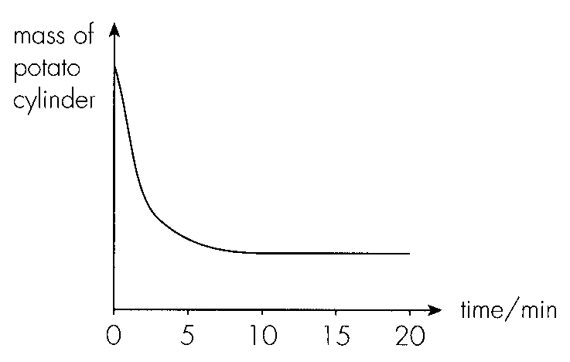
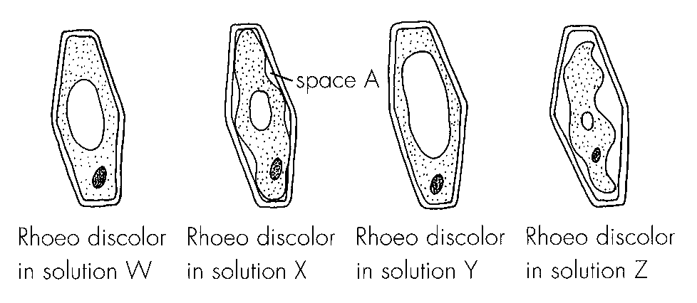
 | 0.1 solution | 5% solution | 15% solution
A. | 9%- | +0.2% | +6%
B. | +0.2% | 9%- | +6%
C. | +6% | +0.2% | 9%-
D. | 9%- | +6% | +0.2%

8. The potato strip loses weight most rapidly between
A. 05 minutes.-
B. 5 10 minutes.-
C. 10 15 minutes.-
D. 15 20 minutes.-
9. The unknown solution was most probably
A. distilled water.
B. dilute glucose solution.
C. dilute sucrose solution.
D. concentrated sucrose solution.
10. This experiment can be used to demonstrate
A. gaseous exchange in leaves.
B. transpiration in leaves.
C. number of stomata in leaves.
D. the distribution of stomata in leaves.
11. The mass of water transpired from the leafy shoot and the mass of water absorbed by the leafy shoot are respectively
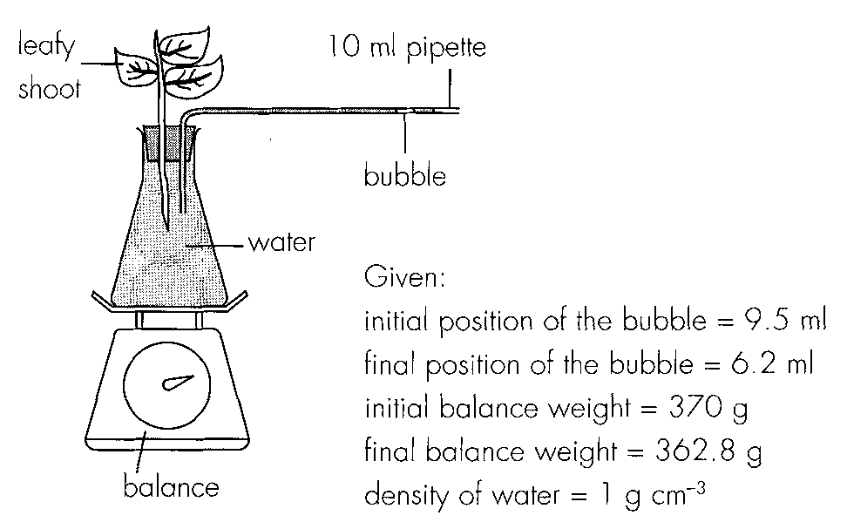
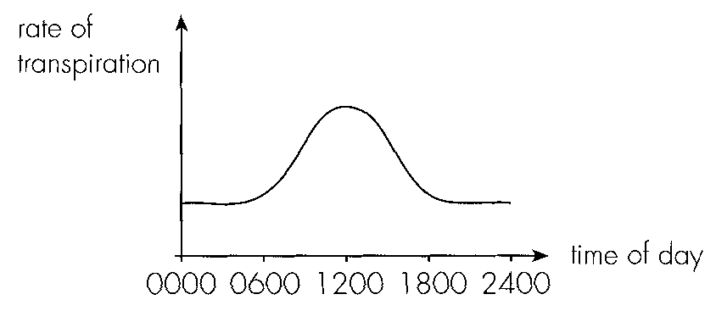
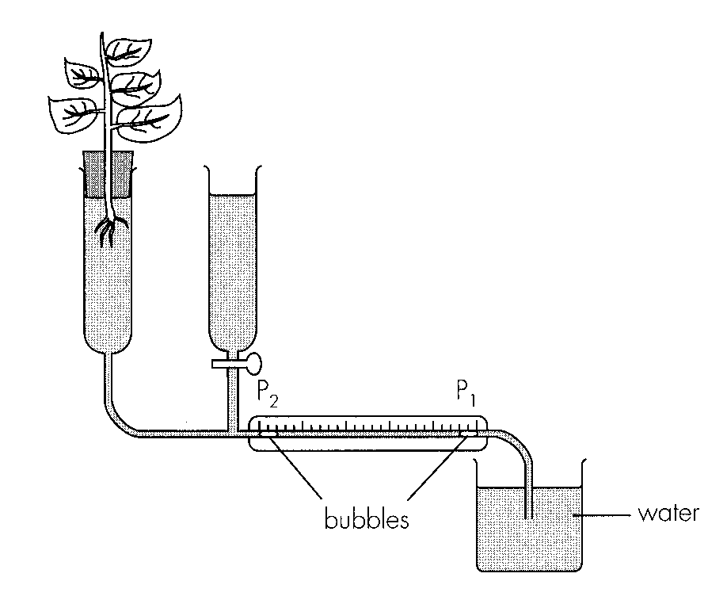
 | Mass of water transpired | Mass of water absorbed
A. | 3.3 g | 7.2 g
B. | 7.2 g | 3.3 g
C. | 360.5 g | 356.6 g
D. | 356.6 g | 360.5 g

Part B — HKDSE-style (YKTo)
12. Directions: Questions 1 to 4 refer to the following processes of transport across a membrane : Which of the processes concern with the movement of particles in a random manner?
A. (1) and (2) only
B. (1) and (3) only
C. (2) and (3) only
D. (3) and (4) only
13. Which processes involve the movement of particles in one direction only?
A. (1) and (2) only
B. (2) and (3) only
C. (3) and (4) only
D. (4) and (1) only
14. Which of the following substances can move along pathways X and Y respectively?
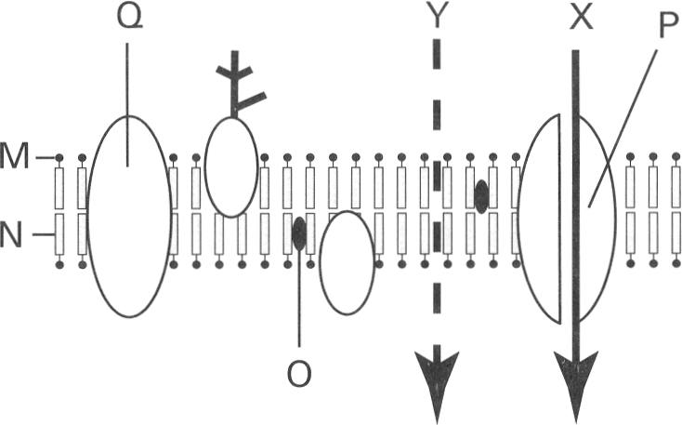
 | Pathway X | Pathway Y
A. | Glucose | Oxygen
B. | Alcohol | Water
C. | Oxygen | Glucose
D. | Glucose | Water

15. Which labelled part prevents polar molecules to pass through?
A. M
B. N
C. P
D. Q
16. Which of the following is/are selectively permeable membrane (s)? (1) Cell wall (2) Cell membrane (3) Envelope of chloroplast (4) Nuclear membrane
A. (1) and (2) only
B. (2) and (3) only
C. (1), (3) and (4) only
D. (2), (3) and (4) only
17. The cell sap of beetroot contains a red pigment. Four pieces of beetroot cylinders of equal thickness and length were washed thoroughly and then immersed in distilled water. They were maintained at four different temperatures as shown below:
After 40 minutes the distilled water maintained at 30°C and 40°C remained clear while those maintained at 50°C and 60°C turned red. Which of the following explanation of the result is CORRECT?
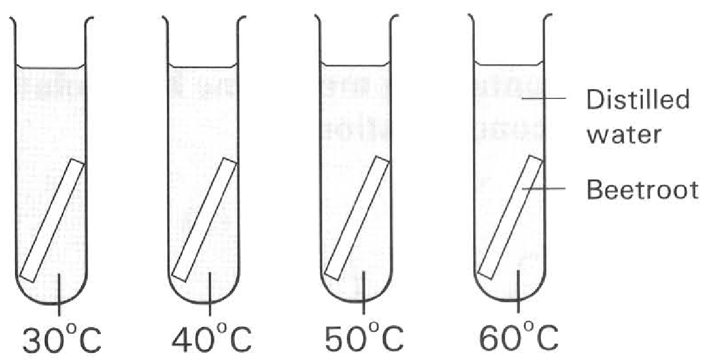
A. Temperature above 50°C destroys the selective permeability of the cytoplasmic membrane of the cell.
B. Increase in temperature increases the kinetic energy of the pigment molecules which vibrate more vigorously at 50°C and 60°C.
C. Temperatures at 30°C and 40°C are too low to catalyse the enzymes responsible for the transport of pigments across the membrane.
D. Osmosis of water occurs at 30°C and 40°C but it fails to occur at 50°C and 60°C.
B. Diffusion
18. Which of the following factors increase the rate of diffusion of particles?
(1) Smaller size of particles
(2) Higher temperature
(3) Smaller surface area for the particles to pass through
(4) Smaller concentration gradient of the particles between two regions
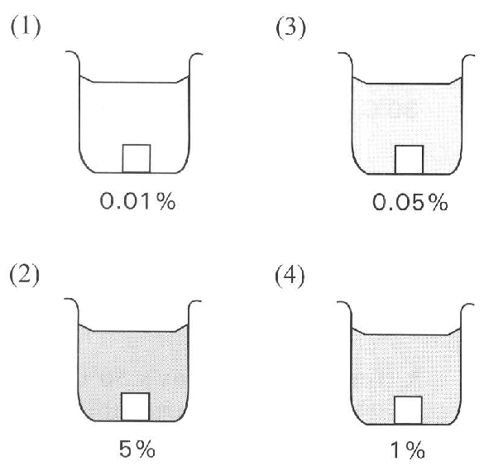
A. (1) and (2) only B. (2) and (3) only
C. (3) and (4) only D. (1), (2) and (3) only Directions: Questions 13 and 14 refer to the diagram below, which shows an experiment in progress. Four potato cubes each of 1 cm long are immersed in four beakers containing methylene blue solution of different concentrations.
19. Which methylene blue solution gives the slowest rate of diffusion into the potato cube?
A. (1)
B. (2)
C. (3)
D. (4)
20. The relative rate of diffusion of the methylene blue solution into the potato cube is found by measuring
A. the total surface area of the potato cube that turns blue.
B. the increase in weight of each potato cube.
C. the decrease in intensity of the solution.
D. the depth of penetration of the blue colour into each potato cube.
21. Which of the following processes involve simple diffusion? (1) Passage of oxygen into the red blood cells in the lungs. (2) Re-absorption of water from the kidney tubules into the blood capillaries surrounding them. (3) Absorption of digested products into the villi of the small intestine. (4) Engulfing the germs by the white blood cells. C. Osmosis
A. (1) and (2) only
B. (1) and (3) only
C. (2) and (4) only
D. (2), (3) and (4) only
22. Which of the following statements or definitions is/are CORRECT? (1) Osmosis is the movement of water molecules from a region of lower water potential to a region of higher water potential. (2) The movement of water molecules from a region of higher water potential to a region of lower water potential is an example of specific diffusion. (3) There is a mixture of urea and protein contained inside a dialysis tubing that only permits urea to pass out. This is an example of osmosis. (4) When osmosis stops, no water molecules will pass through the membrane any more.
A. (1) only
B. (2) only
C. (2) and (3) only
D. (3) and (4) only
23. At the end of the experiment the liquid level inside the glass tube stops to change any further. The solution inside the dialysis tubing is said to have reached the equilibrium. Which of the following description of the condition of the sucrose solution is CORRECT at this state?
(1) The water potential of the sucrose solution both inside and outside the dialysis tubing is the same.
(2) No more movement of water molecules occurs across the dialysis membrane.
(3) The equilibrium is due to the movement of sucrose molecules from a region of higher concentration to a region of lower concentration.
(4) The concentration of the sucrose solution both inside and outside the dialysis membrane is the same.
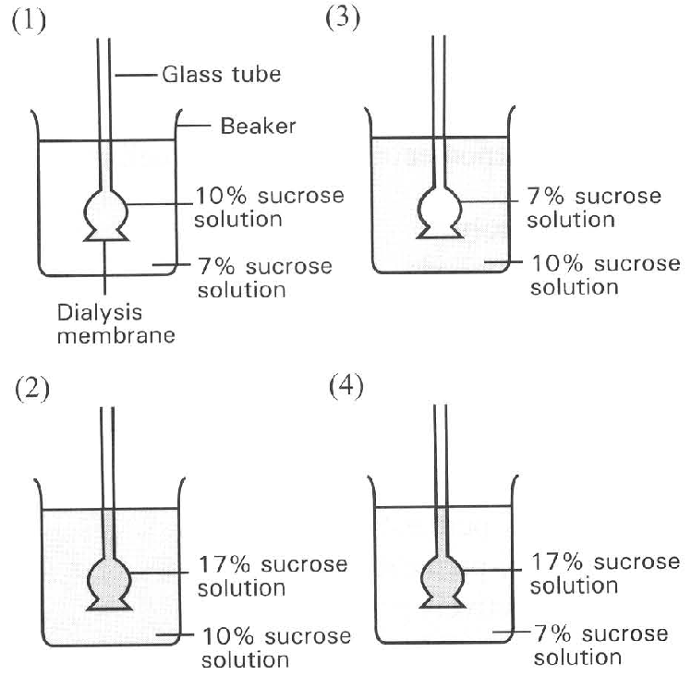
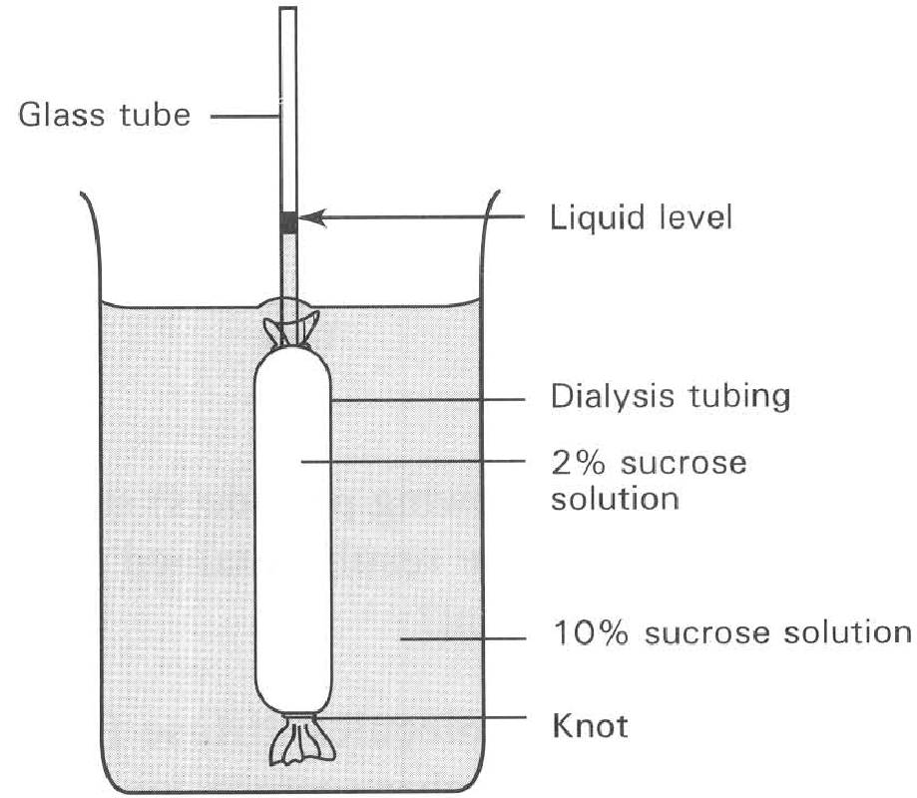
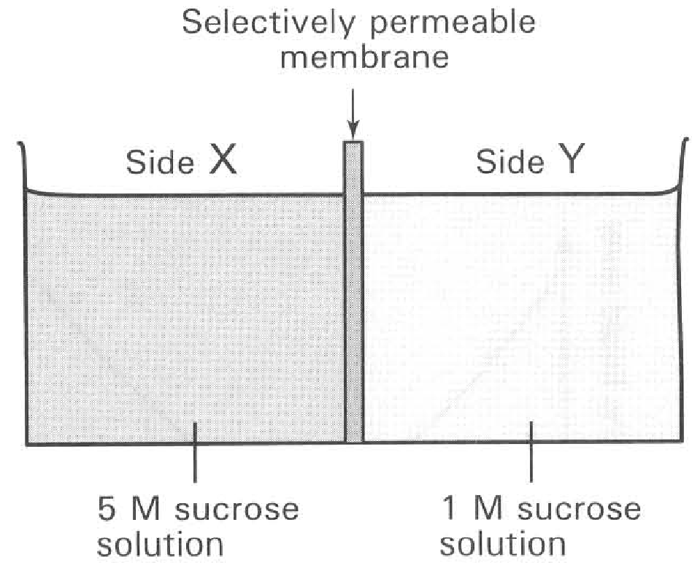
A. (1) only B. (1) and (2) only C. (1) and (4) only D. (2) and (3) only Directions: Questions 23 and 24 refer to the diagram below, which shows the set-up of four osmometers.
24. When the cell shown has reached the state of equilibrium,
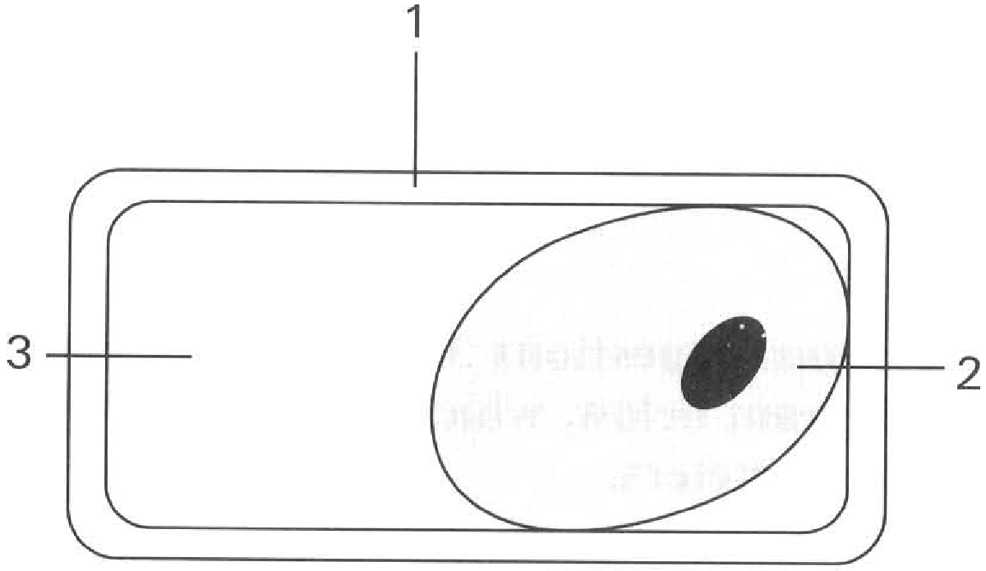
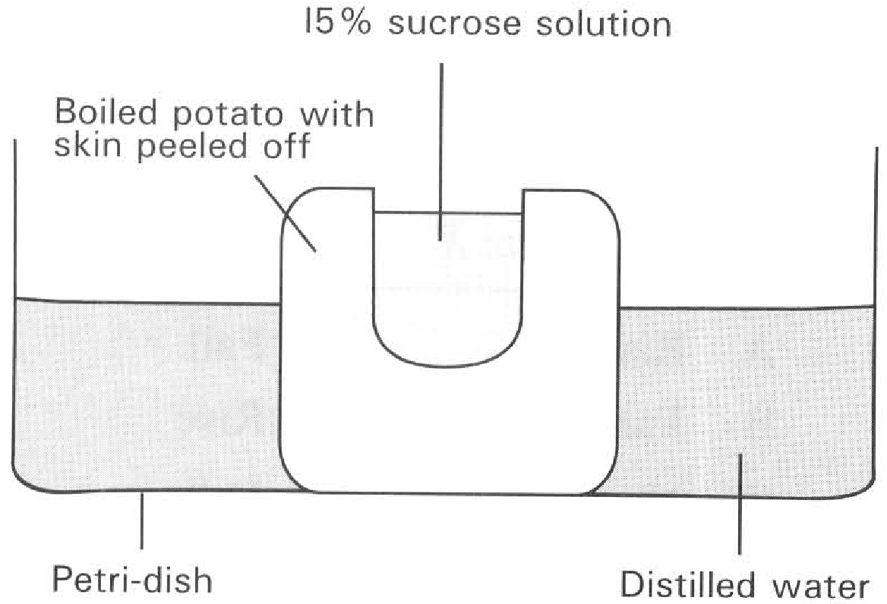
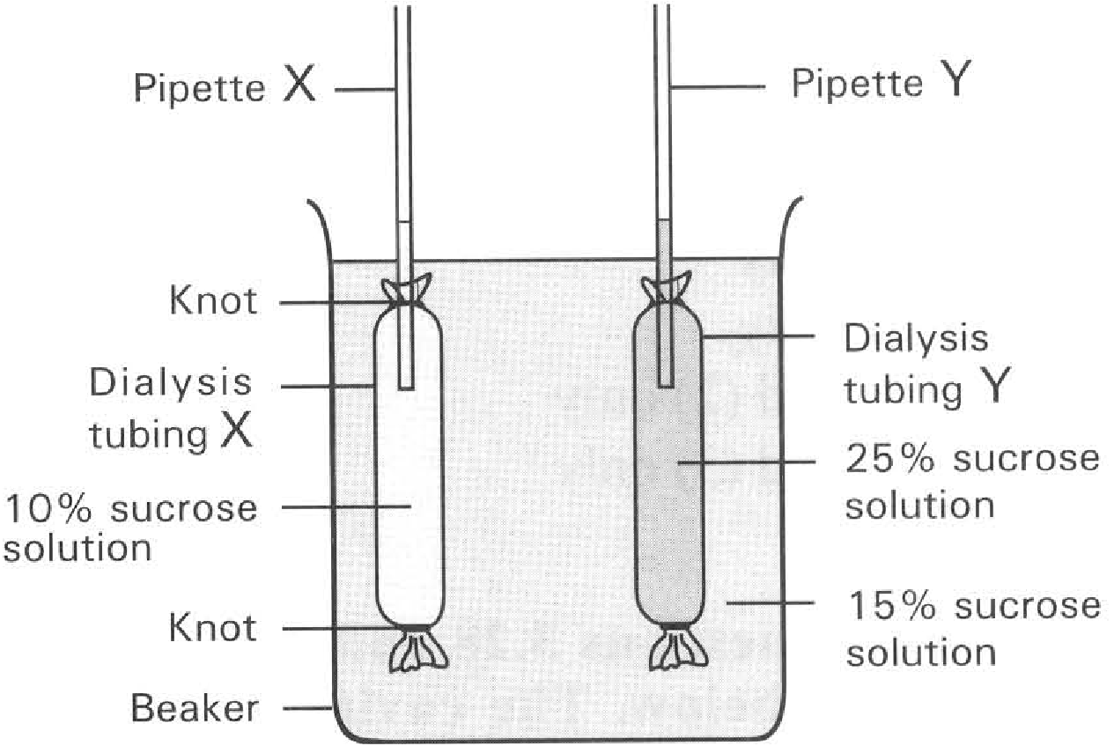
A. osmosis stops.
B. water molecules enter and leave the structure labelled 2 at the same rate.
C. structure labelled 1 exerts no wall pressure on the cytoplasm of the cell.
D. all of the above are correct.
25. The space labelled 3 is
A. empty.
B. filled with a solution with the same strength as that bathing the cell.
C. filled with a solution more dilute than that bathing the cell.
D. filled with a solution more concentrated than that bathing the cell.
26. The solution bathing the cell is
A. hypertonic to the cell.
B. isotonic with the cell.
C. hypotonic to the cell.
D. less concentrated than the cell sap.
27. A strip of epidermal tissue has reached the plasmolysed condition by immersing it in a hypertonic solution. It is then put back into distilled water. Which of the following is the CORRECT sequence of changes that can be observed?
A. (5), (4), (2), (3), (1)
B. (1), (3), (4),(2), (5)
C. (5), (2), (4), (3), (1)
D. (1),(4), (3),(5), (2) Directions: If the diagrams in the previous question represent the cells of five strips of epidermal tissues that have been immersed in five sucrose solution of different concentrations, answer questions 38 and 39 with reference to these diagrams.
28. Arrange the petioles in ascending order in respect to the concentration of the sucrose solutions in which the petioles have been immersed.
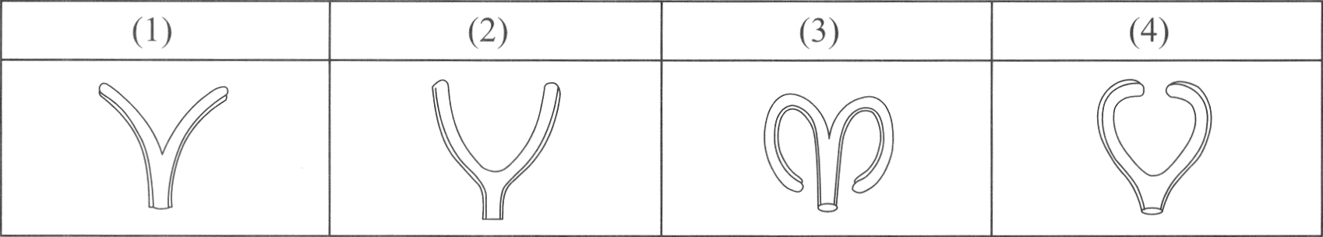
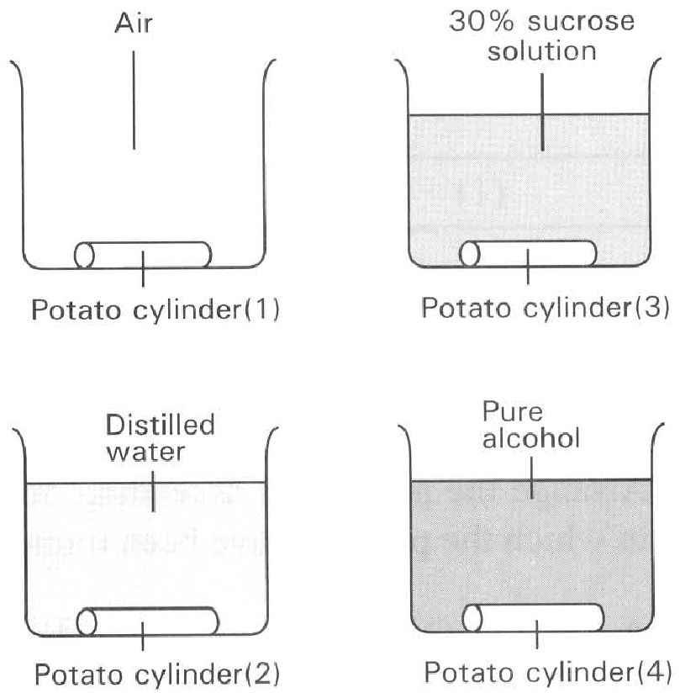
A. (4), (2), (1) and (3)
B. (3), (4), (2) and (1)
C. (4),(3), (1) and (2)
D. (3), (1), (2) and (4)
29. What will be the final appearance of the split petiole after it has been immersed in distilled water for two hours?
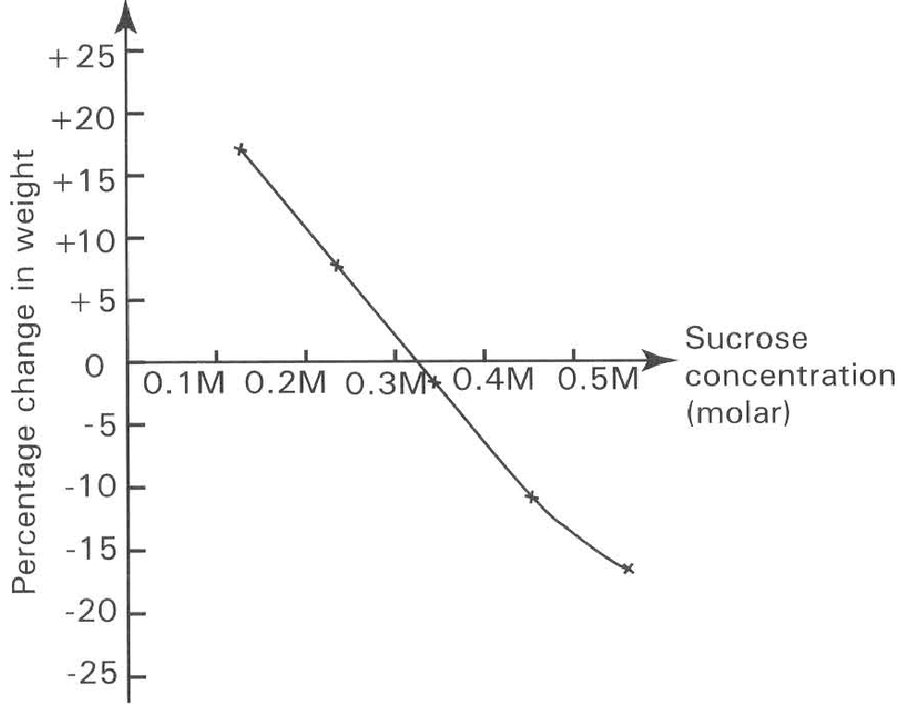
A. (1) B. (2) C. (3) D. (4) Directions: Questions 57 to 59 refer to the graph below.

Answers
Answers are printed in red.
1. B. (2) only
Class: 37.2% correct (n=43) usual slip C
2. B. The blood should be citrated first.
Class: 62.8% correct (n=43) usual slip D
3. B. (1) and (3) only
Class: 75.7% correct (n=74) usual slip A
4. D. (1), (3) and (4) only
Class: 39.5% correct (n=43) usual slip A
5. B
Class: 69.8% correct (n=149) usual slip C
6. A. (1) and (2) only
Class: 74.7% correct (n=75) usual slip B
7. C
Class: 51.2% correct (n=43) usual slip A
8. A. 05 minutes.-
Class: 72.1% correct (n=43) usual slip B
9. D. concentrated sucrose solution.
Class: 79.1% correct (n=43) usual slip B
10. D. the distribution of stomata in leaves.
Class: 44.2% correct (n=43) usual slip C
11. B
Class: 56.1% correct (n=57) usual slip A
12. A. (1) and (2) only
Class: 59.0% correct (n=117) usual slip C
13. C. (3) and (4) only
Class: 67.1% correct (n=149) usual slip B
14. A
Class: 48.4% correct (n=192) usual slip C
15. B. N
Class: 44.2% correct (n=43) usual slip C
16. D. (2), (3) and (4) only
Class: 67.4% correct (n=43) usual slip A
17. A. Temperature above 50°C destroys the selective permeability of the cytoplasmic membrane of the cell.
Class: 30.2% correct (n=43) usual slip C
18. A. (1) and (2) only B. (2) and (3) only
Class: 72.0% correct (n=75) usual slip B
19. A. (1)
Class: 39.5% correct (n=43) usual slip D
20. D. the depth of penetration of the blue colour into each potato cube.
Class: 78.1% correct (n=192) usual slip D
21. B. (1) and (3) only
Class: 75.5% correct (n=192) usual slip C
22. B. (2) only
Class: 55.2% correct (n=192) usual slip B
23. A. (1) only B. (1) and (2) only C. (1) and (4) only D. (2) and (3) only Directions: Questions 23 and 24 refer to the diagram below, which shows the set-up of four osmometers.
Class: 11.6% correct (n=43) usual slip A
24. D. all of the above are correct.
Class: 79.1% correct (n=43) usual slip C
25. B. filled with a solution with the same strength as that bathing the cell.
Class: 46.5% correct (n=43) usual slip A
26. A. hypertonic to the cell.
Class: 67.4% correct (n=43) usual slip B
27. C. (5), (2), (4), (3), (1)
Class: 34.9% correct (n=43) usual slip A
28. D. (3), (1), (2) and (4)
Class: 52.6% correct (n=57) usual slip D
29. C
Class: 40.4% correct (n=57) usual slip B

Class percentage correct
Matched to this paper by question wording in the source bank and the form answer key, not by a shifted paper number.
Q | Answer | % correct | n | Usual slip
1 | B | 37.2% | 43 | C
2 | B | 62.8% | 43 | D
3 | B | 75.7% | 74 | A
4 | D | 39.5% | 43 | A
5 | B | 69.8% | 149 | C
6 | A | 74.7% | 75 | B
7 | C | 51.2% | 43 | A
8 | A | 72.1% | 43 | B
9 | D | 79.1% | 43 | B
10 | D | 44.2% | 43 | C
11 | B | 56.1% | 57 | A
12 | A | 59.0% | 117 | C
13 | C | 67.1% | 149 | B
14 | A | 48.4% | 192 | C
15 | B | 44.2% | 43 | C
16 | D | 67.4% | 43 | A
17 | A | 30.2% | 43 | C
18 | A | 72.0% | 75 | B
19 | A | 39.5% | 43 | D
20 | D | 78.1% | 192 | D
21 | B | 75.5% | 192 | C
22 | B | 55.2% | 192 | B
23 | A | 11.6% | 43 | A
24 | D | 79.1% | 43 | C
25 | B | 46.5% | 43 | A
26 | A | 67.4% | 43 | B
27 | C | 34.9% | 43 | A
28 | D | 52.6% | 57 | D
29 | C | 40.4% | 57 | B

