Microorganisms and humans
Multiple-choice practice
Name: ________________________ Class: ____________
There are 40 questions compiled from Longman HKCEE and/or YKTo papers. Choose the one best answer.
Part A — HKCEE level (Longman)
1. Which of the following involve the activities of fungi? (1) Cycling of materials (2) Wine and bread production (3) Production of antibodies
A. (1) and (2) only
B. (1) and (3) only
C. (2) and (3) only
D. (1), (2) and (3)
2. Which of the following are examples of useful microorganisms? (1) Nitrogenfixing bacteria-(2) Bacteria and fungi in soil (3) Yeast
A. (1) and (2) only
B. (1) and (3) only
C. (2) and (3) only
D. (1), (2) and (3)
3. Which of the following involve the activities of usefu l microorganisms? (1) Brewing(2) Bakery (3) Decomposition
A. (1) and (2) only
B. (1) and (3) only
C. (2) and (3) only
D. (1), (2) and (3)
4. Which of the following involve the activities of bacteria? (1) Cycling of materials (2) Wine and bread making (3) Nitrogen fixation
A. (1) and (2) only
B. (1) and (3) only
C. (2) and (3) only
D. (1), (2) and (3)
5. The significance of nitrogenfixing bacteria includes:- (1)They increase the protein content of some crops. (2)They reduce the use of chemical fer tilizers. (3)They help in the cycling of minerals in soil.
A. (1) and (2) only
B. (1) and (3) only
C. (2) and (3) only
D. (1), (2) and (3)
6. Which of the following correctly states the significance of bacteria and fungi in soil?
(1) To facilitate the cycling of energy
(2) To facilitate the cycling of materials
(3) As decomposers of organic matters
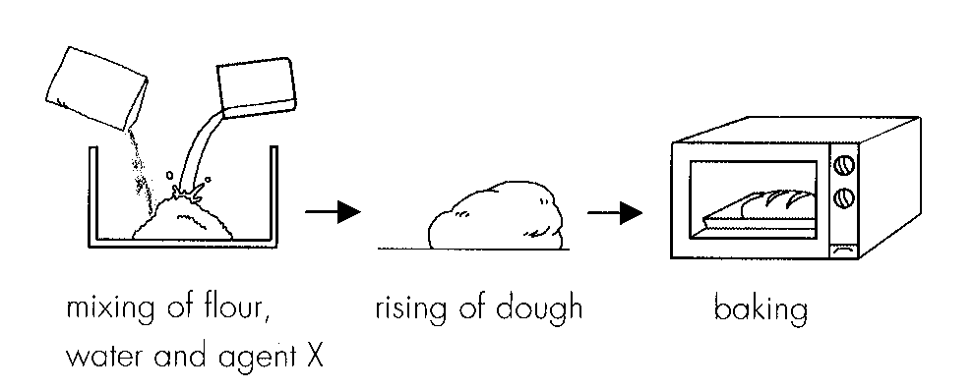
A. (1) and (2) onlyB. (1) and (3) only C. (2) and (3) onlyD. (1), (2) and (3) Directions: Questions 7 and 8 refer to the steps in bread making.
7. Agent X can be (1) yeast.(2) calcium carbonate. (3) sodium bicarbonate.
A. (1) and (2) only
B. (1) and (3) only
C. (2) and (3) only
D. (1), (2) and (3)
8. Which of the following are related to the rising of dough?
(1) Production of ethanol
(2) Lack of oxygen in the dough
(3) Production of carbon dioxide
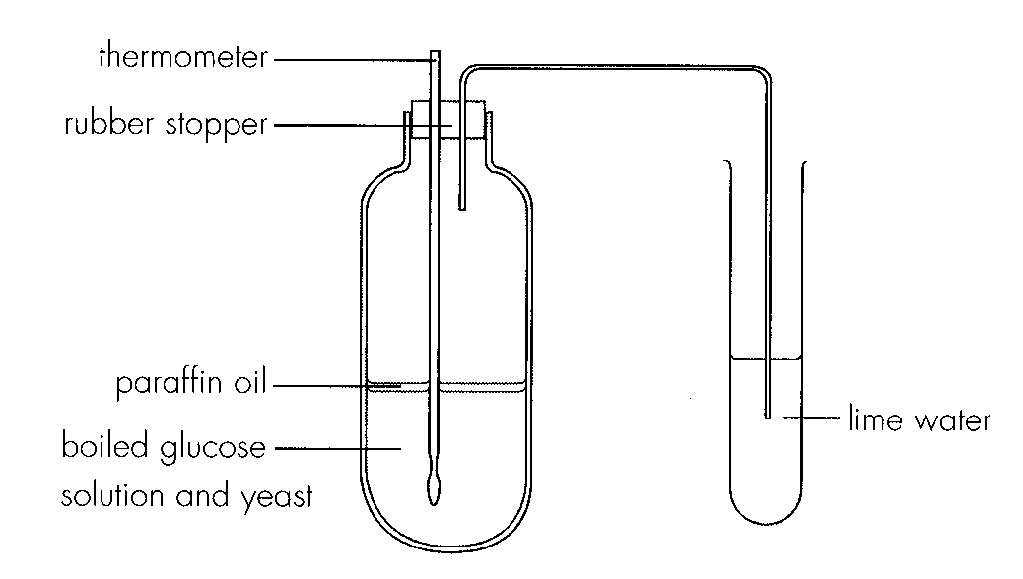
A. (1) and (2) only B. (1) and (3) only C. (2) and (3) onlyD. (1), (2) and (3) Directions: Questions 9 to 11 refer to the following experiment which shows the brewing of wine in the laboratory.
9. Which of the following account for the anaerobic condition in the reaction mixture? (1) Paraffin oil (2) Boiled glucose solution (3) Rubber stopper
A. (1) and (2) only
B. (1) and (3) only
C. (2) and (3) only
D. (1), (2) and (3)
10. Which of the following correctly states the results of this experiment?
 | Thermometer reading | Lime water
A. | unchanged | milky
B. | unchanged | clear
C. | rose | milky
D. | rose | clear

11. Which of the following can be concluded from this experiment? (1) Carbon dioxide was produced during anaerobic respiration. (2) Heat was given off. (3) Ethanol was produced.
A. (1) and (2) only
B. (1) and (3) only
C. (2) and (3) only
D. (1), (2) and (3)
12. Which of the following diseases are not caused by bacteria? (1) Tetanus (2) AIDS (3) Cholera (4) Influenza A. (1) and (3) only
A. (1) and (3) only
B. (2) and (4) only
C. (1), (2) and (3) only
D. (2), (3) and (4) only
13. Which of the following are examples of harmful microorganisms? (1) Pathogens (2) Agents causing food decay (3) Decomposers
A. (1) and (2) only
B. (1) and (3) only
C. (2) and (3) only
D. (1), (2) and (3)
14. Which of the following are consequences caused by harmful microorganisms? (1) Diseases in man (2) Food decay (3) Deterioration of useful substances
A. (1) and (2) only
B. (1) and (3) only
C. (2) and (3) only
D. (1), (2) and (3)
15. Which of the following are not activities of harmful microorganisms? (1) Food poisoning (2) Decomposition (3) Decay of timber
A. (2) only
B. (1) and (2) only
C. (1) and (3) only
D. (2) and (3) on ly
16. Which of the following diseases is caused by bacteria?
A. German measles
B. Poliomyelitis
C. Tuberculosis
D. Yellow fever
17. Which of the following diseases is caused by viruses?
A. Typhoid B. Tetanus C. Cholera D. Rabies
18. Which of the following diseases are not caused by viruses? (1) Tuberculosis (2) Typhoid (3) Colds
A. (1) and (2) only
B. (1) and (3) only
C. (2) and (3) only
D. (1), (2) and (3)
19. Which of the following diseases should be treated with antibiotics?
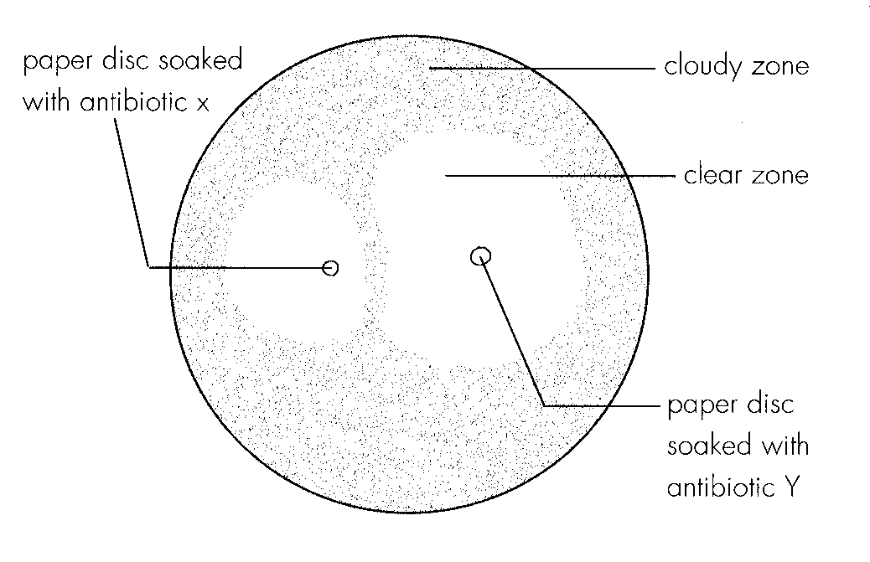
A. Small pox B. Tetanus C. Measles D. AIDS Directions: Questions 20 to 22 refer to the following experiment which studied the effectiveness of 2 antibiotics X and Y on inhibiting the growth of a certain bacteria. The results are shown below.
20. The cloudy zone appeared on the surface was due to
A. the absence of antibiotic.
B. the presence of antibiotic.
C. the absence of bacteria.
D. the presence of bacteria.
21. What conclusion would you draw about the relative effectiveness of the two antibiotics? A. Antibiotic X is more effective.
B. Antibiotic Y is more effective.
C. Antibiotics X and Y are equally effective.
D. Antibiotics X and Y are equally ineffective.
22. What additional conclusion can be drawn from the cloudy zone between the two paper discs?
A. Antibiotic X should be prescribed before Y.
B. Antibiotic Y should be prescribed before X.
C. Antibiotics X and Y should not be prescribed together.
D. Antibiotics X and Y should be prescribed together.
23. Abuse of antibiotics is undesirable because
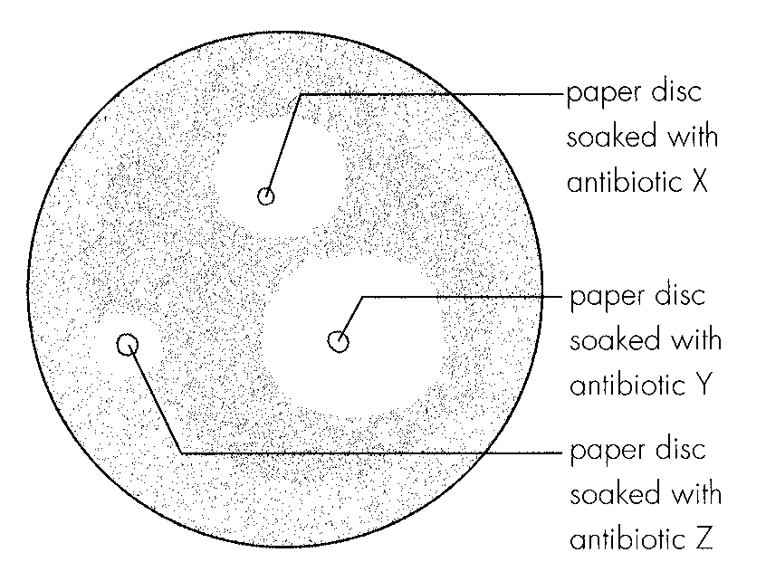
A. it may cause the bacteria to become resistant to antibiotics. B.it may cause the viruses to become resistant to antibiotics. C.it may cause the patient to become addicted to antibiotics. D.it may impair the immune system of the patient. Directions: Questions 24 and 25 refer to the experiment below which attempts to find out the best antibiotic for a bacterial disease. The results are shown below.
24. The effectiveness of antibiotics X, Y and Z in ascending order is
A. X, Y, Z.
B. Y, X, Z.
C. Y , Z, X.
D. Z, X, Y.
25. Antibiotic Z is temporarily out of stock. Which of the following should be adopted?
A. To wait for antibiotic Z.
B. To prescribe antibiotics X and Y together.
C. To prescribe antibiotic Y.
D. To prescribe antibiotic X.
26. Which of the following statements about antibiotics are correct? (1)Antibiotics are produced by microorganisms. (2)Antibiotics can kill other species of microorganisms. (3)Antibiotics are used by man to cure viral diseases.
A. (1) and (2) only
B. (1) and (3 ) only
C. (2) and (3) only
D. (1), (2) and (3)
27. Which of the following may be the consequences of antibiotics abuse? (1) It may cause rejection. (2)It may cause drug poisoning to patients. (3)Beneficial microorganisms in the human body are also killed. A.(1) and (2) only
A. (1) and (2) only
B. (1) and (3) only
C. (2) and (3) only
D. (1), (2) and (3)
28. Which of the following statements about antibiotics are incorrect? (1) The action is specific. (2) Antibiotics are produced by lymphocytes (3) They are protein in na ture. A.(1) and (2) only
A. (1) and (2) only
B. (1) and (3) only
C. (2) and (3) only
D. (1), (2) and (3)
29. Which of the following arc the possible drawbacks to the use of antibiotics? (1) It may cause allergy to the patients. (2) It may damage normal body cells. (3) It may inhibit the immune system of the patients A.(1) and (2) only
A. (1) and (2) only
B. (1) and (3) only
C. (2) and (3) only
D. (1), (2) and (3)
30. Which of the following comparisons between antibiotics and antibodies is incorrect?
 | Antibiotics | Antibodies
A. | produced by microorganisms | produced by man
B. | do not have memory | have memory
C. | nonspecific in action - | specific in action
D. | applicable to bacterial diseases only | applicable to bacterial diseases

31. Which of the following food most likely contains the least amount of preservatives?
A. Raisins
B. Sausage
C. Jam
D. Oyster sauce
32. The 4 photographs below show 4 consumer products commonly available in local supermarkets. Which of the consumer products contains no preservatives?
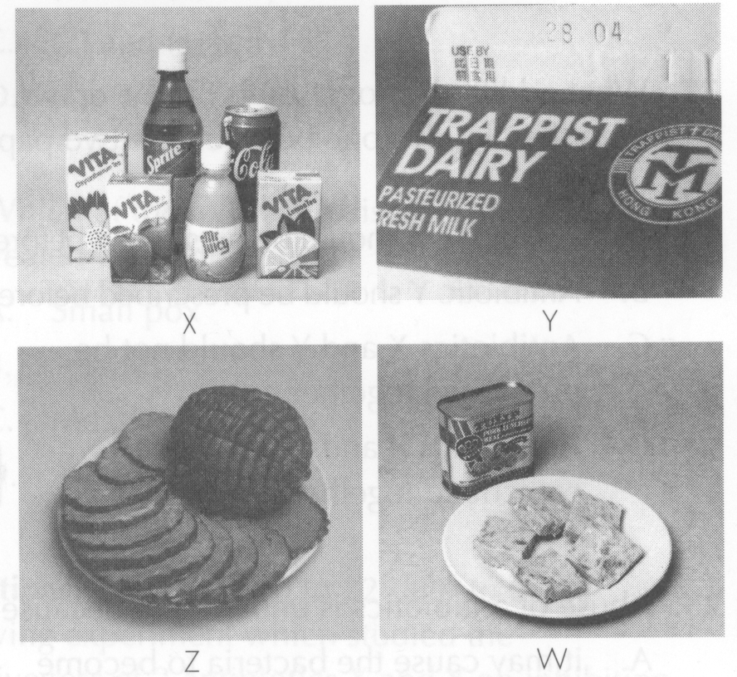
A. W
B. X
C. Y
D. Z
33. Which of the following methods of preservation would lead to food deterioration most easily?
A. Refrigeration
B. Pickling
C. Using preservatives
D. Heating
34. Which of the following is the least effective in killing bacteria?
A. Irradiation B. Drying C. Cooking D. Refrigeration
35. Which of the following methods of preservation remove water from the food? (1) Fruit in syrup (2) Salting (3) Irradiation (4) Drying
A. (4) only
B. (1) and (2) only
C. (2) and (4) only
D. (1), (2) and (4) only
36. The advantages of deep freezing over slow freezing include (1) the texture of food is preserved better. (2) all bacteria are killed. (3) the duration of preservation is longer.
A. (1) and (2) only
B. (1) and (3) only
C. (2) and (3) only
D. (1), (2) and (3)
37. Which of the following correctly describe the general principle of food preservation? (1) It slows down the growth of microorganisms in the food. (2) It kills microorganisms in the food. (3)It removes microorganisms from the fo od.
A. (1) and (2) only
B. (1) and (3) only
C. (2) and (3) only
D. (1), (2) and (3)
38. Which of the following are the reasons for preserving fresh milk not by heating to 100°C? (1) To preserve the antibodies in milk. (2) To preserve the texture of milk. (3) To prevent milk proteins from denaturing.
A. (1) and (2) only
B. (1) and (3) only
C. (2) and (3) only
D. (1), (2) and (3)
39. Which of the following methods of food preservation can kill microorganisms? (1) Irradiation (2) Deep freezing (3) Usi ng preservatives
A. (1) and (2) only
B. (1) and (3) only
C. (2) and (3) only
D. (1), (2) and (3)
40. Which of the following correctly states the processes involved in various methods of preservation?
 | Heating | Drying | Salting
A. | osmosis | evaporation | denaturation
B. | evaporation | denaturation | osmosis
C. | denaturation | osmosis | evaporation
D. | denaturation | evaporation | osmosis

Answers
Answers are printed in red.
1. A. (1) and (2) only

2. D. (1), (2) and (3)

3. D. (1), (2) and (3)

4. B. (1) and (3) only

5. A. (1) and (2) only

6. C

7. B. (1) and (3) only

8. C

9. A. (1) and (2) only

10. C

11. A. (1) and (2) only

12. B. (2) and (4) only

13. A. (1) and (2) only

14. D. (1), (2) and (3)

15. A. (2) only

16. C. Tuberculosis

17. D

18. A. (1) and (2) only

19. B

20. D. the presence of bacteria.

21. B. Antibiotic Y is more effective.

22. C. Antibiotics X and Y should not be prescribed together.

23. ?

24. B. Y, X, Z.

25. D. To prescribe antibiotic X.

26. A. (1) and (2) only

27. ?

28. D. (1), (2) and (3)

29. A. (1) and (2) only

30. B

31. ?

32. ?

33. ?

34. D

35. D. (1), (2) and (4) only

36. B. (1) and (3) only

37. A. (1) and (2) only

38. C. (2) and (3) only

39. B. (1) and (3) only

40. D

