Microorganisms and humans · items under 80% correct
Multiple-choice practice
Name: ________________________ Class: ____________
No classroom item analysis matched this topic reliably. Items below are those predicted to be answered correctly by fewer than 80% of students. Choose the one best answer.
Part A — HKCEE level (Longman)
1. Which of the following are related to the rising of dough?
(1) Production of ethanol
(2) Lack of oxygen in the dough
(3) Production of carbon dioxide
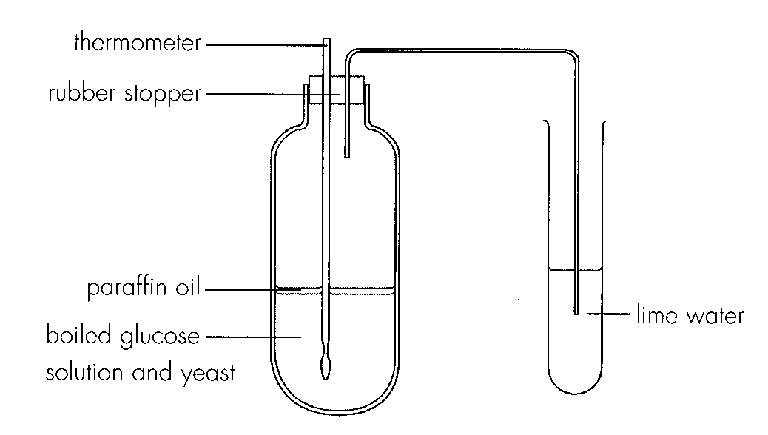
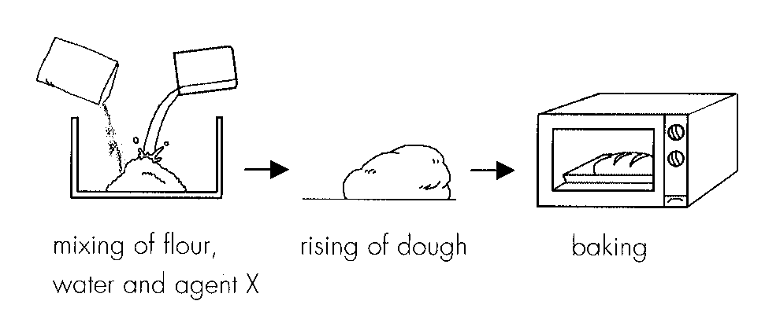
A. (1) and (2) only B. (1) and (3) only C. (2) and (3) onlyD. (1), (2) and (3) Directions: Questions 9 to 11 refer to the following experiment which shows the brewing of wine in the laboratory.
2. Which of the following can be concluded from this experiment? (1) Carbon dioxide was produced during anaerobic respiration. (2) Heat was given off. (3) Ethanol was produced.
A. (1) and (2) only
B. (1) and (3) only
C. (2) and (3) only
D. (1), (2) and (3)
3. Which of the following statements about antibiotics are incorrect? (1) The action is specific. (2) Antibiotics are produced by lymphocytes (3) They are protein in na ture. A.(1) and (2) only
A. (1) and (2) only
B. (1) and (3) only
C. (2) and (3) only
D. (1), (2) and (3)
4. Which of the following correctly states the significance of bacteria and fungi in soil?
(1) To facilitate the cycling of energy
(2) To facilitate the cycling of materials
(3) As decomposers of organic matters
A. (1) and (2) onlyB. (1) and (3) only C. (2) and (3) onlyD. (1), (2) and (3) Directions: Questions 7 and 8 refer to the steps in bread making.
5. Agent X can be (1) yeast.(2) calcium carbonate. (3) sodium bicarbonate.
A. (1) and (2) only
B. (1) and (3) only
C. (2) and (3) only
D. (1), (2) and (3)
6. Which of the following account for the anaerobic condition in the reaction mixture? (1) Paraffin oil (2) Boiled glucose solution (3) Rubber stopper
A. (1) and (2) only
B. (1) and (3) only
C. (2) and (3) only
D. (1), (2) and (3)
7. Which of the following comparisons between antibiotics and antibodies is incorrect?
 | Antibiotics | Antibodies
A. | produced by microorganisms | produced by man
B. | do not have memory | have memory
C. | nonspecific in action - | specific in action
D. | applicable to bacterial diseases only | applicable to bacterial diseases

8. Which of the following correctly states the results of this experiment?
 | Thermometer reading | Lime water
A. | unchanged | milky
B. | unchanged | clear
C. | rose | milky
D. | rose | clear

9. Which of the following diseases should be treated with antibiotics?
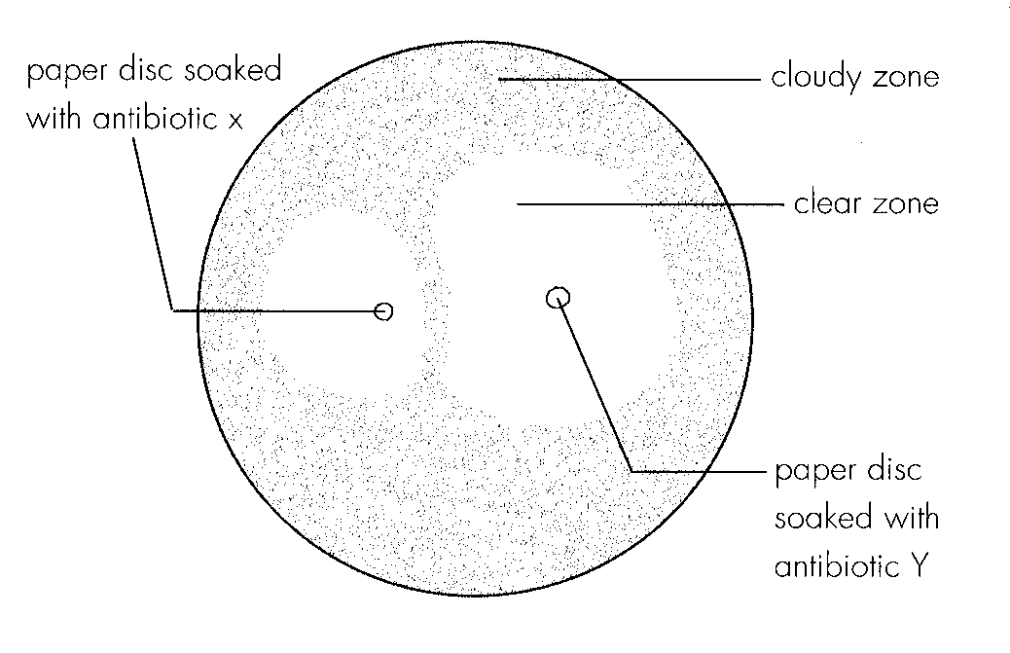
A. Small pox B. Tetanus C. Measles D. AIDS Directions: Questions 20 to 22 refer to the following experiment which studied the effectiveness of 2 antibiotics X and Y on inhibiting the growth of a certain bacteria. The results are shown below.
10. Abuse of antibiotics is undesirable because
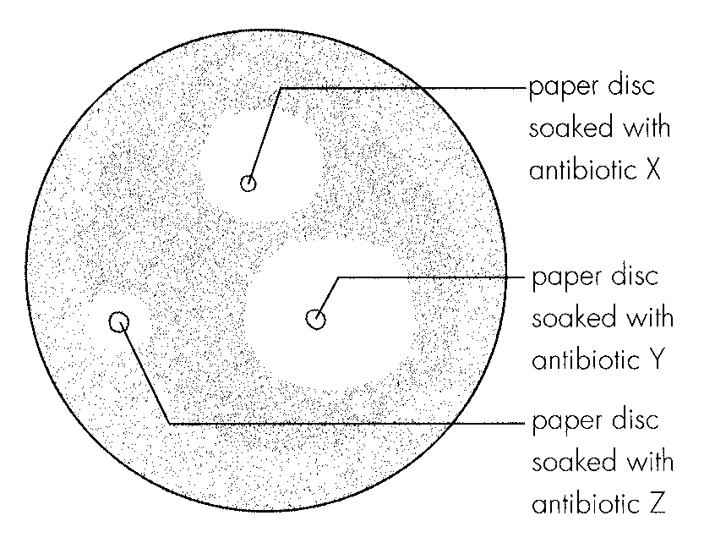
A. it may cause the bacteria to become resistant to antibiotics. B.it may cause the viruses to become resistant to antibiotics. C.it may cause the patient to become addicted to antibiotics. D.it may impair the immune system of the patient. Directions: Questions 24 and 25 refer to the experiment below which attempts to find out the best antibiotic for a bacterial disease. The results are shown below.
11. The 4 photographs below show 4 consumer products commonly available in local supermarkets. Which of the consumer products contains no preservatives?
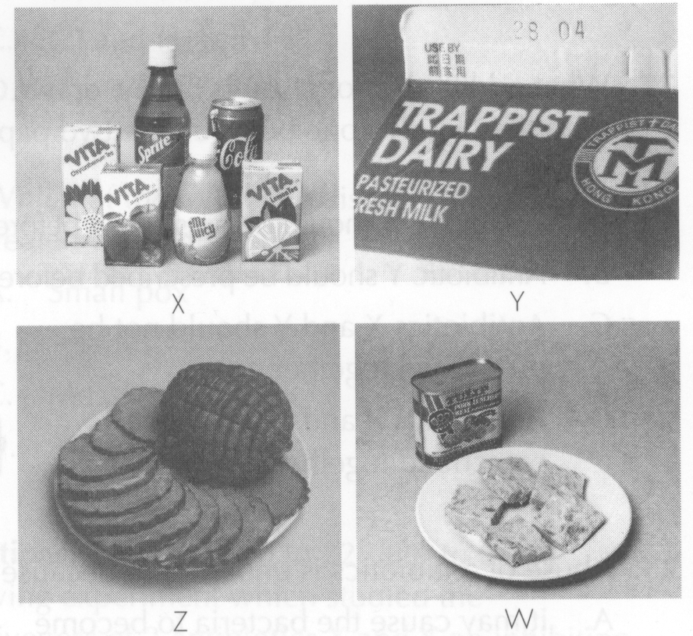
A. W
B. X
C. Y
D. Z
12. Which of the following involve the activities of fungi? (1) Cycling of materials (2) Wine and bread production (3) Production of antibodies
A. (1) and (2) only
B. (1) and (3) only
C. (2) and (3) only
D. (1), (2) and (3)
13. Which of the following are examples of useful microorganisms? (1) Nitrogenfixing bacteria-(2) Bacteria and fungi in soil (3) Yeast
A. (1) and (2) only
B. (1) and (3) only
C. (2) and (3) only
D. (1), (2) and (3)

Answers
Answers are printed in red.
1. C
Predicted class correct ≈ 51% (no classroom match)
2. A. (1) and (2) only
Predicted class correct ≈ 51% (no classroom match)
3. D. (1), (2) and (3)
Predicted class correct ≈ 55% (no classroom match)
4. C
Predicted class correct ≈ 57% (no classroom match)
5. B. (1) and (3) only
Predicted class correct ≈ 57% (no classroom match)
6. A. (1) and (2) only
Predicted class correct ≈ 57% (no classroom match)
7. B
Predicted class correct ≈ 60% (no classroom match)
8. C
Predicted class correct ≈ 61% (no classroom match)
9. B
Predicted class correct ≈ 61% (no classroom match)
10. ?
Predicted class correct ≈ 61% (no classroom match)
11. ?
Predicted class correct ≈ 61% (no classroom match)
12. A. (1) and (2) only
Predicted class correct ≈ 62% (no classroom match)
13. D. (1), (2) and (3)
Predicted class correct ≈ 62% (no classroom match)

Class percentage correct
Matched to this paper by question wording in the source bank and the form answer key, not by a shifted paper number.
Q | Answer | % correct | n | Usual slip
1 | C | 51.0% | pred | —
2 | A | 51.0% | pred | —
3 | D | 55.0% | pred | —
4 | C | 57.0% | pred | —
5 | B | 57.0% | pred | —
6 | A | 57.0% | pred | —
7 | B | 60.0% | pred | —
8 | C | 61.0% | pred | —
9 | B | 61.0% | pred | —
10 | ? | 61.0% | pred | —
11 | ? | 61.0% | pred | —
12 | A | 62.0% | pred | —
13 | D | 62.0% | pred | —

