Molecular genetics and biotechnology
Multiple-choice practice
Name: ________________________ Class: ____________
There are 106 questions compiled from Longman HKCEE and/or YKTo papers. Choose the one best answer.
Part A — Molecular genetics (YKTo)
1. Which of the following features are essential for DNA to act as genetic material? (1) Its structures are complex enough to provide the basis of genetic information. (2) Its structures enable it to replicate. (3) It is present in the nucleus only. D. (1), (2) and (3) 3Which of the following statements about DNA is/are CORRECT? (1) DNA directly controls the synthesis of carbohydrates. (2) DNA is made of nucleotides. (3) DNA is in form of a double helix. B. (2) only C. (1) and (2) only D. (2) and (3) only
A. (1) and (2) only
B. (2) and (3) only
C. (1) and (3) only
A. (1) only
2. Which of the following bonds holding the two polynucleotide chains together in a DNA molecule?
A. Peptide bond
B. Glycosidic bond
C. Hydrogen bond
D. Phosphate bond
3. What is the advantage for DNA to consist of two pieces of polynucleotide chains with their bases complementary to each other?
A. They permit pairing to take pace during meiosis.
B. They permit transcription and translation to occur at the same time.
C. They permit gametes to bear haploid number of chromosomes.
D. They enable replication to take place that produces an exact copy of DNA.
4. The diagram below shows the structure of a basic unit of DNA.
Which of the following combinations of the parts is CORRECT?
7Which of the following combinations truly represent the basic structure of mRNA?
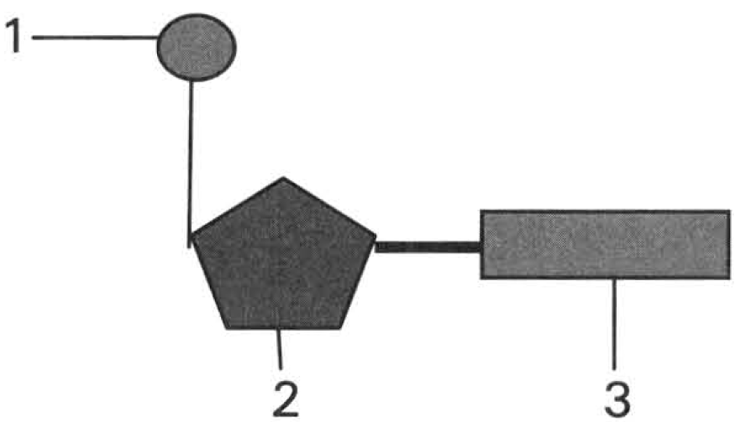
 | Part (1) | Part (2) | Part (3)
A. | Base | Phosphate | Deoxyribose
B. | Deoxyribose | Phosphate | Base
C. | Phosphate | Deoxyribose | Base
D. | Deoxyribose | Base | Phosphate

 | Pentose | Inorganic salt | Nitrogenous base
A. | Deoxyribose | Hydrogencarbonate | Uracil
B. | Ribose | Phosphate | Thymine
C. | Ribose | Phosphate | Uracil
D. | Deoxyribose | Hydrogencarbonate | Thymine

5. Which of the following components in the polynucleotide chain varies along its length?
A. Phosphate group B. Nitrogenous base C. Deoxyribose D. Ribose
6. Which of the following features is responsible for providing genetic information of DNA?
A. The alternate arrangement of phosphate and deoxyribose.
B. The two polynucleotide chains run in opposite directions.
C. The sequence of bases along the polynucleotide strand.
D. The complementary relationship between the bases of the two polynucleotide strands.
7. The table below shows the base composition of DNA from several different species.
Approximate amount of nitrogenous bases (arbitrary units)
Which of the following deductions can be drawn from the information given in the table?
 | Purine | Pyrimidines
 | Adenine | Guanine | Cytosine | Thymine
Human thymus | 0.28 | 0.19 | 0.18 | 0.28
Human sperm | 0.29 | 0.18 | 0.18 | 0.30
Human liver | 0.27 | 0.18 | 0.15 | 0.27
Ox thymus | 0.28 | 0.22 | 0.17 | 0.25
Ox spleen | 0.25 | 0.20 | 0.17 | 0.24
Yeast | 0.30 | 0.14 | 0.15 | 0.29
Bacillus | 0.12 | 0.28 | 0.15 | 0.29

A. The total amount of DNA is roughly the same in all the cells of the same species.
B. The total amount of DNA in microorganisms is smaller than that in animal cells.
C. The amounts of adenine is roughly the same as that of thymine, as are the amounts of guanine and cytosine.
D. The proportion of bases supports that DNA is composed of double strands.
8. In the chemical analysis of the relative amount of the four nitrogenous bases in the DNA of the cell of a species, the following results are obtained:
Which of the following combinations of the bases is CORRECT?
Pyrimidine | Purine
Thymine | Base (X) | Base (Y) | Base (Z)
32.4% | 17.8% | 31.7% | 18.1%

 | Base (X) | Base (Y) | Base (Z)
A. | Cytosine | Adenine | Guanine
B. | Adenine | Guanine | Cytosine
C. | Guanine | Cytosine | Adenine
D. | Cytosine | Guanine | Adenine

9. The DNA in the nucleus of the liver cell of humans contains 30% guanine (G). What is the percentage of thymine (T) in the nucleus of the pancreatic cell of the same person? A.20% B.30% C.40% D.60%
A. 20%
B. 30%
C. 40%
D. 60%
10. If 32% of the nitrogenous bases in a DNA molecule of a human white blood cell are thymine, what will be the percentage of the nitrogenous bases in the human ovum to be cytosine? C.32% D.36%
A. 9%
B. 18%
C. 32%
D. 36%
11. Which of the following statements about the base pairing in the nucleic acids of a cell is/are CORRECT? (1) This is essential for the duplication of gene. (2) This is essential for the transcription of DNA. (3) A pyrimidine must pair with another pyrimidine. (4) There must be a complementary relationship between adenine and thymine in the RNA formation.
A. (1) only
B. (2) only
C. (1) and (2) only
D. (3) and (4) only
12. Which of the following is the CORRECT linking between a DNA nucleotide and a RNA nucleotide?
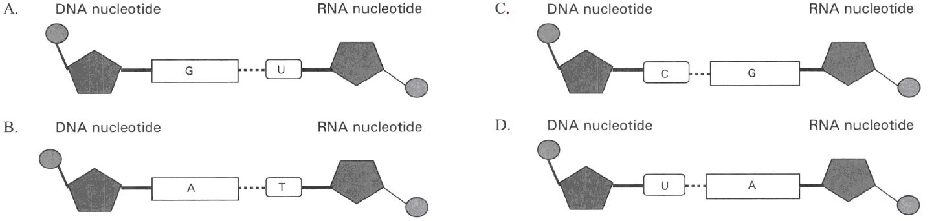
13. Which of the following can be found in both DNA and mRNA?
A. Sugar-phosphate strand
B. Structure in form of a double helix
C. Uracil
D. Thymine
14. Which of the following nitrogenous bases have complementary relationship between the codon of mRNA and the anticodon of the tRNA?
A. Guanine and adenine B. Cytosine and thymine
C. Uracil and adenine D. Adenine and thymine
15. Which of the following statements about gene are CORRECT? (1) It is made of DNA which encloses histone molecules (a type of protein). (2) It is very stable and will not change is structure even exposed to high energy radiations. (3) It takes an important role in the protein synthesis of cells. (4) Each characteristic of humans is controlled by one gene only.
A. (1) and (2) only
B. (1) and (3) only
C. (2) and (4) only
D. (1), (2) and (3) only
16. During puberty large amount of female sex hormones are produced by a girl to support the development of the female secondary sexual characteristics. Genes for controlling the production of these female sex hormones are present in the (1) cells of the ovary (2) cells of the oviduct (3) cells of the uterus (4) cells of the vagina
A. (1) only
B. (1) and (2) only
C. (1), (2) and (3) only
D. (1), (2) ,(3) and (4)
17. Which of the following matching of the number of chromosomes in the human cells is CORRECT?
 | Number of chromosomes
 | 0 | 23 | 46
A. | White blood cell | Liver cell | Sperm
B. | Mature red blood cell | White blood cell | Egg
C. | Mature red blood cell | Egg | Liver cell
D. | White blood cell | Sperm | Mature red blood cell

18. In a hybrid, a particular gene is comprised of two allelic forms. In which of the following cells does each allele occur singly in the hybrid?
A. Insulin-producing cells B. Bone cells C. Muscle cells D. Sperms
19. Arrange the following cells of a boy in ascending order according to the amount of DNA present in them. (1) Sperm bearing X-chromosome (2) Sperm bearing Y-chromosome (3) Mature red blood cell (4) Mature T lymphocyte
A. (1) (2) (3) (4)
B. (4) (3) (2) (1)
C. (2) (1) (3) (4)
D. (3) (2) (1) (4)
20. Which of the following cells of each organism have the same genetic constitution? (1) All the ova released from the same ovary into the oviduct of a female. (2) Cells in the liver, pancreas and gall bladder of the same person. (3) Cells in the seeds of a pea pod. (4) Daughter rhizomes of the same lotus plant.
A. (1) and (2)
B. (2) and (4)
C. (1), (2) and (3)
D. (2), (3) and (4)
21. Which of the following have the genetic constitution different from the others?
A. Sperms produced in the same testis of a male. B. Neurones.
C. Liver cells. D. B lymphocytes.
22. Which sequence is the CORRECT representation of the steps in the control of inherited characters to later generation? (1) The sequence of bases in DNA controls the sequence of amino acids in protein. (2) The replication of chromosomes before meiotic division. (3) Fusion of gametes. (4) Enzymes control the metabolic activities. B. Genetic code
A. (1), (3), (2), and (4)
B. (2), (3), (1), and (4)
C. (2), (4), (3), and (1)
D. (1), (2), (4), and (3)
23. Which of the following concerning genetic code is CORRECT?
A. This coding system is discovered by humans and is applicable to humans only.
B. Each codon consists of four bases.
C. All codons are functional to direct the arrangement of amino acids of the polypeptide synthesized.
D. An amino acid can be coded by more than one codon.
24. Which of the following is the degenerate feature of the genetic code?
A. The genetic code is applicable to all organisms.
B. A specific codon stops the translation process.
C. More than one codon codes for one amino acid.
D. The mRNA can be used again after the synthesis of the first polypeptide.
25. The codon of the mRNA that is transcribed from the base sequence of AGC on the template strand of DNA is
A. AGC B. CGA C. TCG D. UCG
26. If a synthetic mRNA molecule is made by using three types of nucleotides, how many different types of codons could it contain? C. Protein synthesis
A. 3
B. 6
C. 9
D. 27
27. Which of the following substances are involved in the process of transcription inside a cell? (1) DNA(2) mRNA (3) tRNA (4) Nucleolus (5) Ribonucleotides (6) Amino acids
A. (1), (2) and (5) only
B. (1), (3) and (6) only
C. (2), (3) and (6) only
D. (1), (2) and (4) only
28. Which of the following statements about the transcription of DNA is CORRECT? A. D. This is essential for the replication of DNA. Directions: Questions 32 to 36 refer to the diagram below, which shows the process of transcription of a section of DNA.
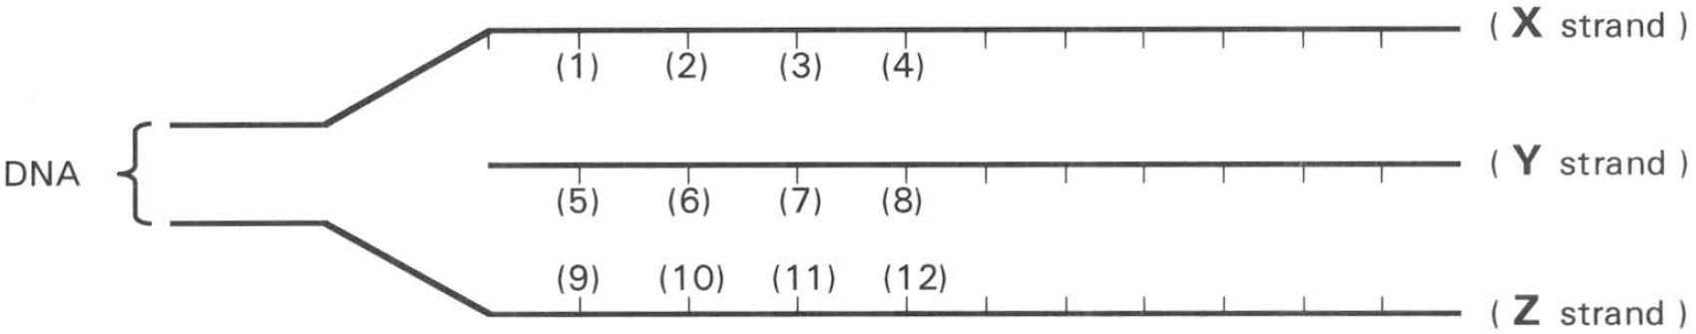
A. This directly produces polypeptides.
B. This produces tRN
A.
C. This produces mRN
29. Where will the above process take place?
A. Inside the nucleus
B. Inside the ribosome
C. Inside the endoplasmic reticulum
D. Inside the cytoplasm
30. Which of the following matching of the labelled strands is CORRECT?
34 Symbols for the nitrogenous bases in the diagram :
C = cytosine G = guanine A = adenine T = thymine U = uracil
If the base sequence (1), (2),(3) and (4) of strand X is G ,A ,C ,T, which of the following matching of the base sequence for strand Y is CORRECT?
 | Strand X | Strand Y | Strand Z
A. | Coding | Template | mRNA
B. | Template | Coding | mRNA
C. | Template | mRNA | Coding
D. | Coding | mRNA | Template

 | (5) | (6) | (7) | (8)
A. | G | A | C | T
B. | C | U | G | A
C. | G | A | C | U
D. | C | U | G | A

31. If the base sequence (1), (2),(3) and (4) of strand X is G ,A ,C ,T, which of the following matching of the base sequence for strand Z is CORRECT?
 | (9) | (10) | (11) | (12)
A. | T | C | A | G
B. | C | T | G | A
C. | A | G | C | T
D. | T | A | G | C

32. Which of the following enzyme is important for the synthesis of strand Y?
A. DNA polymerase B. RNA polymerase
C. Restriction enzyme D. Ligase
33. Which of the following features about mRNA is CORRECT?
A. Like DNA mRNA is composed of two strands coiled together.
B. The size of mRNA is constant to provide stable information for the synthesis of proteins.
C. The codons of mRNA are complementary to the anticodons of tRNAs.
D. Each strand of mRNA is attached to one ribosome only for the synthesis of specific polypeptide.
34. If a mRNA controls the synthesis of a polypeptide composed of 150 amino acids, what is the least number of bases present in the mRNA?
A. 453
B. 153
C. 103
D. 53
35. Which of the following comparison between mRNA and tRNA is CORRECT?
 | mRNA | tRNA
(1) | Length of its polynucleotide chain varies | Length of its polynucleotide chain is constant
(2) | Its coding unit is called anticodon | Its coding unit is called codon.
(3) | It has a unique base called uracil. | It has a unique base called thymine.
(4) | Types of mRNA are varied. | Types of tRNA are fixed.

A. (1) and (3) only
B. (1) and (4) only
C. (2) and (4) only
D. (3) and (4) only
36. What is an anticodon?
A. It is a triplet of amino acids.
B. It is a triplet of nitrogenous present on DNA.
C. It is a triplet of nitrogenous present on mRNA.
D. It is a triplet of nitrogenous present on tRNA.
37. What is the role of nucleolus? A. C. The replication of DNA
A. The formation of ribosomes.
B. The transcription of mRN
A.
D. The formation of nuclear membrane.
38. Where is ribosome produced?
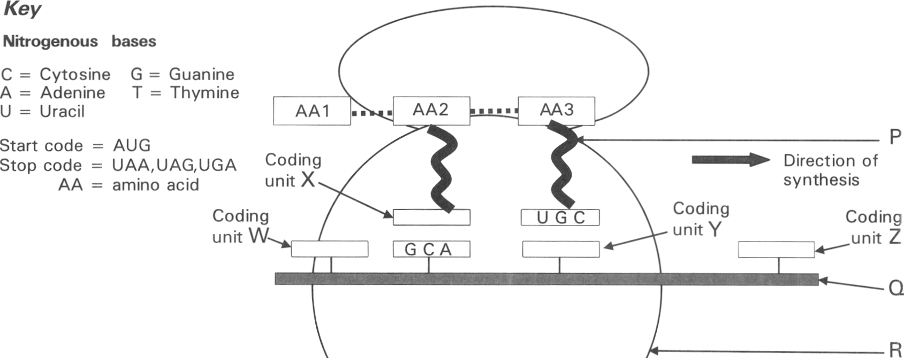
A. Rough endoplasmic reticulum B. Mitochondrion
C. Nucleolus D. Smooth endoplasmic reticulum Directions: Questions 43 to 47 refer to the diagram below, which shows a biological process of producing a polypeptide composed of three amino acids inside a cell.
39. Which of the following matching of the labelled parts is CORRECT?
 | Part P | Part Q | Main component of Part R
A. | mRNA | tRNA | rRNA
B. | tRNA | rRNA | mRNA
C. | tRNA | mRNA | rRNA
D. | mRNA | rRNA | tRNA

40. Which of the following matching of the coding units is CORRECT?
 | Coding unit W | Coding unit X | Coding unit Y | Coding unit Z
A. | AUG | GCT | TGC | UAG
B. | UGA | CGU | ACG | AUG
C. | UGA | CGT | UGC | AUG
D. | AUG | CGU | ACG | UGA

41. Which of the following is the process illustrated by the diagram?
A. Transcription B. Translation C. Translocation of geneD. Duplication of bases
42. Where will this process mainly take place?
A. Nucleus
B. Rough endoplasmic reticulum
C. Mitochondrion
D. Nucleolus
43. What is the advantage of having a number of R attached together at Q ?
AA1 | AA3 | AA5 | AA1 | AA4 | AA2 | AA4 | AA3 | AA5 | AA1

AA 1 | AA 2 | AA3 | AA4 | AA5
AUG | CAU | GCC | GGC | UGU

A. A longer polypeptide is formed.
B. A greater variety of different polypeptides is formed.
C. Several pieces of the same type of polypeptide are formed at the same time.
D. Less tRNA molecules are needed in the synthesis of proteins. Directions: Questions 48 and 49 refer to the diagram below, which shows a polypeptide chain composed of five different types of amino acids (labelled AA1 to AA5). The codons for the five different types of amino acids are:
44. Which of the following is the mRNA that produces the above polypeptide?
A. | UGU | AUG | UGU | AUG | GCC | UGU | UGU | AUG | GCC | GCC
B. | AUG | GCC | UGU | AUG | GGC | CAU | GGC | GCC | UGU | AUG
C. | GCC | UGU | UGU | AUG | UGU | AUG | GCC | UGU | AUG | UGU
D. | AUG | UGU | GCC | UGU | UGU | AUG | UGU | AUG | UGU | AUG

45. Which of the following is the corresponding DNA that transcribes the above mRNA?
A. | UAC | CGG | ACA | UAC | CCG | GUA | CCG | CGG | ACA | UAC
B. | GCC | TGT | TGT | ATG | TGT | ATG | GCC | TGT | ATG | TGT
C. | TAC | GCC | TGT | ATG | GGC | CAT | GGC | GCC | TGT | ACA
D. | TAC | CGG | ACA | TAC | CCG | GTA | CCG | CGG | ACA | TAC

46. The following are steps involved in protein synthesis. (1) Release of polypeptide chain from the ribosome. (2) Formation of peptide bond between adjacent amino acids on the ribosome. (3) Movement of mRNA through the nuclear pore to the cytoplasm. (4) Transcription of mRNA from a DNA template. (5) Attachment of several ribosomes on a piece of mRNA. (1), (3), (2), (4), (5) D. (3), (4), (5), (1), (2)
A.
A. (1), (3), (2), (4), (5)
B. (4), (5), (3), (1), (2)
C. (4), (3), (5), (2), (1)
47. The synthesis of a polypeptide is completed when
A. all the amino acids in the cell are exhausted.
B. the ribosome reaches the stop codon of the mRNA.
C. the ribosome reads the anticodon of the tRNA that brings in the last amino acid.
D. all the tRNAs leave the ribosome.
48. If a piece of DNA composed of 4206 nucleotides is transcribed and translated into protein,how many amino acids are linked to form this protein?
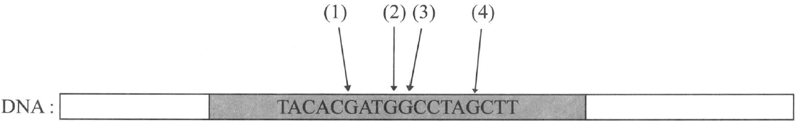
A. 700 B. 1 400 C. 2 100 D. 2 800 Directions: Questions 53 to 55 refer to the diagram below ,which shows the base sequence of a small section of a gene on the DNA that controls the production of an enzyme.
49. How many amino acids are present in the polypeptide produced by this section of DNA? C.9 D.6
A. 18
B. 15
C. 9
D. 6
50. Which of the following is the mRNA produced in the transcription of the above segment of DNA?
A. ATGTGCTACCGGATTGUU B. AUGUGCUACCGGAUCGAA
C. T ACACGATGGCCTAGCTT D. UACUCGAUGCGGUTTCTT
51. If UAG is the stop codon of the mRNA, where will mutation occur that substitutes the base G to C of the above DNA segment to cause the early termination of the translation process?
A. (1)
B. (2)
C. (3)
D. (4)
52. If a polypeptide chain consisted of 21 amino acids is built from 7 different types of amino acids, what is the least number of tRNA molecules needed for the synthesis of this polypeptide?
A. 7
B. 14
C. 21
D. 28
53. Which of the following statements concerning the synthesis of the polypeptide chain in the previous question is CORRECT?
A. The mRNA concerned consists of 7 codons.
B. The mRNA concerned consists of 8 codons.
C. The mRNA concerned consists of 21 codons.
D. The mRNA concerned consists of 22 codons.
D. Mutation
54. A mutation in a gene of a somatic cell is very harmful if it
A. affects the normal gamete formation.
B. is dominant.
C. is passed on to subsequent generations.
D. leads to the development of a malignant tumour .
55. Which of the following will bring about mutation? (1) X-ray (2) Ultra-violet ray (3) Uranium (4) Magnesium (5) Nitrous acid (6) Citric acid
A. (1) and (2) only
B. (1), (3) and (6) only
C. (2), (4) and (5) only
D. (1), (2), (3) and (5) only
56. The diagram below shows a small segment of a normal DNA strand.
Normal DNA strand TTC-GGC-CCG-CAG-ACG
If gene mutation occurs by substituting one nitrogenous base with another , a mutant is formed as shown below:
Mutant DNA strand TTC-GGC-GCG-CAG-ACG
The amino acids coded by some codons of mRNA are shown below:
Which of the following is the protein produced due to the mutation of the gene?
Codon in mRNA | Amino acid coded | Codon in mRNA | Amino acid coded
AAG | Lysine | GGC | Glycine
CCG | Proline | GUC | Valine
CGC | Arginine | UGC | Cysteine

A. Lysine-Proline-Glycine-Valine-Cysteine
B. Arginine-Lysine-Proline-Arginine-Valine
C. Lysine-Proline-Arginine-Valine-Cysteine
D. Glycine-Valine-Cysteine-Arginine-Lysine
57. Which of the following diseases are results of the inherited disorders in humans? (1) Haemophilia (2) Anaemia (3) Mediterranean Anaemia (4) Down's Syndrome(5) Severe Acute Respiratory Syndrome (SARS)
A. (1), (3) and (4) only
C. (2), (3) and (4) only
B. (1), (2) and (5) only
D. (2), (4) and (5) only
58. Which of the following diseases are due to defective genes in humans?
(1) Night blindness (2) Colour blindness (3) Sickle-cell Anaemia
(4) Cystic fibrosis (5) Dengue Fever
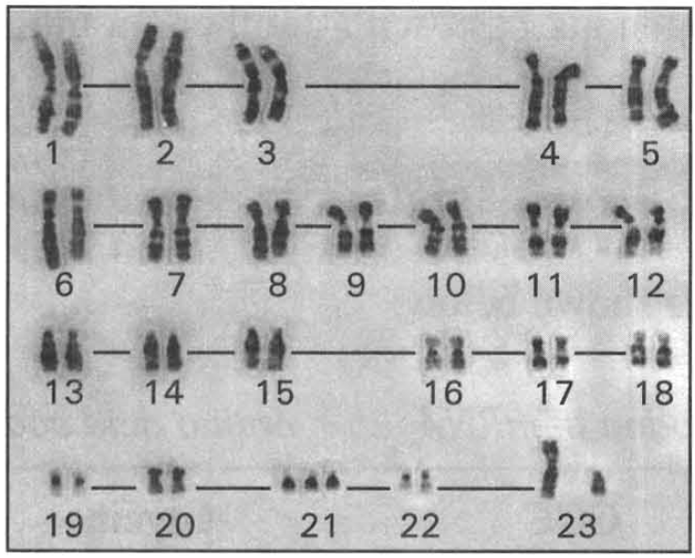
A. (1), (3) and (5) only B. (2), (3) and (4) only
C. (2), (4) and (5) only D. (3), (4) and (5) only Directions: Questions 63 and 64 refer to the diagram below, which is the karyotype of a cell of person E.
59. Which of the following statements can be deduced from the information obtained from the karyotype? (1) The karyotype is taken from a germ cell of person E. (2) This person has an abnormal number of chromosomes. (3) This person is a male. (4) This person has sex-linked disease.
A. (1) and (2) only
B. (2) and (3) only
C. (3) and (4) only
D. (2), (3) and (4) only
60. There are three pieces of chromosomes numbered 21 while the other chromosomes are in pairs. Which of the following is the cause for the presence of the extra chromosome?
A. Crossing over between the homologous chromosomes during meiosis.
B. Independent assortment of the non-homologous chromosomes during meiosis.
C. Non-disjunction in the formation of gametes during meiosis.
D. Gene mutation occurs during the formation of gametes.
61. The graph below shows the relationship between the incidence of Down syndrome in baby and the mother's age.
What can be deduced from the information obtained from the graph?
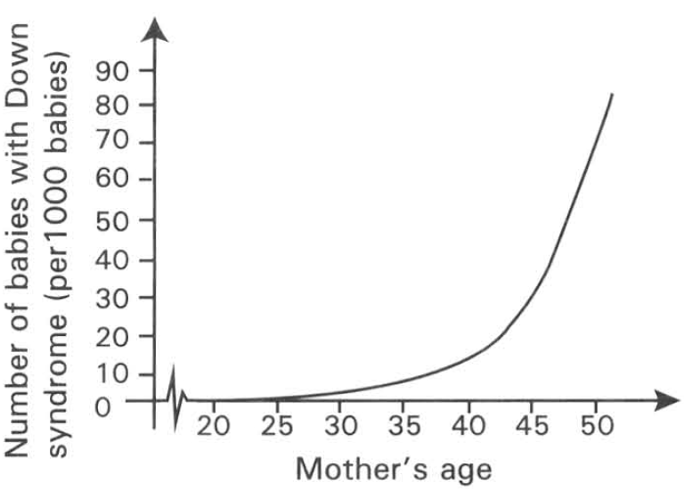
A. Down syndrome is due to the presence of an extra chromosome numbered 21.
B. Mothers at age below 20 will not have babies with Down syndrome.
C. Mothers in under developed countries have higher chance to give birth to babies with Down syndrome.
D. The older the mother, the higher is the chance of giving birth to babies with Down syndrome.
62. Which of the following karyotypes belongs to a person with normal number of chromosomes?
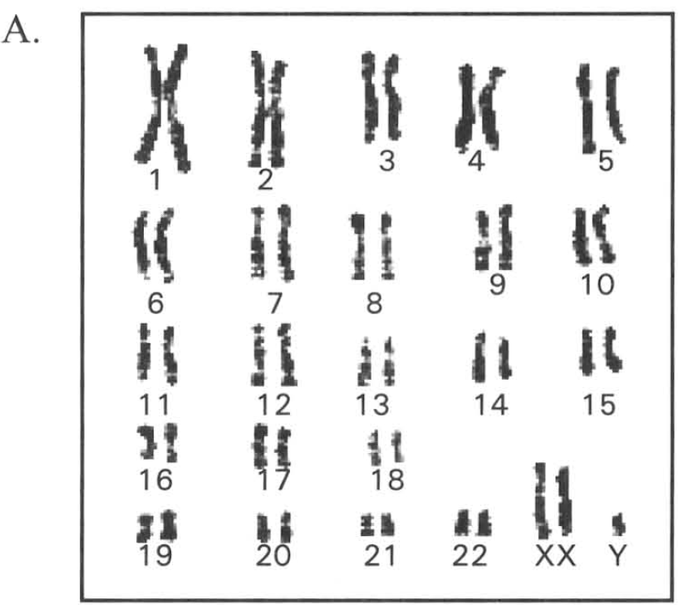
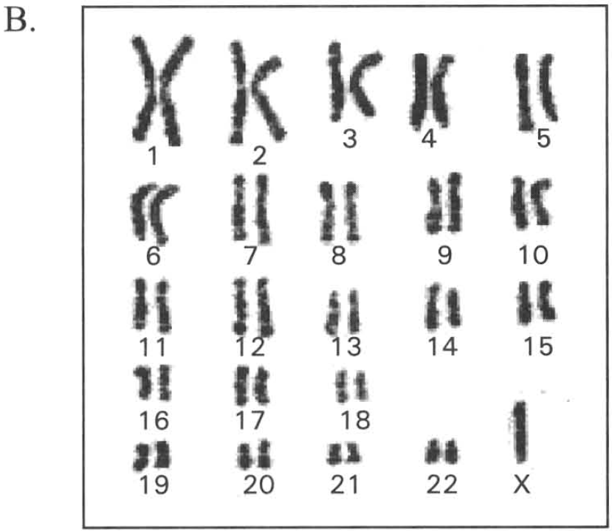
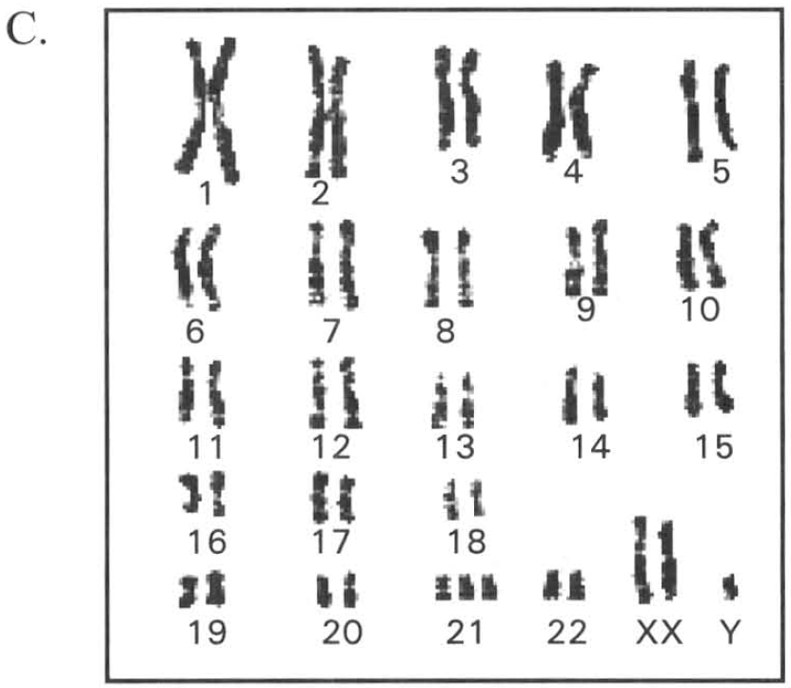
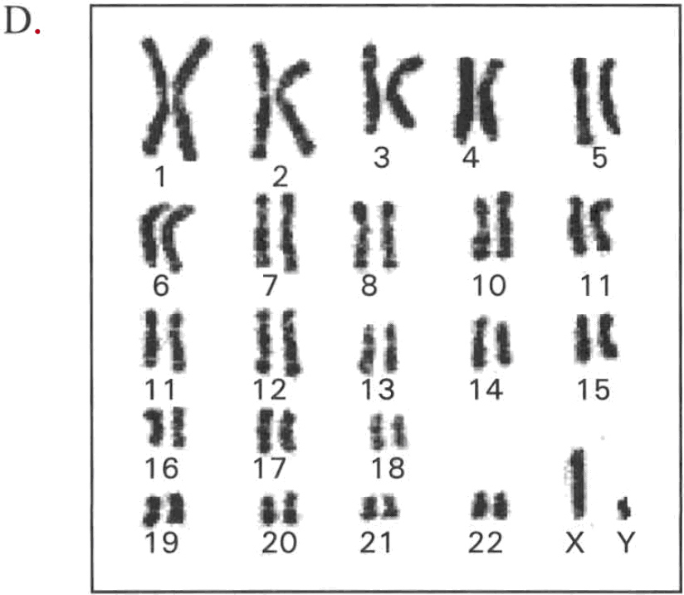
D. Applied genetics — Recombinant DNA Technology & DNA Fingerprinting
63. Viruses and plasmids are usually chosen to act as vectors in genetic engineering. Which of the following is an appropriate reason for such a choice?
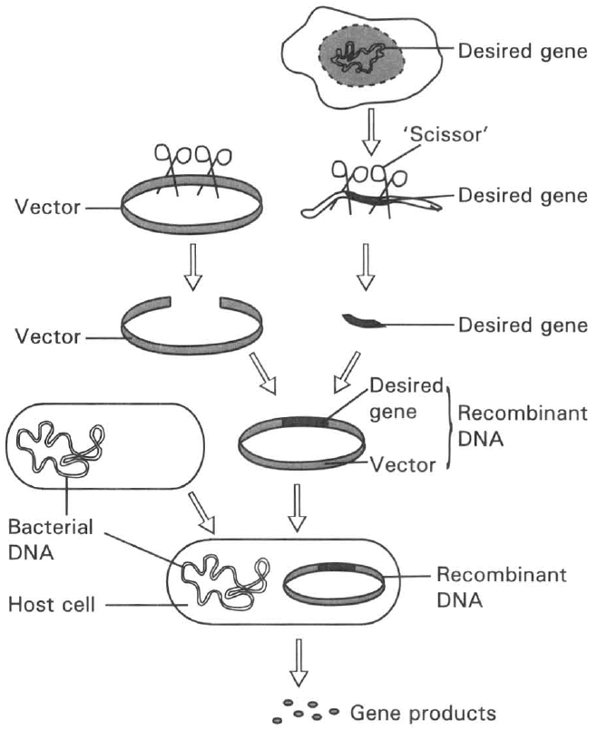
A. They are so tough that they will not easily die in the experiment.
B. They have very short life time.
C. They have very high rate of replication of the genetic material.
D. They can easily incorporate with the desired gene and penetrate into the host cells. Directions: Questions 68 to 72 refer to the diagram below, which shows the basic procedures of applying genetic engineering to produce substances useful to humans.
64. What is the process described in the diagram?
A. Protein synthesis B. Recombinant DNA technology
C. Independent assortment of genes D. DNA fingerprinting
65. What do the "Scissors" in the above diagram represent?
A. Hormones
B. Restriction enzyme
C. Structural proteins
D. Vitamins
66. Which of the following can act as "vectors" in this technique? (1) Virus (2) Circular DNA in the cytoplasm of some bacteria (3) Mosguito
A. (1) only
B. (2) only
C. (1) and (2) only
D. (1), (2) and (3)
67. Which of the following is/are very suitable to act as host cell? (1) Virus (2) Bacteria (3) Yeast cells (4) Human cells
A. (1) only
B. (2) and (3) only
C. (3) and (4) only
D. (1) and (2) only
68. Which of the following is the product of genetic engineering that is of great importance to cure a very common disease in humans?
A. Amylase B. Insulin C. Haemogloloin D. Glucagon
69. What is the function of DNA ligase?
A. Breaks down the DNA at specific points into fragments.
B. Joins the DNA fragments together.
C. Catalyzes the transcription process.
D. Catalyzes the translation process.
70. Which of the following statements about plasmids is/are CORRECT? (1) Plasmids are small circular rings of DNA present in the cytoplasm of bacteria. (2) Plasmids are small genetic material present inside the virus. (3) Plasmids can be used to introduce the desired gene into host cells in genetic engineering.
A. (1) only
B. (2) only
C. (1) and (3) only
D. (2) and (3) only
71. Arrange the following steps of genetic engineering in the CORRECT order. (1) Insert the desired gene into the plasmid. (2) Desired gene in the host cell multiplies and produces the desired gene products. (3) Use the restriction enzyme to cut out the desired gene from the human chromosome. (4) Cut open a plasmid and insert the desired gene to it. (5) Isolate and purify the gene product. (6) Use specific antibiotic to screen for the host cells with the desired gene.
A. (1), (3), (4), (6), (5), (2)
B. (3), (4), (2), (5), (6), (1)
C. (3), (4), (1), (6), (2), (5)
D. (2), (4), (3), (5), (1), (6)
72. Which of the following is/are application of recombinant DNA technology? (1) Production of vaccines and human hormones. (2) Production of genetically modified food. (3) Splitting DNA into small fragments. (4) Gene therapy.
A. (1) and (2) only
B. (2) and (3) only
C. (1) and (4) only
D. (1), (2) and (4) only
73. Human insulin can be produced by genetic engineering. Which of the following statements about the production of such human insulin is CORRECT? (1) Such human insulin has fewer side effects than the insulin extracted from the pancreas of cows and pigs. (2) It can be produced at large scale within a short period of time. (3) The production cost is much lower than that by extracting the hormone from other animals.
A. (1) and (2) only
B. (2) and (3) only
C. (3) and (1) only
D. (1), (2) and (3)
74. Insulin produced by genetic engineering provides steady supply of hormone to treat diabetes. The desired insulin gene can be extracted from (1) the cells of the pancreas. (2) the cells of the liver. (3) the cells of the small intestine.
A. (1) only
B. (2) only
C. (1) and (2) only
D. (1), (2) and (3)
75. Which of the following are the advantages of developing genetically modified crops in food production?
(1) Provides high yield of crops production
(2) Produces crops with rich nutritional values
(3) Prolongs the shelf life of the plant food
(4) Increase the variety of plant food in the market
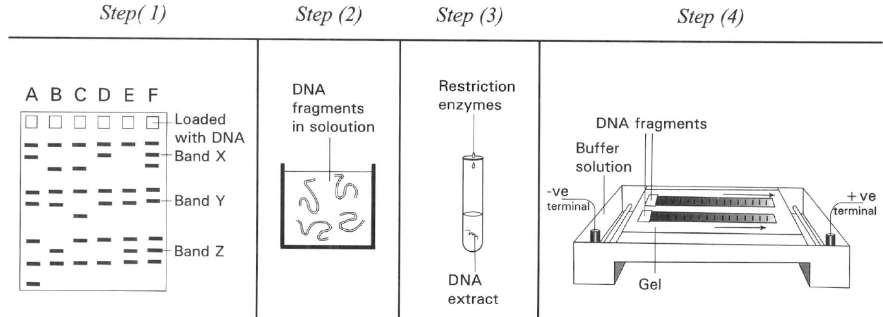
A. (1) and (2) only B. (2) and (3) only C. (3) and (4) only D. (1), (2) and (3) only Directions: Questions 80 to 83 refer to the diagram below , which shows the steps, not in proper order, involved in the preparation of DNA fingerprint.
76. Arrange these steps in the CORRECT order.
A. (2),(3),(1),(4)
B. (4),(3),(2),(1)
C. (2),(3),(1),(4)
D. (3),(2),(4),(1)
77. What is the purpose of adding restriction enzyme in step (3)?
A. To join the DNA fragments together.
B. To catalyzes the replication of DNA.
C. To break down the DNA into small fragments .
D. To stain the DNA fragments.
78. What is the purpose of applying an electric field in the tank in step (4)?
A. To move the negatively charged DNA fragments towards the anode as a method to separate the DNA according to different size.
B. To kill the bacteria present in the DNA solution.
C. To ionize the DNA in order to label them.
D. To remove the protein component from the DNA molecules.
79. Which of the following CORRECTLY arrange the DNA bands in step (1) in ascending order?
A. band X, band Y, band Z
B. band Y, band Z, band X
C. band Z, band X, band Y
D. band Z, band Y, band X
80. The diagram below is the DNA fingerprints of a sample of blood obtained from the crime scene and that of four suspects.
Which suspect is most likely to be in the crime scene?
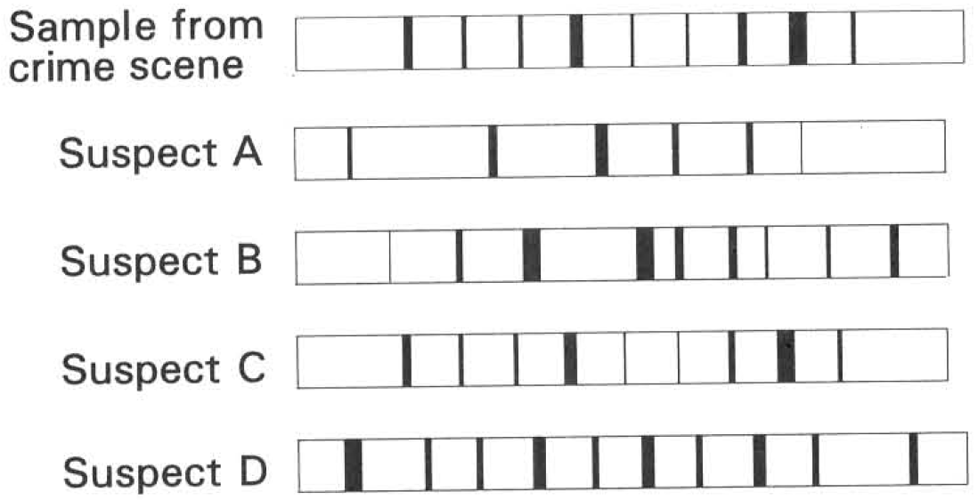
A. Suspect A B. Suspect B C. Suspect C D. Suspect D
81. Which of the following concerning with genetically modified food are INCORRECT? (1) GM food is only common in industrial countries. (2) GM food will not impose any harms to humans. (3) It is very expensive to produce GM food. (4) GM food can reduce the wastage by having longer shelf time.
A. (1) and (2) only
B. (3) and (4) only
C. (1), (2) and (3) only
D. (2), (3) and (4) only
82. Which of the following is NOT the advantage of producing genetically modified food?
A. Producing greater yield within a shorter period of time.
B. Producing cereals rich in vitamin A.
C. Increasing the resistance to pests and thus reducing the use of pesticides.
D. Disturbing the equilibrium in the ecosystem by having plants with genetically modified characters introduced into the natural environment.
83. The Human Genome Project was completed in 2002. This project studied
A. the mechanism triggering the inherited diseases in humans.
B. the impact of the global changes on humans as the consequence of ‘Greenhouse Effect’.
C. the complete arrangement of the base sequence in the DNA of the whole set of human chromosomes.
D. the mechanism of gene expression through protein synthesis.
84. The Human Genome Project has significant effect in (1) understanding the cause of inherited diseases. (2) finding ways of curing or preventing inherited diseases. (3) inducing some scientists to develop the controversial attempt of human cloning. D. (1), (2) and (3) Suggested Solutions
A. (1) only
B. (2) only
C. (1) and (2) only
D. (1), (2) and (3) Suggested Solutions
Part B — Applied genetics (YKTo)
85. Viruses and plasmids are usually chosen to act as vectors in genetic engineering. Which of the following is an appropriate reason for such a choice?
A. They are so tough that they will not easily die in the experiment.
B. They have very short life time.
C. They have very high rate of replication of the genetic material.
D. They can easily incorporate with the desired gene and penetrate into the host cells. Directions: Questions 2 to 6 refer to the diagram below, which shows the basic procedures of applying genetic engineering to produce substances useful to humans.
86. What is the process described in the diagram?
A. Protein synthesis B. Recombinant DNA technology
C. Independent assortment of genes D. DNA fingerprinting
87. What do the "Scissors" in the above diagram represent?
A. Hormones
B. Restriction enzyme
C. Structural proteins
D. Vitamins
88. Which of the following can act as "vectors" in this technique? (1) Virus (2) Circular DNA in the cytoplasm of some bacteria (3) Mosguito
A. (1) only
B. (2) only
C. (1) and (2) only
D. (1), (2) and (3)
89. Which of the following is/are very suitable to act as host cell? (1) Virus (2) Bacteria (3) Yeast cells (4) Human cells
A. (1) only
B. (2) and (3) only
C. (3) and (4) only
D. (1) and (2) only
90. Which of the following is the product of genetic engineering that is of great importance to cure a very common disease in humans?
A. Amylase B. Insulin C. Haemogloloin D. Glucagon
91. What is the function of DNA ligase?
A. Breaks down the DNA at specific points into fragments.
B. Joins the DNA fragments together.
C. Catalyzes the transcription process.
D. Catalyzes the translation process.
92. Which of the following statements about plasmids is/are CORRECT? (1) Plasmids are small circular rings of DNA present in the cytoplasm of bacteria. (2) Plasmids are small genetic material present inside the virus. (3) Plasmids can be used to introduce the desired gene into host cells in genetic engineering.
A. (1) only
B. (2) only
C. (1) and (3) only
D. (2) and (3) only
93. Arrange the following steps of genetic engineering in the CORRECT order. (1) Insert the desired gene into the plasmid. (2) Desired gene in the host cell multiplies and produces the desired gene products. (3) Use the restriction enzyme to cut out the desired gene from the human chromosome. (4) Cut open a plasmid and insert the desired gene to it. (5) Isolate and purify the gene product. (6) Use specific antibiotic to screen for the host cells with the desired gene.
A. (1), (3), (4), (6), (5), (2)
B. (3), (4), (2), (5), (6), (1)
C. (3), (4), (1), (6), (2), (5)
D. (2), (4), (3), (5), (1), (6)
94. Which of the following is/are application of recombinant DNA technology? (1) Production of vaccines and human hormones. (2) Production of genetically modified food. (3) Splitting DNA into small fragments. (4) Gene therapy.
A. (1) and (2) only
B. (2) and (3) only
C. (1) and (4) only
D. (1), (2) and (4) only
95. Human insulin can be produced by genetic engineering. Which of the following statements about the production of such human insulin is CORRECT? (1) Such human insulin has fewer side effects than the insulin extracted from the pancreas of cows and pigs. (2) It can be produced at large scale within a short period of time. (3) The production cost is much lower than that by extracting the hormone from other animals.
A. (1) and (2) only
B. (2) and (3) only
C. (3) and (1) only
D. (1), (2) and (3)
96. Insulin produced by genetic engineering provides steady supply of hormone to treat diabetes. The desired insulin gene can be extracted from (1) the cells of the pancreas. (2) the cells of the liver. (3) the cells of the small intestine.
A. (1) only
B. (2) only
C. (1) and (2) only
D. (1), (2) and (3)
97. Which of the following are the advantages of developing genetically modified crops in food production?
(1) Provides high yield of crops production
(2) Produces crops with rich nutritional values
(3) Prolongs the shelf life of the plant food
(4) Increase the variety of plant food in the market
A. (1) and (2) only B. (2) and (3) only C. (3) and (4) only D. (1), (2) and (3) only Directions: Questions 14 to 17 refer to the diagram below , which shows the steps, not in proper order, involved in the preparation of DNA fingerprint.
98. Arrange these steps in the CORRECT order.
A. (2),(3),(1),(4)
B. (4),(3),(2),(1)
C. (2),(3),(1),(4)
D. (3),(2),(4),(1)
99. What is the purpose of adding restriction enzyme in step (3)?
A. To join the DNA fragments together.
B. To catalyzes the replication of DNA.
C. To break down the DNA into small fragments .
D. To stain the DNA fragments.
100. What is the purpose of applying an electric field in the tank in step (4)?
A. To move the negatively charged DNA fragments towards the anode as a method to separate the DNA according to different size.
B. To kill the bacteria present in the DNA solution.
C. To ionize the DNA in order to label them.
D. To remove the protein component from the DNA molecules.
101. Which of the following CORRECTLY arrange the DNA bands in step (1) in ascending order?
A. band X, band Y, band Z
B. band Y, band Z, band X
C. band Z, band X, band Y
D. band Z, band Y, band X
102. The diagram below is the DNA fingerprints of a sample of blood obtained from the crime scene and that of four suspects.
Which suspect is most likely to be in the crime scene?
A. Suspect A B. Suspect B C. Suspect C D. Suspect D
103. Which of the following concerning with genetically modified food are INCORRECT? (1) GM food is only common in industrial countries. (2) GM food will not impose any harms to humans. (3) It is very expensive to produce GM food. (4) GM food can reduce the wastage by having longer shelf time.
A. (1) and (2) only
B. (3) and (4) only
C. (1), (2) and (3) only
D. (2), (3) and (4) only
104. Which of the following is NOT the advantage of producing genetically modified food?
A. Producing greater yield within a shorter period of time.
B. Producing cereals rich in vitamin A.
C. Increasing the resistance to pests and thus reducing the use of pesticides.
D. Disturbing the equilibrium in the ecosystem by having plants with genetically modified characters introduced into the natural environment.
105. The Human Genome Project was completed in 2002. This project studied
A. the mechanism triggering the inherited diseases in humans.
B. the impact of the global changes on humans as the consequence of ‘Greenhouse Effect’.
C. the complete arrangement of the base sequence in the DNA of the whole set of human chromosomes.
D. the mechanism of gene expression through protein synthesis.
106. The Human Genome Project has significant effect in (1) understanding the cause of inherited diseases. (2) finding ways of curing or preventing inherited diseases. (3) inducing some scientists to develop the controversial attempt of human cloning. D. (1), (2) and (3) Suggested Solutions
A. (1) only
B. (2) only
C. (1) and (2) only
D. (1), (2) and (3) Suggested Solutions

Answers
Answers are printed in red.
1. A. (1) only
Class: 70.3% correct (n=37) usual slip C
2. C. Hydrogen bond

3. D. They enable replication to take place that produces an exact copy of DNA.

4. C
Class: 53.1% correct (n=49) usual slip D
5. B

6. C. The sequence of bases along the polynucleotide strand.

7. C. The amounts of adenine is roughly the same as that of thymine, as are the amounts of guanine and cytosine.

8. A

9. A. 20%
Class: 64.9% correct (n=37) usual slip D
10. B. 18%

11. C. (1) and (2) only

12. C

13. A. Sugar-phosphate strand

14. C. Uracil and adenine D. Adenine and thymine

15. B. (1) and (3) only

16. D. (1), (2) ,(3) and (4)

17. C

18. D

19. D. (3) (2) (1) (4)

20. B. (2) and (4)

21. A. Sperms produced in the same testis of a male. B. Neurones.

22. B. (2), (3), (1), and (4)

23. D. An amino acid can be coded by more than one codon.

24. C. More than one codon codes for one amino acid.

25. D

26. D. 27

27. A. (1), (2) and (5) only

28. C. This produces mRN

29. A. Inside the nucleus

30. D

31. B

32. B

33. C. The codons of mRNA are complementary to the anticodons of tRNAs.

34. A. 453

35. B. (1) and (4) only

36. D. It is a triplet of nitrogenous present on tRNA.

37. A

38. C. Nucleolus D. Smooth endoplasmic reticulum Directions: Questions 43 to 47 refer to the diagram below, which shows a biological process of producing a polypeptide composed of three amino acids inside a cell.

39. C

40. D

41. B

42. B. Rough endoplasmic reticulum

43. C. Several pieces of the same type of polypeptide are formed at the same time.

44. B

45. D

46. C. (4), (3), (5), (2), (1)

47. B. the ribosome reaches the stop codon of the mRNA.

48. A. 700 B. 1 400 C. 2 100 D. 2 800 Directions: Questions 53 to 55 refer to the diagram below ,which shows the base sequence of a small section of a gene on the DNA that controls the production of an enzyme.

49. D. 6

50. B

51. B. (2)

52. A. 7

53. D. Mutation

54. D. leads to the development of a malignant tumour .

55. D. (1), (2), (3) and (5) only

56. C. Lysine-Proline-Arginine-Valine-Cysteine

57. A. (1), (3) and (4) only

58. B

59. B. (2) and (3) only

60. C. Non-disjunction in the formation of gametes during meiosis.

61. D. The older the mother, the higher is the chance of giving birth to babies with Down syndrome.

62. D. Applied genetics — Recombinant DNA Technology & DNA Fingerprinting

63. D. They can easily incorporate with the desired gene and penetrate into the host cells. Directions: Questions 68 to 72 refer to the diagram below, which shows the basic procedures of applying genetic engineering to produce substances useful to humans.

64. B

65. B. Restriction enzyme

66. C. (1) and (2) only

67. B. (2) and (3) only

68. B

69. B. Joins the DNA fragments together.

70. C. (1) and (3) only

71. C. (3), (4), (1), (6), (2), (5)

72. D. (1), (2) and (4) only

73. D. (1), (2) and (3)

74. D. (1), (2) and (3)

75. D

76. D. (3),(2),(4),(1)

77. C. To break down the DNA into small fragments .

78. A. To move the negatively charged DNA fragments towards the anode as a method to separate the DNA according to different size.

79. D. band Z, band Y, band X

80. C

81. C. (1), (2) and (3) only

82. D. Disturbing the equilibrium in the ecosystem by having plants with genetically modified characters introduced into the natural environment.

83. C. the complete arrangement of the base sequence in the DNA of the whole set of human chromosomes.

84. D. (1), (2) and (3) Suggested Solutions

85. D. They can easily incorporate with the desired gene and penetrate into the host cells. Directions: Questions 2 to 6 refer to the diagram below, which shows the basic procedures of applying genetic engineering to produce substances useful to humans.
Class: 68.6% correct (n=121) usual slip B
86. B

87. B. Restriction enzyme
Class: 84.3% correct (n=121) usual slip B
88. C. (1) and (2) only

89. B. (2) and (3) only
Class: 68.6% correct (n=35) usual slip D
90. B

91. B. Joins the DNA fragments together.
Class: 76.9% correct (n=121) usual slip A
92. C. (1) and (3) only
Class: 81.0% correct (n=105) usual slip D
93. C. (3), (4), (1), (6), (2), (5)

94. D. (1), (2) and (4) only
Class: 87.5% correct (n=16) usual slip B
95. D. (1), (2) and (3)
Class: 37.1% correct (n=35) usual slip B
96. D. (1), (2) and (3)
Class: 31.4% correct (n=35) usual slip A
97. D
Class: 87.5% correct (n=16) usual slip A
98. D. (3),(2),(4),(1)
Class: 50.0% correct (n=16) usual slip C
99. C. To break down the DNA into small fragments .

100. A. To move the negatively charged DNA fragments towards the anode as a method to separate the DNA according to different size.

101. D. band Z, band Y, band X

102. C

103. C. (1), (2) and (3) only

104. D. Disturbing the equilibrium in the ecosystem by having plants with genetically modified characters introduced into the natural environment.

105. C. the complete arrangement of the base sequence in the DNA of the whole set of human chromosomes.

106. D. (1), (2) and (3) Suggested Solutions

