Molecular genetics and biotechnology · items under 80% correct
Multiple-choice practice
Name: ________________________ Class: ____________
These items were answered correctly by fewer than 80% of students in class Google Forms, matched by the wording in the source bank and the form answer key. Choose the one best answer.
Part A — Molecular genetics (YKTo)
1. Which of the following features are essential for DNA to act as genetic material? (1) Its structures are complex enough to provide the basis of genetic information. (2) Its structures enable it to replicate. (3) It is present in the nucleus only. D. (1), (2) and (3) 3Which of the following statements about DNA is/are CORRECT? (1) DNA directly controls the synthesis of carbohydrates. (2) DNA is made of nucleotides. (3) DNA is in form of a double helix. B. (2) only C. (1) and (2) only D. (2) and (3) only
A. (1) and (2) only
B. (2) and (3) only
C. (1) and (3) only
A. (1) only
2. The diagram below shows the structure of a basic unit of DNA.
Which of the following combinations of the parts is CORRECT?
7Which of the following combinations truly represent the basic structure of mRNA?
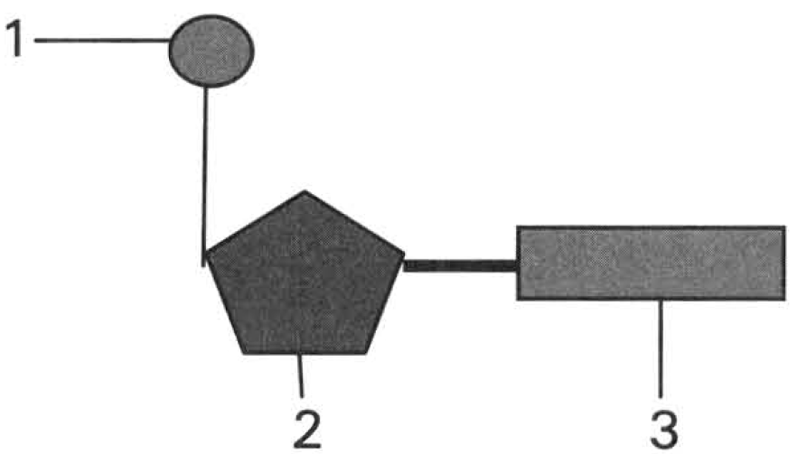
 | Part (1) | Part (2) | Part (3)
A. | Base | Phosphate | Deoxyribose
B. | Deoxyribose | Phosphate | Base
C. | Phosphate | Deoxyribose | Base
D. | Deoxyribose | Base | Phosphate

 | Pentose | Inorganic salt | Nitrogenous base
A. | Deoxyribose | Hydrogencarbonate | Uracil
B. | Ribose | Phosphate | Thymine
C. | Ribose | Phosphate | Uracil
D. | Deoxyribose | Hydrogencarbonate | Thymine

3. The DNA in the nucleus of the liver cell of humans contains 30% guanine (G). What is the percentage of thymine (T) in the nucleus of the pancreatic cell of the same person? A.20% B.30% C.40% D.60%
A. 20%
B. 30%
C. 40%
D. 60%
Part B — Applied genetics (YKTo)
4. Viruses and plasmids are usually chosen to act as vectors in genetic engineering. Which of the following is an appropriate reason for such a choice?
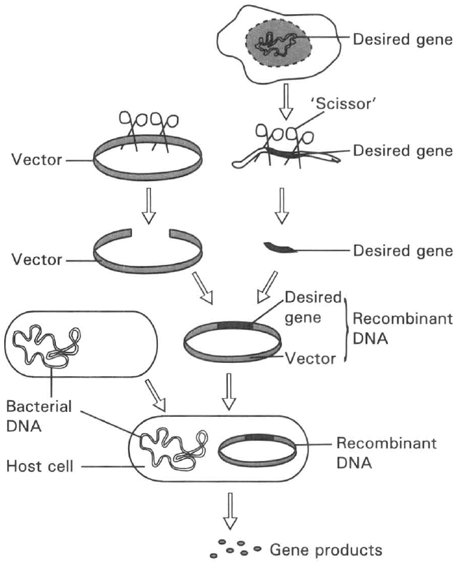
A. They are so tough that they will not easily die in the experiment.
B. They have very short life time.
C. They have very high rate of replication of the genetic material.
D. They can easily incorporate with the desired gene and penetrate into the host cells. Directions: Questions 2 to 6 refer to the diagram below, which shows the basic procedures of applying genetic engineering to produce substances useful to humans.
5. Which of the following is/are very suitable to act as host cell? (1) Virus (2) Bacteria (3) Yeast cells (4) Human cells
A. (1) only
B. (2) and (3) only
C. (3) and (4) only
D. (1) and (2) only
6. What is the function of DNA ligase?
A. Breaks down the DNA at specific points into fragments.
B. Joins the DNA fragments together.
C. Catalyzes the transcription process.
D. Catalyzes the translation process.
7. Human insulin can be produced by genetic engineering. Which of the following statements about the production of such human insulin is CORRECT? (1) Such human insulin has fewer side effects than the insulin extracted from the pancreas of cows and pigs. (2) It can be produced at large scale within a short period of time. (3) The production cost is much lower than that by extracting the hormone from other animals.
A. (1) and (2) only
B. (2) and (3) only
C. (3) and (1) only
D. (1), (2) and (3)
8. Insulin produced by genetic engineering provides steady supply of hormone to treat diabetes. The desired insulin gene can be extracted from (1) the cells of the pancreas. (2) the cells of the liver. (3) the cells of the small intestine.
A. (1) only
B. (2) only
C. (1) and (2) only
D. (1), (2) and (3)
9. Arrange these steps in the CORRECT order.
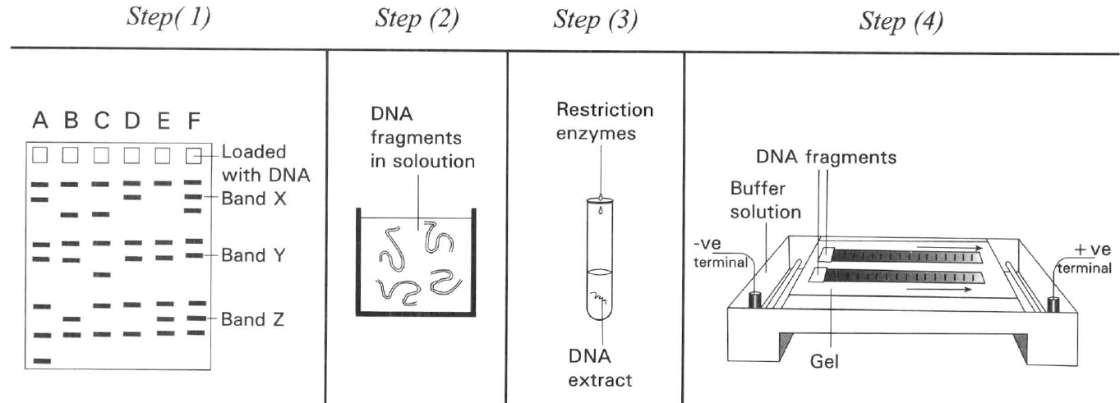
A. (2),(3),(1),(4)
B. (4),(3),(2),(1)
C. (2),(3),(1),(4)
D. (3),(2),(4),(1)

Answers
Answers are printed in red.
1. A. (1) only
Class: 70.3% correct (n=37) usual slip C
2. C
Class: 53.1% correct (n=49) usual slip D
3. A. 20%
Class: 64.9% correct (n=37) usual slip D
4. D. They can easily incorporate with the desired gene and penetrate into the host cells. Directions: Questions 2 to 6 refer to the diagram below, which shows the basic procedures of applying genetic engineering to produce substances useful to humans.
Class: 68.6% correct (n=121) usual slip B
5. B. (2) and (3) only
Class: 68.6% correct (n=35) usual slip D
6. B. Joins the DNA fragments together.
Class: 76.9% correct (n=121) usual slip A
7. D. (1), (2) and (3)
Class: 37.1% correct (n=35) usual slip B
8. D. (1), (2) and (3)
Class: 31.4% correct (n=35) usual slip A
9. D. (3),(2),(4),(1)
Class: 50.0% correct (n=16) usual slip C

Class percentage correct
Matched to this paper by question wording in the source bank and the form answer key, not by a shifted paper number.
Q | Answer | % correct | n | Usual slip
1 | A | 70.3% | 37 | C
2 | C | 53.1% | 49 | D
3 | A | 64.9% | 37 | D
4 | D | 68.6% | 121 | B
5 | B | 68.6% | 35 | D
6 | B | 76.9% | 121 | A
7 | D | 37.1% | 35 | B
8 | D | 31.4% | 35 | A
9 | D | 50.0% | 16 | C

