Molecules of life
Multiple-choice practice
Name: ________________________ Class: ____________
There are 41 questions compiled from Longman HKCEE and/or YKTo papers. Choose the one best answer.
Part A — HKDSE-style (YKTo)
1. Which of the statements below TRULY represent the properties of water? (1) Its highest density is at 0°C. (2) It is a solvent for all non-polar molecules. (3) It has high heat capacity that enables it to absorb large amount of heat. (4) It has high latent heat of vaporization that enhances the loss of heat from the human body. D. (4) and (1) only
C. (2) It is a solvent for all non-polar molecules. (3) It has high heat capacity that enables it to absorb large amount of heat. (4) It has high latent heat of vaporization that enhances the loss of heat from the human body.
A. (1) and (2) only
B. (2) and (3) only
C. (3) and (4) only
2. Water is a very good solvent for ionic compounds because
A. it is neutral in nature.
B. its molecular size is very small.
C. it is the most abundant substance in organisms.
D. it is polar.
3. What is the importance of the high heat capacity of water to organisms? (1) It absorbs large amount of heat to produce the cooling effect brought by transpiration in plants. (2) It enables fish to survive in the lake when the air temperature is 0°C. (3) It reduces the temperature changes of the aquatic environment. D. (1) and (2) only
C. (3) It reduces the temperature changes of the aquatic environment.
A. (1) only
B. (2) only
C. (3) only
4. Which of the following properties of water is responsible for maintaining the transpiration stream in form of a continuous water column without breakage to flow along the xylem of plants? C. High cohesive force between water molecules. D. The melting point is very low.
A. Its density is highest at 4°
C.
B. It has a high latent heat of vaporization.
C. High cohesive force between water molecules.
5. Which of the following are functions of water in organisms? (1) It absorbs shock or reduces friction in the joints. (2) It provides support to soft organs. (3) It provides medium for biochemical reactions to take place inside the cells. B. Minerals
A. (1) and (2) only
B. (2) and (3) only
C. (1) and (3) only
D. (1), (2) and (3)
6. Which of the following about inorganic substances in organisms is INCORRECT?
A. Water is the most abundant inorganic substance in the body of organisms.
B. Minerals are important to keep the body healthy.
C. Nitrogen is directly absorbed into all the green plants to synthesize proteins.
D. Phosphorus is important to both plants and animals.
7. Which of the following are the symptoms of the deficiency of calcium in humans?
(1) Rickets (2) Continuous bleeding from the wounds
(3) Easy convulsion of muscles (4) Anaemia
A. All except (1) B. All except (2) C. All except (3) D. All except (4)
8. Which of the following are important for the healthy formation of bones in humans? (1) Calcium (2) Iron (3) Magnesium (4) Phosphate (5) Vitamin C (6) Vitamin D
A. (1), (3) and (5)
B. (2), (4) and (6)
C. (1), (4) and (6)
D. (2), (3) and (5)
9. Which of the following are responsible for the symptom of anaemia? (1) Shortage of oxygen (2) Shortage of iron (3) Shortage of vitamin C
A. (1) only
B. (2) only
C. (1) and (2) only
D. (2) and (3) only
10. Which of the following compounds may contain phosphorus? (1) ATP (2) Nucleic acid (3) Lipid (4) Protein
A. (1) and (2) only
B. (1) and (3) only
C. (2) and (3) only
D. (1), (2), (3) and (4)
11. Which of the following are the advantages of drinking isotonic solution after performing vigorous exercises? (1) Replaces for the loss of water. (2) Replaces for the loss of electrolytes. (3) Strengthening the bones. (4) Strengthening the muscles. C. Carbohydrates
A. (1) and (2) only
B. (2) and (3) only
C. (3) and (4) only
D. (1) and (4) only
12. Which of the following about carbohydrates is/are INCORRECT? (1) The ratio of hydrogen atoms to oxygen atoms is 2:1. (2) Due to the low ratio of carbon atoms they cannot be used as structural material. (3) Some of them can act as food reserve because they can exist in form of polymers.
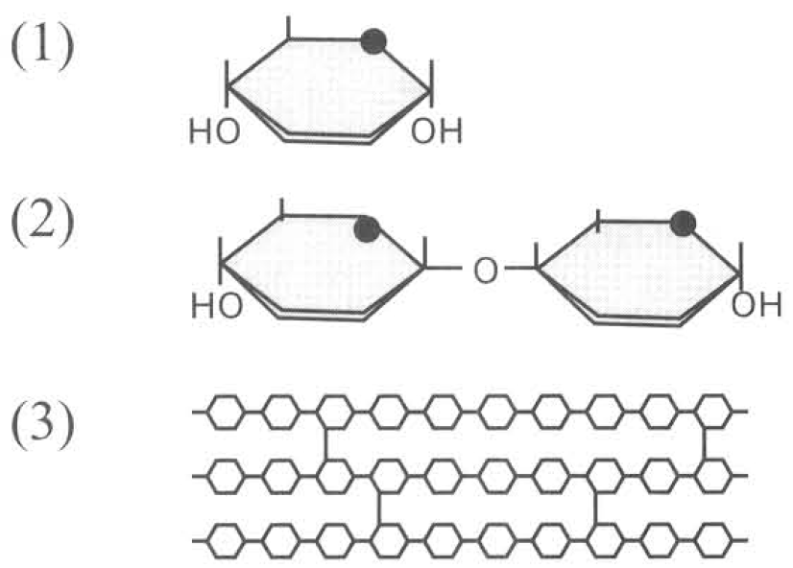
A. (1) only
B. (2) only
C. (1) and (2) only
D. (1), (2) and (3)
13. The following are the diagrammatic representation of the structures of carbohydrates:
Which of the following matching is CORRECT?
 | Molecules | Diagrammatic representation of the structures
A. | Sucrose | (1)
B. | Cellulose | (3)
C. | Glucose | (2)
D. | Starch | (3)

14. Which of the following bonds can combine two simple sugars together to form a double sugar?
A. Hydrogen bond
B. Peptide bond
C. Sulphide bond
D. Glycosidic bond
15. Which of the following processes is responsible for the formation of starch from glucose?
A. Condensation B. Glycolysis C. Hydrolysis D. Respiration
16. Which of the following statements about starch and sucrose are BOTH CORRECT? (1) They have reducing power. (2) Their subunits are linked together by hydrogen bonds. (3) Both can be completely hydrolyzed to monosaccharides. (4) They can be detected by using Benedict's test.
A. (1) only
B. (3) only
C. (1) and (2) only
D. (2) and (4) only
17. Which of the following statements about starch and glycogen are CORRECT? (1) Both are present in animal cells. (2) Both are polysaccharides. (3) Both act as food reserve. (4) Both are soluble in the cytoplasm.
A. (1) and (2) only.
B. (2) and (3) only.
C. (3) and (4) only.
D. (1), (2) and (3) only.
18. Which of the following contain glycogen? (1) Liver cells of humans (2) Muscle cells of humans (3) Mesophyll cells of leaf (4) Hyphae of fungi
A. (1) and (2) only
B. (2) and (3) only
C. (3) and (4) only
D. (1), (2) and (4) only
19. Which of the following statements about the cellulose molecules is/are CORRECT? (1) They are composed of a-glucose. (2) They can pass through the hydrophilic channel proteins at the cell membrane. (3) They strengthen the cell wall to provide mechanical support to the plant cell. (4) They can be identified by the Albustix paper.
A. (1) only
B. (3) only
C. (1) and (2) only
D. (2) and (4) only
20. Which of the following comparison between starch and cellulose is INCORRECT?
 | Starch | Cellulose
A. | Composed of -glucose. | Composed of -glucose.
B. | Polysaccharide chain coiled in spiral form. | Polysaccharide chains bridged by hydrogen bonds.
C. | Food storage form in plant cell. | Structural components of the cell wall.
D. | Can be digested in human body. | Cannot be digested in human body.

21. Which of the following statements about the carbohydrates and their functions are INCORRECT? (1) Starch is the storage form in liver. (2) Glucose is the easily oxidised respiratory fuel in organisms. (3) Sucrose is the transported form in flowering plants. (4) Cellulose is the supporting material in bones. D. Lipids
A. (1) and (2) only
B. (2) and (3) only
C. (1) and (4) only
D. (2), (3) and (4)
22. Which of the following compounds are lipids?
(1) Haemoglobin (2) Sex hormones (3) Cholesterol (4) Insulin
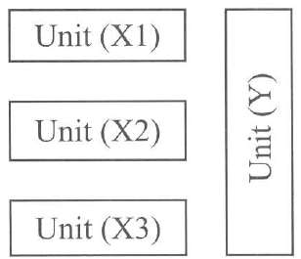
A. (1) and (2) only B. (2) and (3) only C. (3) and (4) only D. (2), (3) and (4) only Directions: Questions 23 to 25 refer to the following diagram which represents the basic components of lipids.
23. How many water molecules will be released when these four units join together to form lipid?
A. 1
B. 2
C. 3
D. 4
24. If the product of the condensation between the above units is a triglyceride, which of the following are the true components of this reaction?
 | Units XI, X2 and X3 | Unit Y
A. | Amino acids | Ethanol
B. | Ethanol | Amino acids
C. | Fatty acids | Glycerol
D. | Glycerol | Fatty acids

25. Phospholipid differs from triglyceride by having unit X1 replaced by
A. Nitrate
B. Sulphate
C. Phosphate
D. Lactate
26. Which of the following matching between the types of lipids and their functions is/are CORRECT?
 | Lipids | Functions
(1) | Triglycerides | As component of the plant surface to reduce the water loss.
(2) | Phospholipids | An important component of the cell membrane.
(3) | Steroids | Forming sex hormones

A. (1) only
B. (2) only
C. (3) only
D. (1), (2) and (3)
27. Which of the statements below TRULY represent the properties/functions of a triglyceride? (1) Soluble in water. (2) Has insulating effect. (3) Ideal energy reserve. (4) Essential for the transport of vitamin B in the human body.
A. (1) and (2) only
B. (2) and (3) only
C. (3) and (4) only
D. (1) and (4) only
28. What is the function of cholesterol in the cell surface membrane ?
A. To enhance facilitated diffusion.
B. To enhance active transport.
C. To enhance osmosis.
D. To regulate the fluidity of membrane. E. Proteins
29. Which of the following contains nitrogen? (1) Carbohydrates (2) Lipids (3) Proteins (4) Nucleotides
A. (1) and (2) only
B. (2) and (3) only
C. (3) and (4) only
D. (1), (3) and (4) only
30. Which of the following molecules contain amino group? (1) Glucose (2) Glycogen (3) Insulin (4) Haemoglobin
A. (1) and (2) only
B. (3) and (4) only
C. (1), (2) and (4) only
D. (2), (3) and (4) only
31. Which of the following processes are responsible for the formation of proteins ? (1) Hydrolysis (2) Condensation (3) Polymerization (4) Deamination
A. (1) and (2) only
B. (2) and (3) only
C. (3) and (4) only
D. (1), (3) and (4) only
32. Which of the following properties of proteins is responsible for the buffering effect?
A. They are lipid soluble.
B. They contain nitrogen.
C. They are amphoteric.
D. They are the important component of the cell membrane.
33. Which of the following bonds are involved in the formation of haemoglobin ? (1) Hydrogen bonds (2) Peptide bonds (3) Glycosidic bonds
A. (1) only
B. (2) only
C. (1) and (2) only
D. (2) and (3) only
34. Which of the following are the functions of proteins? (1) Growth and repair (2) Readily oxidised to release energy (3) Takes important role in body defence (4) Forms biocatalysts D. (1), (3) and (4) only F. Nucleotides
A. (1) and (2) only
B. (2) and (3) only
C. (1), (2) and (3) only
D. (1), (3) and (4) only F. Nucleotides
35. Which molecule is represented by the diagram below ?
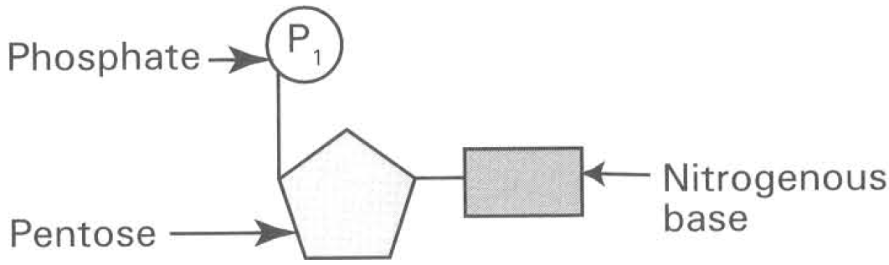
A. Triglycerides
B. Sucrose
C. Starch
D. Nucleotide
36. Which of the following about nucleotide is INCORRECT? (1) It is the structural unit of protein. (2) DNA and RNA are the only biomolecules of nucleotides. (3) Nucleotide is composed of sulphates, triose and nitrogenous base.
A. (3) only
B. (1) and (2) only
C. (2) and (3) only
D. (1), (2) and (3)
37. Which of the following diagrams is the true representation of a molecule of deoxyribosenucleic acid (DNA)?
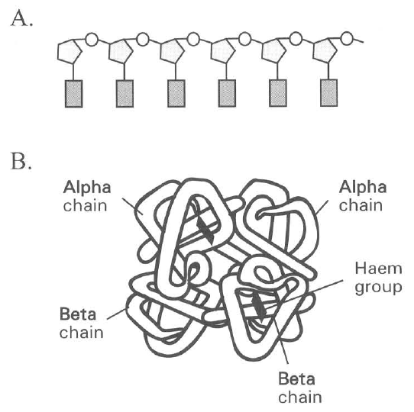
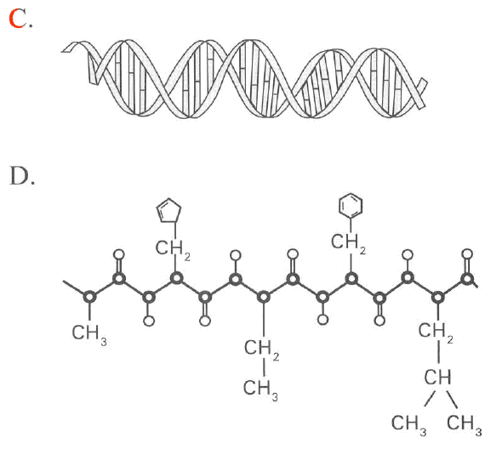
38. Which of the following about RNA are INCORRECT?
(1) It is a single strand.
(2) It is confined in rough endoplasmic reticulum only.
(3) It contains uracil.
(4)It is only replicated during cell division.
A. (1) and (2) only B. (2) and (4) only
C. (3) and (4) only D. (1) and (4) only G. Biochemical tests
39. A student added a given volume of Benedict's solution to a sample of fruit juice A. He heated the mixture and measured the amount of precipitate formed. Then he repeated the experiment by hydrolyzing the fruit juice before performing the Benedict's test. The whole set of experiment was repeated by testing three other samples of fruit juices B, C and D. The result was shown in the table below:
Which fruit juice contains the greatest amount of non-reducing sugars?
 | Relative amount of precipitate BEFORE hydrolysis (arbitrary units) | Relative amount of precipitate AFTER hydrolysis (arbitrary units)
A. | 14 | 20
B. | 16 | 22
C. | 18 | 25
D. | 12 | 21

40. Biochemical tests were carried out to identify the biomolecules in four food samples. Which food sample contains both maltose and lipids? 41. Some germinating seeds are crushed with water in a mortar. After filtration the filtrate was subjected to several biochemical tests. The following results are obtained. What biomolecules are present in the filtrate?
 | Benedict's test | Grease spot test | Iodine test | Albustix paper
A.
B.
C.
D.

Biochemical tests | Results
Iodine's test | Brown colour
Benedict's test | Brick red precipitate
Albustix test | Blue solution
Grease spot test | Permanent translucent spot

A. Starch and glucose
B. Protein and lipid
C. Maltose and lipid
D. Starch and protein
41. Biochemical tests were carried out to identify the biomolecules present in three samples of food. The results were shown below:
Foodsample | Iodinetest | Clinistixpaper | Albustixpaper
X | Brown | Pink | Green
Y | Brown | Purple | Yellow
Z | Blue-black | Pink | Yellow

 | Food sample X | Food sample Y | Food sample Z
A. | Protein | Glucose | Starch
B. | Starch | Protein | Glucose
C. | Protein | Starch | Glucose
D. | Glucose | Protein | Starch

Answers
Answers are printed in red.
1. C. (3) and (4) only

2. D. it is polar.

3. C. (3) only

4. C. High cohesive force between water molecules.

5. D. (1), (2) and (3)

6. C. Nitrogen is directly absorbed into all the green plants to synthesize proteins.

7. D

8. C. (1), (4) and (6)

9. B. (2) only

10. D. (1), (2), (3) and (4)

11. A. (1) and (2) only

12. D. (1), (2) and (3)

13. B

14. D. Glycosidic bond

15. A. Condensation B. Glycolysis C. Hydrolysis D. Respiration

16. B. (3) only

17. B. (2) and (3) only.

18. D. (1), (2) and (4) only

19. B. (3) only

20. A

21. C. (1) and (4) only

22. B

23. C. 3

24. C

25. C. Phosphate

26. D. (1), (2) and (3)

27. B. (2) and (3) only

28. D. To regulate the fluidity of membrane. E. Proteins

29. C. (3) and (4) only

30. B. (3) and (4) only

31. B. (2) and (3) only

32. C. They are amphoteric.

33. C. (1) and (2) only

34. D. (1), (3) and (4) only F. Nucleotides

35. D. Nucleotide

36. B. (1) and (2) only

37. C

38. B

39. D

40. C. Maltose and lipid

41. A

