Molecules of life · items under 80% correct
Multiple-choice practice
Name: ________________________ Class: ____________
No classroom item analysis matched this topic reliably. Items below are those predicted to be answered correctly by fewer than 80% of students. Choose the one best answer.
Part A — HKDSE-style (YKTo)
1. Which of the following about carbohydrates is/are INCORRECT? (1) The ratio of hydrogen atoms to oxygen atoms is 2:1. (2) Due to the low ratio of carbon atoms they cannot be used as structural material. (3) Some of them can act as food reserve because they can exist in form of polymers.
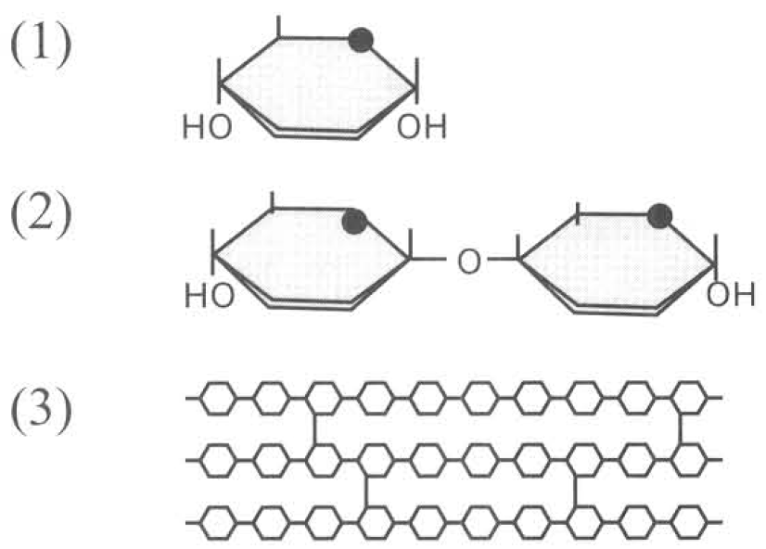
A. (1) only
B. (2) only
C. (1) and (2) only
D. (1), (2) and (3)
2. Which of the following are the symptoms of the deficiency of calcium in humans?
(1) Rickets (2) Continuous bleeding from the wounds
(3) Easy convulsion of muscles (4) Anaemia
A. All except (1) B. All except (2) C. All except (3) D. All except (4)
3. Which of the following statements about the carbohydrates and their functions are INCORRECT? (1) Starch is the storage form in liver. (2) Glucose is the easily oxidised respiratory fuel in organisms. (3) Sucrose is the transported form in flowering plants. (4) Cellulose is the supporting material in bones. D. Lipids
A. (1) and (2) only
B. (2) and (3) only
C. (1) and (4) only
D. (2), (3) and (4)
4. Which of the following about nucleotide is INCORRECT? (1) It is the structural unit of protein. (2) DNA and RNA are the only biomolecules of nucleotides. (3) Nucleotide is composed of sulphates, triose and nitrogenous base.
A. (3) only
B. (1) and (2) only
C. (2) and (3) only
D. (1), (2) and (3)
5. Which of the following about RNA are INCORRECT?
(1) It is a single strand.
(2) It is confined in rough endoplasmic reticulum only.
(3) It contains uracil.
(4)It is only replicated during cell division.
A. (1) and (2) only B. (2) and (4) only
C. (3) and (4) only D. (1) and (4) only G. Biochemical tests
6. Which of the following compounds are lipids?
(1) Haemoglobin (2) Sex hormones (3) Cholesterol (4) Insulin
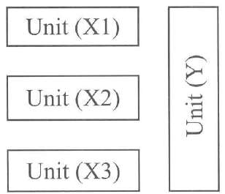
A. (1) and (2) only B. (2) and (3) only C. (3) and (4) only D. (2), (3) and (4) only Directions: Questions 23 to 25 refer to the following diagram which represents the basic components of lipids.
7. Which of the following matching between the types of lipids and their functions is/are CORRECT?
 | Lipids | Functions
(1) | Triglycerides | As component of the plant surface to reduce the water loss.
(2) | Phospholipids | An important component of the cell membrane.
(3) | Steroids | Forming sex hormones

A. (1) only
B. (2) only
C. (3) only
D. (1), (2) and (3)
8. Which of the following comparison between starch and cellulose is INCORRECT?
 | Starch | Cellulose
A. | Composed of -glucose. | Composed of -glucose.
B. | Polysaccharide chain coiled in spiral form. | Polysaccharide chains bridged by hydrogen bonds.
C. | Food storage form in plant cell. | Structural components of the cell wall.
D. | Can be digested in human body. | Cannot be digested in human body.

9. A student added a given volume of Benedict's solution to a sample of fruit juice A. He heated the mixture and measured the amount of precipitate formed. Then he repeated the experiment by hydrolyzing the fruit juice before performing the Benedict's test. The whole set of experiment was repeated by testing three other samples of fruit juices B, C and D. The result was shown in the table below:
Which fruit juice contains the greatest amount of non-reducing sugars?
 | Relative amount of precipitate BEFORE hydrolysis (arbitrary units) | Relative amount of precipitate AFTER hydrolysis (arbitrary units)
A. | 14 | 20
B. | 16 | 22
C. | 18 | 25
D. | 12 | 21

10. Which of the statements below TRULY represent the properties of water? (1) Its highest density is at 0°C. (2) It is a solvent for all non-polar molecules. (3) It has high heat capacity that enables it to absorb large amount of heat. (4) It has high latent heat of vaporization that enhances the loss of heat from the human body. D. (4) and (1) only
C. (2) It is a solvent for all non-polar molecules. (3) It has high heat capacity that enables it to absorb large amount of heat. (4) It has high latent heat of vaporization that enhances the loss of heat from the human body.
A. (1) and (2) only
B. (2) and (3) only
C. (3) and (4) only
11. What is the importance of the high heat capacity of water to organisms? (1) It absorbs large amount of heat to produce the cooling effect brought by transpiration in plants. (2) It enables fish to survive in the lake when the air temperature is 0°C. (3) It reduces the temperature changes of the aquatic environment. D. (1) and (2) only
C. (3) It reduces the temperature changes of the aquatic environment.
A. (1) only
B. (2) only
C. (3) only
12. Which of the following are functions of water in organisms? (1) It absorbs shock or reduces friction in the joints. (2) It provides support to soft organs. (3) It provides medium for biochemical reactions to take place inside the cells. B. Minerals
A. (1) and (2) only
B. (2) and (3) only
C. (1) and (3) only
D. (1), (2) and (3)
13. Which of the following are important for the healthy formation of bones in humans? (1) Calcium (2) Iron (3) Magnesium (4) Phosphate (5) Vitamin C (6) Vitamin D
A. (1), (3) and (5)
B. (2), (4) and (6)
C. (1), (4) and (6)
D. (2), (3) and (5)

Answers
Answers are printed in red.
1. D. (1), (2) and (3)
Predicted class correct ≈ 40% (no classroom match)
2. D
Predicted class correct ≈ 45% (no classroom match)
3. C. (1) and (4) only
Predicted class correct ≈ 45% (no classroom match)
4. B. (1) and (2) only
Predicted class correct ≈ 45% (no classroom match)
5. B
Predicted class correct ≈ 45% (no classroom match)
6. B
Predicted class correct ≈ 47% (no classroom match)
7. D. (1), (2) and (3)
Predicted class correct ≈ 47% (no classroom match)
8. A
Predicted class correct ≈ 50% (no classroom match)
9. D
Predicted class correct ≈ 51% (no classroom match)
10. C. (3) and (4) only
Predicted class correct ≈ 52% (no classroom match)
11. C. (3) only
Predicted class correct ≈ 52% (no classroom match)
12. D. (1), (2) and (3)
Predicted class correct ≈ 52% (no classroom match)
13. C. (1), (4) and (6)
Predicted class correct ≈ 52% (no classroom match)

Class percentage correct
Matched to this paper by question wording in the source bank and the form answer key, not by a shifted paper number.
Q | Answer | % correct | n | Usual slip
1 | D | 40.0% | pred | —
2 | D | 45.0% | pred | —
3 | C | 45.0% | pred | —
4 | B | 45.0% | pred | —
5 | B | 45.0% | pred | —
6 | B | 47.0% | pred | —
7 | D | 47.0% | pred | —
8 | A | 50.0% | pred | —
9 | D | 51.0% | pred | —
10 | C | 52.0% | pred | —
11 | C | 52.0% | pred | —
12 | D | 52.0% | pred | —
13 | C | 52.0% | pred | —

