Nutrition in humans
Multiple-choice practice
Name: ________________________ Class: ____________
There are 193 questions compiled from Longman HKCEE and/or YKTo papers. Choose the one best answer.
Part A — HKCEE level (Longman)
1. Which of the following is a characteristic of saprophytic organisms?
A. They carry out extracellular digestion.
B. They ingest solid food.
C. They feed on dead organic matter.
D. They secrete digestive enzymes.
2. Which of the following statements about the nutrition of bread mould is correct? (1) It ingests the bread. (2) It digests the organic matter in bread. (3) It obtains inorganic nutrients from the bread. (4) It egests the indigestible part of the bread.
A. (1) and (2) only
B. (1) and (4) only
C. (2) and (3) only
D. (2), (3) and (4) only
3. What are the functions of the rhizoids of a bread mould? (1) Secretion of digestive enzymes (2) Absorption of digested food (3) Anchorage to substratum
A. (1) and (2) only
B. (1) and (3) only
C. (2) and (3) only
D. (1), (2) and (3)
4. Which of the following about tapeworm are correct? (1) It carries out extracellular digestion. (2) It absorbs digested food from host. (3) It does not ingest food.
A. (1) and (2) only
B. (1) and (3) only
C. (2) and (3) only
D. (1), (2) and (3)
5. Which of the following is/are parasite(s)? (1) Tapeworm (2) Disease causing bacteria-(3) Insectivorous plants
A. (1) only
B. (1) and (2) only
C. (1) and (3) only
D. (1), (2) and (3)
6. All parasites
A. feed on dead organic matter.
B. do not digest food.
C. absorb digested food through their body surfaces.
D. obtain nutrients from hosts.
7. Tapeworm lives in the host's small intestine because
A. there is plenty of undigested food.
B. the food there has been digested by the host.
C. the effect of the host's digestive enzymes on it is minimum.
D. the intestine is long enough to accommodate the worm.
8. Tapeworm absorbs digested food from the host mainly through its
A. mouth.
B. sucker.
C. gut.
D. body surface.
9. Which of the following are the adaptations of tapeworm to parasitic mode of life? (1) Presence of hooks (2) Presence of suckers (3) Long and flattened body
A. (1) and (2) only
B. (1) and (3) only
C. (2) and (3) only
D. (1), (2) and (3)
10. Which of the following comparisons between tapeworm and bread mould is correct?
 | Tapeworm | Bread mould
A. | carries out intracellular digestion | carries out extracellular digestion
B. | acquires food from other living organisms | acquires food from dead organic matter
C. | has hooks for attachment | has roots for anchorage
D. | absorbs food by suckers | absorbs food by hyphae

11. Which of the following combinations is correct?
 | Holozoic nutrition | Parasitic nutrition | Saprophytic nutrition
A. | humans | tapeworms | pathogenic bacteria
B. | insectivorous plants | pathogenic bacteria | moulds
C. | humans | tapeworms | mosses
D. | mosses | insectivorous plants | pathogenic bacteria

12. Arrange the following processes of human nutrition in the correct sequence. (1) Digestion (2) Assimilation (3) Ingestion (4) Absorption
A. (1), (2), (3), (4)
B. (1), (4), (3), (2)
C. (3), (1), (4), (2)
D. (3), (2), (1), (4)
13. Which of the following about the functions of human incisors, canines and molars is correct?
Directions: Questions 14 to 17 refer to the diagram below which shows the vertical section of a human tooth.
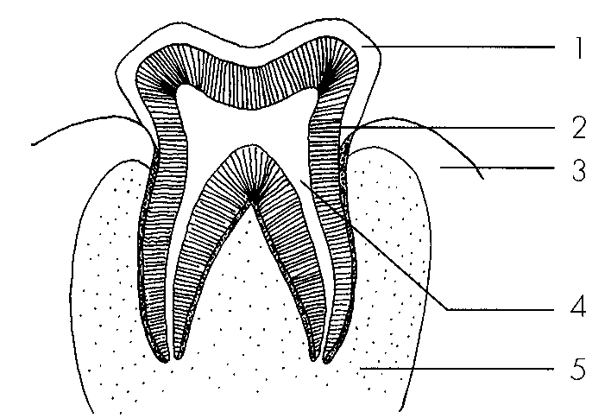
 | Incisors | Canines | Molars
A. | grind food | cut food | tear food
B. | cut food | tear food | grind food
C. | tear food | grind food | cut food
D. | cut food | grind food | tear food

14. Which type of tooth is shown in the diagram?
A. Incisor B. Canine C. Premolar D. Premolar or molar
15. Which of the labelled parts are living?
A. 1, 2 and 3 only
B. 2, 3 and 4 only
C. 3, 4 and 5 only
D. 2, 3, 4 and 5 only
16. Blood vessels can be found in
A. 1, 2 and 3 only
B. 2, 3 and 4 only
C. 3, 4 and 5 only
D. 2, 3, 4 and 5 only
17. Which of the following parts is most densely packed with calcium compounds?
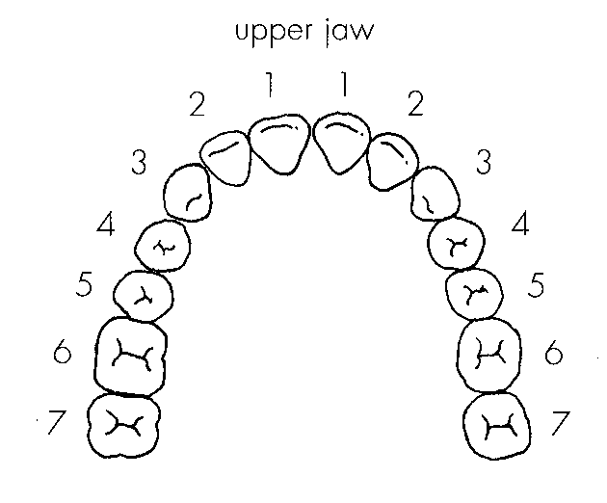
A. 1B. 2 C. 3 D. 4 Directions: Questions 18 to 20 refer to the diagram below which shows the teeth on the upper jaw of a person.
18. The teeth labelled 2 are
A. incisors.
B. canines.
C. premolars.
D. molars.
19. How many molars does this person have?
A. 4.
B. 6
C. 8
D. 12
20. The age of this person is most likely to be
A. 6.
B. 16.
C. 24.
D. 32.
21. Tooth decay is mainly caused by
A. sugary food.
B. acids produced by bacterial activity.
C. enzymes secreted by bacteria.
D. calcium deficiency.
22. Which of the following helps to prevent tooth decay? (1) Use toothpaste that contain fluoride.(2) Chew chewing gum after each meal. (3) Remove the plaque by a dentist. (4) Avoid eating too much sugary food. C.(2), (3) and (4) only
A. (1), (2) and (3) only
B. (1), (3) and (4) only
C. (2), (3) and (4) only
D. (1), (2), (3) and (4)
23. Which of the following is not a necessary function of toothpaste? A.It contains abrasives to remove plaque on the tooth surface. B.It contains alkaline substances to neutralise the acid released from bacterial activity. C.It contains calcium to support growth of the teeth. D.It contains fluoride to increase the resistance of enamel to acid.
A. It contains abrasives to remove plaque on the tooth surface.
B. It contains alkaline substances to neutralise the acid released from bacterial activity.
C. It contains calcium to support growth of the teeth.
D. It contains fluoride to increase the resistance of enamel to acid.
24. Which of the following functions is performed by a dental disclosing agent?
A.It neutralises the acid released from the plaque.
B.It stains the plaque.
C.It kills the bacteria in the plaque.
D.It stains the tooth which has started to decay.
Directions: Questions 25 to 27 refer to the graph below which shows the changes in pH of the plaque of a boy in a certain period of a day. The critical pH is the pH below which tooth decay may occur.
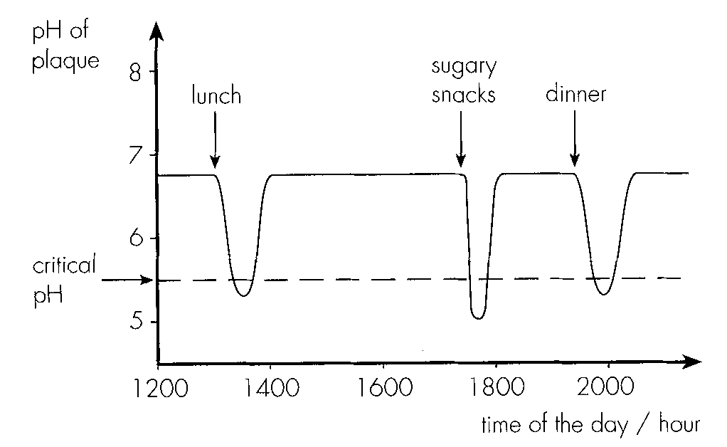
25. Which of the following conclusions can be drawn by referring only to the information provided in the above graph?
A.Bacteria in the plaque turn food substances into acid.
B.Acidity of the plaque increases shortly after the intake of food.
C.The tooth starts to decay when the pH of the plaque decreases.
D.All the meals contain acidic foodstuffs.
26. A low pH in the plaque may cause tooth decay because
A. bacteria which attack enamal are most active in an acidic condition.
B. acids dissolve enamal.
C. it is the optimum pH for the bacterial enzymes which break down enamal.
D. enamal is least resistant to bacterial attack at low pH values.
27. Based on the information provided in the graph, which of the preventive measures listed below can reduce the chance of tooth decay? (1) Brushing the teeth after meals (2) Avoiding sugary food (3) Eating more food rich in calcium (4) Using an alkaline toothpaste
A. (1) and (2) only
B. (1), (2) and (4) only
C. (2), (3) and (4) only
D. (1), (2), (3) and (4)
28. Which of the following is a means of physical digestion? (1) Chewing food by teeth (2) Churning action of the stomach (3)Peristalsis of small intestine (4) Emulsifying fat by bile
A. (1) and (2) only
B. (2) and (3) only
C. (1), (2) and (3) only
D. (1), (2), (3) and (4)
29. Physical digestion is essential for facilitating (1) swallowing. (2) absorption. (3) chemical digestion. (4) sterilization.
A. (1) and (2) only
B. (1) and (3) only
C. (1), (3) and (4) only
D. (2), (3) and (4) only
30. Chemical digestion of meat starts from the
A. mouth.
B. stomach.
C. duodenum.
D. pancreas.
31. Mucus lining the stomach wall
A. prevents proteases from digesting the stomach wall.
B. prevents collapse of the stomach.
C. kills microorganisms in food. -
D. traps the dust particles in the incoming air.
32. Which of the following will occur as a result of the removal of stomach?
A. Protein cannot be digested in the body.
B. Protein cannot be absorbed by the body.
C. Bacteria in food cannot be killed effectively.
D. Food cannot be broken down mechanically.
33. Which of the following digestive juices is not affected by heating?
A. Saliva B. Gastric juice C. Pancreatic juice D. Bile
34. Which of the following juices contain(s) digestive enzymes for fat? (1) Saliva (2) Gastric juice (3) Pancreatic juice (4) Bile
A. (1) and (2) only
B. (2) and (4) only
C. (3) and (4) only
D. (3) only
35. Which of the following can be digested by the human body? (1) Starch (2) Glucose (3) Cellulose D. (1), (2) and (3) Directions: Questions 36 to 39 refer to the experiment described below. Four test tubes containing equal volumes of coagulated egg white cubes were set up. Different solutions were then added to the test tubes and they were allowed to stand at 37°C. The table below shows the solutions added to the test tubes and the results observed after 24 hours: Key: += egg white cube present - = egg white cube absent
Tube | 1 | 2 | 3 | 4
Solutionsadded | sodium hydrogencarbonate solution | 5 cm3 | 5 cm3 | - | 5 cm3
 | solution X | - | 5 cm3 | 5 cm3 | 5 cm3(boiled solution X)
 | distilled water | 5 cm3 | - | 5 cm3 | -
Results after 24 hours | + | - | + | +

A. (1) only
B. (1) and (2) only
C. (2) and (3) only
C. The table below shows the solutions added to the test tubes and the results observed after 24 hours: Key: += egg white cube present - = egg white cube absent
36. Which of the following can be concluded from the results of tubes 1 and 2?
A. Solution X is pancreatic juice.
B. Solution X can break down protein.
C. Solution X can digest protein only in an alkaline medium.
D. Solution X contains protease.
37. Which of the tubes helps to confirm that the results obtained are due to the action of an enzyme in solution X?
A. Tube 1 B. Tube 2 C. Tube 3 D Tube 4
38. Which of the following digestive juices contains enzymes which can produce the same result as solution X?
A. Saliva B. Gastric juice C. Pancreatic juiceD. Bile
39. Which of the following tests will give a positive result with solution X?
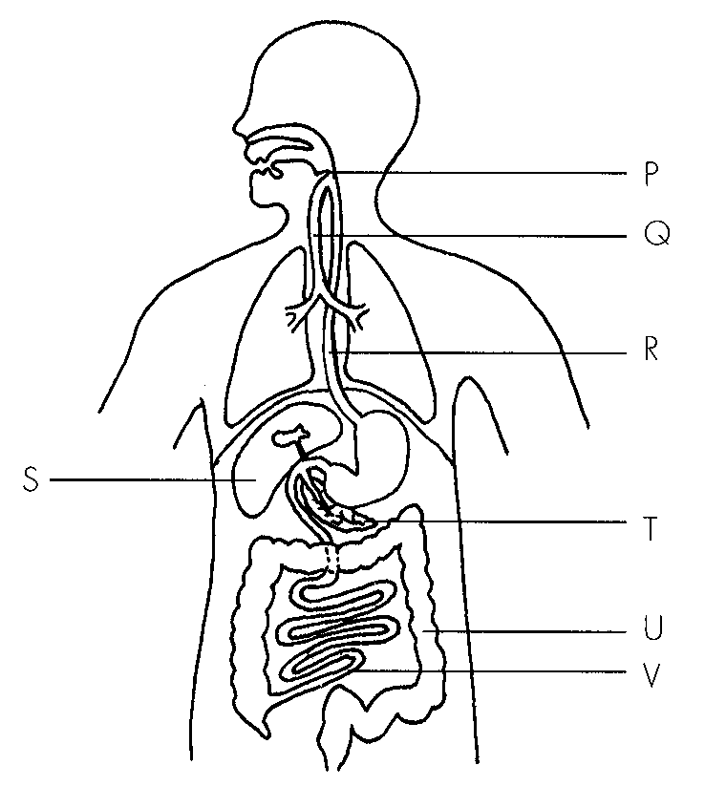
A. Benedict's test B. Biuret test C. Emulsion test D. Iodine test Directions: Questions 40 to 45 refer to the diagram below which shows the digestive system of a man.
40. Which of the following statements concerning structure P is correct?
A.It is a piece of bone.
B.It separates the trachea from the oesophagus.
C.It closes the oesophagus during inhalation.
DIt lowers to cover the trachea during swallowing.
41. Peristalsis occurs in A.R only.
A. R only.
B. R and U only.
C. R, U and V only.
D. R, S, T, U and V only.
42. Mucus can be found in
A. Q only
B. R only
C. R, U and V only
D. Q, R, U and V only
43. If a large part of U of the man is removed, which of the following will occur? A.He cannot absorb water. C.He will suffer from constipation.
A. He cannot absorb water.
B. He cannot absorb digested food efficiently.
C. He will suffer from constipation.
D. His faeces will become watery.
44. Which of the following is not a function of S?
A. Production of bile B. Storage of glycogen
C. Breakdown of old red blood cells D. Secretion of insulin
45. Which of the following can be a consequence of blocking the duct of T?
A. He cannot digest protein.
B. Fat cannot be emulsified.
C. Acid from the stomach cannot be neutralised sufficiently.
D. Excess glucose cannot be converted to glycogen for storage.
46. Bile facilitates fat digestion because it contains
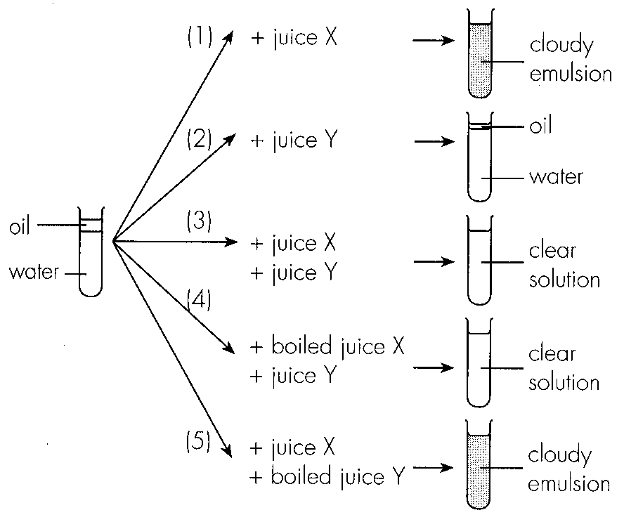
A. lipase. B. bile pigments. C. bile salts. D. sodium hydrogencarbonate. Directions: Questions 47 to 49 refer to an experiment in which two juices X and Y that can be found in human alimentary canal were collected and their effects on oil were investigated. The results are shown below.
47. By comparing the results of (1), (2) and (3), which of the following conclusions can be drawn?
A.Both juices contain enzymes to digest fat.
B.Juice X facilitates the digestion of oil by juice Y.
C.Juice Y can digest oil only in the presence of juice X.
D.Juice X digests oil better than juice Y.
48. What is the effect of heating on the functioning of the two juices?
 | Juice X | Juice Y
A. | unaffected | unaffected
B. | function lost | function lost
C. | unaffected | function lost
D. | function lost | unaffected

49. Which of the following combinations correctly identify the two juices?
Directions: Questions 50 to 52 refer to the experimental setup shown below.-
After 30 minutes, the water outside is tested with Benedict's solution and Biuret reagent. The results are shown in the table below.
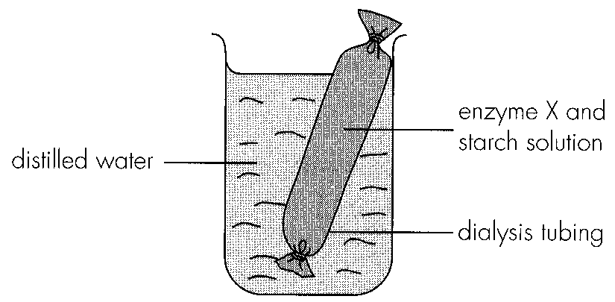
 | Juice X | juice Y
A. | bile produced by gall bladder | pancreatic juice produced by pancreas
B. | pancreatic juice produced by pancreas | bile produced by liver
C. | bile produced by liver | pancreatic juice produced by pancreas
D. | bile produced by liver | intestinal juice produced by duodenum

Benedict's test | Biuret test
red precipitate formed | remains blue

50. Which of the following conclusions can be drawn from the experimental results?
A. Starch cannot pass through the dialysis tubing.
B. Reducing sugar can pass through the dialysis tubing by osmosis.
C. Enzyme X can digest starch into glucose.
D. Protein cannot pass through the dialysis tubing.
51. Enzyme X can be found in
A. gastric juice.
B. bile.
C. pancreatic juice.
D. intestinal juice.
52. Which of the following is a necessary precaution for this experiment?
A. The distilled water outside the dialysis tubing should be stirred from time to time.
B. The contents inside the dialysis tubing should be shaken from time to time.
C. The dialysis tubing should be completely immersed in the distilled water.
D. The outside of the dialysis tubing should be rinsed with distilled water before it is lowered into the beaker.
53. Which of the following parts of the alimentary canal is the longest?
A. OesophagusB. Duodenum C. Ileum D. Colon
54. Which of the following helps) to facilitate the movement of food in the alimentary canal? (1) Peristalsis (2) Mucus (3) Water
A. (1) only
B. (1) and (2) only
C. (2) and (3) only
D. (1), (2) and (3)
55. Which part of the alimentary canal absorbs most water?
A. Small intestineB. Colon C. Caecum D. Rectum
56. The small intestine provides a large surface area for absorption by
(1) being long and coiled. (2) having a thin epithelium. (3) having a folded inner lining.
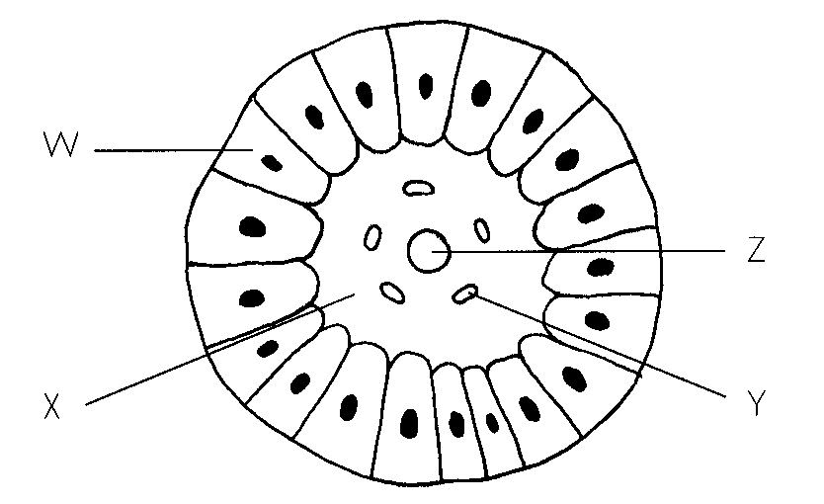
A. (1) and (2) only B. (1) and (3) onlyC. (2) and (3) only D. (1), (2) and (3) Directions: Questions 57 and 58 refer to the diagram below which shows the crosssection of a villus.-
57. Amino acids and simple sugars are absorbed into
A. W.
B. X.
C. Y.
D. Z.
58. The products of fat digestion are absorbed into
A. W.
B. X.
C. Y.
D. Z.
59. The digested products of protein are transported from the small intestine to the liver through
A. hepatic artery. B hepatic vein. C. hepatic portal vein.D. intestinal vein.
60. How is rice assimilated in humans after being digested and absorbed?
A. Oxidised to release energy
B. Stored in the form of starch
C. For building up muscles
D. None of the above
61. How is lean meat assimilated in humans after being digested and absorbed? (1)For making plasma proteins (2) For making enzymes (3) Excess amino acids excreted by the kidney
A. (1) and (2) only
B. (1) and (3) only
C. (2) and (3) only
D. (1), (2) and (3)
62. The faeces of a person becomes whitish. Which of the following may be the cause of it? (1) His bile duct is blocked.(2) His liver fails to secrete bile. (3) He eats only rice for many days.
A. (1) only
B. (2) only
C. (1) and (2) only
D. (1), (2) and (3)
63. Which of the following should be absent in faeces?
A. Digestible food materials B. Bacteria C. Cellulose D. Water
Part B — HKDSE-style (YKTo)
64. 1Which of the following matchings of diseases is CORRECT?
 | Mineral deficiencydisease | Vitamin deficiencydisease | hormone deficiencydisease | Hereditary disease
A. | Rickets | Colour blindness | Anaemia | Night blindness
B. | Anaemia | Rickets | Colour blindness | Scurvy
C. | Rickets | Night blindness | Diabetes | Colour blindness
D. | Night blindness | Colour blindness | Rickets | Anaemia

65. Which of the following are important for the growth of teeth and bones?
A. Sunlight, vitamin D and chloride
B. Phosphate, calcium and chloride
C. Potassium,vitamin D and phosphate
D. Calcium, phosphate, vitamin D and fluoride
66. 3Which of the following activities are effective to reduce the risk of osteoporosis? (1) Adequate exposure of the skin to sunlight. (2) Eat more cheese, bean curd and milk. (3) Do aerobic exercises three times a week. (4) Eat more meat which has rich iron content.
A. (1) and (2) only
B. (2) and (3) only
C. (3) and (4) only
D. (4) and (1) only
67. 4A female has to increase calcium and iron in her diet during (1) pregnancy. (2) breast-feeding. (3) puberty when menstruation starts. (4) after menopause.
A. (1) and (2) only
B. (2) and (3) only
C. (3) and (4) only
D. (2), (3) and (4) only
68. Which of the following disease(s) is/are NOT related with the intake of improper diet? (1) Osteoporosis (2) Colour blindness (3) Anaemia (4) Haemophilia
A. (1) only
B. (1) and (2) only
C. (2) and (4) only
D. (3) and (4) only
69. 6The following photographs show vegetables that are composed of large amount of an indigestible carbohydrate. What is the importance of this carbohydrate to the human body? (1) It stimulates peristalsis that reduces the risk of having constipation. (2) It makes the food more bulky that gives the sense of fullness. This is helpful to reduce the excessive intake of food. (3) Vegetables contain large amount of vitamin A so that the person will not have colour-blindness. (4) Vegetables contain large amount of iron so that the person will not have haemophilia.
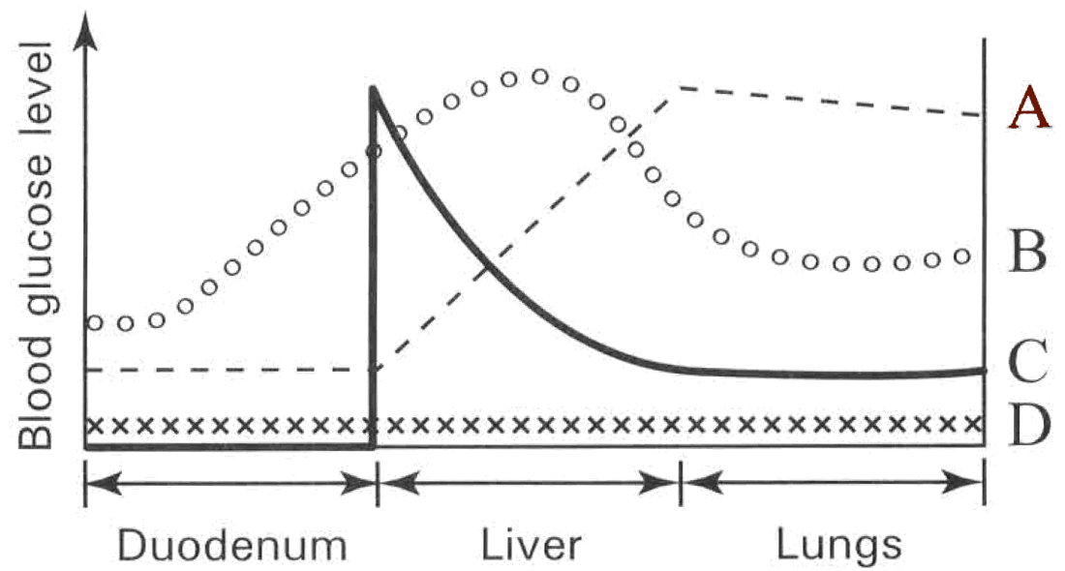
A. (1) and (2) only
B. (2) and (3) only
C. (3) and (4) only
D. (1), (2) and (3) only
70. 7Which of following statements about vitamins is/are WRONG?
(1) They are complex organic compounds.
(2) They are mainly transported throughout body by the blood system.
(3) None of them can be produced inside the body of human.
(4) They provide energy to support the body activities.
A. (1) onlyB. (2) only C. (1) and (3) only D. (3) and (4) only Directions: Questions 10.8 to 10.10 refer to the following experiment. A litter of rats was divided into two groups. Group A was fed with synthetic diet (sugar, starch, purified proteins, mineral salts and water). Group B was fed with the same synthetic diet and with a milk supplement. After 18 days, the diets taken by groups A and B rats were exchanged. The average mass of these rats was recorded and shown in the graph below:
71. 8What conclusion can be drawn from this experiment?
A. Carbohydrates, proteins, mineral salts and water are essential for the healthy growth of rats.
B. Vitamins are most important for the healthy growth of rats.
C. Milk contains some substances that are essential for the healthy growth of rats.
D. Rats will die in taking diet without vitamins .
72. 9What is the purpose of using rats from the same litter in doing this experiment?
A. The genetic variations between the rats are kept to the minimum.
B. The rats do not have any reserves of vitamins in their bodies at the beginning of the experiment.
C. They have the same genotype in order to show the effect of the environmental differences on the growth of rats.
D. They are young and healthy that will not easily die under the different environmental conditions.
73. Why are young rats used instead of mature one in doing this experiment?
(1) Young rats are at the active stage of growth that can give more conspicuous results.
(2) Young rats contain less reserve of the nutrients tested.
(3) Young rats can eat more food than the mature ones.
(4) Young rats have longer life span than the mature ones.
Fruit extract | cm3 of fruit extract used to change 1 cm3 DCPIP from blue to colourless
W | 11
X | 18
Y | 2
Z | 9

A. (1) and (2) only B. (2) and (3) only C. (3) and (4) only D. (2), (3) and (4) only Directions: Questions 10.11 to 10.13 refer to the table below which shows the result of an experiment using the reagent DCPIP (dichloro-phenol-indophenol):
74. 11This experiment shows that all the fruit extracts contain D. vitamin C.
A. glucose.
B. starch.
C. vitamin
A.
75. According to the concentration of the chemical detected by DCPIP arrange the fruit extracts in descending order.
A. Y, Z, W, X
B. Z, Y, X , W
C. W, X, Y, Z
D. Y, W, X, Z
76. When a person is suffering from bleeding gum, which fruit extract would you recommend him to drink?
A. W
B. X
C. Y
D. Z
77. Which of the following diets is good for a girl suffering from scurvy?
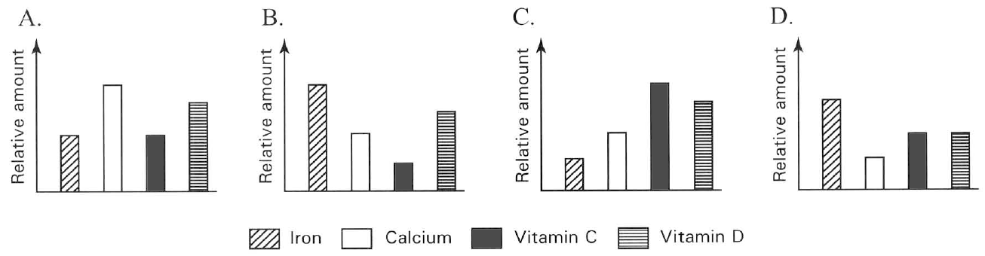
Food (100 g) | Proteins (g) | Calcium (mg) | Iron (mg) | Vitamin A (IU) | Vitamin C (mg)
Bananas | 1.09 | 5 | 0.26 | 64 | 8.7
Green peas | 5.42 | 23 | 1.47 | 765 | 40
Carrot | 0.93 | 33 | 0.30 | 16 705 | 5.9
Bell peppers | 0.99 | 7 | 0.43 | 3 131 | 127.7
Orange | 0.94 | 40 | 0.10 | 225 | 53.2
Kiwi fruits | 1.00 | 34 | 0.31 | 87 | 92.7

A. Potato, eggs and liver B. Milk, cheese and peanuts
C. Orange, lemons and tomatoes D. Carrot, fish and pork Directions: Questions 10.15 to 10.17 refer to the following bar charts that show the persons taking different diets. C10.15 Which person is least likely to suffer from scurvy? A10.16 Which person is least likely to suffer from rickets? C10.17 Which person is most likely to suffer from anaemia? Directions: Questions 10.18 to 10.22 refer to the following table which lists the amount of proteins, some minerals and vitamins in six different foods:
78. Which food is most important to prevent both rickets and night blindness?
A. Carrot B. Bell peppers C. Kiwi fruits D. Bananas
79. Which food is important both for growth and to prevent scurvy?
A. Bananas B. Green peas C. Carrot D. Orange
80. Which food component will lose its function if the bell peppers are well cooked before consumption?
A. Calcium B. Iron C. Vitamin A D. Vitamin C
81. A vegetarian may be short of proteins in his diet. Which vegetables listed above is recommended to be included in his diet?
A. Green peas B. Carrot C. Bell peppers D. Orange
82. Why a diet mainly composed of the vegetables listed above is helpful to reduce weight of the obese people?
(1) It is mainly composed of the indigestible cellulose in the plant fibres.
(2) It has very low fat content.
(3) It increases the bulk of food that quickly gives the sense of fullness to reduce the appetite to eat.
 | Food | Water(g) | Protein(g) | Fat(g) | Carbohydrate(g) | Calcium(mg) | Iron(g)
A. | Rice (Cooked) | 74 | 2.2 | 0.1 | 23 | 8 | 0.2
B. | Peanuts | 5 | 30.0 | 46.0 | 18 | 74 | 1.9
C. | Egg | 74 | 12.9 | 11.5 | 0.7 | 54 | 2.7
D. | Fish | 82 | 16.5 | 0.4 | - | 18 | 0.9

A. (1) only B. (2) only C. (3) only D. (2) and (3) only Directions: Questions 10.23 to 10.25 refer to the table below which shows the percentage composition by weight of 100 g edible portion of each of the following food. B10.23 In under-developed countries children easily have the disease of 'kwashiorkor'. Which of the above food provides a cheap source of sufficient nutrients to reduce the risk of this disease? **C10.24 Which of the above food has no dietary fibre and provides very rich nutrients for a pregnant or breast-feeding woman? D10.25 Which of the above food has the lowest energy content?
83. Which of the following structures in humans can produce vitamins?
(1) Pancreas (2) Liver (3) Skin
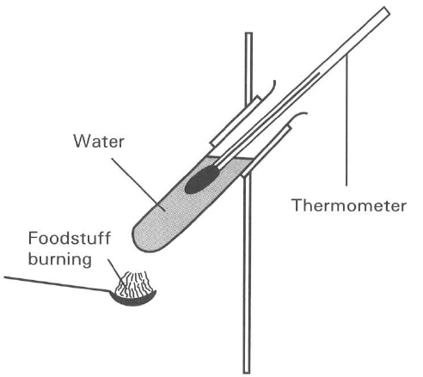
Dietary Requirement | Average man | A | B | C | D
Energy(kAg-1day-1) | 2700 | 800 | 1500 | 2300 | 2500
Protein (g) | 90 | 30 | 58 | 75 | 83
Iron (mg) | 10 | 5 | 10 | 10 | 12.5
Calcium (g) | 0.7 | 0.9 | 0.7 | 0.7 | 1.4

A. (1) only B. (2) only C. (3) only D. (1) and (2) only Directions: Questions 10.27 to 10.29 refer to the dietary requirements of an average man and four other persons. A10.27 Which person represents the dietary requirement of an infant of 9 months old? C10.28 Which person represents the dietary requirement of a normal average woman? D10.29 Which person represents the dietary requirement of a pregnant woman? **D10.30 The relative heat loss per unit skin surface area of a boy is greater than that of a man. Which of the following explanations is FALSE?
A. The boy is at the stage of active growth while the man has reached maturity.
B. The average amount of energy per body weight needed by a boy is greater than that needed by a man.
C. The basal metabolic rate of a boy is higher than that of a man.
D. More physiological activities are taking place inside a boy than that in a man. Directions: Questions 10.31 and 10.32 refer to the diagram below which shows a simple calorimeter used to estimate the energy value of foodstuff.
84. Which of the following foodstuff releases the greatest amount of energy?
A. Pea nuts B. Butter C. Honey D. Bread
85. Which of the following are the possible causes of errors in finding the energy value of the foodstuff by using the simple calorimeter? (1) The effect of wind around the boiling tube. (2) Not all the heat released from the burning food is completely absorbed by the water in the boiling tube. (3) The foodstuff may not burn completely.
A. (1) only
B. (2) only
C. (1) and (3) only
D. (1), (2) and (3)
86. A balanced diet helps to prevent
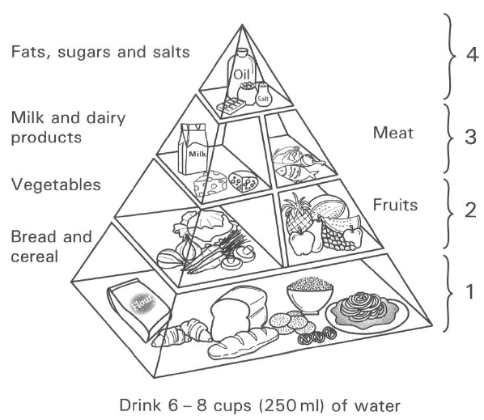
A. SARS. B. osteoporosis. C. colour-blindness. D. haemophilia. Directions: Questions 10.34 and 10.35 refer to the diagram below which shows a food pyramid.
87. If a person takes diet mainly composed of food in levels 3 and 4 only for a long period of time, what will be the health risks to him?" (1) Osteoporosis (2) Cardiovascular diseases (3) Constipation (4) Haemophilia
A. (1) and (2) only
B. (2) and (3) only
C. (3) and (4) only
D. (1) and (3) only
88. Which of the following food substances are not present in the food in level 3?
A. Vitamins B. Lipids C. Proteins D. Dietary fibres
89. A balanced diet is essential for the normal healthy growth of humans because it (1) prevents the occurrence of constipation. (2) provides sufficient energy to support the metabolic activities. (3) provides adequate substances for the proper development of the body. (4) promotes the removal of the nitrogenous wastes from the body.
A. (2) only
B. (3) only
C. (1), (2) and (3) only
D. (2), (3) and (4) only
90. Which of the following are NOT included in the balanced diet of humans? (1) Water (2) Hormones (3) Dietary fibres (4) Vitamines (5) Carbohydrates (6) Auxin
A. (1) and (3) only
B. (2) and (6) only
C. (3) and (5) only
D. (1), (4) and (6) only
91. Milk is an ideal balanced diet for young children. But it alone is an unsuitable diet for adults because it lacks (1) proteins. (2) iron. (3) vitamin C. (4) dietary fibres. (5) lipids. (6) vitamin D
A. (1), (3) and (4) only
B. (1), (2) and (6) only
C. (2), (3) and (4) only
D. (2), (5) and (6) only
92. Which of the following are health risks to an obese person? (1) Diabetes (2) Bone cancer (3) Stroke (4) Heart diseases
A. (1) and (2) only
B. (2) and (3) only
C. (1), (3) and (4) only
D. (2), (3) and (4) only
93. The percentage of primary school students in Hong Kong found to be overweight increased by 5% from 2005 to 2010. Which of the following are the reasons for such increase? (1) More students are lack of physical exercises. (2) More students are lack of dietary fibres in their diet. (3) More students have excessive intake of fatty and starchy food.
A. (1) and (2) only
B. (2) and (3) only
C. (1) and (3) only
D. (1), (2) and (3)
94. An obese person is advised to eat beans rather than meat for the intake of proteins because beans contain
A. more mineral salts.
B. more vitamins.
C. less fats.
D. less carbohydrates.
95. Which of the following diets are responsible for causing obesity and constipation?
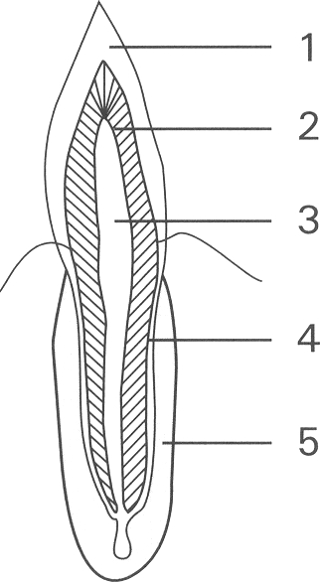
 | Obesity | Constipation
A. | High fibre diet | Low calorie diet
B. | Low fibre diet | High calorie diet
C. | High calorie diet | Low fibre diet
D. | Low calorie diet | High fibre diet

B. Ingestion Directions: Questions 10.43 to 10.48 refer to the diagram below which represents the vertical section through a tooth.
96. | 2 | 3 | 4 | 5 | A. | Enamel | Pulp cavity | Dentine | Cement | Jaw bone | B. | Cement | Dentine | Jaw bone | Enamel | Pulp cavity | C. | Enamel | Dentine | Pulp cavity | Cement | Jaw bone | D. | Cement | Pulp cavity | Enamel | Jaw bone | Dentine
97. Which of the labelled structure is the hardest one?
A. 1
B. 2
C. 3
D. 4
98. The part of the tooth where blood vessels and nerve fibres are found is
A. 1
B. 2
C. 3
D. 4
99. The tooth will be loosened when bacterial infection occurs in
A. 1
B. 2
C. 3
D. 4
100. Which of the following parts will be affected upon the deficiency of calcium salts and vitamin D?
A. (1) and (2) only
B. (2) and (3) only
C. (1), (2) and (3) only
D. (1), (2) and (5) only
101. The tooth shown in the diagram is
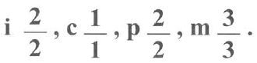
A. a molar. B. a canine. C. a premolar. D. a carnassial tooth. Directions: Questions 10.49 to 10.51 refer to the diagram below which shows the skull of an adult man. The dental formula of this
102. What is the total number of teeth present in this skull?
A. 16
B. 20
C. 28
D. 32
103. What should be the number of teeth possessed by this person when he was five years old?
A. 10
B. 20
C. 30
D. 32
104. 51Which of the following labelled teeth are absent in the milk dentition?
A. 3 and 4 only
B. 4 and 5 only
C. 4, 5 and 8 only
D. 6, 7 and 8 only
105. A canine differs from a molar in the former (1) having a sharp and pointed top. (2) having blood vessels and nerve endings in the pulp cavity. (3) having one root only. (4) having a flattened, grinding surface.
A. (1) only
B. (1) and (3) only
C. (2) and (4) only
D. (1), (2) and (3) only
106. Which of the following comparisons between milk dentition and permanent dentition is INCORRECT?
 | Milk dentition | Permanent dentition
A. | Less teeth | More teeth
B. | Smaller teeth | Bigger teeth
C. | Will have tooth decay | Will not have tooth decay
D. | No premolars | Has premolars

107. Which of the comparisons between the milk dentition and the permanent dentition of humans is /are CORRECT?
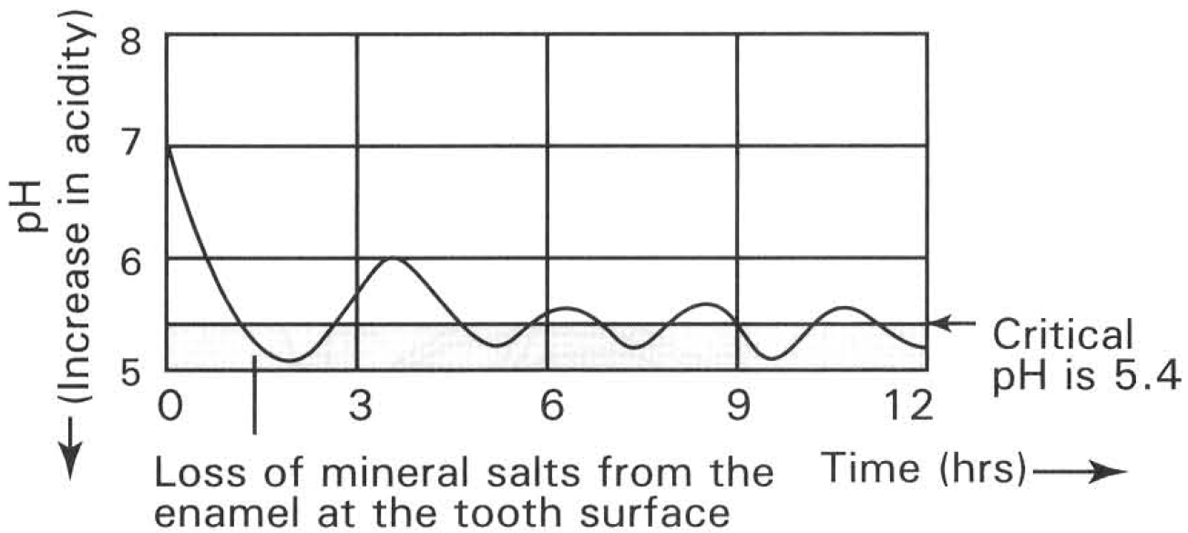
 | Milk dentition | Permanent dentition
(1) | Smaller number of teeth | Greater number of teeth
(2) | Canines not yet developed | Canines well developed
(3) | Last in children only | Never fall in adulthood
(4) | Specialized for babies to take milk | Specialized for adults to eat solid food

A. (1) only B. (1) and (2) only C. (2) and (3) only D. (3) and (4) only Directions: Questions 10.55 to 10.58 refer to the graph below which shows the effect of frequent eating to the change of pH inside the mouth cavity
108. The change in pH during the first 2 hrs is most likely caused by
A. the decomposition of the starchy food debris by bacteria.
B. the hydrolysis of the starchy food lodged in the crevices between teeth.
C. the secretion of saliva from the digestive glands around the mouth cavity.
D. the dissolution of mineral salts from the enamel of the teeth.
109. Calcium salts are dissolved from the tooth as a result of the reaction between the enamel and
A. the enzymes present in the saliva.
B. the alkaline component of the saliva.
C. the acidic wastes released from the reaction between the food debris and the bacteria.
D. the direct action of the sugary food on the enamel of the teeth.
110. Which of the following statements about critical pH is CORRECT?
A. It is the pH below which tooth decay occurs.
B. It is the pH for the growth of the teeth.
C. It is the optimum pH for enzymes inside the saliva to function.
D. It is the optimum pH for the growth of bacteria inside the plaque.
111. Taking snacks frequently will increase the risk of tooth decay because
(1) snacks are mostly composed of sugar that is easily decomposed by bacteria to form acidic wastes.
(2) there is insufficient time for the saliva to neutralize the acidic condition inside the mouth cavity.
(3) snacks increase the chance for plaque to be digested on the tooth surface.
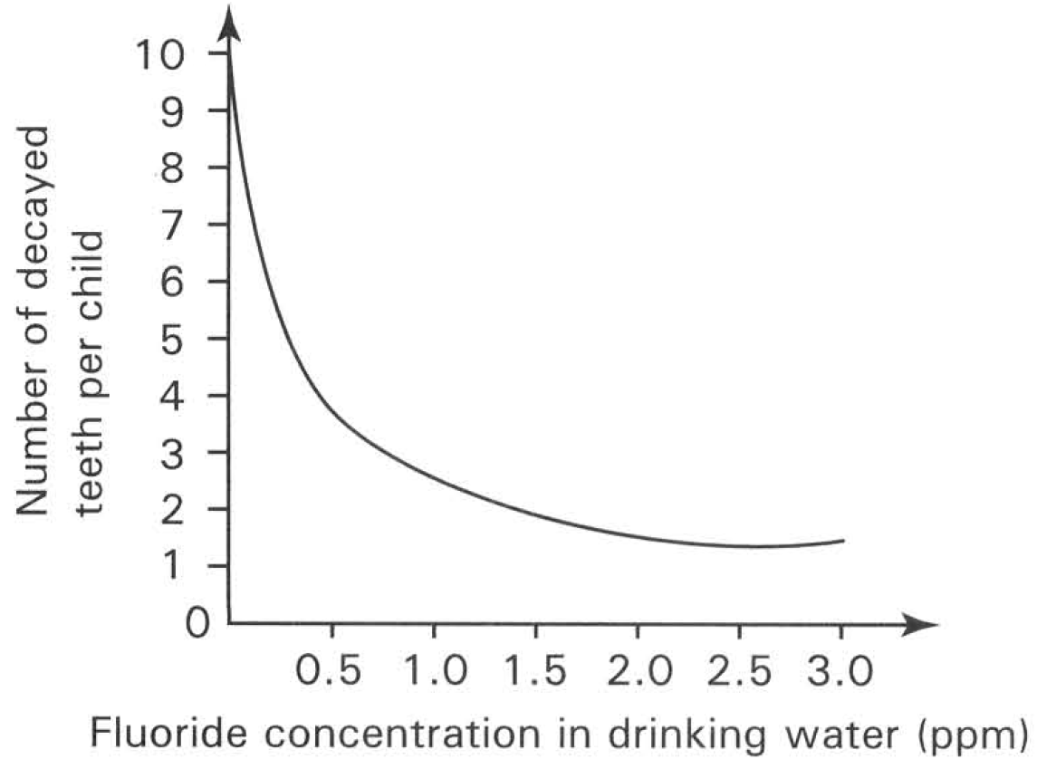
A. (1) only B. (2) only C. (1) and (2) only D. (1), (2) and (3) Directions: Questions 10.59 and 10.60 refer to the graph below which shows the relationship between the relative number of decayed teeth per child and the fluoride concentration in drinking water in ppm. 3
112. Which of the following conclusions CAN be drawn from the graph?
A. The number of decayed teeth decreases rapidly as the concentration of fluoride in drnking water increases.
B. A child will have no decayed teeth if he has been drinking water with very high fluoride concentration.
C. A child will have about two decayed teeth if he has been drinking water added with fluoride.
D. Drinking water added with fluoride cannot completely remove tooth decay from a child.
113. Increasing the fluoride concentration from 2.0 ppm to 3.0 ppm will
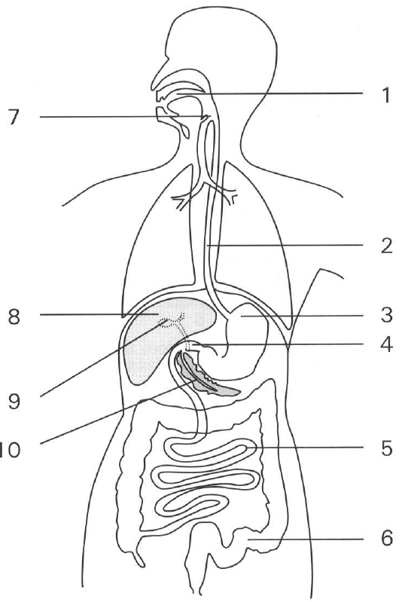
A. remove the risk of tooth decay completely.
B. reduce the risk of tooth decay by 40%.
C. reduce the risk of tooth decay by 80%.
D. not reduce the risk of tooth decay any further.
C. Digestive system and digestion Directions: Questions 10.62 to 10.73 refer to the diagram below which shows the digestive system of humans.
114. Which of the following is the most effective measure in preventing tooth decay?
A. Check the teeth by dentist once a year.
B. Do not eat any starchy food or drink any juices with sugar content.
C. Brush the teeth after each meal.
D. Brush the teeth harder with large amount of toothpaste in the morning.
115. Which of the labelled parts secrete mucus?
A. 1 and 2 only B. 3 and 5 only C. 5 and 6 only D. All of the above
116. The function of the structure labelled 7 is
A. to prevent food passing into the trachea.
B. to prevent air passing into the oesopnagus.
C. to prevent food regurgitating into the nasal cavities.
D. to filter air passing into the trachea.
117. Digestive enzymes are released from
A. 3 and 4 only.
B. 5 and 6 only.
C. 8 and 9 only.
D. 3, 4 and 5 only.
118. Digestion of starch mainly takes place in
A. 1 and 3 only.
B. 3 and 4 only.
C. 5 and 6 only.
D. 1, 4 and 5 only.
119. Digestion of protein takes place in
A. 1 and 2 only.
B. 3 and 4 only.
C. 3 and 5 only.
D. 3, 4 and 5 only.
120. Emulsification of fats mainly depends on the secretion produced by
A. 3 only.
B. 4 only.
C. 8 only.
D. 9 only.
121. The effect of removing the part labelled 9 is that
A. no more bile is produced.
B. no fat can be emulsified.
C. no fat can be digested.
D. no control can be exerted on the release of bile.
122. Mechanical digestion of food takes place in
A. 1 only.
B. 3 only.
C. 6 only.
D. 1 and 3 only.
123. Which of the following structures can produce both digestive juices and hormone?
A. 2
B. 8
C. 9
D. 10
124. 71If the part labelled 10 is damaged, human will suffer (1) diabetes. (2) constipation. (3) poor digestion.
A. (1) only.
B. (2) only.
C. (3) only.
D. (1) and (3) only.
125. The main function of the structure labelled 6 is
A. the storage of faeces.
B. the storage of food reserves.
C. the absorption of water.
D. the absorption of minerals.
126. Which labelled part absorbs most water from the substances moving along them?
A. 2
B. 3
C. 5
D. 6
127. Food passes through the alimentary canal in the following order:
A. mouth, oesophagus, duodenum, stomach, ileum, rectum, colon and anus.
B. mouth, oesophagus, stomach, ileum, colon, duodenum, rectum and anus.
C. mouth, oesophagus, stomach, duodenum, colon, ileum, rectum and anus.
D. mouth, oesophagus, stomach, duodenum, ileum, colon, rectum and anus.
128. Which of the following glands are located outside the alimentary canal? (1) Gastric gland (2) Liver (3) Pancreas (4) Salivary gland
A. (1) only
B. (2) only
C. (2) and (3) only
D. (2), (3) and (4) only
129. Which of the following combinations shows the correct pH values of the fluids in the various organs concerned?
 | Mouth cavity | Stomach | Duodenum
A. | 7 | 9 | 2
B. | 9 | 2 | 7
C. | 2 | 9 | 7
D. | 7 | 2 | 9

130. The rhythmic movement taking place along the intestine of human is known as
A. dialysis.
B. peristalsis.
C. cardiac rhythm.
D. respiratory rhythm.
131. Which of the following is/are function(s) of peristalsis?
(1) Mixing food contents and digestive juices more thoroughly.
(2) Pushing faeces forward along the rectum.
(3) Churning the stomach contents into smaller pieces.
(4) Conveying food along the oesophagus during swallowing.
(5) Squeezing food substances forward along the small intestine.
A. (4) only B. (5) only C. (1), (3) and (5) only D. All of the above
132. In which of the following organs does peristalsis occur? (1) oesophagus (2) liver (3) stomach (4) pancreas (5) duodenum (6) rectum
A. (1) and (6) only
B. (2) and (5) only
C. (1), (2), (3) and (6) only
D. (1), (3), (5) and (6) only
133. Which of the following is NOT an action taking place in the stomach of humans?
A. Digesting protein into smaller fragments.
B. Changing the soluble proteins in milk into an insoluble form.
C. Killing some of the germs in the food entering the stomach.
D. Emulsifying oil.
134. Hydrochloric acid is an important component of gastric juice. Hydrochloric acid serves to (1) inhibit the growth of bacteria in the stomach. (2) reduce the surface tension of oil so that oil breaks into small oil droplets. (3) activate the action of amylase. (4) provide an optimum pH condition for the proteolytic enzymes to act.
A. (1) only
B. (2) only
C. (1) and (4) only
D. (2) and (3) only
135. Which of the following are the functions of the mucous epithelium lined at the inner surface of the stomach wall? (1) Secretes mucus to protect the stomach wall from the eroding action of the gastric juice. (2) Provides acid to kill the germs present in food. (3) Provides proteases to digest protein.
A. (1) and (2) only
B. (2) and (3) only
C. (1) and (3) only
D. (1), (2) and (3)
136. Which of the following is/are the CORRECT function(s) of bile? (1) Neutralizes chime (2) Makes chyme acidic (3) Hydrolyses fat (4) Emulsifies fat
A. (1) only
B. (2) only
C. (3) only
D. (1) and (4) only
137. A patient is found to have gall stones formed in his gall bladder and blocked his bile duct. Which of the following is most UNLIKELY to occur?
A. No more bile is produced.
B. His faeces become greyish white in colour.
C. The pancreatic juice flows normally into the duodenum.
D. The digestion of fat becomes very difficult.
138. Which of the following diets is unsuitable for a person who cannot secrete enough bile for his daily use?
A. Rice
B. Spinach
C. Lean meat
D. Margarine
139. Which of the following concerning the emulsification of oil in the alimentary canal of humans is/are INCORRECT? (1) Emulsification of oil in the duodenum is not a digestive process because enzymes are not involved. (2) Emulsification of oil is brought about by the lipase present in the pancreatic juice. (3) Emulsification of oil takes place inside the gall bladder.
A. (1) only
B. (2) only
C. (1) and (3) only
D. (1), (2) and (3)
140. Bile is a digestive juice of humans. Which of the following statements about bile is CORRECT?
A. It is responsible for the digestion of fat into fatty acids and glycerol.
B. No more bile is produced once the gall bladder is removed by surgery from the body.
C. Bile is important to maintain the alkaline condition in the duodenum to enhance digestive processes to take place there.
D. The enzyme in bile is responsible to increase the surface area of oil in the small intestine to enhance chemical digestion.
141. Which of the following are important for the complete digestion of fats in humans? (1) Production of bile by the liver. (2) Secretion of lipase by the pancreas. (3) Presence of numerous villi in the small intestine. (4) Presence of lacteal in the villi of the small intestine.
A. (1) and (2) only
B. (2) and (3) only
C. (3) and (4) only
D. (1) and (4) only
142. Apart from producing gastric juice, the stomach wall also secretes mucus which (1) dissolves oxygen gas to enhance its diffusion into the cells of the stomach wall. (2) lubricates the churning of food in the stomach to reduce the mechanical damage of the stomach wall. (3) forms a protective layer to prevent the digestive action of the gastric juice from eroding the stomach wall.
A. (1) only
B. (2) only
C. (1) and (2) only
D. (2) and (3) only
143. Which of the following statements about the pancreas/pancreatic juice is INCORRECT?
A. Pancreatic juice helps neutralize the acidic chyme from the stomach.
B. Pancreatic juice containing enzymes for the digestion of carbohydrates, fats and proteins.
C. The pancreas contains an endocrine structure.
D. The pancreas secretes hormone which passes down the pancreatic duct into the duodenum. Directions: Questions 10.91 to 10.94 refer to the diagram below which shows the extend of digestion of three types of food substances 1 , 2 and 3 along the alimentary canal of humans:
144. Which of the following identity of the food substances is CORRECT?
145. | 2 | 3 |
A. | Proteins | Lipids | Starch |
B. | Starch | Proteins | Lipids |
C. | Lipids | Starch | Proteins |
D. | Starch | Lipids | Proteins
146. Which labelled food substance is the last one to start its digestion in the alimentary canal?
A. 1 only
B. 2 only
C. 3 only
D. 1 and 3 only
147. Which of the following digestive juices(s) is/are important for the food substances suggested in the previous question to complete its digestion? (1) Gastric juice (2) Pancreatic juice (3) Bile
A. (1) only
B. (2) only
C. (3) only
D. (2) and (3) only
148. Which food substances can be digested in both acidic and alkaline conditions in the alimentary canal?
A. 1 only
B. 2 only
C. 3 only
D. 2 and 3 only
149. 95Dialysis is the process to separate
A. water molecules and mineral salts through a selectively permeable membrane.
B. glucose molecules and starch molecules through a selectively permeable membrane.
C. plasma and white blood cells through the thin capillary wall.
D. amino acids and fatty acids through a selectively permeable membrane. Directions: Questions 10.96 to 10.102 refer to the diagram below which shows the set-up of an experiment.
150. After 45 minutes, two samples of distilled water are removed from the boiling tube and are subjected to Benedict's Test and Iodine Test respectively. Which of the following is the CORRECT result?
 | Benedict's test | Iodine test
A. | Blue | Bule black
B. | Red precipitate | Pale brown
C. | Red precipitate | Blue black
D. | Blue | Pale brown

151. According to the result of the above experiment the substance(s) that appeared in the distilled water is/are
A. glucose.
B. starch.
C. reducing sugar.
D. starch and reducing sugar.
152. The distilled water in the boiling tube represents
A. the water component of saliva.
B. the body fluid in the abdominal cavity.
C. the blood flowing into the villi of the small intestine.
D. digestive juices in the small intestine.
153. Which of the following conclusions CANNOT be drawn from the experiment? (1) Starch molecules are too big to pass through the dialysis tubing. (2) Protein molecules in saliva are too big to pass ghrough the dialysis tubing. (3) Reducing sugars are small enough to pass through the dialysis tubing.
A. (1) only
B. (2) only
C. (3) only
D. (1) and (3) only
154. The above experiment demonstrates the (1) process of osmosis in the large intestine. (2) absorption of simple molecules in the small intestine. (3) effect of temperature on enzymatic reaction. (4) hydrolysis of starch in the buccal cavity.
A. (1) only
B. (2) only
C. (3) only
D. (2) and (4) only
155. Which of the following are the appropriate controls of this experiment? (1) Keeping the water bath at 30°C. (2) Using a PVC tubing instead of the dialysis tubing. (3) Using tap water instead of distilled water. (4) Boiling the saliva first before it is added to the dialysis tubing.
A. (1) and (2) only
B. (1) and (3) only
C. (2) and (3) only
D. (2) and (4) only
156. Which of the following is an essential precaution to this experiment?
A. Frequently and thoroughly shake the contents of the dialysis tubing.
B. Vigorously stir the distilled water in the boiling tube.
C. Rinse the outside of the dialysis tubing with water before putting it in the boiling tube.
D. Put the boiling tube in a water bath kept at 37°C.
157. Which of the following processes require enzymes?
(1) Hydrolysis of protein to form amino acids
(2) Digestion of fat to form glycerol and fatty acids
(3) Oxidation of sugar to form carbon dioxide and water
(4) Emulsification of oil to form oil droplets
(5) Absorption of water by osmosis into the blood capillaries of the small intestine
A. (1) and (2) only B. (2) and (4) only
C. (1), (3) and (5) only D. (1), (2) and (3) only Directions: Questions 10.104 to 10.107 refer to the diagram below which shows an experimental set-up to illustrate enzymatic reaction.
158. After the tubes have been kept at 37°C for 6 hours, which tube shows sign of digestion?
A. (1) only
B. (2) only
C. (3) only
D. (4) only
159. Which of the following tests is used to show that the digestion of the potato has occurred?
A. Spot test B. Albustix paper test C. Emulsion test D. Benedict's test
160. If the potato cube is replaced by a small piece of boiled egg white, in which test(s) will the boiled egg white disappear?
A. (1) only
B. (2) only
C. (2) and (4) only
D. (1) and (3) only
161. Which of the following conclusions CANNOT be drawn from the above experiments using both potato cube and boiled egg white? (1) Bile has no enzyme. (2) Enzyme can only act in one specific pH value. (3) Each of the above digestive juices contains one enzyme only.
A. (1) only
B. (2) only
C. (1) and (2) only
D. (1) and (3) only
162. Macromolecules are completely digested into simple molecules in the small intestine of humans. Which of the following matching is CORRECT?
 | Macromolecules | Final end products
A. | Fat | Fatty acids and glycerol
B. | Starch | Maltose
C. | Protein | Peptides
D. | Cane sugar | Amylase

D. Absorption Directions: Questions 10.109 to 10.114 refer to the photomicrograph below which shows the transverse section of part of the alimentary canal.
163. The section illustrated is taken from the
A. oesophagus.
B. stomach.
C. ileum.
D. caecum.
164. The part labelled X is
A. villus.
B. hair.
C. intestinal gland.
D. pancreas.
165. The part labelled Y is
A. blood capillary.
B. lacteal.
C. hepatic portal vein.
D. intestinal gland.
166. Which of the following substances are present in Y?
A. Fat and fatty acids.
B. Large amount of glucose after taking a starchy meal.
C. Large amount of urea after taking a meal composed of beef only.
D. Glycogen.
167. The part labelled X is adapted for
A. releasing more bile.
B. moving the ovum along the oviduct.
C. absorbing more digested food.
D. reabsorbing more glucose and amino acids from the lumen of the kidney tubules.
168. Through which of the following organs will the glucose and amino acids absorbed in X be transported to the heart?
A. pancreas B. spleen C. liver D. lungs Directions: Questions 10.115 to 10.118 refer to the diagram below which shows the transverse section (T.S.) of the villus of the small intestine
169. Which part(s) of the diagram will turn milky after a person has taken a fatty meal?
A. X only
B. Y only
C. Z only
D. Y and Z only
170. Which of the following combinations TRULY represent the substances transported by them?
 | Y | Z
A. | Fat | Amino acid
B. | Glucose | Protein
C. | Vitamin C | Vitamin D
D. | Glycerol | Glucose

171. Which of the following sub-cellular structures is/are adaptation(s) of cell X to carry out its functions effectively? (1) Microvillus (2) Numerous mitochondria (3) Numerous capillaries
A. (1) only
B. (2) only
C. (1) and (2) only
D. (1) and (3) only
172. Which of the following TRULY represent the first organ to receive the absorbed substances from Y and Z respectively ?
 | From Y | From Z
A. | Heart | Liver
B. | Kidneys | Pancreas
C. | Liver | Heart
D. | Pancreas | Kidneys

173. Which of the following food substances is/are absorbed directly by the small intestine without breaking down by enzymes? (1) Cane sugar (2) Vitamin A (3) Nucleic acids
A. (1) only
B. (2) only
C. (1) and (2) only
D. (2) and (3) only
174. More than 90% of water is absorbed by the small intestine because the small intestine (1) is very long with folded mucosa that bears numerous villi. (2) has rich supply of capillaries. (3) has absorbed most digested food that decreases the water potential of the blood present inside the villi.
A. (1) only
B. (1) and (2) only
C. (2) and (3) only
D. (1), (2) and (3)
175. Most mineral salts are absorbed in the
A. stomach.
B. small intestine.
C. colon.
D. rectum.
176. Which of the following surgical operation is/are helpful for an obese person to reduce body weight?
(1) Use an adjustable silicone band to constrict the upper part of the stomach to create a small pouch. This pouch can easily be filled up with food to give a sense of fullness.
(2) Cutting the stomach unequally to form a upper small pouch which is joined by a bypass directly to the ileum.
(3) Remove a length of small intestine.
(4) Remove a length of large intestine.
A. (1) and (2) only B. (2) and (3) only C. (3) and (4) only D. (1), (2) and (3) only E. Assimilation
177. Liver is a gland having digestive function because it
A. breaks down the excess amino acids to urea for excretion.
B. produces bile that has emulsifying action on fat.
C. changes the stored glycogen into glucose.
D. changes harmful substances into harmless forms.
178. Liver is the metabolic centre which produces many substances for excretion out of the body. These substances are
(1) bile pigment. (2) carbon dioxide. (3) sodium hydrogencarbonate in bile.
(4) urea. (5) iron.
A. (1) And (2) only B. (2) And (3) only C. (3) And (5) only D. (1), (2) and (4) only
179. The liver of the human body converts the excess amino acids to (1) protein for storage. (2) urea for excretion. (3) carbohydrates for energy reserve.
A. (1) only
B. (2) only
C. (3) only
D. (2) and (3) only
180. Which of the following are TRUE functions of the liver? (1) Deamination of amino acids (2) Detoxication of toxic substances (3) Storage of excess sugar in form of starch (4) Production of bile (5) Production of white blood cells (6) Synthesis of vitamin D
A. (1), (3) and (5) only
B. (2), (4) and (6) only
C. (1), (2) and (4) only
D. (3), (5) and (6) only
181. Which of the following comparisons between the blood contents of the hepatic vein and the hepatic portal vein are CORRECT?
 | Hepatic vein | Hepatic portal vein
(1) | More oxygen | Less oxygen
(2) | Less wastes | More wastes
(3) | More urea | Less urea
(4) | Less glucose | More glucose
(5) | Less carbon | More carbon
 | dioxide | dioxide

A. (1) and (2) only
B. (3) and (5) only
C. (3) and (4) only
D. (2), (4) and (5) only
182. When a man is in starvation, the food reserve he first used will be the
A. fatty cells. B. liver glycogen. C. plasma protein. D. contractile protein. Directions: Questions 10.129 to 10.132 refer to the diagram below which shows the liver, a part of the small intestine and the associated blood vessels in a mammal:
183. Which of the following matching of the names of the blood vessels and ducts are CORRECT?
 | Aorta | Hepatic artery | Hepatic vein | Hepatic portal vein | Posterior vena cava | Bile duct
A. | J | K | L | M | P | N
B. | J | Q | P | M | O | N
C. | N | Q | P | K | J | M
D. | N | O | K | P | J | M

184. Which of the following shows the CORRECT blood flow in this region?
A. JKMQN
B. JKPQN
C. NQPKJ
D. N QPMK
185. Which of the follwing groups of labelled structures carry the right digestive juices or hormones?
 | M | P
A. | Pancreatic juice | Insulin
B. | Bile | Pancreatic juice
C. | Insulin | Intestinal juice
D. | Bile | Insulin

186. Which blood vessles carry blood with the highest concentration of the following substances?
 | Carbon dioxide | Glucose after a meal | Oxygen | Urea
A. | Q | P | O | M
B. | K | P | N | K
C. | J | K | O | M
D. | M | K | Q | O

187. Which of the following curves best represents the change in the glucose level of blood flowing through the following organs of a man who has starved for eight hours?
Directions: Questions 10.134 and 10.135 refer to the graph below which shows the rate of consuming the food reserve in the body of a human during starvation.
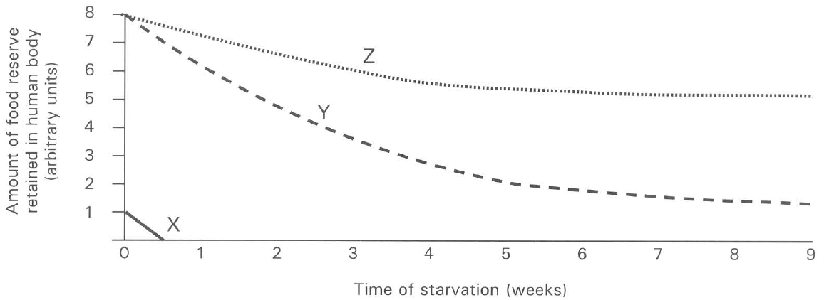
188. Which of the following identity of the food reserves is CORRECT?
 | X | Y | Z
A. | Glycogen | Proteins | Lipids
B. | Proteins | Lipids | Glycogen
C. | Lipids | Glycogen | Proteins
D. | Glycogen | Lipids | Proteins

189. Which of the following are the CORRECT locations inside the human body that store these food reserves?
F. Egestion
 | X | Y | Z
A. | Beneath the skin | Around the heart and kidneys | Liver
B. | Liver | Beneath the skin | Muscles
C. | Muscles | Pancreas | Liver
D. | Muscles | Liver | Bones

190. Which of the following are normal components of the faeces of a healthy young woman? (1) Red blood cells (2) Urea (3) Epithelial cells of gut (4) Mucus (5) Bile pigments (6) Bacteria
A. (1) and (2) only
B. (2), (3) and (4) only
C. (1), (5) and (6) only
D. (3), (4), (5) and (6) only
191. Which of the following comparisons between small intestine and large intestine is INCORRECT?
 | Small intestine | Large intestine
A. | Longer length | Shorter length
B. | Has villi | No villi
C. | Has digestive activities taking place | No digestive activities
D. | Small amount of water is absorbed | Water is mainly absorbed there

192. Which of the following concerning large intestine is INCORRECT?
A. It absorbs water from the food mass passing along it.
B. Constipation occurs under long term shortage of dietary fibres in the diet.
C. It stores faeces.
D. It stores glycogen.
193. Which of the following is NOT a function of the large intestine?
A. Absorption of water from the undigested food.
B. Digestion of protein.
C. Storing the undigested materials before they are egested.
D. Absorption of minerals. Suggested Solutions

Answers
Answers are printed in red.
1. ?

2. ?

3. D. (1), (2) and (3)
Class: 70.4% correct (n=476) usual slip D
4. D. (1), (2) and (3)
Class: 72.2% correct (n=475) usual slip C
5. ?

6. B. do not digest food.
Class: 73.3% correct (n=476) usual slip A
7. B. the food there has been digested by the host.
Class: 71.0% correct (n=476) usual slip A
8. D. body surface.
Class: 79.9% correct (n=482) usual slip A
9. B. (1) and (3) only
Class: 67.7% correct (n=427) usual slip B
10. ?

11. B
Class: 68.3% correct (n=426) usual slip B
12. ?

13. ?

14. ?

15. C. 3, 4 and 5 only
Class: 63.2% correct (n=318) usual slip C
16. C. 3, 4 and 5 only
Class: 69.9% correct (n=249) usual slip A
17. C
Class: 63.2% correct (n=201) usual slip A
18. ?

19. ?

20. ?

21. ?

22. ?

23. B. It contains alkaline substances to neutralise the acid released from bacterial activity.
Class: 72.6% correct (n=106) usual slip B
24. C
Class: 68.3% correct (n=104) usual slip D
25. D
Class: 77.9% correct (n=104) usual slip C
26. ?

27. B. (1), (2) and (4) only
Class: 61.5% correct (n=104) usual slip C
28. C. (1), (2) and (3) only
Class: 78.8% correct (n=104) usual slip A
29. C. (1), (3) and (4) only
Class: 76.0% correct (n=104) usual slip A
30. A. mouth.
Class: 79.8% correct (n=104) usual slip B
31. ?

32. ?

33. ?

34. ?

35. ?

36. ?

37. ?

38. ?

39. ?

40. ?

41. ?

42. ?

43. D. His faeces will become watery.
Class: 91.1% correct (n=56) usual slip A
44. ?

45. ?

46. ?

47. ?

48. ?

49. ?

50. ?

51. ?

52. ?

53. ?

54. ?

55. ?

56. ?

57. ?

58. ?

59. ?

60. ?

61. ?

62. ?

63. ?

64. A

65. D. Calcium, phosphate, vitamin D and fluoride
Class: 66.0% correct (n=156) usual slip B
66. A. (1) and (2) only

67. A. (1) and (2) only

68. C. (2) and (4) only
Class: 88.5% correct (n=87) usual slip A
69. A. (1) and (2) only

70. A. (1) onlyB. (2) only C. (1) and (3) only D. (3) and (4) only Directions: Questions 10.8 to 10.10 refer to the following experiment. A litter of rats was divided into two groups. Group A was fed with synthetic diet (sugar, starch, purified proteins, mineral salts and water). Group B was fed with the same synthetic diet and with a milk supplement. After 18 days, the diets taken by groups A and B rats were exchanged. The average mass of these rats was recorded and shown in the graph below:

71. A. Carbohydrates, proteins, mineral salts and water are essential for the healthy growth of rats.

72. A. The genetic variations between the rats are kept to the minimum.

73. A. (1) and (2) only B. (2) and (3) only C. (3) and (4) only D. (2), (3) and (4) only Directions: Questions 10.11 to 10.13 refer to the table below which shows the result of an experiment using the reagent DCPIP (dichloro-phenol-indophenol):

74. A

75. A. Y, Z, W, X
Class: 85.6% correct (n=111) usual slip C
76. C. Y

77. C. Orange, lemons and tomatoes D. Carrot, fish and pork Directions: Questions 10.15 to 10.17 refer to the following bar charts that show the persons taking different diets. C10.15 Which person is least likely to suffer from scurvy? A10.16 Which person is least likely to suffer from rickets? C10.17 Which person is most likely to suffer from anaemia? Directions: Questions 10.18 to 10.22 refer to the following table which lists the amount of proteins, some minerals and vitamins in six different foods:
Class: 79.4% correct (n=63) usual slip A
78. A. Carrot B. Bell peppers C. Kiwi fruits D. Bananas

79. B

80. D
Class: 87.7% correct (n=106) usual slip A
81. A. Green peas B. Carrot C. Bell peppers D. Orange
Class: 87.9% correct (n=58) usual slip B
82. D
Class: 84.5% correct (n=58) usual slip C
83. C. The basal metabolic rate of a boy is higher than that of a man.

84. B
Class: 78.6% correct (n=56) usual slip A
85. D. (1), (2) and (3)

86. B
Class: 92.9% correct (n=56) usual slip C
87. B. (2) and (3) only

88. D

89. C. (1), (2) and (3) only

90. B. (2) and (6) only

91. C. (2), (3) and (4) only

92. C. (1), (3) and (4) only
Class: 76.8% correct (n=56) usual slip D
93. C. (1) and (3) only

94. C. less fats.

95. C

96. C

97. A. 1

98. C. 3

99. D. 4

100. D. (1), (2) and (5) only

101. B

102. D. 32

103. B. 20

104. A. 3 and 4 only

105. B. (1) and (3) only

106. C

107. A. (1) only B. (1) and (2) only C. (2) and (3) only D. (3) and (4) only Directions: Questions 10.55 to 10.58 refer to the graph below which shows the effect of frequent eating to the change of pH inside the mouth cavity

108. A. the decomposition of the starchy food debris by bacteria.

109. C. the acidic wastes released from the reaction between the food debris and the bacteria.

110. A. It is the pH below which tooth decay occurs.

111. C

112. D. Drinking water added with fluoride cannot completely remove tooth decay from a child.

113. D. not reduce the risk of tooth decay any further.

114. C. Brush the teeth after each meal.

115. D

116. A. to prevent food passing into the trachea.

117. D. 3, 4 and 5 only.

118. D. 1, 4 and 5 only.

119. D. 3, 4 and 5 only.

120. C. 8 only.

121. D. no control can be exerted on the release of bile.

122. D. 1 and 3 only.

123. D. 10

124. A. (1) only.

125. A. the storage of faeces.

126. C. 5

127. D. mouth, oesophagus, stomach, duodenum, ileum, colon, rectum and anus.

128. D. (2), (3) and (4) only

129. D

130. B. peristalsis.

131. D

132. D. (1), (3), (5) and (6) only

133. D. Emulsifying oil.

134. A. (1) only

135. A. (1) and (2) only

136. A. (1) only

137. A. No more bile is produced.

138. A. Rice

139. A. (1) only

140. A. It is responsible for the digestion of fat into fatty acids and glycerol.

141. A. (1) and (2) only

142. A. (1) only

143. A. Pancreatic juice helps neutralize the acidic chyme from the stomach.

144. A

145. C. | Lipids | Starch | Proteins |

146. A. 1 only

147. A. (1) only

148. A. 1 only

149. A. water molecules and mineral salts through a selectively permeable membrane.

150. A

151. A. glucose.

152. A. the water component of saliva.

153. A. (1) only

154. A. (1) only

155. A. (1) and (2) only

156. A. Frequently and thoroughly shake the contents of the dialysis tubing.

157. A. (1) and (2) only B. (2) and (4) only

158. A. (1) only

159. A. Spot test B. Albustix paper test C. Emulsion test D. Benedict's test

160. A. (1) only

161. A. (1) only

162. A

163. A. oesophagus.

164. A. villus.

165. A. blood capillary.

166. A. Fat and fatty acids.

167. A. releasing more bile.

168. A. pancreas B. spleen C. liver D. lungs Directions: Questions 10.115 to 10.118 refer to the diagram below which shows the transverse section (T.S.) of the villus of the small intestine

169. A. X only

170. A

171. A. (1) only

172. A

173. A. (1) only

174. A. (1) only

175. A. stomach.

176. A. (1) and (2) only B. (2) and (3) only C. (3) and (4) only D. (1), (2) and (3) only E. Assimilation

177. A. breaks down the excess amino acids to urea for excretion.

178. A. (1) And (2) only B. (2) And (3) only C. (3) And (5) only D. (1), (2) and (4) only

179. A. (1) only

180. A. (1), (3) and (5) only

181. A. (1) and (2) only

182. A. fatty cells. B. liver glycogen. C. plasma protein. D. contractile protein. Directions: Questions 10.129 to 10.132 refer to the diagram below which shows the liver, a part of the small intestine and the associated blood vessels in a mammal:

183. A

184. A. JKMQN

185. A

186. A

187. A

188. A

189. A

190. A. (1) and (2) only

191. A

192. A. It absorbs water from the food mass passing along it.

193. A. Absorption of water from the undigested food.

