Nutrition in humans · items under 80% correct
Multiple-choice practice
Name: ________________________ Class: ____________
These items were answered correctly by fewer than 80% of students in class Google Forms, matched by the wording in the source bank and the form answer key. Choose the one best answer.
Part A — HKCEE level (Longman)
1. What are the functions of the rhizoids of a bread mould? (1) Secretion of digestive enzymes (2) Absorption of digested food (3) Anchorage to substratum
A. (1) and (2) only
B. (1) and (3) only
C. (2) and (3) only
D. (1), (2) and (3)
2. Which of the following about tapeworm are correct? (1) It carries out extracellular digestion. (2) It absorbs digested food from host. (3) It does not ingest food.
A. (1) and (2) only
B. (1) and (3) only
C. (2) and (3) only
D. (1), (2) and (3)
3. All parasites
A. feed on dead organic matter.
B. do not digest food.
C. absorb digested food through their body surfaces.
D. obtain nutrients from hosts.
4. Tapeworm lives in the host's small intestine because
A. there is plenty of undigested food.
B. the food there has been digested by the host.
C. the effect of the host's digestive enzymes on it is minimum.
D. the intestine is long enough to accommodate the worm.
5. Tapeworm absorbs digested food from the host mainly through its
A. mouth.
B. sucker.
C. gut.
D. body surface.
6. Which of the following are the adaptations of tapeworm to parasitic mode of life? (1) Presence of hooks (2) Presence of suckers (3) Long and flattened body
A. (1) and (2) only
B. (1) and (3) only
C. (2) and (3) only
D. (1), (2) and (3)
7. Which of the following combinations is correct?
 | Holozoic nutrition | Parasitic nutrition | Saprophytic nutrition
A. | humans | tapeworms | pathogenic bacteria
B. | insectivorous plants | pathogenic bacteria | moulds
C. | humans | tapeworms | mosses
D. | mosses | insectivorous plants | pathogenic bacteria

8. Which of the labelled parts are living?
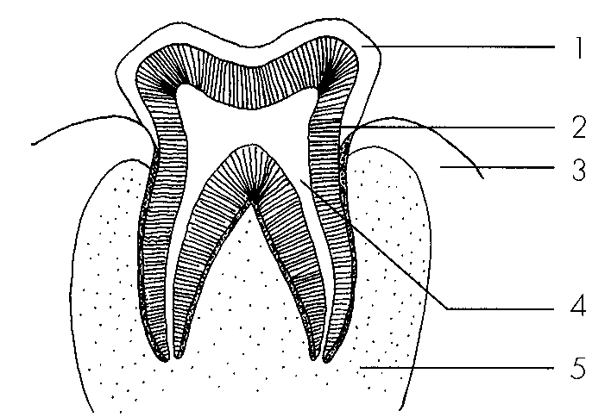
A. 1, 2 and 3 only
B. 2, 3 and 4 only
C. 3, 4 and 5 only
D. 2, 3, 4 and 5 only
9. Blood vessels can be found in
A. 1, 2 and 3 only
B. 2, 3 and 4 only
C. 3, 4 and 5 only
D. 2, 3, 4 and 5 only
10. Which of the following parts is most densely packed with calcium compounds?
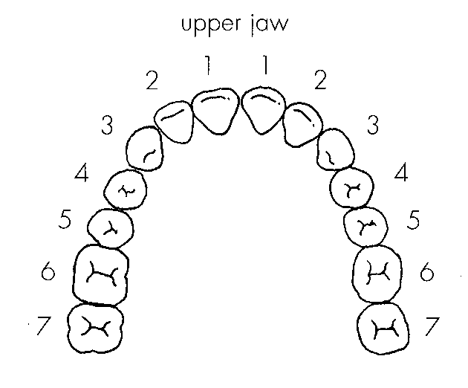
A. 1B. 2 C. 3 D. 4 Directions: Questions 18 to 20 refer to the diagram below which shows the teeth on the upper jaw of a person.
11. Which of the following is not a necessary function of toothpaste? A.It contains abrasives to remove plaque on the tooth surface. B.It contains alkaline substances to neutralise the acid released from bacterial activity. C.It contains calcium to support growth of the teeth. D.It contains fluoride to increase the resistance of enamel to acid.
A. It contains abrasives to remove plaque on the tooth surface.
B. It contains alkaline substances to neutralise the acid released from bacterial activity.
C. It contains calcium to support growth of the teeth.
D. It contains fluoride to increase the resistance of enamel to acid.
12. Which of the following functions is performed by a dental disclosing agent?
A.It neutralises the acid released from the plaque.
B.It stains the plaque.
C.It kills the bacteria in the plaque.
D.It stains the tooth which has started to decay.
Directions: Questions 25 to 27 refer to the graph below which shows the changes in pH of the plaque of a boy in a certain period of a day. The critical pH is the pH below which tooth decay may occur.
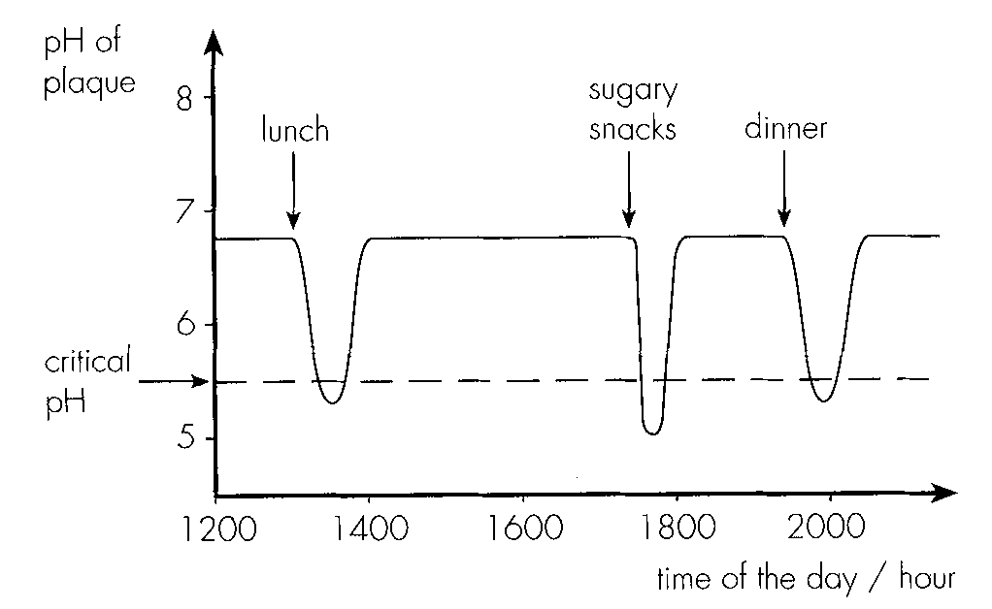
13. Which of the following conclusions can be drawn by referring only to the information provided in the above graph?
A.Bacteria in the plaque turn food substances into acid.
B.Acidity of the plaque increases shortly after the intake of food.
C.The tooth starts to decay when the pH of the plaque decreases.
D.All the meals contain acidic foodstuffs.
14. Based on the information provided in the graph, which of the preventive measures listed below can reduce the chance of tooth decay? (1) Brushing the teeth after meals (2) Avoiding sugary food (3) Eating more food rich in calcium (4) Using an alkaline toothpaste
A. (1) and (2) only
B. (1), (2) and (4) only
C. (2), (3) and (4) only
D. (1), (2), (3) and (4)
15. Which of the following is a means of physical digestion? (1) Chewing food by teeth (2) Churning action of the stomach (3)Peristalsis of small intestine (4) Emulsifying fat by bile
A. (1) and (2) only
B. (2) and (3) only
C. (1), (2) and (3) only
D. (1), (2), (3) and (4)
16. Physical digestion is essential for facilitating (1) swallowing. (2) absorption. (3) chemical digestion. (4) sterilization.
A. (1) and (2) only
B. (1) and (3) only
C. (1), (3) and (4) only
D. (2), (3) and (4) only
17. Chemical digestion of meat starts from the
A. mouth.
B. stomach.
C. duodenum.
D. pancreas.
Part B — HKDSE-style (YKTo)
18. Which of the following are important for the growth of teeth and bones?
A. Sunlight, vitamin D and chloride
B. Phosphate, calcium and chloride
C. Potassium,vitamin D and phosphate
D. Calcium, phosphate, vitamin D and fluoride
19. Which of the following diets is good for a girl suffering from scurvy?
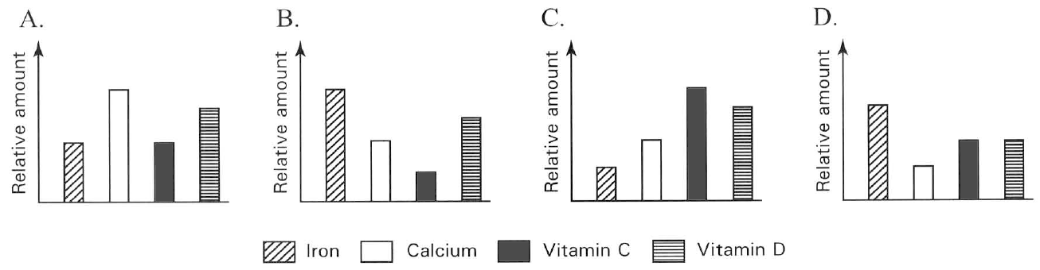
Food (100 g) | Proteins (g) | Calcium (mg) | Iron (mg) | Vitamin A (IU) | Vitamin C (mg)
Bananas | 1.09 | 5 | 0.26 | 64 | 8.7
Green peas | 5.42 | 23 | 1.47 | 765 | 40
Carrot | 0.93 | 33 | 0.30 | 16 705 | 5.9
Bell peppers | 0.99 | 7 | 0.43 | 3 131 | 127.7
Orange | 0.94 | 40 | 0.10 | 225 | 53.2
Kiwi fruits | 1.00 | 34 | 0.31 | 87 | 92.7

A. Potato, eggs and liver B. Milk, cheese and peanuts
C. Orange, lemons and tomatoes D. Carrot, fish and pork Directions: Questions 10.15 to 10.17 refer to the following bar charts that show the persons taking different diets. C10.15 Which person is least likely to suffer from scurvy? A10.16 Which person is least likely to suffer from rickets? C10.17 Which person is most likely to suffer from anaemia? Directions: Questions 10.18 to 10.22 refer to the following table which lists the amount of proteins, some minerals and vitamins in six different foods:
20. Which of the following foodstuff releases the greatest amount of energy?
A. Pea nuts B. Butter C. Honey D. Bread
21. Which of the following are health risks to an obese person? (1) Diabetes (2) Bone cancer (3) Stroke (4) Heart diseases
A. (1) and (2) only
B. (2) and (3) only
C. (1), (3) and (4) only
D. (2), (3) and (4) only

Answers
Answers are printed in red.
1. D. (1), (2) and (3)
Class: 70.4% correct (n=476) usual slip D
2. D. (1), (2) and (3)
Class: 72.2% correct (n=475) usual slip C
3. B. do not digest food.
Class: 73.3% correct (n=476) usual slip A
4. B. the food there has been digested by the host.
Class: 71.0% correct (n=476) usual slip A
5. D. body surface.
Class: 79.9% correct (n=482) usual slip A
6. B. (1) and (3) only
Class: 67.7% correct (n=427) usual slip B
7. B
Class: 68.3% correct (n=426) usual slip B
8. C. 3, 4 and 5 only
Class: 63.2% correct (n=318) usual slip C
9. C. 3, 4 and 5 only
Class: 69.9% correct (n=249) usual slip A
10. C
Class: 63.2% correct (n=201) usual slip A
11. B. It contains alkaline substances to neutralise the acid released from bacterial activity.
Class: 72.6% correct (n=106) usual slip B
12. C
Class: 68.3% correct (n=104) usual slip D
13. D
Class: 77.9% correct (n=104) usual slip C
14. B. (1), (2) and (4) only
Class: 61.5% correct (n=104) usual slip C
15. C. (1), (2) and (3) only
Class: 78.8% correct (n=104) usual slip A
16. C. (1), (3) and (4) only
Class: 76.0% correct (n=104) usual slip A
17. A. mouth.
Class: 79.8% correct (n=104) usual slip B
18. D. Calcium, phosphate, vitamin D and fluoride
Class: 66.0% correct (n=156) usual slip B
19. C. Orange, lemons and tomatoes D. Carrot, fish and pork Directions: Questions 10.15 to 10.17 refer to the following bar charts that show the persons taking different diets. C10.15 Which person is least likely to suffer from scurvy? A10.16 Which person is least likely to suffer from rickets? C10.17 Which person is most likely to suffer from anaemia? Directions: Questions 10.18 to 10.22 refer to the following table which lists the amount of proteins, some minerals and vitamins in six different foods:
Class: 79.4% correct (n=63) usual slip A
20. B
Class: 78.6% correct (n=56) usual slip A
21. C. (1), (3) and (4) only
Class: 76.8% correct (n=56) usual slip D

Class percentage correct
Matched to this paper by question wording in the source bank and the form answer key, not by a shifted paper number.
Q | Answer | % correct | n | Usual slip
1 | D | 70.4% | 476 | D
2 | D | 72.2% | 475 | C
3 | B | 73.3% | 476 | A
4 | B | 71.0% | 476 | A
5 | D | 79.9% | 482 | A
6 | B | 67.7% | 427 | B
7 | B | 68.3% | 426 | B
8 | C | 63.2% | 318 | C
9 | C | 69.9% | 249 | A
10 | C | 63.2% | 201 | A
11 | B | 72.6% | 106 | B
12 | C | 68.3% | 104 | D
13 | D | 77.9% | 104 | C
14 | B | 61.5% | 104 | C
15 | C | 78.8% | 104 | A
16 | C | 76.0% | 104 | A
17 | A | 79.8% | 104 | B
18 | D | 66.0% | 156 | B
19 | C | 79.4% | 63 | A
20 | B | 78.6% | 56 | A
21 | C | 76.8% | 56 | D

