Photosynthesis · Multiple-choice practice
Name: ________________________ Class: ____________
There are two parts. Part A is HKCEE level (questions 1–60). Part B is HKDSE style (questions 61–143). Choose the one best answer.
Part A — Photosynthesis basic (HKCEE level) · 60 questions
1. During photosynthesis, light energy is converted to
A. chemical energy.
B. heat energy.
C. electrical energy.
D. potential energy.

2. Which of the following about photosynthesis is correct?
A. Greenhouse is made of green glass to facilitate photosynthesis inside it.
B. The primary product of photosynthesis can be converted to lipids for storage.
C. Aquatic plants obtain carbon dioxide directly from the atmosphere.
D. The metabolites for photosynthesis include chlorophyll and water.

3. Which of the following is/are correct about autotrophs?
(1) Energy comes from the dead bodies of animals.
(2) Autotrophs absorb carbon dioxide and give out oxygen at night.
(3) Autotrophs can survive independently of animals.
A. (1) only
B. (2) only
C. (3) only
D. (1) and (3) only

4. Which of the following is correct about photosynthesis and respiration in green plants?
A. Photosynthesis is catabolic in nature while respiration is anabolic.
B. In the daytime, plants always have a net uptake of carbon dioxide.
C. At night, plants always have a net release of carbon dioxide.
D. Photosynthesis takes place in the daytime while respiration occurs at night.

5. The role of chlorophyll in photosynthesis is to
A. make leaves appear green.
B. split water into oxygen and hydrogen.
C. reduce carbon dioxide into glucose.
D. absorb light energy.

Directions: Questions 6 to 8 refer to the following steps about the test for starch in green leaves.
(1) Soak the leaf in warm water.
(2) Add iodine solution onto the leaf.
(3) Immerse the leaf in boiling ethanol for 15 minutes.
(4) Immerse the leaf in boiling water for 1 minute.
6. The correct sequence of the four steps is
A. (1), (3), (4), (2)
B. (2), (3), (4), (1)
C. (3), (4), (2), (1)
D. (4), (3), (1), (2)

7. The purpose of step (1) is to
A. kill the leaf cells.
B. rehydrate the leaf.
C. cool down the leaf.
D. denature the enzymes in leaf cells.

8. Ethanol is used in step (3) because
A. ethanol is a good solvent for organic molecules.
B. ethanol has a lower boiling point than water.
C. ethanol is a dehydrating agent.
D. ethanol can destroy the permeability of cell membrane.

9. To test for starch in a leaf, the leaf should be boiled in alcohol first because
A. alcohol can decolourize the leaf.
B. alcohol can dehydrate the leaf.
C. alcohol can soften the leaf.
D. alcohol can kill the cells.

10. In the experiment to show the occurrence of photosynthesis in a leaf, starch is tested for instead of glucose because
A. glucose is oxidized as rapidly as it is produced in the leaf.
B. Benedict's test cannot be carried out on a leaf.
C. glucose will be converted to starch when excess.
D. glucose produced in the leaf will be transported away quickly.

Directions: Questions 11 to 13 refer to the following experiment in which a green leaf was tested for starch.
11. In order to show the presence of starch, how should the leaf be treated before the experiment?
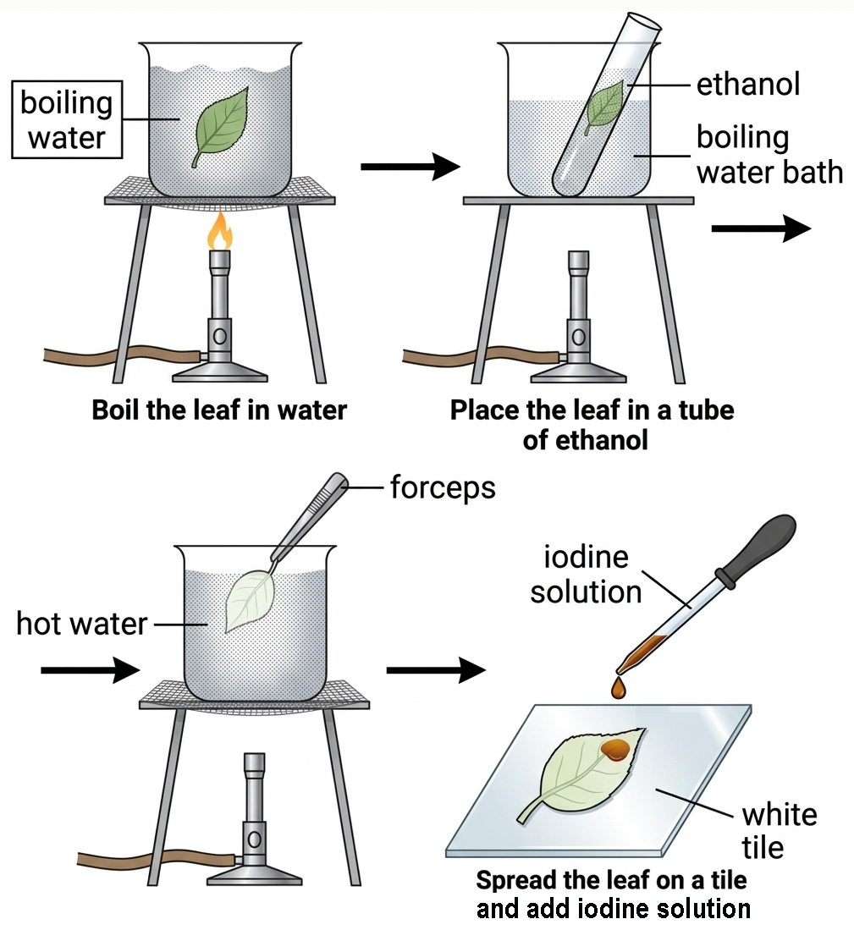
A. kept in darkness for 2 days.
B. kept in carbon dioxide supply for 2 hours
C. kept in light for 4 hours.
D. kept in water supply for 4 hours.

12. Why are students advised to switch off the burner when the leaf is immersing in boiling ethanol?
A. To save town gas.
B. To prevent ethanol vapour from catching fire.
C. Ethanol can remain boiling in hot water.
D. To prevent overheating.

13. What can be concluded if iodine solution turns the leaf dark blue?
A. The rate of photosynthesis is higher than that of respiration.
B. The rate of photosynthesis is lower than that of respiration.
C. Respiration has occurred in the leaf.
D. Photosynthesis has occurred in the leaf.

14. The role of light in photosynthesis is
A. to be absorbed by chlorophyll.
B. to reduce carbon dioxide.
C. to split water into oxygen and hydrogen.
D. to convert glucose into starch.

15. The set-up below was placed against a well-lighted background for 2 hours and the indicator solution changed from red to purple.
The result showed that
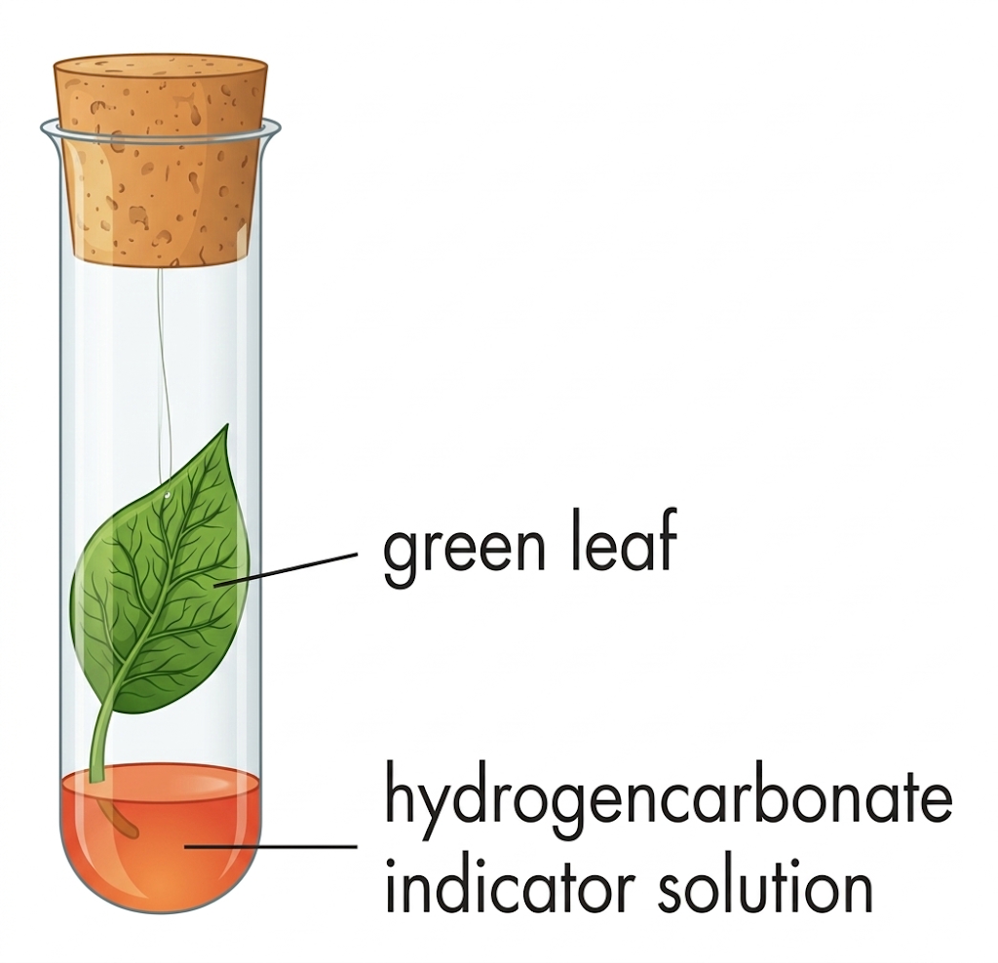
A. oxygen is produced during photosynthesis.
B. carbon dioxide is consumed during photosynthesis.
C. light is necessary for photosynthesis.
D. chlorophyll is necessary for photosynthesis.

Directions: Questions 16 to 18 refer to the experiment below which investigates the necessity of a certain condition in photosynthesis.
16. The condition being investigated in this experiment is
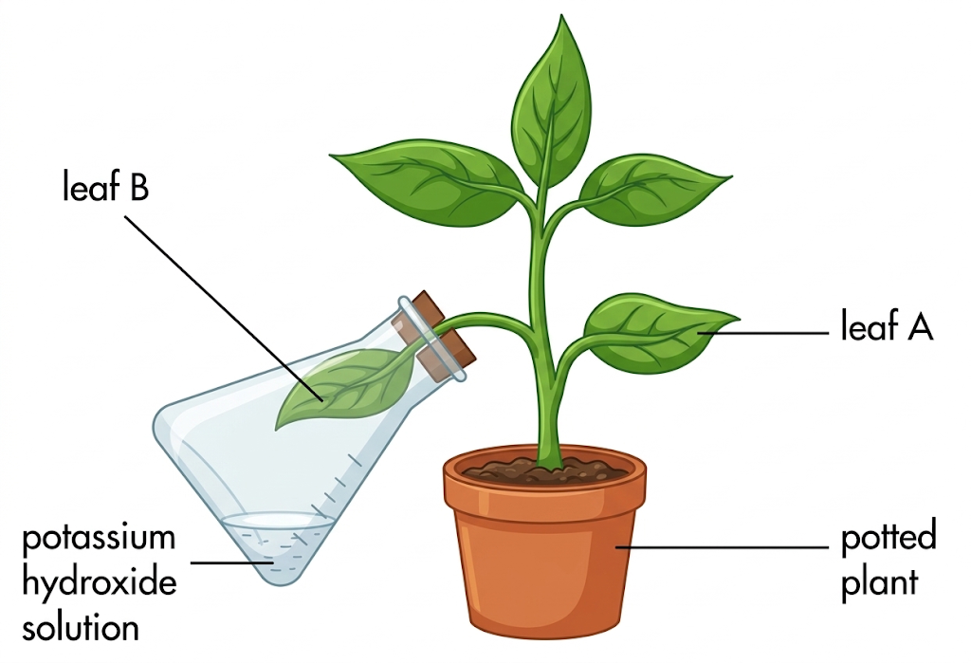
A. light.
B. carbon dioxide.
C. chlorophyll.
D. water.

17. Before the experiment, the potted plant should be kept in darkness for two days so as to
A. make the results more accurate.
B. accumulate carbon dioxide.
C. deprive the potted plant of starch reserve.
D. regenerate chlorophyll.

18. After illumination for 3 hours, leaves A and B were subjected to an iodine test. The expected results are
 | Leaf A | Leaf B
A | brown | brown
B | brown | blue-black
C | blue-black | brown
D | blue-black | blue-black

Directions: Questions 19 to 21 refer to the experiment below which investigates the necessity for light in photosynthesis.
19. The expected results in leaves X and Y are
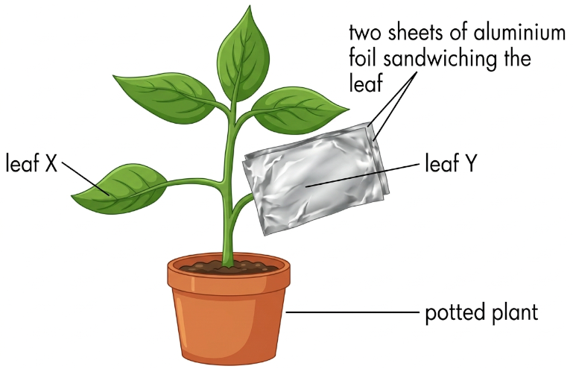
 | Leaf X | Leaf Y
A | brown | brown
B | blue-black | blue-black
C | blue-black | brown
D | brown | blue-black

20. If starch was detected in leaf Y, which of the following was the possible reason?
A. Leaf Y has not been kept in darkness long enough.
B. Light is not necessary for photosynthesis.
C. Light can penetrate aluminium foil.
D. Starch is transported from other parts of the plant to leaf Y.

21. What is the advantage of carrying out this experiment on a single leaf?
A. To save time.
B. To avoid the variations between leaves.
C. To have better comparison of results.
D. To save one leaf.

Directions: Questions 22 to 24 refer to the following experiment to investigate the necessity of chlorophyll in photosynthesis.
22. Coleus plant was used in this experiment because
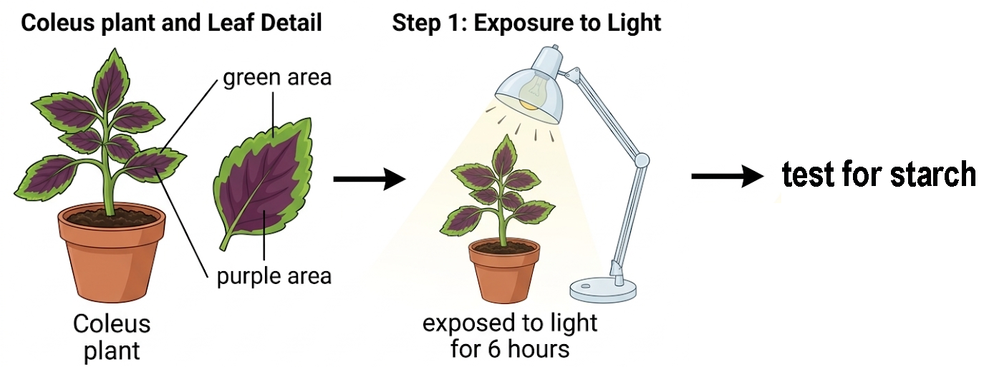
A. it is easily available.
B. it is cheap.
C. the size of its leaves is suitable for this experiment.
D. its leaves are variegated.

23. Which of the following correctly describes the result of this experiment?
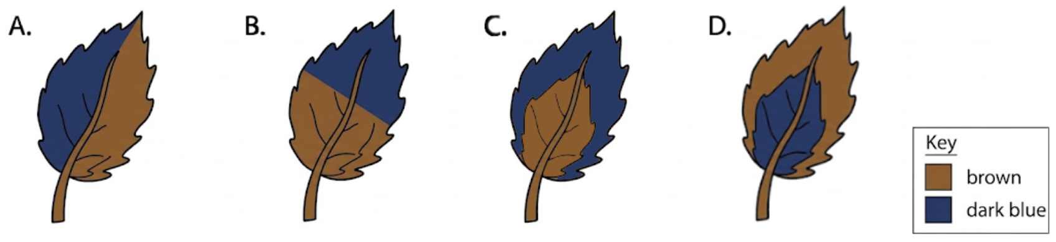

24. Which of the following represents the control part of the experiment?
A. Green area of the leaf
B. Purple area of the leaf
C. Lower half of the leaf
D. Upper half of the leaf

25. In photosynthesis, the by-product oxygen is formed during
A. reduction of carbon dioxide.
B. photolysis of carbon dioxide.
C. hydrolysis of water.
D. photolysis of water.

Directions: Questions 26 to 28 refer to the diagram below which outlines the reactions occurring in a certain kind of plant cell
26. Substance U is
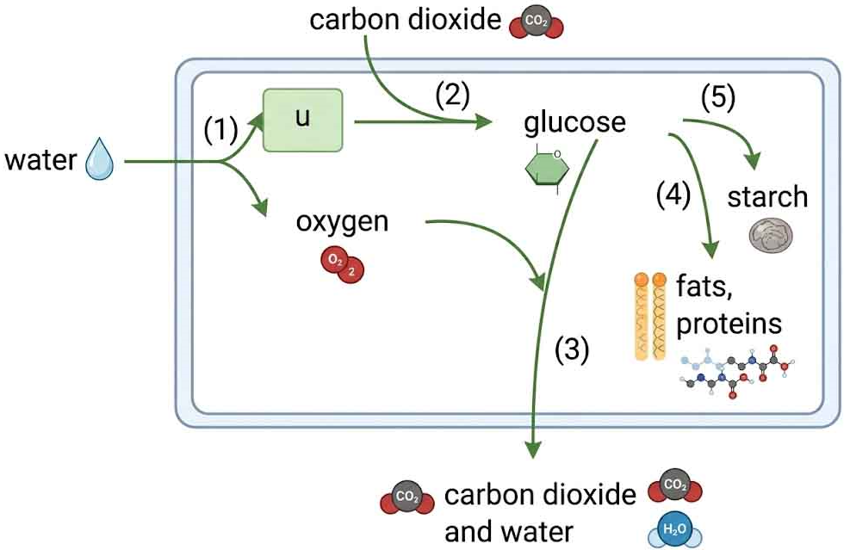
A. hydrogen produced by photolysis of water.
B. chlorophyll that traps light energy.
C. oxygen used in aerobic respiration.
D. carbon dioxide released from glucose.

27. Which of the following matchings is correct?
 | Examples of anabolism | Examples of catabolism
A. | (3) | (1), (2), (4) and (5)
B. | (1), (2), (4) and (5) | (3)
C. | (4) and (5) | (1), (2) and (3)
D. | (2), (4) and (5) | (1) and (3)

28. The probable plant cell type is
A. guard cell.
B. epidermal cell.
C. root hair cell.
D. xylem cell.

29. Which of the following correctly describes the events taking place in the light stage and dark stage of photosynthesis?
 | Light stage | Dark Stage
A. | reduction of water | production of carbohydrates
B. | production of oxygen | reduction of carbon dioxide
C. | photolysis of water | production of oxygen
D. | reduction of water | reduction of carbon dioxide

30. If a plant was supplied with heavy water, i.e. H₂¹⁸O, which of the following equations best represents the fate of the radioactive oxygen in photosynthesis?
A. 6CO₂ + 6 H₂¹⁸O → C₆H₁₂O₆ + 3¹⁸O₂ + 3O₂
B. 6CO₂ + 18H₂¹⁸O → C₆H₁₂¹⁸O₆ + 6¹⁸O₂ + 12H₂O
C. 6CO₂ + 6 H₂¹⁸O → C₆H₁₂¹⁸O₆ + 6O₂
D. 6CO₂ + 12 H₂¹⁸O → C₆H₁₂O₆ + 6¹⁸O₂ + 6H₂O

31. If a plant was supplied with heavy carbon dioxide, i.e. C¹⁸O₂, which of the following equations best represents the fate of the radioactive oxygen in photosynthesis?
A. 6C¹⁸O₂ + 6 H₂O → C₆H₁₂O₆ + 6¹⁸O₂
B. 6C¹⁸O₂ + 6H₂O → C₆H₁₂¹⁸O₆ + 3¹⁸O₂ + 3O₂
C. 6C¹⁸O₂ + 12 H₂O → C₆H₁₂¹⁸O₆ + 6O₂ + 6 H₂¹⁸O
D. 6C¹⁸O₂ + 18 H₂O → C₆H₁₂O₆ + 6O₂ + 12H₂¹⁸O

Directions: Questions 32 to 34 refer to the set-up below.
32. In order to ensure the smooth running of this experiment, solution X should be
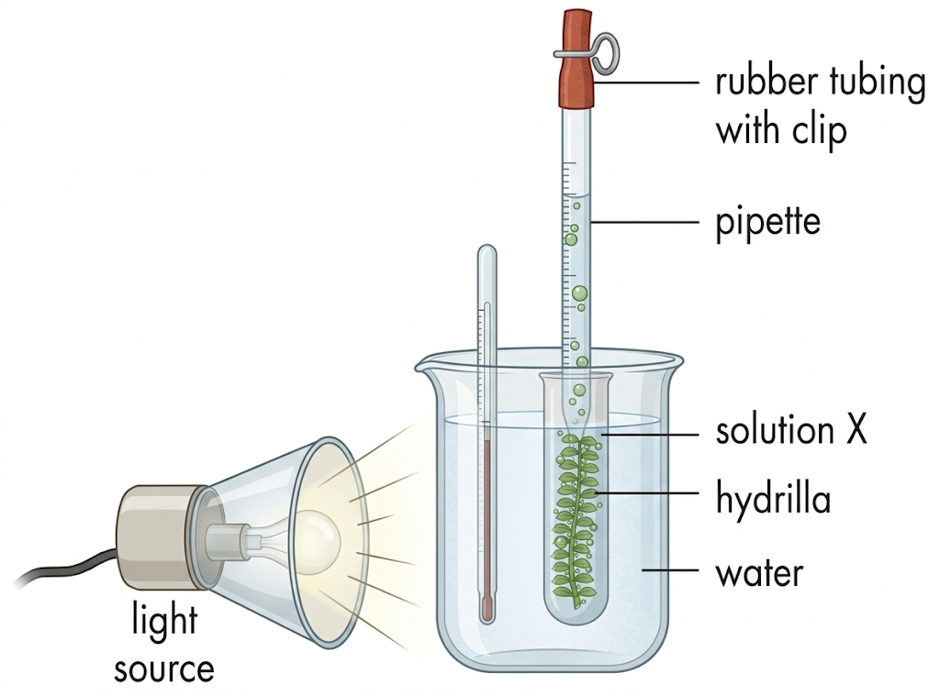
A. sodium chloride solution.
B. sodium hydrogencarbonate solution.
C. hydrogencarbonate indicator solution.
D. calcium carbonate solution.

33. The identity of gas bubbles can be tested by
A. lime water.
B. hydrogencarbonate indicator solution.
C. pH paper.
D. glowing splint.

34. Which of the following factors can be studied by this experiment on the rate of photosynthesis?
(1) Light intensity (2) Carbon dioxide concentration (3) temperature
A. (1) and (2) only
B. (1) and (3) only
C. (2) and (3) only
D. (1), (2) and (3)

35. Which of the following can only be synthesized with substances absorbed from the soil?
(1) Oil (2) Enzyme (3) Chlorophyll
A. (1) and (2) only
B. (1) and (3) only
C. (2) and (3) only
D. (1), (2) and (3)

36. Which of the following shows the correct routes through which a plant obtains the essential elements?
 | Nitrogen | oxygen | carbon
A. | stem | root | leaf
B. | root | leaf | stem
C. | root | stem | leaf
D. | leaf | stem | root

Directions: Questions 37 to 39 refer to the diagram below which shows the transverse section of a leaf.
37. Where are the sites of photosynthesis?
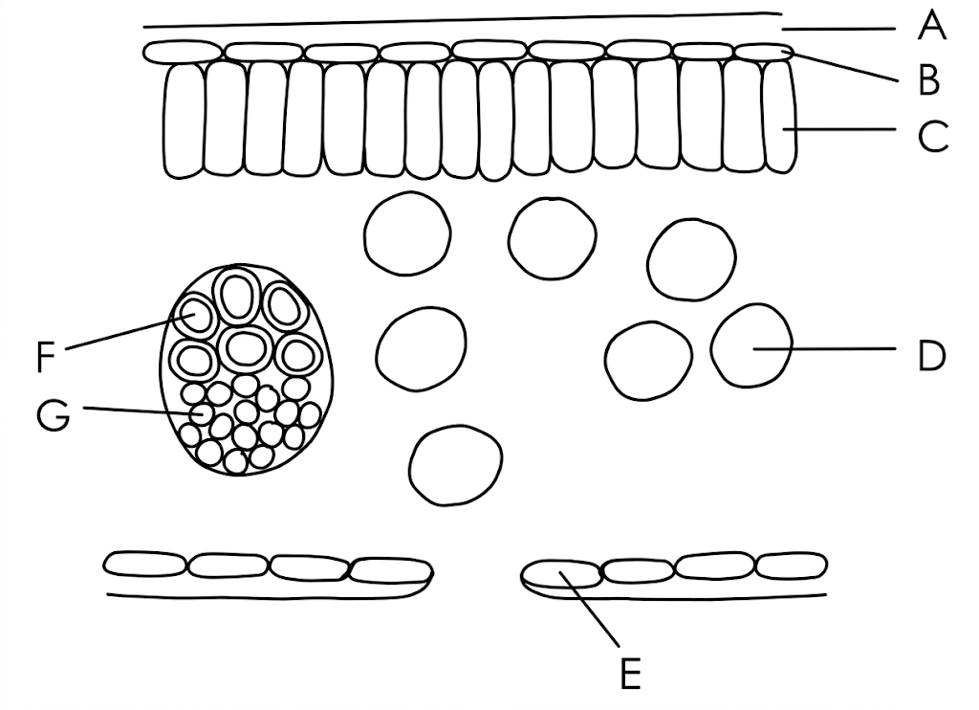
A. B, C and D
B. C, D and E
C. C, D and G
D. B, E and G

38. Water used in photosynthesis is brought to the leaf via
A. D
B. E
C. F
D. G

39. Photosynthetic products are brought away from the leaf via
A. A
B. B
C. F
D. G

Directions: Questions 40 and 41 refer to the graph below which shows the percentage absorption of different colours of light by chlorophyll.
40. Which colours of light can speed up photosynthesis?
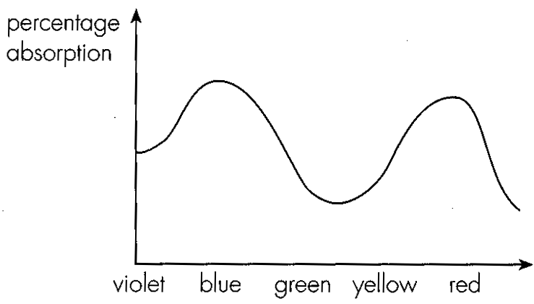
A. Violet and red
B. Blue and yellow
C. Blue and red
D. Green and yellow

41. What advice would you give concerning the construction of greenhouses?
A. They should be built using green glass.
B. They should be built using blue glass.
C. They should be built using red glass.
D. They should be built using transparent glass.

Directions: Questions 42 to 44 refer to the diagram below which represents the transverse section of a leaf.
42. Photosynthesis mainly occurs in
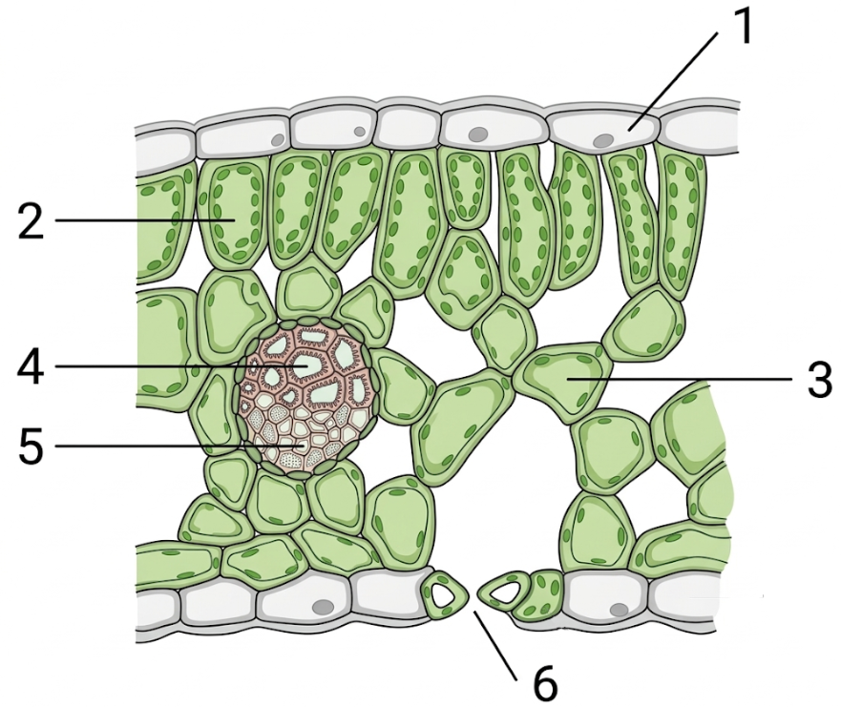
A. 1.
B. 2.
C. 4.
D. 5.

43. The products of photosynthesis are stored in
A. 1 and 2.
B. 1 and 3.
C. 2 and 3.
D. 3 and 5.

44. Substances that may pass through 6 include
(1) water vapour. (2) oxygen. (3) carbon dioxide.
A. (1) and (2) only
B. (1) and (3) only
C. (2) and (3) only
D. (1), (2) and (3)

45. Which of the following are the fate of carbohydrate products in the plants?
(1) Releasing energy
(2) Storage
(3) Converted into other products for growth
A. (1) and (2) only
B. (1) and (3) only
C. (2) and (3) only
D. (1), (2) and (3)

46. Which of the following pairs of matching is correct?
 | Parts of leaf | Function
A. | cuticle | to prevent entry of bacteria or fungi
B. | stomata | to allow water vapour to diffuse into the leaf
C. | epidermis | to store up photosynthetic products
D. | phloem | to transport water to the leaf

47. Which of the following are the functions of veins in a leaf?
(1) To support and maintain the shape of the leaf for photosynthesis.
(2) To transport water to the leaf.
(3) To transport food away from the leaf.
A. (1) and (2) only
B. (1) and (3) only
C. (2) and (3) only
D. (1), (2) and (3)

Directions: questions 48 to 50 refer to the diagram below.
48. This diagram is probably the surface view of
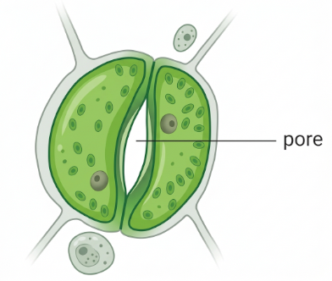
A. root epidermis.
B. leaf epidermis.
C. stem epidermis.
D. petiole epidermis.

49. Which of the following correctly states the direction of gaseous diffusion through the pore in the daytime and at night?
 | In the daytime | At night
A. | carbon dioxide in | oxygen out
B. | carbon dioxide out | oxygen in
C. | carbon dioxide in | oxygen in
D. | carbon dioxide out | oxygen out

50. Besides oxygen and carbon dioxide, what other substance will also diffuse through the pore shown in the diagram?
A. Nitrogen
B. Water vapour
C. Hydrogen
D. Noble gases

51. Chlorophyll makes the leaves look green in colour because
A. it absorbs mainly red and blue lights.
B. it absorbs mainly green light.
C. it reflects mainly red and blue lights.
D. it reflects mainly yellow light.

52. Which of the following is/are essential for making enzymes in flowering plants?
(1) To absorb nitrogen gas from the air by the leaves,
(2) To absorb nitrates from the soil by the roots.
(3) To make glucose by photosynthesis.
A. (2) only
B. (3) only
C. (1) and (3) only
D. (2) and (3) only

53. Nitrates are absorbed by plants for making
(1) carbohydrates. (2) lipids. (3) proteins. (4) enzymes.
A. (3) only
B. (4) only
C. (1) and (2) only
D. (3) and (4) only

Directions: Questions 54 to 56 refer to the water culture experiment below which investigates the necessity of magnesium to plants.
54. After a few weeks, the young seedling will
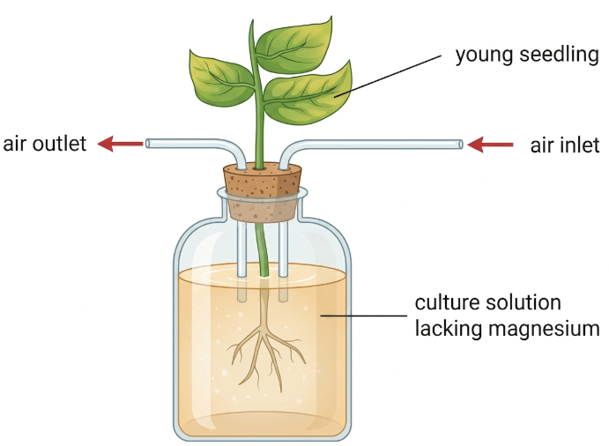
A. become very tall but slender.
B. have little growth.
C. be killed.
D. have yellow leaves.

55. The result in Question 54 showed that magnesium is used in
A. protein synthesis.
B. chlorophyll synthesis.
C. DNA synthesis.
D. cell wall synthesis.

56. Which of the following are the necessary steps in this experiment?
(1) Air is blown into the culture solution daily.
(2) Culture solution is renewed twice a week.
(3) The bottle containing culture solution should be covered with black paper.
A. (1) and (2) only
B. (1) and (3) only
C. (2) and (3) only
D. (1), (2) and (3)

57. In water culture experiments, young seedlings are preferable to mature plants because
A. young seedlings grow faster than mature ones.
B. young seedlings need more minerals than mature ones.
C. young seedlings have less mineral reserve.
D. young seedlings enable the experiment to be conducted longer in time.

58. In order to carry out water culture experiment for two weeks or so, air is blown into the culture solution daily. This is to
A. supply oxygen to the roots.
B. remove carbon dioxide from the roots.
C. sterilize the culture solution.
D. oxidize the organic waste produced by the seedling.

59. The bottle containing culture solution should be covered with black paper because
A. light will damage the roots.
B. light will decompose the mineral ions in the culture solution.
C. light will heat up the culture solution.
D. light will stimulate algal growth which consumes mineral ions.

60. In agriculture, chemical fertilizer is added to the soil as
(1) an additional source of minerals.
(2) a pesticide.
(3) a weed-killer.
A. (1) only
B. (3) only
C. (1) and (2) only
D. (2) and (3) only

Part B — Photosynthesis (HKDSE style) · 83 questions
61. Which of the following statements about the autotroph is TRUE?
A. An organism that moves about automatically.
B. The fungus that avoids the trouble of manufacturing food by obtaining energy through saprophytic mode of life.
C. The green plant that absorbs solar energy to change simple inorganic molecules into complex organic molecules.
D. The green plant that moves its growing tip towards the light source automatically.

62. Which of the following statements about photosynthesis is INCORRECT?
A. Carbon dioxide and water are the raw materials used in photosynthesis.
B. Oxygen and sugar are the end products of photosynthesis.
C. Green light is the most effective part of the visible spectrum for photosynthesis.
D. Water is split in the light stage and carbon dioxide is reduced in the dark stage of photosynthesis.

63. Which of the statements about photosynthesis is CORRECT?
A. The light-independent stage can only occur in darkness.
B. Photochemical reactions take place in the inner membrane of all the organelles with double membranes inside the green plant cells.
C. Hexose is the product of the photochemical reactions in photosynthesis.
D. Oxygen comes from the photolysis of water in the light-dependent stage.

64. The following is the equation of photosynthesis. If the water taking part contains the radioactive isotope ¹⁸O, which product(s) will contain this radioactivity?
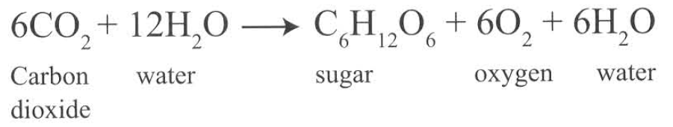
A. Sugar
B. Oxygen
C. Carbon dioxide
D. Sugar and oxygen

65. Green plants produce carbon dioxide during
A. night time only.
B. day time only.
C. both day time and night time.
D. the illumination of green light only.

Directions: Questions 66 to 70 refer to the diagram below, which represents the organelle of a green plant cell.
66. Which of the following are CORRECTLY matched with the chemicals labelled (1) to (4)?
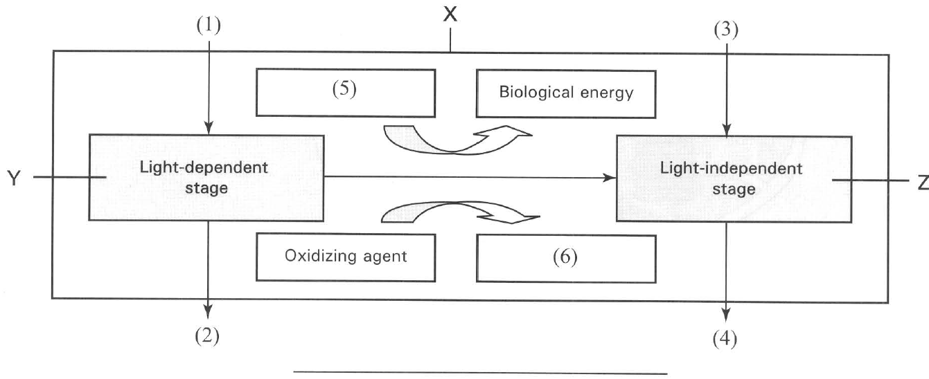
 | (1) | (2) | (3) | (4)
A. | Water | Hydrogen | Carbon dioxide | Oxygen
B. | Water | Oxygen | Carbon dioxide | Carbohydrate
C. | Carbon dioxide | Carbohydrate | Water | Oxygen
D. | Carbon dioxide | Glucose | Water | Hydrogen

67. Which of the following are CORRECTLY matched with the chemicals labelled (5) aand (6)?
 | (5) | (6)
A. | ATP | NADH
B. | ADP | NADPH
C. | NADH | ATP
D. | ATP | NAD

68. Y and Z are two locations inside the organelle where the light-dependent and light-independent stages of photosynthesis take place. Which of the following places for these two locations are CORRECT?
 | Y | Z
A. | Stroma | Granum
B. | Thylakoid | Stroma
C. | Mitochondrial matrix | Granum
D. | Cytoplasm | Thylakoid

69. The rectangle labelled X represents the
A. nucleus.
B. mitochondrion.
C. chloroplast.
D. endoplasmic reticulum.

70. The organelle represented by the rectangle labelled X can be found in the
A. apical meristematic cell of stem apex.
B. cortical cell of root.
C. onion epidermal cell.
D. spongy cells of leaf.

Directions : Questions 71 to 73 refer to the diagram below, which shows the organelle involved in photosynthesis.
71. Which of the following labels for structures X, Y and Z are CORRECT?
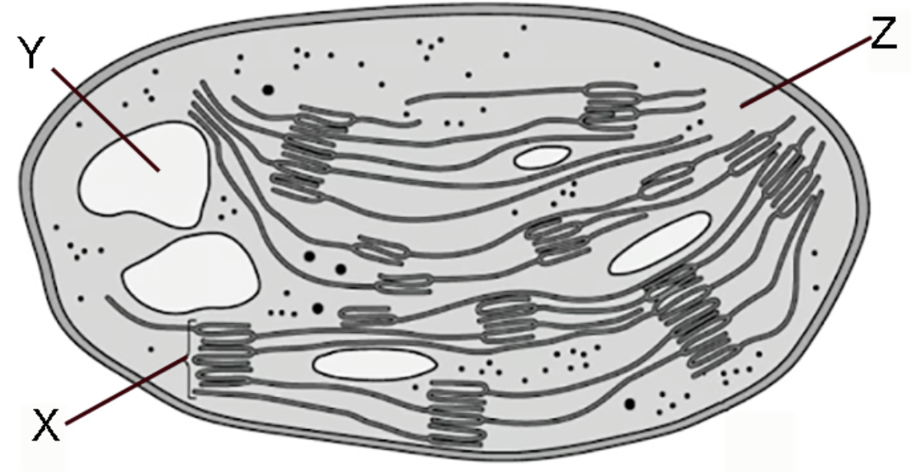
 | X | Y | Z
A. | Stroma | Cluster of DNA | Cytoplasm
B. | Thylakoids | Starch grain | Stroma
C. | Stroma | Lipid droplet | Grana
D. | Grana | Lipid droplet | Matrix

72. Which of the following functions of structures X, Y and Z are CORRECT?
 | X | Y | Z
A. | Fixation of carbon dioxide | Reduction of carbon dioxide | Photophosphorylation
B. | Light absorption | Storage of lipids | Occurrence of Krebs cycle
C. | Photolysis of water | Fixation of carbon dioxide | Storage of carbohydrate
D. | Photophosphorylation | Storage of carbohydrate | Fixation of carbon dioxide

73. Which of the following are products of the biological processes taking place in X and Z during photosynthesis?
1. Photosynthetic pigments
 | X | Z
A. | ATP and NADPH | Oxygen and carbohydrate
B. | Carbohydrate and oxygen | ATP and NADH
C. | ATP and oxygen | Carbohydrate and water
D. | ADP and NADP | Oxygen and hydrogen

74. The graph below shows the absorption spectra of photosynthetic pigments.
Which of the following matching of the curves X, Y and Z with the pigments is TRUE?
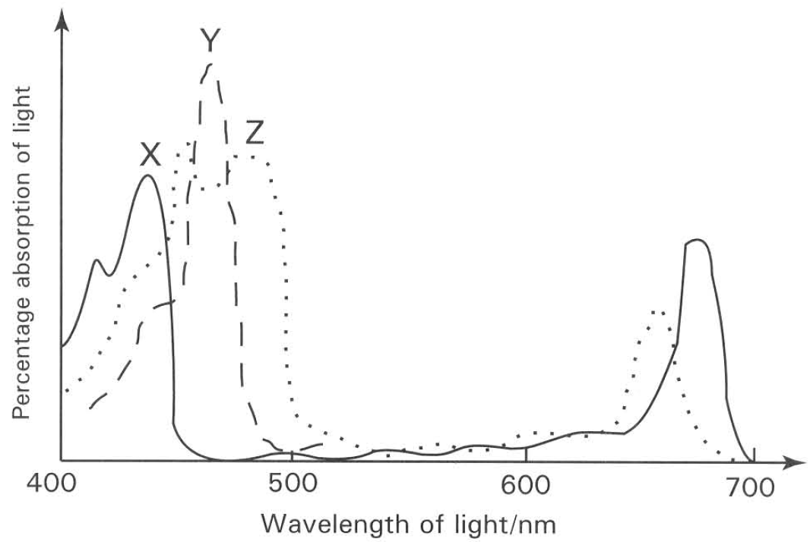
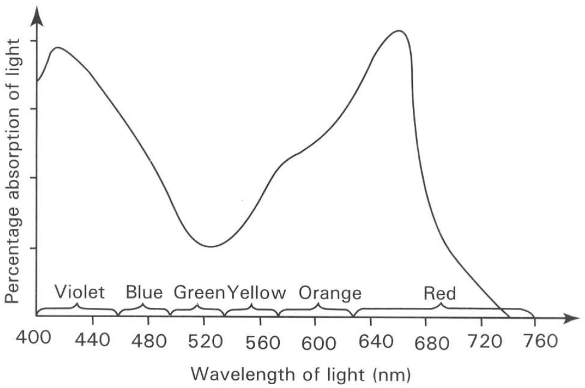
 | X | Y | Z
A. | Chlorophyll a | Chlorophyll b | Carotenoids
B. | Carotenoids | Chlorophyll a | Chlorophyll b
C. | Carotenoids | Chlorophyll b | Chlorophyll a
D. | Chlorophyll a | Carotenoids | Chlorophyll b

Directions: Questions 75 to 78 refer to the graph below, which shows the absorption spectrum of light in chlorophyll solution. There is a close correspondence of the percentage absorption of light and the relative photosynthetic rate of the green leaves.
75. Which of the following combinations of colours is most effective to bring about photosynthesis?
A. Violet + red
B. Blue + orange
C. Green + yellow
D. Green + red

76. In the laboratory a balanced aquarium with green algae and snails (herbivores) inside is exposed to light at the wavelengths range from 500 nm to 560 nm. Which of the following will happen?
A. The glass surface of the aquarium is completely covered with green algae.
B. The snails (herbivores) living inside the aquarium increase in number.
C. The oxygen content of the water in the aquarium increases.
D. The carbon dioxide content of the water in the aquarium increases.

77. Most plants are green in colour because
A. chlorophyll is most effective to absorb green light.
B. the atmosphere filters out all the colours of the visible spectrum in sunlight except green.
C. green light is the most effective wavelength of the visible spectrum in sunlight for photosynthesis.
D. chlorophyll is least effective to absorb green light.

78. If the atmosphere only permits green light to pass down to the earth's surface, what result would be expected?
A. The oxygen concentration of the atmosphere would increase.
B. The carbon dioxide concentration would decrease.
C. No green plants could carry out photosynthesis.
D. The crop production would decrease.
2. Energy conversion

79. The solar energy absorbed by the leaf is changed into
(1) heat energy. (2) light energy. (3) mechanical energy. (4) chemical energy.
A. (1) only
B. (2) only
C. (3) only
D. (1) and (4) only

80. Which of the following structures have enzymes to catalyze the biochemical reactions taking place during photosynthesis?
(1) Outer membrane of chloroplast (2) Stroma (3) Thylakoid (4) Starch grains
A. (1) and (2) only
B. (2) and (3) only
C. (3) and (4) only
D. (4) and (1) only

81. The following are the major events taking place in the process of photosynthesis. List them in the CORRECT sequence.
(1) Carbon dioxide acceptor combines with carbon dioxide to form the first product of carbon fixation.
(2) Regeneration of carbon dioxide acceptor.
(3) Photolysis of water produces hydrogen and releases oxygen.
(4) Reduced NADP reduces the first product of carbon fixation to carbohydrate.
A. (1) (3) (2) (4)
B. (4) (3) (1) (2)
C. (3) (1) (4) (2)
D. (2) (3) (1) (4)

82. Which of the following will be involved in the photochemical reactions of photosynthesis?
(1) ADP is phosphorylated. (2) NADP is reduced.
(3) Carbohydrate is formed. (4) Oxygen is evolved.
(5) Carbon dioxide is reduced.
A. (1), (2) and (4) only
B. (1), (3) and (4) only
C. (2), (4) and (5) only
D. (1), (3) and (5) only

83. Which of the following are the products of the photochemical reactions of photosynthesis?
(1) ATP (2) NADP (3) Reduced NAD
(4) Reduced NADP (5) Oxygen (6) Carbohydrate
A. (1), (3) and (4) only
B. (2), (5) and (6) only
C. (1), (4) and (5) only
D. (2), (3) and (6) only

84. Which of the following activities occur in the photochemical reactions of photosynthesis?
A. Fixation of carbon dioxide
B. Photophosphorylation
C. Oxidation of NADPH
D. Regeneration of carbon dioxide acceptor

85. An enzyme inhibitor blocks the flow of electrons along the electron transport chain in the thylakoid. Which of the following processes will be inhibited?
A. Photolysis of water
B. Photo-activation of the photosynthetic pigments
C. Photophosphorylation of ADP and reduction of NADP
D. Active transport of magnesium ions into the chloroplast

86. The diagram below shows the biochemical processes taking place during the dark stage of photosynthesis.
Which of the following matching is CORRECT?
(1) Carbon dioxide is fixed (2) The first product of carbon fixation is reduced.
(3) ATP is generated (4) ATP is hydrolyzed
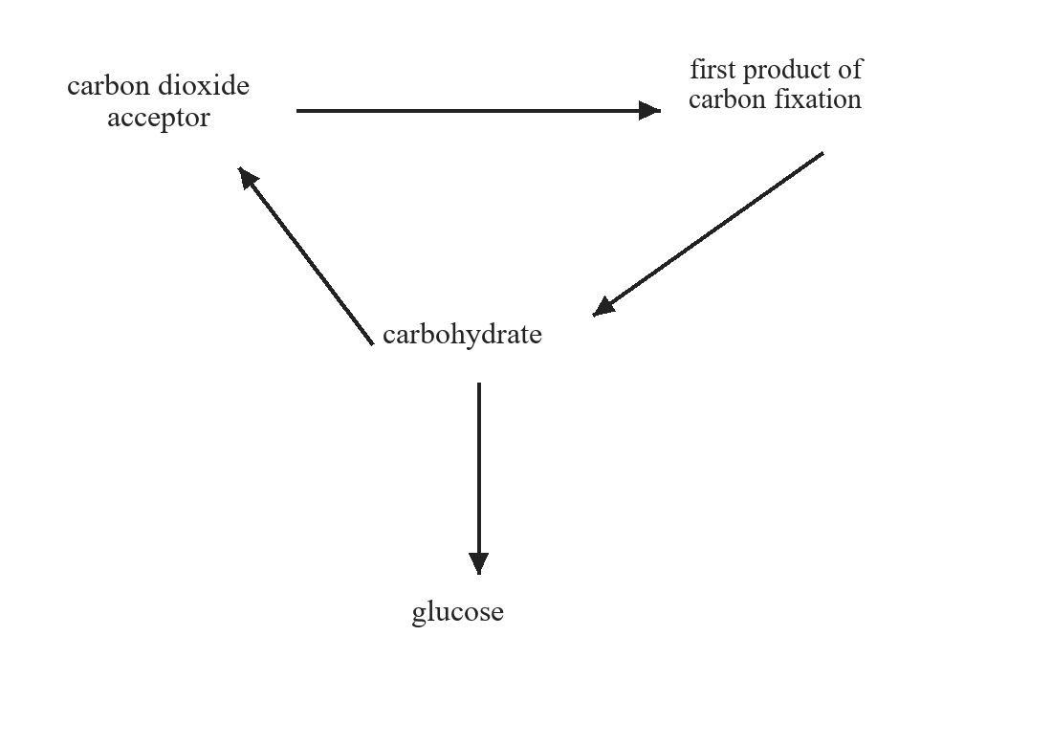
A. (1) and (2) only
B. (2) and (3) only
C. (1), (2) and (3) only
D. (1), (2) and (4) only

87. Which of the following statements concerning the events taking place in the carbon fixation of photosynthesis is CORRECT?
A. The carbon dioxide acceptor is a 2-carbon compound which combines with one molecule of carbon dioxide to form the first product of carbon fixation.
B. The biochemical reactions involved in this stage is not affected by temperature.
C. The conversion of the first product of carbon fixation to carbohydrate is a reaction involving reduction.
D. All the carbohydrate formed in the dark stage will be changed completely to glucose phosphates.

88. In an experiment performed by R. C. Hill, isolated chloroplasts could produce oxygen in the presence of an artificial hydrogen acceptor. Which of the following is the natural hydrogen acceptor used in this process in a living chloroplast?
A. ATP
B. Carbon dioxide acceptor
C. Carbon dioxide
D. NADP

89. Removing carbon dioxide from an experiment results in changes in the concentration of the following chemicals in a green plant cell.
 | ATP | Carbon dioxide acceptor | First product of carbon fixation
A | No change | Increases | Decreases
B | Increases | Increases | Decreases
C | Decreases | Decreases | Increases
D | Decreases | No change | Increases

90. Which of the following statements concerning the Calvin cycle of photosynthesis is CORRECT?
(1) The biochemical reactions involved in this stage are independent of temperature.
(2) The carbon dioxide acceptor is regenerated at the end of the stage.
(3) NADPH is oxidized in the synthesis of carbohydrates.
(4) Photolysis of water occurs.
A. (1) and (2) only
B. (2) and (3) only
C. (3) and (4) only
D. (1) and (4) only

91. Carbon dioxide labelled with radioactive isotope 14C is used in an experiment to identify the intermediate compounds formed in the dark stage of photosynthesis. Which of the following compounds is the first one to be detected with radioactivity?
A. Glucose
B. Starch
C. Carbon dioxide acceptor
D. First product of carbon fixation

Directions: Questions 92 to 96 refer to the following diagram, which shows an experiment in progress.
92. The diagram above shows the first part of a plant physiology experiment which demonstrates
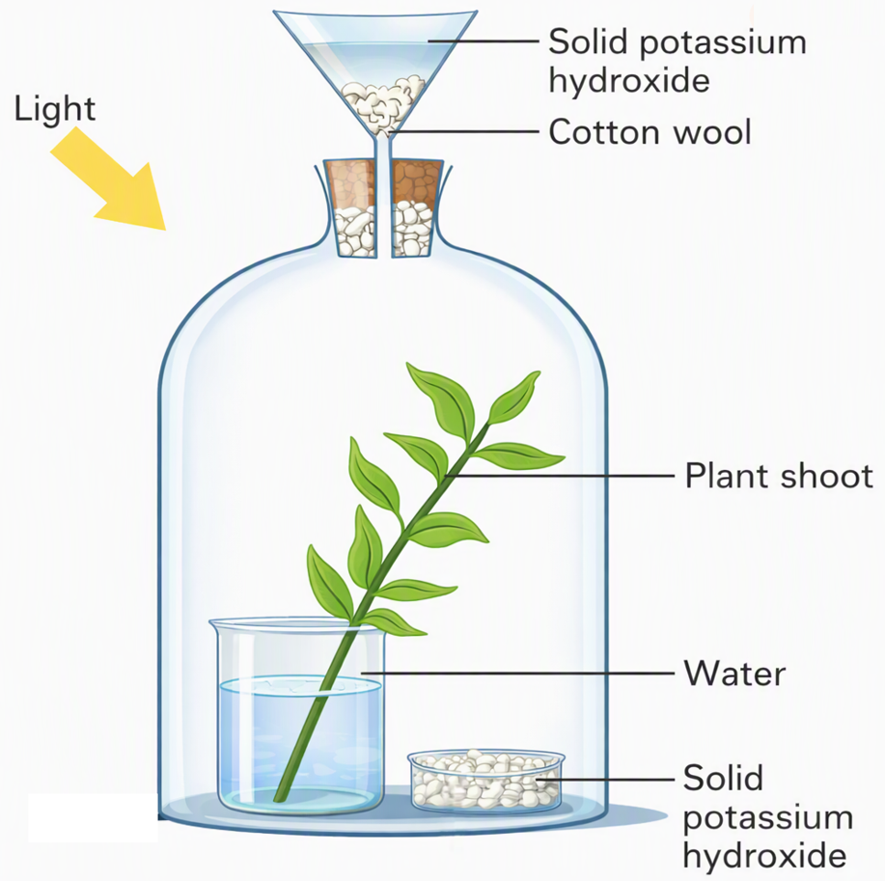
A. the release of water vapour by the process of transpiration.
B. that carbon dioxide is essential to photosynthesis.
C. the anaerobic respiration of the plant with a limited supply of oxygen.
D. the release of carbon dioxide by respiration.

93. A control for the above experiment is set-up by
A. removing solid potassium hydroxide from the funnel and the dish.
B. replacing the beaker of water with a beaker of lime water.
C. removing all the green leaves.
D. covering the whole set-up with a piece of black cloth.

94. Which of the following observations CORRECTLY justifies the aim of this demonstration?
A. There is increase in the weight of the solid potassium hydroxide in the first part of the experiment.
B. There is decrease in weight of the solid potassium hydroxide in the first part of the experiment.
C. Starch is formed in the shoot in the first part of the experiment but not in the control.
D. Starch is not formed in the shoot in the first part of the experiment but formed in the control.

95. To make sure that the result is TRUE, before the experiment is done
A. the solid potassium hydroxide must be weighed accurately.
B. the plant shoot must be weighed accurately.
C. the amount of starch inside the plant shoot must be found.
D. the whole set-up must be left in darkness for 48 hours.

96. The following procedures are necessary to complete this experiment. Outline the steps in order.
(1) Immerse the leaves into iodine solution.
(2) Immerse the leaves into boiling water.
(3) Immerse the leaves into a test-tube of alcohol which is heated in a water bath.
(4) Immerse the leaves into warm water.
A. (1), (2), (3) and (4)
B. (2), (3), (4) and (1)
C. (3), (4), (1) and (2)
D. (4), (1), (2) and (3)

97. In the experiment used to illustrate that carbon dioxide is essential to photosynthesis, which of the following reagents CANNOT be used for absorbing carbon dioxide?
A. Soda lime
B. Hydrogencarbonate indicator solution
C. Sodium hydroxide solution
D. Potassium hydroxide solution

98. In a plant physiology experiment variegated leaves are used to show that
A. carbon dioxide is essential for photosynthesis.
B. water vapour is given out during the process of transpiration.
C. starch is synthesized during the process of photosynthesis.
D. chlorophyll is essential for photosynthesis.

99. The five leaves shown in the following diagrams were illuminated.
After 8 hours of illumination, these leaves were detached from the plant and tested with iodine solution. Which of the following diagrams represents the results?
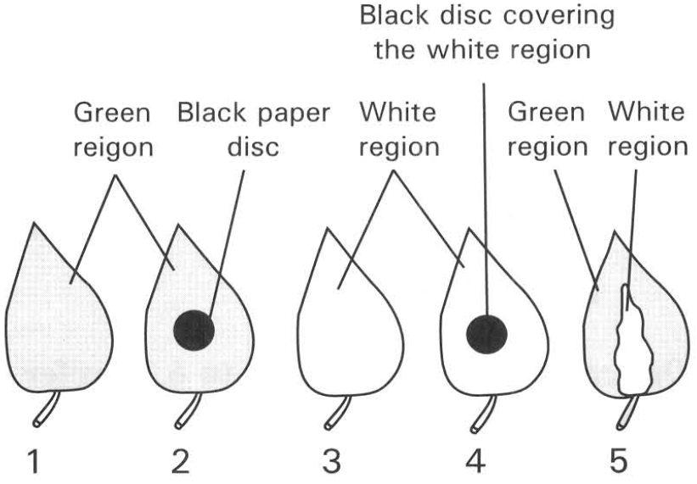

Directions: Questions 100 to 104 refer to the diagram below, which shows an experiment on photosynthesis. The plant has been kept in a dark cupboard for two days. A leaf of the plant is then treated as shown in the diagram. Regions K, N and P of the leaf are green and regions L, M and O are yellow. An aluminium foil with a rectangular opening is attached on the middle part of the leaf. The plant is exposed to sunlight for several hours.
100. The process for keeping the plant in a dark cupboard for two days before the experiment started is called
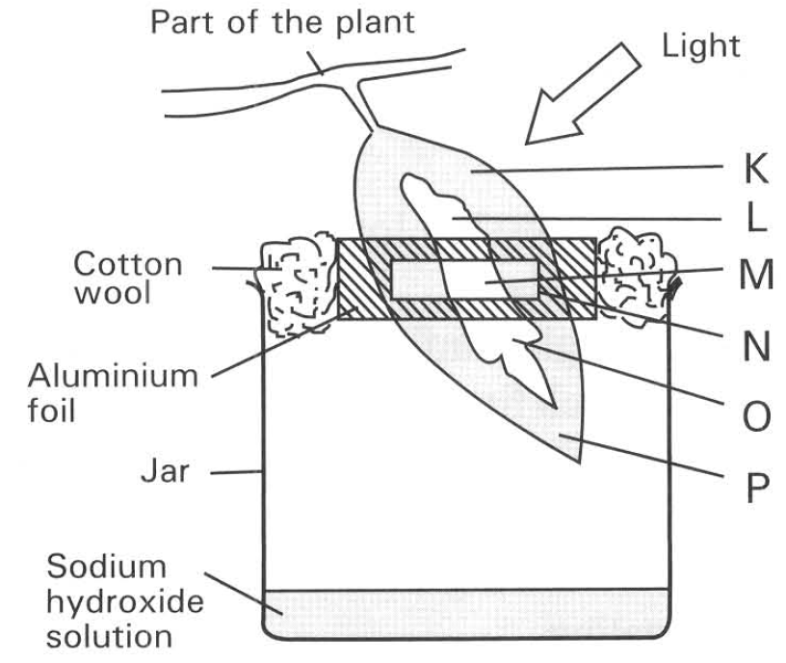
A. photosynthesis.
B. re-starching.
C. destarching.
D. respiration.

101. The reason for keeping the plant in the dark cupboard for two days before the experiment is to
A. reduce the amount of sugar used by the respiration of the leaf.
B. reduce the amount of water lost by the transpiration of the leaf.
C. reduce the amount of chlorophyll produced by the leaf.
D. remove the starch previously stored in the leaf

102. The reason for putting potassium hydroxide solution in the jar is to
A. measure the relative concentration of carbon dioxide in the jar.
B. remove the carbon dioxide from the jar.
C. detect the presence of carbon dioxide in the jar.
D. supply carbon dioxide to the lower part of the leaf inside the jar.

103. The leaf is removed and is treated with iodine test. Which of the diagrams below represents the result of the test?
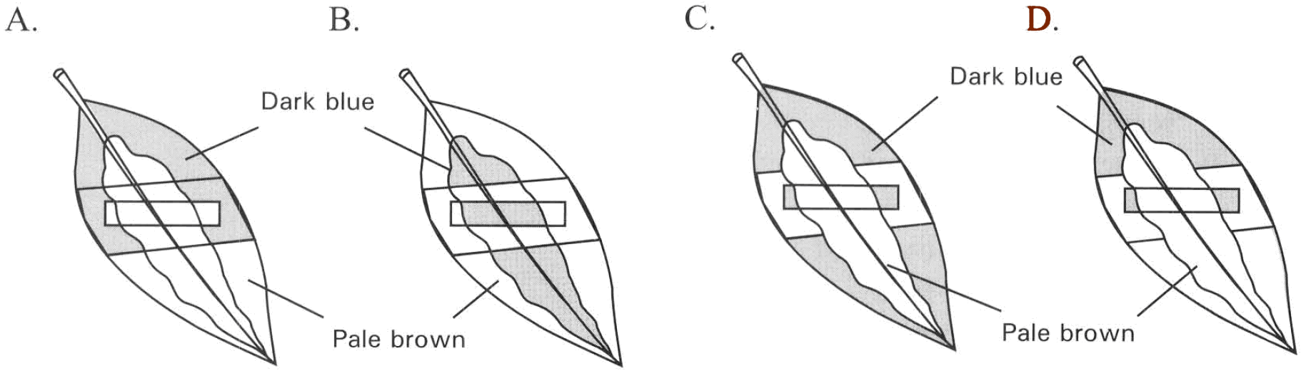

104. From the result of this experiment it can be concluded that the conditions essential for photosynthesis to take place are
(1) light (2) water (3) chlorophyll (4) carbon dioxide
A. (1) and (4) only
B. (1) and (3) only
C. (2) and (4) only
D. (1), (3) and (4) only

Directions: Questions 105 to 107 refer to the diagram below, which shows the set-up used for testing the presence of starch in a leaf.
105. Before putting the leaf in alcohol, it is put in boiling water for five minutes to
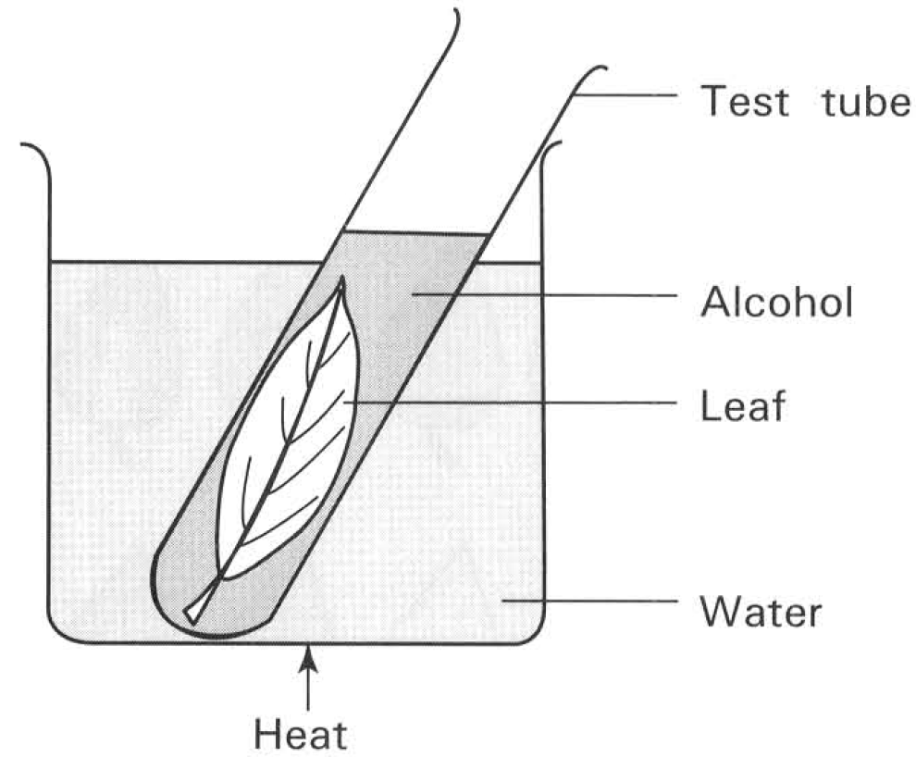
A. melt the waxy cuticle of the leaf.
B. dissolve all the starch grains present inside the chloroplasts of the leaf cells.
C. dissolve the chlorophyll present in the leaf.
D. denature the enzymes in order to stop the metabolic activities of the leaf cells.

106. The reason for putting the leaf in hot alcohol is to
A. decolourize the leaf.
B. destarch the leaf.
C. remove the glucose from the leaf.
D. activate the enzymes to speed up the metabolic activities of the cell.

107. The reason for heating alcohol in a beaker of water is to avoid
A. the excessive loss of alcohol which is very volatile.
B. the highly inflammable alcohol vapour to catch fire.
C. the boiling of alcohol that may spill out of the test tube.
D. the cracking of test-tube due to direct heating.

108. Though glucose is an important photosynthetic product, however, the production of starch in terrestrial leaf is usually taken as the evidence of the occurrence of photosynthesis. Which of the following explanations is CORRECT?
A. Glucose will be oxidized to release energy.
B. Glucose is more soluble than starch.
C. Glucose molecule is too small to be detected.
D. Starch can easily be detected by the conspicuous colour change in the iodine test.

109. The graph below shows the change in the pH of water in a freshwater pond.
Which of the following statements concerning the pH change in the period concerned is CORRECT?
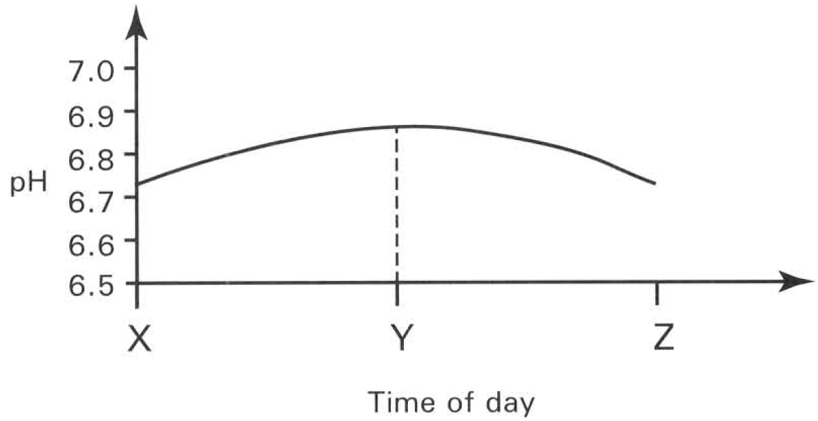
A. The pH increases between X and Y because of the decrease in the carbon dioxide concentration in pond water due to the occurrence of photosynthesis.
B. The pH decreases between Y and Z because of the release of large amount of oxygen by photosynthesis.
C. The pH increases between time X and Y because the rate of respiration is faster than the rate of photosynthesis.
D. The pH decreases between Y and Z because of the consumption of large amount of magnesium salt by the occurrence of photosynthesis.

Directions: Questions 110 to 112 refer to the diagram below, which shows an experiment in progress.
110. Bubbles released from the plant are collected in the graduated tube. This gas relights a glowing splint. According to such result which of the following is a proper conclusion?
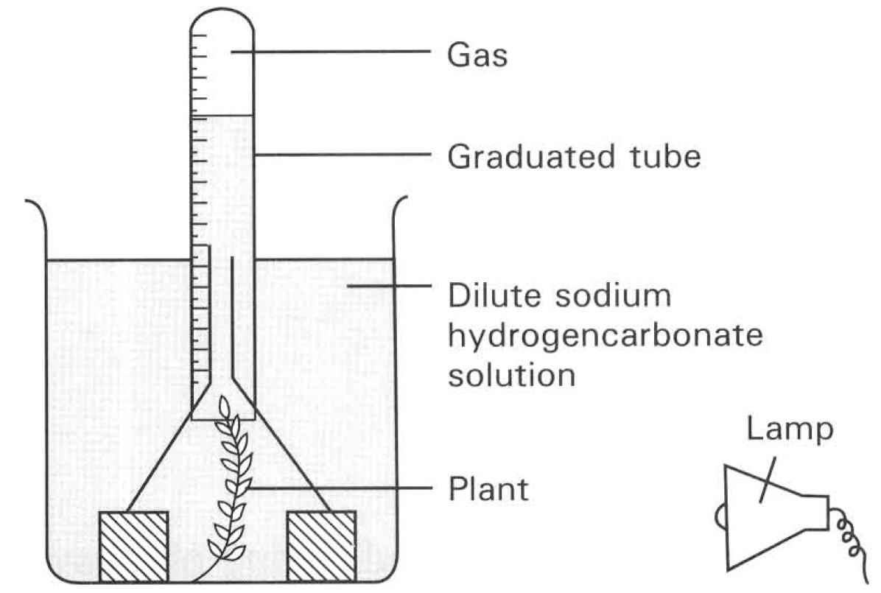
A. The long term exposure to bright light raises the temperature of water. This reduces the solubility of gases and thus drives gases out of water.
B. The plant absorbs carbon dioxide from the sodium hydrogencarbonate solution to carry out photosynthesis.
C. Chlorophyll is essential for the process of photosynthesis.
D. The gas released from the illuminated green plant has higher oxygen content than that of the atmosphere.

111. Which of the following is/are NOT a control for the above experiment?
(1) There is no plant in the set-up.
(2) Put the whole set-up inside a dark cupboard.
(3) Use a smaller plant.
A. (1) only
B. (2) only
C. (3) only
D. (1) and (2) only

112. The gas collected in the graduated tube consists of
(1) carbon dioxide. (2) oxygen. (3) water vapour.
A. (2) only
B. (1) and (2) only
C. (1) and (3) only
D. (1), (2) and (3)

113. The oxygen evolved during photosynthesis comes from the
A. oxygen initially absorbed into the leaf for respiration.
B. carbon dioxide which is one of the raw materials required for photosynthesis.
C. water which is one of the raw materials required for photosynthesis.
D. Carbohydrate which is produced by photosynthesis.

Directions: Questions 114 to 117 refer to the following description of an experiment. A 4 kg deciduous plant was grown in a pot which contained 100 kg of dry soil. Nothing was added to the soil except water. After 6 years' time the plant was found to be about 80 kg while the dry weight of the soil was about 88 kg.
114. Which of the following processes is mainly responsible for the increase in weight of the plant?
A. Translocation
B. Photosynthesis
C. Transpiration
D. Respiration

115. "The increase in weight of the plant should be more than 76 kg (80 kg - 4 kg)". Without which of the following phenomena would this statement become TRUE?
A. Loss of pollen grains during pollination.
B. Leaves fall in every autumn.
C. Loss of water through transpiration.
D. Denitrification of the soil.

116. Which of the following substances is most important for the increase in weight of the plant?
A. Carbon dioxide
B. Nitrogen
C. Oxygen
D. Water vapour

117. Substances lost from the dry soil partially contribute to the synthetic process of the plant in manufacturing
A. vitamins.
B. glucose.
C. starch.
D. proteins.

118. Which of the following graphs represents the change in carbon dioxide concentration in a freshwater pond?
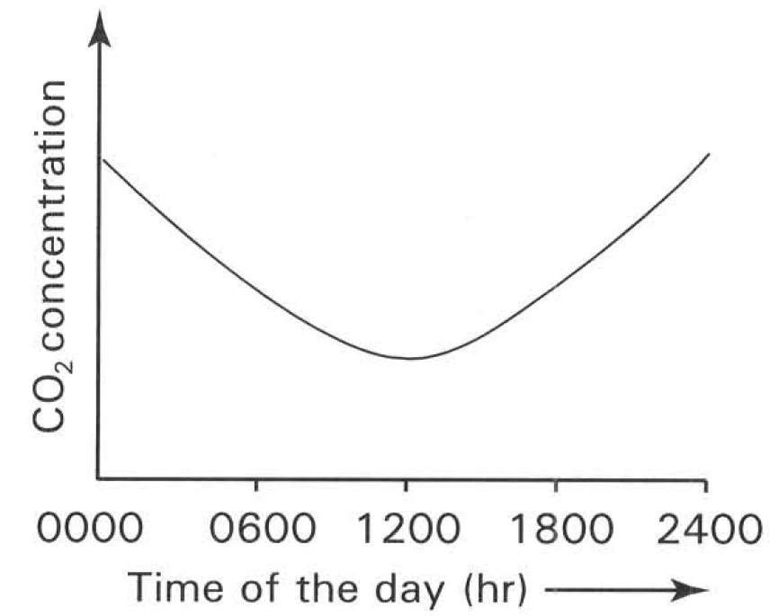
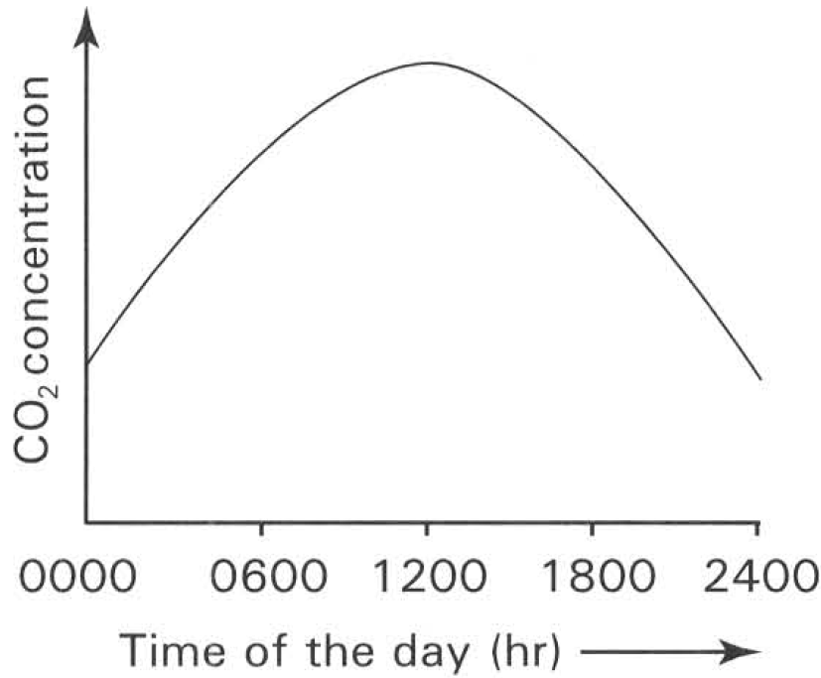
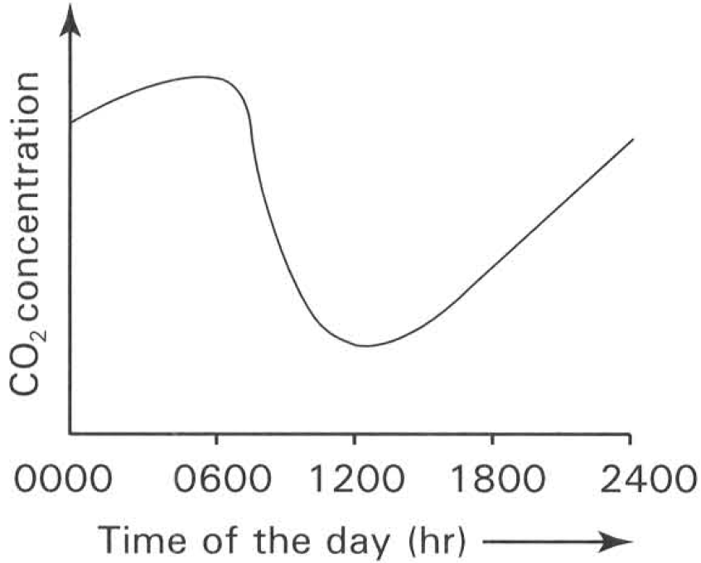
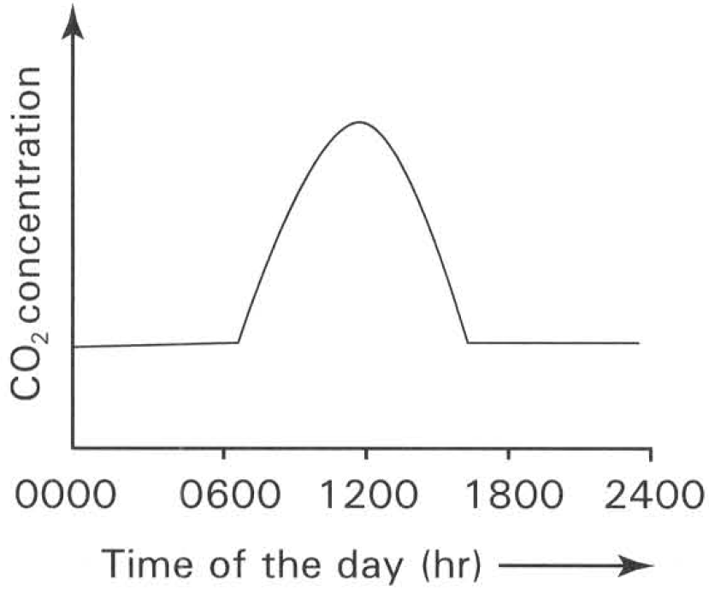
A. | B. | C. | D.

119. If the light intensity is relatively high inside a greenhouse, under which of the following conditions is carbon dioxide most likely to be the major limiting factor in the rate of photosynthesis?
 | Temperature (°C) | Carbon dioxide concentration (%)
A. | 25 | 4.00
B. | 25 | 0.01
C. | 15 | 0.04
D. | 5 | 0.04

120. The rate of photosynthesis of a plant always relates with the surrounding light intensity. Three samples of phytoplankton were collected at different depths of the sea: X at surface water, Y at medium water and Z at great depth. Which of the following graphs shows the CORRECT effects of light intensity on the rate of photosynthesis of the three plant species concerned?
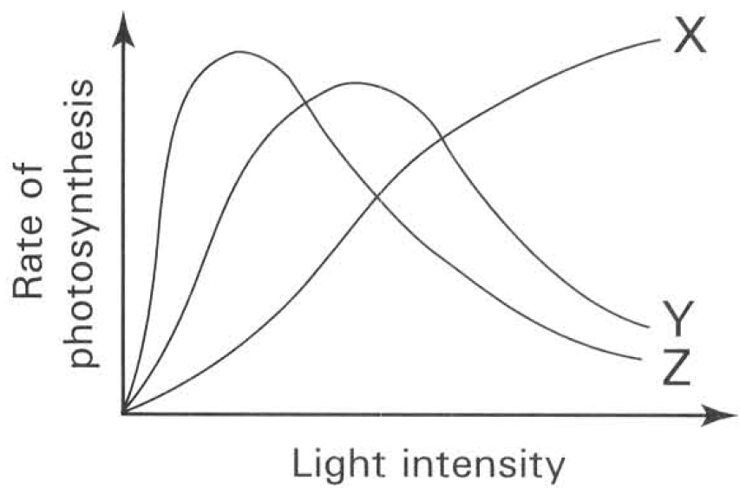
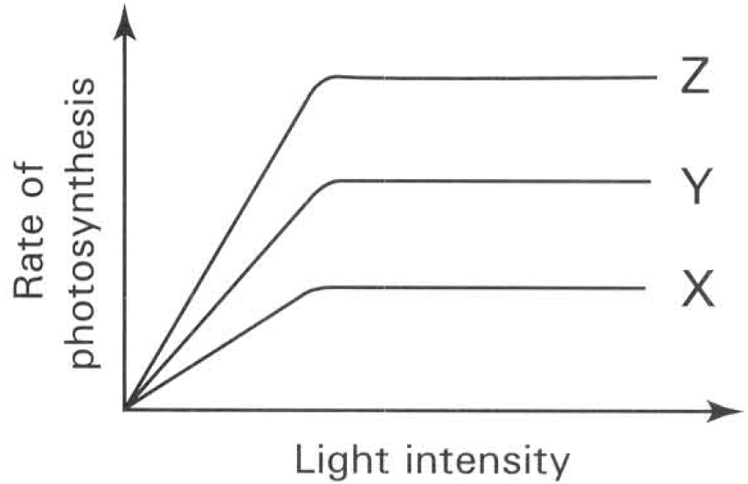
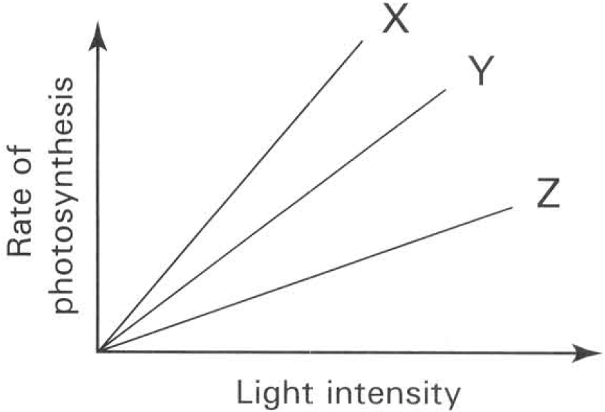
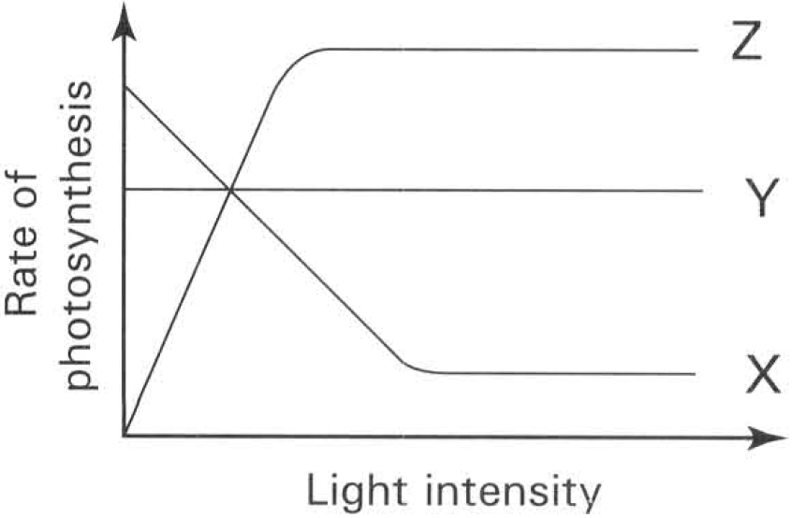
A. | B. | C. | D.

121. X is a sun-loving plant while Y is a shade-loving plant. Which of the following graphs best illustrates the relationship between their leaf area and the light intensity?
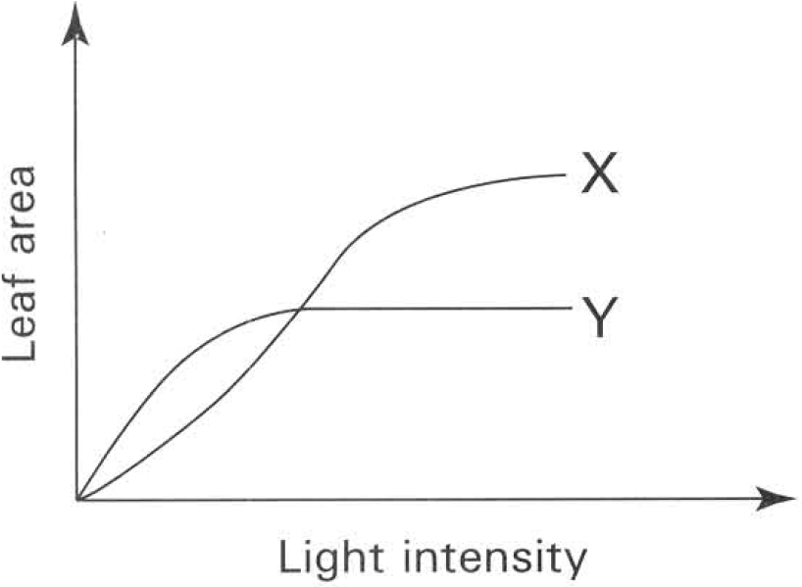
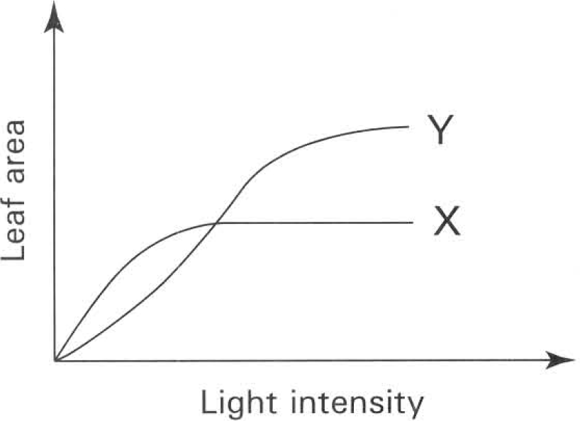
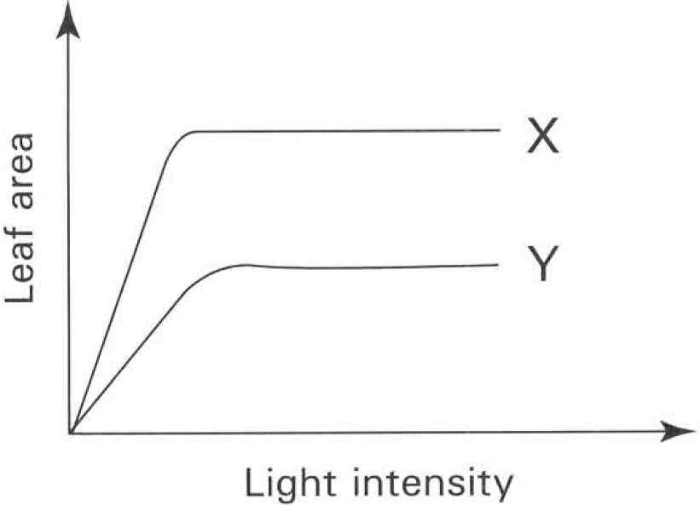
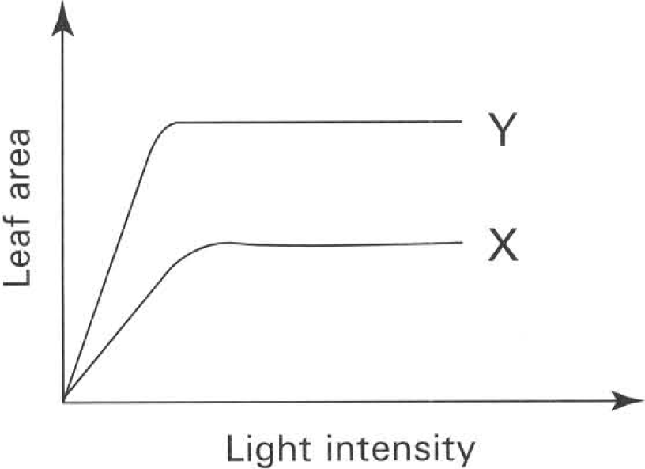
A. | B. | C. | D.

Directions: Questions 122 to 125 refer to the graph below, which shows the relative rate of carbon dioxide released or absorbed by a green plant at different time of the day.
122. What is the rate of respiration of the plant in arbitrary units of carbon dioxide released at mid-night?
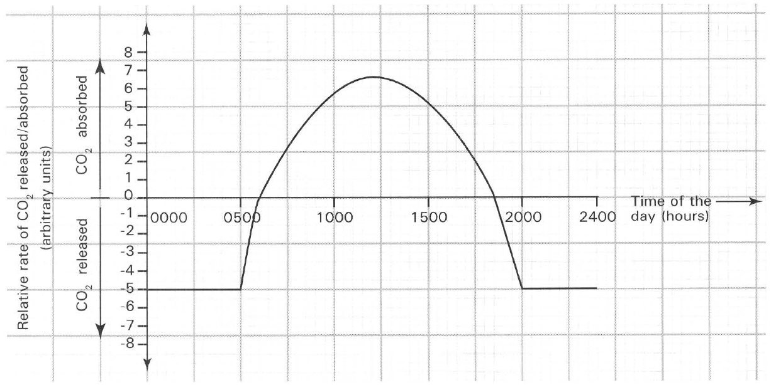
A. 0
B. -1
C. -3
D. -5

123. At what time of the day does the plant reach the compensatory point?
A. 0000 hour only
B. 0600 hour only
C. 1230 hour only
D. 0600 hour and 1830 hour only

124. What is the absolute rate of photosynthesis of the green plant in arbitrary units of carbon dioxide at 1100 hour of the day?
A. 0
B. 0.5
C. 5.5
D. 11.5

125. Which of the following statements can be deduced from the graph above?
(1) Only respiration occurs at 0000 hour of the day.
(2) There is a decrease in the dry weight of the plant from 1830 hour to 2400 hour.
(3) The release and the absorption of carbon dioxide of the plant depend on the light intensity at different time of the day.
(4) There is no photosynthetic activity in the plant from 1830 hour to 2400 hour.
A. (1) and (2) only
B. (2) and (3) only
C. (1) and (3) only
D. (1), (3) and (4) only

Directions : Questions 126 to 129 refer to the graph below, which shows the effect of increasing light intensity on the rate of photosynthesis of an aquatic plant in pond water under two different temperatures.
126. When the light intensity is at point Y, which of the following statements is CORRECT?
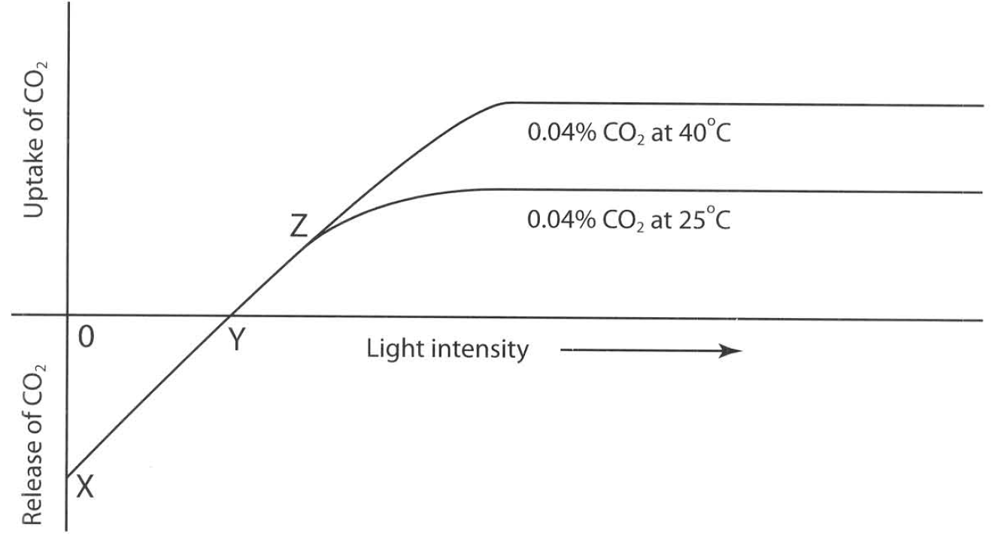
A. The rate of photosynthesis is faster than the rate of respiration.
B. The rate of respiration is faster than the rate of photosynthesis.
C. The rate of photosynthesis is equal to the rate of respiration.
D. Carbon dioxide is the limiting factor to the rate of photosynthesis.

127. Which of the following terms for points X, Y and Z are CORRECT?
(1) X is the compensation point in darkness.
(2) Y is the compensation point in the presence of light.
(3) Z is the saturation point.
A. (1) only
B. (2) only
C. (1) and (2) only
D. (2) and (3) only

Directions: Questions 126 to 129 refer to the graph of photosynthetic rate against light intensity at two temperatures.
128. When the light intensity is increased beyond point Z, the rate of photosynthesis does not increase further. The best explanation is
A. chlorophyll has been used up.
B. a factor other than light (for example carbon dioxide concentration) is limiting.
C. the plant has finished photosynthesis for the day.
D. the compensation point has been reached.

Directions : Questions 126 to 129 refer to the graph below, which shows the effect of increasing light intensity on the rate of photosynthesis of an aquatic plant in pond water under two different temperatures.
129. Which of the following is/are the limiting factor(s) when the carbon dioxide concentration is maintained at 0.04% and the temperature is maintained at 40°C?
(1) Carbon dioxide concentration (2) Light intensity (3) Temperature
A. (1) only
B. (2) only
C. (3) only
D. None of the above

130. The rate of photosynthesis of a leaf can be measured by finding the gain in weight of the leaf after a period of exposure to light. The actual rate of photosynthesis is affected by the occurrence of other biological processes. Which of the following processes should be considered in making correction to find out the actual gain in weight of the leaf?
(1) Transpiration (2) Respiration
(3) Outward translocation of organic matter (4) Absorption of water from the root
A. (1) and (2) only
B. (2) and (3) only
C. (3) and (4) only
D. (1) and (4) only

Directions: Questions 131 to 142 refer to the following diagram, which shows the transverse section of a leaf.
131. Which of the following is/are the main function(s) of the part labelled 1?
(1) Reduces the loss of water from the leaf
(2) Provides mechanical support to the leaf
(3) Prevents the bacterial and fungal infection
(4) Reduces the heat lost from the leaf
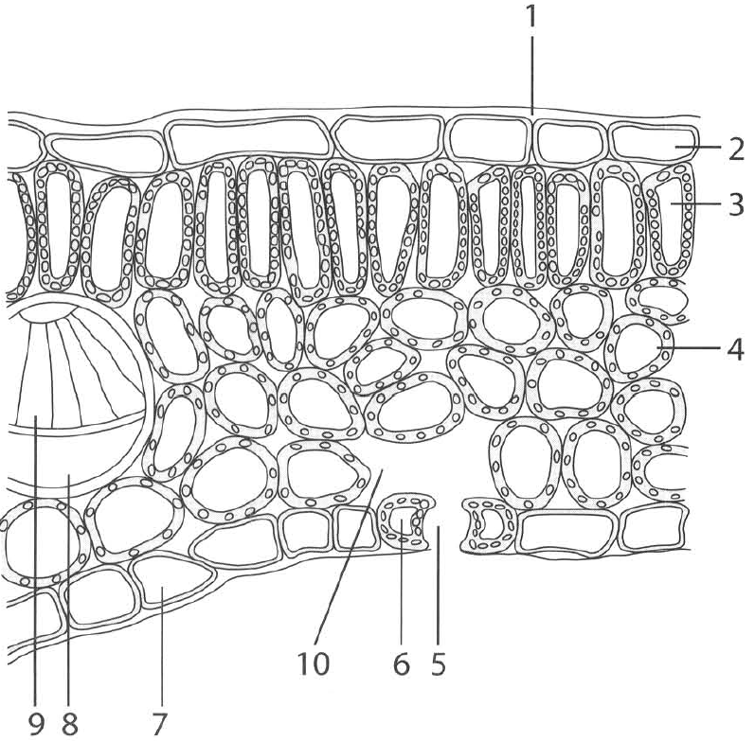
A. (1) only
B. (2) only
C. (2) and (3) only
D. (3) and (4) only

132. Which of the following structures BOTH possess chloroplasts?
A. 2 and 4
B. 4 and 6
C. 7 and 8
D. 8 and 9

133. In a bright sunny day, the two gases that pass out of the pore labelled 5 are
(1) oxygen. (2) carbon dioxide. (3) water vapour. (4) hydrogen.
A. (1) only
B. (2) and (4) only
C. (1) and (3) only
D. (2) and (3) only

134. In a dry day without wind, the amount of gases passing through the pore labelled 5 is indirectly controlled by
A. the amount of soluble substances in the cell sap of the cells surrounding the pore labelled 5.
B. the nitrogen content of the soil.
C. the percentage of oxygen in air.
D. the thickness of the cell layer labelled 7.

135. The carbohydrates synthesized in the chlorophyllous cells of the leaf are transported to the growing points and storage organs of the plant via
A. 4.
B. 8.
C. 6.
D. 9.

136. In a sunny day the gas present in the highest concentration in the air space labelled 10 is
A. carbon dioxide.
B. oxygen.
C. nitrogen.
D. water vapour.

137. Structure that provides mechanical support to the leaf is
A. 4.
B. 7.
C. 8.
D. 9.

138. Which of the following matching is CORRECT?
 | 1 | 3 | 4 | 5 | 8 | 9
A. | Upper epidermis | Palisade mesophyll | Spongy mesophyll | Guard cell | Xylem | Phloem
B. | Cuticle | Palisade mesophyll | Spongy mesophyll | Stoma | Xylem | Phloem
C. | Cuticle | Palisade mesophyll | Spongy mesophyll | Stoma | Phloem | Xylem
D. | Upper epidermis | Spongy mesophyll | Palisade mesophyll | Guard cell | Xylem | Phloem

139. The rate of water loss through the pore labelled 5 is controlled by
(1) atmospheric humidity. (2) wind velocity. (3) light intensity.
(4) air temperature. (5) water content of the soil.
A. (2) and (3) only
B. (2), (3) and (4) only
C. (3), (4) and (5) only
D. (1), (2), (3), (4) and (5)

140. A leaf having the above structures is immersed in water maintained at 80 °
A. 1
B. 2
C. 5
D. 7

141. The bubbles that appear on the leaf surface are due to
A. the continuous production of carbon dioxide by the respiration of the mesophyll cells.
B. the continuous production of oxygen by the photosynthesis of mesophyll cells.
C. the expansion of air originally present in the intercellular space.
D. the loss of water vapour by transpiration.

142. Which of the following structures is/are ABSENT in the submerged leaves of aquatic plants?
A. 1 only
B. 5 only
C. 1 and 5 only
D. 1, 5 and 8

143. Which of the following are the functions of the mid-rib in a leaf?
(1) Gives support and strength to the leaf
(2) Exchanges gases with the surroundings.
(3) Synthesizes food.
(4) Transports water, mineral salts and food.
A. (1) and (2) only
B. (1) and (4) only
C. (2) and (3) only
D. (3) and (4) only

Answers
Answers are printed in red. No. 18 and No. 19 are shown as tables (Leaf A/B and Leaf X/Y). A table of answers and distractors, and class percentages from a previous photosynthesis form, is at the end.
1. A. chemical energy.
Usual slip: B. This is the usual wrong choice for this item.
2. B. The primary product of photosynthesis can be converted to lipids for storage.
Usual slip: A. This is the usual wrong choice for this item.
3. C. (3) only
Usual slip: D. This is the usual wrong choice for this item.
4. C. At night, plants always have a net release of carbon dioxide.
Usual slip: D. This is the usual wrong choice for this item.
5. D. absorb light energy.
Usual slip: C. This is the usual wrong choice for this item.
6. D. (4), (3), (1), (2)
Usual slip: C. This is the usual wrong choice for this item.
7. B. rehydrate the leaf.
Usual slip: D. Step (1) is soaking in warm water after ethanol, to soften and rehydrate the leaf. Denaturing enzymes is the job of boiling water.
8. A. ethanol is a good solvent for organic molecules.
Usual slip: B. The lower boiling point is why ethanol is heated in a water bath. Ethanol is used because it dissolves chlorophyll.
9. A. alcohol can decolourize the leaf.
Usual slip: B. This is the usual wrong choice for this item.
10. C. glucose will be converted to starch when excess.
Usual slip: D. This is the usual wrong choice for this item.
11. C. kept in light for 4 hours.
Usual slip: D. This is the usual wrong choice for this item.
12. B. To prevent ethanol vapour from catching fire.
Usual slip: A. This is the usual wrong choice for this item.
13. D. Photosynthesis has occurred in the leaf.
Usual slip: C. This is the usual wrong choice for this item.
14. A. to be absorbed by chlorophyll.
Usual slip: B. This is the usual wrong choice for this item.
15. B. carbon dioxide is consumed during photosynthesis.
Usual slip: A. This is the usual wrong choice for this item.
16. B. carbon dioxide.
Usual slip: A. This is the usual wrong choice for this item.
17. C. deprive the potted plant of starch reserve.
Usual slip: D. Destarching is confused with making chlorophyll.
18. C

Leaf A | Leaf B
blue-black | brown
Usual slip: D. Both leaves look the same if you forget that KOH removes carbon dioxide from leaf B.
19. C

Leaf X | Leaf Y
blue-black | brown
Usual slip: B. Both leaves stain blue-black if you forget that foil keeps light off leaf Y.
20. A. Leaf Y has not been kept in darkness long enough.
Usual slip: B. This is the usual wrong choice for this item.
21. B. To avoid the variations between leaves.
Usual slip: A. This is the usual wrong choice for this item.
22. D. its leaves are variegated.
Usual slip: C. This is the usual wrong choice for this item.
23. C (see the four leaf drawings)
Usual slip: A. The purple (no chlorophyll) region is often stained as if it had made starch.
24. B. Purple area of the leaf
Usual slip: A. This is the usual wrong choice for this item.
25. D. photolysis of water.
Usual slip: B. Oxygen is treated as if it came from carbon dioxide, not from photolysis of water.
26. A. hydrogen produced by photolysis of water.
Usual slip: B. U is drawn as a green box, so it is taken for chlorophyll. It is hydrogen from the photolysis of water.
27. B. Examples of anabolism: (1), (2), (4) and (5) ; Examples of catabolism: (3)
Usual slip: A. This is the usual wrong choice for this item.
28. A. guard cell.
Usual slip: B. This is the usual wrong choice for this item.
29. B. Light stage: production of oxygen ; Dark Stage: reduction of carbon dioxide
Usual slip: A. This is the usual wrong choice for this item.
30. D. 6CO₂ + 12 H₂¹⁸O → C₆H₁₂O₆ + 6¹⁸O₂ + 6H₂O
Usual slip: C. The ¹⁸O is put into glucose. The oxygen gas released comes from water.
31. C. 6C¹⁸O₂ + 12 H₂O → C₆H₁₂¹⁸O₆ + 6O₂ + 6 H₂¹⁸O
Usual slip: A. The ¹⁸O from carbon dioxide is put into oxygen gas. That oxygen comes from water.
32. B. sodium hydrogencarbonate solution.
Usual slip: A. This is the usual wrong choice for this item.
33. D. glowing splint.
Usual slip: C. This is the usual wrong choice for this item.
34. D. (1), (2) and (3)
Usual slip: C. This is the usual wrong choice for this item.
35. C. (2) and (3) only
Usual slip: D. This is the usual wrong choice for this item.
36. B. Nitrogen: root ; oxygen: leaf ; carbon: stem
Usual slip: A. This is the usual wrong choice for this item.
37. B. C, D and E
Usual slip: A. This is the usual wrong choice for this item.
38. C. F
Usual slip: D. This is the usual wrong choice for this item.
39. D. G
Usual slip: C. This is the usual wrong choice for this item.
40. C. Blue and red
Usual slip: D. This is the usual wrong choice for this item.
41. D. They should be built using transparent glass.
Usual slip: C. This is the usual wrong choice for this item.
42. B. 2.
Usual slip: A. This is the usual wrong choice for this item.
43. C. 2 and 3.
Usual slip: D. This is the usual wrong choice for this item.
44. D. (1), (2) and (3)
Usual slip: C. This is the usual wrong choice for this item.
45. D. (1), (2) and (3)
Usual slip: C. This is the usual wrong choice for this item.
46. A. Parts of leaf: cuticle ; Function: to prevent entry of bacteria or fungi
Usual slip: B. This is the usual wrong choice for this item.
47. D. (1), (2) and (3)
Usual slip: C. This is the usual wrong choice for this item.
48. B. leaf epidermis.
Usual slip: A. This is the usual wrong choice for this item.
49. C. In the daytime: carbon dioxide in ; At night: oxygen in
Usual slip: D. This is the usual wrong choice for this item.
50. B. Water vapour
Usual slip: A. This is the usual wrong choice for this item.
51. A. it absorbs mainly red and blue lights.
Usual slip: B. This is the usual wrong choice for this item.
52. D. (2) and (3) only
Usual slip: C. This is the usual wrong choice for this item.
53. D. (3) and (4) only
Usual slip: C. This is the usual wrong choice for this item.
54. D. have yellow leaves.
Usual slip: C. This is the usual wrong choice for this item.
55. B. chlorophyll synthesis.
Usual slip: A. This is the usual wrong choice for this item.
56. D. (1), (2) and (3)
Usual slip: C. This is the usual wrong choice for this item.
57. C. young seedlings have less mineral reserve.
Usual slip: D. This is the usual wrong choice for this item.
58. A. supply oxygen to the roots.
Usual slip: B. This is the usual wrong choice for this item.
59. D. light will stimulate algal growth which consumes mineral ions.
Usual slip: C. This is the usual wrong choice for this item.
60. A. (1) only
Usual slip: B. This is the usual wrong choice for this item.
61. C. The green plant that absorbs solar energy to change simple inorganic molecules into complex organic molecules.
Usual slip: D. This is the usual wrong choice for this item.
62. C. Green light is the most effective part of the visible spectrum for photosynthesis.
Usual slip: D. This is the usual wrong choice for this item.
63. D. Oxygen comes from the photolysis of water in the light-dependent stage.
Usual slip: C. This is the usual wrong choice for this item.
64. B. Oxygen
Usual slip: D. Students put the label from water into both sugar and oxygen.
65. C. both day time and night time.
Usual slip: D. This is the usual wrong choice for this item.
66. B. (1): Water ; (2): Oxygen ; (3): Carbon dioxide ; (4): Carbohydrate
Usual slip: A. This is the usual wrong choice for this item.
67. B. (5): ADP ; (6): NADPH
Usual slip: A. This is the usual wrong choice for this item.
68. B. Y: Thylakoid ; Z: Stroma
Usual slip: A. This is the usual wrong choice for this item.
69. C. chloroplast.
Usual slip: D. This is the usual wrong choice for this item.
70. D. spongy cells of leaf.
Usual slip: C. This is the usual wrong choice for this item.
71. B. X: Thylakoids ; Y: Starch grain ; Z: Stroma
Usual slip: A. This is the usual wrong choice for this item.
72. D. X: Photophosphorylation ; Y: Storage of carbohydrate ; Z: Fixation of carbon dioxide
Usual slip: C. This is the usual wrong choice for this item.
73. C. X: ATP and oxygen ; Z: Carbohydrate and water
Usual slip: D. This is the usual wrong choice for this item.
74. D. X: Chlorophyll a ; Y: Carotenoids ; Z: Chlorophyll b
Usual slip: C. This is the usual wrong choice for this item.
75. A. Violet + red
Usual slip: B. This is the usual wrong choice for this item.
76. D. The carbon dioxide content of the water in the aquarium increases.
Usual slip: C. This is the usual wrong choice for this item.
77. D. chlorophyll is least effective to absorb green light.
Usual slip: C. This is the usual wrong choice for this item.
78. D. The crop production would decrease.
2. Energy conversion
Usual slip: C. This is the usual wrong choice for this item.
79. D. (1) and (4) only
Usual slip: C. This is the usual wrong choice for this item.
80. B. (2) and (3) only
Usual slip: A. This is the usual wrong choice for this item.
81. C. (3) (1) (4) (2)
Usual slip: D. This is the usual wrong choice for this item.
82. A. (1), (2) and (4) only
Usual slip: B. This is the usual wrong choice for this item.
83. C. (1), (4) and (5) only
Usual slip: D. This is the usual wrong choice for this item.
84. B. Photophosphorylation
Usual slip: A. This is the usual wrong choice for this item.
85. C. Photophosphorylation of ADP and reduction of NADP
Usual slip: D. This is the usual wrong choice for this item.
86. D. (1), (2) and (4) only
Usual slip: C. This is the usual wrong choice for this item.
87. C. The conversion of the first product of carbon fixation to carbohydrate is a reaction involving reduction.
Usual slip: D. This is the usual wrong choice for this item.
88. D. NADP
Usual slip: C. Carbon dioxide is fixed in the light-independent stage. The hydrogen acceptor in the light-dependent stage is NADP.
89. B. ATP increases; carbon dioxide acceptor increases; first product of carbon fixation decreases
Usual slip: A. This is the usual wrong choice for this item.
90. B. (2) and (3) only
Usual slip: A. This is the usual wrong choice for this item.
91. D. First product of carbon fixation
Usual slip: C. This is the usual wrong choice for this item.
92. B. that carbon dioxide is essential to photosynthesis.
Usual slip: A. This is the usual wrong choice for this item.
93. A. removing solid potassium hydroxide from the funnel and the dish.
Usual slip: B. This is the usual wrong choice for this item.
94. D. Starch is not formed in the shoot in the first part of the experiment but formed in the control.
Usual slip: C. This is the usual wrong choice for this item.
95. D. the whole set-up must be left in darkness for 48 hours.
Usual slip: C. This is the usual wrong choice for this item.
96. B. (2), (3), (4) and (1)
Usual slip: A. This is the usual wrong choice for this item.
97. B. Hydrogencarbonate indicator solution
Usual slip: A. This is the usual wrong choice for this item.
98. D. chlorophyll is essential for photosynthesis.
Usual slip: C. This is the usual wrong choice for this item.
99. D (see the four leaf drawings)
Usual slip: C. This is the usual wrong choice for this item.
100. C. destarching.
Usual slip: D. This is the usual wrong choice for this item.
101. D. remove the starch previously stored in the leaf
Usual slip: C. This is the usual wrong choice for this item.
102. B. remove the carbon dioxide from the jar.
Usual slip: A. This is the usual wrong choice for this item.
103. D (see the four leaf drawings)
Usual slip: C. This is the usual wrong choice for this item.
104. D. (1), (3) and (4) only
Usual slip: C. This is the usual wrong choice for this item.
105. D. denature the enzymes in order to stop the metabolic activities of the leaf cells.
Usual slip: C. This is the usual wrong choice for this item.
106. A. decolourize the leaf.
Usual slip: B. This is the usual wrong choice for this item.
107. B. the highly inflammable alcohol vapour to catch fire.
Usual slip: A. This is the usual wrong choice for this item.
108. D. Starch can easily be detected by the conspicuous colour change in the iodine test.
Usual slip: C. This is the usual wrong choice for this item.
109. A. The pH increases between X and Y because of the decrease in the carbon dioxide concentration in pond water due to the occurrence of photosynthesis.
Usual slip: B. This is the usual wrong choice for this item.
110. D. The gas released from the illuminated green plant has higher oxygen content than that of the atmosphere.
Usual slip: C. This is the usual wrong choice for this item.
111. C. (3) only
Usual slip: D. This is the usual wrong choice for this item.
112. D. (1), (2) and (3)
Usual slip: C. This is the usual wrong choice for this item.
113. C. water which is one of the raw materials required for photosynthesis.
Usual slip: D. This is the usual wrong choice for this item.
114. B. Photosynthesis
Usual slip: A. This is the usual wrong choice for this item.
115. B. Leaves fall in every autumn.
Usual slip: A. This is the usual wrong choice for this item.
116. A. Carbon dioxide
Usual slip: B. This is the usual wrong choice for this item.
117. D. proteins.
Usual slip: C. This is the usual wrong choice for this item.
118. A. Graph A
Usual slip: B. This is the usual wrong choice for this item.
119. B. Temperature (°C): 25 ; Carbon dioxide concentration (%): 0.01
Usual slip: A. This is the usual wrong choice for this item.
120. A. Graph A
Usual slip: B. This is the usual wrong choice for this item.
121. B. Graph B
Usual slip: A. This is the usual wrong choice for this item.
122. D. -5
Usual slip: C. This is the usual wrong choice for this item.
123. D. 0600 hour and 1830 hour only
Usual slip: C. This is the usual wrong choice for this item.
124. D. 11.5
Usual slip: C. This is the usual wrong choice for this item.
125. B. (2) and (3) only
Usual slip: A. This is the usual wrong choice for this item.
126. C. The rate of photosynthesis is equal to the rate of respiration.
Usual slip: D. This is the usual wrong choice for this item.
127. D. (2) and (3) only
Usual slip: C. This is the usual wrong choice for this item.
128. B. a factor other than light (for example carbon dioxide concentration) is limiting.
Usual slip: A. This is the usual wrong choice for this item.
129. A. (1) only
Usual slip: B. This is the usual wrong choice for this item.
130. B. (2) and (3) only
Usual slip: A. This is the usual wrong choice for this item.
131. A. (1) only
Usual slip: B. This is the usual wrong choice for this item.
132. B. 4 and 6
Usual slip: A. This is the usual wrong choice for this item.
133. C. (1) and (3) only
Usual slip: D. This is the usual wrong choice for this item.
134. A. the amount of soluble substances in the cell sap of the cells surrounding the pore labelled 5.
Usual slip: B. This is the usual wrong choice for this item.
135. B. 8.
Usual slip: A. This is the usual wrong choice for this item.
136. C. nitrogen.
Usual slip: D. This is the usual wrong choice for this item.
137. D. 9.
Usual slip: C. This is the usual wrong choice for this item.
138. C. 1: Cuticle ; 3: Palisade mesophyll ; 4: Spongy mesophyll ; 5: Stoma ; 8: Phloem ; 9: Xylem
Usual slip: D. This is the usual wrong choice for this item.
139. D. (1), (2), (3), (4) and (5)
Usual slip: C. This is the usual wrong choice for this item.
140. C. 5
Usual slip: D. This is the usual wrong choice for this item.
141. C. the expansion of air originally present in the intercellular space.
Usual slip: D. This is the usual wrong choice for this item.
142. C. 1 and 5 only
Usual slip: D. This is the usual wrong choice for this item.
143. B. (1) and (4) only
Usual slip: A. This is the usual wrong choice for this item.

Percentage correct and distractor
The distractor is the choice written to catch the usual slip on this paper.
Q | Answer | Distractor
1 | A | B
2 | B | A
3 | C | D
4 | C | D
5 | D | C
6 | D | C
7 | B | D
8 | A | B
9 | A | B
10 | C | D
11 | C | D
12 | B | A
13 | D | C
14 | A | B
15 | B | A
16 | B | A
17 | C | D
18 | C | D
19 | C | B
20 | A | B
21 | B | A
22 | D | C
23 | C | A
24 | B | A
25 | D | B
26 | A | B
27 | B | A
28 | A | B
29 | B | A
30 | D | C
31 | C | A
32 | B | A
33 | D | C
34 | D | C
35 | C | D
36 | B | A
37 | B | A
38 | C | D
39 | D | C
40 | C | D
41 | D | C
42 | B | A
43 | C | D
44 | D | C
45 | D | C
46 | A | B
47 | D | C
48 | B | A
49 | C | D
50 | B | A

Q | Answer | Distractor
51 | A | B
52 | D | C
53 | D | C
54 | D | C
55 | B | A
56 | D | C
57 | C | D
58 | A | B
59 | D | C
60 | A | B
61 | C | D
62 | C | D
63 | D | C
64 | B | D
65 | C | D
66 | B | A
67 | B | A
68 | B | A
69 | C | D
70 | D | C
71 | B | A
72 | D | C
73 | C | D
74 | D | C
75 | A | B
76 | D | C
77 | D | C
78 | D | C
79 | D | C
80 | B | A
81 | C | D
82 | A | B
83 | C | D
84 | B | A
85 | C | D
86 | D | C
87 | C | D
88 | D | C
89 | B | A
90 | B | A
91 | D | C
92 | B | A
93 | A | B
94 | D | C
95 | D | C
96 | B | A
97 | B | A
98 | D | C
99 | D | C
100 | C | D

Q | Answer | Distractor
101 | D | C
102 | B | A
103 | D | C
104 | D | C
105 | D | C
106 | A | B
107 | B | A
108 | D | C
109 | A | B
110 | D | C
111 | C | D
112 | D | C
113 | C | D
114 | B | A
115 | B | A
116 | A | B
117 | D | C
118 | A | B
119 | B | A
120 | A | B
121 | B | A
122 | D | C
123 | D | C
124 | D | C
125 | B | A
126 | C | D
127 | D | C
128 | B | A
129 | A | B
130 | B | A
131 | A | B
132 | B | A
133 | C | D
134 | A | B
135 | B | A
136 | C | D
137 | D | C
138 | C | D
139 | D | C
140 | C | D
141 | C | D
142 | C | D
143 | B | A

Class performance on a previous Photosynthesis MC form
These percentages are from a 32-item Google Form (two classes, n = 11 and n = 12). The numbering is that form’s numbering, not this compiled paper.
Q (previous form) | Answer | % correct | Distractor
1 | C | 95.7% | A
2 | A | 78.3% | B
3 | B | 82.6% | C
4 | D | 100.0% | A
5 | C | 95.7% | D
6 | D | 87.0% | C
7 | C | 69.6% | A
8 | A | 17.4% | B
9 | D | 91.3% | A
10 | B | 69.6% | A
11 | C | 47.8% | A
12 | C | 100.0% | A
13 | D | 60.9% | A
14 | C | 34.8% | B
15 | B | 78.3% | A
16 | C | 91.3% | A
17 | D | 82.6% | C
18 | C | 78.3% | D
19 | D | 100.0% | A
20 | D | 95.7% | A
21 | D | 82.6% | A
22 | B | 73.9% | D
23 | C | 69.6% | D
24 | D | 87.0% | A
25 | B | 39.1% | A
26 | C | 73.9% | A
27 | B | 87.0% | A
28 | C | 30.4% | B
29 | C | 47.8% | B
30 | C | 78.3% | A
31 | B | 73.9% | D
32 | D | 26.1% | B

