Photosynthesis · school exam items under 80% correct
Multiple-choice practice
Name: ________________________ Class: ____________
These multiple-choice items were answered correctly by fewer than 80% of students in SSGC biology school examinations (2023–24 to 2025–26, whole-cohort optical-mark statistics). Items are sorted from lowest to highest percentage correct. Choose the one best answer.
1. [exam 2324 F6 final Q20, 13% correct] Which of the following structures contain DNA? (1) Nucleus (2) Chloroplast (3) Mitochondria (4) Rough endoplasmic reticulum
A. (1) only
B. (1) and (2) only
C. (1), (2) and (3) only
D. (1), (2), (3) and (4)
2. [exam 2425 F4 mid Q25, 25% correct] The photomicrographs show cell G and cell H.
HHGG
Which of the following statement about cells G and H is correct?
A.The c ell membrane is present in cell G, while it is absent in cell H.

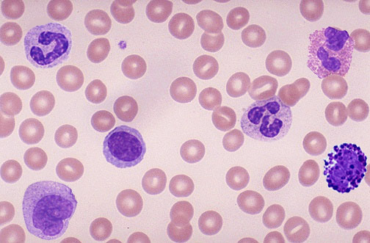
B. Chloroplasts are present in cell H, while they are absent in cell G.
C. Both cells H and G can carry out respiration.
D. A nucleus is present in cell H, while it is absent in cell G.
3. [exam 2324 F4 final Q12, 25% correct] The table below shows the uptake of some nutrients through the roots of a plant in the presence and absence of oxygen.
What of the following conclusions can be drawn from the data in the table?
Nutrients | Rate of uptake (arbitrary units / day)
 | Presence of oxygen | Absence of oxygen
Water | 39.2 | 39.0
Nitrates | 21.2 | 1.7
Phosphates | 15.1 | 2.2

A. Photosynthesis can speed up the absorption of nitrates and phosphates from the soil.
B. The uptake of nitrates can occur when the concentration of nitrates in the root hair cells is higher than that in the soil water.
C. The uptake of phosphates cannot take place in the absence of oxygen.
D. The uptake of water requires oxygen.
4. [exam 2526 F5 final Q3, 26% correct] Radioactively labelled nitrogen is used to trace how a young seedling grows. After several days, the radioactive markers are detected in various parts of the plant's new cells. In which of the following parts would the radioactive nitrogen be found?
(1) The DNA stored within the nucleus
(2) The starch grains stored in the chloroplast
(3) The cell membrane
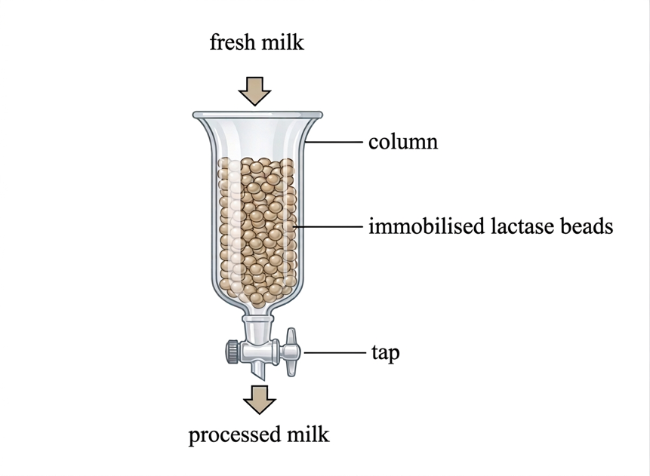
A. (1) and (2) only B. (1) and (3) only
C. (2) and (3) only D. (1), (2) and (3) Directions: Questions 4 and 5 refer to the diagram below, which illustrates an industrial set-up used to produce lactose-free milk. The column is packed with beads containing immobilised lactase on their surface. Fresh milk is passed through the column to undergo a catalytic reaction.
5. [exam 2526 F4 final Q13, 29% correct] The diagram below shows the cross section of a leaf:
Which of the following comparisons of the different cell types are correct?
(1) Cell type X contains thicker cell walls than cell type Z.
(2) Cell type W contains more chloroplasts than cell type Y.
(3) Cell type X contains a larger vacuole than cell type Z.
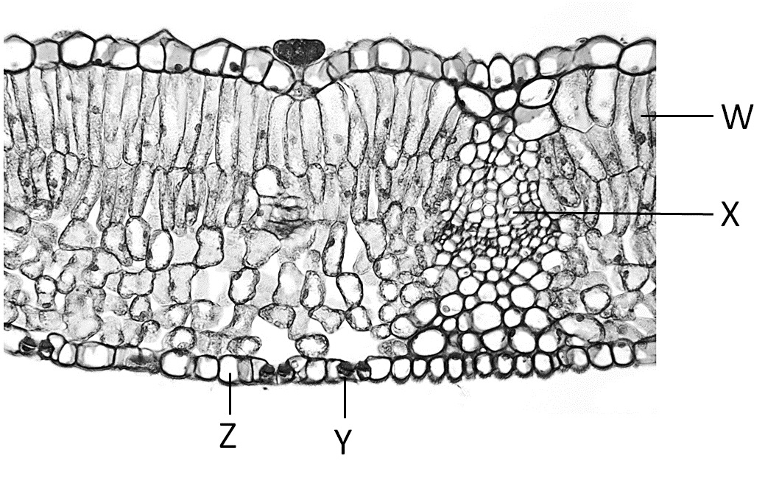
 | Features
 | Chlorophyll | Seeds | Fruits
I | + | + | +
II | - | - | -
III | + | + | -
IV | + | - | -

A. (1) and (2) only
B. (1) and (3) only
C. (2) and (3) only
D. (1), (2) and (3) Directions: Questions 14 and 15 refer to the table below, which shows some features of four organisms. Key: + Present - Absent
6. [exam 2425 F6 final Q28, 31% correct] The diagram below shows how the rate of photosynthesis is affected by different conditions.
What of the following limiting factor for photosynthesis at points 1, 2 and 3 can be deduced from the graph?
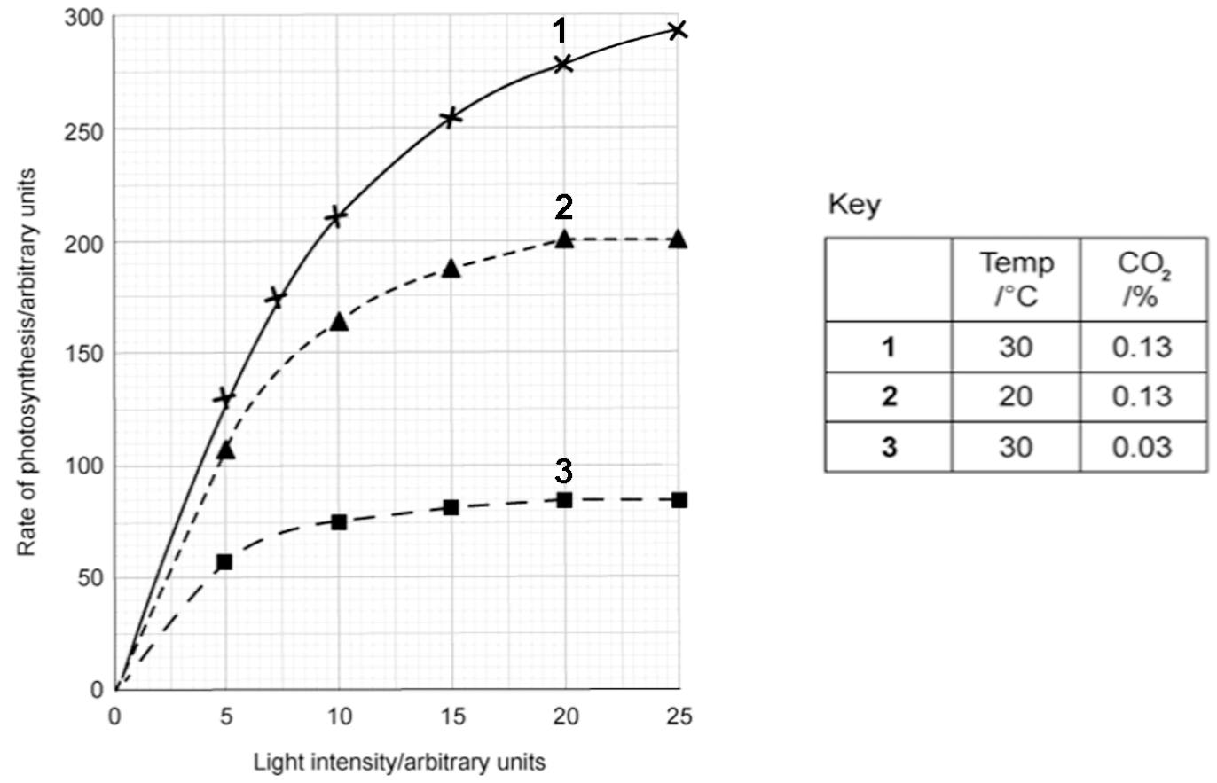
7. [exam 2324 F4 mid Q35, 33% correct] What would happen to the rate of oxygen production and the final volume of oxygen collected if more potato discs were used?
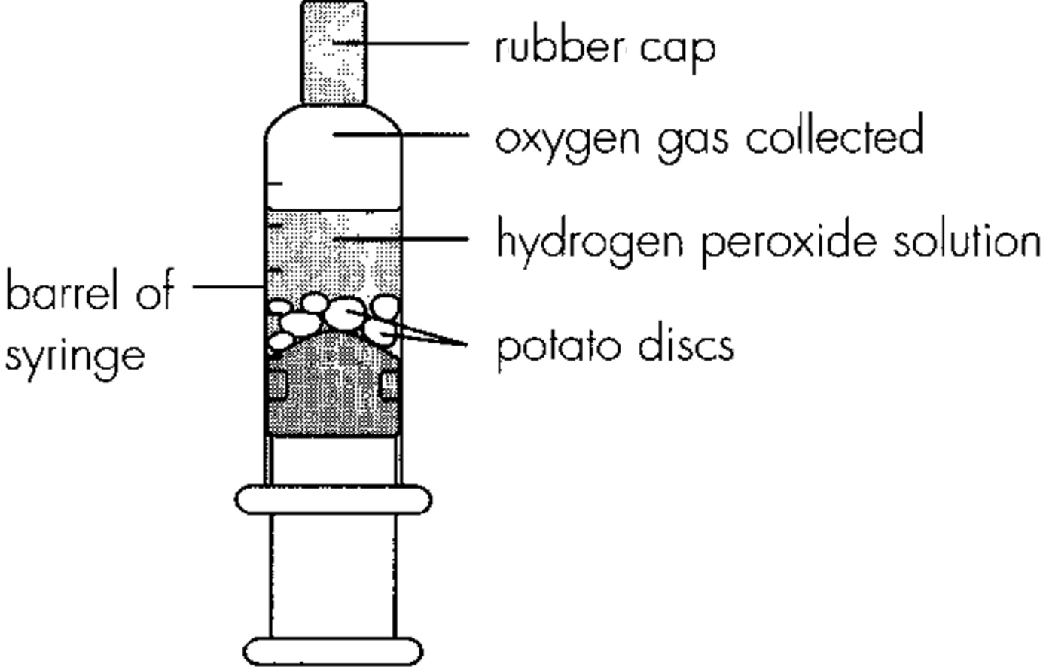
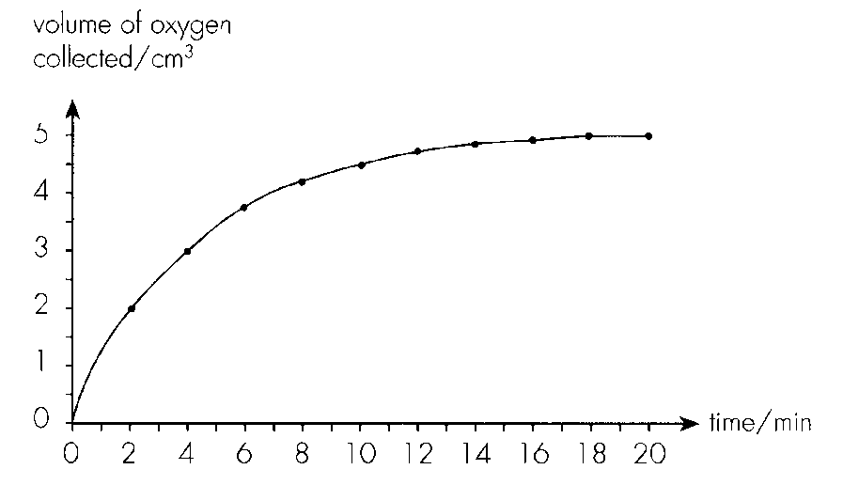
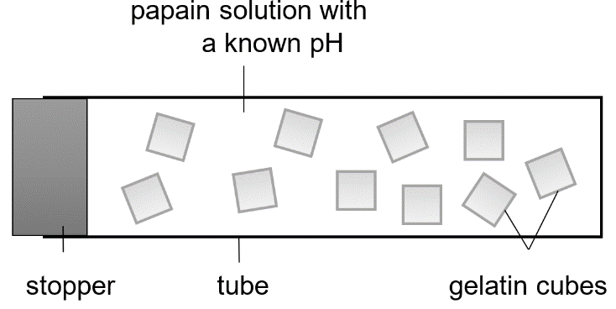
 | Rate of oxygen production | Final volume of oxygen
A. | remain unchanged | increase
B. | decrease | decrease
C. | increase | increase
D. | increase | remain unchanged

8. [exam 2425 F5 final Q25, 34% correct] The Venn diagram on the right compares and contrasts the cellular structure of animals, plants, and photosynthetic prokaryotes. Each circle represents a group of organisms, and the areas where the circles overlap represent features common to these organisms.
Which of the following combinations correctly identifies the sectors in which ribosomes, cell wall and chloroplasts should be placed?
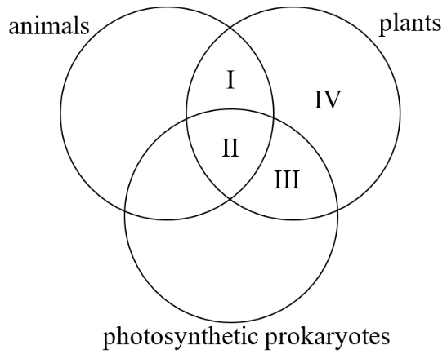
 | Ribosomes | Cell wall | Chloroplasts
A. | I | III | IV
B. | I | IV | III
C. | II | III | IV
D. | II | IV | III

9. [exam 2324 F4 final Q20, 38% correct] The photographs below show a type of aquatic organisms.
x1x100
Which of the following statements about these aquatic organisms is/are correct?
(1) They can carry out photosynthesis.
(2) They are eukaryotic.
(3) They belong to the kingdom Plantae.
A.( 1) only
B.( 1) and (2) only
C.( 2) and (3) only
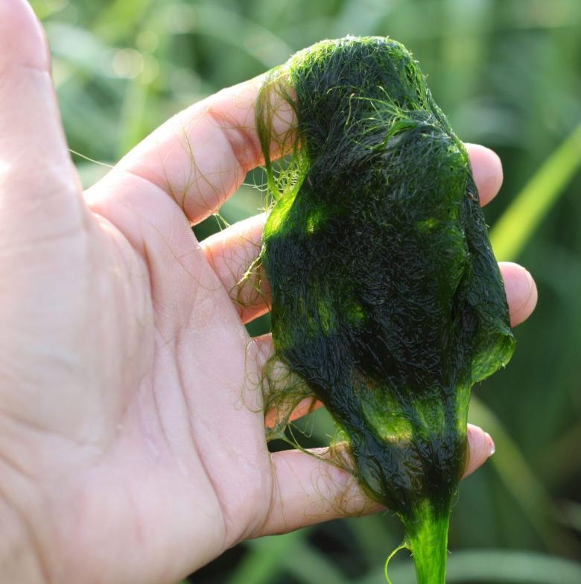
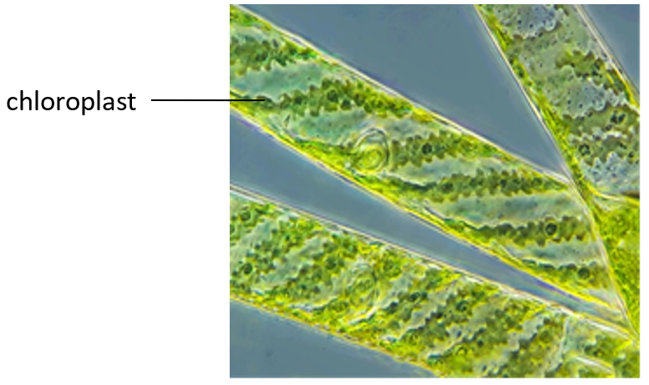
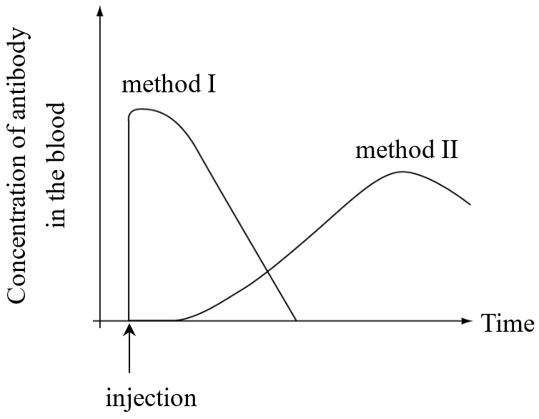
D. (1), (2) and (3) Directions: Questions 21 and 22 refer to the graph below, which shows the effects of two methods (I and II) on the concentration of antibody in the blood of a male.
10. [exam 2526 F4 mid Q29, 43% correct] How much oxygen is released from the plant during photosynthesis between 1200 and 1300 hour?
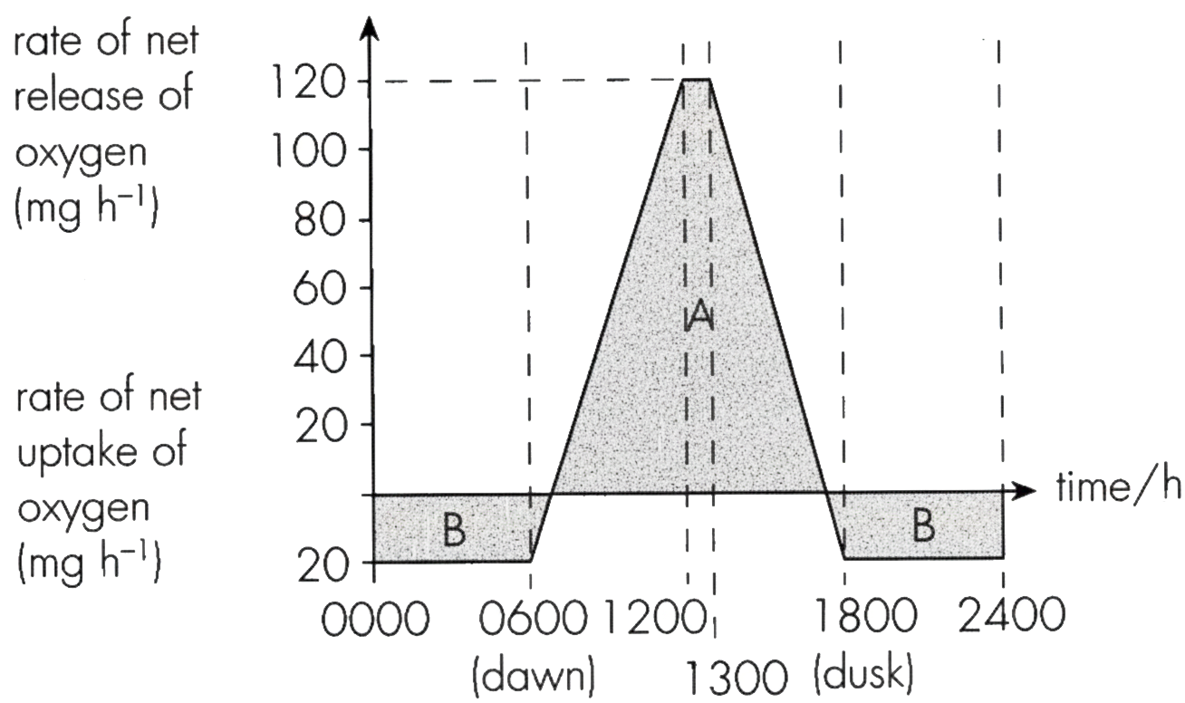
A. 100 mg
B. 120 mg
C. 140 mg
D. 160 mg
11. [exam 2324 F5 final Q24, 48% correct] Which of the following does not occur in the seedling a few days later? A.The curved shoot straightens. B.Young leaves develop to make food by photosynthesis. C.The cotyledons turn green and carry out photosynthesis. D.The food synthesized in photosynthesis is transported to the cotyledons for storage.
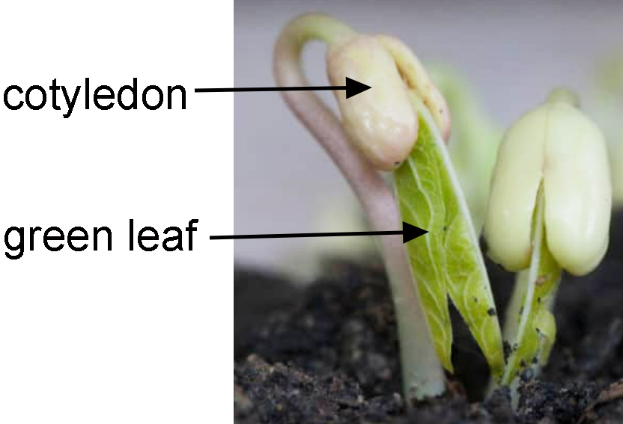
A. The curved shoot straightens.
B. Young leaves develop to make food by photosynthesis.
C. The cotyledons turn green and carry out photosynthesis.
D. The food synthesized in photosynthesis is transported to the cotyledons for storage.
12. [exam 2526 F3 final Q5, 48% correct] The table below compares the stem and root in a woody plant. Which row correctly indicates whether photosynthesis and gas exchange occur in these two parts? (Key: ✓ = Process occurs, ✗ = Process does not occur)
 | Stem | Root
 | Photosynthesis | Gas Exchange | Photosynthesis | Gas Exchange
A. | ✗ | ✗ | ✗ | ✗
B. | ✓ | ✓ | ✗ | ✓
C. | ✓ | ✗ | ✗ | ✗
D. | ✗ | ✓ | ✗ | ✓

13. [exam 2324 F6 final Q34, 58% correct] Which of the following correctly explains the difference in the water potential between the tissue near the developing shoots and the tissue in the centre of the tuber? A.The developing shoots absorbed nutrients from nearby tissue for their growth. B.Enzymes in the tissue near the developing shoots were activated. C. Stored food in the tissue near the developing shoots was converted to soluble food substances for the growth of shoots. D.Food produced by photosynthesis in the developing shoots was transported to nearby tissue.
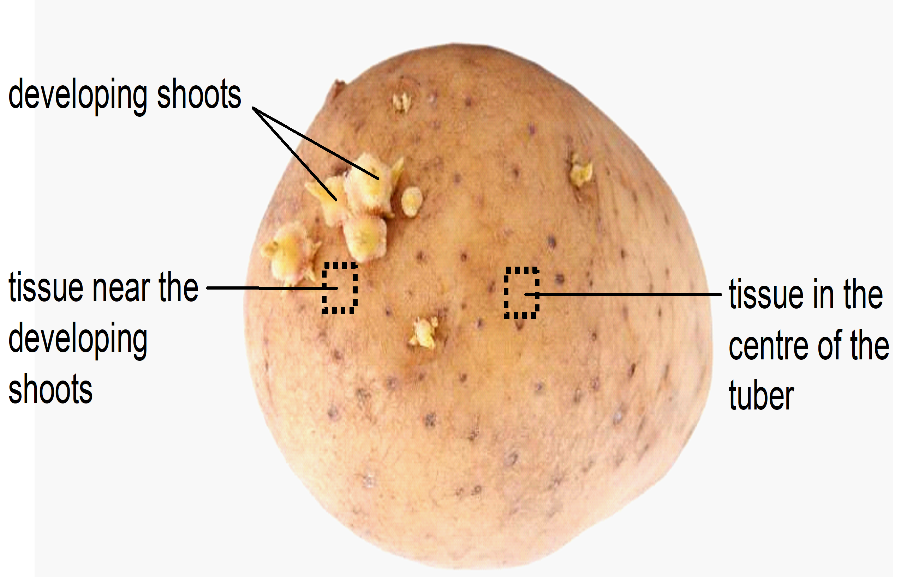
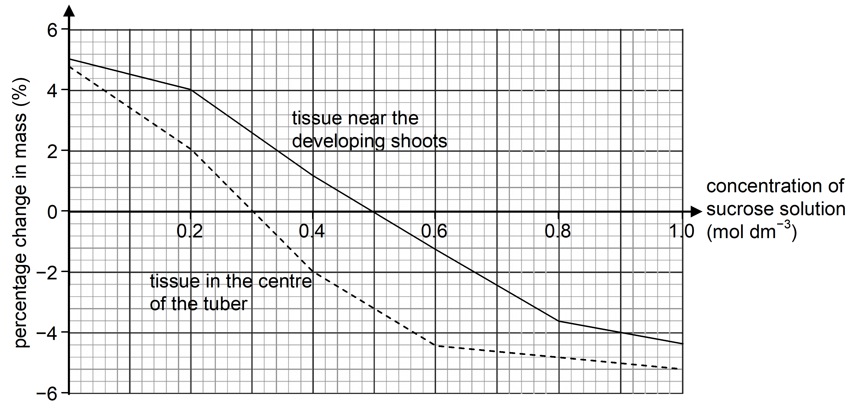
A. The developing shoots absorbed nutrients from nearby tissue for their growth.
B. Enzymes in the tissue near the developing shoots were activated.
C. Stored food in the tissue near the developing shoots was converted to soluble food substances for the growth of shoots.
D. Food produced by photosynthesis in the developing shoots was transported to nearby tissue.
14. [exam 2526 F6 final Q26, 61% correct] Which of the following statements regarding the gas collected is correct?
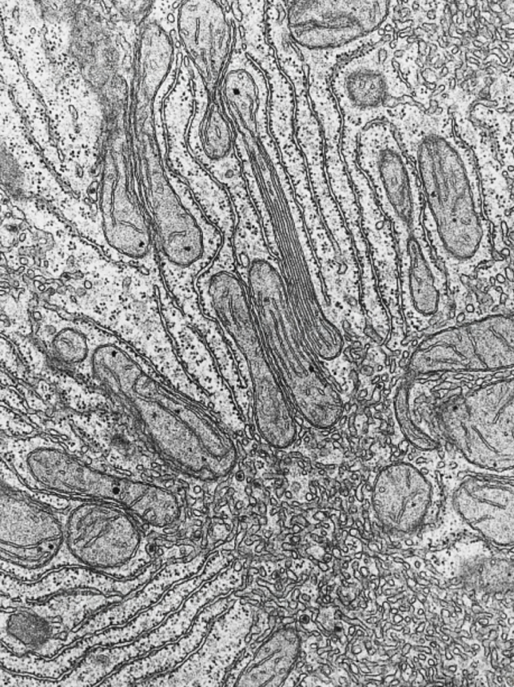
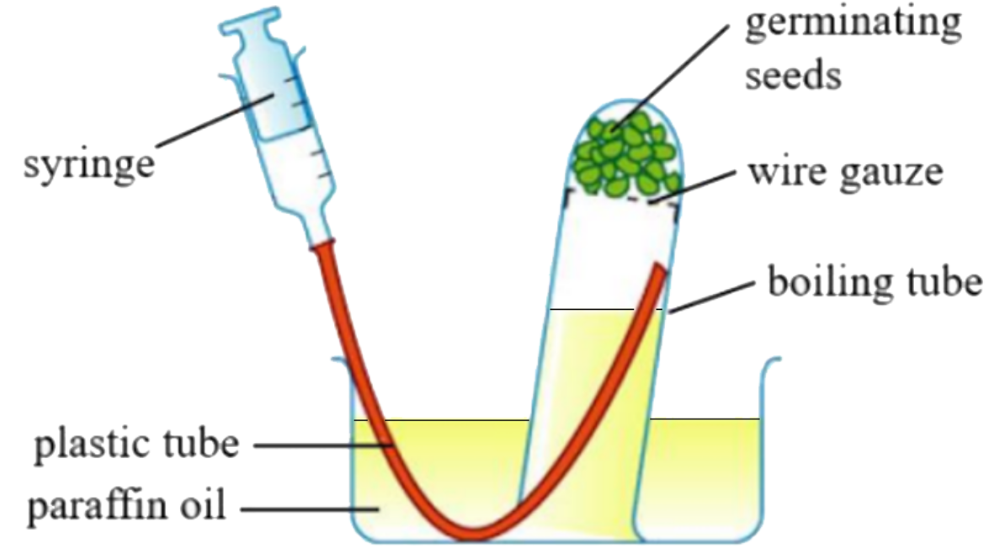
A. The gas is reabsorbed by the seeds for photosynthesis
B. The gas is produced from the Calvin cycle in the seeds.
C. The gas is produced in lactic acid fermentation in humans
D. The gas is produced in alcoholic fermentation in yeasts.
15. [exam 2324 F5 mid Q2, 61% correct] According to the table, which of the following statements best describes cell type R? B.It can carry out photosynthesis. C. It is primarily involved in lipid synthesis. D.It is active in cell division.
A. It actively participates in protein synthesis.
B. It can carry out photosynthesis.
C. It is primarily involved in lipid synthesis.
D. It is active in cell division.
16. [exam 2425 F3 final Q18, 61% correct] At a light intensity of 5 arbitrary units, how many arbitary units of carbon dioxide are used up in photosynthesis ?
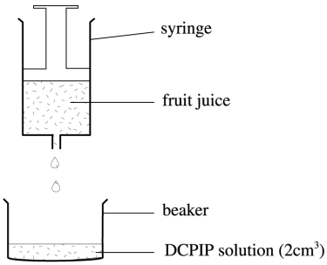
 | Fruit W | Fruit X | Fruit Y | Fruit Z
Number of drops of juice added | 2 | 3 | 4 | 6

A. –2 B. 0
C. 2 D. 4 Directions: Questions 19 and 20 refer to the diagram below, which shows an experiment to compare the vitamin C content in different fruit juice samples. The juice from each fruit sample was added drop by drop using a syringe to 2 cm3 of DCPIP solution until the DCPIP solution turned colourless. The results are shown in the table below.
17. [exam 2324 F5 final Q7, 61% correct] The graph below shows the rate of photosynthesis of two plants, I and II, under different conditions. Which of the following statements is/are correct? (1)Light intensity Y is the compensation point of the two plants. (2)At light intensity X, the two plants do not carry out photosynthesis. (3)Between light intensities X and Y, the reduction in carbon dioxide release is caused by an increase in temperature. A.(1) only B.(1) and (2) only C.(1) and (3) only D.(2) and (3) only
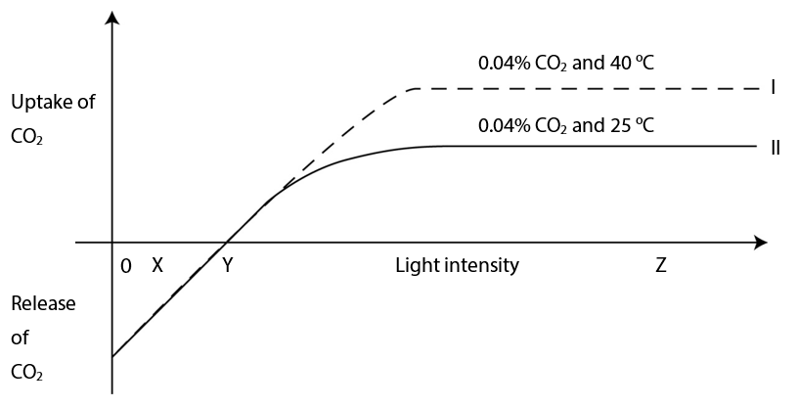
A. (1) only
B. (1) and (2) only
C. (1) and (3) only
D. (2) and (3) only
18. [exam 2425 F3 final Q17, 63% correct] Which of the following can be deduced from the graph ? (1)At a light intensity of 1 arbitrary unit, only respiration takes place. (2)At a light intensity of 2 arbitrary units, there is no net carbon dioxide taken in or given out. (3)At a light intensity of 9 arbitrary units, the rate of photosynthesis is greater than the rate of respiration.
A. (1) and (2) only
B. (1) and (3) only
C. (2) and (3) only
D. (1), (2) and (3)
19. [exam 2526 F6 final Q27, 64% correct] Paraquat is a herbicide that can stop the production of NADPH from the plants, thus inhibit ing photosynthesis. The herbicide most likely affects
A. the electron carriers involved in photochemical reactions located in the thylakoid membrane of chloroplasts.
B. the electron carriers involved in photochemical reactions located in the stroma of chloroplasts.
C. the enzymes involved in carbon fixation located in the thylakoid membrane of chloroplasts.
D. the enzymes involved in carbon fixation located in the stroma of chloroplasts.
20. [exam 2425 F4 mid Q3, 65% correct] Which of the following substances are obtained from the soil for plants to carry out photosynthesis?
(1) carbon dioxide (2) water (3)magnesium
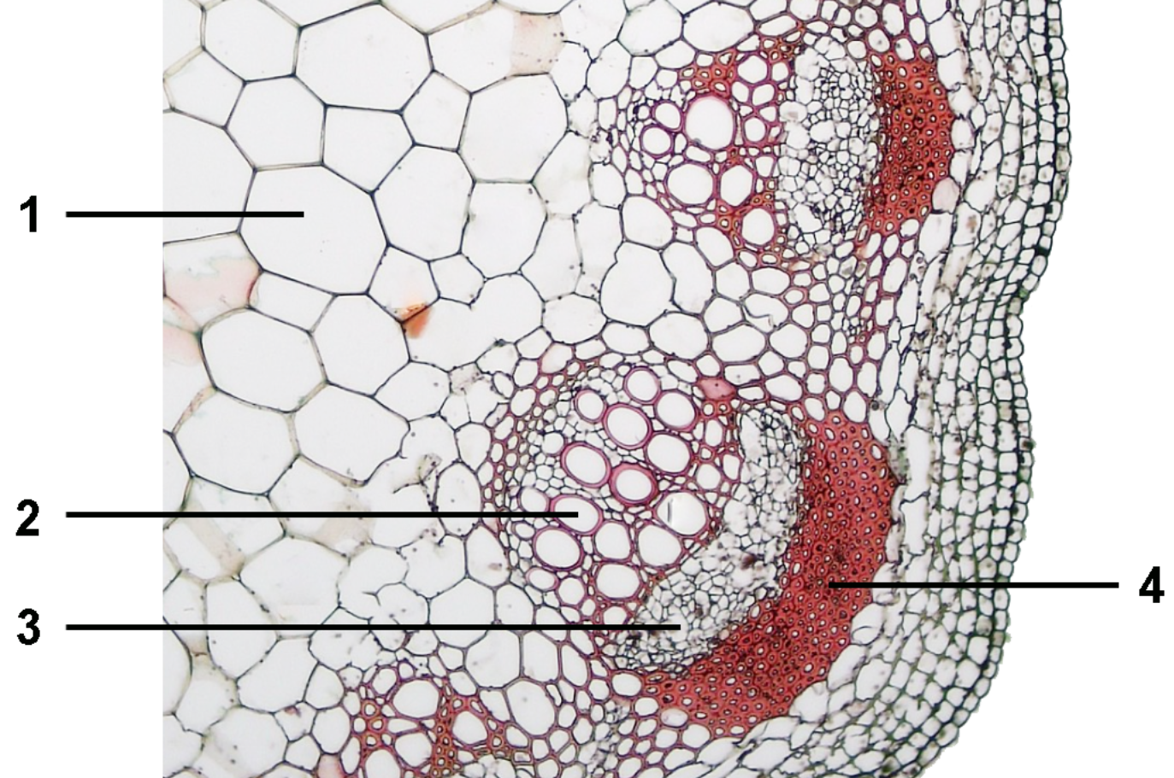
A. (1) and (2) only B. (1) and (3) only
C. (2) and (3) only D. (1), (2) and (3) Directions: Questions 4 to 6 refer to the diagram below, which shows a transverse section of the stem.
21. [exam 2324 F4 final Q2, 70% correct] 4 6 8 10 12 14 16 18 20 22 24Time (hour)Rate of oxygen release
(cm3 hr-1)Rate of oxygen uptake (cm3 hr-1)300250200150100500501002 4 6 8 10 12 14 16 18 20 22 24Time (hour)Rate of oxygen release
(cm3 hr-1)Rate of oxygen uptake (cm3 hr-1)30025020015010050050100
At 18 hours after the beginning of the experiment, what is the actual rate of photosynthesis of the plants in terms of the rate of oxygen release?
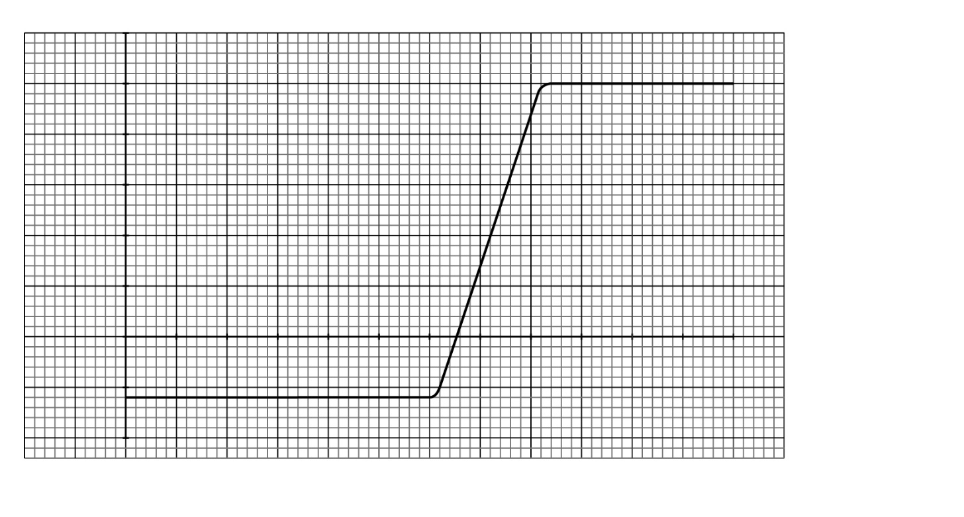
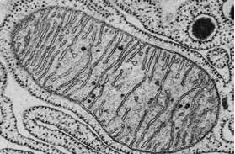
A. 0 cm³ hr-1
B. 60 cm³ hr-1
C. 250 cm³ hr-1
D. 310 cm³ hr-1
22. [exam 2425 F4 final Q8, 80% correct] The leaf carried out photosynthesis from
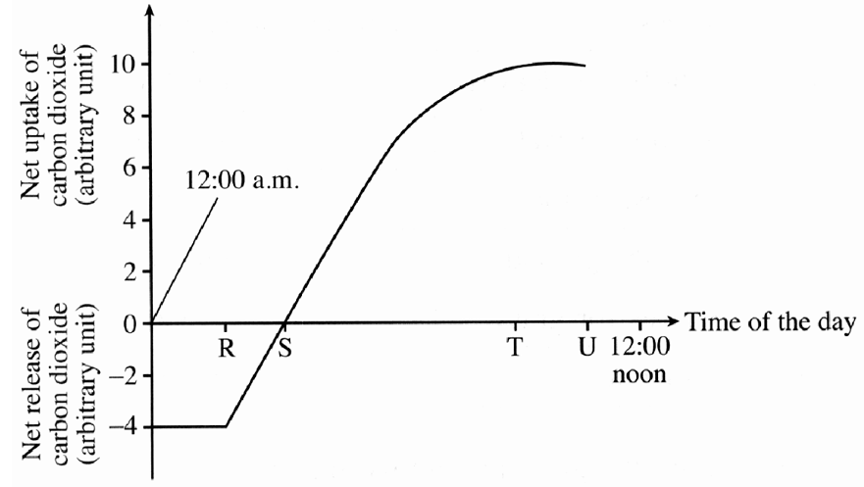
A. R to S.
B. R to U.
C. S to T.
D. S to U.

Answers
Answers are printed in red.
1. C. (1), (2) and (3) only
Class: 13.5% correct (n=52) usual slip A
2. C. Both cells H and G can carry out respiration.
Class: 25.0% correct (n=60) usual slip B
3. B. The uptake of nitrates can occur when the concentration of nitrates in the root hair cells is higher than that in the soil water.
Class: 25.0% correct (n=64) usual slip A
4. B
Class: 25.9% correct (n=54) usual slip D
5. A. (1) and (2) only
Class: 28.6% correct (n=63) usual slip C
6. B
Class: 31.0% correct (n=42) usual slip A
7. D
Class: 32.8% correct (n=64) usual slip A
8. C
Class: 34.5% correct (n=58) usual slip D
9. B
Class: 37.5% correct (n=64) usual slip D
10. C. 140 mg
Class: 43.3% correct (n=67) usual slip B
11. D. The food synthesized in photosynthesis is transported to the cotyledons for storage.
Class: 47.6% correct (n=129) usual slip C
12. D
Class: 47.7% correct (n=151) usual slip B
13. C. Stored food in the tissue near the developing shoots was converted to soluble food substances for the growth of shoots.
Class: 57.7% correct (n=52) usual slip A
14. D. The gas is produced in alcoholic fermentation in yeasts.
Class: 60.7% correct (n=56) usual slip A
15. A. It actively participates in protein synthesis.
Class: 60.9% correct (n=46) usual slip C
16. D
Class: 61.0% correct (n=123) usual slip C
17. A. (1) only
Class: 61.2% correct (n=129) usual slip B
18. C. (2) and (3) only
Class: 62.6% correct (n=123) usual slip B
19. A. the electron carriers involved in photochemical reactions located in the thylakoid membrane of chloroplasts.
Class: 64.3% correct (n=56) usual slip D
20. C. (2) and (3) only D. (1), (2) and (3) Directions: Questions 4 to 6 refer to the diagram below, which shows a transverse section of the stem.
Class: 65.0% correct (n=60) usual slip A
21. C. 250 cm³ hr-1
Class: 70.3% correct (n=64) usual slip D
22. B. R to U.
Class: 80.0% correct (n=60) usual slip D

Class percentage correct
Matched to this paper by question wording in the source bank and the form answer key, not by a shifted paper number.
Q | Answer | % correct | n | Usual slip | Exam
1 | C | 13.5% | 52 | A | exam 2324 F6 final Q20
2 | C | 25.0% | 60 | B | exam 2425 F4 mid Q25
3 | B | 25.0% | 64 | A | exam 2324 F4 final Q12
4 | B | 25.9% | 54 | D | exam 2526 F5 final Q3
5 | A | 28.6% | 63 | C | exam 2526 F4 final Q13
6 | B | 31.0% | 42 | A | exam 2425 F6 final Q28
7 | D | 32.8% | 64 | A | exam 2324 F4 mid Q35
8 | C | 34.5% | 58 | D | exam 2425 F5 final Q25
9 | B | 37.5% | 64 | D | exam 2324 F4 final Q20
10 | C | 43.3% | 67 | B | exam 2526 F4 mid Q29
11 | D | 47.6% | 129 | C | exam 2324 F5 final Q24
12 | D | 47.7% | 151 | B | exam 2526 F3 final Q5
13 | C | 57.7% | 52 | A | exam 2324 F6 final Q34
14 | D | 60.7% | 56 | A | exam 2526 F6 final Q26
15 | A | 60.9% | 46 | C | exam 2324 F5 mid Q2
16 | D | 61.0% | 123 | C | exam 2425 F3 final Q18
17 | A | 61.2% | 129 | B | exam 2324 F5 final Q7
18 | C | 62.6% | 123 | B | exam 2425 F3 final Q17
19 | A | 64.3% | 56 | D | exam 2526 F6 final Q27
20 | C | 65.0% | 60 | A | exam 2425 F4 mid Q3
21 | C | 70.3% | 64 | D | exam 2324 F4 final Q2
22 | B | 80.0% | 60 | D | exam 2425 F4 final Q8

