Nutrition and gas exchange in plants
Multiple-choice practice
Name: ________________________ Class: ____________
There are 37 questions compiled from Longman HKCEE and/or YKTo papers. Choose the one best answer.
Part A — HKCEE level (Longman)
1. Which of the following about photosynthesis is correct?
A. Greenhouse is made of green glasses to facilitate photosynthesis inside it.
B. The primary product of photosynthesis can be converted to lipids for storage.
C. Aquatic plants obtain carbon dioxide directly from the atmosphere.
D. The metabolites for photosynthesis include chlorophyll and water.
2. Which of the following is/are essential for making enzymes in flowering plants? (1) To absorb nitrogen gas from the air by the leaves, (2) To absorb nitrates from the soil by the roots. (3) To make glucose by photosynthesis.
A. (2) only
B. (3) only
C. (1) and (3) only
D. (2) and (3) only
3. Nitrates are absorbed by plants for making
(1) carbohydrates. (2) lipids. (3) proteins. (4) enzymes.
A, (3) only B. (4) only C. (1) and (2) only D. (3) and (4) only
Directions: Questions 54 to 56 refer to the water culture experiment below which investigates the necessity of magnesium to plants.
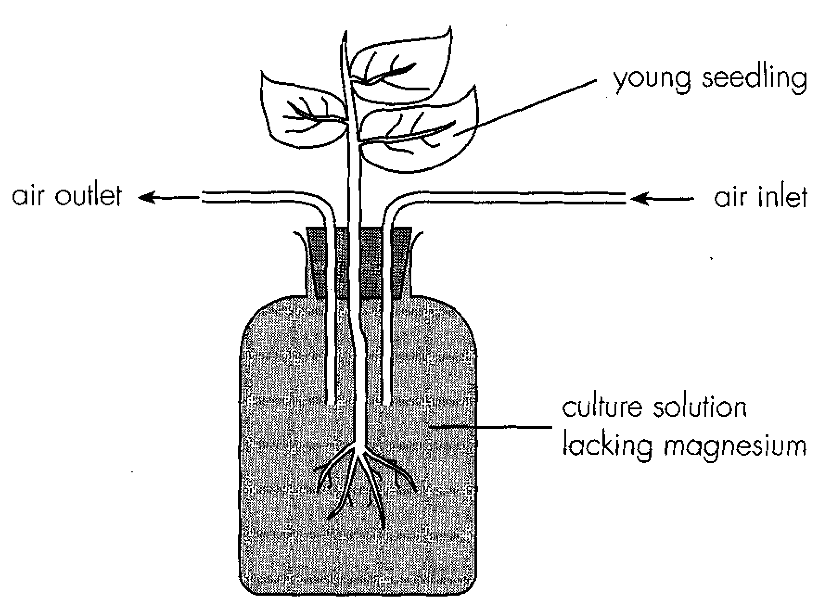
4. After a few weeks, the young seedling will A.become very tall but slender. C.be killed.
A. become very tall but slender.
B. have little growth.
C. be killed.
D. have yellow leaves.
5. The result i n Question 54 showed that magnesium is used in
A. protein synthesis. B. chlorophyll synthesis.
C. DNA synthesis. D. cell wall synthesis.
6. Which of the following are the necessary steps in this experiment? (1)Air is blown into the culture solution dally. (2) Culture solution is renewed twice a week. (3) The bottle containing culture solution should be covered with black paper.
A. (1) and (2) only
B. (1) and (3) only
C. (2) and (3) only
D. (1), (2) and (3)
7. The bottle containing culture solution should be covered with black paper because B.light will decompose the mineral ions in the culture solution. C. light will heat up the culture solution. D.light will stimulate algal growth which consumes mineral ions.
A. light will damage the roots.
B. light will decompose the mineral ions in the culture solution.
C. light will heat up the culture solution.
D. light will stimulate algal growth which consumes mineral ions.
8. In agriculture, chemical fertilizer is added to the soil as (1) an additional source of minerals. (2) a pesticide. (3) a weedkiller.- D. (2) and (3) only Gaseous Exchange in plant
A. (1) only
B. (3) only
C. (1) and (2) only
D. (2) and (3) only Gaseous Exchange in plant
9. Which of the following is correct about photosynthesis and respiration in green plants?
A.Photosynthesis is catabolic in nature while respiration is anabolic.
B.In the daytime, plants always have a net uptake of carbon dioxide.
C.At night, plants always have a net release of carbon dioxide.
D.Photosynthesis takes place in the daytime while respiration occurs at night.
Directions: Questions 60 and 61 refer to the experiment below. The four tubes W to Z contain the same volume of hydrogencarbonate indicator solution.
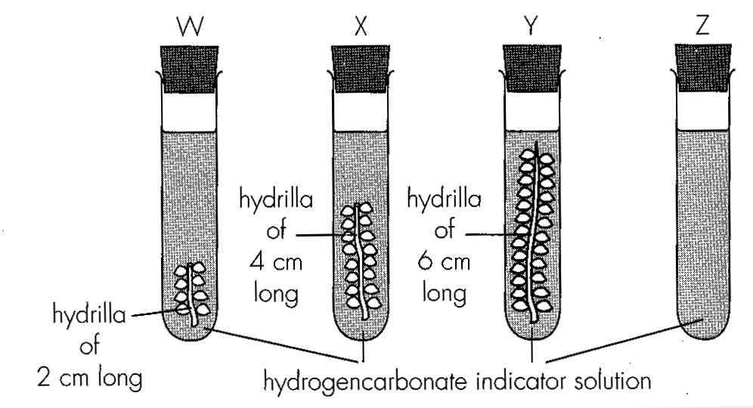
10. If the experiment was conducted under strong and uniform light, which of the following correctly describe the colour change and the relative rate of colour change in tubes W, X and Y?
 | Colour change | Relative rate of colour change
A. | red to yellow | Y>X>W
B. | red to purple | Y>X>W
C. | red to purple | W>X>Y
D. | red to yellow | W>X>Y

11. If the hydrogencarbonate indicator solution in tube Z changed from red to yellow, which of the following is/are the probable reasons) for this?
(1)Strong light decomposes the indicator solution into carbon dioxide.
(2)Carbon dioxide in the air turns the indicator solution yellow.
(3)Test tube Z had been used to hold acid before this experiment.-
A.(1) only B. (2) only C. (3) onlyD. (1) and (2) only
Directions: Questions 62 to 64 refer to the experiment below which studies the effect of light intensity on carbon dioxide exchange in land plants.
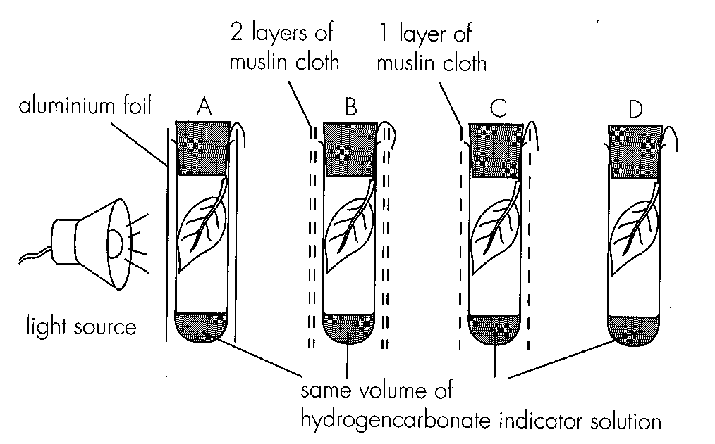
12. What would be the results in tubes A and D respectively?
 | A | D
A. | yellow | purple
B. | yellow | red
C. | red | purple
D. | purple | yellow

13. In a sunny day, the changes in pH of water in a freshwater aquarium with seaweed only are best represented by:
Ans: D
Directions: Questions 66 to 68 refer to the graph below which shows the effect of fight intensity on gaseous exchange of leaves.
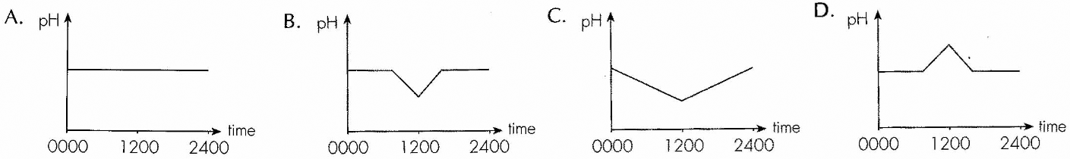
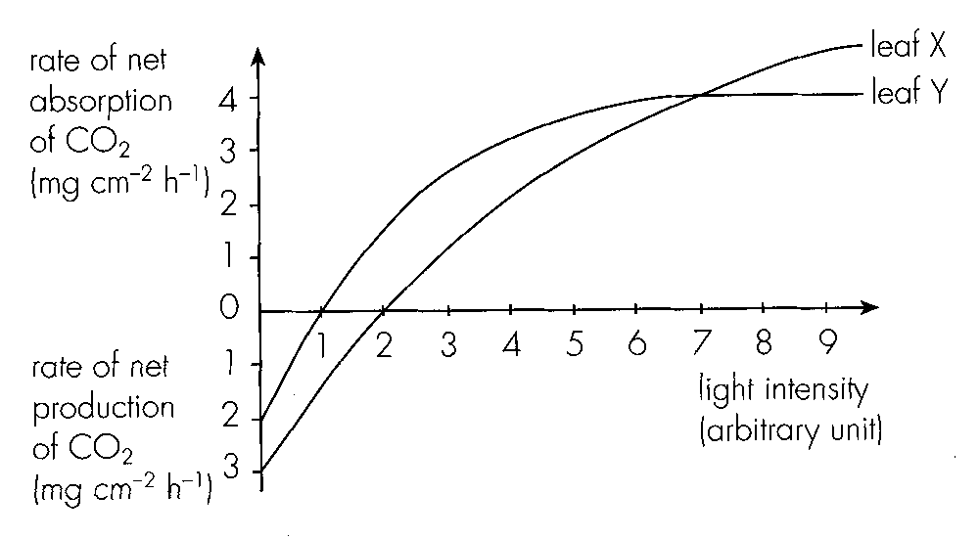
14. Which of the following statements about the graph is/are correct? (1)At zero light intensity, the rate of carbon dioxide production due to respiration was 3 mg cm 2-h1- in leaf X. (2)There was neither carbon dioxide absorption nor carbon dioxide production at alight intensity of 1 unit in leaf Y. (3)At a light intensity of 7 units, the rate of carbon dioxide absorption due to photosynthesis was 4 mg cm 2-h1- in both leaves X and Y.
A. (1) only
B. (1) and (2) only
C. (1) and (3) only
D. (2) and (3) only
15. If the area of leaf X is 16 cm 2, how much carbon dioxide is absorbed during photosynthesis by leaf X at a light intensity of 4 units for 2 hours?
A. 32 mg
B. 64 mg
C. 128 mg
D. 160 mg
16. What is the probable environment in which leaves X and Y are living respectively?
Directions: Questions 69 to 71 refer to the graph below which shows the rates of net uptake and net release of oxygen in a plant over one day.
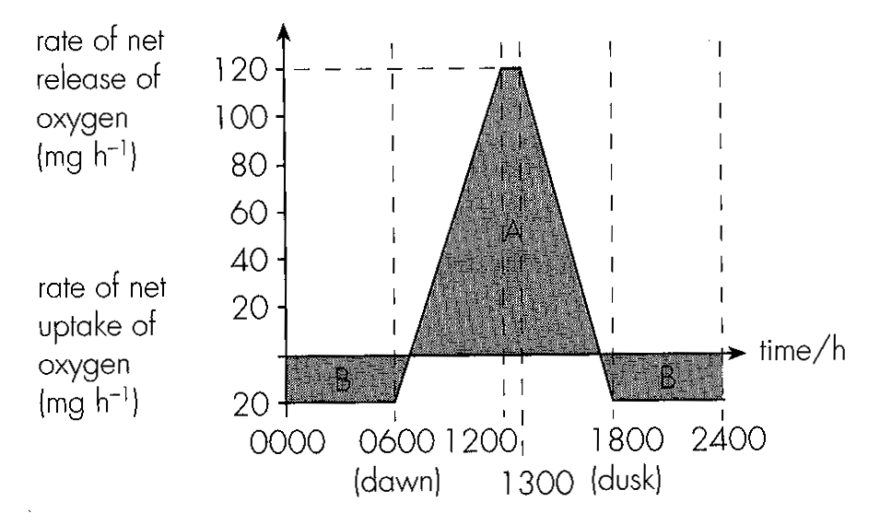
 | leaf X | leaf Y
A. | sunny | sunny
B. | sunny | shaded
C. | shaded | sunny
D. | shaded | shaded

17. Assuming that the rate of respiration remains constant throughout the day, how, much oxygen are absorbed by the plant during respiration in one day?
A. 20 mg
B. 120 mg
C. 240 mg
D. 480 mg
18. How much oxygen are released from the plant during photosynthesis between 1200 and 1300 hour?
A. 100 mg
B. 120 mg
C. 140 mg
D. 160 mg
19. When area A is larger than area B, it indicates that
A. the plant is fully mature.
B. the plant is gaining weight.
C. the plant is ageing.
D. the plant is losing weight.
Part B — HKDSE-style (YKTo)
20. Directions: Question 2 to 7 refer to the dragram below which shows an experimental set-up.
In performing this experiment the jar is covered with a piece of black paper. The purpose is to
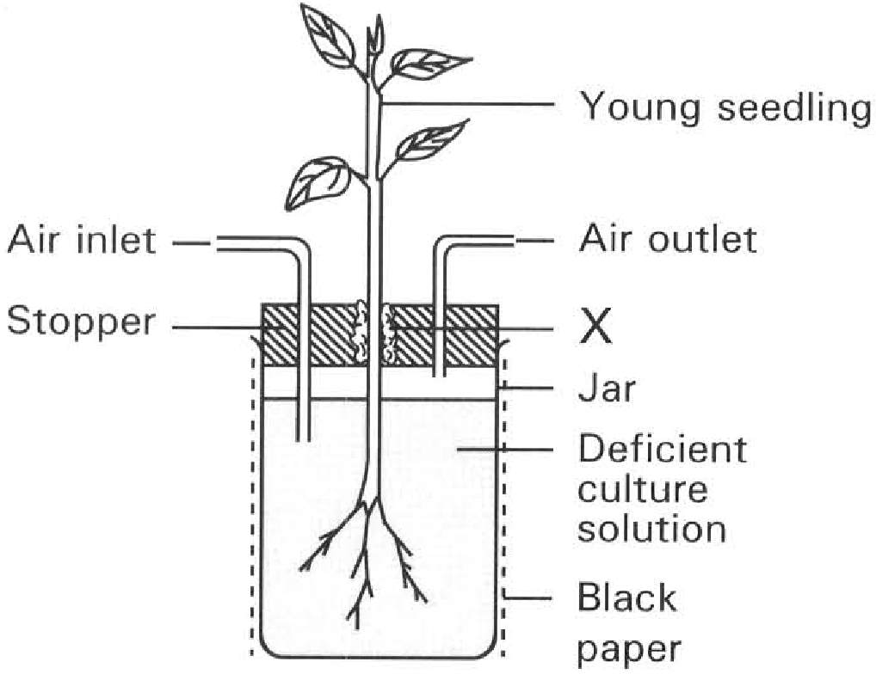
A. destarch the plant seedling.
B. discourage the algal growth inside the jar.
C. indirectly increase the carbon dioxide content of the solution inside the jar.
D. absorb more heat from the surroundings so that the solution is warmed up to an optimum temperature for healthy plant growth.
21. Air is blown via the air inlet into the solution daily. What is the purpose of this action?
A. It enables the roots to obtain additional carbon dioxide supply so that the seedling can carry out photosynthesis at a faster rate to support the active growth of the plant.
B. The seedling can obtain more nitrogen from the solution to support protein synthesis at this stage of active growth.
C. It provides more oxygen in the solution to support the active respiratory activities of roots.
D. It increases the air pressure inside the jar so that more water is pressed into the roots to compensate for the water lost through transpiration. 5A young seedling is preferred to a mature plant in this experiment because (1) the root system of a seedling is small enough to be put completely inside the jar. (2) a seedling has more leaves that permit rapid photosynthesis to take place. (3) a seedling grows faster that gives a more conspicuous result. (4) a seedling does not store large amount of mineral salts that may affect growth.
A. (1) and (2) only B. (1) and (3) only C. (2) and (3) only D. (3) and (4) only
22. If the culture solution used in the above experiment is short of magnesium, which of the following deficiency symptoms are found in the seedling? (1) Chlorotic leaves (2) Poor stunted growth (3) Poor root formation
A. (1) only
B. (2) only
C. (3) only
D. (1) and (2) only
23. A control for this experiment is prepared by setting up a similar set of apparatus but
A. the whole set-up is put in darkness.
B. the seedling is absent.
C. the solution is replaced by a complete culture solution.
D. the solution is replaced by distilled water. 8Nitrogen is essential to plants for the synthesis of (1) proteins. (2) lipids. (3) nucleic acids.
A. (1) only B. (2) only C. (1) and (3) only D. (2) and (3) only
24. Nitrogen required for most green plants except leguminous plants is absorbed directly from
A. air.
B. in form of nitrogen gas from soil.
C. in forms of nitrates or ammonium compounds from soil.
D. from animals.
25. Which of the following elements is the essential component of chlorophyll and ATP for them to carry out their functions respectively?
 | Chlorophyll | ATP
A. | Magnesium | Phosphorus
B. | Iron | Nitrogen
C. | Phosphorus | Magnesium
D. | Nitrogen | Iron

26. Most farmers add fertilizers to soil for getting prosperous yield of crops because the soil becomes infertile due to (1) the previous harvest of crops from soil. (2) the leaching effect in soil. (3) the activities of the nitrifying bacteria in soil .
A. (1) only
B. (2) only
C. (3) only
D. (1) and (2) only
27. Most commercial fertilizers have the warning : ‘Don't add too much fertilizers to the crops.’ Which of the following is the CORRECT reason of this warning?
A. This will enhance the growth of weeds.
B. This will cause excessive uptake of minerals that may poison the plants.
C. This may decrease the water potential of soil water that will draw water out of the plants.
D. The high concentration of minerals in soil water decreases the solubility of oxygen in soil water. 13Which of the following about organic fertilizers is NOT TRUE ?
A. They can improve soil texture.
B. They provide mineral salts that can be immediately absorbed by plants.
C. They can stay longer in soil.
D. They enhance conservation in nature.
28. Which of the following structures of the flowering plants is analogous to the nostrils of man?
A. Leaf
B. Intercellular air space
C. Stomata
D. Cell surface of the palisade mesophyll cells 15 Stomata are important sites for gas exchange to take place in (1) root hairs. (2) leaves of terrestrial plants. (3) woody stems. (4) leaves of submerged plants. (5) herbaceous stems.
A. (1) and (2) only B. (2) and (3) only C. (3) and (4) only D. (2) and (5) only
29. In the mesophyll cells of a green leaf, both oxygen and carbon dioxide are present.
A. Only oxygen is the metabolic end-product.
B. Only carbon dioxide is both the metabolic end product and raw material of the plant metabolism.
C. Only oxygen is both the metabolic end product and raw material of the plant metabolism.
D. Both carbon dioxide and oxygen are metabolic end products and raw materials of the plant metabolism.
30. Which of the following statements about gas exchange in plants is/are INCORRECT?
(1) It occurs at the leaf surface of terrestrial plants at day time only.
(2) It occurs at the root hairs at night only.
(3) It occurs at the surface of the whole plant throughout the day.
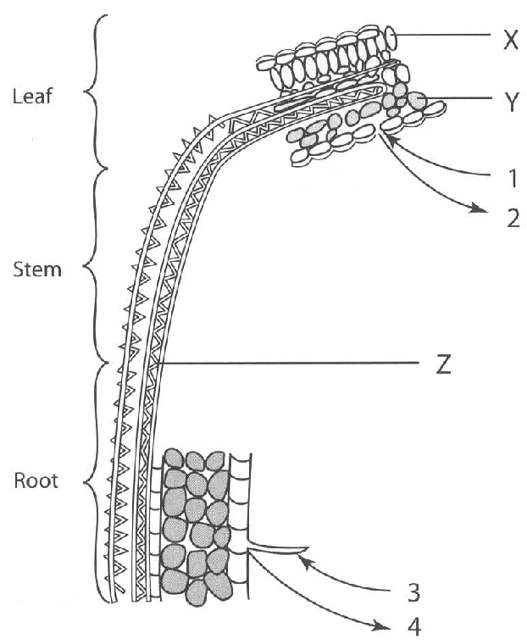
A. (1) only B. (2) only C. (3) only D. (1) and (2) only Directions: Question 18 to 20 refer to the drawing below which shows a diagrammatic representation of the leaf and root of a plant.
31. Which of the following combinations TRULY represents the pathways by which gas exchange takes place in the leaf and root in a sunny day?
 | Pathway of gas exchange in
 | Leaf | Root
 | 1 | 2 | 3 | 4
A.B.C.D. | CO2O2O2CO2 | O2CO2H2OH2O | O2CO2H2OCO2 | CO2O2CO2O2

32. At noon when both the light intensity and temperature are very high, through which labelled pathways will gas exchange be affected?
A. 1 only
B. 2 only
C. 3 only
D. 1 and 2 only
33. Which labelled tissues will have their biological activities be affected under the environmental conditions stated in the previous question ?
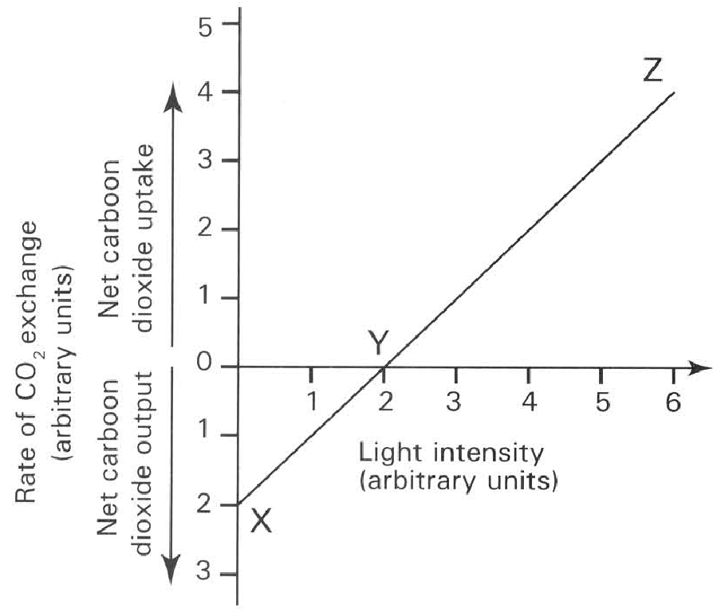
A. X only B. Y only C. Z only D. X, Y and Z 21 Suppose a water plant is put into a boiling tube of distilled water and the tube is stoppred. The tube is left outdoor for 24 hours and the pH value of the water is measured at regular intervals during the experimental period. Which of the following is the most probable result?
A. The pH value is lowest just before sunrise.
B. The pH value is highest just before sunrise.
C. The pH value is lowest at midday.
D. The pH value is lowest just before sunset. Directions: Questions 22 to 27 refer to the graph below which shows the effect of changing the light intensity on the amount of carbon dioxide absorbed or released by green plants. 22Which of the following statements is/ are NOT TURE? (1) Between X and Y the photosynthetic rate is greater than the respiratory rate. (2) Between Y and Z the respiratory rate is greater than the photosynthetic rate. (3) At Z there is no respiration.
A. (1) only B. (2) only C. (1) and (2) only D. (1), (2) and (3) 23At which of the following hours in the day is condition Z most likely to occur?
A. 0100 B. 0400 C. 0600 D. 1300 24At which of the following hours in the day is condition X most likely to occur?
A. 0100 B. 0900 C. 1200 D. 1300
34. What is the rate of respiration in term of carbon dioxide units involved in the process at X?
A. 1
B. 2
C. 3
D. 4
35. How many units of carbon dioxide are fixed by the plant in photosynthesis when the light intensity is at units 4?
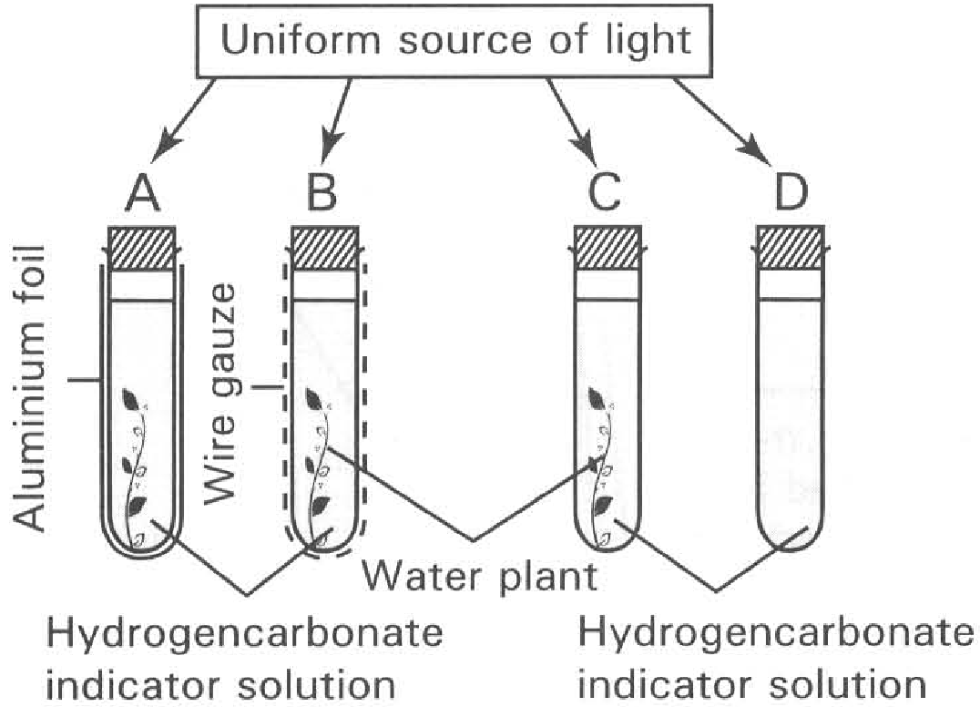
Carbon dioxide concentration | Colour of hydrogencarbonate indicator solution
Less than 0.03% | Purple
0.03% | Red
More than 0.03% | Yellow

A. 1 B. 2 C. 3 D. 4 27What happens to the green plants at Y? A.No repiration occurs.
B. No photosynthesis occurs.
C. The carbon dioxide absorbed is greater than the carbon dioxide released.
D. The sugar produced is equal to the sugar consumed. Directions: Questions 28 to 32 refer to the diagram below which shows an experiments in progress. At the beginning of the experiment, the colour of the hydrogencarbonate indicator solution in each tube is red. 28Which of the following statements about tube A is/are NOT TURE? (1) The aluminium foil is used to absorb heat in order to raise the temperature of the solution. (2) No light can penetrate into the solution. (3) The solution becomes yellow at the end of the experiment. (4) Both photosynthesis and respiration take place inside the water plant in A.
A. (2) only B. (3) only C. (1) and (4) only D. (2) and (3) only 29The function of tube D is to
A. act as a control to compare the colour changes of the solution in other tubes.
B. act as a thermometer to compare the changes of temperature in other tubes.
C. act as a barometer to compare the pressure changes in other tubes.
D. act as a photometer to compare the light intensity changes in other tubes. 30Which of the following statements is CORRECT?
A. In tube A the photosynthetic rate is higher than the respiratory rate.
B. In tube B the respiatory rate and the photosynthetic rate are roughly the same.
C. In tube C the photosynthetic rate is lower than the respiratory rate.
D. In tube D the photosynthetic rate and respiratory rate are roughly the same.
36. If equal mass of midge fly larvae are put in each tube and the tubes are then put in DARKNESS, which of the following combinations TRULY represents the final colour of the indicator solution obtained at the end of the experiment?
 | Tube A | Tube B | Tube C | Tube D
A. | Yellow | Red | Purple | Red
B. | Yellow | Red | Purple | Purple
C. | Yellow | Yellow | Yellow | Yellow
D. | Red | Purple | Purple | Red

37. If the set-up in the previous question is repeated by exposing the tubes to equal illumination, arrange the tubes in ascending order for the TIME required for the hydrogencarbonate indicator solution changes to the final colour.
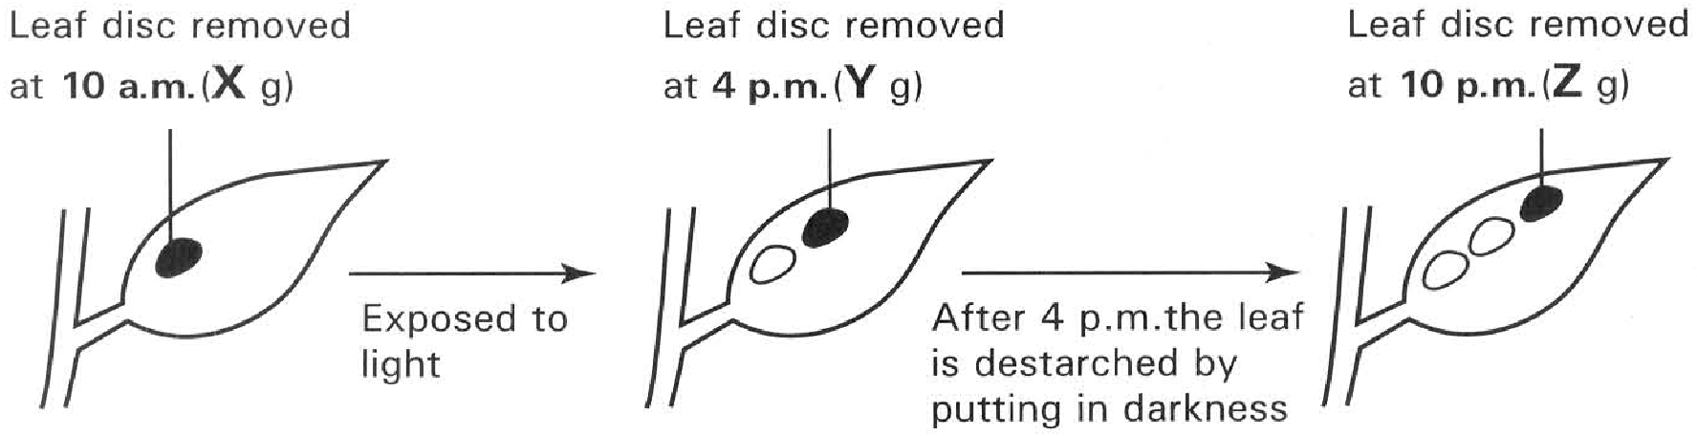
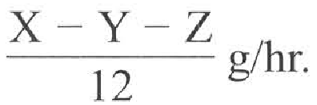
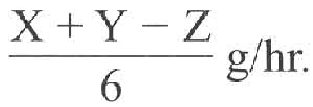
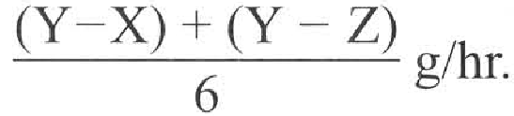
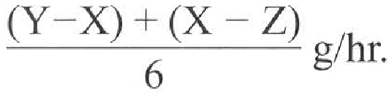
A. Tube D, tube A, tube B, tube C B. Tube A, tube B, tube C, tube D
C. Tube A, tube D, tube B, tube C D. Tube D, tube A, tube C, tube B Directions: Questions 33 to 35 refer to the diagram below which illustrates an experiment in which discs of equal area are removed from the same leaf of a destarched plant. The plant had been treated differently at different time of the day. The dry mass of the leaf discs were measured. The value of (Y-X)g represents
A. the amount of food consumed in respiration.
B. the amount of water lost in transpiration.
C. the net gain of food by photosynthesis.
D. the net gain of water by photosynthesis. 34The value of (Y-Z)/6 g/hr represents the rate of
A. transpiration. B. translocation. C. respiration. D. photosynthesis. 35The true rate of photosynthesis can be expressed by
A. B.
C. D.

Answers
Answers are printed in red.
1. B. The primary product of photosynthesis can be converted to lipids for storage.
Class: 64.9% correct (n=205) usual slip D
2. D. (2) and (3) only
Class: 70.0% correct (n=10) usual slip A
3. D
Class: 70.0% correct (n=10) usual slip A
4. D. have yellow leaves.
Class: 90.0% correct (n=10) usual slip A
5. B
Class: 90.0% correct (n=10) usual slip D
6. D. (1), (2) and (3)
Class: 60.0% correct (n=10) usual slip B
7. D. light will stimulate algal growth which consumes mineral ions.
Class: 90.0% correct (n=10) usual slip C
8. A. (1) only
Class: 80.0% correct (n=10) usual slip B
9. C
Class: 90.0% correct (n=10) usual slip C
10. ?
Class: 80.0% correct (n=10) usual slip B
11. ?

12. ?

13. ?

14. ?

15. ?

16. ?

17. ?

18. ?

19. ?

20. B. discourage the algal growth inside the jar.
Class: 78.5% correct (n=205) usual slip A
21. C. It provides more oxygen in the solution to support the active respiratory activities of roots.
Class: 60.5% correct (n=205) usual slip D
22. D. (1) and (2) only
Class: 66.8% correct (n=205) usual slip B
23. C. the solution is replaced by a complete culture solution.
Class: 85.4% correct (n=205) usual slip A
24. C. in forms of nitrates or ammonium compounds from soil.
Class: 58.5% correct (n=205) usual slip B
25. A
Class: 81.5% correct (n=205) usual slip C
26. D. (1) and (2) only
Class: 45.9% correct (n=133) usual slip B
27. C. They can stay longer in soil.
Class: 71.4% correct (n=133) usual slip D
28. C. Stomata
Class: 86.2% correct (n=130) usual slip D
29. D. Both carbon dioxide and oxygen are metabolic end products and raw materials of the plant metabolism.
Class: 86.2% correct (n=130) usual slip C
30. D
Class: 49.2% correct (n=130) usual slip B
31. A
Class: 83.1% correct (n=130) usual slip A
32. D. 1 and 2 only
Class: 77.7% correct (n=130) usual slip C
33. D. The pH value is lowest just before sunset. Directions: Questions 22 to 27 refer to the graph below which shows the effect of changing the light intensity on the amount of carbon dioxide absorbed or released by green plants. 22Which of the following statements is/ are NOT TURE? (1) Between X and Y the photosynthetic rate is greater than the respiratory rate. (2) Between Y and Z the respiratory rate is greater than the photosynthetic rate. (3) At Z there is no respiration.
Class: 67.7% correct (n=130) usual slip A
34. B. 2
Class: 82.8% correct (n=58) usual slip C
35. D. In tube D the photosynthetic rate and respiratory rate are roughly the same.
Class: 75.9% correct (n=58) usual slip B
36. C
Class: 63.8% correct (n=58) usual slip A
37. C. D.
Class: 46.6% correct (n=58) usual slip B

