Transpiration, absorption and transport in plants
Multiple-choice practice
Name: ________________________ Class: ____________
There are 59 questions compiled from Longman HKCEE and/or YKTo papers. Choose the one best answer.
Part A — HKDSE-style (YKTo)
1. Directions: Questions 1 to 3 refer to the photomicrograph below which shows the surface view of a small part of a leaf. Which of the following structures is present in the cell labelled 1 but absent in the cell lablled 5? A. Chloroplasts B. Cytoplasm D. Cell membrane 2The size of the pore labelled 4 is largest D. before dawn. 3The pore labelled 4 usually closes in dark condition because (1) the cell labelled 1 has lower water potential than its surrounding cells. (2) in the absence of light the cell labelled 1 becomes flaccid due to the loss of water to the surrounding cells. (3) The leaf has to reduce water loss at night. A. (1) only B. (2) only C. (1) and (2) only D. (2) and (3) only Directions: Questions 4 to 7 refer to the table below which shows the stomatal density of three types of plants. One type of plants is living on land and the other two are living on/ in water. 4Which of the following CORRECTLY match the three types of plants?
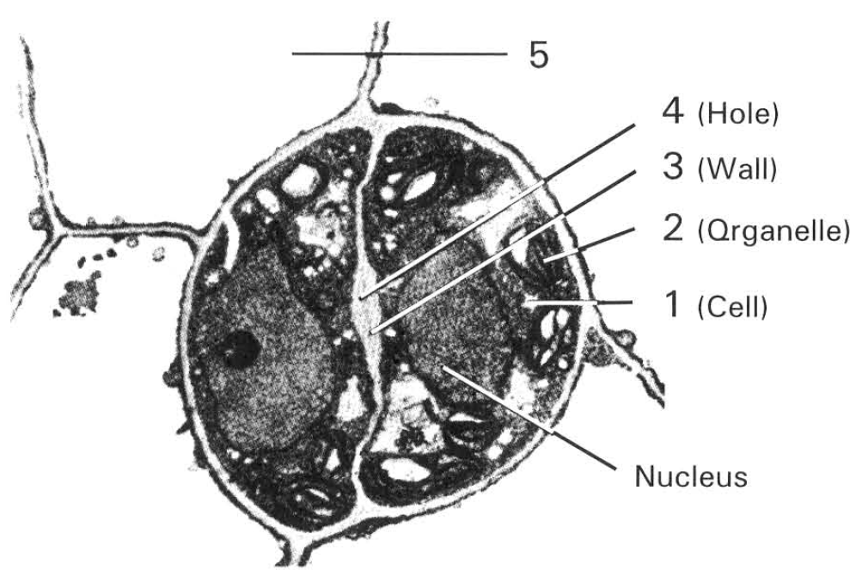
 | Number of stomata per cm2
Plants | Upper epidermis | Lower epidermis
X | 0 | 0
Y | 12 000 | 0
Z | 8 500 | 13 900

 | Terrestrial plant | Plant with leaves floating on water surface | Plant with leaves submerged in water
A. | X | Y | Z
B. | Y | Z | X
C. | Z | Y | X
D. | Y | X | Z

C. Nucleus
A. at mid-night.
B. at noon.
C. at dusk.
2. Which of the following explanation of the absence of stomata in the leaves of plant X is/are CORRECT? (1) These leaves are highly dissected so that there is insufficient area for bearing stomata. (2) These leaves have no cuticle so that they can absorb gases over the whole plant body. There is no need to have stomata specialized for gas exchange. (3) The concentration of 02 and CO2 in water is so low that no gas exchange is possible over these leaves. D. (1) and (2) only 6Which of the following statements about plant Y is CORRECT? (1) It is an aquatic plant completely immersed in water. (2) Such a stomatal distribution facilitates its gas exchange with the atmosphere. (3) Such a stomatal distribution increases its ability to absorb sunlight. C. (1) and (3) only D. (2) and (3) only
A. (1) only
B. (2) only
C. (3) only
A. (1) only
3. Which of the following explanation about the distribution of stomata in plant Z is/are TRUE? (1) Such distribution enhances transpiration because water vapour falls out of the leaf more easily in accordance with the gravity effect. (2) There is no cuticle at the lower epidermis to enhance gas exchange to take place. (3) This reduces the excessive water loss through the stomata because the lower surface is shaded away from the direct illumination of sunlight.
A. (1) only
B. (2) only
C. (3) only
D. (1) and (2) only
4. Which of the following structures of a leaf is NOT an adaptation of a xerophyte against desiccation?
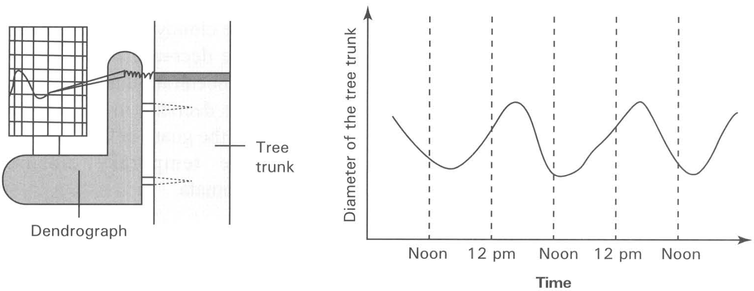
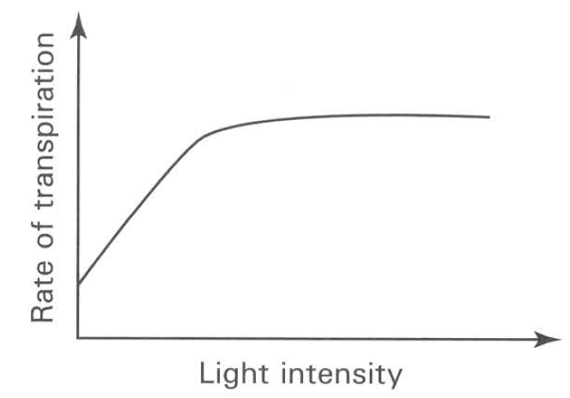
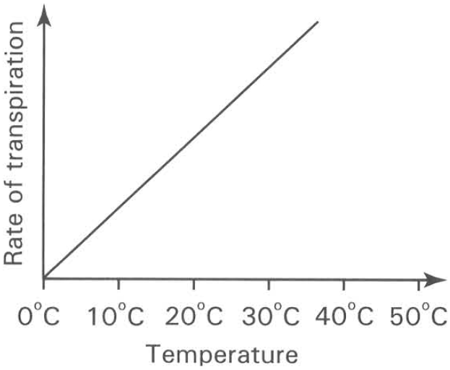
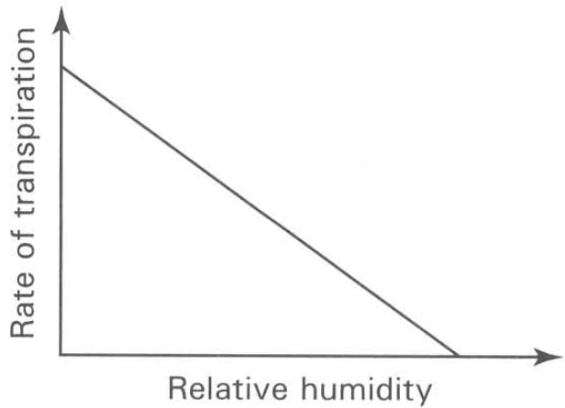
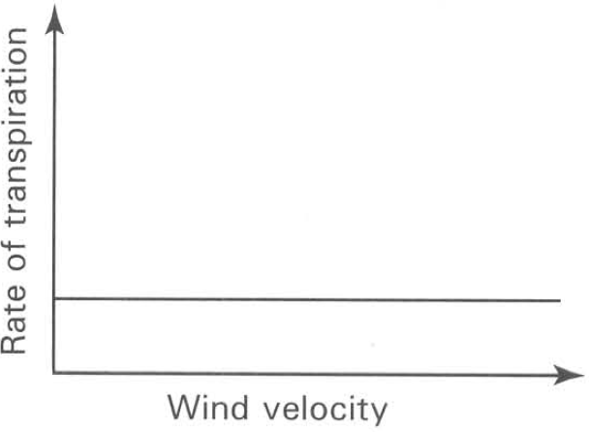
A. | B. | C. | D.

A. The lower epidermis is covered with many hairs.
B. Palisade cells are closely-packed together in the upper portion of the mesophyll.
C. Stomata are restricted to the lower epidermis.
D. There are fewer stomata and they are in sunken form. Directions: Question 9 refers to the diagrams on next page which represent a dendrograph and a recording chart. Dendrograph consists of a ring of metal fitted tightly around the tree trunk in such a way that changes in the diameter of the tree trunk may be recorded on a chart, moving at constant speed. The measurement was carried out for three days which are sunny and hot. 9The change in the diameter of the tree trunk during day time is due to
A. the thermal contraction of the water column in the tree trunk.
B. the thermal contraction of the metal ring of the dendrograph.
C. the increased cohesive tension of the water column in the xylem generated by transpiration in the leaves.
D. the increased pressure flow of sugars down the phloem from the leaves. 10Which of the following graphs INCORRECTLY represents the changes in the rate of transpiration under the given environmental condition?
5. Which of the following conditions of air will speed up the rate of transpiration of a leafy shoot?
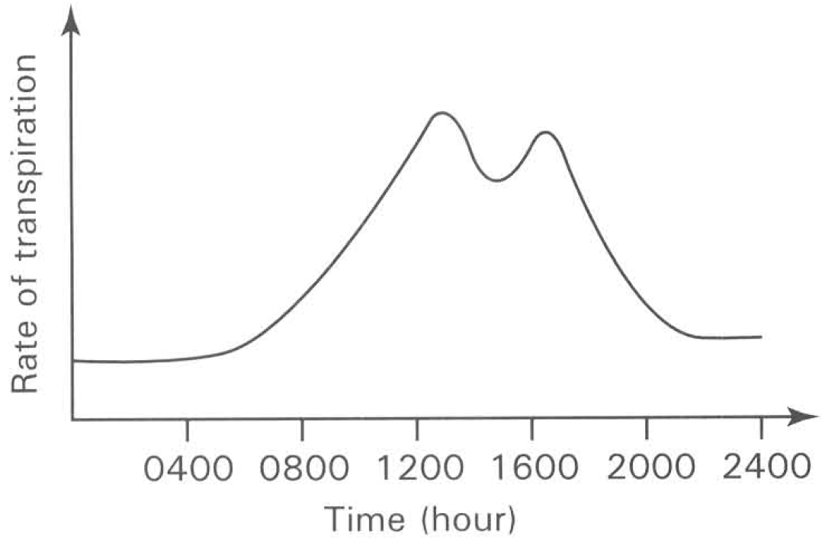
A. Cold, dry and moving B. Still, warm and moist
C. Humid, moving and cold D. Moving, warm and dry Directions: Question 12 to 16 refer to the graph below which shows the changes in the transpiration rate of a plant during a dry, hot, sunny day.
6. The constant rate of transpiration between 0000 to 0600 hour is mainly due to
A. shortage of water supply from the soil. B. high relative humidity of the air.
C. decrease in the air temperature. D. closure of the stomata. 13The sudden change of the transpiration rate at 0600 hour is mainly due to the
A. decrease in the relative humidity of air. B. increase in the water supply from soil.
C. increase in the light intensity. D. decrease in the speed of wind. 14The sudden drop of the transpiration rate at 1400 hour is mainly due to
A. the cloudy condition in the sky.
B. the decrease in the carbon dioxide concentration in air.
C. the decrease in the amount of starch in the guard cells.
D. the temporary closure of the stomata.
7. What is the advantage for the plant to have the change in the rate of transpiration at 1400 hour?
A. To further cool down the temperature of the leaves.
B. To reduce the intake of carbon dioxide in order to reduce the rate of photosynthesis.
C. To avoid the excessive loss of water from the plant.
D. To reduce the rate of water absorption from the root.
8. The leaves of the plant wilt at 1200 noon. But they will return to turgid condition at 2000 hour. Which of the following is the CORRECT explanation for such change?
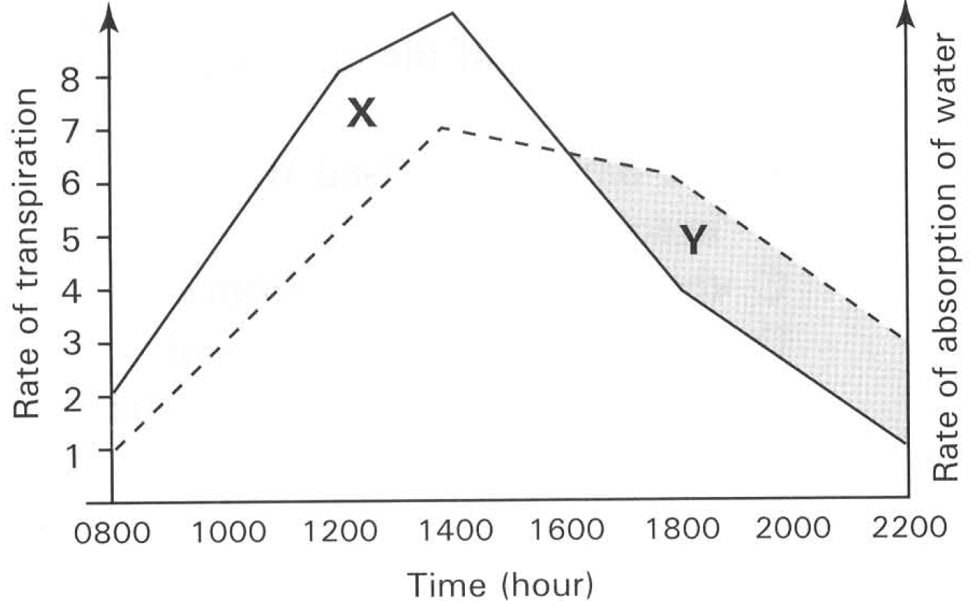
A. All the stomata open to the former state.
B. The drop in photosynthetic rate reduces the amount of sugar produced in the leaves.
C. The increase in the respiratory rate consumes more food reserve in the leaves.
D. The water gain is faster than the loss by the leaves. Directions: Questions 17 and 18 refer to the graph below which shows the change in the rate of transpiration and the rate of absorption of water in a plant from 0800 hour to 2200 hour of a day.
9. At what time of the day did the plant suffer the greatest net loss of water that might cause the temporary wilting of the plant?
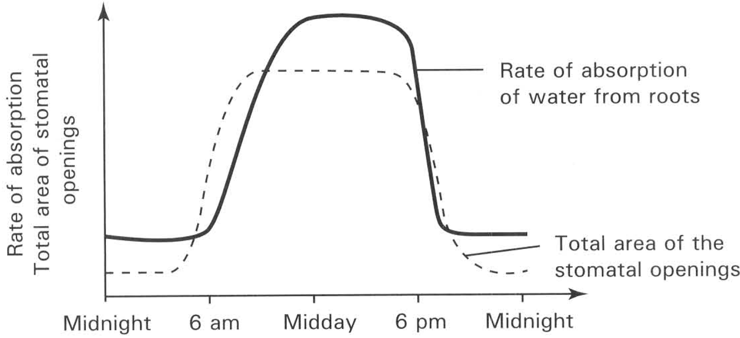
A. 1000 B. 1200 C. 1400 D. 1800 18 X is the area representing the net loss of water and Y is the area representing the net gain of water of the plant at the day.
A. Growth will only take place when X is greater than Y .
B. Growth will only take place when X is smaller than Y.
C. Growth will only take place when X is equal to Y.
D. Growth will only take place when the rate of respiration at night is greater than the rate of photosynthesis at day time. Directions: Questions 19 and 20 refer to the graph below which shows the relationship between the rate of water absorption and the total area of the stomatal openings of a plant over a period of 24 hours. 19Which of the following is responsible for the change in the rate of absorption of water from roots throughout the day?
A. Change in the rate of photosynthesis. B. Change in the rate of respiration.
C. Change in the rate of transpiration. D. Change in the rate of gas exchange.
10. Which of the following environmental factors is responsible for the continuous increase of the rate of absorption of water from roots while the total area of the stomata] openings remain unchanged between 8 am and the midday?
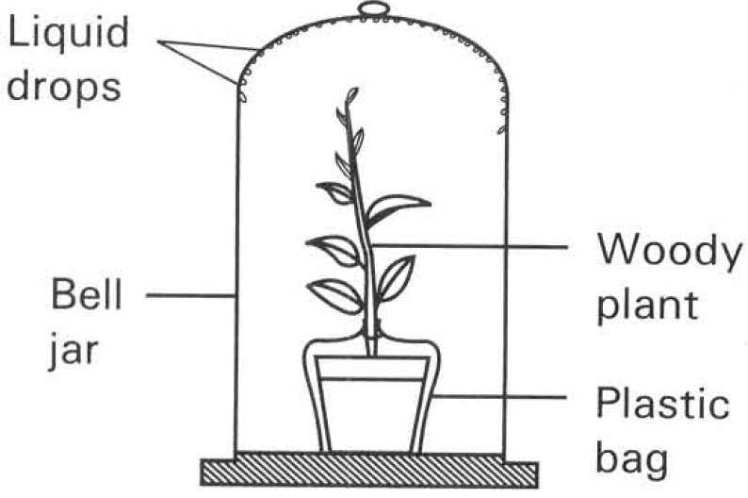
A. Decrease in temperature B. Increase in relative humidity
C. Increase in light intensity D. Decrease in the velocity of wind Directions: Questions 21 to 25 refer to the diagram below which shows an experment in progress.
11. The liquid drops formed at the inner surface of the bell jar is found to be water. Which of the following chemicals can be used for such test? (1) Anhydrous copper sulphate (2) Anhydrous potassium hydroxide (3) Anhydrous calcium chloride (4) Anhydrous cobalt chloride paper
A. (1) only
B. (2) only
C. (1) and (3) only
D. (1) and (4) only
12. The liquid drops formed at the inner surface of the bell jar is due to vapour lost through the plant's
(1) stomata (2) lenticels (3) cuticle
A. (1) only B. (2) only C . (2) and (3) only D. (1), (2) and (3) 23The plastic bag is used to exclude
A. the carbon dioxide released by the respiration of the microorganisms in soil.
B. the oxygen released from the algae in soil.
C. the water evaporated from soil.
D. the heat energy released by the respiration of the microorganisms in soil. 24The amount of water drops formed in the previous experiment is affected by
A. the size of the bell jar.
B. the velocity of air movement outside the bell jar.
C. the humidity of the air surrounding the bell jar.
D. the temperature of the air surrounding the bell jar.
13. A piece of blue cobalt chloride paper is put against the lower surface of a leaf while another piece is put against its upper surface. It is found that the former cobalt chloride paper covering the lower surface changes pink while the one covering the upper surface remains unchanged. This shows that
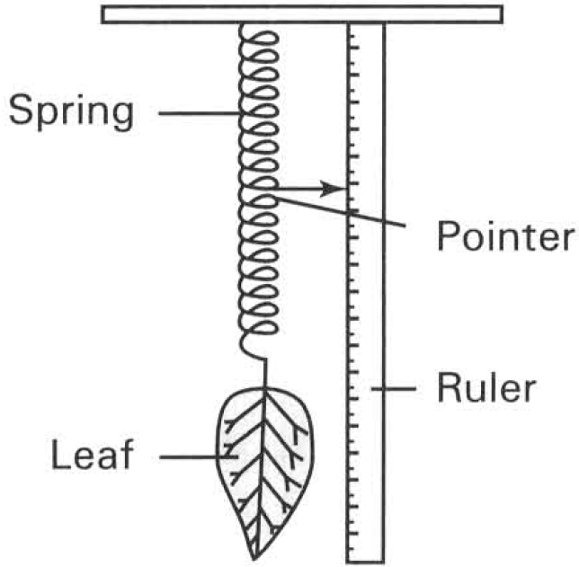
A. the lower epidermis has more stomata than the upper epidermis.
B. guard cells in the lower epidermis are bigger than those in the upper epidermis.
C. the cuticle covering the lower epidermis is thinner than that covering the upper epidermis.
D. the rate of transpiration through the lower surface is higher than that through the upper surface of the leaf Directions: Questions 26 to 28 refer to the diagram below which shows an experiment in progress.
14. A fresh leaf was removed from a potted plant and tied to a spring as shown in the diagram. By means of the pointer the change in mass of the leaf was found by the readings obtained from the ruler. After four hours the position of the pointer was found
A. to be higher than before. B. to remain the same as before.
C. to be lower than before. D. to be defected to the right. 27The result of the previous experiment is due to
A. the supply of water from the plant to the leaf being cut out.
B. the absence of food material because the detached leaf cannot carry out photosynghesis.
C. the loss of water by transpiration.
D. the accumulation of carbon dioxide by respiration.
15. If the above experiment is repeated by using four pieces of similar leaves that are differently smeared with vaseline, the results obtained are shown as follows (The ruler has been calibrated to give units in gram) :
From the above results it is concluded that the stomata are
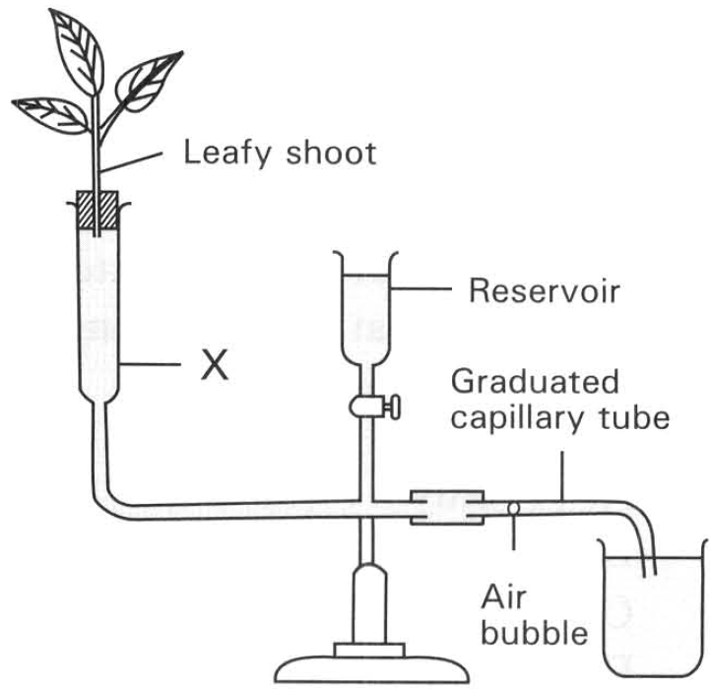
Treatment of the leaf | Change in weight
Leaf without vaseline | 1.9 g
Upper leaf surface is smeared with vaseline | 1.7 g
Lower leaf surface is smeared with vaseline | 0.3 g
Both surfaces of the leaf are smeared with vaseline | 0 g

A. present in equal number on both surfaces of the leaf.
B. present in greater number in the upper leaf surface.
C. present in greater number in the lower leaf surface.
D. present in the upper leaf surface only. Directions: Questions 29 to 35 refer to the diagram below which shows an experment in progress.
16. The purpose(s) of the above apparatus is/are to (1) measure directly the rate of water absorption of the leafy shoot. (2) demonstrate the loss of water through the stomata of the leaves. (3) demonstrate that a plant without its root system still survives.
A. (1) only
B. (2) only
C. (1) and (2) only
D. (1) and (3) only
17. In setting up the above apparatus, the shoot is cut under water to
A. allow the plant to absorb more water so that the experiment can last longer.
B. prevernt the plant from drying up in the atmosphere.
C. prevernt the xylem vessels from being blocked by air bubbles.
D. speed up the rate of water absorp tion.
18. The purpose of having a reservoir in the apparatus is to (1) adjust the water level in the chamber labelled X. (2) introduce an air bubble into the graduated capillary tube. (3) supply more water to the leafy shoot. (4) push the air bubble to the open end of the graduated capillary tube at the beginning of another experiment.
A. (1) only
B. (3) only
C. (4) only
D. (1) and (2) only
19. The purpose of introducing an air bubble into graduated capillary tube is to (1) prevent the air in the atmosphere from getting into the graduated capillary tube. (2) indicate the amount of water taken up by the leafy shoot during the experiment. (3) act in the way like the level spirit to check whether the capillary tube is horizontal or not. (4) saturate the water with oxygen to support the respiration of the submerged portion of the shoot.
A. (1) only
B. (2) only
C. (1) and (4) only
D. (2) and (3) only
20. Under different external conditions M, N, O, P and Q, the following results are obtained: (1) The rate of transpiration is the same under conditions 0 and P. (2) The rate of transpiration is the same under conditions M and N. (3) The rate of transpiration is highest under condition M and lowest under condition P. (4) The rate of transpiration is highest under condition Q and lowest under condition 0. (5) The rate of transpiration is the same under conditions N and Q. Which of the following combinations is CORRECT? D. (4) and (5) only 34Which of the following shows the most likely external conditions of M and P?
External condition | Reading of air bubble | Time period
 | Initial | final
M | 1.2 | 4.6 | 1/2 min
N | 2.2 | 5.4 | 1 min
O | 1.2 | 3.1 | 1/2 min
P | 2.2 | 4.6 | 1 min
Q | 3.1 | 9.5 | 2 min

 | Condition of M | Condition of P
A. | Humid and cloudy | Dry and cloudy
B. | Sunny and dry | Cloudy and humid
C. | Still air and cloudy | Windy and sunny
D. | Humid and windy | Dry and still air

A. (1) and (3) only
B. (2) and (4) only
C. (3) and (5) only
D. (4) and (5) only 34Which of the following shows the most likely external conditions of M and P?
21. Which of the following procedures can increase the accuracy of the experiment? (1) Replacing the reservoir with bigger one. (2) Replacing the graduated capillary tube with one of finer bore. (3) Adding red dye to the water to make the movement of the air bubble more conspicuous. D. (1) and (3) only Directions: Questions 36 to 39 refer to the diagram below which shows an experiment in progress. Initial mass of the whole set-up = 600 g Final mass of the whole set-up = 570 g Initial reading of the graduated tube = 3 cm3 Final reading of the graduated tube = 39 cm3 Density of water = 1 g cm-3 Duration of the experiment = 3 hours 36The rate of transpiration of the plant is B. 15 ghr-1. C. 20 ghr-1. D. 25 ghr-1.
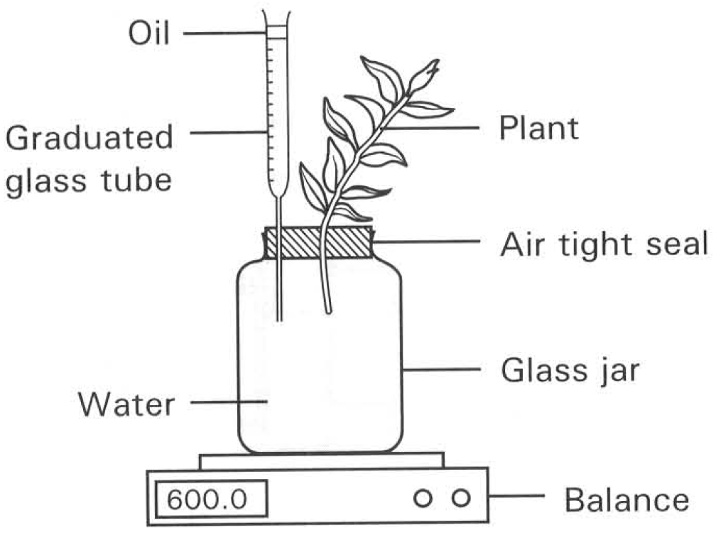
A. (1) only
B. (2) only
C. (3) only
A. 10 ghr-1.
22. 37The amount of water retained by the plant is
A. 6 g.
B. 12 g.
C. 24 g.
D. 25 g.
23. According to the above experiment the rate of water uptake is found to be slightly higher than the rate of water loss through evaporation. Such a difference is due to (1) the water used for photosynthesis. (2) the water escaped through the lenticels of the stems. (3) the water used for respiration. (4) the water retained in the cells to make them turgid.
A. (1) and (2) only
B. (2) and (3) only
C. (1) and (4) only
D. (1), (2) and (4) only
24. 39The addition of oil on top of the water level in the graduated glass tube is to
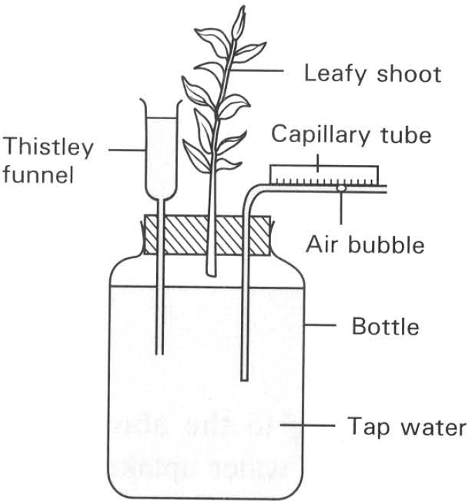
A. lubricate the inner surface of the graduated tube for facilitating the up and down movement of the water level inside the tube.
B. cut down the evaporation of water through the open end of the graduated tube.
C. act as indicator showing the position of the water level.
D. prevent the water vapour in the atmosphere from condensing into the water kept in the graduated tude. Directions: Questions 9.40 and 9.41 refer to the diagram below which shows an experment in progress.
25. There were several mistakes in the above experimental set-up. Which of the following are the corrections that have to be made? (1) An entire plant with root system should be used. (2) A tap funnel should be used instead of a thistle funnel. (3) The end of the shoot inside the bottle should be completely immersed in water. (4) The bottle should be completely filled with water. (5) Dilute hydrogencarbonate solution should be used instead of tap water so that there is sufficient carbon dioxide to support the photosynthesis of the plant.
A. (1) and (5) only
B. (2) and (5) only
C. (2), (3) and (4) only
D. (3), (4) and (5) only
26. After the above corrections have been made,which of the following precautions should be taken to make this apparatus work properly?
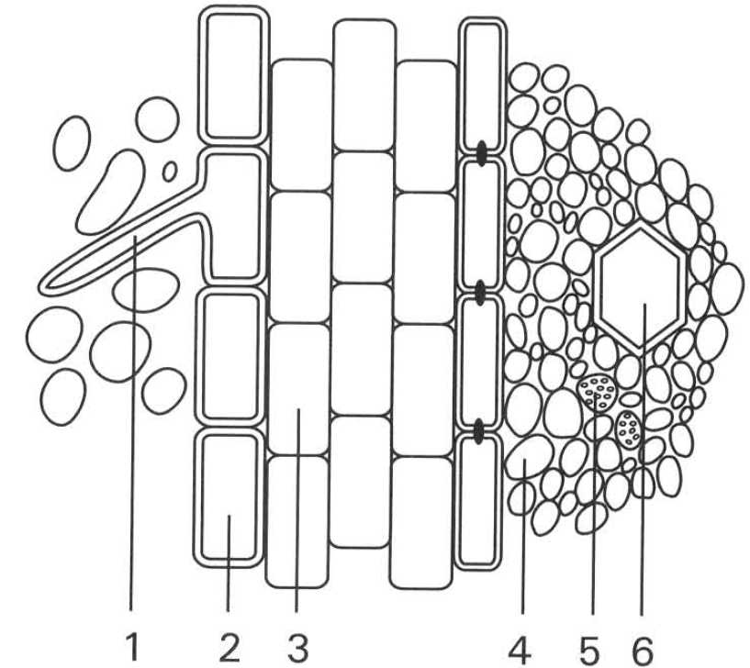
. | 2 | 3 | 5 | 6
A. | Cortex | Epidermis | Phloem | Xylem
B. | Root hair | Cortex | Xylem | Phloem
C. | Epidermis | Cortex | Phloem | Xylem
D. | Root hair | Phloem | Cortex | Xylem

A. Add a laye of oil on the water surface in the funnel.
B. Cover the bottle with a piece of black cloth.
C. Destarch the plant before the experment is started.
D. Cut the shoot under water and insert it into the bottle under water.
B. Absorption by roots Directions: Questions 42 to 48 refer to the diagram below which shows the transverse section of a young root in soil. 42Which of the following combinations is CORRECT? 43In a longitudinal section of a young root tip structure 1 is normally present in the
A. root cap. B. region of maturation. C. region of division. D. region of elongation. 44Which of the following is/are the adaptive feature(s) of the structurelabelled 1? (1) Elongated shape (2) No cuticle (3) No central vacuole
A. (1) only B. (2) only C. (1) and (2) only D. (2) and (3) only 45Which of the following structure(s) has/ have comparatively thin cell wall?
A. 2 only B. 3 only C. 4 only D. 3 and 4 only 46Which of the cells shown is NOT living?
A. 1 only B. 3 only C. 4 only D. 6 only
27. Which of the following substances are translocated in structures 5 and 6 respectively?
28. | 6 | D. | Minerals | Starch 48Which region has the lowest water potential? A. 1 B. 3 C. 4 D. 6 49Minerals are absorbed into the root by means of (1) diffusion. (2) osmosis. (3) active transport. A. (1) only B. (2) only C. (3) only D. (1) and (3) only
A. | Water | Sucrose |
B. | Starch | Minerals |
C. | Sucrose | Water |
D. | Minerals | Starch 48Which region has the lowest water potential?
29. The following graph shows the water gain and water loss of the same plant on two consecutive days.
Which of the following combinations is/are CORRECT?
(1) The leaves of the plant wilt on Day 1.
(2) There is a net gain in the dry mass of the plant on Day 1 which is cloudy, cool and rainy.
(3) Day 2 is most likely to be hot, dry and windy.
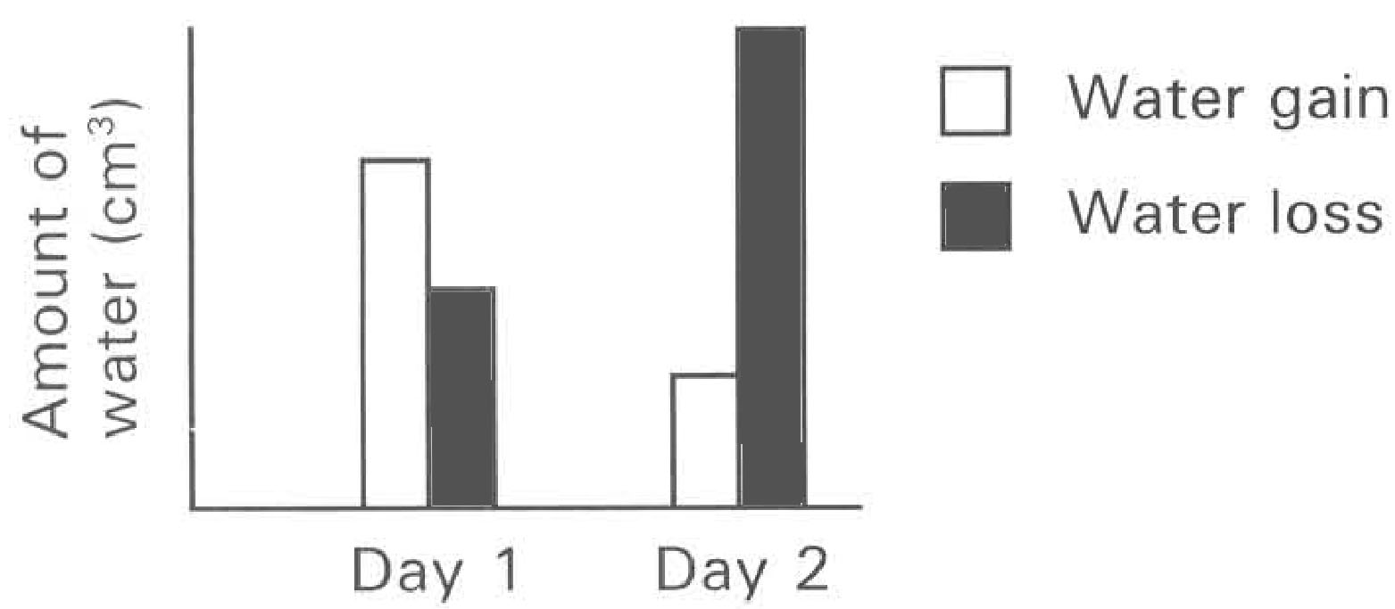
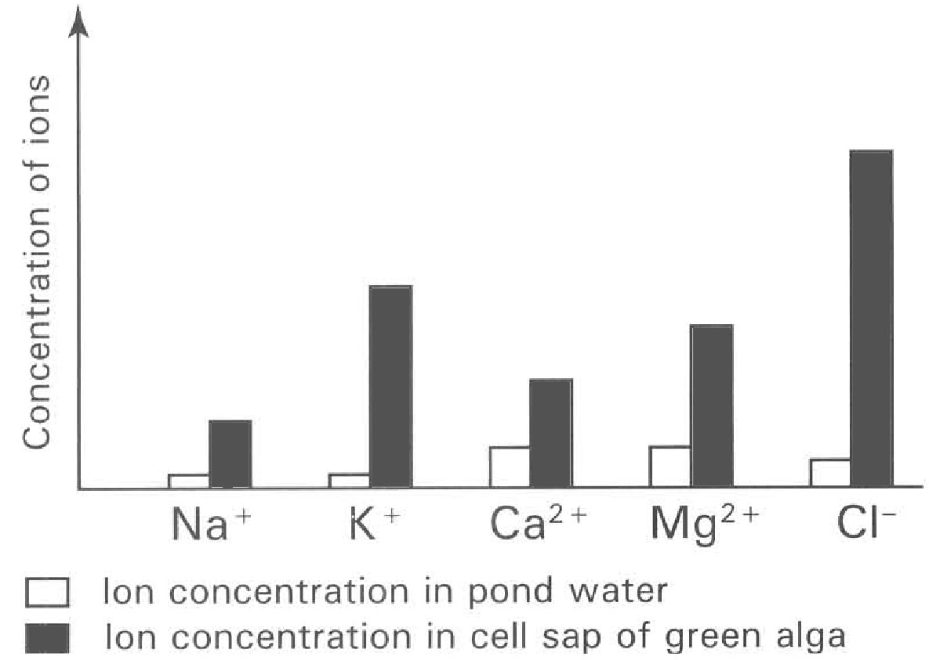
A. (1) only B. (2) only C. (3) only D. (1) and (2) only Directions: Questions 51 and 52 refer to the graph below which shows the concentration of certain ions in the cell sap of a fresh water alga and the surrounding pond water.
30. According to the information given in the graph, which of the following processes is responsible for the absorption of ions into the freshwater alga?
A. Diffusion B. Osmosis C. Active transport D. Phagocytosis
31. Which of the following factors are essential for the above process to take place? (1) Presence of a selectively permeable membrane (2) Presence of a fully permeable cell wall (3) Presence of chloroplasts (4) Expenditure of ATP
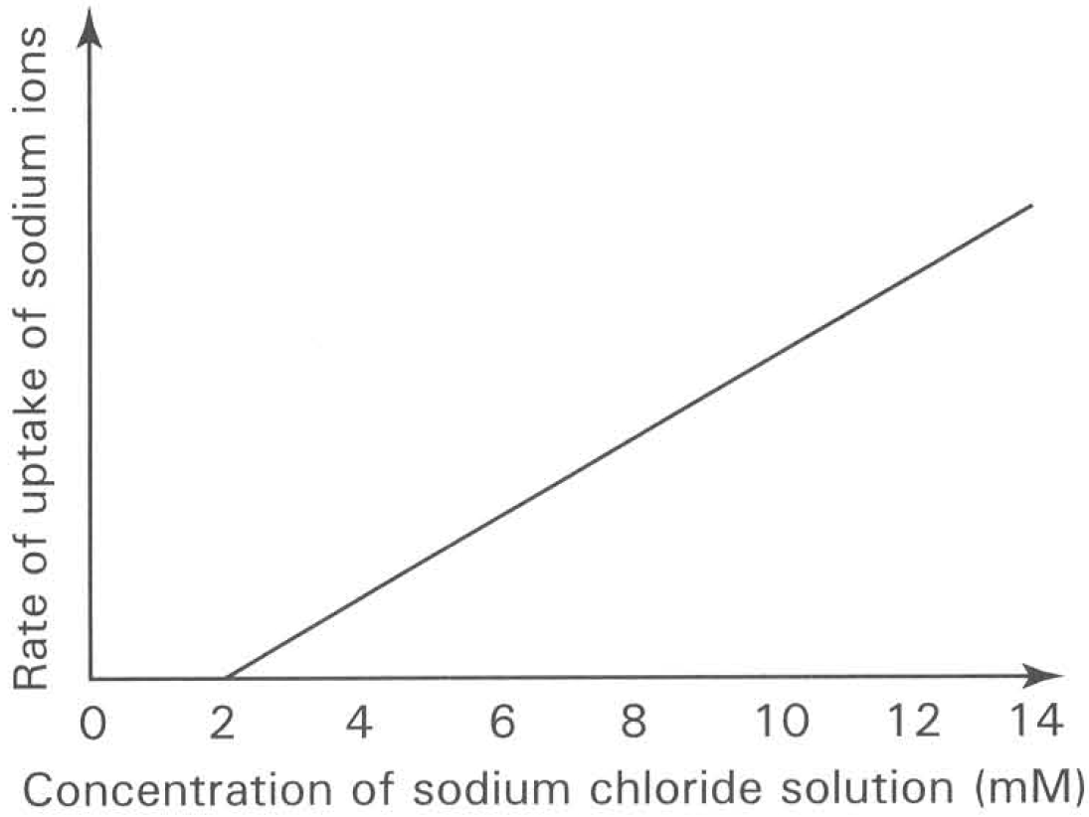
A. (1) and (2) only
B. (2) and (4) only
C. (3) and (4) only
D. (1) and (4) only
32. The graph below shows the rate of uptake of sodium ions by roots which are immersed in sodium chloride solution of different concentrations. Which of the following conclusions can be drawn from the graph? (1) Between 0 and 2 mM sodium chloride concentration no sodium ions are absorbed by the roots. (2) The roots absorb sodium ions when the sodium chloride solution is higher than 2 mM. (3) The uptake of sodium ions depends on active transport when the concentration of the sodium chloride solution is higher than 8 mM.
A. (1) only
B. (2) only
C. (3) only
D. (1) and (2) only
33. The graph below shows the uptake of potassium and bromide ions by roots for 6 hours in oxygen, then 6 hours in nitrogen and then 6 hours in oxygen.
Which of the following conclusions can be drawn from the graph?
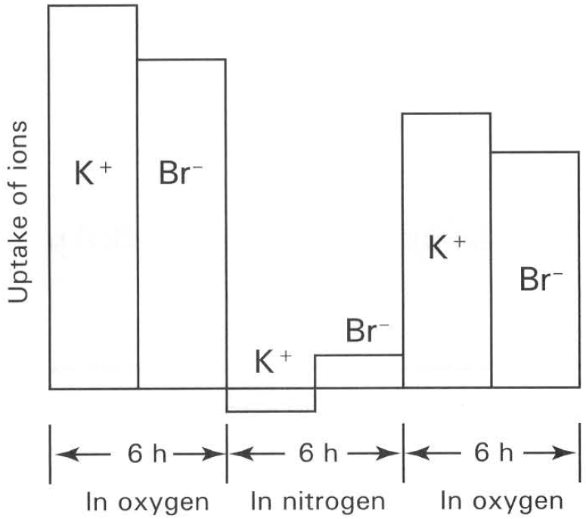
A. Both potassium and bromide ions are absorbed by diffusion in the presence of nitrogen.
B. The active absorption of both potassium and bromide ions depends on the presence of oxygen.
C. Potassium ions must be absorbed together with bromide ions.
D. Active transport cannot take place again after the roots have been exposed to anaerobic condition.
C. Transport in plants
34. The food produced leaves will be transported by the vascular tissues to the roots for storage. Which of the following is the CORRECT combination of the food transported and stored and the vascular tissues involved?
Directions: Questions 56 to 61 refer to the following diagrams which show the transverse sections of stem and root and three types of cells.
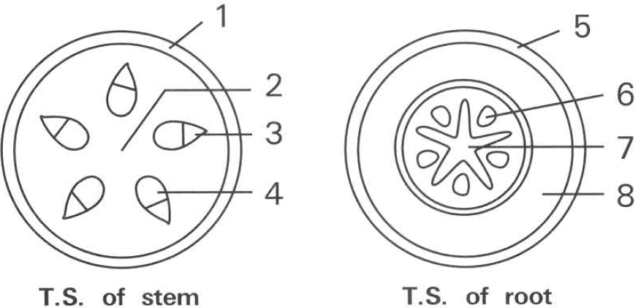
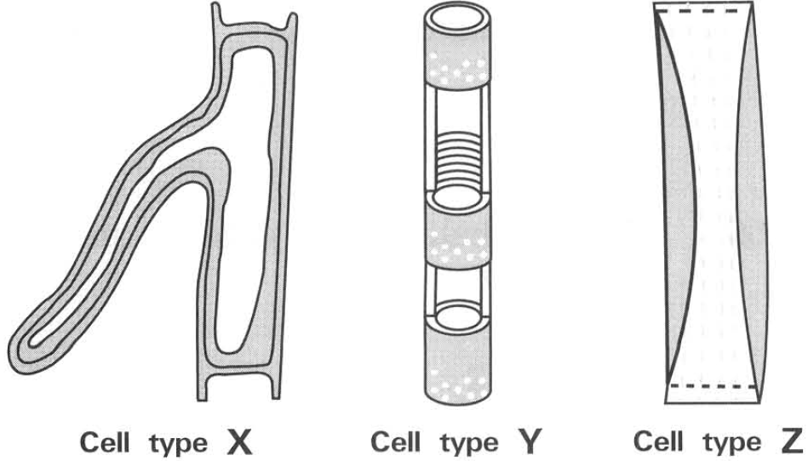
 | Food transported from leaves | Vascular tissues involved | Food stored in roots
A. | Glucose | Xylem | Sucrose
B. | Sucrose | Xylem | Glucose
C. | Sucrose | Phloem | Starch
D. | Starch | Phloem | Sucrose

35. Which of the following combinations of tissues CORRECTLY match with the labels?
 | Epidermis | Xylem | Phloem | Cortex
A. | 1 | 2 | 3 | 4
B. | 5 | 6 | 7 | 8
C. | 1 | 4 | 6 | 8
D. | 5 | 3 | 7 | 2

36. Which of the following CORRECTLY mark the locations of the three types of cells ?
58Which of the following comparison(s) between cell types Y and Z is/are CORRECT?
 | Cell type X | Cell type Y | Cell type Z
A. | 1 | 3 | 7
B. | 5 | 4 | 6
C. | 1 | 4 | 3
D. | 5 | 6 | 7

 | Cell typeY | Cell type Z
(1) | Has end walls | No end walls
(2) | Cannot oxidise sugars to release energy | Can oxidise sugars to release energy
(3) | Bidirectional transport | Unidirectional transport
(4) | Transport minerals | Transport organic food

A. (1) and (2) only B. (2) and (4) only C. (3) and (4) onlyD. (2), (3) and (4) only 59Which of the following CORRECTLY match with the functions of the labelled parts?
37. | 4 | 5 | 6 | A. | Turgid support | Transport of sugars | Absorption of water | Mechanical support | D. | Mechanical support | Transport of water | Gas exchange | Transport of sugars 60Which labelled parts in the stem and root are responsible for the transport of amino acids in the plant? B. 3 and 6 C. 4 and 7 D. 1 and 5
B. | Storage of starch | Transport of minerals | Gas exchange | Transport of sugars |
C. | Turgid support | Mechanical support | Turgid support | Mechanical support |
D. | Mechanical support | Transport of water | Gas exchange | Transport of sugars 60Which labelled parts in the stem and root are responsible for the transport of amino acids in the plant?
A. 2 and 8
38. If the stem belongs to an aquatic plant and the root belongs to a terrestrial plant which labelled parts are responsible for gas exchange of the plants ?
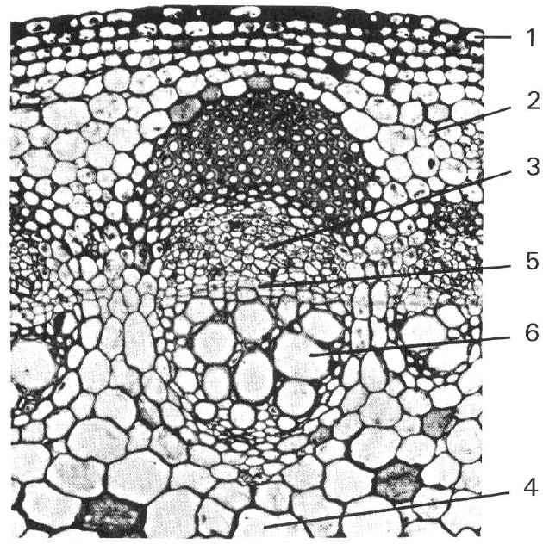
A. 2 and 8 B. 3 and 6 C. 4 and 7 D. 1 and 5 Directions: Questions 62 to 64 refer to the photomicrograph below which shows the transverse section of a dictyledonous stem.
39. If the lower end of the above organ has been cut off and has been immersed in a beaker of red dye for several hours, which labelled part(s) will be stained red? D. 3 and 6 only 63Which of the following conclusions can be drawn from the above experiment? (1) The stained parts are responsible for the transport of water and orgainc nutrients. (2) The stained parts are responsible for the support of the plant. (3) The stained parts are responsible for the transport of water and dissolved minerals. (4) The unstained parts are responsible for the storage of food. A. (1) only B. (2) only C. (3) only D. (1) and (4) only 64Which of the following combinations of the functions of the labelled parts is CORRECT? Directions: Questions 65 to 67 refer to the photomicrograph below which shows the transverse section of a monocotyledonous root.
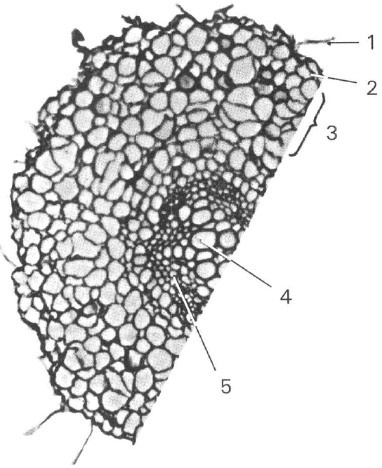
 | Reduction of water loss | Storage of food | Transport of waterand minerals | Transport of sugar
A. | 2 | 4 | 1 | 6
B. | 1 | 3 | 5 | 4
C. | 1 | 4 | 6 | 3
D. | 2 | 5 | 4 | 6

A. 3 only
B. 5 only
C. 6 only
D. 3 and 6 only 63Which of the following conclusions can be drawn from the above experiment? (1) The stained parts are responsible for the transport of water and orgainc nutrients. (2) The stained parts are responsible for the support of the plant. (3) The stained parts are responsible for the transport of water and dissolved minerals. (4) The unstained parts are responsible for the storage of food.
40. Which of the following statements concerning the structure labelled 1 in the section shown is/are CORRECT? (1) It persists as long as the plant survives. (2) It is multinucleated. (3) It increases the surface area of root to absorb water and mineral salts. (4) It increases the anchorage of the plant in soil. D. (1), (2) and (3) only 66Which labelled tissue has the lowest water potential? A. 1B. 2 C. 3 D. 4
A. (1) and (2) only
B. (2) and (3) only
C. (3) and (4) only
D. (1), (2) and (3) only 66Which labelled tissue has the lowest water potential?
41. Which tissures are used for the storage of food and the transport of sugars respectively?
A. 3 and 5
B. 3 and 4
C. 4 and 5
D. 2 and 3
42. Which of the following is NOT a function of the vascular bundles in a higher plant?
A. To give mechanical support to the plant.
B. To transport water up to the plant.
C. To produce new cells for increasing the height of the plant.
D. To transport nutrients up and down the plant. 69Nitrates reach the mesophyll cells of the leaf mainly by way of the
A. xylem. B. epidermis. C. phloem. D. stomata. 70The translocation of water up the plants depends on (1) capillarity. (2) photosynthesis. (3) root pressure. (4) transpiration pull. (5) atmospheric pressures.
A. (1), (2) and (3) only B. (1), (3) and (4) only C. (2), (3) and (4) only D. (3), (4) and (5) only
43. After very heavy rainfall the roots of plants may become waterlogged. Very soon some plants may wilt. Which of the following explanations is CORRECT?
(1) After heavy rainfall the soil water is diluted by the waterlogging condition, thus the roots absorb more water into the plants.
(2) The roots may die due to the shortage of oxygen in the waterlogging condition. As the dead roots cannot absorb water, the loss of water by transpiration without any replenishment of water causes wilting.
(3) The roots absorb less mineral salts because lots of mineral salts have been washed away by the heavy rainfall.
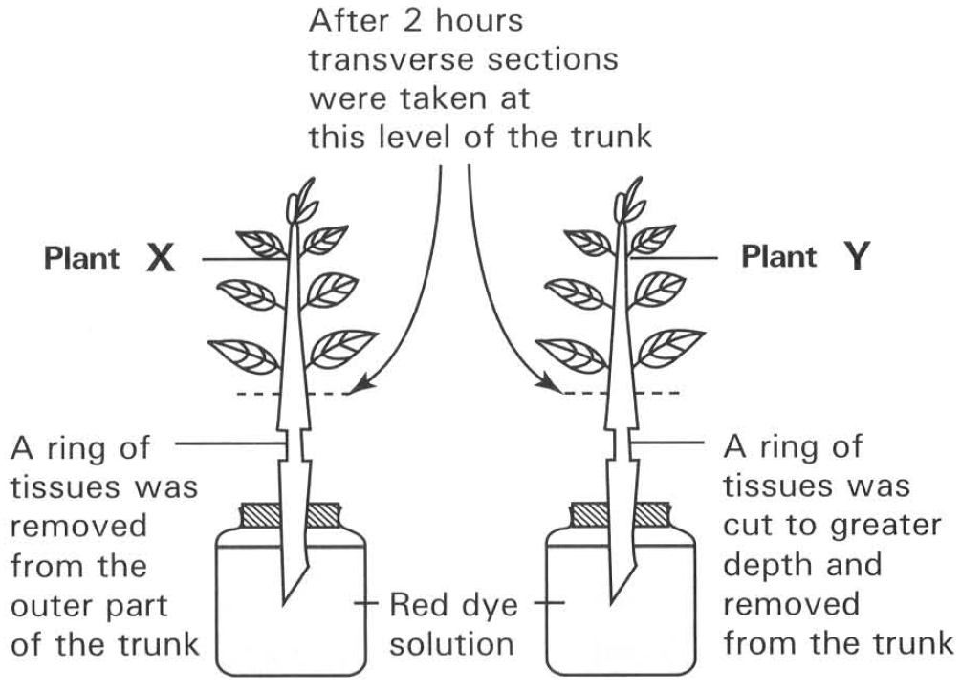
A. (1) only B. (2) only C. (3) only D. (2) and (3) only Directions: Questions 72 and 73 refer to the diagram below which shows an experiment in progress.
44. After two hours the leaves of plant X remained turgid while those of plant Y wilted. Which of the following is the conclusion that can be drawn according to the above observation?
A. Phloem is responsible for the transport of food substances manufactured in the leaves.
B. Water is transported through the xylem throughout the whole plant.
C. The leaves of plant were mainly supported by the turgidity of cells.
D. The rate of transpiration by the leaves is higher than the rate of absorption of water by the roots.
45. After two hours transverse sections of plants X and Y were observed under microscope. Which of the following diagrams show the right staining of the parts concerned?
Directions: Questions 74 and 75 refer to the diagram below which shows an aphid using its long mouth part to pierce into a herbaceous stem to suck plant juice out.
74Which of the following matching is CORRECT?
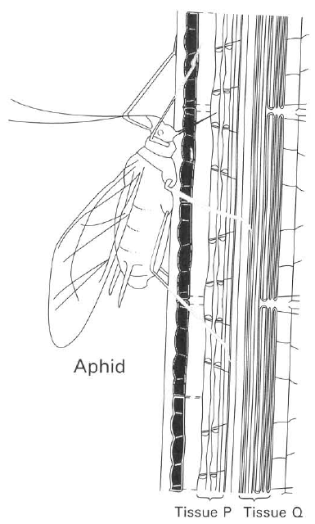
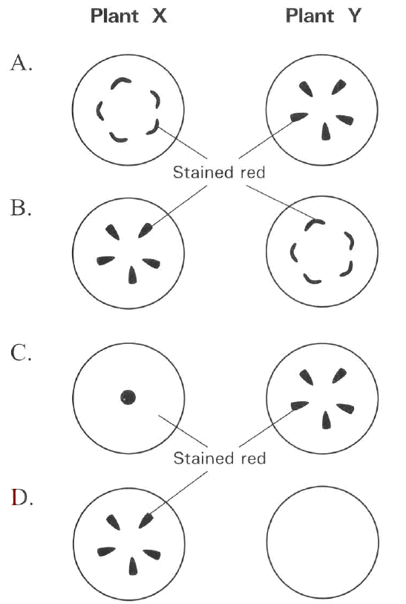
 | Tissue P | Tissue Q
A. | Phloem | Xylem
B. | Xylem | Phloem
C. | Cortex | Pith
D. | Pith | Cortex

46. Which of the following substances may be present in the plant juice sucked by the aphid? (1) Amino acids (2) Magnesium (3) Sugars (4) Water D. (1), (3) and (4) only Directions: Questions 76 and 77 refer to the following diagram which shows the trunk with a ring of bark together with the phloem removed from it and the appearance of the trunk two weeks later. 76Which of the following explanations of the swelling is CORRECT? (1) Cutting stimulates the xylem above the ring to grow. (2) The cortex above the ring absorbs moisture from air and swells. (3) Food cannot pass through the ring and thus accumulates above the ring to cause the swelling. B. (2) only C. (3) only D. (2) and (3) only
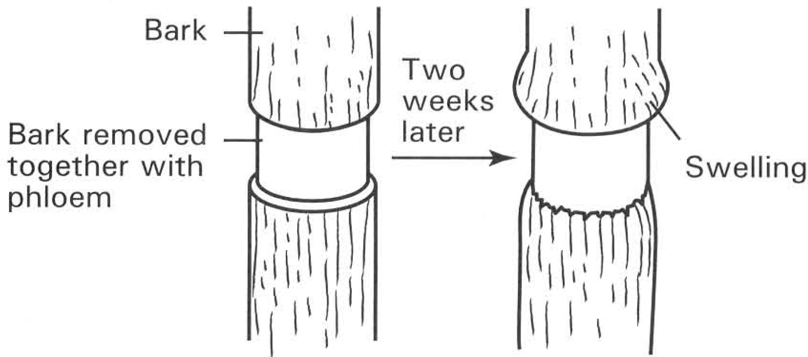
A. (1) and (2) only
B. (2) and (3) only
C. (1) and (4) only
A. (1) only
47. The plant in the ringing experiment may eventually die. Which of the following explanation(s) is/are CORRECT?
(1) Water cannot pass through the ring to support the growth of the leaves above the ring.
(2) Mineral salts cannot be transported through the ring to support the leaves above the ring to carry out photosynthesis.
(3) Organic food cannot be transported across the ring to support the life of the roots.
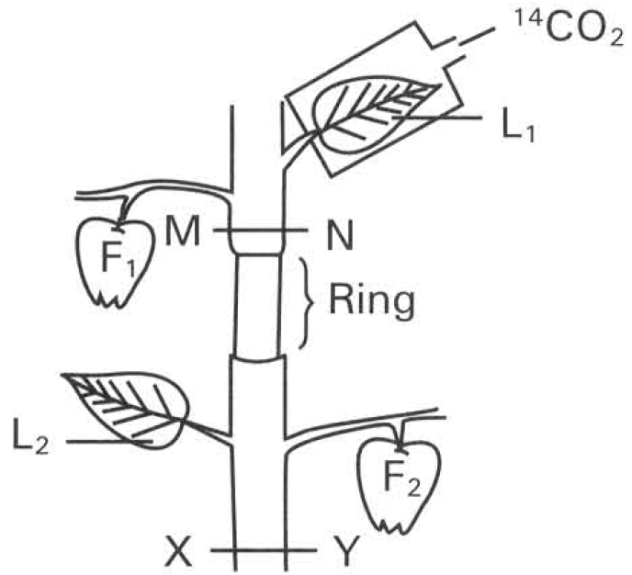
A. (1) only B. (2) only C. (3) only D. (2) and (3) only Directions: Questions 78 to 81 refer to the diagram below which shows that a ring of bark containing phloem has been removed from a leafy branch.
48. After a few weeks a swelling formed above the ring. Which of the following is/are the explanation for the appearance of such swelling? (1) The ringing action stimulated the active cell division of the tissues around the cutting to replace for the damaged tissues. (2) The removal of the phloem caused the downward trans-located food accumulated above the ringed region thus enhanced the active growth of cells. (3) The wounded tissues directly absorb water vapour from the atmosphere to cause the swelling.
A. (1) only
B. (2) only
C. (3) only
D. (1) and (2) only
49. What would be the difference in the size of the fruits labelled F1 and F2 several days after the ring has been cut?
A. F1 became smaller because no more water was transported to it.
B. F1 became bigger because it could receive enough water supply.
C. F2 became bigger because it was nearer to the root region so that more water was transported to it.
D. There is no big difference in size between F1 and F2.
50. If leaf L2 and fruit F2 are removed, after a few weeks the plant may die. Which of the following is the TRUE explanation for the death of the plant?
A. Mineral salts cannot be transported to the the root.
B. Water cannot be transported to the root.
C. Sucrose cannot be transported to the root to support its life.
D. Sucrose cannot be transported to the leaves.
51. If the ring was cut a bit deeper to remove both the xylem and phloem, what would happen to the leaves labelled L1 and L2 after two days?
A. Both leaves would die because without xylem in the ringed region none of them could get any water supply.
B. Leaf L1 would remain healthy because it could continuously receive water supply from the root .
C. Leaf L2 would remain turgid because it could still receive water supply from the root.
D. Leaf L2 would wilt because it could not receive water supply from the root. Directions: Questions 82 and 83 refer to the experiment described below. A similar experiment is set-up as for questions 9.78 to 9.81 but leaf L1 is confined in a chamber which is supplied with radioactive 14CO2. The plant was exposed to light for six hours. Then thin sections were cut across the shoot along MN and XY. These two thin sections were put on two photographic films. The dark area on the films is the place where radioactivity is present.
52. Which of the following combinations CORRECTLY represents the distribution of radioactivity at the two sections MN and XY?
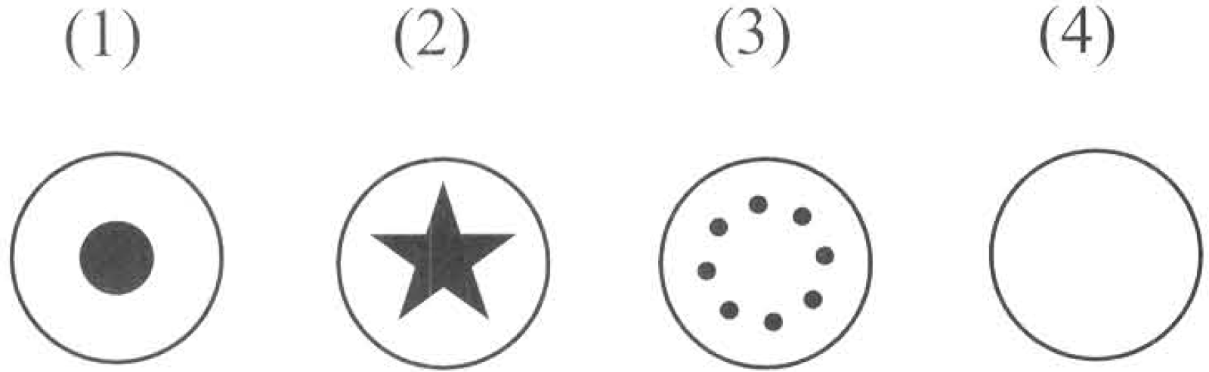
 | MN | XY
A. | (1) | (2)
B. | (2) | (3)
C. | (3) | (4)
D. | (3) | (2)

53. At the end of the experiment, of the following parts contain activity?
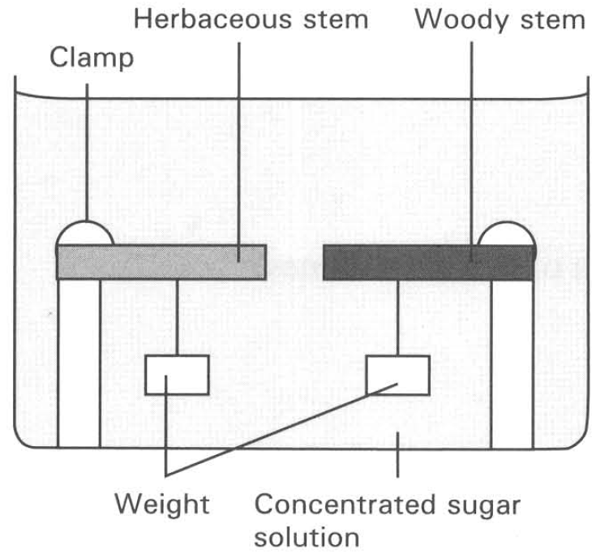
A. L1 and L2 only B. F1 and L2 only C. F1 and L1 only D. F2 and L2 only
D. Support in plants Directions: Questions 84 to 86 refer to the diagram below which shows that a straight herbaceous stem and a straight woody stem are both clamped horizontally in a trough of concentrated sugar solution. 84What will be the appearance of these stems after two hours?
A. Both stems bend downwards.
B. Both stems bend upwards.
C. The herbaceous stem bends downwards while the woody stem remains straight.
D. The woody stem bends downwards while the herbaceous stem remains straight.
54. Referring to the result of the above experiment, which of the following statemens is INCORRECT?
A. The cell sap of the herbaceous stem has a lower water potential than that of the concentrated sugar solution.
B. The woody stem is mainly supported by the mechanical tissues.
C. The herbaceous stem is mainly supported by the turgidity of the cells.
D. The herbaceous stem loses water to the concentrated sugar solution.
55. If the concentrated sugar solution in the above experiment is replaced by distilled water, what will be the appearance of these stems?
A. Both stems bend upwards.
B. Both stems remain in the same appearance as that in the previous experiment.
C. The herbaceous stem bends upwards back to the former straight position while the woody stem remains unchanged.
D. The herbaceous stem remains unchanged while the woody stem bends upwards.
56. The vascular bundles of a dicotyledonous stem are usually present along the periphery. Such a distribution of vascular tissues
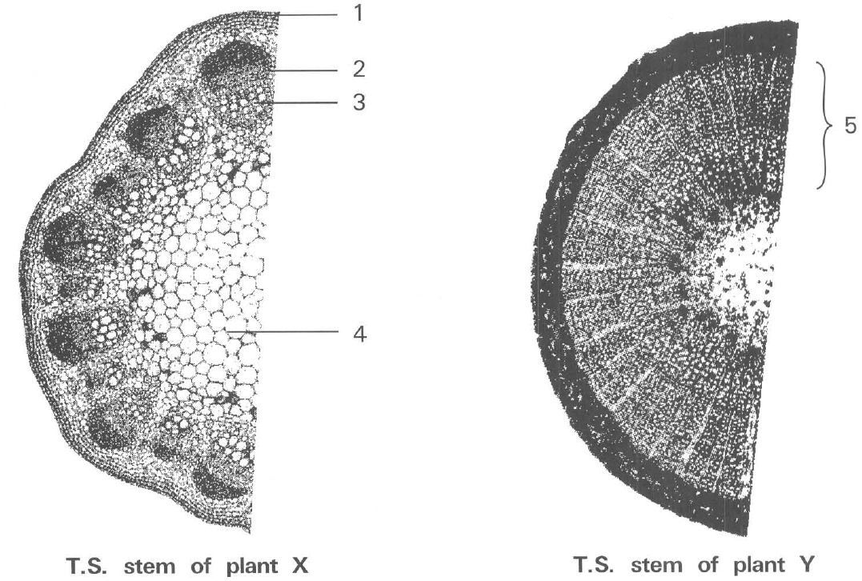
 | Tissue 3 | Tissue 4
 | Means ofsupport | Adaptation of thecells involved | Means ofsupport | Adaptation of thecells involved
A. | Mechanical | Thick cell wall | Turgidity | Thin cell wall
B. | Turgidity | Thin cell wall | Mechanical | Thick cell wall
C. | Mechanical | Thin cell wall | Turgidity | Thick cell wall
D. | Turgidity | Thick cell wall | Mechanical | Thin cell wall

A. increases the capacity of translocating substances throughout the plant.
B. provides better strengthening effect to act against the bending stress of wind.
C. provides more space for actively dividing cells to be present in order to promote growth in length of the stem.
D. gives better protection for the pith at the centre of the stem. 88The vascular bundles of a dicotyledonous root are usually present at the central core. Such a distribution of vascular tissues
A. provides more space for the peripheral cortex to absorb more water from the surrounding soil.
B. increases the strengthening effect against the bending stress of wind.
C. provides more space for translocating water up to the stem.
D. provides better anchoring effect to act against the uprooting stress of wind or by-passing animals. 89The widespread distribution of veins in a leaf
A. gives mechanical support to the flattened blade of the leaf.
B. gives the leaf a distinct shape so as to attract insect for pollination.
C. gives bigger surface area for maximum absorption of sunlight for photosynthesis.
D. translocates more water to the mesophyll to speed up the rate of transpiration. Directions: Questions 90 to 94 refer to the photomicrographs below which show the transverse sections of stems taken from two plants: 90What kind of support is provided by the tissues labelled 3 and 4 and the adaptation of these cells for support in the stem of plant X?
57. Which labelled tissue in plant X has the same function as the tissue labelled 5 in plant Y?
A. 1
B. 2
C. 3
D. 4
58. Which of the following environmental conditions affect the means of support in plant X? (1) Temperature (2) Relative humidity (3) Light intensity (4) Wind velocity
A. (1) and (2) only
B. (3) and (4) only
C. (1), (2) and (3) only
D. (1), (2), (3) and (4)
59. If the stems of plant X and plant Y were cut and the cut ends of both stems were immersed in a poisonous solution, which of the following observation of the stems in respect to support and the explanation given are CORRECT? 94Which labelled tissues in plant X will be greatly reduced if it is living in water? D. 4 Suggested Solutions
 | Plant X | Plant Y
 | Observation | Explanation | Observation | Explanation
A. | Remains in an erect form | Tissue 4 is not affected by the poison | Remains in an erect form | Tissue 5 is killed by the poison
B. | Becomes limp and bents | Tissue 4 is killed by the poison | Remains in an erect form | Tissue 5 is not affected by the poison
C. | Remains in an erect form | Tissue 4 is killed by the poison | Becomes limp and bents | Tissue 5 is killed by the poison
D. | Becomes limp and bents | Tissue 4 remains alive | Becomes limp and bents | Tissue 5 is not affected by the poison

A. 1
B. 2
C. 3
D. 4 Suggested Solutions

Answers
Answers are printed in red.
1. A. at mid-night.
Class: 65.4% correct (n=396) usual slip A
2. B. (2) only

3. C. (3) only
Class: 58.6% correct (n=396) usual slip B
4. B. the thermal contraction of the metal ring of the dendrograph.
Class: 75.8% correct (n=396) usual slip B
5. D
Class: 76.6% correct (n=303) usual slip C
6. D. the temporary closure of the stomata.
Class: 79.9% correct (n=303) usual slip D
7. C. To avoid the excessive loss of water from the plant.
Class: 80.1% correct (n=231) usual slip B
8. D. The water gain is faster than the loss by the leaves. Directions: Questions 17 and 18 refer to the graph below which shows the change in the rate of transpiration and the rate of absorption of water in a plant from 0800 hour to 2200 hour of a day.
Class: 51.9% correct (n=231) usual slip A
9. B. Growth will only take place when X is smaller than Y.
Class: 58.0% correct (n=231) usual slip A
10. C. Increase in light intensity D. Decrease in the velocity of wind Directions: Questions 21 to 25 refer to the diagram below which shows an experment in progress.
Class: 60.0% correct (n=160) usual slip A
11. D. (1) and (4) only
Class: 61.8% correct (n=157) usual slip A
12. D. the temperature of the air surrounding the bell jar.
Class: 56.7% correct (n=157) usual slip D
13. D. the rate of transpiration through the lower surface is higher than that through the upper surface of the leaf Directions: Questions 26 to 28 refer to the diagram below which shows an experiment in progress.
Class: 55.7% correct (n=88) usual slip A
14. A. the supply of water from the plant to the leaf being cut out.
Class: 84.1% correct (n=88) usual slip C
15. C. present in greater number in the lower leaf surface.
Class: 48.9% correct (n=88) usual slip B
16. A. (1) only
Class: 54.5% correct (n=88) usual slip B
17. C. prevernt the xylem vessels from being blocked by air bubbles.
Class: 56.8% correct (n=88) usual slip B
18. C. (4) only
Class: 64.8% correct (n=88) usual slip D
19. B. (2) only
Class: 58.0% correct (n=88) usual slip D
20. C. (3) and (5) only
Class: 76.1% correct (n=88) usual slip A
21. B. (2) only
Class: 78.3% correct (n=46) usual slip C
22. C. 24 g.

23. C. (1) and (4) only
Class: 76.1% correct (n=46) usual slip D
24. C. act as indicator showing the position of the water level.

25. C. (2), (3) and (4) only
Class: 58.7% correct (n=46) usual slip B
26. D. Cut the shoot under water and insert it into the bottle under water.
Class: 73.9% correct (n=46) usual slip A
27. C

28. B. | Starch | Minerals |

29. C

30. C

31. D. (1) and (4) only

32. D. (1) and (2) only

33. B. The active absorption of both potassium and bromide ions depends on the presence of oxygen.

34. C
Class: 89.5% correct (n=38) usual slip D
35. C
Class: 92.1% correct (n=38) usual slip D
36. B
Class: 60.5% correct (n=38) usual slip D
37. B. | Storage of starch | Transport of minerals | Gas exchange | Transport of sugars |
Class: 78.3% correct (n=396) usual slip A
38. D
Class: 97.4% correct (n=38) usual slip A
39. C. 6 only
Class: 71.1% correct (n=38) usual slip D
40. C. (3) and (4) only
Class: 89.5% correct (n=38) usual slip D
41. A. 3 and 5
Class: 78.9% correct (n=38) usual slip B
42. C. To produce new cells for increasing the height of the plant.
Class: 94.7% correct (n=38) usual slip A
43. B
Class: 68.4% correct (n=38) usual slip C
44. B. Water is transported through the xylem throughout the whole plant.
Class: 57.9% correct (n=38) usual slip C
45. D
Class: 94.7% correct (n=38) usual slip B
46. D
Class: 60.5% correct (n=38) usual slip B
47. C
Class: 86.8% correct (n=38) usual slip D
48. D. (1) and (2) only
Class: 7.9% correct (n=38) usual slip B
49. D. There is no big difference in size between F1 and F2.
Class: 60.5% correct (n=38) usual slip A
50. C. Sucrose cannot be transported to the root to support its life.
Class: 89.5% correct (n=38) usual slip A
51. C. Leaf L2 would remain turgid because it could still receive water supply from the root.
Class: 78.9% correct (n=38) usual slip B
52. C
Class: 76.3% correct (n=38) usual slip D
53. C. The herbaceous stem bends downwards while the woody stem remains straight.
Class: 52.6% correct (n=38) usual slip A
54. A. The cell sap of the herbaceous stem has a lower water potential than that of the concentrated sugar solution.
Class: 81.2% correct (n=32) usual slip C
55. C. The herbaceous stem bends upwards back to the former straight position while the woody stem remains unchanged.
Class: 62.5% correct (n=32) usual slip B
56. B. gives the leaf a distinct shape so as to attract insect for pollination.
Class: 62.5% correct (n=32) usual slip A
57. C. 3
Class: 59.4% correct (n=32) usual slip D
58. D. (1), (2), (3) and (4)
Class: 90.6% correct (n=32) usual slip A
59. B. 2
Class: 81.2% correct (n=32) usual slip C

