Receptors
Multiple-choice practice
Name: ________________________ Class: ____________
There are 147 questions compiled from Longman HKCEE and/or YKTo papers. Choose the one best answer.
Part A — HKCEE level (Longman)
1. A receptor A.produces sensation. C.can detect any kind of stimulus.
A. produces sensation.
B. produces nerve impulses upon stimulation.
C. can detect any kind of stimulus.
D. is a sensory neurone.
2. Which of the following is not a stimulus?
A. Temperature B. A sudden loud noise
C. An increase in light intensity D. Stepping on a nail
3. Which of the following correctly matches the stimuli and the receptors?
 | Stimulus | Receptor
A. | smell of ammonia | hairs in nostrils
B. | light | sensory cells of lens
C. | sound vibrations | sensory hair cells in semicircular canals-
D. | presence of food | touch receptors in tongue surface

4. Which of the following correctly matches the sense organs and their respective receptors?
 | Sense organ | Receptor
A. | eye | cornea cells
B. | ear | earbones
C. | tongue | taste buds
D. | skin | sweat glands

5. Which of the following cannot be an effector?
A. Skin B. Tongue C. Inner ear D. Diaphragm
6. Which of the following correctly describes the levels of organisation of the eye structures?
 | Eye | Retina | Cone
A. | tissue | organ | cell
B. | organ | tissue | cell
C. | tissue | cell | organ
D. | organ | cell | tissue

7. Which of the following shows the correct path of light after it enters the eye?
A.Cornea → aqueous humour -→ lens -→ retina -→ optic nerve-
B.Aqueous humour → iris -- > lens -→ ciliary body -→ retina-
C.Cornea → aqueous humour -→ lens -→ vitreous humour -→ retina-
D.Aqueous humour → pupil -→ lens -→ vitreous humour -→ optic nerve-
8. The diagram below shows a clock on the wall.
Which of the following correctly shows the image of the two hands of the clock formed on the retina of a man who is looking at the clock?
Directions: Questions 9 to 15 refer to the diagram below which shows a section through the human eye.
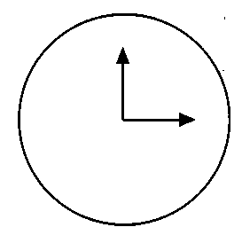
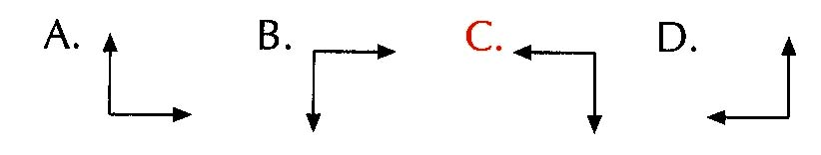
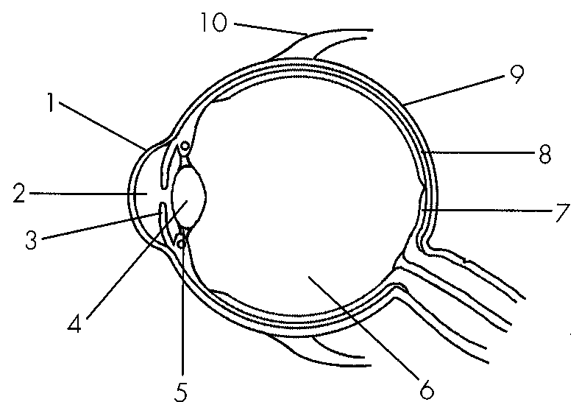
9. Which of the labelled structures are responsible for maintaining the shape of the eyeball?
A. 2, 4, 7, 8
B. 1, 2, 6, 9
C. 2, 6, 8, 9
D. 6, 7, 8, 9
10. Which of the labelled structures are transparent?
A. 1, 2, 3, 4
B. 1,2,4,6
C. 1,3,6,7
D. 2, 3, 4, 6
11. The eye is now focusing on an aeroplane which is taking off from the airport. The conditions of structures 4 and 5 should be:
 | Structure 4 | Structure 5
A. | becomes thicker | becomes taut
B. | becomes thicker | slackens
C. | becomes thinner | becomes taut
D. | becomes thinner | slackens

12. Which of the following correctly matches the functions with the structures?
 | Structure 7 | Structure 8 | Structure 9
A. | detects light | supplies food | protects inner structures
B. | produces vision | supplies oxygen | supports the eyeball
C. | produces vision | absorbs light | maintains shape
D. | supplies food | produces vision | protects inner structures

13. Which of the labelled structures are effectors? A.3 and 5
A. 3 and 5
B. 3 and 10
C. 5 and 10
D. 3, 5 and 10
14. Which of the following comparisons between structures 3 and 10 is correct?
 | Structure 3 | Structure 10
A. | It controls the curvature of structure 4. | It controls the movement of the eyeball.
B. | It attaches to structure 5. | It attaches to the skull bones.
C. | It is involved in focusing. | It is not involved in focusing.
D. | It is not controlled by the cerebrum. | It is controlled by the cerebrum.

15. Which of the following will occur if the optic nerve is cut? (1) No object will be seen. (2) No image will be formed. (3) No nerve impulse will be produced.
A. (1) only
B. (1) and (2) only
C. (2) and (3) only
D. (1), (2) and (3)
16. When a beam of light enters the eye, the rays are refracted by the
A. pupil and iris.
B. pupil and lens.
C. cornea and iris.
D. cornea and lens.
17. If a bright light is suddenly shone into a human eye, the response of the eye will be:
 | Iris | Pupil
A. | circular muscles contract | becomes larger
B. | circular muscles contract | becomes smaller
C. | circular muscles relax | becomes larger
D. | circular muscles relax | becomes smaller

18. The graph below shows the change in size of the pupil of a human eye during a period of time.
Which of the following correctly describes the changes in the environmental condition and the iris muscles during this period of time?
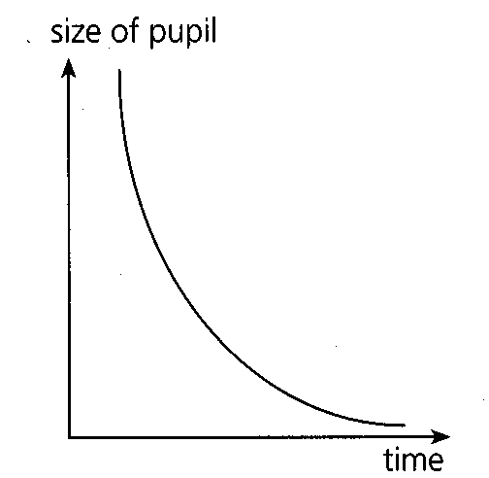
 | Environmental condition | Iris muscles (circular)
A. | getting brighter | relaxing
B. | getting brighter | contracting
C. | getting dimmer | relaxing
D. | getting dimmer | contracting

19. A girl at a bus stop was looking at a bus which was approaching her and then stopped in front of her. Which of the following graphs represents the change in the curvature of the lens of her eye?
Directions: 21 and 22 refer to the graph below which shows the changes in the curvature of the lens of a boy watching a bird feeding on a lawn.
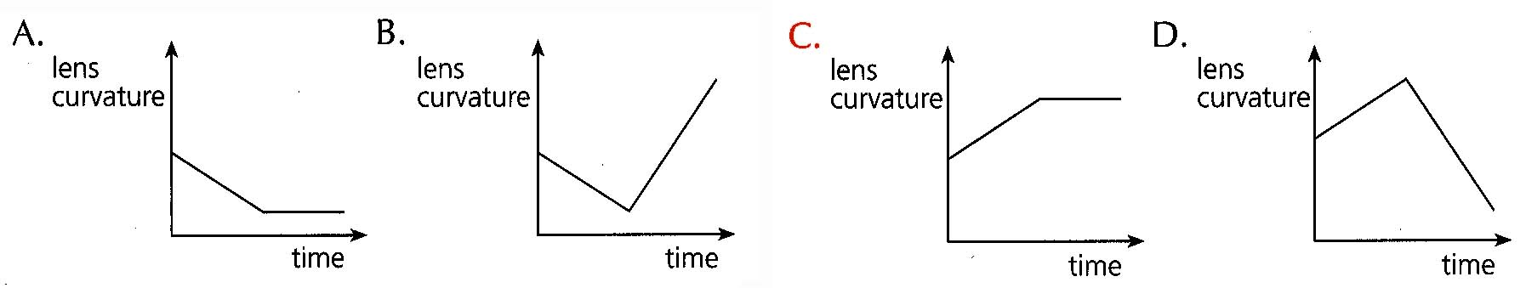
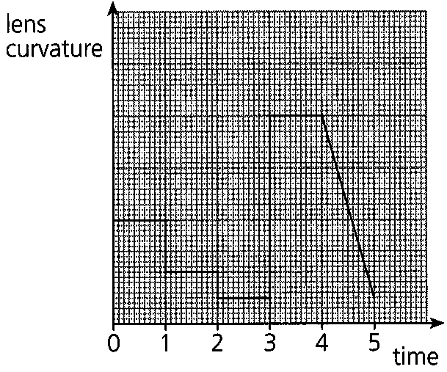
20. During which period of time was the bird farthest from the boy? A.0 - 1 s
A. 0 - 1 s
B. 1 - 2 s
C. 2 - 3 s
D. 3 - 4 s
21. During 4 5 s the bird should be- A.approaching the boy. C.resting at a place far away from the boy.
A. approaching the boy.
B. moving away from the boy.
C. resting at a place far away from the boy.
D. resting at a place near the boy.
22. A KCR passenger sees a train approaching from a distance. He looks at the station clock and then checks it with his watch. Which of the following diagrams shows the sequence of changes taking place in the shape of the lens of his eye?
23. Which of the following comparisons between rods and cones on the retina of the eye is incorrect?
 | Rods | Cones
A. | one type | three types
B. | for black and white vision | for colour vision
C. | for vision at night | for vision during the day
D. | absent at the yellow spot | most concentrated at the yellow spot

24. The diagram below shows the sensitivity of three types of cones towards different wavelengths of light. Which of the following statements is correct? (1)Red cones are sensitive to red light only. (2)A wavelength of 550 nm can stimulate both red cones and green cones. (3)The sensitivity of blue cones is higher than that of red cones or green cones at a wavelength of 450 nm. A.(1) and (2) only
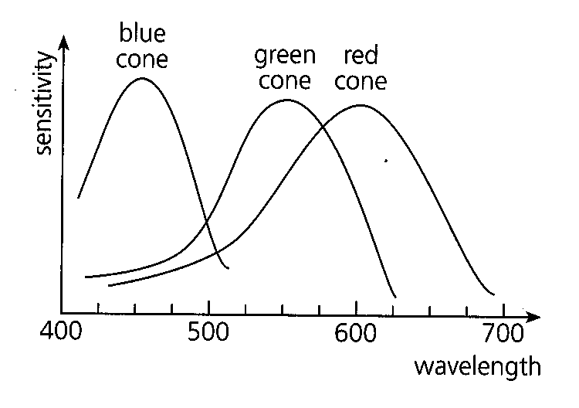
A. (1) and (2) only
B. (1) and (3) only
C. (2) and (3) only
D. (1), (2) and (3)
25. Which of the following descriptions of cones are correct? (1) Their functioning requires a sufficient supply of vitamin A. (2) They are sensitive to strong light. (3) They are most concentrated at the yellow spot. D. (1), (2) and (3) Directions: Questions 27 and 28 refer to the graph below which shows the distribution of light-sensitive cells on the retina of the eye.
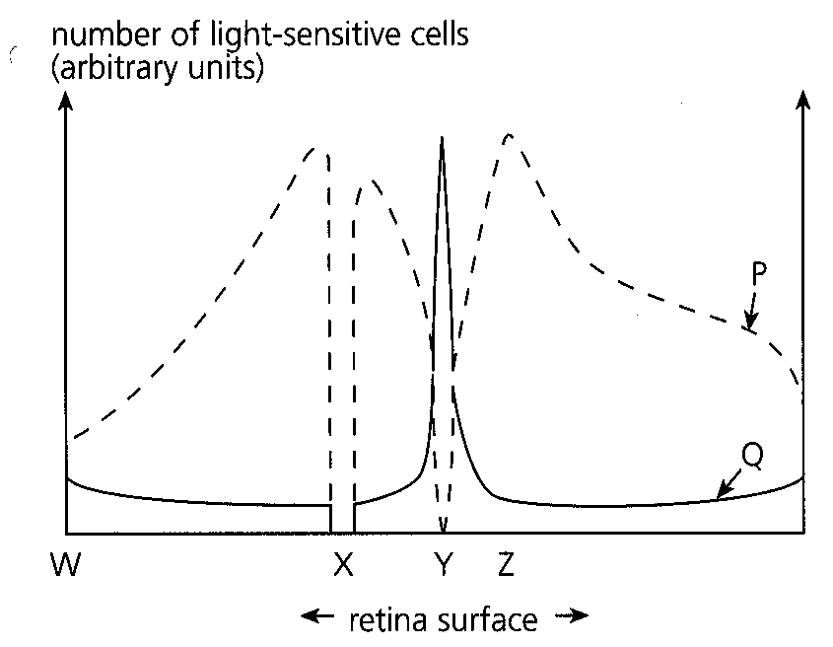
A. (2) They are sensitive to strong light. (3) They are most concentrated at the yellow spot.
A. (1) and (2) only
B. (1) and (3) only
C. (2) and (3) only
26. P, Q, X and Y represent:
 | P | Q | X | Y
A. | cones | rods | blind spot | yellow spot
B. | cones | rods | yellow spot | blind spot
C. | rods cones | blind | blind spot | yellow spot
D. | rods | cones | yellow spot | blind spot

27. When an object is seen in a dimly lit room, the clearest vision is obtained when the image is focused on
AW. B. X. C. Y. D. Z.
Directions: Questions 29 to 31 refer to the diagram below which shows part of the retina.
Cell 1
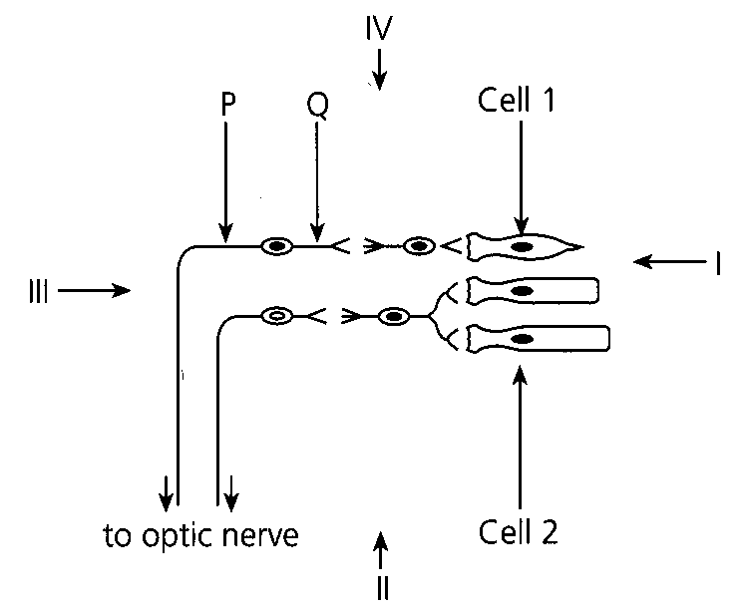
28. Identify the following:
 | Cell 1 | Cell 2 | Structure P | Structure Q
A. | rod | cone | dendron | axon
B. | rod | cone | axon | dendron
C. | cone | rod | dendron | axon
D. | cone | rod | axon | dendron

29. The diagram cannot represent the blind spot nor the yellow spot because A.blind spot should consist only of rods and yellow spot should consist only of cones. B.blind spot should have no light sensitive cells and yellow spot should consist only of cones.- C.blind spot should consist only of rods and yellow spot should have no light sensitive cells.- D.blind spot should have no light sensitive cells and yellow spot should consist only of rods.-
A. blind spot should consist only of rods and yellow spot should consist only of cones.
B. blind spot should have no light sensitive cells and yellow spot should consist only of cones.-
C. blind spot should consist only of rods and yellow spot should have no light sensitive cells.-
D. blind spot should have no light sensitive cells and yellow spot should consist only of rods.-
30. Which of the arrows I, II, III and IV, indicates correctly the normal direction of light that falls on the retina?
A. I
B. II
C. III
D. IV
31. The diagram below shows the path of light rays from a distant object through a human eye. Which of the following statements about the image is correct?
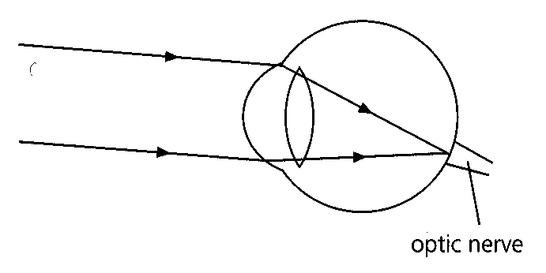
A. The image cannot be formed.
B. The image cannot be detected.
C. The image will be distorted.
D. The image will be the sharpest.
32. Colour blindness is caused by D. the defects in the lens.
A. the deficiency of vitamin
A.
B. the defects in rods.
C. a gene defect.
33. A boy had normal colour vision, but he found it difficult to distinguish the colour of the cars on the road when it was getting dark. This is because
A. the boy was suffering from night blindness.
B. the boy was suffering from colour blindness.
C. rods can only give black and white vision.
D. cones cannot function properly at low light intensity.
34. Which of the following diagrams correctly shows the path of light rays entering the eye when a shortsighted person tries to focus on a near object?-
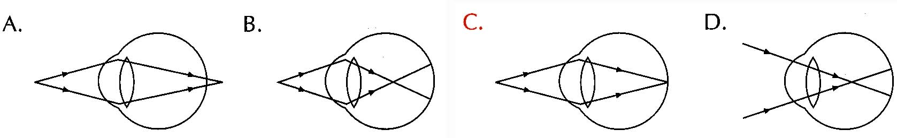
35. Which of the following diagrams correctly shows how short sightedness is corrected by a lens?-
36. Which of the following statements about long-sightedness is/are correct?
(1) Distant objects cannot be seen clearly.
(2) Images of near objects are formed behind the retina.
(3) The eyeball may be too short.
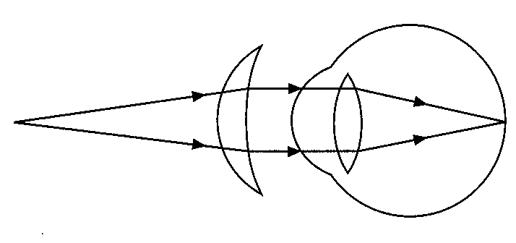
A. (1) only B. (3) only C. (1) and (2) only D. (2) and (3) only Directions: Questions 38 and 39 refer to the diagram below which shows the path of light rays from a near object to a defective eye through a corrective lens.
37. Which of the following is a possible cause of this eye defect?
A. The lens is too thick.
B. The surface of the cornea is rough.
C. The ciliary muscle is too strong.
D. The eyeball is too short.
38. Which of the following correctly describes the conditions of various structures of the eyeball?
 | Ciliary muscles | Suspensory ligament | Lens
A. | relaxed | tension increased | thin
B. | relaxed | tension decreased | thin
C. | contracted | tension increased | thick
D. | contracted | tension decreased | thick

39. Three students X, Y and Z have the following problems in vision:
X needs to wear concave lenses.
Y finds it difficult to distinguish colours when it is getting dark.
Z can see near objects clearly but not distant objects.
Which of the following correctly describes the eye defects, if any, in X, Y and Z?
Directions: Questions 41 to 47 refer to the diagram below which shows the structure of a human ear.
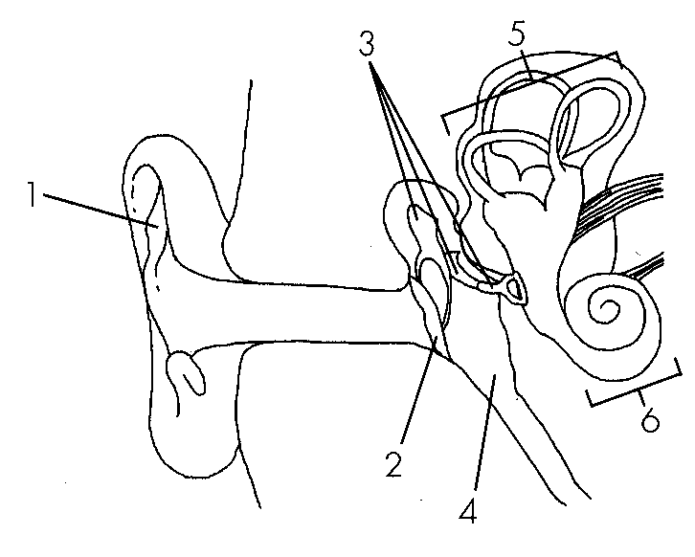
 | X | Y | Z
A. | long-sightedness | colour blindness | short-sightedness
B. | long-sightedness | night blindness | long-sightedness
C. | short-sightedness | night blindness | long-sightedness
D. | short-sightedness | normal | short-sightedness

40. The function of structure 4 is to
A. transmit nerve impulses to the brain.
B. locate the direction of sound.
C. direct sound vibrations to the inner ear.
D. equalize the pressure on both sides of the eardrum.
41. Which of the following are the functions of structure 3? (1) To transmit sound vibrations (2) To amplify sound vibrations (3) To stabilize the pressure in the middle ear
A. (1) and (2) only
B. (1) and (3) only
C. (2) and (3) only
D. (1), (2) and (3)
42. Which of the following fluids is found in structure 5?
A.Cerebrospinal fluid B. Plasma C. Endolymph D. Perilymph
43. Which structures contain sensory hair cells?
A. 2 and 5
B. 2 and 7
C. 5 and 6
D. 6 and 7
44. Which of the following correctly describes the function of structures 5 and 6?
 | Structure 5 | Structure 6
A. | to maintain balance | to produce the hearing sensation
B. | to maintain balance | to detect sound vibrations
C. | to detect head movement | to produce the hearing sensation
D. | to detect head movement | to detect sound vibrations

45. . If structure 3 is made of a single bone,
A. the air pressure in the middle ear cannot be stabilized.
B. sound vibrations cannot be transmitted.
C. body balance cannot be maintained.
D. vibrations transmitted to the inner ear will be much weaker.
46. While travelling on boats, one may feel sick as a result of repetitive stimulations of
A. structure 2.
B. structure 3.
C. structure 5.
D. structure 6.
47. Which of the following correct?
A.The sensation of hearing is produced at the cochlea of the inner ear.
B.The eardrum can amplify sound vibrations.
C.The earbones raise the frequency of sound.
D.The air in the middle ear can be released through the Eustachian tube.
Directions: Questions 50 to 52 refer to the diagram below which shows the structure of a human ear.
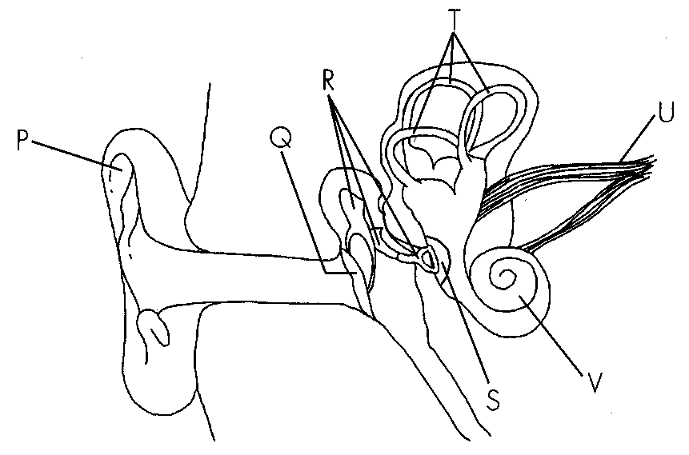
48. Which of the following correctly describes the functions of various parts of the ear? 51. Sound vibrations are amplified because A.structure P has a large surface area. B.structure V is long and coiled. C.structure S has a much smaller area than structure Q. D.structure R is rigid.
 | Structure | Function
A. | Q | to amplify sound vibrations
B. | R | to transmit nerve impulses
C. | T | to generate nerve impulses
D. | U | to transmit sound vibrations

A. structure P has a large surface area.
B. structure V is long and coiled.
C. structure S has a much smaller area than structure Q.
D. structure R is rigid.
49. Which of the following will happen if structure U of a person is cut? (1)He will lose the sensation of hearing. (2)He will not realize the direction of movement of his head. (3)He will lose the ability to coordinate body balance.
A. (1) only
B. (3) only
C. (1) and (2) only
D. (2) and (3) only
50. The following diagram shows certain regions on the surface of a human tongue. Which region is the most sensitive to sweetness?
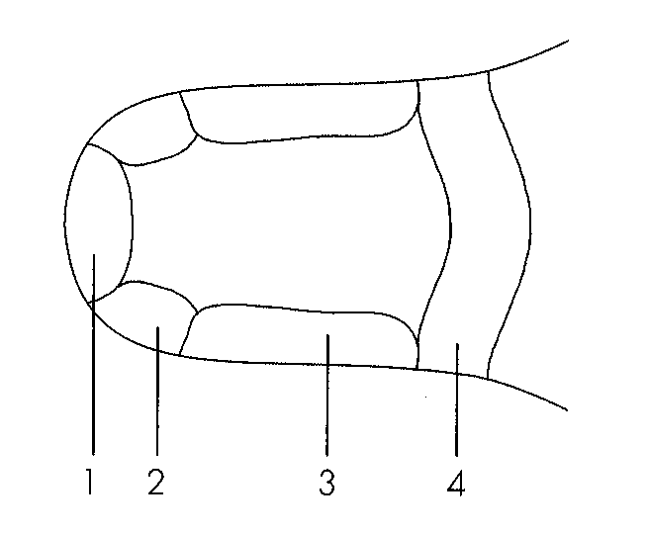
A. 1
B. 2
C. 3
D. 4
51. The diagrams below show two vertical sections of skin obtained from different regions of a mammalian body.
Which of the following correctly explain why the skin shown in figure 1 is more sensitive?
(1)The number of structure X is larger.
(2)Structure Y is longer.
(3)Structure X is situated closer to the skin surface.
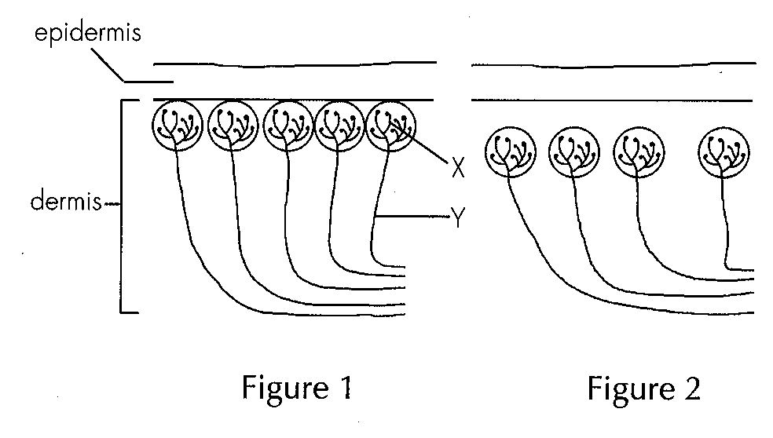
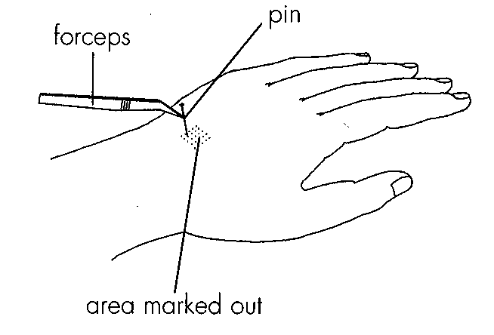
Region of skin | Number of positive responses
finger tip | 25
Palm of hand | 21
Back of hand | 13
Forearm | 19

A. (1) and (2) only B. (1) and (3) onlyC. (2) and (3) only D. (1), (2) and (3) Directions: Questions 55 and 56 refer to the diagram below which shows an experiment to investigate the sensitivity of different parts of the skin to touch. A pin was used to touch gently each of the 25 marks drawn on the skin and the number of positive responses (i.e. the touch was felt) was recorded. The test was repeated on several regions of the skin and the results are shown below.
52. Which of the tested regions was most sensitive to touch?
A.Finger tip B. Palm of hand C. Back of hand D. Forearm
53. Which of the following statements about receptors is correct? A.The heat and cold receptors of the skin detect the actual air temperature. B.The flavour of food is resulted from the stimulation of either the taste receptors or the smell receptors. C.The parts of the skin with more touch receptors can detect the size and shape of an object more precisely. D.Particles in the air must dissolve in the mucus lining of the nasal cavity before they can stimulate any receptor.
A. The heat and cold receptors of the skin detect the actual air temperature.
B. The flavour of food is resulted from the stimulation of either the taste receptors or the smell receptors.
C. The parts of the skin with more touch receptors can detect the size and shape of an object more precisely.
D. Particles in the air must dissolve in the mucus lining of the nasal cavity before they can stimulate any receptor.
54. The central nervous system of a mammal includes (1) the brain. (2) the spinal cord. (3) the nerves.
A. (1) and (2) only
B. (1) and (3) only
C. (2) and (3) only
D. (1), (2) and (3)
55. Which of the following are the examples of effectors? (1) Triceps (2) Tendon (3) Tear gland
A. (1) and (2) only
B. (1) and (3) only
C. (2) and (3) only
D. (1), (2) and (3)
56. A motor neurone transmits nerve impulses from
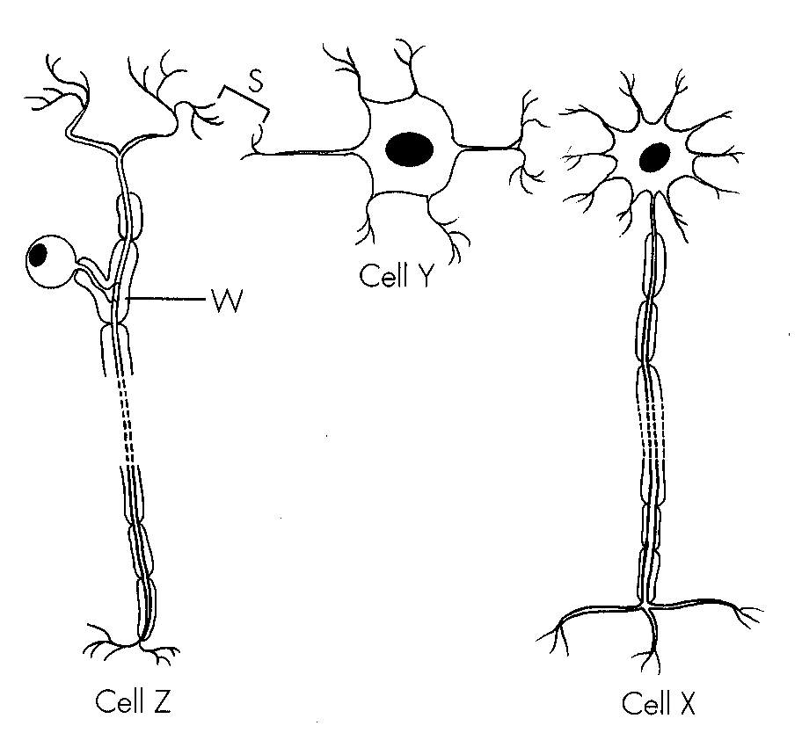
A. the eye to the brain. B. an arm muscle to the brain.
C. the spinal cord to a leg muscle.D. the spinal cord to the brain. Directions: Questions 61 to 63 refer to the diagram below which shows the arrangement of three neurones in a nervous pathway.
57. Which of the following comparisons between cells X and Z is correct?
 | Cell X | Cell Z
A. | cell body is outside CNS | cell body is inside
B. | dendron is long | CNS dendron is short
C. | transmits nerve impulse to effector | tansmit nerve impulse to CNS
D. | sensory in function | motor in function

58. Which of the following features of cell X are essential for the coordination of a mammal? (1) Highly branched endings (2) Long nerve fibre (3) Possession of a nucleus
A. (1) and (2) only
B. (1) and (3) only
C. (2) and (3) only
D. (1), (2) and (3)
59. What are the functions of structure W? (1) It speeds up the rate of transmission. (2) It protects the nerve fibre. (3) It prevents the spreading of nerve impulses to other neurones.
A. (1) and (2) only
B. (1) and (3) only
C. (2) and (3) only
D. (1), (2) and (3)
60. The function of S is
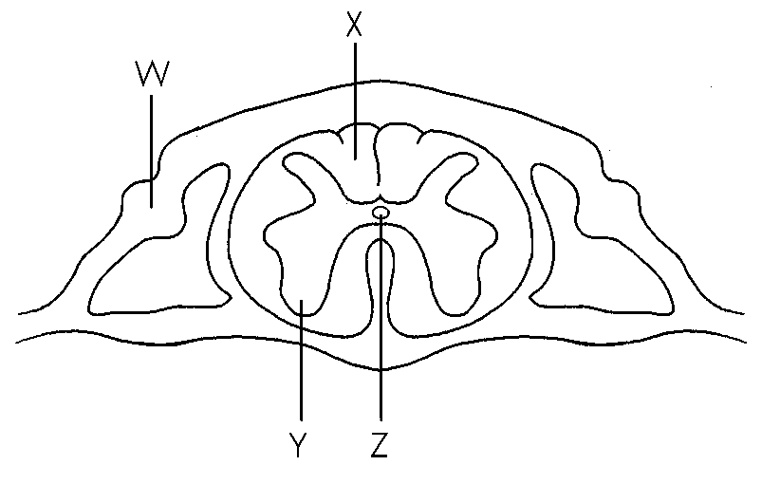
A. to slow down the transmission of nerve impulses.
B. to ensure unidirectional transmission of nerve impulses.
C. to keep two neurones in contact.
D. to amplify the nerve impulse. Directions: Questions 65 to 67 refer to the following diagram which shows a section of the spinal cord.
61. Which of the following about structure W are correct? (1) It contains the cell bodies of motor neurones. (2) It is part of the dorsal root. (3) It is concerned with the transmission of nerve impulses to the spinal cord. D. (1), (2) and (3) 66.Structure Y consists mainly of the cell bodies of (1) sensory neurones. (2) association neurones. (3) motor neurones. B. (1) and (3) only C. (2) and (3) only D. (1), (2) and (3)
A. (1) and (2) only
B. (2) and (3) only
C. (1) and (3) only
D. (1), (2) and (3) 66.Structure Y consists mainly of the cell bodies of (1) sensory neurones. (2) association neurones. (3) motor neurones.
62. Which of the following describes correctly the functions of the fluid present in Z?
(1) As a cushion to absorb shock
(2) As a lubricant to facilitate the movement of substances
(3) Nourishes the cells of the spinal cord
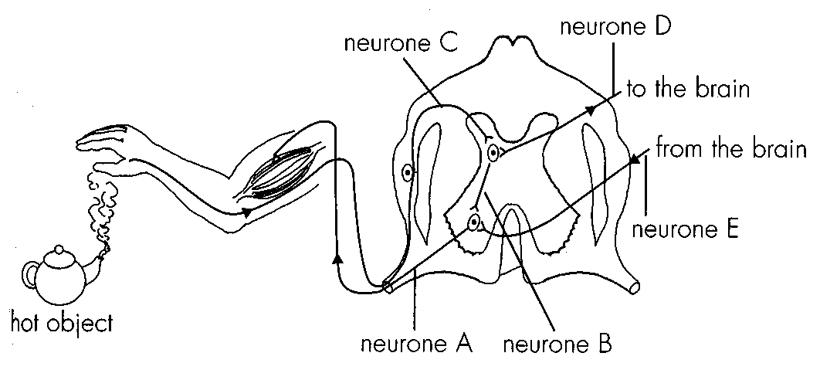
A. (1) and (2) only B. (1) and (3) onlyC. (2) and (3) only D. (1), (2) and (3) Directions: Questions 68 and 69 refer to the following diagram which shows some neurones involved in a withdrawal reflex.
63. Which of the following correctly describes the pathway of nerve impulses if a withdrawal reflex is triggered?
A.A -→ B -→ C B. A -→ B →D -→ C-
C. C -→ B -→ A D. C -→ D -→ E -→ A
64. If neurone B of a man was damaged, what would happen when he touched a hot object?
A.He would feel pain and would show the withdrawal reflex.
B.He would feel pain but would not show the withdrawal reflex.
C.He would not feel pain but would show the withdrawal reflex.
D.He would not feel pain and would not show the withdrawal reflex.
Directions: Questions 70 and 71 refer to the diagram below which shows the reflex arc for the knee jerk reflex.
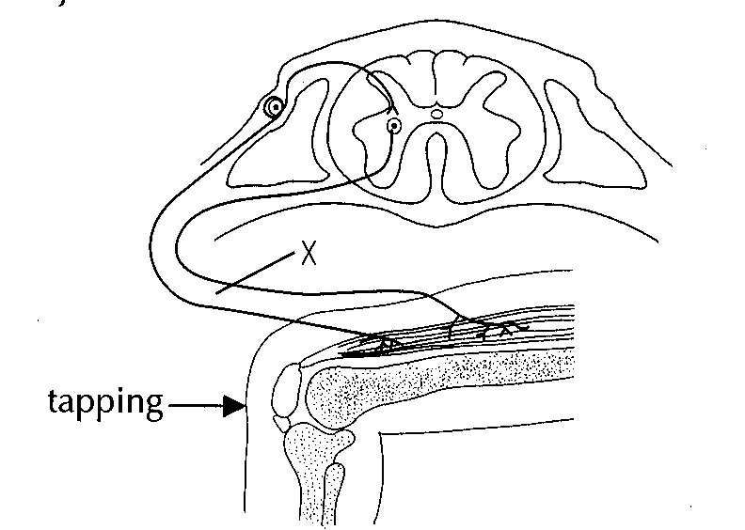
65. Which of the following concerning the reflex arc is correct? A.There are three neurones in this reflex arc. B.There is no receptor in this reflex arc. C.The effector of this reflex arc is a tendon. D.The reflex arc passes through the spinal cord.
A. There are three neurones in this reflex arc.
B. There is no receptor in this reflex arc.
C. The effector of this reflex arc is a tendon.
D. The reflex arc passes through the spinal cord.
66. If a cut was made at X, which of the following correctly describes the effect?
A.The stimulus was not felt but the leg kicked up.
B.No sensation nor response was produced upon stimulation.
C.The stimulus was felt but the leg did not kick up.
D.The reflex was unaffected.
Directions: Questions 72 and 73 refer to the diagram below which shows a nervous pathway through the spinal cord.
72. Structures P and Q are:
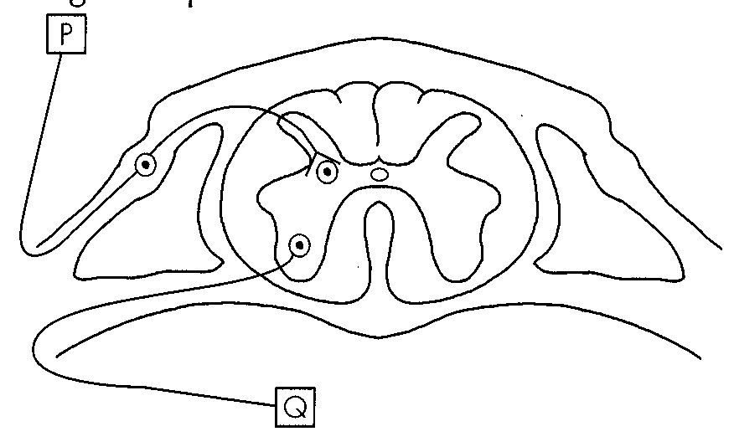
 | P | Q
A. | retina | iris muscle
B. | diaphragm muscle | nose
C. | skin of toes | leg muscle
D. | tongue | salivary glands

67. The diagram below shows the cross section of the spinal cord of a rat and a spinal nerve leading to one of its legs.-
A segment of B between points X and Y is cut and removed. An electric current, which is strong enough to trigger a nerve impulse in a nerve fibre, is then applied at points X and Y in turn. What would be the responses of the rat's leg?
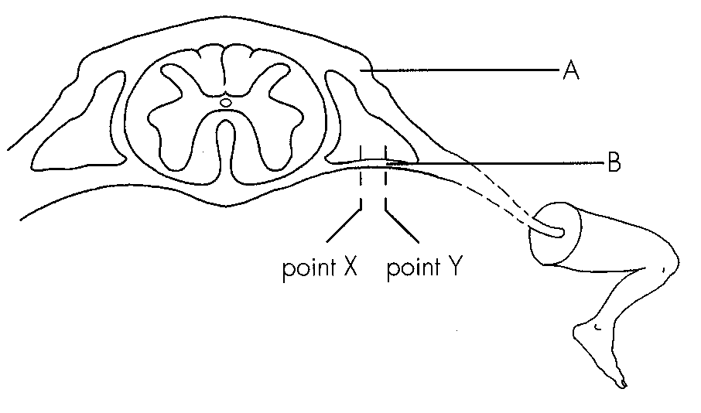
 | Point X | Point Y
A. | contracting | contracting
B. | contracting | no response
C. | no response | contracting
D. | no response | no response

68. The flow chart below shows a simple reflex pathway:
stimulus → receptor -→ M --→ effector -→ response-
M can be
(1) the spinal cord. (2) the medulla. (3) the cerebrum.
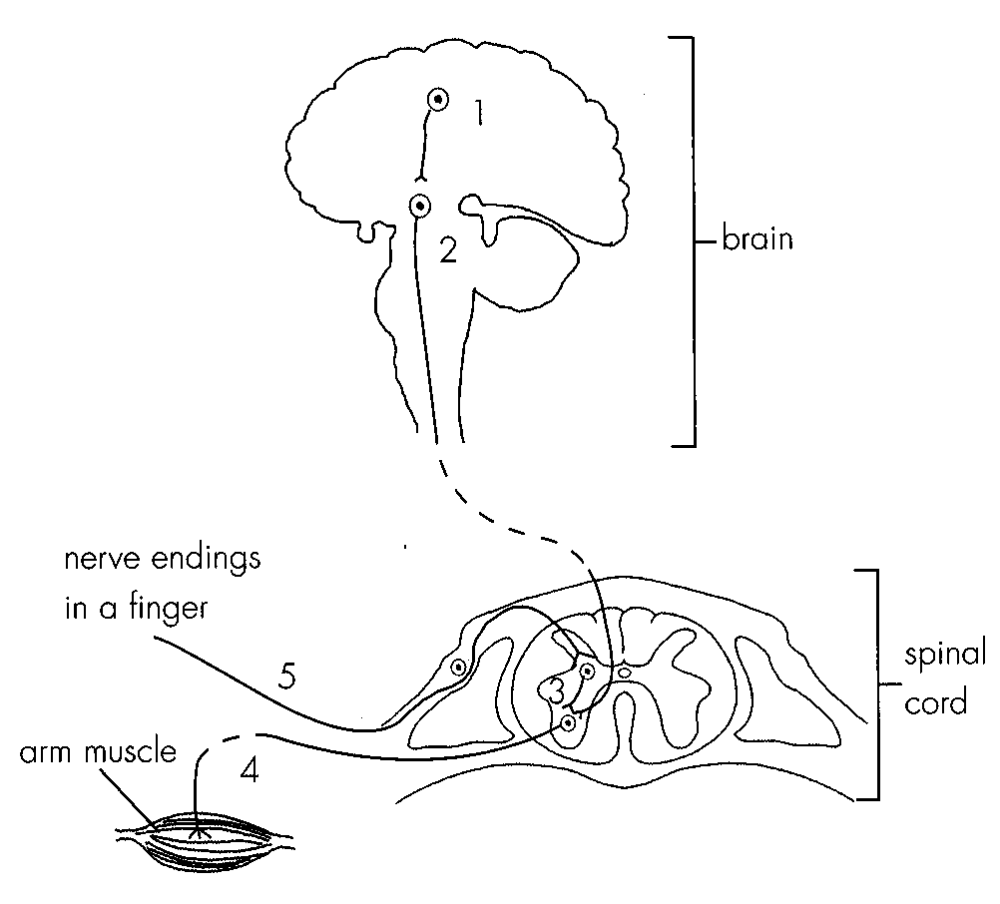
A. (1) onlyB. (3) only C. (1) and (2) onlyD. (2) and (3) only Directions: Questions 75 and 76 refer to the diagram below which shows the arrangement of some neurones in a man.
69. Which of the following pathways of nerve impulses may bring about the voluntary action of the man?
A. 1→2-→4-
B. 1 →2-→3-→ 5-
C. 5 →3-→4-
D. 5 →3-→2-→ 1 -→ 2-→ 4-
70. Which of the following describes incorrectly the effect on the man if a certain neurone is damaged?
 | Neurone damaged | Effect
A. | 2 | Stimuli applied to the finger cannot be felt.
B. | 3 | Withdrawal reflex of the arm is lost.
C. | 4 | Voluntary action of the arm is lost.
D. | 5 | Stimuli applied to the finger cannot be felt.

71. Which of the following is a voluntary action?
A. A man withdraws his leg immediately when he steps on a nail.
B. A man covers his eyes with his hand when he faces the sun.
C. A man secretes saliva when he is eating.
D. A man breathes vigorously when he is running.
72. Which of the following comparisons between voluntary actions and reflex actions is correct?
Directions Questions 79 and 80 refer to the diagram below which shows a vertical section of a human head.
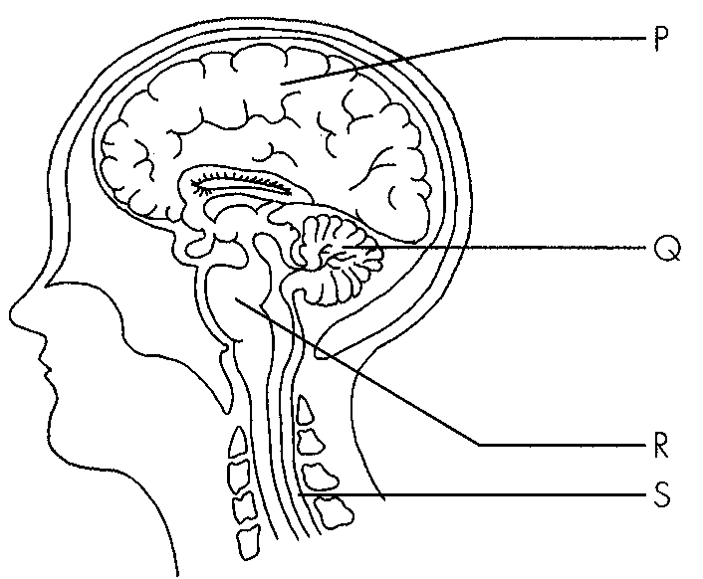
 | Voluntary actions | Reflex actions
A. | stereotyped response is produced | variable responses are produced
B. | may be initiated spontaneously | require stimulation of receptors
C. | inborn | require learning
D. | the brain is involved | the brain is not involved

73. A man was hurt in an accident. He feat pain in his injured arm. Which part of the brain produced the pain sensation?
A. P
B. Q
C. R
D. S
74. After the accident, the man found difficulty in coordinating his muscular activities. Which part of his brain may be injured?
A. P
B. Q
C. R
D. S
75. Which of the following comparisons between parts P and S is correct?
 | Part P | Part S
A. | cortex consists of white matter | cortex consists of grey matter
B. | protected by bones | protected by cartilages
C. | controls involuntary actions | controls reflex actions
D. | can interpret nerve impulses | cannot interpret nerve impulses

76. The cerebral cortex is highly folded so that C.more oxygen can be absorbed by the brain cells. D.it can attach to the skull bones more firmly.
A. more nerve fibres can be packed.
B. more cell bodies of neurones can be packed.
C. more oxygen can be absorbed by the brain cells.
D. it can attach to the skull bones more firmly.
77. The brain of a person was damaged in an accident and he lost his ability to smell. Which part of his brain is probably damaged?
A. Cerebellum B. Medulla
C. Sensory area of the cerebrum D. Motor area of the cerebrum
78. Which of the following would not affect body balance when damaged?
A. Cerebellum B. CochleaC. Semicircular canals D. Auditory nerve
79. Which of the following may result in blindness if damaged?
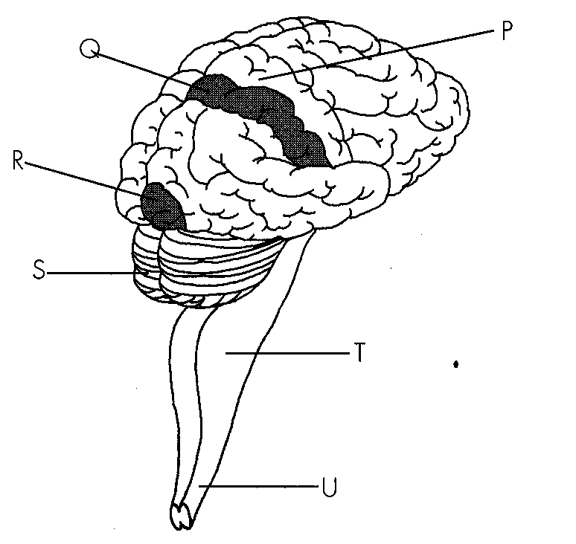
A. Cerebellum B. Spinal cord C. Medulla D. Cerebrum Directions: Questions 86 to 88 refer to the diagram below which shows part of the nervous system of a human being.
80. Which of the following combinations correctly shows the functions of the three functional areas of the cerebrum?
 | P | Q | R
A. | give sensation of smell | initiate finger movement | give sensation of hearing
B. | give sensation of sight | initiate finger movement | make decisions
C. | make decisions give sensation of smell | give sensation of smell | give sensation of sight
D. | initiate tongue movement | give sensation of taste | give sensation of sight

81. Which of the following comparisons between structures T and U is correct?
 | T | U
A. | do not control reflex actions | control reflex actions
B. | white matter is found in the inner region | white matter is found in the outer region
C. | control peristalsis | control withdrawal reflexes
D. | folded outer surface | smooth outer surface

82. What may happen if some regions of the medulla in a man's brain is damaged? (1) He may lose balance. (2) He may not be able to breathe properly. (3) He may have abnormal heartbeat.
A. (1) only
B. (3) only
C. (1) and (2) only
D. (2) and (3) only
83. Three men P, Q and R were injured in a traffic accident. Their brains were found to be
functioning properly but other parts of their nervous systems suffered from different types of damages. The table below shows the tests conducted and the observed results.
Which part of their nervous system was damaged respectively?
Men | Test(s) conducted with their eyes blindfolded | Observed results
P | P's finger tip was pricked by apin. | P withdrew his hand but he could not feel the pain.
Q | Q's finger tip was pricked by a pin. | Q felt the pain but did not withdraw his hand.
R | R's finger tip was pricked by a pin. | R could not feel the pain and did not withdraw his hand.

 | P | Q | R
A. | sensory neurone | motor neurone | association neurone
B. | sensory neurone | association neurone | motor neurone
C. | association neurone to the brain | motor neurone | sensory neurone
D. | motor neurone | sensory neurone | association neurone

84. Which of the following statements about hormones is/are incorrect? (1) They are transported in the blood. (2) They are all made of proteins. (3) Each of them has only one specific target organ. A.(1) only
A. (1) only
B. (2) only
C. (1) and (2) only
D. (2) and (3) only
85. Which of the following statements about. an endocrine gland are correct? (1) It secretes chemical substances. (2) It is ductless. (3) Its contents are secreted to the outside of the body.
A. (1) and (2) only
B. (1) and (3) only
C. (2) and (3) only
D. (1), (2) and (3)
86. Which of the following glands has/have both endocrine and exocrine functions? (1) Pancreas (2) Salivary gland (3) Testis
A. (1) and (2) only
B. (1) and (3) only
C. (2) and (3) only
D. (1), (2) and (3)
87. Which of the following combinations is incorrect?
 | Gland | Substance secreted | Site of action
A. | salivary gland | amylase | mouth
B. | pancreas | insulin | muscle
C. | seminal vesicle | male sex hormone | penis
D. | sweat | water | skin surface

88. Which of the following glands secretes hormone but not enzyme?
A. Pancreas
B. Ovary
C. Gastric gland
D. Liver
89. Which of the following statements about insulin is correct? C.It catalyses the conversion of glucose to glycogen.
A. It can be taken orally by diabetic persons.
B. It increases the uptake of carbohydrate by the liver cells.
C. It catalyses the conversion of glucose to glycogen.
D. It is secreted in response to a drop in blood glucose level.
90. Which of the following comparisons between nervous coordination and hormonal coordination are correct?
 | Nervous coordination | Hormonal coordination
(1) | fast transmission | slow transmission
(2) | widespread effect | localized effect
(3) | shortlived response - | longlasting response-

A. (1) and (2) only
B. (1) and (3) only
C. (2) and (3) only
D. (1), (2) and (3)
Part B — HKDSE-style (YKTo)
91. Directions: Questions 1 to 13 refer to the diagram below, which shows the horizontal section of a human eye. Referring to the functions given in question 16.2, which of them are carried out by the part labelled 2?
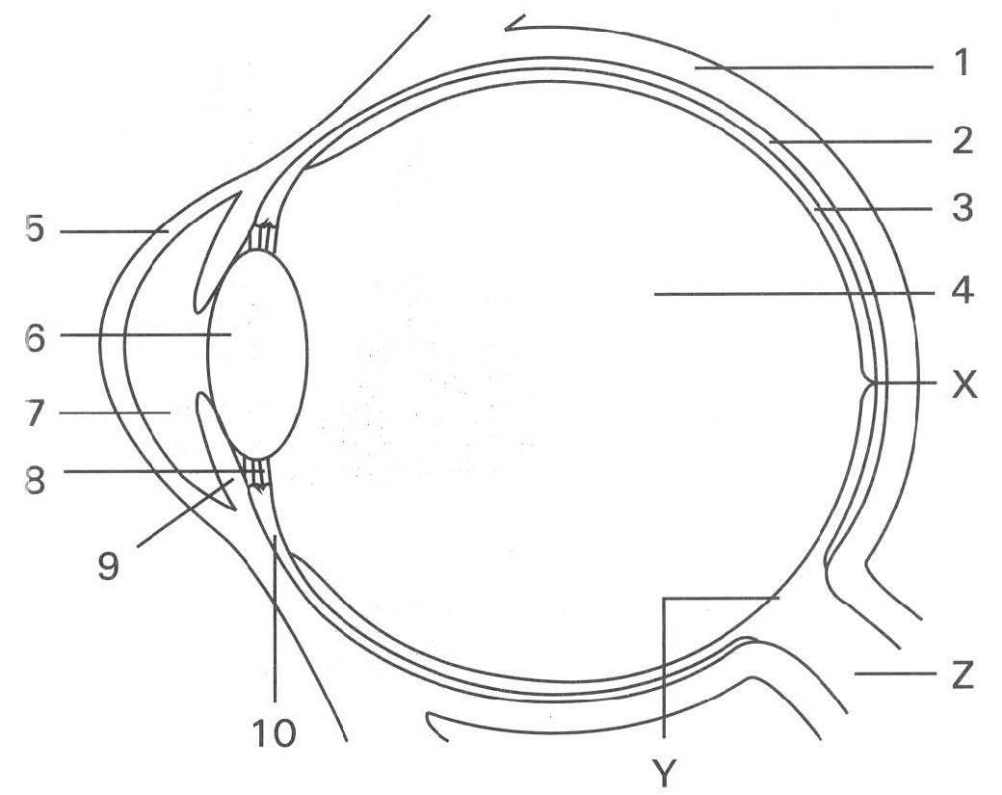
 | Part 1 | Part 2 | Part 3 | Part 4
A. | Choroid | Sclera | Retina | Aqueous humour
B. | Sclera | Retina | Choroid | Vitreous humour
C. | Sclera | Choroid | Retina | Vitreous humour
D. | Retina | Sclera | Choroid | Aqueous humour

A. (1) and (3) only
B. (4) and (5) only
C. (1) and (4) only
D. (4) and (6) only
92. Which of the following is NOT a function of part 4?
A. To refract light onto the retina.
B. To reflect light entering the eyeball.
C. To maintain the shape of the eyeball.
D. To provide additional path for the diffusion of nutrients and wastes through it. 5Which parts are transparent?
A. 5 and 6 only B. 4 and 7 only C. 4, 6 and 7 only D. 4, 5, 6 and 7 6Which part has the highest converging power?
A. 4 B. 5 C. 6 D. 7
93. Which part can change its converging power during the accommodation of the eye? D. 7 8Which part(s) contain(s) pigments? A. 2 only B. 3 only C. 2 and 9 only D. 2, 3 and 9
A. 4
B. 5
C. 6
D. 7 8Which part(s) contain(s) pigments?
94. Which of the following occurs when a person is looking at a close object?
 | Part 6 | Part 8 | Part 10
A. | More convex | Stretched | Contracted
B. | Less convex | Slackened | Relaxed
C | More convex | Slackened | Contracted
D. | Less convex | Stretched | Relaxed

95. Which parts act passively when a person is looking at a distant object?
A. 4 and 6 only
B. 6 and 8 only
C. 7, 9 and 10 only
D. 4, 6, 8 and 10
96. Which of the following statements about the part labelled X is CORRECT?
A. It contains more cone cells than rod cells.
B. It contains more rod cells than cone cells.
C. It has cone cells alone.
D. It has rod cells alone.
97. When the light rays of an object are falling on the part labelled Y, which of the following statements is CORRECT?
A. No image s formed at Y.
B. No nerve impulses are generated at Y.
C. A blurred black and white vision is produced.
D. A sharp colour vision is produced.
98. Part Z connects the eyeball to the
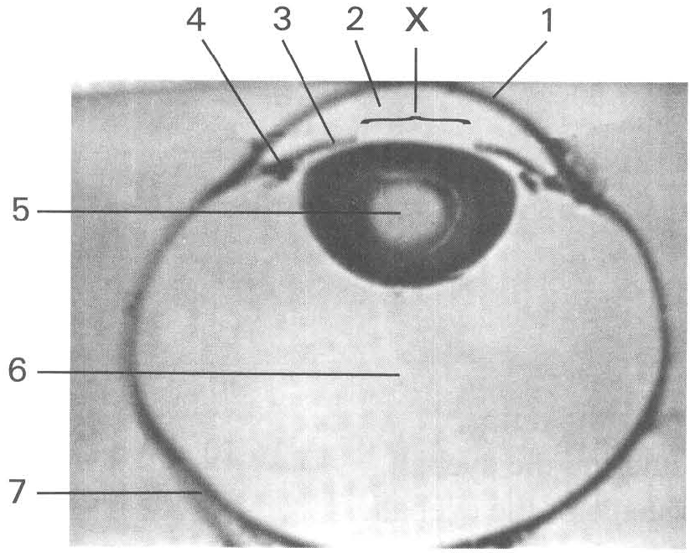
A. cerebrum. B. cerebellum. C. spinal cord. D. hypothalamus. Directions: Questions 14 to 21 refer to the photomicrograph below, which shows the horizontal section of a human eye.
99. Which of the following statements about structures 1 and 5 is CORRECT? (1) The converging power of structure 5 is higher than that of structure 1. (2) Both structures receive nutrients from structure 2. (3) The curvature of both structures can be changed to focus the incoming light rays onto the retina.
A. (1) only
B. (2) only
C. (3) only
D. (1) and (3) only
100. Which structures are involved to maintain the shape of the eyeball?
A. 1 and 2 only
B. 2 and 5 only
C. 2 and 6 only
D. 5 and 6 only
101. The size of X changes according to the amount of light entering the eyeball. It is a response to the stimuli of light perceived by receptors present on structure
A. 1 only
B. 3 only
C. 5 only
D. 7 only
102. What will be the changes in the following structures when a man is coming out of a cinema to open space in a bright sunny day and is looking at his wrist watch?
 | Circular muscles ofstructure 3 | Size of X | Circular muscles ofstructure 4 | Convexity ofstructure 5
A. | Relaxed | Decreased | Relaxed | Decreased
B. | Contracted | Increased | Contracted | Increased
C. | Relaxed | Increased | Relaxed | Increased
D. | Contracted | Decreased | Contracted | Increased

103. When a person with short-sightedness looks at a distant object, the image will fall on
A. structure 5. B structure 6.C. structure 7. D. behind structure 7.
104. A person has the eye defect of longsightedness when
A. the image of a close object falls in structure 6.
B. the image of a close object falls behind structure 7.
C. the convexity of the structure 5 is too great.
D. the eyeball is too long.
105. Vision can be improved by operation that uses a laser beam to reduce the curvature of structure 1. Remedy is made by this operation
A. to increase the converging power of the eye to refract the light rays.
B. to decrease the converging power of the eye to refract the light rays.
C. to increase the elasticity of structure 1 in focusing the light rays onto the retina.
D. to increase the transparency of structure 1 to enhance the light rays passing into the eyeball.
106. Which labelled part can be replaced by an artificial structure as a way to treat cataract?
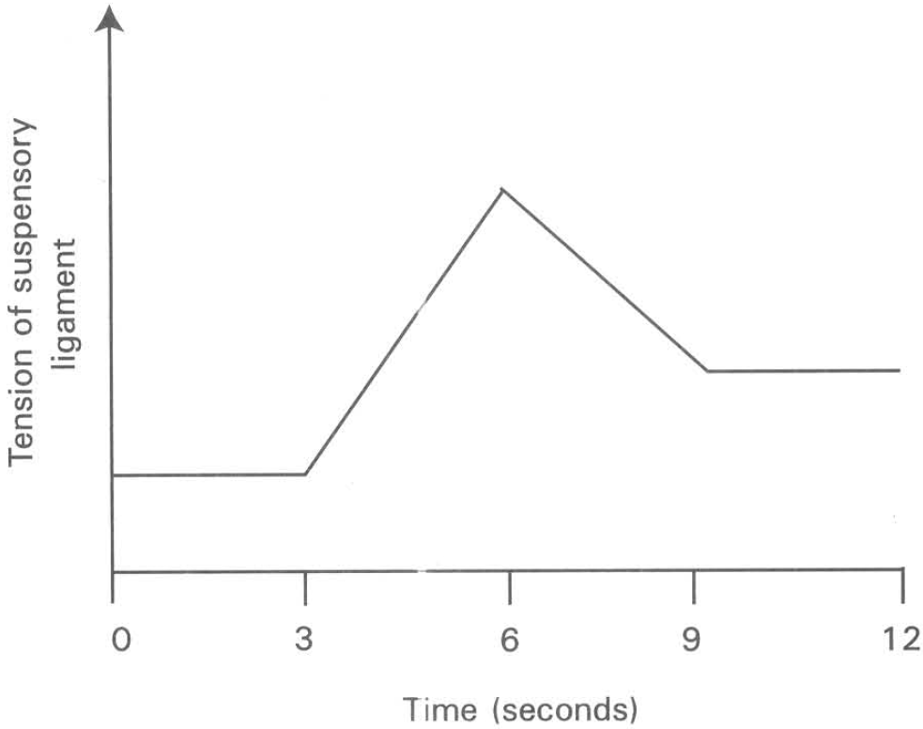
A. 1 B. 3 C. 5 D. 7 Directions: Questions 22 and 23 refer to the graph below, which shows the changes in the tension of the suspensory ligament of a man's eye in a period of 12 seconds.
107. Which of the following combinations TRULY represents the time periods during which this man was looking at a cat moving away from him and then turning back approaching him again ?
 | Time period the cat moving away from him | Time period the cat approaching him
A. | 0 to 3 seconds | 3 to 6 seconds
B. | 3 to 6 seconds | 6 to 9 seconds
C. | 6 to 9 seconds | 9 to 12 seconds
D. | 0 to 3 seconds | 9 to 12 seconds

108. The convexity of the lens of this man is affected by the changes in the tension of the suspensory ligament of his eye. Which of the following curves represents the right changes in the convexity of the lens in the above period?
Directions: Questions 24 to 28 refer to the graph below, which shows the density and distribution of photoreceptors, X and Y, along the horizontal section of the retina of a human eye.
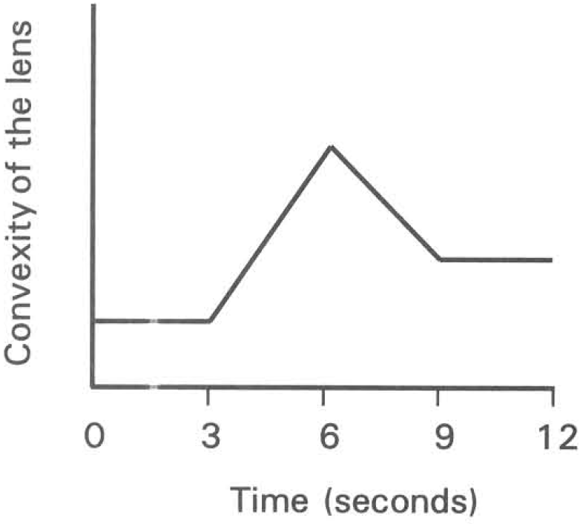
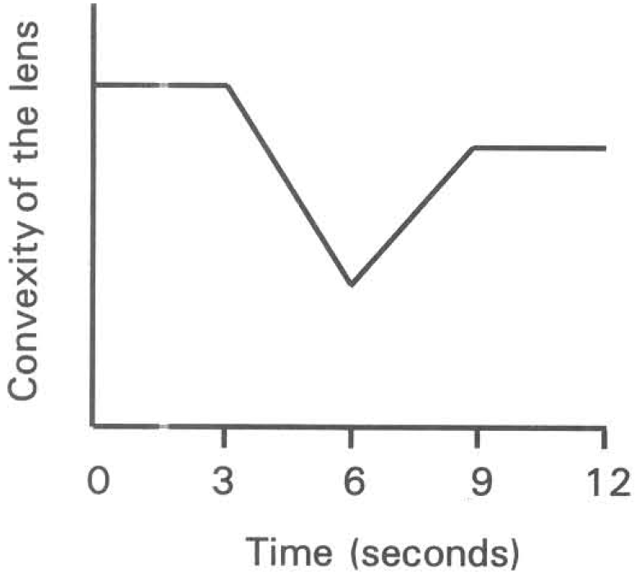
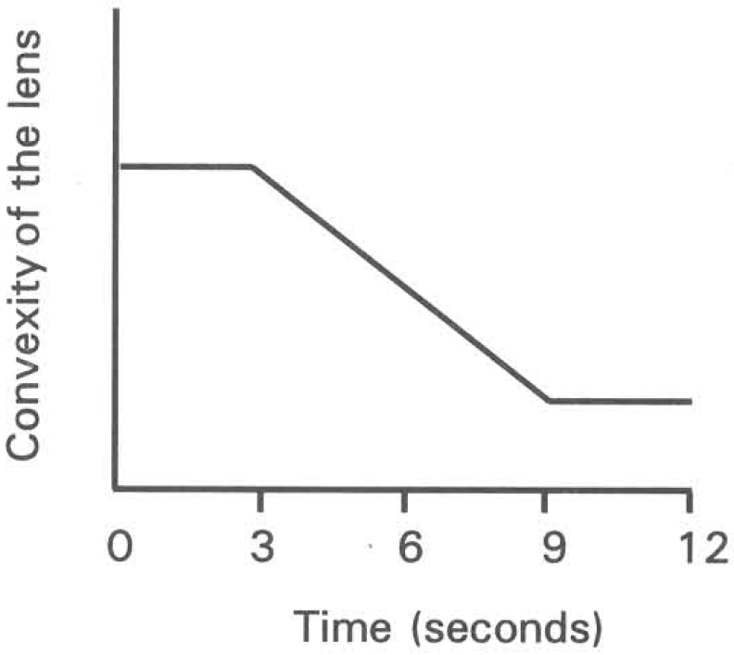
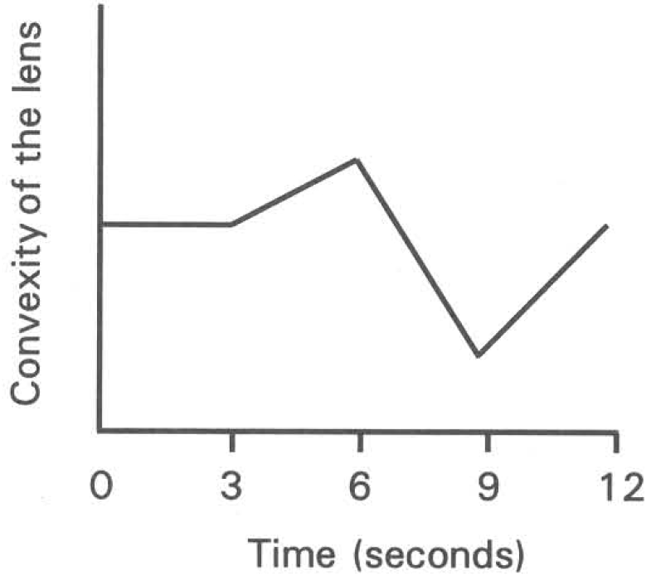
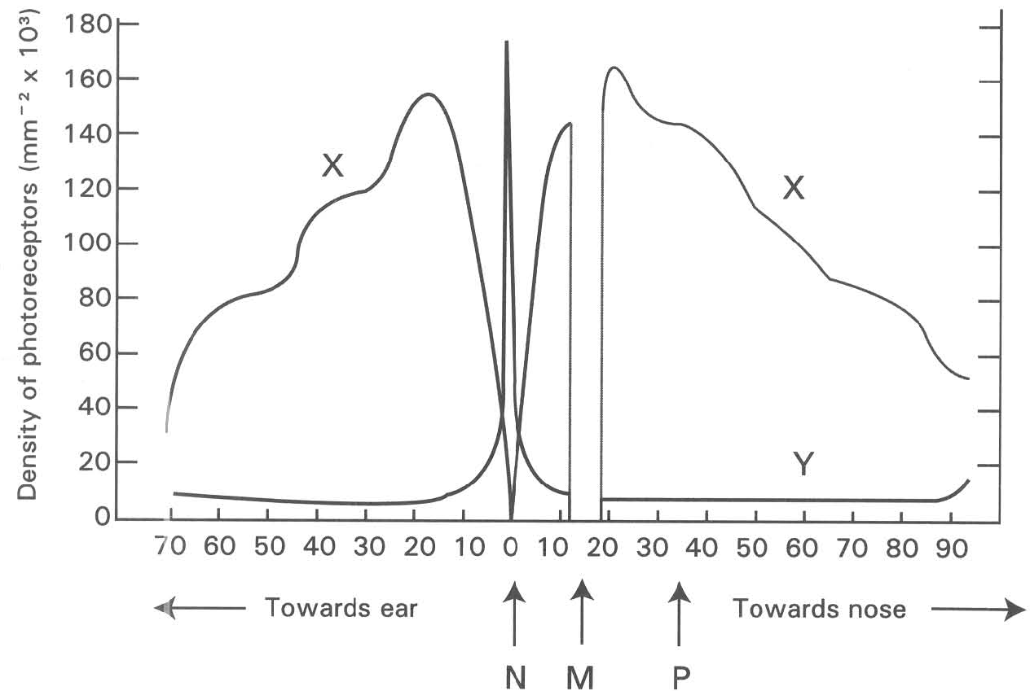
A. | B. | C. | D.

109. Which of the following groups of names CORRECTLY match the cells/spots labelled X, Y, M and N?
 | X | Y | M | N
A. | Cones | Rods | Blind spot | Yellow spot
B. | Rods | Cones | Yellow spot | Blind spot
C. | Cones | Rods | Yellow spot | Blind spot
D. | Rods | Cones | Blind spot | Yellow spot

110. Which of the following statements are useful to identify these two types of photoreceptors on the retina of the human eye? (1) Photoreceptors X are more abundant than photoreceptors Y. (2) No photoreceptor is present on spot M. (3) Only photoreceptors Y are present on spot N.
A. (1) and (2) only
B. (1) and (3) only
C. (2) and (3) only
D. (1), (2) and (3)
111. Which of the following statements about spots M and N are CORRECT?
A. Both photoreceptors X and Y are present on spot N.
B. No image can be formed on spot M.
C. Blood vessels enter the retina at spot N.
D. Neurones leave the retina at spot M.
112. Which of the following explanation for night blindness is CORRECT?
A. Insufficient number of photoreceptors X on spot N.
B. Insufficient number of photoreceptors Y on spot N.
C. Insufficient amount of visual pigments in photoreceptors X.
D. Insufficient amount of visual pigments in photoreceptors Y.
113. Which of the following combinations for the production of vision is CORRECT?
Directions: Questions 29 and 30 refer to the diagrams below, which show two types of photoreceptors, P and Q, present in the retina of the human eye.
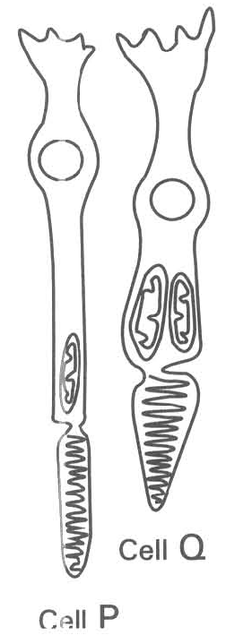
 | Colour vision(under bright light condition ) | Black and white vision (under dim light condition)
A. | M | N

B. | N | M
C. | M | P
D. | N | P

114. Which of the following statements about photoreceptor P is CORRECT?
A. Photoreceptor P is responsible for colour vision.
B. Photoreceptor P is present in great abundance at the yellow spot.
C. Photoreceptor P can be activated under dim light conditions.
D. Photoreceptor P is present at the site of the retina where the optic nerve leaving the eyeball.
115. Which of the following statements about photoreceptor Q is CORRECT?
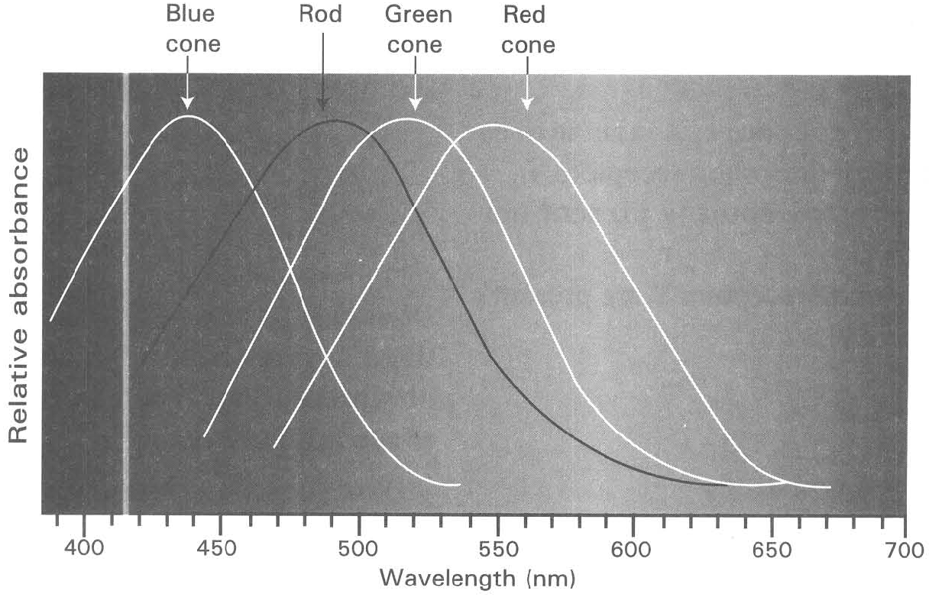
A. There are three different types of photoreceptor Q responsible for the absorption of light of different wavelengths.
B. Malfunctioning of photoreceptor Q will cause night blindness.
C. Photoreceptor Q is present in great abundance at the periphery of the retina.
D. There are more photoreceptors Q than photoreceptors P at the blind spot. Directions: Questions 31 and 32 refer to the graph below, which shows the relative absorbance of different types of photoreceptors that are effective to absorb light of different wavelengths.
116. Which of the following eye defects will occur when the genes controlling the production of pigments in the cones cannot function?
A. Short-sightedness B. Long-sightedness
C. Night blindness D. Colour blindness
117. Under dim light condition only black and white vision is produced. Which of the following explanation is CORRECT?
A. Only cones absorbing light at short wavelengths are stimulated.
B. Only cones absorbing light at long wavelengths are stimulated.
C. Only rods are stimulated.
D. No photoreceptors are functional under low light intensity.
118. When a boy is reading a book, he can only see a few words on the page clearly at a time. Which of the following is a CORRECT explanation of this phenomenon?
A. The book was held too far away from the boy's eyes.
B. The light intensity in the room is not high enough for all the cones to be activated.
C. The area of the yellow spot with high density of cones is very small that can only focus a few words on it at a time.
D. The pupil is so small that only the light rays of a few words can pass through it at a time.
119. Which of the following statements about night blindness is CORRECT?
A. Cannot see things at all under bright light conditions.
B. Cannot see things clearly under dim light conditions.
C. It is a disease caused by the deficiency of vitamin C in diet.
D. Cannot see colour objects under bright light conditions.
120. Which of the following statements about colour blindness is CORRECT?
A. Cannot distinguish the colours of objects under dim light conditions.
B. Cannot distinguish certain colours of objects under bright light condition.
C. It is a disease caused by the deficiency of vitamin A in diet.
D. It is due to the defective rod cells in the retina.
121. Which of the fallowing statements about visual purple is CORRECT? (1) It is sensitive to the perception of purple colour. (2)It is concentrated in the photoreceptors present at the yellow spot. (3) It is responsible for dim light vision. (4) Its deficiency will cause colour blindness.
A. (3) only
B. (1) and (2) only
C. (1) and (4) only
D. (2) and (3) only
122. A boy closes his left eye but opens his right eye to stare at the cross of the following card.
At a distance about 18cm from his eyes, he can only see the cross, but not the black dot. The purpose of this experiment is to
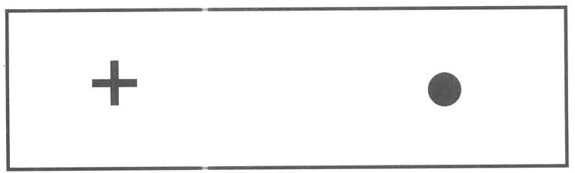
A. show that the yellow spot has the highest concentration of cones.
B. detect the presence of a blind spot in the eyeball.
C. measure the relative focal length of the lens in the eyeball.
D. measure the adequate distance for reading.
123. It is difficult to distinguish the different colours of an object in a poorly lit room. Which of the following is the CORRECT explanation for this phenomenon?
A. Cone cells cannot function properly under dim light conditions.
B. Rod cells cannot function properly under dim light conditions.
C. Light rays from the object cannot be focused propel ly at the yellow spot.
D. Light rays from the object cannot be refracted properly by the optical system of the eyeball.
124. If a person enters a dark room from open space, he/she CANNOT see clearly for 10 minutes because it takes time for
(1) the pupil to constrict.
(2) the ciliary muscles to contract.
(3) the rod cells to produce sufficient visual purple for clear vision in dim light condition.
(4) the cone cells to concentrate in the yellow spot to give high visual acuity.
(5) the lens to achieve a convex shape in order to concentrate more light on the retina.
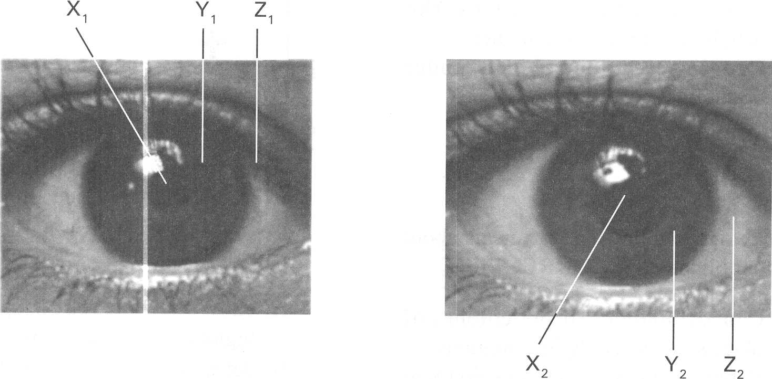
A. (1) only B. (3) only C. (2) and (5) only D. (1), (3) and (4) only Directions: Questions 40 and 41 refer to the photographs below. Photograph 1 Photograph 2
125. Which of the following statements concerning photograph 1 is/are CORRECT? (1) The eye shown is adapted for seeing in bright light conditions. (2) The diameter of X1 is brought into the condition shown by the contraction of the radial muscle in Y1. (3) Z1 is part of the sclerotic coat of the eyeball.
A. (1) only
B. (2) only
C. (3) only
D. (1) and (3) only
126. Which of the following statements concerning photograph 2 is/are CORRECT? (1)The outermost layer covering structures X2 and Y2 is called cornea. (2) Structure Y2 is colourless in an albino who lacks pigments. (3)The eye shown is adapted for seeing in dim light conditions.
A. (1) only
B. (2) only
C. (3) only
D. (1) and (3) only
127. Which of the following combinations is CORRECT when a person looks at a distant object?
 | Condition of CiliaryMuscle | Circumference of Ciliary Body | Tension in Suspensory Ligament | Convexity of the Lens
A. | Contracts | Shorter | Increases | Less convex
B. | Relaxes | Shorter | Decreases | More convex
C. | Relaxes | Longer | Increases | Less convex
D. | Contracts | Longer | Decreases | More convex

128. The diagram below shows the correction of an eye defect. Which of the following condition(s) will lead to the eye defect corrected by the method shown in the diagram above? (1) The lens is not convex enough to focus the light rays onto the retina. (2) The lens is too convex that focuses the light rays of distant objects in front of the retina. (3) The eyeball is too long. (4) The eyeball is too short.
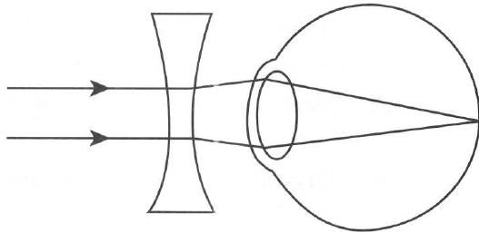
A. (1) only
B. (2) only
C. (1) and (4)
D. (2) and (3)
129. Which of the following diagrams CORRECTLY illustrates the short-sighted condition''
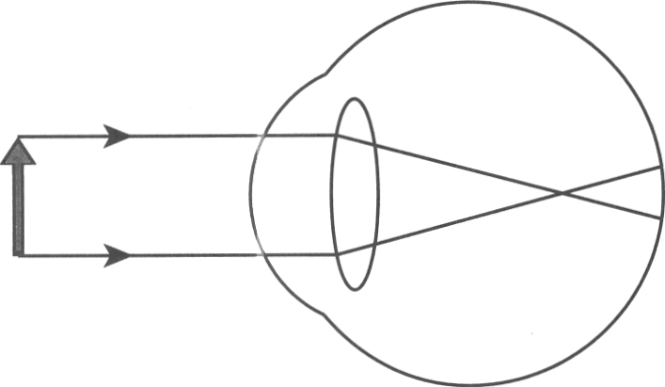
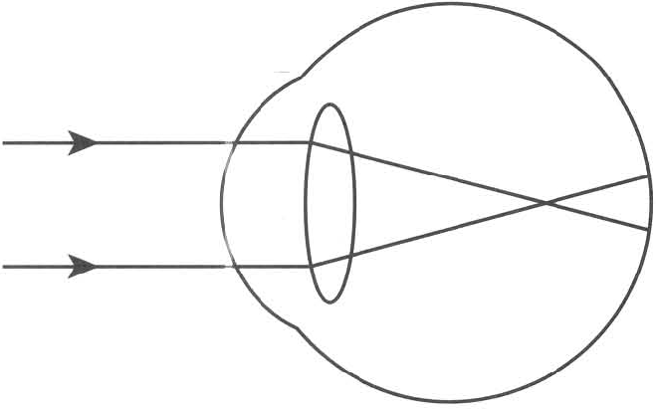
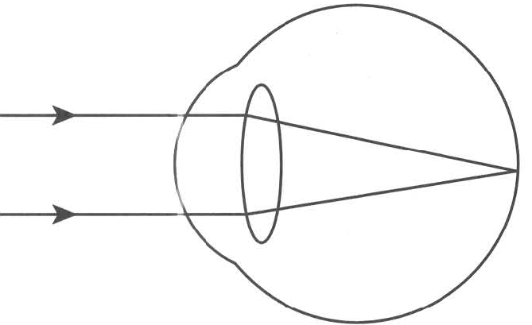
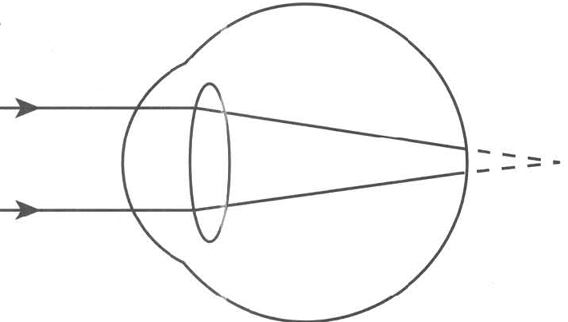
A. | B. | C. | D.

130. Which of the following is/are the possible method(s) of correcting short-sightedness? (1) Prescribing spectacles with diverging lens. (2) Prescribing spectacles with converging lens. (3) Laser surgery to reshape the cornea of the eye.
A. (1) only
B. (2) only
C. (1) and (3)
D. (2) and (3)
131. The diagram below shows the light rays of an object seen by a person with an eye defect.
Which of the following combinations CORRECTLY matches the object seen by this person with the eye defect?
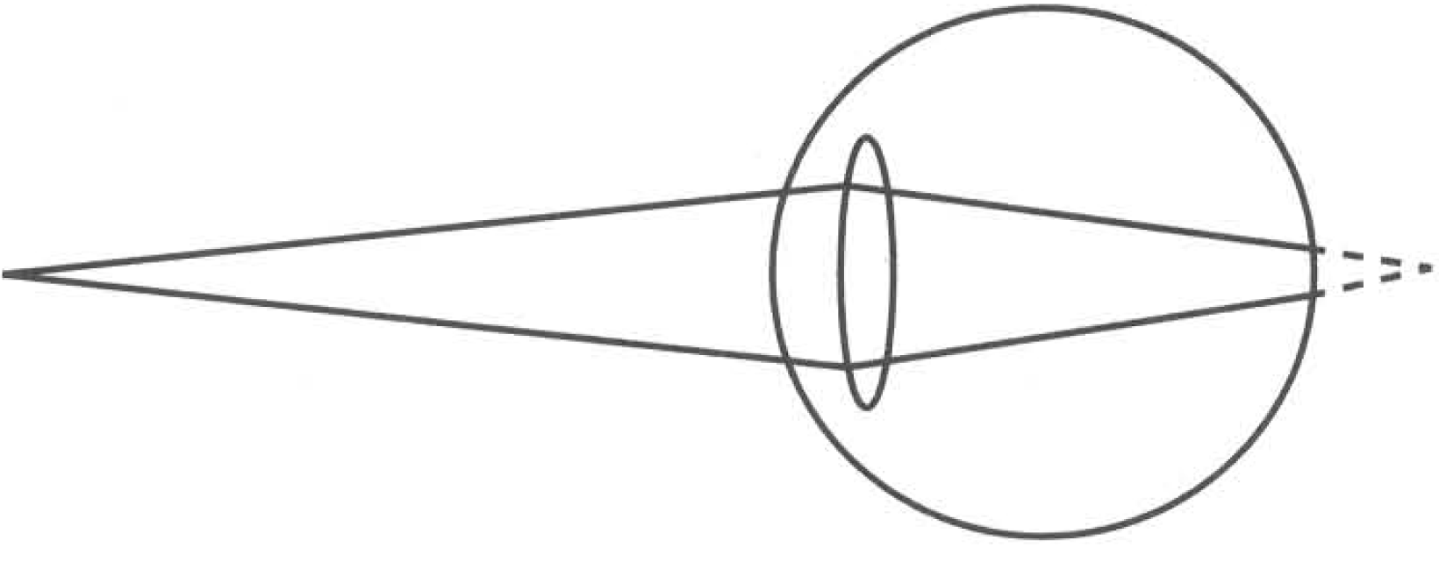
 | Object seen | Eye defect
A. | Near object | Long-sightedness
B. | Distant object | Long-sightedness
C. | Near object | Short-sightedness
D. | Distant object | Short-sightedness

132. Which of the following diagrams shows the right method of correcting the eye defect shown in the previous question?
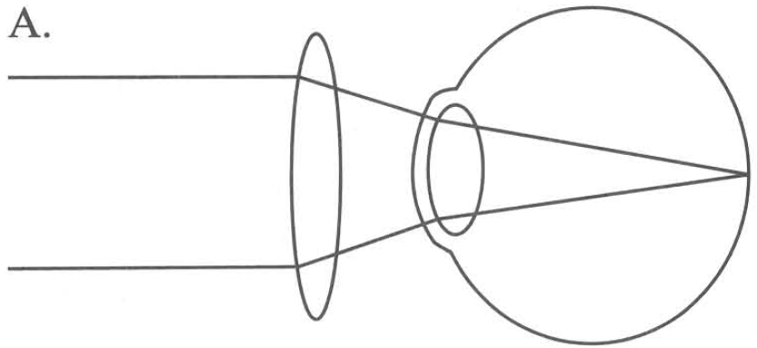
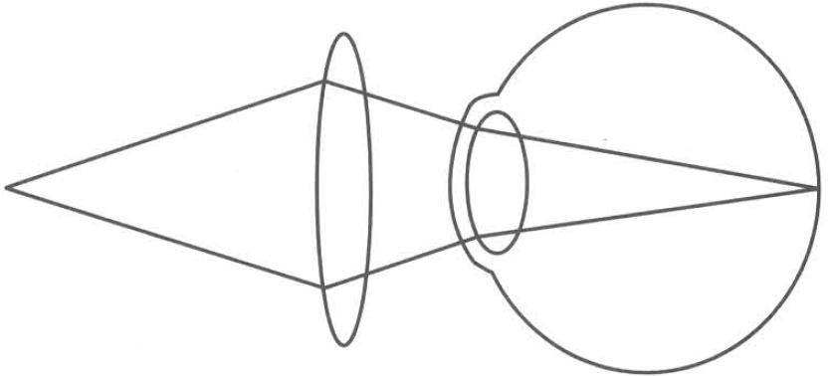
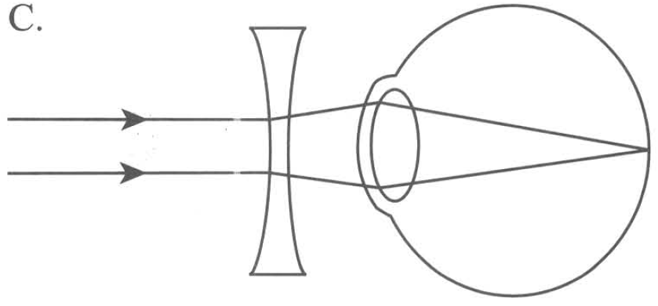
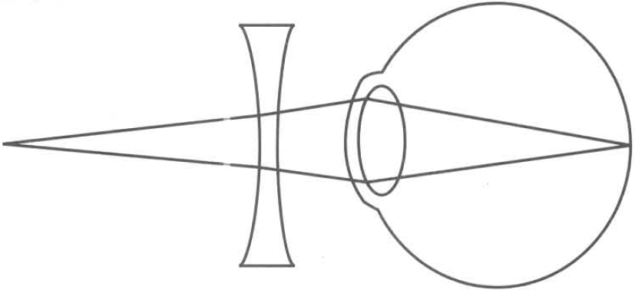
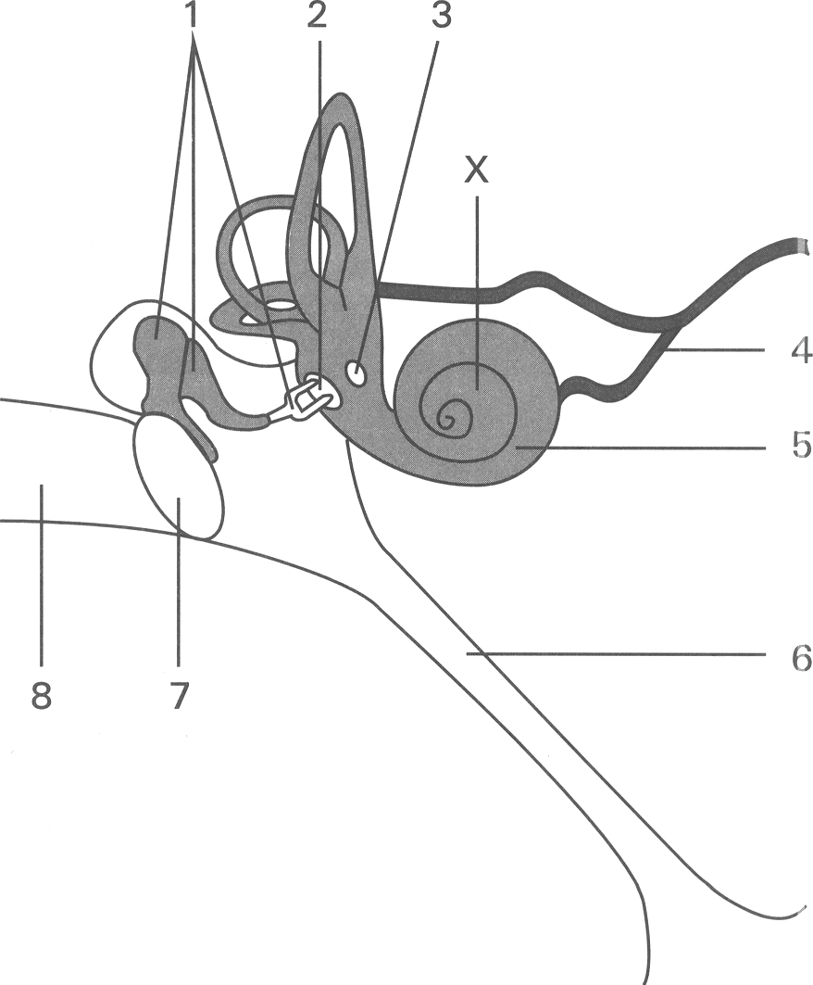
A. | B. | C. | D.

B. Ear Directions: Questions 48 to 56 refer to the diagram below, which shows the structure of a human ear.
133. Where will structure 4 connect to?
A. Spinal cord B. Cerebrum
C. Cerebellum D. Medulla oblongata
134. Where will structure 6 lead to?
A. Brain B. Nasal cavity C. Spinal cord D. Eye
135. Which labelled parts are filled with air?
A. 1 and 6
B. 1 and 8
C. 3 and 5
D. 6 and 8
136. Which labelled part is filled with fluid?
A. 1 only
B. 3 only
C. 5 only
D. 6 only
137. Which of the following combinations is CORRECTLY matching with the parts labelled 2, 3, 4 and 7?
138. | 3 | 4 | 7 | A. | Oval window | Round window | Auditory nerve | Ear drum | B. | Round window | Ear drum | Optic nerve | Oval window | C. | Ear drum | Round window | Auditory nerve | Oval window | D. | Ear drum | Oval window | Optic nerve | Round window
139. Which of the following is/are NOT the function(s) of structure 1? (1) To equalize the air pressure on both sides of structure 7. (2) To amplify the vibrations of sound waves into the inner ear. (3) To generate nerve impulses (4) To transmit the vibrations of sound waves into the inner ear.
A. (1) only
B. (2) only
C. (1) and (3) only
D. (2) and (4) only
140. When a boy contracts influenza and has a running nose, he cannot hear clearly because
A. structure 1 cannot amplify the vibrations of sound waves.
B. structure 3 cannot bulge outwards to release the pressure of the fluid in structure 5.
C. fluid inside structure 5 cannot vibrate freely.
D. structure 7 cannot vibrate freely due to the imbalance of air pressure at its two sides.
141. Which labelled structure is the place where the receptors are located to convert the vibrations of sound waves to nerve impulses?
A. 1
B. 3
C. 5
D. 7
142. If part X is damaged by prolonged exposure to loud sound of high pitch, which of the following would happen?
A. The ear cannot perceive any sound waves.
B. No nerve impulses can be generated from any part of structure 5.
C. The person may not hear sound of certain pitch.
D. The ear cannot detect the direction from which the sound is produced.
143. Which of the following structures generates nerve impulses in the perception of sound waves?
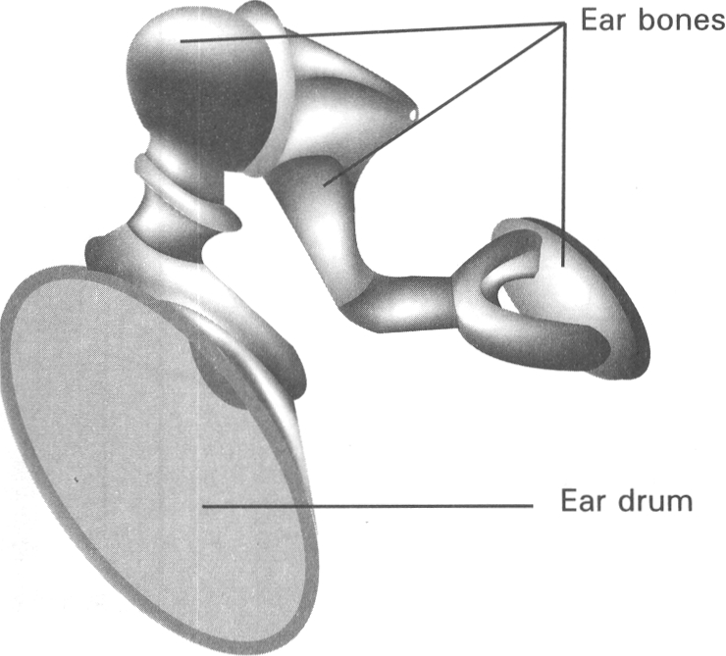
A. Ear drumB. Ear bones C. Cochlea D. Auditory nerve
144. If the following ear bones of a man are fused into a single structure instead of three pieces of bones, which of the following would happen?
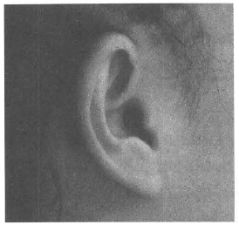
A. The man would become deaf.
B. The man could not balance his posture.
C. His hearing ability would be reduced.
D. The man could not balance the air pressure at the two sides of the ear drum.
145. What would happen to a man if he loses the following structure in a traffic accident?
A. The man would become deaf.
B. The man would easily faint due to difficulty iii balancing his posture.
C. The man could not balance the air pressure at the two sides of the ear drum.
D. The man could not properly detect the direction from which the sound waves are produced.
146. Which of the following is responsible for the amplification of the sound waves?
A. Ear drum B. Ear bones C. Oval windowD. Cochlea
147. Which of the following combinations is CORRECT when an aeroplane is landing?
62 Some people will have a painful experience of their eardrums in the above condition. What should they do to reduce the pain?
 | Changes in the atmospheric pressure | Movement of ear drum
A. | Decreases | Bulges outwards
B. | Decreases | Bulges inwards
C. | Increases | Bulges outwards
D. | Increases | Bulges inwards

A. Close their mouths tightly. B. Swallow more frequently.
C. Lie down. D. Close their eyes.

Answers
Answers are printed in red.
1. B. produces nerve impulses upon stimulation.
Class: 66.7% correct (n=129) usual slip C
2. ?

3. D

4. C
Class: 70.2% correct (n=47) usual slip A
5. C
Class: 75.2% correct (n=129) usual slip A
6. B
Class: 70.5% correct (n=129) usual slip A
7. ?

8. B
Class: 69.0% correct (n=129) usual slip B
9. B. 1, 2, 6, 9
Class: 95.1% correct (n=82) usual slip D
10. B. 1,2,4,6
Class: 25.5% correct (n=47) usual slip A
11. C
Class: 70.7% correct (n=82) usual slip D
12. A

13. ?

14. D
Class: 42.7% correct (n=82) usual slip C
15. ?

16. D. cornea and lens.

17. B

18. B

19. ?

20. ?

21. B. moving away from the boy.

22. ?

23. C
Class: 81.7% correct (n=82) usual slip A
24. C. (2) and (3) only
Class: 73.2% correct (n=82) usual slip D
25. C. (2) and (3) only
Class: 73.2% correct (n=82) usual slip D
26. C

27. D

28. D
Class: 62.0% correct (n=129) usual slip C
29. ?

30. ?

31. B. The image cannot be detected.
Class: 68.3% correct (n=82) usual slip C
32. ?

33. ?

34. ?

35. ?

36. D
Class: 90.2% correct (n=82) usual slip C
37. D. The eyeball is too short.
Class: 75.6% correct (n=82) usual slip C
38. D
Class: 95.1% correct (n=82) usual slip C
39. D

40. D. equalize the pressure on both sides of the eardrum.

41. A. (1) and (2) only

42. ?

43. C. 5 and 6

44. D

45. D. vibrations transmitted to the inner ear will be much weaker.
Class: 68.3% correct (n=82) usual slip B
46. ?

47. ?

48. C. structure S has a much smaller area than structure Q.
Class: 42.7% correct (n=82) usual slip A
49. C. (1) and (2) only

50. A. 1

51. B

52. A

53. ?

54. A. (1) and (2) only

55. B. (1) and (3) only

56. C. the spinal cord to a leg muscle.D. the spinal cord to the brain. Directions: Questions 61 to 63 refer to the diagram below which shows the arrangement of three neurones in a nervous pathway.

57. C

58. D. (1), (2) and (3)

59. D. (1), (2) and (3)

60. B. to ensure unidirectional transmission of nerve impulses.

61. ?

62. B

63. C. C -→ B -→ A D. C -→ D -→ E -→ A

64. ?

65. ?

66. C

67. C

68. C

69. ?

70. A

71. ?

72. B

73. A. P

74. ?

75. D

76. B. more cell bodies of neurones can be packed.

77. ?

78. B

79. D

80. D

81. C

82. D. (2) and (3) only

83. C

84. D. (2) and (3) only

85. ?

86. B. (1) and (3) only

87. C

88. B. Ovary

89. B. It increases the uptake of carbohydrate by the liver cells.

90. B. (1) and (3) only

91. D. (4) and (6) only

92. B. To reflect light entering the eyeball.
Class: 96.3% correct (n=82) usual slip C
93. C. 6
Class: 80.9% correct (n=47) usual slip B
94. C
Class: 65.9% correct (n=129) usual slip C
95. D. 4, 6, 8 and 10

96. C. It has cone cells alone.
Class: 26.8% correct (n=82) usual slip A
97. B. No nerve impulses are generated at Y.

98. A. cerebrum. B. cerebellum. C. spinal cord. D. hypothalamus. Directions: Questions 14 to 21 refer to the photomicrograph below, which shows the horizontal section of a human eye.
Class: 54.3% correct (n=129) usual slip C
99. B. (2) only
Class: 56.6% correct (n=129) usual slip D
100. C. 2 and 6 only

101. D. 7 only

102. D

103. B

104. B. the image of a close object falls behind structure 7.
Class: 80.5% correct (n=82) usual slip C
105. B. to decrease the converging power of the eye to refract the light rays.

106. C
Class: 87.8% correct (n=82) usual slip D
107. B
Class: 82.9% correct (n=82) usual slip A
108. B

109. D
Class: 57.4% correct (n=47) usual slip C
110. B. (1) and (3) only
Class: 59.6% correct (n=47) usual slip D
111. D. Neurones leave the retina at spot M.
Class: 55.3% correct (n=47) usual slip A
112. C. Insufficient amount of visual pigments in photoreceptors X.
Class: 57.4% correct (n=47) usual slip B
113. D

114. C. Photoreceptor P can be activated under dim light conditions.

115. A. There are three different types of photoreceptor Q responsible for the absorption of light of different wavelengths.

116. D

117. C. Only rods are stimulated.

118. C. The area of the yellow spot with high density of cones is very small that can only focus a few words on it at a time.
Class: 91.5% correct (n=82) usual slip A
119. B. Cannot see things clearly under dim light conditions.

120. B. Cannot distinguish certain colours of objects under bright light condition.

121. A. (3) only

122. B. detect the presence of a blind spot in the eyeball.

123. A. Cone cells cannot function properly under dim light conditions.

124. B

125. D. (1) and (3) only

126. C. (3) only
Class: 69.5% correct (n=82) usual slip A
127. C
Class: 76.8% correct (n=82) usual slip D
128. D. (2) and (3)
Class: 65.9% correct (n=82) usual slip B
129. B

130. C. (1) and (3)
Class: 90.2% correct (n=82) usual slip A
131. A

132. B. Ear Directions: Questions 48 to 56 refer to the diagram below, which shows the structure of a human ear.

133. B
Class: 52.4% correct (n=82) usual slip A
134. B

135. D. 6 and 8

136. C. 5 only
Class: 95.1% correct (n=82) usual slip C
137. A

138. D

139. C. (1) and (3) only
Class: 36.6% correct (n=82) usual slip B
140. D. structure 7 cannot vibrate freely due to the imbalance of air pressure at its two sides.

141. C. 5

142. C. The person may not hear sound of certain pitch.

143. C

144. C. His hearing ability would be reduced.

145. D. The man could not properly detect the direction from which the sound waves are produced.

146. B

147. D

