Receptors · items under 80% correct
Multiple-choice practice
Name: ________________________ Class: ____________
These items were answered correctly by fewer than 80% of students in class Google Forms, matched by the wording in the source bank and the form answer key. Choose the one best answer.
Part A — HKCEE level (Longman)
1. A receptor A.produces sensation. C.can detect any kind of stimulus.
A. produces sensation.
B. produces nerve impulses upon stimulation.
C. can detect any kind of stimulus.
D. is a sensory neurone.
2. Which of the following correctly matches the sense organs and their respective receptors?
 | Sense organ | Receptor
A. | eye | cornea cells
B. | ear | earbones
C. | tongue | taste buds
D. | skin | sweat glands

3. Which of the following cannot be an effector?
A. Skin B. Tongue C. Inner ear D. Diaphragm
4. Which of the following correctly describes the levels of organisation of the eye structures?
 | Eye | Retina | Cone
A. | tissue | organ | cell
B. | organ | tissue | cell
C. | tissue | cell | organ
D. | organ | cell | tissue

5. The diagram below shows a clock on the wall.
Which of the following correctly shows the image of the two hands of the clock formed on the retina of a man who is looking at the clock?
Directions: Questions 9 to 15 refer to the diagram below which shows a section through the human eye.
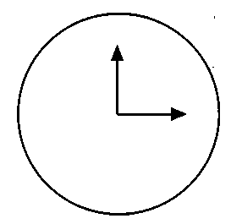
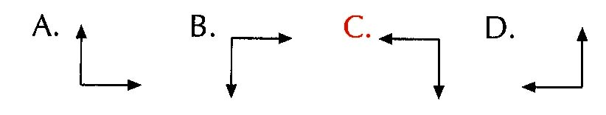
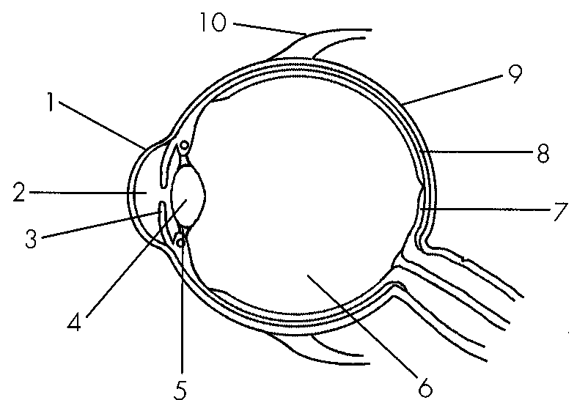
6. Which of the labelled structures are transparent?
A. 1, 2, 3, 4
B. 1,2,4,6
C. 1,3,6,7
D. 2, 3, 4, 6
7. The eye is now focusing on an aeroplane which is taking off from the airport. The conditions of structures 4 and 5 should be:
 | Structure 4 | Structure 5
A. | becomes thicker | becomes taut
B. | becomes thicker | slackens
C. | becomes thinner | becomes taut
D. | becomes thinner | slackens

8. Which of the following comparisons between structures 3 and 10 is correct?
 | Structure 3 | Structure 10
A. | It controls the curvature of structure 4. | It controls the movement of the eyeball.
B. | It attaches to structure 5. | It attaches to the skull bones.
C. | It is involved in focusing. | It is not involved in focusing.
D. | It is not controlled by the cerebrum. | It is controlled by the cerebrum.

9. The diagram below shows the sensitivity of three types of cones towards different wavelengths of light. Which of the following statements is correct? (1)Red cones are sensitive to red light only. (2)A wavelength of 550 nm can stimulate both red cones and green cones. (3)The sensitivity of blue cones is higher than that of red cones or green cones at a wavelength of 450 nm. A.(1) and (2) only
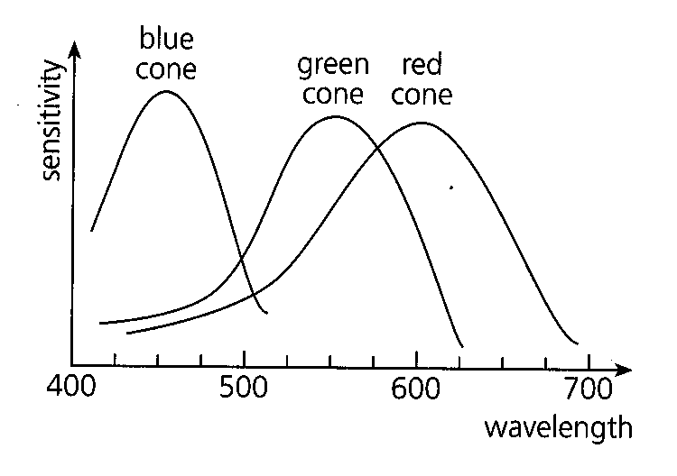
A. (1) and (2) only
B. (1) and (3) only
C. (2) and (3) only
D. (1), (2) and (3)
10. Which of the following descriptions of cones are correct? (1) Their functioning requires a sufficient supply of vitamin A. (2) They are sensitive to strong light. (3) They are most concentrated at the yellow spot. D. (1), (2) and (3) Directions: Questions 27 and 28 refer to the graph below which shows the distribution of light-sensitive cells on the retina of the eye.
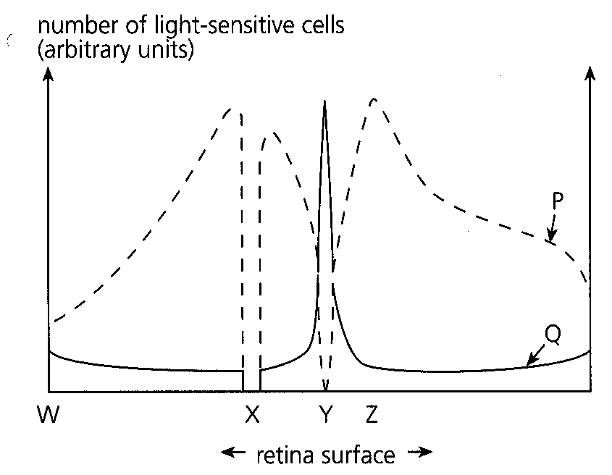
A. (2) They are sensitive to strong light. (3) They are most concentrated at the yellow spot.
A. (1) and (2) only
B. (1) and (3) only
C. (2) and (3) only
11. Identify the following:
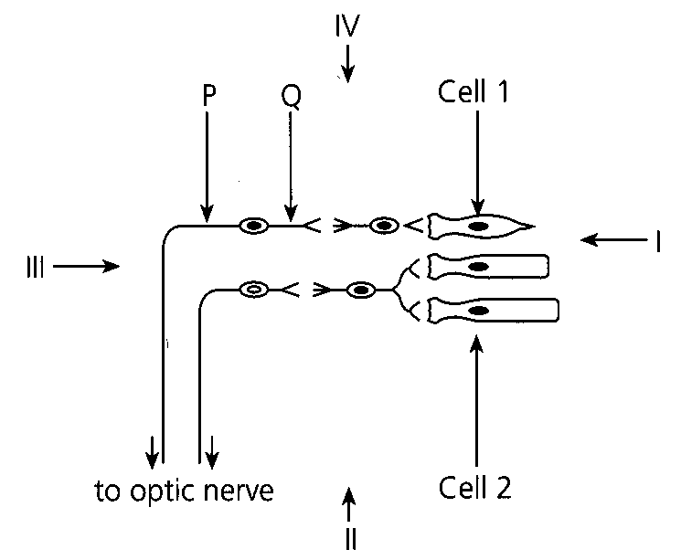
 | Cell 1 | Cell 2 | Structure P | Structure Q
A. | rod | cone | dendron | axon
B. | rod | cone | axon | dendron
C. | cone | rod | dendron | axon
D. | cone | rod | axon | dendron

12. The diagram below shows the path of light rays from a distant object through a human eye. Which of the following statements about the image is correct?
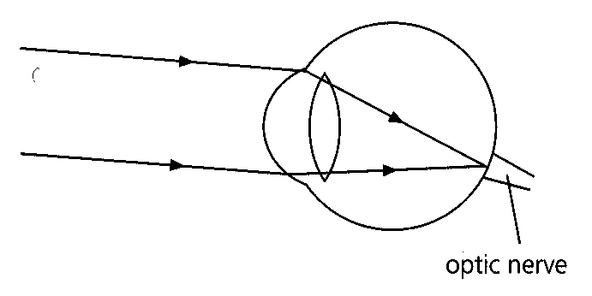
A. The image cannot be formed.
B. The image cannot be detected.
C. The image will be distorted.
D. The image will be the sharpest.
13. Which of the following is a possible cause of this eye defect?
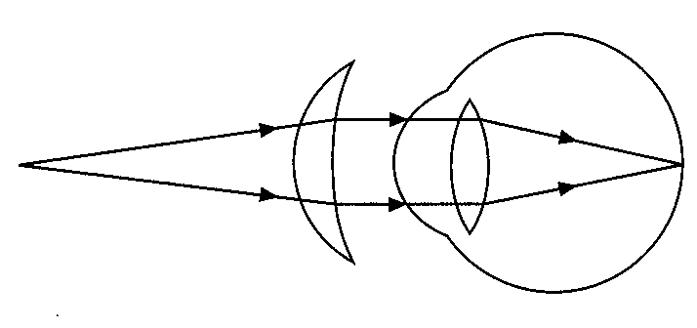
A. The lens is too thick.
B. The surface of the cornea is rough.
C. The ciliary muscle is too strong.
D. The eyeball is too short.
14. . If structure 3 is made of a single bone,
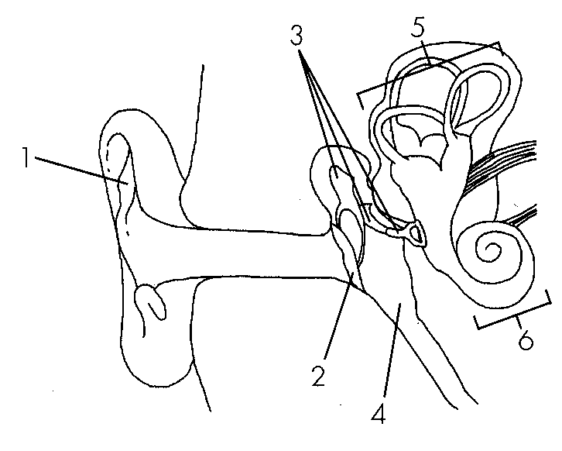
A. the air pressure in the middle ear cannot be stabilized.
B. sound vibrations cannot be transmitted.
C. body balance cannot be maintained.
D. vibrations transmitted to the inner ear will be much weaker.
15. Which of the following correctly describes the functions of various parts of the ear? 51. Sound vibrations are amplified because A.structure P has a large surface area. B.structure V is long and coiled. C.structure S has a much smaller area than structure Q. D.structure R is rigid.
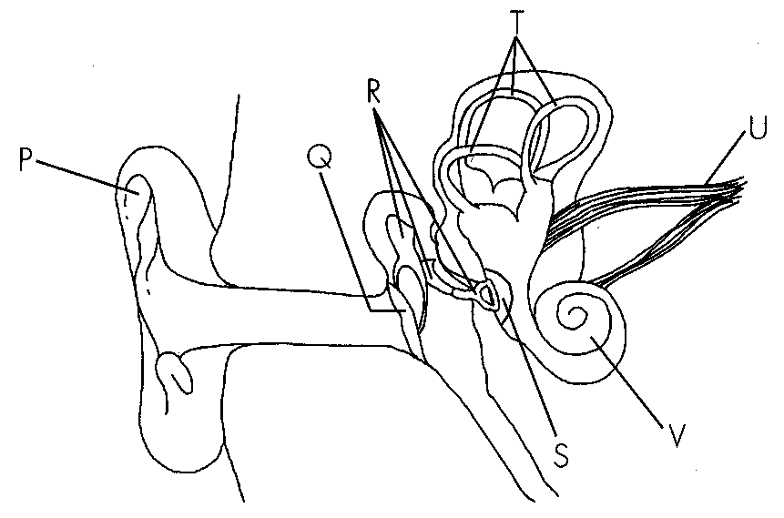
 | Structure | Function
A. | Q | to amplify sound vibrations
B. | R | to transmit nerve impulses
C. | T | to generate nerve impulses
D. | U | to transmit sound vibrations

A. structure P has a large surface area.
B. structure V is long and coiled.
C. structure S has a much smaller area than structure Q.
D. structure R is rigid.
Part B — HKDSE-style (YKTo)
16. Which of the following occurs when a person is looking at a close object?
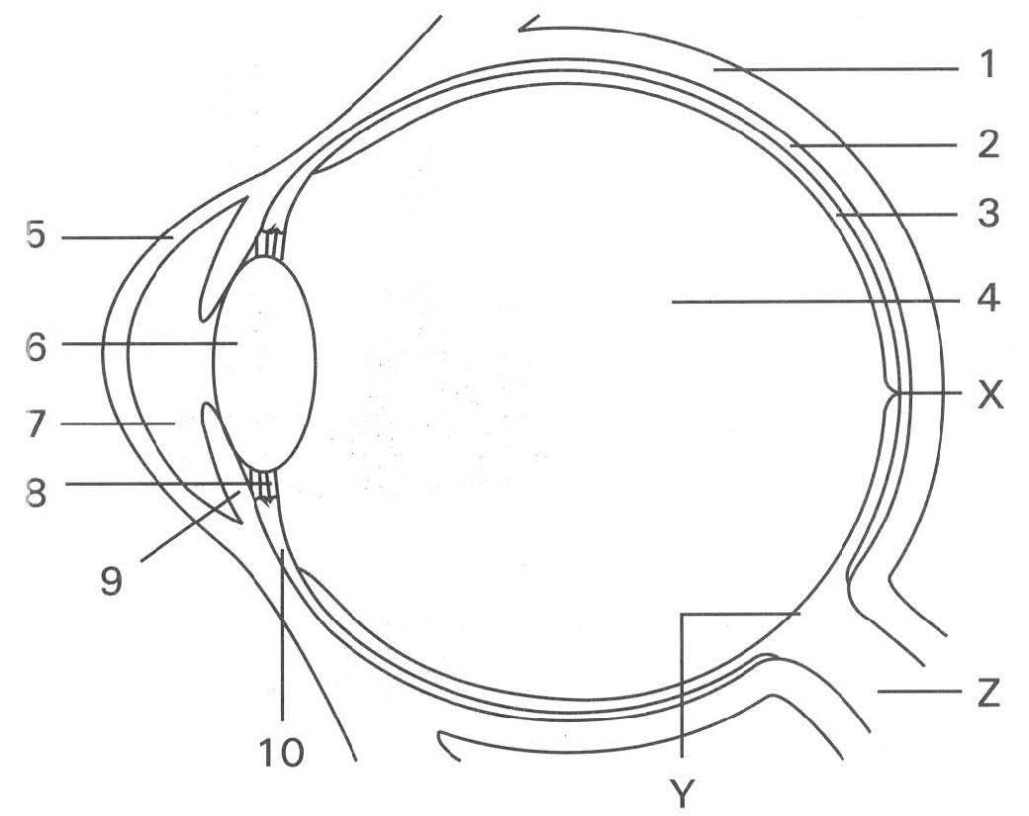
 | Part 6 | Part 8 | Part 10
A. | More convex | Stretched | Contracted
B. | Less convex | Slackened | Relaxed
C | More convex | Slackened | Contracted
D. | Less convex | Stretched | Relaxed

17. Which of the following statements about the part labelled X is CORRECT?
A. It contains more cone cells than rod cells.
B. It contains more rod cells than cone cells.
C. It has cone cells alone.
D. It has rod cells alone.
18. Part Z connects the eyeball to the
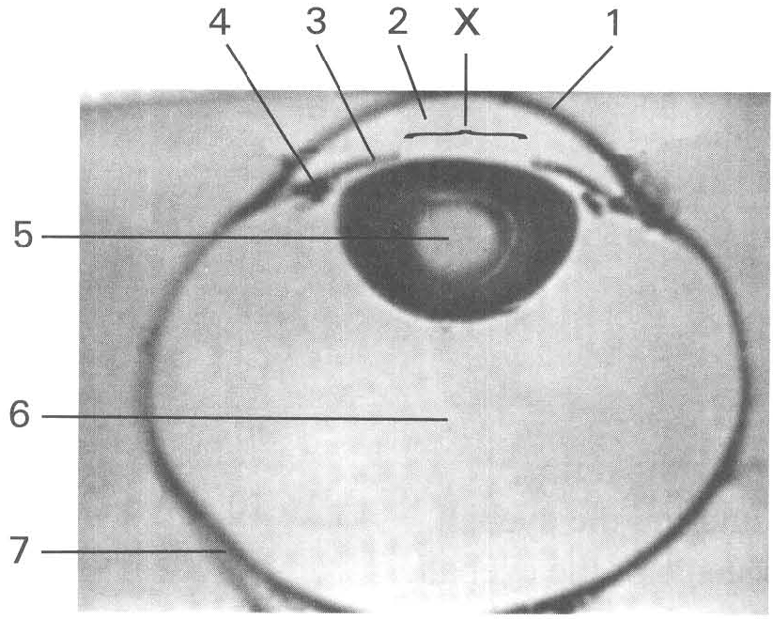
A. cerebrum. B. cerebellum. C. spinal cord. D. hypothalamus. Directions: Questions 14 to 21 refer to the photomicrograph below, which shows the horizontal section of a human eye.
19. Which of the following statements about structures 1 and 5 is CORRECT? (1) The converging power of structure 5 is higher than that of structure 1. (2) Both structures receive nutrients from structure 2. (3) The curvature of both structures can be changed to focus the incoming light rays onto the retina.
A. (1) only
B. (2) only
C. (3) only
D. (1) and (3) only
20. A person has the eye defect of longsightedness when
A. the image of a close object falls in structure 6.
B. the image of a close object falls behind structure 7.
C. the convexity of the structure 5 is too great.
D. the eyeball is too long.
21. Which of the following groups of names CORRECTLY match the cells/spots labelled X, Y, M and N?
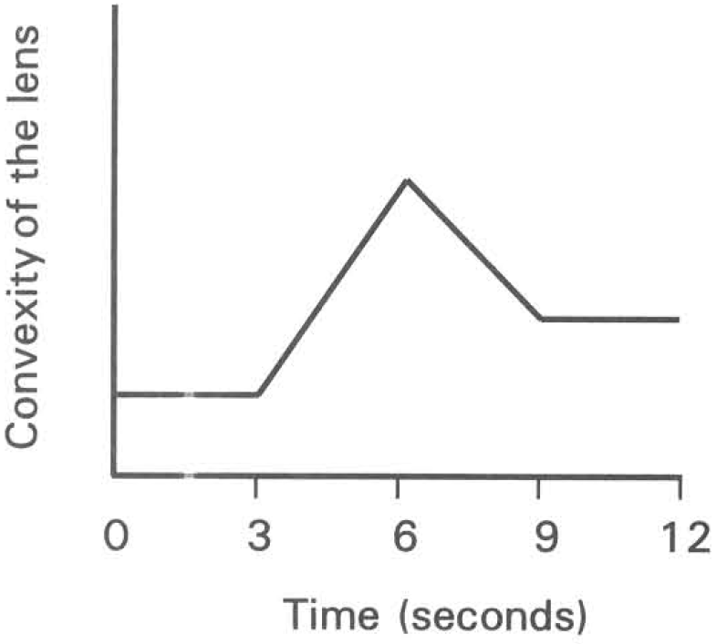
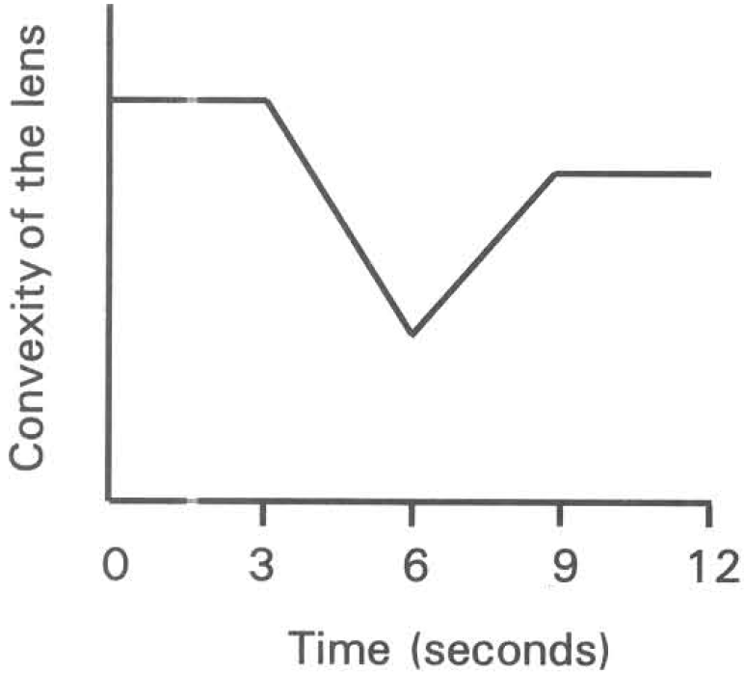
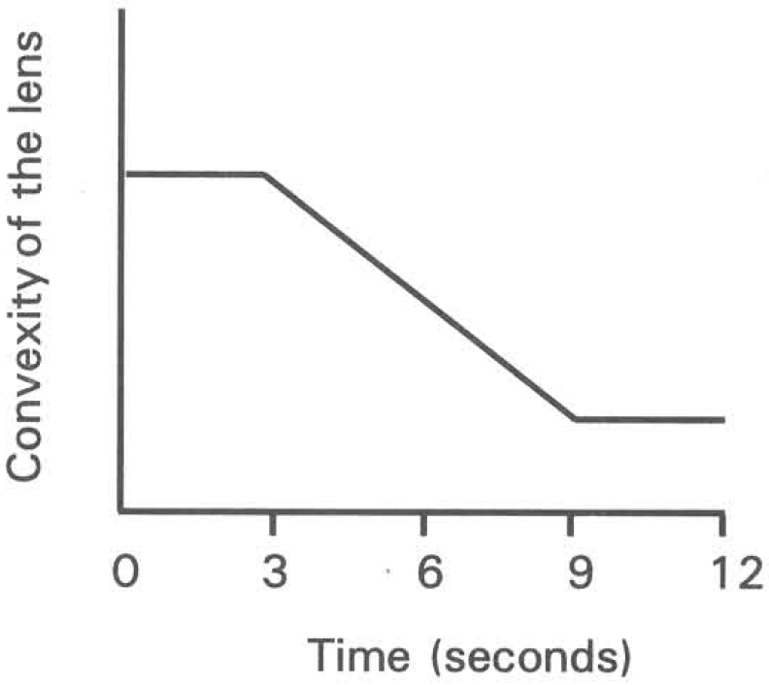
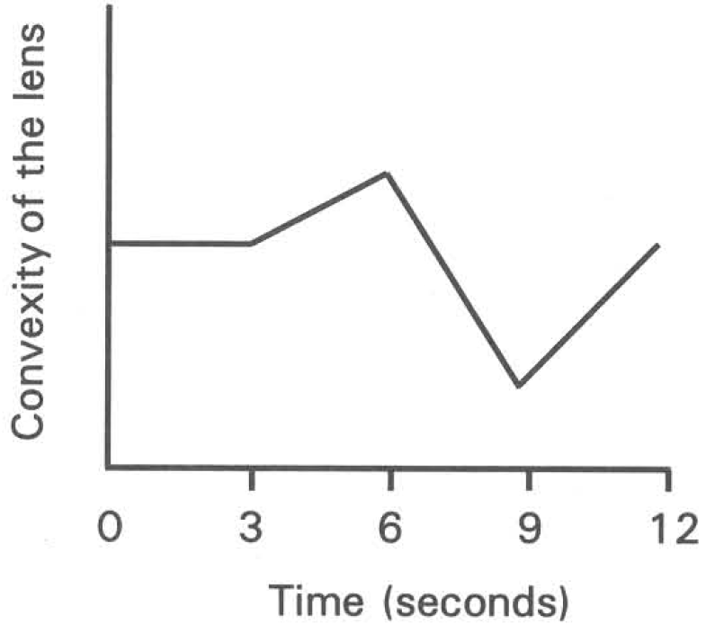
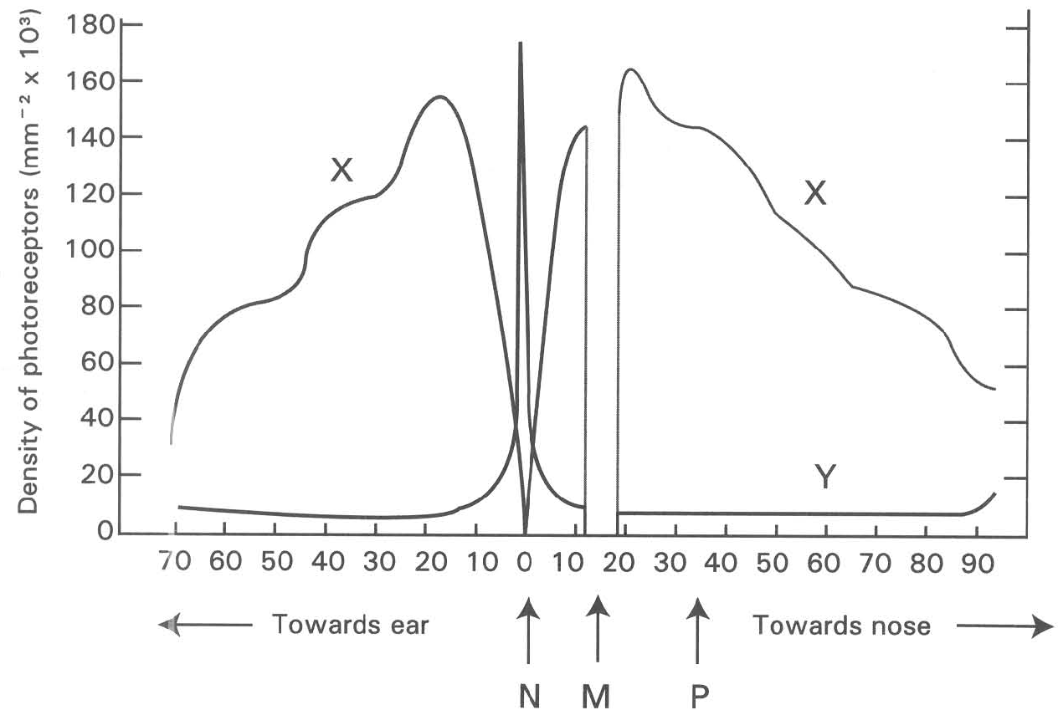
 | X | Y | M | N
A. | Cones | Rods | Blind spot | Yellow spot
B. | Rods | Cones | Yellow spot | Blind spot
C. | Cones | Rods | Yellow spot | Blind spot
D. | Rods | Cones | Blind spot | Yellow spot

22. Which of the following statements are useful to identify these two types of photoreceptors on the retina of the human eye? (1) Photoreceptors X are more abundant than photoreceptors Y. (2) No photoreceptor is present on spot M. (3) Only photoreceptors Y are present on spot N.
A. (1) and (2) only
B. (1) and (3) only
C. (2) and (3) only
D. (1), (2) and (3)
23. Which of the following statements about spots M and N are CORRECT?
A. Both photoreceptors X and Y are present on spot N.
B. No image can be formed on spot M.
C. Blood vessels enter the retina at spot N.
D. Neurones leave the retina at spot M.
24. Which of the following explanation for night blindness is CORRECT?
A. Insufficient number of photoreceptors X on spot N.
B. Insufficient number of photoreceptors Y on spot N.
C. Insufficient amount of visual pigments in photoreceptors X.
D. Insufficient amount of visual pigments in photoreceptors Y.
25. Which of the following statements concerning photograph 2 is/are CORRECT? (1)The outermost layer covering structures X2 and Y2 is called cornea. (2) Structure Y2 is colourless in an albino who lacks pigments. (3)The eye shown is adapted for seeing in dim light conditions.
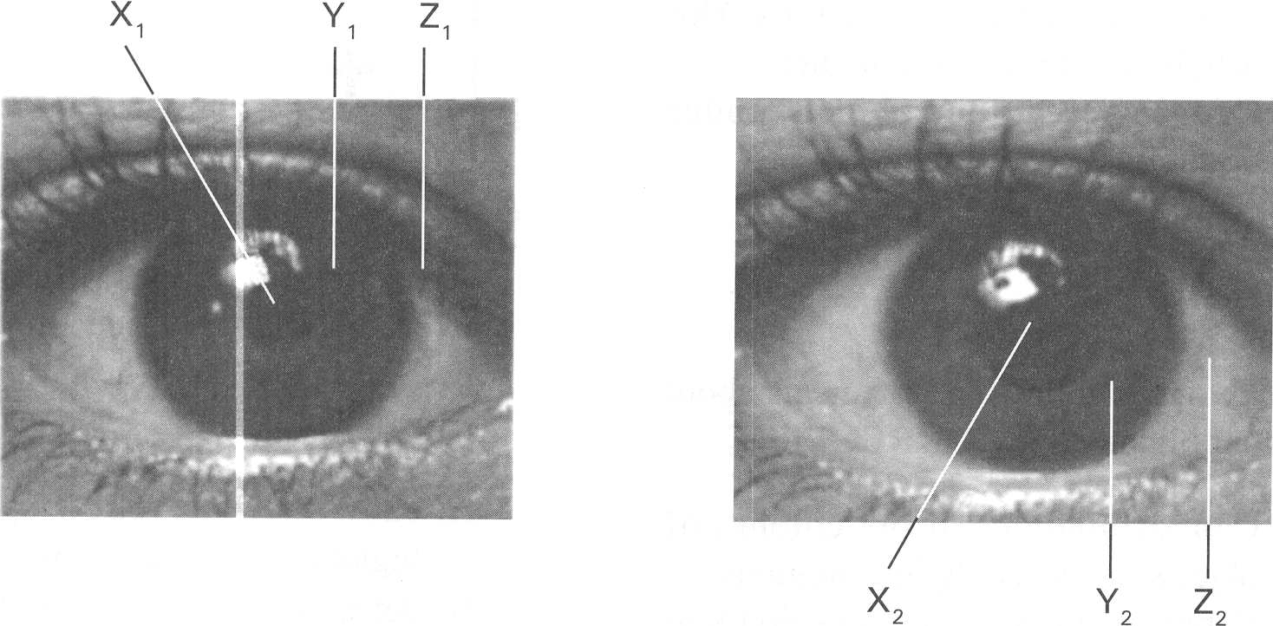
A. (1) only
B. (2) only
C. (3) only
D. (1) and (3) only
26. Which of the following combinations is CORRECT when a person looks at a distant object?
 | Condition of CiliaryMuscle | Circumference of Ciliary Body | Tension in Suspensory Ligament | Convexity of the Lens
A. | Contracts | Shorter | Increases | Less convex
B. | Relaxes | Shorter | Decreases | More convex
C. | Relaxes | Longer | Increases | Less convex
D. | Contracts | Longer | Decreases | More convex

27. The diagram below shows the correction of an eye defect. Which of the following condition(s) will lead to the eye defect corrected by the method shown in the diagram above? (1) The lens is not convex enough to focus the light rays onto the retina. (2) The lens is too convex that focuses the light rays of distant objects in front of the retina. (3) The eyeball is too long. (4) The eyeball is too short.
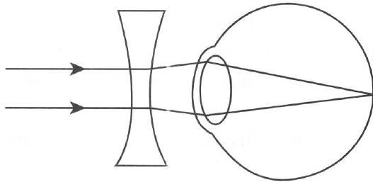
A. (1) only
B. (2) only
C. (1) and (4)
D. (2) and (3)
28. Where will structure 4 connect to?
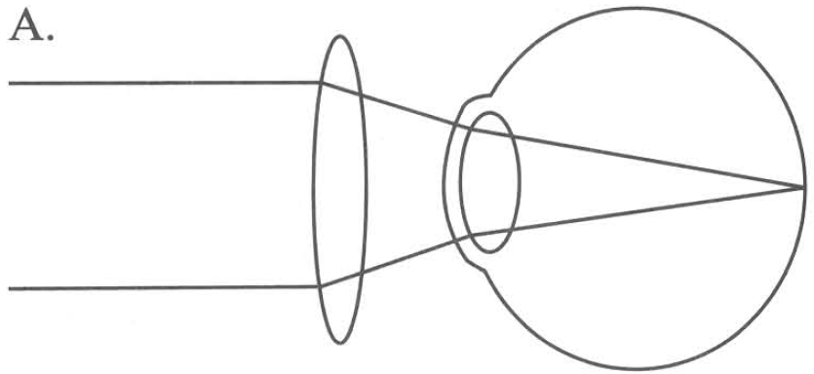
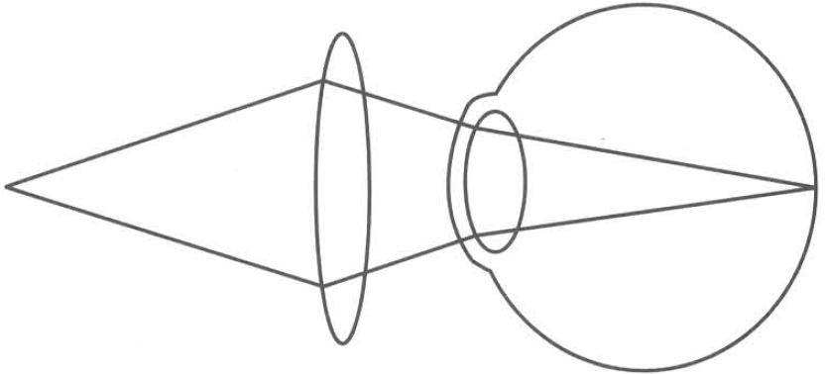
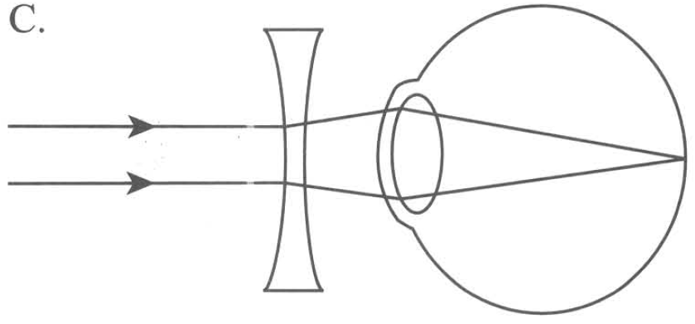
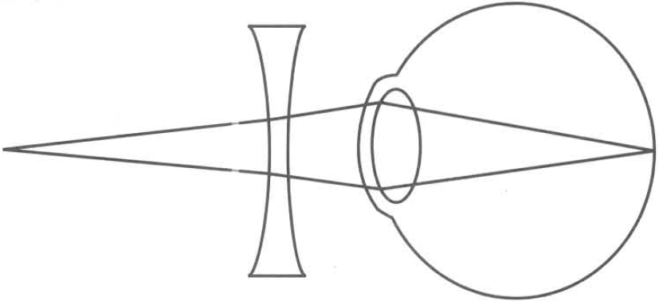
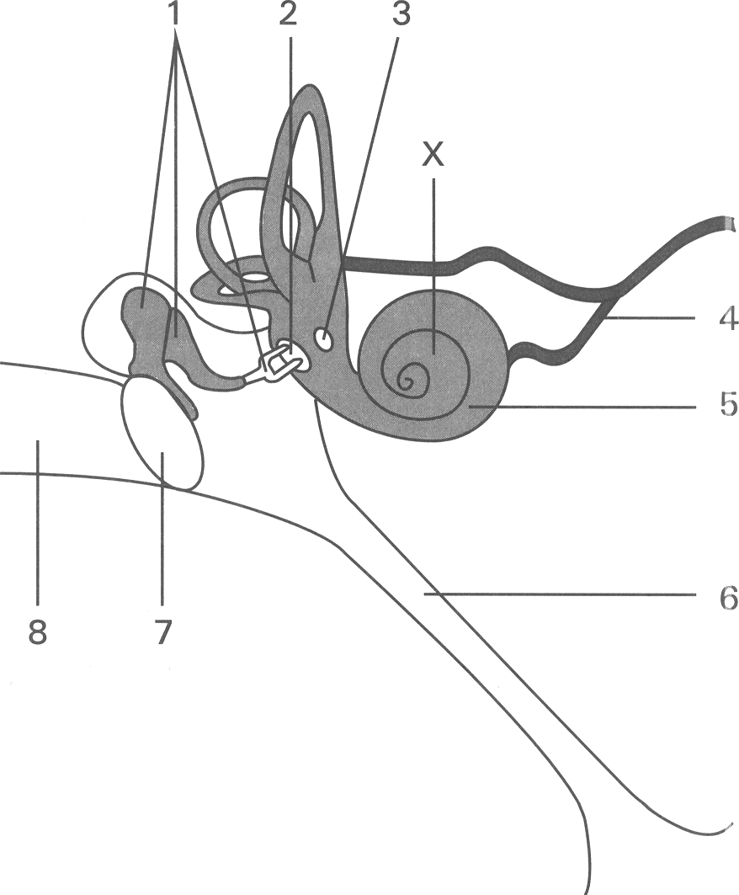
A. Spinal cord B. Cerebrum
C. Cerebellum D. Medulla oblongata
29. Which of the following is/are NOT the function(s) of structure 1? (1) To equalize the air pressure on both sides of structure 7. (2) To amplify the vibrations of sound waves into the inner ear. (3) To generate nerve impulses (4) To transmit the vibrations of sound waves into the inner ear.
A. (1) only
B. (2) only
C. (1) and (3) only
D. (2) and (4) only

Answers
Answers are printed in red.
1. B. produces nerve impulses upon stimulation.
Class: 66.7% correct (n=129) usual slip C
2. C
Class: 70.2% correct (n=47) usual slip A
3. C
Class: 75.2% correct (n=129) usual slip A
4. B
Class: 70.5% correct (n=129) usual slip A
5. B
Class: 69.0% correct (n=129) usual slip B
6. B. 1,2,4,6
Class: 25.5% correct (n=47) usual slip A
7. C
Class: 70.7% correct (n=82) usual slip D
8. D
Class: 42.7% correct (n=82) usual slip C
9. C. (2) and (3) only
Class: 73.2% correct (n=82) usual slip D
10. C. (2) and (3) only
Class: 73.2% correct (n=82) usual slip D
11. D
Class: 62.0% correct (n=129) usual slip C
12. B. The image cannot be detected.
Class: 68.3% correct (n=82) usual slip C
13. D. The eyeball is too short.
Class: 75.6% correct (n=82) usual slip C
14. D. vibrations transmitted to the inner ear will be much weaker.
Class: 68.3% correct (n=82) usual slip B
15. C. structure S has a much smaller area than structure Q.
Class: 42.7% correct (n=82) usual slip A
16. C
Class: 65.9% correct (n=129) usual slip C
17. C. It has cone cells alone.
Class: 26.8% correct (n=82) usual slip A
18. A. cerebrum. B. cerebellum. C. spinal cord. D. hypothalamus. Directions: Questions 14 to 21 refer to the photomicrograph below, which shows the horizontal section of a human eye.
Class: 54.3% correct (n=129) usual slip C
19. B. (2) only
Class: 56.6% correct (n=129) usual slip D
20. B. the image of a close object falls behind structure 7.
Class: 80.5% correct (n=82) usual slip C
21. D
Class: 57.4% correct (n=47) usual slip C
22. B. (1) and (3) only
Class: 59.6% correct (n=47) usual slip D
23. D. Neurones leave the retina at spot M.
Class: 55.3% correct (n=47) usual slip A
24. C. Insufficient amount of visual pigments in photoreceptors X.
Class: 57.4% correct (n=47) usual slip B
25. C. (3) only
Class: 69.5% correct (n=82) usual slip A
26. C
Class: 76.8% correct (n=82) usual slip D
27. D. (2) and (3)
Class: 65.9% correct (n=82) usual slip B
28. B
Class: 52.4% correct (n=82) usual slip A
29. C. (1) and (3) only
Class: 36.6% correct (n=82) usual slip B

Class percentage correct
Matched to this paper by question wording in the source bank and the form answer key, not by a shifted paper number.
Q | Answer | % correct | n | Usual slip
1 | B | 66.7% | 129 | C
2 | C | 70.2% | 47 | A
3 | C | 75.2% | 129 | A
4 | B | 70.5% | 129 | A
5 | B | 69.0% | 129 | B
6 | B | 25.5% | 47 | A
7 | C | 70.7% | 82 | D
8 | D | 42.7% | 82 | C
9 | C | 73.2% | 82 | D
10 | C | 73.2% | 82 | D
11 | D | 62.0% | 129 | C
12 | B | 68.3% | 82 | C
13 | D | 75.6% | 82 | C
14 | D | 68.3% | 82 | B
15 | C | 42.7% | 82 | A
16 | C | 65.9% | 129 | C
17 | C | 26.8% | 82 | A
18 | A | 54.3% | 129 | C
19 | B | 56.6% | 129 | D
20 | B | 80.5% | 82 | C
21 | D | 57.4% | 47 | C
22 | B | 59.6% | 47 | D
23 | D | 55.3% | 47 | A
24 | C | 57.4% | 47 | B
25 | C | 69.5% | 82 | A
26 | C | 76.8% | 82 | D
27 | D | 65.9% | 82 | B
28 | B | 52.4% | 82 | A
29 | C | 36.6% | 82 | B

