Reproduction and growth
Multiple-choice practice
Name: ________________________ Class: ____________
There are 323 questions compiled from Longman HKCEE and/or YKTo papers. Choose the one best answer.
Part A — HKCEE level (Longman)
1. Which of the following matchings about asexual reproduction is incorrect?
 | Asexual reproduction | Organism involved
A. | binary fission | bacteria
B. | budding | Mucor
C. | spore formation | Rhizopus
D. | vegetative propagation | angiosperms

2. Which of the following statements about binary fission is correct?
A.It occurs in Amoeba only.
B.Each fission will give rise to one daughter Amoeba and the parent Amoeba remains.
C.The daughter Amoeba can undergo binary fission immediately after its birth.
D.The daughter Amoeba is genetically identical to the parent Amoeba.
3. Compared with the parent plant, the daughter plant developed from a corm (1)has the same chromosome number. (2)is identical to the parent plant. (3)can reproduce by vegetative propagation only.
A. (1) and (2) only
B. (1) and (3) only
C. (2) and (3) only
D. (1), (2) and (3)
4. Which of the following statements about sexual reproduction is correct?
(1) It always involve two parents.
(2) It always involve the fusion of gametes.
(3) Offspring are genetically different from their parents.
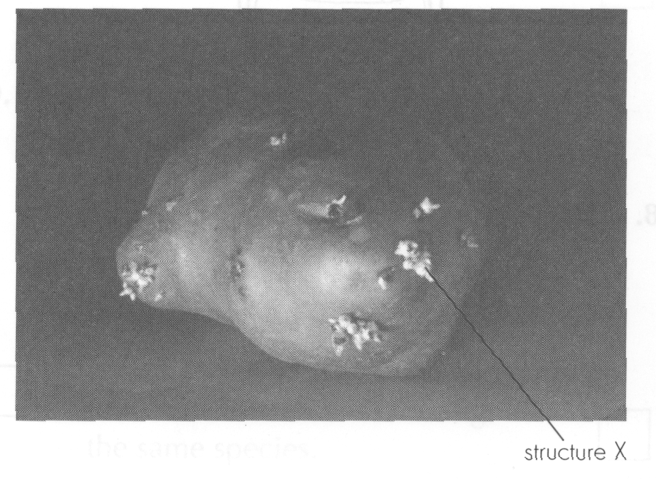
A. (1) and (2) only B. (1) and (3) only C. (2) and (3) onlyD. (1), (2) and (3) Directions: Questions 5 to 7 refer to the following photograph which shows a vegetative organ.
5. The vegetative organ is a
A. corm.
B. bulb.
C. rhizome.
D. tuber.
6. From which part of the parent plant is this vegetative organ developed? A. Flower D. Leaf 7.Structure X will A.be dispersed to other places for germination. B.develop into a new plant at the same place. C.develop into the root system. D.develop into a flower. Directions: Questions 8 to 10 refer to the drawing below which shows a vegetative organ.
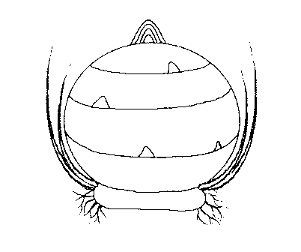
A. Flower
B. Root
C. Stem
D. Leaf 7.Structure X will
7. The vegetative organ is a
A. corm.
B. bulb.
C. rhizome.
D. tuber.
8. From which part of the parent plant is this vegetative organ developed?
A. Flower
B. Root
C. Stem
D. Leaf
9. What will happen to this vegetative organ when it is developing into a new plant?
A.It will become bigger to store up the excess food for the next germination.
B.It will remain unchanged.
C.It will be pulled deeper into the soil by the contractile roots.
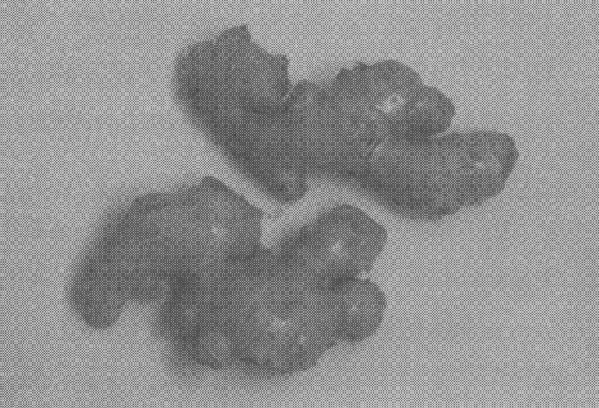
D. It will become smaller to supply food for germination. Directions: 11 to 13 refer to the photograph below which shows a vegetative organ.
10. The vegetative organ is a
A. corm.
B. bulb.
C. rhizome.
D. tuber.
11. From which part of the parent plant is this vegetative organ developed?
A. Flower
B. Root
C. Stem
D. Leaf
12. The lines on the vegetative organ are
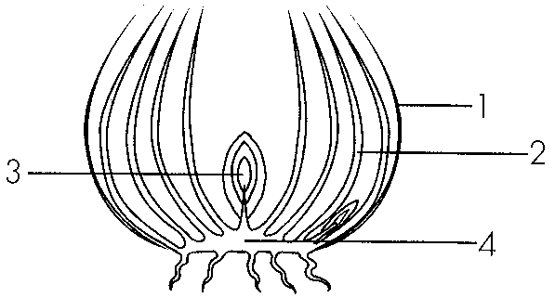
A. nodes. B. internodes. C. annual rings. D. veins. Directions: Questions 14 to 16 refer to the drawing below which shows a vegetative organ.
13. The vegetative organ is a
A. corm.
B. bulb.
C. rhizome.
D. tuber.
14. From which part of the parent plant is this vegetative organ developed? (1) Root (2) Stem (3) Leaf
A. (1) and (2) only
B. (1) and (3) only
C. (2) and (3) only
D. (1), (2) and (3)
15. Which part of the vegetative organ supplies most energy for its development into a new plant?
A. 1
B. 2
C. 3
D. 4
16. Which of the following are the disadvantages of vegetative propagation? (1) Daughter plants are produced more slowly. (2) Less daughter plants are produced at one time. (3) Daughter plants will get diseases more easily.
A. (1) and (2) only
B. (1) and (3) only
C. (2) and (3) only
D. (1), (2) and (3)
17. Which of the following comparisons between reproduction by seeds and reproduction by vegetative organs is incorrect?
 | Reproduction by seeds | Reproduction by vegetative organs
A. | Offspring are more adaptable to changing environment. | Offspring are less adaptable to changing environment.
B. | It takes a longer time. | It takes a shorter time.
C. | Wind or insects are necessary. | Wind or insects are not necessary.
D. | Offspring cannot survive during winter. | Offspring can survive during winter.

18. Which of the following statements about pollen grains is correct?
A.Pollen grains are the male gametes.
B.Pollen grains are produced in nectaries.
C.Pollen grains are smaller and lighter in insectedpollinated flowers.-
D.Pollen grains only germinate into pollen tubes when landed on the stigma of the same species.
Directions: Questions 20 to 22 refer to the following diagram which shows the longitudinal section of a bisexual flower.
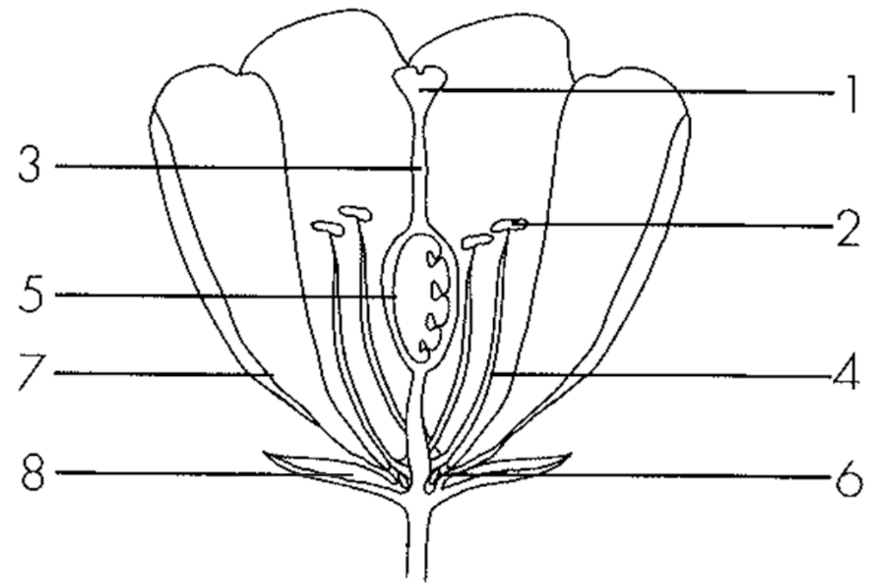
19. Which structure protects the flower at the bud stage?
A. 2
B. 5
C. 7
D. 8
20. Which structures attract insects to visit this flower?
A. 3 and 4
B. 5 and 6
C. 6 and 7
D. 7 and 8
21. Which structures will persist after fertilisation?
A. 3 and 4 B. 5 and 8 C. 6 and 7 D. 7 and 8 Directions: Questions 23 to 25 refer to the diagrams below which show the longitudinal section of a flower and that of a female reproductive system.
22. Where does meiosis occur in the flower and the female reproductive system respectively?
 | Flower | Female reproductive system
A. | 2 | 6
B. | 1 | 5
C. | 3 | 7
D. | 4 | 8

23. Which structure in the flower has similar function as that of structure 7 in the female reproductive system?
A. 1
B. 2
C. 3
D. 4
24. What will structure 3 in the flower become after fertilisation?
A. Embryo
B. Seed coat
C. Seed
D. Fruit
25. Which of the following are the features of wind pollinated flowers?- (1) Stigma hanged outside the petals (2) Large petals (3) Large number of pollen grains produced
A. (1) and (2) only
B. (1) and (3) only
C. (2) and (3) only
D. (1), (2) and (3)
26. Which of the following are not the features of windpollinated flowers? -
(1) The anther is kept inside the petals.
(2) The stigma is large and feathery.
(3) Pollen grains are either sticky or with spikes.
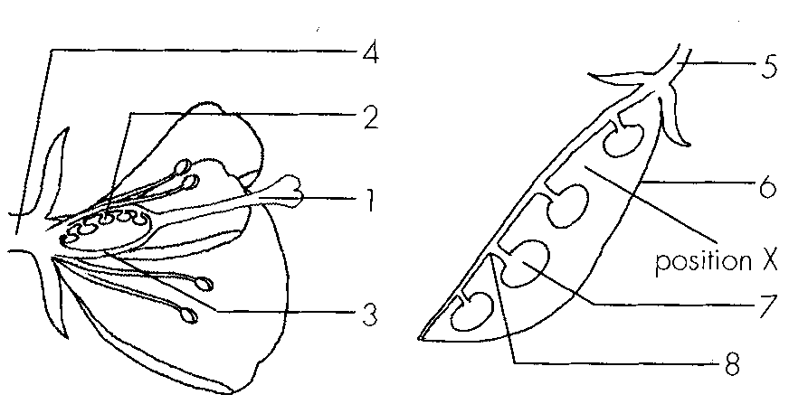
A. (1) and (2) only B. (1) and (3) only C. (2) and (3) only D. (1), (2) and (3) Directions: Questions 28 to 30 refer to the diagrams below which show the longitudinal section of a flower and that of its fruit.
27. From which of the following structures is structure 5 developed?
A. 1
B. 2
C. 3
D. 4
28. Which of the following structures is equivalent to the umbilical cord in human?
A. 5
B. 6
C. 7
D. 8
29. What is the most likely reason for the absence of structure 7 at position X?
A. fertilisation does not occur at position X.
B. Structure 7 has not developed yet at position X.
C. No pollen grains reached position X.
D. Ovary is absent at position X.
30. From which of the following parts of a flower is fruit developed?
A. Ovule
B. Ovule wall
C. Ovary
D. Ovary wall
31. Which of the following are implications of seed dispersal? (1) It may reduce competition between parents and offspring. (2) It may reduce competition among offspring. (3) It may increase the chance of survival.
A. (1) and (2) only
B. (1) and (3) only
C. (2) and (3) only
D. (1), (2) and (3)
32. The conditions for seed germination in general include:
(1) Warmth (2) Moisture (3) Oxygen
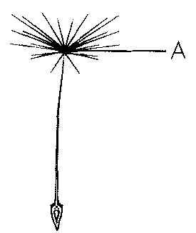
A. (1) and (2) only B. (1) and (3) only C.(2) and (3) only D. (1), (2) and (3) Directions: Questions 34 and 35 refer to the following diagram of a fruit produced by a certain plant.
33. The plant from which this fruit is produced and its mode of dispersal are respectively
 | Plant | Mode of dispersal
A. | Dandelion | animal
B. | Dandelion | wind
C. | Sycamore | animal
D. | Sycamore | wind

34. Part A can facilitate dispersal by
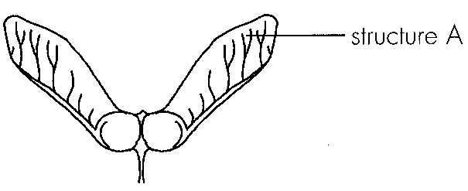
A. secreting scent to attract animals.
B. acting as hooks for attaching to animals.
C. acting as a hairy parachute for flying.
D. acting as winglike outgrowths for flying.- Directions: Questions 36 to 37 refer to the following diagram which shows the fruits of a certain plant.
35. The plant from which this fruit is produced and its mode of dispersal are respectively
37. Structure A can facilitate dispersal by
 | Plant | Mode of dispersal
A | Dandelion | animal
B | Dandelion | wind
C | Sycamore | animal
D | Sycamore | wind

A. acting as winglike outgrowth for flying. -
B. acting as a hairy parachute for flying.
C. being colourful and delicious to attract animals.
D. being sticky for attaching to animals.
36. Which of the following structures help the dispersal of fruits by wind? (1) Hooks (2) Wing like outgrowth- (3) Hairy parachute
A. (1) and (2) only
B. (1) and (3) only
C. (2) and (3) only
D. (1), (2) and (3)
37. Which of the following features help the dispersal of fruits by animals?
(1) Presence of hooks (2) Brightly coloured (3) Scented or juicy
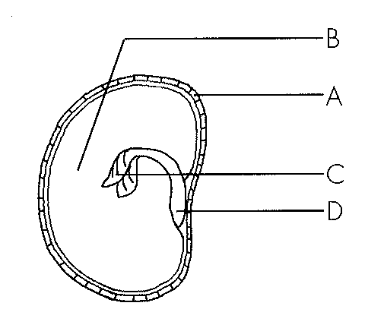
A. (1) and (2) only B. (1) and (3) only C. (2) and (3) only D. (1), (2) and (3) Directions: Questions 40 to 42 refer to the following diagram which shows the longitudinal section of a dicotyledonous seed.
38. Which of the following correctly state the parts of a flower from which structures A and B are developed?
 | A | B
A. | ovule wall | funicle
B. | ovule wall | zygote
C. | ovary wall | ovule wall
D. | ovary wall | zygote

39. Which of the following statements about C and D is correct?
A. Structure C will absorb food from structure B during the early stage of germination.
B. Structure C will grow out of A earlier than structure D.
C. Structure D will show positive phototropism.
D. Structure D will absorb water from structure B during the early stage of germination.
40. This dicotyledonous seed usually does not germinate immediately after its formation. Such period of dormancy is due to (1) the physical nature of A. (2) the dehydration of B. (3) the presence of starch in B. (1) and (3) only C. (2) and (3) only D. (1), (2) and (3) Directions: Questions 43 to 45 refer to the following experiment which investigates the conditions necessary for seed germination.
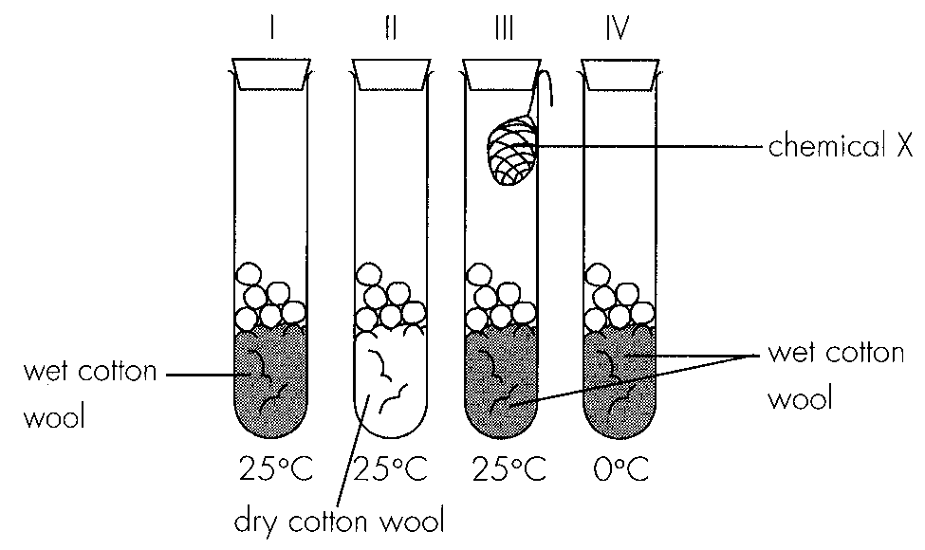
A. (2) the dehydration of
B. (3) the presence of starch in
B.
A. (1) and (2) only
41. Chemical X is most probably
A. anhydrous calcium chloride.
B. anhydrous calcium carbonate.
C. alkaline pyrogallol.
D. acidic pyrogallol.
42. In which of the tubes will germination most likely to occur?
A. I
B. II
C. III
D. IV
43. In view of your answer to Question 44, which of the following conditions are found to be necessary for seed germination?
(1) Water (2) Oxygen (3) Light (4) Warm temperature
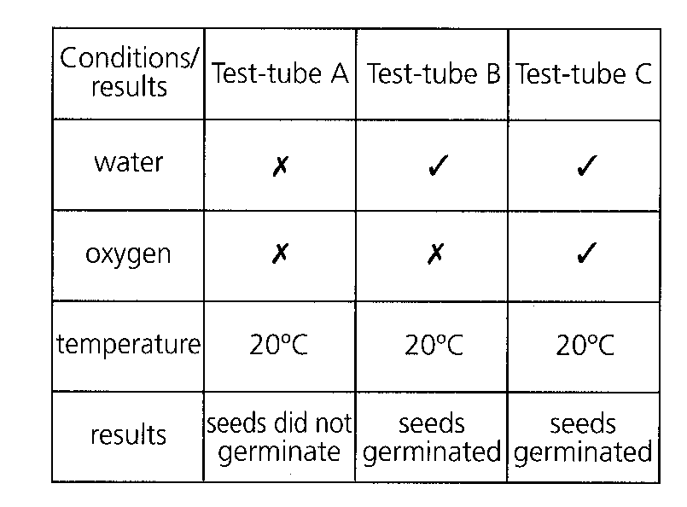
A. (1), (2) and (3) only B. (1), (2) and (4) only C. (2), (3) and (4) onlyD. (1), (2), (3) and (4) Directions: Questions 46 to 47 refer to the table below which summarizes the conditions and results of the three testtubes in the study of seed germination.-
44. Which of the following can be concluded from this experiment?
A. Seed germination needs water.
B. Seed germination needs oxygen.
C. Seed germination needs warmth.
D. No conclusion can be drawn.
45. Which of the following may be a necessary precaution for this experiment?
A. The seeds should be sterilized beforehand.
B. The seeds should be dehydrated beforehand.
C. The seeds should be kept in low temperature beforehand.
D. The seed coats should be removed beforehand.
46. Which of the following graphs correctly shows the changes in dry mass of cotyledons and that of plumule during germination?
Directions: Questions 49 and 50 refer to the diagram below which shows the longitudinal section of a pear.
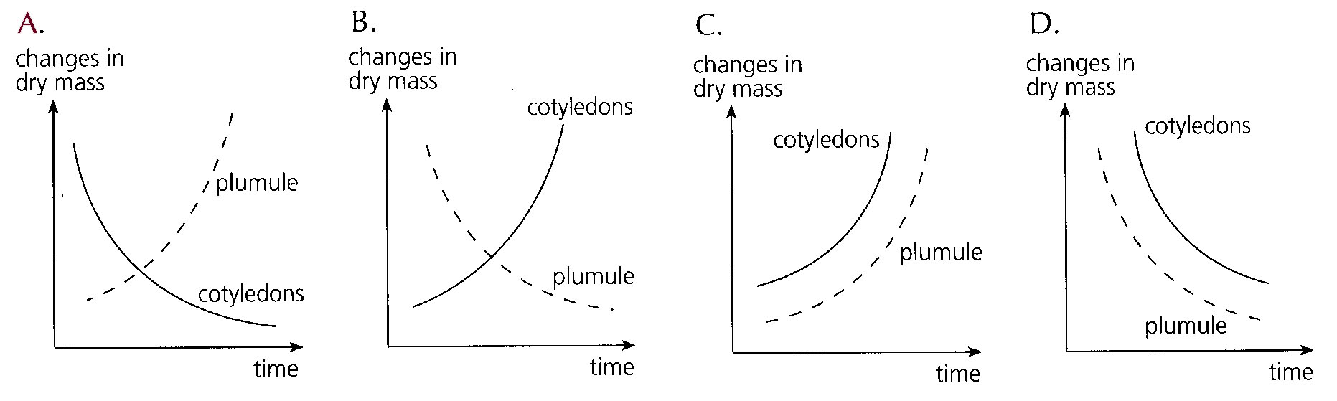
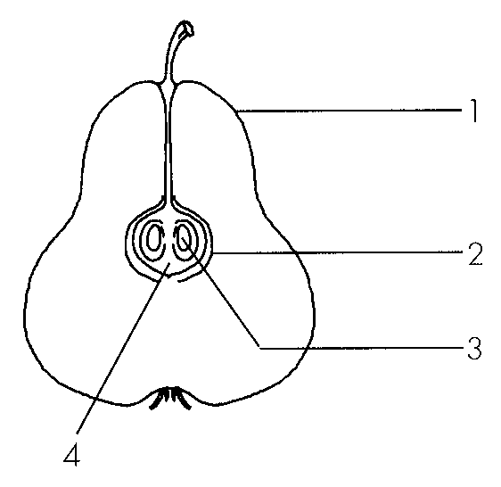
47. Which of the following structure is developed from the ovary wall?
A. 1
B. 2
C. 3
D. 4
48. Which of the following correctly states and explains the means of seed dispersal in pear plants?
 | Means of dispersal | Explanation
A. | wind | pears are small and light
B. | wind | pears have streamlined shape
C. | animal | fleshy and juicy
D. | animal | possession of hooks

49. Which of the following is/are not the advantage(s) of fruit dispersal? (1) Reduce transmission of diseases within the species (2) Enable the species to have more variations (3) Make the species become fitter for the changing environment
A. (1) only
B. (1) and (2) only
C. (1) and (3) only
D. (2) and (3) only
50. On the day of ovulation, the female body normally shows an increase in
A. heart rate.
B. breathing rate.
C. blood pressure.
D. body temperature.
51. Vagina in the female reproductive system is a passage for (1) penis during copulation. (2) blood during menstruation. (3) baby during labour.
A. (1) and (2) only
B. (1) and (3) only
C. (2) and (3) only
D. (1), (2) and (3)
52. Which of the following statements about a sperm cell is incorrect?
A. The chromosomes in a sperm cell cannot pair up.
B. The whole sperm cell fuses with an ovum during fertilisation.
C. It is produced in the testes.
D. The DNA content of a sperm cell is half of the sperm mother cell.
53. Which of the following is not the secondary characteristics of girls?
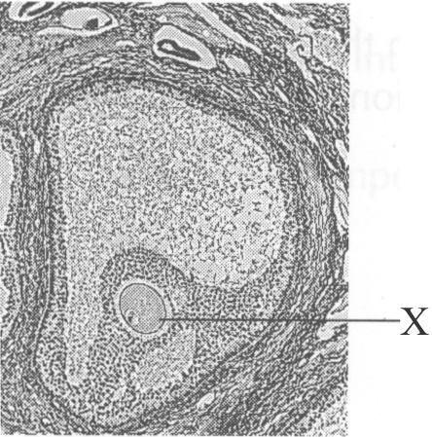
A. Growth of larynx B. Development of breasts
C. Growth of pubic hair D. Widening of hips Directions: Questions 56 and 57 refer to the following photomicrograph which shows one of the Graafian follicles in an organ.
54. The photomicrograph is probably showing the transverse section of D. the oviduct. *57.Structure labelled X is A. a sperm cell. B. an ovum. C. the nucleus of the Graafian follicle. D. the vacuole of the Graafian follicle.
A. the testis.
B. the vas deferens.
C. the ovary.
D. the oviduct. *57.Structure labelled X is
55. Which of the following is not the secondary sexual characteristics of boys?
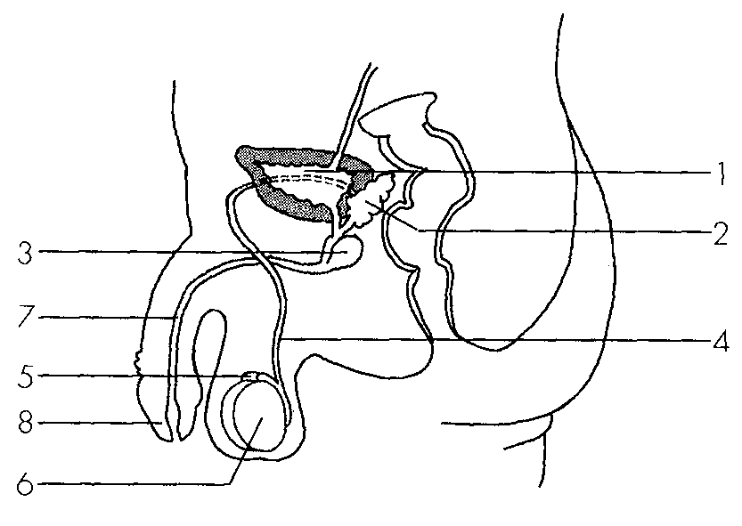
A. Development of muscles B. Growth of axillary hair
C. Widening of hip D. Growth of larynx Directions: Questions 59 to 61 refer to the diagram below which shows the reproductive system of a man. 59.Sperm is manufactured in
A. 2. B. 3. C. 5. D. 6. *60.Sperm is stored in
A. 2 only. B. 5 only.C. 2 and 5. D. 5 and 6. 61.Semen is a mixture of secretions from the activities of
A. 3 and 4. B. 3 and 6. C. 5 and 6. D. 7 and 8.
56. Which of the following statements about menstrual cycle is incorrect?
A. It begins at puberty and stops at menopause.
B. It is maintained by the interactions of hormones.
C. It occurs in female mammals only.
D. The cycle is 28day long.-
57. Which of the following statements about ejaculation is correct?
A. It involves the contraction of epididymis.
B. It begins at puberty and stops during menopause.
C. It is brought about by male sex hormone.
D. It does not occur after vasectomy.
58. Which of the following do not occur during pregnancy? (1) Ovulation (2) Development of mammary glands (3) Menstruation
A. (1) and (2) only
B. (1) and (3) only
C. (2) and (3) only
D. (1), (2) and (3)
59. Which of the following matchings is correct?
Directions: Questions 66 to 68 refer to the diagram below which shows the female reproductive system.
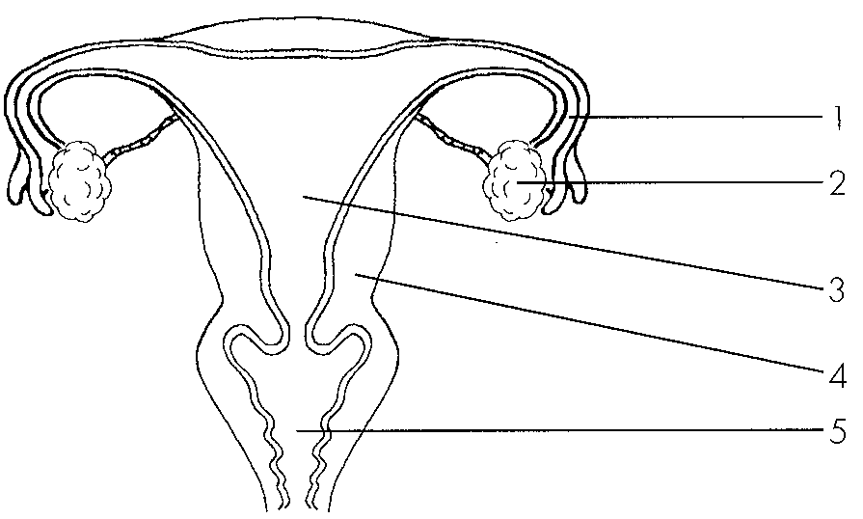
 | Structure for producing male sex hormone | Structure for producing seminal fluid | Structure for producing sperm
A. | epididymis | prostate gland | testis
B. | testis | prostate gland | epididymis
C. | testis | cowper's gland | testis
D. | epididymis | cowper's gland | epididymis

60. Which of the following produces haploid cells?
A. 1
B. 2
C. 3
D. 4
61. Where in the female reproductive system does fertilisation normally take place?
A. 1
B. 3
C. 4
D. 5
62. Which of the following is not the reason for structure 4 being muscular and vascularized?
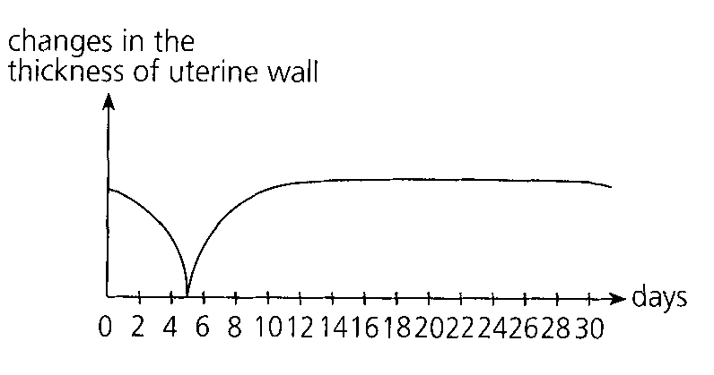
A. Structure 4 is responsible for expelling the placenta during labour.
B. Structure 4 is responsible for nourishing the foetus.
C. Structure 4 is responsible for menstruation.
D. Structure 4 is responsible for protecting the foetus. Directions: Questions 69 to 71 refer to the following diagram which shows the changes in the thickness of uterine wall during a menstrual cycle of 30day long.-
63. When does menstruation occur?
A. Day 0 to Day 5 B. Day 5 to Day 10 C. Day 12 to Day 17 D. Day 20 to Day 25
64. Which of the following happens on Day 15? (1)The mature ovum in the ovary is released into the oviduct. (2)The embryo is implanted into the uterine wall. (3)There is a rise in body temperature.
A. (1) and (2) only
B. (1) and (3) only
C. (2) and (3) only
D. (1), (2) and (3)
65. Which of the following is incorrect?
 | Parts of male reproductive system | Functions
A. | testis | production of male sex hormone
B. | epididymis | storage of semen
C. | prostate gland | production of seminal fluid
D. | urethra | passage for semen

66. Which of the following is incorrect?
 | Parts of female reproductive system | Functions
A. | ovary | production of ovum
B. | fallopian tubes | helping the movement of zygote
C. | uterus | site of fertilisation
D. | vagina | passage for foetus during parturition

67. Which of the following comparisons between sperm and ovum is incorrect?
 | Sperm | Ovum
A. | produced in the testis | produced in the ovary
B. | can move by itself | cannot move by itself
C. | smaller in size | larger in size
D. | carries Y chromosome | carries X chromosome

68. Which is the correct sequence of the processes in sexual reproduction? (1) Labour (2) Meiosis (3) Ejaculation (4) Pregnancy (5) fertilisation
A. (1), (3), (2), (5), (4)
B. (2), (1), (3), (5), (4)
C. (2), (3), (5), (4), (1)
D. (3), (2), (5), (4), (1)
69. Which of the following are the essential roles of amniotic fluid during the development of an embryo? (1) To prevent the embryo from drying up (2) To nourish the embryo (3) To buoy up the embryo
A. (1) and (2) only
B. (1) and (3) only
C. (2) and (3) only
D. (1), (2) and (3)
70. Which of the following substances can be passed from mother to foetus through the placenta? (1) Antibodies (2) AIDS virus (3) Narcotics
A. (1) and (2) only
B. (1) and (3) only
C. (2) and (3) only
D. (1), (2) and (3)
71. Which of the following comparisons between a foetus and a newborn baby are correct? (1) Digestion occurs in a newborn baby but not in a foetus. (2) Egestion occurs in a newborn baby but not in a foetus. (3) Excretion occurs in a newborn baby but not in a foetus.
A. (1) and (2) only
B. (1) and (3) only
C. (2) and (3) only
D. (1), (2) and (3)
72. Which of the following substances cannot be transmitted from mother to foetus?
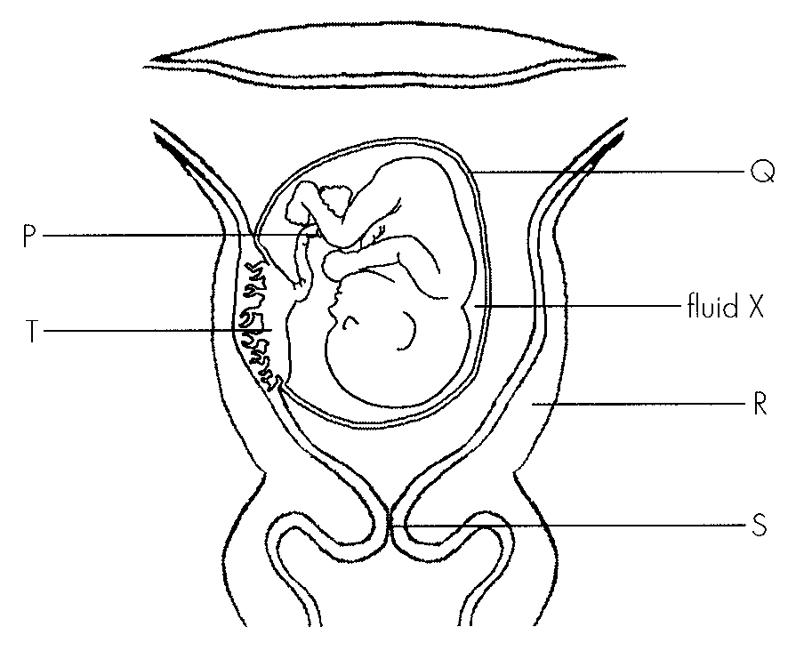
A. Ethanol B. Nicotine C. Red blood cells D. Minerals Directions: Questions 80 to 82 refer to the diagram below.
73. Which structure enables the foetus to obtain food for its development?
A. P
B. Q
C. R
D. S
74. How does the foetus dispose of urea?
A. Urea is disposed of by diffusing into fluid X.
B. Urea is disposed of by R.
C. Urea is disposed of by S.
D. Urea is disposed of through T.
75. The foetus can be protected by (1) Q. (2) R. (3) fluid X.
A. (1) and (2) only
B. (1) and (3) only
C. (2) and (3) only
D. (1), (2) and (3)
76. Which of the following comparisons between the blood in umbilical artery and the umbilical vein is correct?
 | Umbilical artery | Umbilical vein
A. | oxygenated | deoxygenated
B. | higher blood pressure | lower blood pressure
C. | less carbon dioxide | more carbon dioxide
D. | less urea | more urea

77. The following list shows the stages of parturition in the wrong sequence: (1) Expulsion of baby (2) Rupture of amnion and release of amniotic fluid (3)Rhythmic contractions of uterus (4) Expulsion of placenta The correct sequence should be
A. (3), (2), (4), (1)
B. (3), (2), (1), (4)
C. (2), (3), ( 4), (1)
D. (2), ( 3), (1), (4)
78. Which of the following are the functions of placenta in mammals? (1)It facilitates the diffusion of nutrients from maternal blood to foetal blood. (2)It facilitates the diffusion of respiratory gases between maternal blood and foetal blood. (3)It facilitates the diffusion of metabolic waste from maternal blood to foetal blood.
A. (1) and (2) only
B. (1) and (3) only
C. (2) and (3) only
D. (1), (2) and (3)
79. Which of the following will be expelled from a mother's body when she is giving birth to her child?
(1) Amnion (2) Foetus (3) Placenta
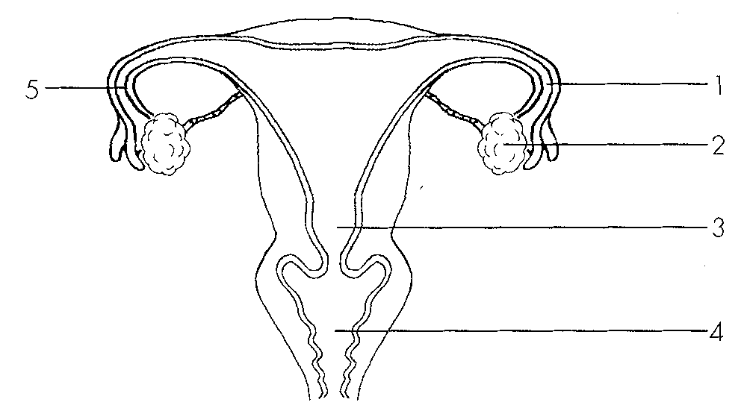
A. (1) and (2) only B. (1) and (3) only C. (2) and (3) only D. (1), (2) and (3) Directions: Questions 87 to 89 refer to the female reproductive system below.
80. Intra uterine device should be placed at-
A. 1.
B. 2.
C. 3.
D. 4.
81. The site of action of contraceptive pills is mainly at
A. 1.
B. 2.
C. 3.
D. 4.
82. If the woman wants to achieve contraception by surgical method, where in the reproductive system should be cut and tied?
A. 1
B. 1 and 4
C. 1 and 5
D. 4 and 5
83. Which of the following will not happen after the surgery of vasectomy?
A. Production of sperm
B. Production of male sex hormone
C. Ejaculation
D. fertilisation
84. Which of the following is/are the consequence(s) of vasectomy? (1) Loss of ejaculation (2) Accumulation of sperm (3) Loss of secondary sexual characteristics
A. (1) and (2) only
B. (1) and (3) only
C. (2) and (3) only
D. None of the above
85. The use of intra uterine device can achieve contraception because it-
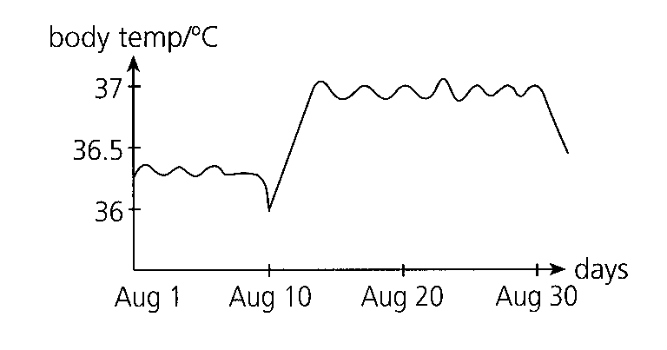
A. reduces the chance of implantation. B. prevents fertilisation.
C. inhibits ovulation. D. hinders sperm mobility. Directions: Questions: 93 to 95 refer to the graph below which shows the record of body temperatures of a woman measured in the morning over one
86. The advantage of measuring body temperature in the morning is that
A. if you forget to measure, you still have the chance to measure it later in the day.
B. it is the lowest temperature in the day.
C. it is the highest temperature in the day.
D. it minimizes the effect of air temperature on the measurement.
87. What is happening on August 10?
A. The woman is getting a fever.
B. The woman is doing exercise in the morning.
C. The woman is ovulating.
D. The woman is menstruating.
88. Which period of time is the safe period for contraception?
A. August 1 to August 10 B. August 10 to August 20
C. August 10 to August 30 D. August 20 to August 30
89. Which of the following correctly compares condom with diaphragm?
 | Condom | Diaphragm
A. | higher failure rate | lower failure rate
B. | as a barrier to sperm | as a barrier to ovum
C. | used once only | used more than one time
D. | used with spermicide | not used with spermicide

90. Which of the following matchings is incorrect?
 | Biological principles | Contraceptive methods
A. | natural (rhythm) | absence of ovum
B. | contraceptive pills | hinders implantation
C. | condom | as a barrier to sperm
D. | vasectomy | absence of sperm in semen

91. Which of the following methods of contraception allows fertilisation to occur?
A. Intrauterine device-B. Contraceptive pills C. Tubal ligature D. Diaphragm
92. Which of the following statements about contraceptive methods is incorrect?
A. Contraceptive pills contain female sex hormones which inhibit ovulation.
B. Diaphragm is placed at the cervix.
C. Condom can also prevent sexually transmitted diseases.
D. Safe period can be worked out more easily from the day of ovulation.
93. Which of the following will be prevented by tubal ligature? (1) Ovulation (2) fertilisation (3) Menstruation
A. (2) only
B. (1) and (2) only
C. (1) and (3) only
D. (2) and (3) only
94. Which of the following contraceptive methods has the highest failure rate? A. Contraceptive pills D. Vasectomy 102.Growth in an organism is the permanent increase in (1) height. (2) weight. (3) complexity. B. (1) and (2) onlyC. (1) and (3) only D. (2) and (3) only
B. Natural method
C. Tubal ligature
D. Vasectomy 102.Growth in an organism is the permanent increase in (1) height. (2) weight. (3) complexity.
A. (1) only
95. Which of the following contribute to the growth of an organism? (1) Cell division(2) Cell expansion (3) Cell differentiation
A. (1) and (2) only
B. (1) and (3) only
C. (2) and (3) only
D. (1), (2) and (3)
96. Development in an organism is the permanent increase in (1) height. (2) weight. (3) the number of cell types.
A. (3) only
B. (1) and (2) only
C. (1) and (3) only
D. (2) and (3) only
97. Which of the following contribute(s) to the development of an organism? (1) Cell division(2) Cell expansion (3) Cell differentiation A.(3) only
A. (3) only
B. (1) and (2) only
C. (1) and (3) only
D. (2) and (3) only
98. Which of the following parameters can be used to measure growth in plants? (1) Height (2) Width (3) Dry mass
A. (1) and (2) only
B. (1) and (3) only
C. (2) and (3) only
D. (1), (2) and (3)
99. Which of the following parameters can be used to measure growth in man?
(1) Length of the middle finger (2) Fresh weight (3) Dry weight
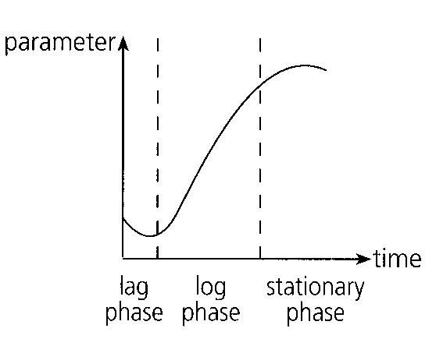
A. (1) and (2) only B. (1) and (3) only C. (2) and (3) only D. (1), (2) and (3) Directions: Questions 108 to 110 refer to the following graph which shows the growth curve of a plant from a seed to a mature plant.
100. The parameter used for the measurement of growth in this experiment is probably
A. height.
B. circumference.
C. fresh mass.
D. dry mass.
101. Which of the following can explain the negative growth during the lag phase of the growth curve? (1)There is net release of carbon dioxide during the lag phase. (2)There is net absorption of water during the lag phase. (3)There is net consumption of food during the lag phase.
A. (3) only
B. (1) and (2) only
C. (1) and (3) only
D. (2) and (3) only
102. Which of the following contribute to the positive growth during the log phase of the growth curve?
(1) Cell division(2) Cell expansion (3) Cell differentiation
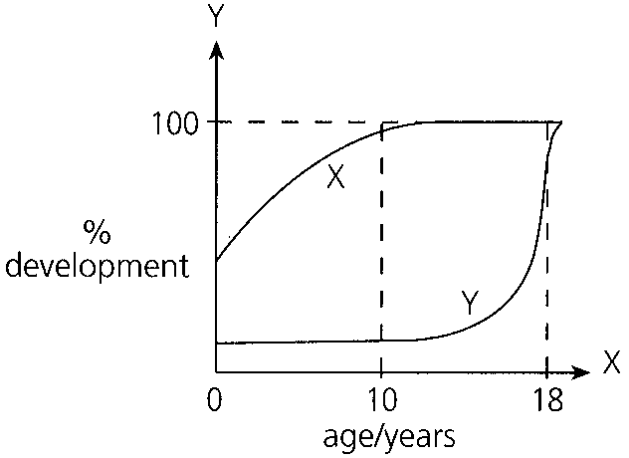
A. (1) and (2) only B. (1) and (3) only C. (2) and (3) only D. (1), (2) and (3) Directions: Questions 111 and 112 refer to the,, following graph which shows the percentage development of two systems in a human body.
103. Curves X and Y are probably representing:
 | X | Y
A. | digestive system | nervous system
B. | reproductive system | excretory system
C. | reproductive system | nervous system
D. | nervous system | reproductive system

104. Which of the following can be concluded from the graph?
(1) Different systems may become fully developed at different ages.
(2)Some systems are more developed than others at birth.
(3) Different systems are developing at the same rate.
Age groups | Average height (cm) of boys | Average height(cm) of girls
0-5 | 96 | 92
6-10 | 124 | 121
11-15 | 146 | 159
16-20 | 175 | 165

A. (1) and (2) only B. (1) and (3) only C. (2) and (3) only D. (1), (2) and (3) Directions: Questions 113 and 114 refer to the table below which shows the average height of boys and girls in different age groups.
105. The age group for puberty in boys and girls are respectively:
 | Boys | Girls
A. | 610 - | 05-
B. | 1115 - | 610-
C. | 1620 - | 1115-
D. | 1620- | 1620-

106. What conclusion can be drawn from the information in the table?
A. Puberty begins earlier in boys. B. Puberty begins earlier in girls.
C. Girls are initially taller than boys. D. Boys are eventually taller than girls.
107. The diagram below shows the proportions of different parts of a human body at four different stages of growth.
Which of the following statements about the diagram are correct?
(1)Comparing with other parts of the body, the head is most developed at birth.
(2)The trunk becomes shorter after birth.
(3)After birth, the limbs grow fastest.
A.(1) and (2) only B. (1) and (3) only C. (2) and (3) only D. (1), (2) and (3)
Directions: Questions: 116 to 118 refer to the following diagram which shows the longitudinal section of a dicotyledonous root.
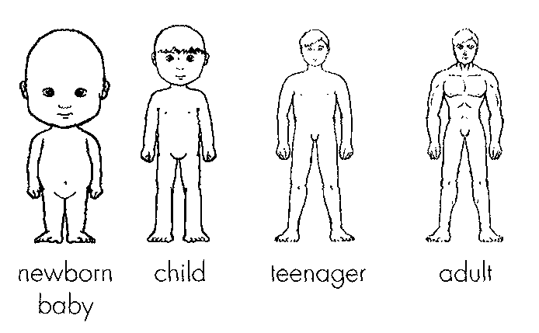
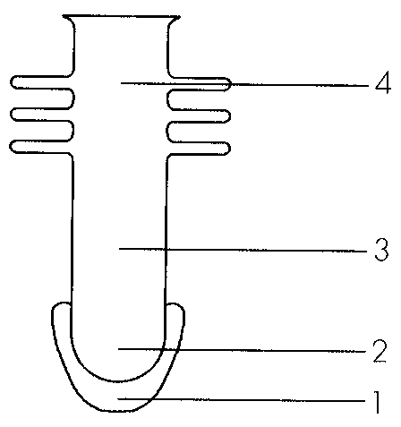
108. Which region(s) of the root contribute(s) most to its growth?
A. 1 only
B. 2 only
C. 3 only
D. 4 only
109. Which region of the root contributes most to its development?
A. 1
B. 2
C. 3
D. 4
110. Where do cell division and cell expansion occur in the root?
 | Cell division | Cell expansion
A. | 1 | 2
B. | 2 | 3
C. | 3 | 4
D. | 4 | 1

111. Which of the following is not a suitable parameter for measuring growth in man?
A. Length of nail B. Length of fingers C. Length of legs D. Length of arms Distractor
Part B — Reproduction in humans (YKTo)
112. Which of the following is the CORRECT sequence of processes in the human reproduction? (1) Gamete formation (2) Implantation (3) Sexual intercourse (4) fertilisation (5) Embryo development
A. (1),(4),(5),(3),(2)
B. (1),(3),(4),(2),(5)
C. (2),(5),(4),(1),(3)
D. (3),(4),(1),(5),(2)
113. One of the features accounts for the success of humans is having the young one developed within the uterus of the female. This is possible because
(1) a placenta is developed inside the uterus.
(2) of the presence of the well developed male external sex organ, the penis.
(3) of the presence of large egg which contains a large amount of nutrients to support the complete development of the foetus inside the uterus.
(4) the ovaries are present inside the abdominal cavity of the female body.
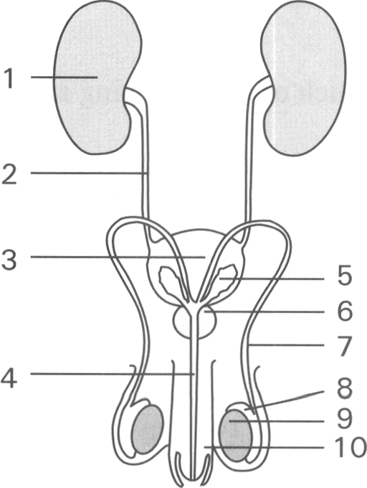
A. (1) only B. (4) only C. (1) and (2) only D. (1) and (3) only Directions: Questions 4 to 16 refer to the diagram below which shows the front view of the male reproductive system. 4Which of the following matching of structures is CORRECT?
114. | 4 | 7 | D. | Urethra | Sperm duct | Ureter 5Which structures are responsible for the production, storage and discharge of urine?
 | Production of urine | Storage of urine | Discharge of urine
A. | 1 | 2 | 3
B. | 1 | 3 | 4
C. | 3 | 6 | 4
D. | 8 | 7 | 4

A. | Ureter | Urethra | Sperm duct |
B. | Ureter | Sperm duct | Urethra |
C. | Urethra | Ureter | Sperm duct |
D. | Urethra | Sperm duct | Ureter 5Which structures are responsible for the production, storage and discharge of urine?
115. Which of the following CORRECTLY match the functions of structures labelled 6 ,8,9 and 10?
116. | 8 | 9 | 10 | C. | Production of seminal fluid | Passage of semen | Production of sperms | Discharge of urine | D. | Storage of sperms | Production of sex hormones | Storage of sex hormones | Discharge of semen 7Semen is mainly formed by the products /substances from C. 3 and 7 D. 8 and 9 8Which of the following are the functions of the structure labelled 9? (1) Produces sperms (2) Produces sex hormones (3) Produces urine (4) Produces seminal fluid A. (1) and (2) only B. (1) and (3) only C. (1) and (4) only D. (2) and (4) only
A. | Ejaculation of semen | Storage of sperms | Maturation of sperms | Production of sperms |
B. | Production of seminal fluid | Maturation of sperms | Production of sex hormones | Ejaculation of semen |
A. 1 and 3
B. 6 and 8
117. If structure 9 remains inside the abdomen, which of the following may occur?
A. No sperms are produced.
B. The sex hormones are denatured at the relatively high body temperature.
C. The sperms produced are inactivated at the relatively high body temperature.
D. Secondary sexual characteristics cannot properly develop.
118. The function of structure 7 is to
A. lead urine to the urinary bladder.
B. pass nerve impulses to the urinary bladder which contracts to expel urine out of the body.
C. lead sperms out of the body.
D. transport nutrients and oxygen to the bladder
119. If structure 7 at both sides of the body are cut and tied, which of the following is INCORRECT?
(1) No sperm is produced. (2) No semen is produced. (3) No sex hormone is produced.
A. (1) only B. (1) and (2) only C. (2) and (3) only D. All
120. Which structure(s) can greatly increase its (their) volume(s)?
A. 3 only
B. 10 only
C. 3 and 10 only
D. 1 and 3 only
121. The pathway of the sperms passing out of the body is D. 2 3 4 14 Structure 4 is the passage for (1) sperms. (2) urine. (3) seminal fluid. (4) male sex hormones. A. (1) and (2) only B. (1) and (3) only C. (1), (2) and (3) only D. (1), (2) and (4) only
A. 9 7 4
B. 2 7 4
C. 1 2 4
D. 2 3 4 14 Structure 4 is the passage for (1) sperms. (2) urine. (3) seminal fluid. (4) male sex hormones.
122. Which structure is essential to bring about the internal fertilisation in humans?
A. 3 only
B. 4 only
C. 6 only
D. 10 only
123. Which of the following is/are the function(s) of the structure labelled 5? (1) Storage of sperms (2) Storage of urine (3) Production of male sex hormones (4) Production of fluid to protect the sperms against the acidic condition of the urethra of man and the vagina of woman and to activate the sperms.
A. (1) only
B. (4) only
C. (1) and (2) only
D. (3) and (4) only
124. Which of the following comparisons between the functions of the penis of humans and the pollen tube of the flowering plant is INCORRECT?
Directions: Questions 18 to 24 refer to the diagrams below which show the male and female urinary and reproductive systems of humans.
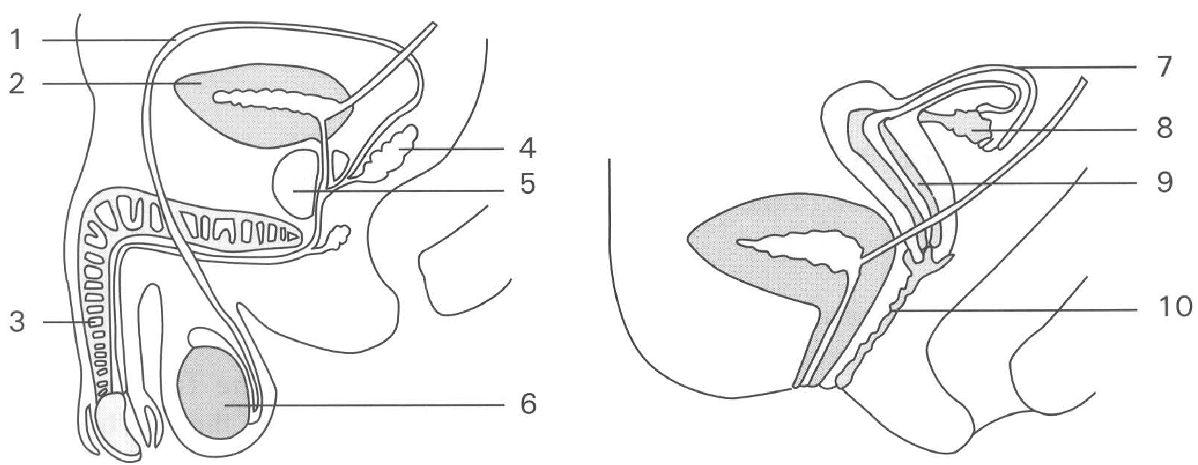
 | Penis of humans | Pollen tube of flowering plant
A. | Change in size by the change in blood pressure inside the blood vessels of the penis. | Change in size by growth.
B. | Ejaculates the male gametes to place where is still far away from the ovum inside the female body. | Delivers the male gametes close to the ovum by growing next to the ovule inside the ovary.
C. | Ejaculation of semen into the vagina of the female reproductive system. | Growth of the pollen tube inside the style of the female sex organ.
D. | Penis ejaculates millions of sperms in sexual intercourse to increase the chance of fertilisation. | Each pollen tube carries large number of male gametes close to the ovule to increase the chance of fertilisation.

125. Which of the following structures have similar functions in both the male and female reproductive systems?
 | Male reproductive system | Female reproductive system
A. | 3 | 7
B. | 1 | 10
C. | 2 | 9
D. | 6 | 8

126. Which structures produce haploid cells?
A. 2, 7
B. 3, 10
C. 4, 5
D. 6, 8
127. Which labelled structures secrete hormones? D. 2, 6, 9 21Which structures shows monthly changes in size under hormonal control? A. 4 B. 3 C. 6 D. 9
A. 4, 5, 6
B. 8, 9, 10
C. 6, 8, 9
D. 2, 6, 9 21Which structures shows monthly changes in size under hormonal control?
128. Which structure permits both reproductive cells and excretory wastes discharging out of the body? D.10
A. 1
B. 3
C. 7
D. 10
129. Which of the following methods provide permanent contraception?
A. Cut and tie structure 1 present on both sides of the body.
B. Wrap a condom around structure 3 during sexual intercourse.
C. Put an intra-uterine device in structure 9.
D. Put a diaphragm at top of structure 10.
130. Which of the following is TRUE if structure 7 at both sides of the body is cut and tied?
A. No ovulation occurs.
B. Artificial implantation cannot take place even if the embryos prepared by in vitro fertilisation are introduced into the uterus.
C. Sex hormones can still be produced.
D. No urination occurs.
131. The following are reproductive structures of humans
(1) Vagina (2) Oviduct (3) Uterus (4) Sperm duct (5) Urethra (6) Epididymis
Sperms will swim through the above structures to fertilise the egg. Which of the following sequence is CORRECT?
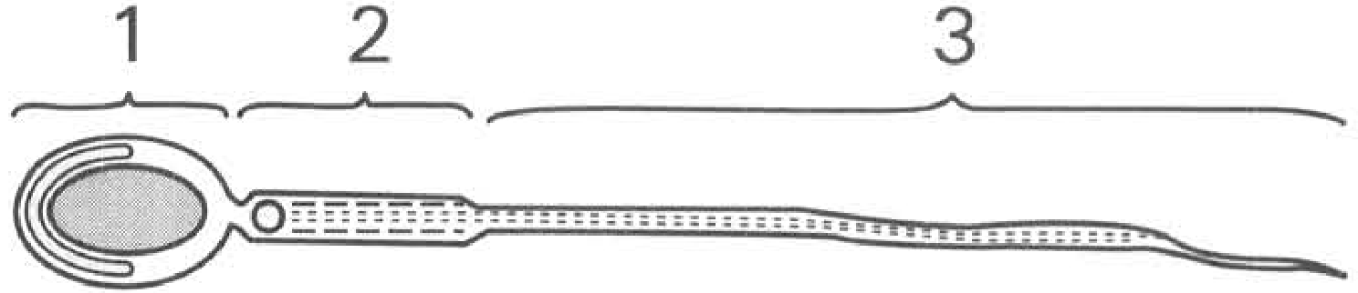
A. (1), (3), (2), (5), (6), (4) B. (6), (4), (5), (1), (3), (2)
C. (5), (4), (2), (1), (3), (6) D. (2), (3), (1), (5), (4), (6) Directions: Questions 26 and 27 refer to the following diagram which shows the structure of a sperm.
132. Which of the following combinations TRULY represents the functions of the labelled parts of the sperm?
133. | 2 | 3 |
A. | Transmits genetic information | Protein synthesis | Provides energy for swimming |
B. | Provides energy for swimming | Transmits genetic information | Swimming |
C. | Swimming | Protein synthesis | Provides energy for swimming |
D. | Transmits genetic information | Provides energy for swimming | swimming
134. The sperm is similar to the male gamete of a flowering plant by both of them
A. moving actively towards the ovum.
B. possessing mitochondria to release energy to support their movement.
C. bearing haploid number of chromosomes.
D. fusing with the ovum inside the ovary.
135. Animals usually produce a large number of sperms. It is an adaptation to
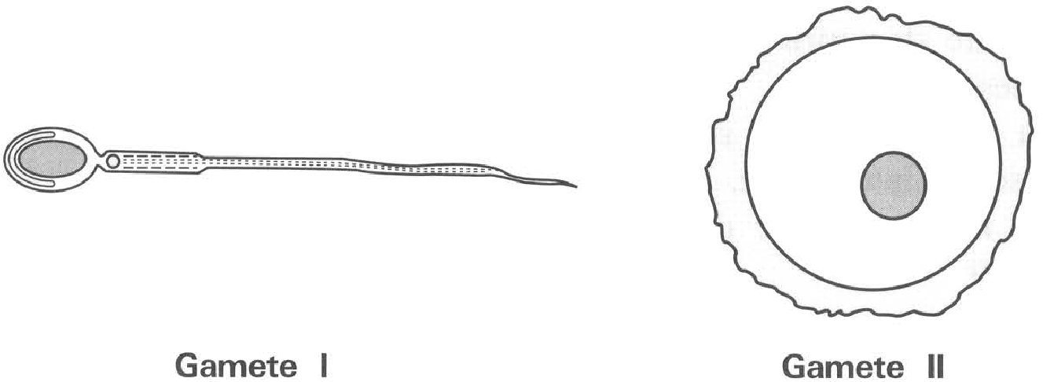
A. increase the chance of fertilizing the egg.
B. provide more vigorous offspring.
C. provide more food reserves for supporting the development of the zygote to the embryo.
D. transmit more genetic materials to the offspring. Directions: Question 29 and 30 refer to the diagrams below which show too different gametes of humans .
136. Which of the following comparisons between these two types of gametes of humans are CORRECT?
 | Gamete I | Gamete II
(1) | The sex chromosome must be Y chromosome | The sex chromosome must be X chromosome
(2) | Both have haploid number of chromosomes
(3) | Both can undergo meiosis
(4) | Move actively | Move passively

A. (1) and (2) only
B. (1) and (3) only
C. (1),(2) and (4) only
D. (2) and (4) only
137. In humans gamete II is much bigger than gamete I because it
A. contains more food reserve.
B. contains more chromosomes.
C. contains more mitochondria.
D. dose not need to move away from the ovary.
138. Which of the following comparisons between the production of gametes in men and women is INCORRECT?
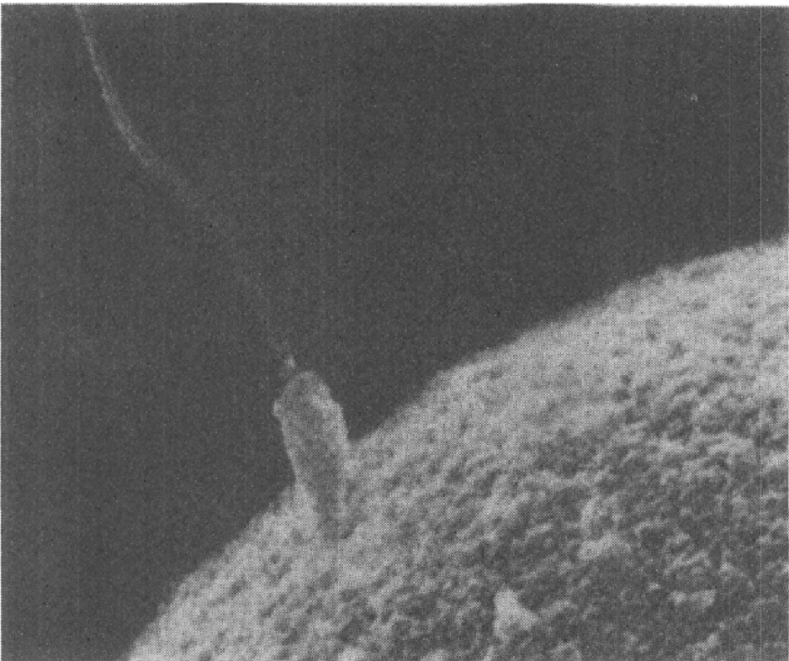
 | Men | Women
(1) | The production of gametes in both is under the influence of hormones.
(2) | Both start to produce gametes at puberty.
(3) | Both stop to produce gametes between ages of 45-55.
(4) | It occurs once a week. | It occurs once a month.

A. (1) and (2) only B. (2) and (3) only C. (3) and (4) only D. (4) and (1) only Directions: Questions 32 to 34 refer to the photomicrograph below which shows a sperm and an ovum. 32What biological process is going to take place?
A. Implantation B. Abortion
C. fertilisation D. Embryo development 33Where will the biological process shown in the photomicrograph take place inside the female body?
A. Ovary B. Oviduct C. Uterus D. Vagina
139. Which of the following statements about the biological process illustraed in the photomicrograph is TRUE?
A. Usually several sperms can penetrate into the ovum.
B. The ovum is bigger because it has more genetic material for the development of the embryo.
C. The process is takign place inside the ovary.
D. Both ovum and sperm are produced by meiosis.
140. Humans produce relatively few viable eggs. Each egg mother cell undergoes two consecutive divisions to produce four daughter cells of which only one remains viable as the egg while the other three degenerate. The number of chromosomes in this viable egg is
A. Four times that in the egg mother cell.
B. Twice of that in the egg mother cell.
C. Equal to that in the egg mother cell.
D. Half of that in the egg mother cell.
141. A zygote is different from an ovum in that it has
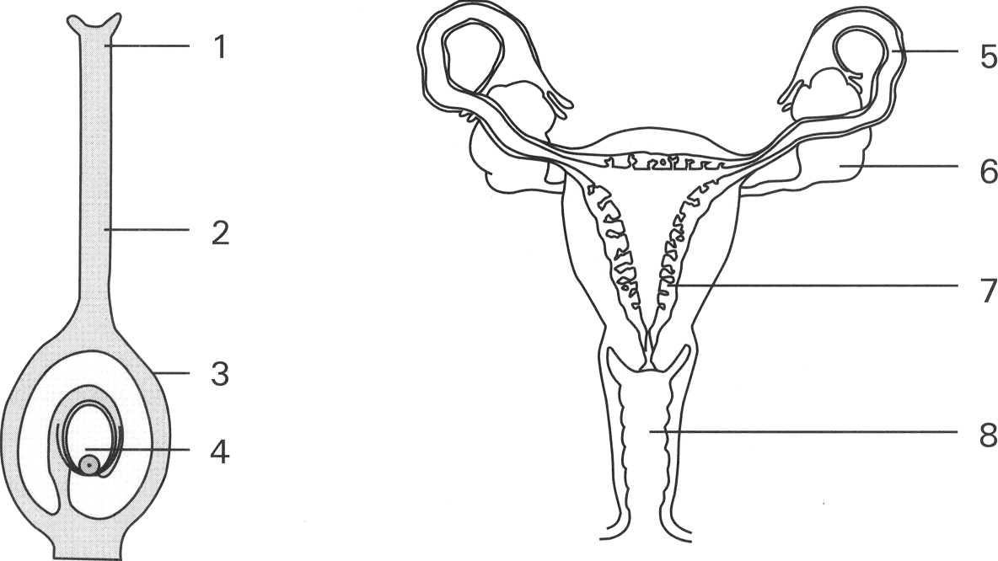
A. replicated its chromosomes. B. more cytoplasm.
C. two nuclei while ovum has one nucleus only
D. diploid number of chromosomes while the ovum is haploid Directions: Questions 37 and 38 refer to the diagrams below which show the carpel of a flowering plant and the female reproductive system of humans.
142. Which of the following comparisons between the structures of the carpel and the female reproductive system is CORRECT?
A. Meiosis takes place inside structures 4 and 6.
B. fertilisation takes place at structures 1 and 8.
C. Structures 3 and 7 supply nutrients for the development of the embryo.
D. Structures 3 and 5 increase greatly in size after fertilisation occurs.
143. Which parts may enlarge greatly after fertilisation has occurred?
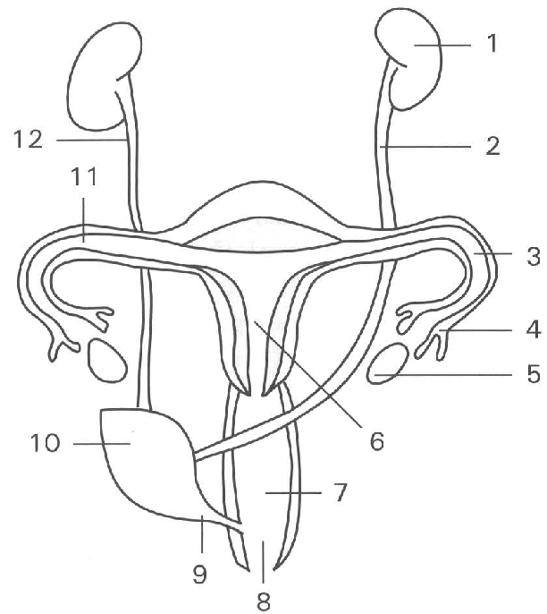
A. 2 and 8 B. 3 and 7 C. 4 and 6 D. 2 and 5 Directions: Questions 39 to 47 refer to the diagram below which shows the urinogenital system of a woman.
144. Which structure is also known as the 'birth canal'?
A. 2 only
B. 3 only
C. 6 only
D. 7 only
145. Urine is stored in
A. 1 only
B. 6 only
C. 7 only
D. 10 only
146. Which of the following statements about the products of the structure labelled 5 and that of the flowering plant is/are CORRECT? (1) Both are fertilised at the site of production. (2) Both are produced by meiosis. (3) Both can move about by themselves. (4) Both develop on the sites of production after fertilisation.
A. (2) only
B. (2) and (3) only
C. (3) and (4) only
D. (1), (2) and (4) only
147. At what age range does structure 5 remain functioning ? A. Age 6 to 12 B. Age 12 to 18 C. Age 14 to 55 D. Age 55 to 70 43Fertilization of the egg usually takes place in
A. 3
B. 4
C. 5
D. 6
148. The shaded part is a physiological change of a woman prepared for
A. copulation.
B. implantation.
C. fertilisation.
D. menstruation.
149. The woman will probably be in this physiological state when she is at time (1) menstruation just starts. (2) during ovulation. (3) in the fourth month of pregnancy.
A. (1) only
B. (2) only
C. (3) only
D. (1), (2) and (3)
150. If the tubes labelled 2 and 12 were ligatured, which of the following statements is/are INCORRECT? (1) Structure 5 would enlarge. (2) Structure 10 would enlarge. (3) No urine would be produced. (4) No fertilisation occurs.
A. (1) only
B. (2) only
C. (3) only
D. (1), (2), (3) and (4)
151. Which of the following comparisons between humans and flowering plants is CORRECT?
A. Both produce large number of male gametes.
B. Both have their embryos developed inside the female bodies.
C. The delivery of the male gametes into the female bodies depends on external agents.
D. The genetic variations brought about by the sexual reproduction in humans are greater than that by flowering plants.
152. Which of the following are the functions of the ovaries in women? (1) Produce egg cells (2) Produce female sex houmones (3) Produce lubricating fluid to enhance copulation (4) Form placenta to support the nutrition, excretion and gas exchange of the foetus
A. (1) and (2) only
B. (2) and (3) only
C. (3) and (4) only
D. (1), (2) and (4) only
153. Which of the following are the functions of the female sex hormones? (1) Control the development of the secondary sexual characteristics. (2) Control the occurrence of menstrual cycle (3) Maintain pregnancy (4) Maintain the exchange of substances between the maternal blood and foetal blood
A. (1) and (2) only
B. (2) and (3) only
C. (1), (2) and (3) only
D. (1), (3) and (4) only
154. Which of the following is/are the importance of fertilisation? (1) Retains the desirable characters of both parents (2) Restores the diploid number of chromosomes (3) Increases the genetic variations
A. (1) only
B. (2) only
C. (1) and (3) only
D. (2) and (3) only
155. In human females the ova are conveyed to the uterus along the
A. vagina.
B. oviduct.
C. ureter.
D. urethra.
156. Which of the following comparisons between the fertilisation in humans and flowering plants is TRUE?
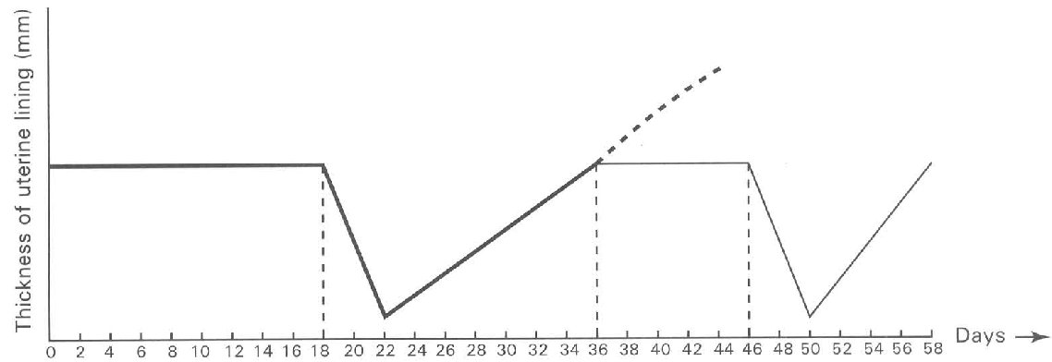
 | Humans | Floweing plants
(1) | Take place inside the female body.
(2) | The ovum is fertilised by the male gamete outside the ovary. | The ovum is fertilised by the male gamete inside the ovary.
(3) | Both male gametes move by themselves to fertilise the ova.

A. (1) only B. (2) only C. (3) only D. (1) and (2) only Directions: Questions 53 to 55 refer to the diagram below which shows the menstrual cycle of a human female.
157. Within the time period indicated in the diagram above menstruation occurs
A. once.
B. twice.
C. three times.
D. four times.
158. Ovulation takes place at
A. day 4 only.
B. day 14 only.
C. day 28 only.
D. days 4 and 32 only.
159. If the thickness of the uterine lining increases along the dotted line, it indicates that
A. sperms have entered the vagina.
B. an egg is released from the ovary.
C. hormone is secreted from the oviduct.
D. a fertilised egg has implanted in the uteirne wall.
160. Which of the following controls the menstrual cycle in human females?
A. Hormones released from the ovary.
B. Maturity of the mammary gland.
C. Nerve impulses generated in the spinal cord.
D. Ovulation (release of eggs from the ovary).
161. The onset of each menstrual cycle in a sexually mature human female begins
Sunday | Monday | Tuesday | Wednesday | Thursday | Friday | Saturday
1 | 2 | 3 | 4 | 5 | 6 | 7
8 | 9 | 10 | 11 | 12 | 13 | 14
15 | 16 | 17 | 18 | 19 | 20 | 21
22 | 23 | 24 | 25 | 26 | 27 | 28
29 | 30 | 31

A. at time of ovulation(release of eggs from the ovary).
B. on the last day of each month.
C. when the thickened uterine lining begins to break down.
D. after the fertilised egg has implanted on the uterine lining. Directions: Questions 58 to 60 refer to the following calendar which shows the month of January 2012. A woman has regular menstruation and the last one started on 31st December 2011 and lasted for 4 days.
162. According to the rhythm method of contraception which of the following period should the woman avoid sexual intercourse in order to prevent having pregnancy?
A. 4th to 1lth January
B. 12th to 18th January
C. 19th to 25th January1st
D. 1st to 4th February
163. If this woman is pregnant in spite of avoiding sexual intercourse in the above-suggested period, which of the following event will occur?
A. Menstruation will start on lst February.
B. Ovulation will take place on 14th February.
C. The uterine lining will continue its thickening.
D. The mammary glands will begin to secrete milk to nourish the embryo.
164. Even the woman follows the suggestion of avoiding sexual intercourse in the above period, she still gets pregnancy.
Which of the following is unlikely to be the reason for the failure of the rhythm method?
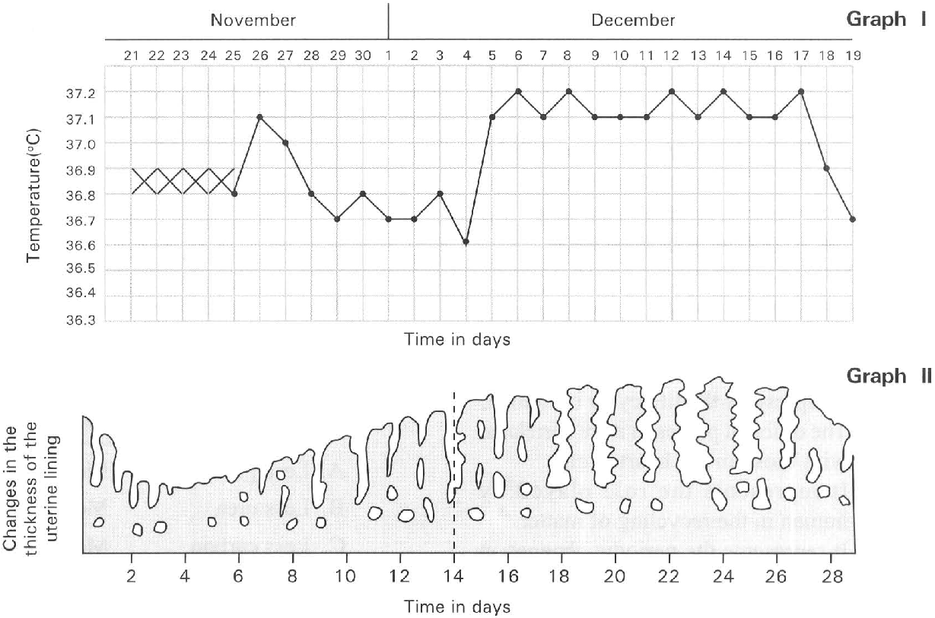
A. The timing of ovulation is not so accurately to take place on the 14th day after the start of the menstruation.
B. The length of the menstrual cycle may be affected by many other factors such as stress in life.
C. Several ova may be released from the two ovaries at different time of the menstrual cycle.
D. The life span of the sperms ejaculated into the vagina of the women is extremely long that can last for nearly a whole month. Directions: Questions 61 and 62 refer to the following graphs. Graph I shows the record of the oral temperature of a woman taken every morning for one month and Graph II shows the changes in the thickness of the uterine lining in the same period 61Which of the following most likely occurs in the period stated?
A. Ovulation occurs from 21st to 25th November.
B. Higher chance for pregnancy to occur if sexual intercourse takes place from 4th to 11th December.
C. Menstruation begins on 24th Novmeber.
D. Implantation most likely occurs on the 28th December.
165. The above record of the oral temperature of this woman is used
A. to find the best time to reduce weight in the month.
B. to find the best itme of using condum or diaphragm to achieve contraception.
C. to find the best time to avoid sexual intercourse in order to achieve contraception.
D. to reduce the monthly discomfort by taking leave in advance.
166. The greatest chance for the human egg to be fertilised is by having copulation at
A. the beginning of the menstrual flow.
B. the end of the menstrual flow.
C. two weeks after menstrual flow.
D. the end of the menstrual cycle.
167. Which of the following statements about the menstrual cycle is CORRECT?
A. It represents the life cycle of human.
B. The different phases in it are correlated with those in the heart cycle.
C. It represents the role played by human in the recycling of matter.
D. It represents the periodic changes in certain physiological activities of a sexually mature woman.
168. Which of the following process(es) will stop during pregnancy?
(1) ovulation (2) menstruation (3) production of female sex hormones by ovaries
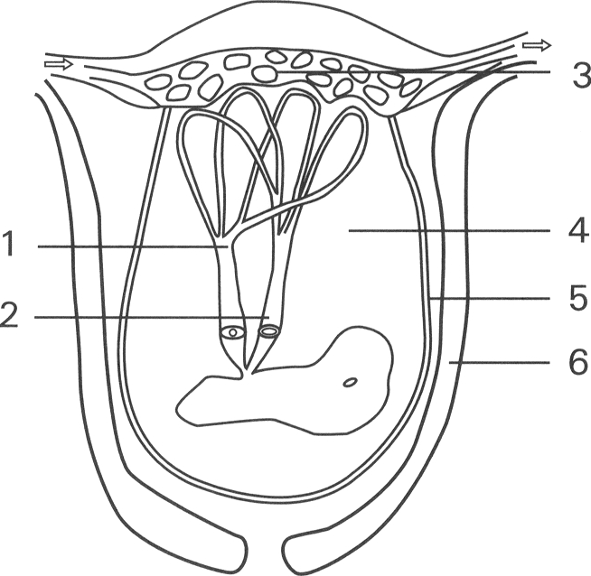
A. (1) and (2) only B. (2) and (3) only C. (1) and (3) only D. (1), (2) and (3) Directions: Questions 66 to 70 refer to the diagram below which shows the structure linked to the foetus.
169. Which of the following comparisons between the blood vessels labelled 1 and 2 is CORRECT?
 | Blood vessel 1 | Blood vessel 2
A. | Less glucose | More glucose
B. | Less urea | More urea
C. | Less carbon dioxide | More carbon dioxide
D. | More oxygen | Less oxygen

170. Which of the following parts has the CORRECT function?
 | Part | Function
A. | 3 | To increase the surface area for promoting the circulation of blood from the mother to the foetus
B. | 4 | To provide a moist medium for the foetus to absorb oxygen from its surrounding fluid
C. | 5 | To contract for expeling the foetus out during birth
D. | 6 | To provide protection against mechanical injury to the foetus

171. Which two labelled parts have the same genetic makeup?
A. 1 and 3 only
B. 2 and 5 only
C. 3 and 5 only
D. 5 and 6 only
172. Which parts will be expelled from the mother's body after the baby is born?
A. (1) and (2) only B. (3) and (6) only C. (5) and (6) only D. (1), (2), (3) and (5) only 70Which of the following combinations is CORRECT?
173. | 2 | 5 | 6 | A. Umbilical artery | Umbilical vein | Amnion | Uterine wall | B. Umbilical artery | Umbilical vein | Uterine wall | Amnion | C. Umbilical vein | Umbilical artery | Amnion | Uterine wall | D. Umbilical vein | Umbilical artery | Uterine wall | Amnion
174. Which of the following substances do not pass from the maternal blood through the placenta into the foetus? (1) White blood cells (2) Alcohol (3) Antibodies (4) Red blood cells (5) Nicotine
A. 4 only
B. 1, 3 and 4 only
C. l, 3 and 5 only
D. 1, 2, 4 and 5 only
175. Which of the following substance(s) do(es) a pregnant mother receive from the placenta? (1) Carbon dioxide (2) Glucose (3) Urea (4) Amino acid
A. (1) only
B. (2) only
C. (1) and (3) only
D. (1) and (4) only
176. Which of the following are adaptaions of the placenta for the exchange of materials between the maternal blood and the foetal blood? (1) Many finger-like projections from the foetal membranes (2) The foetal blood and maternal blood in the placenta are separated by thin membrane only (3) Production of sex hormones
A. (1) and (2) only
B. (2) and (3) only
C. (1) and (3) only
D. (1), (2) and (3)
177. Which of the following is a function of the placenta?
A. It protects the foetus from fluctuation of temperature.
B. It enhances the passage of the maternal blood into the foetal blood.
C. It permits the exchange of diffusible substances between the mother and the foetus.
D. It provides the propulsive force to expel the foetus out during birth.
178. Which of the following related with the development of a human foetus is INCORRECT?
A. The mammary glands secrete milk to nourish the foetus.
B. The umbilical cord provides the channel to transport substances between the foetus and the placenta.
C. The foetus is protected by the foetal membranes.
D. The uterus enlarges continuously to accommodate the growing foetus.
179. The moist thin membrane surronding the foetus is called
A. placenta.
B. uterine lining.
C. amnion.
D. fertilisation membrane.
180. The human foetus baths in the amniotic fluid inside the amniotic cavity. This fluid
(1) acts as a protective cushion which absorbs shock.
(2) acts as a medium through which the exchange of materials takes place between the foetus and the mother.
(3) permits the foetus to have certain degree of movement.
(4) prevents the amniotic membrane from sticking to the developing foetus.
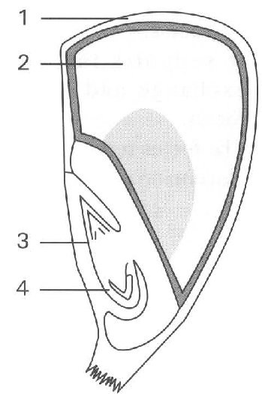
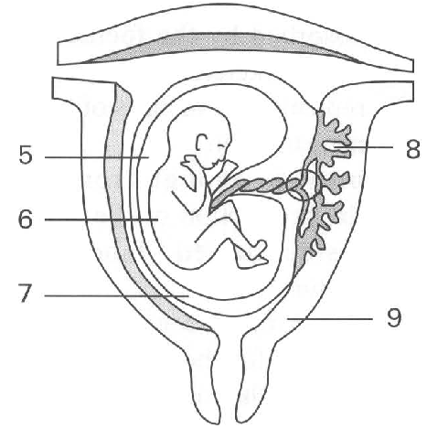
A. (1) only B. (3) only C. (1) and (2) only D. (1), (3) and (4) only Directions: Questions 78 to 84 refer to the diagrams below which show the longitudinal section of a grain and the enlarged uterus of a pregnant woman.
181. Which labelled parts of the grain develops from a fertilised ovum?
A. 2 only
B. 3 only
C. 4 only
D. 3 and 4 only
182. Which of the following substances is/ are stored in the grain ? (1) Oil (2) Glycogen (3) Starch
A. 1 only
B. 2 only
C. 3 only
D. 1 and 3 only
183. Which of the following parts carry out meiotic cell division?
A. 1 and 7 only
B. 2 and 7 only
C. 3 and 6 only
D. None of the above
184. Which of the following are NOT the functions of the fluid labelled 5 during pregnancy? (1) It permits the foetus to move its limbs. (2) It provides a stable environment for the foetus to develop. (3) It supplies nutrients to support the development of the foetus. (4) Its stores the metabolic wastes released by the foetus. D. (4) and (1) only 82 Structures 3 and 4 can develop into a future plant. Which of the enlarged uterus of a pregnant woman is comparable to structures 3 and 4 ? A. 6 B. 8 C. 6 and 7 D. 6 and 8
A. (1) and (2) only
B. (2) and (3) only
C. (3) and (4) only
D. (4) and (1) only 82 Structures 3 and 4 can develop into a future plant. Which of the enlarged uterus of a pregnant woman is comparable to structures 3 and 4 ?
185. Which labelled part of the grain has function comparable to structure 8 of the uterus of the woman ? D. 4 84 Structure 9 is genetically different from structure 6. Which labelled part of the grain is genetically different from structure 4? only only only D. 1 and 2 only
A. 1
B. 2
C. 3
D. 4 84 Structure 9 is genetically different from structure 6. Which labelled part of the grain is genetically different from structure 4?
186. Arrange the following events in CORRECT sequence from the time of fertilisation until the baby is born. (1) Implantation on the uterine lining. (2) Zygote undergoes mitotic cell division to form a ball of cells. (3) Contraction of the abdominal muscles and the uterine wall expel the foetus out. (4) Formation of the placenta supports the nutrition, gas exchange and excretion of the foetus.
A. (1), (3),(4),(2)
B. (2),(1),(4),(3)
C. (3),(1),(2),(4)
D. (4),(3),(2),(1)
187. Which of the following statements about the placenta is TRUE?
A. It s formed by the tissues of the mother only.
B. It prevents the harmful chemicals to pass from the maternal blood into the foetus.
C. It supports the nutrition, gas exchange and excretion of the foetus.
D. The foetus receives milk through the placenta to get nutrients.
188. Doctors may prescribe iron supplement to some women during their pregnancy. The reason is to
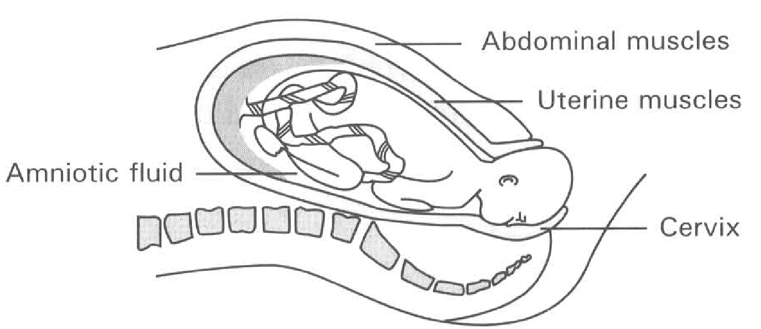
A. replenish for the iron that has been absorbed by the foetus to develop his/her skeleton.
B. replenish for the loss of blood during menstruation.
C. provide enough iron to support the production of the haemoglobin inside the red blood cells of the foetus.
D. to maintain a continuous supply of iron for the secretion of milk to nourish the foetus. Directions: Question 88 refers to the diagram below which shows the process of birth.
189. Which of the following helps the foetus to come out of the mother's body during birth? (1) Contraction of the abdominal muscles. (2) Contraction of the uterine wall. (3) Bursting of the amnion releases the amniotic fluid. (4) Dilation of the cervix.
A. (1) and (2) only
B. (2) and (3) only
C. (3) and (4) only
D. (1), (2), (3) and (4)
190. Which of the following can affect the body mass of the foetus during its development? (1) The genotype of the mother. (2) The genotype of the father. (3) The diet of the mother. (4) The mother is a smoker during pregnancy.
A. (1) only
B. (2) only
C. (3) and (4) only
D. (1), (2), (3) and (4)
191. Which of the following components of food should be increased in amount in the diet of a pregnant woman? (1) Iodine (2) Fluorine (3) Calcium (4) Protein (5) Fat
A. (1) and (2) only
B. (2) and (3) only
C. (3) and (4) only
D. (4) and (5) only
192. Arrange the following processes concerned with the birth of a human foetus in the CORRECT order? (1) Contraction of the uterine muscles and abdominal muscles (2) Cutting and tying of the umbilical cord (3) Dilation of the cervix (4) Breaking of the amnion and flowing out of the amniotic fluid (5) Shedding of the placenta (6) Expulsion of the foetus head first through the cervix
A. (1), (4), (3), (6), (5), (2)
B. (3), (1), (4), (5), (6), (2)
C. (1), (3), (6), (4), (5), (2)
D. (3), (1), (4), (6), (2), (5)
193. Which of the following about identical twins is/are CORRECT? (1) The outward appearance and behaviour of these twins are exactly the same. (2) Both twins are of the same sex. (3) Both twins have the exact life span.
A. (1) only
B. (2) only
C. (1) and (2) only
D. (2) and (3) only
194. Identical twins are formed by having
A. two different sperms fertilised two different eggs to form two embryos.
B. two different sperms fertilised one egg to form two embryos.
C. one sperm fertilised one egg to form one zygote which divides to form two embryos.
D. one sperm fertilised one egg to rorm two zygotes.
195. Which of the following about twins is CORRECT?
A. All twins must have the same sex.
B. All twins must be genetically identical.
C. Fraternal twins are formed by having two sperms fertilised two separate eggs.
D. Onece a woman has borned a pair of identical twins, she cannot give birth to fraternal twins in future.
196. Mothers are encouraged to give breastfeeding to their babies because- (1) breast-feeding provides intimate relationship between the mother and the baby. (2) mother's milk contains antibodies that provide passive immunity to the baby against diseases. (3) mother's milk provides a relatively balanced diet to the baby. (4) mother's milk contains enzymes to enhance digestion of food in the baby.
A. (1) and (2) only
B. (2) and (3) only
C. (3) and (4) Only
D. (1), (2) and (3) only
197. Which of the following about breast-feeding is INCORRECT?
A. This saves money to buy milk powder.
B. This saves the trouble of cleaning the milk bottles and their accessories.
C. This will not affect those women who have to leave home to work.
D. This increases the resistance of the babies to infection because of the presence of antibodies in the mother's milk.
198. Which of the following disadvantages for breast-feeding is/are NOT TRUE?
(1) Women have to give up their jobs and stay at home.
(2) Women over thirty years old cannot provide breast-feeding.
(3) Not all women are suitable to provide breast-feeding.
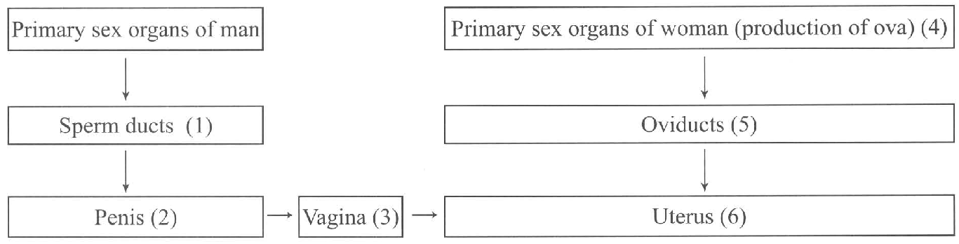
A. (1) only B. (2) only C. (1) and (2) only D. (2) and (3) only Directions: Questions 98 refers to the flowchart below which shows the major structures and events involved in the sexual reproduction of humans.
199. Which of the following combinations TRULY represents the contraceptive methods that can be used to achieve birth control?
 | (1), | (2) | (3) | (4) | (5) | (6)
A. | Cut and tie | Diaphragm | Condom | Rhythm method | Intrauterine device | Contraceptive pills
B. | Contraceptive pills | Condom | Intrauterine device | Rhythm method | Diaphragm | Cut and tie
C. | Cut and tie | Condom | Diaphragm | Contraceptive pills | Rhythm method | Intrauterine device
D. | Rhythm method | Diaphragm | Condom | Contraceptive pills | Cut and tie | Intrauterine device

200. Which of the following methods of birth control has the CORRECT description of its mechanism?
 | Method | Mechanism
A. | Condom | Stops the production of sperms
B. | Safety period (rhytm) | Prevents sperms to enter the oviduct
C. | Diaphragm | Prevents the production of eggs
D. | Intra-uterine device (IUD) | Prevents the fertilised eggs to implant on the uterine lining

201. The following are methods of birth control:
(1) Condom (2) Cut and tie the sex ducts (3) Timing of sexual intercourse in the menstrual cycle (4) Contraceptive pills (5) Diaphragm
Which of the following combinations of the categories of the methods of birth control is CORRECT?
 | Rhythm method | Hormonal method | Surgical method | Mechanical barrier method
A. | (1), (2) | (3) | (5) | (4)
B. | (3) | (4) | (2) | (1), (5)
C. | (3) | (4) | (2) | (1), (5)
D. | (4) | (3) | (1), (5) | (2)

202. Which of the following matching of the biological principles and the methods of birth control is CORRECT?
 | Prevents fusion of male gametes | Prevents implantation of zygote on the uterine lining | Prevents production of ova and female
A. | Condom | Diaphragm | Cut and tie sex ducts
B. | Rhythm method | Condom | Contraceptive pills
C. | Intra-uterine device | Contraceptive pills | Condom
D. | Cut and tie sex ducts | Intra-uterine device | Contraceptive pills

203. Which of the following contraceptive methods is INCORRECT? (1) Diaphragm prevents sperms passing through the sperm ducts to the urethra. (2) The rhythm method avoids the ejaculation of semen inside the uterus. (3) Contraceptive pills prevent the production of ova by the ovaries. (4) Intrauterine device prevents the implantation of embryo on the uterine lining.
A. (1) only
B. (2) only
C. (1) and (2) only
D. (3) and (4) only
204. Which of the following methods of birth control is most reliable?
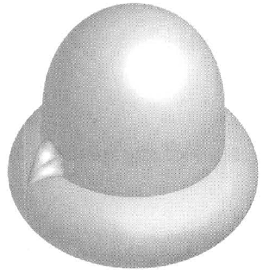
A. Contraceptive pill B. Condom or diaphragm
C. Intra-uterine device (IUD) D. Vesectomy or tubal ligation
205. The diagram below shows a device used for contraception.
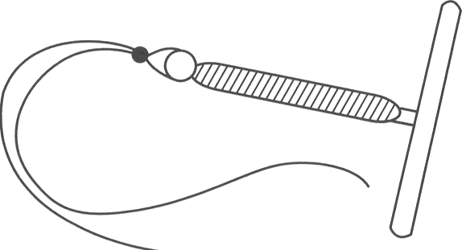
A. It prevents the ejaculation of semen in the vagina.
B. It prevents the sperms from passing through the cervix to the uterus.
C. It prevents the sperms from passing from the uterus into the oviduct.
D. It prevents the sperms from entering the ovary.
206. The followign diagram shows a device which is used for contraception in woman. What is the biological basis for this device to exert its conraceptive effect?
A. It prevents the release of ova from the ovary.
B. It reduces the thickening of the uterine lining.
C. It prevents the implantation of the embryo on the uterine lining.
D. It forms a physical barrier to prevent the sperms to meet the ovum.
207. Which of the following methods of birth control does not prevent the fusion of sperms and eggs?
A. Condon B. Diaphragm C. Intra-uterine device D. Vesectomy
208. Which of the following caused infertility in humans is/are NOT TRUE? (1) Blockage of the urethra in woman (2) Blockage of oviduct (3) Low sperm count (4) No ovulation
A. (1) only
B. (2) and (3) only
C. (3) and (4) only
D. (2), (3) and (4) only
Part C — Reproduction in flowering plants (YKTo)
209. The following events occur in the asexual reproduction of bacteria. Which is the CORRECT sequence? (1) Division of the genetic material into two groups to form two daughter nuclei. (2) Replication of genetic material. (3) Division of the cytoplasm into two portions with a cell wall formed between them. D. (2), (3), (1) 5Which of the following concerning binary fission is/are CORRECT? (1) It is a type of cell division to produce gametes. (2) It is commonly found in unicellular organisms. (3) It usually occurs under adverse condition. B. (2) only C. (3) only D. (1) and (2) only 6Which of the following comparisons between the binary fission of bacteria and seed formation of Hibiscus is CORRECT? 7Which of the following sets concerning the perennating organs is CORRECT? Directions: Questions 8 to 10 refer to the photographs below which show structure W and the aerial parts X,Y and Z produced by it.
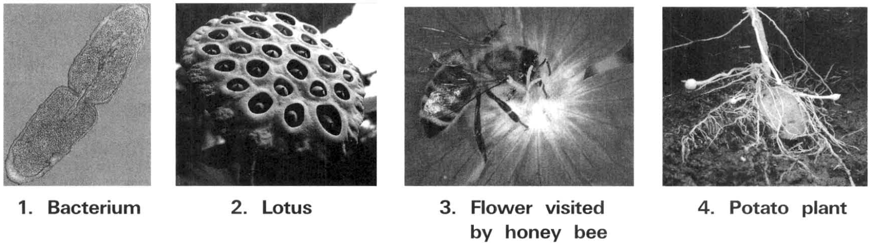
 | Binary fission of bacteria | Seed formation of Hibiscus
A. | It involves two sexes. | It involves one sex only.
B. | No gametes are needed. | Involves fusion of gametes.
C. | Offspring are genetically different from parents. | Offspring are genetically identical from parents.
D. | No replication of chromosomes. | Involves replication of chromosomes.

 | Perennating organ | Origin | Examples
A. | Rhizome | Underground root | Ginger
B. | Stem tuber | Root tip | Carrot
C. | Bulb | Condensed shoot | Onion
D. | Corm | Underground shoot | Potato

A. (2), (1), (3)
B. (3), (1), (2)
C. (1), (2), (3)
A. (1) only
210. Which labelled structure(s) contain(s) food reserve that enables the plant to go through adverse conditions?
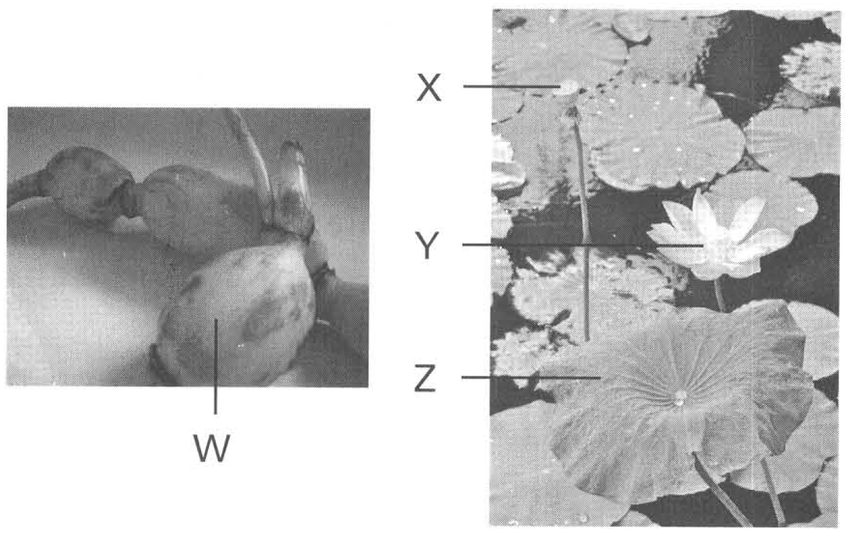
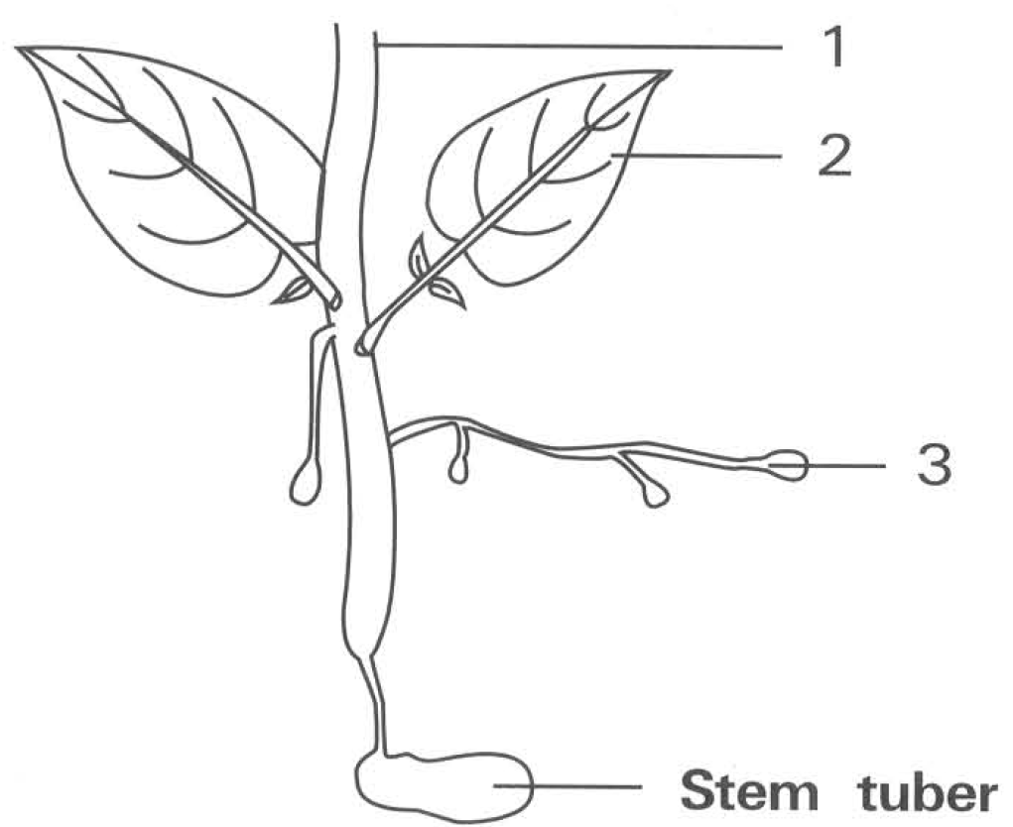
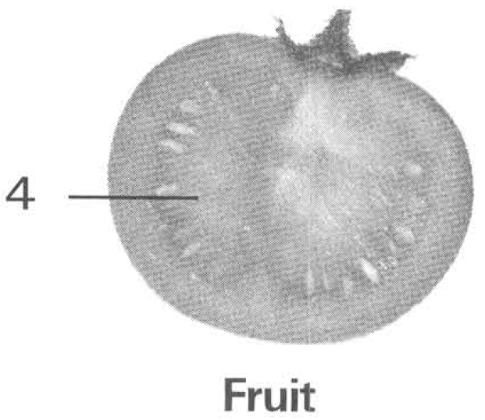
 | Structure W | Structure Y
(1) | Develops offspring without depending on external agent. | Develops offspring depending on external agent.
(2) | Produce genetic variations in offspring. | No genetic variations in offspring produced.
(3) | Avoids overcrowding by providing means of dispersal. | No means of dispersal to avoid overcrowding.

A. W only B. X only C. Y only D. W and X only 9Which labelled parts carry out meiosis?
A. W only B. X only C. Y only D. Z only 10 Structures W and Y carry out two different methods of reproduction. Which of the following comparisons between these two methods of reproduction is/are CORRECT?
A. (1) onlyB. (2) only C. (3) only D. (1) and (2) only Directions: Questions 11 to 13 refer to the diagram and photograph below which show an aerial shoot developing from a potato tuber and the fruit produced by it. 11Which labelled structure is genetically different from the parent tuber?
A. 1 B. 2 C. 3 D. 4
211. Which labelled structure(s) has/have food reserve that can support the development of future plants?
A. 1 only
B. 3 only
C. 4 only
D. 3 and 4 only
212. Farmers usually prefer to use structures labelled 3 rather than structure labelled 4 to produce daughter plants because of the following reason(s). (1) It can produce offspring in shorter time and is more secure because it has lots of food reserve to support its initial growth. (2) All desirable characteristics of the parent plant can be transmitted to the offspring. (3) There is smaller chance of passing infectious diseases to the offspring.
A. (1) only
B. (2) only
C. (3) only
D. (1) and (2) only
213. The following photographs show the vertical section of two structures produced by different methods of reproduction.
Structure X : TS of onion Structure Y : TS of a grain
Which of the following comparisons between the methods of reproduction represented by structures X and Y are INCORRECT?
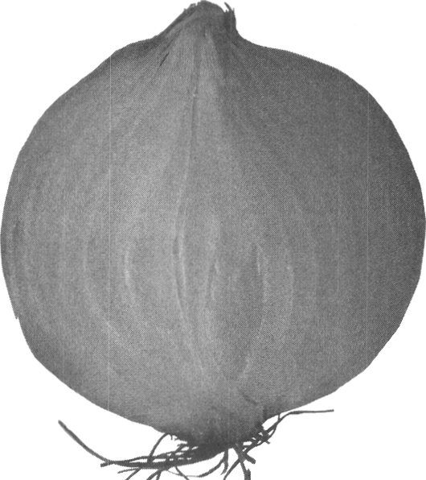
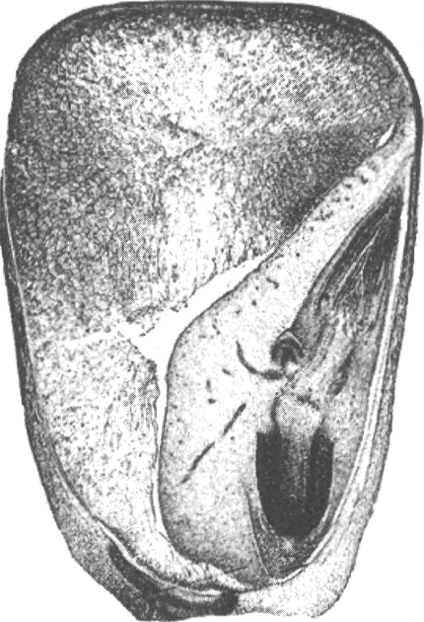
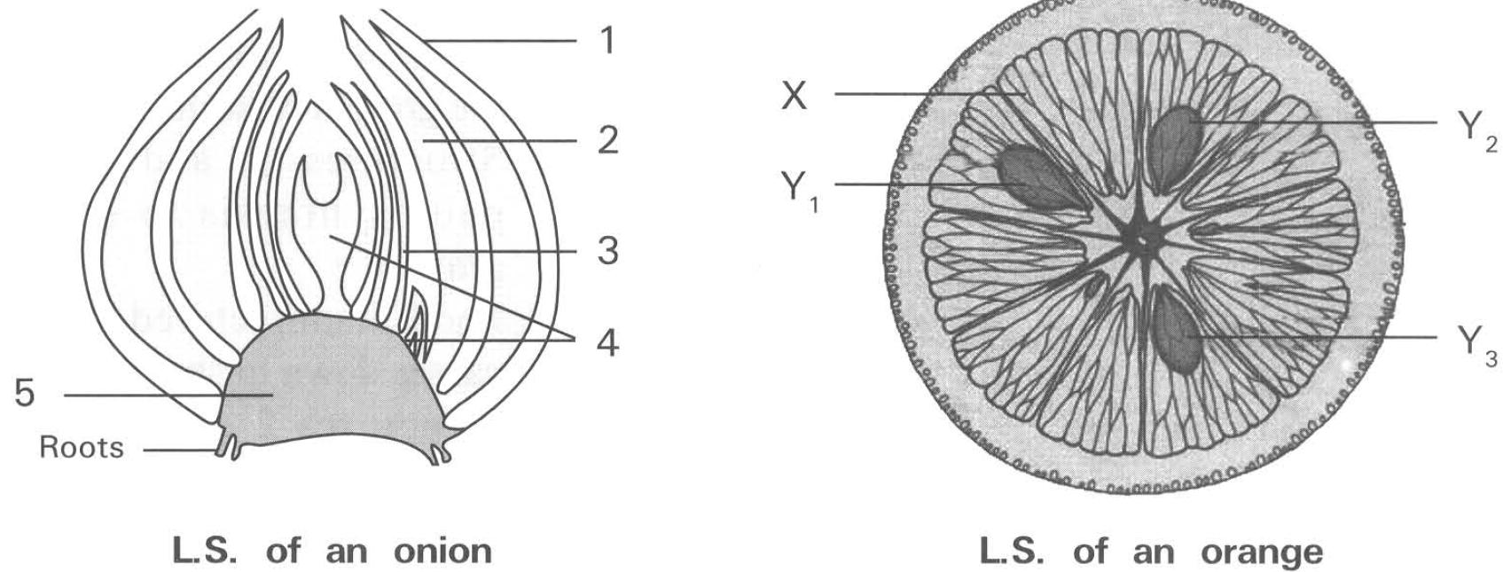
 | Structure X | Structure Y
(1) | All the offspring have diploid number of chromosomes. | Chromosome number of the cells in the offspring is half of that in the cells of the parent plant.
(2) | Lower chance of passing infective diseases to the offspring. | Higher chance of passing infective diseases to the offspring.
(3) | One parent plant is sufficient for its production. | It needs two parent plants for its production.
(4) | It doesn't need any gametes for its production. | It needs gametes for its production.

A. (1) and (2) onlyB. (2) and (3) only C. (3) and (4) only D. (1), (2) and (3) only Directions: Questions 15 and 16 refer to the diagrams below which show the L.S. of an onion bulb and the T.S. of an orange.
214. Which labelled parts of the onion bulb have the same function as parts X, Y1, Y2 and Y3 of the orange?
 | X | Y1, Y2 and Y3
A. | 2 | 3
B. | 3 | 2
C. | 3 | 5
D. | 2 | 4

215. Which of the following matching for the anion bulb is CORRECT?
216. | 2 | 3 | 4 | A. | Dry scale leave | Future foliage leaves | Fleshy scale leaves | Bulb | B. | Future foliage leaves | Fleshy scale leaves | Dry scale leaves | Primary root | C. | Dry scale leaves | Fleshy scale leaves | Future foliage leaves | Bulb | D. | Future foliage leaves | Fleshy scale leaves | Bud | Bulb
Directions: Questions 17 and 18 refer to the diagram below which shows a perennating organ in spring.
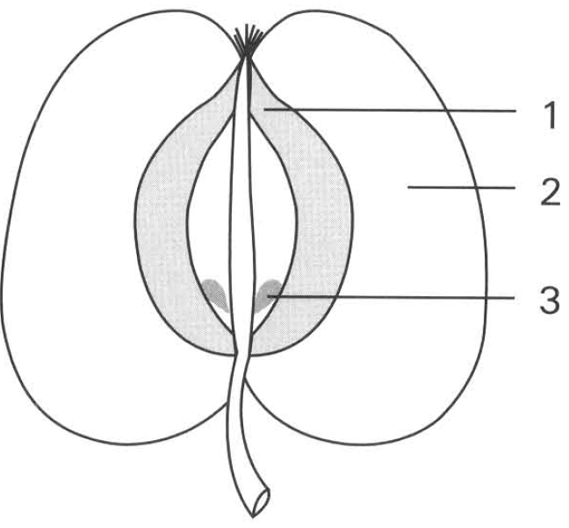
217. Which of the following is/are the function(s) of the structure labelled 3? (1) It provides food to support the initial growth of the aerial shoot under favourable environmental conditions. (2) It contains seeds to favour the dispersal of the species once this structure is eaten by animals. (3) It shrivels at the end of the growing season.
A. (1) only
B. (2) only
C. (3) only
D. (1) and (3) only
218. In late summer structures 2 and 4 will become much bigger. Which of the following are the probable explanations for such change?
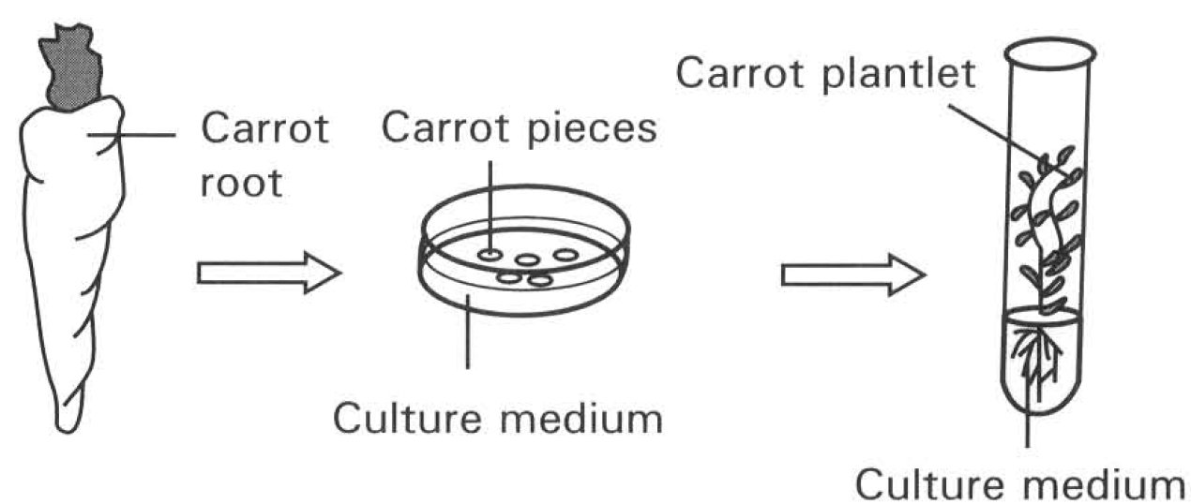
A. Food stored in structure 3 supports the growth of structures 2 and 4.
B. Structures 2 and 4 carry out photosynthesis to support their growth.
C. Food manufactured in structure 1 passes down to structures 2 and 4.
D. Structures 2 and 4 absorb food saprophytically from the surrounding soil. Directions: Questions 19 and 20 refer to the diagrams below which show a technique of producing large number of plants.
219. What type of biological process is illustrated by the diagrams?
A. Production of plants by seed formation B. Natural vegetative propagation
C. Tissue culture D. Binary fission
220. Which of the following are advantages of using this method to produce large number of plants? (1) It does not depend on external agents. (2) All desirable characteristics can be transmitted to offspring. (3) Produces genetic variations. (4) Saves space to reduce the problem of overcrowding.
A. (1) and (2) only
B. (2) and (3) only
C. (3) and (4) only
D. (4) and (1) only
221. Which of the following statements about cutting, an artificial propagation, are CORRECT?
(1) Only leaves can be used for this type of propagation.
(2) Buds are not essential for this type of propagation.
(3) The offspring are genetically identical.
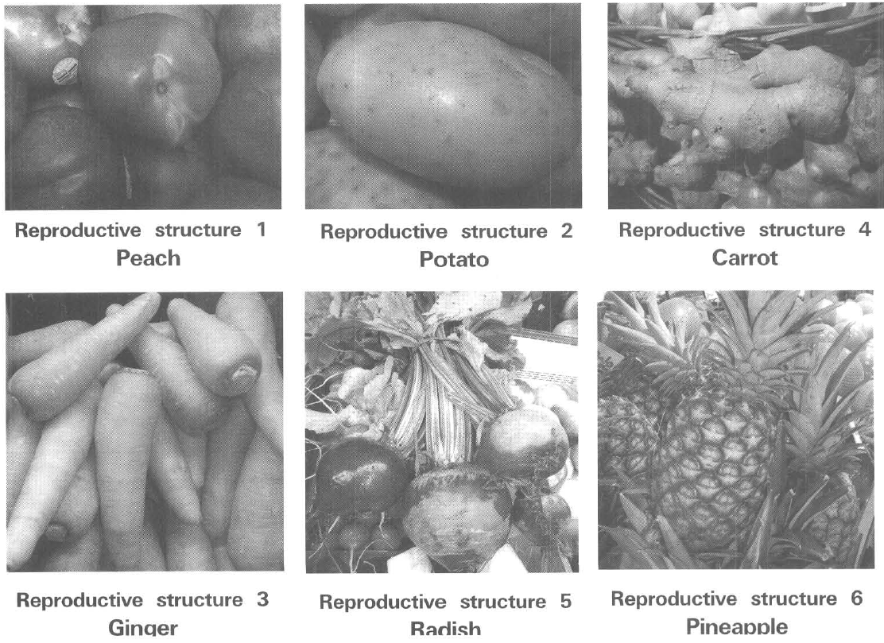
A. (1) and (2) only B. (2) and (3) only C. (1) and (3) only D. (1), (2) and (3) Directions: Questions 22 and 23 refer to the following photographs which show six different reproductive structures of flowering plants.
222. Which of these structures produce offspring by seeds development?
A. 1 and 2 only
B. 2 and 3 only
C. 4 and 5 only
D. 1 and 6 only
223. Which structures have the majority of their stored food reserved for the future development of their offspring? B. Sexual reproduction in flowering plants
A. 1, 2 and 3 only
B. 2, 3 and 4 only
C. 4, 5, 6 and 1 only
D. 2, 3, 4 and 5 only
224. Which of the following sequences of events about the sexual reproduction of a flowering plant is CORRECT?
(1) Meiosis in gamete formation (2) Growth of pollen tube through the style
(3) fertilisation (4) Pollination (5) Seed dispersal
(6) Mitosis in the growth of the embryo
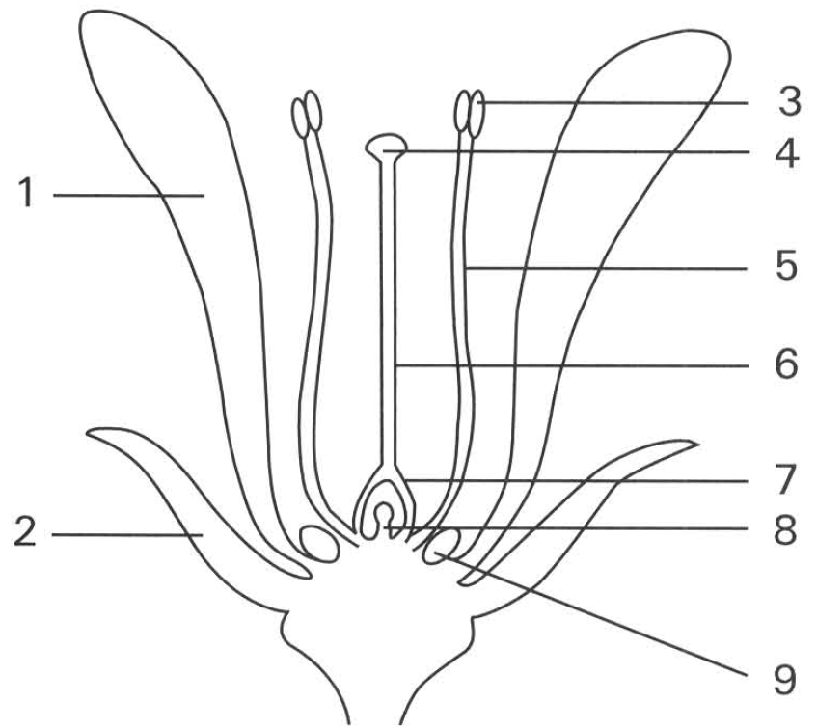
A. (1),(4),(6),(3),(2),(5) B. (1),(4),(2),(3),(6),(5)
C. (4),(1),(3),(2),(5),(6) D. (4),(1),(2),(3),(5),(6) Directions: Questions 25 to 32 to refer the diagram below which shows the structure of a flower.
225. Which of the following matching is CORRECT?
. | 1 | 2 | 8 | 9
A. | Sepal | Petal | Ovary | Nectary
B. | Petal | Sepal | Ovule | Nectary
C. | Petal | Sepal | Ovary | Ovule
D. | Sepal | Petal | Ovule | Ovary

226. Which of the following matching is CORRECT?
227. | 4 | 5 | 6 | A. | Stamen | Stigma | Style | Filament | B. | Stigma | Anther | Filament | Style | C. | Stamen | Stigma | Style | Filament | D. | Anther | Stigma | Filament | Style
228. Which of the following matching of structures and functions is CORRECT?
 | Structure | Function
A. | 1 | Protects the flower at the budding stage
B. | 2 | Attracts the insects to achieve pollination
C. | 3 | Produces pollen grains
D. | 4 | fertilisation occurs

229. Which of the following combinations TRULY represents the features found in a wind-pollinated flower?
 | Size of 1 | Position of 3 and 4 | Structure 9
A. | Very big | Confined inside the corolla | Very big
B. | Greatly reduced | Protruded out of the corolla | Absent
C. | Very big | Protruded out of the corolla | Very big
D. | Greatly | Confined inside reduced the corolla | Absent

230. Which of the following structures contain haploid cells? D. 3 and 5 only 30 Structure 3 contains a mass of yellow grains. Each of these grains contrains A. two sperm nuclei. B. an ovum. C. a zygote. D. a seed.
A. 3 and 8 only
B. 4 and 6 only
C. 5 and 7 only
D. 3 and 5 only 30 Structure 3 contains a mass of yellow grains. Each of these grains contrains
231. If cross-fertilisation has occurred, where on this flower has the pollen grains come from?
A. 3
B. 4
C. 8
D. None of these
232. Which structures have functions similar to the testis and ovary of a mammal?
 | Testis | Ovary
A. | 3 | 4
B. | 4 | 9
C. | 3 | 7
D. | 4 | 8

233. Which of the following is/are the function(s) of the style in a flower?
(1) To act as a reservoir for storing pollen grains.
(2) To act as a place where fertilisation takes place.
(3) To provide a passage and nutrients for the growth of pollen tubes to the ovules.
(4) To support the anthers to facilitate the trapping of pollen grains from air.
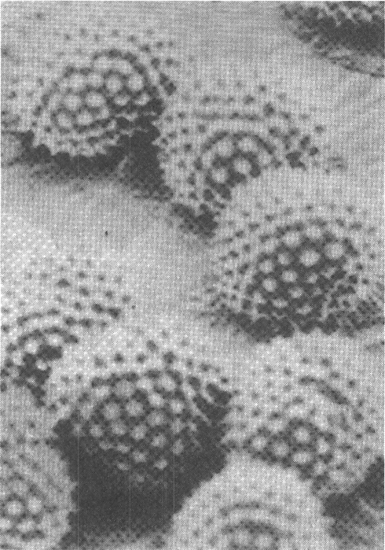
A. (1) only B. (3) only C. (1) and (2) only D. (3) and (4) only Directions: Questions 34 and 35 refer to the photograph below which show the pollen grains of a flowering plant.
234. Which of the statements about these pollen grains is/are CORRECT? (1) They are the male gametes of the flowering plants. (2) They help prevent the problem of overcrowding by carrying the genetic material far away from the parent plant. (3) They protect the 'male' genetic material against desiccation on land during their delivery to the female sex organs of the flowering plants.
A. (1) only
B. (2) only
C. (3) only
D. (1) and (3) only
235. The outer feature of these pollen grains are adapted to enhance
A. dispersal of the species.
B. wind pollination.
C. insect pollination.
D. reduction of water loss to the dry environment.
236. Anthers produce great number of pollen grains. Which of the following is the significance of this feature of flowering plants?
(1) This provides more food to attract insects to visit the flowers.
(2) This increases the chance of successful pollination to reach the stigma of another plant.
(3) This increases the genetic variations of the flowering plant.
(4) This increases the dispersal of the plants to greater distance away from the plants.
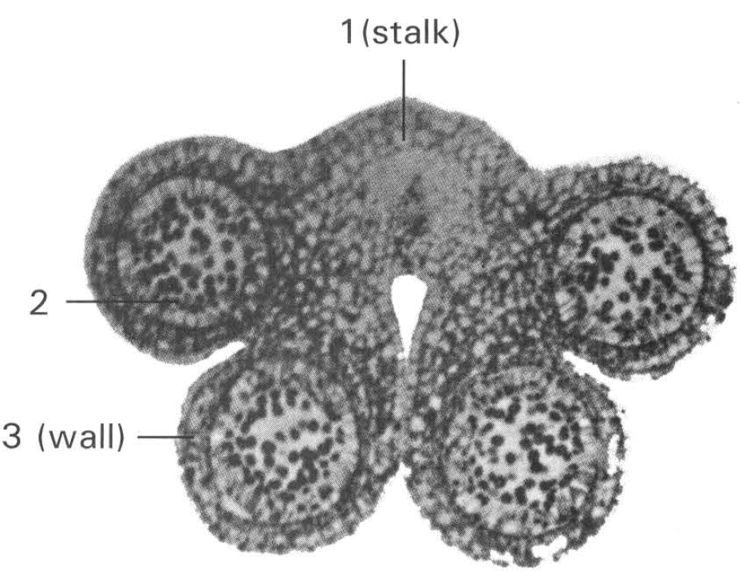
A. (1) only B. (2) only C. (1) and (3) only D. (2) and (4) only Directions: Questions 37 to 40 refer to the photomicrgraph below which shows the transverse section of the male organ of a flowering plant.
237. This section shows the struture of
A. an anther.
B. a pistil.
C. an ovule.
D. a filament.
238. Which structure(s) is/are haploid?
A. 1 only
B. 2 only
C. 3 only
D. 1 and 2 only
239. Which of the following statements about the structures labelled 2 is CORRECT?
A. They help the dispersal of the species during self-pollination of the flower.
B. They grow to form pollen tubes on reaching the stigma of any flower.
C. They are produced in large number to compensate for the great loss during pollination.
D. They fuse with the ovules to accomplish fertilisation.
240. Which of the following mammalian organ resembles the structure produced by the germination of the part labelled 2? D. Sperm duct Directions: Questions 41 to 49 refer to the diagram below which shows the structure of an insect-pollinated flower. 41Meiosis will take place in B. 9 only. C. 2 and 4 only. D. 4 and 6 only.
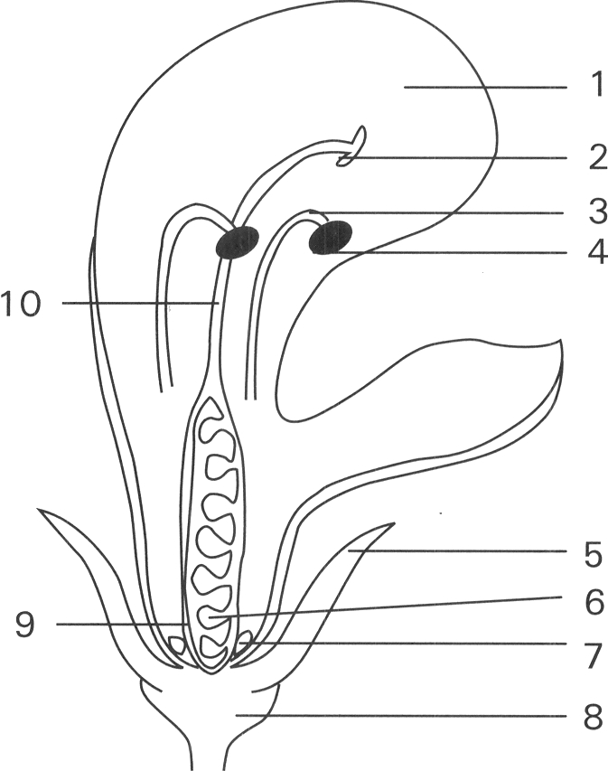
A. Testis
B. Male gamete
C. Penis
A. 7 only.
241. Which of the following colours is the most UNLIKELY one of the part labelled 1?
A. White B. Green
C. Yellow D. Blue
242. Which of the following is the adaptation of the above flower to bring about insect pollination?
A. 10 is longer than 3.
B. 1 is big and brightly coloured.
C. 5 is small and green in colour.
D. 10 is long and pendulous.
243. Which structure is NOT a specific adaptation to insect pollination?
A. 1
B. 7
C. 9
D. 2
244. Which of the following features TRULY ensures cross-pollination?
A. 6 is enclosed by 9.
B. 2 is present at the top of 10.
C. 4 is present at the top of 3.
D. 2 is present above 4.
245. This flower is adapted for (1) wind dispersal(2) insect pollination (3) self-pollination Which of the above statements is/are CORRECT?
A. (2) only
B. (3) only
C. (1) and (2) only
D. (2) and (3) only
246. Which structure becomes the seed after fertilisation has taken place? D. 9 only 48Which labelled parts will increase greatly in size after fertilisation ? A. 1 and 7 only B. 4 and 8 only C. 6 and 9 only D. 7 and 8 only
A. 2 only
B. 4 only
C. 6 only
D. 9 only 48Which labelled parts will increase greatly in size after fertilisation ?
247. Which labelled parts contain haploid cells?
A. 2 and 4 only
B. 3 and 10 only
C. 6 and 7 only
D. 4 and 6 only
248. Which of the following is/are the possible adaptive feature(s) exhibited by insect pollintaed flowers?
(1) Flower produces a large number of small, dry, powdery pollen grains.
(2) Corolla is brightly coloured with conspicuous shape.
(3) Long pendulous styles which bear feathery stigmas at their tips.
(4) Individual flowers are small nd inconspicuous but group together as an inflorescence.
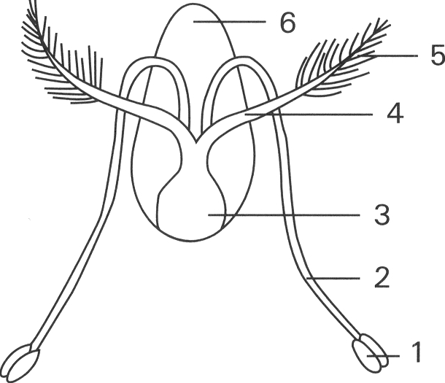
A. (2) only B. (1) and (3) only C. (2) and (4) only D. (1) and (4) only Directions: Questions 51 to 55 refer to the diagram below which shows the structures of a flower. 51Which of the following features are adaptation for wind-pollination?
A. 1 and 3 only B. 2 and 6 only
C. 3 and 4 only D. 2, 4 and 5 only 52 Structure 5, with feathery appearance, is adapted
A. to absorb more light for photosynthesis by increasing its surface area.
B. to reduce water loss by reducing its surface area with needle-like structures.
C. to trap floating pollen grains more easily from air currrent.
D. to attract insects by having a queer shape.
249. Which of the following are adaptative features of the structures produced by the part labelled 1? (1) large (2) light (3) spiny (4) dry (5) fewer (6) small
A. (1), (3) and (5)
B. (2), (4) and (6)
C. (2), (4) and (5)
D. (1), (5) and (4)
250. Which of the following characteristics supporting that the flower shown in the diagram above is adapted to wind pollination?
A. The flower has both stamens and carpels.
B. Structure 1 produces large number of big pollen grains.
C. Structure 1 hangs outside the corolla.
D. Structure 5 is present above structure 1.
251. Which of the following change(s) is/are CORRECT after fertilisation occurs? (1) The content of structure 1 changes into seeds. (2) Structure 3 changes into fruit. (3) Structures 2 and 4 will remain attached on top of the receptacle.
A. (1) only
B. (2) only
C. (2) and (3) only
D. (1) and (3) only
252. Many flowering plants have structures to ensure cross-pollination rather than self-pollination because the former
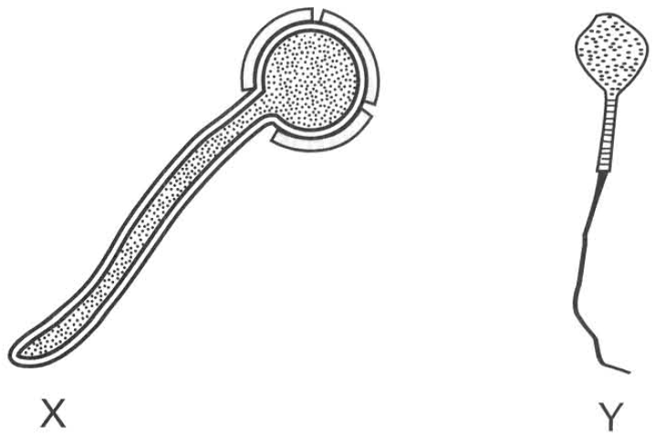
A. is a simpler process.
B. can make use of the external agents to bring about pollination.
C. produces more genetic variations.
D. saves more male gametes. Directions: Questions 57 and 58 refer to diagrams X and Y which show a pollen grain with a pollen tube growing out and a human sperm.
253. Which of the following comparisons between X and Y are CORRECT? (1) Both depend on other agent / structure to bring them to the female sex organs. (2) Both are male gametes. (3) Both have structure to resist against the dry conditions on land. (4) The male nuclei of both can move actively to meet the ovum to achieve fertilisation.
A. (1) only
B. (2) only
C. (3) and (4) only
D. (4) and (1) only
254. Both X and Y are produced in large number. The purpose is
(1) to increase the chance of finding the female sex organ/female individual
(2) to increase the chance of fertilizing the ovum
(3) to increase the amount of food stored for the future development of the embryo.
A. (1) only B.(2) onlyC. (3) only (1) and (3) only
255. Many flowering plants adapt to achieve cross-pollination. Which of the following is/are the advantages of cross-pollination to self-pollination?
(1) It produces greater genetic variations.
(2) It reduces the chance for undesirable alleles to express out.
(3) It disperses the seeds to greater distance.
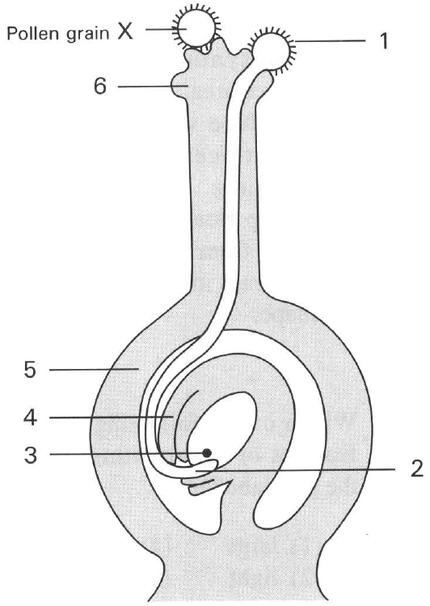
A. (1) only B. (2) only C. (3) only D. (1) and (2) only Directions: Questions 60 to 63 refer to the diagram below which shows the longitude section of a carpel of a flowering plant and some pollen grains on its stigma.
256. Referring to the stage of development shown in the diagram where would the female gamete and male gamete be found in the female and male structures respectively just before fertilisation?
 | Female gamete | Male gamete
A. | 3 | 1
B. | 4 | 2
C. | 3 | 2
D. | 4 | 1

257. Pollen grain X fails to develop on the stigma of this carpel. Which of the following is a probable explanation?
A. It is too big to enter the style of the carpel.
B. It does not belong to the same species as that of the carpel.
C. It has no sperm nuclei inside.
D. It has died by the time it reaches the stigma.
258. In which part of the carpel do pollination and fertilisation occur respectively?
 | Pollination | fertilisation
A. | 6 | 4
B. | 2 | 4
C. | 6 | 5
D. | 2 | 6

259. After fertilisation which labelled part will develop into seed and fruit respectively?
 | Seed | Fruit
A. | 4 | 5
B. | 3 | 4
C. | 5 | 4
D. | 4 | 3

260. Which of the following structures are genetically different? (1) The pollen grains and ova of the same flower. (2) The petals and sepals of the same flower. (3) Seeds in the same orange. (4) The corm and the petals of the Gladiolus flower developing from it
A. (1) and (3) only
B. (2) and (3) only
C. (3) and (4) only
D. (4) and (1) only
261. Different parts of a flower will undergo changes after fertilisation .Which of the following matching of the changes is CORRECT?
66The fruit wall is
. | Integuments | Stamen | Ovule | Ovary wall | fertilised ovum
A. | Fruit wall | Fruit | Seed | Seed coat | Embryo
B. | Seed coat | Drops away | Seed | Fruit wall | Embryo
C. | Fruit wall | Seed | Drops away | Fruit wall | Fruit
D. | Seed coat | Embryo | Fruit wall | Drops away | Fruit

A. the resistant wall of the pollen grain.
B. the structure formed by the ovary wall after fertilisation.
C. the shrivelled seed coat.
D. the waxy surface of an apple.
262. Which of the following is the function of the fruit? (From a biological point of view).
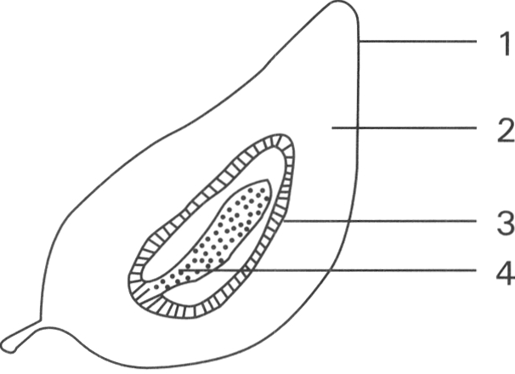
A. Stores food to pass through the unfavourable conditions in winter.
B. Provides a big item for man's diet.
C. Protects seeds and provides means for the dispersal of seeds.
D. Acts as a structure for depositing excess food. 2. Seeds and germination Directions: Questions 68 to 70 refer to the diagram below which shows the longitudinal section of a mango.
263. The agent responsible for the dispersal of the seed of this fruit is
A. bird.
B. wind.
C. water current.
D. animal.
264. Which of the following part(s) is/are adaptation to enhance the above method of dispersal of seed?
A. 1 only
B. 2 only
C. 3 only
D. 1 and 2 only
265. From which parts of the flower will structures 2 and 4 develop?
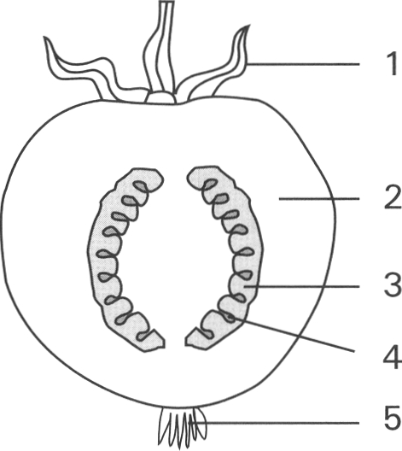
 | Structure 2 | Structure 4
A. | Ovary wall | Ovum
B. | Ovary wall | Ovule
C. | Testa | Ovary wall
D. | Ovary wall | Ovum

266. The following diagram shows the longitudinal section of a fruit.
Which of the following matching between the labelled parts of the fruit and the floral parts before fertilisation is CORRECT?
267. | 2 | 4 | 5 | A. | Calyx | Ovary wall | Ovule | Base of style | B. | Base of filament | Ovum | Ovary | Calyx | C. | Base of style | Ovum | Ovule | Calyx | D. | Calyx | Ovary wall | Ovum | Base of style
268. The following diagram shows the longitudinal section of an apple. Which labelled part provides food for embryo development?
A. (1) only
B. (2) only
C. (3) only
D. (1) and (2) only
269. The diagrams below show 5 types of fruits which are adapted to three methods of dispersal. (The diagrams are NOT drawn to the same scale.)
Which of the following matching is CORRECT?
Directions: Questions 74 to 77 refer to the diagram below which shows the longitudinal section of a broad bean seed.
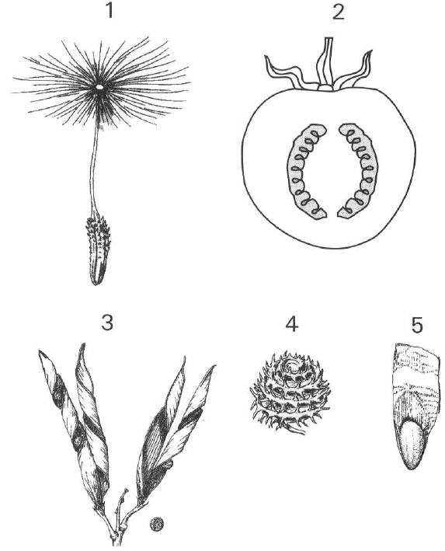
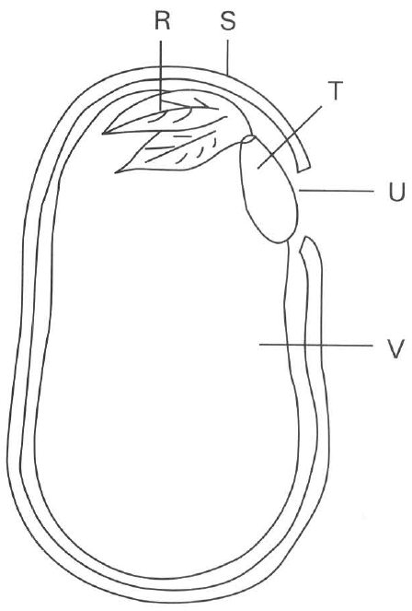
 | Wind dispersal | Animal dispersal | Mechanical / self dispersal
A. | 1, 3 | 2, 4 | 5
B. | 5, 2 | 4, 3 | 1
C. | 1, 5 | 2, 4 | 3
D. | 3, 5 | 2, 4 | 1

270. If V is stained blue black with iodine solution, it shows that the reserved food of this seed consists of
A. sugar.
B. protein.
C. fat.
D. starch.
271. Which structure(s) will develop to form the root system of the broad bean plant?
A. R only
B. T only
C. T and V
D. R and T
272. Which of the following matching is CORRECT?
 | S | R | T | V
A. | Fruit wall | Plumule | Radicle | Endosperm
B. | Testa/seed coat | Plumule | Radicle | Cotyledon
C. | Testa/seed coat | Radicle | Plumule | Endosperm
D. | Fruit wall | Plumule | Radicle | Cotyledon

273. Which of the following is/are the function(s) of the cotyledons in the broad bean seed? (1) They sandwich the plumule to protect it during its growth through soil. (2) They emerge out of soil as the first foliage leaves to carry out photosynthesis. (3) They provide reserved food to support the germination of the seed. D. (1) and (3) only Suggested Solutions
A. (1) only
B. (2) only
C. (3) only
D. (1) and (3) only Suggested Solutions
Part D — Growth (YKTo)
274. 1Which of the following processes is/are involved in growth of plants? (1) Mitosis (2) Cell enlargement (3) Cell differentiation (4) Oxidation of reserved food
A. (1) only
B. (2) and (3) only
C. (1), (2) and (3) only
D. (1), (2), (3) and (4)
275. 2Which of the following statements about growth is/are INCORRECT? (1) Different parts of a human body grow at different rates. (2) The increase in length of the root is mainly due to the activities in the meristematic region, not the elongation region. (3) Growth takes place evenly in all parts of a flowering plant. (4) Only growth in plants is affected by hormones.
A. (1) only
B. (3) only
C. (2) and (3) only
D. (2), (3) and (4) only
276. Which of the following statements concerning growth of individual plant is /are CORRECT? (1) Increase in the number of trees in a community. (2) Increase in the size of the forest. (3) Increase in the complexity of cells in the plant.
A. (1) only
B. (2) only
C. (3) only
D. (1) and (2) only
277. Which of the following statements about the growth in the monocotyledonous flowering plant is INCORRECT?
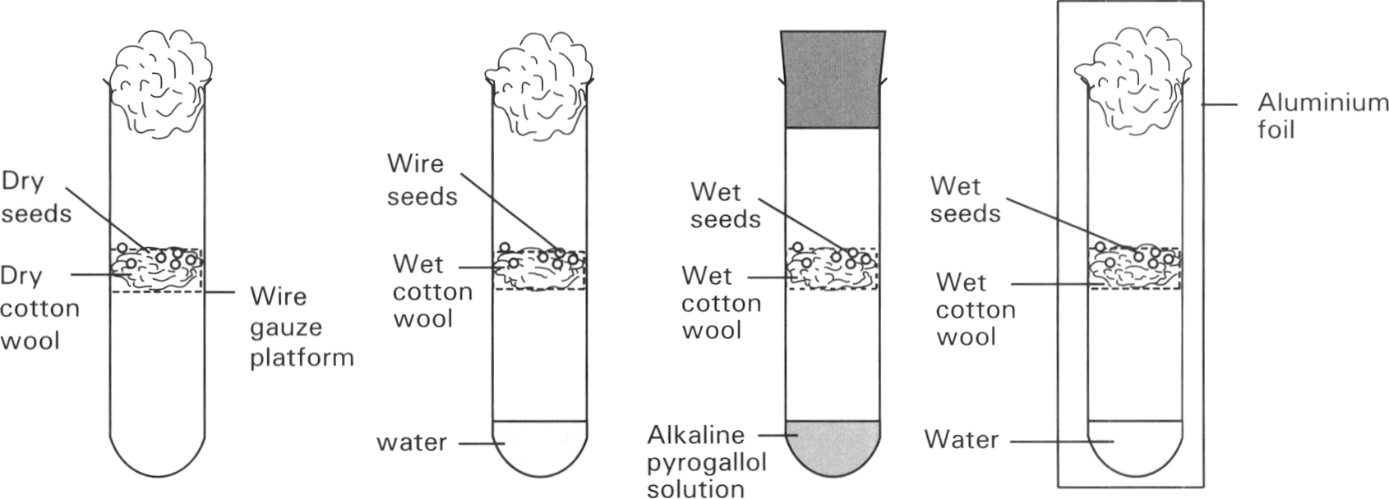
A. It occurs throughout life.
B. Growth in root is mainly apical.
C. The increase of plant tissues is mainly brought about by mitosis.
D. Growth is not affected by light illumination. Directions: Questions 15.5 to 15.8 refer to the diagrams below which show the set up of an experiment to study the conditions needed for germinaton of seeds. The tubes were kept at 30°C. Only seeds in tubes B and D germinated.
278. Which conditions are investigated in this experiment for their need in the germination of seeds? (1) Water (2) Oxygen (3) Light (4) Warmth
A. (1) and (2) only
B. (2) and (3) only
C. (3) and (4) only
D. (1), (2) and (3) only
279. According to the results, what conditions are needed for seeds to germinate.
A. Water and light only
B. Oxygen and light only
C. Water and oxygen only
D. Oxygen and warmth only
280. Which two tubes are used to investigate the need of oxygen for seed germination?
A. Tube A and tube B only B. Tube B and tube C only
C. Tube B and tube D only D. Tube A and tube C only
281. Which of the following graphs CORRECTLY represents the changes in the dry mass of the seeds in tube A throughout the experiment?
Directions: Questions 15.9 to 15.11 refer to the diagram below which shows an experimental setup.
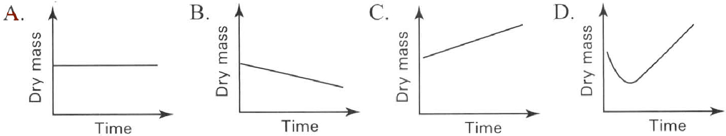
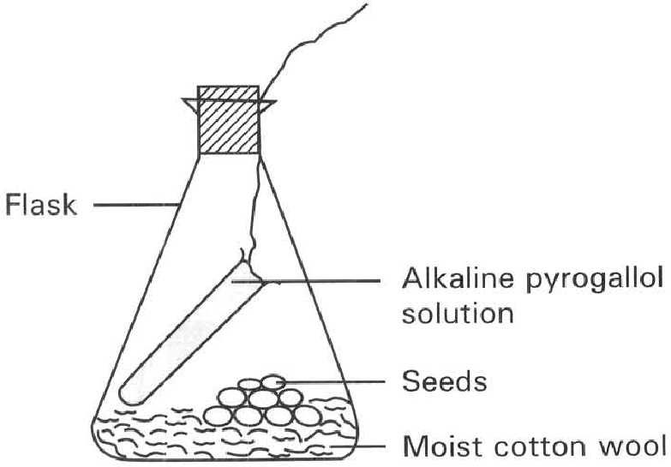
282. 9Which of the following is the probable result of the above experiment?
A. The alkaline pyrogallol solution turns milky.
B. The alkaline pyrogallol solution turns yellow.
C. The alkaline pyrogallol solution turns red.
D. No seed germinates.
283. What is the purpose of the above experiment?
A. To show that carbon dioxide is produced by the living seeds.
B. To show that carbon dioxide is absorbed by the plant tissues in the presence of light.
C. To show that water is essential to germination.
D. To show that oxygen is essential to germination.
284. Which of the following is the method of setting up the control experiment?
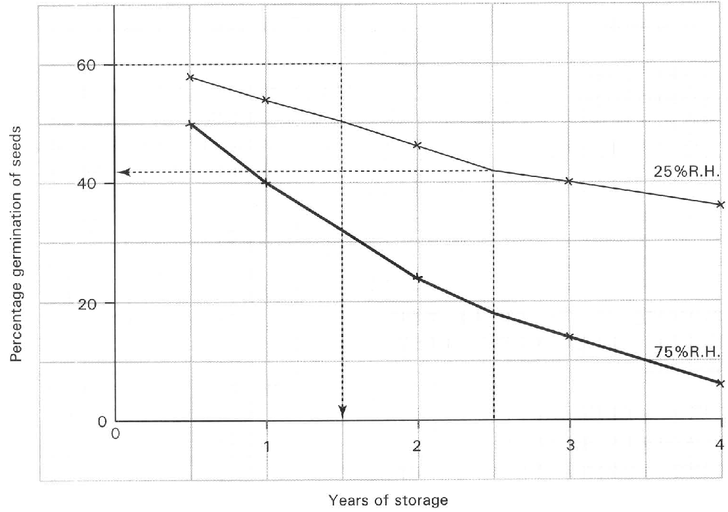
A. Boil the seeds.
B. Replace the alkaline pyrogallol solution with water.
C. Cover the flask with a piece of black cloth to exclude light.
D. Put the flask inside the refrigerator. Directions: Question 15.12 refers to the graph below which shows the effect of the relative humidity and the years of storage of seeds on the percentage of germination of seeds.
285. Which of the following is the conclusion that can be drawn from the above results?
A. The years of storage of seeds do not affect the viability of the seeds.
B. Dry environment is better than moist environment for the storage of seeds.
C. Cold condition is more favourable to warm condition for the storage of seeds.
D. No valid conclusion can be drawn.
286. Broad beans require water to germinate, They absorb water through (1) micropyle. (2) hilum. (3) seed coat.
A. (1) only
B. (2) only
C. (3) only
D. (1) and (3) only
287. Moist germinating seeds are kept inside a thermoflask. After several days the temperature inside the thermoflask compared with that of the control is very high. It indicates that
A. germinating seeds absorb a lot of heat from the surrounding to support their growth and development.
B. the thermoflask is a very good apparatus used to prevent heat loss.
C. the absorption of water by the germinating seeds promotes heat lost from the thermoflask.
D. heat is produced by the germinating seeds as a result of the respiration of the living cells.
288. 15Water is essential for the germination of seeds. It is because water is used (1) to soften the seed coat that facilitates the emergence of the radicle. (2) to activate enzymes. (3) to act as a raw material for photosynthesis. (4) to hydrolyse the stored food.
A. (1) and (2) only
B. (1) and (3) only
C. (2) and (3) only
D. (1), (2) and (4) only
289. When a broad bean seed germinates, the plumule usually penetrates through soil in the shape of a hook.
A. This enables the plumule to emerge out of soil more quickly.
B. The hooked region protects the delicate tissues of the plumule from damage by friction in soil.
C. More food is transported from the cotyledons to the base of the plumule so that the lower part of the plumule is in a hook shape.
D. The basal part of the plumule exhibits stronger positive phototropic response than the plumule tip so that the basal part grows more quickly to produce the hook shape.
290. Which of the following is/are the difference(s) of the embryo of a seed from that of a mammal?
(1) It develops outside the parent's body.
(2) It can remain in a dormant form when the external conditions are unfavourable to its development.
(3) It depends on the nutrients absorbed from the surrounding to support its development.
 | Dry mass(g)
Components | Seeds | Seedlings formed after germination in darkness
Sugars | 6.3 | 18.0
Cellulose | 4.4 | 13.6
Fats | 85.2 | 31.2
Simple proteins | 20.6 | 10.2
Others | 23.9 | 48.1
Total day mass | 140.4 | 121.1

A. (1) only B. (2) only C. (1) and (2) only D. (2) and (3) only Directions: Questions 15.18 to 15.20 refer to the table below which shows the changes in the dry mass of the different components of seeds before and after germination in darkness.
291. Which of the following is the CORRECT reason accounting for the difference in the total dry mass after germination.
A. The seeds carry out photosynthesis to produce food.
B. Destarching occurs in the seedlings growing in darkness.
C. The reserved food is oxidised to support the germination of seeds into seedlings.
D. The activities of parasites living on the seedlings.
292. Which component is the main food reserve in the seeds?
A. Sugar B. Cellulose C. Fats D. Simple proteins
293. The increase in the cellulose content in the seedlings as compared with that of seeds is due to
A. the production of carbohydrates by photosynthesis.
B. the translocation of cellulose from the seeds to the seedlings.
C. the synthesis of more cellulose by the seedlings to build up the cell wall for the increasing number of cells.
D. the formation of flowers and fruits in the seedlings.
294. 21Dry mass is obtained by removing
A. all the food reserve from the organism before measurement.
B. all the fats from the organism.
C. all the water in the organism.
D. all the organic matter from the organism.
295. Dry mass is a more accurate parameter used for measuring growth of an organism. Which of the following reasons is CORRECT?
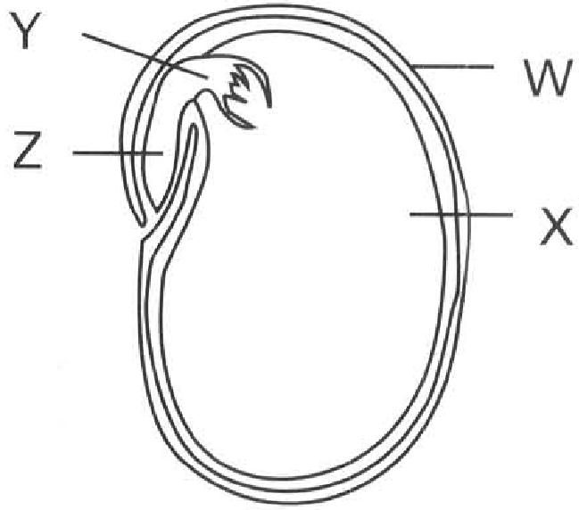
A. All the cells have died so that no further growth occurs to interrupt growth.
B. Growth takes a long period of time to complete. During the measuring period the water content of the organism is easily affected by the environment. Dry mass can remove this unreliable factor.
C. It is a true measurement of all the inorganic substances forming the organism.
D. Only one measurement is needed during the whole experimental period for measuring growth. Directions: Questions 15.23 to 15.27 refer to the diagram below which shows the longitudinal section of a broad bean seed.
296. Which of the following matching of the names of the labelled parts is CORRECT?
 | W | X | Y | Z
A. | Fruit wall | Cotyledon | Radicle | Embryo
B. | Seed coat | Embryo | Pulmule | Cotyledon
C. | Fruit wall | Seed coat | Cotyledon | Embryo
D. | Seed coat | Cotyledon | Plumule | Radicle

297. Which of the following is NOT the function of structure W?
A. Prevents the entry of bacteria and fungi into the seed.
B. Protects the seed content against adverse environmental conditions.
C. Prevents the loss of water from the seed content to air.
D. Promotes the dispersal of the seed.
298. Which of the following is the function of structure X? (1) Promotes the dispersal of seed. (2) Stores food to support the germination of the seed. (3) Prevents the bacterial and fungal invasion.
A. (1) only
B. (2) only
C. (3) only
D. (1) and (3) only
299. Which of the following graphs CORRECTLY shows the changes in the fresh mass of structure X and the total fresh mass of Y and Z?
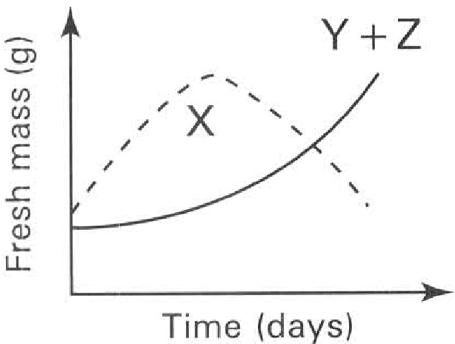
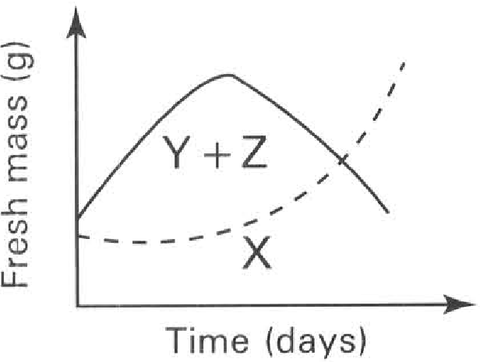
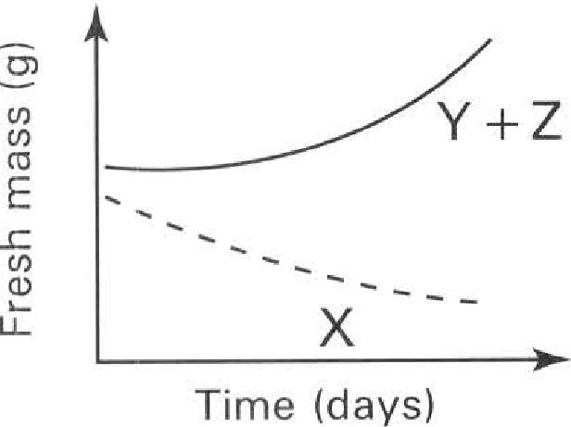
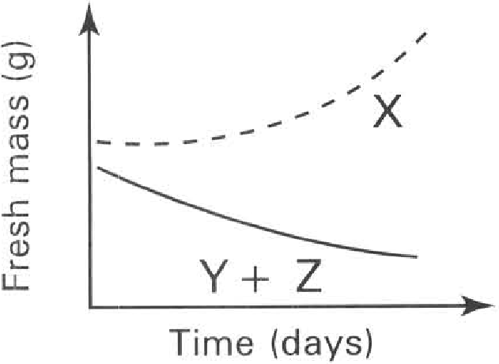
A. | B. | C. | D.

300. Which of the following graphs CORRECTLY shows the changes in the dry mass of the whole seed and its seedling, structure X and the total dry mass of structures Y and Z during the course of germination?
Directions: Question 15.28 refers to the diagrams below which show the different stages of the germination of a seed.
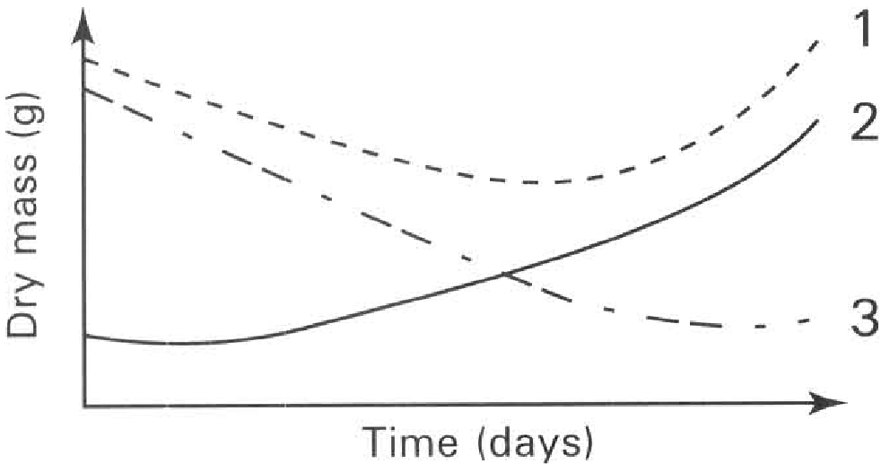
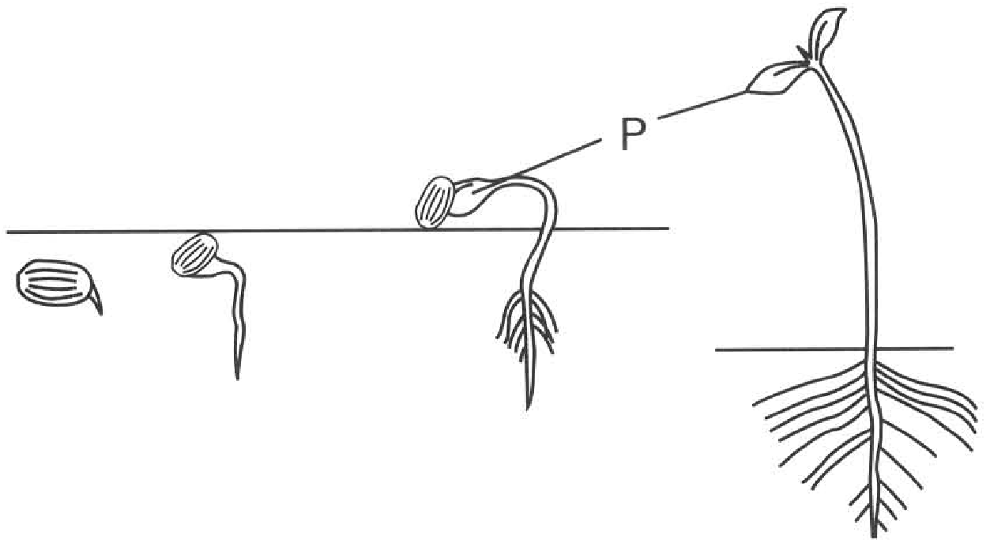
 | Dry mass of the whole seed and its seedling | Dry mass of structure X | Total dry mass of structures Y and Z
A. | 1 | 2 | 3
B. | 3 | 2 | 1
C. | 1 | 3 | 2
D. | 1 | 2 | 3

301. Which of the following is the function(s) of structure P?
(1) It stores food for the germination of the seed.
(2) It protects the young plumule during its emergence through soil.
(3) It turns green once it is emerging into air to carry out photosynthesis.
(4) It protects the seed against adverse environmental conditions.
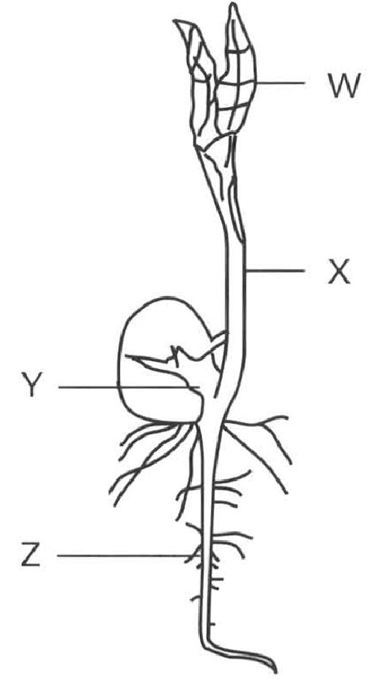
A. (1) and (2) only B. (2) and (3) only C. (3) and (4) only D. (1), (2) and (3) only Directions: Questions 15.29 and 15.30 refer to the diagram below which shows the appearance of a seedling 10 days after the start of germination of the bean seed. W and X are the aerial parts of the seedling and they are green in colour.
302. The development of the seedling up to the stage shown in the diagram initially depends on the food supplied by
A. the absorption of mineral salts from soil by Z.
B. the consumption of the food reserve in Y.
C. the absorption of nitrogen gas from air by X.
D. the photosynthetic activities of W
303. Which of the following graphs CORRECTLY represents the changes in the dry mass and the fresh mass of the seedling from the first day of germination to the stage shown in the diagram?
Directions: Questions 15.31 and 15.32 refer to the experiment described below. Two smaples of seeds, M and N, were germinated under favourable conditions. Sample N was exposed to light while Sample M was kept in darkness. Equal number of seeds/seedings from each sample was removed at equal intervals and their dry mass was measured. The results were shown in the graph below.
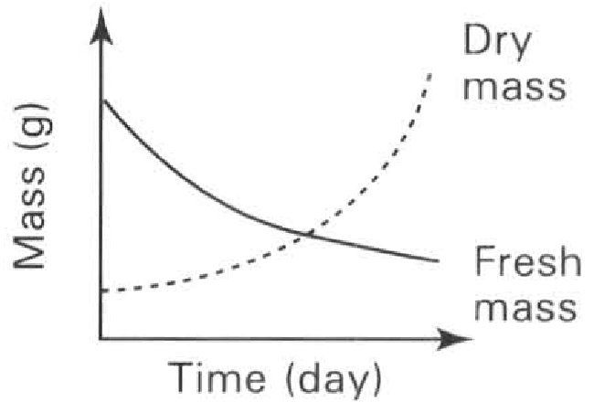
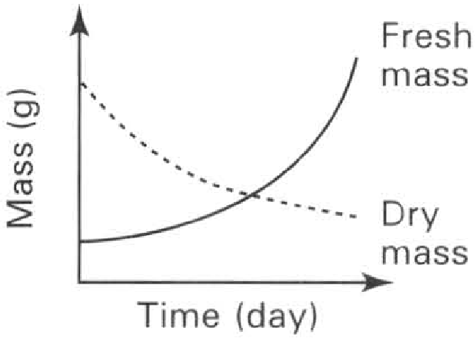
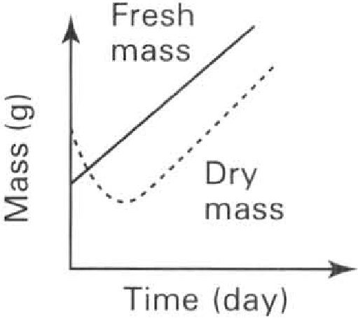
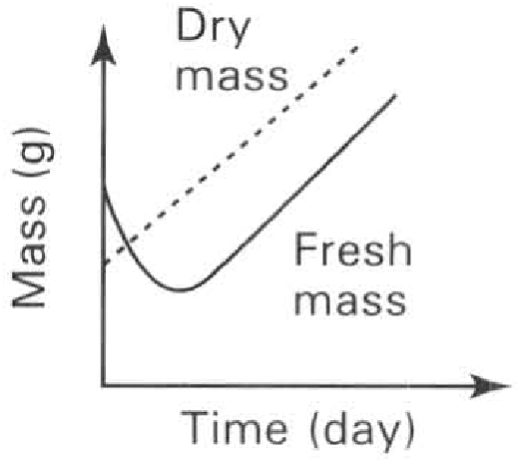
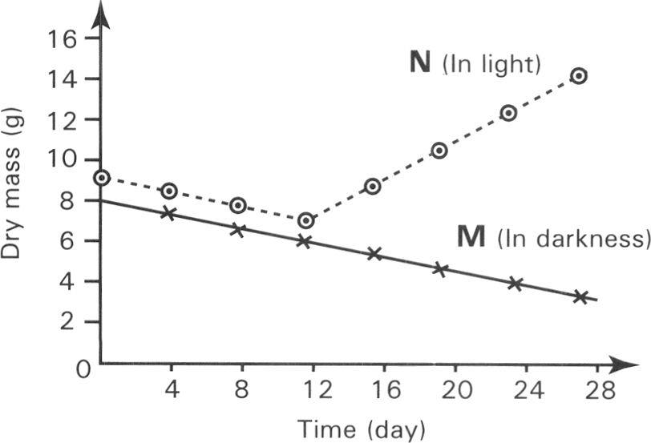
A. | B. | C. | D.

304. The decrease in dry mass of both samples in the first 12 days is probably due to
A. the loss of water through the testa by evaporation.
B. the translocation of food from the storage regions to the plumule and radicle.
C. the respiration of the reserved food during germination.
D. the food stored inside the seeds diffusing out of the seeds.
305. The increase in dry mass of sample N from day 12th to day 28th was due to
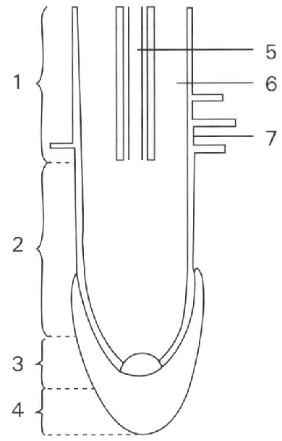
A. the translocation of the reserved food from the storage regions into the plumules.
B. the photosynthetic activities of the foliage leaves just emerging from soil.
C. the absorption of water by the root system of the seedling.
D. the production of new offspring by the seedings. Directions: Questions 15.33 to 15.36 refer to the diagram below which shows the longitudinal section of a root tip.
306. Which of the following matching of regions is CORRECT?
 | Region with the highest complexity of cells | Region with active mitotic cell division | Region with cells bearing the largest vacuoles
A. | 1 | 2 | 3
B. | 3 | 1 | 2
C. | 1 | 3 | 2
D. | 3 | 2 | 1

307. Which of the following matching is CORRECT?
 | Root cap | Region of differentiation | Region of cell division | Region of elongation
A. | 4 | 3 | 2 | 1
B. | 3 | 4 | 1 | 2
C. | 4 | 1 | 3 | 2
D. | 3 | 1 | 2 | 4

308. The following diagrams show the different types of tissues that are present in the root tip.
Which of the following matching of the location of these tissues in the root tip is CORRECT?
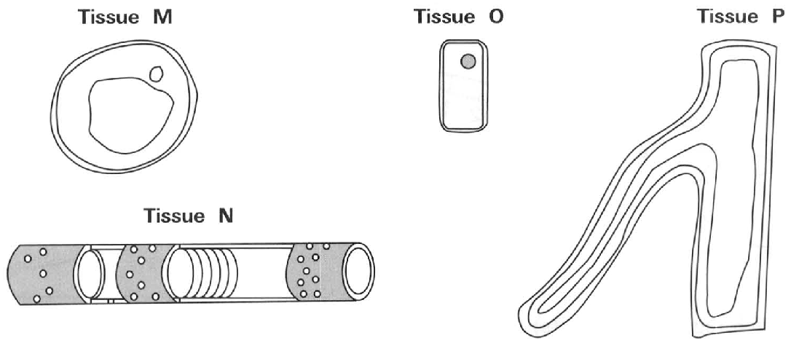
 | Tissue M | Tissue N | Tissue O | Tissue P
A. | 6 | 4 | 3 | 5
B. | 3 | 8 | 4 | 7
C. | 6 | 5 | 3 | 7
D. | 4 | 5 | 6 | 5

309. Which of the following is/are function(s) of the part labelled 4? (1) To protect the growing point (2) To protect the root hair (3) To increase the area for absorbing water and mineral salts
A. (1) only
B. (2) only
C. (1) and (3) only
D. (1) and (2) only
310. 37Which of the following cells in the root tip have completely differentiated?
(1) Xylem vessel (2) Thin-walled cortical cells
(3) Sieve cells (4) Root cap cells
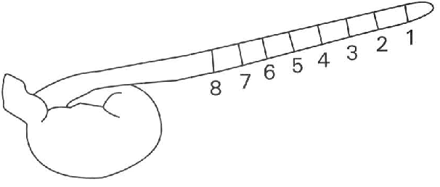
A. (1) and (2) only B. (3) and (4) only C. (1) and (3) only D. (2) and (4) only Directions: Questions 15.38 to 15.41 refer to the diagram below which shows the growth of the radicle of a germinating broad bean seed. The radicle is marked into 8 equal intervals and is placed horizontally.
311. 38Which region(s) exhibit(s) the greatest increase in length after 4 days?
A. 1 only
B. 2 only
C. 2, 3 and 4 only
D. 5, 6 and 7 only
312. Which region(s) has/have the greatest number of actively dividing cells?
A. 1 only
B. 3 only
C. 2 and 3 only
D. 2 and 4 only
313. What is the purpose of this experiment?
A. To find out the growth rate of the whole plant.
B. To find out the region where cell division occurs most actively.
C. To find out the region of differentiation.
D. To find out the region with rapid increase in length.
314. If the radicle is left vertically for two days, the length of each zone was measured again. Which of the graphs below CORRECTLY shows the length of each zone against the zone sequence.
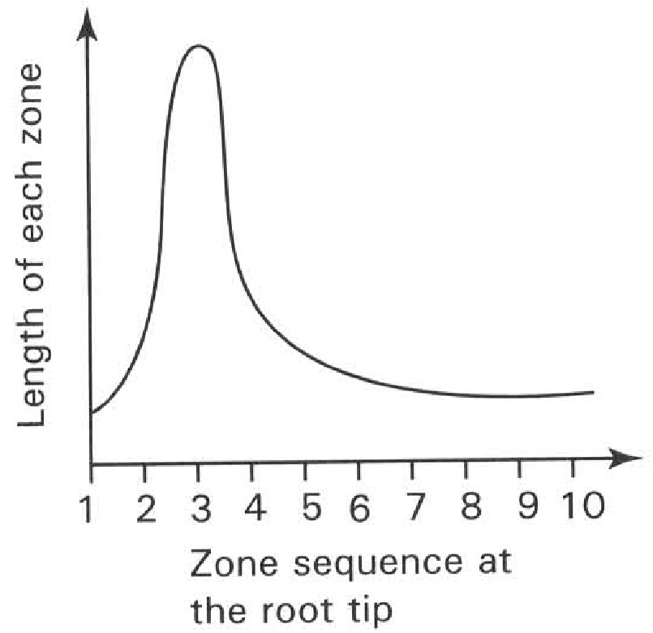
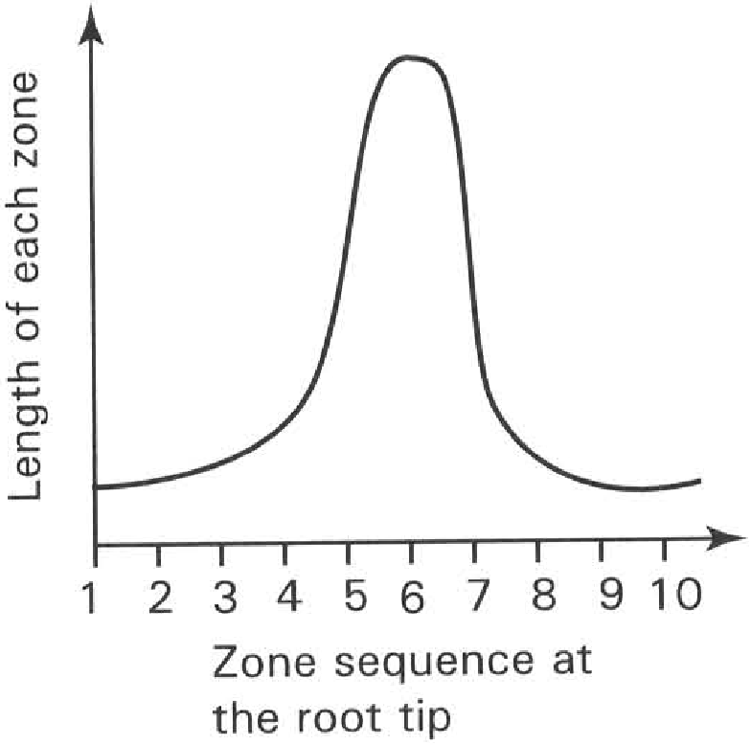
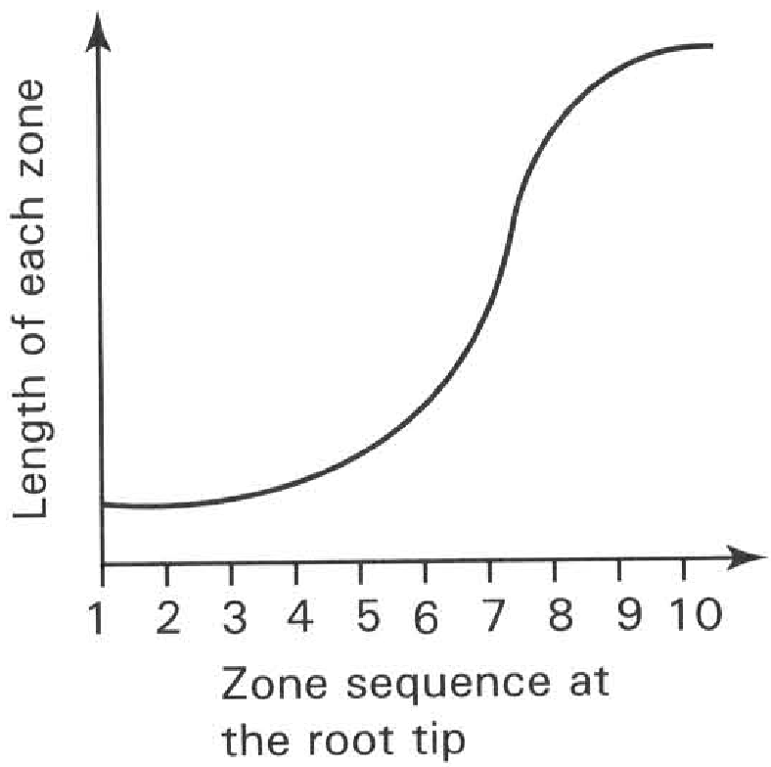
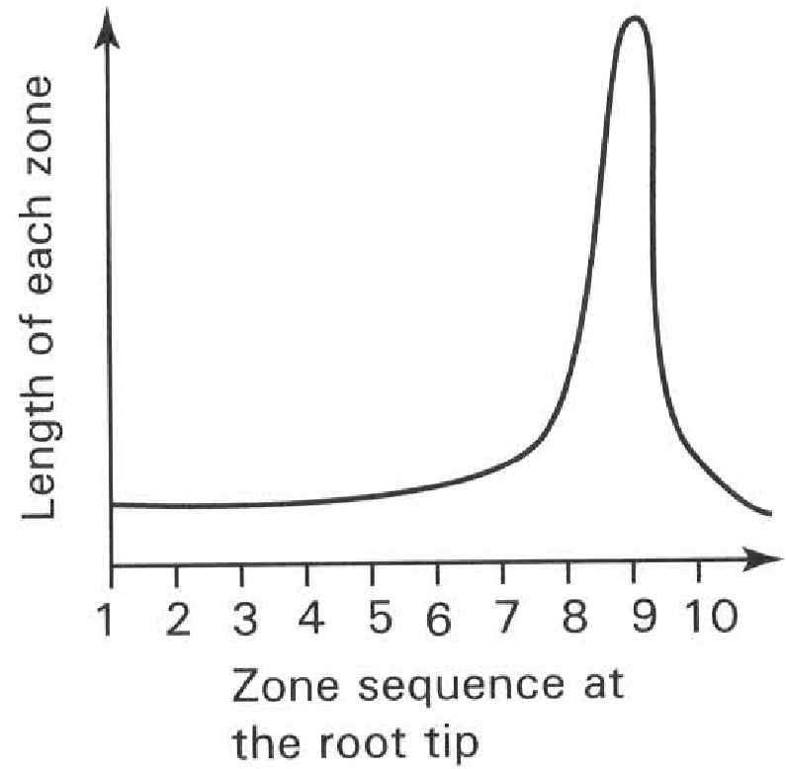
A. | B. | C. | D.

315. Which of the following criteria can be used to measure the rate of growth in flowering plant? (1) Dry mass (2) Wet mass (3) Length (4) Number of cells (5) Area
A. (1), (2) and (3) only
B. (1), (2) and (4) only
C. (1), (3) and (4) only
D. (1), (2), (3) and (5) only
316. The growth rate of a herbaceous flowering plant is most accurately obtained by measuring the change in
A. the height of the plant.
B. the total surface area of the leaves of the plant.
C. the dry mass of the plant.
D. the wet mass of the plant.
317. Which of the following is/are the disadvantage(s) of using fresh mass to measure growth in flowering plants? (1) The plant will be killed in the process. (2) Continuous measurment of the same organism cannot be made. (3) Results easily affected by the environmental conditions.
A. (1) only
B. (3) only
C. (1) and (2) only
D. (2) and (3) only
318. Which of the following is/are the advantage(s) of using dry mass to measure growth in flowering plants? (1) A small number of organisms is used. (2) Accurate measurement of growth. (3) The measurement can easily be completed within a short period of time.
A. (1) only
B. (2) only
C. (1) and (2) only
D. (2) and (3) only
319. Which of the following parameters can be used to measure the growth of a boy from birth to adolescence? (1) Body mass (2) Height (3) Intelligence quotient (IQ) (4) Heart rate
A. (1) and (2) only
B. (2) and (3) only
C. (3) and (4) only
D. (1), (2) and (3) only
320. Which of the following growth curves truly represents the growth pattern of humans?
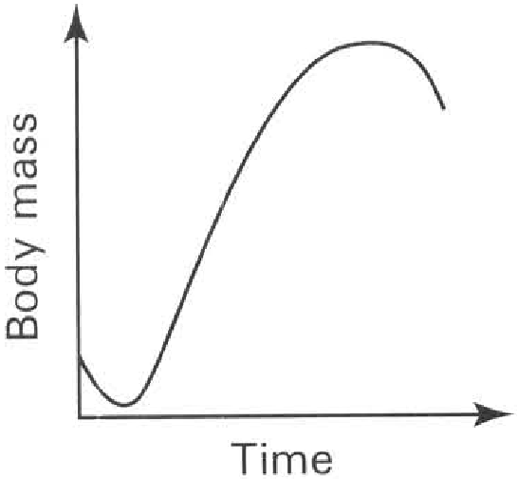
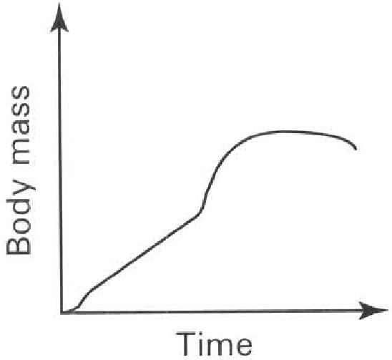
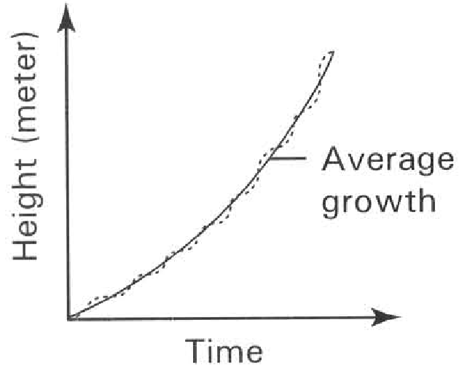
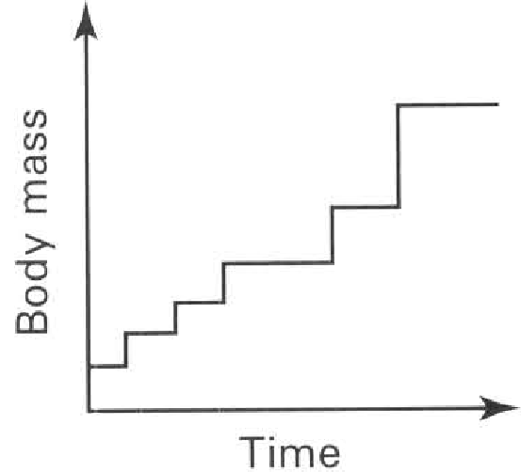
A. | B. | C. | D.

321. The diagram below shows the bodies of a man at different ages drawn to the same scale.
Which of the following interpretation of the diagram is CORRECT?
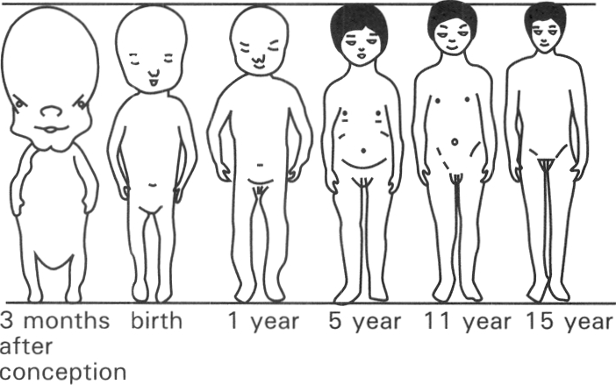
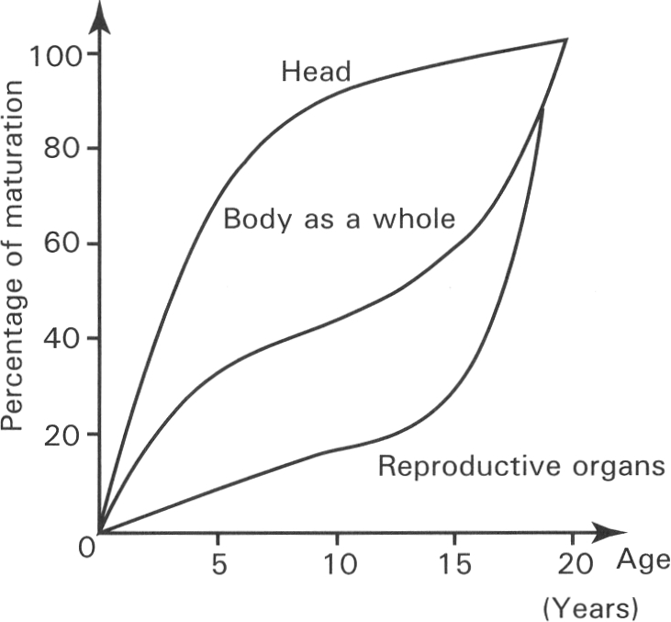
A. The legs grow faster than the arms.
B. The growth rate of different parts of the body is different.
C. The head is decreasing in size with age.
D. The amount of muscles is increasing while the amount of fats is decreasing with age.
322. The graph below shows the relative size of the different organs of the human body at different ages.
Which of the following deductions is CORRECT?
A. The brain stops to grow after age 5.
B. The whole body begins to grow after age 5.
C. The reproductive organs grow rapidly after age 15.
D. The body begins to secrete sex hormones after age 15.
323. The graph below shows the growth curves of boys and girls
Which of the following deductions is CORRECT?
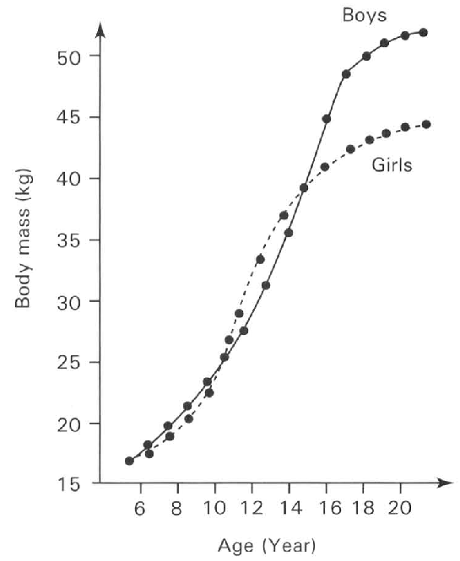
A. The sex organs of both the girls and boys are not yet developed before age 11.
B. The boys are taller than the girls before age 11.
C. The growth rate of the boys is higher than that of the girls between the ages of 18 and 20.
D. The boys are lighter than the girls between the ages of 11 and 15.

Answers
Answers are printed in red.
1. B
Class: 72.2% correct (n=97) usual slip D
2. D
Class: 91.0% correct (n=89) usual slip B
3. A. (1) and (2) only
Class: 79.2% correct (n=130) usual slip D
4. C
Class: 79.7% correct (n=172) usual slip D
5. D. tuber.

6. ?

7. A. corm.

8. ?

9. D. It will become smaller to supply food for germination. Directions: 11 to 13 refer to the photograph below which shows a vegetative organ.

10. C. rhizome.
Class: 72.9% correct (n=199) usual slip A
11. ?

12. A. nodes. B. internodes. C. annual rings. D. veins. Directions: Questions 14 to 16 refer to the drawing below which shows a vegetative organ.

13. ?

14. C. (2) and (3) only
Class: 59.6% correct (n=89) usual slip A
15. B. 2

16. C. (2) and (3) only

17. D

18. D

19. D. 8
Class: 50.0% correct (n=88) usual slip C
20. C. 6 and 7
Class: 85.4% correct (n=96) usual slip B
21. B

22. A

23. D. 4

24. ?

25. ?

26. B
Class: 85.4% correct (n=89) usual slip A
27. D. 4

28. D. 8

29. A. fertilisation does not occur at position X.

30. ?

31. D. (1), (2) and (3)
Class: 70.9% correct (n=55) usual slip A
32. D
Class: 80.2% correct (n=96) usual slip A
33. B
Class: 87.5% correct (n=96) usual slip D
34. C. acting as a hairy parachute for flying.

35. ?

36. C. (2) and (3) only
Class: 94.0% correct (n=83) usual slip A
37. D

38. B
Class: 65.5% correct (n=55) usual slip D
39. A. Structure C will absorb food from structure B during the early stage of germination.

40. D

41. C. alkaline pyrogallol.

42. A. I
Class: 96.4% correct (n=55) usual slip C
43. ?

44. A. Seed germination needs water.

45. C. The seeds should be kept in low temperature beforehand.

46. ?

47. B. 2
Class: 34.5% correct (n=55) usual slip A
48. C

49. D. (2) and (3) only
Class: 51.8% correct (n=83) usual slip A
50. D. body temperature.

51. D. (1), (2) and (3)
Class: 90.9% correct (n=55) usual slip A
52. B. The whole sperm cell fuses with an ovum during fertilisation.
Class: 67.3% correct (n=55) usual slip A
53. ?

54. ?

55. ?

56. D. The cycle is 28day long.-
Class: 35.1% correct (n=37) usual slip C
57. A. It involves the contraction of epididymis.

58. B. (1) and (3) only
Class: 91.9% correct (n=37) usual slip D
59. C
Class: 83.8% correct (n=37) usual slip B
60. ?

61. ?

62. C. Structure 4 is responsible for menstruation.
Class: 70.8% correct (n=65) usual slip B
63. ?

64. B. (1) and (3) only

65. B
Class: 70.3% correct (n=37) usual slip C
66. C

67. D

68. C. (2), (3), (5), (4), (1)
Class: 80.0% correct (n=65) usual slip D
69. B. (1) and (3) only

70. D. (1), (2) and (3)

71. A. (1) and (2) only
Class: 56.8% correct (n=37) usual slip D
72. C
Class: 92.3% correct (n=65) usual slip A
73. A. P
Class: 89.2% correct (n=37) usual slip B
74. D. Urea is disposed of through T.
Class: 83.8% correct (n=37) usual slip A
75. D. (1), (2) and (3)
Class: 85.1% correct (n=67) usual slip B
76. B

77. B. (3), (2), (1), (4)
Class: 79.1% correct (n=67) usual slip D
78. D. (1), (2) and (3)
Class: 56.7% correct (n=67) usual slip A
79. D
Class: 77.6% correct (n=67) usual slip C
80. ?

81. B. 2.
Class: 55.2% correct (n=67) usual slip A
82. C. 1 and 5
Class: 43.3% correct (n=67) usual slip A
83. D. fertilisation
Class: 91.9% correct (n=37) usual slip A
84. D. None of the above

85. A. reduces the chance of implantation. B. prevents fertilisation.
Class: 89.2% correct (n=37) usual slip B
86. B. it is the lowest temperature in the day.
Class: 56.8% correct (n=37) usual slip D
87. ?

88. D

89. C

90. B

91. A. Intrauterine device-B. Contraceptive pills C. Tubal ligature D. Diaphragm
Class: 81.1% correct (n=37) usual slip C
92. D. Safe period can be worked out more easily from the day of ovulation.

93. ?

94. B. Natural method
Class: 91.9% correct (n=37) usual slip A
95. A. (1) and (2) only
Class: 75.7% correct (n=37) usual slip D
96. ?

97. ?

98. D. (1), (2) and (3)
Class: 62.2% correct (n=37) usual slip B
99. A. (1) and (2) only B. (1) and (3) only C. (2) and (3) only D. (1), (2) and (3) Directions: Questions 108 to 110 refer to the following graph which shows the growth curve of a plant from a seed to a mature plant.

100. D. dry mass.
Class: 64.9% correct (n=37) usual slip C
101. C. (1) and (3) only
Class: 16.2% correct (n=37) usual slip A
102. A. (1) and (2) only B. (1) and (3) only C. (2) and (3) only D. (1), (2) and (3) Directions: Questions 111 and 112 refer to the,, following graph which shows the percentage development of two systems in a human body.
Class: 59.5% correct (n=37) usual slip D
103. D
Class: 94.6% correct (n=37) usual slip B
104. A. (1) and (2) only B. (1) and (3) only C. (2) and (3) only D. (1), (2) and (3) Directions: Questions 113 and 114 refer to the table below which shows the average height of boys and girls in different age groups.
Class: 83.8% correct (n=37) usual slip D
105. C
Class: 97.3% correct (n=37) usual slip D
106. B
Class: 89.2% correct (n=37) usual slip D
107. B
Class: 89.2% correct (n=37) usual slip A
108. C. 3 only
Class: 67.6% correct (n=37) usual slip B
109. D. 4
Class: 78.4% correct (n=37) usual slip C
110. B
Class: 78.4% correct (n=37) usual slip A
111. A. Length of nail B. Length of fingers C. Length of legs D. Length of arms Distractor
Class: 94.6% correct (n=37) usual slip B
112. B. (1),(3),(4),(2),(5)

113. C

114. B. | Ureter | Sperm duct | Urethra |

115. B

116. B. 6 and 8

117. C. The sperms produced are inactivated at the relatively high body temperature.
Class: 73.1% correct (n=130) usual slip B
118. C. lead sperms out of the body.
Class: 79.4% correct (n=34) usual slip B
119. D

120. C. 3 and 10 only
Class: 67.3% correct (n=55) usual slip B
121. A. 9 7 4
Class: 36.4% correct (n=55) usual slip B
122. D. 10 only

123. B. (4) only

124. D

125. D
Class: 76.1% correct (n=88) usual slip B
126. D. 6, 8
Class: 70.6% correct (n=34) usual slip B
127. C. 6, 8, 9

128. B. 3

129. A. Cut and tie structure 1 present on both sides of the body.
Class: 76.4% correct (n=55) usual slip C
130. C. Sex hormones can still be produced.

131. B

132. D

133. D. | Transmits genetic information | Provides energy for swimming | swimming

134. C. bearing haploid number of chromosomes.

135. A. increase the chance of fertilizing the egg.

136. D. (2) and (4) only
Class: 85.5% correct (n=55) usual slip C
137. A. contains more food reserve.
Class: 72.9% correct (n=96) usual slip B
138. C. fertilisation D. Embryo development 33Where will the biological process shown in the photomicrograph take place inside the female body?

139. D. Both ovum and sperm are produced by meiosis.
Class: 84.8% correct (n=33) usual slip C
140. D. Half of that in the egg mother cell.
Class: 64.7% correct (n=34) usual slip A
141. D. diploid number of chromosomes while the ovum is haploid Directions: Questions 37 and 38 refer to the diagrams below which show the carpel of a flowering plant and the female reproductive system of humans.
Class: 80.0% correct (n=55) usual slip C
142. A. Meiosis takes place inside structures 4 and 6.

143. B

144. D. 7 only
Class: 81.8% correct (n=55) usual slip C
145. D. 10 only

146. A. (2) only

147. C. 5
Class: 60.7% correct (n=28) usual slip B
148. B. implantation.

149. B. (2) only

150. D. (1), (2), (3) and (4)

151. A. Both produce large number of male gametes.

152. A. (1) and (2) only
Class: 92.7% correct (n=55) usual slip B
153. C. (1), (2) and (3) only

154. D. (2) and (3) only

155. B. oviduct.

156. D
Class: 83.6% correct (n=55) usual slip C
157. B. twice.

158. D. days 4 and 32 only.

159. D. a fertilised egg has implanted in the uteirne wall.

160. A. Hormones released from the ovary.

161. C. when the thickened uterine lining begins to break down.

162. B. 12th to 18th January

163. C. The uterine lining will continue its thickening.

164. D. Implantation most likely occurs on the 28th December.

165. C. to find the best time to avoid sexual intercourse in order to achieve contraception.

166. C. two weeks after menstrual flow.

167. D. It represents the periodic changes in certain physiological activities of a sexually mature woman.

168. A. (1) and (2) only B. (2) and (3) only C. (1) and (3) only D. (1), (2) and (3) Directions: Questions 66 to 70 refer to the diagram below which shows the structure linked to the foetus.
Class: 67.9% correct (n=28) usual slip B
169. A

170. D

171. B. 2 and 5 only

172. D

173. D

174. A. 4 only

175. C. (1) and (3) only

176. A. (1) and (2) only

177. C. It permits the exchange of diffusible substances between the mother and the foetus.

178. A. The mammary glands secrete milk to nourish the foetus.

179. C. amnion.

180. D
Class: 89.2% correct (n=37) usual slip C
181. D. 3 and 4 only
Class: 53.6% correct (n=28) usual slip A
182. D. 1 and 3 only

183. D. None of the above

184. C. (3) and (4) only

185. B. 2
Class: 94.6% correct (n=37) usual slip A
186. B. (2),(1),(4),(3)

187. C. It supports the nutrition, gas exchange and excretion of the foetus.

188. C. provide enough iron to support the production of the haemoglobin inside the red blood cells of the foetus.
Class: 86.6% correct (n=67) usual slip D
189. D. (1), (2), (3) and (4)

190. D. (1), (2), (3) and (4)

191. C. (3) and (4) only
Class: 90.0% correct (n=30) usual slip D
192. D. (3), (1), (4), (6), (2), (5)
Class: 94.6% correct (n=37) usual slip A
193. C. (1) and (2) only

194. C. one sperm fertilised one egg to form one zygote which divides to form two embryos.
Class: 83.3% correct (n=30) usual slip B
195. C. Fraternal twins are formed by having two sperms fertilised two separate eggs.
Class: 78.4% correct (n=37) usual slip D
196. D. (1), (2) and (3) only
Class: 45.9% correct (n=37) usual slip A
197. C. This will not affect those women who have to leave home to work.
Class: 76.1% correct (n=67) usual slip B
198. B
Class: 81.1% correct (n=37) usual slip A
199. C
Class: 96.7% correct (n=30) usual slip A
200. D
Class: 85.1% correct (n=67) usual slip B
201. B
Class: 63.3% correct (n=30) usual slip C
202. D
Class: 100.0% correct (n=30) usual slip A
203. C. (1) and (2) only
Class: 80.6% correct (n=67) usual slip C
204. D
Class: 90.0% correct (n=30) usual slip A
205. B. It prevents the sperms from passing through the cervix to the uterus.
Class: 76.7% correct (n=30) usual slip C
206. C. It prevents the implantation of the embryo on the uterine lining.
Class: 93.3% correct (n=30) usual slip A
207. C
Class: 86.7% correct (n=30) usual slip D
208. A. (1) only
Class: 76.1% correct (n=67) usual slip D
209. A. (1) only
Class: 33.3% correct (n=15) usual slip D
210. D
Class: 69.4% correct (n=111) usual slip A
211. D. 3 and 4 only
Class: 75.0% correct (n=76) usual slip B
212. D. (1) and (2) only

213. D

214. D

215. C

216. C

217. D. (1) and (3) only

218. C. Food manufactured in structure 1 passes down to structures 2 and 4.

219. C. Tissue culture D. Binary fission

220. A. (1) and (2) only
Class: 61.8% correct (n=110) usual slip B
221. B
Class: 81.8% correct (n=33) usual slip A
222. D. 1 and 6 only
Class: 72.0% correct (n=75) usual slip C
223. D. 2, 3, 4 and 5 only

224. B
Class: 71.6% correct (n=67) usual slip D
225. B

226. D

227. D
Class: 59.5% correct (n=42) usual slip C
228. C

229. B
Class: 22.0% correct (n=41) usual slip D
230. A. 3 and 8 only
Class: 54.1% correct (n=74) usual slip C
231. D. None of these
Class: 58.8% correct (n=34) usual slip A
232. C
Class: 73.3% correct (n=75) usual slip B
233. B
Class: 50.7% correct (n=67) usual slip A
234. C. (3) only

235. C. insect pollination.

236. B

237. A. an anther.

238. B. 2 only

239. C. They are produced in large number to compensate for the great loss during pollination.

240. C. Penis

241. B

242. B. 1 is big and brightly coloured.

243. C. 9
Class: 23.5% correct (n=34) usual slip A
244. D. 2 is present above 4.

245. A. (2) only

246. C. 6 only
Class: 14.5% correct (n=55) usual slip B
247. D. 4 and 6 only

248. C. to trap floating pollen grains more easily from air currrent.
Class: 95.2% correct (n=83) usual slip A
249. B. (2), (4) and (6)

250. C. Structure 1 hangs outside the corolla.
Class: 92.9% correct (n=28) usual slip A
251. B. (2) only
Class: 89.3% correct (n=28) usual slip A
252. C. produces more genetic variations.
Class: 80.0% correct (n=55) usual slip A
253. A. (1) only

254. B

255. D
Class: 81.9% correct (n=83) usual slip A
256. C

257. B. It does not belong to the same species as that of the carpel.
Class: 69.9% correct (n=83) usual slip A
258. A

259. A
Class: 62.2% correct (n=37) usual slip C
260. A. (1) and (3) only
Class: 75.0% correct (n=28) usual slip C
261. B. the structure formed by the ovary wall after fertilisation.

262. C. Protects seeds and provides means for the dispersal of seeds.

263. D. animal.

264. D. 1 and 2 only

265. B
Class: 81.1% correct (n=37) usual slip D
266. A

267. C

268. C. (3) only

269. C
Class: 83.8% correct (n=37) usual slip A
270. D. starch.
Class: 81.5% correct (n=65) usual slip B
271. B. T only

272. B
Class: 24.3% correct (n=37) usual slip D
273. C. (3) only

274. D. (1), (2), (3) and (4)

275. D. (2), (3) and (4) only

276. C. (3) only

277. D. Growth is not affected by light illumination. Directions: Questions 15.5 to 15.8 refer to the diagrams below which show the set up of an experiment to study the conditions needed for germinaton of seeds. The tubes were kept at 30°C. Only seeds in tubes B and D germinated.
Class: 91.4% correct (n=35) usual slip B
278. D. (1), (2) and (3) only
Class: 81.7% correct (n=131) usual slip A
279. C. Water and oxygen only
Class: 66.7% correct (n=96) usual slip B
280. B
Class: 78.9% correct (n=256) usual slip C
281. A
Class: 85.5% correct (n=55) usual slip B
282. D. No seed germinates.

283. D. To show that oxygen is essential to germination.
Class: 70.2% correct (n=124) usual slip A
284. B. Replace the alkaline pyrogallol solution with water.

285. B. Dry environment is better than moist environment for the storage of seeds.
Class: 79.4% correct (n=34) usual slip C
286. D. (1) and (3) only

287. D. heat is produced by the germinating seeds as a result of the respiration of the living cells.

288. D. (1), (2) and (4) only

289. B. The hooked region protects the delicate tissues of the plumule from damage by friction in soil.

290. C
Class: 76.4% correct (n=89) usual slip B
291. C. The reserved food is oxidised to support the germination of seeds into seedlings.

292. C

293. C. the synthesis of more cellulose by the seedlings to build up the cell wall for the increasing number of cells.

294. D. all the organic matter from the organism.

295. B. Growth takes a long period of time to complete. During the measuring period the water content of the organism is easily affected by the environment. Dry mass can remove this unreliable factor.

296. D

297. D. Promotes the dispersal of the seed.
Class: 62.2% correct (n=90) usual slip C
298. B. (2) only

299. A

300. C

301. D
Class: 97.7% correct (n=88) usual slip A
302. B. the consumption of the food reserve in Y.
Class: 50.0% correct (n=34) usual slip D
303. C
Class: 89.6% correct (n=67) usual slip D
304. C. the respiration of the reserved food during germination.

305. B. the photosynthetic activities of the foliage leaves just emerging from soil.
Class: 78.8% correct (n=33) usual slip D
306. C

307. C

308. C

309. A. (1) only
Class: 85.1% correct (n=67) usual slip B
310. D

311. D. 5, 6 and 7 only

312. A. 1 only
Class: 83.9% correct (n=62) usual slip B
313. D. To find out the region with rapid increase in length.

314. A

315. D. (1), (2), (3) and (5) only
Class: 21.8% correct (n=55) usual slip A
316. C. the dry mass of the plant.
Class: 49.1% correct (n=55) usual slip B
317. B. (3) only

318. B. (2) only

319. A. (1) and (2) only

320. B

321. B. The growth rate of different parts of the body is different.

322. C. The reproductive organs grow rapidly after age 15.

323. D. The boys are lighter than the girls between the ages of 11 and 15.

