Reproduction and growth · items under 80% correct
Multiple-choice practice
Name: ________________________ Class: ____________
These items were answered correctly by fewer than 80% of students in class Google Forms, matched by the wording in the source bank and the form answer key. Choose the one best answer.
Part A — HKCEE level (Longman)
1. Which of the following matchings about asexual reproduction is incorrect?
 | Asexual reproduction | Organism involved
A. | binary fission | bacteria
B. | budding | Mucor
C. | spore formation | Rhizopus
D. | vegetative propagation | angiosperms

2. Compared with the parent plant, the daughter plant developed from a corm (1)has the same chromosome number. (2)is identical to the parent plant. (3)can reproduce by vegetative propagation only.
A. (1) and (2) only
B. (1) and (3) only
C. (2) and (3) only
D. (1), (2) and (3)
3. Which of the following statements about sexual reproduction is correct?
(1) It always involve two parents.
(2) It always involve the fusion of gametes.
(3) Offspring are genetically different from their parents.
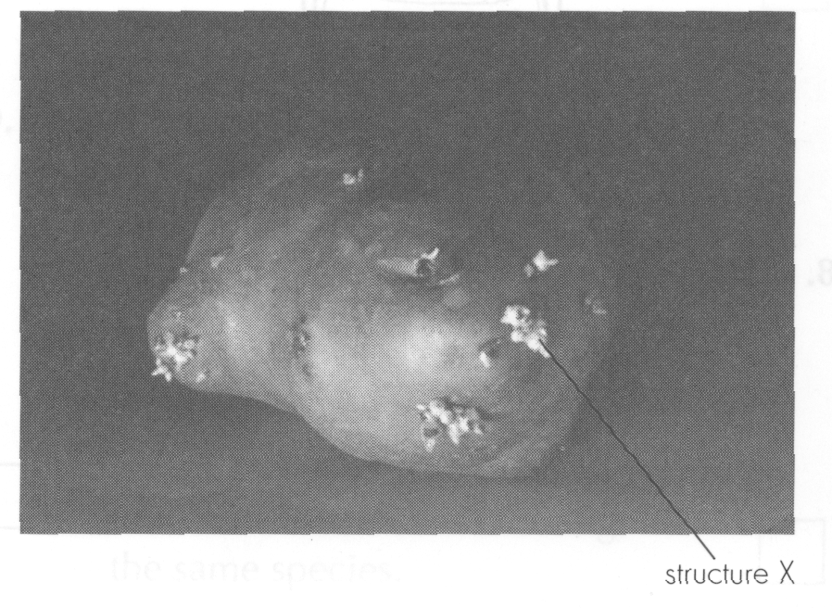
A. (1) and (2) only B. (1) and (3) only C. (2) and (3) onlyD. (1), (2) and (3) Directions: Questions 5 to 7 refer to the following photograph which shows a vegetative organ.
4. The vegetative organ is a
A. corm.
B. bulb.
C. rhizome.
D. tuber.
5. From which part of the parent plant is this vegetative organ developed? (1) Root (2) Stem (3) Leaf
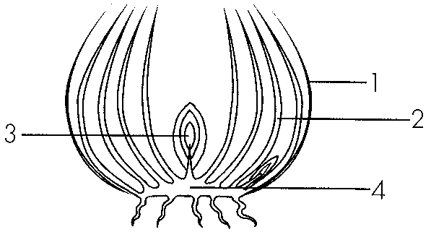
A. (1) and (2) only
B. (1) and (3) only
C. (2) and (3) only
D. (1), (2) and (3)
6. Which structure protects the flower at the bud stage?
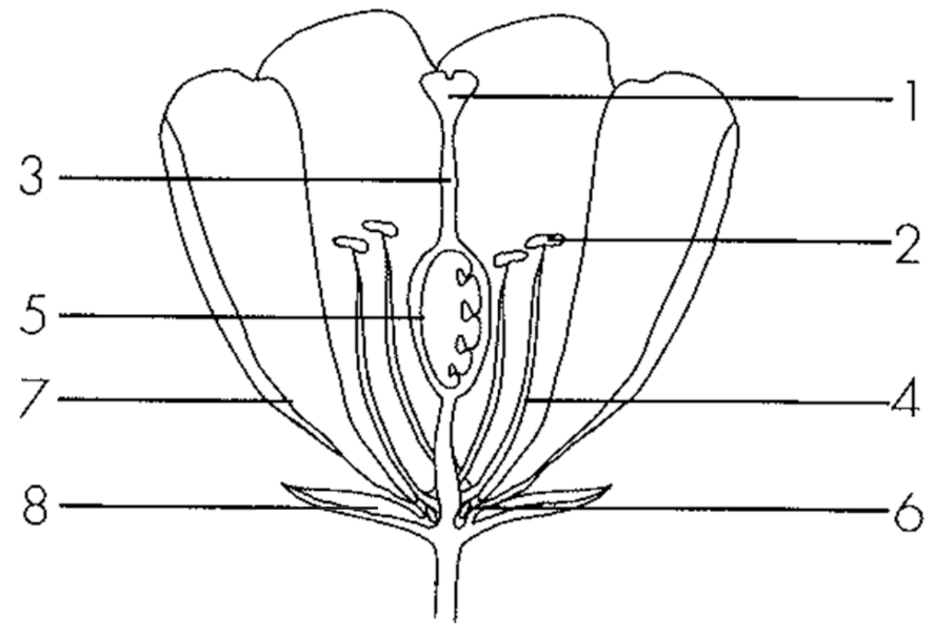
A. 2
B. 5
C. 7
D. 8
7. Which of the following are implications of seed dispersal? (1) It may reduce competition between parents and offspring. (2) It may reduce competition among offspring. (3) It may increase the chance of survival.
A. (1) and (2) only
B. (1) and (3) only
C. (2) and (3) only
D. (1), (2) and (3)
8. The conditions for seed germination in general include:
(1) Warmth (2) Moisture (3) Oxygen
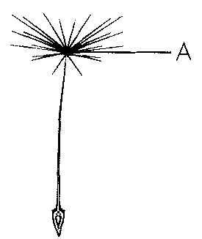
A. (1) and (2) only B. (1) and (3) only C.(2) and (3) only D. (1), (2) and (3) Directions: Questions 34 and 35 refer to the following diagram of a fruit produced by a certain plant.
9. Which of the following correctly state the parts of a flower from which structures A and B are developed?
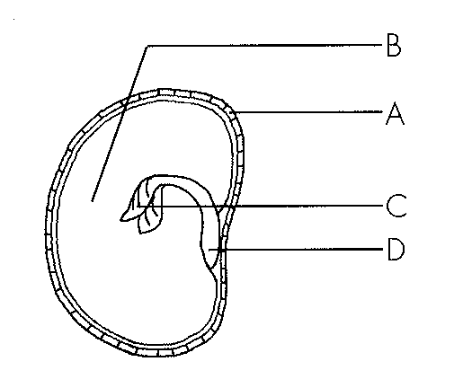
 | A | B
A. | ovule wall | funicle
B. | ovule wall | zygote
C. | ovary wall | ovule wall
D. | ovary wall | zygote

10. Which of the following structure is developed from the ovary wall?
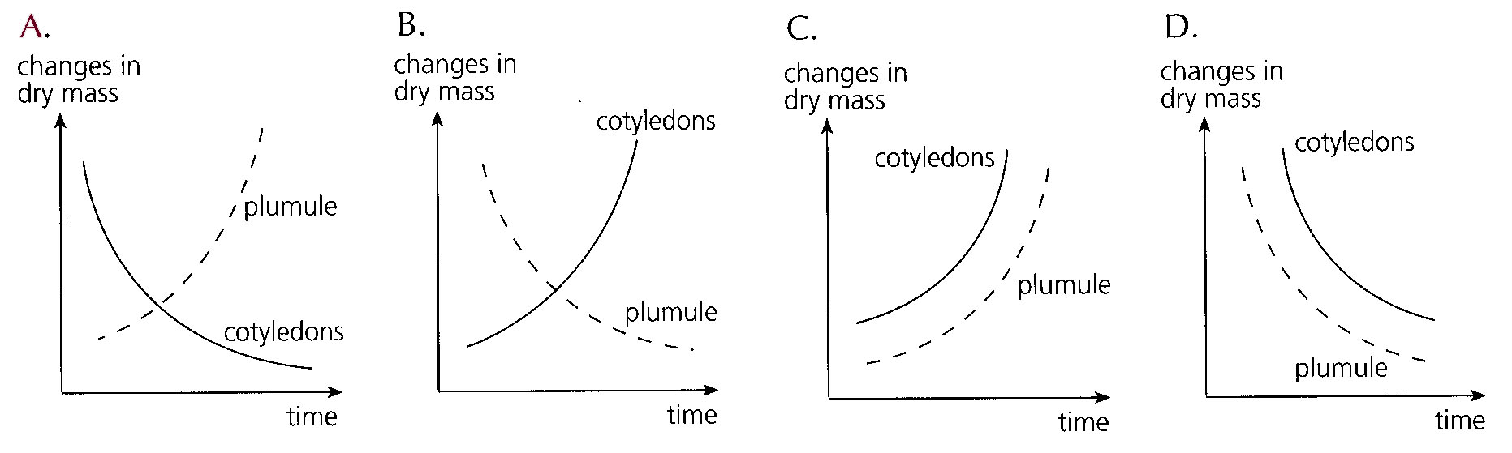
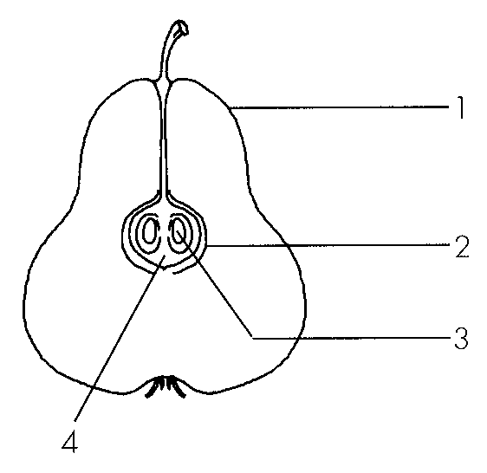
A. 1
B. 2
C. 3
D. 4
11. Which of the following is/are not the advantage(s) of fruit dispersal? (1) Reduce transmission of diseases within the species (2) Enable the species to have more variations (3) Make the species become fitter for the changing environment
A. (1) only
B. (1) and (2) only
C. (1) and (3) only
D. (2) and (3) only
12. Which of the following statements about a sperm cell is incorrect?
A. The chromosomes in a sperm cell cannot pair up.
B. The whole sperm cell fuses with an ovum during fertilisation.
C. It is produced in the testes.
D. The DNA content of a sperm cell is half of the sperm mother cell.
13. Which of the following statements about menstrual cycle is incorrect?
A. It begins at puberty and stops at menopause.
B. It is maintained by the interactions of hormones.
C. It occurs in female mammals only.
D. The cycle is 28day long.-
14. Which of the following is not the reason for structure 4 being muscular and vascularized?
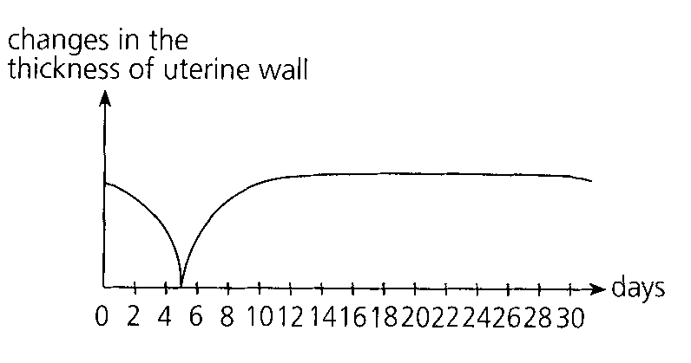
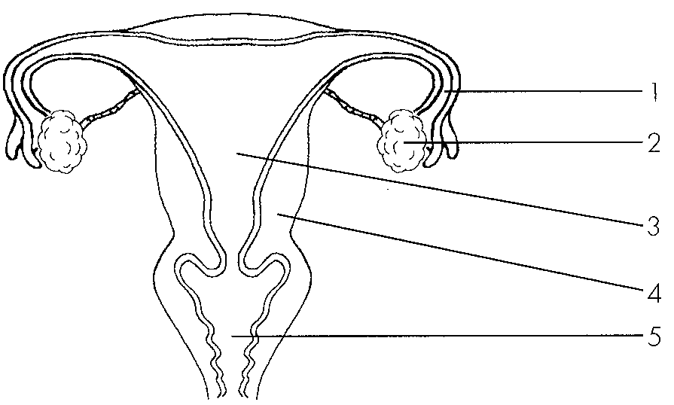
A. Structure 4 is responsible for expelling the placenta during labour.
B. Structure 4 is responsible for nourishing the foetus.
C. Structure 4 is responsible for menstruation.
D. Structure 4 is responsible for protecting the foetus. Directions: Questions 69 to 71 refer to the following diagram which shows the changes in the thickness of uterine wall during a menstrual cycle of 30day long.-
15. Which of the following is incorrect?
 | Parts of male reproductive system | Functions
A. | testis | production of male sex hormone
B. | epididymis | storage of semen
C. | prostate gland | production of seminal fluid
D. | urethra | passage for semen

16. Which is the correct sequence of the processes in sexual reproduction? (1) Labour (2) Meiosis (3) Ejaculation (4) Pregnancy (5) fertilisation
A. (1), (3), (2), (5), (4)
B. (2), (1), (3), (5), (4)
C. (2), (3), (5), (4), (1)
D. (3), (2), (5), (4), (1)
17. Which of the following comparisons between a foetus and a newborn baby are correct? (1) Digestion occurs in a newborn baby but not in a foetus. (2) Egestion occurs in a newborn baby but not in a foetus. (3) Excretion occurs in a newborn baby but not in a foetus.
A. (1) and (2) only
B. (1) and (3) only
C. (2) and (3) only
D. (1), (2) and (3)
18. The following list shows the stages of parturition in the wrong sequence: (1) Expulsion of baby (2) Rupture of amnion and release of amniotic fluid (3)Rhythmic contractions of uterus (4) Expulsion of placenta The correct sequence should be
A. (3), (2), (4), (1)
B. (3), (2), (1), (4)
C. (2), (3), ( 4), (1)
D. (2), ( 3), (1), (4)
19. Which of the following are the functions of placenta in mammals? (1)It facilitates the diffusion of nutrients from maternal blood to foetal blood. (2)It facilitates the diffusion of respiratory gases between maternal blood and foetal blood. (3)It facilitates the diffusion of metabolic waste from maternal blood to foetal blood.
A. (1) and (2) only
B. (1) and (3) only
C. (2) and (3) only
D. (1), (2) and (3)
20. Which of the following will be expelled from a mother's body when she is giving birth to her child?
(1) Amnion (2) Foetus (3) Placenta
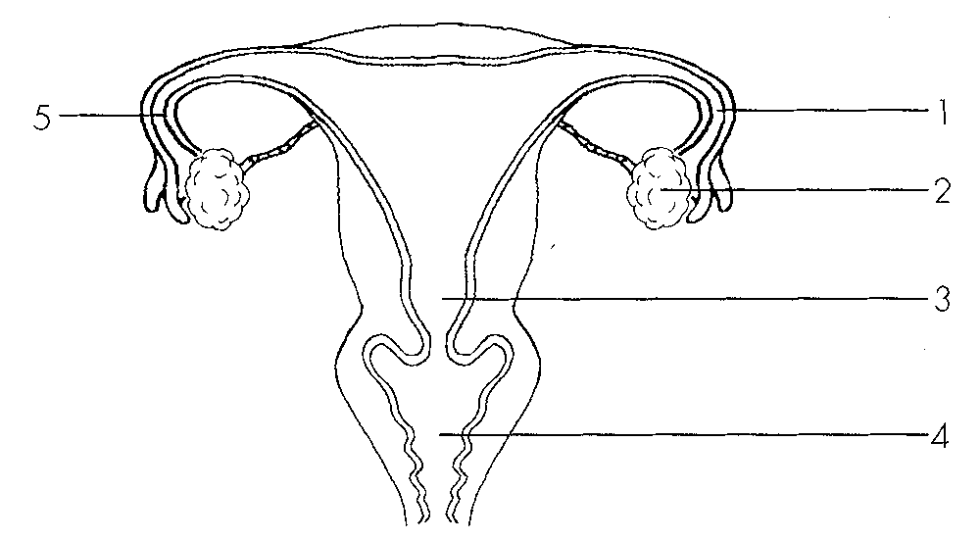
A. (1) and (2) only B. (1) and (3) only C. (2) and (3) only D. (1), (2) and (3) Directions: Questions 87 to 89 refer to the female reproductive system below.
21. The site of action of contraceptive pills is mainly at
A. 1.
B. 2.
C. 3.
D. 4.
22. If the woman wants to achieve contraception by surgical method, where in the reproductive system should be cut and tied?
A. 1
B. 1 and 4
C. 1 and 5
D. 4 and 5
23. The advantage of measuring body temperature in the morning is that
A. if you forget to measure, you still have the chance to measure it later in the day.
B. it is the lowest temperature in the day.
C. it is the highest temperature in the day.
D. it minimizes the effect of air temperature on the measurement.
24. Which of the following contribute to the growth of an organism? (1) Cell division(2) Cell expansion (3) Cell differentiation
A. (1) and (2) only
B. (1) and (3) only
C. (2) and (3) only
D. (1), (2) and (3)
25. Which of the following parameters can be used to measure growth in plants? (1) Height (2) Width (3) Dry mass
A. (1) and (2) only
B. (1) and (3) only
C. (2) and (3) only
D. (1), (2) and (3)
26. The parameter used for the measurement of growth in this experiment is probably
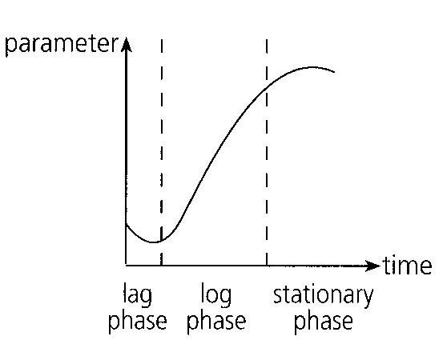
A. height.
B. circumference.
C. fresh mass.
D. dry mass.
27. Which of the following can explain the negative growth during the lag phase of the growth curve? (1)There is net release of carbon dioxide during the lag phase. (2)There is net absorption of water during the lag phase. (3)There is net consumption of food during the lag phase.
A. (3) only
B. (1) and (2) only
C. (1) and (3) only
D. (2) and (3) only
28. Which of the following contribute to the positive growth during the log phase of the growth curve?
(1) Cell division(2) Cell expansion (3) Cell differentiation
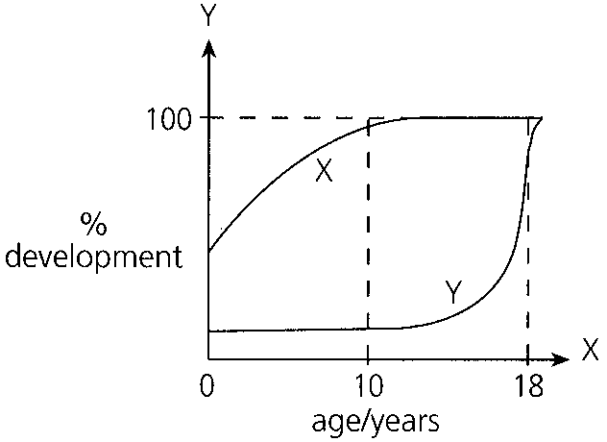
A. (1) and (2) only B. (1) and (3) only C. (2) and (3) only D. (1), (2) and (3) Directions: Questions 111 and 112 refer to the,, following graph which shows the percentage development of two systems in a human body.
29. Which region(s) of the root contribute(s) most to its growth?
A. 1 only
B. 2 only
C. 3 only
D. 4 only
30. Which region of the root contributes most to its development?
A. 1
B. 2
C. 3
D. 4
31. Where do cell division and cell expansion occur in the root?
 | Cell division | Cell expansion
A. | 1 | 2
B. | 2 | 3
C. | 3 | 4
D. | 4 | 1

Part B — Reproduction in humans (YKTo)
32. If structure 9 remains inside the abdomen, which of the following may occur?
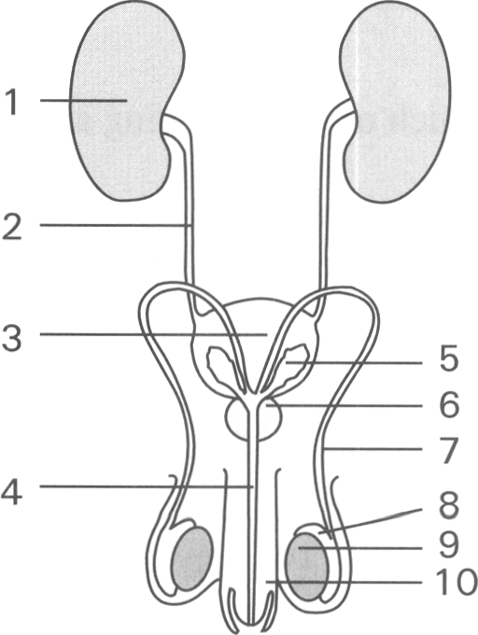
A. No sperms are produced.
B. The sex hormones are denatured at the relatively high body temperature.
C. The sperms produced are inactivated at the relatively high body temperature.
D. Secondary sexual characteristics cannot properly develop.
33. The function of structure 7 is to
A. lead urine to the urinary bladder.
B. pass nerve impulses to the urinary bladder which contracts to expel urine out of the body.
C. lead sperms out of the body.
D. transport nutrients and oxygen to the bladder
34. Which structure(s) can greatly increase its (their) volume(s)?
A. 3 only
B. 10 only
C. 3 and 10 only
D. 1 and 3 only
35. The pathway of the sperms passing out of the body is D. 2 3 4 14 Structure 4 is the passage for (1) sperms. (2) urine. (3) seminal fluid. (4) male sex hormones. A. (1) and (2) only B. (1) and (3) only C. (1), (2) and (3) only D. (1), (2) and (4) only
A. 9 7 4
B. 2 7 4
C. 1 2 4
D. 2 3 4 14 Structure 4 is the passage for (1) sperms. (2) urine. (3) seminal fluid. (4) male sex hormones.
36. Which of the following structures have similar functions in both the male and female reproductive systems?
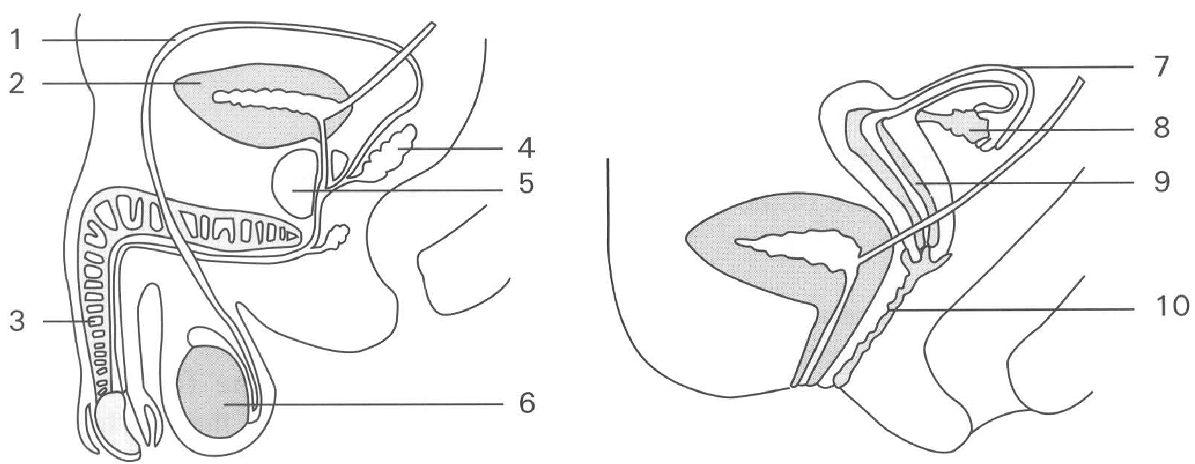
 | Male reproductive system | Female reproductive system
A. | 3 | 7
B. | 1 | 10
C. | 2 | 9
D. | 6 | 8

37. Which structures produce haploid cells?
A. 2, 7
B. 3, 10
C. 4, 5
D. 6, 8
38. Which of the following methods provide permanent contraception?
A. Cut and tie structure 1 present on both sides of the body.
B. Wrap a condom around structure 3 during sexual intercourse.
C. Put an intra-uterine device in structure 9.
D. Put a diaphragm at top of structure 10.
39. In humans gamete II is much bigger than gamete I because it
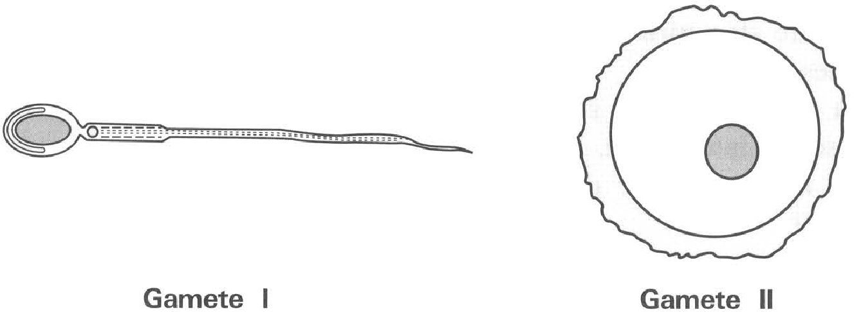
A. contains more food reserve.
B. contains more chromosomes.
C. contains more mitochondria.
D. dose not need to move away from the ovary.
40. Humans produce relatively few viable eggs. Each egg mother cell undergoes two consecutive divisions to produce four daughter cells of which only one remains viable as the egg while the other three degenerate. The number of chromosomes in this viable egg is
A. Four times that in the egg mother cell.
B. Twice of that in the egg mother cell.
C. Equal to that in the egg mother cell.
D. Half of that in the egg mother cell.
41. A zygote is different from an ovum in that it has
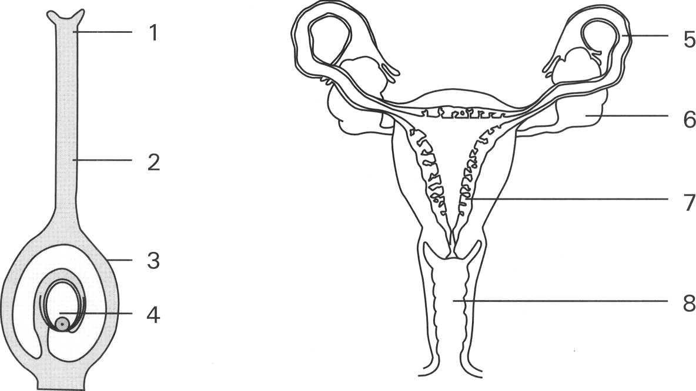
A. replicated its chromosomes. B. more cytoplasm.
C. two nuclei while ovum has one nucleus only
D. diploid number of chromosomes while the ovum is haploid Directions: Questions 37 and 38 refer to the diagrams below which show the carpel of a flowering plant and the female reproductive system of humans.
42. At what age range does structure 5 remain functioning ? A. Age 6 to 12 B. Age 12 to 18 C. Age 14 to 55 D. Age 55 to 70 43Fertilization of the egg usually takes place in
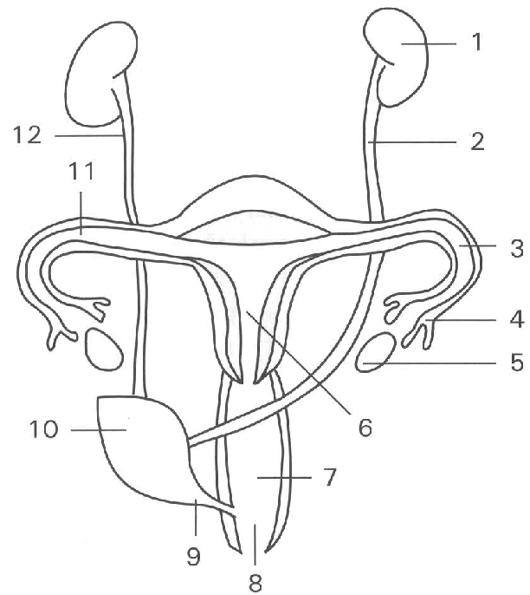
A. 3
B. 4
C. 5
D. 6
43. Which of the following process(es) will stop during pregnancy?
(1) ovulation (2) menstruation (3) production of female sex hormones by ovaries
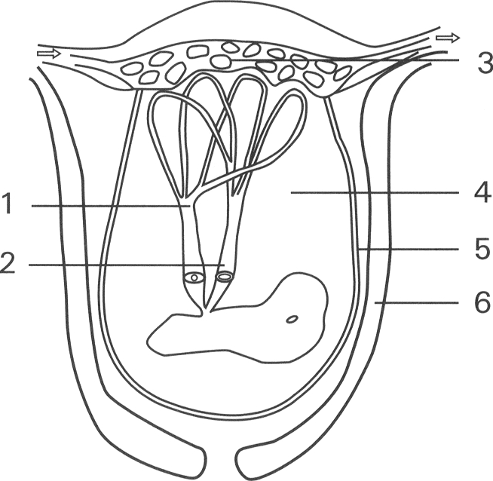
A. (1) and (2) only B. (2) and (3) only C. (1) and (3) only D. (1), (2) and (3) Directions: Questions 66 to 70 refer to the diagram below which shows the structure linked to the foetus.
44. Which labelled parts of the grain develops from a fertilised ovum?
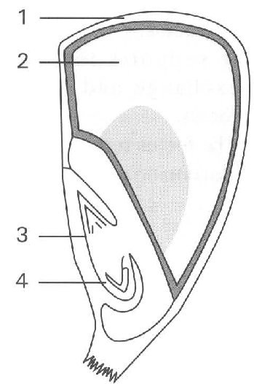
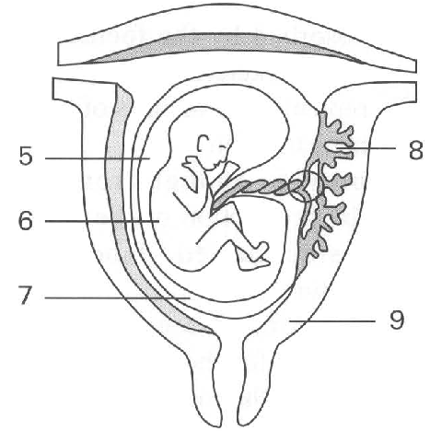
A. 2 only
B. 3 only
C. 4 only
D. 3 and 4 only
45. Which of the following about twins is CORRECT?
A. All twins must have the same sex.
B. All twins must be genetically identical.
C. Fraternal twins are formed by having two sperms fertilised two separate eggs.
D. Onece a woman has borned a pair of identical twins, she cannot give birth to fraternal twins in future.
46. Mothers are encouraged to give breastfeeding to their babies because- (1) breast-feeding provides intimate relationship between the mother and the baby. (2) mother's milk contains antibodies that provide passive immunity to the baby against diseases. (3) mother's milk provides a relatively balanced diet to the baby. (4) mother's milk contains enzymes to enhance digestion of food in the baby.
A. (1) and (2) only
B. (2) and (3) only
C. (3) and (4) Only
D. (1), (2) and (3) only
47. Which of the following about breast-feeding is INCORRECT?
A. This saves money to buy milk powder.
B. This saves the trouble of cleaning the milk bottles and their accessories.
C. This will not affect those women who have to leave home to work.
D. This increases the resistance of the babies to infection because of the presence of antibodies in the mother's milk.
48. The following are methods of birth control:
(1) Condom (2) Cut and tie the sex ducts (3) Timing of sexual intercourse in the menstrual cycle (4) Contraceptive pills (5) Diaphragm
Which of the following combinations of the categories of the methods of birth control is CORRECT?
 | Rhythm method | Hormonal method | Surgical method | Mechanical barrier method
A. | (1), (2) | (3) | (5) | (4)
B. | (3) | (4) | (2) | (1), (5)
C. | (3) | (4) | (2) | (1), (5)
D. | (4) | (3) | (1), (5) | (2)

49. The diagram below shows a device used for contraception.
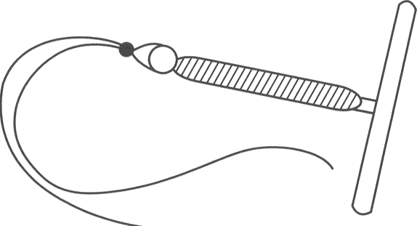
A. It prevents the ejaculation of semen in the vagina.
B. It prevents the sperms from passing through the cervix to the uterus.
C. It prevents the sperms from passing from the uterus into the oviduct.
D. It prevents the sperms from entering the ovary.
50. Which of the following caused infertility in humans is/are NOT TRUE? (1) Blockage of the urethra in woman (2) Blockage of oviduct (3) Low sperm count (4) No ovulation
A. (1) only
B. (2) and (3) only
C. (3) and (4) only
D. (2), (3) and (4) only
Part C — Reproduction in flowering plants (YKTo)
51. The following events occur in the asexual reproduction of bacteria. Which is the CORRECT sequence? (1) Division of the genetic material into two groups to form two daughter nuclei. (2) Replication of genetic material. (3) Division of the cytoplasm into two portions with a cell wall formed between them. D. (2), (3), (1) 5Which of the following concerning binary fission is/are CORRECT? (1) It is a type of cell division to produce gametes. (2) It is commonly found in unicellular organisms. (3) It usually occurs under adverse condition. B. (2) only C. (3) only D. (1) and (2) only 6Which of the following comparisons between the binary fission of bacteria and seed formation of Hibiscus is CORRECT? 7Which of the following sets concerning the perennating organs is CORRECT? Directions: Questions 8 to 10 refer to the photographs below which show structure W and the aerial parts X,Y and Z produced by it.
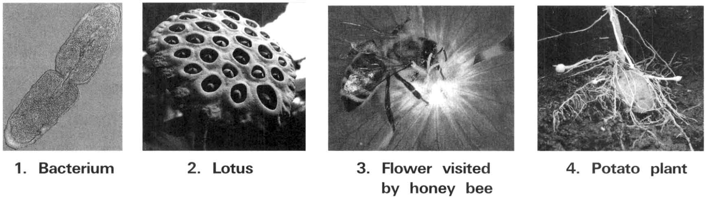
 | Binary fission of bacteria | Seed formation of Hibiscus
A. | It involves two sexes. | It involves one sex only.
B. | No gametes are needed. | Involves fusion of gametes.
C. | Offspring are genetically different from parents. | Offspring are genetically identical from parents.
D. | No replication of chromosomes. | Involves replication of chromosomes.

 | Perennating organ | Origin | Examples
A. | Rhizome | Underground root | Ginger
B. | Stem tuber | Root tip | Carrot
C. | Bulb | Condensed shoot | Onion
D. | Corm | Underground shoot | Potato

A. (2), (1), (3)
B. (3), (1), (2)
C. (1), (2), (3)
A. (1) only
52. Which labelled structure(s) contain(s) food reserve that enables the plant to go through adverse conditions?
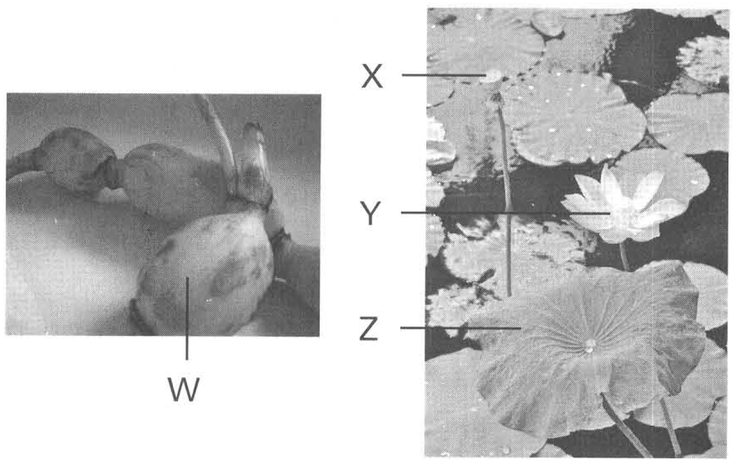
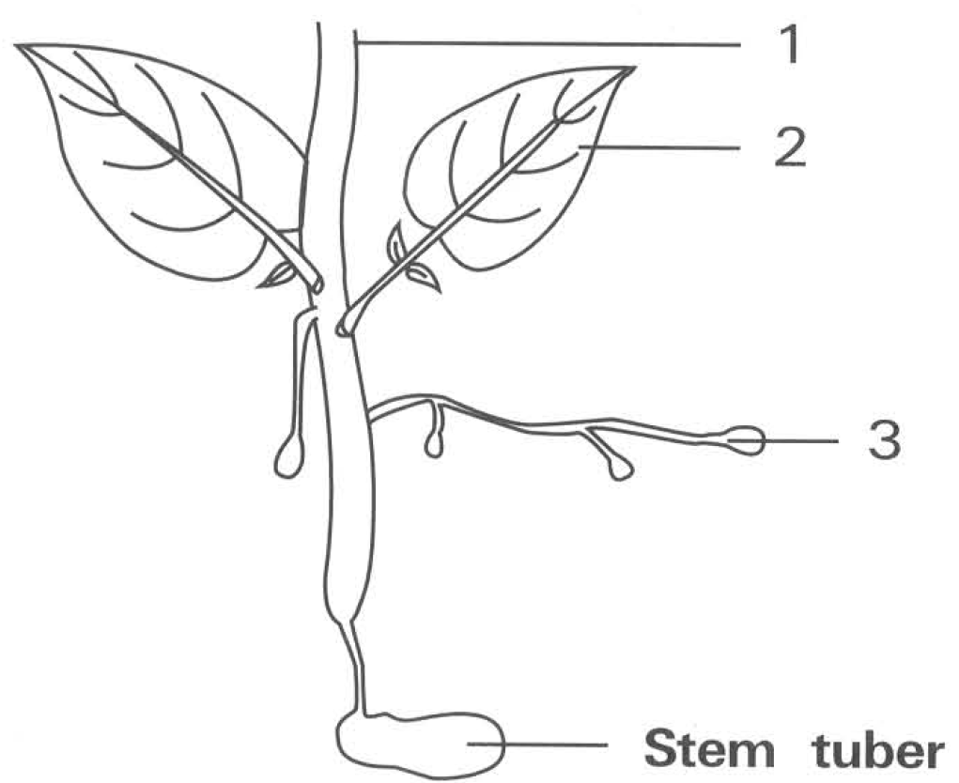
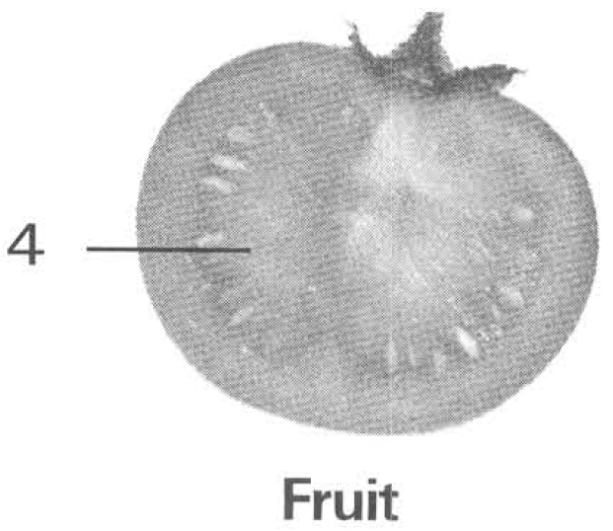
 | Structure W | Structure Y
(1) | Develops offspring without depending on external agent. | Develops offspring depending on external agent.
(2) | Produce genetic variations in offspring. | No genetic variations in offspring produced.
(3) | Avoids overcrowding by providing means of dispersal. | No means of dispersal to avoid overcrowding.

A. W only B. X only C. Y only D. W and X only 9Which labelled parts carry out meiosis?
A. W only B. X only C. Y only D. Z only 10 Structures W and Y carry out two different methods of reproduction. Which of the following comparisons between these two methods of reproduction is/are CORRECT?
A. (1) onlyB. (2) only C. (3) only D. (1) and (2) only Directions: Questions 11 to 13 refer to the diagram and photograph below which show an aerial shoot developing from a potato tuber and the fruit produced by it. 11Which labelled structure is genetically different from the parent tuber?
A. 1 B. 2 C. 3 D. 4
53. Which labelled structure(s) has/have food reserve that can support the development of future plants?
A. 1 only
B. 3 only
C. 4 only
D. 3 and 4 only
54. Which of the following are advantages of using this method to produce large number of plants? (1) It does not depend on external agents. (2) All desirable characteristics can be transmitted to offspring. (3) Produces genetic variations. (4) Saves space to reduce the problem of overcrowding.
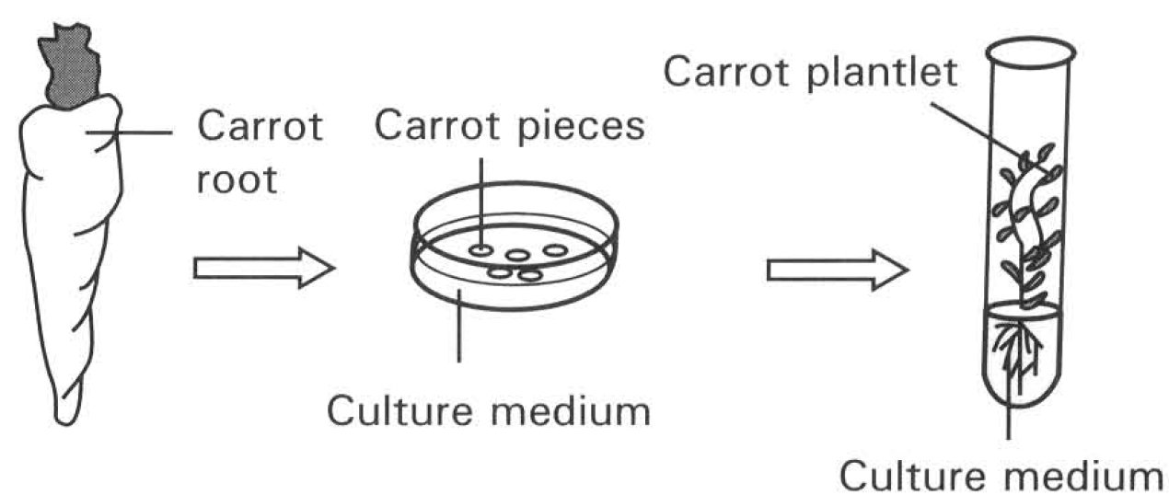
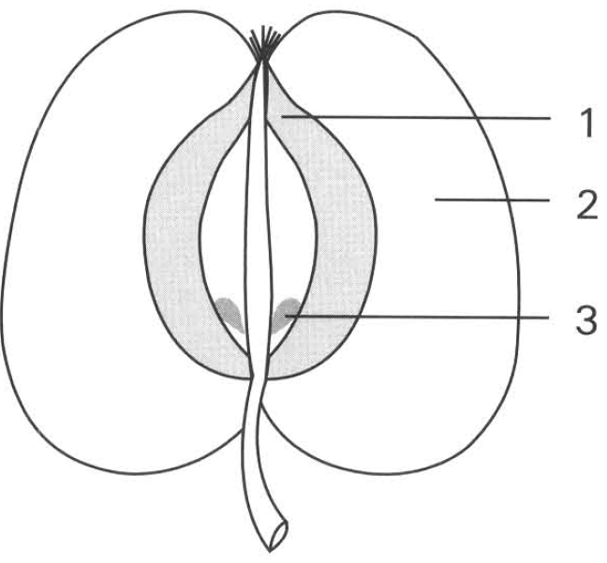
A. (1) and (2) only
B. (2) and (3) only
C. (3) and (4) only
D. (4) and (1) only
55. Which of these structures produce offspring by seeds development?
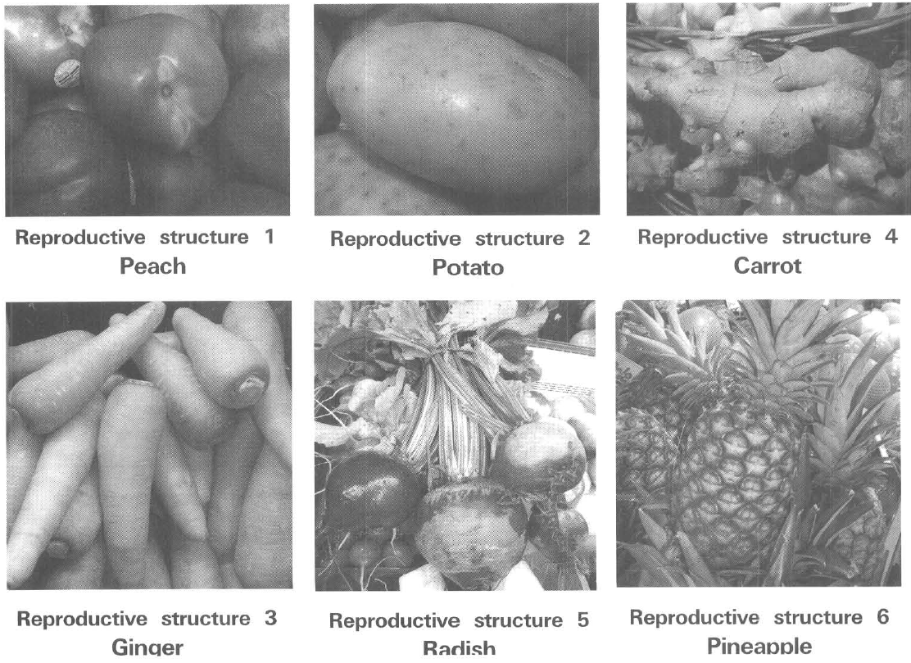
A. 1 and 2 only
B. 2 and 3 only
C. 4 and 5 only
D. 1 and 6 only
56. Which of the following sequences of events about the sexual reproduction of a flowering plant is CORRECT?
(1) Meiosis in gamete formation (2) Growth of pollen tube through the style
(3) fertilisation (4) Pollination (5) Seed dispersal
(6) Mitosis in the growth of the embryo
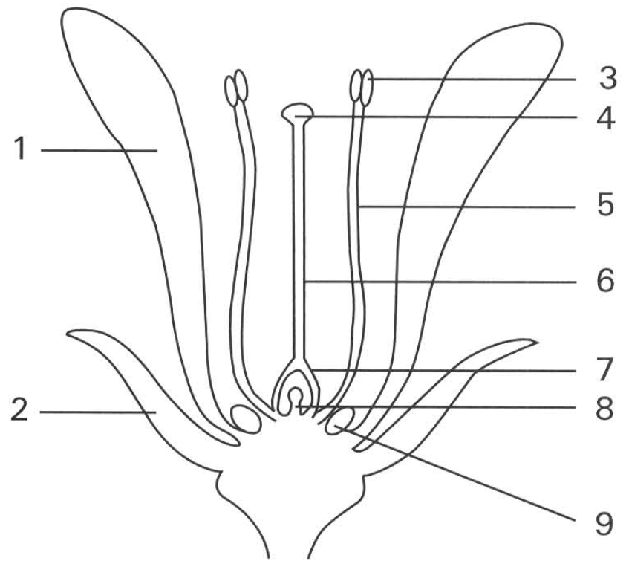
A. (1),(4),(6),(3),(2),(5) B. (1),(4),(2),(3),(6),(5)
C. (4),(1),(3),(2),(5),(6) D. (4),(1),(2),(3),(5),(6) Directions: Questions 25 to 32 to refer the diagram below which shows the structure of a flower.
57. | 4 | 5 | 6 | A. | Stamen | Stigma | Style | Filament | B. | Stigma | Anther | Filament | Style | C. | Stamen | Stigma | Style | Filament | D. | Anther | Stigma | Filament | Style
58. Which of the following combinations TRULY represents the features found in a wind-pollinated flower?
 | Size of 1 | Position of 3 and 4 | Structure 9
A. | Very big | Confined inside the corolla | Very big
B. | Greatly reduced | Protruded out of the corolla | Absent
C. | Very big | Protruded out of the corolla | Very big
D. | Greatly | Confined inside reduced the corolla | Absent

59. Which of the following structures contain haploid cells? D. 3 and 5 only 30 Structure 3 contains a mass of yellow grains. Each of these grains contrains A. two sperm nuclei. B. an ovum. C. a zygote. D. a seed.
A. 3 and 8 only
B. 4 and 6 only
C. 5 and 7 only
D. 3 and 5 only 30 Structure 3 contains a mass of yellow grains. Each of these grains contrains
60. If cross-fertilisation has occurred, where on this flower has the pollen grains come from?
A. 3
B. 4
C. 8
D. None of these
61. Which structures have functions similar to the testis and ovary of a mammal?
 | Testis | Ovary
A. | 3 | 4
B. | 4 | 9
C. | 3 | 7
D. | 4 | 8

62. Which of the following is/are the function(s) of the style in a flower?
(1) To act as a reservoir for storing pollen grains.
(2) To act as a place where fertilisation takes place.
(3) To provide a passage and nutrients for the growth of pollen tubes to the ovules.
(4) To support the anthers to facilitate the trapping of pollen grains from air.
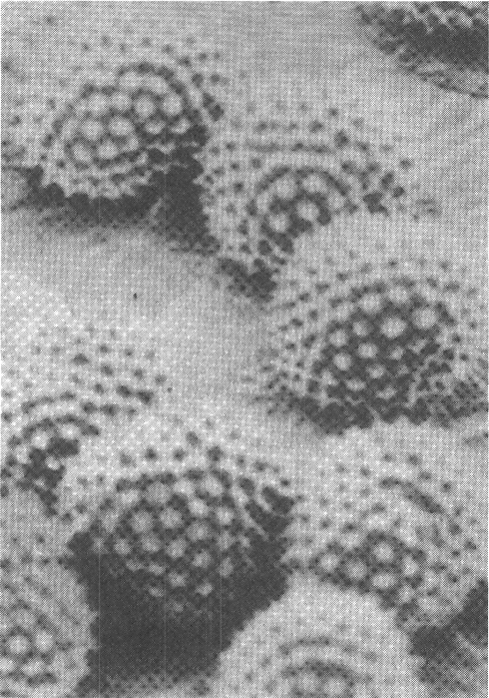
A. (1) only B. (3) only C. (1) and (2) only D. (3) and (4) only Directions: Questions 34 and 35 refer to the photograph below which show the pollen grains of a flowering plant.
63. Which structure is NOT a specific adaptation to insect pollination?
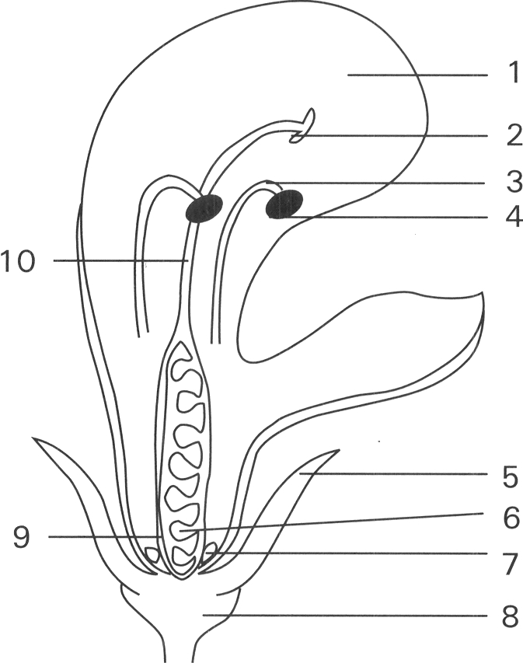
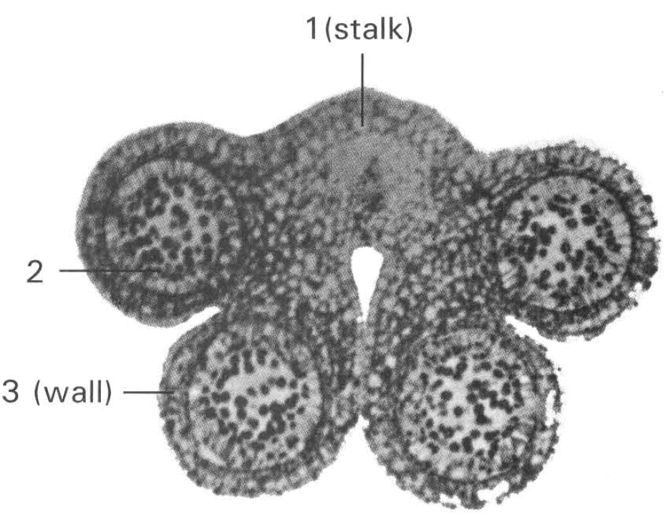
A. 1
B. 7
C. 9
D. 2
64. Which structure becomes the seed after fertilisation has taken place? D. 9 only 48Which labelled parts will increase greatly in size after fertilisation ? A. 1 and 7 only B. 4 and 8 only C. 6 and 9 only D. 7 and 8 only
A. 2 only
B. 4 only
C. 6 only
D. 9 only 48Which labelled parts will increase greatly in size after fertilisation ?
65. Many flowering plants have structures to ensure cross-pollination rather than self-pollination because the former
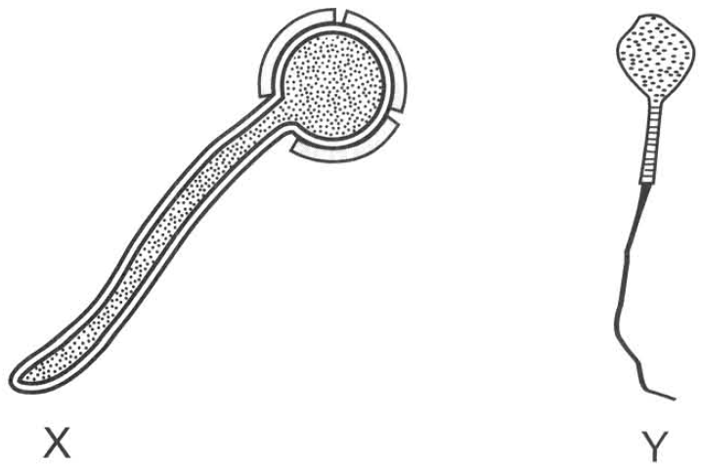
A. is a simpler process.
B. can make use of the external agents to bring about pollination.
C. produces more genetic variations.
D. saves more male gametes. Directions: Questions 57 and 58 refer to diagrams X and Y which show a pollen grain with a pollen tube growing out and a human sperm.
66. Pollen grain X fails to develop on the stigma of this carpel. Which of the following is a probable explanation?
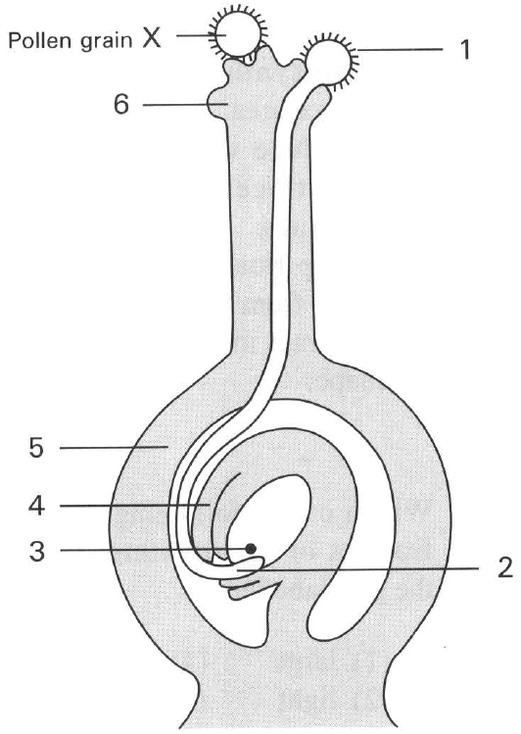
A. It is too big to enter the style of the carpel.
B. It does not belong to the same species as that of the carpel.
C. It has no sperm nuclei inside.
D. It has died by the time it reaches the stigma.
67. After fertilisation which labelled part will develop into seed and fruit respectively?
 | Seed | Fruit
A. | 4 | 5
B. | 3 | 4
C. | 5 | 4
D. | 4 | 3

68. Which of the following structures are genetically different? (1) The pollen grains and ova of the same flower. (2) The petals and sepals of the same flower. (3) Seeds in the same orange. (4) The corm and the petals of the Gladiolus flower developing from it
A. (1) and (3) only
B. (2) and (3) only
C. (3) and (4) only
D. (4) and (1) only
69. Which of the following matching is CORRECT?
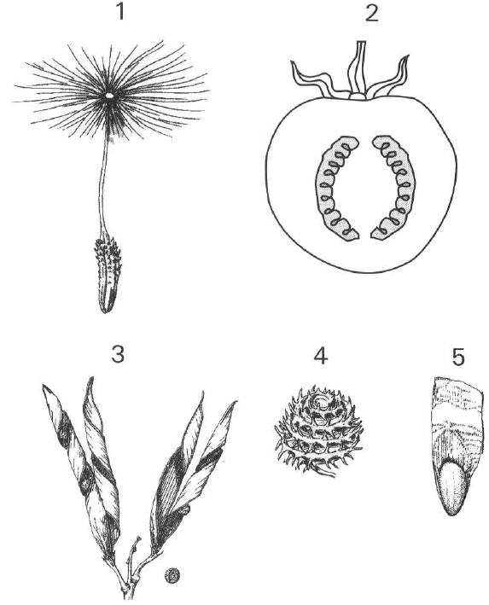
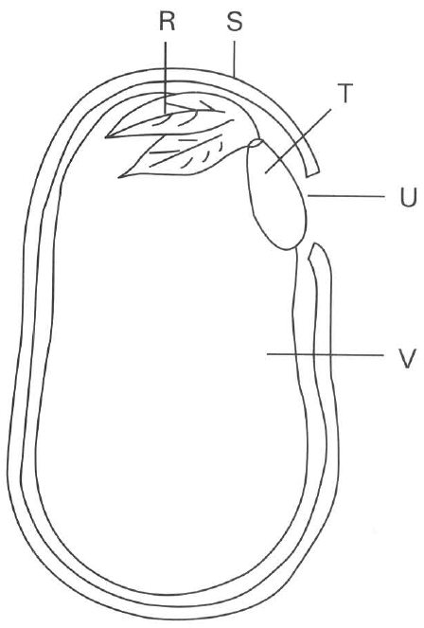
 | S | R | T | V
A. | Fruit wall | Plumule | Radicle | Endosperm
B. | Testa/seed coat | Plumule | Radicle | Cotyledon
C. | Testa/seed coat | Radicle | Plumule | Endosperm
D. | Fruit wall | Plumule | Radicle | Cotyledon

Part D — Growth (YKTo)
70. According to the results, what conditions are needed for seeds to germinate.
A. Water and light only
B. Oxygen and light only
C. Water and oxygen only
D. Oxygen and warmth only
71. Which two tubes are used to investigate the need of oxygen for seed germination?
A. Tube A and tube B only B. Tube B and tube C only
C. Tube B and tube D only D. Tube A and tube C only
72. What is the purpose of the above experiment?
A. To show that carbon dioxide is produced by the living seeds.
B. To show that carbon dioxide is absorbed by the plant tissues in the presence of light.
C. To show that water is essential to germination.
D. To show that oxygen is essential to germination.
73. Which of the following is the conclusion that can be drawn from the above results?
A. The years of storage of seeds do not affect the viability of the seeds.
B. Dry environment is better than moist environment for the storage of seeds.
C. Cold condition is more favourable to warm condition for the storage of seeds.
D. No valid conclusion can be drawn.
74. Which of the following is/are the difference(s) of the embryo of a seed from that of a mammal?
(1) It develops outside the parent's body.
(2) It can remain in a dormant form when the external conditions are unfavourable to its development.
(3) It depends on the nutrients absorbed from the surrounding to support its development.
 | Dry mass(g)
Components | Seeds | Seedlings formed after germination in darkness
Sugars | 6.3 | 18.0
Cellulose | 4.4 | 13.6
Fats | 85.2 | 31.2
Simple proteins | 20.6 | 10.2
Others | 23.9 | 48.1
Total day mass | 140.4 | 121.1

A. (1) only B. (2) only C. (1) and (2) only D. (2) and (3) only Directions: Questions 15.18 to 15.20 refer to the table below which shows the changes in the dry mass of the different components of seeds before and after germination in darkness.
75. Which of the following is NOT the function of structure W?
A. Prevents the entry of bacteria and fungi into the seed.
B. Protects the seed content against adverse environmental conditions.
C. Prevents the loss of water from the seed content to air.
D. Promotes the dispersal of the seed.
76. The development of the seedling up to the stage shown in the diagram initially depends on the food supplied by
A. the absorption of mineral salts from soil by Z.
B. the consumption of the food reserve in Y.
C. the absorption of nitrogen gas from air by X.
D. the photosynthetic activities of W
77. The increase in dry mass of sample N from day 12th to day 28th was due to
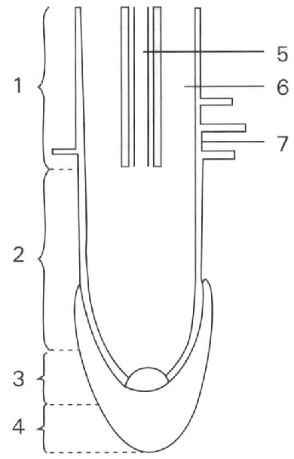
A. the translocation of the reserved food from the storage regions into the plumules.
B. the photosynthetic activities of the foliage leaves just emerging from soil.
C. the absorption of water by the root system of the seedling.
D. the production of new offspring by the seedings. Directions: Questions 15.33 to 15.36 refer to the diagram below which shows the longitudinal section of a root tip.
78. Which of the following criteria can be used to measure the rate of growth in flowering plant? (1) Dry mass (2) Wet mass (3) Length (4) Number of cells (5) Area
A. (1), (2) and (3) only
B. (1), (2) and (4) only
C. (1), (3) and (4) only
D. (1), (2), (3) and (5) only
79. The growth rate of a herbaceous flowering plant is most accurately obtained by measuring the change in
A. the height of the plant.
B. the total surface area of the leaves of the plant.
C. the dry mass of the plant.
D. the wet mass of the plant.

Answers
Answers are printed in red.
1. B
Class: 72.2% correct (n=97) usual slip D
2. A. (1) and (2) only
Class: 79.2% correct (n=130) usual slip D
3. C
Class: 79.7% correct (n=172) usual slip D
4. C. rhizome.
Class: 72.9% correct (n=199) usual slip A
5. C. (2) and (3) only
Class: 59.6% correct (n=89) usual slip A
6. D. 8
Class: 50.0% correct (n=88) usual slip C
7. D. (1), (2) and (3)
Class: 70.9% correct (n=55) usual slip A
8. D
Class: 80.2% correct (n=96) usual slip A
9. B
Class: 65.5% correct (n=55) usual slip D
10. B. 2
Class: 34.5% correct (n=55) usual slip A
11. D. (2) and (3) only
Class: 51.8% correct (n=83) usual slip A
12. B. The whole sperm cell fuses with an ovum during fertilisation.
Class: 67.3% correct (n=55) usual slip A
13. D. The cycle is 28day long.-
Class: 35.1% correct (n=37) usual slip C
14. C. Structure 4 is responsible for menstruation.
Class: 70.8% correct (n=65) usual slip B
15. B
Class: 70.3% correct (n=37) usual slip C
16. C. (2), (3), (5), (4), (1)
Class: 80.0% correct (n=65) usual slip D
17. A. (1) and (2) only
Class: 56.8% correct (n=37) usual slip D
18. B. (3), (2), (1), (4)
Class: 79.1% correct (n=67) usual slip D
19. D. (1), (2) and (3)
Class: 56.7% correct (n=67) usual slip A
20. D
Class: 77.6% correct (n=67) usual slip C
21. B. 2.
Class: 55.2% correct (n=67) usual slip A
22. C. 1 and 5
Class: 43.3% correct (n=67) usual slip A
23. B. it is the lowest temperature in the day.
Class: 56.8% correct (n=37) usual slip D
24. A. (1) and (2) only
Class: 75.7% correct (n=37) usual slip D
25. D. (1), (2) and (3)
Class: 62.2% correct (n=37) usual slip B
26. D. dry mass.
Class: 64.9% correct (n=37) usual slip C
27. C. (1) and (3) only
Class: 16.2% correct (n=37) usual slip A
28. A. (1) and (2) only B. (1) and (3) only C. (2) and (3) only D. (1), (2) and (3) Directions: Questions 111 and 112 refer to the,, following graph which shows the percentage development of two systems in a human body.
Class: 59.5% correct (n=37) usual slip D
29. C. 3 only
Class: 67.6% correct (n=37) usual slip B
30. D. 4
Class: 78.4% correct (n=37) usual slip C
31. B
Class: 78.4% correct (n=37) usual slip A
32. C. The sperms produced are inactivated at the relatively high body temperature.
Class: 73.1% correct (n=130) usual slip B
33. C. lead sperms out of the body.
Class: 79.4% correct (n=34) usual slip B
34. C. 3 and 10 only
Class: 67.3% correct (n=55) usual slip B
35. A. 9 7 4
Class: 36.4% correct (n=55) usual slip B
36. D
Class: 76.1% correct (n=88) usual slip B
37. D. 6, 8
Class: 70.6% correct (n=34) usual slip B
38. A. Cut and tie structure 1 present on both sides of the body.
Class: 76.4% correct (n=55) usual slip C
39. A. contains more food reserve.
Class: 72.9% correct (n=96) usual slip B
40. D. Half of that in the egg mother cell.
Class: 64.7% correct (n=34) usual slip A
41. D. diploid number of chromosomes while the ovum is haploid Directions: Questions 37 and 38 refer to the diagrams below which show the carpel of a flowering plant and the female reproductive system of humans.
Class: 80.0% correct (n=55) usual slip C
42. C. 5
Class: 60.7% correct (n=28) usual slip B
43. A. (1) and (2) only B. (2) and (3) only C. (1) and (3) only D. (1), (2) and (3) Directions: Questions 66 to 70 refer to the diagram below which shows the structure linked to the foetus.
Class: 67.9% correct (n=28) usual slip B
44. D. 3 and 4 only
Class: 53.6% correct (n=28) usual slip A
45. C. Fraternal twins are formed by having two sperms fertilised two separate eggs.
Class: 78.4% correct (n=37) usual slip D
46. D. (1), (2) and (3) only
Class: 45.9% correct (n=37) usual slip A
47. C. This will not affect those women who have to leave home to work.
Class: 76.1% correct (n=67) usual slip B
48. B
Class: 63.3% correct (n=30) usual slip C
49. B. It prevents the sperms from passing through the cervix to the uterus.
Class: 76.7% correct (n=30) usual slip C
50. A. (1) only
Class: 76.1% correct (n=67) usual slip D
51. A. (1) only
Class: 33.3% correct (n=15) usual slip D
52. D
Class: 69.4% correct (n=111) usual slip A
53. D. 3 and 4 only
Class: 75.0% correct (n=76) usual slip B
54. A. (1) and (2) only
Class: 61.8% correct (n=110) usual slip B
55. D. 1 and 6 only
Class: 72.0% correct (n=75) usual slip C
56. B
Class: 71.6% correct (n=67) usual slip D
57. D
Class: 59.5% correct (n=42) usual slip C
58. B
Class: 22.0% correct (n=41) usual slip D
59. A. 3 and 8 only
Class: 54.1% correct (n=74) usual slip C
60. D. None of these
Class: 58.8% correct (n=34) usual slip A
61. C
Class: 73.3% correct (n=75) usual slip B
62. B
Class: 50.7% correct (n=67) usual slip A
63. C. 9
Class: 23.5% correct (n=34) usual slip A
64. C. 6 only
Class: 14.5% correct (n=55) usual slip B
65. C. produces more genetic variations.
Class: 80.0% correct (n=55) usual slip A
66. B. It does not belong to the same species as that of the carpel.
Class: 69.9% correct (n=83) usual slip A
67. A
Class: 62.2% correct (n=37) usual slip C
68. A. (1) and (3) only
Class: 75.0% correct (n=28) usual slip C
69. B
Class: 24.3% correct (n=37) usual slip D
70. C. Water and oxygen only
Class: 66.7% correct (n=96) usual slip B
71. B
Class: 78.9% correct (n=256) usual slip C
72. D. To show that oxygen is essential to germination.
Class: 70.2% correct (n=124) usual slip A
73. B. Dry environment is better than moist environment for the storage of seeds.
Class: 79.4% correct (n=34) usual slip C
74. C
Class: 76.4% correct (n=89) usual slip B
75. D. Promotes the dispersal of the seed.
Class: 62.2% correct (n=90) usual slip C
76. B. the consumption of the food reserve in Y.
Class: 50.0% correct (n=34) usual slip D
77. B. the photosynthetic activities of the foliage leaves just emerging from soil.
Class: 78.8% correct (n=33) usual slip D
78. D. (1), (2), (3) and (5) only
Class: 21.8% correct (n=55) usual slip A
79. C. the dry mass of the plant.
Class: 49.1% correct (n=55) usual slip B

Class percentage correct
Matched to this paper by question wording in the source bank and the form answer key, not by a shifted paper number.
Q | Answer | % correct | n | Usual slip
1 | B | 72.2% | 97 | D
2 | A | 79.2% | 130 | D
3 | C | 79.7% | 172 | D
4 | C | 72.9% | 199 | A
5 | C | 59.6% | 89 | A
6 | D | 50.0% | 88 | C
7 | D | 70.9% | 55 | A
8 | D | 80.2% | 96 | A
9 | B | 65.5% | 55 | D
10 | B | 34.5% | 55 | A
11 | D | 51.8% | 83 | A
12 | B | 67.3% | 55 | A
13 | D | 35.1% | 37 | C
14 | C | 70.8% | 65 | B
15 | B | 70.3% | 37 | C
16 | C | 80.0% | 65 | D
17 | A | 56.8% | 37 | D
18 | B | 79.1% | 67 | D
19 | D | 56.7% | 67 | A
20 | D | 77.6% | 67 | C
21 | B | 55.2% | 67 | A
22 | C | 43.3% | 67 | A
23 | B | 56.8% | 37 | D
24 | A | 75.7% | 37 | D
25 | D | 62.2% | 37 | B
26 | D | 64.9% | 37 | C
27 | C | 16.2% | 37 | A
28 | A | 59.5% | 37 | D
29 | C | 67.6% | 37 | B
30 | D | 78.4% | 37 | C
31 | B | 78.4% | 37 | A
32 | C | 73.1% | 130 | B
33 | C | 79.4% | 34 | B
34 | C | 67.3% | 55 | B
35 | A | 36.4% | 55 | B
36 | D | 76.1% | 88 | B
37 | D | 70.6% | 34 | B
38 | A | 76.4% | 55 | C
39 | A | 72.9% | 96 | B
40 | D | 64.7% | 34 | A
41 | D | 80.0% | 55 | C
42 | C | 60.7% | 28 | B
43 | A | 67.9% | 28 | B
44 | D | 53.6% | 28 | A
45 | C | 78.4% | 37 | D
46 | D | 45.9% | 37 | A
47 | C | 76.1% | 67 | B
48 | B | 63.3% | 30 | C
49 | B | 76.7% | 30 | C
50 | A | 76.1% | 67 | D
51 | A | 33.3% | 15 | D
52 | D | 69.4% | 111 | A
53 | D | 75.0% | 76 | B
54 | A | 61.8% | 110 | B
55 | D | 72.0% | 75 | C
56 | B | 71.6% | 67 | D
57 | D | 59.5% | 42 | C
58 | B | 22.0% | 41 | D
59 | A | 54.1% | 74 | C
60 | D | 58.8% | 34 | A
61 | C | 73.3% | 75 | B
62 | B | 50.7% | 67 | A
63 | C | 23.5% | 34 | A
64 | C | 14.5% | 55 | B
65 | C | 80.0% | 55 | A
66 | B | 69.9% | 83 | A
67 | A | 62.2% | 37 | C
68 | A | 75.0% | 28 | C
69 | B | 24.3% | 37 | D
70 | C | 66.7% | 96 | B
71 | B | 78.9% | 256 | C
72 | D | 70.2% | 124 | A
73 | B | 79.4% | 34 | C
74 | C | 76.4% | 89 | B
75 | D | 62.2% | 90 | C
76 | B | 50.0% | 34 | D
77 | B | 78.8% | 33 | D
78 | D | 21.8% | 55 | A
79 | C | 49.1% | 55 | B

