Respiration
Multiple-choice practice
Name: ________________________ Class: ____________
There are 122 questions compiled from Longman HKCEE and/or YKTo papers. Choose the one best answer.
Part A — HKCEE level (Longman)
1. Which of the following comparisons between burning and respiration is not true?
 | Burning | Respiration
A. | uses oxygen | may not use oxygen
B. | releases energy from inorganic substances only | releases energy from organic substances only
C. | does not require enzymes | requires enzymes
D. | is a singlestep reaction- | is a series of reactions

2. The energy which is released in both burning and respiration is
A. ATP. B. heat energy. C. chemical energy. D. solar energy.
3. Respiration is (1) an energy releasing process. (2) a reduction reaction. (3) catalysed by one single enzyme.(4) a single step reaction.-
A. (1) only
B. (1) and (2) only
C. (3) and (4) only
D. (1), (3) and (4) only
4. Which of the following statements about respiration is/are correct? (1) It occurs in all living cells. (2) It always consumes oxygen. (3) It releases energy only in the form of ATP.
A. (1) only
B. (1) and (2) only
C. (2) and (3) only
D. (1), (2) and (3)
5. Which of the following equations best represents the overall process of aerobic respiration?
A. P → Q-
B. P → Q+R-
C. P + Q →R-
D. P + Q→R+S-
6. Respiration in a green leaf takes place
A. during daytime.
B. at night.
C. when photosynthesis stops.
D. all the time.
7. What is the main function of respiration in a potted plant which is placed under sunlight?
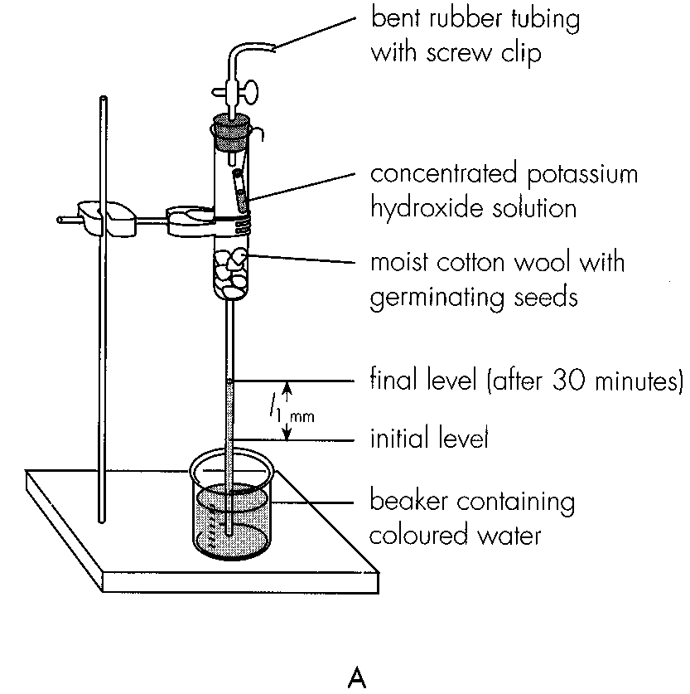
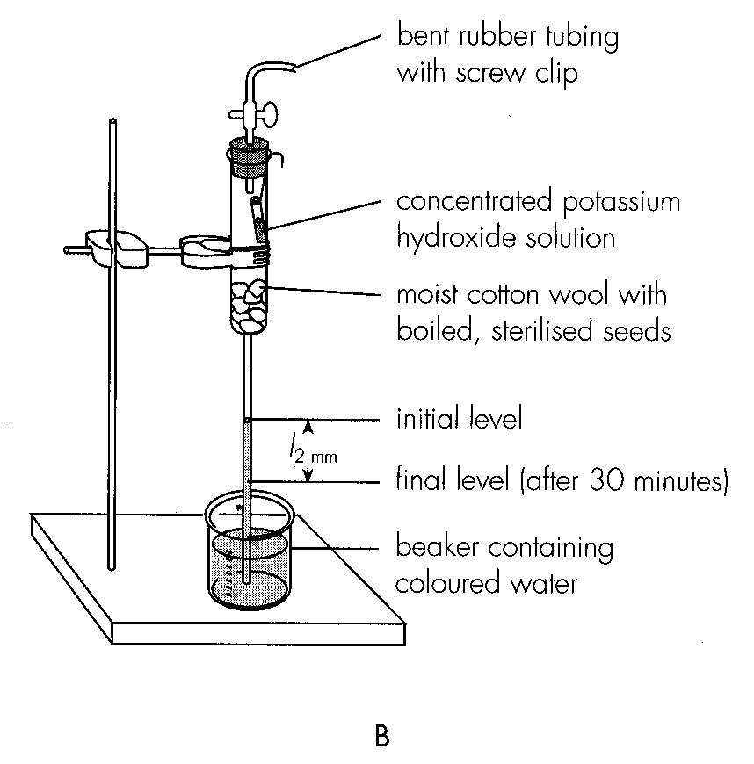
A. To release energy for sustaining metabolic activities.
B. To produce carbon dioxide for photosynthesis. C.To produce metabolic water for compensating the water loss in transpiration.
D. To use up excess sugars produced in photosynthesis. Directions: Questions 8 to 11 refer to the diagram below which shows an experiment to investigate the rate of respiration of germinating seeds.
8. It is better to set the initial water level near the middle of the glass tubing. Which of the following provides the best explanation for this? A.It will be very difficult to draw the water up if the initial level is set too low. B.There will be too little air left in the glass container if the initial level is set too high. C.It will be easier to observe changes in the water level in either direction. D.It is a rule to follow in this kind of experiment.
A. It will be very difficult to draw the water up if the initial level is set too low.
B. There will be too little air left in the glass container if the initial level is set too high.
C. It will be easier to observe changes in the water level in either direction.
D. It is a rule to follow in this kind of experiment.
9. The use of concentrated potassium hydroxide solution is to
A. absorb oxygen in the glass container.
B. absorb carbon dioxide released by the germinating seeds.
C. absorb water vapour in the glass container.
D. show that carbon dioxide is released by the germinating seeds.
10. The movement of the coloured water in set up B is due to
A. an increase in atmospheric pressure.
B. an increase in environmental temperature.
C. the heat produced by microorganisms. -
D. the oxygen produced by micro organisms.-
11. If the cross sectional area of the capillary tube is C mm-2, the rate of respiration of the germinating seeds is:
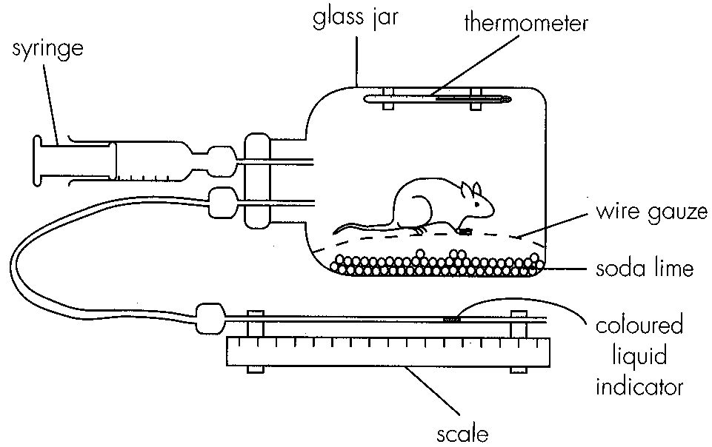
A. C x (l 1 + l2) mm3 hr1- B. 2 x C x l 1 mm3 hr1-
C. 2 x C x (l1 + l2) mm3 hr1- D. 2 x C x (l 1 – l2) mm3 hr1- Directions: Questions 12 to 15 refer to the experimental setup below which measures the rate of respiration of a small mammal.-
12. What is being measured to represent the rate of respiration?
A. The rate of oxygen uptake
B. The rate of carbon dioxide production
C. The rate of heat production
D. The rate of food oxidation
13. Which of the following external factors may affect the results of the experiment? (1) Light intensity (2) External temperature (3) Atmospheric pressure (4) Relative humidity
A. (1) and (2) only
B. (1) and (4) only
C. (2) and (3) only
D. (2), (3) and (4) only
14. Assuming that the external conditions were kept constant, the volume of the gas inside remained unchanged when the soda lime was removed. Which of the following provides the best explanation for this observation? C.The animal carried out anaerobic respiration. D.None of the above
A. The animal died of suffocation.
B. The amount of oxygen consumed by the animal equalled the amount of carbon dioxide produced.
C. The animal carried out anaerobic respiration.
D. None of the above
15. The use of the syringe is to
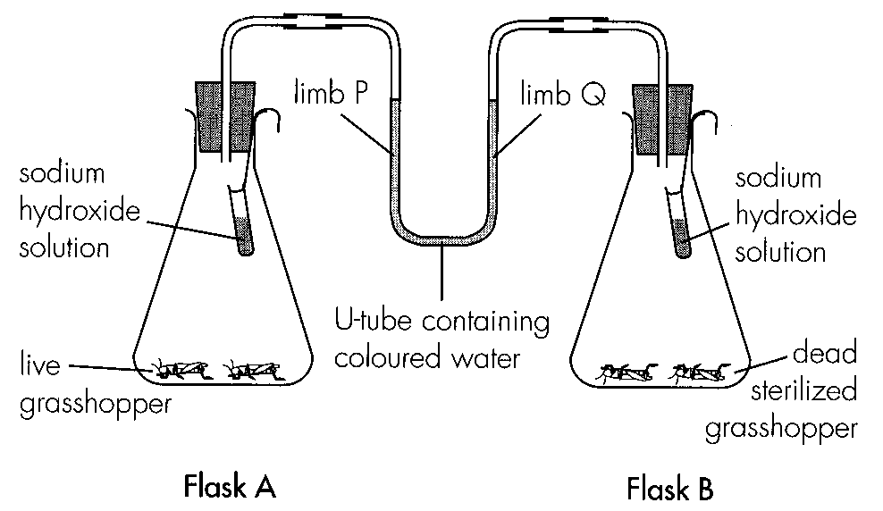
A. add fresh air into the glass jar. B. adjust the position of the liquid indicator.
C. draw out the exhaust gas. D. supply food to the animal. Directions: Questions 16 to 19 refer to the setup below.-
16. The setup measures the change in the amount of a substance. The substance is- A.carbon dioxide.
A. carbon dioxide.
B. oxygen.
C. water.
D. heat energy.
17. If the external temperature is raised, how will the result be different and what is the explanation?
A.The coloured water in limb P will fall because the expansion of air inside flask A masks the small changes in the amount of gas in the flask.
B.The coloured water in limb P will rise less rapidly because the grasshoppers become less active at a higher temperature.
C.The coloured water in limb P will rise more rapidly because the grasshoppers respire faster at a higher temperature.
D.The coloured water in limb P will rise more rapidly because the grasshoppers release more heat at a higher temperature.
Directions: Questions 20 to 22 refer to the diagram below which shows an experimental setup to investigate the respiration of a small mammal.-
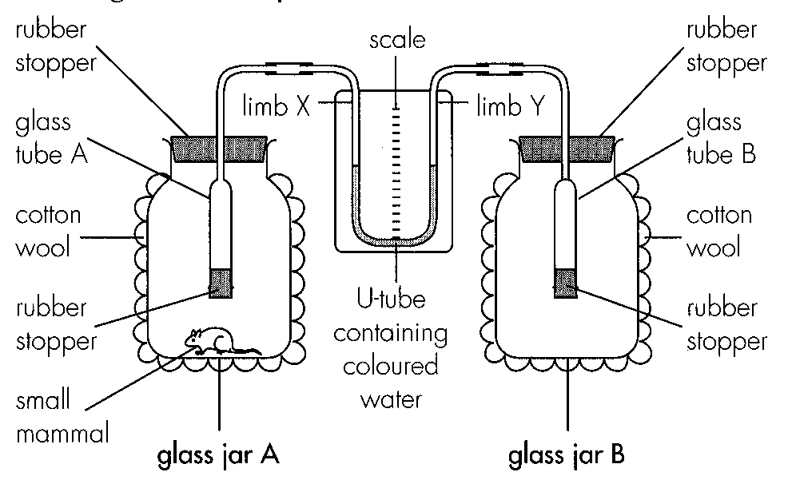
18. What will be the result and what is the explanation?
 | Result | Explanation
A. | The water level in limb X rises. | Oxygen is consumed by the animal.
B. | The water level in limb X drops. | Carbon dioxide is released by the animal.
C. | The water level in limb X drops. | Heat is released by the animal.
D. | The water levels remain unchanged. | Both glass tubes A and B are stoppered.

19. If the experimental setup is used to measure the oxygen uptake by the small mammal, which of the following modifications must be made?-
(1)Remove the rubber stoppers of both glass tubes.
(2)Remove the rubber stoppers of both glass jars.
(3)Replace the coloured water in the U tube by potassium hydroxide solution.-
(4)Remove the cotton wool surrounding the glass jars.
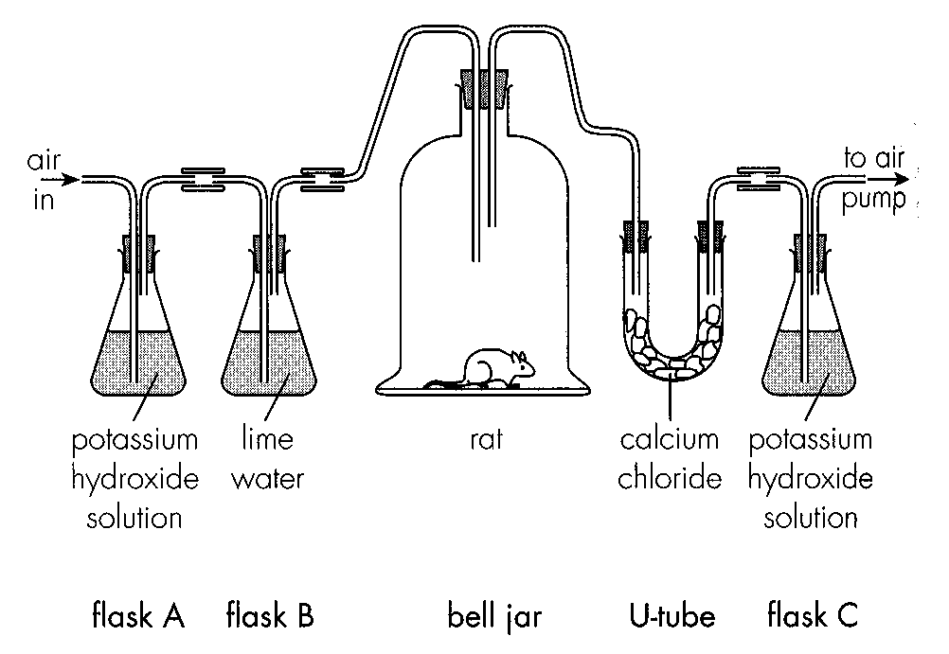
Set-up | Initial weight of flask C (g) | Weight of flask C after l hour (g)
Experimental | 435.2 | 435.0
Control | 423.5 | 422.1
(without rat)

A. (1) and (2) only B. (2) and (3) only C. (3) and (4) only D. (1), (3) and (4) only Directions: Questions 23 to 28 refer to the diagram below which shows an experimental setup to measure the rate of respiration of a rat at 25°C.- The weight of flask C was recorded as shown in the table below.
20. The purpose of the sodium hydroxide solution in flask A is to A.absorb moisture in the incoming air. C.absorb water vapour released by the rat.
A. absorb moisture in the incoming air.
B. absorb carbon dioxide in the incoming air.
C. absorb water vapour released by the rat.
D. absorb carbon dioxide released by the rat.
21. The purpose of the sodium hydroxide solution in flask C is to A.absorb moisture in the incoming air. C.absorb water vapour released by the rat.
A. absorb moisture in the incoming air.
B. absorb carbon dioxide in the incoming air.
C. absorb water vapour released by the rat.
D. absorb carbon dioxide released by the rat.
22. The rate of respiration of the rat is A.0.2 g per hour.
A. 0.2 g per hour.
B. 1.2 g per hour.
C. 1.4 g per hour.
D. 1.6 g per hour.
23. If the weight of the calcium chloride pellets in the Utube was measured, what additional information could be obtained? -
A. The amount of water vapour exhaled by the rat
B. The amount of gases other than carbon dioxide released by the rat
C. The amount of sweat produced by the rat
D. The amount of oxygen used up by the rat
24. If the set up is used to measure the rate of respiration of a potted plant, which of the following are the essential precautions that have to be taken? - (1) The bell jar should be covered with a black cloth. (2) The soil should be wrapped with a plastic bag. (3) A more concentrated sodium hydroxide solution should be put in flask C. (4) The leaves of the plant should be removed. D. (1), (2), (3) and (4)
C. (4) The leaves of the plant should be removed.
A. (1) and (2) only
B. (1) and (3) only
C. (2) and (4) only
25. Anaerobic respiration may take place in (1) vertebrate skeletal muscles. (2) germinating seeds. (3) roots of flowering plants. (4) yeasts.
A. (1) and (2) only
B. (2) and (4) only
C. (1), (3) and (4) only
D. (1), (2), (3) and (4)
26. Both aerobic and anaerobic respiration
A. oxidise food completely. B. produce the same amount of ATP.
C. produce heat energy. D. take place in all kinds of cells.
27. Which of the following compounds contains most chemical energy per mole?
A. ATP B. Ethanol C. Lactic acid D. Glucose
28. Anaerobic respiration of both plant and animal cells releases
A. carbon dioxide.
B. water.
C. energy.
D. ethanol.
29. Which of the following plant cells may carry out anaerobic respiration?
A. A xylem vessel element B. A spongy cell in the dark
C. A palisade cell under light D. A root hair cell in waterlogged soil-
30. Under which of the following conditions will the skeletal muscles of a human carry out anaerobic respiration to the greatest extent?
A. In a 100 m race
B. In a 3000 m race
C. Jogging in the park
D. Sleeping
31. An athlete is taking part in a 100 m sprint race. Which of the following occur(s) inside his/her body? (1)Lactic acid builds up in the muscles. (2)Glycogen is converted to glucose in the muscles. (3) Anaerobic respiration takes place in the muscle cells. (4)Aerobic respiration takes place in the brain cells.
A. (1) only
B. (1) and (3) only
C. (2), (3) and (4) only
D. (1), (2), (3) and (4)
32. Respiration of yeast stops when the temperature is over 60°C because A.all food reserves are used up. C.oxygen is not available at high temperatures.
A. all food reserves are used up.
B. enzymes involved in respiration are denatured.
C. oxygen is not available at high temperatures.
D. yeast cells burst due to over expansion.
33. Which of the following organisms can rely solely on anaerobic respiration for survival?
(1) Human beings(2) Yeast (3) Tapeworms
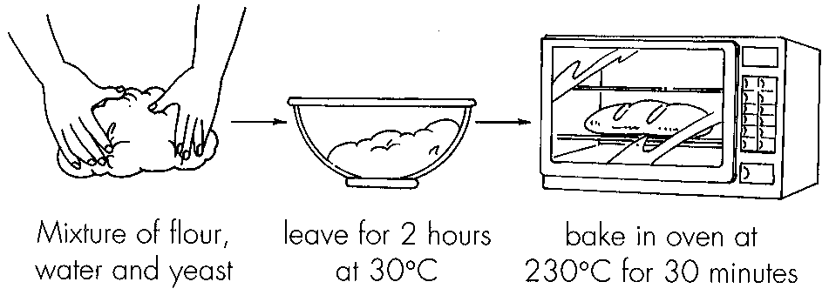
A. (1) only B. (1) and (2) only C. (2) and (3) onlyD. (1), (2) and (3) only Directions: Questions 39 to 41 refer to the diagrams below which show the steps in bread-making.
34. The advantage of adding yeast to the flour is A.to produce larger bread with less flour. C.to add flavour to the bread.
A. to produce larger bread with less flour.
B. to make the bread softer for easier consumption.
C. to add flavour to the bread.
D. to shorten the baking time.
35. The volume of the dough does not increase further after it has been kept in the oven for 10 minutes because
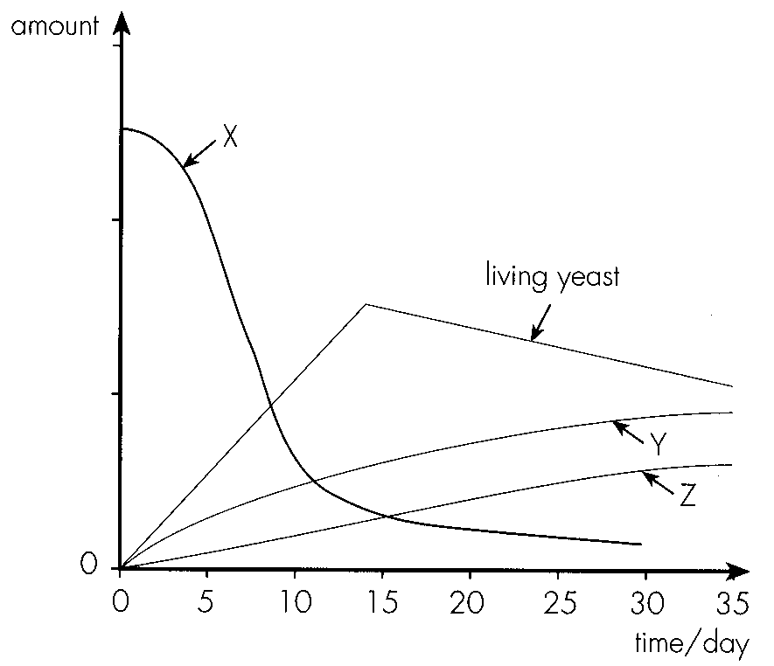
A. all the carbon dioxide trapped in the dough has escaped.
B. the alcohol produced by the yeast has evaporated. C.enzymes are denatured under high temperature.
D. the bread has hardened so that further expansion is restricted. Directions: Questions 42 and 43 refer to the experiment described below. Yeast cells were added to a glucose solution in a container. The graph below shows some of the changes in the mixture during the next 30 days.
36. The curves labelled X, Yand Z represent
 | X | Y | Z
A. | glucose | carbon dioxide | alcohol
B. | carbon dioxide | glucose | alcohol
C. | alcohol | glucose | carbon dioxide
D. | glucose | lactic acid | carbon dioxide

37. Which of the following are the possible causes of the decrease in the amount of living yeast after 14 days?
(1) Exhaustion of glucose (2) Accumulation of toxic wastes (3) Lack of oxygen
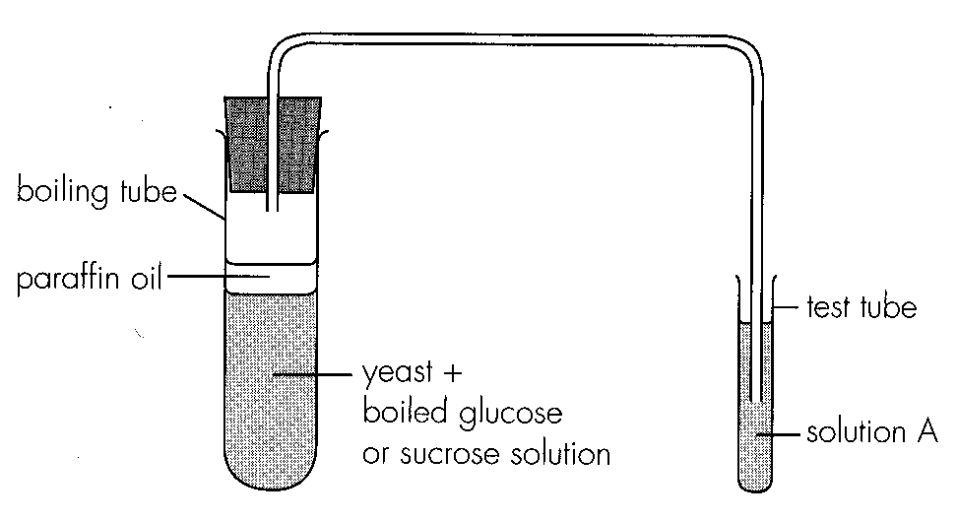
Set-up | Result
With glucose | Bubbles came out from the mixture.
With sucrose | No bubbling occurred.

A. (1) and (2) onlyB. (1) and (3) only C. (2) and (3) only D. (1), (2) and (3) Directions: Questions 44 to 46 refer to the diagram below which shows a setup to study the respiration of yeast.- The setups were observed for 30 minutes and the table below shows the results obtained.-
38. Which of the following can be deduced from the results?
A. Yeast multiplies faster in glucose solution.
B. Yeast is killed by sucrose.
C. Yeast respires aerobically in glucose solution but anaerobically in sucrose solution.
D. Yeast cannot carry out respiration in sucrose solution. 45.Solution A is used to test the gaseous product of respiration. Solution A can be (1) hydrogencarbonate indicator solution. (2) sodium hydrogencarbonate solution. (3) lime water.
A. (1) only B. (1) and (3) onlyC. (2) and (3) only D. (1), (2) and (3)
39. Which of following show that the condition for the respiration of yeast is anaerobic? (1) Paraffin oil is added. (2) The boiling tube is stoppered. (3) The sugar solutions are boiled. (4) All joints are vaselined.
A. (1) and (2) only
B. (1) and (3) only
C. (1), (2) and (3) only
D. (2), (3) and (4) only
40. When compared with photosynthesis, respiration (1) takes place only in the dark. (2) is always slower. (3) does not involve enzymes.
A. (1) only
B. (3) only
C. (1) and (2) only
D. None of the above
41. In the presence of light, there is a net release of oxygen from green leaves. This is because B.photosynthesis exceeds respiration. C.respiration exceeds photosynthesis. D.guard cells allow only oxygen to pass through.
A. photosynthesis takes place while respiration stops.
B. photosynthesis exceeds respiration.
C. respiration exceeds photosynthesis.
D. guard cells allow only oxygen to pass through.
Part B — HKDSE-style (YKTo)
42. Which of the following is the best definition of respiration?
A. The release of energy by oxidative breakdown of organic compounds in living organisms.
B. The intake of oxygen and release of carbon dioxide in animals, and the intake of carbon dioxide and release of oxygen in plants.
C. The gas exchange at the respiratory surfaces of living organisms.
D. The inhaling of oxygen and exhaling of carbon dioxide.
43. Which of the following statements concerning respiration is CORRECT?
A. All living organisms can only respire in the presence of oxygen.
B. Green plants respire all day and night.
C. Respiration is an anabolic process.
D. An embryo developing inside the mother's body does not respire.
44. Respiration takes place in the (1) cuticle of leaf. (2) xylem vessels. (3) bones. (4) enamel of tooth. (5) retina of the eye.
A. (3) and (5) only
B. (1), (2) and (4) only
C. (1), (3) and (5) only
D. (2), (3) and (4) only
45. Which of the following matching between the functions and the chemicals is INCORRECT?
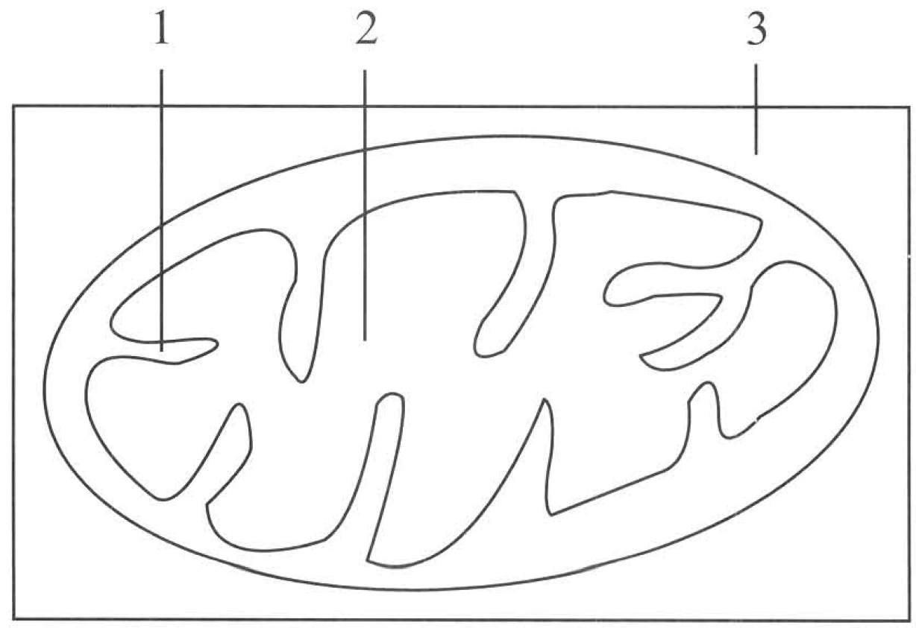
 | Chemical | Functions
A. | Lime water | Detects the presence of CO2
B. | Hydrogencar bonate indicator solution | Measures the relative concentration of CO2
C. | Sodium hydroxide solution | Absorbs CO2
D. | Sodium hydrogencarbonate solution | Detects the presence of CO2

B. Biochemical reactions and energy release
46. The following is the diagram of a mitochondrion.
The following indicates the photochemical reactions taking place in three different locations in the diagram. Which of the following combinations CORRECTLY match the processes concerned?
47. | 2 | 3 | A. | Krebs cycle | Oxidative phosphorylation | Glycolysis | B. | Glycolysis | Krebs cycle | Oxidative phosphorylation | C. | Oxidative phosphorylation | Krebs cycle | Glycolysis | D. | Krebs cycle | Glycolysis | Oxidative phosphorylation
Directions: Questions 6 to 10 refer to the diagram below, which shows the outline of the different processes of respiration in the skeletal muscle cells of humans.
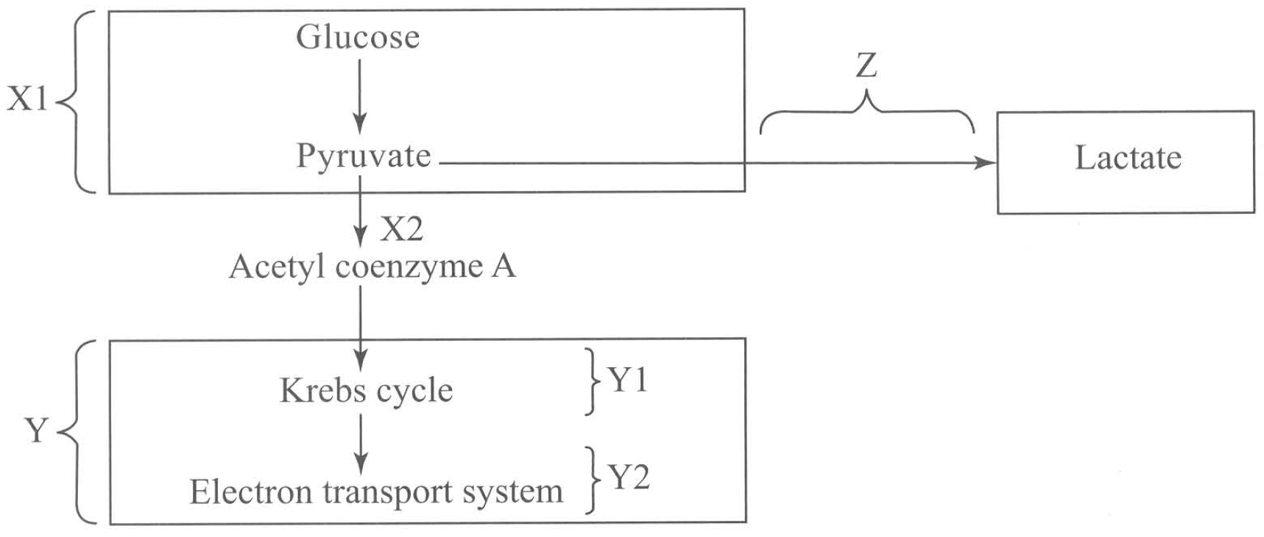
48. Which of the following matching of processes X1, Y and Z involved in respiration is CORRECT?
 | X1 | Y | Z
A. | Aerobic respiration | Glycolysis | Anaerobic respiration
B. | Anaerobic respiration | Aerobic respiration | Glycolysis
C. | Glycolysis | Aerobic respiration | Anaerobic respiration
D. | Glycolysis | Anaerobic respiration | Aerobic respiration

49. Which of the following is the importance of process Z to the muscle cells? (1) It oxidizes the NADH produced in X1 so that glycolysis can take place continuously. (2) It permits the additional supply of biological energy during vigorous exercises. (3) It provides an alternate process of providing biological energy in the presence of oxygen.
A. (1) and (2) only
B. (2) and (3) only
C. (1) and (3) only
D. (1), (2) and (3)
50. The following shows the places where the biochemical processes occur. Which of the following combinations concerning the occurrence of these processes are CORRECT?
 | XI | Y1 | Y2 | Z
A. | Cytoplasm | Mitochondrial matrix | Mitochondrial cristae | Cytoplasm
B. | Mitochondrial matrix | Cytoplasm | Mitochondrial cristae | Stroma
C. | Mitochondrial cristae | Mitochondrial matrix | Grana | Cytoplasm
D. | Thylakoids | Mitochondrial matrix | Grana | Mitochondrial cristae

51. Which process(es) produce(s) the greatest amount of biological energy from one molecule of glucose?
A. X1
B. Y
C. X1 +Y
D. Y + Z
52. At which processes will carbon dioxide be released?
A. X1 and X2
B. X2 and Y1
C. Y and Z
D. X1 and Z
53. Which of the following processes occur during glycolysis? (1) Phosphorylation of ADP (2) Phosphorylation of ethanol (3) Phosphorylation of glucose (4) Reduction of NADP
A. (1) and (2) only
B. (1) and (3) only
C. (2) and (4) only
D. (1) and (4) only
54. The enzymes involved in the biochemical reactions of glycolysis are present in
A. mitochondrial matrix.
B. cristae of mitochondria.
C. stroma of chloroplast.
D. cytosol (fluid part of cytoplasm).
55. Oxidative phosphorylation is the process of adding inorganic phosphate
A. to ADP in the passage of electrons along the electron carriers in the thylakoid membrane.
B. to ADP in the passage of electrons along the electron carriers in the cristae of mitochondria.
C. to the glucose to activate glycolysis.
D. to ADP during the conversion of triose phosphate to pyruvate in glycolysis.
56. What happen to most of the NADH formed in the Krebs cycle of a plant cell?
A. They oxidise the pyruvate to carbon dioxide and water.
B. They undergo redox reactions in the cristae of the mitochondrion to produce ATP.
C. They oxidise in the light stage of the cell.
D. They take part in the regeneration of the starting material needed for Krebs cycle.
57. Which of the following flow charts is CORRECT to outline the events taking place in aerobic respiration?
A. Glucose Pyruvate Triose phosphate Krebs cycle Acetyl Co-A CO2 + H2O + ATP
B. Glucose Triose phosphate Pyruvate Acetyl Co-A-.-Krebs cycle →CO2 + H2O + ATP
C. Glucose Triose phosphate .Pynivate Acetyl Co-A CO2 + H2O + ATP Krebs cycle
D. Glucose Triose phosphate Acetyl Co-A Pyruvate Krebs cycle CO2 + H2O + ATP
58. Which of the following processes is most effective to release energy in form of ATP?
A. Oxidation of pyruvate to lactate
B. Oxidation of pyruvate to carbon dioxide and water
C. Oxidation of glucose to carbon dioxide and ethanol
D. Oxidation of glucose to pyruvate
59. What is the role of molecular oxygen in aerobic respiration?
A. To oxidise triose phosphate to pyruvate
B. To oxidise the phosphorylation of ADP to ATP
C. To remove hydrogen from the coenzyme NADH
D. To combine with carbon released from the breakdown of triose phosphate to form carbon dioxide
60. Which of the following is the proper order of drawing energy in case of starvation? (1) Breakdown of proteins in body tissues to amino acids which are shifted to the Krebs cycle for energy release. (2) Mobilization of fats from adipose tissues and their subsequent oxidation to release energy. (3) Conversion of glycogen in liver and muscles to glucose for energy release.
A. (1) (2) (3)
B. (3) (2) (1)
C. (2) (3) (1)
D. (3) (1) (2)
61. The passage of electrons along the electron transport chain in plant cell is mainly coupled with the
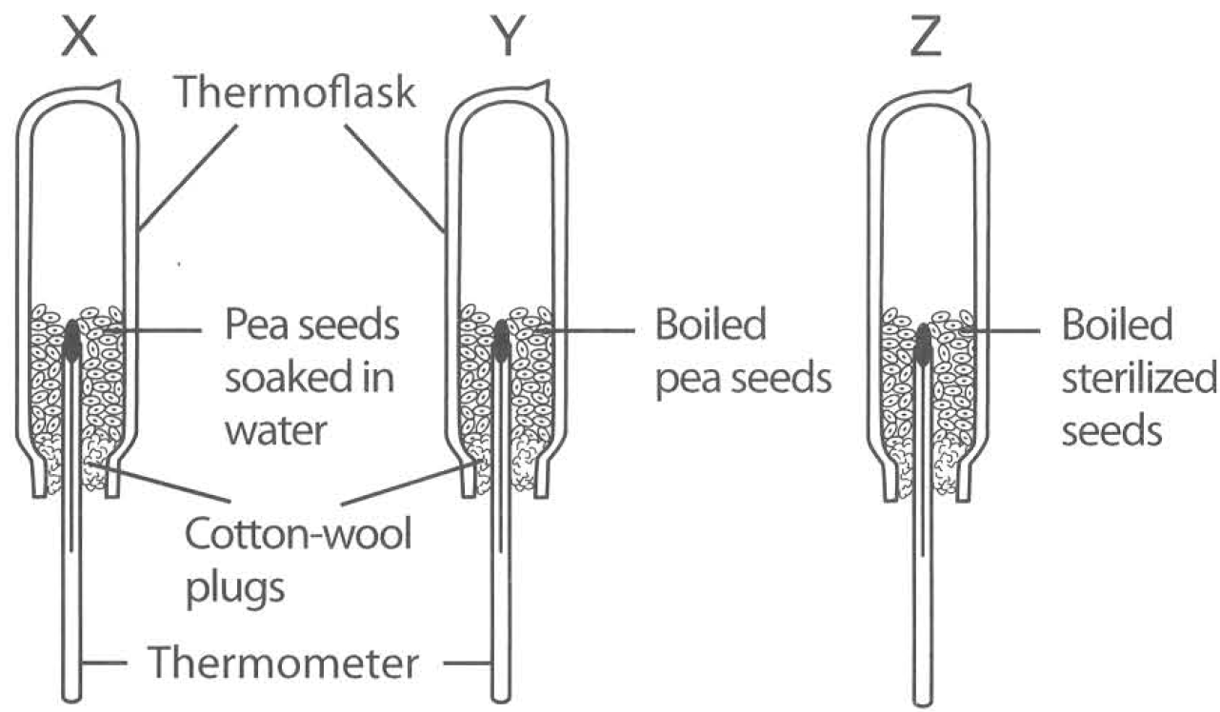
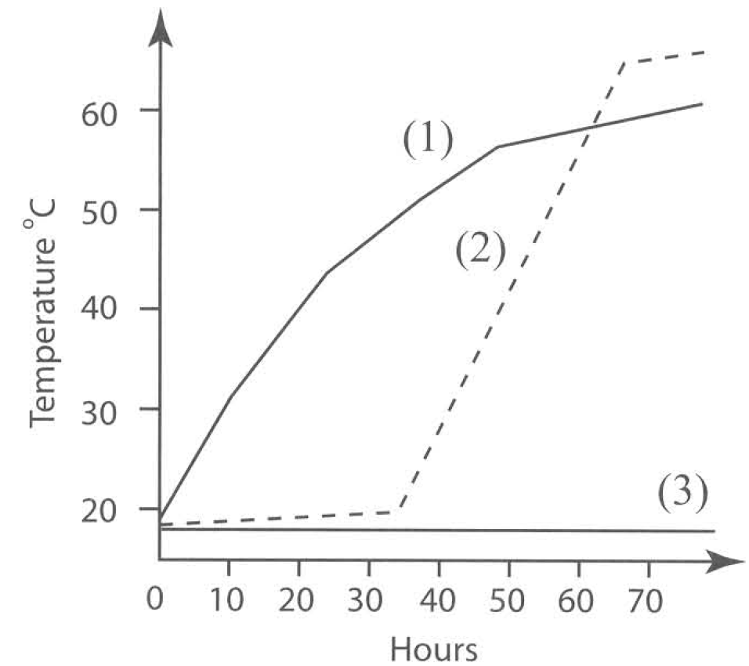
A. fixation of carbon dioxide. B. dehydrogenation of triose phosphate.
C. formation of ATP. D. regeneration of carbon dioxide acceptor (RuBP).
C. Aerobic respiration Directions: Questions 20 to 25 refer to the experiment described below. Three groups of pea seeds were treated differently and put into three separate thermoflasks X, Y and Z. A thermometer was put in each flask with the bulb embedded in the seeds, and a plug of cotton wool was put at the neck of each flask. The readings of thermometers were recorded at regular intervals for three days and are expressed graphically below.
62. The thermoflasks are NOT completely packed with seeds. The reason is
A. to provide a layer of air above the seeds that acts as an insulator to reduce heat loss.
B. to provide space for the carbon dioxide to accumulate in order to speed up the rate of photosynthesis.
C. to provide air to support the aerobic respiration of the seeds.
D. to provide space for the seeds to grow.
63. An advantage of inverting the thermoflasks is
A. to prevent the oxygen diffusing out of the thermoflasks.
B. to get easy reading of the thermometer without pulling it out.
C. to enhance the geotropic response of the radicles.
D. to prevent the water vapour leaking out of the thermoflasks.
64. The temperature change in flasks X, Y and Z were represented by the curves in the order of
A. (1), (2), (3)
B. (2), (1), (3)
C. (3), (2), (1)
D. (1), (3), (2)
65. The temperature change shown by curve (2) was due to
A. the anaerobic respiration of the boiled pea seeds.
B. the respiration of the rapidly growing bacterial population on the seeds.
C. a rapid rise of the environmental temperature.
D. removal of the seed dormancy by the boiling effect so that the pea seeds would germinate to give out a large amount of heat.
66. The temperature change shown by curve (3) was zero throughout the experiment. Which of the following explanation is/are CORRECT? (1) There was no metabolic activities taking place in the pea seeds. (2) The accumulation of carbon dioxide inside the flask inhibited respiration. (3) The seeds had been sterilized.
A. (1) only
B. (2) only
C. (1) and (2) only
D. (1) and (3) only
67. If the thermoflasks were replaced by metal containers, which curve(s) would change its / their shape?
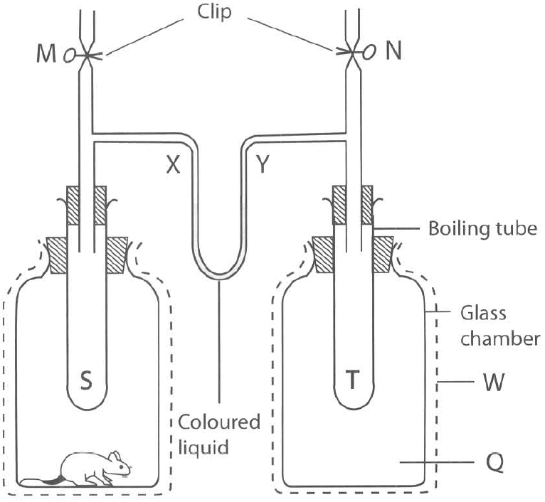
A. (1) only B. (2) only C. (3) only D. (1) and (2) only Directions: Questions 26 to 30 refer to the diagram below which shows an experiment in progress.
68. In order to make the result more satisfactory, W should be
A. a piece of black cloth.
B. a layer of cotton wool.
C. a sheet of aluminium foil.
D. an additional glass sheet.
69. At the end of the experiment the level of the coloured liquid in tubes X and Y will
 | Tube X | Tube Y
A. | Rise | Fall
B. | Be the same | Be the same
C. | Rise | Rise
D. | Drop | Rise

70. This set-up is used to find out
A. the relative rate of respiration of the rat.
B. the relative amount of heat energy released by the rat.
C. the relative amount of water vapour released by the rat.
D. the relative amount of oxygen absorbed by the rat.
71. Which of the following is the reason accounting to the change in level of the coloured liquid in tube X ?
A. The carbon dioxide released by the rat diffuses into the boiling tube S and increases the pressure there.
B. The absence of a rat in Q sets up a suction force that draws the coloured liquid up the tube Y.
C. The water vapour released by the rat through perspiration, urination and expiration increases the vapour pressure in the boiling tube S, thus increasing the presence there.
D. The heat released by the rat causes the air inside boiling tube S to expand and presses the coloured liquid down tube X.
72. What would be the result when both clips M and N are opened?
Directions: Questions 31 to 34 refer to the set-up shown below for studying the rate of respiration of the insects. Two thirds of the boiling tubes are immersed in a water bath with the temperature maintained at 20°C.
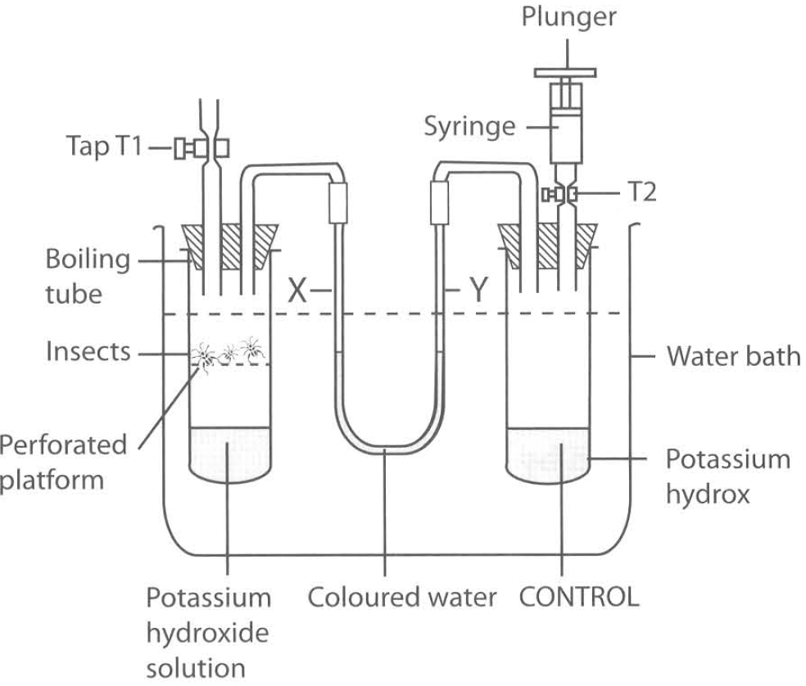
 | Tube X | Tube Y
A. | Rise | Fall
B. | Be the same | Be the same
C. | Rise | Rise

D. | Drop | Rise

73. Which of the following can shorten the time of the experiment? (1) Increase the concentration of the potassium hydroxide solution. (2) Increase the temperature of the water bath by 10°C. (3) Use a U-tube with a smaller bore. (4) Use larger boiling tubes. D. (4) and (1) only
C. (3) Use a U-tube with a smaller bore. (4) Use larger boiling tubes.
A. (1) only
B. (2) only
C. (2) and (3) only
74. Which of the following result and the explanation is CORRECT?
 | Change in liquid level inside tube Y | Reason
A. | Rise | Absorption of carbon dioxide by KOH
B. | Rise | Uptake of oxygen by insects
C. | Fall | Absorption of carbon dioxide by KOH
D. | Fall | Uptake of oxygen by insects

75. If the experiment is repeated by replacing the potassium hydroxide solution with hydrogencarbonate indicator solution, what will be the change in the liquid level of tube X and the reason for it?
 | Liquid level in tube X | Reason
A. | Rise | Oxygen absorbed by insects
B. | Fall | Carbon dioxide released by insects
C. | No significant change | Oxygen uptake is equal to carbon dioxide released
D. | Rise | Carbon dioxide is absorbed by hydrogencarbonate indicator solution

76. What is the use of the syringe attached to the control?
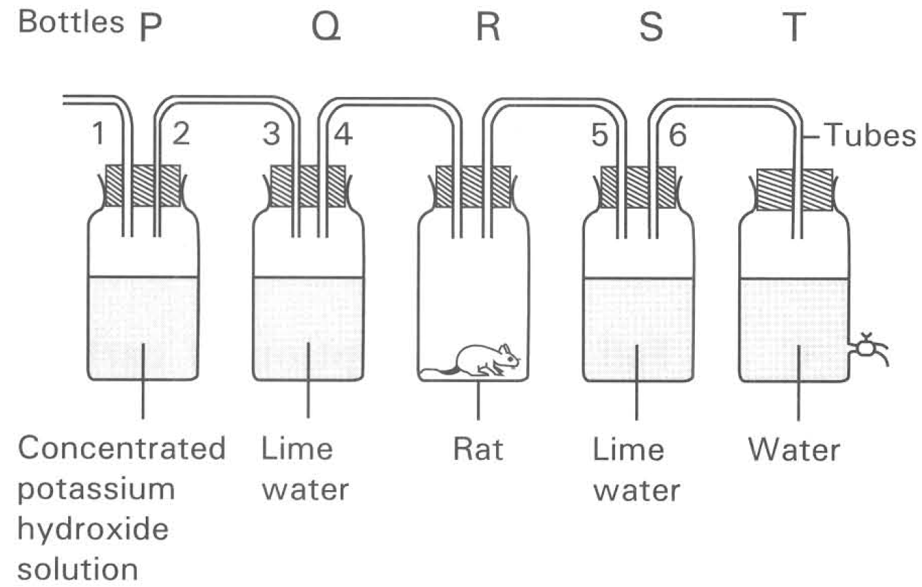
A. Prevent air leakage from the control.
B. Introduce oxygen to support the respiration of the insects.
C. Adjust the liquid level in the U-tube to repeat the experiment.
D. Prevent the effect of changes in the atmospheric pressure on the result of the experiment. Directions: Questions 35 to 42 refer to the diagram below which shows an experiment in progress.
77. This experiment is improperly set-up. Correction is made by
A. immersing tubes 1, 3 and 5 into the solutions.
B. immersing tubes 2, 4 and 6 into the solutions.
C. replacing the lime water with hydrogencarbonate indicator solution.
D. covering bottle R with a piece of black cloth throughout the experiment.
78. The function of the solution in bottle P is to
A. indicate the presence of carbon dioxide in the incoming air.
B. neutralize the incoming air so that the pH value of the cellular fluid of the rat will not be affected.
C. absorb the carbon dioxide present in the incoming air.
D. absorb the water vapour in the incoming air.
79. The function of the solution in bottle S is
A. to remove any carbon dioxide present in the incoming air before the air is breathed by the rat.
B. to provide a suction pressure to draw air throughout the flasks.
C. to balance the pressure in the whole setup.
D. to indicate the presence of carbon dioxide in the gas bubbling through it.
80. When water flows out of bottle T ,
A. lime water is sucked out of bottle S.
B. air will pass from bottle T through bottle S to bottle R.
C. lime water in bottle Q is sucked into bottle R.
D. air is drawn into the set-up.
81. The control for the above experiment is prepared by
A. putting distilled water instead of potassium hydroxide in bottle P.
B. leaving bottle R empty.
C. covering bottle R with a piece of black cloth.
D. using a filter pump instead of bottle T.
82. Which of the following is the CORRECT observation of the solutions in bottles P, Q and S at the end of the experiment?
 | Bottle P | Bottle Q | Bottle S
A. | Milky | Clear | Clear
B. | Clear | Clear | Milky
C. | Clear | Milky | Clear
D. | Milky | Milky | Clear

83. The primary aim of this experiment is to demonstrate that
A. oxygen is absorbed to support the metabolic activities of the rat.
B. carbon dioxide is present in the atmosphere.
C. the rat releases energy in form of heat.
D. the rat releases carbon dioxide.
84. If the tap of bottle T was closed, what will happen to the rate of breathing of the rat in the next 10 minutes?
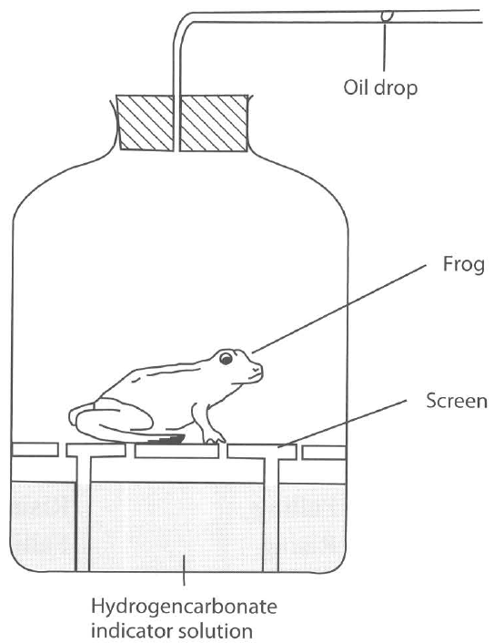
A. The rate of breathing increases.
B. The rate of breathing decreases.
C. The rate of breathing remains unchanged.
D. The rate of breathing fluctuates with an initial decrease and then followed by an increase and the pattern repeats continuously. Directions: Questions 43 to 49 refer to the diagram below, which shows a set-up used to study the respiration of a frog.
85. What will be the colour of the hydrogencarbonate indicator solution 20 minutes after the start of the experiment?
A. Purple
B. Orange
C. Yellow
D. Milky
86. To prepare a control set-up of this experiment, which of the following procedures is CORRECT?
A. Remove the frog.
B. Replace the hydrogencarbonate indicator solution with lime water.
C. Replace the hydrogencarbonate indicator solution with potassium hydroxide solution.
D. Replace the oil drop with coloured liquid.
87. At the end of the experiment the oil drop moves inward. Which of the following CORRECTLY account(s) for this result? (1) Uptake of oxygen by the frog. (2) An increase in atmospheric pressure. (3) An increase in temperature of the surrounding.
A. (1) only
B. (2) only
C. (1) and (2) only
D. (1) and (3) only
88. If the hydrogencarbonate indicator solution is replaced by potassium hydroxide solution, what will happen to the result of the experiment if the environmental conditions remain unchanged?
A. The oil drop moves outwards.
B. The oil drop moves further inwards.
C. The potassium hydroxide solution turns milky.
D. The potassium hydroxide solution turns yellow.
89. If the hydrogencarbonate indicator solution is replaced by alkaline pyrogallol solution, very soon the frog will
A. increase its rate of perspiration.
B. become very active.
C. hibernate.
D. have all its metabolic activities stopped.
90. If the frog is replaced by a batch of germinating seeds which are illuminated by strong light, at the end of the experiment the colour of the hydrogencarbonate indicator solution will be
 | Colour | Reason
A. | Orange | The photosynthetic rate and the respiratory rate is the same so that no carbon dioxide is released nor any oxygen is absorbed.
B. | Yellow | Respiration takes place so that the seeds absorb oxygen and give out carbon dioxide.
C. | Purple | Photosynthetic rate is higher than respiratory rate so that more carbon dioxide is absorbed than released.
D. | Purple | Only photosynthesis takes place; carbon dioxide is used for the process.

91. There is a mistake in the previous set-up to study the respiration of seeds. Which of the following is the right correction?
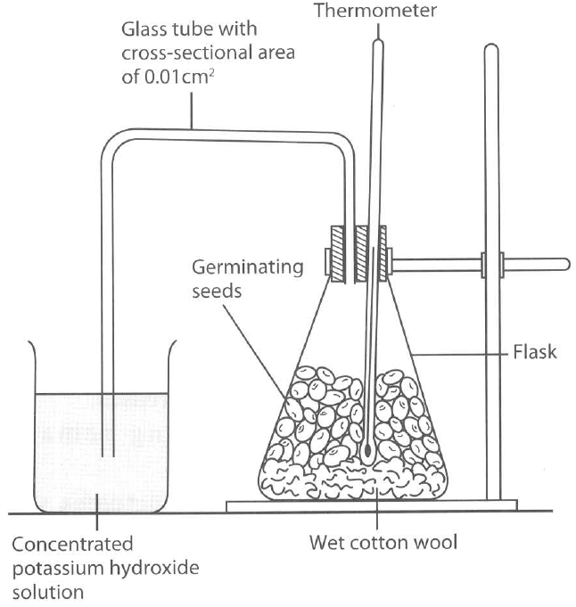
A. The hydrogencarbonate indicator solution is replaced by calcium hydroxide solution.
B. The hydrogencarbonate indicator solution is replaced by distilled water.
C. The germinating seeds are replaced by a small potted plant.
D. The whole set up is covered by a piece of black cloth.
D. Anaerobic respiration
D. Anaerobic respiration Directions: Questions 50 to 57 refer to the diagram below which shows an experiment in progress.
92. In order to get a more conspicuous temperature change, which of the following should be done?
A. Boil the seeds before putting them into the flask.
B. Use a glass tube of smaller bore.
C. Surround the flask with cotton wool.
D. Put the flask in a water bath which is kept at a constant temperature.
93. After the improvement suggested in the previous question has been made, what results will be expected 30 minutes after the start of the experiment?
 | Thermometer reading | Liquid level in the glass tube
A. | Falling | Rising
B. | Rising | Falling
C. | Rising | Rising
D. | Falling | Falling

94. Which of the following is the CORRECT explanation of the change in the liquid level inside the glass tube?
A. The reduction in pressure inside the flask caused by the absorption of oxygen by the germinating seeds and the absorption of carbon dioxide by the concentrated potassium hydroxide solution.
B. The increase in pressure inside the flask caused by the release of carbon dioxide by the germinating seeds.
C. The increase in pressure inside the flask caused by the absorption of oxygen by the germinating seeds and the absorption of carbon dioxide by the concentrated potassium hydroxide solution.
D. The increase in pressure inside the flask caused by the release of water vapour by the germinating seeds.
95. Which of the following can act as the control for the above experiment? (1) Removing the seeds. (2) Covering the flask with a piece of black cloth. (3) Replace the concentrated potassium hydroxide solution with concentrated sodium hydroxide solution. (4) Using sterilized, boiled seeds instead of living germinating seeds.
A. (1) only
B. (1) and (4) only
C. (2) and (3) only
D. (3) and (4) only
96. If after two days the concentrated potassium hydroxide solution of the experimental set-up rises up to tube by 6.4 cm and that of the control rises by 1.2 cm, the volume of oxygen absorbed by the germinating seeds per day is
A. (6.4 +1.2) x 0.01 cm3.
B. (6.4 + 1.2)/2 x 0.01 cm3.
C. (6.4 -1.2) x 0.01 cm3.
D. (6.4 - 1.2)/2 x 0.01 cm3
97. If the concentrated potassium hydroxide solution inside the glass tube of the control drops, it is due to (1) decrease in atmospheric temperature. (2) increase in atmospheric temperature. (3) decrease in atmospheric pressure. (4) increase in atmospheric pressure.
A. (1) only
B. (2) only
C. (1) and (4) only
D. (2) and (3) only
98. At the end of the experiment there is loss in dry weight of the seeds because
A. water is lost from the seeds by evaporation.
B. the amount of oxygen absorbed is less than the amount of carbon dioxide released.
C. some of the seeds have been burnt away in the drying process of the seeds.
D. some of the stored food has been oxidised for energy release in respiration.
99. The energy evolved from the respiration of the seeds in the above process concerned is in the form of
(1) heat energy. (2) light energy. (3) chemical energy.
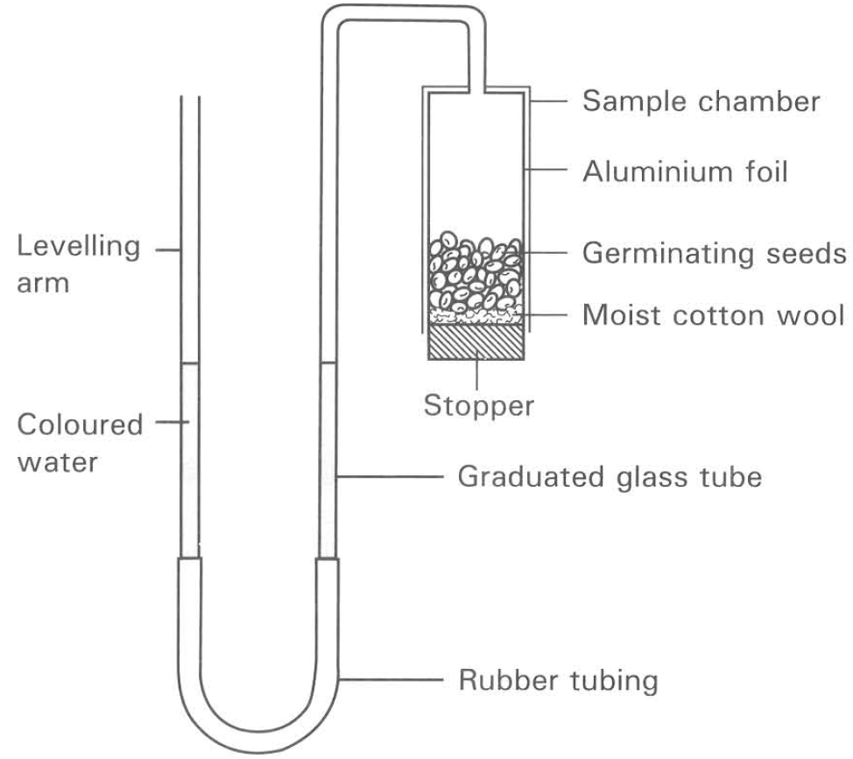
A. (1) only B. (2) only C. (3) only D. (1) and (3) only Directions: Questions 58 to 61 refer to the diagram below which shows an experiment in progress.
100. Each time before the level of the coloured water in the graduated glass tube is measured, the levelling arm has to be moved up and down until the water levels in both the levelling arm and the graduated glass tube are the same. Such procedure
A. ensures the complete absorption of carbon dioxide by the coloured water.
B. ensures the complete absorption of oxygen by the germinating seeds.
C. ensures that each time the volume of the gas trapped in the sample chamber is measured under the same pressure.
D. lubricates the glass tube so that it produces a more obvious result.
101. If the atmospheric pressure and temperature remain the same throughout the experiment, the liquid level of the coloured water in the graduated tube drops at the end of the experiment. Which of the following is the most probable explanation of such liquid level drop?
A. The amount of oxygen absorbed by the germinating seeds is the same as that of the carbon dioxide released by the seeds.
B. Photosynthesis of the germinating seeds produces a large amount of oxygen.
C. Both aerobic and anaerobic respiration take place inside the germinating seeds.
D. The water vapour produced by the respiration of the germinating seeds presses the liquid level down.
102. Which of the set-up below is/are suitable for measuring the oxygen uptake by the seeds?
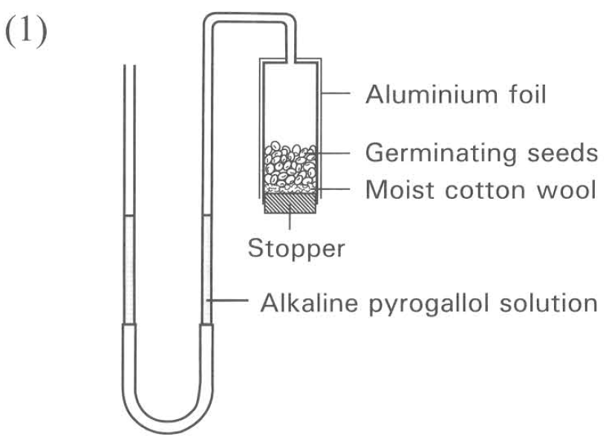
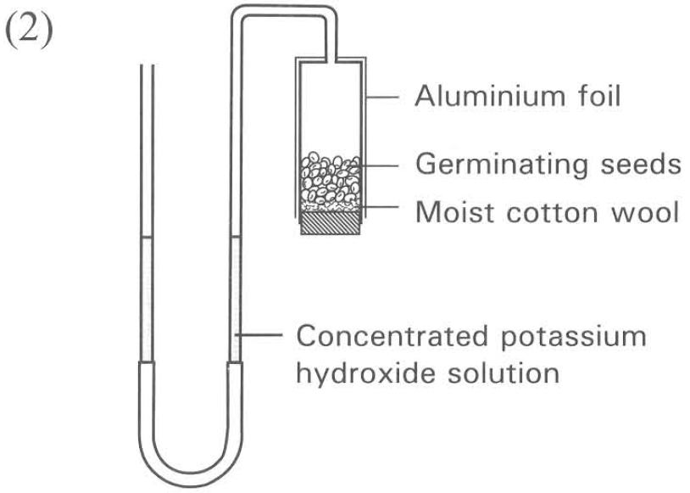
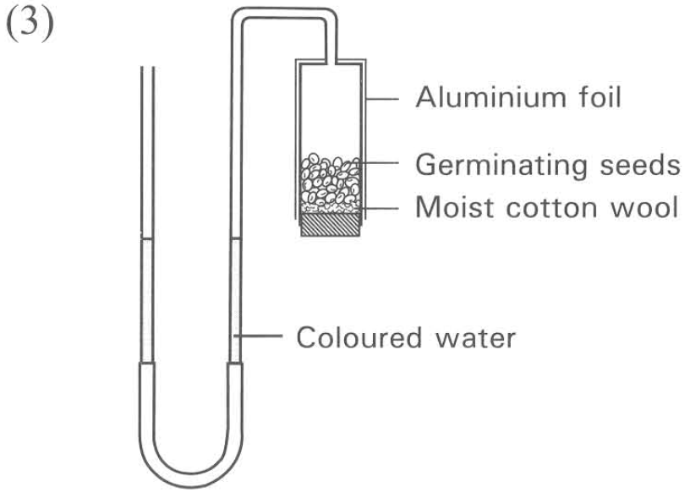
A. (1) only
B. (2) only
C. (3) only
D. (1) and (2) only
103. If the coloured water of the experimental set-up is replaced by concentrated potassium hydroxide solution and the experiment is repeated, what would happen to the level of the solution and why?
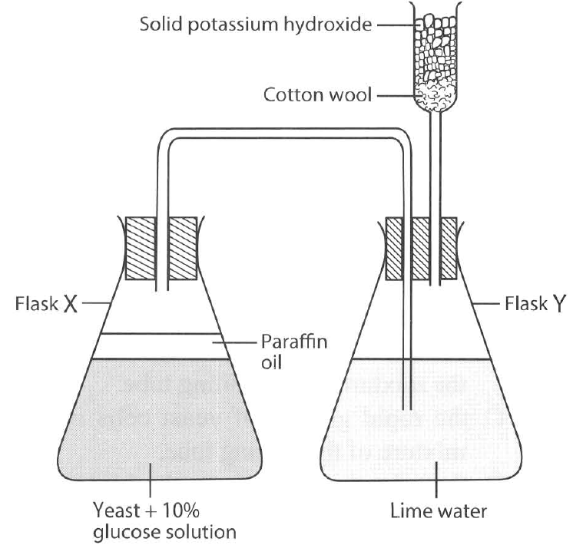
A. It remains the same because the volume of oxygen absorbed is the same as that of the carbon dioxide released.
B. It falls because a large amount of oxygen is released by the photosynthesis of the seeds.
C. It rises because the heat released by the respiration of the seeds is absorbed by the potassium hydroxide solution.
D. It rises because the oxygen inside the chamber is absorbed by the seeds and the carbon dioxide released by the seeds is absorbed by the potassium hydroxide solution. Directions: Questions 62 to 66 refer to the diagram below which shows an experiment in progress.
104. The purpose of adding paraffin oil is
A. to prevent the oxygen to escape from the solution.
B. to prevent the evaporation of water from the solution.
C. to prevent the oxygen in the air above the glucose solution to dissolve in it.
D. to prevent the heat produced by the yeast to escape out.
105. The glucose solution is boiled first and then cooled before it is mixed with the yeast. The purpose of boiling the glucose solution first is (1) to kill all the microorganisms present in the solution. (2) to drive away the dissolved oxygen. (3) to dissolve all the glucose.
A. (1) only
B. (1) and (2) only
C. (2) and (3) only
D. (1) and (3) only
106. Which of the following TRULY represents the conditions of the content in the flasks?
 | Flask X | Flask Y
A. | Clear | Milky
B. | Milky | Clear
C. | Clear | Clear
D. | Milky | Milky

107. The above set-up is used to demonstrate that
A. yeast can only live in glucose solution.
B. yeast requires carbon dioxide for photosynthesis.
C. yeast absorbs oxygen to carry out respiration.
D. yeast liberates carbon dioxide in anaerobic respiration.
108. Which of the following is the significance of anaerobic respiration to the yeast?
A. It enables the yeast to survive in the absence of oxygen.
B. It produces more energy to support the rapid process of asexual reproduction under abundant nutrient supply.
C. It produces more ethanol for the continuous proceeding of respiration.
D. It is the only means by which yeast can consume the nutrients.
109. If the 10% glucose solution is replaced by 50% glucose solution, the yeast will die. Which of the following is the proper explanation?
A. The yeast cells absorb so much glucose that they burst.
B. The yeast cells die because there is insufficient oxygen to oxidise the glucose completely; thus they die due to suffocation.
C. The yeast cells die as a result of the dehydration of their protoplasm because too much water is drawn from their cells by osmosis out to the concentrated glucose solution.
D. The nutrient is so rich that the yeast cells die due to the problems arising from over-population.
110. A better demonstration can be obtained if the whole set-up is kept at 30°. The reason is that such temperature
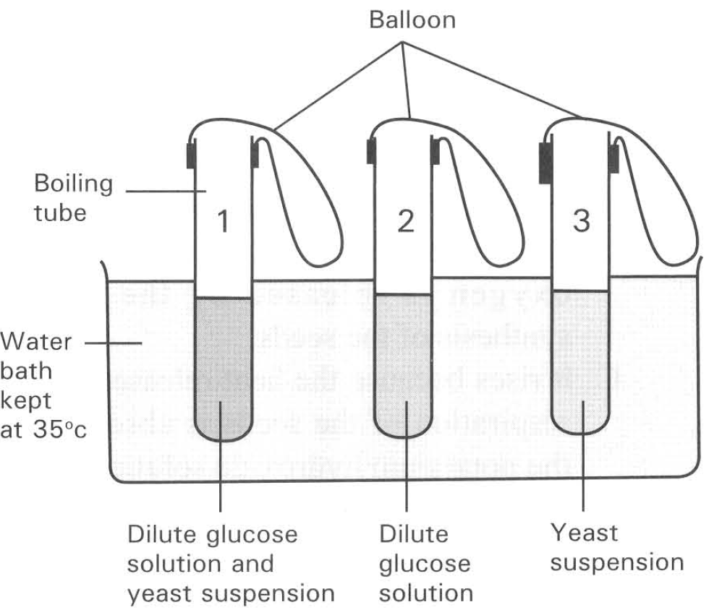
A. increases the solubility of gases in water so that more oxygen can be absorbed by the yeast cells.
B. decreases the solubility of gases in water so that more carbon dioxide is evolved.
C. can speed up the enzymatic reactions of the biological process involved.
D. can speed up the rate of diffusion of glucose into the yeast cells. Directions: Questions 7.69 to 7.71 refer to the diagram below which shows the set-up of an experiment.
111. Which of the following is the CORRECT result at the end of the experiment?
 | Size of the balloon at
 | 1 | 2 | 3
A. | Decrease | The same | Increase
B. | Increase | The same | Decrease
C. | The same | Decrease | Increase
D. | Increase | The same | The same

112. The balloon increases in size because of
A. the heating effect of the water bath that causes the air inside the balloon to expand.
B. the heating effect of the water bath that causes more water to evaporate from the mixture of the boiling tube.
C. the rapid growth of yeast cells in the mixture of the boiling tube.
D. the release of gas from the biological process taking place in the mixture of the boiling tube.
113. The substance in the inflated balloon will
A. turn the hydrogencarbonate indicator solution purple.
B. relight a glowing splint.
C. turn the potassium hydroxide solution milky.
D. turn the lime water milky.
114. Yeast is an important component in making bread. It is because yeast
A. is easy to handle due to its small size.
B. contains a large amount of vitamin B12.
C. releases carbon dioxide which causes the dough to rise.
D. produces alcohol that makes the bread tasteful.
115. Which of the following factors are necessary for fermentation of yeast to take place? (1) Glucose (2) Carbon dioxide (3) Oxygen (4) Water (5) Alcohol
A. (1) and (4) only
B. (2) and (4) only
C. (1) and (3) only
D. (2) and (5) only
116. Which of the following products are common to both the alcoholic fermentation and aerobic respiration of plants? (1) Carbon dioxide (2) Water (3) Alcohol (4) Energy (5) Lactic acid
A. (1) and (2) only
B. (1) and (3) only
C. (2) and (5) only
D. (1) and (4) only
117. Bread making involves a biological activity of yeasts in a mixture of flour, sugar and water. Which of the following combinations is CORRECT in the type of biological process, the products and the energy converted to?
 | Type of biological process | Products | Energy converted
A. | Aerobic respiration | Lactic acid | Mainly ATP
B. | Aerobic respiration | Water | Mainly heat
C. | Fermentation | Lactic acid | Mainly chemical energy stored in alcohol
D. | Fermentation | Carbon dioxide | Lots of energy trapped in alcohol

118. Which of the following are the products of the anaerobic respiration in vertebrate muscles? (1) Water (2) Carbon dioxide (3) Alcohol (4) Lactic acid (5) Glycogen
A. (2), (3) and (5) only
B. (1), (3) and (5) only
C. (2) and (4) only
D. (4) only
119. The number of aerobes present in a fresh water pond is limited mainly by
A. the amount of oxygen dissolved in water.
B. the amount of salts dissolved in water.
C. the amount of carbon dioxide dissolved in water.
D. the number of holozoic organisms.
120. In comparing the aerobic respiration in flowering plants with that in mammals one can find that
A. they are more or less the same.
B. only the non-green parts of the flowering plants respire while all the cells in mammals respire.
C. the biochemical reactions involved in them proceed in opposite directions.
D. mammals oxidise the food substances they have eaten while flowering plants oxidise the raw materials they absorbed from air and soil.
121. Which of the following comparisons between aerobic and anaerobic respirations is NOT true?
. |  | Aerobic respiration | Anaerobic respiration
(1) | Energy released | Less | More
(2) | Oxidation of respiratory fuel | Complete | Incomplete
(3) | End products | Carbon dioxide and lactic acid | Carbon dioxide and alcohol
(4) | Occurrence | In animals only | In plants only
(5) | Time of occurrence | All day long | At night long

A. (1) and (2) only
B. (3) and (5) only
C. (3), (4) and (5) only
D. (1), (3), (4) and (5) only
122. What will be the effect of inhibiting the enzyme catalysing the following process in the absence of oxygen?

A. The rate of glycolysis decreases due to insufficient NAD.
B. Krebs cycle proceeds at faster rate because of the increase in pyruvate.
C. Decrease in pH due to the accumulation of lactic acid.
D. More carbon dioxide is released because more pyruvate enters the Krebs cycle. Suggested Solutions

Answers
Answers are printed in red.
1. B
Class: 58.3% correct (n=12) usual slip A
2. B

3. ?

4. A. (1) only
Class: 72.4% correct (n=29) usual slip D
5. ?

6. D. all the time.
Class: 83.3% correct (n=12) usual slip B
7. A. To release energy for sustaining metabolic activities.

8. C. It will be easier to observe changes in the water level in either direction.
Class: 83.3% correct (n=12) usual slip A
9. B. absorb carbon dioxide released by the germinating seeds.
Class: 83.3% correct (n=12) usual slip C
10. B. an increase in environmental temperature.

11. ?

12. ?

13. C. (2) and (3) only
Class: 75.9% correct (n=29) usual slip B
14. B. The amount of oxygen consumed by the animal equalled the amount of carbon dioxide produced.

15. B

16. B. oxygen.

17. ?

18. C

19. D
Class: 83.3% correct (n=12) usual slip B
20. B. absorb carbon dioxide in the incoming air.

21. D. absorb carbon dioxide released by the rat.

22. B. 1.2 g per hour.

23. A. The amount of water vapour exhaled by the rat

24. ?

25. D. (1), (2), (3) and (4)

26. ?

27. D
Class: 50.0% correct (n=12) usual slip A
28. C. energy.
Class: 83.3% correct (n=12) usual slip B
29. D
Class: 83.3% correct (n=12) usual slip B
30. ?

31. D. (1), (2), (3) and (4)
Class: 50.0% correct (n=12) usual slip B
32. B. enzymes involved in respiration are denatured.
Class: 91.7% correct (n=12) usual slip D
33. C
Class: 100.0% correct (n=12) usual slip A
34. B. to make the bread softer for easier consumption.

35. C
Class: 66.7% correct (n=12) usual slip D
36. A

37. A. (1) and (2) onlyB. (1) and (3) only C. (2) and (3) only D. (1), (2) and (3) Directions: Questions 44 to 46 refer to the diagram below which shows a setup to study the respiration of yeast.- The setups were observed for 30 minutes and the table below shows the results obtained.-
Class: 50.0% correct (n=12) usual slip D
38. ?

39. B. (1) and (3) only

40. D. None of the above

41. B. photosynthesis exceeds respiration.
Class: 91.7% correct (n=12) usual slip A
42. A. The release of energy by oxidative breakdown of organic compounds in living organisms.

43. B. Green plants respire all day and night.
Class: 82.8% correct (n=29) usual slip D
44. A. (3) and (5) only
Class: 58.3% correct (n=12) usual slip B
45. D

46. C
Class: 58.8% correct (n=17) usual slip B
47. A

48. C
Class: 100.0% correct (n=17) usual slip A
49. A. (1) and (2) only
Class: 65.5% correct (n=29) usual slip D
50. A

51. C. X1 +Y
Class: 82.4% correct (n=17) usual slip D
52. B. X2 and Y1
Class: 50.0% correct (n=12) usual slip C
53. B. (1) and (3) only
Class: 82.4% correct (n=17) usual slip D
54. D. cytosol (fluid part of cytoplasm).

55. B. to ADP in the passage of electrons along the electron carriers in the cristae of mitochondria.

56. B. They undergo redox reactions in the cristae of the mitochondrion to produce ATP.
Class: 75.0% correct (n=12) usual slip A
57. B. Glucose Triose phosphate Pyruvate Acetyl Co-A-.-Krebs cycle →CO2 + H2O + ATP
Class: 79.3% correct (n=29) usual slip C
58. B. Oxidation of pyruvate to carbon dioxide and water
Class: 50.0% correct (n=12) usual slip A
59. C. To remove hydrogen from the coenzyme NADH
Class: 69.0% correct (n=29) usual slip C
60. B. (3) (2) (1)
Class: 55.2% correct (n=29) usual slip D
61. C. Aerobic respiration Directions: Questions 20 to 25 refer to the experiment described below. Three groups of pea seeds were treated differently and put into three separate thermoflasks X, Y and Z. A thermometer was put in each flask with the bulb embedded in the seeds, and a plug of cotton wool was put at the neck of each flask. The readings of thermometers were recorded at regular intervals for three days and are expressed graphically below.
Class: 75.0% correct (n=12) usual slip A
62. C. to provide air to support the aerobic respiration of the seeds.
Class: 66.7% correct (n=12) usual slip A
63. B. to get easy reading of the thermometer without pulling it out.
Class: 91.7% correct (n=12) usual slip A
64. A. (1), (2), (3)

65. B. the respiration of the rapidly growing bacterial population on the seeds.
Class: 91.7% correct (n=12) usual slip A
66. D. (1) and (3) only
Class: 91.7% correct (n=12) usual slip C
67. D
Class: 75.0% correct (n=12) usual slip C
68. B. a layer of cotton wool.
Class: 66.7% correct (n=12) usual slip A
69. A
Class: 91.7% correct (n=12) usual slip B
70. B. the relative amount of heat energy released by the rat.

71. D. The heat released by the rat causes the air inside boiling tube S to expand and presses the coloured liquid down tube X.
Class: 75.0% correct (n=12) usual slip C
72. B

73. B. (2) only

74. D

75. C

76. C. Adjust the liquid level in the U-tube to repeat the experiment.

77. A. immersing tubes 1, 3 and 5 into the solutions.

78. C. absorb the carbon dioxide present in the incoming air.
Class: 75.0% correct (n=12) usual slip C
79. D. to indicate the presence of carbon dioxide in the gas bubbling through it.

80. D. air is drawn into the set-up.

81. B. leaving bottle R empty.
Class: 66.7% correct (n=12) usual slip A
82. B
Class: 83.3% correct (n=12) usual slip A
83. D. the rat releases carbon dioxide.

84. A. The rate of breathing increases.
Class: 83.3% correct (n=12) usual slip D
85. C. Yellow

86. A. Remove the frog.

87. B. (2) only
Class: 66.7% correct (n=12) usual slip D
88. B. The oil drop moves further inwards.
Class: 50.0% correct (n=12) usual slip A
89. D. have all its metabolic activities stopped.
Class: 91.7% correct (n=12) usual slip A
90. C

91. D. Anaerobic respiration Directions: Questions 50 to 57 refer to the diagram below which shows an experiment in progress.

92. C. Surround the flask with cotton wool.

93. C

94. A. The reduction in pressure inside the flask caused by the absorption of oxygen by the germinating seeds and the absorption of carbon dioxide by the concentrated potassium hydroxide solution.

95. B. (1) and (4) only

96. D. (6.4 - 1.2)/2 x 0.01 cm3

97. D. (2) and (3) only

98. D. some of the stored food has been oxidised for energy release in respiration.

99. D

100. C. ensures that each time the volume of the gas trapped in the sample chamber is measured under the same pressure.

101. C. Both aerobic and anaerobic respiration take place inside the germinating seeds.

102. B. (2) only

103. D. It rises because the oxygen inside the chamber is absorbed by the seeds and the carbon dioxide released by the seeds is absorbed by the potassium hydroxide solution. Directions: Questions 62 to 66 refer to the diagram below which shows an experiment in progress.

104. C. to prevent the oxygen in the air above the glucose solution to dissolve in it.

105. B. (1) and (2) only

106. A

107. D. yeast liberates carbon dioxide in anaerobic respiration.

108. A. It enables the yeast to survive in the absence of oxygen.

109. C. The yeast cells die as a result of the dehydration of their protoplasm because too much water is drawn from their cells by osmosis out to the concentrated glucose solution.

110. C. can speed up the enzymatic reactions of the biological process involved.

111. D

112. D. the release of gas from the biological process taking place in the mixture of the boiling tube.

113. D. turn the lime water milky.

114. C. releases carbon dioxide which causes the dough to rise.

115. A. (1) and (4) only

116. D. (1) and (4) only

117. D

118. D. (4) only

119. A. the amount of oxygen dissolved in water.

120. A. they are more or less the same.

121. D. (1), (3), (4) and (5) only

122. A. The rate of glycolysis decreases due to insufficient NAD.

