Respiration · items under 80% correct
Multiple-choice practice
Name: ________________________ Class: ____________
These items were answered correctly by fewer than 80% of students in class Google Forms, matched by the wording in the source bank and the form answer key. Choose the one best answer.
Part A — HKCEE level (Longman)
1. Which of the following comparisons between burning and respiration is not true?
 | Burning | Respiration
A. | uses oxygen | may not use oxygen
B. | releases energy from inorganic substances only | releases energy from organic substances only
C. | does not require enzymes | requires enzymes
D. | is a singlestep reaction- | is a series of reactions

2. Which of the following statements about respiration is/are correct? (1) It occurs in all living cells. (2) It always consumes oxygen. (3) It releases energy only in the form of ATP.
A. (1) only
B. (1) and (2) only
C. (2) and (3) only
D. (1), (2) and (3)
3. Which of the following external factors may affect the results of the experiment? (1) Light intensity (2) External temperature (3) Atmospheric pressure (4) Relative humidity
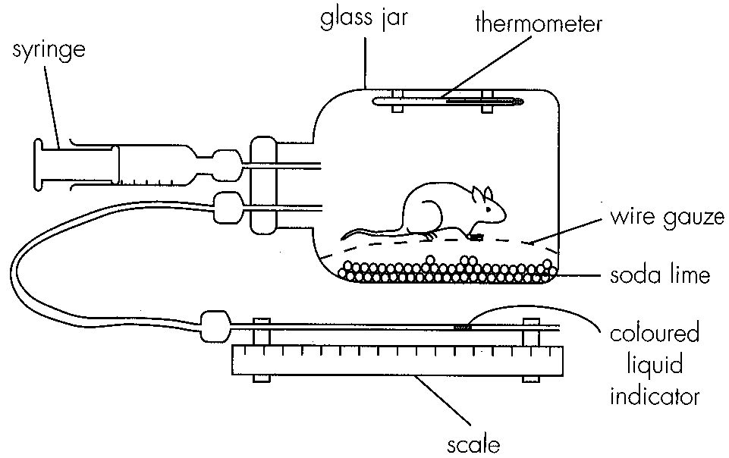
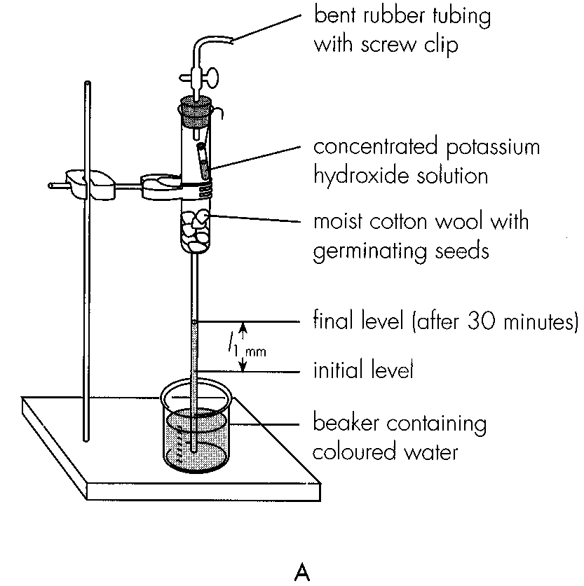
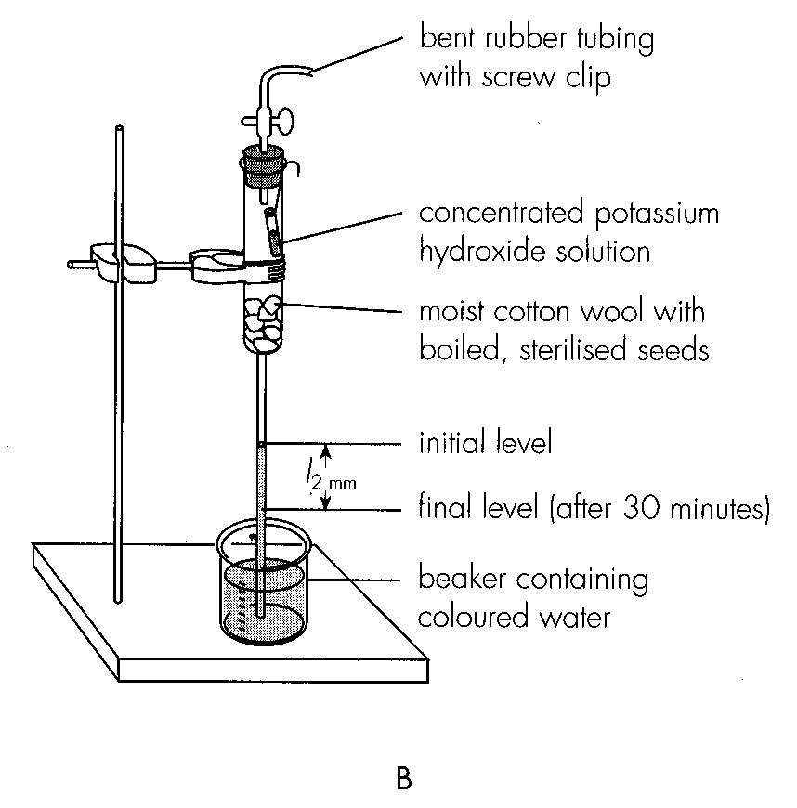
A. (1) and (2) only
B. (1) and (4) only
C. (2) and (3) only
D. (2), (3) and (4) only
4. Which of the following compounds contains most chemical energy per mole?
A. ATP B. Ethanol C. Lactic acid D. Glucose
5. An athlete is taking part in a 100 m sprint race. Which of the following occur(s) inside his/her body? (1)Lactic acid builds up in the muscles. (2)Glycogen is converted to glucose in the muscles. (3) Anaerobic respiration takes place in the muscle cells. (4)Aerobic respiration takes place in the brain cells.
A. (1) only
B. (1) and (3) only
C. (2), (3) and (4) only
D. (1), (2), (3) and (4)
6. The volume of the dough does not increase further after it has been kept in the oven for 10 minutes because
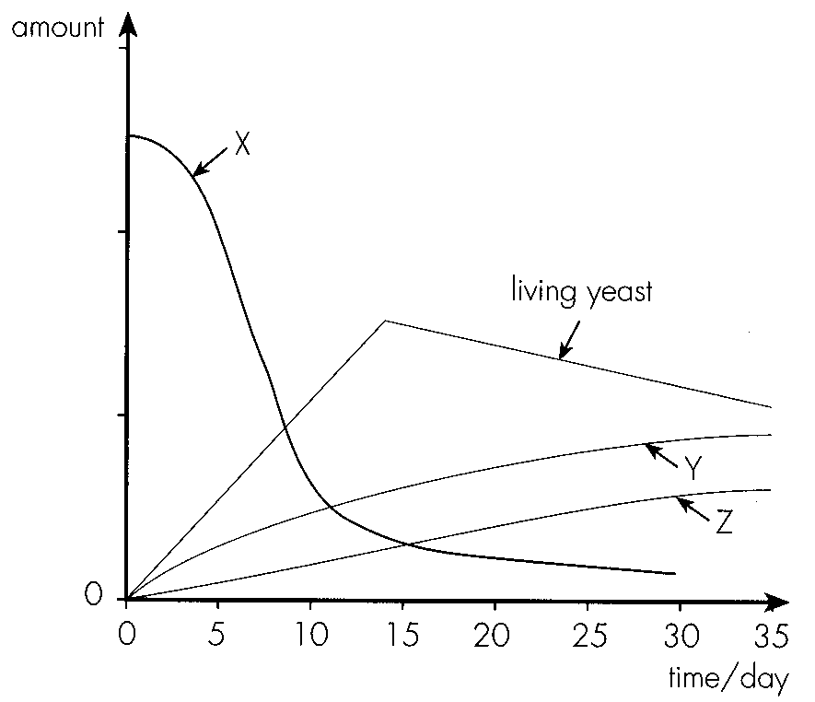
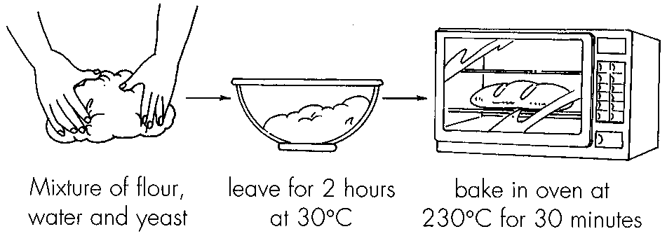
A. all the carbon dioxide trapped in the dough has escaped.
B. the alcohol produced by the yeast has evaporated. C.enzymes are denatured under high temperature.
D. the bread has hardened so that further expansion is restricted. Directions: Questions 42 and 43 refer to the experiment described below. Yeast cells were added to a glucose solution in a container. The graph below shows some of the changes in the mixture during the next 30 days.
7. Which of the following are the possible causes of the decrease in the amount of living yeast after 14 days?
(1) Exhaustion of glucose (2) Accumulation of toxic wastes (3) Lack of oxygen
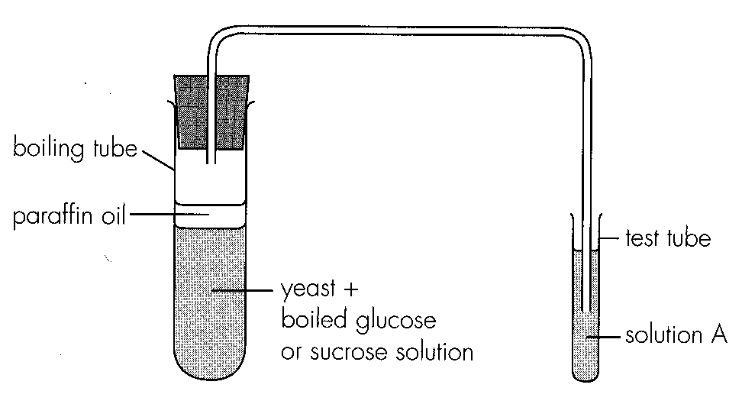
Set-up | Result
With glucose | Bubbles came out from the mixture.
With sucrose | No bubbling occurred.

A. (1) and (2) onlyB. (1) and (3) only C. (2) and (3) only D. (1), (2) and (3) Directions: Questions 44 to 46 refer to the diagram below which shows a setup to study the respiration of yeast.- The setups were observed for 30 minutes and the table below shows the results obtained.-
Part B — HKDSE-style (YKTo)
8. Respiration takes place in the (1) cuticle of leaf. (2) xylem vessels. (3) bones. (4) enamel of tooth. (5) retina of the eye.
A. (3) and (5) only
B. (1), (2) and (4) only
C. (1), (3) and (5) only
D. (2), (3) and (4) only
9. The following is the diagram of a mitochondrion.
The following indicates the photochemical reactions taking place in three different locations in the diagram. Which of the following combinations CORRECTLY match the processes concerned?
10. Which of the following is the importance of process Z to the muscle cells? (1) It oxidizes the NADH produced in X1 so that glycolysis can take place continuously. (2) It permits the additional supply of biological energy during vigorous exercises. (3) It provides an alternate process of providing biological energy in the presence of oxygen.
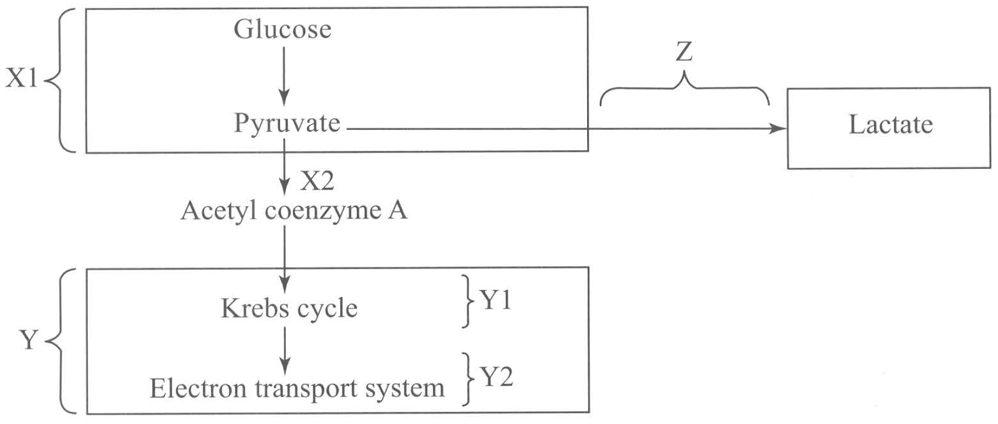
A. (1) and (2) only
B. (2) and (3) only
C. (1) and (3) only
D. (1), (2) and (3)
11. At which processes will carbon dioxide be released?
A. X1 and X2
B. X2 and Y1
C. Y and Z
D. X1 and Z
12. What happen to most of the NADH formed in the Krebs cycle of a plant cell?
A. They oxidise the pyruvate to carbon dioxide and water.
B. They undergo redox reactions in the cristae of the mitochondrion to produce ATP.
C. They oxidise in the light stage of the cell.
D. They take part in the regeneration of the starting material needed for Krebs cycle.
13. Which of the following flow charts is CORRECT to outline the events taking place in aerobic respiration?
A. Glucose Pyruvate Triose phosphate Krebs cycle Acetyl Co-A CO2 + H2O + ATP
B. Glucose Triose phosphate Pyruvate Acetyl Co-A-.-Krebs cycle →CO2 + H2O + ATP
C. Glucose Triose phosphate .Pynivate Acetyl Co-A CO2 + H2O + ATP Krebs cycle
D. Glucose Triose phosphate Acetyl Co-A Pyruvate Krebs cycle CO2 + H2O + ATP
14. Which of the following processes is most effective to release energy in form of ATP?
A. Oxidation of pyruvate to lactate
B. Oxidation of pyruvate to carbon dioxide and water
C. Oxidation of glucose to carbon dioxide and ethanol
D. Oxidation of glucose to pyruvate
15. What is the role of molecular oxygen in aerobic respiration?
A. To oxidise triose phosphate to pyruvate
B. To oxidise the phosphorylation of ADP to ATP
C. To remove hydrogen from the coenzyme NADH
D. To combine with carbon released from the breakdown of triose phosphate to form carbon dioxide
16. Which of the following is the proper order of drawing energy in case of starvation? (1) Breakdown of proteins in body tissues to amino acids which are shifted to the Krebs cycle for energy release. (2) Mobilization of fats from adipose tissues and their subsequent oxidation to release energy. (3) Conversion of glycogen in liver and muscles to glucose for energy release.
A. (1) (2) (3)
B. (3) (2) (1)
C. (2) (3) (1)
D. (3) (1) (2)
17. The passage of electrons along the electron transport chain in plant cell is mainly coupled with the
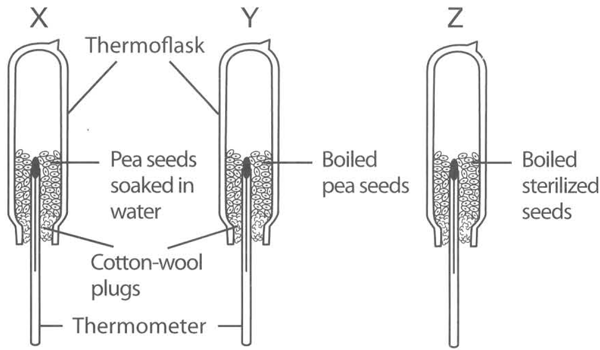
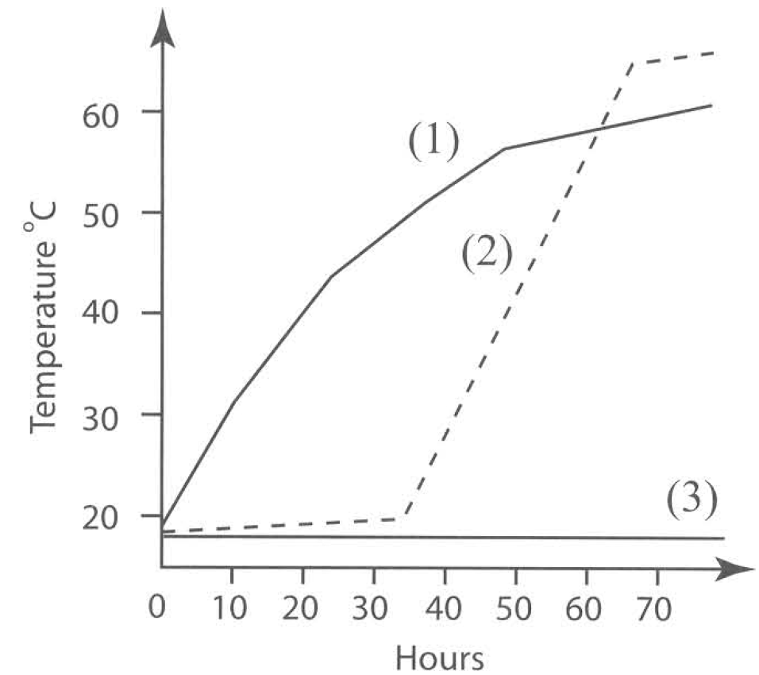
A. fixation of carbon dioxide. B. dehydrogenation of triose phosphate.
C. formation of ATP. D. regeneration of carbon dioxide acceptor (RuBP).
C. Aerobic respiration Directions: Questions 20 to 25 refer to the experiment described below. Three groups of pea seeds were treated differently and put into three separate thermoflasks X, Y and Z. A thermometer was put in each flask with the bulb embedded in the seeds, and a plug of cotton wool was put at the neck of each flask. The readings of thermometers were recorded at regular intervals for three days and are expressed graphically below.
18. The thermoflasks are NOT completely packed with seeds. The reason is
A. to provide a layer of air above the seeds that acts as an insulator to reduce heat loss.
B. to provide space for the carbon dioxide to accumulate in order to speed up the rate of photosynthesis.
C. to provide air to support the aerobic respiration of the seeds.
D. to provide space for the seeds to grow.
19. If the thermoflasks were replaced by metal containers, which curve(s) would change its / their shape?
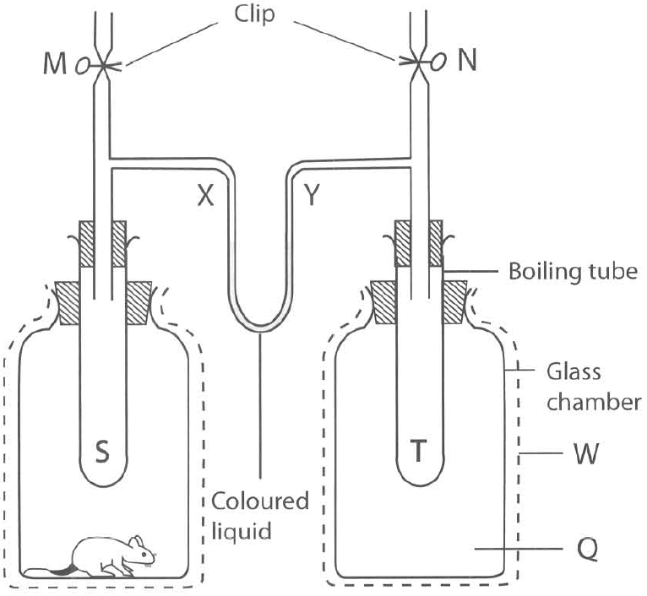
A. (1) only B. (2) only C. (3) only D. (1) and (2) only Directions: Questions 26 to 30 refer to the diagram below which shows an experiment in progress.
20. In order to make the result more satisfactory, W should be
A. a piece of black cloth.
B. a layer of cotton wool.
C. a sheet of aluminium foil.
D. an additional glass sheet.
21. Which of the following is the reason accounting to the change in level of the coloured liquid in tube X ?
A. The carbon dioxide released by the rat diffuses into the boiling tube S and increases the pressure there.
B. The absence of a rat in Q sets up a suction force that draws the coloured liquid up the tube Y.
C. The water vapour released by the rat through perspiration, urination and expiration increases the vapour pressure in the boiling tube S, thus increasing the presence there.
D. The heat released by the rat causes the air inside boiling tube S to expand and presses the coloured liquid down tube X.
22. The function of the solution in bottle P is to
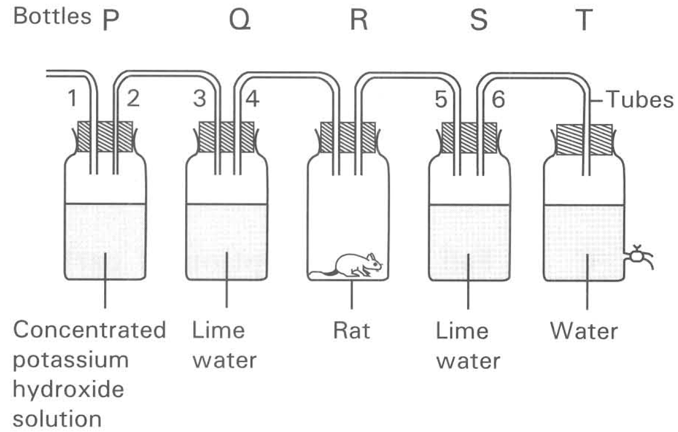
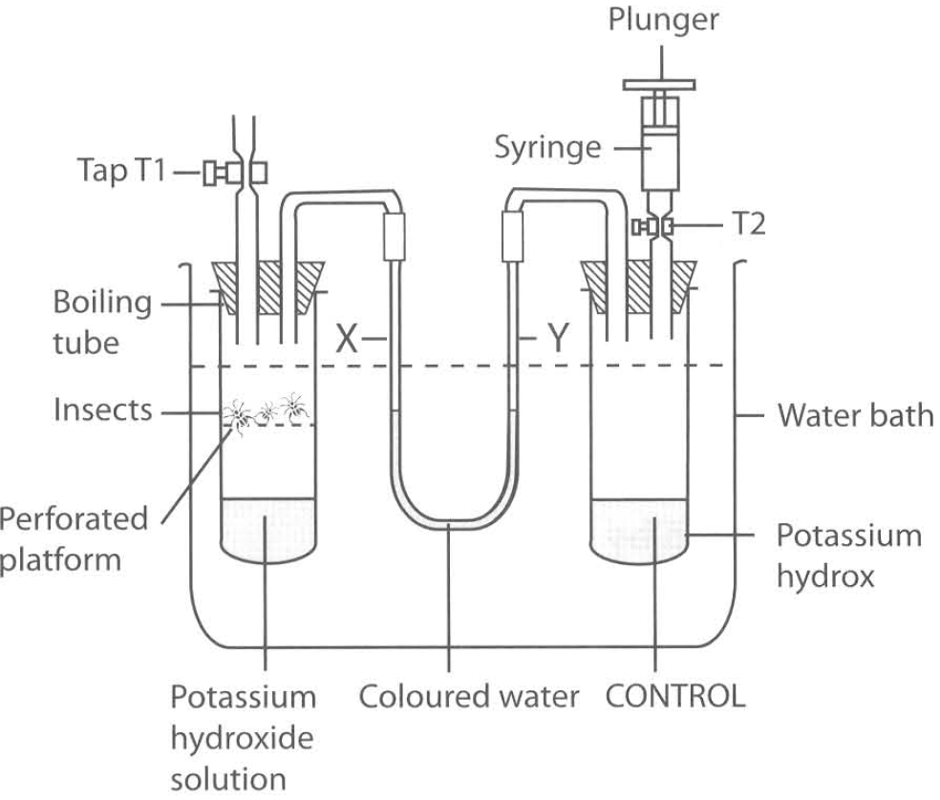
A. indicate the presence of carbon dioxide in the incoming air.
B. neutralize the incoming air so that the pH value of the cellular fluid of the rat will not be affected.
C. absorb the carbon dioxide present in the incoming air.
D. absorb the water vapour in the incoming air.
23. The control for the above experiment is prepared by
A. putting distilled water instead of potassium hydroxide in bottle P.
B. leaving bottle R empty.
C. covering bottle R with a piece of black cloth.
D. using a filter pump instead of bottle T.
24. At the end of the experiment the oil drop moves inward. Which of the following CORRECTLY account(s) for this result? (1) Uptake of oxygen by the frog. (2) An increase in atmospheric pressure. (3) An increase in temperature of the surrounding.
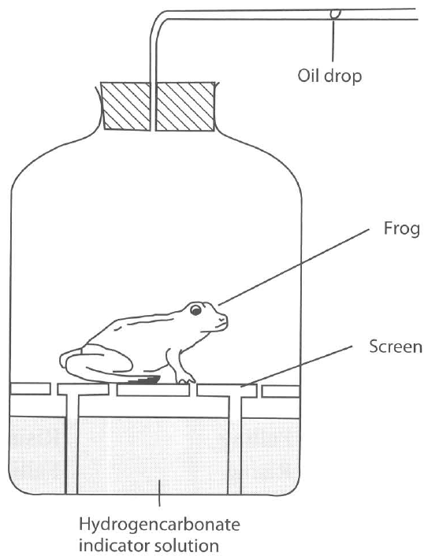
A. (1) only
B. (2) only
C. (1) and (2) only
D. (1) and (3) only
25. If the hydrogencarbonate indicator solution is replaced by potassium hydroxide solution, what will happen to the result of the experiment if the environmental conditions remain unchanged?
A. The oil drop moves outwards.
B. The oil drop moves further inwards.
C. The potassium hydroxide solution turns milky.
D. The potassium hydroxide solution turns yellow.

Answers
Answers are printed in red.
1. B
Class: 58.3% correct (n=12) usual slip A
2. A. (1) only
Class: 72.4% correct (n=29) usual slip D
3. C. (2) and (3) only
Class: 75.9% correct (n=29) usual slip B
4. D
Class: 50.0% correct (n=12) usual slip A
5. D. (1), (2), (3) and (4)
Class: 50.0% correct (n=12) usual slip B
6. C
Class: 66.7% correct (n=12) usual slip D
7. A. (1) and (2) onlyB. (1) and (3) only C. (2) and (3) only D. (1), (2) and (3) Directions: Questions 44 to 46 refer to the diagram below which shows a setup to study the respiration of yeast.- The setups were observed for 30 minutes and the table below shows the results obtained.-
Class: 50.0% correct (n=12) usual slip D
8. A. (3) and (5) only
Class: 58.3% correct (n=12) usual slip B
9. C
Class: 58.8% correct (n=17) usual slip B
10. A. (1) and (2) only
Class: 65.5% correct (n=29) usual slip D
11. B. X2 and Y1
Class: 50.0% correct (n=12) usual slip C
12. B. They undergo redox reactions in the cristae of the mitochondrion to produce ATP.
Class: 75.0% correct (n=12) usual slip A
13. B. Glucose Triose phosphate Pyruvate Acetyl Co-A-.-Krebs cycle →CO2 + H2O + ATP
Class: 79.3% correct (n=29) usual slip C
14. B. Oxidation of pyruvate to carbon dioxide and water
Class: 50.0% correct (n=12) usual slip A
15. C. To remove hydrogen from the coenzyme NADH
Class: 69.0% correct (n=29) usual slip C
16. B. (3) (2) (1)
Class: 55.2% correct (n=29) usual slip D
17. C. Aerobic respiration Directions: Questions 20 to 25 refer to the experiment described below. Three groups of pea seeds were treated differently and put into three separate thermoflasks X, Y and Z. A thermometer was put in each flask with the bulb embedded in the seeds, and a plug of cotton wool was put at the neck of each flask. The readings of thermometers were recorded at regular intervals for three days and are expressed graphically below.
Class: 75.0% correct (n=12) usual slip A
18. C. to provide air to support the aerobic respiration of the seeds.
Class: 66.7% correct (n=12) usual slip A
19. D
Class: 75.0% correct (n=12) usual slip C
20. B. a layer of cotton wool.
Class: 66.7% correct (n=12) usual slip A
21. D. The heat released by the rat causes the air inside boiling tube S to expand and presses the coloured liquid down tube X.
Class: 75.0% correct (n=12) usual slip C
22. C. absorb the carbon dioxide present in the incoming air.
Class: 75.0% correct (n=12) usual slip C
23. B. leaving bottle R empty.
Class: 66.7% correct (n=12) usual slip A
24. B. (2) only
Class: 66.7% correct (n=12) usual slip D
25. B. The oil drop moves further inwards.
Class: 50.0% correct (n=12) usual slip A

Class percentage correct
Matched to this paper by question wording in the source bank and the form answer key, not by a shifted paper number.
Q | Answer | % correct | n | Usual slip
1 | B | 58.3% | 12 | A
2 | A | 72.4% | 29 | D
3 | C | 75.9% | 29 | B
4 | D | 50.0% | 12 | A
5 | D | 50.0% | 12 | B
6 | C | 66.7% | 12 | D
7 | A | 50.0% | 12 | D
8 | A | 58.3% | 12 | B
9 | C | 58.8% | 17 | B
10 | A | 65.5% | 29 | D
11 | B | 50.0% | 12 | C
12 | B | 75.0% | 12 | A
13 | B | 79.3% | 29 | C
14 | B | 50.0% | 12 | A
15 | C | 69.0% | 29 | C
16 | B | 55.2% | 29 | D
17 | C | 75.0% | 12 | A
18 | C | 66.7% | 12 | A
19 | D | 75.0% | 12 | C
20 | B | 66.7% | 12 | A
21 | D | 75.0% | 12 | C
22 | C | 75.0% | 12 | C
23 | B | 66.7% | 12 | A
24 | B | 66.7% | 12 | D
25 | B | 50.0% | 12 | A

