Support and movement in humans
Multiple-choice practice
Name: ________________________ Class: ____________
There are 117 questions compiled from Longman HKCEE and/or YKTo papers. Choose the one best answer.
Part A — HKCEE level (Longman)
1. Which of the following pairs of bones allows the greatest degree of movement?
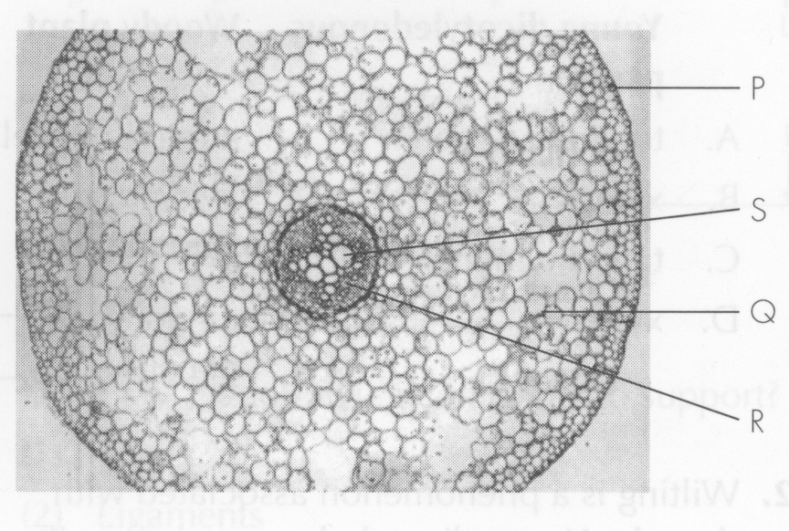
A. Humerus and ulna B. Humerus and radius
C. Femur and tibia D. Femur and pelvic girdle Directions: Questions 2 to 4 refer to the following drawing which shows the structure of a synovial joint.
2. During movement, bones X and Y are prevented from wearing by
A. P and Q.
B. Q and R.
C. R and S.
D. S and P.
3. This type of synovial joint can be found at the (1) hip. (2) elbow. (3) finger.
A. (1) and (2) only
B. (1) and (3) only
C. (2) and (3) only
D. (1), (2) and (3)
4. Which of the following correctly describe the physical nature and function of P?
Directions: Questions 5 to 7 refer to the following experiment.
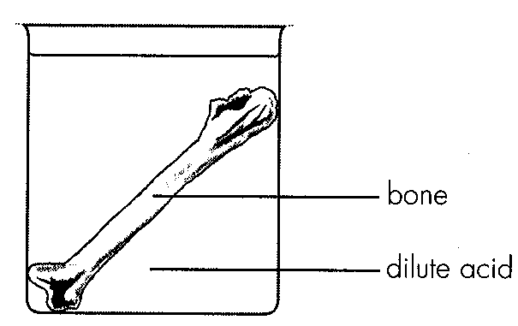
 | Physical nature | Function
A. | elastic | to transmit force between bones X and Y
B. | elastic | to allow relative movement between bones X and Y
C. | inelastic | to transmit force between bones X and Y
D. | inelastic | to allow relative movement between bones X and Y

5. After immersing the bone in dilute acid for a few days, the bone will become
A. softer.
B. harder.
C. more brittle.
D. less brittle.
6. Which of the following is the best conclusion for this experiment?
A.The toughness of bones is due to the presence of inorganic ions.
B.The toughness of bones is due to the presence of organic compounds.
C.The hardness of bones is due to the presence of inorganic ions.
D.The hardness of bones is due to the presence of bone cells.
Directions: Questions 8 and 9 refer to the diagram below.
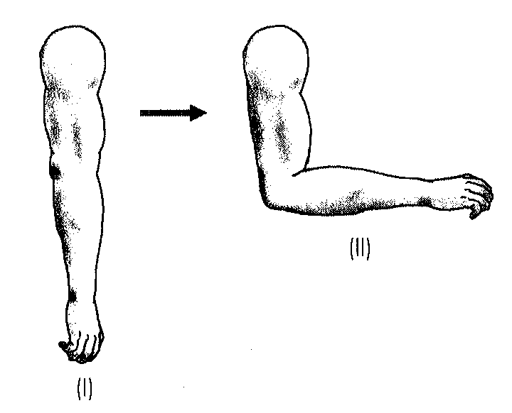
7. Which of the following causes the forearm to change from posture (I) to (II)?
A.Contraction of biceps muscle only
B. Contraction of triceps muscle only C.Contraction of biceps muscle and relaxation of triceps muscle D.Contraction of triceps muscle and relaxation of biceps muscle
8. Which of the following lever diagrams represents the forearm when it is maintaining posture (II)?
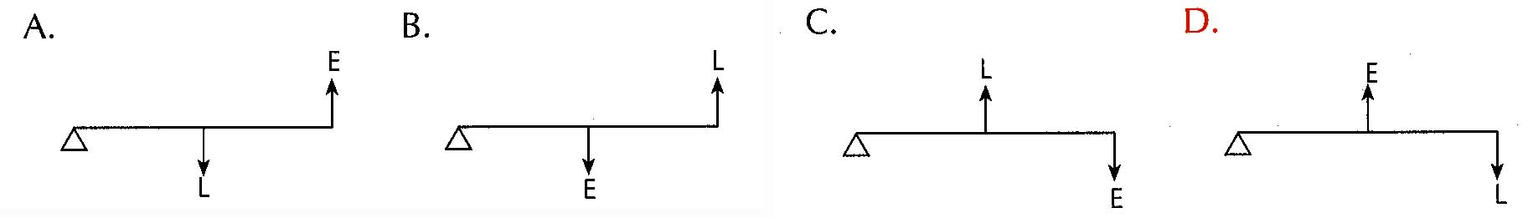
9. Which of the following are brought about by antagonistic muscles? (1) Movement of eyeball (2) Changing the size of pupil (3) Changing the thickness of lens
A. (1) and (2) only
B. (1) and (3) only
C. (2) and (3) only
D. (1), (2) and (3)
10. Which of the following do not involve antagonistic muscles? (1) Movement of rib cage (2) Movement of diaphragm (3) Erection of hair
A. (1) and (2) only
B. (1) and (3) only
C. (2) and (3) only
D. (1), (2) and (3)
11. Which of the following are functions of the mammalian skeleton? (1)It supports the body. (2)It protects some internal organs. (3)It forms a lever system for muscles to act on.
A. (1) and (2) only
B. (1) and (3) only
C. (2) and (3) only
D. (1), (2) and (3)
12. Which of the following is not the function of mammalian skeleton?
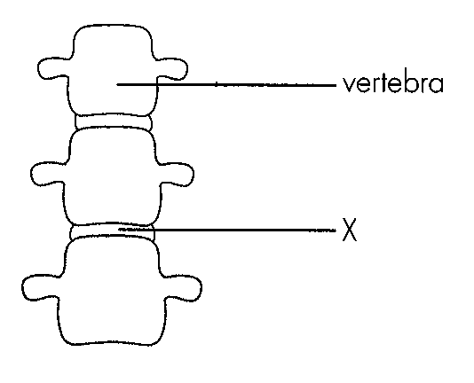
A. It manufactures blood cells.
B. It regulates the calcium content in the body.
C. It protects the central nervous system.
D. It serves as the sites of attachment for muscles. Directions: Questions 14 and 15 refer to the diagram below which shows a segment of the vertebral column. 14.X is probably a
A. tendon. B. cartilage. C. ligament. D. bone.
13. The function of X is to
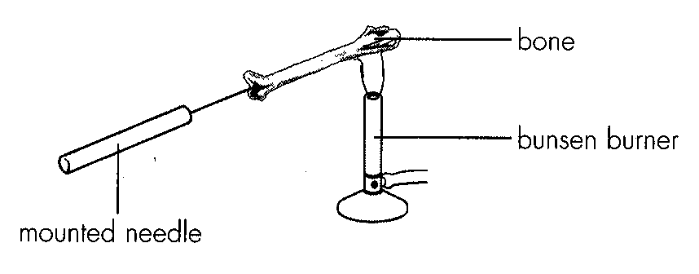
A. reduce friction between vertebrae. B. hold two vertebrae together.
C. provide the site for muscle attachment. D. support the vertebrae. Directions: Questions 16 to 18 refer to the following experiment.
14. After burning completely, the bone will become
A. softer.
B. harder.
C. more brittle.
D. less brittle.
15. The result in Question 16 is caused by A.the evaporation of water in the bone. D.the burning away of organic substances in the bone.
A. the evaporation of water in the bone.
B. the denaturation of proteins in the bone.
C. the burning away of mineral ions in the bone.
D. the burning away of organic substances in the bone.
16. Which of the following is the best conclusion for this experiment? A.The toughness of bones is due to the presence of mineral ions. B.The toughness of bones is due to the presence of organic substances. C.The hardness of bones is due to the presence of mineral ions. D.The hardness of bones is due to the presence of organic substances.
A. The toughness of bones is due to the presence of mineral ions.
B. The toughness of bones is due to the presence of organic substances.
C. The hardness of bones is due to the presence of mineral ions.
D. The hardness of bones is due to the presence of organic substances.
17. Which of the following are mainly made of cartilage in a newborn baby?
(1) Nose (2) Ears (3) Skull
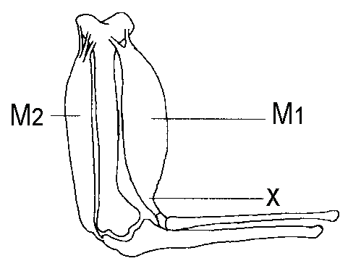
A. (1) and (2) onlyB. (1) and (3) only C. (2) and (3) only D. (1), (2) and (3) Directions: Questions 20 to 22 refer to the following diagram which shows the bones and the associated muscles in a human arm.
18. What is the name and function of M2 ?
 | Name | Function
A. | biceps | as a flexor
B. | biceps | as an extensor
C. | triceps | as a flexor
D. | triceps | as an extensor

19. Which of the following will occur when M 1 is becoming thicker and shorter?
A. The arm will be straightened at the elbow.
B. The arm will be straightened at the wrist.
C. The arm will be bent at the elbow.
D. The arm will he bent at the wrist.
20. What will structure X become when M 1 is relaxing?
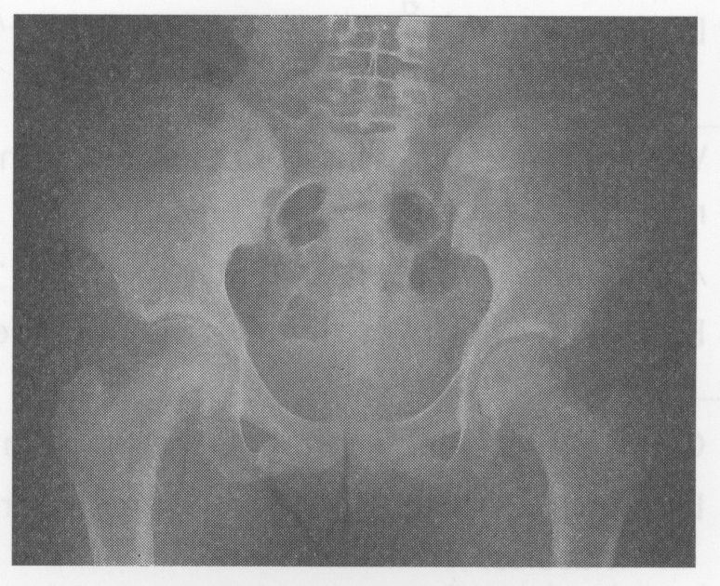
A. Remain the same B. Longer C. Shorter D. Under higher tension Directions: Questions 23 and 24 refer to the Xray photograph of the pelvic girdle and the associated bones.-
21. Which of the following correctly describes the type of joint shown in the photograph and the degree of movement it permits?
 | Type of joint | Degree of movement
A. | ball and socket | in three planes
B. | ball and socket | in many planes
C. | hinge | in one plane
D. | hinge | in one dimension

22. Dislocation is prevented between the pelvic girdle and the legs by
A. cartilage.
B. tendon.
C. ligaments.
D. muscles.
23. Which of the following descriptions of different parts of a long bone is correct?
 | Parts of long bone | Description
A. | compact bone | innermost for support
B. | compact bone | outermost for protection
C. | cartilages | in the middle for support
D. | cartilages | at both ends for protection

24. Long bones like femur are hollow in structure because
(1) it makes the bone lighter.
(2) it is more resistant to bending than a solid bone of the same mass.
(3) it can accommodate blood vessels and nerves.
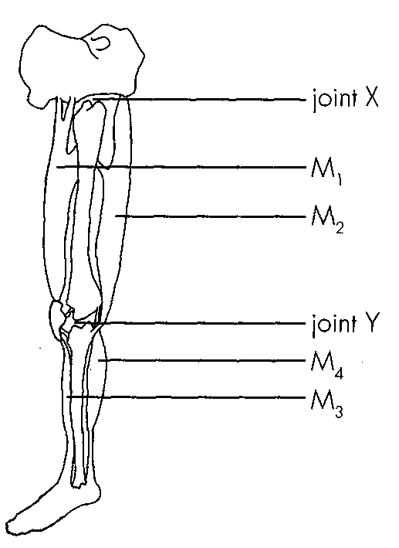
A. (1) and (2) onlyB. (1) and (3) only C. (2) and (3) only D. (1), (2) and (3) Directions: Questions 27 to 29 refer to the diagram below.
25. Which of the following classification of the muscle is correct?
 | Flexor | Extensor
A. | M1 and M3 | M2 and M4
B. | M2 and M3 | M1 and M4
C. | M1 and M4 | M2 and M3
D. | M2 and M4 | M1 and M3

26. When muscles M2 and M4 contract at the same time, the leg will
A. bend at the knee only.
B. bend at the ankle only.
C. bend at the knee and ankle.
D. straighten out.
27. Which of the following comparisons between joints X and Y is correct?
Directions: Questions 30 to 32 refer to the human skeleton below.
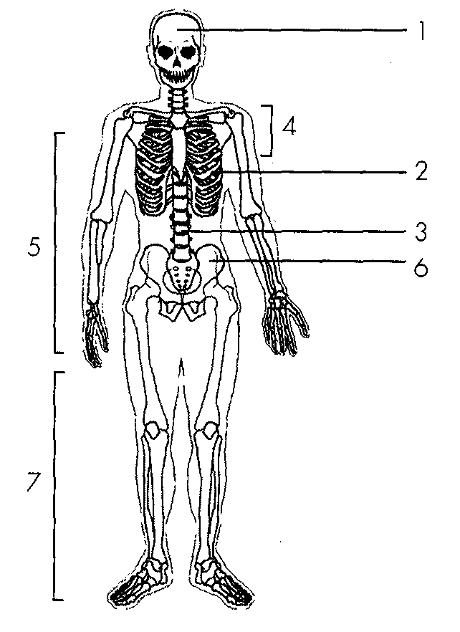
 | Joint X | Joint Y
A. | allows movement in three planes | allows movement in one plane
B. | synovial fluid present | synovial fluid also present
C. | operated by M1 and M2 | operated by M3 and M4
D. | hinge joint | ball and socket joint

28. Appendicular skeleton consists of
A. 1, 2 and 3.
B. 1, 2, 3 and 4.
C. 2, 3, 4 and 6.
D. 4, 5, 6 and 7.
29. Which of the following matchings is correct?
 | Name of 4 | Function
A. | pectoral girdle | for the attachment of forelimbs
B. | pectoral girdle | for the attachment of hindlimbs
C. | pelvic girdle | for the attachment of forelimbs
D. | pelvic girdle | for the attachment of hindlimbs

30. Which of the following are the functions of 3? (1) Storage of iron (2) Protection of spinal cord (3) Attachment of rib cage
A. (1) and (2) only
B. (1) and (3) only
C. (2) and (3) only
D. (1), (2) and (3)
31. Which part of along bone manufactures blood cells?
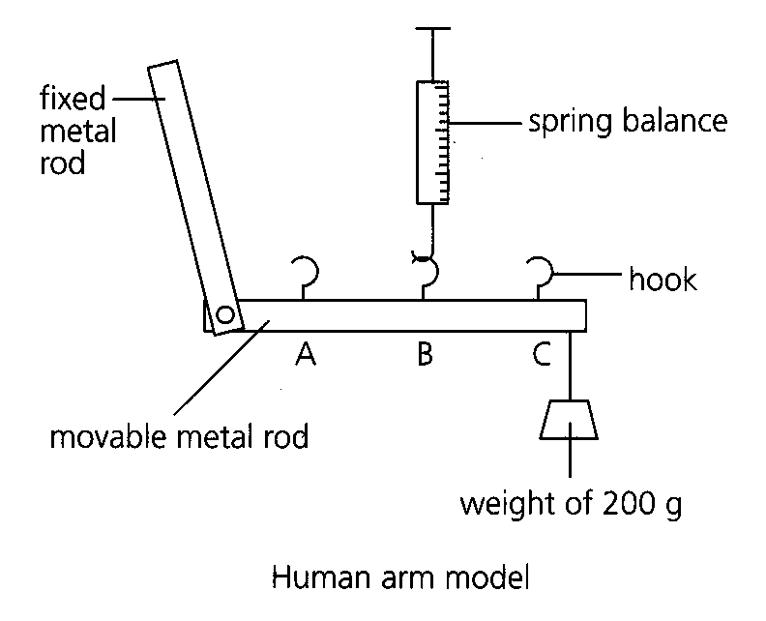
Position to which the spring balance attached | Reading on the spring balance (g)
A | 280
B | 250
C | 220

A. Compact bone B. Bone marrowC. Spongy bone D. Cartilage Directions: Questions 34 and 35 refer to the following experiment which makes use of a human arm model to measure the force needed to lift up a mass. The spring balance will be attached to different positions of the movable metal rod.
32. Which of the following correctly shows the parts of human arm represented by the human arm model?
 | Movable metal rod | Spring balance
A. | humerus | triceps
B. | ulna and radius | triceps
C. | humerus | biceps
D. | ulna and radius | biceps

33. Which of the following correctly states and explains the position of muscle attachment in human arm?
 | Position of muscle attachment in human arm | Explanation
A. | A | A smaller shortening of the muscle can produce the same arm movement.
B. | A | The arm muscle can be shorter and thicker.
C. | C | A smaller force is needed to lift up the same mass.
D. | C | The arm muscle can be longer and thinner.

34. Which of the following statements aboutskeletal muscles are correct? (1) Their contractions are initiated by the cerebrum. (2) They usually function in antagonistic pairs. (3) They store up ATP as energy reserve.
A. (1) and (2) only
B. (1) and (3) only
C. (2) and (3) only
D. (1), (2) and (3)
35. Which of the following constitute the axial skeleton in man? (1) Cranium(2) Vertebral column (3) Rib cage
A. (1) and (2) only
B. (1) and (3) only
C. (2) and (3) only
D. (1), (2) and (3)
36. Which of the following comparisons between tendon and ligament is incorrect?
 | Tendon | Ligament
A. | for muscle to bone attachment | for bone to bone attachment
B. | unable to transmit force | able to transmit force
C. | does not prevent dislocation | prevents dislocation
D. | inelastic | elastic

37. Which of the following correctly states the organs protected by different parts of the axial skeleton?
 | Skull | Backbone | Rib cage
A. | nose | trachea | liver
B. | nose | trachea | heart
C. | brain | spinal cord | heart
D. | brain | spinal cord | liver

38. Which of the following constitute the appendicular skeleton in human?
(1) Pectoral girdle(2) Pelvic girdle (3) Four limbs
A. (1) and (2) only B. (1) and (3) only C. (2) and (3) only D. (1), (2) and (3) Directions: Questions 41 to 43 refer to the following diagram which shows a lever system.
39. Which of the following exhibit this type of lever system? (1) A ballet dancer standing on tiptoes. (2) A patient under knee jerk reflex test. (3) A housewife withdrawing her hand when touching a hot pot.
A. (1) and (2) only
B. (1) and (3) only
C. (2) and (3) only
D. (1), (2) and (3)
40. This type of lever system is disadvantageous in that B. the magnitude of E is greater than that of L. C.the displacement of L is greater than that of E
A. the magnitude of L is greater than that of E.
B. the magnitude of E is greater than that of L.
C. the displacement of L is greater than that of E
D. the displacement of E is greater than that of L.
41. The distance between EF is shorter than that between LF because
A. the lever will be broken less easily.
B. the displacement of E will be shorter.
C. the muscle represented by E will be shorter.
D. the load can be heavier.
42. Which of the following physical objects comprise ball and socket joint?
A. Joystick B. Door C. Window D. Spectacles
43. Which of the following pairs of bones allow movement in one plane?
(1) Humerus and ulna (2) Femur and tibia (3) Humerus and pectoral girdle
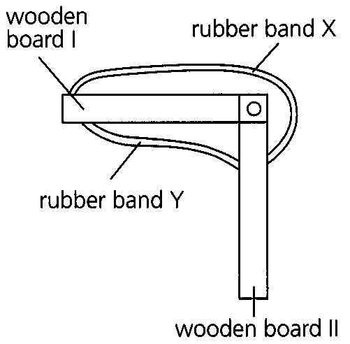
A. (1) and (2) only B. (1) and (3) only C. (2) and (3) only D. (1), (2) and (3) Directions: Questions 46 and 47 refer to the following model of human leg.
44. Which of the following correctly describes the states of rubber band X and wooden board II when the knee cap of the leg represented by this model is tapped?
 | Rubber band X | Wooden board II
A. | contracted | moved downward
B. | shortened | moved downward
C. | contracted | moved upward
D. | shortened | moved upward

45. Which of the following lever diagrams correctly represent the situation in Question 46?
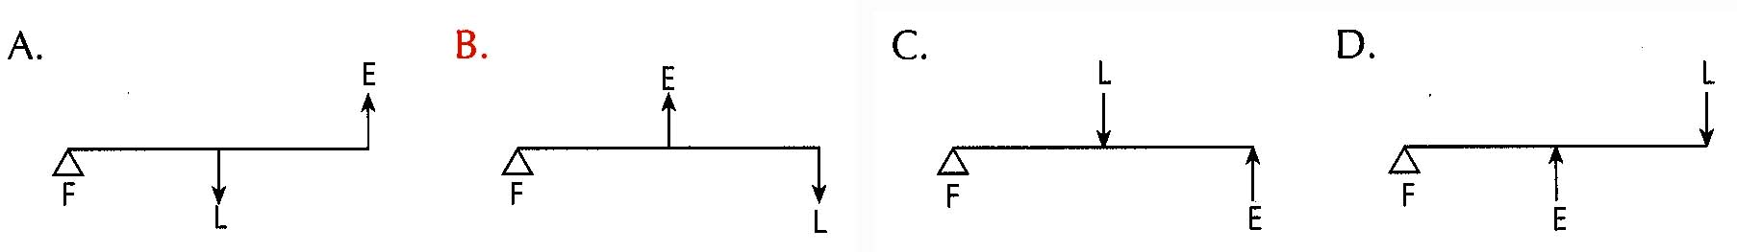
46. Which of the following contribute to support? (1) Bones (2) Ligaments (3) Muscles
A. (1) and (2) only
B. (1) and (3) only
C. (2) and (3) only
D. (1), (2) and (3)
47. Which of the following is/are mainly responsible for keeping a young dicotyledonous plant upright? (1) Turgidity of cells (2) Physical nature of xylem (3) Physical nature of phloem
A. (1) only
B. (2) only
C. (3) only
D. (1) and (2) only
48. Which of the following is/are responsible for keeping a woody plant upright? (1) Turgidity of cells (2) Physical nature of xylem (3) Physical nature of phloem D. (1) and (2) only 51.Support of young dicotyledonous plant and woody plant are mainly by
 | Young dicotyledonous | Woody plant
A. | turgidity of cells | turgidity of cells
B. | xylem | xylem
C. | turgidity of cells | xylem
D. | xylem | turgidity of cells

A. (1) only
B. (2) only
C. (3) only
D. (1) and (2) only 51.Support of young dicotyledonous plant and woody plant are mainly by:
49. Wilting is a phenomenon associated with drought. Young dicotyledonous plants wilt more easily than woody plants because A.the waxy cuticle of leaves has not fully developed. B.the root system has not fully developed. C.the surface area to volume ratio is larger. D.the xylem has not fully developed. directions: Questions 53 to 55 refer to the diagram low which shows the transverse section of a part of a plant.
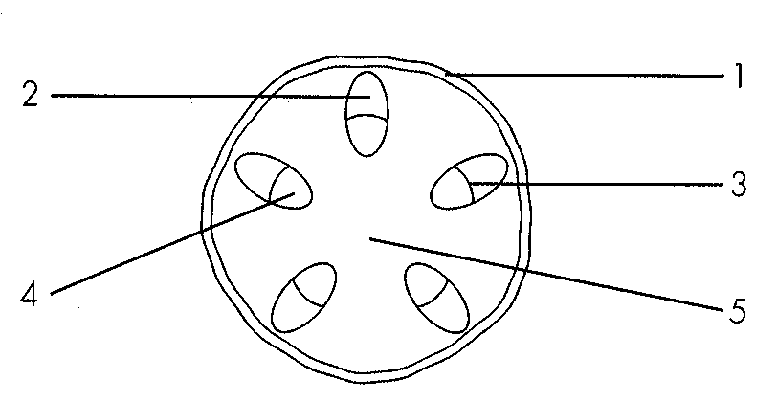
A. the waxy cuticle of leaves has not fully developed.
B. the root system has not fully developed.
C. the surface area to volume ratio is larger.
D. the xylem has not fully developed. directions: Questions 53 to 55 refer to the diagram low which shows the transverse section of a part of a plant.
50. From which part of the plant is this section obtained? D. Petiole 54.Support in this plant is mainly by A. 2. B. 3. C. 4. D. 5.
A. Root
B. Stem
C. Leaf
D. Petiole 54.Support in this plant is mainly by
51. Which of the following numbered structures is the hardest tissue in the section?
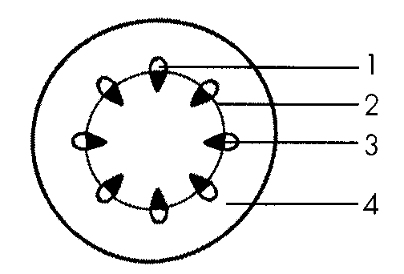
A. 1 B. 2 C. 3 D. 4 Directions: Questions 56 to 58 refer to the diagram below which shows the transverse section of the stem of a dicotyledonous plant.
52. Which of the following correctly states the functions of 1, 3 and 4?
53. | 3 | 4 |
A. | support | transport of water | support |
B. | transport of water | transport of food | support |
C. | transport of food | support | storage of food |
D. | transport of water | transport of food | storage of food
54. Which of the following cell types is capable of undergoing mitosis?
A. 1
B. 2
C. 3
D. 4
55. In the stem, tissue 3 is located in the periphery because such distribution
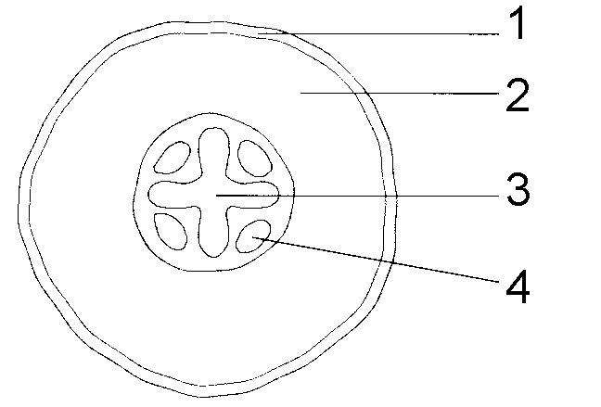
A. can increase the resistance to bending.
B. can increase the resistance to pulling.
C. can protect the tissues at the centre.
D. can make the surface harder. Directions: Questions 59 to 61 refer to the diagram below which shows the transverse section of certain part of a dicotyledonous plant.
56. From which part of the plant is this section obtained?
A. Root
B. Stem
C. Leaf
D. Petiole
57. Which of the following correctly states the functions of 2 and 4?
58. | 4 |
A. | storage of food | transport water |
B. | storage of food | support by xylem |
C. | support by turgidity | transport food |
D. | support by turgidity | transport water
59. Which of the following comparisons between 1 and 3 is correct?
60. | 3 | A. | with cuticle | without cuticle | B. | living tissue | dead tissue | C. | hollow in structure | solid in structure | D. | for transport | for support
Directions: Questions 62 to 64 refer to the photomicrograph below which shows the transverse section of a dicotyledonous roof.
61. Which of the following correctly functions of P, Q and S?
 | P | Q | S
A. | support | food storage | water transport
B. | water absorption | gaseous exchange | water transport
C. | gaseous exchange | support | support
D. | gaseous exchange | support | food transport

62. Which of the following can still offer support to the root after a period of drought?
A. P
B. Q
C. R
D. S
63. In the root, tissue S is located at the centre because such distribution
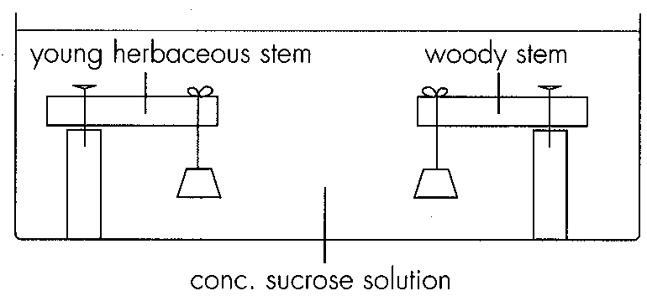
A. can increase the resistance to pulling. B. can increase the resistance to bending.
C. can be better protected by outer tissues.D. can facilitate the transport of water. Directions: Questions 65 to 67 refer to the following experiment which compares the means of support in young herbaceous stem and woody stem.
64. After immersing in concentrated sucrose solution for 2 hours, the two stems would
 | Young herbaceous stem | Woody stem
A. | become shorter. | remain unchanged.
B. | remain unchanged. | become shorter.
C. | bend downward. | remain unchanged.
D. | remain unchanged. | bend downward.

65. Which of the following account for the result in young herbaceous stem? (1) Xylem in young stem has not fully developed. (2) Cells in the young stem were plasmolysed. (3) Cells in the young stem became flaccid.
A. (1) and (2) only
B. (1) and (3) only
C. (2) and (3) only
D. (1), (2) and (3)
66. The result in woody stem is due to the (1) plasmolysis of cells. (2) flaccidity of cells. (3) physical nature of the xylem.
A. (3) only
B. (1) and (2) only
C. (1) and (3) only
D. (2) and (3) only
Part B — HKDSE-style (YKTo)
67. After a piece of bone has been immersed in dilute acid for a long period of time, it becomes very flexible because
A. the acid has killed the living cells of the bone.
B. the acid has dissolved the organic component so that the strengthening effect is lost.
C. the water potential of the acid is lower than that of the bone so that water is withdrawn from the latter.
D. the acid has dissolved the mineral salts so that only the soft organic matter is left in the bone. 4The bones of old people are more fragile than that of the young ones because
A. their bones contain less iron. B. their bones have less living cells.
C. their bones contain less calcium salts. D. they are lack of doing exercises.
68. Elders usually have the problem of osteoporosis. What is the importance of vitamin D to them?
A. It enhances the absorption of calcium salts from food in the small intestine.
B. It is an essential component of bones.
C. It catalyzes the buildup of calcium salts from bones.
D. It reduces the loss of calcium salts from bones.
69. Long bone can easily fracture in a person who has
A. anaemia.
B. beriberi.
C. osteoporosis.
D. haemorrhage.
70. If the two broken ends of the fractured bone are properly joined together, the bone can heal after a period of time. This shows that
A. bone is an effector that can respond to stimulus.
B. bone needs hormones to support a long term metabolic process.
C. bone is a living tissue that can grow.
D. old man takes longer time to heal broken bone.
71. After a piece of bone has been heated in a Bunsen flame for a certain period of time, it becomes very brittle because
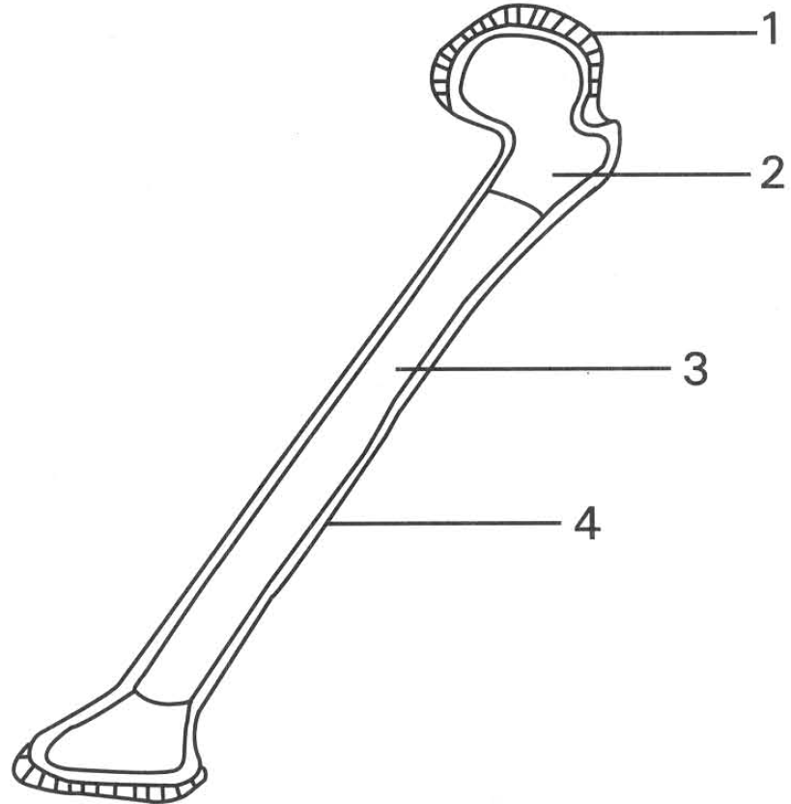
A. the heat kills all the living cells of the bone.
B. the heat burns away the organic matter so that only the mineral salts are left.
C. the heat decomposes the mineral salts of the bone to a simpler form.
D. the heat drives all the water away. Direction: Questions 9 to 11 refer to the diagram below, which shows the longitudinal section of a long bone.
72. Which of the following CORRECTLY identifies the structures labelled 1, 2, 3 and 4?
73. | 2 | 3 | 4 | A. | Ligament | Yellow bone marrow | Cartilage | Compact bone | B. | Cartilage | Red bone marrow | Yellow bone marrow | Compact bone | C. | Ligament | Compact bone | Red bone marrow | Spongy bone | D. | Cartilage | Spongy bone | Compact bone | Ligament
74. Which of the following groups of functions CORRECTLY match with the structures concerned?
 | Structure 1 | Structure 2 | Structure 3
A. | Reduces friction | Stores fat | Produces red blood cells
B. | Binds with the bones articulated at the same joint | Contains fluid to lubricate the joint | Stores fat
C. | Reduces friction | Produces red blood cells | Stores fat
D. | Stores calcium salts | Stores fat | Stores phosphate

75. Which of the following CORRECTLY describes the property of structures 1 and 4?
 | Structure 1 | Structure 4
A. | Elastic | Rigid
B. | Rigid | Elastic
C. | Living | Dead
D. | Dead | Living

76. Which of the following structures has NO cartilage?
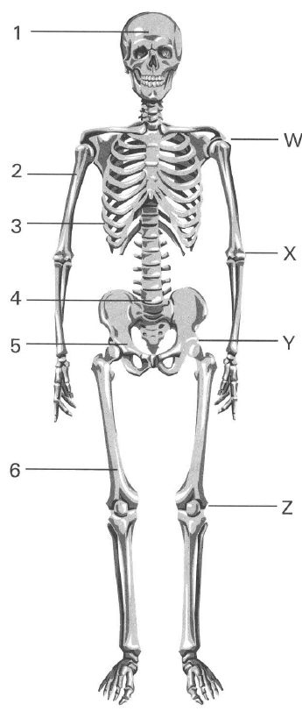
A. Trachea B. Bronchiole C. Vertebral column D. Elbow joint
77. Which of the following is NOT a function of the human skeletal system?
A. It forms the firm framework to support the body.
B. It protects the delicate internal organs of the body.
C. It stores iron for the body.
D. It forms lever systems of the body to permit rapid locomotion. Directions: Questions 14 to 18 refer to the diagram below, which shows the skeleton of a human.
78. Which of the following combinations CORRECTLY represents the axial skeleton and appendicular skeleton of human?
 | Axial skeleton | Appendicular skeleton
A. | 1,4,5 | 2,3,6
B. | 2,5,6 | 1,3,4
C. | 1,3,4 | 2,5,6
D. | 1,5,6 | 2,3,4

79. Which labelled parts have protective function?
A. 1, 3 and 4 only
B. 1, 2 and 3 only
C. 3, 4 and 6 only
D. 3, 5 and 6 only
80. Which types of joints are found at W, X, Y and Z?
 | Joint W | Joint X | Joint Y | Joint Z
A. | Ball and socket | Ball and socket | Hinge | Hinge
B. | Hinge | Hinge | Ball and socket | Ball and socket
C. | Ball and socket | Hinge | Ball and socket | Hinge
D. | Hinge | Ball and socket | Hinge | Ball and socket

81. Which joint gives the greatest degree of movement of a normal healthy person?
A. Joint W
B. Joint X
C. Joint Y
D. Joint Z
82. Which of the following are functions of structure 3? (1) Storage of white blood cells. (2) Production of red blood cells. (3) Protection of the lungs and heart. (4) Aiding breathing action.
A. (1) and (3) only
B. (2) and (4) only
C. (1), (2) and (3) only
D. (2), (3) and (4) only
83. The vertebral column is made up of many pieces of small bones instead of a single piece of long bone because such structure
A. enables the body to bend easily.
B. allows the bod to absorb shock effectively.
C. allows each piece of bone to secrete fluid to lubricate the bending movement of the body.
D. provides bigger area for attaching with more muscles to bring about locomotion.
84. Which of the following statements related with the ribs in humans is INCORRECT?
(1) All ribs are completely made of bones.
(2) All ribs Connect the thoracic vertebrae and the sternum.
(3) Ribs are involved in the respiratory movement of the thoracic wall.
(4) Ribs are capable of producing red blood cells.
(5) Ribs protect the delicate internal organs of the abdominal cavity.
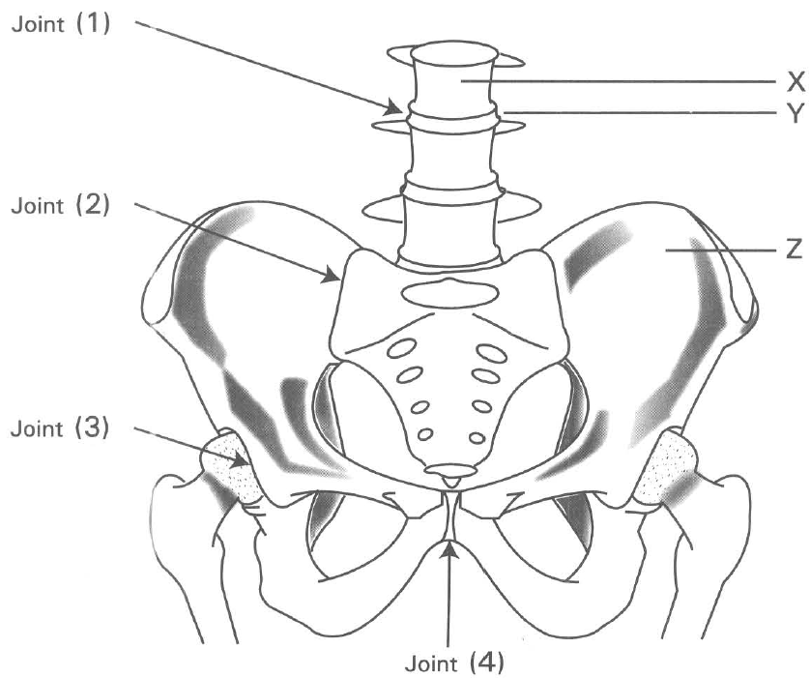
A. (1) only B. (5) only C. (3) and (4) only D. (1), (2) and (5) only Directions: Questions 21 to 25 refer to the diagram below, which shows the bones in the abdomen and the thigh bones in humans.
85. Which labelled joints have relatively high degree of movement?
A. (1) and (2) only
B. (1) and (3) only
C. (2) and (3) only
D. (3) and (4) only
86. Which of the following joints has the same degree of movement as that of joint 3?
A. Elbow joint B. Shoulder joint
C. Knee joint D. Ankle joint
87. Which of the following are functions of structure X? (1) Protects the spinal cord (2) Produces white blood cells (3) Stores iron (4) Provides more surface for muscle attachment
A. (1) and (4) only
B. (2) and (3) only
C. (3) and (4) only
D. (1), (2) and (4) only
88. Both Y and Z are skeletal tissues. Which of the following comparisons between Y and Z is CORRECT?
 | Tissue Y | Tissue Z
A. | Rigid | Elastic
B. | Elastic | Rigid
C. | Contains more calcium salts | Contains more iron
D. | Living | Dead

89. Which of the following is/are function(s) of structure Z? (1) Produces red blood cells (2) Destroys white blood cells (3) Produces vitamin D (4) Stores calcium slats
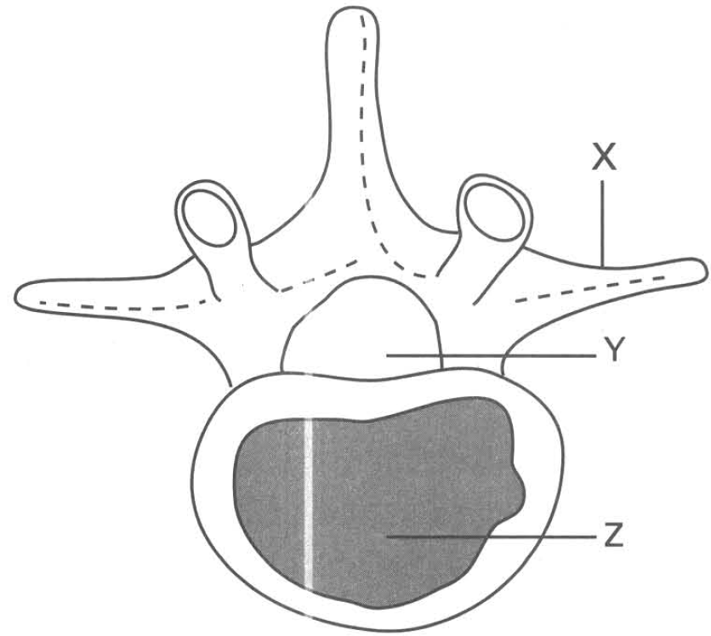
A. (1) and (2) only
B. (1) and (4) only
C. (2) and (3) only
D. (3) and (4) only
90. The diagram below shows the vertebra of a mammal. Which of the following combinations of functions CORRECTLY matches the parts labelled X, Y and Z?
 | X | Y | Z
A. | Attachment of muscles | Protection of arteries inside | Storage of calcium salts
B. | Attachment with other bones | Protection of veins inside | Storage of iron
C. | Attachment of muscles | Protection of spinal cord inside | Support of the body
D. | Attachment with other bones | Protection of veins inside | Storage of calcium salts

B. Tissues involved in movement
91. Which of the following comparisons between ligament and tendon are CORRECT?
. | Ligament | Tendon
(1) | Elastic | Inelastic
(2) | Attaches muscles to bone | Attaches bone to bone
(3) | Generates force to move bones | Lubricates bones at the joint
(4) | Prevents dislocation of bones at the joint | Transmits force from muscle to bone

A. (1) and (2) only
B. (2) and (3) only
C. (3) and (4) only
D. (1) and (4) only
92. The peristaltic movement of food along the alimentary canal depends on the alternate contraction and relaxation of
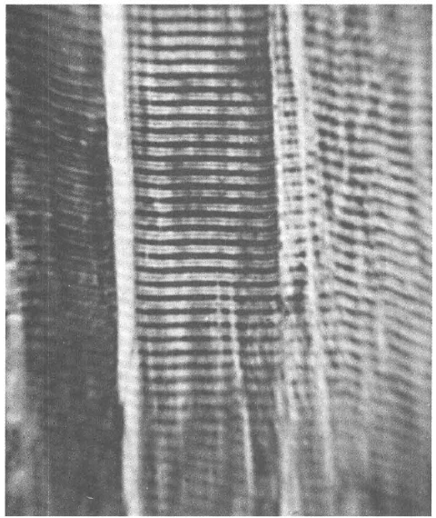
A. the skeletal muscles. B. the cardiac muscles.
C. the smooth muscles. D. the tendon and ligament. Directions: Questions 29 and 30 refer to the photomicrograph below.
93. Which of the following are characteristics of the tissue shown in the photomicrograph? (1) They are attached to skeleton. (2) They are composed of non-striated muscle fibres. (3) They are capable of very powerful contraction and become fatigue easily. (4) Their activities are usually NOT under voluntary control.
A. (1) and (2) only
B. (1) and (3) only
C. (1) and (4) only
D. (2) and (3) only
94. Which of the following structures has the tissues shown in the photomicrograph?
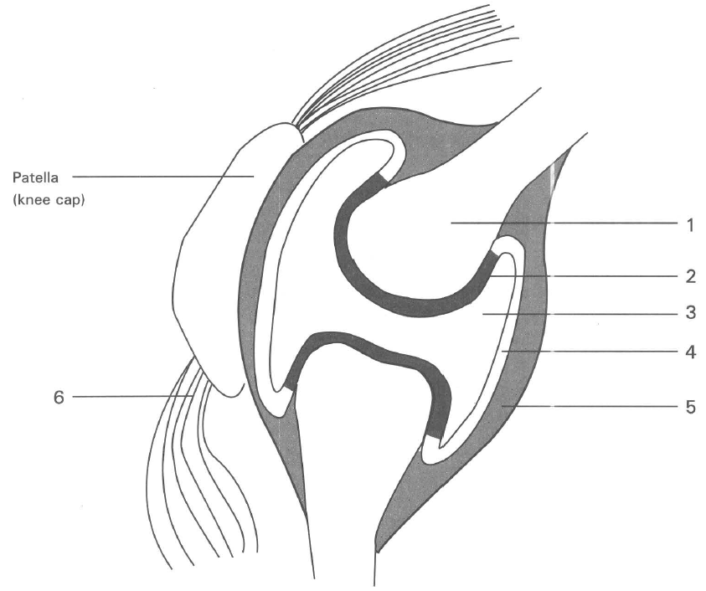
A. Biceps B. Iris C. Oesophagus D. Hepatic artery
C. Joints Directions: Questions 31 to 36 refer to the diagram below, which shows the structure of a joint.
95. Which of the following groups of names CORRECTLY matches with structures 1, 2, 4 and 5?
96. | 2 | 4 | 5 | A. | Bone | Synovial membrane | Ligament | Cartilage | B. | Cartilage | Bone | Synovial membrane | Ligament | C. | Cartilage | Synovial membrane | Ligament | Tendon | D. | Bone | Cartilage | Synovial membrane | Ligament
97. The function of structure 2 is to (1) reduce friction. (2) secrete fluid into 3. (3) absorb shock. (4) protect the bony surface from wearing.
A. (1) and (2) only
B. (2) and (3) only
C. (2), (3) and (4) only
D. (1), (3) and (4) only
98. The fluid contained in 3 is
A. cerebrospinal fluid.
B. plasma.
C. synovial fluid.
D. lymph.
99. What is the function of the fluid contained in 3? (1) Lubricates the movement of the bones articulated at the joint. (2) Absorbs the heat released from the muscles. (3) Maintains the shape of the joint. (4) Transports nutrients to and removes metabolic wastes from structure 2.
A. (1) only
B. (1) and (2) only
C. (1) and (4) only
D. (2) and (3) only
100. Which of the structures labelled in the diagram are responsible for reducing friction?
A. 2 and 3 only
B. 3 and 4 only
C. 5 and 6 only
D. 2 and 5 only
101. Arthritis is due to the damage of the tissue labelled
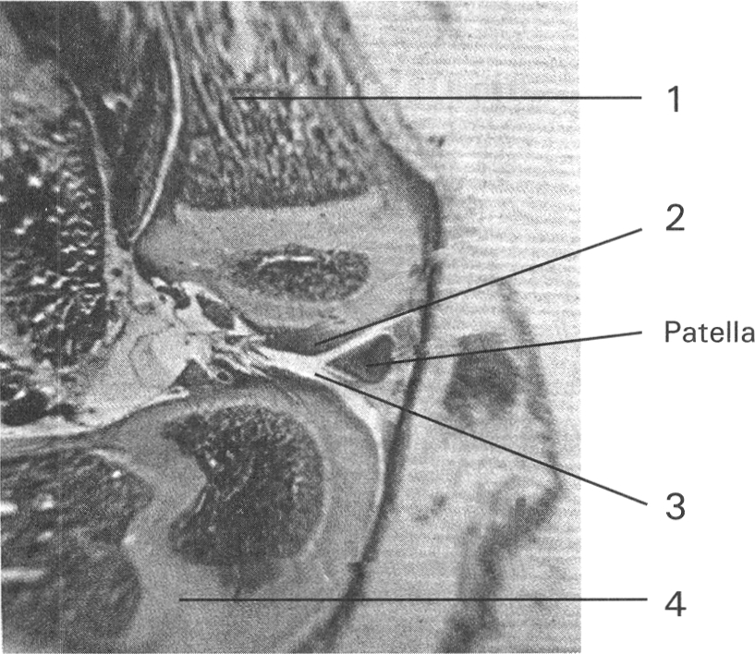
A. 1 B. 2 C. 4 D. 5 Directions: Questions 37 and 38 refer to the photomicrograph below, which shows the structure of a joint.
102. Which of the following combinations CORRECTLY matches the functions of the parts/substances labelled (2) and (3)? 38 Structures 1 and 4 are bound together by
 | (2) | (3)
A. | Produces red blood cells | Produces white blood cells
B. | Stores calcium salts | Stores iron
C. | Reduces friction by its smooth surface | Reduces friction by lubricating effect
D. | Very rigid to protect the end of bone | Very soft to reduce the friction on the end of bone

A. muscles.
B. ligament.
C. tendon.
D. cartilage.
103. Which of the following comparison of the shoulder joint and elbow joint is CORRECT?
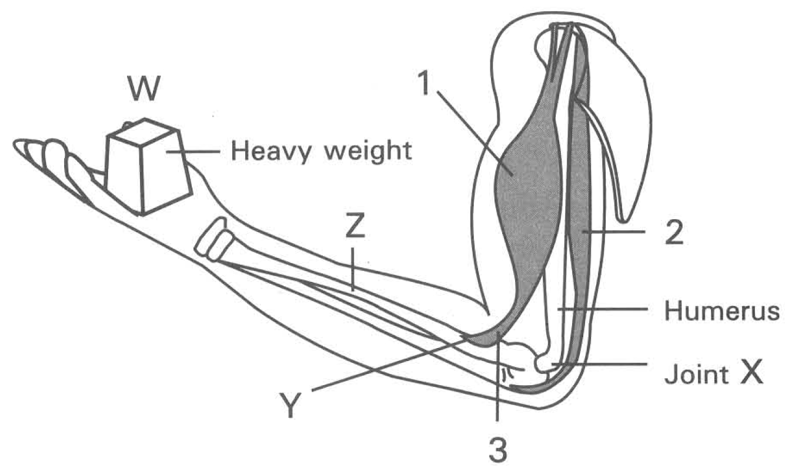
. | Shoulder joint | Elbow joint
A. | Movable joint | Immovable joint
B. | Permits moment in three planes | Permits movement in one plane only
C. | Hinge joint | Ball and socket joint
D. | Formed between three pieces of bones | Formed between two pieces of bones

D. Movement Directions: Questions 40 to 45 refer to the diagram below, which shows a human arm holding a heavy weight.
104. Which of the following groups of names CORRECTLY matches with the terms biceps, triceps,extensor and flexor respectively?
41 Structures 1 and 2 are antagonistic muscles because
 | Biceps | Triceps | Extensor | Flexor
A. | 2 | 1 | 2 | 1
B. | 1 | 2 | 2 | 1
C. | 2 | 1 | 1 | 2
D. | 1 | 2 | 1 | 2

A. when one muscle is damaged the other can function.
B. they are present on the opposite sides of the bone of the upper arm.
C. when one muscle contracts, the other muscle relaxes.
D. they are attached to two different bones of the lower arm.
105. Which of the following occurs when structure 2 contracts and structure 1 relaxes?
A. Structure 2 increases its length.
B. Structure 1 increases its thickness.
C. Tension on structure 3 increases.
D. Structure 3 is slackened.
106. When the weight(W) is lifted up, which of the following matching is CORRECT?
 | Effort | Load | Fulcrum
A. | Weight W | Muscle 1 | Muscle 2
B. | Muscle 1 | Humerus | Joint X
C. | Muscle 1 | Weight W | Joint X
D. | Joint X | Muscle 2 | Humerus

107. What is the advantage for muscle 1 to attach at position Y instead of at position Z?
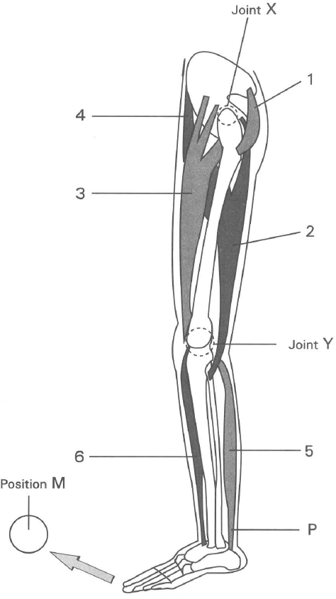
A. The lower arm can be bent at faster rate.
B. The lower arm can be bent with greater force.
C. The muscle will not be torn away from the bone so easily.
D. It enables the fore-arm to move to greater degree. Directions: Questions 46 to 52 refer to the diagram below, which is a left human leg viewed from outside.
108. The degree of movement permitted by joint X and joint Y are respectively at
 | Joint X | Joint Y
A. | 180° | 360°
B. | 180° | 180°
C. | 360° | 360°
D. | 360° | 180°

109. Which of the following combinations for the muscles concerned is CORRECT?
 | Extensors | Flexors
A. | 4,5,6 | 1,2,3
B. | 1,2,3 | 4,5,6
C. | 1,3,5 | 2,4,6
D | 2,4,6 | 1,3,5

110. To bring about knee jerk reflex, which of the following muscles will be involved and are in the CORRECT state?
 | Contracted | Relaxed
A. | 2 | 1
B. | 3 | 2
C. | 2 | 3
D. | 1 | 2

111. Which of the following combinations CORRECTLY describes the state of the muscles concerned in moving the leg to position M? 51Which muscles are involved in keeping an upright standing posture?
. | 1 | 2 | 3 | 4
A. | Contracted | Relaxed | Relaxed | Relaxed
B. | Relaxed | Relaxed | Contracted | Contracted
C. | Relaxed | Relaxed | Relaxed | Contracted
D. | Contracted | Relaxed | Relaxed | Contracted

A. 3 and 5 only
B. 2 and 6 only
C. 1, 2 and 3 only
D. 1, 2, 3, 4, 5 and 6
112. If structure P of a student is broken in a high jump practice, which of the following is/are CORRECT?
(1) The upper leg can still move properly. (2) The lower leg cannot move properly.
(3) Knee jerk reflex cannot occur. (4) Muscle 5 cannot contract.
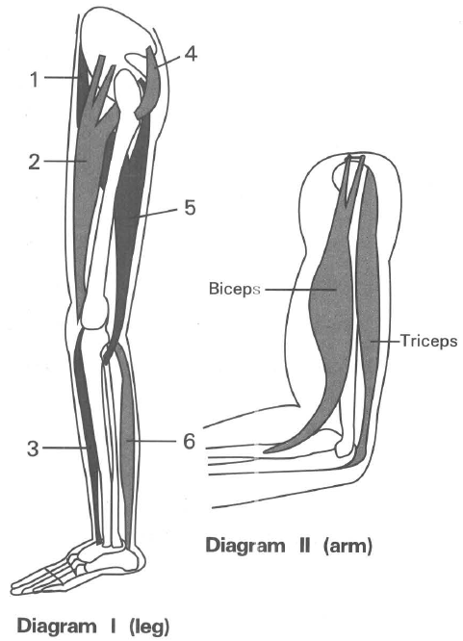
A. (1) only B. (2) only C. (1) and (4) only D. (2) and (3) only Directions: Questions 53 to 57 refer to diagrams I and II below, which show some muscles associated with the leg and the arm of humans.
113. The diagram below shows the posture of a dancer. With reference to diagram I , which labelled muscles in her left leg are in the following state in order to maintain the posture shown in the diagram?
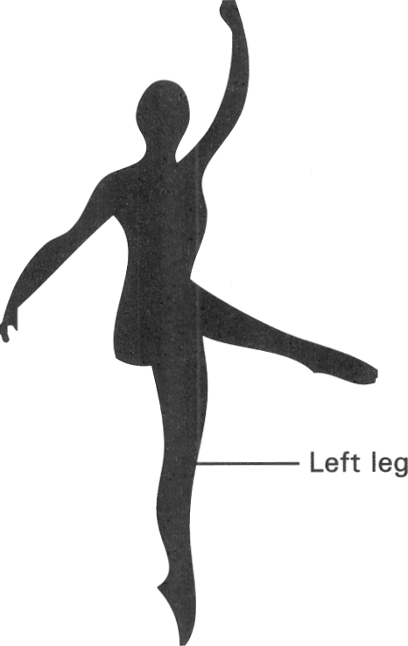
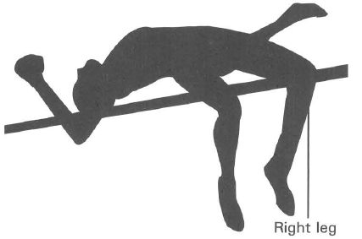
 | Contracted | Relaxed
A. | 1, | 3, | 5 | 2, | 4, | 6
B. | 1, | 4, | 6 | 2, | 3, | 5
C. | 2, | 4, | 6 | 1, | 3, | 5
D. | 2, | 3, | 5 | 1, | 4, | 6

114. The diagram below shows the action of a man in high jump. With reference to diagram I , which labelled muscles in his right leg are in the following state?
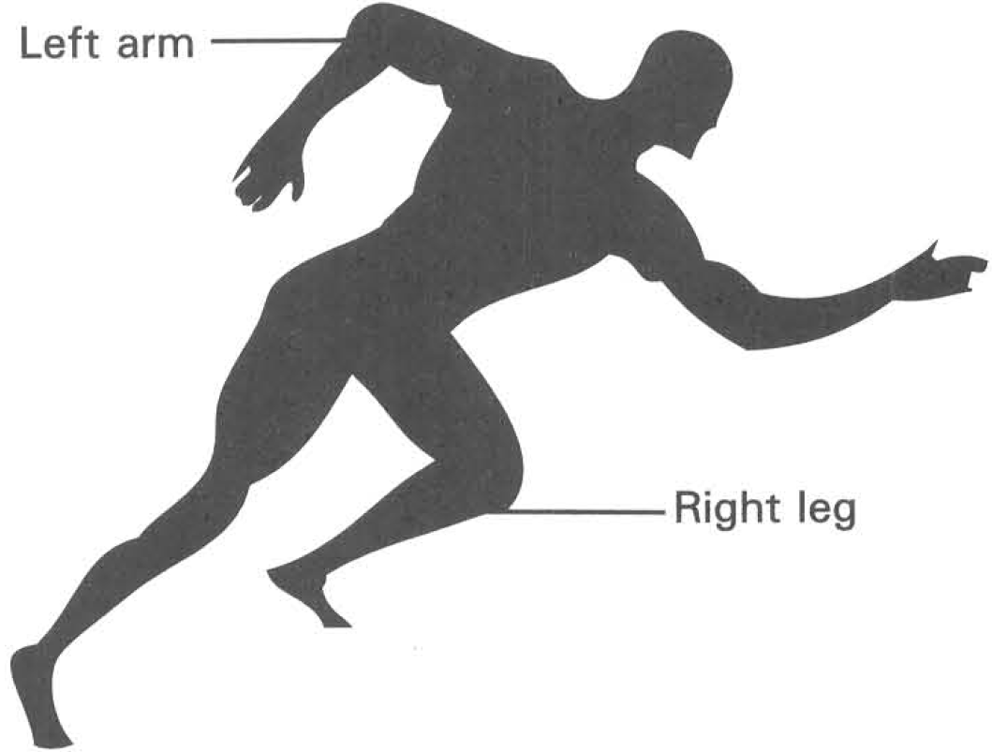
 | Contracted | Relaxed
A. | 1, | 2, | 3 | 4, | 5, | 6
B. | 1, | 3, | 5 | 2, | 4, | 6
C. | 2, | 4, | 6 | 1, | 3, | 5
D. | 4, | 5, | 6 | 1, | 2, | 3

115. The diagram below shows an athlete who is running in a 100-metre race. With reference to diagrams I and II, which labelled muscles in his right leg and left arm are in the contracted state?
 | Right leg | Left arm
A. | 1, | 3, | 5 | Biceps
B. | 3, | 4, | 5, | Biceps
C. | 2, | 3, | 4 | Triceps
D. | 4, | 5, | 6 | Triceps

116. The diagram below shows the posture of a woman who is doing yoga. With reference to diagram I which labelled muscles in her left leg and right leg are in the state described below?
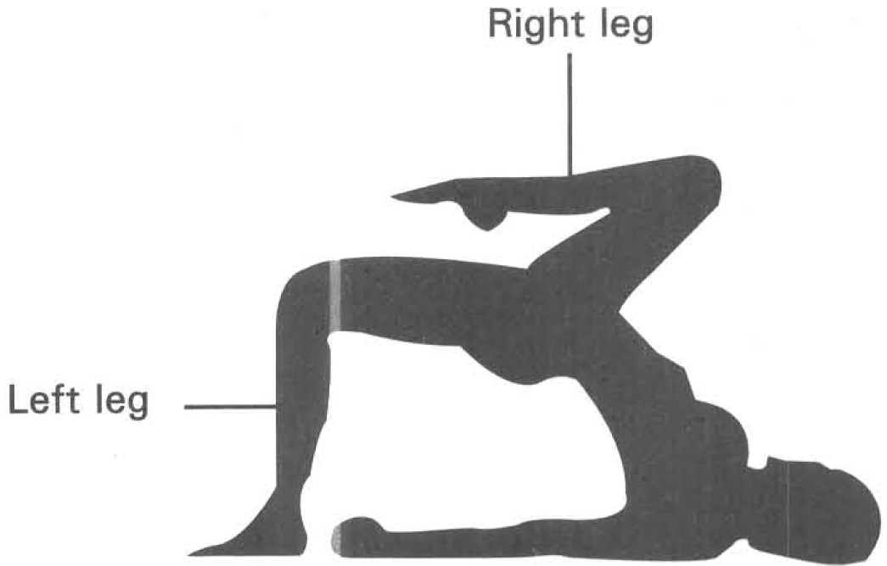
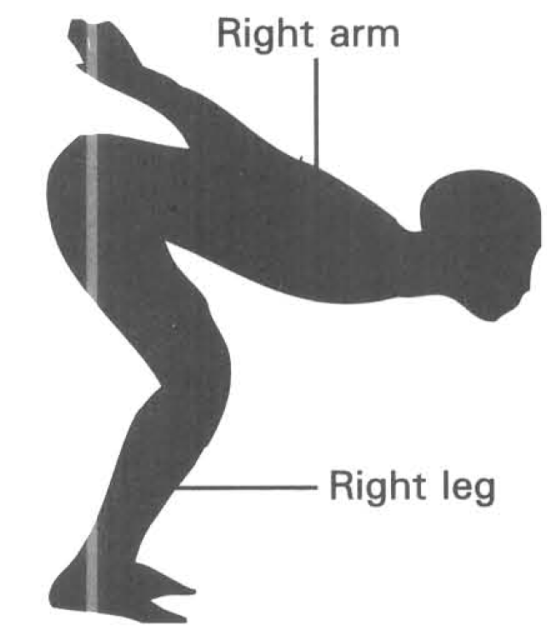
 | Muscles in left leg in contracted state | Muscles in right leg in relaxed state
A. | 3, | 4, | 5 | 2, | 3, | 4
B. | 1, | 2, | 6 | 1, | 5, | 6
C. | 2, | 3, | 4 | 3, | 4, | 5
D. | 1, | 5, | 6 | 1, | 2, | 6

117. The diagram below shows a swimmer who is going to jump into water. With reference to diagrams I and II, which labelled muscles in his right arm and right leg are in the contracted state?
 | Right arm | Right leg
A. | Biceps | 1, | 3, | 5
B. | Biceps | 2, | 4, | 6
C. | Triceps | 1, | 3, | 5
D. | Triceps | 2, | 4, | 6

Answers
Answers are printed in red.
1. ?
Class: 69.2% correct (n=13) usual slip A
2. C. R and S.

3. ?

4. B
Class: 70.9% correct (n=165) usual slip C
5. ?

6. C

7. ?

8. ?

9. A. (1) and (2) only
Class: 51.6% correct (n=122) usual slip C
10. C. (2) and (3) only
Class: 26.6% correct (n=109) usual slip D
11. D. (1), (2) and (3)
Class: 82.9% correct (n=123) usual slip A
12. B. It regulates the calcium content in the body.
Class: 83.5% correct (n=109) usual slip D
13. A. reduce friction between vertebrae. B. hold two vertebrae together.

14. C. more brittle.

15. D. the burning away of organic substances in the bone.
Class: 63.3% correct (n=109) usual slip C
16. B. The toughness of bones is due to the presence of organic substances.
Class: 66.7% correct (n=123) usual slip C
17. D
Class: 35.0% correct (n=123) usual slip A
18. D

19. C. The arm will be bent at the elbow.
Class: 86.2% correct (n=109) usual slip D
20. A. Remain the same B. Longer C. Shorter D. Under higher tension Directions: Questions 23 and 24 refer to the Xray photograph of the pelvic girdle and the associated bones.-
Class: 35.8% correct (n=109) usual slip D
21. B
Class: 73.9% correct (n=138) usual slip A
22. ?

23. D
Class: 47.7% correct (n=109) usual slip B
24. A. (1) and (2) onlyB. (1) and (3) only C. (2) and (3) only D. (1), (2) and (3) Directions: Questions 27 to 29 refer to the diagram below.
Class: 20.3% correct (n=138) usual slip B
25. B
Class: 65.1% correct (n=109) usual slip C
26. A. bend at the knee only.
Class: 61.8% correct (n=123) usual slip C
27. B

28. D. 4, 5, 6 and 7.
Class: 88.1% correct (n=109) usual slip A
29. A
Class: 72.5% correct (n=109) usual slip D
30. ?

31. B
Class: 91.0% correct (n=89) usual slip C
32. D

33. A

34. A. (1) and (2) only
Class: 40.4% correct (n=89) usual slip C
35. D. (1), (2) and (3)
Class: 85.4% correct (n=89) usual slip A
36. B
Class: 74.2% correct (n=89) usual slip A
37. C
Class: 89.9% correct (n=89) usual slip D
38. D
Class: 80.9% correct (n=89) usual slip A
39. C. (2) and (3) only
Class: 47.2% correct (n=89) usual slip B
40. B. the magnitude of E is greater than that of L.
Class: 66.3% correct (n=89) usual slip C
41. B. the displacement of E will be shorter.
Class: 40.4% correct (n=89) usual slip C
42. A. Joystick B. Door C. Window D. Spectacles
Class: 93.3% correct (n=89) usual slip B
43. A. (1) and (2) only B. (1) and (3) only C. (2) and (3) only D. (1), (2) and (3) Directions: Questions 46 and 47 refer to the following model of human leg.

44. D

45. ?

46. D. (1), (2) and (3)

47. A. (1) only

48. ?

49. D. the xylem has not fully developed. directions: Questions 53 to 55 refer to the diagram low which shows the transverse section of a part of a plant.

50. ?

51. D

52. ?

53. C. | transport of food | support | storage of food |
Class: 69.2% correct (n=13) usual slip A
54. B. 2

55. A. can increase the resistance to bending.

56. ?

57. ?

58. C. | support by turgidity | transport food |

59. ?

60. B
Class: 69.2% correct (n=13) usual slip A
61. C

62. D. S

63. ?

64. C

65. B. (1) and (3) only

66. A. (3) only

67. D. the acid has dissolved the mineral salts so that only the soft organic matter is left in the bone. 4The bones of old people are more fragile than that of the young ones because

68. A. It enhances the absorption of calcium salts from food in the small intestine.
Class: 89.7% correct (n=29) usual slip B
69. C. osteoporosis.
Class: 81.2% correct (n=165) usual slip A
70. C. bone is a living tissue that can grow.
Class: 78.9% correct (n=109) usual slip A
71. B. the heat burns away the organic matter so that only the mineral salts are left.

72. B
Class: 92.9% correct (n=14) usual slip C
73. C

74. C

75. A
Class: 69.0% correct (n=29) usual slip D
76. B

77. C. It stores iron for the body.
Class: 65.5% correct (n=29) usual slip D
78. C
Class: 77.6% correct (n=152) usual slip B
79. A. 1, 3 and 4 only
Class: 84.6% correct (n=123) usual slip C
80. C
Class: 86.2% correct (n=29) usual slip D
81. A. Joint W

82. D. (2), (3) and (4) only

83. A. enables the body to bend easily.

84. D
Class: 79.7% correct (n=138) usual slip C
85. B. (1) and (3) only
Class: 72.4% correct (n=29) usual slip C
86. B
Class: 51.7% correct (n=29) usual slip D
87. A. (1) and (4) only

88. B

89. B. (1) and (4) only
Class: 55.2% correct (n=29) usual slip A
90. C

91. D. (1) and (4) only
Class: 93.1% correct (n=29) usual slip B
92. C. the smooth muscles. D. the tendon and ligament. Directions: Questions 29 and 30 refer to the photomicrograph below.

93. B. (1) and (3) only
Class: 49.5% correct (n=109) usual slip A
94. A. Biceps B. Iris C. Oesophagus D. Hepatic artery

95. D

96. C

97. D. (1), (3) and (4) only

98. C. synovial fluid.

99. A. (1) only
Class: 73.0% correct (n=89) usual slip D
100. A. 2 and 3 only
Class: 19.1% correct (n=89) usual slip C
101. B

102. C. tendon.

103. B

104. B. they are present on the opposite sides of the bone of the upper arm.

105. C. Tension on structure 3 increases.

106. C

107. A. The lower arm can be bent at faster rate.

108. D

109. C

110. B

111. B. 2 and 6 only

112. A. (1) only B. (2) only C. (1) and (4) only D. (2) and (3) only Directions: Questions 53 to 57 refer to diagrams I and II below, which show some muscles associated with the leg and the arm of humans.

113. C

114. D

115. A

116. A

117. C

