Support and movement in humans · items under 80% correct
Multiple-choice practice
Name: ________________________ Class: ____________
These items were answered correctly by fewer than 80% of students in class Google Forms, matched by the wording in the source bank and the form answer key. Choose the one best answer.
Part A — HKCEE level (Longman)
1. Which of the following pairs of bones allows the greatest degree of movement?
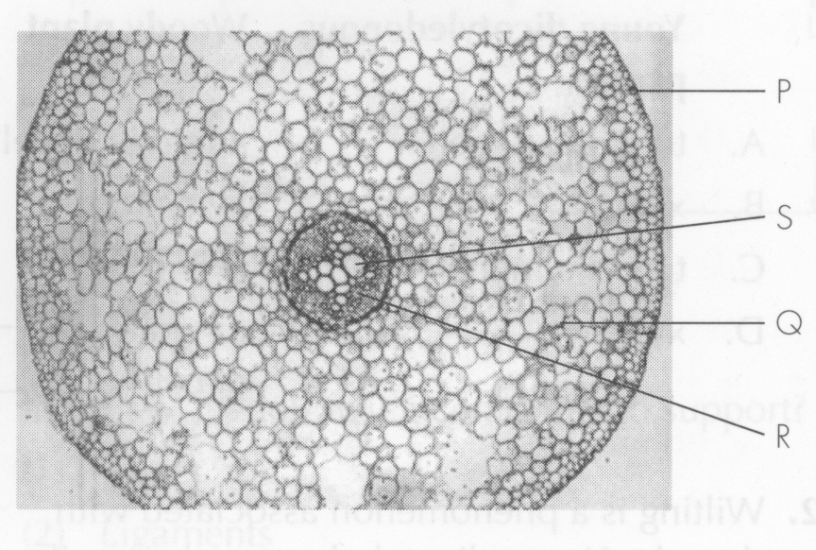
A. Humerus and ulna B. Humerus and radius
C. Femur and tibia D. Femur and pelvic girdle Directions: Questions 2 to 4 refer to the following drawing which shows the structure of a synovial joint.
2. Which of the following correctly describe the physical nature and function of P?
Directions: Questions 5 to 7 refer to the following experiment.
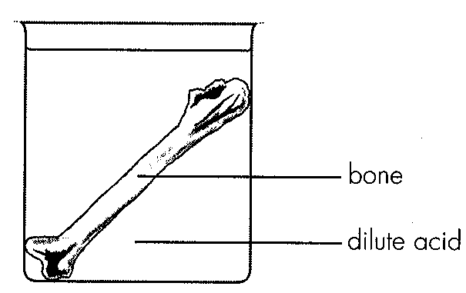
 | Physical nature | Function
A. | elastic | to transmit force between bones X and Y
B. | elastic | to allow relative movement between bones X and Y
C. | inelastic | to transmit force between bones X and Y
D. | inelastic | to allow relative movement between bones X and Y

3. Which of the following are brought about by antagonistic muscles? (1) Movement of eyeball (2) Changing the size of pupil (3) Changing the thickness of lens
A. (1) and (2) only
B. (1) and (3) only
C. (2) and (3) only
D. (1), (2) and (3)
4. Which of the following do not involve antagonistic muscles? (1) Movement of rib cage (2) Movement of diaphragm (3) Erection of hair
A. (1) and (2) only
B. (1) and (3) only
C. (2) and (3) only
D. (1), (2) and (3)
5. The result in Question 16 is caused by A.the evaporation of water in the bone. D.the burning away of organic substances in the bone.
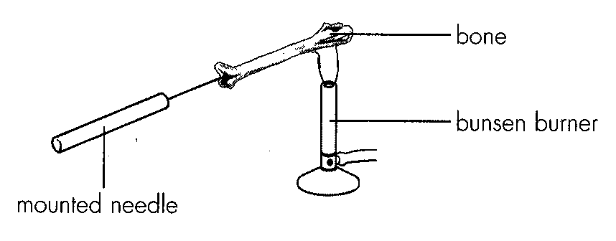
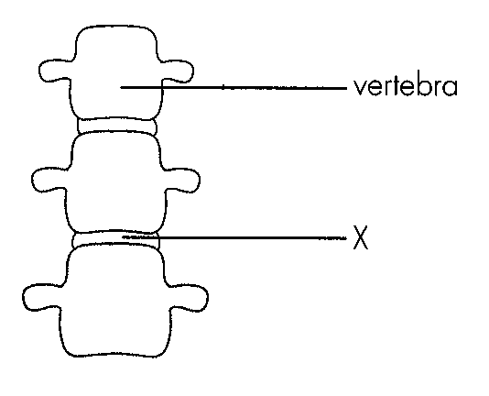
A. the evaporation of water in the bone.
B. the denaturation of proteins in the bone.
C. the burning away of mineral ions in the bone.
D. the burning away of organic substances in the bone.
6. Which of the following is the best conclusion for this experiment? A.The toughness of bones is due to the presence of mineral ions. B.The toughness of bones is due to the presence of organic substances. C.The hardness of bones is due to the presence of mineral ions. D.The hardness of bones is due to the presence of organic substances.
A. The toughness of bones is due to the presence of mineral ions.
B. The toughness of bones is due to the presence of organic substances.
C. The hardness of bones is due to the presence of mineral ions.
D. The hardness of bones is due to the presence of organic substances.
7. Which of the following are mainly made of cartilage in a newborn baby?
(1) Nose (2) Ears (3) Skull
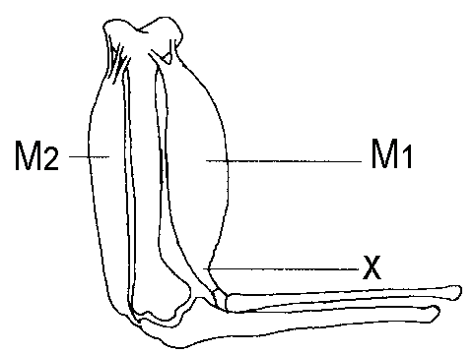
A. (1) and (2) onlyB. (1) and (3) only C. (2) and (3) only D. (1), (2) and (3) Directions: Questions 20 to 22 refer to the following diagram which shows the bones and the associated muscles in a human arm.
8. What will structure X become when M 1 is relaxing?
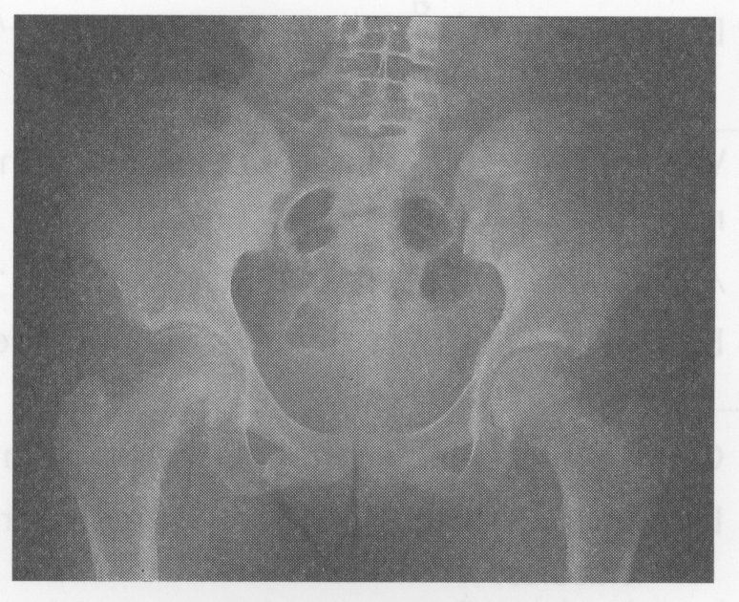
A. Remain the same B. Longer C. Shorter D. Under higher tension Directions: Questions 23 and 24 refer to the Xray photograph of the pelvic girdle and the associated bones.-
9. Which of the following correctly describes the type of joint shown in the photograph and the degree of movement it permits?
 | Type of joint | Degree of movement
A. | ball and socket | in three planes
B. | ball and socket | in many planes
C. | hinge | in one plane
D. | hinge | in one dimension

10. Which of the following descriptions of different parts of a long bone is correct?
 | Parts of long bone | Description
A. | compact bone | innermost for support
B. | compact bone | outermost for protection
C. | cartilages | in the middle for support
D. | cartilages | at both ends for protection

11. Long bones like femur are hollow in structure because
(1) it makes the bone lighter.
(2) it is more resistant to bending than a solid bone of the same mass.
(3) it can accommodate blood vessels and nerves.
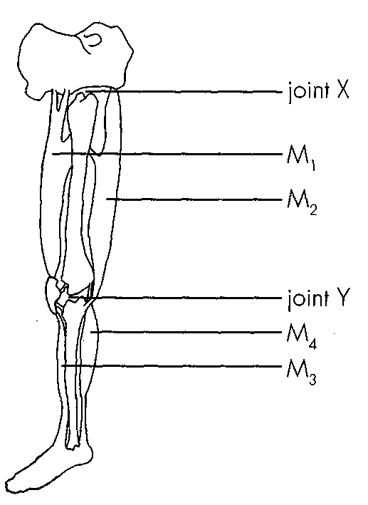
A. (1) and (2) onlyB. (1) and (3) only C. (2) and (3) only D. (1), (2) and (3) Directions: Questions 27 to 29 refer to the diagram below.
12. Which of the following classification of the muscle is correct?
 | Flexor | Extensor
A. | M1 and M3 | M2 and M4
B. | M2 and M3 | M1 and M4
C. | M1 and M4 | M2 and M3
D. | M2 and M4 | M1 and M3

13. When muscles M2 and M4 contract at the same time, the leg will
A. bend at the knee only.
B. bend at the ankle only.
C. bend at the knee and ankle.
D. straighten out.
14. Which of the following matchings is correct?
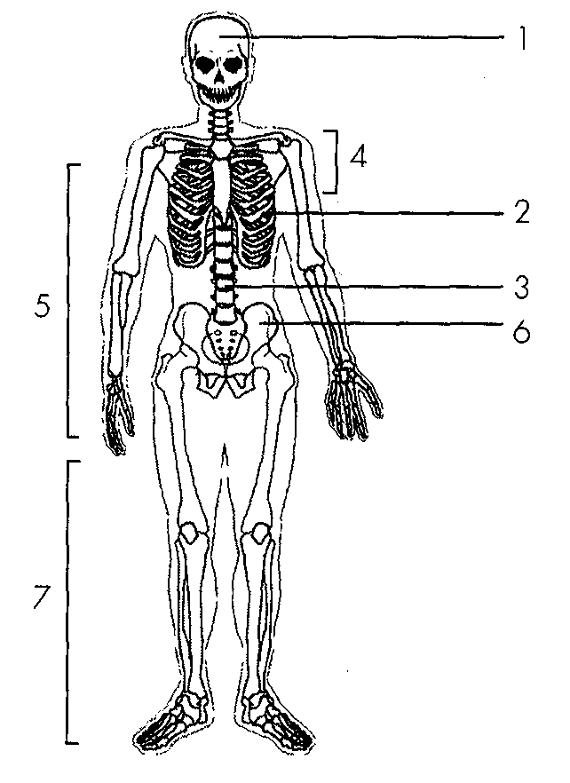
 | Name of 4 | Function
A. | pectoral girdle | for the attachment of forelimbs
B. | pectoral girdle | for the attachment of hindlimbs
C. | pelvic girdle | for the attachment of forelimbs
D. | pelvic girdle | for the attachment of hindlimbs

15. Which of the following statements aboutskeletal muscles are correct? (1) Their contractions are initiated by the cerebrum. (2) They usually function in antagonistic pairs. (3) They store up ATP as energy reserve.
A. (1) and (2) only
B. (1) and (3) only
C. (2) and (3) only
D. (1), (2) and (3)
16. Which of the following comparisons between tendon and ligament is incorrect?
 | Tendon | Ligament
A. | for muscle to bone attachment | for bone to bone attachment
B. | unable to transmit force | able to transmit force
C. | does not prevent dislocation | prevents dislocation
D. | inelastic | elastic

17. Which of the following exhibit this type of lever system? (1) A ballet dancer standing on tiptoes. (2) A patient under knee jerk reflex test. (3) A housewife withdrawing her hand when touching a hot pot.
A. (1) and (2) only
B. (1) and (3) only
C. (2) and (3) only
D. (1), (2) and (3)
18. This type of lever system is disadvantageous in that B. the magnitude of E is greater than that of L. C.the displacement of L is greater than that of E
A. the magnitude of L is greater than that of E.
B. the magnitude of E is greater than that of L.
C. the displacement of L is greater than that of E
D. the displacement of E is greater than that of L.
19. The distance between EF is shorter than that between LF because
A. the lever will be broken less easily.
B. the displacement of E will be shorter.
C. the muscle represented by E will be shorter.
D. the load can be heavier.
20. | 3 | 4 |
A. | support | transport of water | support |
B. | transport of water | transport of food | support |
C. | transport of food | support | storage of food |
D. | transport of water | transport of food | storage of food
21. | 3 | A. | with cuticle | without cuticle | B. | living tissue | dead tissue | C. | hollow in structure | solid in structure | D. | for transport | for support
Directions: Questions 62 to 64 refer to the photomicrograph below which shows the transverse section of a dicotyledonous roof.
Part B — HKDSE-style (YKTo)
22. If the two broken ends of the fractured bone are properly joined together, the bone can heal after a period of time. This shows that
A. bone is an effector that can respond to stimulus.
B. bone needs hormones to support a long term metabolic process.
C. bone is a living tissue that can grow.
D. old man takes longer time to heal broken bone.
23. Which of the following CORRECTLY describes the property of structures 1 and 4?
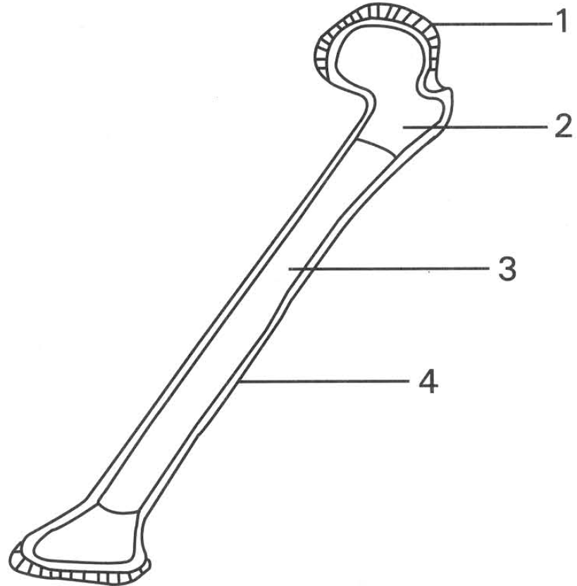
 | Structure 1 | Structure 4
A. | Elastic | Rigid
B. | Rigid | Elastic
C. | Living | Dead
D. | Dead | Living

24. Which of the following is NOT a function of the human skeletal system?
A. It forms the firm framework to support the body.
B. It protects the delicate internal organs of the body.
C. It stores iron for the body.
D. It forms lever systems of the body to permit rapid locomotion. Directions: Questions 14 to 18 refer to the diagram below, which shows the skeleton of a human.
25. Which of the following combinations CORRECTLY represents the axial skeleton and appendicular skeleton of human?
 | Axial skeleton | Appendicular skeleton
A. | 1,4,5 | 2,3,6
B. | 2,5,6 | 1,3,4
C. | 1,3,4 | 2,5,6
D. | 1,5,6 | 2,3,4

26. Which of the following statements related with the ribs in humans is INCORRECT?
(1) All ribs are completely made of bones.
(2) All ribs Connect the thoracic vertebrae and the sternum.
(3) Ribs are involved in the respiratory movement of the thoracic wall.
(4) Ribs are capable of producing red blood cells.
(5) Ribs protect the delicate internal organs of the abdominal cavity.
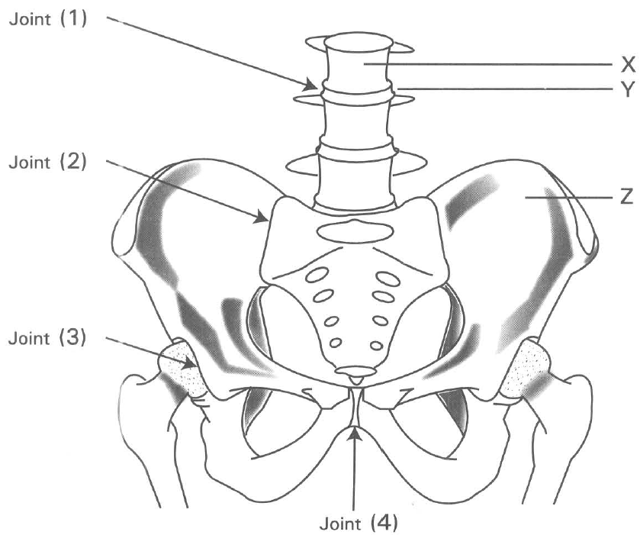
A. (1) only B. (5) only C. (3) and (4) only D. (1), (2) and (5) only Directions: Questions 21 to 25 refer to the diagram below, which shows the bones in the abdomen and the thigh bones in humans.
27. Which labelled joints have relatively high degree of movement?
A. (1) and (2) only
B. (1) and (3) only
C. (2) and (3) only
D. (3) and (4) only
28. Which of the following joints has the same degree of movement as that of joint 3?
A. Elbow joint B. Shoulder joint
C. Knee joint D. Ankle joint
29. Which of the following is/are function(s) of structure Z? (1) Produces red blood cells (2) Destroys white blood cells (3) Produces vitamin D (4) Stores calcium slats
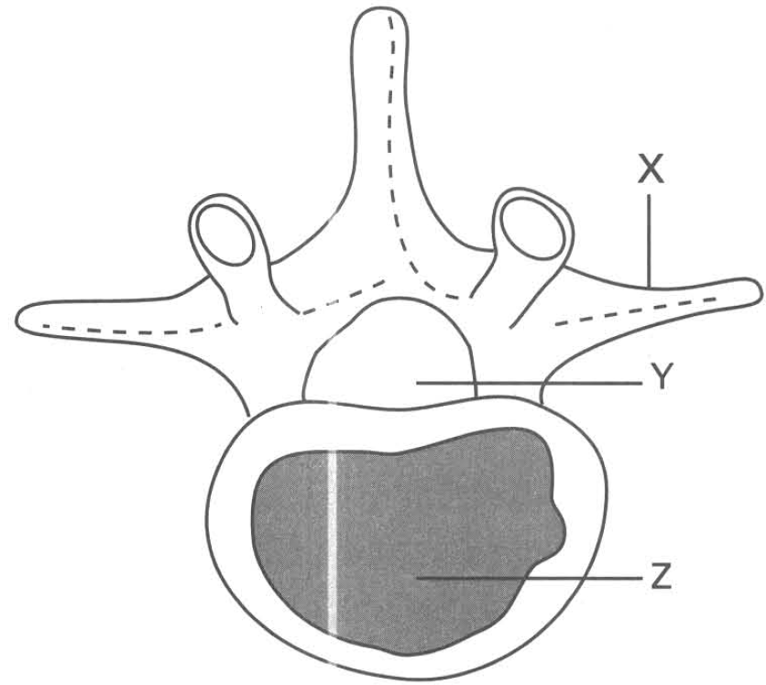
A. (1) and (2) only
B. (1) and (4) only
C. (2) and (3) only
D. (3) and (4) only
30. Which of the following are characteristics of the tissue shown in the photomicrograph? (1) They are attached to skeleton. (2) They are composed of non-striated muscle fibres. (3) They are capable of very powerful contraction and become fatigue easily. (4) Their activities are usually NOT under voluntary control.
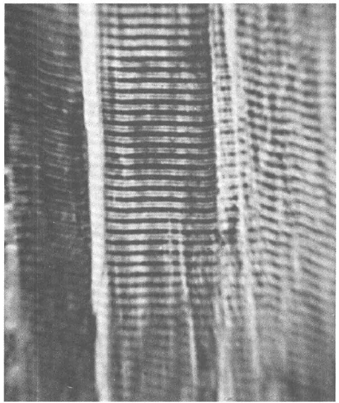
A. (1) and (2) only
B. (1) and (3) only
C. (1) and (4) only
D. (2) and (3) only
31. What is the function of the fluid contained in 3? (1) Lubricates the movement of the bones articulated at the joint. (2) Absorbs the heat released from the muscles. (3) Maintains the shape of the joint. (4) Transports nutrients to and removes metabolic wastes from structure 2.
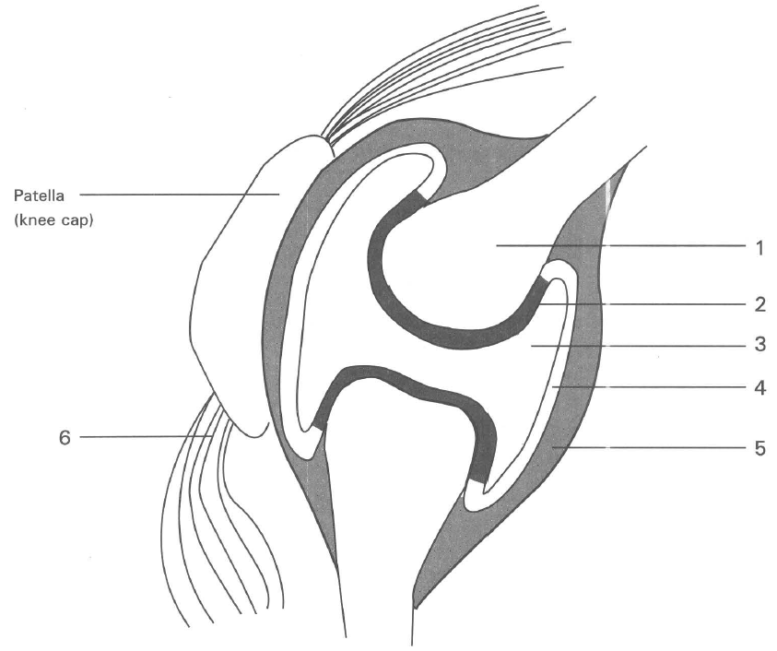
A. (1) only
B. (1) and (2) only
C. (1) and (4) only
D. (2) and (3) only
32. Which of the structures labelled in the diagram are responsible for reducing friction?
A. 2 and 3 only
B. 3 and 4 only
C. 5 and 6 only
D. 2 and 5 only

Answers
Answers are printed in red.
1. ?
Class: 69.2% correct (n=13) usual slip A
2. B
Class: 70.9% correct (n=165) usual slip C
3. A. (1) and (2) only
Class: 51.6% correct (n=122) usual slip C
4. C. (2) and (3) only
Class: 26.6% correct (n=109) usual slip D
5. D. the burning away of organic substances in the bone.
Class: 63.3% correct (n=109) usual slip C
6. B. The toughness of bones is due to the presence of organic substances.
Class: 66.7% correct (n=123) usual slip C
7. D
Class: 35.0% correct (n=123) usual slip A
8. A. Remain the same B. Longer C. Shorter D. Under higher tension Directions: Questions 23 and 24 refer to the Xray photograph of the pelvic girdle and the associated bones.-
Class: 35.8% correct (n=109) usual slip D
9. B
Class: 73.9% correct (n=138) usual slip A
10. D
Class: 47.7% correct (n=109) usual slip B
11. A. (1) and (2) onlyB. (1) and (3) only C. (2) and (3) only D. (1), (2) and (3) Directions: Questions 27 to 29 refer to the diagram below.
Class: 20.3% correct (n=138) usual slip B
12. B
Class: 65.1% correct (n=109) usual slip C
13. A. bend at the knee only.
Class: 61.8% correct (n=123) usual slip C
14. A
Class: 72.5% correct (n=109) usual slip D
15. A. (1) and (2) only
Class: 40.4% correct (n=89) usual slip C
16. B
Class: 74.2% correct (n=89) usual slip A
17. C. (2) and (3) only
Class: 47.2% correct (n=89) usual slip B
18. B. the magnitude of E is greater than that of L.
Class: 66.3% correct (n=89) usual slip C
19. B. the displacement of E will be shorter.
Class: 40.4% correct (n=89) usual slip C
20. C. | transport of food | support | storage of food |
Class: 69.2% correct (n=13) usual slip A
21. B
Class: 69.2% correct (n=13) usual slip A
22. C. bone is a living tissue that can grow.
Class: 78.9% correct (n=109) usual slip A
23. A
Class: 69.0% correct (n=29) usual slip D
24. C. It stores iron for the body.
Class: 65.5% correct (n=29) usual slip D
25. C
Class: 77.6% correct (n=152) usual slip B
26. D
Class: 79.7% correct (n=138) usual slip C
27. B. (1) and (3) only
Class: 72.4% correct (n=29) usual slip C
28. B
Class: 51.7% correct (n=29) usual slip D
29. B. (1) and (4) only
Class: 55.2% correct (n=29) usual slip A
30. B. (1) and (3) only
Class: 49.5% correct (n=109) usual slip A
31. A. (1) only
Class: 73.0% correct (n=89) usual slip D
32. A. 2 and 3 only
Class: 19.1% correct (n=89) usual slip C

Class percentage correct
Matched to this paper by question wording in the source bank and the form answer key, not by a shifted paper number.
Q | Answer | % correct | n | Usual slip
1 | ? | 69.2% | 13 | A
2 | B | 70.9% | 165 | C
3 | A | 51.6% | 122 | C
4 | C | 26.6% | 109 | D
5 | D | 63.3% | 109 | C
6 | B | 66.7% | 123 | C
7 | D | 35.0% | 123 | A
8 | A | 35.8% | 109 | D
9 | B | 73.9% | 138 | A
10 | D | 47.7% | 109 | B
11 | A | 20.3% | 138 | B
12 | B | 65.1% | 109 | C
13 | A | 61.8% | 123 | C
14 | A | 72.5% | 109 | D
15 | A | 40.4% | 89 | C
16 | B | 74.2% | 89 | A
17 | C | 47.2% | 89 | B
18 | B | 66.3% | 89 | C
19 | B | 40.4% | 89 | C
20 | C | 69.2% | 13 | A
21 | B | 69.2% | 13 | A
22 | C | 78.9% | 109 | A
23 | A | 69.0% | 29 | D
24 | C | 65.5% | 29 | D
25 | C | 77.6% | 152 | B
26 | D | 79.7% | 138 | C
27 | B | 72.4% | 29 | C
28 | B | 51.7% | 29 | D
29 | B | 55.2% | 29 | A
30 | B | 49.5% | 109 | A
31 | A | 73.0% | 89 | D
32 | A | 19.1% | 89 | C

