Transport in humans
Multiple-choice practice
Name: ________________________ Class: ____________
There are 231 questions compiled from Longman HKCEE and/or YKTo papers. Choose the one best answer.
Part A — HKCEE level (Longman)
1. A transport system should include (1) a source of driving force. (2) a transport medium. (3) specific paths.

A. (1) and (2) only
B. (1) and (3) only
C. (2) and (3) only
D. (1), (2) and (3)
2. An amoeba transports substances mainly by
A. diffusion.
B. active transport.
C. osmosis.
D. cytoplasmic streaming.
3. Transport systems are essential in large animals but not in small animals because
A. large animals have large surface areas for diffusion.
B. body cells of large animals are far away from the surfaces of material exchange with the surroundings.
C. large animals have higher metabolic rate.
D. large animals have blood but small animals have not. blood
4. When blood cells are removed from the blood, the liquid left is called
A. plasma.
B. tissue fluid.
C. serum.
D. lymph.
5. Which of the following fluids collected from a healthy person give(s) a violet colour with Biuret reagents?
(1) Plasma (2) Urine (3) Saliva
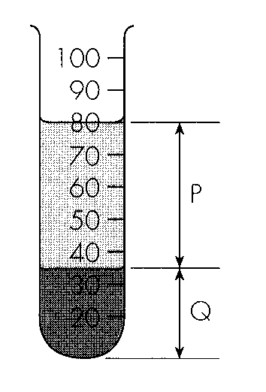
A. (1) only B. (1) and (3) onlyC. (2) and (3) only D. (1), (2) and (3) Directions: Questions 6 to 10 refer to the diagram below which shows the appearance of a blood sample after it is allowed to separate into layers.
6. The two layers are
 | P | Q
A. | Serum | Blood cells
B. | Lymph | Proteins
C. | Plasma | Blood cells
D. | Plasma | Proteins

7. The common method for separating the blood into layers is
A. filtration.
B. centrifugation.
C. sedimentation.
D. suspension.
8. A substance must be first added into the blood sample to prevent clotting. The substance is
A. sodium chloride.
B. sodium hydroxide.
C. sodium citrate.
D. sodium hydrogencarbonate.
9. With reference to the diagram above, the percentage by volume of P in the blood sample is
A. 35.
B. 44.
C. 56.
D. 80.
10. How will the percentage by volume of P change if the blood sample is taken from a man suffering from diarrhoea?
A. Increase B. Decrease C. Remain unchanged D. Drop to 0
11. The diagrams below show how two blood products are obtained.
The two products produced are:
Directions: Questions 12 and 13 refer to the diagram below which shows the setup which investigates the effect of two gases on a sample of citrated chicken blood.-
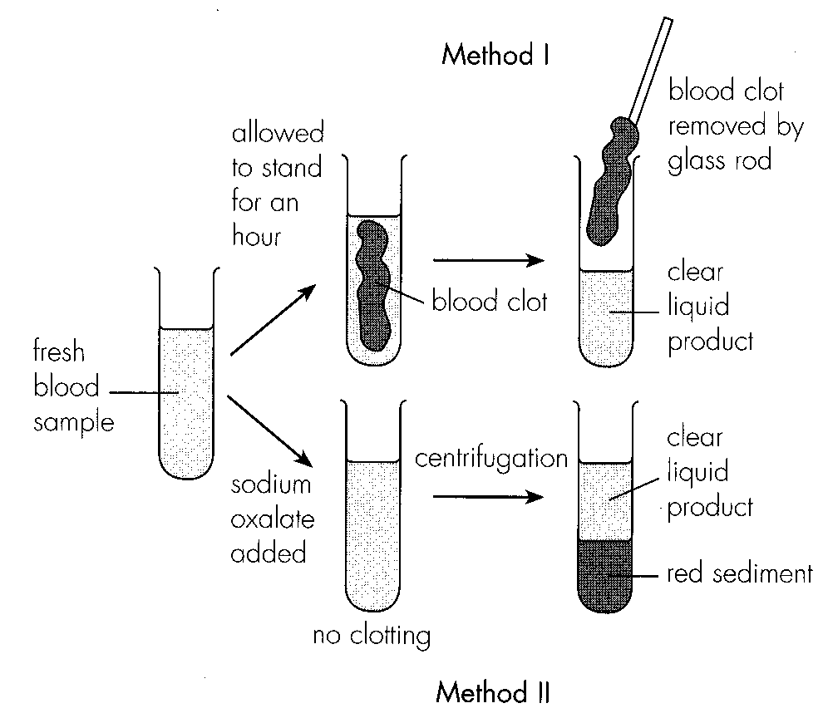
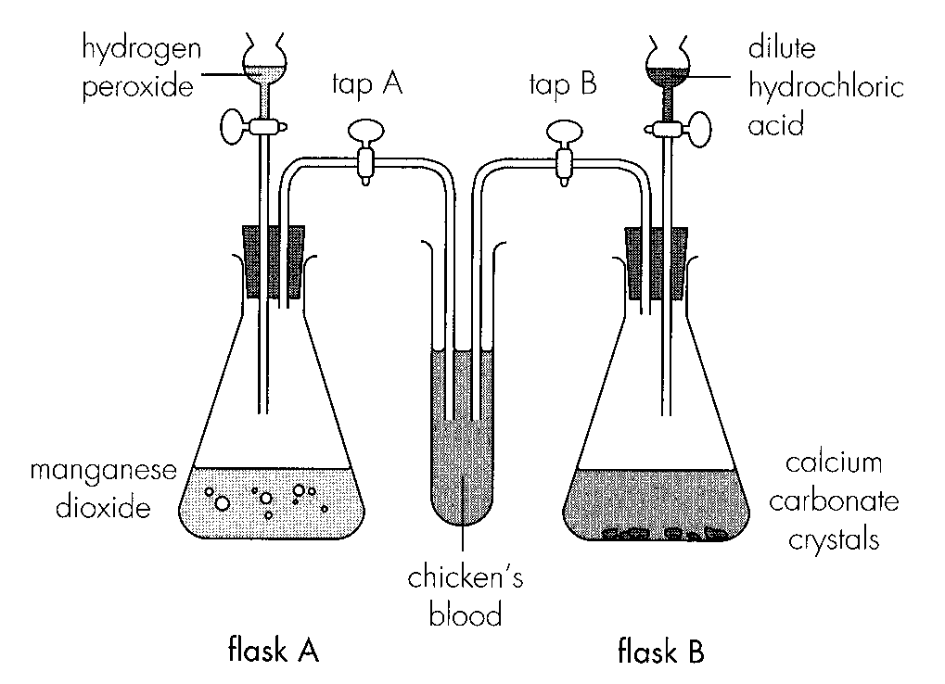
 | Method I | Method II
A. | plasma | serum
B. | serum | plasma
C. | lymph | plasma
D. | serum | lymph

12. The two gases generated when the reactants are allowed to react are:
 | In flask A | In flask B
A. | hydrogen | carbon dioxide
B. | oxygen | carbon monoxide
C. | oxygen | carbon dioxide
D. | carbon monoxide | oxygen

13. Which of the following correctly describes the colour of the citrated blood when each of the two gases is bubbled through it?
 | Gas from flask A | Gas from flask B
A. | bright red | pink
B. | dull red | pink
C. | bright red | dull red
D. | pink | bright red

14. For a healthy person, which of the following comparisons is correct?
 | Red blood cells | White blood cells | Blood platelets
A. | carry oxygen | kill germs | carry carbon dioxide
B. | have no nuclei | large have nuclei | have no nucleus
C. | most numerous | numerous | few
D. | red in colour | colourless | red in colour

15. Red blood cells are biconcave in shape so that they can
A. carry more oxygen.
B. take up and release oxygen more quickly.
C. squeeze through the capillary wall more easily.
D. hold more haemoglobin.
16. Which of the following cell types is most abundant in mammalian blood?
A. lymphocytes
B. red blood cells
C. blood platelets
D. phagocytes
17. Which of the following is the major way of carbon dioxide transport in the blood?
A. By combining with haemoglobin in red blood cells.
B. By combining with proteins in plasma.
C. As dissolved carbon dioxide gas in plasma.
D. As hydrogencarbonate ion in plasma.
18. Haemoglobin can combine with the following gases: (1) oxygen (2) carbon monoxide (3) carbon dioxide Which of the following arrange the three gases in the descending order according to their affinity to haemoglobin.
A. (1), (2) and (3)
B. (1), (3) and (2)
C. (2), (1) and (3)
D. (3), (2) and (1)
19. Red blood cells can take up and release oxygen quickly because
A. they are large.
B. they are discshaped.-
C. they have lost their nuclei when mature.
D. they have little cytoplasm.
20. Which of the following helps to protect the body from bacteria? (1) White blood cells (2) Red blood cells (3) Blood platelets
A. (1) only
B. (1) and (3) only
C. (2) and (3) only
D. (1), (2) and (3)
21. Which of the following is/are the function(s) of white blood cells? (1) They engulf and digest bacteria. (2) They produce antibiotics against bacteria. (3) They initiate blood clotting.
A. (1) only
B. (1) and (2) only
C. (2) and (3) only
D. (1), (2) and (3)
22. A haemophiliac person fails to clot blood. Which of the following substances is most likely to be lacking?
A. Vitamin C B. Iron C. Platelets D. Amino acids
23. Which of the following may cause the blood oxygen level lower than normal? (1) Excessive bleeding (2) Anaemia (3) Carbon monoxide poisoning
A. (1) and (2) only
B. (1) and (3) only
C. (2) and (3) only
D. (1), (2) and (3)
24. Which of the following substances are transported by mammalian blood? (1) Hormones (2) Nutrients (3) Digestive enzymes
A. (1) and (2) only
B. (1) and (3) only
C. (2) and (3) only
D. (1), (2) and (3)
25. Persons with blood group O can receive blood from donors with blood groups)
A. O only. B. A and B only. C. A, B and O only. D. A, B, AB and O.
26. Which of the following blood transfusion may cause harm to the recipient? A.People of group O donate blood to people of group A. B.People of group A donate blood to people of group AB. C.People of group O receive blood from people of group B. D.People of group AB receive blood from people of group A.
A. People of group O donate blood to people of group
A.
B.
C. People of group O receive blood from people of group
27. Which of the following substances is the major component of the agglutinated blood?
 | Donor
 | Gigi | Sammy | Kelly
Recipient | Gigi |  | X | X
 | Sammy | V |  | X
 | Kelly | V | X

A. Platelets B. Antibodies C. Red blood cells D. Fibrinogen Directions: Questions 28 and 29 refer to the table below which summarizes the results of a compatibility test for blood transfusion among three persons. Key: V = blood can be transfused without ill effect X = blood cannot be transfused
28. If the blood group of Kelly is B, what is the blood group of Gigi and Sammy respectively? 29.Sally can receive blood from Gigi but cannot donate blood to Kelly. Her blood group is C. AD. either A or AB.
 | Gigi | Sammy
A. | AB | B
B. | O | A
C. | AB | A
D. | A | O

A. O.
B.
A.
B.
29. Two samples of human blood were mixed, clumping of blood was observed. The best conclusion is:
A. The samples were of blood groups A and B respectively.
B. The samples were of blood groups O and AB respectively.
C. The samples were of different blood groups.
D. The samples were of the same blood groups.
30. Which heart chamber produces the greatest blood pressure?
A. Right atrium
B. Right ventricle
C. Left atrium
D. Left ventricle
31. Which heart chamber will first receive the following substances after their entry into our body?
Directions: Questions 33 and 34 refer to the following diagram which shows the crosssection of a mammalian heart.-
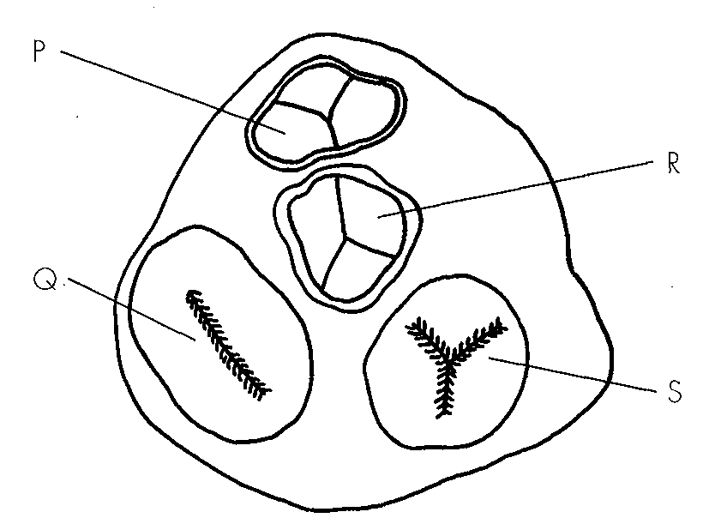
 | Oxygen in air | Calcium in food
A. | right atrium | left atrium
B. | left ventricle | right ventricle
C. | left atrium | right atrium
D. | right ventricle | left ventricle

32. P, Q, R and S are valves. Valve S lies between A.the pulmonary artery and the right ventricle. C.the right atrium and the right ventricle.
A. the pulmonary artery and the right ventricle.
B. the aorta and the left ventricle.
C. the right atrium and the right ventricle.
D. the left atrium and the left ventricle.
33. Which of the following valves will open if the ventricles are relaxing?
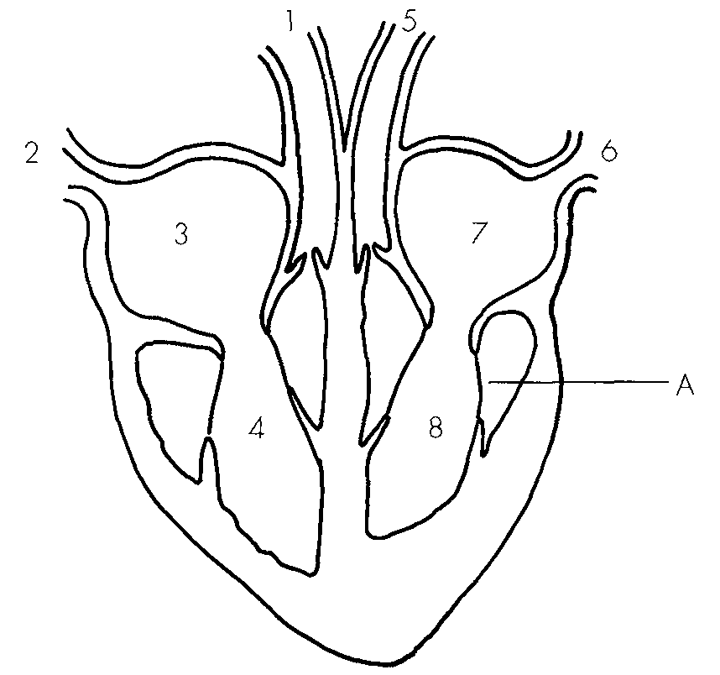
A. Valves P and Q B. Valves R and S C. Valves P and R D. Valves Q and S Directions: Questions 35 to 37 refer to the diagram below which shows the longitudinal section of a mammalian heart and its associated blood vessels.
34. The correct route for the blood flowing from the kidney and then return to the kidney is
A. 1 → 4 -→ 3 -→ 2 -→ 5 -→ 8 -→ 7 -→ 6 -
B. 2 → 3 -→ 4 -→ 1 -→ 6 -→ 7 -→ 8 -→ 5-
C. 5 → 8 -→ 7 -→ 6 -→ 1 -→ 4 -→ 3 -→ 2 -
D. 6 → 7 -→ 8 -→ 5 -→ 2 -→ 3 -→ 4 -→ 1-
35. Between the four heart chambers, blood flows from
A. 3 to 4.
B. 4 to 7.
C. 4 to 8.
D. 8 to 7.
36. The function of structure A is
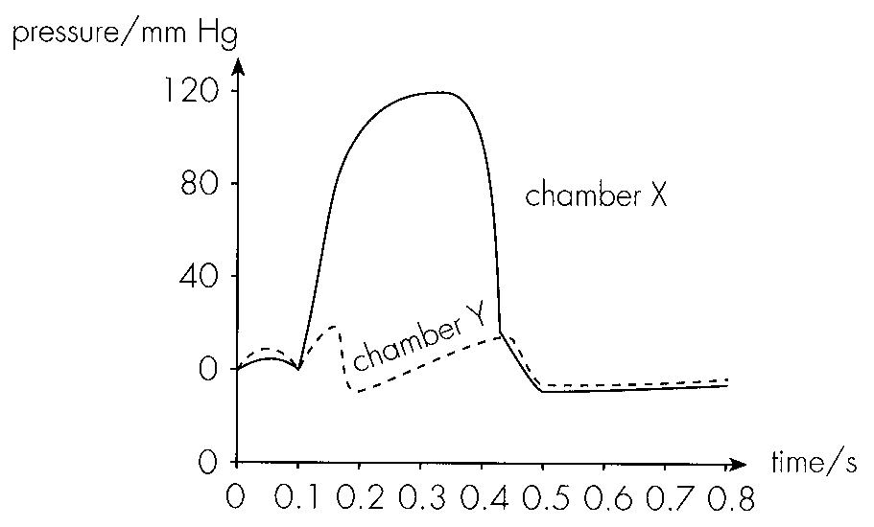
A. to prevent overexpansion of the heart. - B. to prevent the valve from turning inside out.
C. to pull the valve open. D. to return the valve to its original position. Directions: Questions 38 to 41 refer to the graph below which shows the change in pressure in the two chambers of the same side of the heart during a cardiac cycle. pressure/mm Hg
37. The two chambers are
 | X | Y
A. | right atrium | right ventricle
B. | right ventricle | right atrium
C. | left atrium | left ventricle
D. | left ventricle | left atrium

38. The blood vessels which are connected to X and Y respectively are
 | Blood vessel connected to X | Blood vessel connected to Y
A. | aorta | vena cava
B. | aorta | pulmonary vein
C. | pulmonary artery | vena cava
D. | pulmonary vein | aorta

39. If the valve mentioned in Question 40 fails to close completely, which of the following is the probable effect of this defect?
A.Cardiac output will be reduced.
B.The valve may be turned inside out.
C.No heart sound can be produced.
D.Oxygenated blood and deoxygenated blood will mix.
Directions: Questions 42 to 44 refer to the graph below which shows the change in volume of the left ventricle of the heart of a resting man in one second.
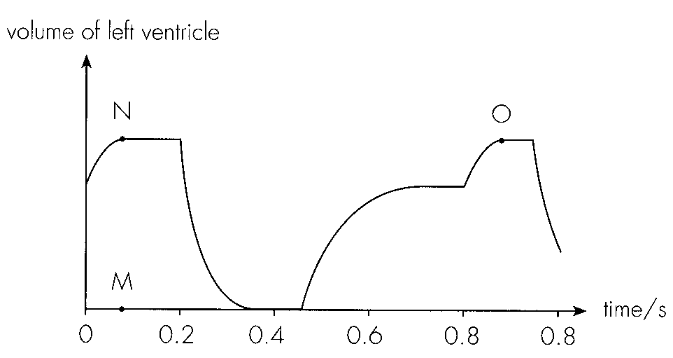
40. With reference to the graph, the rate of heart beat is
A. 50 beats per minute.
B. 60 beats per minute.
C. 75 beats per minute.
D. 100 beats per minute.
41. What are the conditions of the left atrium and the valves on the left side of the heart at 0.6 s?
 | Left atrium | Bicuspid valve | Semilunar valve-
A. | contracting | open | closed
B. | contracting | closed | open
C. | relaxing | open | closed
D. | relaxing | closed | open

42. What will be the change in the distance between the points M and N and the distance between the points N and O if the man is performing exercise?
Directions: Questions 45 to 47 refer to the following information:
Cholesterol plaque formed on the wall of arteries will cause blockage. The diagram below shows a type of operation which is used to treat the blockage of coronary arteries by cholesterol plaque.
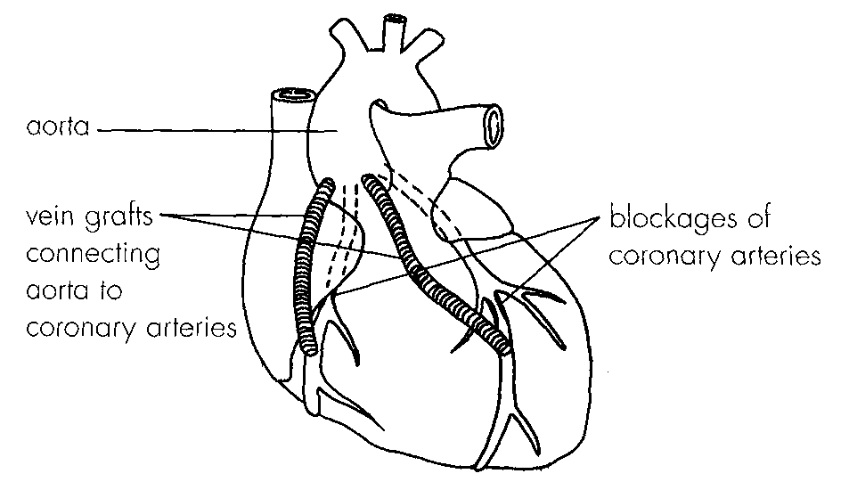
 | Distance between MN | Distance between NO
A. | shortens | shortens
B. | shortens | lengthens
C. | lengthens | shortens
D. | lengthens | lengthens

43. The circulation of blood around the body is reduced as a result of the partial blockage of the coronary arteries. Which of the following is the most probable explanation for this? A.Less blood is pumped out from the heart as the exit is blocked. B.The heart muscle contracts less powerfully due to the reduced supply of blood. C.The resistance to blood flow increases as the lumen of the arteries is reduced by the cholesterol plaque. D.The blood pressure decreases after the blood passes through the blocked arteries.
A. Less blood is pumped out from the heart as the exit is blocked.
B. The heart muscle contracts less powerfully due to the reduced supply of blood.
C. The resistance to blood flow increases as the lumen of the arteries is reduced by the cholesterol plaque.
D. The blood pressure decreases after the blood passes through the blocked arteries.
44. Which of the following statements is incorrect? A.The vein grafts by pass the cholesterol plaque.- B.This operation helps to restore normal blood flow to the heart muscles. C.The blood pressure in the vein grafts is higher than that in the blocked arteries. D.Heart attack may occur if the cholesterol plaque continues to thicken.
A. The vein grafts by pass the cholesterol plaque.-
B. This operation helps to restore normal blood flow to the heart muscles.
C. The blood pressure in the vein grafts is higher than that in the blocked arteries.
D. Heart attack may occur if the cholesterol plaque continues to thicken.
45. Which of the following habits of the patient should be restricted?
(1) Smoking cigarettes(2) Morning walk (3) Eating ice cream-
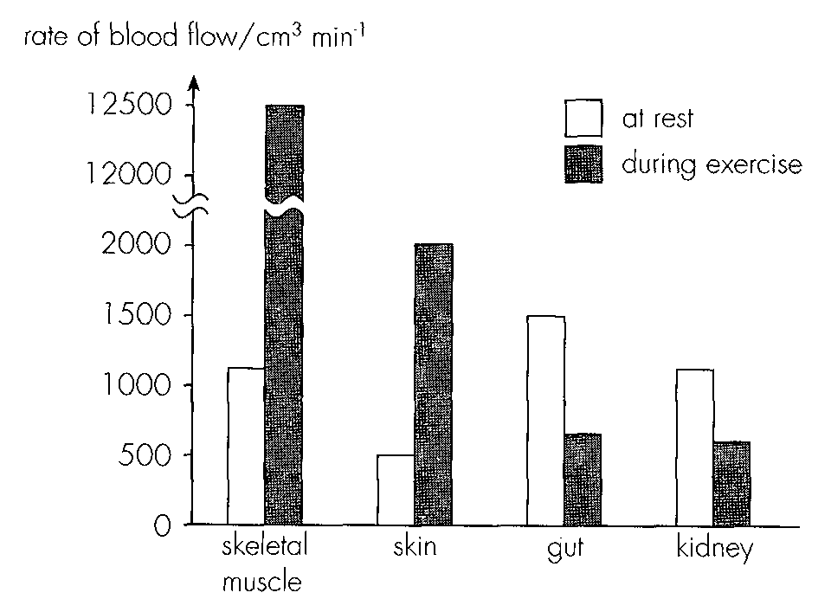
A. (1) only B. (1) and (3) onlyC. (2) and (3) only D. (1), (2) and (3) Directions: Questions 48 to 51 refer to the bar chart below which shows the rate of blood flow to four organs of a person at rest and during exercise:
46. Which of the following is/are the possible explanation(s) of the increase in blood flow to the skeletal muscle during exercise? (1) Increased heart beat rate (2) Stronger heart beat (3) Dilation of arteries to the skeletal muscle
A. (1) only
B. (3) only
C. (1) and (2) only
D. (1), (2) and (3)
47. Which of the following is/are the possible explanation(s) of the reduction in blood flow to gut during exercise? (1) Reduction in heart beat rate (2) Weaker heart beat (3) Constriction of arteries to the gut
A. (1) only
B. (3) only
C. (1) and (2) only
D. (1), (2) and (3)
48. Which of the following explains the importance of the increase in blood supply to the skin during exercise? A.More oxygen and food is supplied to the muscle cells for faster energy production. B.More heat is carried to the skin for dissipation. C.More urea is carried to the sweat glands for excretion. D.More carbon dioxide is removed to avoid accumulation.
A. More oxygen and food is supplied to the muscle cells for faster energy production.
B. More heat is carried to the skin for dissipation.
C. More urea is carried to the sweat glands for excretion.
D. More carbon dioxide is removed to avoid accumulation.
49. Which of the following correctly describes the effect of exercise on urine production of this person?
A.A larger amount of dilute urine is produced.
B.A larger amount of concentrated urine is produced.
C.A smaller amount of dilute urine is produced.
D.A smaller amount of concentrated urine is produced.
50. Blood flowing from the intestine returns to the heart by way of the
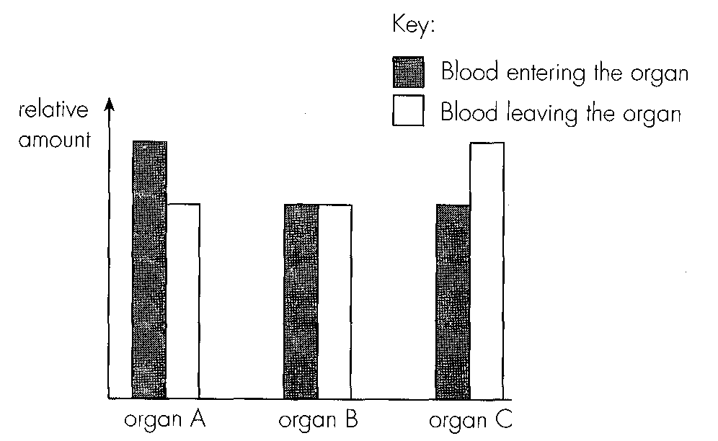
A. kidneys. B. liver. C. lungs. D. brain. Directions: Questions 53 and 54 refer to the bar chart below which shows the relative amounts of urea in the blood entering and leaving three organs in the body.
51. These three organs are most likely to be
 | Organ A | Organ B | Organ C
A. | liver | brain | kidney
B. | liver | lung | small intestine
C. | kidney | lung | liver
D. | rectum | brain | kidney

52. The bar chart below shows the relative amounts of four substances in the blood entering and leaving a certain organ of a man after fasting for 12 hours. This organ is most probably
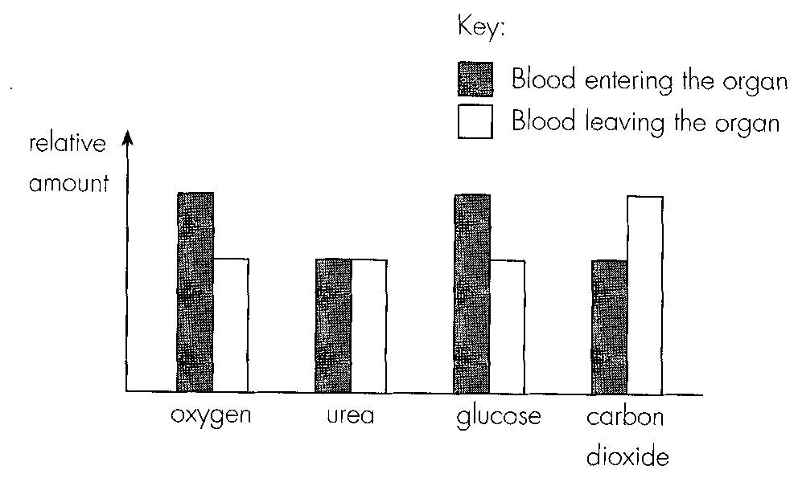
A. the kidney.
B. the liver.
C. the small intestine.
D. the lung.
53. Which of the following correctly shows the route of an oxygen molecule from the site of uptake to the site of consumption?
A.lung -→ pulmonary vein → left atrium -→ left ventricle -→ aorta --.> renal artery -→ kidney-
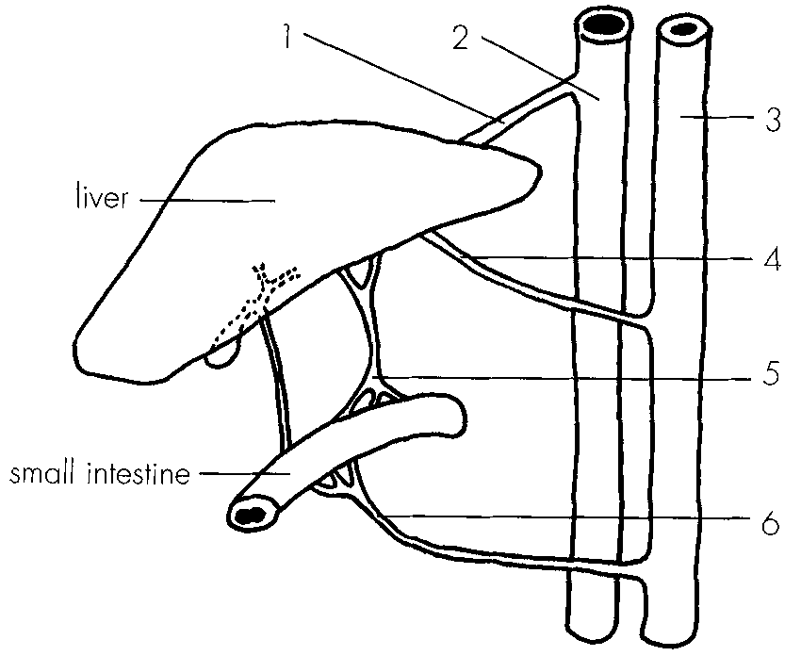
B. lung -→ pulmonary vein -→ right atrium -→ right ventricle -→ aorta → hepatic artery -→ liver- C.lung -→ vena cava -→ left atrium -→ left ventricle -→ aorta → hepatic artery -→ liver- D.lung -→ vena cava -→ right atrium -→ right -→ ventricle -→ pulmonary artery -→ lung Directions: Questions 57 to 59 refer to the diagram below which shows the part of the circulatory system associated with the liver and the small intestine in a mammal.
54. Which of the labelled blood vessels carries blood with the highest concentration of urea?
A. 1
B. 4
C. 5
D. 6
55. Which of the following blood vessels contain valves along their length?
A. 4 and 6 only
B. 1, 2 and 5 only
C. 4, 5 and 6 only
D. 2, 4 and 6 only
56. Which of the following routes of blood flow is incorrect?
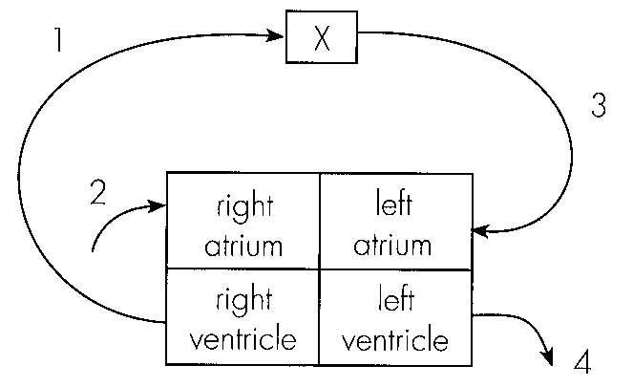
A. 3 -→ 4 -→ 1 -→ 2 B. 6 -→ 5 -→ 4 -→ 3 C. 6 -→ 5 -→ 1 -→ 2D. 3 -→ 6 -→ 5 -→ 1 Directions: Questions 60 and 61 refer to the diagram below which shows the four heart chambers and a portion of the circulation in the body. Letters 1, 2, 3 and 4 represent the four blood vessels associated with the heart.
57. Organ X is
A. the liver.
B. the brain.
C. the kidney.
D. the lung.
58. The two blood vessels represented by the cross sections shown in figures A and B respectively are-
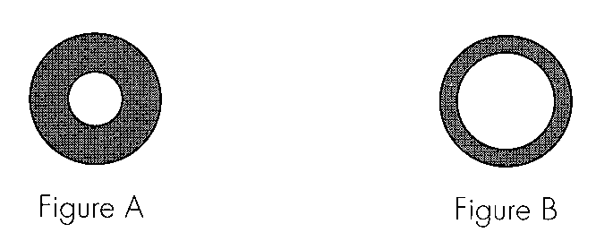
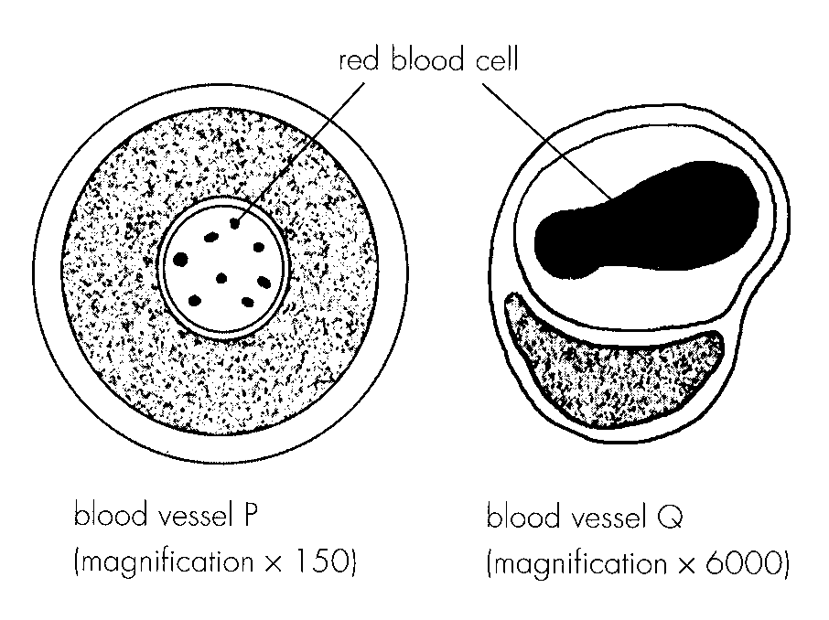
A. 1 and 2. B. 2 and 3. C. 3 and 4. D. 1 and 4. Directions: Questions 62 to 64 refer to the diagrams below which show the cross sections of two blood vessels.
59. The types of blood vessels P and Q are respectively
. | P | Q
A. | artery | vein
B. | capillary | vein
C. | vein | capillary
D. | artery | capillary

60. Which of the following are adaptations of vessel P to its function?
(1)It has a thick wall to withstand the high blood pressure.
(2)It has a muscular wall to pump blood.
(3)It has an elastic wall to maintain the high blood pressure.
A. (1) and (2) only B. (1) and (3) onlyC. (2) and (3) only D (1), (2) and (3)
61. Blood vessel P can be found in the wall of the heart. Which of the following may be a possible effect of its blockage?
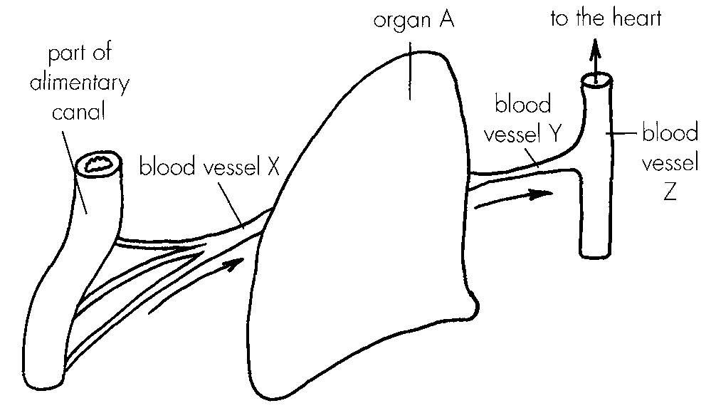
A. The heart muscle cells die. B. Blood cannot be pumped out of the heart.
C. No blood circulates in the body. D. Blood pressure in the ventricles increases. Directions: Questions 65 to 70 refer to the diagram below which shows the blood vessels associated with an organ in the abdomen.
62. Organ A is most probably. A.the stomach.
A. the stomach.
B. the kidney.
C. the liver.
D. the spleen.
63. The blood vessels X, Y and Z are X
 | X | Y | Z
A. | hepatic artery | hepatic vein | vena cava
B. | hepatic portal vein | hepatic vein | vena cava
C. | hepatic artery | hepatic portal vein | hepatic vein
D. | hepatic vein | hepatic portal vein | hepatic artery

64. Blood vessel X is different from blood vessel Y in that
A. it has no valve.
B. it has a thicker wall.
C. it connects two capillary networks.
D. it carries deoxygenated blood.
65. Which of the following statements concerning the changes in the blood glucose level in vessel X is correct?
A. The blood glucose level increases after a piece of bread is eaten.
B. The blood glucose level remains more or less constant all the time under the influence of insulin.
C. The blood glucose level is higher than normal during fasting.
D. The blood glucose level increases after a pork steak is eaten.
66. Which of the following correctly describes the difference between the composition of blood in blood vessel X and blood vessel Y of a person after fasting for a day?
 | Blood in vessel X | Blood in vessel Y
A. | more glucose | less glucose
B. | less bile pigments | more bile pigments
C. | less urea | more urea
D. | less insulin | more insulin

67. According to the diagram, the type of blood vessel to which Z belongs can be identified by
A. the presence of valves.
B. its large lumen.
C. the direction of blood flow in it.
D. its thin wall.
68. Which of the following features is not always true for all veins? A.They carry deoxygenated blood. C.They transport blood towards the heart.
A. They carry deoxygenated blood.
B. The blood pressure is relatively low.
C. They transport blood towards the heart.
D. They have valves to prevent the backflow of blood.
69. Which of the following matching is correct?
 | Blood vessels having the largest total crosssectional -area | Blood vessels having total surface area
A. | arteries | veins
B. | capillaries | veins
C. | veins | arteries
D. | capillaries | capillaries

70. The diagram below shows the longitudinal section of a portion of a vein and its surrounding skeletal muscles.
Which of the following correctly matches the conditions of valves A and B with the direction of blood flow when the skeletal muscles relax?
Directions: Questions 75 and 76 refer to the diagram below which shows part of the circulatory system in a mammal.
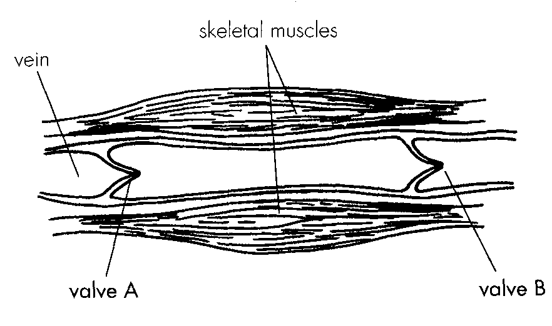
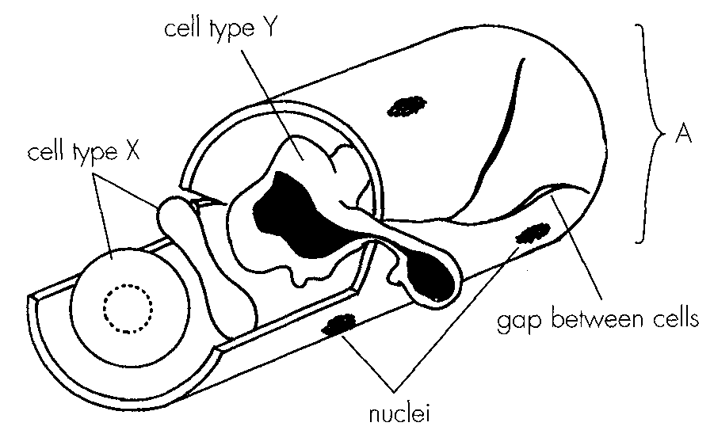
 | Valve A | Valve B | Direction of blood flow
A. | open | closed | to the right
B. | closed | open | to the left
C. | open | open | to the left
D. | closed | closed | blood remains stationary

71. The part labelled A is a capillary. Which of the following provide(s) the evidence? (1) It has a one cell thick wall.- (2) It contains red blood cells. (3) It contains white blood cells.
A. (1) only
B. (1) and (2) only
C. (2) and (3) only
D. (1), (2) and (3)
72. Which of the following comparisons between cells X and Y is correct? Directions: Questions 77 and 78 refer to the graph below which shows the changes in blood urea content and blood pressure along three types of blood vessels X, Y and Z. 77. X is artery. Which of the following provide reasons to support this identification? (1) The blood in X is flowing away from the heart. (2) The blood pressure in X is the highest. (3) The blood urea content in X is the lowest.
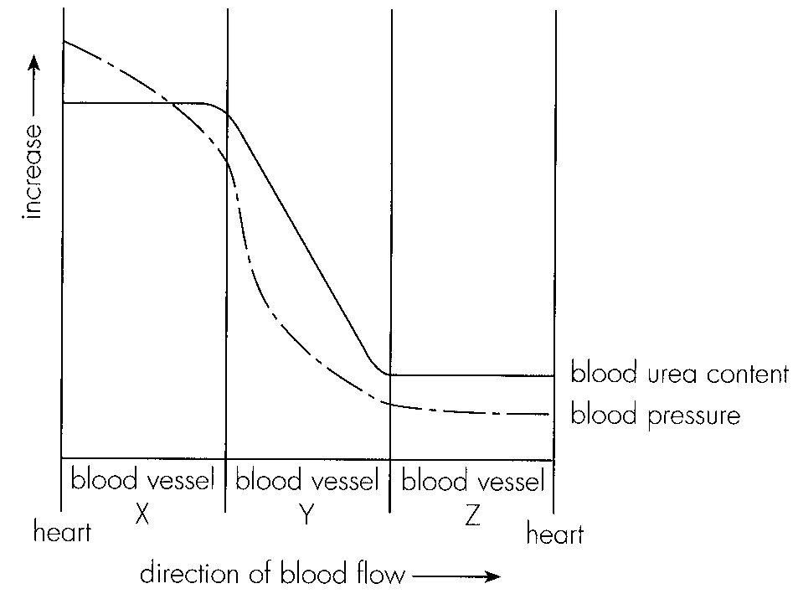
 | Cell X | Cell Y
A. | spherical in shape | irregular in shape
B. | has no nucleus | has a lobed nucleus
C. | red in colour | white in colour
D. | can move actively | moves passively

A. (1) and (2) only
B. (1) and (3) only
C. (2) and (3) only
D. (1), (2) and (3)
73. Blood vessel Y passes through an organ. This organ is most probably
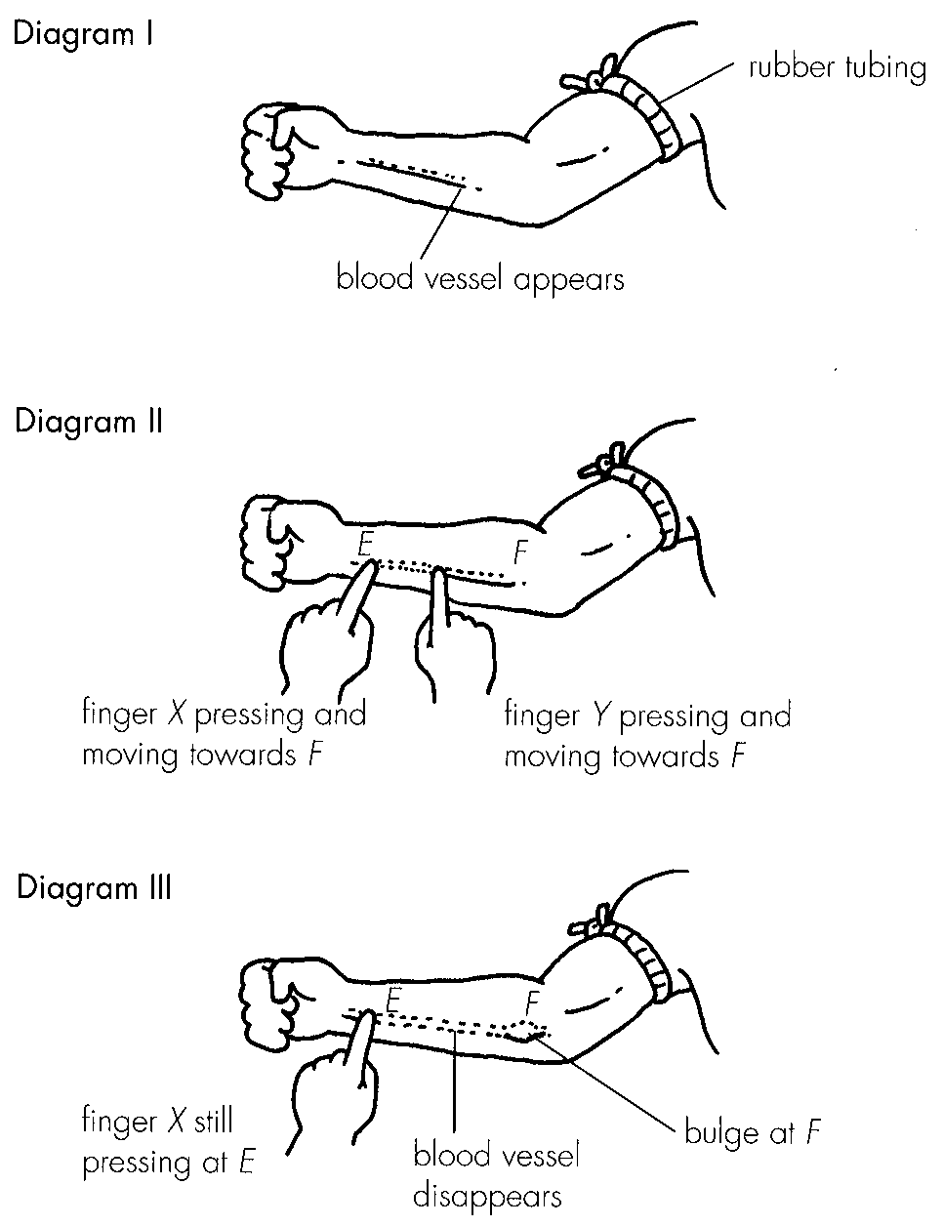
A. the kidney. B. the small intestine. C. the liver. D. the pancreas. Directions: Questions 79 and 80 refer to the following diagrams which show an experiment to demonstrate the presence of a certain type of blood vessel in a human arm.
74. Which of the following matching is correct?
 | Type of blood vessel demonstrated | Structure indicated by the bulge at F
A. | lymph vessel | lymph node
B. | artery | cholesterol plaque
C. | vein | valve
D. | capillary | valve

75. The purpose of tying the arm with a rubber tubing is A.to stop the blood supply to the arm. C.to prevent the arm from moving.
A. to stop the blood supply to the arm.
B. to make the blood vessel more conspicuous.
C. to prevent the arm from moving.
D. to facilitate the return of blood to the heart.
76. The table below shows the blood pressure of four blood vessels in the human body.
Which of the four blood vessels is most likely to be vena cava?
Blood vessel | Blood pressure in kPa
I | 12.0
II | 0.4
III | 1.2
IV | 2.6

A. I B. II C III D. IV
77. Which of the following is true for all veins?
A. They all have low nutrient content.
B. They all have high waste content.
C. They all carry deoxygenated blood.
D. They all have low blood pressure.
78. Which of the following vessels possess valves?
A. All veins only. B. All veins and some arteries only.
C. All lymph vessels only. D. All veins and all lymph vessels only.
79. The valves in veins
A. prevent the back flow of blood into the heart.
B. contract to raise the blood pressure.
C. prevent collapse of the blood vessels.
D. ensure unidirectional flow of blood to the heart.
80. Which of the following substances move across the capillary wall? (1) Metabolic wastes (2) Hormones (3) Respiratory gases
A. (1) and (2) only
B. (1) and (3) only
C. (2) and (3) only
D. (1), (2) and (3)
81. Which of the following fluids is directly in contact with body cells?
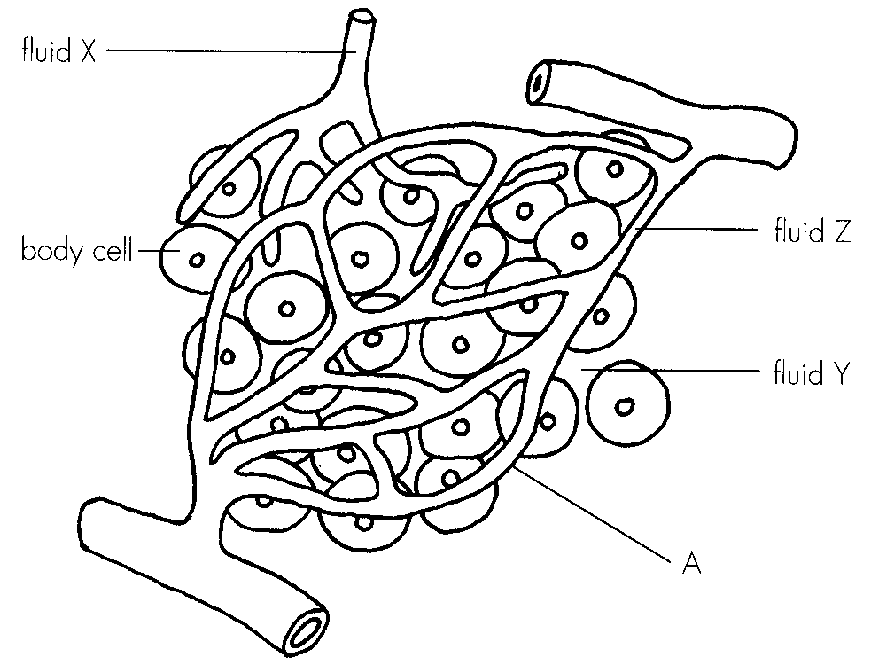
A. Blood B. Plasma C. Tissue fluid D. Lymph Directions: Questions 87 to 93 refer to the diagram below which shows part of the mammalian circulatory system and its surrounding cells.
82. Blood vessel A is highly branched. Which of the following explain the importance of this feature? (1) This provides a large surface area for material exchange. (2) This produces a large total crosssectional area to slow down blood flow. - (3) This helps to reduce blood pressure.
A. (1) and (2) only
B. (1) and (3) only
C. (2) and (3) only
D. (1), (2) and (3)
83. Fluid X, Y and Z are respectively
 | X | Y | Z
A. | blood | tissue fluid | lymph
B. | blood | lymph | tissue fluid
C. | lymph | tissue fluid | blood
D. | tissue fluid | lymph | blood.

84. The processes involved in the formation and reabsorption of fluid Y are
 | Formation | Reabsorption
A. | diffusion | active transport
B. | filtration | osmosis
C. | osmosis | diffusion
D. | active transport | filtration

85. Which of the following may be the fate of excess fluid Y? (1) Reabsorbed at the venous end of A (2) Forming fluid X (3) Absorbed by body cells D. (1), (2) and (3) 91.Substances in fluid X will finally enter the heart through A. the pulmonary vein. B. the pulmonary artery. C. the aorta. D. the vena cava.
A. (1) and (2) only
B. (1) and (3) only
C. (2) and (3) only
D. (1), (2) and (3) 91.Substances in fluid X will finally enter the heart through
86. The chamber of the heart which first receives the substances in fluid X is
A. the right atrium.
B. the right ventricle.
C. the left atrium.
D. the left ventricle.
87. Continuous flow of fluid X towards the heart is maintained by (1) the residual fluid pressure. (2) the contraction of the surrounding skeletal muscles. (3) valves which prevents the backflow of fluid X.
A. (1) and (2) only
B. (1) and (3) only
C. (2) and (3) only
D. (1), (2) and (3)
88. Which of the following is/are the function(s) of lymphatic system? (1) It accomodates white blood cells. (2) It transfers absorbed fats to the blood. (3) It returns tissue fluid to the blood.
A. (1) and (2) only
B. (1) and (3) only
C. (2) and (3) only
D. (1), (2) and (3)
89. Which of the following comparisons between the blood circulatory system and the lymphatic system of a mammal is correct?
Directions: Questions 96 to 99 refer to the diagram below which represents the relationships between the blood circulatory system, lymphatic system and a muscle in the leg.
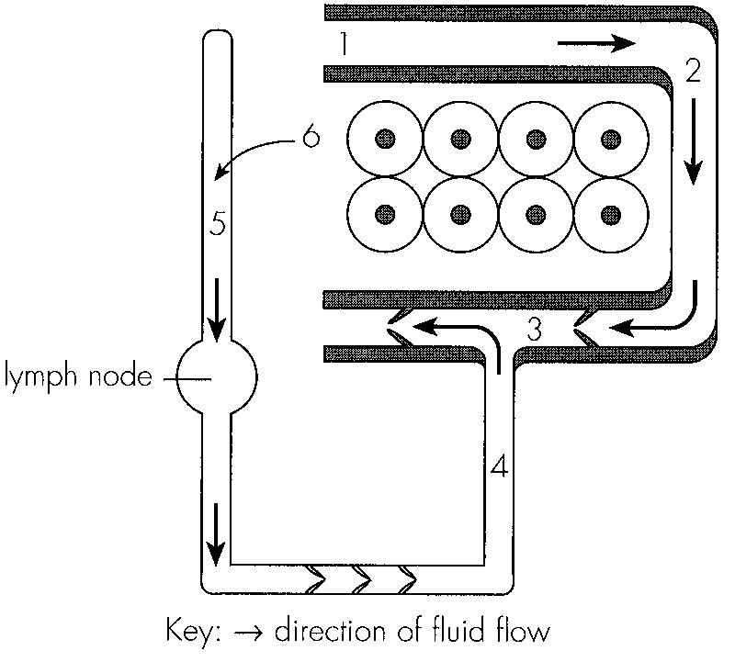
 | Blood circulatory system | Lymphatic system
A. | valves are present in veins | valves are absent in lymph vessels
B. | contains phagocytes | contains lymphocytes
C. | blood is driven by the heart | lymph is driven by lymph nodes
D. | contains red blood cells | contains no red blood cells

90. Which of the following is found at 2 but not at 5?
A. Fat B. Glucose C. White blood cells D. Blood platelets
91. The fluid pressure is highest at
A. 1.
B. 2.
C. 5.
D. 6.
92. Which of the following is a correct route of blood flow?
A. 3 -→ lung -→ heart -→ 1
B. 3 -→ heart -→ lung -→ 1
C. 3 -→ heart -→ lung -→ heart → 1-
D. 3 -→ heart -→ lung -→ heart → liver -→ 1-
93. Which of the following changes may occur after the person has finished a 100 m race?
A. The glucose level at 1 decreases.
B. The oxygen level at 1 decreases.
C. The urea level at 3 increases.
D. The lactic acid level at 3 increases.
94. In flowering plants, organic nutrients are transported
A. in the xylem only.
B. in the phloem only.
C. in both the xylem and phloem.
D. from the leaves to the roots only.
95. Which of the following are transported in the xylem? (1) Minerals (2) Sugars (3) Water
A. (1) and (2) only
B. (1) and (3) only
C. (2) and (3) only
D. (1), (2) and (3)
96. Which of the following are the adaptations of xylem for its functions?
(1) It has an empty lumen. (2) It forms a continuous tube. (3) It has a thick cell wall.
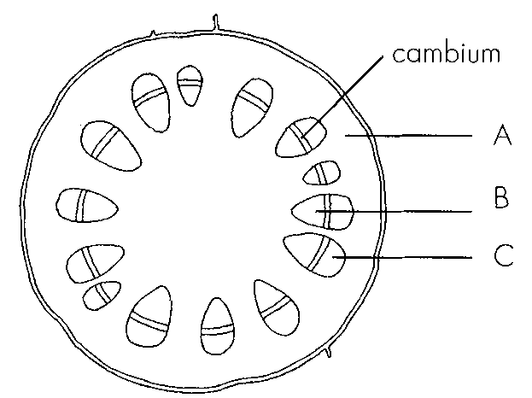
A. (1) and (2) only B. (1) and (3) only C. (2) and (3) only D. (1), (2) and (3) Directions: Questions 103 to 105 refer to the diagram on the next page which shows the transverse section of part of a dicotyledonous plant organ.
97. Which of the following combinations concerning the identification of this organ is correct?
 | Identification | Reason
A. | root | root hairs are present
B. | root | vascular tissues are found at the centre
C. | leaf | veins are present
D. | stem | vascular bundles are found at the periphery

98. Which of the following correctly describes the functions of A, B and C?
 | A | B | C
A. | photosynthesis | water transport | food transport
B. | support | support | food transport
C. | food storage | water transport | support
D. | food transport | support | food storage

99. Which of the following state(s) the probable function(s) of the epidermal hairs?
(1)To increase the surface area for water absorption.
(2)To reduce heat loss to the surroundings.
(3)To reduce water loss by trapping moisture.
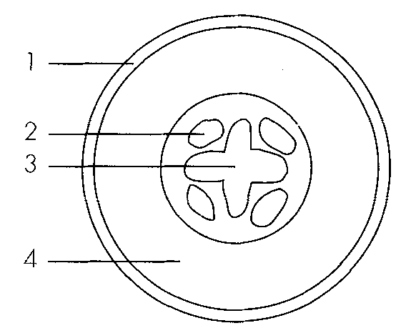
A. (1) only B. (1) and (3) only C. (2) and (3) onlyD. (1), (2) and (3) Directions: Questions 106 and 107 refer to the diagram below which shows a section of a certain part of a plant:
100. The section is taken from
A. a young stem.
B. a woody stem.
C. a young root.
D. a woody root.
101. Which of the following pairs matches correctly?
Directions: Questions 108 to 110 refer to the diagram below which shows a section of a certain part of a plant.
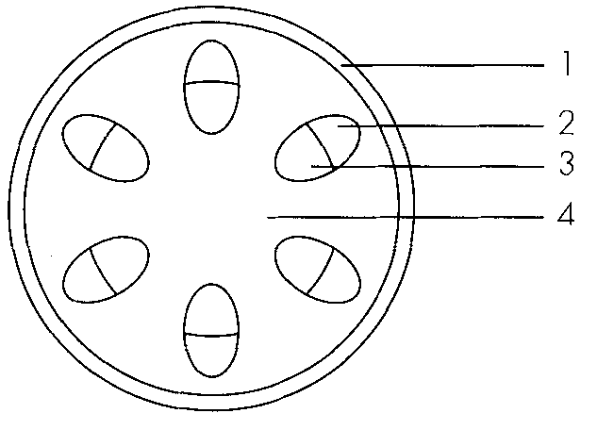
 | Site of water transport | Site of carbohydrate transport
A. | 1 | 2
B. | 2 | 3
C. | 3 | 2
D. | 3 | 4

102. This section is taken from
A. a young stem.
B. a woody stem.
C. a young root.
D. a woody root.
103. Which region is made up of cells with the thickest wall?
A. 1
B. 2
C. 3
D. 4
104. Which region is responsible for the transport of mineral salts?
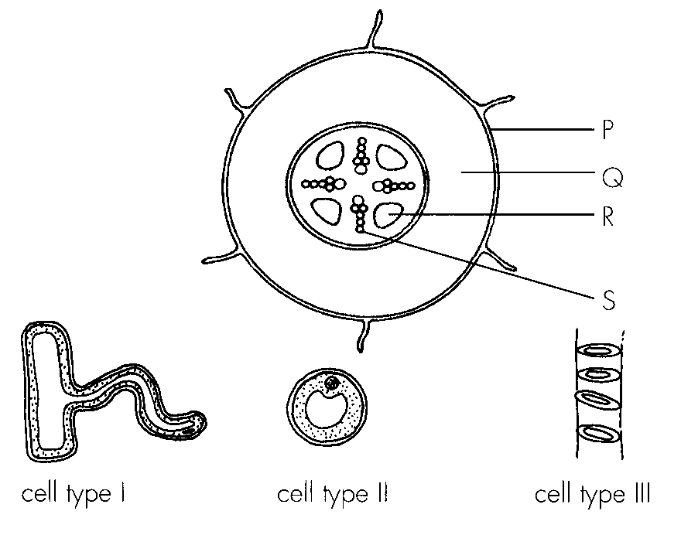
A. 1 B. 2 C. 3 D. 4 Directions: Questions 111 to 113 refer to the diagrams below. The diagram at the top shows the transverse section of a plant organ. The remaining three diagrams show three types of cells found in this organ.
105. With reference to the diagram, this organ is
A. a young stem.
B. a woody stem.
C. a young root.
D. a woody root.
106. Which of the following correctly describes the locations of the three types of cells?
 | Cell type I | Cell type II | Cell type III
A. | P | R | S
B. | P | Q | S
C. | S | Q | R
D. | Q | P | R

107. Which of the following correctly describes the functions of P, Q and S?
Directions: Questions 114 to 117 refer to the diagram below which shows an experimental setup to determine the path and rate of ascent of water in a leafy shoot.
After 90 minutes, crosssections of the shoot were cut, starting from the top end, until red dye appeared in the cut section. The length of the remaining shoot in the beaker was 12 cm.-
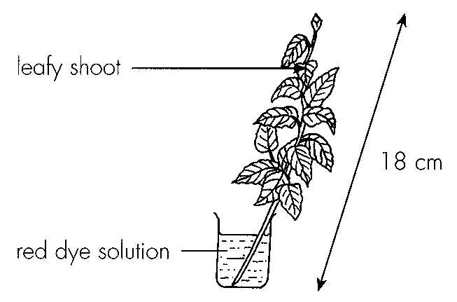
 | P | Q | S
A. | prevention of water loss | transport of food | support
B. | protection | food storage | transport of water
C. | absorption of water | support | food storage
D. | support | food storage | support

108. Which of the following is a precaution of this experiment? A.The set up should be placed under a fan.- B.The set up should be placed under sunlight.- C.The base of the shoot should be cut under the red dye solution. D.The leaves should be vaselined.
A. The set up should be placed under a fan.-
B. The set up should be placed under sunlight.-
C. The base of the shoot should be cut under the red dye solution.
D. The leaves should be vaselined.
109. The tissue stained red in the cut section is
A. epidermis.
B. cortex.
C. xylem.
D. phloem.
110. According to the information provided, the rate of ascent of water in the shoot is
A. 4 cm per hour.
B. 6 cm per hour.
C. 8 cm per hour.
D. 12 cm per hour.
111. Thin sections were also cut across the remaining shoot and one of the lowest leaves. The sections were examined under a low powered microscope. Which of the following shows the most probable locations of the red colour in both the shoot and the leaf? (Dark areas in the diagrams represent red colour.)
Directions: Questions 118 to 120 refer to the diagram below which shows an experimental setup to investigate the transport pathway of a potted plant
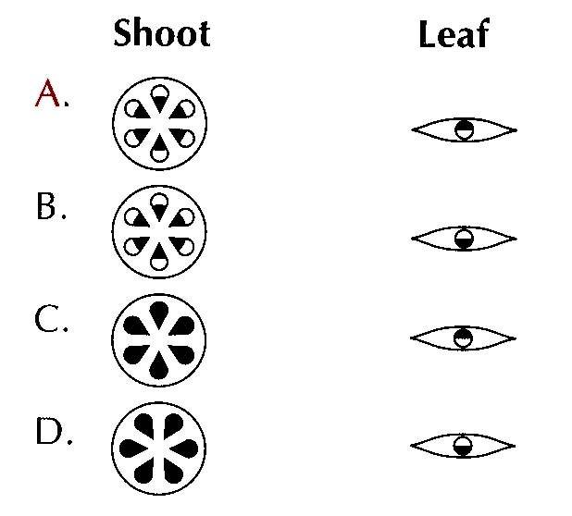
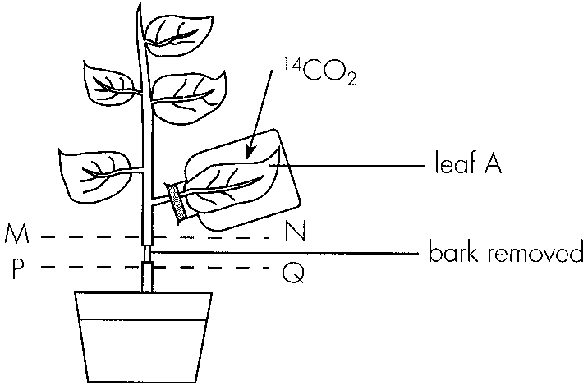
112. The radioactive substance and the tissue in the stem carrying it correspond to
 | Radioactive substance | Tissue
A. | water | xylem
B. | starch | phloem
C. | sucrose | phloem
D. | sucrose | xylem

113. The plant may finally die because
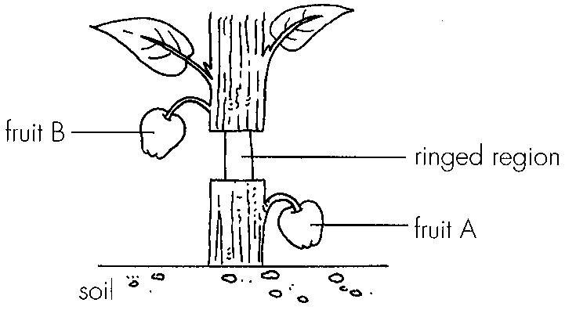
A. the roots die of starvation. B. the shoot dies of dehydration.
C. the roots die of dehydration. D. the shoot dies of starvation. Directions: Questions 121 and 122 refer to the diagram below which shows a woody plant with a ring of bark removed. The plant was left to grow.
114. Originally, fruits A and B were of similar size. Which of the following correctly describes the change in their size after a week?
 | Fruit A | Fruit B
A. | become larger | become larger
B. | become larger | become smaller
C. | become smaller | become larger
D. | become smaller | become smaller

115. Besides the change in size of the fruits, which of the following may also be observed?
A.The region above the ring becomes swollen.
B.The region below the ring becomes swollen.
C.The leaves above the ring drop.
D.A new bark is regenerated at the ringed region.
116. Which of the following blood transfusion may cause harm to the recipient? A.People of group O donate blood to people of group A. B.People of group A donate blood to people of group AB. C.People of group O receive blood from people of group B. D.People of group AB receive blood from people of group A.
A. People of group O donate blood to people of group
A.
B.
C. People of group O receive blood from people of group
Part B — HKDSE-style (YKTo)
117. Directions: Questions 1 to 6 refer to the following experiment to find out the composition of blood.
The purpose of adding sodium oxalate solution to tube A is to
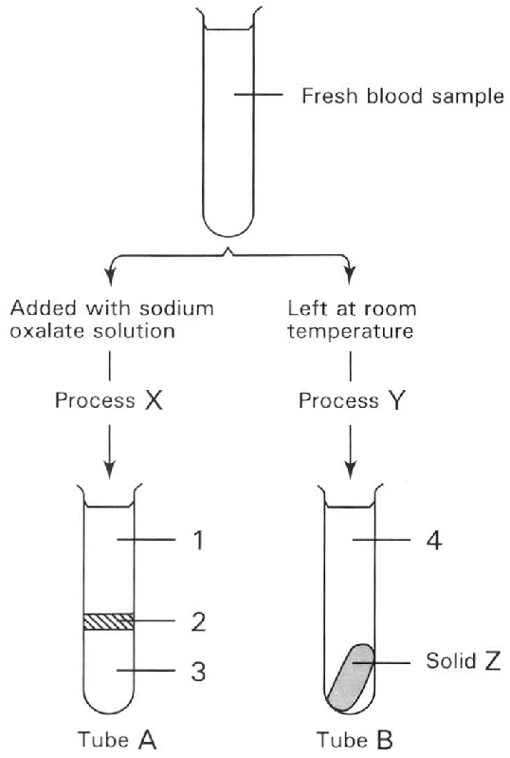
A. dissolve the blood platelets to prevent blood clotiting.
B. add sodium ions to prevent blood clotting.
C. act as a buffer to prevent the denaturation of plasma protein.
D. remove calcium ions to prevent blood clotting.
118. Which of the following CORRECTLY represents processes X and Y respectively?
3Which of the following CORRECTLY identifies the parts lablled 1 to 4?
 | Process X | Process Y
A. | Sedimentation | Agglutination
B. | Centrifugation | Sedimentation
C. | Sedimentation | Osmosis
D. | Centrifugation | Clotting

119. | 2 | 3 | 4 | A. | Plasma | Red blood cells | White blood cells | Blood | B. | Lymph | Blood platelets | Red blood cells | Serum | D. | Serum | White blood cells | Blood | Lymph 4Which of the following are the main components of solid Z? (1) Fibrin (2) Blood cells (3) Germs (4) Antibodies D. (1) and (4) only
C. | Plasma | White blood cells | Red blood cells | Serum |
A. (1) and (2) only
B. (2) and (3) only
C. (3) and (4) only
120. Which labelled part(s) is/are responsible for the transport of glucose and amino acids in the human body? D. (1) and (3) only 6Which of the following are functions of the part labelled 1 in the human body? (1) Transfer of heat throughout the body. (2) Defence of the body against germs. (3) Transport of oxygen. (4) Transport of carbon dioxide. B. (2) and (3) only C. (3) and (4) only D. (1), (2) and (4) only Directions: Questions 7 to 13 refer to the photomicrographs below which represent the blood smear of humans observed under different magnification of the microscope. 7Which of the following are reasons to support that photomicrograph I is obtained from the low powered observation? (1) The image obtained is dimmer. (2) It takes shorter time to focus the object. (3) More cells are observed. (4) Size of the blood cell is smaller. B. (2) and (3) only C. (3) and (4) only D. (4) and (1) only
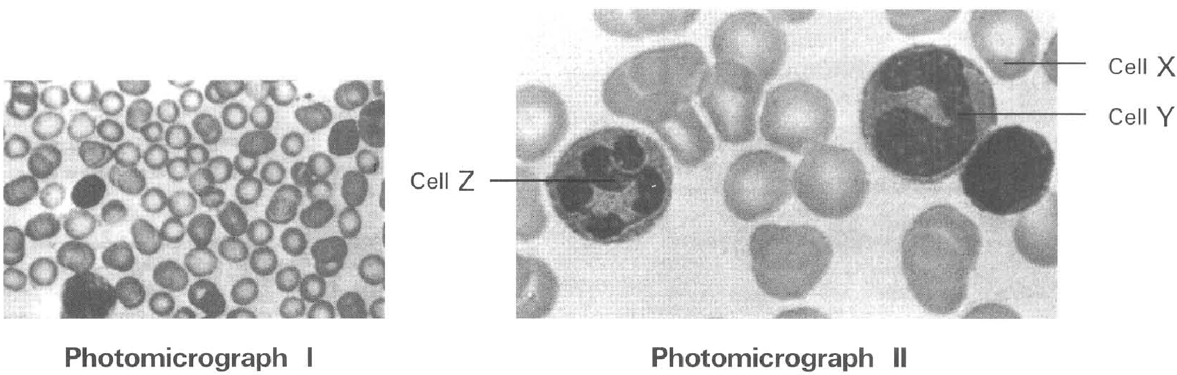
A. (1) only
B. (2) only
C. (3) only
A. (1) and (2) only
121. The following steps are involved in obtaining the high powered image of the bigger blood cells. Which sequence of steps is CORRECT? (1) Move the slide until the bigger blood cell is seen. (2) Observe the blood smear under the low powered magnification. (3) Turn the condenser knob to adjust the brightness of the image. (4) Turn the fine adjustment knob to move the body tube slowly up and down until sharp image is obtained. (5) Turn the nosepiece until the high-power objective is in position. D. (1), (2), (4), (3) and (5) 9The specific appearance of cell X in photomicrograph 1I is due to the (1) shortage of haemoglobin in the cell. (2) shortage of iron in the cell. (3) biconcave shape of the cell. (4) loss of nucleus. A. (1) and (2) only B. (2) and (3) only C. (3) and (4) only D. (3) and (1) only
A. (1), (2), (3), (4) and (5)
B. (2), (1), (3), (5) and (4)
C. (2), (1), (5), (4) and (3)
D. (1), (2), (4), (3) and (5) 9The specific appearance of cell X in photomicrograph 1I is due to the (1) shortage of haemoglobin in the cell. (2) shortage of iron in the cell. (3) biconcave shape of the cell. (4) loss of nucleus.
122. Which of the following are the advantages for cell X to be in the specific shape shown in the photomicrograph 1I? (1) Provides big surface area for gas exchange. (2) Shorten the distance to enhance the diffusion of oxygen into the cell. (3) Provide more space to accommodate more haemoglobin. (4) Enhance the penetration of the cell through the capillary wall.
A. (1) and (2) only
B. (2) and (3) only
C. (3) and (4) only
D. (1), (2) and (3) only
123. Which of the following is the essential factor for cell X to act as the 'carrier' of oxygen in the human body?
A. It is in biconcave shape.
B. It can be produced in large number.
C. It has no nucleus.
D. It contains haemoglobin.
124. Which of the following are functions of cells Y and Z? (1) Kills germs by phagocytosis. (2) Acts against antigen by producing antibodies. (3) Clears damaged tissues in the body. (4) Aids the transport of oxygen.
A. (1) and (2) only
B. (1) and (3) only
C. (2) and (4) only
D. (1), (2) and (3) only
125. Which of the following statements is CORRECT during an infection of the body by germs?
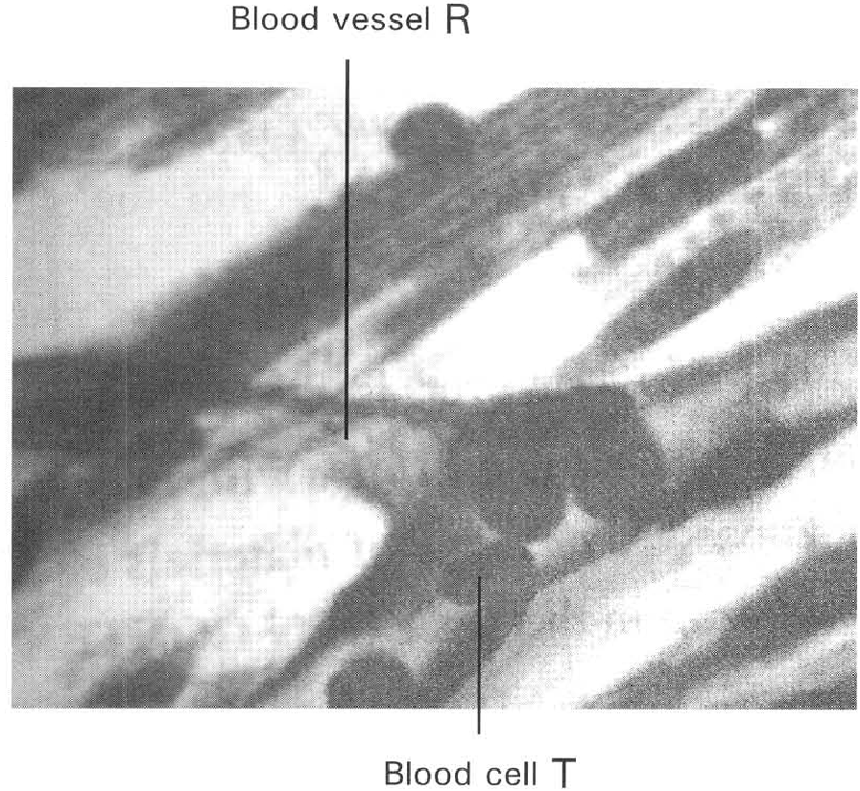
A. There is an increase in the number of cell X.
B. There is an increase in the number of cell Y.
C. There is an increase in the size of cell Z.
D. The nucleus of cell Y divides into several lobes as cell Z. Directions: Questions 14 to 16 refer to the photomicrograph below which shows the longitudinal section of a blood vessel with a blood cell inside.
126. Which of the following is the TRUE identity of blood vessel R?
A. Arteriole B. Venule
C. Blood capillary D. Lymph capillary
127. Which of the following is/are the TRUE adaptive feature(s) of the cell labelled T to perform its function? (1) Biconcave shape (2) No nucleus (3) Can squeeze through the wall of the blood vessel (4) Can secrete antibodies
A. (1) and (2) only
B. (2) and (3) only
C. (3) and (4) only
D. (1), (2) and (3) only
128. Which of the following matching of the site of production and destruction of the cell labelled T is CORRECT?
 | Site of production | Site of destruction
A. | Yellow bone marrow | Spleen
B. | Red bone marrow | Liver
C. | Lymph node | Spleen
D. | Red bone marrow | Lymph node

129. Which of the following statements related with the red blood cell is NOT TRUE? (1) In human it is biconcave in shape. (2) It contains haemoglobin molecules in its nucleus. (3) It does not carry carbon dioxide. (4) Oxygen mainly exists as oxyhaemoglobin in red blood cell.
A. (1) and (2) only
B. (2) and (3) only
C. (3) and (4) only
D. (2), (3) and (4) only
130. Haemoglobin is an ideal blood pigment to transport oxygen because
A. it is red in colour.
B. it is not present inside the white blood cells.
C. it does not react with carbon dioxide.
D. it combines reversibly with oxygen.
131. Blood in equilibrium with the alveolar air can take up in solution only 0.25 ml of oxygen per 100 ml, but with the presence of haemoblobin 100 ml of blood can carry about 20 ml of oxygen. The function of the haemogbin is (1) to transport more oxygen to the lungs. (2) to increase the oxygen carrying capacity of blood. (3) to increase the respiratory activities of blood.
A. (1) only
B. (2) only
C. (3) only
D. (1) and (3) only
132. Carbon monoxide is fatal to humans because it
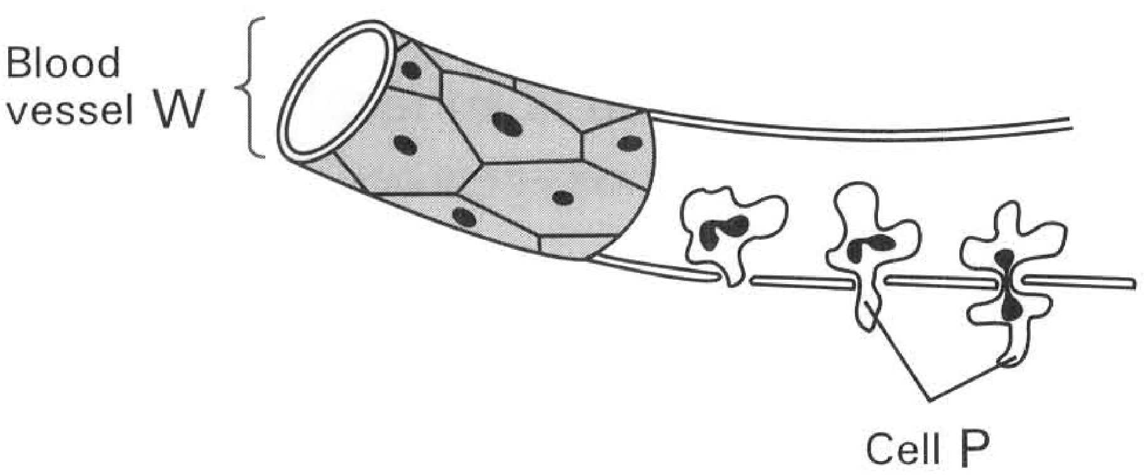
A. combines more readily with haemoglobin than oxygen.
B. dissolves haemoglobin.
C. blocks the 'pores' in the cell membrane to prevent the penetration of gases into the cell.
D. inhibits the enzymes involved in respiration. Directions: Questions 21 and 22 refer to the diagram below which shows a blood vessel W and blood cell P that can pass through the wall of the blood vessel. 21What is the importance for cell P to pass through the wall of blood vessel W?
A. It carries oxygen to the tissue cells adjacent to W.
B. It removes carbon dioxide from the tissue cells back to W.
C. It can attack the germs invading the tissue cells outside W.
D. This prevents cell P to be attacked by the germs present in blood.
133. Which of the following features of cell P is CORRECT? (1) It achieves body defence by engulfing the germs invading the body. (2) It has no nucleus to provide more space to digest the germs taken into the ell by phagocytosis. (3) It has no pigments to provide more space to transport carbon dioxide inside the body. (4) It is produced in large number in the lymph nodes in case of infection.
A. (1) and (2) only
B. (2) and (3) only
C. (3) and (4) only
D. (4) and (1) only
134. Which of the following will occur when the skin of a person is cut in an accident? (1) There is an increase in the number of red blood cells. (2) There is an increase in the number of white blood cells. (3) Blood clotting occurs at the wound. (4) The antibody level in blood increases.
A. (1) and (2) only
B. (2) and (3) only
C. (2) and (4) only
D. (2), (3) and (4) only
135. Which of the following components of blood take part in body defence? (1) Lymphocytes (2) Red blood cells (3) Blood platelets (4) Immunoglobulin in plasma
A. (1) and (2) only
B. (2) and (3) only
C. (3) and (4) only
D. (1), (3) and (4) only
136. Which of the following statements about white blood cells are 1NCORRECT? (1) They have no respiratory pigment. (2) They possess large lobed nucleus. (3) They will cause the agglutination of blood during a wrong blood transfusion. (4) All white blood cells can engulf germs.
A. (1) and (2) only
B. (2) and (4) only
C. (1) and (4) only
D. (3) and (4) only
137. Which of the following comparisons between red blood cells and white blood cells is WRONG?
 | Red blood cells | White blood cells
(1) | No nucleus ever exists in them | Large nucleus present in them
(2) | Can pass throuth the capillary wall due to their small size | Cannot pass through the capillary wall due to their big size
(3) | More numerous in number | Fewer in number
(4) | Regular biconvex shape to increase the surface area | Irregular shape to permit amoeboid movement to take place

A. (1) only B . (2) only C . (3) and (4) only D. (1), (2) and (4) only
138. Which of the following fluids give(s) positive result in Benedict's test of a healthy person? (1) Serum (2) Glomerular filtrate/renal fluid (3) Urine
A. (1) only
B. (2) only
C. (1) and (2) only
D. (1), (2) and (3) only
139. Refer to the following table which shows the result of a blood test taken by a person after fasting. With reference to the result of the blood test, what disease may the person have? (1) Diabetes (2) Cardiovascular disease (3) Anaemia (4) Haemophilia
Tests | Result | Normal range
Red blood count (ML-1) | 5.1 | 4.3 – 6.0
Urea (mmolL-1) | 4.9 | 3.2 – 7.4
Cholesterol (mmolL-1) | 6.4 | < 5.2
Glucose (mmolL-1) | 7.8 | 3.9 – 5.8

A. (1) only
B. (2) only
C. (1) and (2) only
D. (3) and (4) only
140. The purpose of having fasting before the blood test is to
A. prevent the intake of food that will interrupt the condition of blood.
B. reduce the effect of the body activities on the amount of food reserve inside the body.
C. consume the food reserve as much as possible.
D. remove the metabolic wastes from the body as much as possible.
B. Blood vessels
141. Which of the following matching of the statements of the arteries, veins and capillaries are CORRECT? 31Which structure is present in all the blood vessels in humans?
 | Arteries | Capillaries | Veins
A. | All the blood carried must be oxygenated. | All the blood carried must be deoxygenated | All the blood carried must be oxygenated.
B. | All the blood carried must be deoxygenated | All the blood carried must be oxygenated. | All the blood carried must be deoxygenated
C. | Carries blood away from the heart. | Carries blood towards the heart. | Join the arterioles to the lymph vessels.
D. | Carries blood away from the heart. | Link the arterioles to the venules. | Carries blood towards the heart.

A. Valves
B. Muscle fibres
C. Elastic fibres
D. Endothelial cells
142. Arrange the following blood vessels according to the size of their lumen in ascending order? (1) Venule (2) Vein (3) Capillary (4) Arteriole
A. (3) (4) (1) (2)
B. (3) (1) (2) (4)
C. (4) (3) (2) (1)
D. (1) (2) (3) (4)
143. Which of the following statements concerning the arteries is/are INCORRECT? (1) All arteries drain blood away from the heart. (2) All arteries contain oxygenated blood. (3) All arteries carry blood under pressure. (4) All arteries do not contain any valve.
A. (1) only
B. (2) only
C. (1) and (3) only
D. (2) and (4) only
144. The pulmonary artery resembles all other arteries EXCEPT that it.
A. has a larger lumen.
B. has a thicker muscular wall.
C. carries deoxygenated blood.
D. carries blood rich in urea.
145. Pressing the thumb on the wrist of the left hand one will feel a pulse. This pulse is produced because
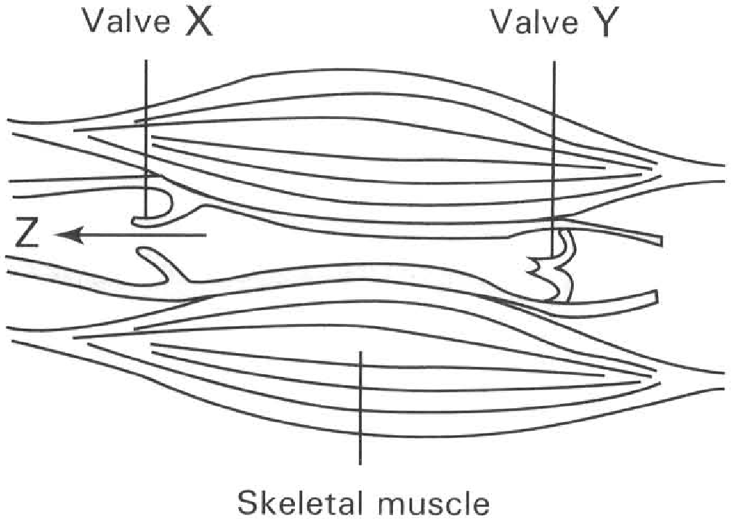
A. the wall of the arteries is thicker than that of the veins.
B. the arteries carry oxygenated blood.
C. the veins have larger lumen than the arteries.
D. of the alternate stretching and elastic recoil of the artery in response to the systole and diastole of the heart. Directions: Questions 36 and 37 refer to the diagram below which shows the longitudinal section of a blood vessel.
146. The blood vessel illustrated above is
A. an artery.
B. an arteriole.
C. a capillary.
D. a vein.
147. Which of the following combinations of the structures concerned enables blood to flow in direction Z?
 | Skeletal muscle | Valve X | Valve Y
A. | Contracting | Closed | Closed
B. | Contracting | Open | Closed
C. | Relaxing | Open | Closed
D. | Relaxing | Open | Open

148. The function of valves in the veins is to
A. control the rate of blood flow.
B. propel blood to flow in a forward direction.
C. prevent back flow of the blood.
D. act as pockets for storing blood temporarily.
149. In which of the following places are valves absent? (1) The base of the pulmonary artery. (2) The renal artery. (3) Lymph vessels. (4) The junction between the right atrium (auricle) and right ventricle of the heart.
A. (1) only
B. (2) only
C. (3) only
D. (1) and (4) only
150. In blood donation blood is collected from the vein instead of the artery because
A. the vein has thinner wall for easy penetration of the needle.
B. the vein has bigger lumen for easy collection of blood.
C. the vein contains deoxyenated blood to reduce the loss of oxygen from the donor.
D. the lower blood pressure in the vein ensures a safe draining of blood from the donor.
151. People travelling in international flight may feel uncomfortable due to the swelling of their feet. Some TV programmes in the plane teach people some stretching exercises of the legs. These stretching exercises relieve such discomfort experience of the passengers by
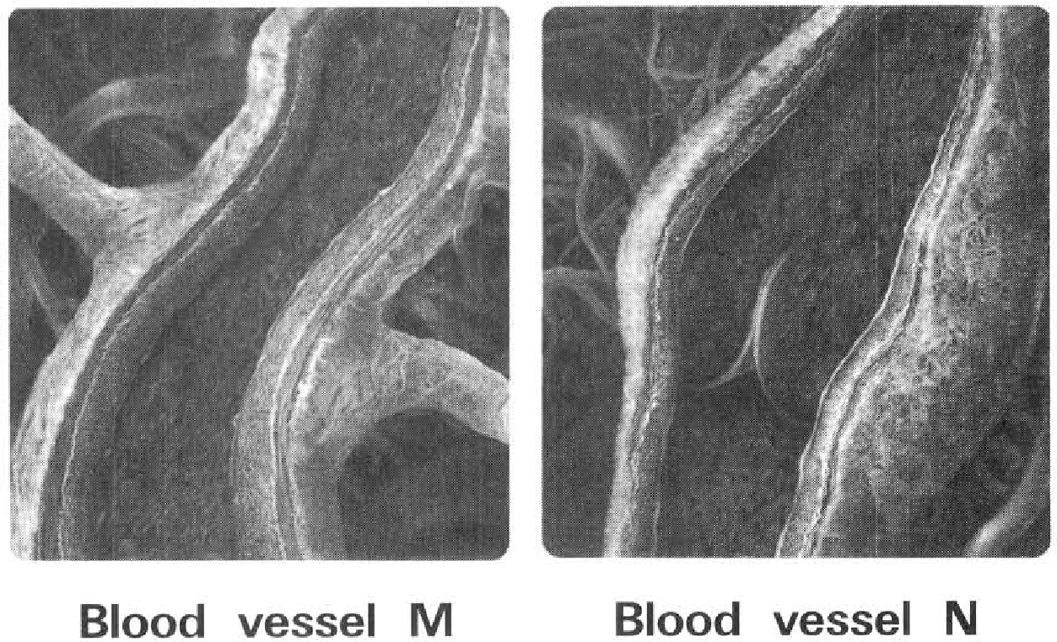
A. triggering the increase in the rate of heartbeat that speeds up the rate of blood flow from the legs.
B. increasing the stroke volume of the heart that increases the blood pressure and hence promotes the lymph away from the legs.
C. squeezing the lymph vessels that push more lymph to flow away from the legs.
D. causing vasoconstriction of the arterioles supplying the leg muscles that increases the blood pressure to push more blood away from the legs. Directions: Questions 12.42 and 12.43 refer to the diagrams below which show the transverse section of blood vessels M and N
152. Which of the following reasons supporting that blood vessel M is an artery and N is a vein?
 | Blood vessel M | Blood vessel N
(1) | Thicker wall | Thinner wall
(2) | Smaller lumen | Bigger lumen
(3) | No valves | Has valves

A. (1) onlyB . (1) and (2) onlyC . (2) and (3) only D. (1), (2) and (3)
153. Which of the following accounts for the blood flow in the blood vessels concerned is/are CORRECT?
(1) The contraction of the heart produces strong propelling force to push blood forwards along blood vessels.
(2) The elastic recoil of the muscular wall of the blood vessel.
(3) The contraction of the skeletal muscles adjacent to the blood vessel squeezing the blood vessel.
(4) The suction effect produced by the inhalation of the body.
Directions: Questions 44 to 47 refer to the photomicrograph below which shows the transverse section of blood vessels S and T connecting with a kidney.
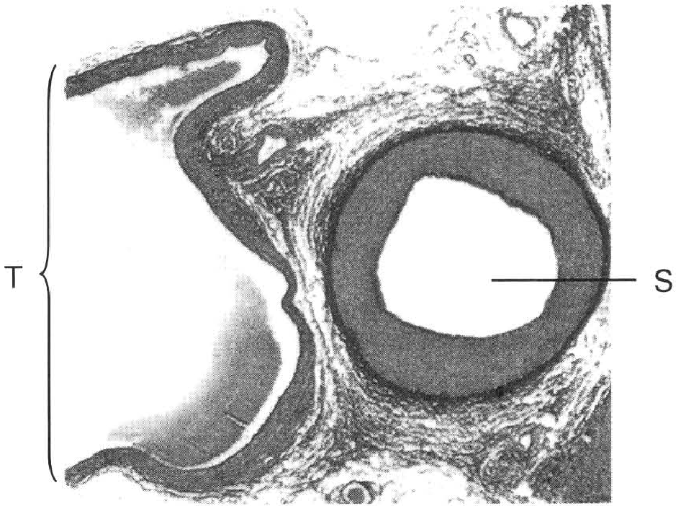
 | Blood vessel M | Blood vessel N
A. | (1) only | (2) only
B. | (1) and (2) | (3) and (4)

C. | (3) only | (4) only
D. | (3) and (4) | (1) and (2)

154. Which of the following comparisons between blood vessels S and T are 1NCORRECT? D. (4) and (1) only 45 S has thicker wall than T because it (1) has to withstand the high blood pressure. (2) contains more muscle fibres to contract rhythmically for draining the blood forward. (3) has to branch into many arterioles. A. (1) only B. (2) only C. (1) and (2) only D. (1) and (3) only
. | S | T
(1) Direction of blood flow | Towards the heart | Away from the heart
(2) Presence of valves along its length | Yes | No
(3) Blood | Higher | Lower pressure
(4) Amount of muscle fibres | Higher | Lower

A. (1) and (2) only
B. (2) and (3) only
C. (3) and (4) only
D. (4) and (1) only 45 S has thicker wall than T because it (1) has to withstand the high blood pressure. (2) contains more muscle fibres to contract rhythmically for draining the blood forward. (3) has to branch into many arterioles.
155. Which heart chambers will these blood vessels eventually connect to?
 | T | S
A. | Right atrium | Left atrium
B. | Right ventricle | Left ventricle
C. | Right ventricle | Left atrium
D. | Right atrium | Left ventricle

156. If these two blood vessels connecting the heart and the kidney, which of the following comparisons between them is/are CORRECT?
 | Urea concentration | Carbon dioxide concentration | Glucose concentration
 | S | T | S | T | S | T
A. | Higher | Lower | Higher | Lower | Lower | Higher
B. | Higher | Lower | Lower | Higher | Higher | Lower
C. | Lower | Higher | Higher | Lower | Lower | Higher
D. | Lower | Higher | Lower | Higher | Higher | Lower

157. Which of the following comparisons of the artery and the vein is 1NCORRECT?
 | Artery | Vein
A. | Bigger lumen | Smaller lumen
B. | Thicker muscular wall | Thinner muscular wall
C. | It carries blood away from the heart | It carries blood towards the heart
D. | It usually carries oxygenated blood | It usually carries deoxygenated blood

158. Usually a nurse injects some medical fluid out of the needle of a syringe before inserting the needle into the body of a patient. What is the reason of such a practice?
A. To reduce over injection of the medical fluid into the body of the patient.
B. To test the efficiency of injection of the needle of the syringe.
C. To avoid introducing air bubbles into the veins of the patient.
D. To wash out the germs sticking at the mouth of the needle of the syringe.
159. What will be the consequence if the precaution described in the previous question is not carried out?
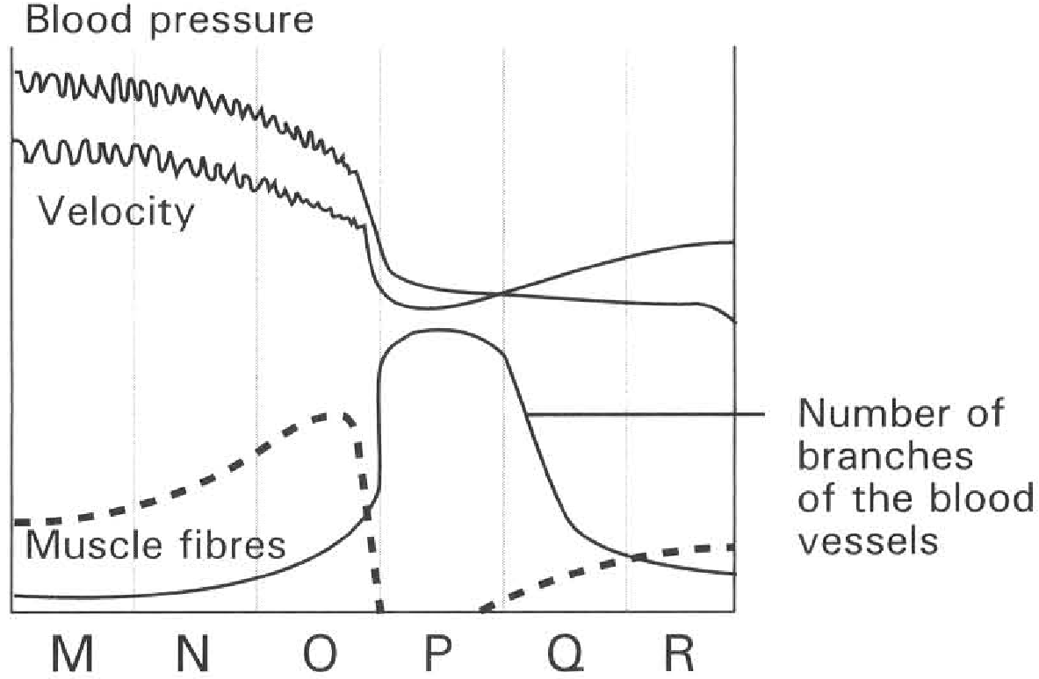
A. Air bubbles may get into the blood stream and block the small vessels that may impede the smooth blood flow.
B. Too much oxygen may be introduced into the body that may oxidise some useful substances in the body.
C. The nitrogen in air may disrupt the function of the haemoglobin.
D. Germs may get into the body through the injection. Directions: Questions 51 to 55 refer to the graph below which shows the blood pressure, velocity of blood flow, amount of muscle fibres and the number of branches of the blood vessels.
160. Which of the following CORRECTLY identifies the blood vessels labelled M to R?
 | vessel M | vessel N | vessel O | vessel P | vessel Q | vessel R
A. | Arteries | Aorta | Arteriole | Veins | Venules | Capillaries
B. | Aorta | Arterioles | Arteries | Capillaries | Veins | Venules
C. | Venule | Vein | Aorta | Capillaries | Arteriole | Arteries
D. | Aorta | Arteries | Arterioles | Capillaries | Venules | Veins

161. The high blood pressure in vessel M is maintained by (1) The pumping action of the heart. (2) The gravitational pull on blood. (3) The contraction of the skeletal muscles around the blood vessel (4) The elastic recoil of the vessel wall.
A. (1) and (2) only
B. (2) and (3) only
C. (1) and (4) only
D. (3) and (4) only
162. O has large amount of muscle fibres to (1) provide a thicker wall for withstanding the high blood pressure. (2) contract in order to force blood flowing forwards during relaxation of the heart. (3) regulate the lumen size for controlling the amount of blood draining into the network.
A. (1) only
B. (2) only
C. (2) and (3) only
D. (1) and (3) only
163. Which of the following are adaptive features of blood vessel P to carry out its functions? (1) High blood pressure (2) Slow rate of blood flow (3) Thin wall (4) Greatest surface area caused by branching D. (2), (3) and (4) only 55The increase in the velocity of blood flow in Q is due to the (1) contraction of the muscle fibres in its wall. (2) squeezing effect exerted by the contraction of the skeletal muscles adjacent to it. (3) suction effect developed during inhalation . (4) decrease in the total cross-sectional area of the blood vessels. D. (2), (3) and (4) only Directions: Questions 56 and 57 refer to the photomicrograph below which shows the transverse section of an artery with a plaque inside.
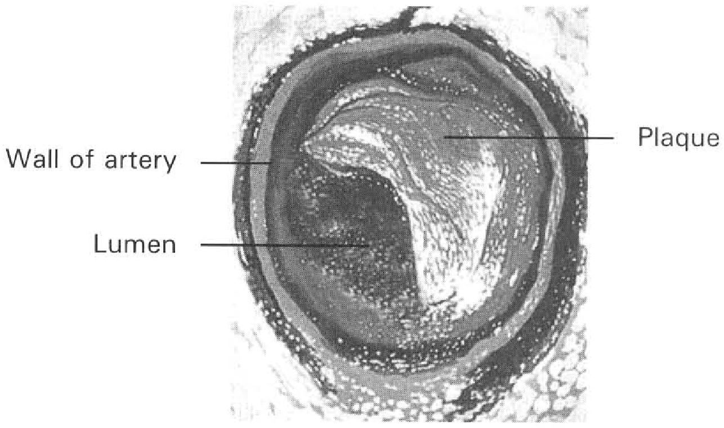
A. (1) and (2) only
B. (2) and (3) only
C. (3) and (4) only
D. (2), (3) and (4) only 55The increase in the velocity of blood flow in Q is due to the (1) contraction of the muscle fibres in its wall. (2) squeezing effect exerted by the contraction of the skeletal muscles adjacent to it. (3) suction effect developed during inhalation . (4) decrease in the total cross-sectional area of the blood vessels.
164. Which of the following is/are responsible for the formation of plaque inside the artery? (1) Diet composed of high lipid content and low fibre food. (2) Meal rich in starch. (3) Diet mainly composed of fruits and vegetables. (4) Lack of exercises
A. (1) and (2) only
B. (2) and (3) only
C. (3) and (4) only
D. (4) and (1) only
165. Which of the following is/are the effects of the formation of plaque in the artery? (1) Narrowing of the lumen of the artery. (2) Increase in blood pressure. (3) Slowing down the rate of blood flow. D. (1), (2) and (3) wDirections: Questions 58 and 59 refer to the diagram below which shows a device inserting into an artery to treat with the plaque deposited there. 58What is the purpose of inflating the balloon in the above device? (1) Supply more oxygen to the cells lining the artery. (2) Remove more carbon dioxide and wastes away. (3) Compress the plaque to widen the lumen of the artery. (4) Resume the normal blood flow through the blood vessel. B. (2) and (3) only C. (3) and (4) only D. (4) and (1) only 59 Suppose that this blood vessel is branching from the aorta to the heart wall. What will be the consequence if no action is taken to remove the plaque? (1) The rate of heart beat will increase. (2) The blood pressure will decrease. (3) There is a high risk to have heart attack. (4) Stroke volume increases. C. (3) only D. (3) and (4) only
A. (1) only
B. (2) only
C. (2) and (3) only
A. (1) and (2) only
166. Which of the following features of the capillaries are responsible for the efficient exchange of materials between blood and tissue fluid? (1) Small lumen reduces the blood flow. (2) Thin wall provides short distance that enhances the diffusion of substances through it. (3) It is highly branched to provide large surface area to enhance diffusion. (4) It has gaps in its wall to facilitate the passage of white blood cells across it. C. Heart Directions: Questions 61 to 63 refer to the diagram below which shows a heart and the blood vessels connected to it. 61Which of the following connection between the labelled chambers and labelled blood vessels are CORRECT?
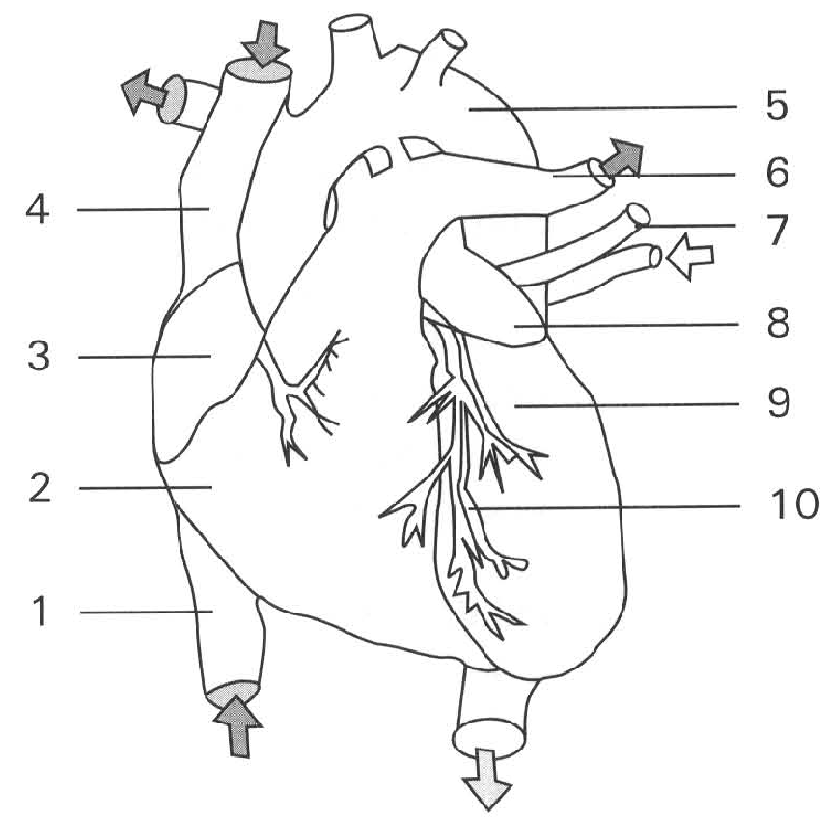
 | Chamber labelled 2 | Chamber labelled 3 | Chamber labelled 8 | Chamber labelled 9
A. | 1 | 6 | 5 | 7
B. | 6 | 1 | 7 | 5
C. | 1 | 4 | 10 | 6
D. | 5 | 4 | 6 | 5

A. (1) and (2) only
B. (2) and (3) only
C. (3) and (4) only
D. (1), (2) and (3) only
167. Which labelled blood vessel will blood vessel 10 connect to ?
A. 4
B. 5
C. 6
D. 7
168. If the blood vessel labelled 10 is blocked by a plaque and no proper treatment is given, which of the following will occur?
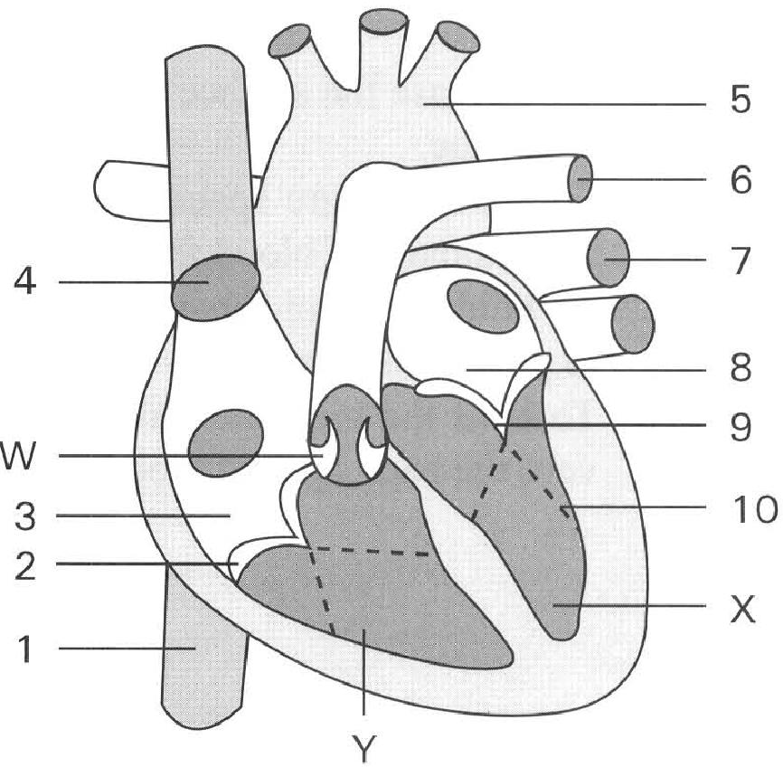
A. The blood pressure will decrease.
B. The rate of blood flow will decrease.
C. The stroke volume of the heart will increase.
D. Some heart muscles may die due to the insufficient blood supply. Directions: Questions 64 to 70 refer to the diagram below which shows a heart and the blood vessels connected to it.
169. Which of the following CORRECTLY match with the blood vessels labelled 1,4,5,6 and 7 ?
170. | 4 | 5 | 6 | 7 | A. | Aorta | Posteriorvena cava | Pulmonaryvein | Anteriorvena cava | Pulmonaryartery | B. | AnteriorVena cava | Aorta | Pulmonaryartery | Posteriorvena cava | Pulmonaryvein | C. | Pulmonaryartery | Pulmonaryartery | Pulmonaryvein | Anteriorvena cava | Aorta | D. | Posteriorvera cava | Anteriorvena cava | Aorta | Pulmonaryartery | Pulmonaryvein
171. The wall of chamber X is thicker than that of chamber Y. The difference in thickness of the muscular wall suggests that
A. the rate of blood flow in chamber X is higher than that in chamber Y.
B. more blood is stored in chamber X than in chamber Y.
C. the function performed by chamber X is more important than that by chamber Y.
D. chamber X produces a stronger force in pumping blood than chamber Y.
172. What is the function of sturcture labelled 10?
A. To increase the surface area for gas exchange.
B. To provide more space to speed up the drainage of blood from 8 to X.
C. To hold the semi-lunar valves so as to prevent the back flow of blood.
D. To hold the bicuspid valves to prevent the back flow of blood.
173. Which structure is responsible for draining deoxygenated blood from the body into the heart?
A. 1 and 4 only
B. 4 and 7 only
C. 5 and 6 only
D. 6 and 7 only
174. Which of the following blood vessels are CORRECTLY connected with the lungs and the heart?
 | From the heart to the lungs | From the lungs to the heart
A. B. C. D. | 4567 | 6475

175. Which of the following routes CORRECTLY describes the pathway taken by a red blood cell flowing from the liver and then back to the liver again?
A. 5 X 87 43 Y 6
B. 4 3 Y 6 5 X 87
C. 13 Y6 7 8 X 5
D. 1 3Y 6 5 X8 7
176. | 9 | W | A. | Closed | Opened | Opened | B. | Closed | Closed | Opened | C. | Opened | Opened | Closed | D. | Opened | Closed | Closed
Directions: Questions 71 and 72 refer to the diagram below which shows the horizontal structure of a mammalian heart.
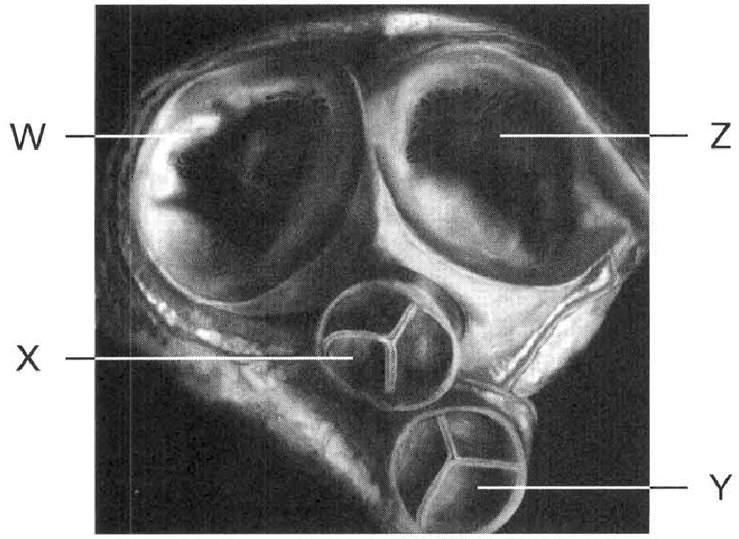
177. Which of the following combinations CORRECTLY represent the location of the valves labelled W, X, Y and Z?
(1) Between the right atrium (auricle) and the right ventricle
(2) Between the left atrium (auricle) and the left ventricle
(3) Beteen the pulmonary artery and the right ventricle
(4) Between the aorta and the left ventricle
Valves: | W | X | Y | Z
A. | (1) | (2) | (3) | (4)
B. | (2) | (1) | (4) | (3)
C. | (2) | (4) | (3) | (1)
D. | (1) | (3) | (4) | (2)

178. Which of the following combinations TRULY represent the conditions of the valves when the ventricles are relaxing?
Directions: Questions 73 and 74 refer to the diagram below which shows the changes in the volume of the ventricles of a person during a cardiac cycle.
(1) Blood flows from the pulmonary veins into the left atrium.
(2) Blood flows from the venae cavae into the right atrium.
(3) Blood flows from the left ventricle into the aorta.
(4) Blood flows from the right ventricle into the pulmonary arteries.
Which of the above description about the direction of blood flow is CORRECT in the following time periods?
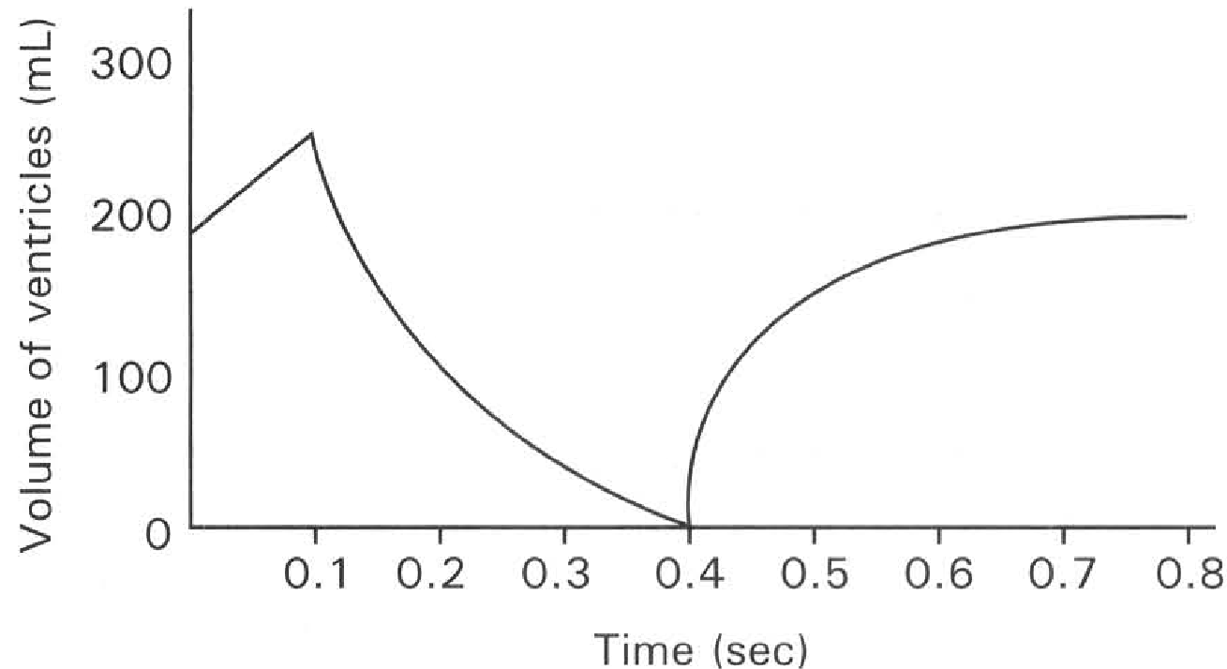
 | Valves: | W | X | Y | Z
A. |  | open | closed | open | closed
B. |  | closed | closed | open | open
C. |  | open | closed | closed | open
D. |  | closed | open | open | closed

179. From 0.4 sec to 0.8 sec D. (3) and (4) only Directions: Questions 75 to 78 refer to the diagram below which shows the time sequence of different events during one complete heart beat of a person. 75What is the rate of heart beat of this person? B. 70 per minute C. 75 per minute D. 80 per minute
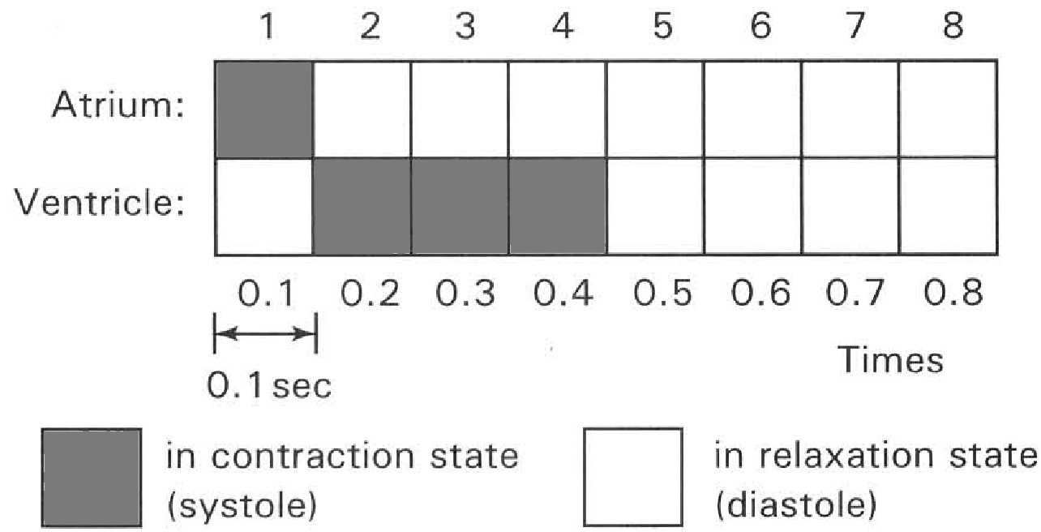
A. (1) only
B. (2) only
C. (1) and (2) only
A. 65 per minute
180. At which period(s) is/are blood flowing out of the atria (auricles) into the ventricles?
A. 1 only
B. 2 to 5 only
C. 5 to 8 only
D. 1 and 5 to 8 only
181. At which period(s) is/are blood flowing into the pulmonary arteries and aorta?
A.1 only B . 4 only C. 2 to 4 only D. 5 to 8 only
182. What are the conditions of the following valves during period(6)?
Directions: Questions 79 to 84 refer to the graph below which shows the changes in pressure in the left atrium (auricle) and left ventricle of a person at rest.
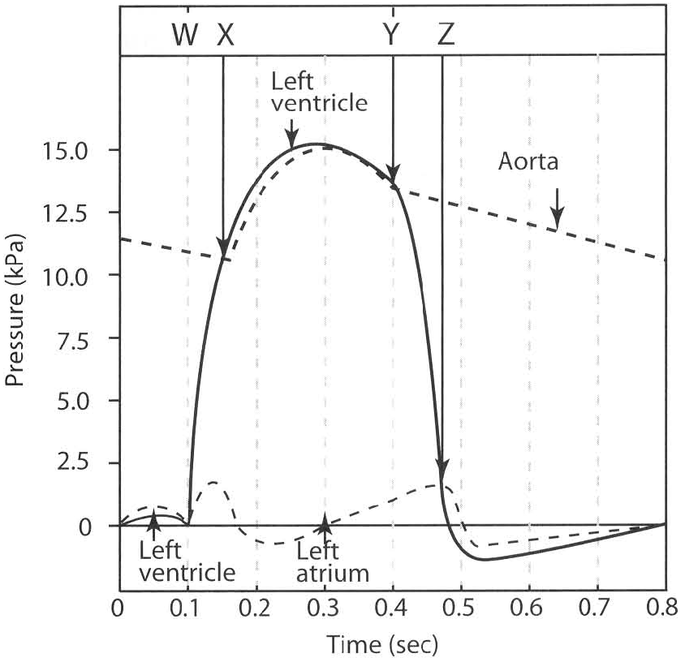
. | Semi-lunar valves | Bicuspid and tricuspid valves
A. | Open | Closed
B. | Closed | Open
C. | Open | Open
D. | Closed | Closed

183. Which of the following CORRECTLY describe the events taking place inside the heart at time X?
Bicuspid valve | Semi-lunar valve | Direction of blood flow
A. | Closed | Open | From the left ventricle to the aorta
B. | Open | Closed | From the auricle to the ventricle
C. | Closed | Closed | From the pulmonary veins into the left auricle
D. | Open | Open | From the venae cavae into the left auricle

184. Which of the following CORRECTLY describe the events taking place inside the heart at time Z?
 | Bicuspid valve | Semi-lumar valve | Direction of blood flow
A. | Open | Open | From the left atrium (auricle) into the left ventricle
B. | Closed | Open | From the aorta into the left ventricle
C. | Open | Closed | From the left atrium (auricle) into the left ventricle
D. | Closed | Open | From the left ventricle into the left atrium (auricle)

185. At what time is blood flowing into the ventricles? (1) 0 sec to 0.1 sec (2) 0.1 sec to 0.47 sec (3) 0.47 sec to 0.8 sec
A. (1) only
B. (2) only
C. (3) only
D. (1) and (3) only
186. Which of the following accounts for the blood flow along the aorta from 0.47 sec to 0.8 sec?
A. Contraction of the left atrium. B. Contraction of the left ventricles.
C. Elastic recoil of the wall of the aorta.
D. Contraction of the muscle fibres in the wall of the aorta.
187. Which of the following is responsible for the flow of blood into the ventricles?
(1) Contraction of the atria.
(2) When the blood pressure inside the ventricles is lower than that in the atria.
(3) Relaxation of the atria.
A (1) only B (2) only C (3) only D (1) and (2) only
188. At which of the following time is heart sound produced?
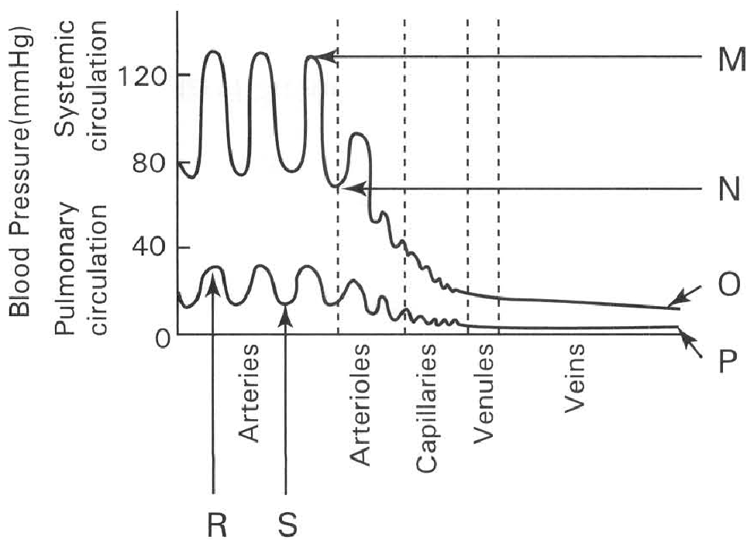
A. X and Y only B. W and Z only C. W and Y only D. X and Z only Directions: Questions 85 to 87 refer to the graph below which shows the changes in blood pressure along the blood vessels in systemic circulation and pulmonary circulation.
189. Which of the labelled blood pressures are obtained by the contraction and relaxation of the heart?
 | Contraction of the heart | Relaxation of the heart
A.B.C.D. | M , N and O onlyM and NM and N onlyM and R only | P, R and S onlyO, P, R and S R and S only N and S only

190. When the blood pressure is at N, which of the following is responsible for the forward movement of blood in the arteries?
A. Contraction of the heart muscles
B. Contraction of the skeletal muscles adjacent to the blood vessels.
C. Elastic recoil of the blood vessels.
D. Suction effect produced by the inhalation of the body.
191. Why are the blood pressures for the systemic circulation higher than that for pulmonary circulation?
A. The resistance encountered in the capillary networks of the unit organ in the systemic circulation is higher than that in the pulmonary circulation.
B. There are more capillaries per unit organ in the systemic circulation than that in the pulmonary circulation.
C. Organs supplied by the systemic circulation are far away from the heart than that supplied by the pulmonary circulation. .
D. The pulmonary arteries and pulmonary veins in the pulmonary circulation have smaller lumen than the venae cavae and aorta in the systemic circulation.
192. Two students X and Y are of the same age, sex and body weight. X is a school basketball team member and Y is the first violinist of the school orchestra. Both are taking a fitness test. Which of the following is the most likely result to be obtained?
A.B.C.D. | X | Y
 | Rate of heart beat | Stroke volume | Rate of heart beat | Stroke volume
 | FasterSlowerSlowerFaster | HigherLowerHigherLower | SlowerFasterFasterSlower | LowerHigherLowerHigher

193. Which of the following is/are responsible to the development of high blood pressure in the body? (1) Formation of plaque at the inner surface of the artery. (2) Hardening of the arteries. (3) Pumping action of the heart.
A. (1) only
B. (1) and (2) only
C. (2) and (3) only
D. (1), (2) and (3) only
194. Which of the following is the reason causing heart attack?
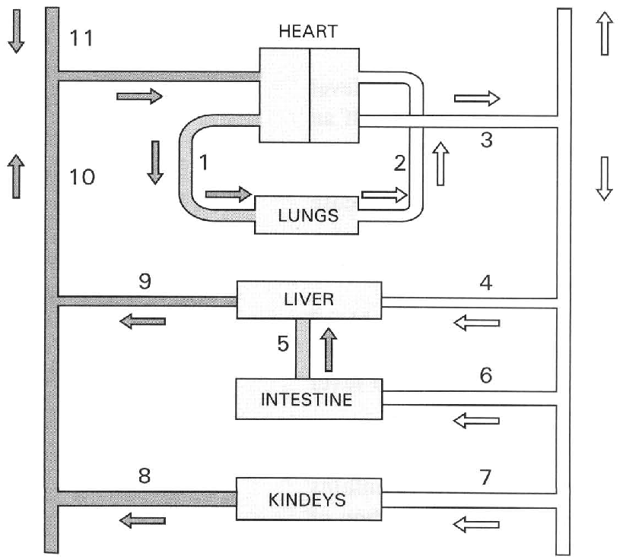
A. Decrease in the density of red blood cells in blood.
B. Increase in blood pressure.
C. Decrease in the blood glucose level.
D. Decrease in the supply of blood to the heart muscles. 91Which of the following are possible causes leading to stroke in humans? (1) Deposition of fats reduces the lumen of arteries. (2) Formation of plaques inside the arteries hardens their wall. (3) How glucose level in blood damages the blood vessels. (4) High level of cholesterol leads to formation of gall stone.
A. (1) and (2) only B. (2) and (3) only C. (3) and (4) only D. (1) and (4) only
D. Circulation Directions: Questions 92 to 100 refer to the diagram below which shows the general blood circulation of a mammal.
195. Which of the following combinations of names for the given blood vessels are CORRECT?
 | Vessel 1 | Vessel 2 | Vessel 3 | Vessel 10
A. | Aorta | Vena cava | Pulmonary vein | Pulmonary artery
B. | Pulmonary vein | Pulmonary artery | Aorta | Vena cava
C. | Pulmonary artery | Pulmonary vein | Aorta | Vena cava
D. | Vena cava | Aorta | Pulmonary artery | Pulmonary vein

196. Which of the following combinations of blood vessels have the right identities?
 | Hepatic artery | Hepatic vein | Hepatic portal vein
A. | 4 | 5 | 9
B. | 9 | 4 | 5
C. | 9 | 5 | 4
D. | 4 | 9 | 5

197. The nature of the blood inside blood vessels 1, 2, 4 and 5 is
95What wil l be the relative glucose level in the blood vessels labelled 5 half an hour after a meal rich in starch?
 | Vessel 1 | Vessel 2 | Vessel 4 | Vessel 5
A. | Oxygenated | Deoxygenated | Oxygenated | Deoxygenated
B. | Deoxygenated | Oxygenated | Deoxygenated | Deoxygenated
C. | Oxygenated | Deoxygenated | Deoxygenated | Oxygenated
D. | Deoxygenated | Oxygenated | Oxygenated | Deoxygenated

A. 5 will have a higher blood glucose level than 9.
B. 9 will have a higher blood glucose level than 5.
C. 5 and 9 will have the same blood glucose level.
D. 5 will have a high glucsose level while 9 has no blood glucose.
198. In fasting the vessel which contains blood with the highest concetration of glucose is
A. 4
B. 5
C. 6
D. 9
199. The vessels which contain blood having the lowest and highest concentration of urea respectively are
 | Lowest | Highest
A. | 8 | 9
B. | 9 | 7
C. | 8 | 7
D. | 4 | 7

200. The blood vessels that contain blood with the highest and lowest pressure respectively are
 | Highest blood pressure | Lowest blood pressure
A. | 4 | 5
B. | 3 | 10
C. | 2 | 1
D. | 7 | 8

201. Which blood vessel has the highest glucose concentration during vigorous exercise?
A. 4
B. 5
C. 9
D. 10
202. After taking a meal rich in fats, which labelled blood vessel will fat first appear?
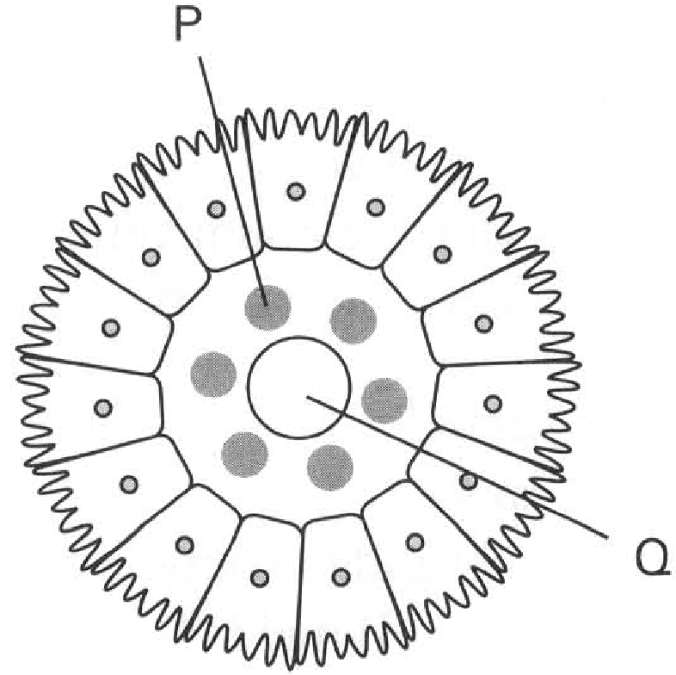
A. 11 B. 5 C. 8 D. 9 Directions: Questions 101 to 104 refer to the diagram below which shows the transverse section of a villus of the small intestine.
203. Which of the following substances are absorbed into Q from the lumen of the small intestine? (1) Vitamins B (2) Glucose (3) Fats (4) Vitamin A
A. (1) and (2) only
B. (2) and (3) only
C. (3) and (4) only
D. (1) and (4) only
204. Which of the following is the first structure receiving the substances absorbed by Q ?
A. Liver
B. Lung
C. Heart
D. Kidney
205. Which of the following substances are absorbed into P from the lumen of the small intestine? (1) Water (2) Mineral salts (3) Proteins (4) Fats (5) Glucose
A. (1), (2) and (3) only
B. (2), (3) and (4) only
C. (1), (4) and (5) only
D. (1), (2) and (5) only
206. Which of the following is the first structure receiving the substances absorbed by P ?
A. Liver
B. Lung
C. Heart
D. Kidney
207. Which of the following two blood vessels supply the same amount of oxygen? (1) Coronary artery (2) Hepatic artery (3) Hepatic portal vein (4) Vena cava
A. (1) and (2) only
B. (2) and (3) only
C. (3) and (4) only
D. (1) and (4) only
208. Which of the following blood vessels have the highest concentration of carbon dioxide during strenuous exercises?
A. Vessel leaving the lungs
B. Vessel leaving the brain
C. Vessel leaving the kidneys
D. Vessel leaving the skeletal muscles
209. Which of the following shows the CORRECT sequence of the blood vessels in ascending order of the lactic acid concentration in blood after exercise?
 | Blood flow (mL/min)
 | At Rest | Strenuous exercises
Skeletal muscles | 1 200 | 12 500
Brain | 750 | X
Skin | 500 | Y
Intestine | 1 400 | Z

 | X | Y | Z
A. | Faster | Slower | Same
B. | Same | Slower | Faster
C. | Same | Faster | Slower
D. | Slower | Same | Faster

A. Vein leaving leg muscles, hepatic vein, pulmonary vein.
B. Hepatic vein, pulmonary vein , vein leaving leg muscle.
C. Pulmonary vein, vein leaving leg muscles, hepatic vein.
D. Hepatic vein, vein leaving leg muscle, pulmonary vein. 108 What will be the rate of blood flow at X, Y and Z during strenuous exercise compared with that at rest?
210. Which of the following factors regulate the rate of blood flow in the body? (1) Rate of heart beat (2) Stroke volume (3) Blood pressure (4) Vasodilation and vasoconstriction of the arterioles (5) Rate of breathing (6) Depth of breathing
A. (1), (2) and (3) only
B. (2), (3) and (4) only
C. (4), (5) and (6) only
D. (1), (2), (3) and (4) only
211. Which of the following blood vessels contain deoxygenated blood? (1) Pulmonary arteries (2) Renal vein (3) Hepatic portal vein (4) Umbilical artery
A. (1) and (2) only
B. (2) and (3) only
C. (1), (2) and (3) only
D. (1), (2), (3) and (4)
212. Which of the following organs has/have the right blood content of the blood vessels entering and leaving it?
Organs | Glucose | Urea | Carbon dioxide | Oxygen
 | Entering | Leaving | Entering | Leaving | Entering | Leaving | Entering | Leaving
(1) Liver | Higher | Lower | Lower | Higher | Lower | Higher | Higher | Lower
(2) Kidney | Higher | Lower | Higher | Lower | Lower | Higher | Higher | Lower
(3) Lungs | Higher | Lower | Same | Same | Higher | Lower | Lower | Higher

A. (1) only
B. (2) only
C. (3) only
D. (1), (2) and (3)
213. Which of the following is the CORRECT sequence of a red blood cell flowing out of the villus of the small intestine and returning to the villus again?
A. Heart Liver Lungs Heart
B. Heart Lungs Liver Heart
C. Liver Heart Lungs Heart
D. Lungs Heart Liver Heart
214. Which of the following statements concerning the hepatic portal vein is/are CORRECT? (1) It joins the liver and the small intestine together. (2) It contains oxygenated blood. (3) It has capillaries at both ends. (4) Digested products of fats absorbed from the small intestine are mainly carried by this vessel into the liver.
A. (1) only
B. (2) only
C. (1) and (3) only
D. (2), (3) and (4) only
215. During vigorous activities, which of the following statements is/are TRUE? (1) More blood flows to the kidneys. (2) Less blood flows to the skin. (3) Less blood flows to the stomach. (4) More blood flows to the skeletal muscles.
A. (1) only
B. (2) only
C. (4) only
D. (3) and (4) only
216. The pathway for blood to move from the kidney to the lungs is in the sequence: (1) Tricuspid valve (2) Pulmonary artery (3) Renal vein (4) Right ventricle (5) Inferior (posterior) vena cava
A. (5), (3), (2), (1) and (4)
B. (3), (5), (1), (4) and (2)
C. (2), (4), (3), (1) and (5)
D. (4), (1), (3), (2) and (5)
217. After vigorous muscular activities the blood entering and leaving the muscles of the leg of a man is analysed. Which of the following results is most likely to be CORRECT?
E. Tissue fluid and lymphatic system
Directions: Questions 117 to 129 refer to the diagram below which shows part of the circulatory system of human.
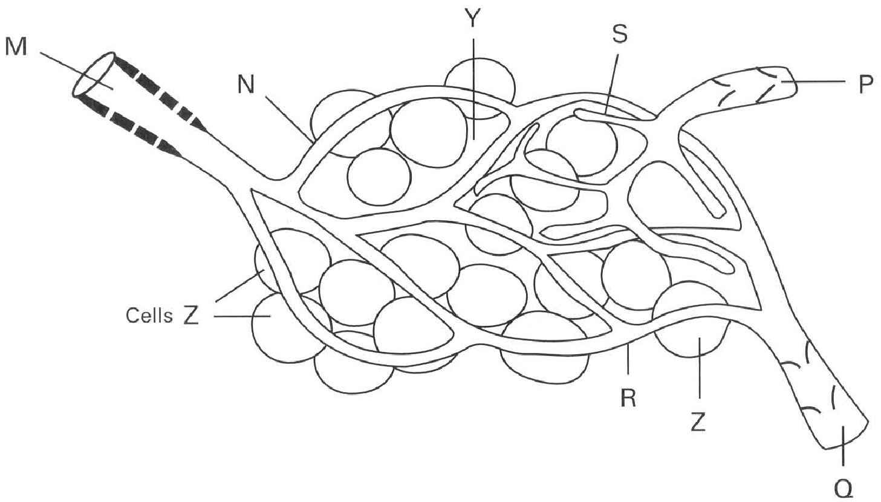
A.B.C.D. | Blood entering | Blood leaving
 | Pressure | Glucose | Oxygen | Carbondioxide | Wastes | Pressure | Glucose | Oxygen | Carbondioxide | Wastes
 | HigherHigherLowerSame | MoreSameMoreLess | MoreMoreSameMore | LessMoreLessLess | LessLessMoreMore | LowerLowerHigherSame | LessSameLessMore | LessLessSameLess | MoreLessMoreMore | MoreMoreLessLess

218. Which of the following CORRECTLY labels the blood vessels M, N, P and Q?
 | Vessel M | Vessel N | Vessel P | Vessel Q
A. | Aorta | Capillary | Venule | Lymph vessel
B. | Artery | Lymph capillary | Lymph vessel | Vena cava
C. | Arteriole | Blood capillary | Lymph vessel | Venule
D. | Artery | Blood capillary | Venule | Lymph vessel

219. Which of the following is/are the characteristics of blood vessel P? (1) It has valves. (2) The wall permits water, glucose, urea and proteins to pass through. (3) It has the greatest area among the five given types of blood vessels.
A. (1) only
B. (2) only
C. (1) and (2) only
D. (1) and (3) only
220. Which of the follwing pathways is the right direction of the fluid flowing along it?
A. PYNM
B. QXNM
C. MNYP
D. Q X Y P
221. The process responsible for the exchange of materials to take place through N is
A. diffusion.
B. osmosis.
C. hydrolysis.
D. plasmolysis.
222. What is the fluid present in N and Y respectively?
 | Fluid in N | Fluid in Y
A. | Blood | Serum
B. | Tissue fluid | Blood
C. | Serum | Plasma
D. | Blood | Tissue fluid

223. Which of the following is found in N but NOT in Y?
A. Amino acids B. White blood cells C. Glucose D. Red blood cells
224. Which of the following cannot be found in Y? (1) Red blood cells (2) White blood cells (3) Blood platelets (4) Immunoglobulin
A. (1) and (2) only
B. (2) and (3) only
C. (3) and (4) only
D. (1), (3) and (4) only
225. Which of the following comparisons between N and S are CORRECT?
 | N | S
(1) | Open at both ends | Has one blind end
(2) | Has red blood cells | No red blood cells
(3) | Has oxygen | No oxygen
(4) | Has white blood cells | No white blood cells

A. (1) and (2) only
B. (2) and (3) only
C. (1) and (4) only
D. (2) and (1) only
226. Which of the following is mainly responsible for the return of water into R?
A. Blood pressure B. Osmosis C. Diffusion D. Active transport
227. If Z is a muscle cell in the leg the two compounds that are most likely to pass from blood through Y to Z are
A. ammonia and urea.
B. oxygen and glucose.
C. bile and carbon dioxide.
D. glucose and bile.
228. If Z is a muscle cell in the leg and vessel P is blocked by some parasitic worms, which of the following will occur?
A. Muscle fibres around P will contract more vigorously to increase the flow of fluid along it.
B. Fluid in Y accumulates that causes swelling at the leg muscles.
C. More fluid flows away via Q.
D. More carbon dioxide is produced by the muscle fibres.
229. If Z is a glandular cell in the pancreas, which of the following will pass from Z to R? (1) Glucagon (2) Insulin (3) Pancreatic juice (4) Carbon dioxide (5) Glucose
A. (1) and (2) only
B. (2) and (3) only
C. (3), (4) and (5) only
D. (1), (2) and (4) only
230. Which parts experience the highest and lowest blood pressure respectively?
 | Highest blood pressure | Lowest pressure
A. | M | Q
B. | N | P
C. | P | N
D. | Q | M

231. Which of the following concerning the lymphatic system is 1NCORRECT? (1) Involved in the body defence. (2) Transport of vitamins B and C. (3) Returning excess tissue fluid back to the heart. D. (2) and (3) only Suggested Solutions
C. (3) Returning excess tissue fluid back to the heart.
A. (1) only
B. (2) only
C. (1) and (3) only

Answers
Answers are printed in red.
1. D. (1), (2) and (3)

2. A. diffusion.
Class: 87.8% correct (n=49) usual slip B
3. B. body cells of large animals are far away from the surfaces of material exchange with the surroundings.
Class: 66.0% correct (n=203) usual slip D
4. C. serum.
Class: 80.8% correct (n=203) usual slip A
5. B
Class: 86.2% correct (n=123) usual slip C
6. C
Class: 70.0% correct (n=203) usual slip D
7. B. centrifugation.
Class: 71.9% correct (n=203) usual slip D
8. C. sodium citrate.

9. A. 35.
Class: 63.1% correct (n=203) usual slip A
10. B

11. B

12. C
Class: 92.0% correct (n=25) usual slip A
13. C
Class: 81.2% correct (n=80) usual slip D
14. B
Class: 49.0% correct (n=49) usual slip C
15. B. take up and release oxygen more quickly.
Class: 80.0% correct (n=80) usual slip A
16. ?

17. D. As hydrogencarbonate ion in plasma.

18. C. (2), (1) and (3)
Class: 85.7% correct (n=49) usual slip B
19. B. they are discshaped.-

20. B. (1) and (3) only
Class: 77.6% correct (n=49) usual slip A
21. ?

22. C

23. D. (1), (2) and (3)

24. A. (1) and (2) only

25. A. O only. B. A and B only. C. A, B and O only. D. A, B, AB and O.

26. C. People of group O receive blood from people of group

27. C

28. ?

29. C. The samples were of different blood groups.

30. D. Left ventricle

31. C

32. C. the right atrium and the right ventricle.

33. D

34. ?

35. A. 3 to 4.

36. B

37. D

38. B

39. A

40. C. 75 beats per minute.

41. C

42. C

43. B. The heart muscle contracts less powerfully due to the reduced supply of blood.

44. C. The blood pressure in the vein grafts is higher than that in the blocked arteries.

45. B

46. D. (1), (2) and (3)

47. B. (3) only

48. B. More heat is carried to the skin for dissipation.

49. D

50. ?

51. C

52. C. the small intestine.

53. ?

54. ?

55. B. 1, 2 and 5 only

56. ?

57. D. the lung.

58. ?

59. D

60. B

61. ?

62. C. the liver.

63. B

64. ?

65. A. The blood glucose level increases after a piece of bread is eaten.

66. C

67. ?

68. ?

69. D

70. A

71. B. (1) and (2) only

72. ?

73. A. the kidney. B. the small intestine. C. the liver. D. the pancreas. Directions: Questions 79 and 80 refer to the following diagrams which show an experiment to demonstrate the presence of a certain type of blood vessel in a human arm.

74. C

75. B. to make the blood vessel more conspicuous.

76. B

77. D. They all have low blood pressure.

78. D

79. D. ensure unidirectional flow of blood to the heart.

80. D. (1), (2) and (3)

81. C

82. A. (1) and (2) only

83. C

84. B

85. ?

86. A. the right atrium.

87. D. (1), (2) and (3)

88. D. (1), (2) and (3)

89. D

90. D

91. A. 1.

92. ?

93. D. The lactic acid level at 3 increases.

94. B. in the phloem only.

95. B. (1) and (3) only

96. D

97. D

98. B

99. C

100. C. a young root.

101. C

102. A. a young stem.

103. C. 3

104. ?

105. C. a young root.

106. B

107. B

108. C. The base of the shoot should be cut under the red dye solution.

109. C. xylem.

110. C. 8 cm per hour.

111. ?

112. C

113. ?

114. C

115. A

116. C. People of group O receive blood from people of group

117. D. remove calcium ions to prevent blood clotting.

118. D

119. D

120. A. (1) and (2) only
Class: 77.4% correct (n=31) usual slip B
121. C. (2), (1), (5), (4) and (3)
Class: 54.5% correct (n=154) usual slip A
122. A. (1) and (2) only
Class: 63.6% correct (n=154) usual slip C
123. D. It contains haemoglobin.
Class: 82.6% correct (n=178) usual slip A
124. D. (1), (2) and (3) only

125. B. There is an increase in the number of cell Y.
Class: 61.2% correct (n=49) usual slip D
126. C. Blood capillary D. Lymph capillary
Class: 81.6% correct (n=49) usual slip B
127. A. (1) and (2) only
Class: 79.6% correct (n=49) usual slip B
128. B
Class: 75.9% correct (n=79) usual slip A
129. B. (2) and (3) only

130. D. it combines reversibly with oxygen.

131. B. (2) only
Class: 64.5% correct (n=31) usual slip A
132. A. It carries oxygen to the tissue cells adjacent to W.
Class: 71.0% correct (n=31) usual slip C
133. D. (4) and (1) only

134. D. (2), (3) and (4) only

135. D. (1), (3) and (4) only

136. D. (3) and (4) only

137. D

138. C. (1) and (2) only

139. C. (1) and (2) only

140. A. prevent the intake of food that will interrupt the condition of blood.

141. D. Endothelial cells

142. A. (3) (4) (1) (2)

143. D. (2) and (4) only

144. C. carries deoxygenated blood.

145. D. of the alternate stretching and elastic recoil of the artery in response to the systole and diastole of the heart. Directions: Questions 36 and 37 refer to the diagram below which shows the longitudinal section of a blood vessel.

146. D. a vein.

147. B

148. C. prevent back flow of the blood.

149. B. (2) only

150. D. the lower blood pressure in the vein ensures a safe draining of blood from the donor.

151. C. squeezing the lymph vessels that push more lymph to flow away from the legs.

152. D

153. B

154. A. (1) and (2) only

155. D

156. B

157. A

158. C. To avoid introducing air bubbles into the veins of the patient.

159. A. Air bubbles may get into the blood stream and block the small vessels that may impede the smooth blood flow.

160. D

161. C. (1) and (4) only

162. D. (1) and (3) only

163. D. (2), (3) and (4) only 55The increase in the velocity of blood flow in Q is due to the (1) contraction of the muscle fibres in its wall. (2) squeezing effect exerted by the contraction of the skeletal muscles adjacent to it. (3) suction effect developed during inhalation . (4) decrease in the total cross-sectional area of the blood vessels.

164. D. (4) and (1) only

165. D

166. D. (1), (2) and (3) only

167. B. 5

168. D. Some heart muscles may die due to the insufficient blood supply. Directions: Questions 64 to 70 refer to the diagram below which shows a heart and the blood vessels connected to it.

169. D

170. D

171. D. chamber X produces a stronger force in pumping blood than chamber Y.

172. D. To hold the bicuspid valves to prevent the back flow of blood.

173. A. 1 and 4 only

174. C

175. C. 13 Y6 7 8 X 5

176. D

177. D

178. C

179. C. (1) and (2) only

180. D. 1 and 5 to 8 only

181. C

182. B

183. A

184. C

185. D. (1) and (3) only

186. C. Elastic recoil of the wall of the aorta.

187. D

188. C

189. D

190. C. Elastic recoil of the blood vessels.

191. C. Organs supplied by the systemic circulation are far away from the heart than that supplied by the pulmonary circulation. .

192. C

193. B. (1) and (2) only

194. D. Circulation Directions: Questions 92 to 100 refer to the diagram below which shows the general blood circulation of a mammal.

195. C

196. D

197. D. 5 will have a high glucsose level while 9 has no blood glucose.

198. D. 9

199. A

200. B

201. C. 9

202. A. 11 B. 5 C. 8 D. 9 Directions: Questions 101 to 104 refer to the diagram below which shows the transverse section of a villus of the small intestine.

203. C. (3) and (4) only

204. C. Heart

205. D. (1), (2) and (5) only

206. A. Liver

207. A. (1) and (2) only

208. D. Vessel leaving the skeletal muscles

209. B. Hepatic vein, pulmonary vein , vein leaving leg muscle.

210. D. (1), (2), (3) and (4) only

211. D. (1), (2), (3) and (4)

212. D. (1), (2) and (3)

213. C. Liver Heart Lungs Heart

214. C. (1) and (3) only

215. D. (3) and (4) only

216. B. (3), (5), (1), (4) and (2)

217. A

218. C

219. A. (1) only

220. C. MNYP

221. A. diffusion.

222. D

223. D

224. D. (1), (3) and (4) only

225. A. (1) and (2) only

226. B

227. B. oxygen and glucose.

228. B. Fluid in Y accumulates that causes swelling at the leg muscles.

229. D. (1), (2) and (4) only

230. A

231. B. (2) only

