Transport in humans · items under 80% correct
Multiple-choice practice
Name: ________________________ Class: ____________
These items were answered correctly by fewer than 80% of students in class Google Forms, matched by the wording in the source bank and the form answer key. Choose the one best answer.
Part A — HKCEE level (Longman)
1. Transport systems are essential in large animals but not in small animals because
A. large animals have large surface areas for diffusion.
B. body cells of large animals are far away from the surfaces of material exchange with the surroundings.
C. large animals have higher metabolic rate.
D. large animals have blood but small animals have not. blood
2. The two layers are
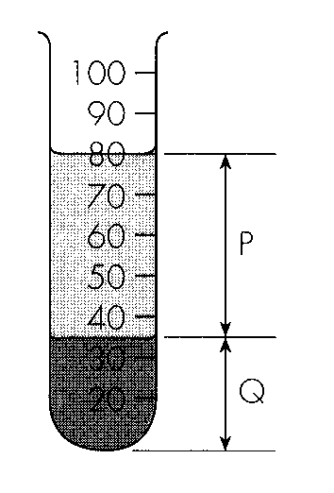
 | P | Q
A. | Serum | Blood cells
B. | Lymph | Proteins
C. | Plasma | Blood cells
D. | Plasma | Proteins

3. The common method for separating the blood into layers is
A. filtration.
B. centrifugation.
C. sedimentation.
D. suspension.
4. With reference to the diagram above, the percentage by volume of P in the blood sample is
A. 35.
B. 44.
C. 56.
D. 80.
5. For a healthy person, which of the following comparisons is correct?
 | Red blood cells | White blood cells | Blood platelets
A. | carry oxygen | kill germs | carry carbon dioxide
B. | have no nuclei | large have nuclei | have no nucleus
C. | most numerous | numerous | few
D. | red in colour | colourless | red in colour

6. Red blood cells are biconcave in shape so that they can
A. carry more oxygen.
B. take up and release oxygen more quickly.
C. squeeze through the capillary wall more easily.
D. hold more haemoglobin.
7. Which of the following helps to protect the body from bacteria? (1) White blood cells (2) Red blood cells (3) Blood platelets
A. (1) only
B. (1) and (3) only
C. (2) and (3) only
D. (1), (2) and (3)
Part B — HKDSE-style (YKTo)
8. Which labelled part(s) is/are responsible for the transport of glucose and amino acids in the human body? D. (1) and (3) only 6Which of the following are functions of the part labelled 1 in the human body? (1) Transfer of heat throughout the body. (2) Defence of the body against germs. (3) Transport of oxygen. (4) Transport of carbon dioxide. B. (2) and (3) only C. (3) and (4) only D. (1), (2) and (4) only Directions: Questions 7 to 13 refer to the photomicrographs below which represent the blood smear of humans observed under different magnification of the microscope. 7Which of the following are reasons to support that photomicrograph I is obtained from the low powered observation? (1) The image obtained is dimmer. (2) It takes shorter time to focus the object. (3) More cells are observed. (4) Size of the blood cell is smaller. B. (2) and (3) only C. (3) and (4) only D. (4) and (1) only
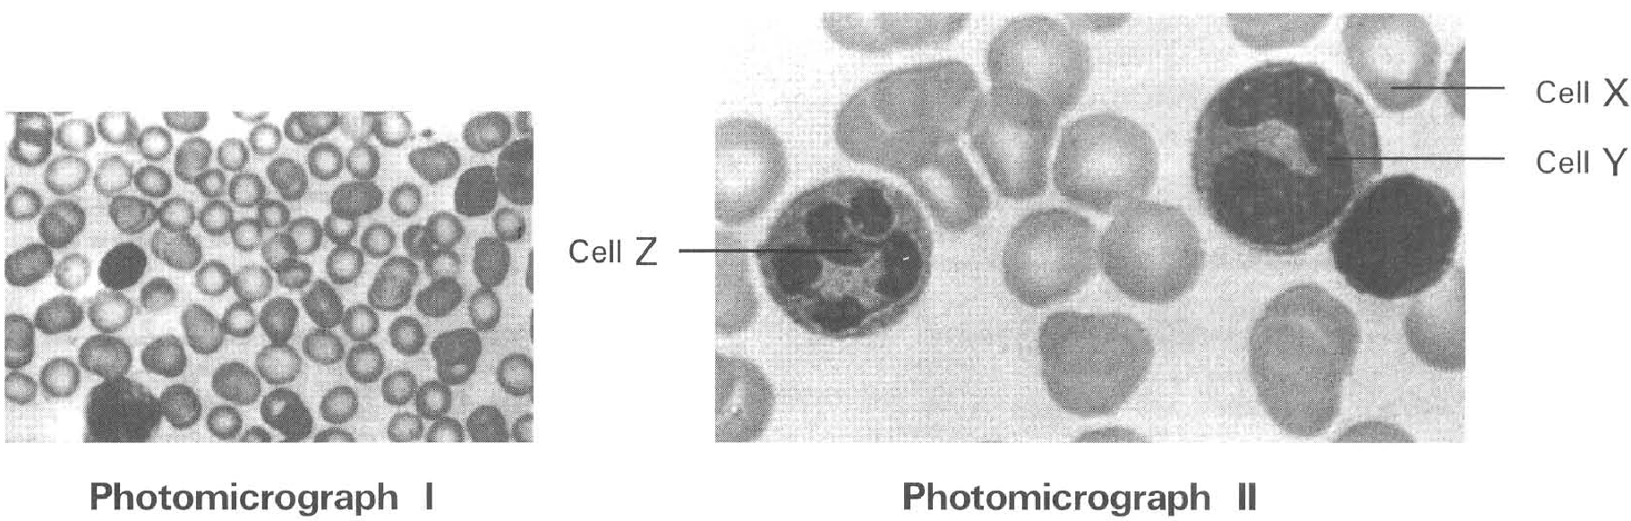
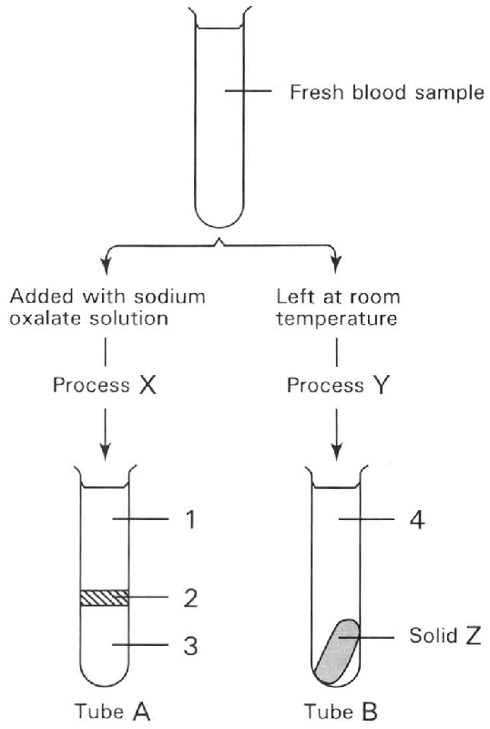
A. (1) only
B. (2) only
C. (3) only
A. (1) and (2) only
9. The following steps are involved in obtaining the high powered image of the bigger blood cells. Which sequence of steps is CORRECT? (1) Move the slide until the bigger blood cell is seen. (2) Observe the blood smear under the low powered magnification. (3) Turn the condenser knob to adjust the brightness of the image. (4) Turn the fine adjustment knob to move the body tube slowly up and down until sharp image is obtained. (5) Turn the nosepiece until the high-power objective is in position. D. (1), (2), (4), (3) and (5) 9The specific appearance of cell X in photomicrograph 1I is due to the (1) shortage of haemoglobin in the cell. (2) shortage of iron in the cell. (3) biconcave shape of the cell. (4) loss of nucleus. A. (1) and (2) only B. (2) and (3) only C. (3) and (4) only D. (3) and (1) only
A. (1), (2), (3), (4) and (5)
B. (2), (1), (3), (5) and (4)
C. (2), (1), (5), (4) and (3)
D. (1), (2), (4), (3) and (5) 9The specific appearance of cell X in photomicrograph 1I is due to the (1) shortage of haemoglobin in the cell. (2) shortage of iron in the cell. (3) biconcave shape of the cell. (4) loss of nucleus.
10. Which of the following are the advantages for cell X to be in the specific shape shown in the photomicrograph 1I? (1) Provides big surface area for gas exchange. (2) Shorten the distance to enhance the diffusion of oxygen into the cell. (3) Provide more space to accommodate more haemoglobin. (4) Enhance the penetration of the cell through the capillary wall.
A. (1) and (2) only
B. (2) and (3) only
C. (3) and (4) only
D. (1), (2) and (3) only
11. Which of the following statements is CORRECT during an infection of the body by germs?
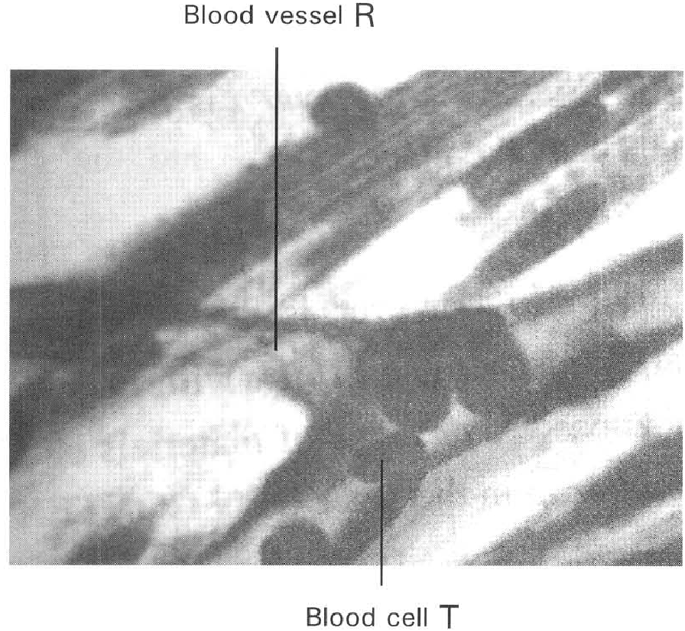
A. There is an increase in the number of cell X.
B. There is an increase in the number of cell Y.
C. There is an increase in the size of cell Z.
D. The nucleus of cell Y divides into several lobes as cell Z. Directions: Questions 14 to 16 refer to the photomicrograph below which shows the longitudinal section of a blood vessel with a blood cell inside.
12. Which of the following is/are the TRUE adaptive feature(s) of the cell labelled T to perform its function? (1) Biconcave shape (2) No nucleus (3) Can squeeze through the wall of the blood vessel (4) Can secrete antibodies
A. (1) and (2) only
B. (2) and (3) only
C. (3) and (4) only
D. (1), (2) and (3) only
13. Which of the following matching of the site of production and destruction of the cell labelled T is CORRECT?
 | Site of production | Site of destruction
A. | Yellow bone marrow | Spleen
B. | Red bone marrow | Liver
C. | Lymph node | Spleen
D. | Red bone marrow | Lymph node

14. Blood in equilibrium with the alveolar air can take up in solution only 0.25 ml of oxygen per 100 ml, but with the presence of haemoblobin 100 ml of blood can carry about 20 ml of oxygen. The function of the haemogbin is (1) to transport more oxygen to the lungs. (2) to increase the oxygen carrying capacity of blood. (3) to increase the respiratory activities of blood.
A. (1) only
B. (2) only
C. (3) only
D. (1) and (3) only
15. Carbon monoxide is fatal to humans because it
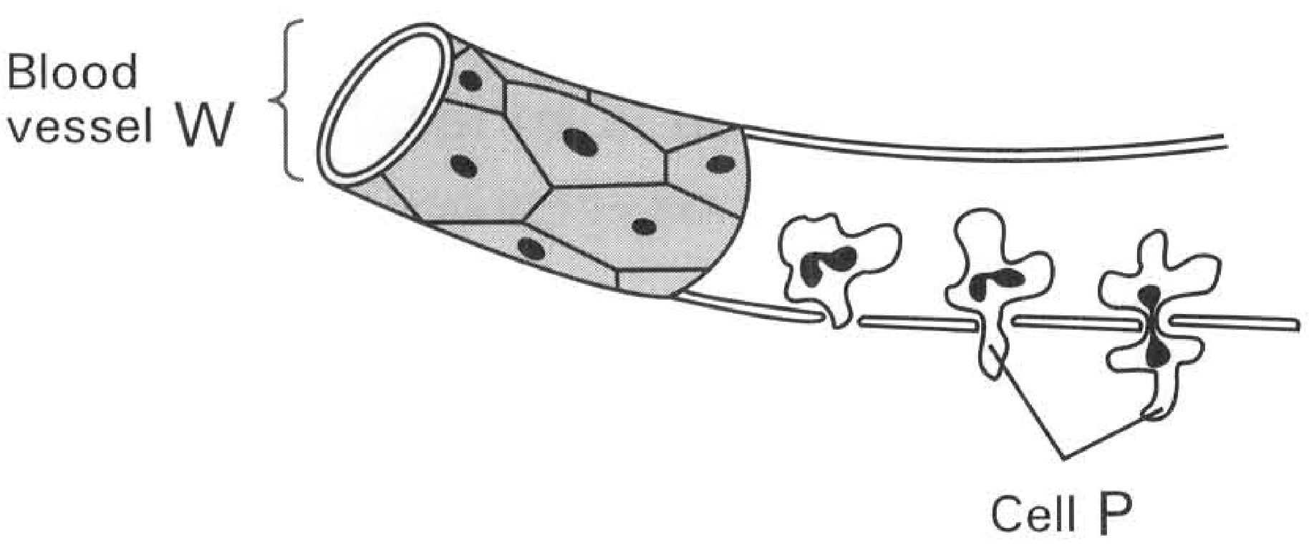
A. combines more readily with haemoglobin than oxygen.
B. dissolves haemoglobin.
C. blocks the 'pores' in the cell membrane to prevent the penetration of gases into the cell.
D. inhibits the enzymes involved in respiration. Directions: Questions 21 and 22 refer to the diagram below which shows a blood vessel W and blood cell P that can pass through the wall of the blood vessel. 21What is the importance for cell P to pass through the wall of blood vessel W?
A. It carries oxygen to the tissue cells adjacent to W.
B. It removes carbon dioxide from the tissue cells back to W.
C. It can attack the germs invading the tissue cells outside W.
D. This prevents cell P to be attacked by the germs present in blood.

Answers
Answers are printed in red.
1. B. body cells of large animals are far away from the surfaces of material exchange with the surroundings.
Class: 66.0% correct (n=203) usual slip D
2. C
Class: 70.0% correct (n=203) usual slip D
3. B. centrifugation.
Class: 71.9% correct (n=203) usual slip D
4. A. 35.
Class: 63.1% correct (n=203) usual slip A
5. B
Class: 49.0% correct (n=49) usual slip C
6. B. take up and release oxygen more quickly.
Class: 80.0% correct (n=80) usual slip A
7. B. (1) and (3) only
Class: 77.6% correct (n=49) usual slip A
8. A. (1) and (2) only
Class: 77.4% correct (n=31) usual slip B
9. C. (2), (1), (5), (4) and (3)
Class: 54.5% correct (n=154) usual slip A
10. A. (1) and (2) only
Class: 63.6% correct (n=154) usual slip C
11. B. There is an increase in the number of cell Y.
Class: 61.2% correct (n=49) usual slip D
12. A. (1) and (2) only
Class: 79.6% correct (n=49) usual slip B
13. B
Class: 75.9% correct (n=79) usual slip A
14. B. (2) only
Class: 64.5% correct (n=31) usual slip A
15. A. It carries oxygen to the tissue cells adjacent to W.
Class: 71.0% correct (n=31) usual slip C

Class percentage correct
Matched to this paper by question wording in the source bank and the form answer key, not by a shifted paper number.
Q | Answer | % correct | n | Usual slip
1 | B | 66.0% | 203 | D
2 | C | 70.0% | 203 | D
3 | B | 71.9% | 203 | D
4 | A | 63.1% | 203 | A
5 | B | 49.0% | 49 | C
6 | B | 80.0% | 80 | A
7 | B | 77.6% | 49 | A
8 | A | 77.4% | 31 | B
9 | C | 54.5% | 154 | A
10 | A | 63.6% | 154 | C
11 | B | 61.2% | 49 | D
12 | A | 79.6% | 49 | B
13 | B | 75.9% | 79 | A
14 | B | 64.5% | 31 | A
15 | A | 71.0% | 31 | C

