Tropism
Multiple-choice practice
Name: ________________________ Class: ____________
There are 52 questions compiled from Longman HKCEE and/or YKTo papers. Choose the one best answer.
Part A — HKCEE level (Longman)
1. Which of the following statements about tropism are correct? (1)It is the response to a unilateral stimulus. (2)It is a slow growth movement. (3)It is caused by uneven elongation of cells on the two sides of a plant structure. A.(1) and (2) only
A. (1) and (2) only
B. (1) and (3) only
C. (2) and (3) only
D. (1), (2) and (3)
2. Tropism is useful in plants because (1) it helps to maximise light absorption. (2) it helps to maximise water absorption. (3) it helps to protect the plants from danger.
A. (1) and (2) only
B. (1) and (3) only
C. (2) and (3) only
D. (1), (2) and (3)
3. he shoot of a green plant is said to be negatively geotropic. This means that it grows
A. towards light.
B. away from light.
C. in the same direction of gravity.
D. in the opposite direction of gravity.
4. The diagram below shows a pinned bean seedling on a clinostat which was rotating throughout the investigation.
Which diagram correctly shows the appearance of the seedling after two days?
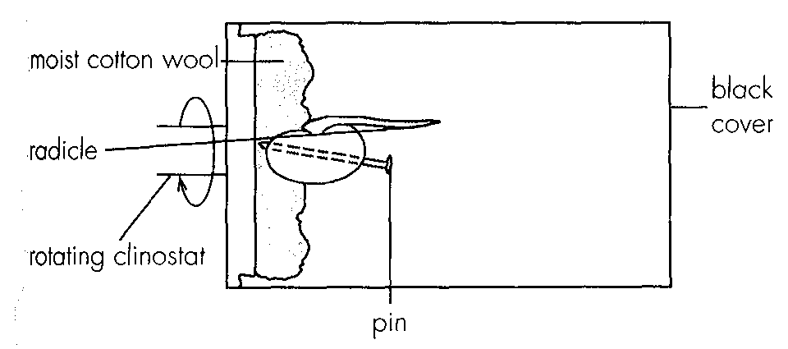
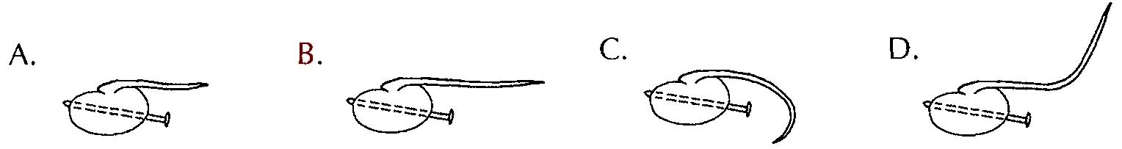
5. A germinating bean seed was rotated in the same direction through an angle of 90° every 2 days. Which of the following diagrams correctly shows the appearance of the radicle of the seedling after 8 days?
Directions: Questions 6 and 7 refer to an experiment in which a potted plant with a straight shoot was placed in the middle of four lamps, I, II, III and IV, in a dark room as shown in Figure 1. Only one of the lamps was lit. Figure 2 shows the appearance of the shoot after 24 hours.
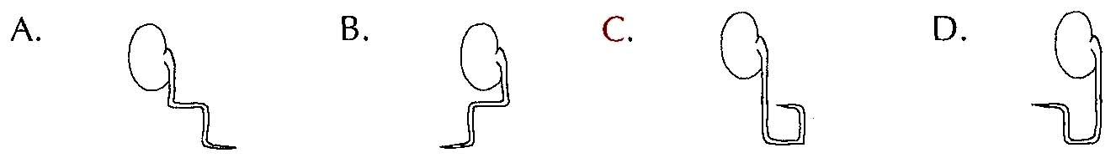
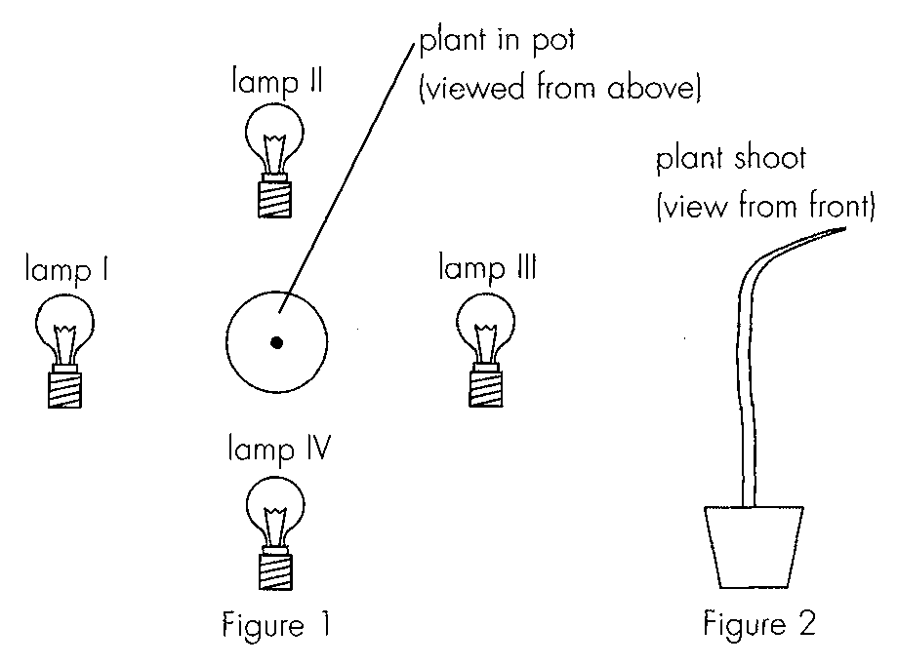
6. Which lamp was lit to produce the response shown in figure 2?
A. I
B. II
C. III
D. IV
7. After this 24 hour period, all the lamps were switched off, which of the following may happen? -
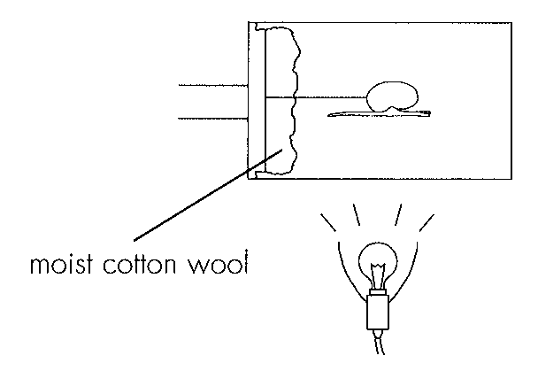
A. The shoot stopped growing.
B. The shoot continued to grow in the direction as shown in figure 2.
C. The shoot bent upwards.
D. The shoot bent downwards. Directions: Questions 8 to 11 refer to the diagram below which shows an experimental setup in a dark room.-
8. The diagram below shows the appearance of the plumule after 8 hours when the clinostat was kept stationary. Which of the following provides the best explanation for this result? A.The shoots are positively phototropic. B.The shoots are positively geotropic. C.The effect of unilateral light on shoot growth is stronger than that of gravity. D.The effect of gravity is counteracted by the effect of unilateral light.
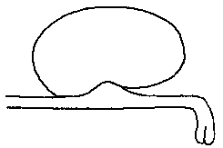
A. The shoots are positively phototropic.
B. The shoots are positively geotropic.
C. The effect of unilateral light on shoot growth is stronger than that of gravity.
D. The effect of gravity is counteracted by the effect of unilateral light.
9. A similar seedling with straight plumule and radicle was used to repeat the experiment after the light was switched off and the clinostat was kept stationary. The radicle of the seedling was marked with ink at 2 mm intervals. Which of the following shows the most likely appearance of the seedling at the end of an 8hour period?-
Directions: Questions 12 and 13 refer to the diagram below which shows the experimental setups used to study the effect of unilateral light on the growth of plant seedlings.
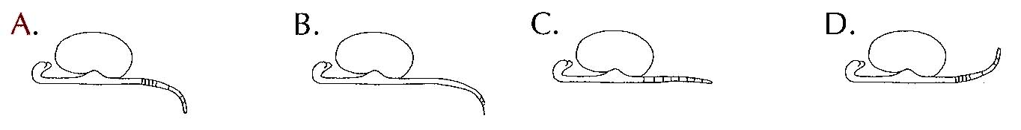
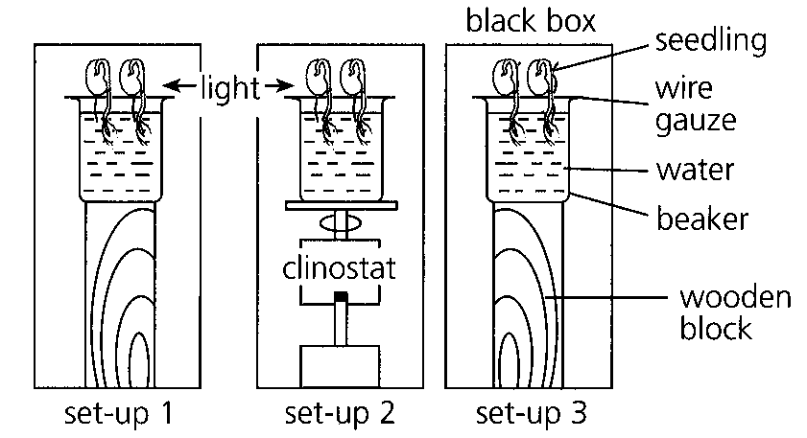
10. After several days, the appearance of the plant seedlings in the three setups would be:-
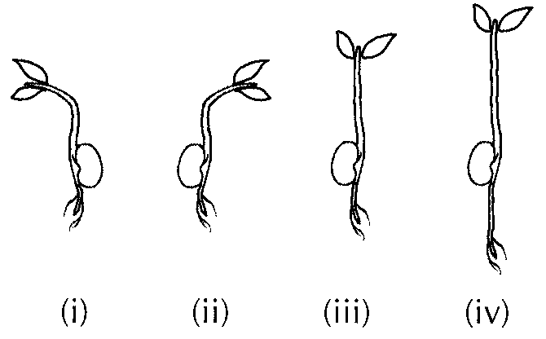
 | Setup 1- | Setup 2- | Setup 3-
A. | (i) | (ii) | (iii)
B. | (i) | (iv) | (iii)
C. | (ii) | (i) | (iv)
D. | (ii) | (iii) | (iv)

11. The result of setup 3 illustrates -
A. geotropism.
B. hydrotropism.
C. etiolation.
D. germination.
12. The diagram below shows an experimental setup which was put in darkness. The radicle was marked with ink at 2 mm intervals.-
If this experiment were to be carried out inside a space shuttle travelling in space, what would be the appearance of the radicle after several days?
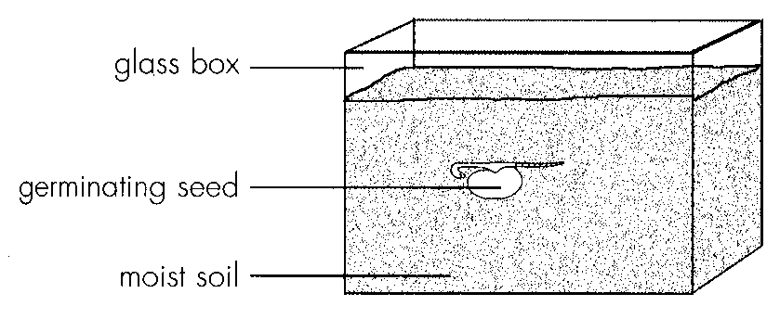
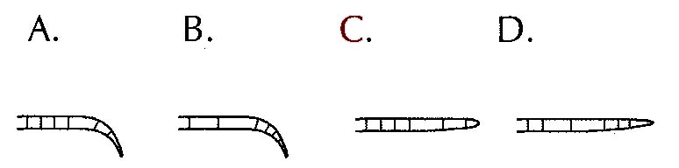
13. The diagram below shows the result of an experimental set up in a dark room. The -petridish is held vertically.
Which of the following gives the best explanation for the appearance of the radicle?
A.The radicle is positively hydrotropic.
B.The radicle is negatively geotropic.
C.The effect of water is greater than that of gravity.
D.The effect of gravity is greater than that of water.
Directions: Questions 16 and 17 refer to the following experiment which investigated the growth of a bean seedling.
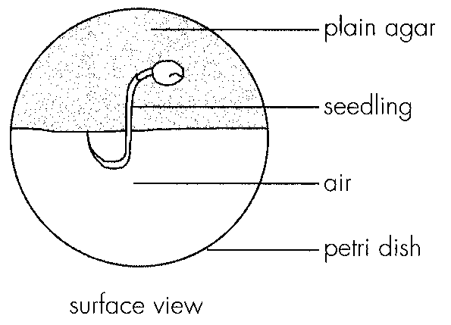
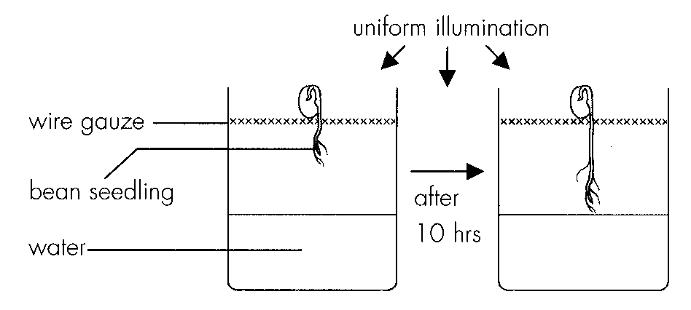
14. What would happen to the seedling if water in the beaker is replaced with paraffin oil?
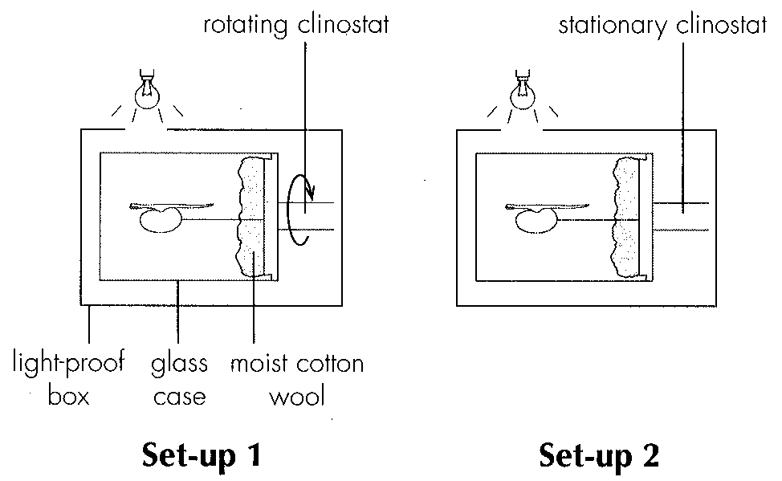
A. The root tip would grow in the same way.
B. The root tip would bent upwards.
C. The root tip would grow faster.
D. The root tip would not grow. Directions: Questions 18 and 19 refer to the diagram below which shows two clinostats set up by a student.
15. What conclusion can be drawn from the result of the experiment?
A.The plumule shows positive phototropism and the radicle shows negative phototropism.
B.The radicle shows positive geotropism and the plumule shows negative geotropism.
C.The radicle shows positive hydrotropism.
D.No conclusion can be drawn.
Directions: Questions 20 to 23 refer to the graph below which shows the effect of different concentrations of auxin on the growth of roots and shoots.
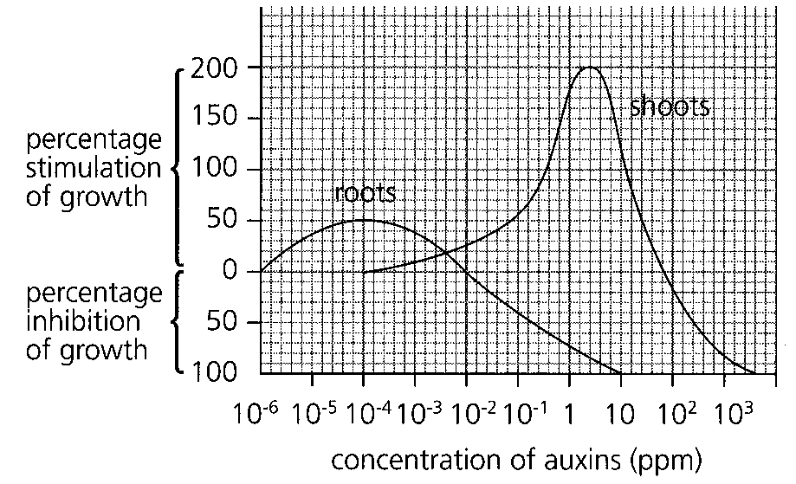
16. What is the range of auxin concentrations that can stimulate the growth of both shoots and roots?
A. 10 6- to 102 ppm
B. 106- to 10-2 ppm
C. 104- to 102 ppm
D. 104- to 10-2 ppm
17. What is the effect of auxin at a concentration of 10 ppm on the growth of shoots and roots?
 | Growth of shoots | Growth of roots
A. | stimulated | stimulated
B. | stimulated | inhibited
C. | inhibited | stimulated
D. | inhibited | inhibited

18. Which of the following interprets the above graph correctly?
 | Increase in auxin concentration (ppm) | Growth ofshoots | Growth ofroots
A.B.C.D. | 10-6 to 10-410-4 to 10-210-2 to 1010 to 102 | inhibitedstimulatedinhibitedinhibited | stimulatednot affectedinhibitednot affected

19. Two agar blocks with different concentrations of auxin were placed on a decapitated root as shown below.
Which of the following correctly describes the most likely growth pattern of the root?
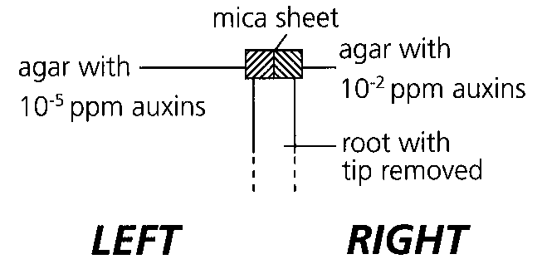
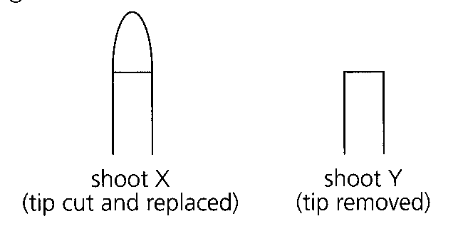
A. It will bend to the left.
B. It will bend to the right.
C. It will stop growing.
D. It will grow vertically upwards. Directions: Questions 24 and 25 refer to the experiment described below: In an experiment, the effects of tropism on two young shoots were investigated. The tip of shoot X was cut and replaced, the tip of shoot Y was removed. Both shoots were placed under uniform illumination. After several days, the appearances of the young shoots were observed.
20. Which of the following correctly describes the growth of the two shoots?
 | Shoot X | Shoot Y
A. | grows straight up quickly | grows straight up slowly
B. | grows straight up | does not grow
C. | does not grow | grows straight up
D. | does not grow | does not grow

21. Which of the following can be concluded from the experiment,?
A.The shoot tip is required for growth.
B.The shoot tip is sensitive to light.
C.Light is needed for growth.
D.Auxins are synthesized in the shoot tip.
Directions: Questions 26 and 27 refer to the diagram below which shows a young shoot placed in the dark.
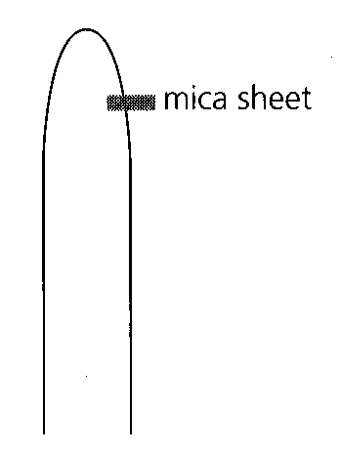
22. Which of the following gives the best explanation for this?
A.The mica sheet stops the downward movement of auxin at that side.
B.Auxin inhibits the growth of the shoot.
C.The side of the shoot with the mica sheet grows faster than the other side.
D.Phototropism cannot occur without light.
23. The diagram below shows an experiment to investigate the phototropic responses in the coleoptiles of oat seedlings. Which of the four coleoptiles will bend towards light?
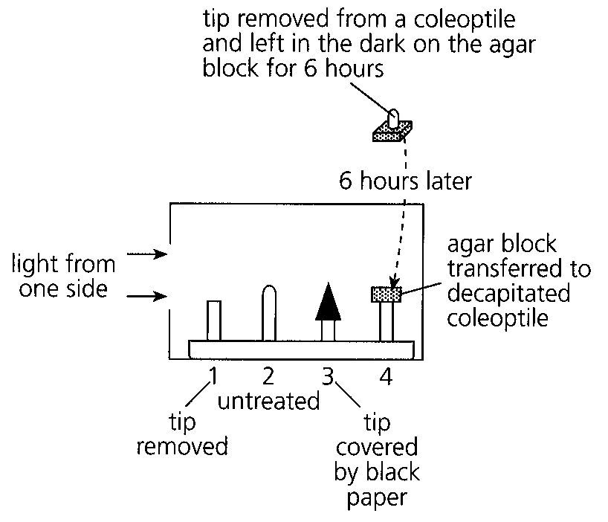
A. 2 only
B. 2 and 4 only
C. 3 and 4 only
D. 2, 3 and 4 only
24. The diagram below shows an experimental set up.-
Which of the following setups will give a similar result as the one above?-
Directions: Questions 30 and 31 refer to the diagram below which shows four oat seedlings treated differently to investigate their response to unilateral light.
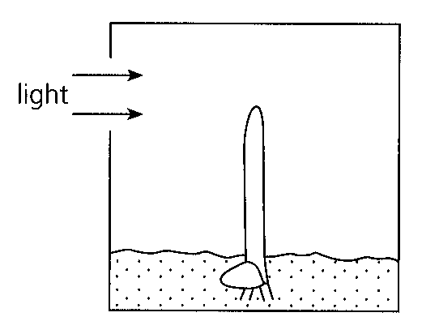
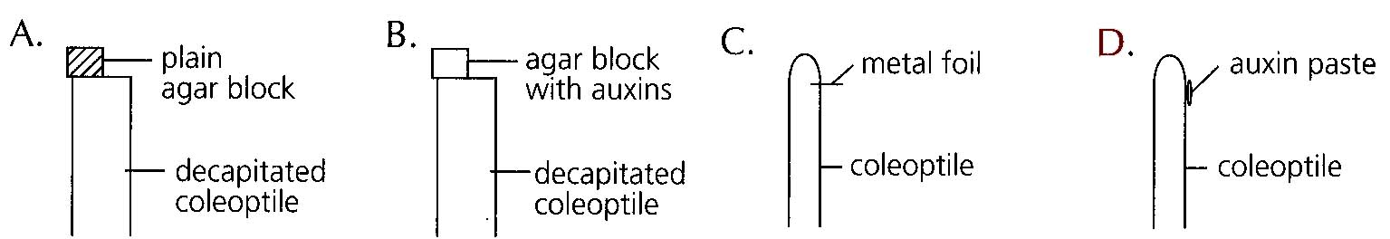
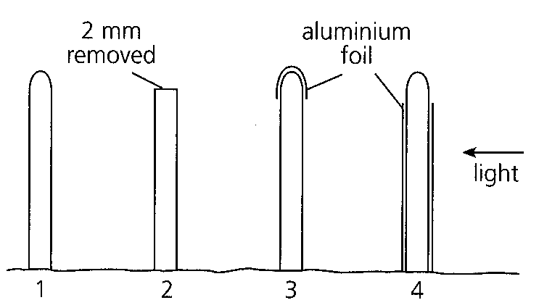
25. | 2 | 3 | 4 |
A. | bends towards light | remains unchanged | remains unchanged | remains unchanged |
B. | bends towards light | remains unchanged | grows upwards | bends towards light |
C. | grows upwards | grows upwards | bends towards light | grows upwards |
D. | grows upwards | grows upwards | remains unchanged | bends towards light
26. What conclusion can be drawn if the results of 3 and 4 are compared?
A. The shoot tip is the site of light reception.
B. The shoot tip is the site of auxin synthesis.
C. The shoot tip is the region of elongation.
D. The shoot shows positive phototropism.
27. In an experiment, a pea seedling was illuminated from one side for a period of 10 hours. The angle of curvature of the radicle and the plumule was recorded at 2hour intervals for 10 hours. The results are shown the table below.- ‘+’ indicates positive phototropism ‘- ’ indicates negative phototropism Which of the following can be deduced from the results above? (1) The effect of light is greater on the plumule than the radicle. (2) The plumule and the radicle were bending at a steady rate throughout the 10hour period. - (3) The amount of auxin present in the plumule is greater than that in the radicle.
Duration of illumination /hours | Angle of curvature / degreesRadicle Plumule
0 | 0 | 0
2 | -2 | +6
4 | -3 | +12
6 | -7 | +16
8 | -10 | +22
10 | -12 | +25

A. (1) only
B. (2) only
C. (1) and (2) only
D. (2) and (3) only
28. The diagram below shows five coleoptiles which were given different treatments. All the coleoptiles were uniformly illuminated. Which coleoptile will resemble coleoptile 1 most closely? C.4
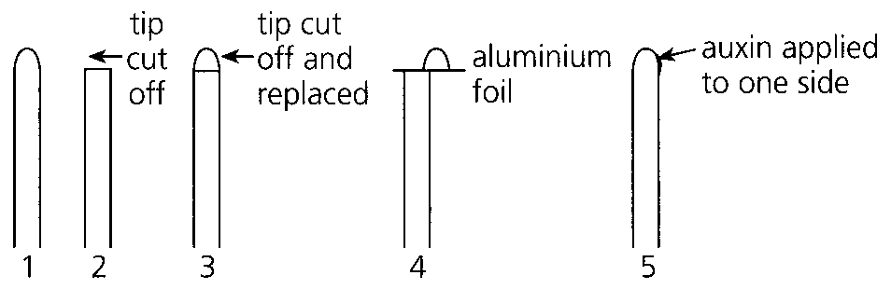
A. 2
B. 3
C. 4
D. 5
29. The diagram below shows two treatments designed to investigate the geotropic responses in the roots of maize and the observed results.
Which of the following is the best conclusion of this experiment?
A.Maize roots show positive geotropic response.
B.The root cap is responsible for the detection of gravity.
C.Auxins are synthesized in the root cap.
D.The root cap is the growing point of the root.
Directions: Questions 35 to 37 refer to the diagram below which shows two root tips A and B, resting on agar blocks 1, 2, 3 and 4. The root tips are orientated as shown below.
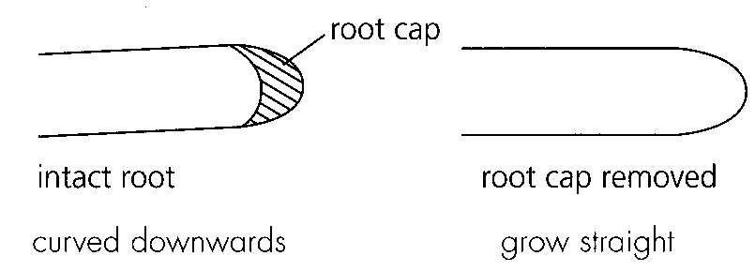
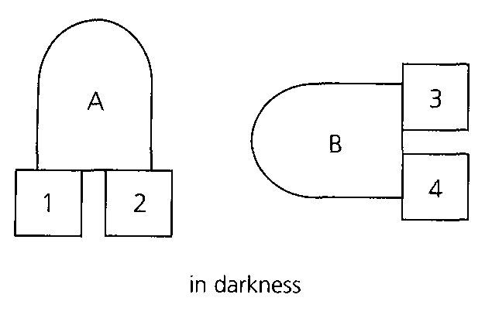
30. Which of the following correctly describes the distribution of auxins in the four agar blocks after 24 hours?
31. | 2 | 3 | 4 |
A. | 0% | 100% | 100% | 0% |
B. | 50% | 50% | 50% | 50% |
C. | 50% | 50% | 20% | 80% |
D. | 30% | 70% | 30% | 70%
32. Which of the following processes accounts for the transport of auxins from the tip to the agar block?
A. Active transport B. Diffusion C. Osmosis D. Gravity
33. Each of the agar blocks 3 and 4 was then placed on one side of a decapitated root as shown below. The set up was kept in a dark room for a few days.-
Which of the following would be the expected result?
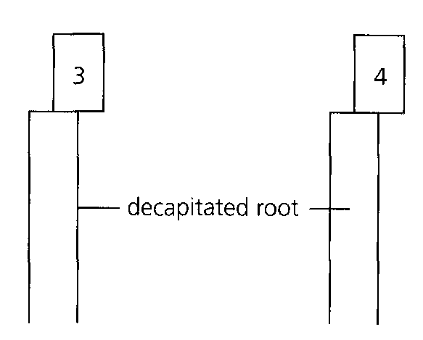
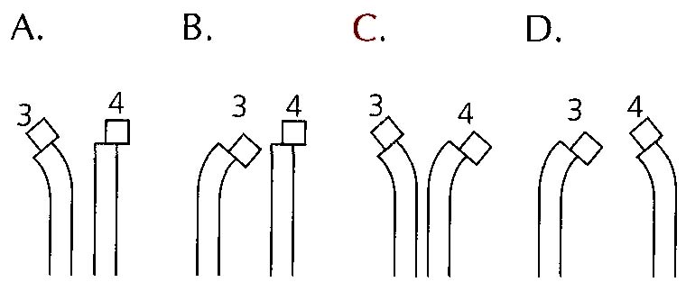
34. The diagram below shows an experiment performed on an oat seedling in darkness. Which of the following can be deduced from the result? A.The substance promotes elongation of the coleoptile. B.The substance retards elongation of the coleoptile. C.The substance being tested is auxin. D.No deduction is possible as light is absent.
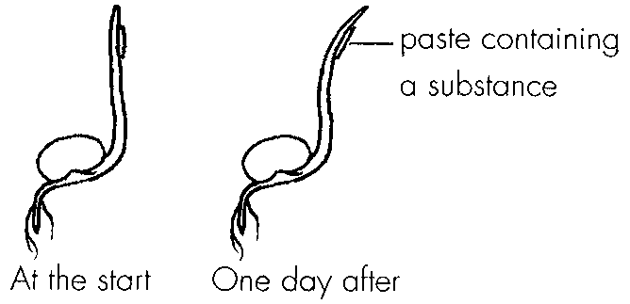
A. The substance promotes elongation of the coleoptile.
B. The substance retards elongation of the coleoptile.
C. The substance being tested is auxin.
D. No deduction is possible as light is absent.
35. In an experiment, the tip of a coleoptile was removed and placed on top of an agar block. A mica sheet was used to separate the tip and the agar block vertically into two halves. The set up was illuminated from one side for several hours. The agar blocks A and B were then transferred separately to two decapitated coleoptiles -
Which of the following would be the expected result?
Directions: Questions 40 and 41 refer to an experiment in which a number of coleoptile tips were placed horizontally in a dark room. Two agar blocks which were separated by a metal foil were attached to each tip as shown below. The agar blocks were then transferred to a decapitated coleoptile. The appearance of the coleoptiles was observed after 8 hours.
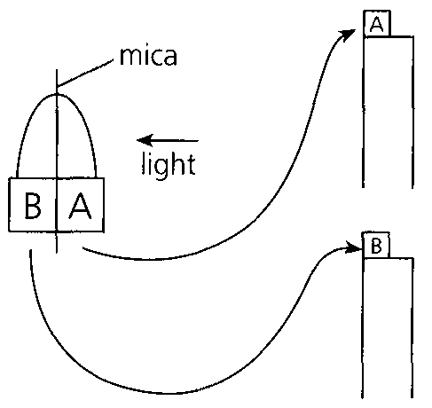
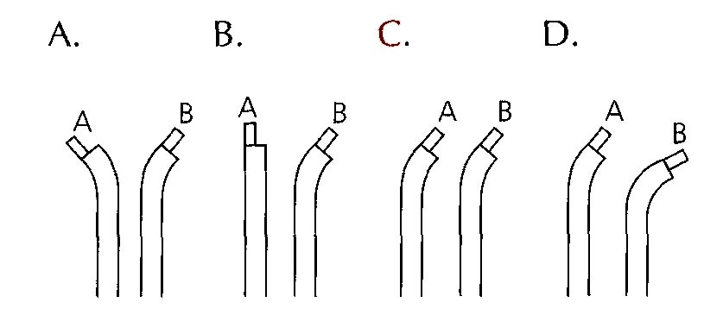
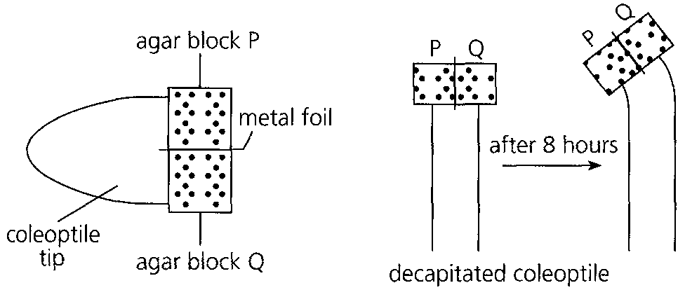
36. Which of the following can be deduced from the result? (1)The growth rate of the side under agar block Q was faster than that under P. (2)The growth of the coleoptile at the side under agar block P was inhibited. (3)More substances that stimulate growth were synthesized at the lower side of the coleoptile tips.
A. (1) only
B. (3) only
C. (1) and (2) only
D. (2) and (3) only
37. If the agar blocks P and Q were transferred to a decapitated root, which of the following best shows the likely appearance of the root after 8 hours?
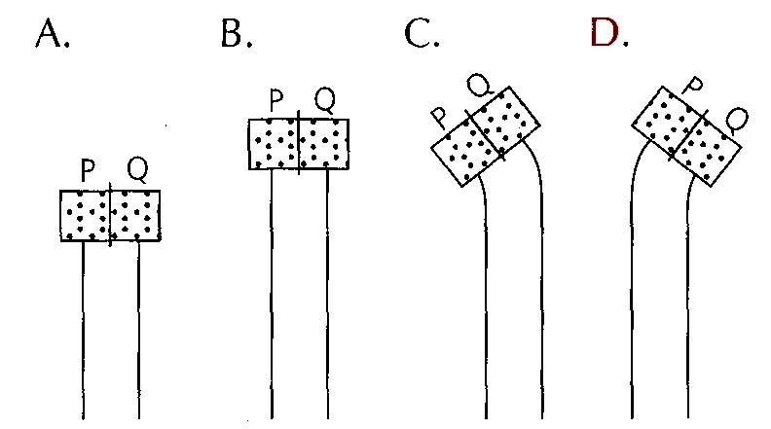
Part B — HKDSE-style (YKTo)
38. Directions: Question 1 refers to the diagram below, which shows a set-up to investigate the effect of light on the growth of coleoptiles under different treatments.
What will be the growth response of the coleoptiles after four days?
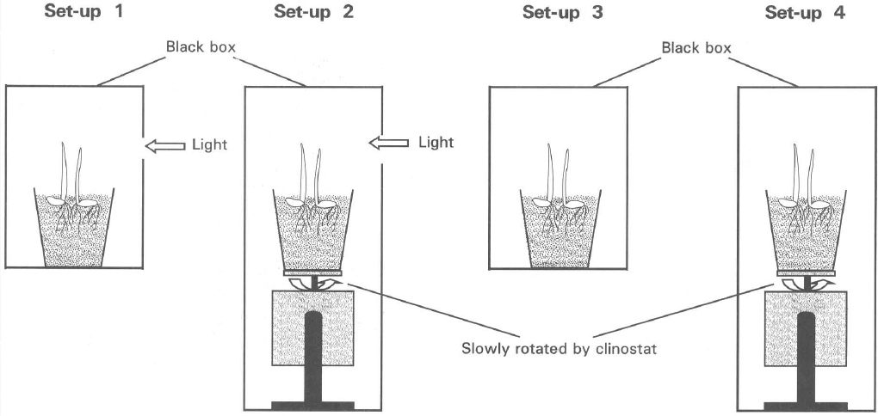
 | Set-up 1 | Set-up 2 | Set-up 3 | Set-up 4
A. | Bends to the right | No bending, with height taller than that in (3) and (4) | No bending | No bending
B. | Bends to the left | Bends to the right | No growth | No growth
C. | No bending, with height taller than that in (4). | Bends to the right | No bending, with height shorter than that in (1). | Bends to the left.
D. | Bends to the right | No bending | No bending, with height taller than that in (2). | No bending, with height roughly the same as that in (3).

39. The following diagram shows one of the experiments performed by Boysen Jensen in 1913.
Which of the following is the conclusion that can be drawn from this experiment?
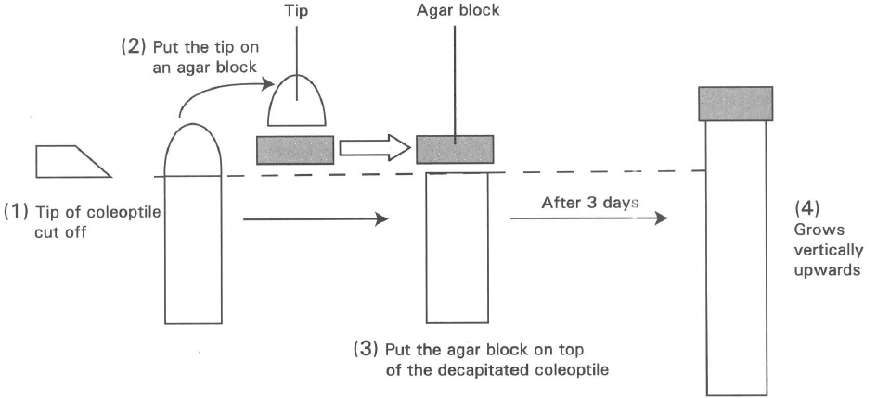
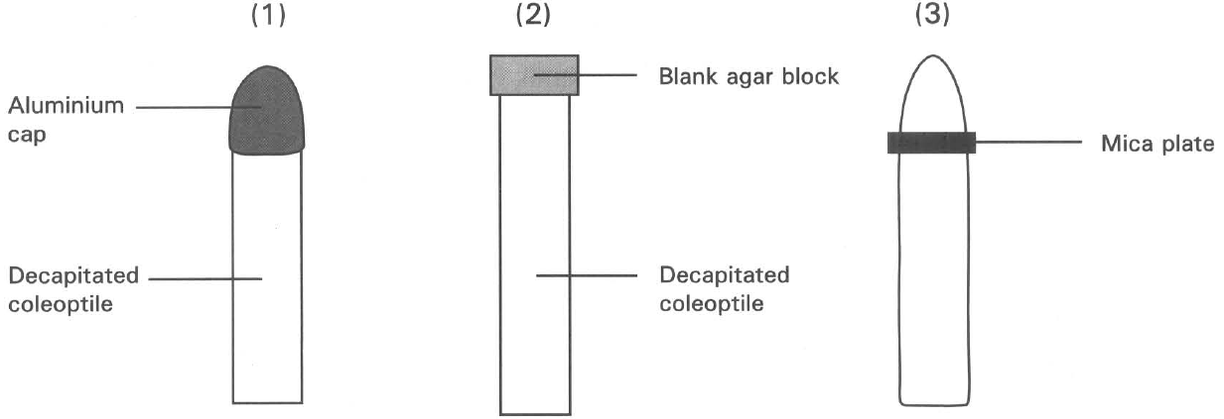
A. The tip is essential for the growth of the coleoptile.
B. A blank agar block can replace the action of the tip.
C. The tip produces a diffusible substance that controls growth.
D. The tip produces auxins.
40. Which of the following can act as the control set-up of the above experiment?
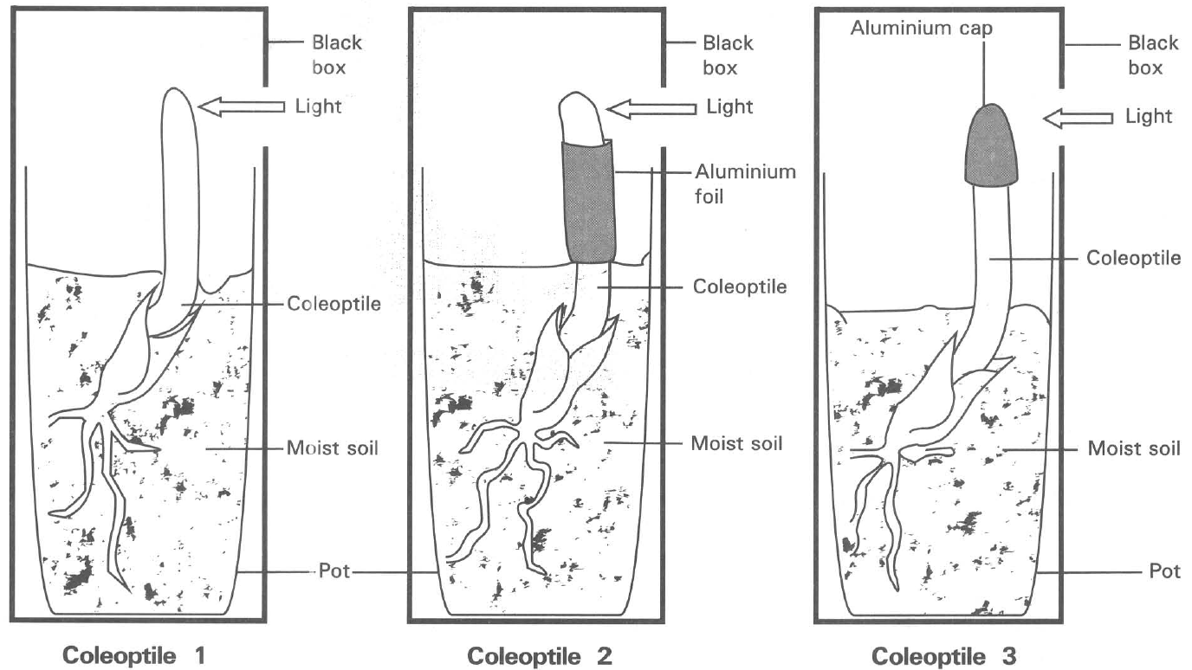
A. (1) only B. (2) only
C. (3) only D. (1) and (2) Directions: Questions 4 to 6 refer to the diagrams below, which shows an experiment resembled the one carried out by Boysen-Jensen. (The diagrams are not drawn to scale)
41. Which of the following are the most probable results after two days?
 | Coleootile 1 | Coleoptile 2 | Coleoptile 3
A. | Bends to the left | Bends to the right | Bends to the right
B. | Bends to the right | Bends to the left | Bends to the right
C. | Bends to the right | Bends to the right | Grows upwards
D. | Grows upwards | Bends to the left | Grows upwards

42. What conclusion can be drawn from the results of the above experiment?
A. The tip of the coleoptile is essential for growth.
B. Auxins produced by the tip of the coleoptile are responsible for bending it towards light.
C. The part below the tip is responsible for growth to take place.
D. The tip of the coleoptile is important for detecting the direction of the unilateral light to give the tropic response.
43. Which of the following set-ups would replace set-up (2) and (3) in the previous experiment?
Directions: Questions 7 to 10 refer to the diagram below, which shows four set-ups to investigate the effect of unilateral light on the growth of coleoptile.
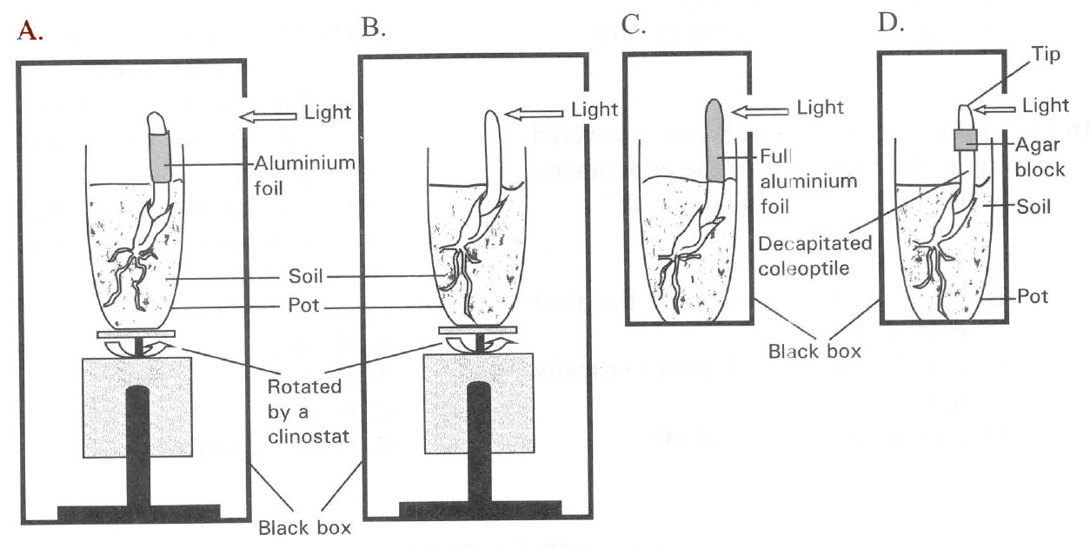
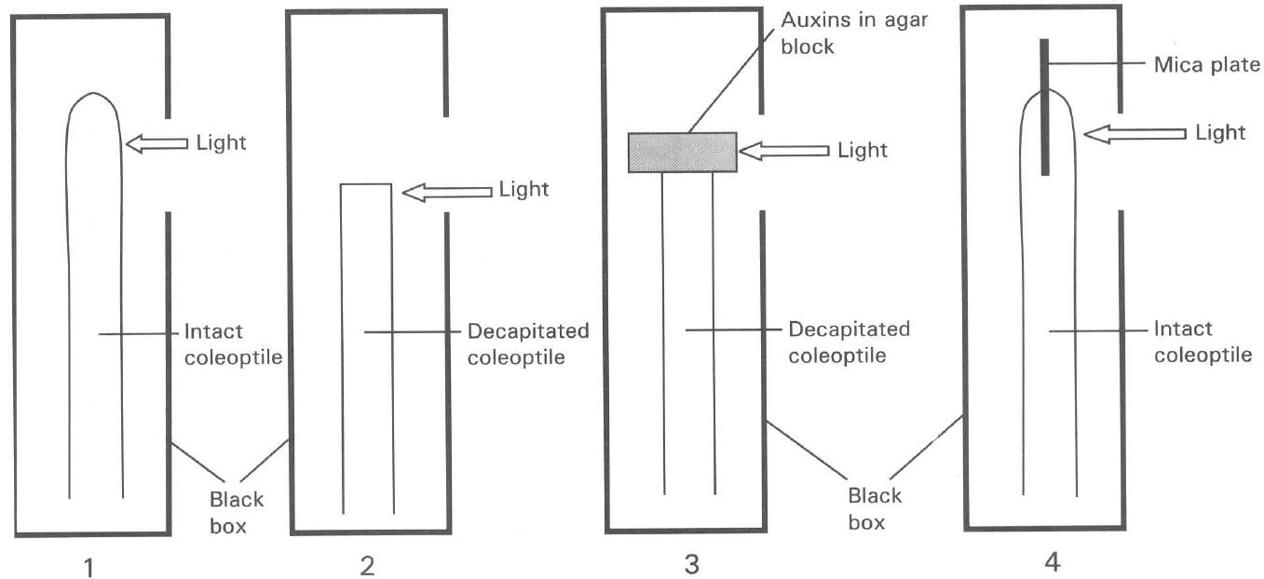
44. Which coleoptile will exhibit positive phototropism?
A. (1) only
B. (2) only
C. (1) and (3) only
D. (2) and (4) only
45. Which coleoptile will not grow?
A. (2) only
B. (3) only
C. (4) only
D. (2) and (3) only
46. If the hole of the black box is covered up at the beginning of the experiment, which of the following will occur?
A. (1) will bend to the left.
B. No growth occurs in all the four coleoptiles.
C. (1), (3) and (4) will grow vertically upwards.
D. (1) is taller than (3) and (4).
47. Which of the following conclusions can be drawn from this experiment?
(1) The tip of the coleoptile is essential for growth.
(2) The tip is sensitive to the perception of light to affect growth.
(3) Auxins are mostly likely to be produced by the tip to affect growth.
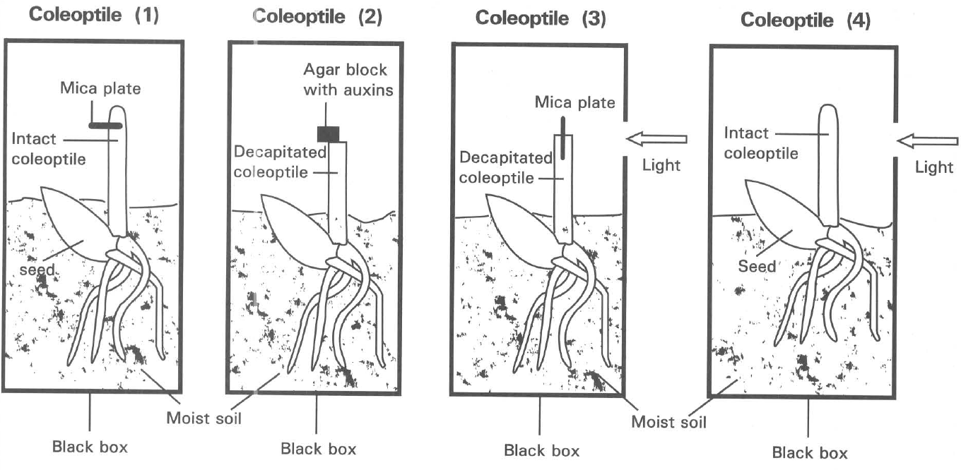
Coleoptile (1) | Coleoptile (2) | Coleoptile (3) | Coleoptile (4)
Grows and bends to the left | Grows and bends to the right | No growth | Grows and bends to the right

A. (1) only B. (2) only C. (3) only D. (1) and (2) only Directions: Questions 11 and 12 refer to the diagram below, which shows four coleoptiles put under different treatments. The following are the growth responses of these four coleoptiles:
48. What conclusion can be drawn by comparing the results of coleoptiles (1) and (2)? (1) Unilateral light affects the growth response of the coleoptiles. (2) Mica plate harms the tissues of the coleoptile that fails to grow. (3)Unequal distribution of auxins affects the growth of the coleoptiles. (4) Decapitated coleoptile without auxins does not grow.
A. (1) only
B. (2) only
C. (3) only
D. (4) only
49. Referring to the conclusions given in the previous question,what conclusions can be drawn by comparing the results of coleoptiles (3) and (4)?
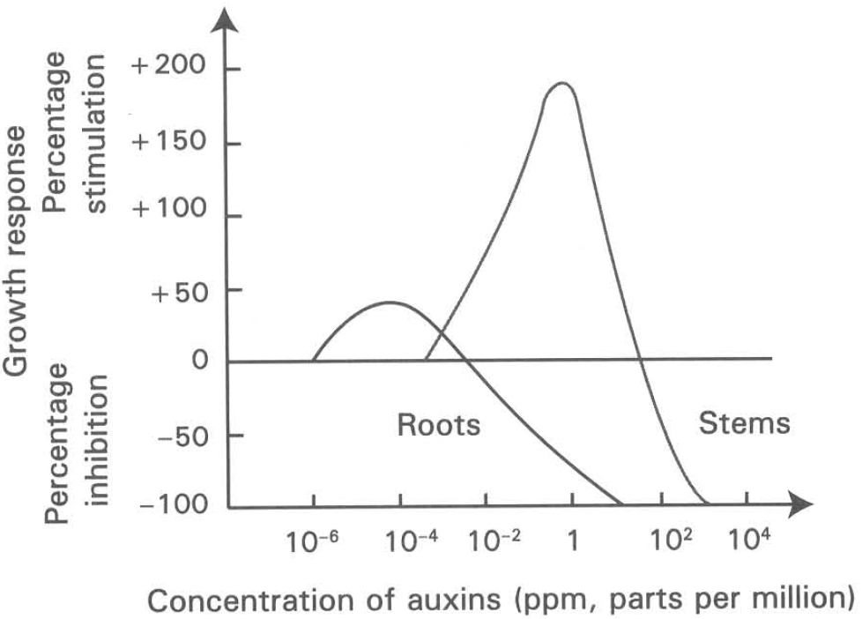
A. (1) and (2) only B. (1) and (4) only C. (2) and (3) only D. (3) and (4) only Directions: Questions 13 to 14 refer to the diagram below, which shows the effect of auxin concentration on the growth of stems and roots.
50. Which of the following interpretation of the graph is CORRECT?
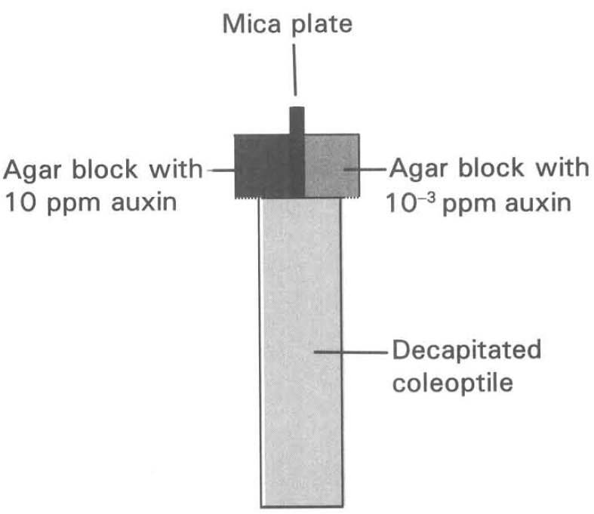
 | Range of auxin concentration (ppm) | Effect of growth on
 |  | Stems | Roots
A. | 10-3 to 10-2 | Inhibited | Stimulated
B. | 10-6 to 10-4 | No effect | Stimulated
C. | 10-2 to 1 | Inhibited | Inhibited
D. | 10-2 to 103 | Stimulated | Inhibited

51. Two pieces of agar blocks immersed in different auxin concentrations are put on top of a decapitated coleoptile. What will be the response of the coleoptile?
A. It will not have any response.
B. It will grow vertically upwards.
C. It will grow and bend to the right.
D. It will grow and bend to the left.
52. Which of the following set-ups with the coleoptiles inside black boxes will have the result similar to the previous question?
Suggested Solutions
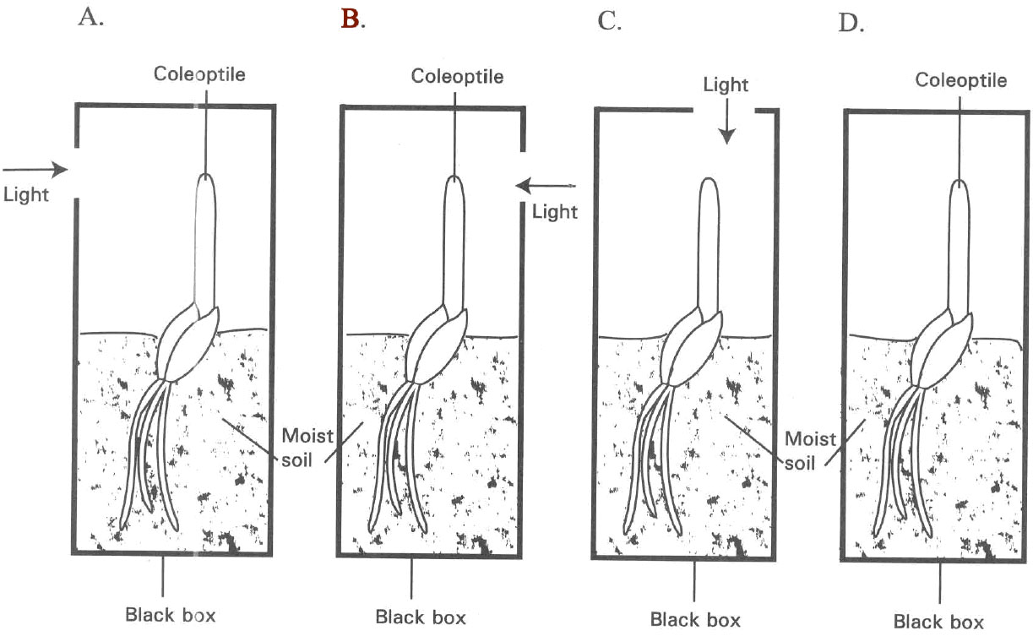

Answers
Answers are printed in red.
1. D. (1), (2) and (3)

2. A. (1) and (2) only
Class: 51.1% correct (n=45) usual slip B
3. D. in the opposite direction of gravity.

4. ?

5. ?

6. ?

7. C. The shoot bent upwards.

8. C. The effect of unilateral light on shoot growth is stronger than that of gravity.

9. ?

10. D

11. C. etiolation.

12. ?

13. C

14. A. The root tip would grow in the same way.
Class: 91.1% correct (n=45) usual slip C
15. D
Class: 68.9% correct (n=45) usual slip C
16. D. 104- to 10-2 ppm
Class: 84.4% correct (n=45) usual slip D
17. B
Class: 48.9% correct (n=45) usual slip D
18. D
Class: 42.2% correct (n=45) usual slip D
19. B. It will bend to the right.
Class: 42.2% correct (n=45) usual slip A
20. B
Class: 57.8% correct (n=45) usual slip D
21. A
Class: 75.6% correct (n=45) usual slip C
22. A

23. ?

24. ?

25. B. | bends towards light | remains unchanged | grows upwards | bends towards light |

26. A. The shoot tip is the site of light reception.

27. A. (1) only

28. ?

29. B

30. ?

31. C. | 50% | 50% | 20% | 80% |

32. ?

33. ?

34. B. The substance retards elongation of the coleoptile.

35. ?

36. ?

37. ?

38. D
Class: 60.0% correct (n=45) usual slip B
39. C. The tip produces a diffusible substance that controls growth.

40. C. (3) only D. (1) and (2) Directions: Questions 4 to 6 refer to the diagrams below, which shows an experiment resembled the one carried out by Boysen-Jensen. (The diagrams are not drawn to scale)
Class: 95.6% correct (n=45) usual slip B
41. C
Class: 35.6% correct (n=45) usual slip D
42. D. The tip of the coleoptile is important for detecting the direction of the unilateral light to give the tropic response.
Class: 53.3% correct (n=45) usual slip C
43. A

44. C. (1) and (3) only

45. A. (2) only

46. C. (1), (3) and (4) will grow vertically upwards.
Class: 33.3% correct (n=45) usual slip A
47. C
Class: 55.6% correct (n=45) usual slip A
48. C. (3) only

49. B

50. B
Class: 68.9% correct (n=45) usual slip A
51. C. It will grow and bend to the right.

52. B

