Tropism · items under 80% correct
Multiple-choice practice
Name: ________________________ Class: ____________
These items were answered correctly by fewer than 80% of students in class Google Forms, matched by the wording in the source bank and the form answer key. Choose the one best answer.
Part A — HKCEE level (Longman)
1. Tropism is useful in plants because (1) it helps to maximise light absorption. (2) it helps to maximise water absorption. (3) it helps to protect the plants from danger.
A. (1) and (2) only
B. (1) and (3) only
C. (2) and (3) only
D. (1), (2) and (3)
2. What conclusion can be drawn from the result of the experiment?
A.The plumule shows positive phototropism and the radicle shows negative phototropism.
B.The radicle shows positive geotropism and the plumule shows negative geotropism.
C.The radicle shows positive hydrotropism.
D.No conclusion can be drawn.
Directions: Questions 20 to 23 refer to the graph below which shows the effect of different concentrations of auxin on the growth of roots and shoots.
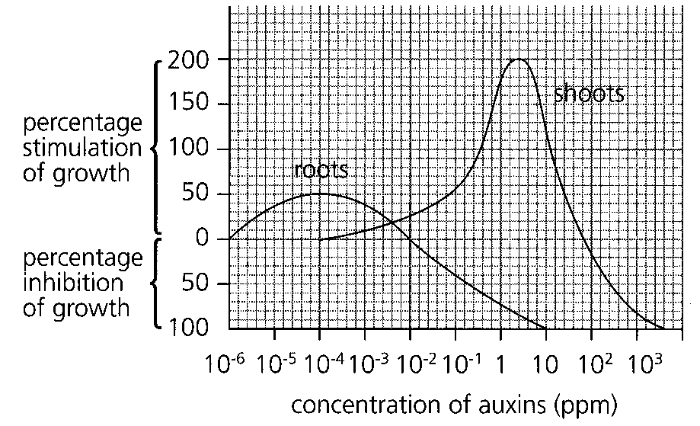
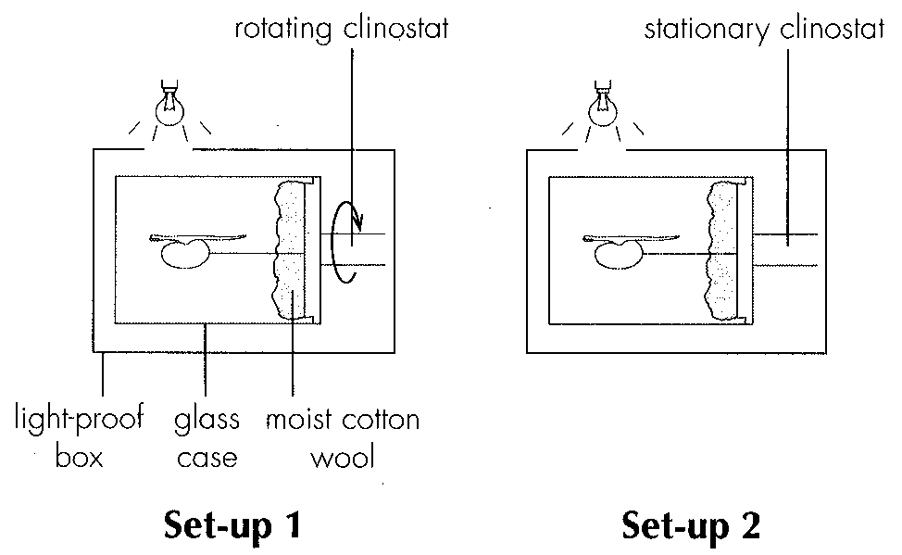
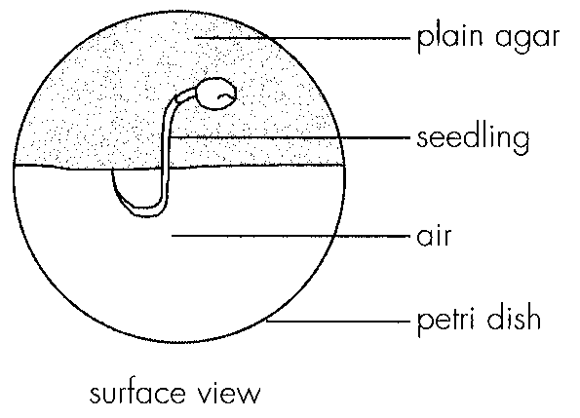
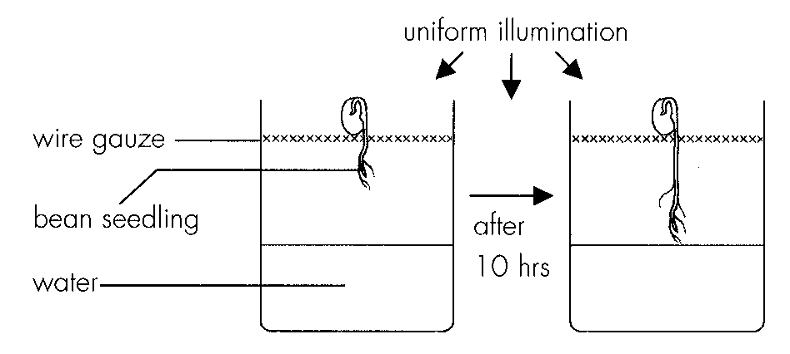
3. What is the effect of auxin at a concentration of 10 ppm on the growth of shoots and roots?
 | Growth of shoots | Growth of roots
A. | stimulated | stimulated
B. | stimulated | inhibited
C. | inhibited | stimulated
D. | inhibited | inhibited

4. Which of the following interprets the above graph correctly?
 | Increase in auxin concentration (ppm) | Growth ofshoots | Growth ofroots
A.B.C.D. | 10-6 to 10-410-4 to 10-210-2 to 1010 to 102 | inhibitedstimulatedinhibitedinhibited | stimulatednot affectedinhibitednot affected

5. Two agar blocks with different concentrations of auxin were placed on a decapitated root as shown below.
Which of the following correctly describes the most likely growth pattern of the root?
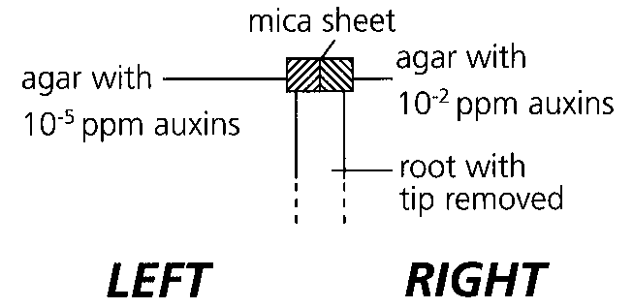
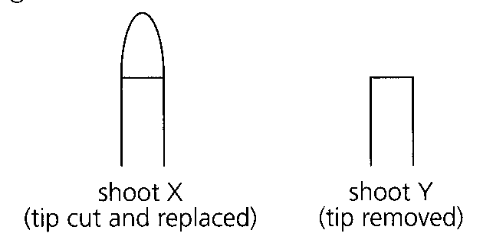
A. It will bend to the left.
B. It will bend to the right.
C. It will stop growing.
D. It will grow vertically upwards. Directions: Questions 24 and 25 refer to the experiment described below: In an experiment, the effects of tropism on two young shoots were investigated. The tip of shoot X was cut and replaced, the tip of shoot Y was removed. Both shoots were placed under uniform illumination. After several days, the appearances of the young shoots were observed.
6. Which of the following correctly describes the growth of the two shoots?
 | Shoot X | Shoot Y
A. | grows straight up quickly | grows straight up slowly
B. | grows straight up | does not grow
C. | does not grow | grows straight up
D. | does not grow | does not grow

7. Which of the following can be concluded from the experiment,?
A.The shoot tip is required for growth.
B.The shoot tip is sensitive to light.
C.Light is needed for growth.
D.Auxins are synthesized in the shoot tip.
Directions: Questions 26 and 27 refer to the diagram below which shows a young shoot placed in the dark.
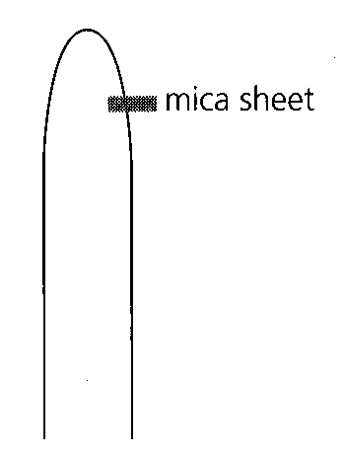
Part B — HKDSE-style (YKTo)
8. Directions: Question 1 refers to the diagram below, which shows a set-up to investigate the effect of light on the growth of coleoptiles under different treatments.
What will be the growth response of the coleoptiles after four days?
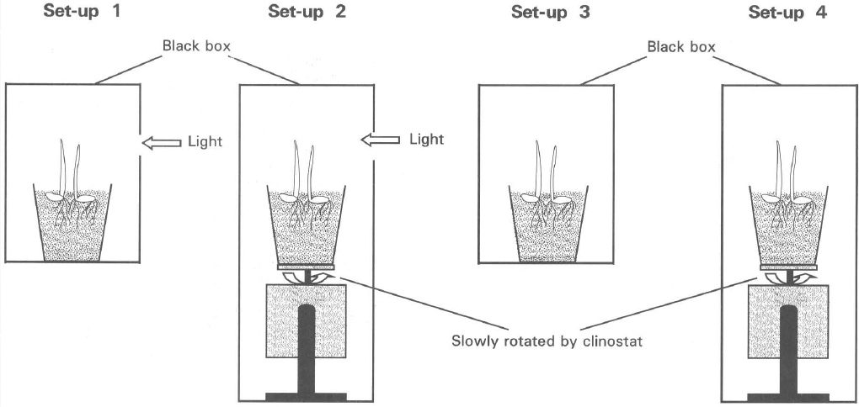
 | Set-up 1 | Set-up 2 | Set-up 3 | Set-up 4
A. | Bends to the right | No bending, with height taller than that in (3) and (4) | No bending | No bending
B. | Bends to the left | Bends to the right | No growth | No growth
C. | No bending, with height taller than that in (4). | Bends to the right | No bending, with height shorter than that in (1). | Bends to the left.
D. | Bends to the right | No bending | No bending, with height taller than that in (2). | No bending, with height roughly the same as that in (3).

9. Which of the following are the most probable results after two days?
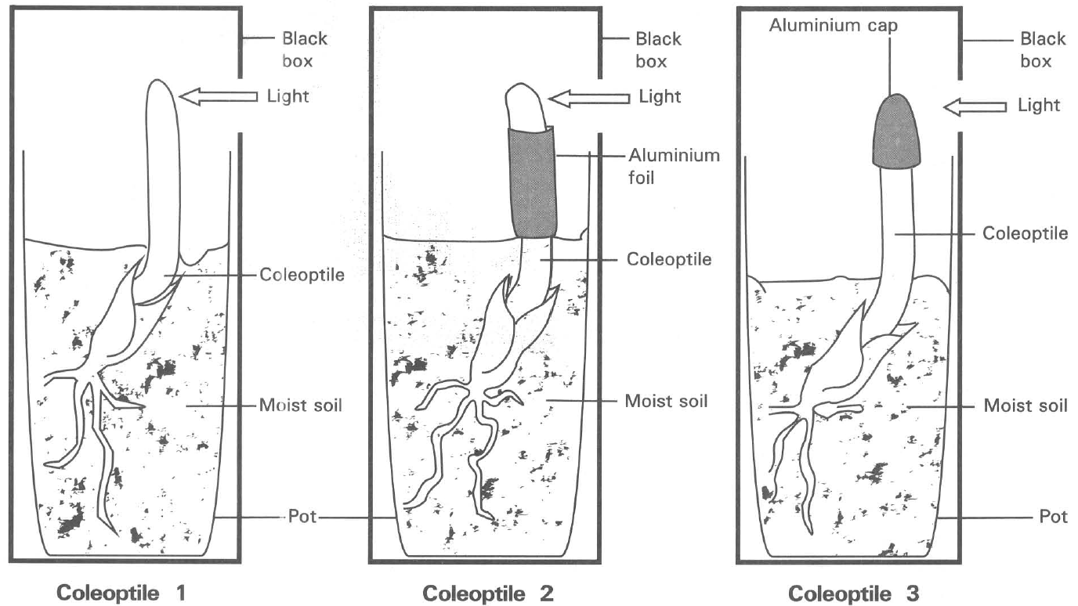
 | Coleootile 1 | Coleoptile 2 | Coleoptile 3
A. | Bends to the left | Bends to the right | Bends to the right
B. | Bends to the right | Bends to the left | Bends to the right
C. | Bends to the right | Bends to the right | Grows upwards
D. | Grows upwards | Bends to the left | Grows upwards

10. What conclusion can be drawn from the results of the above experiment?
A. The tip of the coleoptile is essential for growth.
B. Auxins produced by the tip of the coleoptile are responsible for bending it towards light.
C. The part below the tip is responsible for growth to take place.
D. The tip of the coleoptile is important for detecting the direction of the unilateral light to give the tropic response.
11. If the hole of the black box is covered up at the beginning of the experiment, which of the following will occur?
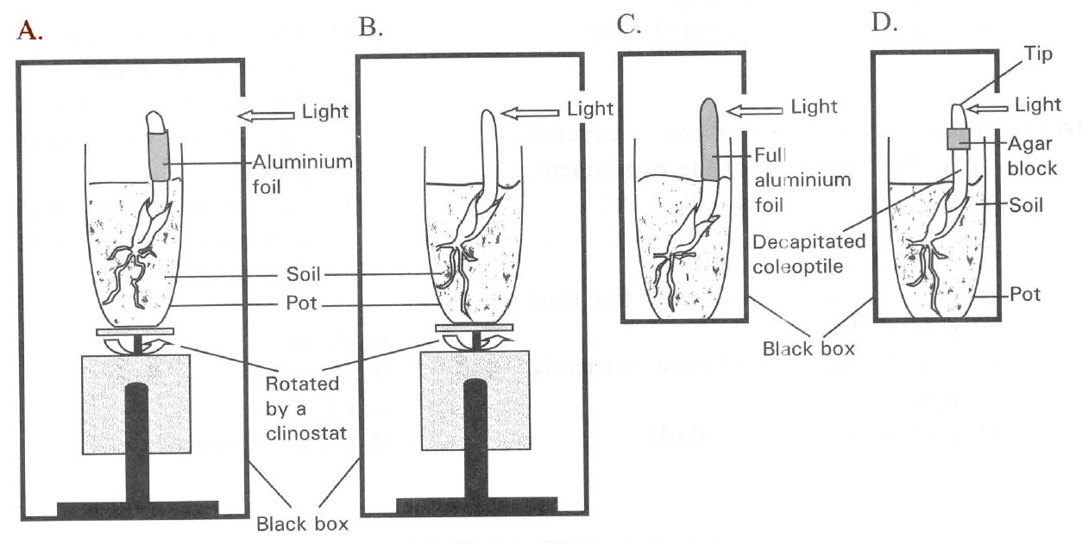
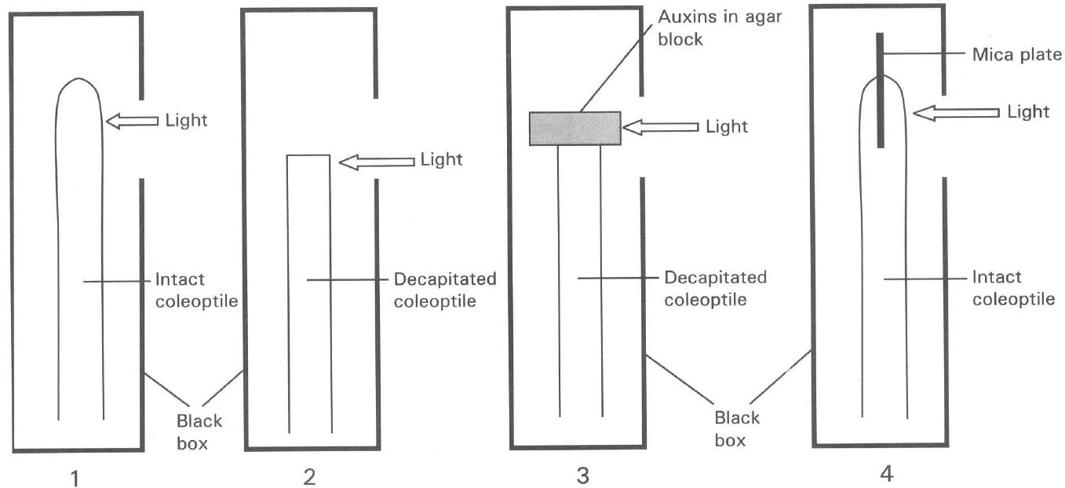
A. (1) will bend to the left.
B. No growth occurs in all the four coleoptiles.
C. (1), (3) and (4) will grow vertically upwards.
D. (1) is taller than (3) and (4).
12. Which of the following conclusions can be drawn from this experiment?
(1) The tip of the coleoptile is essential for growth.
(2) The tip is sensitive to the perception of light to affect growth.
(3) Auxins are mostly likely to be produced by the tip to affect growth.
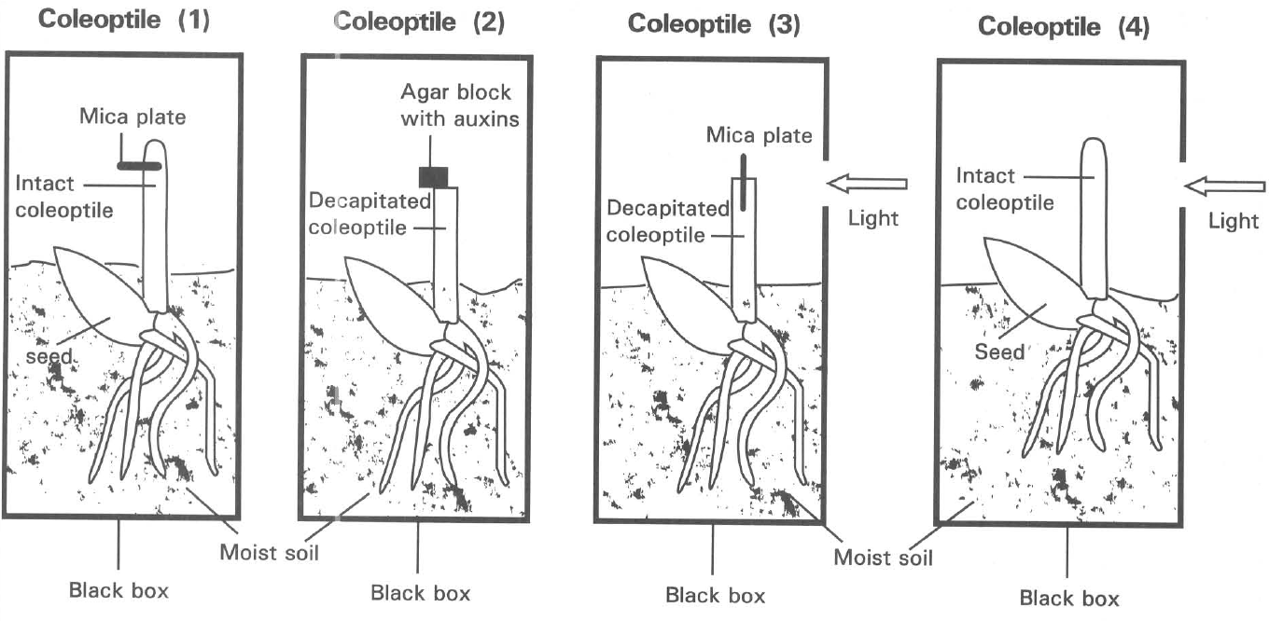
Coleoptile (1) | Coleoptile (2) | Coleoptile (3) | Coleoptile (4)
Grows and bends to the left | Grows and bends to the right | No growth | Grows and bends to the right

A. (1) only B. (2) only C. (3) only D. (1) and (2) only Directions: Questions 11 and 12 refer to the diagram below, which shows four coleoptiles put under different treatments. The following are the growth responses of these four coleoptiles:
13. Which of the following interpretation of the graph is CORRECT?
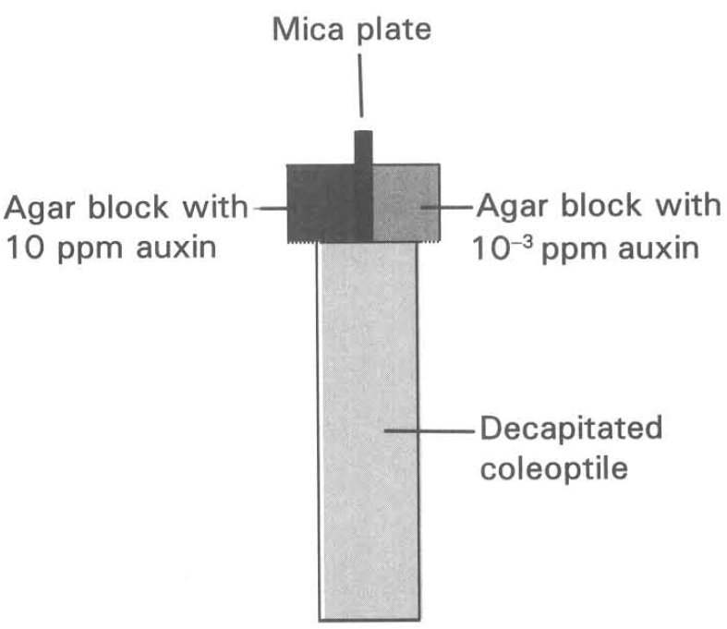
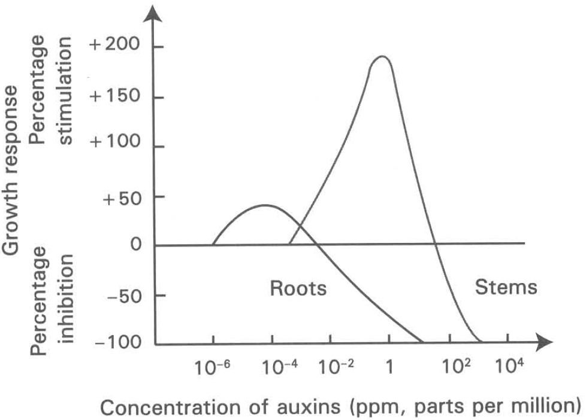
 | Range of auxin concentration (ppm) | Effect of growth on
 |  | Stems | Roots
A. | 10-3 to 10-2 | Inhibited | Stimulated
B. | 10-6 to 10-4 | No effect | Stimulated
C. | 10-2 to 1 | Inhibited | Inhibited
D. | 10-2 to 103 | Stimulated | Inhibited

Answers
Answers are printed in red.
1. A. (1) and (2) only
Class: 51.1% correct (n=45) usual slip B
2. D
Class: 68.9% correct (n=45) usual slip C
3. B
Class: 48.9% correct (n=45) usual slip D
4. D
Class: 42.2% correct (n=45) usual slip D
5. B. It will bend to the right.
Class: 42.2% correct (n=45) usual slip A
6. B
Class: 57.8% correct (n=45) usual slip D
7. A
Class: 75.6% correct (n=45) usual slip C
8. D
Class: 60.0% correct (n=45) usual slip B
9. C
Class: 35.6% correct (n=45) usual slip D
10. D. The tip of the coleoptile is important for detecting the direction of the unilateral light to give the tropic response.
Class: 53.3% correct (n=45) usual slip C
11. C. (1), (3) and (4) will grow vertically upwards.
Class: 33.3% correct (n=45) usual slip A
12. C
Class: 55.6% correct (n=45) usual slip A
13. B
Class: 68.9% correct (n=45) usual slip A

Class percentage correct
Matched to this paper by question wording in the source bank and the form answer key, not by a shifted paper number.
Q | Answer | % correct | n | Usual slip
1 | A | 51.1% | 45 | B
2 | D | 68.9% | 45 | C
3 | B | 48.9% | 45 | D
4 | D | 42.2% | 45 | D
5 | B | 42.2% | 45 | A
6 | B | 57.8% | 45 | D
7 | A | 75.6% | 45 | C
8 | D | 60.0% | 45 | B
9 | C | 35.6% | 45 | D
10 | D | 53.3% | 45 | C
11 | C | 33.3% | 45 | A
12 | C | 55.6% | 45 | A
13 | B | 68.9% | 45 | A

