Respiration
Multiple-choice practice · 36 items · class <80% plus difficult uncovered scenarios
Name: ________________________ Class: ____________ Class no.: ______
Questions 1–25 were answered correctly by fewer than 80% of students in class Google Forms. Questions 26–36 cover syllabus areas and unfamiliar scenarios that those items do not, including comparison with photosynthesis. Choose the one best answer. Not posted to the web.
Newly drawn set-ups from the under-80 file are kept. Graphs are redrawn. OUP mock electron micrographs are not used.
Part A — HKCEE level (Longman)
1. Which of the following comparisons between burning and respiration is not true?
 | Burning | Respiration
A. | uses oxygen | may not use oxygen
B. | releases energy from inorganic substances only | releases energy from organic substances only
C. | does not require enzymes | requires enzymes
D. | is a single-step reaction | is a series of reactions

2. Which of the following statements about respiration is/are correct?
(1) It occurs in all living cells.
(2) It always consumes oxygen.
(3) It releases energy only in the form of ATP.
A. (1) only
B. (1) and (2) only
C. (2) and (3) only
D. (1), (2) and (3)
Directions: Question 3 refers to the set-up below, which measures the rate of respiration of a small mammal.
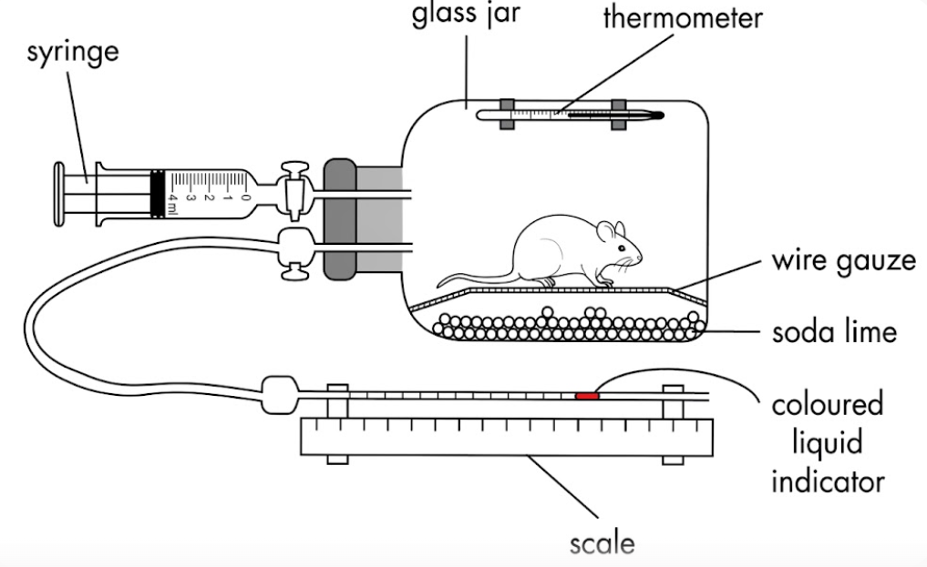
3. Which of the following external factors may affect the results of the experiment?
(1) Light intensity
(2) External temperature
(3) Atmospheric pressure
(4) Relative humidity
A. (1) and (2) only
B. (1) and (4) only
C. (2) and (3) only
D. (2), (3) and (4) only
4. Which of the following compounds contains most chemical energy per mole?
A. ATP
B. Ethanol
C. Lactic acid
D. Glucose
5. An athlete is taking part in a 100 m sprint race. Which of the following occur(s) inside his/her body?
(1) Lactic acid builds up in the muscles.
(2) Glycogen is converted to glucose in the muscles.
(3) Anaerobic respiration takes place in the muscle cells.
(4) Aerobic respiration takes place in the brain cells.
A. (1) only
B. (1) and (3) only
C. (2), (3) and (4) only
D. (1), (2), (3) and (4)
Directions: Question 6 refers to the steps in bread-making shown below.
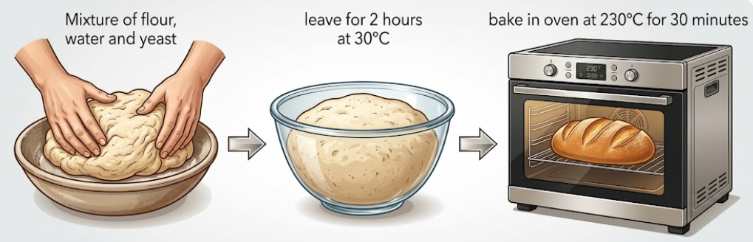
6. The volume of the dough does not increase further after it has been kept in the oven for 10 minutes because
A. all the carbon dioxide trapped in the dough has escaped.
B. the alcohol produced by the yeast has evaporated.
C. enzymes are denatured under high temperature.
D. the bread has hardened so that further expansion is restricted.
Directions: Question 7 refers to the experiment below. Yeast cells were added to a glucose solution in a container. The graph shows some of the changes in the mixture during the next 35 days.
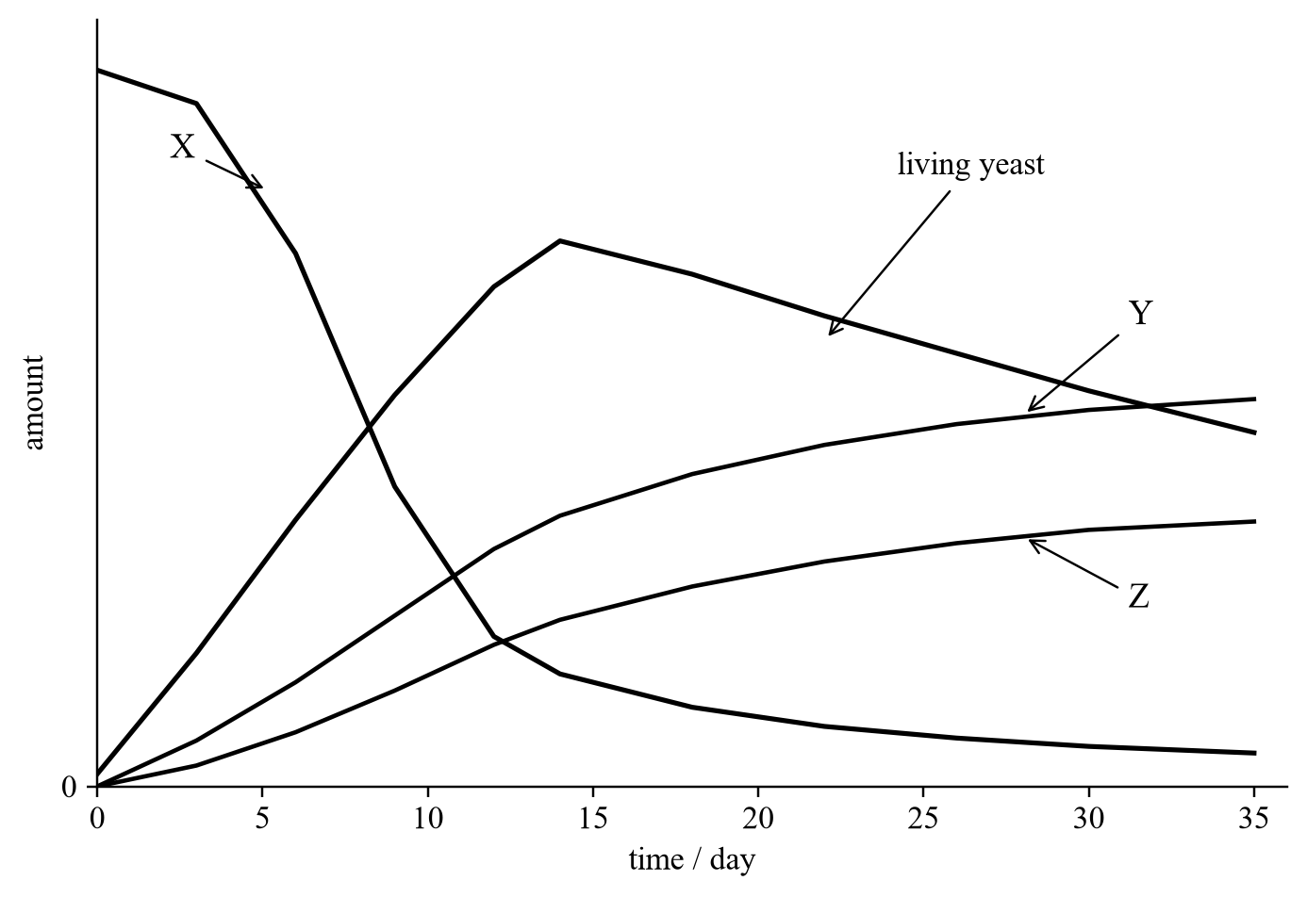
7. Which of the following are the possible causes of the decrease in the amount of living yeast after 14 days?
(1) Exhaustion of glucose
(2) Accumulation of toxic wastes
(3) Lack of oxygen
A. (1) and (2) only
B. (1) and (3) only
C. (2) and (3) only
D. (1), (2) and (3)
Part B — HKDSE-style (YKTo)
8. Respiration takes place in the
(1) cuticle of leaf.
(2) xylem vessels.
(3) bones.
(4) enamel of tooth.
(5) retina of the eye.
A. (3) and (5) only
B. (1), (2) and (4) only
C. (1), (3) and (5) only
D. (2), (3) and (4) only
Directions: Question 9 refers to the diagram of a mitochondrion below.
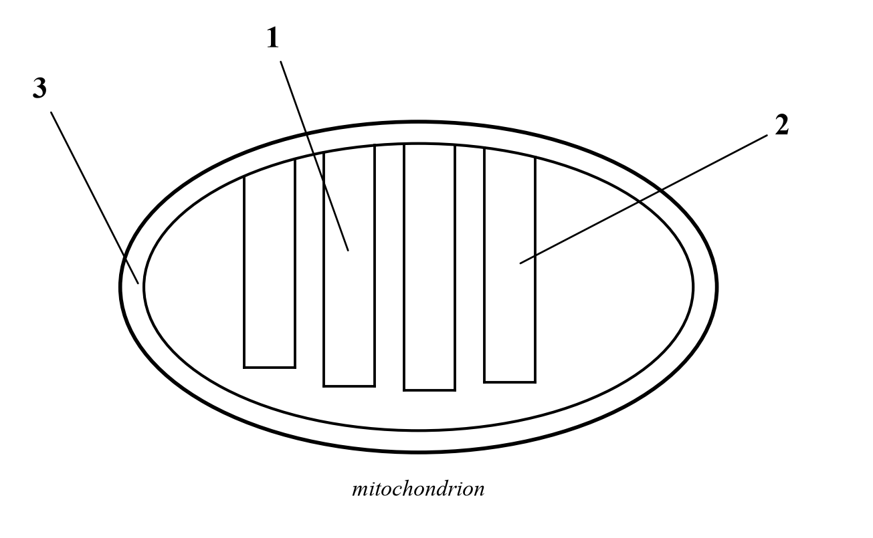
9. The following indicates the biochemical reactions taking place in three different locations in the diagram. Which of the following combinations CORRECTLY match the processes concerned?
 | 1 | 2 | 3
A. | Krebs cycle | Oxidative phosphorylation | Glycolysis
B. | Glycolysis | Krebs cycle | Oxidative phosphorylation
C. | Oxidative phosphorylation | Krebs cycle | Glycolysis
D. | Krebs cycle | Glycolysis | Oxidative phosphorylation

Directions: Questions 10 and 11 refer to the outline of respiration in human skeletal muscle cells.
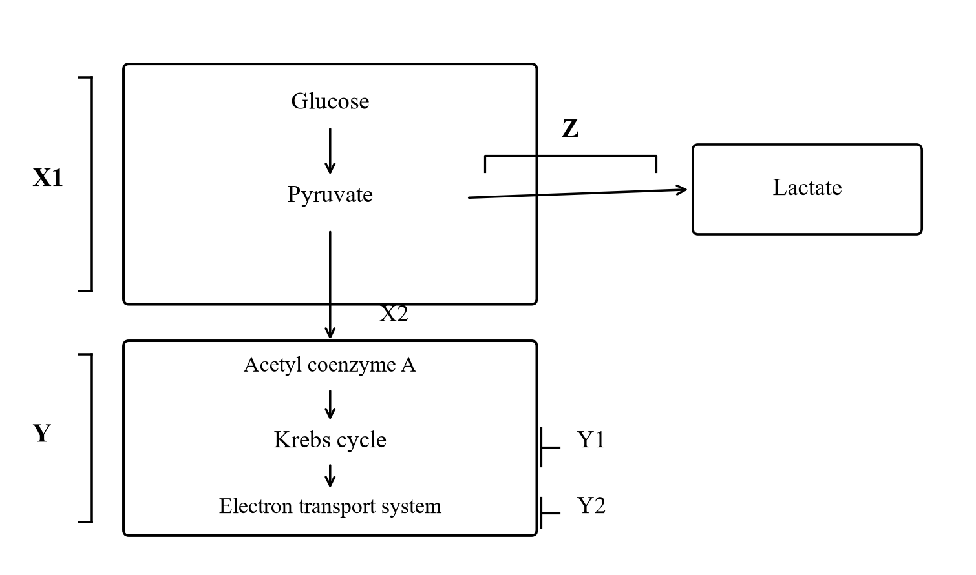
10. Which of the following is the importance of process Z to the muscle cells?
(1) It oxidizes the NADH produced in X1 so that glycolysis can take place continuously.
(2) It permits the additional supply of biological energy during vigorous exercise.
(3) It provides an alternate process of providing biological energy in the presence of oxygen.
A. (1) and (2) only
B. (2) and (3) only
C. (1) and (3) only
D. (1), (2) and (3)
11. At which processes will carbon dioxide be released?
A. X1 and X2
B. X2 and Y1
C. Y and Z
D. X1 and Z
12. What happen to most of the NADH formed in the Krebs cycle of a plant cell?
A. They oxidise the pyruvate to carbon dioxide and water.
B. They undergo redox reactions in the cristae of the mitochondrion to produce ATP.
C. They oxidise in the light stage of the cell.
D. They take part in the regeneration of the starting material needed for Krebs cycle.
13. Which of the following flow charts is CORRECT to outline the events taking place in aerobic respiration?
A. Glucose → Pyruvate → Triose phosphate → Krebs cycle → Acetyl Co-A → CO2 + H2O + ATP
B. Glucose → Triose phosphate → Pyruvate → Acetyl Co-A → Krebs cycle → CO2 + H2O + ATP
C. Glucose → Triose phosphate → Pyruvate → Acetyl Co-A → CO2 + H2O + ATP → Krebs cycle
D. Glucose → Triose phosphate → Acetyl Co-A → Pyruvate → Krebs cycle → CO2 + H2O + ATP
14. Which of the following processes is most effective to release energy in form of ATP?
A. Oxidation of pyruvate to lactate
B. Oxidation of pyruvate to carbon dioxide and water
C. Oxidation of glucose to carbon dioxide and ethanol
D. Oxidation of glucose to pyruvate
15. What is the role of molecular oxygen in aerobic respiration?
A. To oxidise triose phosphate to pyruvate
B. To oxidise the phosphorylation of ADP to ATP
C. To remove hydrogen from the coenzyme NADH
D. To combine with carbon released from the breakdown of triose phosphate to form carbon dioxide
16. Which of the following is the proper order of drawing energy in case of starvation?
(1) Breakdown of proteins in body tissues to amino acids which are shifted to the Krebs cycle for energy release.
(2) Mobilization of fats from adipose tissues and their subsequent oxidation to release energy.
(3) Conversion of glycogen in liver and muscles to glucose for energy release.
A. (1) → (2) → (3)
B. (3) → (2) → (1)
C. (2) → (3) → (1)
D. (3) → (1) → (2)
17. The passage of electrons along the electron transport chain in plant cell is mainly coupled with the
A. fixation of carbon dioxide.
B. dehydrogenation of triose phosphate.
C. formation of ATP.
D. regeneration of carbon dioxide acceptor (RuBP).
Directions: Questions 18 and 19 refer to the experiment below. Three groups of pea seeds were treated differently and put into three separate thermoflasks X, Y and Z. A thermometer was put in each flask with the bulb embedded in the seeds, and a plug of cotton wool was put at the neck of each flask. The readings were recorded at regular intervals for three days.
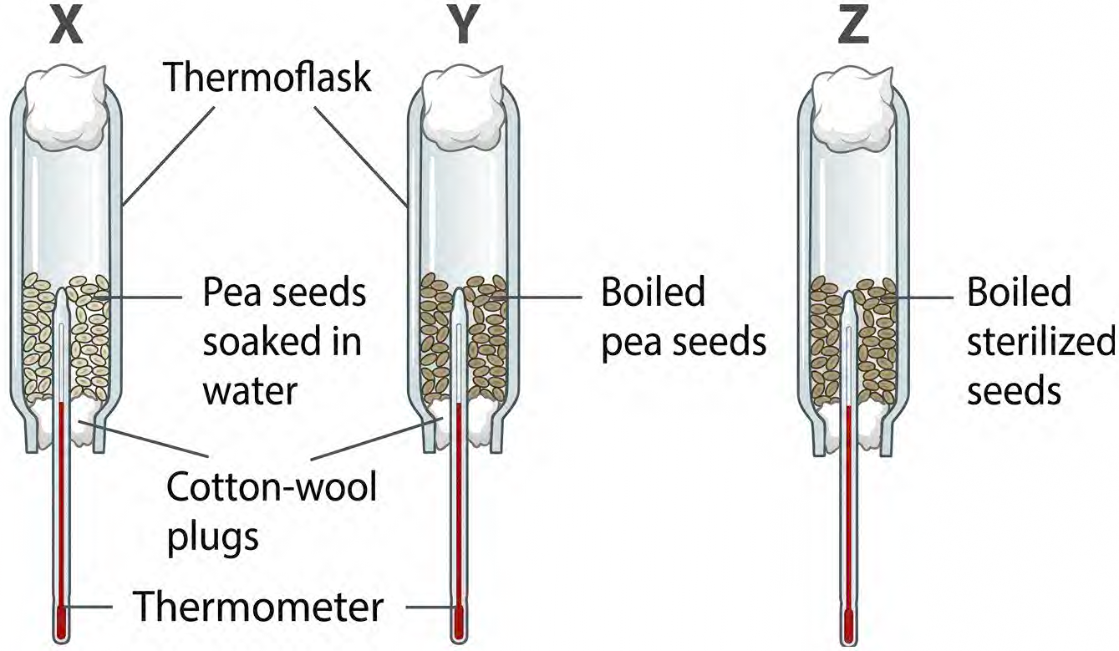
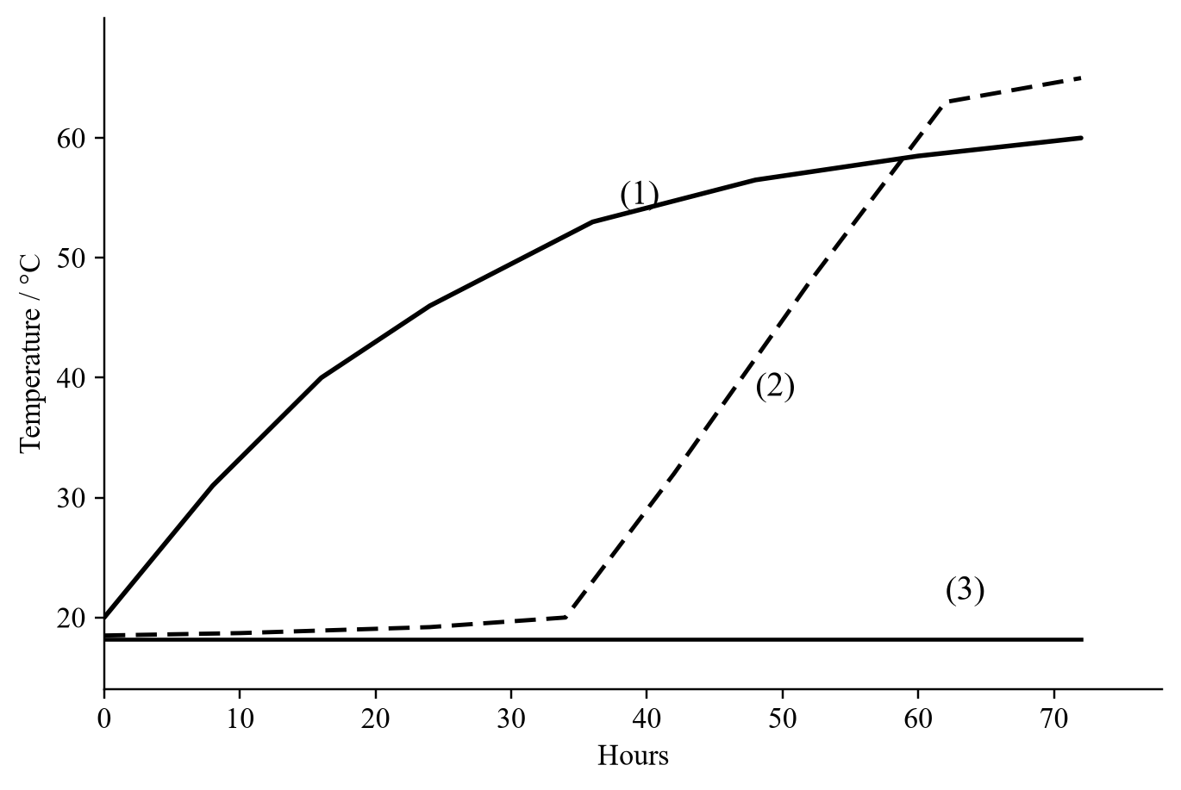
18. The thermoflasks are NOT completely packed with seeds. The reason is
A. to provide a layer of air above the seeds that acts as an insulator to reduce heat loss.
B. to provide space for the carbon dioxide to accumulate in order to speed up the rate of photosynthesis.
C. to provide air to support the aerobic respiration of the seeds.
D. to provide space for the seeds to grow.
19. If the thermoflasks were replaced by metal containers, which curve(s) would change its / their shape?
A. (1) only
B. (2) only
C. (3) only
D. (1) and (2) only
Directions: Questions 20 and 21 refer to the diagram below, which shows an experiment in progress.
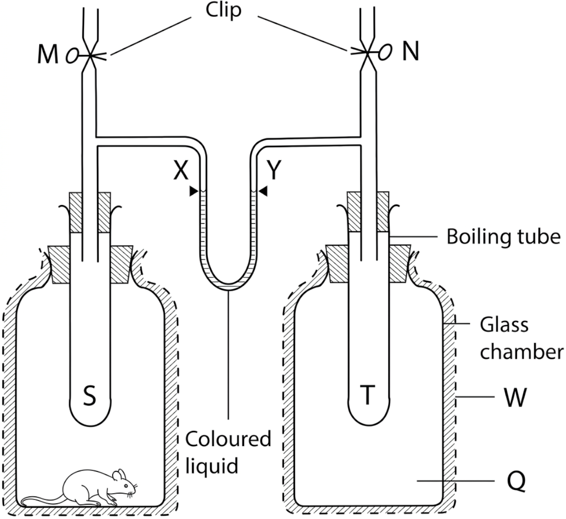
20. In order to make the result more satisfactory, W should be
A. a piece of black cloth.
B. a layer of cotton wool.
C. a sheet of aluminium foil.
D. an additional glass sheet.
21. Which of the following is the reason accounting to the change in level of the coloured liquid in tube X?
A. The carbon dioxide released by the rat diffuses into the boiling tube S and increases the pressure there.
B. The absence of a rat in Q sets up a suction force that draws the coloured liquid up the tube Y.
C. The water vapour released by the rat through perspiration, urination and expiration increases the vapour pressure in the boiling tube S, thus increasing the pressure there.
D. The heat released by the rat causes the air inside boiling tube S to expand and presses the coloured liquid down tube X.
Directions: Questions 22 and 23 refer to the set-up below, which is used to study the gas exchange of a rat.
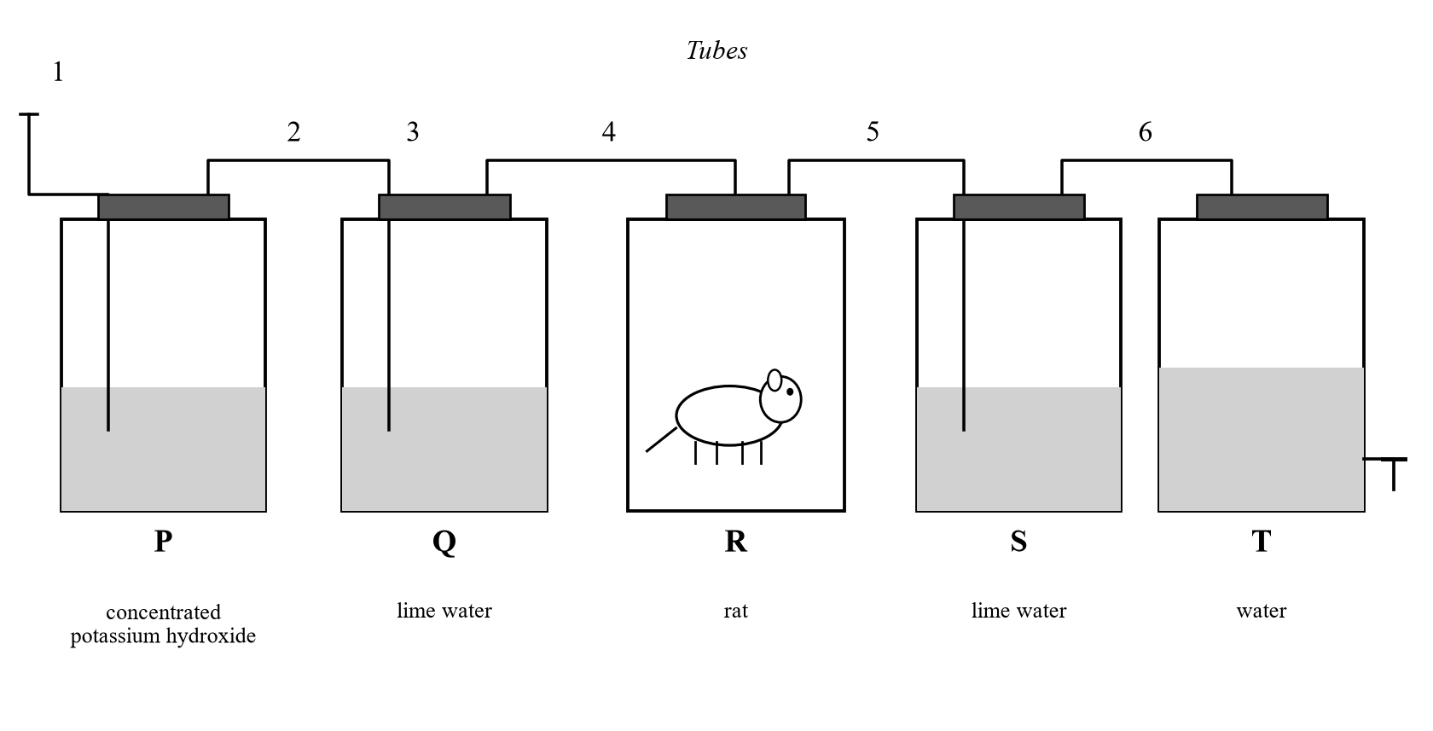
22. The function of the solution in bottle P is to
A. indicate the presence of carbon dioxide in the incoming air.
B. neutralize the incoming air so that the pH value of the cellular fluid of the rat will not be affected.
C. absorb the carbon dioxide present in the incoming air.
D. absorb the water vapour in the incoming air.
23. The control for the above experiment is prepared by
A. putting distilled water instead of potassium hydroxide in bottle P.
B. leaving bottle R empty.
C. covering bottle R with a piece of black cloth.
D. using a filter pump instead of bottle T.
Directions: Questions 24 and 25 refer to the set-up below, which is used to study the respiration of a frog.
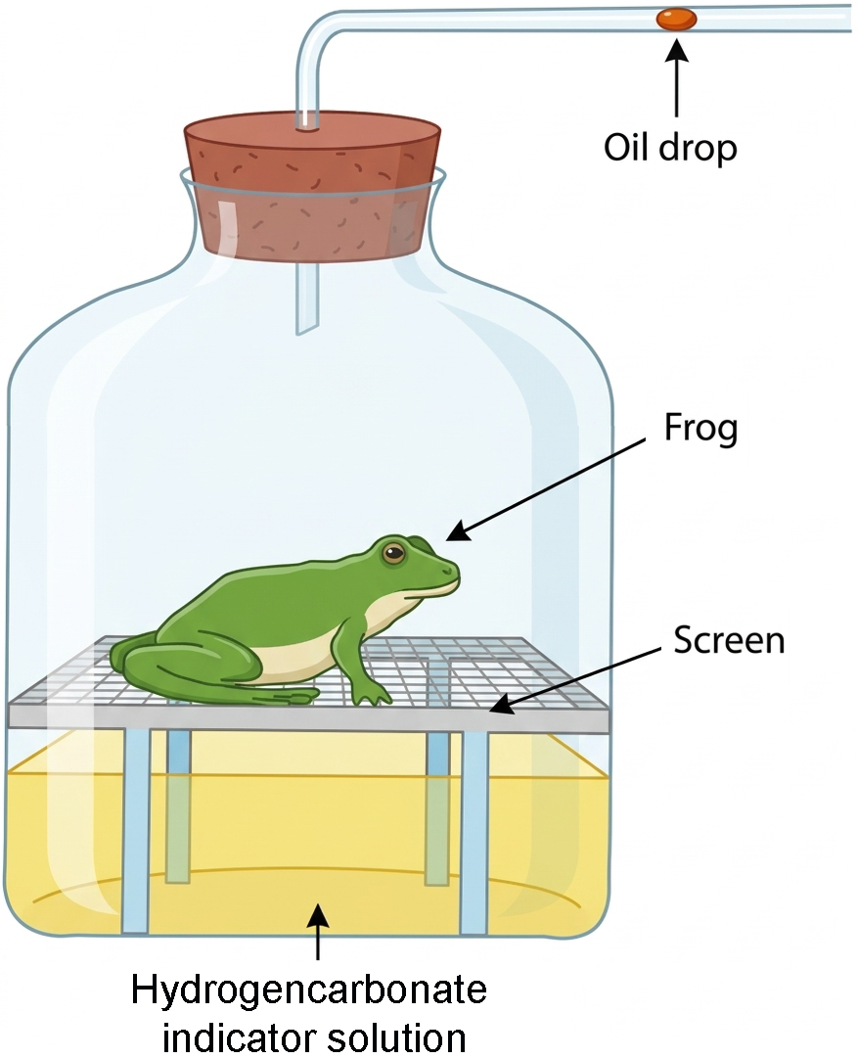
24. At the end of the experiment the oil drop moves inward. Which of the following CORRECTLY account(s) for this result?
(1) Uptake of oxygen by the frog.
(2) An increase in atmospheric pressure.
(3) An increase in temperature of the surrounding.
A. (1) only
B. (2) only
C. (1) and (2) only
D. (1) and (3) only
25. If the hydrogencarbonate indicator solution is replaced by potassium hydroxide solution, what will happen to the result of the experiment if the environmental conditions remain unchanged?
A. The oil drop moves outwards.
B. The oil drop moves further inwards.
C. The potassium hydroxide solution turns milky.
D. The potassium hydroxide solution turns yellow.
Part C — additional difficult items (areas not covered by the under-80% set, or unfamiliar scenarios)
These stems are rewritten from the demand of OUP mock Paper 1A respiration items and class gaps. Graphs are drawn for this paper. Electron micrographs from the mock file are not used.
26. If radioactively-labelled oxygen gas is supplied to a culture of human muscle cells for a short time, in which of the following molecules produced from these cells can radioactivity first be detected?
A. pyruvate
B. ATP
C. carbon dioxide
D. water
Directions: Question 27 refers to an investigation in which intact mitochondria were extracted from liver cells. A glucose solution was added to the extract at time 0. After 5 minutes, a pyruvate solution was added. ADP and phosphate were present throughout.
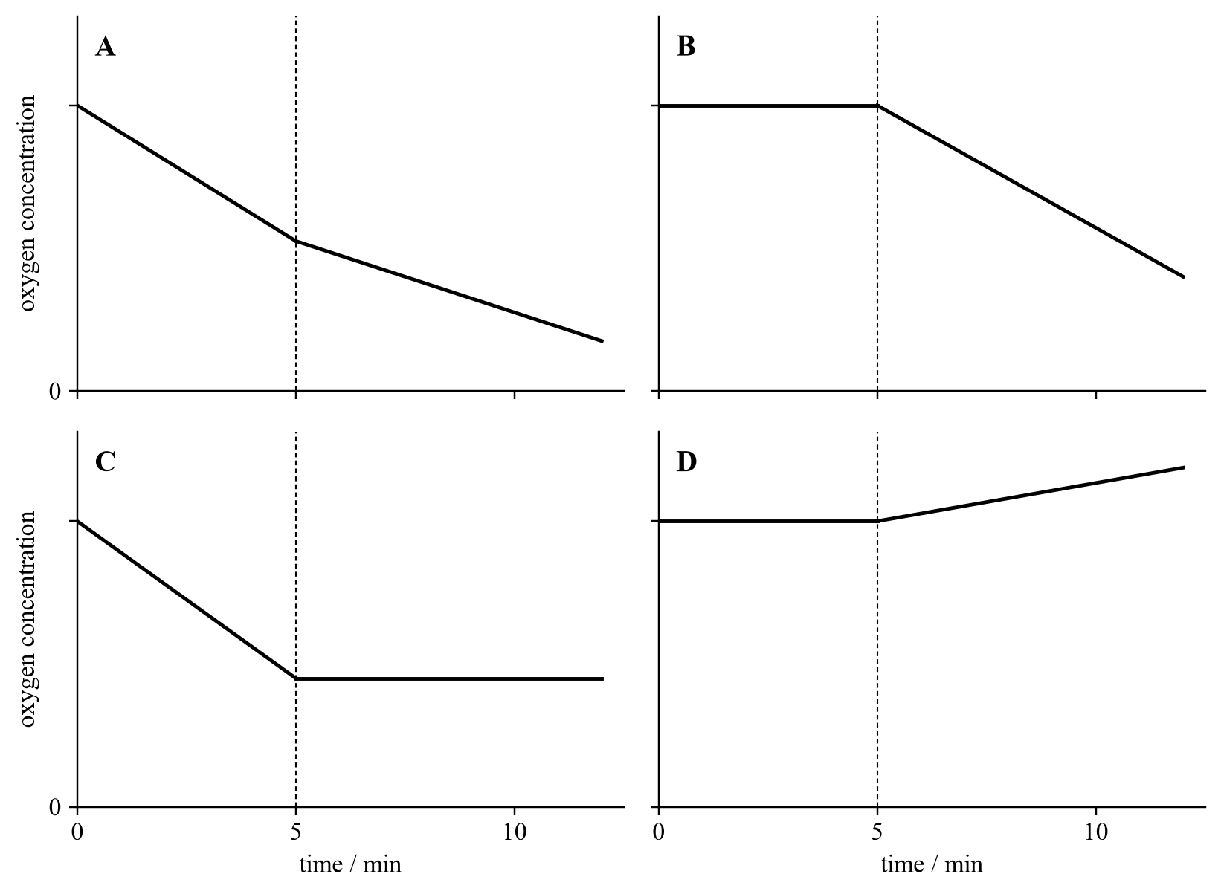
27. Which graph correctly shows the change in oxygen concentration in the extract?
A. Graph A
B. Graph B
C. Graph C
D. Graph D
28. A student set up a tube containing freshly isolated mitochondria, pyruvate, ADP and phosphate. Oxygen was supplied throughout. ATP was produced. Which of the following about the experiment is/are correct?
(1) Carbon dioxide was evolved from the tube.
(2) Little or no ATP would be produced if oxygen was not supplied.
(3) More ATP would be produced if glucose was used instead of pyruvate.
A. (1) only
B. (2) only
C. (1) and (2) only
D. (1) and (3) only
29. The inner membrane of a mitochondrion is highly folded. The enzymes packed on this membrane include those which catalyse
A. the conversion of glucose to pyruvate.
B. the conversion of pyruvate to acetyl-CoA.
C. the conversion of ATP to ADP.
D. the conversion of NADH to NAD.
Directions: Question 30 refers to the graph below, which shows the rate of oxygen uptake of a person before, during and after a period of vigorous exercise.
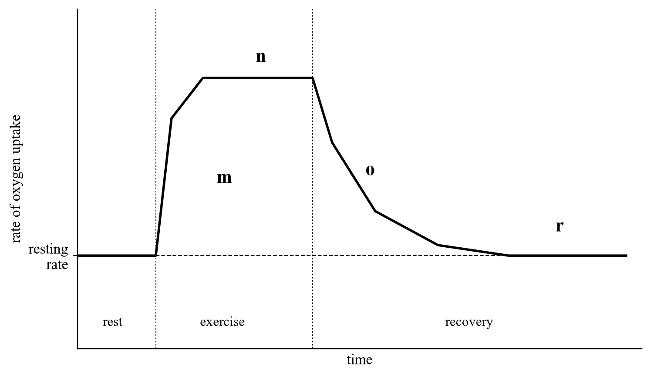
30. The oxygen debt of the person can be obtained by measuring the area of
A. m.
B. o.
C. n + o.
D. o + r.
31. The following are some processes in respiration or photosynthesis. Which of them produce ATP?
(1) Krebs cycle
(2) Calvin cycle
(3) glycolysis
(4) oxidative phosphorylation
A. (1) and (2) only
B. (3) and (4) only
C. (1), (3) and (4) only
D. (2), (3) and (4) only
32. Which of the following biochemical pathways use energy from ATP?
(1) conversion of glucose to triose phosphate in glycolysis
(2) regeneration of the 4-C compound in the Krebs cycle
(3) regeneration of the carbon dioxide acceptor in the Calvin cycle
A. (1) and (2) only
B. (1) and (3) only
C. (2) and (3) only
D. (1), (2) and (3)
33. In anaerobic respiration of skeletal muscles, pyruvate is converted to lactic acid. Which of the following statements about this reaction is correct?
A. Two ATP are produced in this conversion.
B. Carbon dioxide is produced.
C. NADH is oxidized to NAD.
D. The reaction occurs in the mitochondrial matrix.
Directions: Question 34 refers to an experiment with mitochondria extracted from liver tissue, placed in a solution containing ADP and inorganic phosphate. Succinate was added, then inhibitor C. Inhibitor C targets membrane proteins in the inner mitochondrial membrane that are involved in respiration. The amounts of oxygen consumed and of ATP formed were recorded.
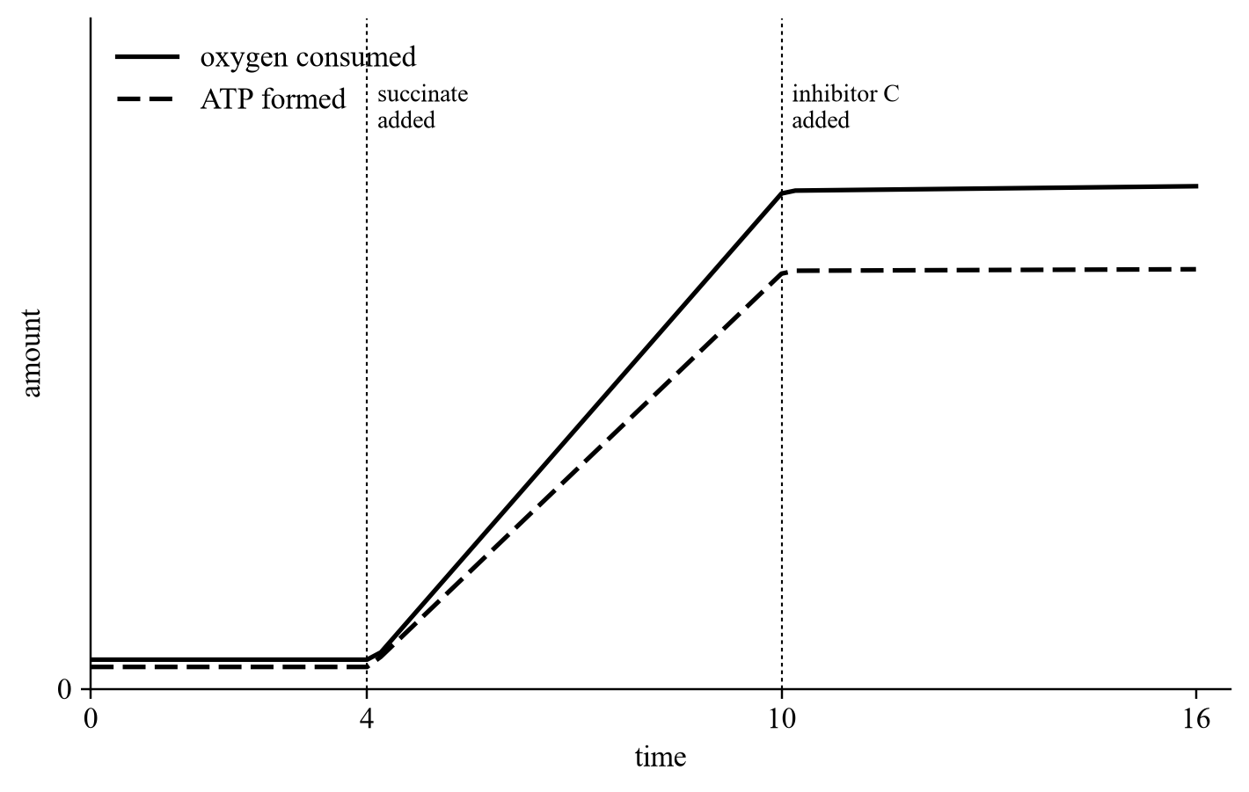
34. Which of the following can be deduced from the results?
(1) Succinate is an intermediate of glycolysis.
(2) Inhibitor C stops the synthesis of ATP that is coupled to oxygen use.
(3) Oxidative phosphorylation takes place at the inner membrane of mitochondria.
A. (2) only
B. (1) and (2) only
C. (1) and (3) only
D. (2) and (3) only
Directions: Question 35 refers to the experiment below. Yeast cells were added to an oxygen-free glucose solution. After 6 hours, oxygen was supplied. The graph shows the rate of carbon dioxide production.
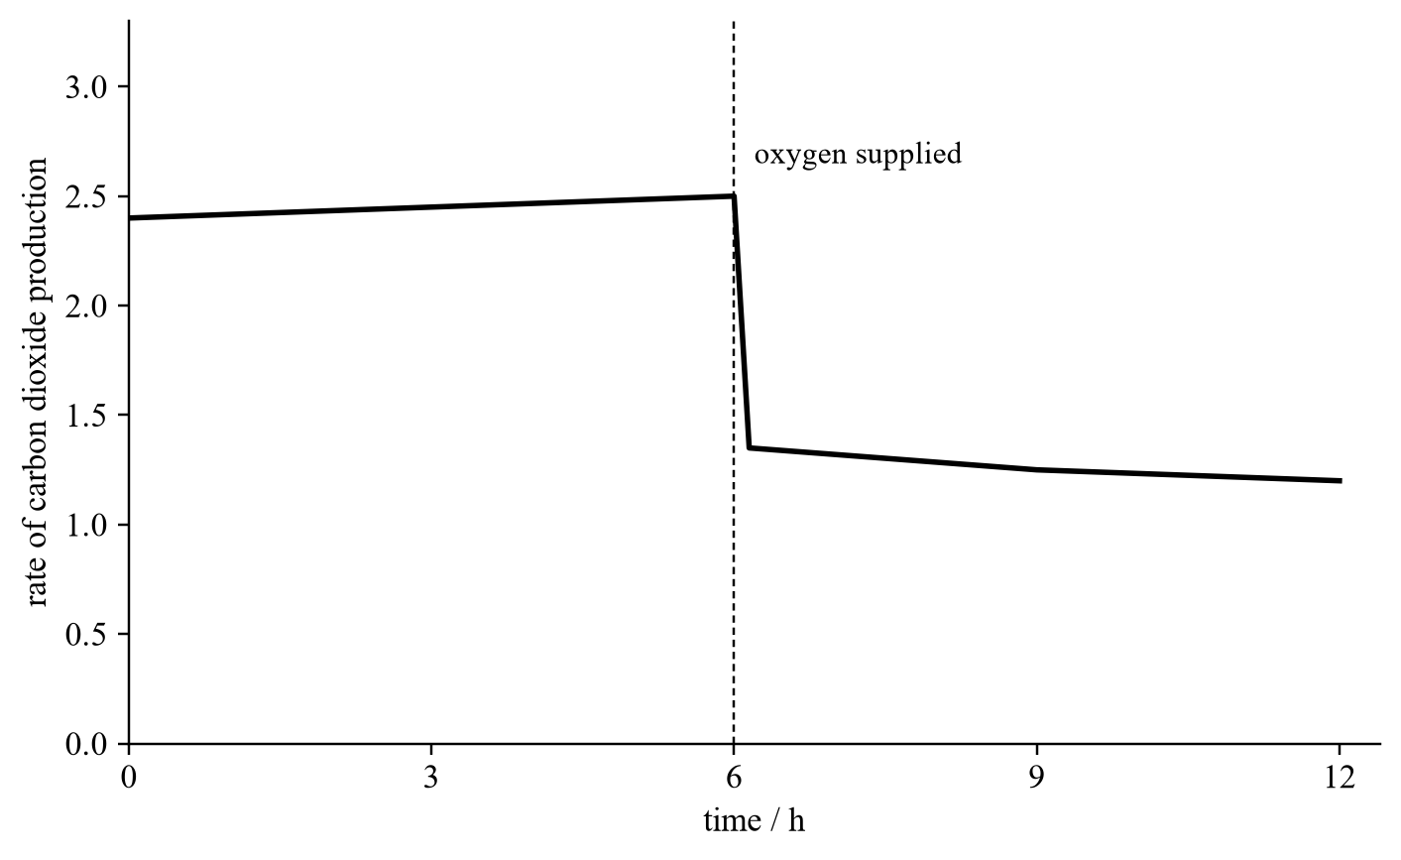
35. At which time is the concentration of alcohol in the suspension the highest?
A. time 0
B. 3rd hour
C. 6th hour
D. 9th hour
36. Yeast cells were ground with distilled water. After centrifugation, the supernatant contained cytoplasm and the precipitate contained mitochondria. Three tubes were prepared as shown and kept at 35 °C in air-free conditions for two days.
Tube | Portion of ground yeast | Glucose solution
A | Supernatant | added
B | Precipitate | added
C | Whole suspension, not centrifuged | added

Which of the following would happen?
A. No reaction would occur in tube B.
B. Carbon dioxide and water would be the end products in tube A.
C. A large quantity of ATP would be produced in tube C.
D. No carbon dioxide would be produced in tube C.
Answers
Answers are printed in red. Class percentages are from the Google Form, matched by wording.
1. B Class: 58.3% correct (n=12) usual slip A
2. A Class: 72.4% correct (n=29) usual slip D
3. C Class: 75.9% correct (n=29) usual slip B
4. D Class: 50.0% correct (n=12) usual slip A
5. D Class: 50.0% correct (n=12) usual slip B
6. C Class: 66.7% correct (n=12) usual slip D
7. A Class: 50.0% correct (n=12) usual slip D
8. A Class: 58.3% correct (n=12) usual slip B
9. C Class: 58.8% correct (n=17) usual slip B
10. A Class: 65.5% correct (n=29) usual slip D
11. B Class: 50.0% correct (n=12) usual slip C
12. B Class: 75.0% correct (n=12) usual slip A
13. B Class: 79.3% correct (n=29) usual slip C
14. B Class: 50.0% correct (n=12) usual slip A
15. C Class: 69.0% correct (n=29) usual slip C
16. B Class: 55.2% correct (n=29) usual slip D
17. C Class: 75.0% correct (n=12) usual slip A
18. C Class: 66.7% correct (n=12) usual slip A
19. D Class: 75.0% correct (n=12) usual slip C
20. B Class: 66.7% correct (n=12) usual slip A
21. D Class: 75.0% correct (n=12) usual slip C
22. C Class: 75.0% correct (n=12) usual slip C
23. B Class: 66.7% correct (n=12) usual slip A
24. B Class: 66.7% correct (n=12) usual slip D
25. B Class: 50.0% correct (n=12) usual slip A
26. D Difficult · labelled O2 ends in water
27. B Difficult · mitochondria cannot use glucose
28. C Difficult · (1) and (2) only; glucose is not a mitochondrial substrate
29. D Difficult · inner membrane: NADH → NAD
30. B Difficult · oxygen debt is area o after exercise
31. C Difficult · ATP from Krebs, glycolysis and oxidative phosphorylation, not Calvin
32. B Difficult · ATP used in glycolysis and in regenerating the CO2 acceptor
33. C Difficult · lactate formation oxidizes NADH to NAD
34. A Difficult · (2) only; the graph does not show where the process occurs
35. C Difficult · alcohol is highest when oxygen is first supplied
36. A Difficult · mitochondria alone cannot start from glucose
Answer summary
Q | Answer | Source
1 | B | Class <80%
2 | A | Class <80%
3 | C | Class <80%
4 | D | Class <80%
5 | D | Class <80%
6 | C | Class <80%
7 | A | Class <80%
8 | A | Class <80%
9 | C | Class <80%
10 | A | Class <80%
11 | B | Class <80%
12 | B | Class <80%
13 | B | Class <80%
14 | B | Class <80%
15 | C | Class <80%
16 | B | Class <80%
17 | C | Class <80%
18 | C | Class <80%
19 | D | Class <80%
20 | B | Class <80%
21 | D | Class <80%
22 | C | Class <80%
23 | B | Class <80%
24 | B | Class <80%
25 | B | Class <80%
26 | D | Difficult · labelled O2 ends in water
27 | B | Difficult · mitochondria cannot use glucose
28 | C | Difficult · (1) and (2) only; glucose is not a mitochondrial substrate
29 | D | Difficult · inner membrane: NADH → NAD
30 | B | Difficult · oxygen debt is area o after exercise
31 | C | Difficult · ATP from Krebs, glycolysis and oxidative phosphorylation, not Calvin
32 | B | Difficult · ATP used in glycolysis and in regenerating the CO2 acceptor
33 | C | Difficult · lactate formation oxidizes NADH to NAD
34 | A | Difficult · (2) only; the graph does not show where the process occurs
35 | C | Difficult · alcohol is highest when oxygen is first supplied
36 | A | Difficult · mitochondria alone cannot start from glucose

36 items. Original under-80 file was not overwritten. Not posted to the web. Part C graphs are original drawings of the same experimental meaning as OUP Paper 1A respiration items.

