St. Stephen’s Girls’ College
Biology
Reproduction in humans
32 multiple-choice items · teacher check
Name: ________________________ Class: ________ Class no.: ________
Setter: Miss Lai K.F.
Practice 1 (Questions 1 to 16). Reproductive systems, gametes and the menstrual cycle.
Practice 2 (Questions 17 to 32). Pregnancy, birth and contraception.
Choose the one best answer. On this teacher copy the keyed option is printed in red. Do not give this copy to students. Growth curves and seed germination are not in this paper.
1. [class 67%, n=55] Which of the following statements about a sperm cell is incorrect?
A. The chromosomes in a sperm cell cannot pair up.
B. The whole sperm cell fuses with an ovum during fertilisation.
C. It is produced in the testes.
D. The DNA content of a sperm cell is half that of the sperm mother cell.
Directions: Question 2 refers to the diagrams of two human gametes below.
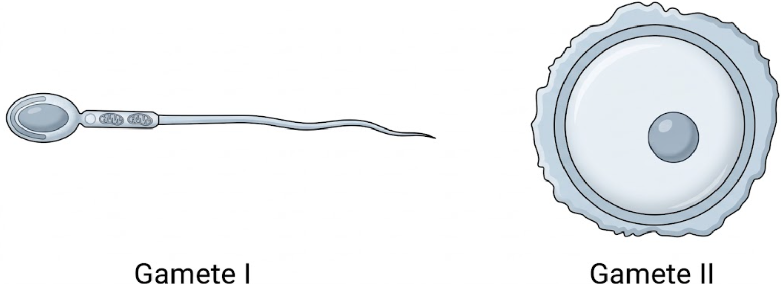
2. [class 73%, n=96] In humans, gamete II is much bigger than gamete I because it
A. contains more food reserve.
B. contains more chromosomes.
C. contains more mitochondria.
D. does not need to move away from the ovary.
3. [class 65%, n=34] Humans produce relatively few viable eggs. Each egg mother cell undergoes two consecutive divisions to produce four daughter cells, of which only one remains viable as the egg. The number of chromosomes in this viable egg is
A. four times that in the egg mother cell.
B. twice that in the egg mother cell.
C. equal to that in the egg mother cell.
D. half that in the egg mother cell.
Directions: Questions 4 to 6 refer to the front view of the male reproductive system below.
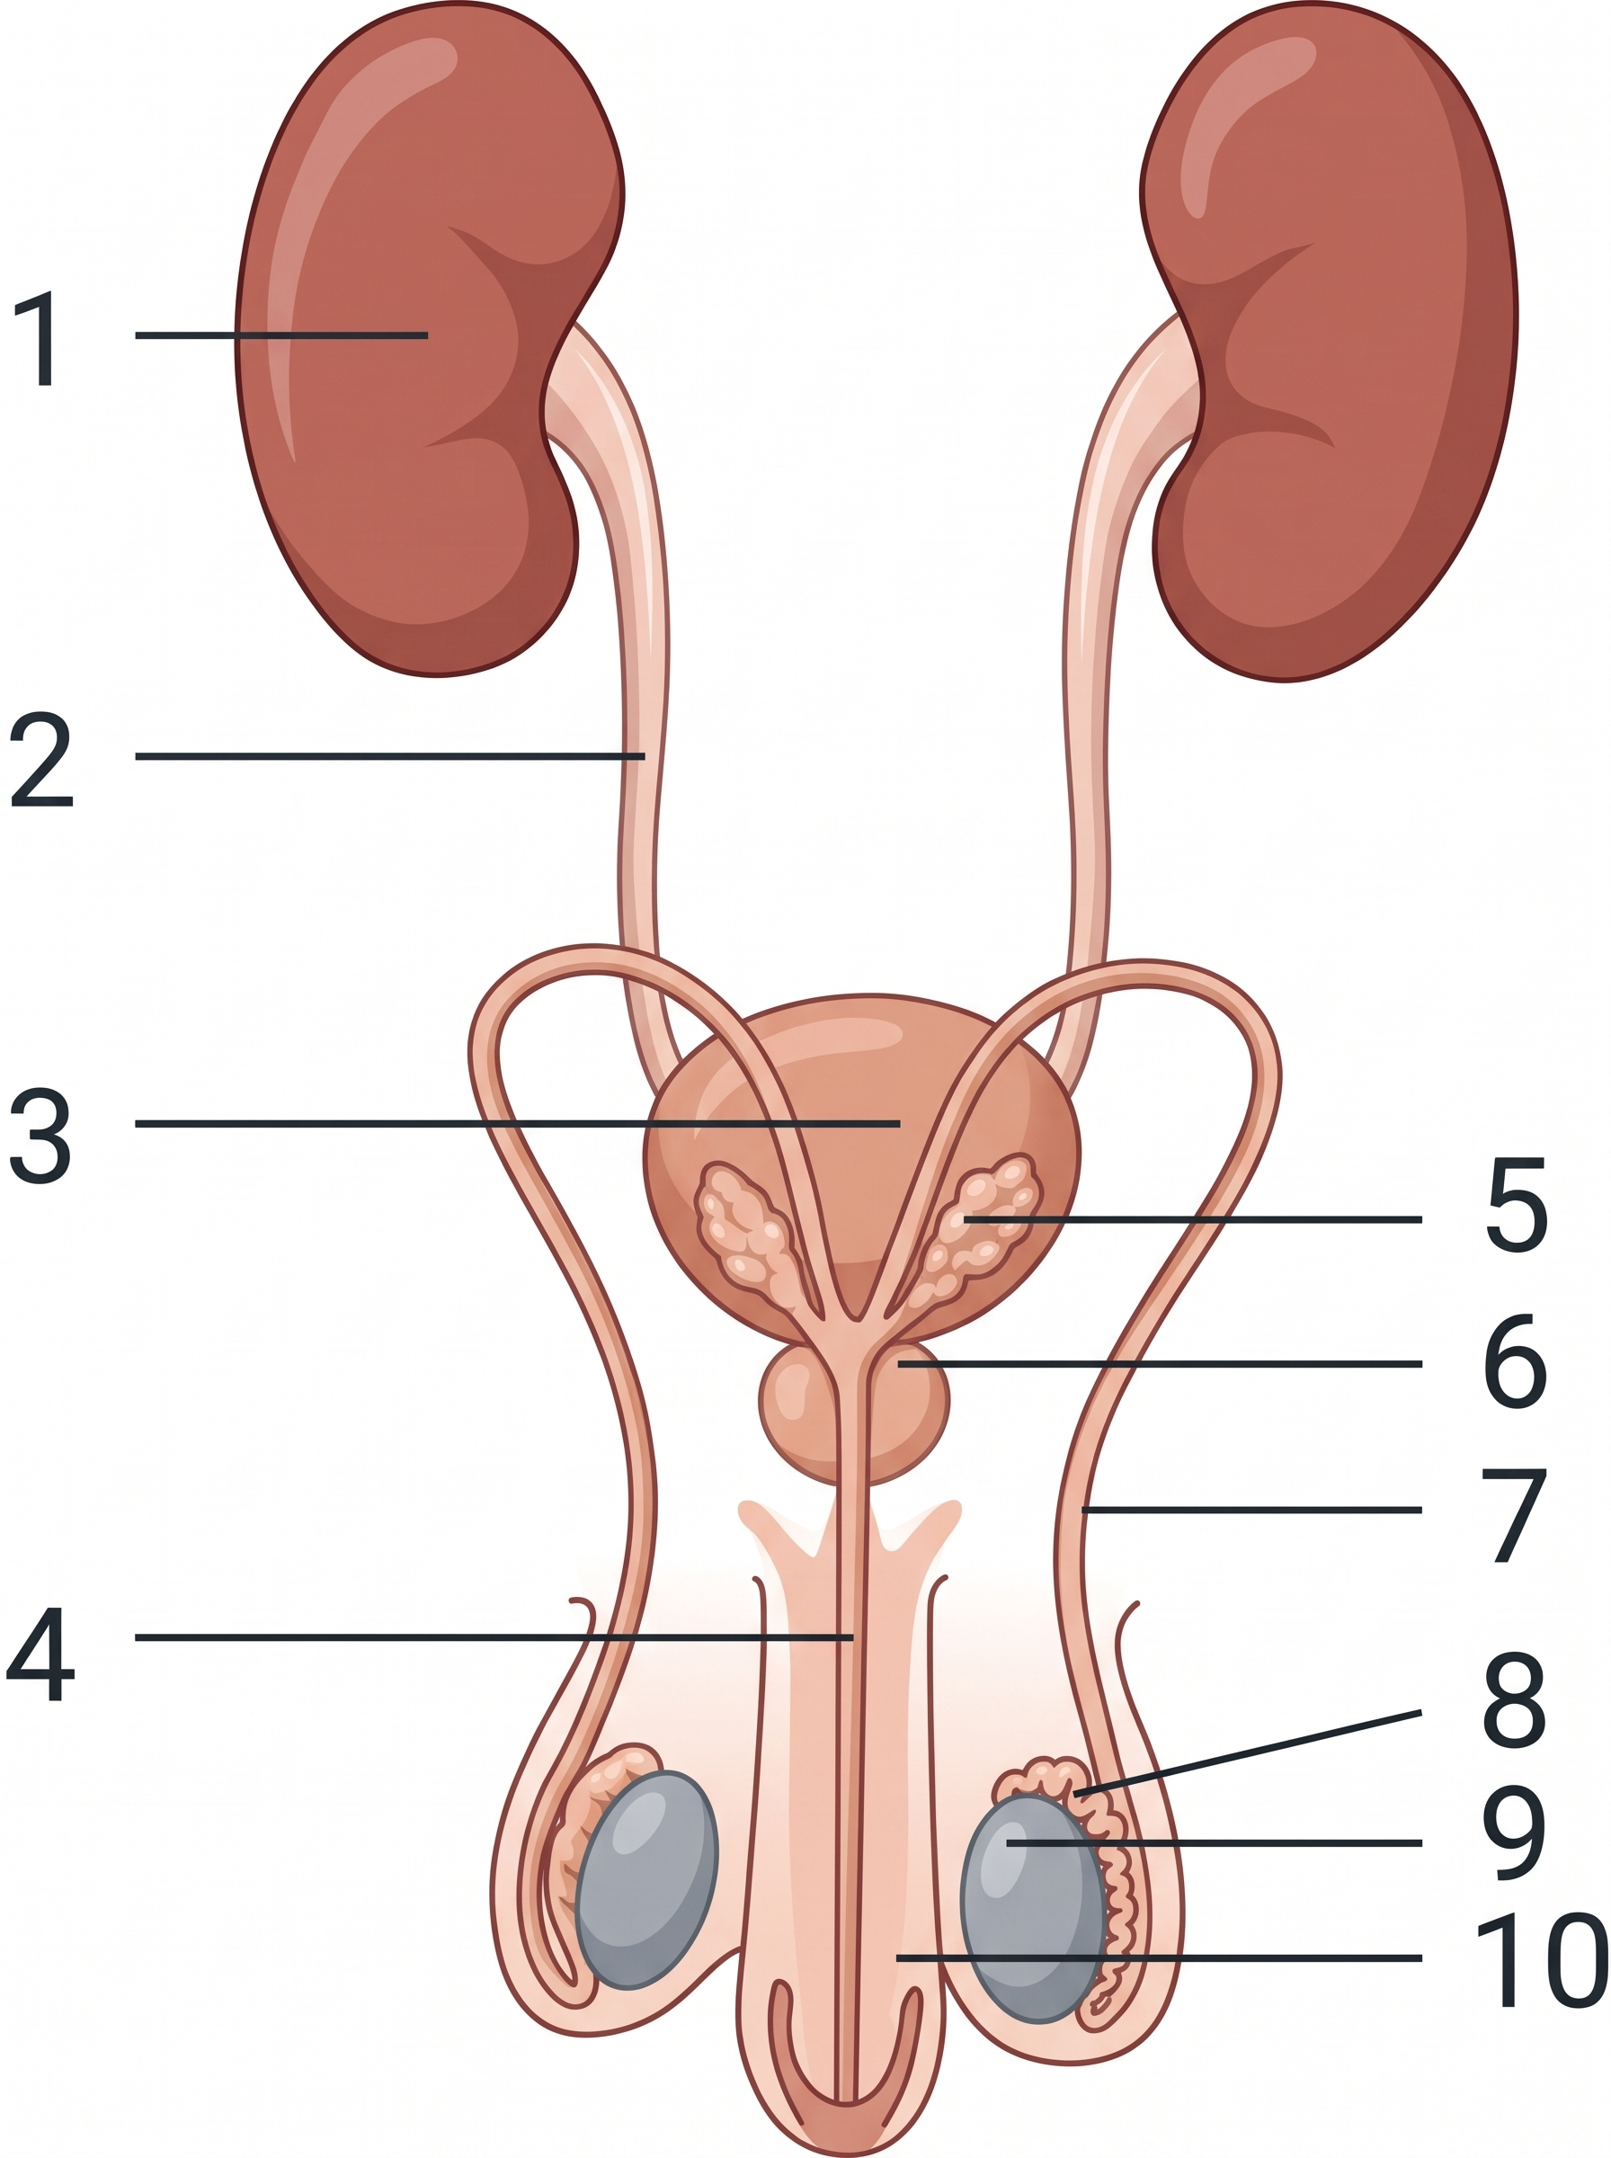
4. [class 73%, n=130] If structure 9 remains inside the abdomen, which of the following may occur?
A. No sperms are produced.
B. The sex hormones are denatured at the relatively high body temperature.
C. The sperms produced are inactivated at the relatively high body temperature.
D. Secondary sexual characteristics cannot develop properly.
5. [class 36%, n=55] The pathway of the sperms passing out of the body is
A. 9 → 7 → 4
B. 2 → 7 → 4
C. 1 → 2 → 4
D. 2 → 3 → 4
6. [class 67%, n=55] Which structure(s) can greatly increase its (their) volume(s)?
A. 3 only
B. 10 only
C. 3 and 10 only
D. 1 and 3 only
Directions: Questions 7 to 9 refer to the male and female reproductive systems below.

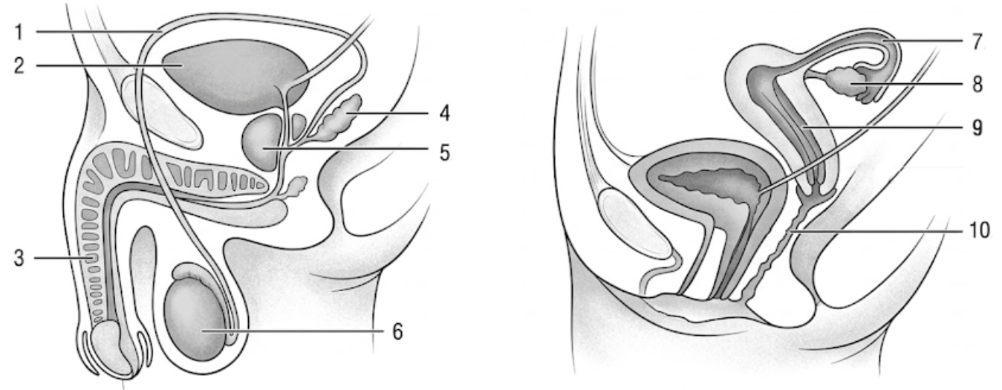
7. [class 71%, n=34] Which structures produce haploid cells?
A. 2 and 7
B. 3 and 10
C. 4 and 5
D. 6 and 8
8. [class 74%, n=35] Which structure permits both reproductive cells and excretory wastes to leave the body?
A. 1
B. 3
C. 7
D. 10
9. [class 76%, n=55] Which of the following methods provides permanent contraception?
A. Cut and tie structure 1, present on both sides of the body.
B. Wrap a condom around structure 3 during sexual intercourse.
C. Put an intrauterine device in structure 9.
D. Put a diaphragm at the top of structure 10.
10. [class 70%, n=37] Which of the following is incorrect?
 | Part of the male reproductive system | Function
A. | testis | production of male sex hormone
B. | epididymis | storage of semen
C. | prostate gland | production of seminal fluid
D. | urethra | passage for semen

Directions: Questions 11 and 12 refer to the female reproductive system below.
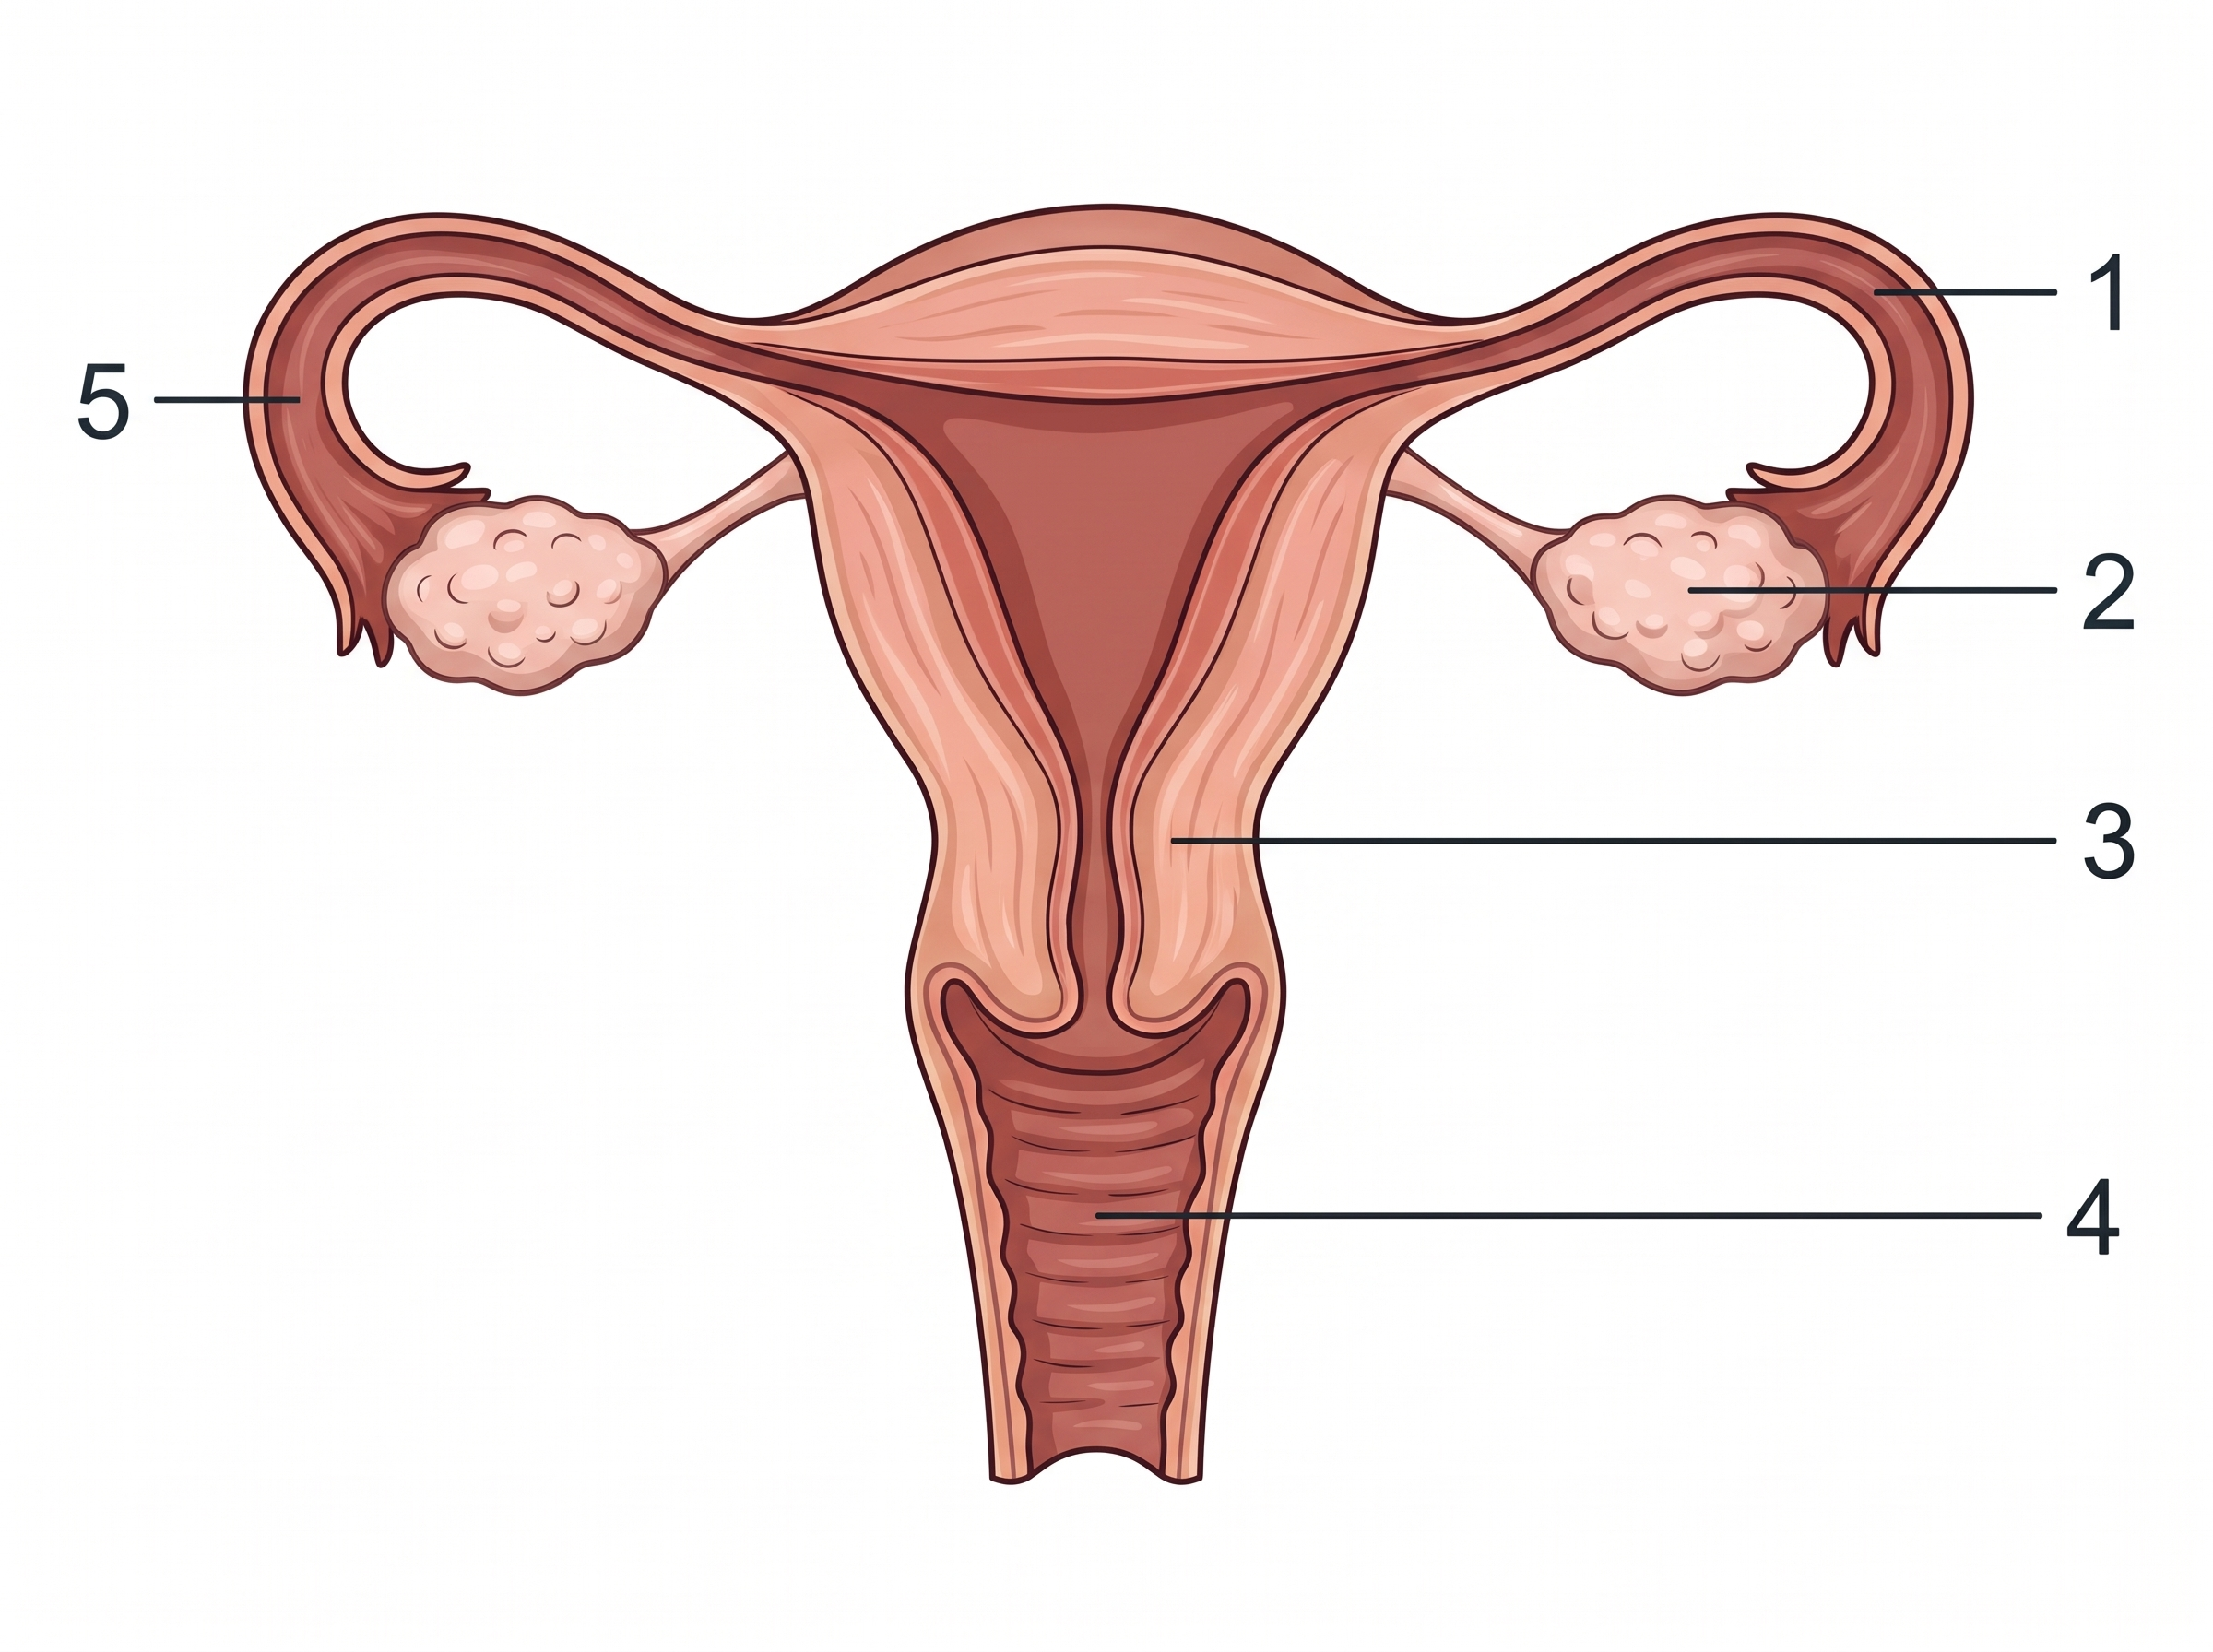
11. [class 55%, n=67] The site of action of contraceptive pills is mainly at
A. 1.
B. 2.
C. 3.
D. 4.
12. [class 43%, n=67] If the woman wants contraception by a surgical method, where should the reproductive system be cut and tied?
A. 1
B. 1 and 4
C. 1 and 5
D. 4 and 5
13. [class 35%, n=37] Which of the following statements about the menstrual cycle is incorrect?
A. It begins at puberty and stops at menopause.
B. It is maintained by the interactions of hormones.
C. It occurs in female mammals only.
D. The cycle is 28 days long.
Directions: Question 14 refers to the female reproductive system below.
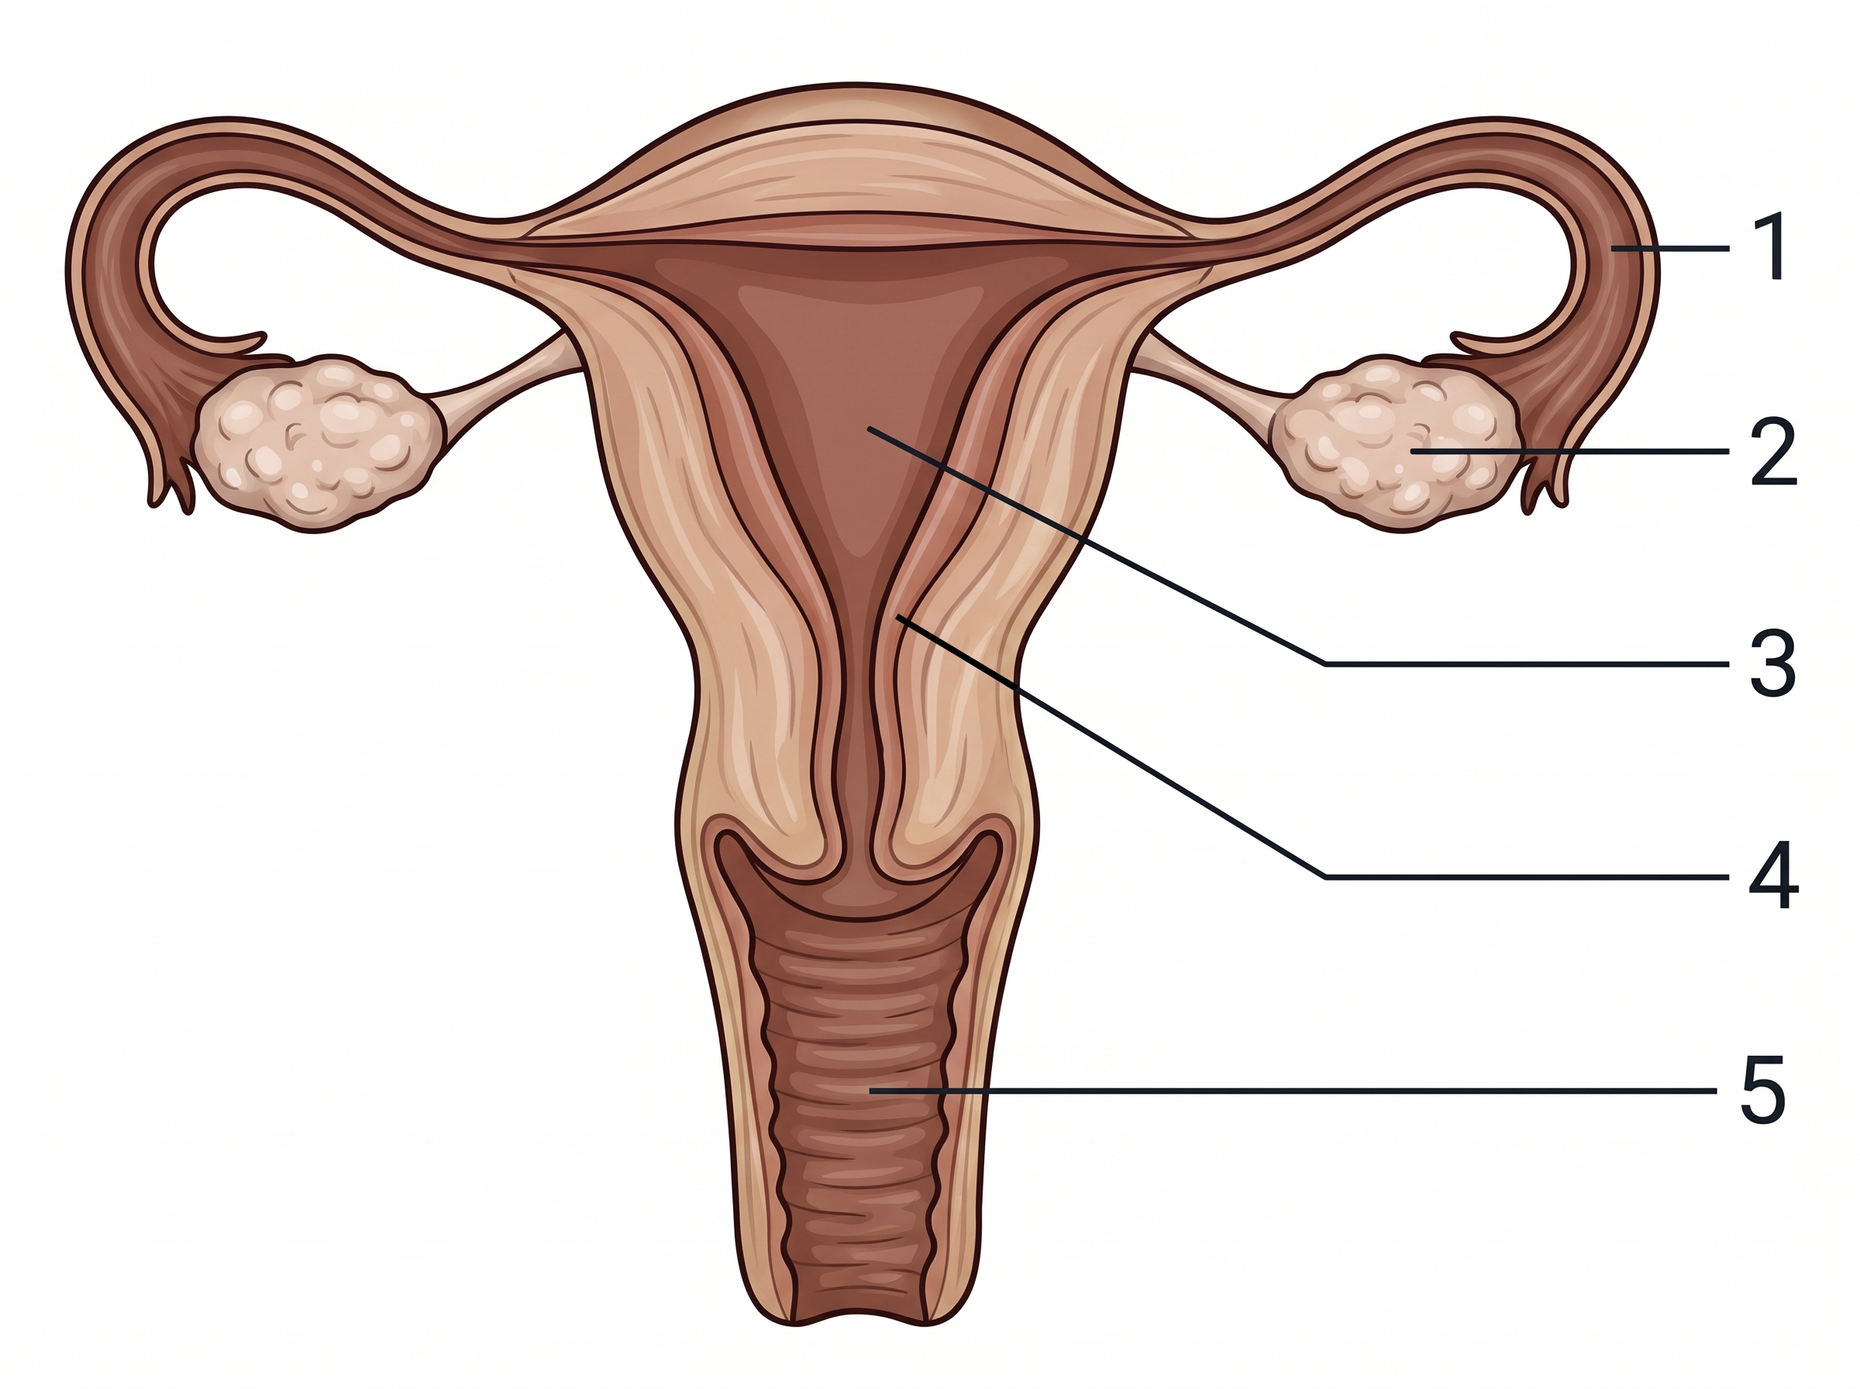
14. [class 71%, n=65] Which of the following is not a reason for structure 4 being muscular and richly supplied with blood vessels?
A. Structure 4 expels the placenta during labour.
B. Structure 4 nourishes the foetus.
C. Structure 4 is responsible for menstruation.
D. Structure 4 protects the foetus.
Directions: Question 15 refers to the diagrams below, which show a carpel and the female reproductive system.
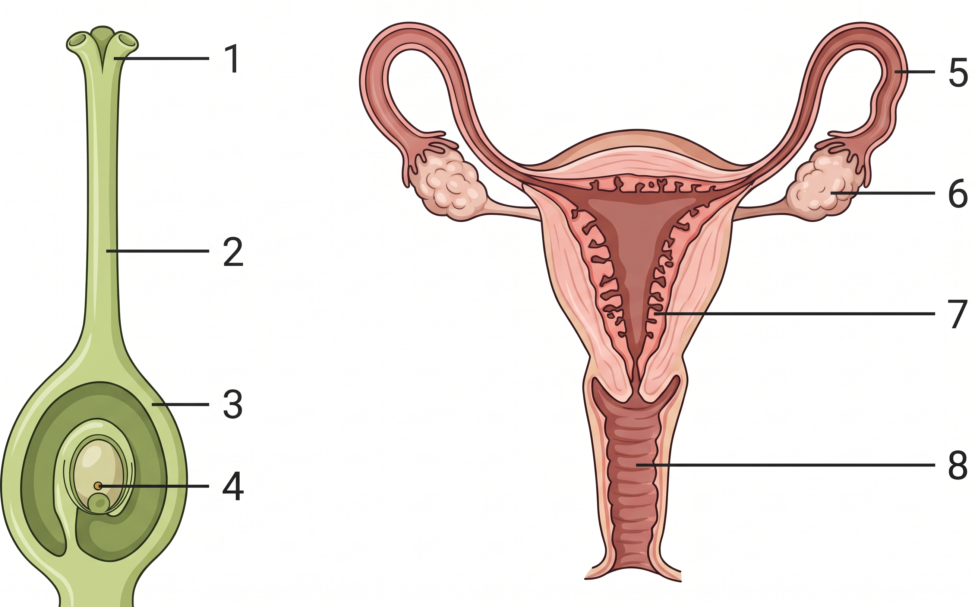

15. [class 61%, n=28] Fertilisation of the egg usually takes place in
A. 3
B. 4
C. 5
D. 6
16. [difficult extra] A baby is female, so the zygote is XX rather than XY. Which gamete caused this?
A. The ovum, because it carried an X chromosome.
B. The sperm, because it carried an X chromosome.
C. The sperm, because it carried a Y chromosome.
D. The ovum, because it carried a Y chromosome.
Practice 2
Questions 17 to 32. Pregnancy, birth and contraception.
17. [class 57%, n=37] Which of the following comparisons between a foetus and a newborn baby are correct?
(1) Digestion occurs in a newborn baby but not in a foetus.
(2) Egestion occurs in a newborn baby but not in a foetus.
(3) Excretion occurs in a newborn baby but not in a foetus.
A. (1) and (2) only
B. (1) and (3) only
C. (2) and (3) only
D. (1), (2) and (3)
18. [class item; waste direction corrected] Which of the following are functions of the placenta?
(1) It allows nutrients to diffuse from the mother’s blood to the foetal blood.
(2) It allows respiratory gases to diffuse between the mother’s blood and the foetal blood.
(3) It allows metabolic waste to diffuse from the foetal blood to the mother’s blood.
A. (1) and (2) only
B. (1) and (3) only
C. (2) and (3) only
D. (1), (2) and (3)
19. [exam 16%, n=55] The blood systems of the foetus and the mother are separate. What is the importance of this?
(1) To prevent the high blood pressure of the mother from damaging the fine blood vessels of the foetus.
(2) To avoid mixing the blood of the foetus and the mother, because their blood groups may not be compatible.
(3) To prevent viruses from entering the blood of the foetus.
A. (1) and (2) only
B. (1) and (3) only
C. (2) and (3) only
D. (1), (2) and (3)
Directions: Question 20 refers to the foetus in the mother’s body.
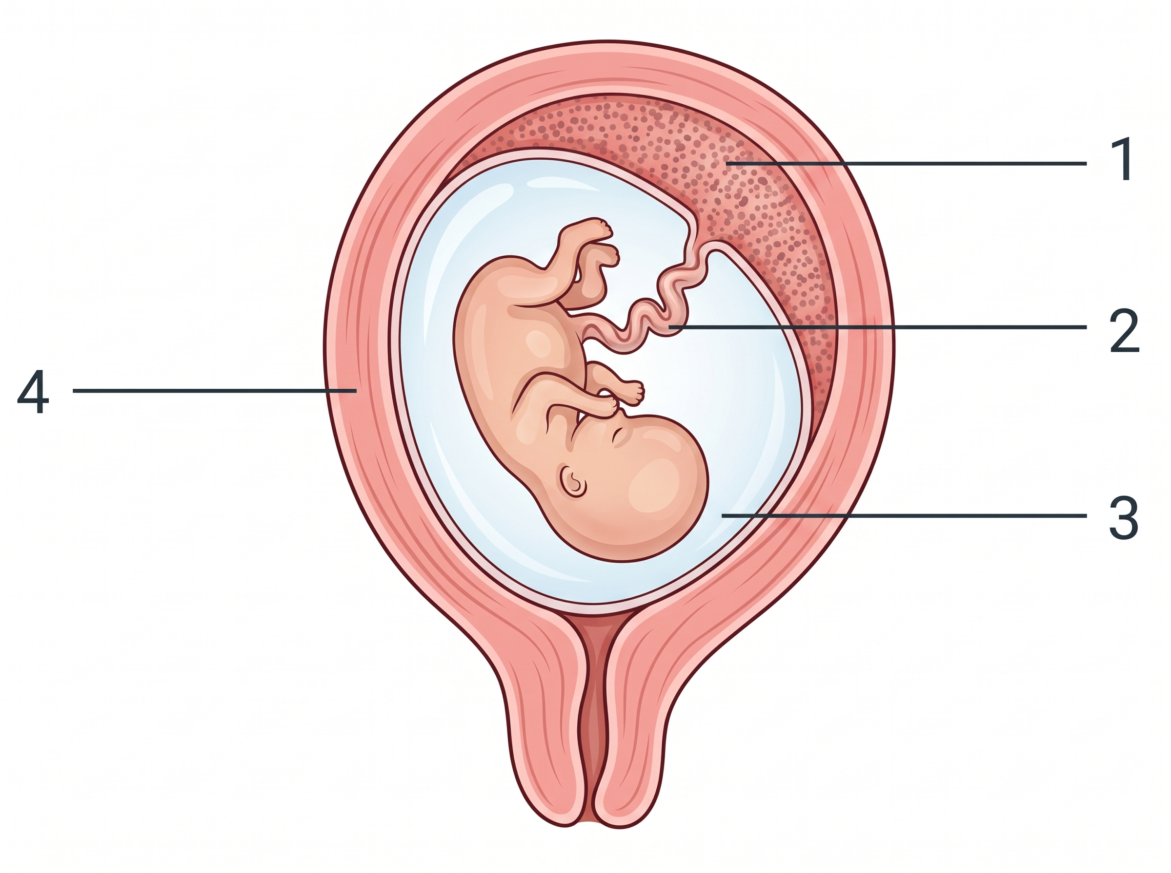
20. [exam 72%, n=58] Which of the following combinations of functions is correct?
 | Structure 1 | Structure 2 | Structure 3
A. | gaseous exchange | transport of waste | protection
B. | food supply | oxygen transport | removal of waste
C. | protection | transport of food | gaseous exchange
D. | transport of waste | gaseous exchange | protection

21. [class 79%, n=67] The following stages of birth are in the wrong order. Which is the correct sequence?
(1) Expulsion of the baby
(2) Rupture of the amnion and release of amniotic fluid
(3) Rhythmic contractions of the uterus
(4) Expulsion of the placenta
A. (3), (2), (4), (1)
B. (3), (2), (1), (4)
C. (2), (3), (4), (1)
D. (2), (3), (1), (4)
22. [class 78%, n=67] Which of the following are expelled from the mother’s body when she gives birth?
(1) Amnion
(2) Foetus
(3) Placenta
A. (1) and (2) only
B. (1) and (3) only
C. (2) and (3) only
D. (1), (2) and (3)
23. [class 68%, n=28] Which of the following processes stop during pregnancy?
(1) Ovulation
(2) Menstruation
(3) Production of female sex hormones by the ovaries
A. (1) and (2) only
B. (2) and (3) only
C. (1) and (3) only
D. (1), (2) and (3)
24. [class 78%, n=37] Which of the following statements about twins is correct?
A. All twins must be of the same sex.
B. All twins must be genetically identical.
C. Fraternal twins are formed when two sperms fertilise two separate eggs.
D. Once a woman has given birth to identical twins, she cannot later give birth to fraternal twins.
25. [class 46%, n=37] Mothers are encouraged to breastfeed because
(1) breastfeeding provides a close relationship between the mother and the baby.
(2) the mother’s milk contains antibodies that give the baby passive immunity.
(3) the mother’s milk provides a relatively balanced diet for the baby.
(4) the mother’s milk contains enzymes that digest the baby’s food.
A. (1) and (2) only
B. (2) and (3) only
C. (3) and (4) only
D. (1), (2) and (3) only
26. [class 76%, n=67] Which of the following is not a true cause of infertility in humans?
(1) Blockage of the urethra in a woman
(2) Blockage of an oviduct
(3) A low sperm count
(4) No ovulation
A. (1) only
B. (2) and (3) only
C. (3) and (4) only
D. (2), (3) and (4) only
27. [exam 59%, n=54] Amniocentesis collects foetal cells from the amniotic fluid. The cells are cultured and a karyotype is prepared. Which of the following can be determined from this chromosomal analysis?
(1) The biological sex of the foetus
(2) Whether the foetus is a carrier of red-green colour blindness
(3) Whether the foetus has Down syndrome
A. (1) and (2) only
B. (1) and (3) only
C. (2) and (3) only
D. (1), (2) and (3)
Directions: Question 28 refers to the contraceptive device below.
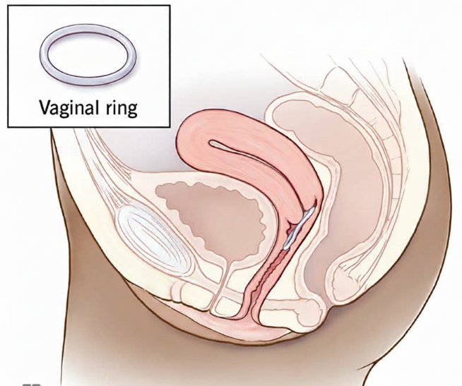
28. [exam item; key corrected] The vaginal ring releases hormones that prevent the release of ova and thicken the cervical mucus. Which contraceptive method has a similar biological principle?
(1) Intrauterine device
(2) Contraceptive pills
(3) Condom
A. (2) only
B. (1) and (2) only
C. (2) and (3) only
D. (1), (2) and (3)
29. [difficult extra] A pregnant woman has blood group O. The foetus has blood group A. Which of the following statements are correct?
(1) Red blood cells of the foetus do not mix with red blood cells of the mother across the placenta.
(2) The foetus received the allele for blood group A from the father.
(3) The mother’s blood group changes to A, because foetal red blood cells enter her blood.
(4) The placenta contains the mother’s genes only.
A. (1) and (2) only
B. (1) and (3) only
C. (2) and (4) only
D. (1), (2) and (3) only
30. [difficult extra] Both oviducts of a woman are cut and tied. Which row is correct?
 | Release of ova | Menstruation | Fertilisation
A. | stops | stops | cannot occur
B. | continues | continues | cannot occur
C. | continues | stops | can still occur
D. | stops | continues | can still occur

31. [difficult extra] A couple have a son. Which of the following statements are correct?
(1) The ovum had 23 chromosomes, one of which was an X chromosome.
(2) The sperm that fertilised the ovum had 23 chromosomes, one of which was a Y chromosome.
(3) A cell of the umbilical cord has 46 chromosomes, including both an X and a Y chromosome.
(4) A cell of the mother’s uterine wall has the same sex chromosomes as a cell of the umbilical cord.
A. (1) and (2) only
B. (1), (2) and (3) only
C. (2), (3) and (4) only
D. (1), (2), (3) and (4)
Directions: Question 32 refers to the diagram below. P carries blood from the placenta to the foetus. Q carries blood from the foetus to the placenta.
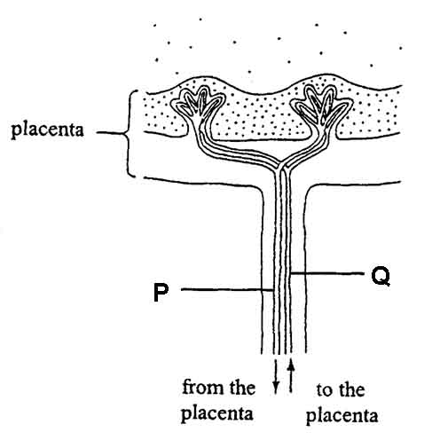
32. [difficult extra] Which comparison is correct?
A. The blood in P has a higher oxygen content than the blood in Q.
B. The blood in Q has a higher oxygen content than the blood in P.
C. The oxygen content is the same in P and Q, because maternal blood mixes with foetal blood in the placenta.
D. P carries oxygen, but Q carries carbon dioxide and no oxygen.
Answers
The keyed option is also printed in red on the questions. Percentages are class Google Form or whole-cohort OMR, matched by wording. Do not quote a percentage for Q18 or Q28: those printed bank keys were biologically impossible and have been corrected. Difficult extras have no class percentage.
1. B Only the sperm head enters the ovum. Usual slip A: students think the chromosomes can pair, so they mark A as the incorrect statement.
2. A The ovum is larger because of food store, not because it has more chromosomes. Usual slip B.
3. D Meiosis halves the chromosome number. Usual slip A (four times). n=34.
4. C Structure 9 is the testis. A high abdominal temperature inactivates sperm. It does not denature the sex hormone. Usual slip B.
5. A Pathway is testis 9 → sperm duct 7 → urethra 4. Usual slip B starts at the ureter.
6. C The bladder (3) and the penis (10) change volume. Usual slip B is the penis only.
7. D Haploid cells are produced in the testis (6) and the ovary (8). Usual slip B. n=34.
8. B Structure 3 is the penis, with the urethra inside it. Urine and semen both leave here. Usual slip A.
9. A Cutting both sperm ducts (1) is permanent. An intrauterine device is not. Usual slip C.
10. B The epididymis stores sperm, not semen. Semen is formed only at ejaculation. Usual slip C.
11. B Pills act on the ovary (2), by preventing ovulation. Usual slip A is an oviduct.
12. C Both oviducts (1 and 5) must be cut and tied. Usual slip A is one side only.
13. D The cycle is not always 28 days. Usual slip C. Statement C is loosely worded; the class key still treats D as the incorrect statement.
14. C Structure 4 is the uterine wall. Menstruation is not why that wall is muscular and vascular. Usual slip B.
15. C Fertilisation is in the oviduct (5), not in the ovule (4) and not in the ovary (6). Usual slip B. n=28.
16. B Every ovum carries an X chromosome. The sperm carries X or Y and so decides XX or XY. Usual slip: the ovum decides, or a Y-bearing sperm produces a girl.
17. A The foetus does excrete. It does not digest a meal or egest faeces. Usual slip D includes (3).
18. D The printed bank sent waste from the mother to the foetus and still keyed D. That direction is impossible. This copy runs waste from foetus to mother, so D is now correct. Do not quote 56.7%.
19. A Some viruses do cross the placenta, so (3) is not a reason. Usual slip D. Exam 2526 F5 mid Q16.
20. A 1 placenta, gaseous exchange; 2 umbilical cord, transport of waste; 3 amniotic fluid, protection. Usual slip D swaps 1 and 2. Exam 2425 F5 final Q12.
21. B Contractions, then the waters break, then the baby, then the placenta. Usual slip D starts with rupture of the amnion.
22. D The amnion is expelled as well as the baby and the placenta. Usual slip C omits the amnion.
23. A Ovulation and menstruation stop. The ovary does not stop producing female sex hormones. Usual slip B. n=28.
24. C Fraternal twins are two zygotes. Identical twins are one zygote that splits. Usual slip D.
25. D (4) is not a reason taught for breastfeeding. Antibodies, not digestive enzymes. Usual slip A.
26. A A blocked urethra in a woman is not a cause of infertility. Oviduct, sperm count and ovulation are. Usual slip D.
27. B A karyotype shows sex chromosomes and an extra chromosome 21. It does not show a colour-blindness allele. Usual slip D. Exam 2526 F5 final Q18.
28. A The ring and the pill both use hormones to stop ovulation and thicken cervical mucus. A condom does not. The exam print keyed C. This copy keys A (pills only). Do not quote 26.8%.
29. A Mother group O has no A allele, so the foetus’s A allele came from the father. Red cells do not mix, so her group does not become A. The placenta is not the mother’s genes only. Usual slips: (3) and (4).
30. B Tying both oviducts stops the egg meeting a sperm. Ovulation and menstruation continue. Usual slip: the operation is like menopause, so both stop.
31. B A son is XY, so the successful sperm carried Y. The ovum is haploid and carries X. The cord is foetal tissue and is diploid. The uterine wall is the mother’s and is XX. Usual slip: omit (3), or treat the cord as the mother’s tissue.
32. A P is the umbilical vein: oxygenated blood towards the foetus. Q is the umbilical artery. Blood does not mix in the placenta, and Q still carries some oxygen.
Answer summary
Q | Answer | Source
1 | B | class 67% n=55 slip A
2 | A | class 73% n=96 slip B
3 | D | class 65% n=34 slip A
4 | C | class 73% n=130 slip B
5 | A | class 36% n=55 slip B
6 | C | class 67% n=55 slip B
7 | D | class 71% n=34 slip B
8 | B | class 74% n=35 slip A
9 | A | class 76% n=55 slip C
10 | B | class 70% n=37 slip C
11 | B | class 55% n=67 slip A
12 | C | class 43% n=67 slip A
13 | D | class 35% n=37 slip C
14 | C | class 71% n=65 slip B
15 | C | class 61% n=28 slip B
16 | B | difficult extra
17 | A | class 57% n=37 slip D
18 | D | corrected; do not quote 57%
19 | A | exam 16% n=55 slip D
20 | A | exam 72% n=58 slip D
21 | B | class 79% n=67 slip D
22 | D | class 78% n=67 slip C
23 | A | class 68% n=28 slip B
24 | C | class 78% n=37 slip D
25 | D | class 46% n=37 slip A
26 | A | class 76% n=67 slip D
27 | B | exam 59% n=54 slip D
28 | A | corrected; do not quote 27%
29 | A | difficult extra
30 | B | difficult extra
31 | B | difficult extra
32 | A | difficult extra

