Movement of substances across the cell membrane
Chapter 3 review · 44 questions
Name: ________________________ Class: ____________ Class no.: ______
Choose the one best answer. All figures are redrawn. Off-topic items (importance of water, kidney / urine / tears, transpiration / potometer, split petioles) are not in this paper.
Part A — Membrane structure (textbook 3.1–3.2)
1. The fluid mosaic model describes the cell membrane as
A. a continuous protein coat covering a lipid bilayer.
B. a mosaic of proteins floating in a fluid phospholipid bilayer.
C. a fully permeable cellulose wall with scattered proteins.
D. a bilayer of cholesterol with a continuous protein coat on both surfaces.
Directions: Questions 2 and 3 refer to one phospholipid molecule.
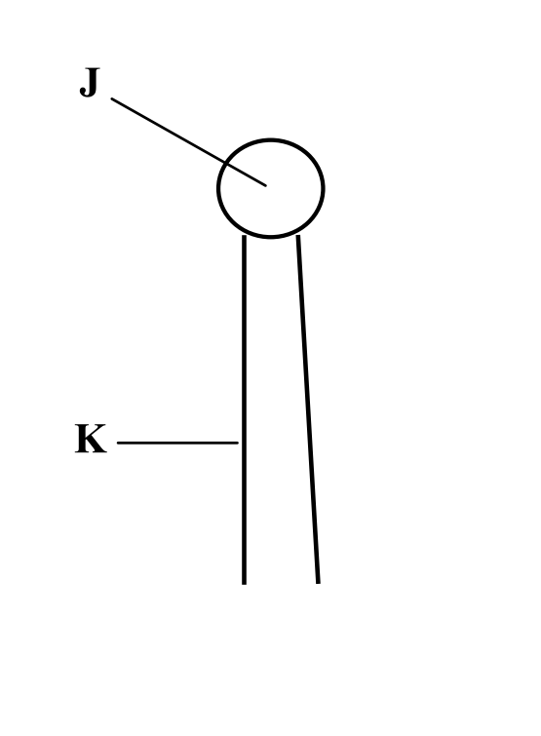
2. Which description of J and K is correct?
 | J | K
A | hydrophobic tail | hydrophilic head
B | hydrophilic head | hydrophobic tail
C | protein | starch
D | cellulose | channel

3. In the phospholipid bilayer of a living cell, these molecules are arranged so that
A. the parts labelled K face the watery fluids on both sides of the membrane.
B. the parts labelled J meet in the middle of the bilayer.
C. the parts labelled J face the watery fluids on both sides of the membrane.
D. all parts labelled J point towards the cytoplasm only.
Directions: Questions 4 to 8 refer to the diagram of a cell membrane. J–M are structures. X and Y are pathways.
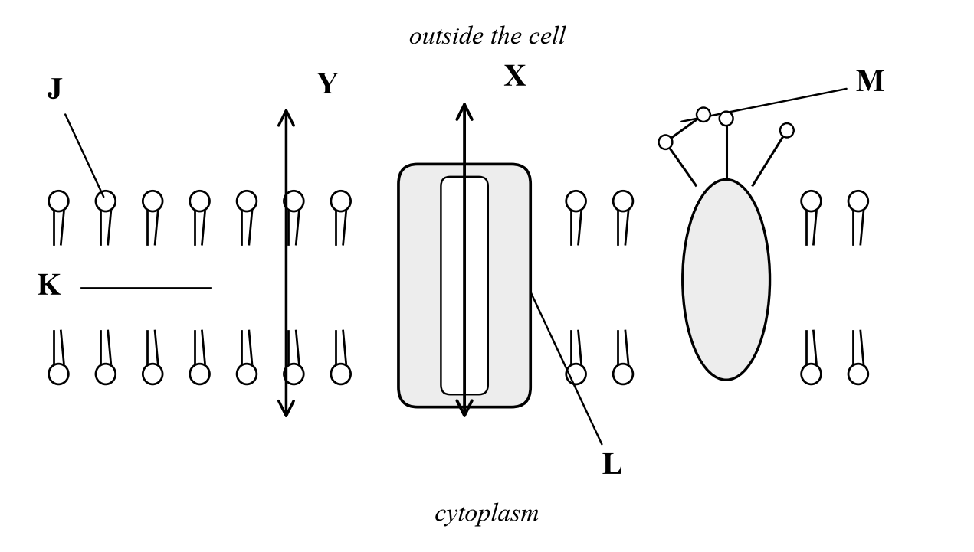
4. Which labelled part prevents polar molecules and ions from passing directly through the bilayer?
A. J
B. K
C. L
D. M
5. Which of the following substances can move along pathways X and Y respectively?
 | Pathway X | Pathway Y
A | Glucose | Oxygen
B | Alcohol | Water
C | Oxygen | Glucose
D | Glucose | Water

6. Which labelled part may act as an antigen or a receptor on the cell surface?
A. J
B. K
C. L
D. M
7. Sodium ions cannot cross the phospholipid bilayer freely. The best reason is that they are
A. non-polar, so they dissolve in J only.
B. lipid-soluble, so they are trapped in M.
C. charged, so they cannot dissolve in the hydrophobic core K and must use L.
D. larger than starch.
8. Starch cannot cross this living membrane. The best explanation is that starch
A. is non-polar, so it is trapped in the watery cytoplasm.
B. is too large to pass through the bilayer or through L.
C. is pumped out by M as soon as it arrives.
D. dissolves the phospholipids, so it never reaches the membrane.
9. The cell membrane can change shape, and two membranes can fuse, when a cell divides. This is possible because
A. phospholipid molecules can move sideways in the bilayer.
B. the cell wall is fully permeable to water.
C. carbohydrate chains form a rigid coat outside the cell.
D. ions are fixed in position in the core of the bilayer.
Directions: Questions 10 and 11 refer to an investigation in which lipids were extracted from a known number of mature mammalian red blood cells and spread as a single layer on water.
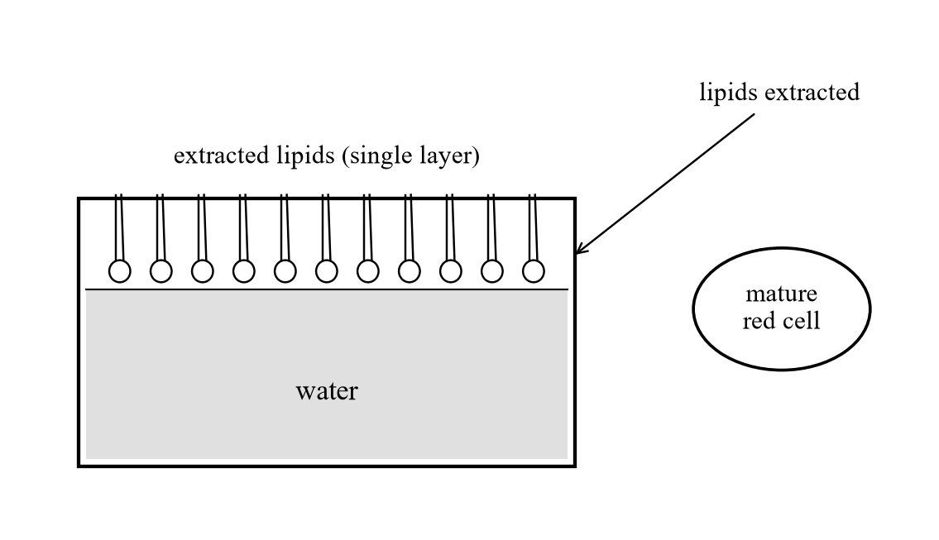
10. The area of this lipid layer was about twice the total surface area of the cells. This result supports the idea that
A. the cell membrane is two phospholipid molecules thick.
B. the cell membrane is one phospholipid molecule thick.
C. the cell membrane is made only of protein.
D. red blood cells have a cellulose cell wall.
11. Mature mammalian red blood cells were used mainly because
A. the cells can be seen without a microscope.
B. almost all of the extracted lipid came from one membrane, the plasma membrane.
C. the cells contain chlorophyll.
D. the cells have a fully permeable cellulose wall.
12. Beetroot discs in water at 20 °C stay unstained. Similar discs in alcohol at 20 °C turn the liquid red. The best explanation is that alcohol
A. raises the temperature so enzymes make more pigment.
B. stops osmosis, so the cells burst.
C. dissolves phospholipids, so the membrane is damaged and pigment leaks.
D. converts cellulose in the cell wall into a differentially permeable membrane.
13. The cell sap of beetroot contains a red pigment. Four pieces of beetroot cylinders of equal thickness and length were washed thoroughly and then immersed in distilled water. They were maintained at four different temperatures as shown below.
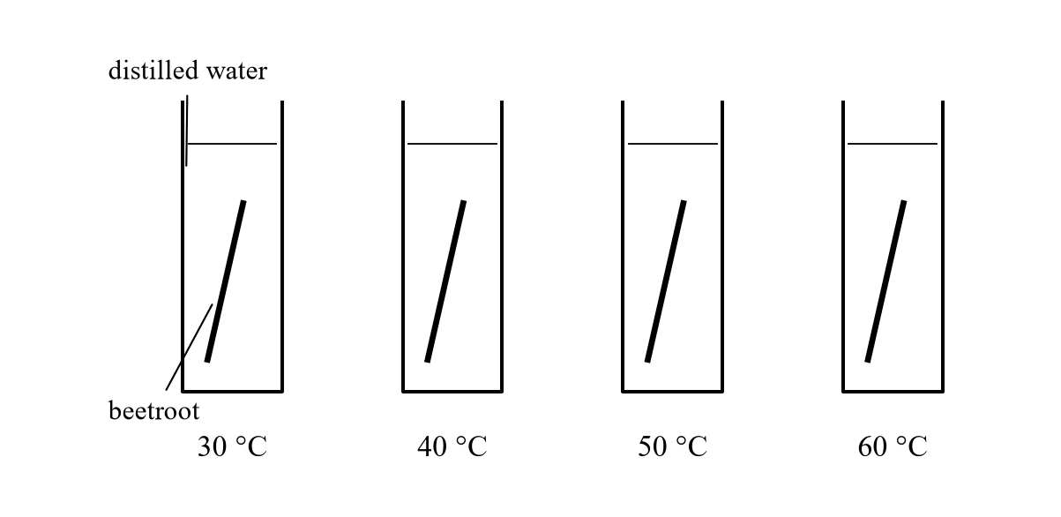
After 40 minutes the distilled water maintained at 30 °C and 40 °C remained clear while those maintained at 50 °C and 60 °C turned red. Which of the following explanations of the result is correct?
A. Temperature above 50 °C destroys the differential permeability of the cytoplasmic membrane of the cell.
B. Increase in temperature increases the kinetic energy of the pigment molecules, which vibrate more vigorously at 50 °C and 60 °C.
C. Temperatures at 30 °C and 40 °C are too low to catalyse the enzymes responsible for the transport of pigments across the membrane.
D. Osmosis of water occurs at 30 °C and 40 °C but it fails to occur at 50 °C and 60 °C.
14. A student treats three sets of beetroot discs: ice-cold water, boiling water, and 40% alcohol at room temperature. Which treatment damages the membrane by dissolving phospholipids?
A. Ice-cold water only
B. Boiling water only
C. 40% alcohol only
D. Boiling water and 40% alcohol equally, by the same mechanism
15. Which of the following is/are differentially permeable?
(1) Cell wall
(2) Cell membrane
(3) Envelope of chloroplast
(4) Nuclear membrane
A. (1) and (2) only
B. (2) and (3) only
C. (1), (3) and (4) only
D. (2), (3) and (4) only
Part B — Diffusion, osmosis and experiments
Directions: Questions 16 to 18 refer to the set-up below. Living red blood cells are added to each tube.
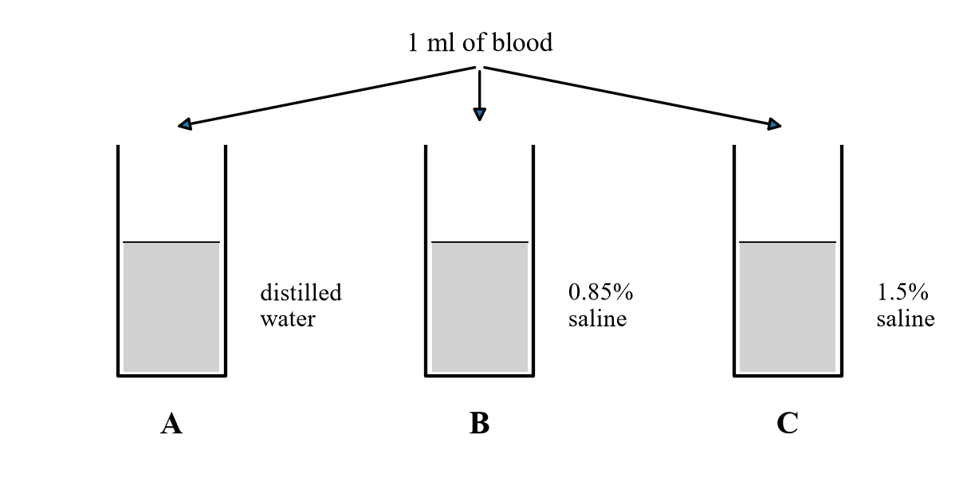
16. In which tube will the red blood cells burst?
A. tube A only
B. tube B only
C. tube C only
D. tubes A and C only
17. After 10 minutes the cells in tube C are
A. burst, because 1.5% saline is hypotonic to the cells.
B. turgid, because water has entered by osmosis.
C. crenated, because 1.5% saline is hypertonic to the cells.
D. plasmolysed, because animal cells have a cellulose wall.
18. The experiment is repeated with living algal cells of the same water potential as the red blood cells. The algal cells in tube A do not burst. The best reason is that
A. algal cells contain chlorophyll instead of haemoglobin.
B. algal cells are larger than red blood cells.
C. algal cells are protected by a rigid cell wall.
D. algal cells have a nucleus and mature red blood cells do not.
19. When placed in a hypertonic solution, living cells in a plant tissue will
(1) be plasmolysed.
(2) become flaccid.
(3) become crenated.
A. (1) and (2) only
B. (1) and (3) only
C. (2) and (3) only
D. (1), (2) and (3)
20. Three groups of potato strips of equal mass were immersed in 0.1%, 5% and 15% sucrose. Which row is the probable percentage change in mass?
 | 0.1% | 5% | 15%
A | −9% | +0.2% | +6%
B | +0.2% | −9% | +6%
C | +6% | +0.2% | −9%
D | −9% | +6% | +0.2%

Directions: Questions 21 and 22 refer to the graph of a potato cylinder in an unknown solution.
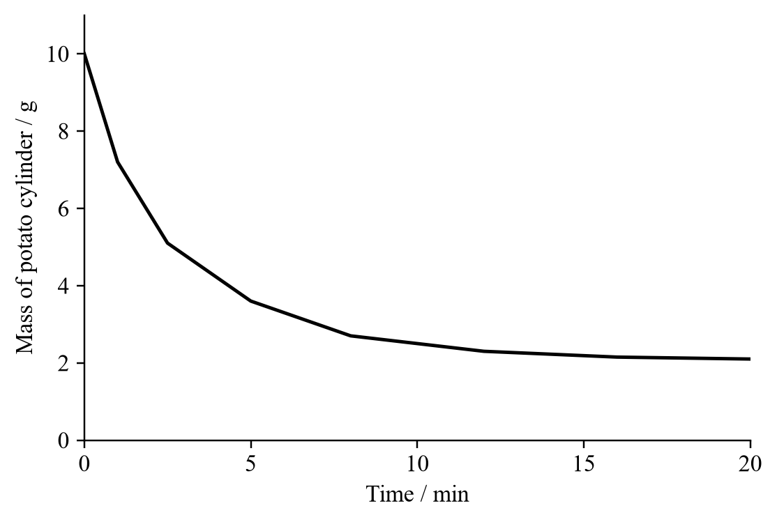
21. The potato cylinder loses mass most rapidly between
A. 0–5 minutes
B. 5–10 minutes
C. 10–15 minutes
D. 15–20 minutes
22. The unknown solution was most probably
A. distilled water.
B. dilute glucose solution.
C. dilute sucrose solution.
D. concentrated sucrose solution.
Directions: Question 23 refers to potato cylinders left in sucrose solutions of different concentrations.
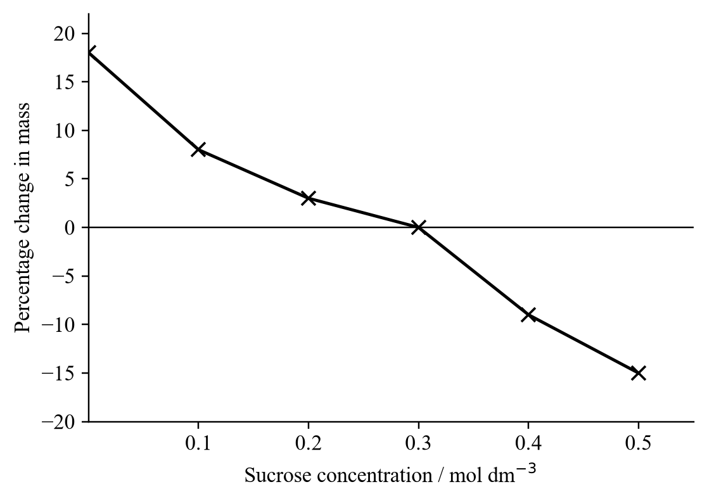
23. The sucrose concentration closest to the water potential of the potato cells is
A. 0.1 mol dm⁻³
B. 0.3 mol dm⁻³
C. 0.4 mol dm⁻³
D. 0.5 mol dm⁻³
24. Which of the following factors increase the rate of diffusion of particles?
(1) Smaller size of particles
(2) Higher temperature
(3) Smaller surface area for the particles to pass through
(4) Smaller concentration gradient of the particles between two regions
A. (1) and (2) only
B. (2) and (3) only
C. (3) and (4) only
D. (1), (2) and (3) only
Directions: Questions 25 and 26. Four potato cubes, each 1 cm long, are placed in methylene blue of different concentrations.
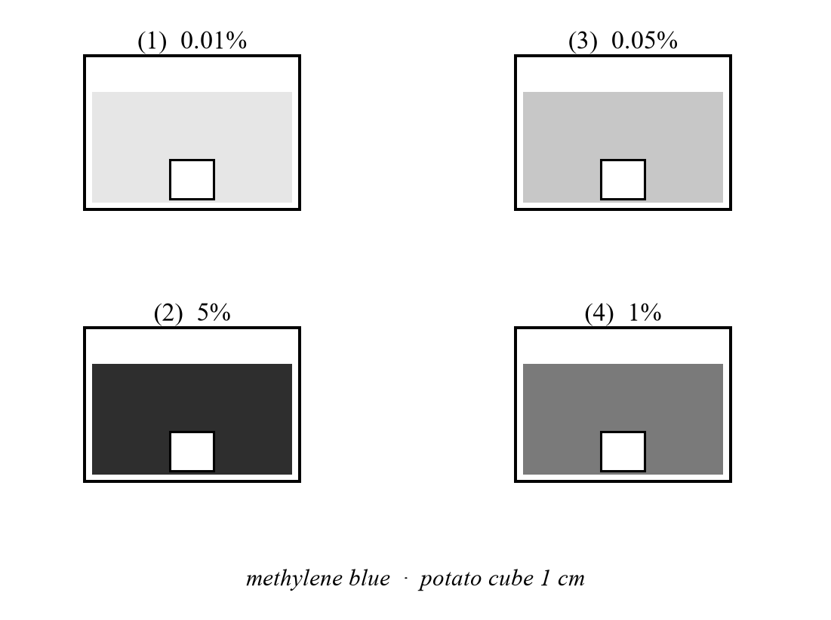
25. Which solution gives the slowest rate of diffusion into the potato cube?
A. (1)
B. (2)
C. (3)
D. (4)
26. The relative rate of diffusion into the cube is found by measuring
A. the total surface area of the cube that turns blue.
B. the increase in mass of each cube.
C. the decrease in intensity of the solution.
D. the depth of penetration of the blue colour into each cube.
27. Which of the following processes involve simple diffusion?
(1) Passage of oxygen into the red blood cells in the lungs.
(2) Reabsorption of water from the kidney tubules into the blood capillaries surrounding them.
(3) Absorption of digested products into the villi of the small intestine.
(4) Engulfing the germs by the white blood cells.
A. (1) and (2) only
B. (1) and (3) only
C. (2) and (4) only
D. (2), (3) and (4) only
28. Which of the following statements or definitions is/are correct?
(1) Osmosis is the movement of water molecules from a region of lower water potential to a region of higher water potential.
(2) The movement of water molecules from a region of higher water potential to a region of lower water potential is an example of specific diffusion.
(3) There is a mixture of urea and protein contained inside a dialysis tubing that only permits urea to pass out. This is an example of osmosis.
(4) When osmosis stops, no water molecules will pass through the membrane any more.
A. (1) only
B. (2) only
C. (2) and (3) only
D. (3) and (4) only
Directions: Questions 29 and 30 refer to the set-up below. The dialysis tubing contains 2% sucrose. The beaker contains 10% sucrose. The tubing is differentially permeable.
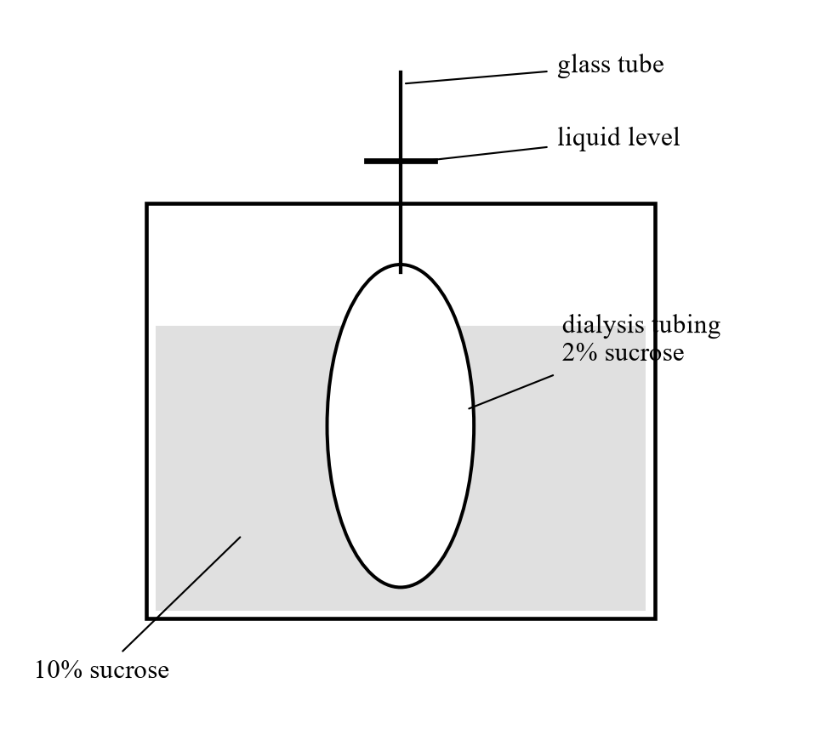
29. Which graph shows the liquid level in the glass tube during the experiment?
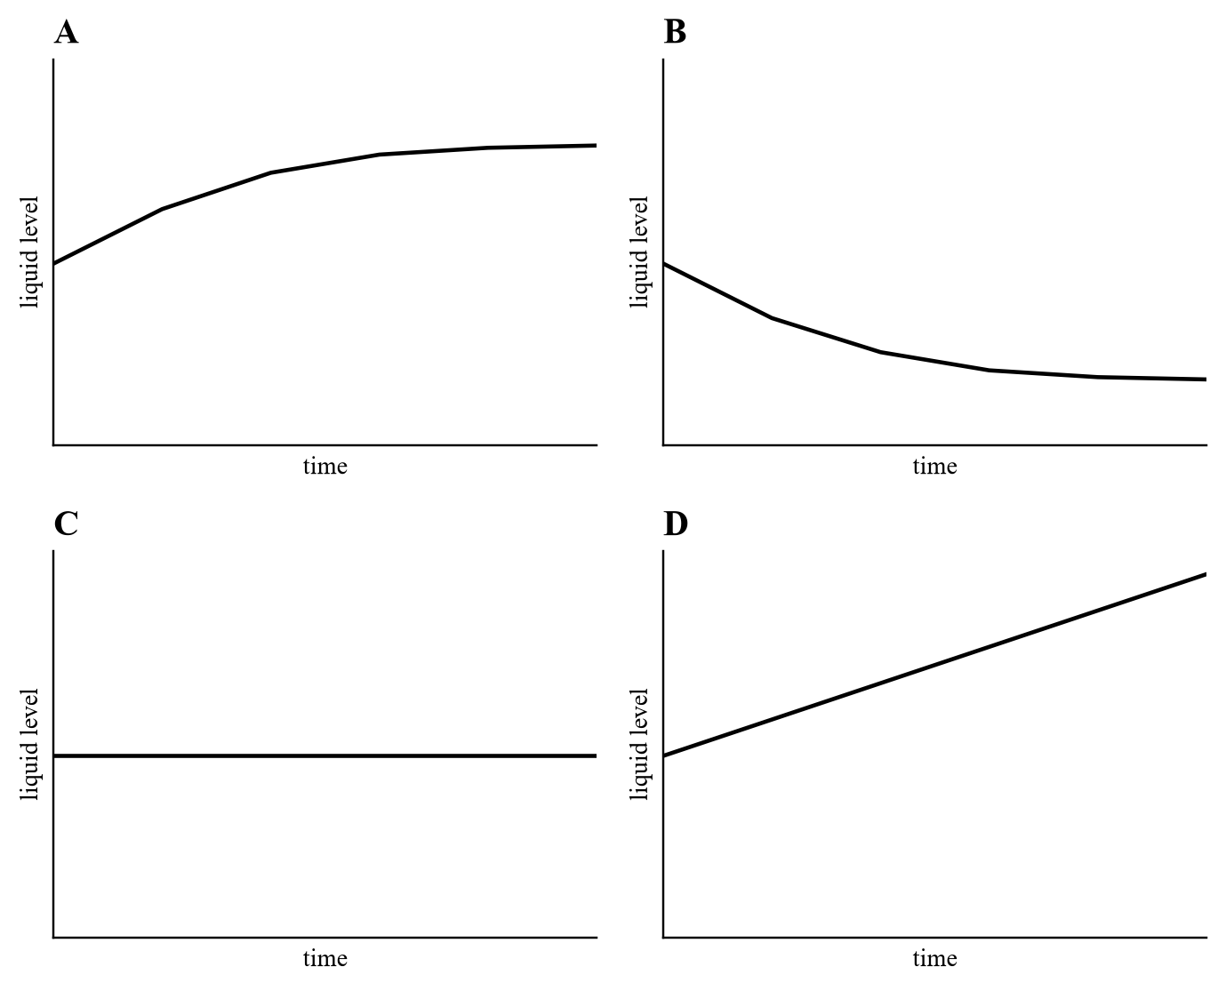
A. A
B. B
C. C
D. D
30. The liquid level later stops changing. Which description is correct at this state?
(1) The water potential of the sucrose solution both inside and outside the dialysis tubing is the same.
(2) No more movement of water molecules occurs across the dialysis membrane.
(3) The equilibrium is due to the movement of sucrose molecules from a region of higher concentration to a region of lower concentration.
(4) The concentration of the sucrose solution both inside and outside the dialysis membrane is the same.
A. (1) only
B. (1) and (2) only
C. (1) and (4) only
D. (2) and (3) only
Directions: Questions 31 to 35 refer to a plant cell after 12 hours in solution X.
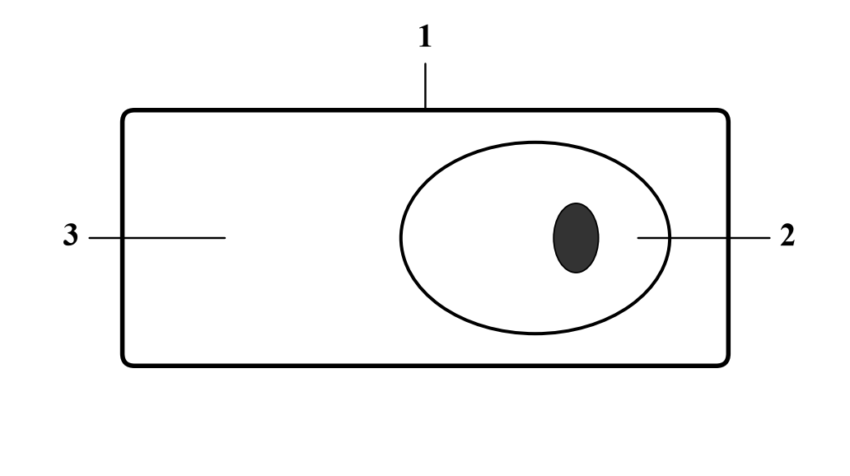
1 cell wall 2 protoplast 3 space between wall and membrane
31. The phenomenon shown by the cell is
A. hydrolysis.
B. haemolysis.
C. dialysis.
D. plasmolysis.
32. The structure labelled 1 is
A. fully permeable.
B. impermeable.
C. a phospholipid bilayer only.
D. made of haemoglobin.
33. When this cell has reached equilibrium,
A. osmosis stops.
B. water molecules enter and leave the structure labelled 2 at the same rate.
C. the structure labelled 1 exerts no wall pressure on the cytoplasm of the cell.
D. all of the above are correct.
34. The space labelled 3 is
A. empty.
B. filled with a solution with the same strength as that bathing the cell.
C. filled with a solution more dilute than that bathing the cell.
D. filled with a solution more concentrated than that bathing the cell.
35. The solution bathing the cell is
A. hypertonic to the cell.
B. isotonic with the cell.
C. hypotonic to the cell.
D. less concentrated than the cell sap.
36. Which combination shows how water, oxygen and glucose pass into a living cell?
 | Water | Oxygen | Glucose
A | osmosis | diffusion | active transport
B | active transport | diffusion | osmosis
C | osmosis | active transport | diffusion
D | active transport | osmosis | diffusion

37. Which of the following properties of a differentially permeable membrane is/are correct?
(1) It only permits lipid-soluble molecules, and never polar molecules, to pass through.
(2) It only permits water molecules, and never large soluble molecules, to pass through.
(3) It permits some molecules to pass through but prevents others.
A. (1) only
B. (2) only
C. (3) only
D. (1) and (2) only
38. Which statement about osmosis is correct?
A. A living cell membrane is essential for the process.
B. Energy from respiration is needed.
C. Water moves down a water potential gradient.
D. Water molecules move in one direction only.
Directions: Question 39 refers to three plant cells in contact.
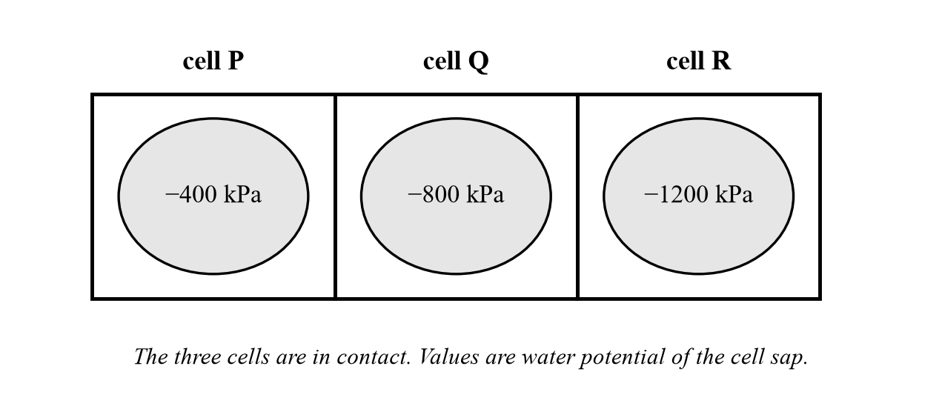
39. Which shows the net movement of water among the cells?
A. P → Q → R
B. R → Q → P
C. Q → P → R
D. P → R → Q
40. Three strips of plant tissue with a mean water potential of −600 kPa are placed in sucrose solutions of different water potential.
Solution X −200 kPa
Solution Y −600 kPa
Solution Z −1000 kPa
Which row shows the state of the epidermal cells?
 | In X | In Y | In Z
A | full turgor | incipient plasmolysis | plasmolysis
B | incipient plasmolysis | plasmolysis | full turgor
C | full turgor | plasmolysis | incipient plasmolysis
D | plasmolysis | incipient plasmolysis | full turgor

41. A strip of raw carrot was placed in concentrated sucrose. After several hours it became limp and soft. The proper explanation is that
A. the cells were killed by the concentrated sucrose solution.
B. the supporting tissues of the carrot were dissolved by the sucrose.
C. the carrot lost water to the concentrated sucrose solution.
D. the carrot absorbed water from the concentrated sucrose solution.
Directions: Questions 42 and 43 refer to four osmometers. Each dialysis tubing is differentially permeable.
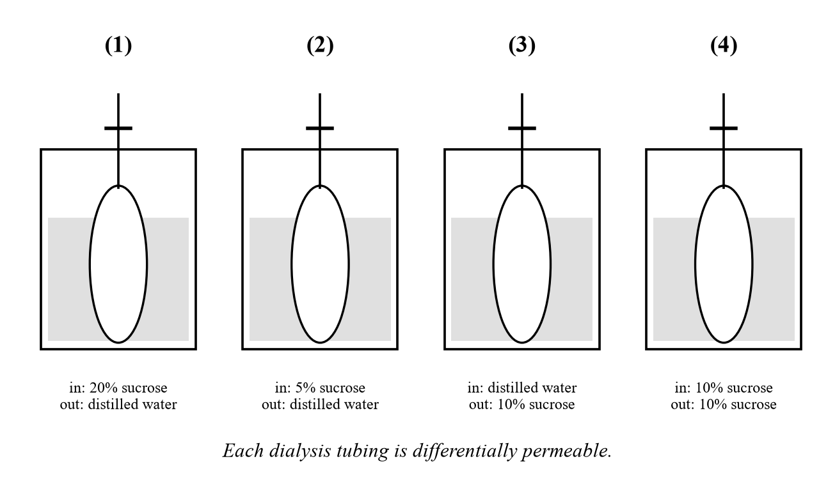
42. Which osmometer has the greatest rise in the liquid level in the glass tube?
A. (1)
B. (2)
C. (3)
D. (4)
43. Which osmometer has a drop in the liquid level in the glass tube?
A. (1)
B. (2)
C. (3)
D. (4)
44. Which comparison of plasmolysis and haemolysis is not true?
 | Plasmolysis | Haemolysis
(1) | occurs in hypotonic solution | occurs in hypertonic solution
(2) | a phenomenon in plant cells | a phenomenon in red blood cells
(3) | net water movement out of the cell | net water movement into the cell

A. (1) only
B. (2) only
C. (3) only
D. (2) and (3) only

Answers (teachers)
Live web quiz. Question numbers match membrane-mc (Practice 1: Q1–22; Practice 2: Q23–44). Cholesterol is not required as an answer.
1B 2B 3C 4B 5A 6D 7C 8B 9A 10A 11B 12C 13A 14C 15D 16A 17C 18C 19A 20C 21A 22D 23B 24A 25A 26D 27B 28B 29B 30A 31D 32A 33D 34B 35A 36A 37C 38C 39A 40A 41C 42A 43C 44A
Q | Key | Demand | Note
1 | B | Difficult | Proteins form a mosaic in a fluid phospholipid bilayer.
2 | B | Difficult | J is the hydrophilic head; K is the hydrophobic tail.
3 | C | Difficult | Heads face water on both sides of the bilayer.
4 | B | Difficult | K is the hydrophobic core that blocks polar molecules.
5 | A | Average | X is the channel (glucose); Y is the bilayer (oxygen).
6 | D | Difficult | M is carbohydrate of a glycoprotein (antigen / receptor).
7 | C | Difficult | Sodium is charged, so it cannot dissolve in K; it uses L.
8 | B | Difficult | Starch is too large for the bilayer or for L.
9 | A | Difficult | Lateral movement of phospholipids = fluid.
10 | A | Difficult | Film area ≈ 2 × cell surface → bilayer.
11 | B | Difficult | Mature mammalian red cells have almost no internal membranes.
12 | C | Difficult | Alcohol dissolves phospholipids at room temperature.
13 | A | Difficult | Above 50 °C the membrane loses differential permeability.
14 | C | Difficult | Alcohol dissolves phospholipids; boiling denatures proteins.
15 | D | Average | Wall fully permeable; the three membranes are differentially permeable.
16 | A | Average | Under80 blood figure, on-syllabus. Distilled water is hypotonic: haemolysis.
17 | C | Average | 1.5% saline is hypertonic: red cells crenate. Plasmolysis is for plant cells.
18 | C | Average | The cellulose wall prevents bursting. Algal / plant cells in hypotonic solution.
19 | A | Average | Plant cells plasmolyse and become flaccid. Crenation is for animal cells.
20 | C | Average | 0.1% hypotonic (gain); 15% hypertonic (loss).
21 | A | Average | Steepest gradient at the start, 0–5 min.
22 | D | Average | Mass falls: concentrated sucrose.
23 | B | Average | Zero mass change ≈ isotonic, 0.3 mol dm⁻³.
24 | A | Average | (1) and (2) only. Smaller area and a smaller gradient slow diffusion.
25 | A | Average | Beaker (1) 0.01% — shallowest gradient.
26 | D | Average | Depth of blue stain.
27 | B | Average | Under80 class key (1) and (3).
28 | B | Average | (2) only. Urea leaving dialysis tubing is diffusion, not osmosis.
29 | B | Average | 2% inside / 10% outside: water leaves, so the level falls then levels off.
30 | A | Difficult | (1) only. Water potentials become equal; water still moves both ways.
31 | D | Average | The cell is plasmolysed.
32 | A | Average | The cell wall is fully permeable.
33 | D | Average | All of A–C at equilibrium in a plasmolysed cell.
34 | B | Average | Space 3 is the external solution. The wall is fully permeable.
35 | A | Average | Hypertonic bathing solution causes plasmolysis.
36 | A | Average | Water osmosis, oxygen diffusion, glucose active transport.
37 | C | Difficult | (3) only. Polar molecules can cross through proteins; it is not water-only.
38 | C | Difficult | Osmosis is water down the WP gradient. A living membrane is not essential.
39 | A | Difficult | Water moves from higher WP to lower WP: P → Q → R.
40 | A | Difficult | External WP higher → turgid; equal → incipient; lower → plasmolysis.
41 | C | Average | The carrot lost water to the concentrated sucrose.
42 | A | Difficult | Greatest rise: 20% inside, distilled water outside.
43 | C | Average | Level falls when distilled water is inside and 10% sucrose is outside.
44 | A | Difficult | (1) is false: plasmolysis is in hypertonic solution; haemolysis is in hypotonic.

Dropped or replaced
• Importance of water, kidney / urine / tears, transpiration / potometer, split petioles — wrong chapter.
• Citrate / sterilise / centrifuge the blood — out of syllabus. The same under-80 blood figure is now haemolysis / crenation (Q16–18).
• Five-cell recovery sequence and the diffusion / osmosis / active transport / phagocytosis process list (old Q31–34) — replaced.
• Added from the under-80 / YKTo bank, proofread: algal cells vs red cells; plasmolysis name and fully permeable wall; water / oxygen / glucose; differentially permeable property; osmosis down a WP gradient; three cells; kPa turgor table; limp carrot; four osmometers; plasmolysis vs haemolysis.

