Respiration
Student web quiz · same question numbers
Name: ________________________ Class: ____________ Class no.: ______
Question numbers on this paper are the same as on the student webpage. Question 1 here is question 1 on the web. Practice 1 (16 questions) + Practice 2 (16 questions).
Practice 1 — Meaning, gases and experiments
1. Respiration is best defined as
A. gas exchange between the lungs and the air.
B. the intake of oxygen only.
C. the release of energy from organic compounds in living cells.
D. the production of oxygen inside mitochondria.

2. Which statement about where respiration occurs is correct?
A. Only animals respire.
B. Only organisms without chloroplasts respire.
C. All living organisms respire.
D. Green plants respire only at night.

3. Which description of a green plant is correct?
A. It photosynthesises in the day and respires only at night.
B. It respires all the time. It also photosynthesises in the light.
C. It does not respire, because it makes its own food.
D. It stops respiration when stomata close.

4. Which comparison of burning and respiration is correct?
A. Both always need oxygen. Only burning needs enzymes.
B. Burning can be a single-step oxidation. Respiration is a series of enzyme-controlled reactions.
C. Both store most of the released energy as ATP.
D. Respiration releases energy from inorganic substances only.

5. The useful product of respiration for the cell is mainly
A. heat.
B. ATP.
C. carbon dioxide.
D. water.

6. Which word equation for aerobic respiration of glucose is correct?
A. glucose + oxygen → carbon dioxide + water + energy
B. glucose → ethanol + carbon dioxide + energy
C. carbon dioxide + water → glucose + oxygen
D. glucose + water → carbon dioxide + oxygen + energy

7. Anaerobic respiration in yeast produces
A. lactate only.
B. ethanol and carbon dioxide.
C. oxygen and water.
D. ATP with no organic waste.

8. During a short sprint, human muscle may produce
A. ethanol.
B. lactate (lactic acid).
C. oxygen.
D. starch.

9. Oxygen debt after vigorous exercise is paid by
A. stopping all respiration.
B. using extra oxygen to oxidise or convert lactate and to restore ATP and phosphocreatine.
C. continuing anaerobic respiration in the lungs.
D. holding the breath.

10. Germinating seeds are placed in a vacuum flask with a thermometer. The temperature inside the flask rises. The best explanation is
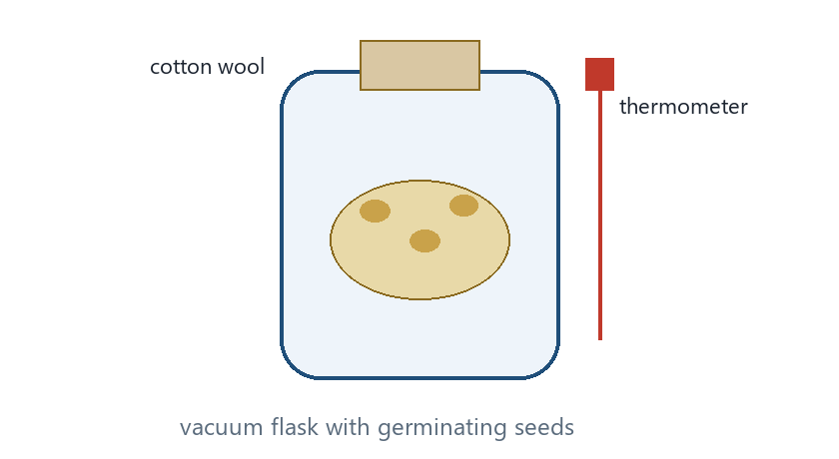
Vacuum flask with germinating seeds and a thermometer.
A. photosynthesis in the seeds.
B. respiration, which releases heat as a by-product.
C. evaporation of water from the seeds.
D. heat produced by the thermometer.

11. The same flask is set up with boiled seeds. The temperature barely rises because
A. boiling adds extra oxygen.
B. enzymes are denatured, so respiration stops.
C. boiled seeds photosynthesise faster.
D. boiling removes all water, so there is no heat to measure.

12. Germinating seeds are enclosed with potassium hydroxide (KOH). A manometer is attached. The liquid moves towards the seeds. Why?
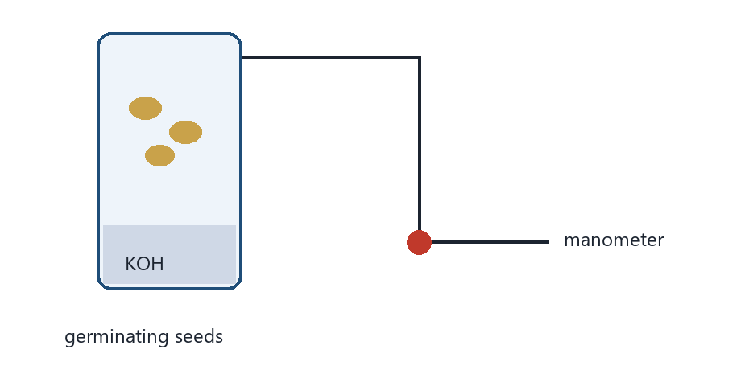
Closed tube with germinating seeds and KOH, connected to a manometer.
A. The seeds produce oxygen.
B. KOH absorbs carbon dioxide, and oxygen is used in respiration, so the gas volume falls.
C. Water vapour from the seeds increases the pressure.
D. Heat from respiration expands the air and always pulls liquid towards the seeds.

13. Gas from a yeast-and-glucose mixture is bubbled through lime water, which turns milky. This shows that
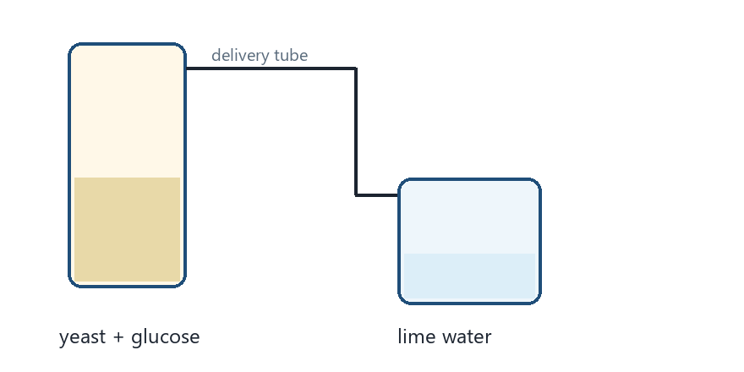
Yeast in glucose solution, with a delivery tube to lime water.
A. oxygen is produced.
B. carbon dioxide is produced.
C. ethanol is produced.
D. nitrogen is used.

14. Hydrogencarbonate indicator is used with small animals in the dark (no plants). The indicator is expected to go
A. purple, because carbon dioxide is removed.
B. yellow, because carbon dioxide is added.
C. blue, because oxygen is used.
D. colourless, because ethanol is formed.

15. Which statements are correct?
(1) Respiration can occur in the cytoplasm and in mitochondria.
(2) Aerobic respiration needs oxygen.
(3) Anaerobic respiration in muscle needs oxygen.
A. (1) and (2) only
B. (1) and (3) only
C. (2) and (3) only
D. (1), (2) and (3)

16. The purpose of respiration is
A. to take in oxygen.
B. to provide energy for metabolic activities.
C. to produce carbon dioxide so that plants can photosynthesise.
D. to cool the body.

Practice 2 — Mitochondria, RQ and plants
17. Glycolysis takes place in the
A. mitochondrial matrix.
B. cytosol (cytoplasm).
C. cristae.
D. nucleus.

18. The Krebs cycle takes place in the
A. cytoplasm.
B. mitochondrial matrix.
C. nucleus.
D. chloroplast stroma.

19. The electron transport chain of aerobic respiration is located on the
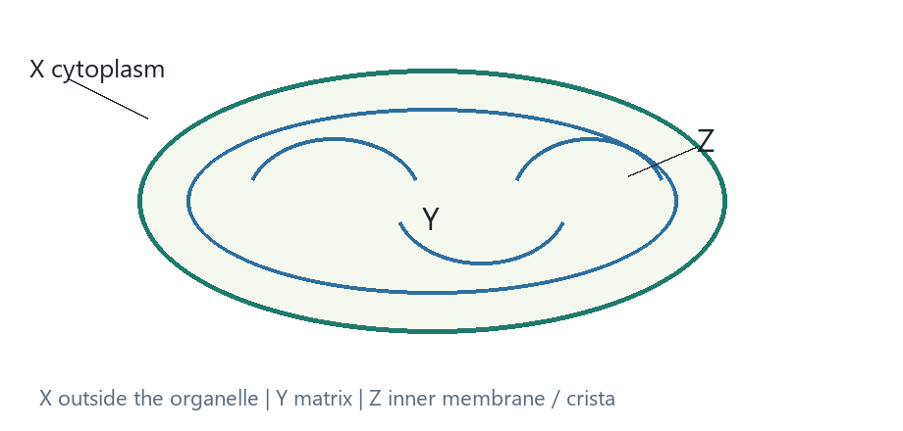
Mitochondrion. X cytoplasm; Y matrix; Z inner membrane / crista.
A. nuclear envelope.
B. cristae (inner mitochondrial membrane).
C. cell wall.
D. tonoplast of the vacuole.

20. On the diagram, where is most of the ATP from aerobic respiration made?
Mitochondrion. X cytoplasm; Y matrix; Z inner membrane / crista.
A. X
B. Y
C. Z
D. The cell wall (not labelled).

21. Compared with anaerobic respiration of one glucose molecule, aerobic respiration
A. produces much less ATP.
B. produces much more ATP.
C. produces ethanol in human muscle.
D. does not need enzymes.

22. In respiration, NAD / NADH mainly
A. carries oxygen to the lungs.
B. carries hydrogen / electrons to the electron transport chain.
C. is a waste product exhaled as gas.
D. stores glucose as starch.

23. Cyanide blocks the electron transport chain. Aerobic ATP production then
A. increases.
B. falls sharply.
C. is unaffected, because glycolysis still uses oxygen.
D. switches to photosynthesis in animal cells.

24. Respiratory quotient (RQ) is
A. volume of oxygen used / volume of carbon dioxide produced.
B. volume of carbon dioxide produced / volume of oxygen used.
C. ATP produced / glucose used.
D. water produced / oxygen used.

25. For complete aerobic respiration of carbohydrate, RQ is about
A. 0.7
B. 1.0
C. 0.5
D. 4.0

26. For complete aerobic respiration of lipid, RQ is typically
A. about 1.0
B. about 0.7
C. about 2.0
D. zero

27. In bright light a green leaf may show a net uptake of carbon dioxide because
A. respiration has stopped.
B. the rate of photosynthesis exceeds the rate of respiration.
C. stomata are closed.
D. mitochondria have been converted into chloroplasts.

28. At night a green plant typically
A. has a net release of carbon dioxide from respiration.
B. produces a net surplus of oxygen.
C. does not respire.
D. has an RQ of zero because there is no gas exchange.

29. The compensation point is the light intensity at which
A. all stomata close.
B. the rate of photosynthesis equals the rate of respiration, so net carbon dioxide exchange is zero.
C. the plant dies.
D. only anaerobic respiration occurs.

30. In a respirometer with KOH present, the fall in gas volume measures
A. carbon dioxide produced.
B. oxygen consumed.
C. nitrogen used.
D. water evaporated.

31. If KOH is omitted and the tissue has RQ = 1, the manometer
A. still falls at the same rate as with KOH.
B. shows little net change, because carbon dioxide produced equals oxygen used.
C. rises, because oxygen is produced.
D. always falls twice as fast.

32. Which statements are correct?
(1) Heat is a by-product of respiration.
(2) Respiratory enzymes can be denatured by high temperature.
(3) Respiration occurs only in animals.
A. (1) and (2) only
B. (1) and (3) only
C. (2) and (3) only
D. (1), (2) and (3)

Answers (teachers)
These keys match the student web quiz.
Practice 1
1C 2C 3B 4B 5B 6A 7B 8B 9B 10B 11B 12B 13B 14B 15A 16B
Practice 2
17B 18B 19B 20C 21B 22B 23B 24B 25B 26B 27B 28A 29B 30B 31B 32A

