Cell cycle and division
Student web quiz · same question numbers
Name: ________________________ Class: ____________ Class no.: ______
Question numbers on this paper are the same as on the student webpage. Question 1 here is question 1 on the web. Practice (26 questions).
Practice — Items fewer than 80% of students answered correctly
1. The following graph shows the relative DNA content of a cell in the cell cycle. Which matching of processes at X and Y is correct?
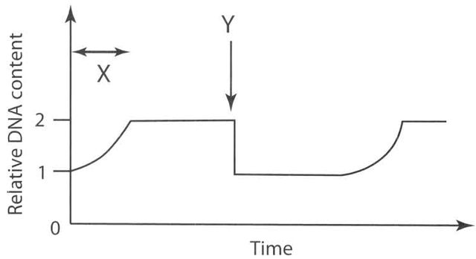
A. X: replication of DNA; Y: mitosis
B. X: replication of DNA; Y: meiosis
C. X: fertilization of male and female gametes; Y: mitosis
D. X: fertilization of male and female gametes; Y: meiosis

Directions: The following items refer to the graph below, which shows the relative DNA content of a cell in the cell cycle.
2. Which of the following cells has N units of DNA content in period W of a flowering plant?
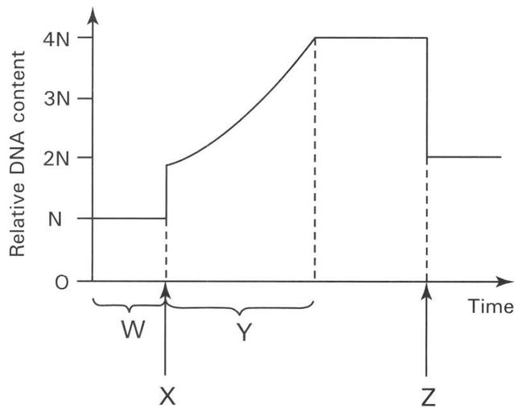
A. Integument of ovule
B. Ovary wall
C. Ovum
D. Wall of pollen sac

3. Which of the following processes take place at X and Z respectively?
A. X: pollination; Z: fertilization
B. X: fertilization; Z: pollination
C. X: karyokinesis; Z: dispersal
D. X: fertilization; Z: cytokinesis

4. Which of the following events takes place in period Y?
A. Assortment of chromosomes into gametes.
B. Crossing over between the original and replicated chromosomes.
C. Replication of chromosomes.
D. Pairing of chromosomes in prophase.

5. Which of the following statements about interphase is CORRECT? (1) The cell is metabolically inactive. (2) The chromosomes usually exist in a non-distinct form which is known as chromatin. (3) The chromosomes are not in an actively dividing stage. (4) Interphase is a characteristic stage in mitosis, not in meiosis.
A. (1) and (3) only
B. (1) and (4) only
C. (2) and (3) only
D. (3) and (4) only

6. The chromosome number of humans is 46. Under normal conditions which of the following statements is INCORRECT? (1) All the matured red blood cells contain 46 chromosomes. (2) All the egg cells produced contain 23 chromosomes. (3) All the sperms produced contain 23 chromosomes. (4) The white blood cell at the second stage (metaphase) of cell division with the chromosomes arranged at the equator has 46 chromatids.
A. (1) and (2) only
B. (2) and (3) only
C. (3) and (4) only
D. (4) and (1) only

7. The body cells of humans have 23 pairs of homologous chromosomes. Which of the following statements is CORRECT?
A. The number of DNA molecules in the interphase just before cell division is 46.
B. The number of chromatids in the cell at the first stage of cell division (prophase) is 46.
C. The number of chromosomes in the tubular cell of the sperm duct (vas deferens) is 23.
D. The number of chromosomes in the zygote in the oviduct is 46.

8. Which of the following is responsible for producing the same kind and same number of chromosomes in the daughter cells in mitosis?
A. Sister chromatids bound by the same centromere arranged individually at the equator and then separate and move into opposite poles.
B. Chromosomes exist as homologous chromosomes in the prophase.
C. Cytoplasm separates into two equal parts.
D. Nuclear membrane reforms around the two daughter nuclei.

9. Which of the following regions will mitosis occur actively in a man of thirty years old? (1) Inner lining of the alimentary canal (2) Cerebral cortex of the brain (3) Epidermis of the skin (4) Red bone marrow
A. (1) and (2) only
B. (2) and (3) only
C. (3) and (4) only
D. (1), (3) and (4) only

10. In which of the following processes does mitosis occur? (1) The division of meristematic cells in the root tip of flowering plants. (2) The production of white blood cells in the lymph nodes of mammals. (3) The production of eggs in the ovary of mammals. (4) The vegetative propagation of a ginger.
A. (1) and (2) only
B. (2) and (3) only
C. (2) and (4) only
D. (1), (2) and (4) only

11. Which of the following statements about mitosis is INCORRECT?
A. All somatic cells are produced by mitosis.
B. Mitosis is responsible for the growth of a zygote to an embryo.
C. A single cell will divide into four daughter cells by mitosis.
D. The daughter cells retain the same chromosome number that their mother cell has.

Directions: The following items refer to the diagrams below, which represent chromosomes in cells of the salivary gland of the fruit fly, Drosophila melanogaster. (1) (2) (3) (4)
12. Which diagram represents the product of cell division in the gut cells of the fruit fly?
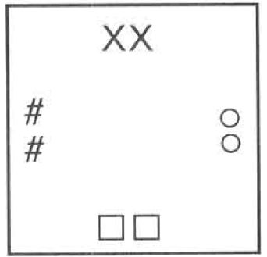
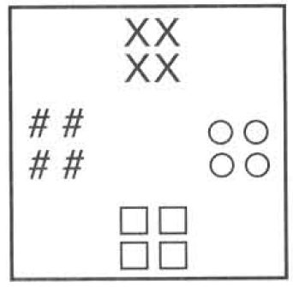
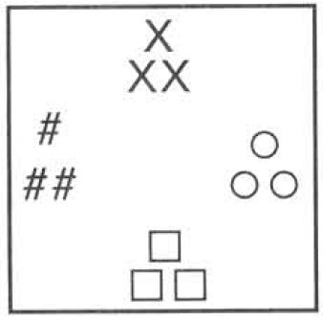
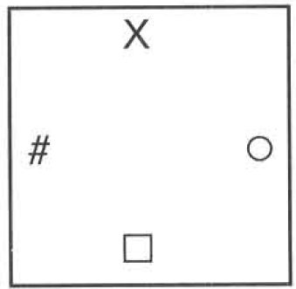
A. (1)
B. (2)
C. (3)
D. (4)

13. Which diagram represents the cell coming out of the testes of the fruit fly and passing down the sperm ducts?
A. (1)
B. (2)
C. (3)
D. (4)

14. Which diagram represents the zygote formed by the fusion of the gametes of the fruit fly?
A. (1)
B. (2)
C. (3)
D. (4)

Directions: The following items refer to the diagrams below, which show four different stages of a nuclear division.
15. Which of the following is the CORRECT sequence of the above process?
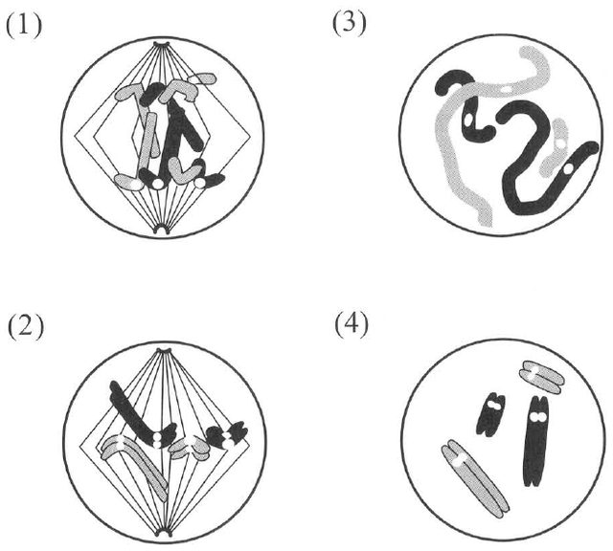
A. (1), (2), (3), (4)
B. (3), (2), (4), (1)
C. (4), (2), (1), (3)
D. (2), (1), (3), (4)

16. Where will the above type of cell division occur?
A. In the sperm-producing tubules
B. In the bone marrow
C. In the root cap
D. In the matured cells of the petal

Directions: The following items refer to the diagram below, which shows one stage of nuclear division.
17. How many chromosomes will be present in each daughter cell?
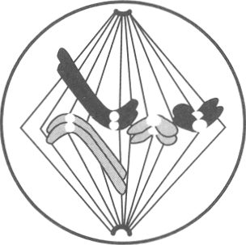
A. 2
B. 4
C. 6
D. 8

18. Which stage of nuclear division is illustrated above ?
A. Interphase (resting stage)
B. Prophase (first stage)
C. Metaphase (second stage)
D. Telophase (fourth stage)

19. Which matching of the events in cell division is CORRECT? (Interphase = resting stage; prophase = 1st; metaphase = 2nd; anaphase = 3rd; telophase = 4th)
A. Replication of chromosomes: interphase; nuclear membrane reforms: metaphase; chromosomes at equator: anaphase; chromatids separate: telophase
B. Replication of chromosomes: interphase; nuclear membrane reforms: telophase; chromosomes at equator: metaphase; chromatids separate: anaphase
C. Replication of chromosomes: telophase; nuclear membrane reforms: interphase; chromosomes at equator: anaphase; chromatids separate: metaphase
D. Replication of chromosomes: prophase; nuclear membrane reforms: interphase; chromosomes at equator: telophase; chromatids separate: anaphase

Directions: The following items refer to the photomicrograph, which shows several cells obtained from the root tip of onion.
20. Which activity is demonstrated by the cell labelled (X)?
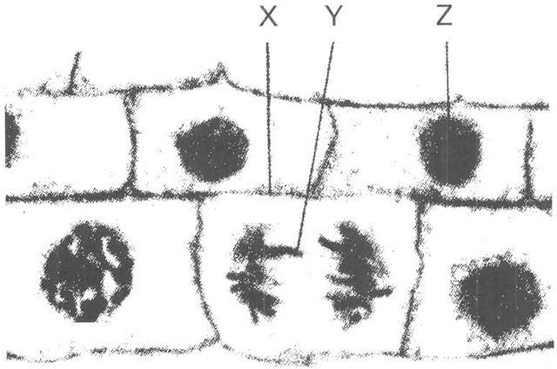
A. Cell enlargement
B. Cell differentiation
C. Mitosis
D. Meiosis

21. The structure labelled (Y) is
A. chromatin.
B. chromosome.
C. nucleus.
D. chloroplast.

22. Which of the following is used to build up the structure labelled (X)?
A. Cellulose
B. Glycogen
C. Starch
D. Nucleic acid

23. A cell plate is formed in a cell in the root tip. Which of the following concerning the condition or activity of this cell is CORRECT?
A. Cytokinesis takes place after the occurrence of meiosis.
B. Cytokinesis takes place after the occurrence of mitosis.
C. In the interphase before the cell elongates.
D. Replication of chromosomes is taking place.

24. A horse (chromosome number = 64) can cross with a donkey (chromosome number = 62) to produce a sterile mule (chromosome number = 63). Which are correct explanations for the sterility of the mule?
(1) A mule's chromosomes cannot all pair up during meiosis.
(2) Mules cannot carry out nuclear division.
(3) Mules have an odd number of chromosomes.
A. (1) and (2) only
B. (1) and (3) only
C. (2) and (3) only
D. (1), (2) and (3)

25. Drug X is designed to kill cancer cells by inhibiting nucleotide synthesis. Which processes of the cancer cells would be inhibited?
(1) DNA replication
(2) transcription
(3) translation
A. (1) and (2) only
B. (1) and (3) only
C. (2) and (3) only
D. (1), (2) and (3)

Directions: The following items refer to an investigation of fin length in fish from two equal-sized populations of the same species over 40 generations.
26. In each generation, fins of different lengths are always observed among the fish in aquarium X. Which of the following contribute to this phenomenon?
(1) crossing over
(2) independent assortment
(3) random fertilisation
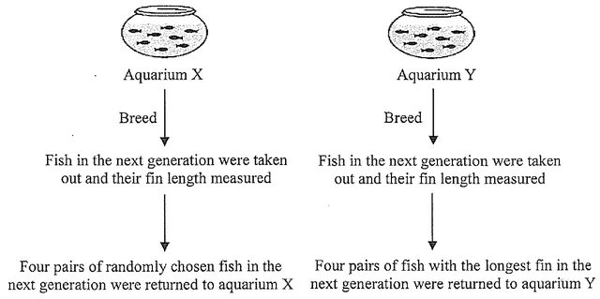
A. (1) and (2) only
B. (1) and (3) only
C. (2) and (3) only
D. (1), (2) and (3)

Answers (teachers)
These keys match the student web quiz.
Practice
1A 2C 3D 4C 5C 6D 7D 8A 9D 10D 11C 12C 13D 14C 15C 16B 17B 18C 19B 20C 21B 22A 23B 24B 25D 26D

