Cellular organisation · F.4
Student web quiz · same question numbers
Name: ________________________ Class: ____________ Class no.: ______
Question numbers on this paper are the same as on the student webpage. Question 1 here is question 1 on the web. Practice 1 (32 questions) + Practice 2 (32 questions).
Practice 1 — Using a microscope
1. The letter "b" is viewed with a compound light microscope. Which image is seen?
A. b
B. d
C. p
D. q

2. Under the microscope, a water flea is seen swimming towards the left edge and then leaves the field. To bring the image back to the centre, the slide should be moved
A. to the left.
B. to the right.
C. upwards with the coarse adjustment knob.
D. by turning to a higher-power objective.

Directions: Questions 3 to 5 refer to the table below, which shows five microscopes used to view the same blood smear.
Microscope | Eyepiece | Objective
(1) | 5× | 10×
(2) | 10× | 10×
(3) | 5× | 40×
(4) | 10× | 40×
(5) | 10× | 20×

3. Which microscope shows the smallest number of red blood cells, and which shows the greatest number?
A. (4) and (1)
B. (1) and (4)
C. (3) and (2)
D. (2) and (5)

4. Which microscope gives the brightest image?
A. (1)
B. (2)
C. (3)
D. (4)

5. Which two microscopes show red blood cells of about the same size?
A. (1) and (2)
B. (2) and (3)
C. (1) and (3)
D. (3) and (5)

6. Which of the following are incorrect ways to use a light microscope with a temporary mount?
(1) Tilt the microscope.
(2) Use a plane mirror when the lamp is dim.
(3) Lower the body tube while looking through the eyepiece.
A. (1) only
B. (1) and (2) only
C. (2) and (3) only
D. (1), (2) and (3)

7. The photomicrograph below shows a blood smear under a light microscope. Which change lets you see more cells from the same slide?
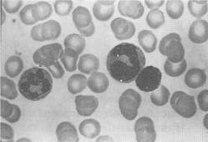
Photomicrograph of a blood smear
A. Turn to a higher-power objective.
B. Turn to a lower-power objective.
C. Use a brighter lamp only.
D. Add more stain, without changing the objective.

8. Nuclei are large enough to see with a light microscope, but they are almost colourless. Which step makes them easier to see?
A. Use a thinner cover slip.
B. Increase the light intensity.
C. Rack the high-power objective closer to the slide.
D. Add a stain that colours the nuclei.

9. A strip of onion epidermis is mounted in iodine solution. Which structure becomes most deeply coloured?
A. Cell wall
B. Nucleus
C. Central vacuole
D. Chloroplast

10. After focusing under the low-power objective, which step should come next if you want to study a chosen region at high magnification?
A. Use the coarse adjustment under high power until the image is sharp.
B. Move the slide until that region is at the centre of the field, then turn the nosepiece.
C. Remove the cover slip and add more stain.
D. Tilt the microscope to let more light in.

11. Which are reasons for lowering a cover slip onto a stained wet mount?
(1) It lets more light through, so the specimen becomes transparent.
(2) It keeps the specimen flat.
(3) It slows drying of the specimen.
(4) It keeps stain off the objective.
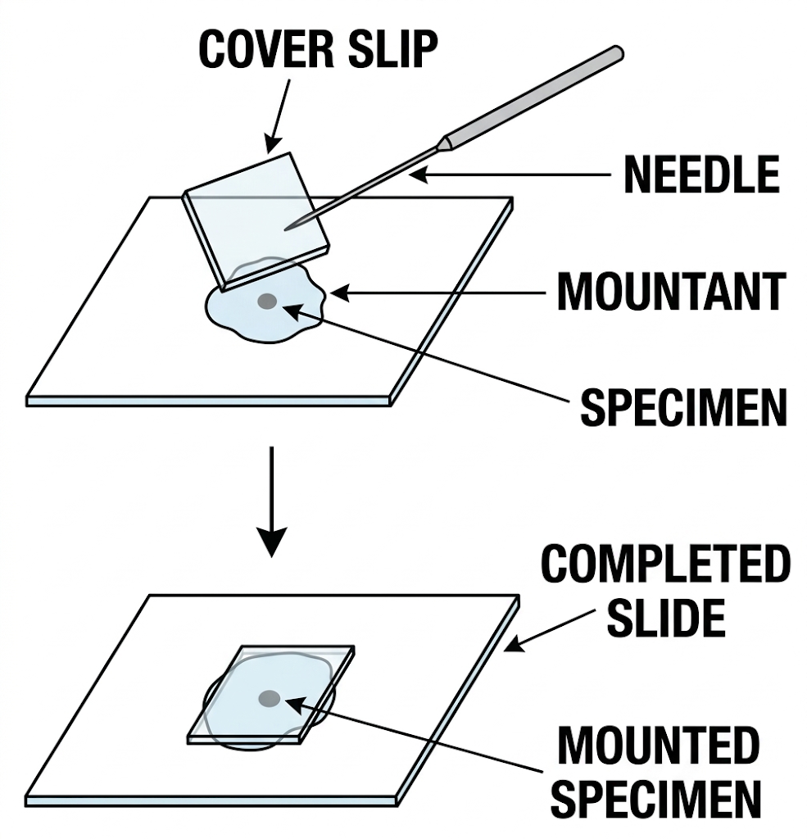
Lowering a cover slip onto a temporary mount
A. (1), (2) and (3) only
B. (2), (3) and (4) only
C. (1), (3) and (4) only
D. (1), (2) and (4) only

12. Photomicrograph I and Photomicrograph II show the same root section under different magnifications. Which sequence is needed to obtain the higher-magnification image from the lower-magnification image?
(1) Focus with the fine adjustment under high power.
(2) Turn the nosepiece to the high-power objective.
(3) Focus with the coarse adjustment under low power.
(4) Move the slide until the chosen region is in the centre.
(5) Watching from the side, lower the tube until it is just above the slide.
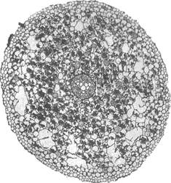 | 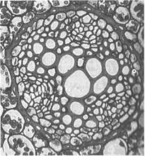

Photomicrograph I (left) and Photomicrograph II (right)
A. (5), (3), (4), (2), (1)
B. (3), (4), (2), (5), (1)
C. (2), (1), (5), (3), (4)
D. (5), (2), (1), (4), (3)

13. A light microscope cannot usefully magnify above about 1500×. Which statement explains this limit?
A. Glass lenses cannot be made thick enough.
B. A table lamp is not bright enough.
C. Resolution is limited by the wavelength of light.
D. An eyepiece cannot be made stronger than 15×.

14. An electron microscope can resolve smaller structures than a light microscope. Which is the reason?
A. An electron beam has a much shorter wavelength than light.
B. Electromagnetic lenses have a higher magnifying power than glass lenses.
C. Electrons travel faster than light.
D. Electrons make a brighter image than a lamp.

15. Which are advantages of an electron microscope over a light microscope?
(1) Higher resolution
(2) Higher useful magnification
(3) Specimen preparation is simpler
(4) It can be used with little training
A. (1) and (2) only
B. (2) and (3) only
C. (3) and (4) only
D. (1), (2) and (3) only

16. Which structure can be seen clearly with a school light microscope?
A. Ribosomes on rough endoplasmic reticulum
B. The double membrane of a mitochondrion
C. A chloroplast
D. Grana inside a chloroplast

17. Which structure can be distinguished only with an electron microscope?
A. A chloroplast
B. Rough endoplasmic reticulum
C. The nucleus
D. A large central vacuole

18. The photomicrographs below show the same type of cell, obtained with three different microscopes. Which matching of the microscopes is correct?
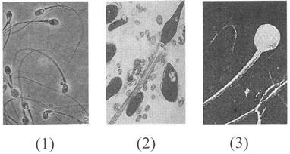
The same type of cell, viewed with three microscopes
 | (1) | (2) | (3)
A | light microscope | scanning electron microscope | transmission electron microscope
B | transmission electron microscope | light microscope | scanning electron microscope
C | light microscope | transmission electron microscope | scanning electron microscope
D | scanning electron microscope | transmission electron microscope | light microscope

19. Which parts can change the brightness of the image?
(1) Mirror
(2) Iris diaphragm
(3) Changing to a higher-power objective
A. (1) only
B. (1) and (2) only
C. (2) and (3) only
D. (1), (2) and (3)

20. Which is the better way to measure the diameter of the field of view?
A. A ruler marked in cm, under low power
B. A ruler marked in cm, under high power
C. A transparent ruler marked in mm, under low power
D. A transparent ruler marked in mm, under high power

21. The eyepiece is 10× and the objective is 10×. By how many times is the area of the image greater than the area of the object?
A. 10 times
B. 20 times
C. 100 times
D. 10 000 times

22. The eyepiece is 15× and the objective is 40×. What is the total magnification?
A. 55×
B. 150×
C. 600×
D. 1 500×

23. In a drawing, a cheek cell is 12 mm across. The actual cell is 40 μm across. What is the magnification of the drawing?
A. ×30
B. ×300
C. ×3 000
D. ×12 000

24. The photomicrograph below shows unstained plant cells. What is the actual length of W?
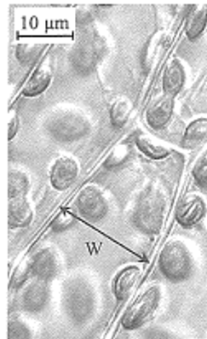
Unstained plant cells
A. 10 μm
B. 19 μm
C. 1.9 μm
D. 190 μm

25. The photograph below shows a light microscope. Which parts should be adjusted to obtain a clear, sharp image when you switch from low magnification to high magnification?
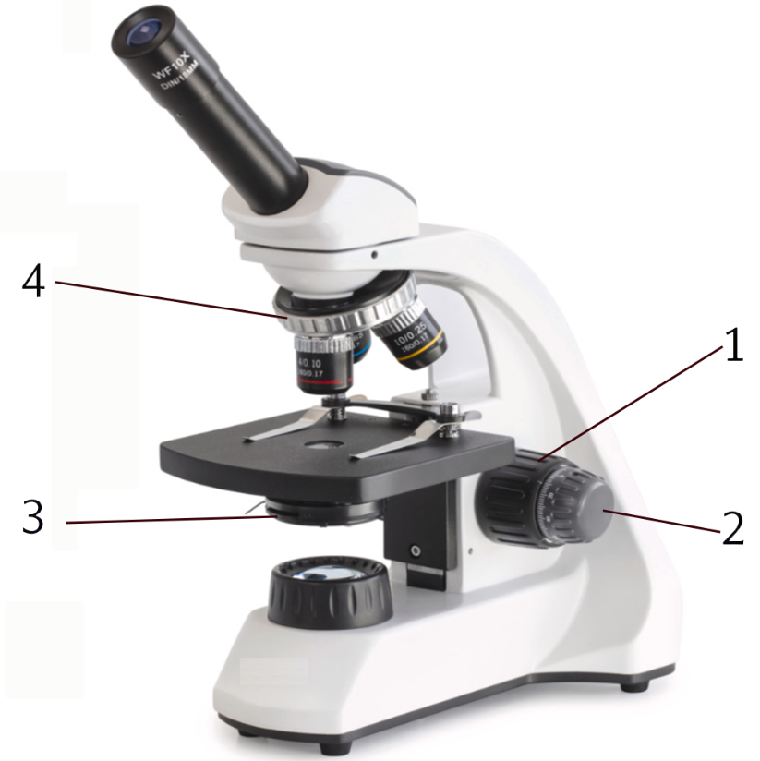
A light microscope
A. 1 and 4 only
B. 2 and 3 only
C. 1, 3 and 4 only
D. 2, 3 and 4 only

26. In the photomicrograph below, chloroplast 1 is sharp and chloroplast 2 is blurred. They lie at slightly different depths. How should the microscope be adjusted to sharpen chloroplast 2?
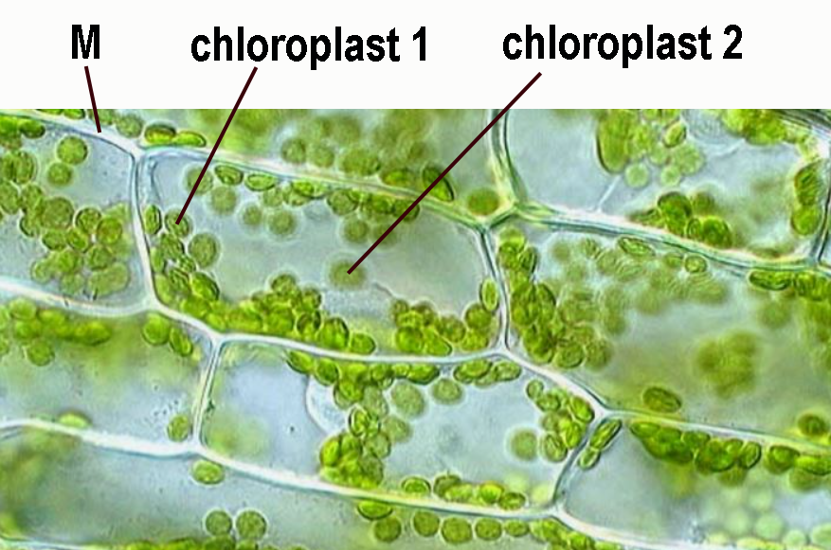
Chloroplasts in a leaf cell
A. Rotate the fine adjustment knob.
B. Rotate the coarse adjustment knob through a large angle.
C. Change at once to a lower-power objective.
D. Add a drop of stain to the eyepiece.

27. The photomicrograph below shows several chloroplasts in a leaf cell. Which part of a chloroplast cannot be distinguished in that photomicrograph?
A. A granum
B. The outline of the chloroplast
C. Whether the chloroplast is in the cytoplasm
D. How many chloroplasts are in that cell

28. Which equipment can show the grana inside a chloroplast?
A. A hand lens
B. A light microscope with a 40× objective
C. An electron microscope
D. A magnifying glass and a brighter lamp

29. Which practices are incorrect?
(1) Start with the lowest-power objective.
(2) Under low power, use only the fine adjustment and never the coarse adjustment.
(3) Under high power, look through the eyepiece while focusing downwards with the coarse adjustment.
A. (1) and (2) only
B. (1) and (3) only
C. (2) and (3) only
D. (1), (2) and (3)

30. Photomicrographs X and Y show a human blood smear. Y is a higher magnification of the white blood cell. What is the actual diameter of the white blood cell, VW, in Photomicrograph Y?
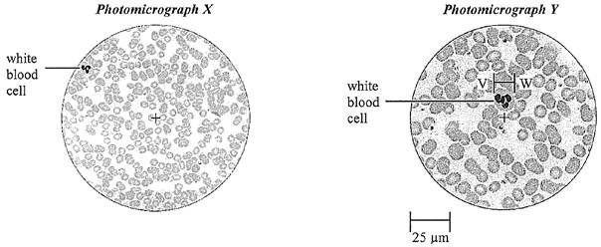
Photomicrograph X and Photomicrograph Y
A. 12.5 μm
B. 20.0 μm
C. 50.0 μm
D. 0.5 cm

31. The diagram below shows the last step in making a temporary mount. After this step the objective lens becomes wet. Which step was most likely missed?
Lowering a cover slip onto a temporary mount
A. Lowering a cover slip onto the mountant
B. Adding a stain
C. Switching off the lamp
D. Using the coarse adjustment first

32. A fresh leaf epidermis is to be mounted for viewing. Which liquid is suitable?
A. Dilute hydrochloric acid
B. Antiseptic
C. Dilute glycerol
D. Dilute sodium hydroxide

Practice 2 — Cell structure
1. Which statements about cells are incorrect?
(1) Cells can arise from non-living matter.
(2) The outermost boundary of every living cell is a cell wall.
(3) Every living human cell has a nucleus.
A. (1) only
B. (1) and (2) only
C. (2) and (3) only
D. (1), (2) and (3)

2. Which structure is the control centre of a cell?
A. Nucleus
B. Cytoplasm
C. Cell wall
D. Chloroplast

3. Which living human cells have no nucleus?
(1) Bone cells
(2) Mature red blood cells
(3) Liver cells
A. (1) only
B. (2) only
C. (1) and (2) only
D. (2) and (3) only

4. Which process is carried out by mitochondria, not by the nucleus?
A. Storing genetic information as DNA
B. Releasing energy from respiratory fuel
C. Making ribosomes
D. Controlling which proteins the cell makes

5. Which statements about the cell wall are incorrect?
(1) A cell wall is present in every plant cell.
(2) A cell wall stops sucrose from passing through.
(3) A cell wall is made mainly of cellulose.
(4) A cell wall carries out metabolic reactions.
A. (1) and (2) only
B. (2) and (4) only
C. (3) and (4) only
D. (1), (3) and (4) only

6. Which comparison of the cell wall and the cell membrane is incorrect?
A. The wall is fully permeable. The membrane is differentially permeable.
B. The wall is found only in plant cells. The membrane is found only in animal cells.
C. The wall is made mainly of carbohydrate. The membrane is made mainly of lipid and protein.
D. A plant cell in a very dilute solution is kept from bursting by its wall. An animal cell in the same solution may burst.

7. Which structures are present in both a palisade cell and a liver cell?
(1) Cell wall
(2) Cell membrane
(3) Cytoplasm
(4) Chloroplast
(5) Nucleus
(6) Mitochondrion
A. (1), (2), (3) and (4) only
B. (2), (3), (4) and (5) only
C. (2), (3), (5) and (6) only
D. (1), (3), (4) and (6) only

8. Which comparison of an animal cell and a green leaf cell is incorrect?
A. The animal cell has no chloroplast. The leaf cell has chloroplasts.
B. The animal cell has no cell wall. The leaf cell has a cell wall.
C. The animal cell stores glycogen. The leaf cell does not store glycogen.
D. The animal cell has mitochondria. The leaf cell has no mitochondria.

9. Which is an incorrect difference between a spongy mesophyll cell and a root hair cell?
A. Gas exchange occurs at the surface of the mesophyll cell, but it cannot occur at the surface of the root hair cell.
B. The mesophyll cell has chloroplasts. The root hair cell does not.
C. The mesophyll cell has an irregular shape. The root hair cell has a long projection.
D. The mesophyll cell makes food. The root hair cell does not.

10. Chloroplasts are present in
A. guard cells and ordinary epidermal cells.
B. mesophyll cells and ordinary epidermal cells.
C. guard cells and mesophyll cells.
D. guard cells, mesophyll cells and ordinary epidermal cells.

11. Which cells produce carbon dioxide?
(1) An epidermal cell of a leaf
(2) A root hair cell
(3) A xylem vessel
A. (1) only
B. (2) only
C. (1) and (2) only
D. (2) and (3) only

12. Which structure is absent from a root hair cell?
A. Chloroplasts
B. A nucleus
C. A vacuole
D. A cell membrane

13. Which structure is present in every plant cell but absent from animal cells?
A. Nucleus
B. Chloroplast
C. Large permanent vacuole
D. Cell wall

14. Which are shared by a mature red blood cell and a neurone?
(1) DNA
(2) Cell membrane
(3) A large central vacuole
(4) Nucleus
A. (2) only
B. (1) and (2) only
C. (2) and (3) only
D. (3) and (4) only

15. Which are true of both a root hair cell and a human red blood cell?
(1) It has a cell membrane.
(2) It has a nucleus.
(3) It has no chloroplasts.
(4) It has no cell wall.
A. (1) and (2) only
B. (1) and (3) only
C. (1) and (4) only
D. (2) and (3) only

16. An onion epidermal cell differs from an Amoeba in having
(1) chloroplasts.
(2) a large central vacuole.
(3) a cell wall.
A. (1) only
B. (3) only
C. (2) and (3) only
D. (1), (2) and (3)

17. Which structure is absent from a mature xylem vessel?
A. Cell wall
B. Nucleus
C. Lignin
D. Pits

18. Which structure is present in all plant cells and all animal cells?
A. A nucleus
B. A cell membrane
C. A nucleus and a cell membrane
D. A nucleus, a cell membrane and a large vacuole

19. Which list is in ascending order of complexity?
A. Cell, tissue, organ, organ system, organism
B. Organism, organ system, organ, tissue, cell
C. Cell, organ, organ system, tissue, organism
D. Tissue, cell, organ, organism, organ system

20. The photomicrograph below shows cheek cells. Which statements about these cells are incorrect?
(1) They have no cell wall.
(2) They have chloroplasts.
(3) They move about like an Amoeba.
(4) They have a nucleus.
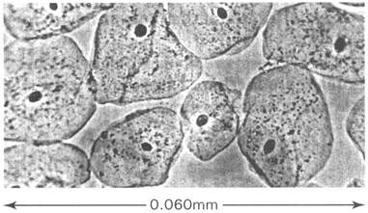
Cheek cells
A. (1) only
B. (3) only
C. (1) and (4) only
D. (2) and (3) only

21. The diagrams below show five types of cell, not drawn to the same scale. Which matching of the cells is correct?
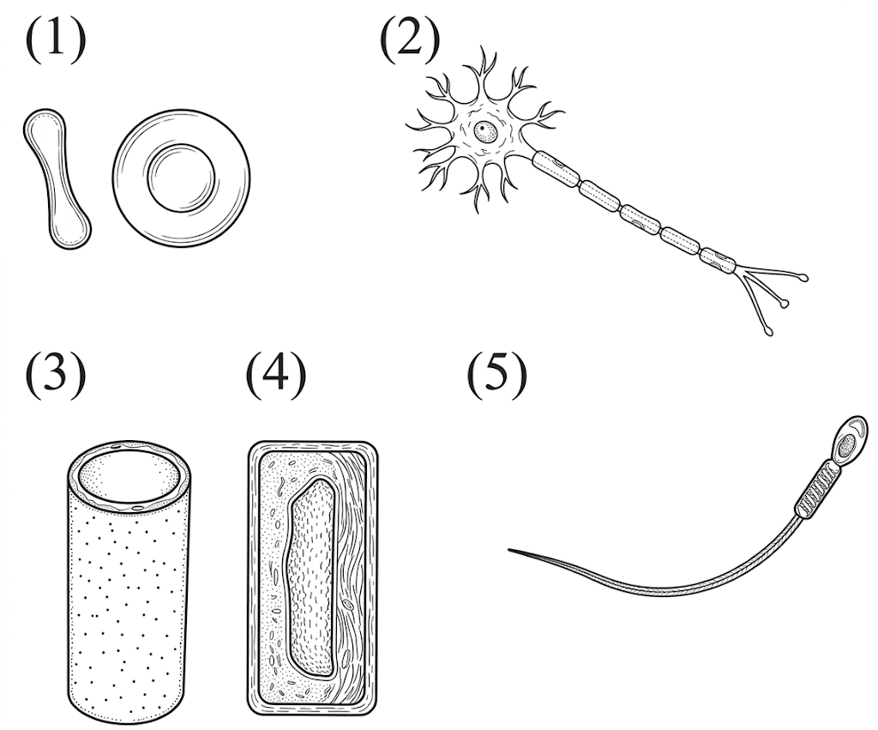
Five types of cell, not drawn to the same scale
 | (1) | (2) | (3) | (4) | (5)
A | white blood cell | muscle cell | xylem | epidermal cell | sperm
B | red blood cell | nerve cell | phloem | epidermal cell | muscle cell
C | red blood cell | nerve cell | xylem | palisade cell | sperm
D | white blood cell | muscle cell | xylem | spongy mesophyll | sperm

22. The diagram below shows a young leaf cell. Which labelled parts support the cell?
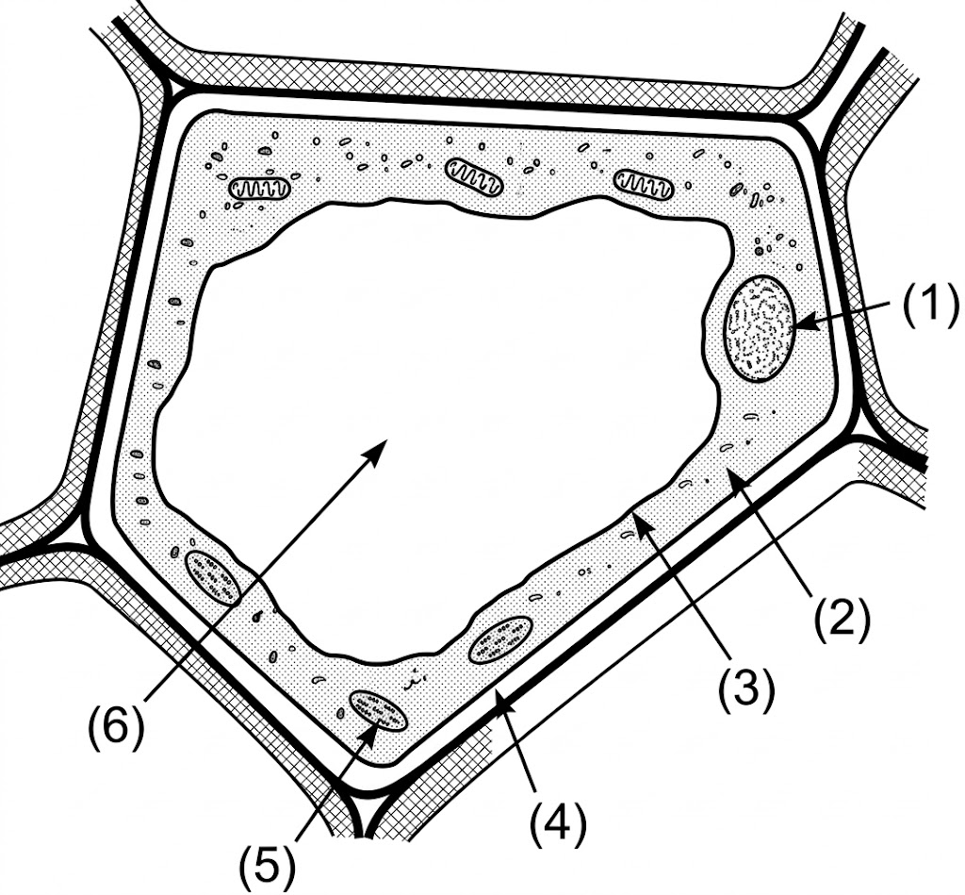
A young leaf cell
A. (1) only
B. (1) and (4) only
C. (4) only
D. (4) and (6) only

23. Which are functions of the cell membrane?
(1) It can allow glucose to enter the cell.
(2) It stops starch leaving the cell.
(3) It stops all movement of water into or out of the cell.
A. (1) and (2) only
B. (1) and (3) only
C. (2) and (3) only
D. (1), (2) and (3)

24. Which statements about the cell wall are correct?
(1) It supports the cell.
(2) It is fully permeable.
(3) It controls which substances enter and leave the cell.
A. (1) and (2) only
B. (1) and (3) only
C. (2) and (3) only
D. (1), (2) and (3)

25. Which description fits a palisade cell?
A. It has many chloroplasts and also has mitochondria.
B. It has many chloroplasts and no mitochondria.
C. It has no chloroplasts and many cilia.
D. It has a cell wall and no cell membrane.

26. The diagram below shows part of a pancreas cell. How do structures B and C work together in protein secretion?
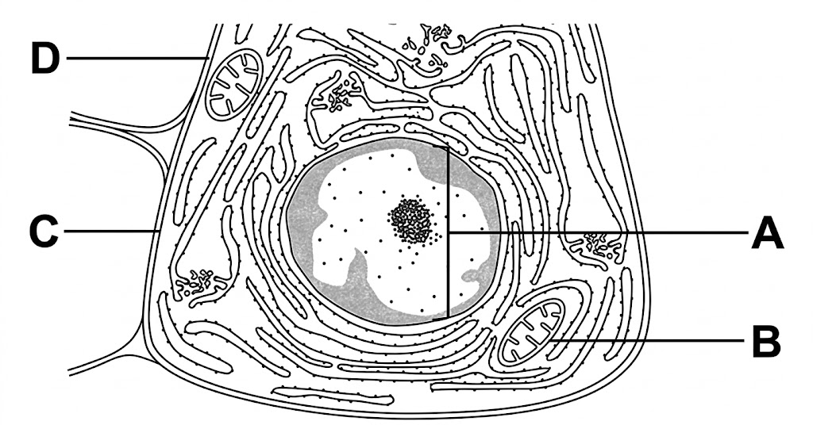
Part of a pancreas cell
A. Structure B synthesises the proteins, while structure C breaks down waste products.
B. Structure C synthesises the proteins, while structure B carries out aerobic respiration to release the energy required.
C. Both structures copy nuclear DNA and assemble it into functional proteins.
D. Structure C stores the proteins, while structure B transports them across the cell membrane.

27. Which cell has the most rough endoplasmic reticulum?
A. A ciliated epithelial cell of the trachea
B. A cell that secretes protease into the stomach
C. A mature red blood cell
D. A mature xylem vessel

28. The diagram below shows a prokaryotic cell. Which set of structures is found in such a cell?
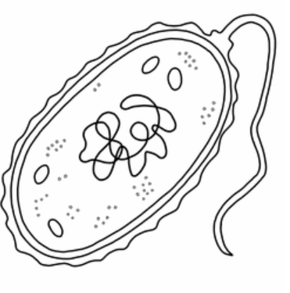
A prokaryotic cell
A. Cell wall, ribosome, cell membrane
B. Ribosome, cell membrane, chloroplast
C. Cell wall, cell membrane, mitochondrion
D. Cell membrane, chloroplast, mitochondrion

29. Which statement about the cell membrane is correct?
A. It is fully permeable.
B. It is differentially permeable.
C. It is a complete barrier that stops every virus.
D. It allows only lipid-soluble substances to enter.

30. The diagrams below show two organelles, X and Y, from a green plant cell. Which of the following statements are correct?
(1) X releases energy from food. Y builds food using light.
(2) X is bounded by a double membrane. Y is bounded by a single membrane.
(3) Folds of the inner membrane of X increase the surface for respiration. Membranes inside Y increase the surface for absorbing light.
(4) Y is present in every plant cell.
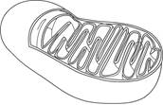 | 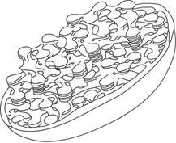

Organelle X (left) and organelle Y (right)
A. (1) and (2) only
B. (2) and (4) only
C. (3) and (4) only
D. (1) and (3) only

31. The electron micrographs below show two membranous organelles, X and Y. Which pairing is correct?
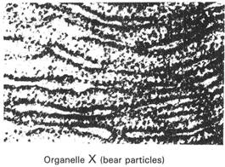 | 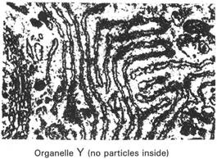

Organelle X (left) and organelle Y (right)
A. X synthesises proteins. Y synthesises lipids.
B. X synthesises lipids. Y synthesises proteins.
C. X makes glycogen. Y makes starch.
D. X makes DNA. Y makes cellulose.

32. The diagram below shows an organelle. Which of the following is this organelle?
An organelle
A. Nucleus
B. Mitochondrion
C. Ribosome
D. Chloroplast

Answers (teachers)
These keys match the student web quiz.
Practice 1
1D 2A 3A 4A 5D 6D 7B 8D 9B 10B 11B 12A 13C 14A 15A 16C 17B 18C 19D 20C 21D 22C 23B 24B 25C 26A 27A 28C 29C 30A 31A 32C
Practice 2
1D 2A 3B 4B 5B 6B 7C 8D 9A 10C 11C 12A 13D 14A 15B 16C 17B 18B 19A 20D 21C 22D 23A 24A 25A 26B 27B 28A 29B 30D 31A 32B

