Photosynthesis
Student web quiz · same question numbers
Name: ________________________ Class: ____________ Class no.: ______
Question numbers on this paper are the same as on the student webpage. Question 1 here is question 1 on the web. Practice 1 (16 questions) + Practice 2 (16 questions).
Practice 1 — Average / difficult · Questions 1–16
1. Which of the following about photosynthesis is correct?
A. Greenhouse is made of green glass to facilitate photosynthesis inside it.
B. The primary product of photosynthesis can be converted to lipids for storage.
C. Aquatic plants obtain carbon dioxide directly from the atmosphere.
D. The metabolites for photosynthesis include chlorophyll and water.

2. Which of the following is/are correct about autotrophs?
(1) Energy comes from the dead bodies of animals.
(2) Autotrophs absorb carbon dioxide and give out oxygen at night.
(3) Autotrophs can survive independently of animals.
A. (1) only
B. (2) only
C. (3) only
D. (1) and (3) only

3. Which of the following is correct about photosynthesis and respiration in green plants?
A. Photosynthesis is catabolic in nature while respiration is anabolic.
B. In the daytime, plants always have a net uptake of carbon dioxide.
C. At night, plants always have a net release of carbon dioxide.
D. Photosynthesis takes place in the daytime while respiration occurs at night.

4. The role of chlorophyll in photosynthesis is to
A. make leaves appear green.
B. split water into oxygen and hydrogen.
C. reduce carbon dioxide into glucose.
D. absorb light energy.

Directions: Refer to the following steps about the test for starch in green leaves.
(1) Soak the leaf in warm water.
(2) Add iodine solution onto the leaf.
(3) Immerse the leaf in boiling ethanol for 15 minutes.
(4) Immerse the leaf in boiling water for 1 minute.
5. The purpose of step (1) is to
A. kill the leaf cells.
B. rehydrate the leaf.
C. cool down the leaf.
D. denature the enzymes in leaf cells.

Directions: Refer to the following steps about the test for starch in green leaves.
(1) Soak the leaf in warm water.
(2) Add iodine solution onto the leaf.
(3) Immerse the leaf in boiling ethanol for 15 minutes.
(4) Immerse the leaf in boiling water for 1 minute.
6. Ethanol is used in step (3) because
A. ethanol is a good solvent for organic molecules.
B. ethanol has a lower boiling point than water.
C. ethanol is a dehydrating agent.
D. ethanol can destroy the permeability of cell membrane.

7. To test for starch in a leaf, the leaf should be boiled in alcohol first because
A. alcohol can decolourize the leaf.
B. alcohol can dehydrate the leaf.
C. alcohol can soften the leaf.
D. alcohol can kill the cells.

8. In the experiment to show the occurrence of photosynthesis in a leaf, starch is tested for instead of glucose because
A. glucose is oxidized as rapidly as it is produced in the leaf.
B. Benedict's test cannot be carried out on a leaf.
C. glucose will be converted to starch when excess.
D. glucose produced in the leaf will be transported away quickly.

Directions: Refer to the following experiment in which a green leaf was tested for starch.
9. In order to show the presence of starch, how should the leaf be treated before the experiment?
A. kept in darkness for 2 days.
B. kept in carbon dioxide supply for 2 hours
C. kept in light for 4 hours.
D. kept in water supply for 4 hours.

Directions: Refer to the following experiment in which a green leaf was tested for starch.
10. What can be concluded if iodine solution turns the leaf dark blue?
A. The rate of photosynthesis is higher than that of respiration.
B. The rate of photosynthesis is lower than that of respiration.
C. Respiration has occurred in the leaf.
D. Photosynthesis has occurred in the leaf.

11. The set-up below was placed against a well-lighted background for 2 hours and the indicator solution changed from red to purple.
The result showed that
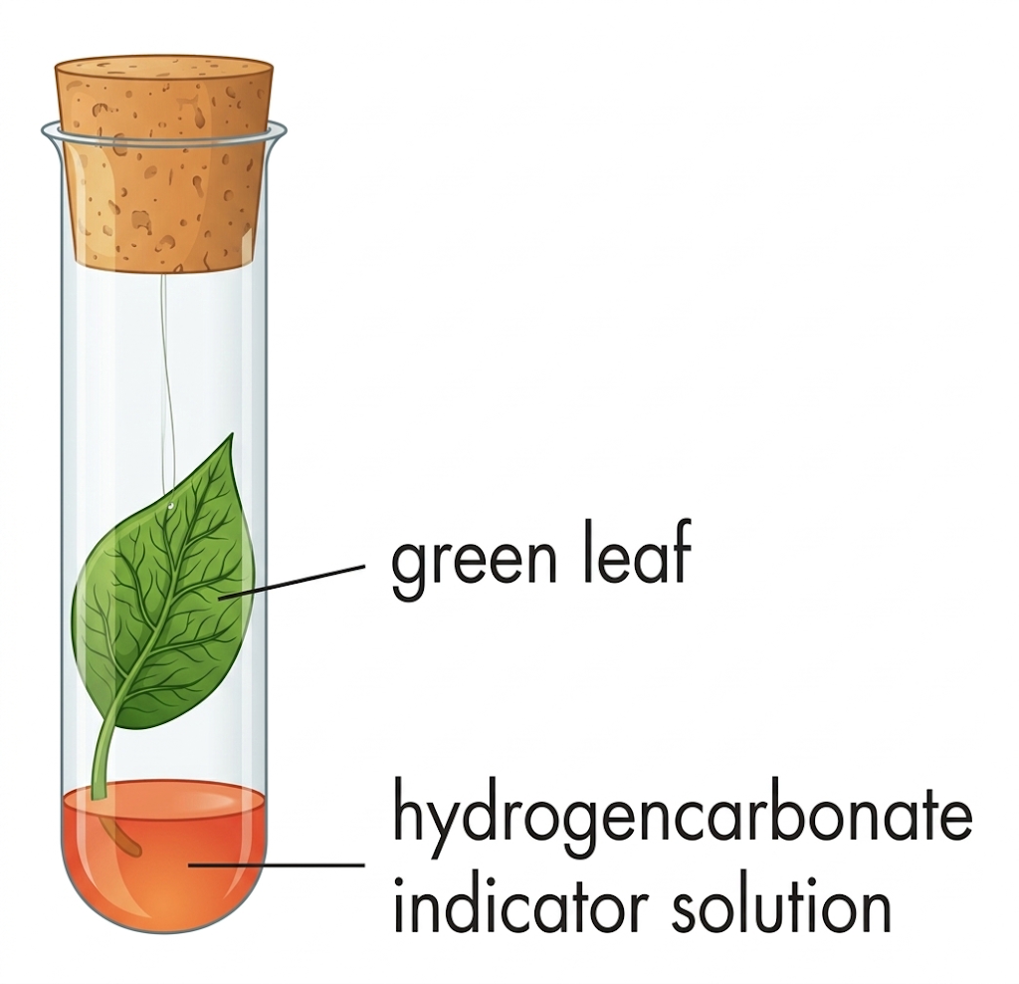
A. oxygen is produced during photosynthesis.
B. carbon dioxide is consumed during photosynthesis.
C. light is necessary for photosynthesis.
D. chlorophyll is necessary for photosynthesis.

Directions: Refer to the experiment below which investigates the necessity of a certain condition in photosynthesis.
 | Leaf A | Leaf B
A | brown | brown
B | brown | blue-black
C | blue-black | brown
D | blue-black | blue-black

12. After illumination for 3 hours, leaves A and B were subjected to an iodine test. The expected results are
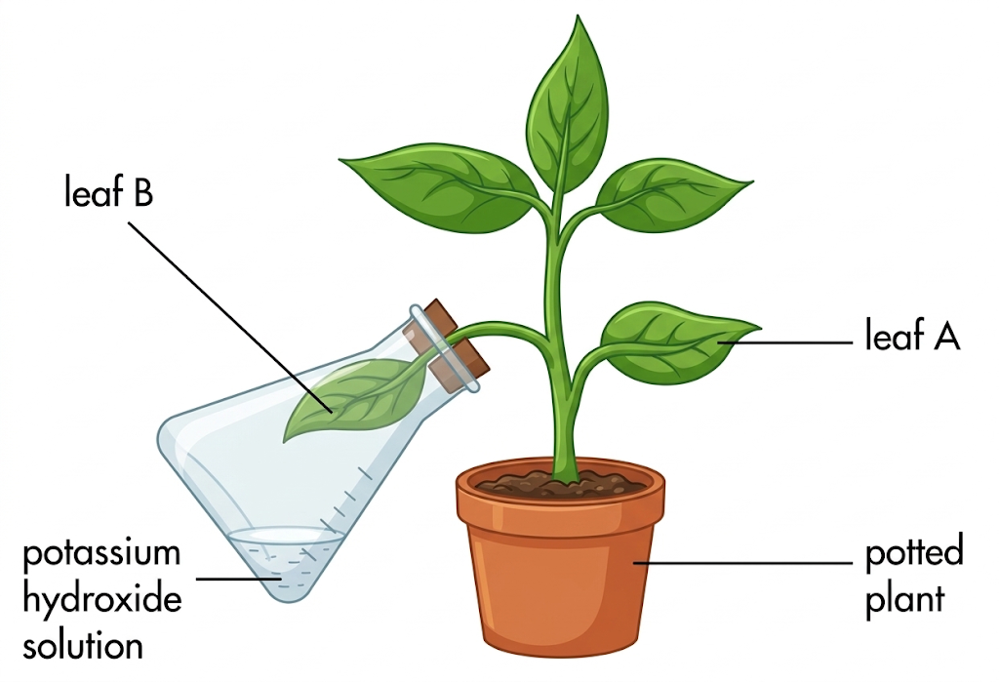
A. Leaf A brown; Leaf B brown
B. Leaf A brown; Leaf B blue-black
C. Leaf A blue-black; Leaf B brown
D. Leaf A blue-black; Leaf B blue-black

Directions: Refer to the experiment below which investigates the necessity for light in photosynthesis.
13. What is the advantage of carrying out this experiment on a single leaf?
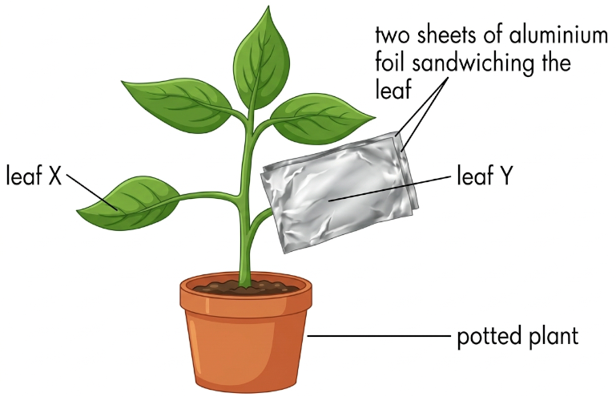
A. To save time.
B. To avoid the variations between leaves.
C. To have better comparison of results.
D. To save one leaf.

Directions: Refer to the diagram below which outlines the reactions occurring in a certain kind of plant cell
14. The probable plant cell type is
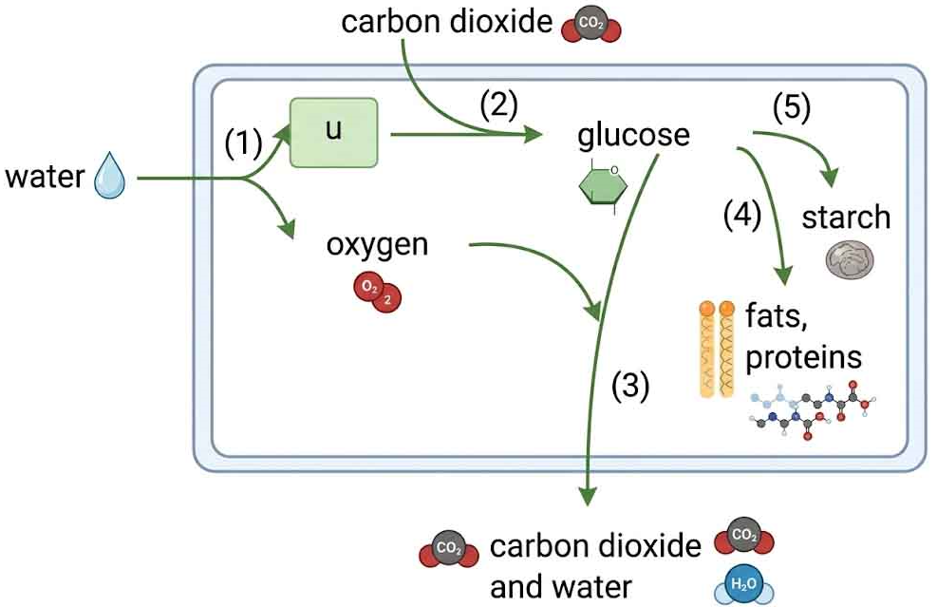
A. guard cell.
B. epidermal cell.
C. root hair cell.
D. xylem cell.

 | Light stage | Dark Stage
A. | reduction of water | production of carbohydrates
B. | production of oxygen | reduction of carbon dioxide
C. | photolysis of water | production of oxygen
D. | reduction of water | reduction of carbon dioxide

15. Which of the following correctly describes the events taking place in the light stage and dark stage of photosynthesis?
A. Light stage: reduction of water ; Dark Stage: production of carbohydrates
B. Light stage: production of oxygen ; Dark Stage: reduction of carbon dioxide
C. Light stage: photolysis of water ; Dark Stage: production of oxygen
D. Light stage: reduction of water ; Dark Stage: reduction of carbon dioxide

16. If a plant was supplied with heavy water, i.e. H2^18O, which of the following equations best represents the fate of the radioactive oxygen in photosynthesis?
A. 6CO2 + 6 H2^18O → C6H12O6 + 3^18O2 + 3O2
B. 6CO2 + 18H2^18O → C6H12^18O6 + 6^18O2 + 12H2O
C. 6CO2 + 6 H2^18O → C6H12^18O6 + 6O2
D. 6CO2 + 12 H2^18O → C6H12O6 + 6^18O2 + 6H2O

Practice 2 — Average / difficult · Questions 17–32
1. If a plant was supplied with heavy carbon dioxide, i.e. C^18O2, which of the following equations best represents the fate of the radioactive oxygen in photosynthesis?
A. 6C^18O2 + 6 H2O → C6H12O6 + 6^18O2
B. 6C^18O2 + 6H2O → C6H12^18O6 + 3^18O2 + 3O2
C. 6C^18O2 + 12 H2O → C6H12^18O6 + 6O2 + 6 H2^18O
D. 6C^18O2 + 18 H2O → C6H12O6 + 6O2 + 12H2^18O

Directions: Refer to the set-up below.
2. In order to ensure the smooth running of this experiment, solution X should be
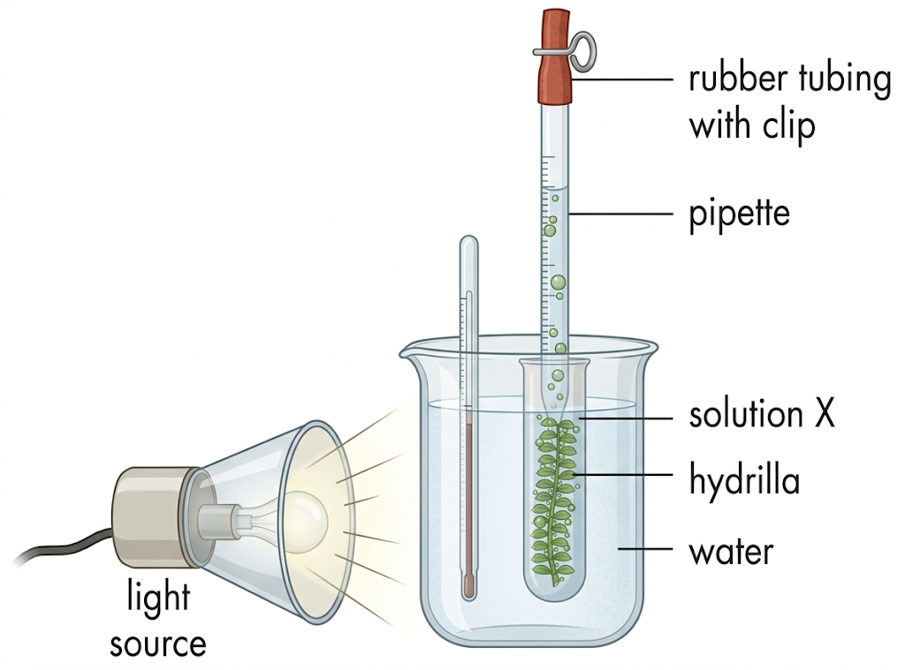
A. sodium chloride solution.
B. sodium hydrogencarbonate solution.
C. hydrogencarbonate indicator solution.
D. calcium carbonate solution.

Directions: Refer to the set-up below.
3. The identity of gas bubbles can be tested by
A. lime water.
B. hydrogencarbonate indicator solution.
C. pH paper.
D. glowing splint.

Directions: Refer to the set-up below.
4. Which of the following factors can be studied by this experiment on the rate of photosynthesis?
(1) Light intensity (2) Carbon dioxide concentration (3) temperature
A. (1) and (2) only
B. (1) and (3) only
C. (2) and (3) only
D. (1), (2) and (3)

5. Which of the following can only be synthesized with substances absorbed from the soil?
(1) Oil (2) Enzyme (3) Chlorophyll
A. (1) and (2) only
B. (1) and (3) only
C. (2) and (3) only
D. (1), (2) and (3)

Directions: Refer to the diagram below which shows the transverse section of a leaf.
6. Water used in photosynthesis is brought to the leaf via
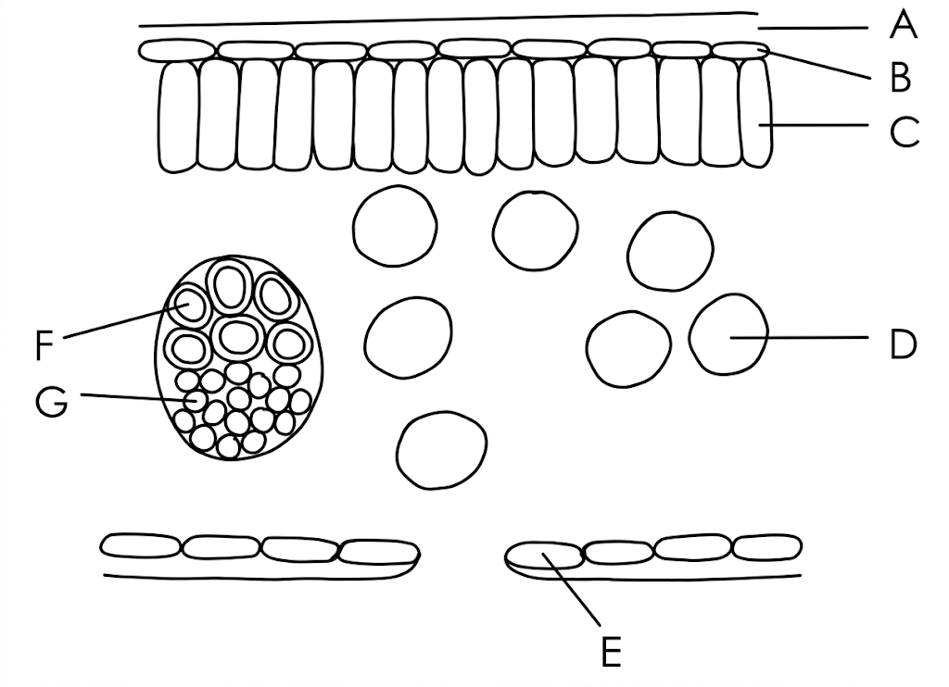
A. D
B. E
C. F
D. G

Directions: Refer to the graph below which shows the percentage absorption of different colours of light by chlorophyll.
7. Which colours of light can speed up photosynthesis?
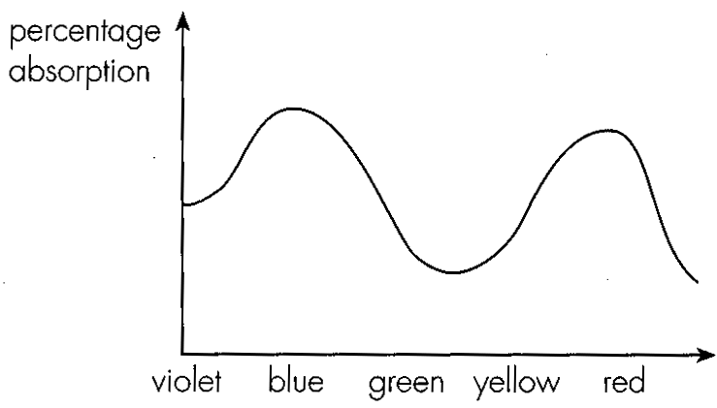
A. Violet and red
B. Blue and yellow
C. Blue and red
D. Green and yellow

Directions: Refer to the graph below which shows the percentage absorption of different colours of light by chlorophyll.
8. What advice would you give concerning the construction of greenhouses?
A. They should be built using green glass.
B. They should be built using blue glass.
C. They should be built using red glass.
D. They should be built using transparent glass.

Directions: Refer to the diagram below which represents the transverse section of a leaf.
9. The products of photosynthesis are stored in
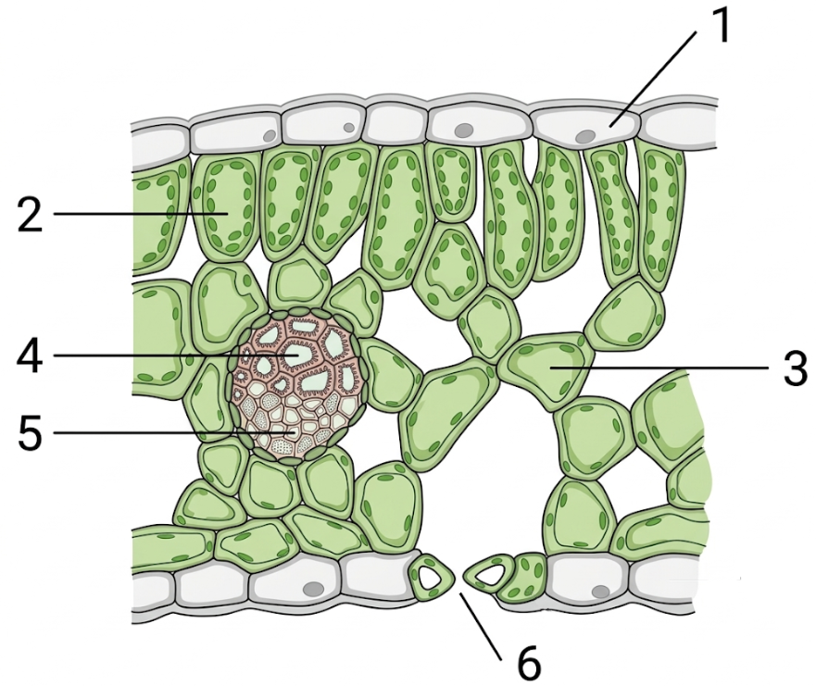
A. 1 and 2.
B. 1 and 3.
C. 2 and 3.
D. 3 and 5.

 | Parts of leaf | Function
A. | cuticle | to prevent entry of bacteria or fungi
B. | stomata | to allow water vapour to diffuse into the leaf
C. | epidermis | to store up photosynthetic products
D. | phloem | to transport water to the leaf

10. Which of the following pairs of matching is correct?
A. Parts of leaf: cuticle ; Function: to prevent entry of bacteria or fungi
B. Parts of leaf: stomata ; Function: to allow water vapour to diffuse into the leaf
C. Parts of leaf: epidermis ; Function: to store up photosynthetic products
D. Parts of leaf: phloem ; Function: to transport water to the leaf

11. Which of the following are the functions of veins in a leaf?
(1) To support and maintain the shape of the leaf for photosynthesis.
(2) To transport water to the leaf.
(3) To transport food away from the leaf.
A. (1) and (2) only
B. (1) and (3) only
C. (2) and (3) only
D. (1), (2) and (3)

12. Chlorophyll makes the leaves look green in colour because
A. it absorbs mainly red and blue lights.
B. it absorbs mainly green light.
C. it reflects mainly red and blue lights.
D. it reflects mainly yellow light.

13. Which of the following is/are essential for making enzymes in flowering plants?
(1) To absorb nitrogen gas from the air by the leaves,
(2) To absorb nitrates from the soil by the roots.
(3) To make glucose by photosynthesis.
A. (2) only
B. (3) only
C. (1) and (3) only
D. (2) and (3) only

14. Nitrates are absorbed by plants for making
(1) carbohydrates. (2) lipids. (3) proteins. (4) enzymes.
A. (3) only
B. (4) only
C. (1) and (2) only
D. (3) and (4) only

Directions: Refer to the water culture experiment below which investigates the necessity of magnesium to plants.
15. Which of the following are the necessary steps in this experiment?
(1) Air is blown into the culture solution daily.
(2) Culture solution is renewed twice a week.
(3) The bottle containing culture solution should be covered with black paper.
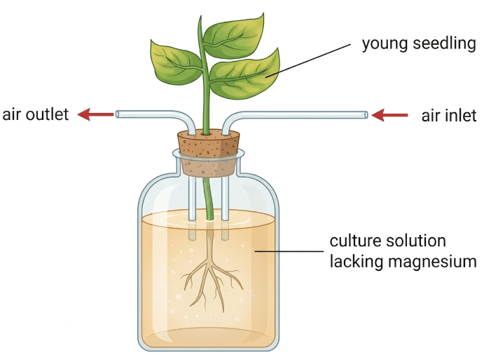
A. (1) and (2) only
B. (1) and (3) only
C. (2) and (3) only
D. (1), (2) and (3)

 | ATP | Carbon dioxide acceptor | First product of carbon fixation
A | No change | Increases | Decreases
B | Increases | Increases | Decreases
C | Decreases | Decreases | Increases
D | Decreases | No change | Increases

16. Removing carbon dioxide from an experiment results in changes in the concentration of the following chemicals in a green plant cell.
A. ATP no change; carbon dioxide acceptor increases; first product of carbon fixation decreases
B. ATP increases; carbon dioxide acceptor increases; first product of carbon fixation decreases
C. ATP decreases; carbon dioxide acceptor decreases; first product of carbon fixation increases
D. ATP decreases; carbon dioxide acceptor no change; first product of carbon fixation increases

Answers (teachers)
These keys match the student web quiz.
Practice 1
1B 2C 3C 4D 5B 6A 7A 8C 9C 10D 11B 12C 13B 14A 15B 16D
Practice 2
1C 2B 3D 4D 5C 6C 7C 8D 9C 10A 11D 12A 13D 14D 15D 16B

