St. Stephen’s Girls’ College
Biology
Transpiration, transport and support in plants
32 multiple-choice items · teacher check
Name: ________________________ Class: ________ Class no.: ________
Setter: Miss Lai K.F.
Practice 1 (Questions 1 to 16). Transpiration, stomata and the potometer.
Practice 2 (Questions 17 to 32). Absorption, xylem, phloem and support.
Question 1 refers to Diagram I and Table II. A leafy shoot was used to measure the movement of an air bubble for three hours in each treatment.

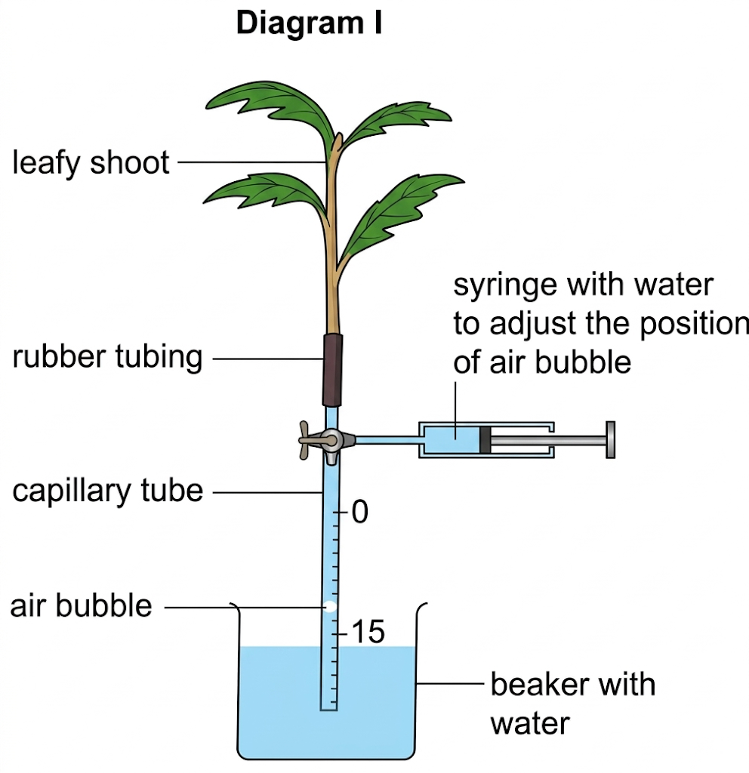
Table II
Treatment | Light intensity | Humidity | Initial reading (cm) | Final reading (cm)
1 | Low | Low | 12.5 | 6.0
2 | Low | High | 13.0 | 11.5
3 | High | Low | 12.8 | 2.7
4 | High | High | 13.2 | 9.3

1. According to the results, which change in conditions leads to a greater reduction in the transpiration rate of the leafy shoot?
A. Increasing humidity at low light intensity
B. Increasing humidity at high light intensity
C. Decreasing light intensity at low humidity
D. Decreasing light intensity at high humidity
2. Which conditions of the air will speed up the rate of transpiration of a leafy shoot?
A. Cold, dry and moving
B. Still, warm and moist
C. Humid, moving and cold
D. Moving, warm and dry
Question 3 refers to the graph below, which shows the transpiration rate of a plant on a dry, hot, sunny day.
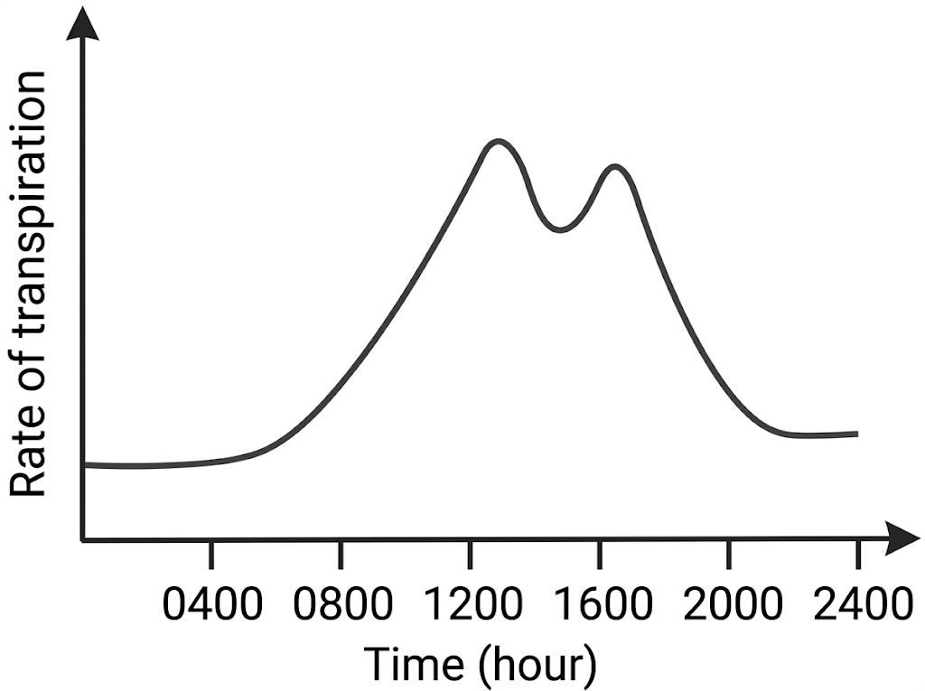
3. The sudden drop in the transpiration rate near 1400 hours is mainly due to
A. cloudy sky.
B. a fall in the carbon dioxide concentration of the air.
C. a fall in the amount of starch in the guard cells.
D. the temporary partial closure of the stomata.
Question 4 refers to the graph below. The solid line is the rate of transpiration. The dashed line is the rate of water absorption.

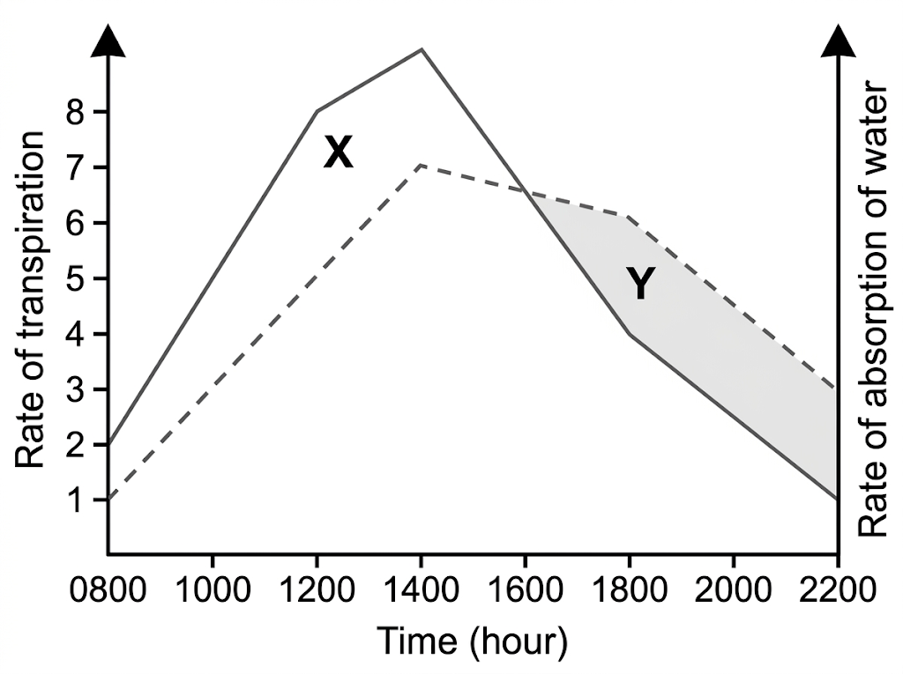
4. The leaves wilt at noon but are turgid again by 2000 hours. Which explanation is correct?
A. All the stomata have opened to their earlier width.
B. A fall in the photosynthetic rate reduces the sugar in the leaves.
C. A rise in the respiratory rate uses up food stored in the leaves.
D. From late afternoon, water is gained faster than it is lost.
Question 5 refers to the graph below.

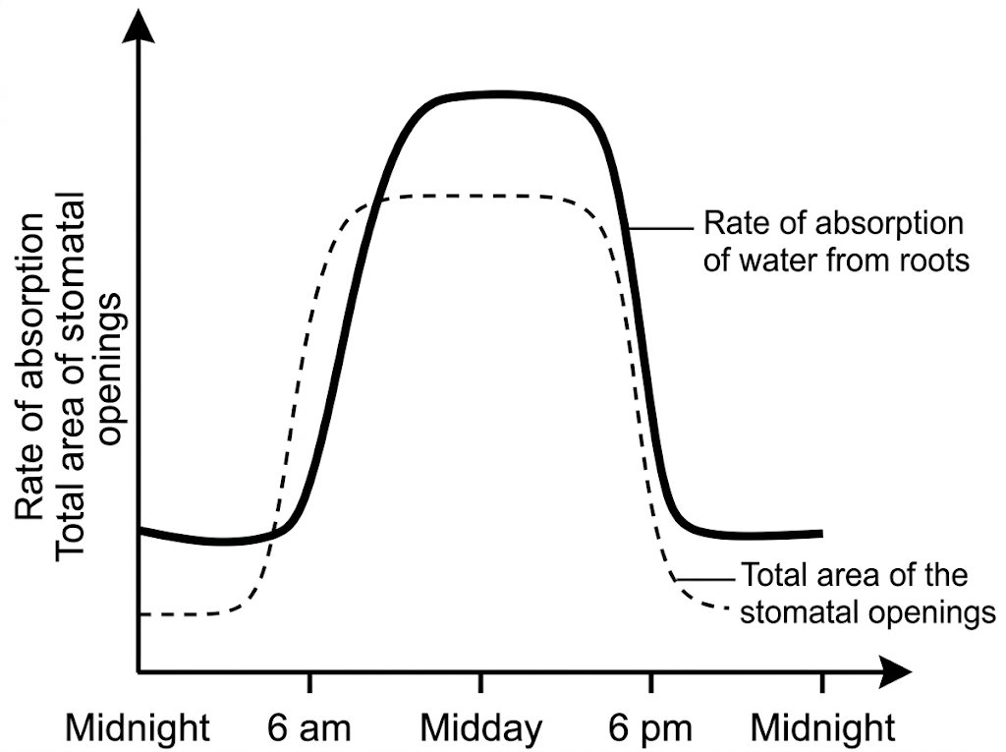

5. Between 8 a.m. and midday the total area of the stomatal openings stays almost constant, but the rate of water absorption from the roots continues to rise. Which environmental factor is mainly responsible?
A. A decrease in temperature
B. An increase in relative humidity
C. An increase in light intensity
D. A decrease in wind speed
Question 6 refers to the weight potometer and the results after two hours. The density of water is 1 g/cm³.
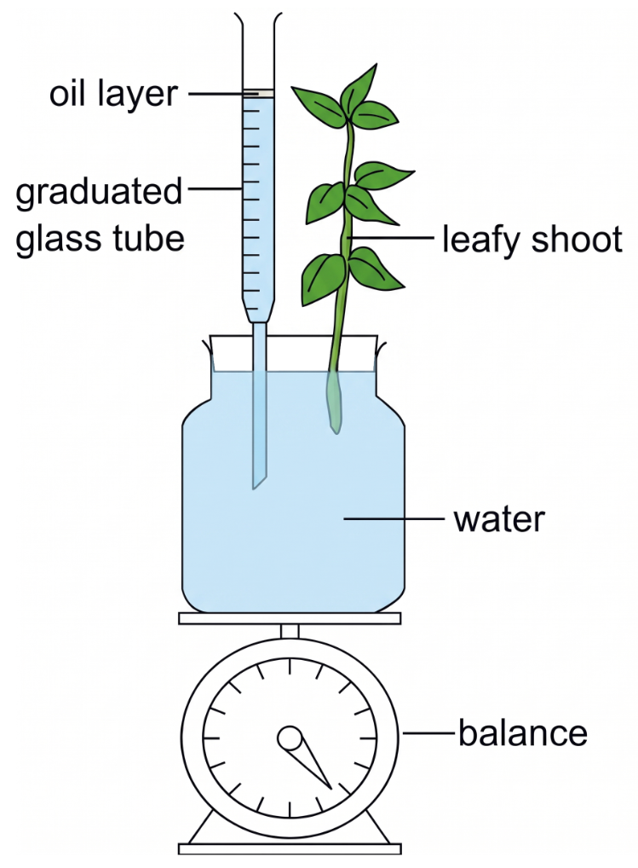
 | Value
Initial weight of the potometer including the plant | 450 g
Final weight of the potometer including the plant | 445 g
Initial reading on the graduated glass tube | 20 cm³
Final reading on the graduated glass tube | 14.5 cm³

6. The amount of water retained by the plant during the experiment was
A. 0.5 g.
B. 5 g.
C. 5.5 g.
D. 10.5 g.
Questions 7 and 8 refer to the leafy shoot below and the volumes of water collected in the bags.
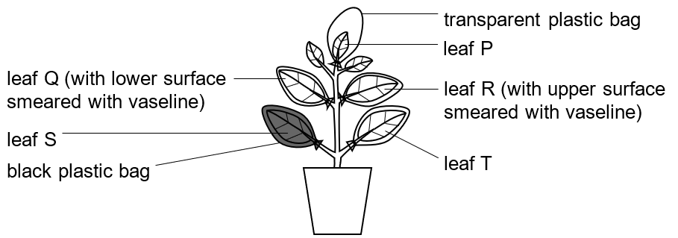
Leaf | Volume of water inside the plastic bag (cm³)
P | 1.19
Q (lower surface smeared with vaseline) | 0.86
R (upper surface smeared with vaseline) | 1.25
S (black plastic bag) | 1.57
T | 2.09

7. A student said that this method may underestimate the rate of transpiration. Which reason is correct?
(1) The leaves reabsorb water vapour from the air inside the plastic bags.
(2) The humidity inside the plastic bags becomes high after some time.
(3) The stomata of all the leaves are closed after some time.
A. (1) only
B. (2) only
C. (1) and (3) only
D. (2) and (3) only
8. Which treatment or factor has the least effect on the rate of transpiration of the leaves?
A. Cutting off the light supply
B. Smearing the lower surface of the leaf with vaseline
C. Smearing the upper surface of the leaf with vaseline
D. Leaf size
9. Blue cobalt chloride paper is placed against the lower surface of a land leaf, and another piece against the upper surface. The paper on the lower surface turns pink; the paper on the upper surface does not. This shows that
A. the lower epidermis has more stomata than the upper epidermis.
B. the guard cells of the lower epidermis are larger.
C. the cuticle of the lower epidermis is thinner.
D. the rate of transpiration through the lower surface is higher than that through the upper surface.
Question 10 refers to the detached-leaf experiment. The ruler has been calibrated in grams. The change in weight after four hours is shown.
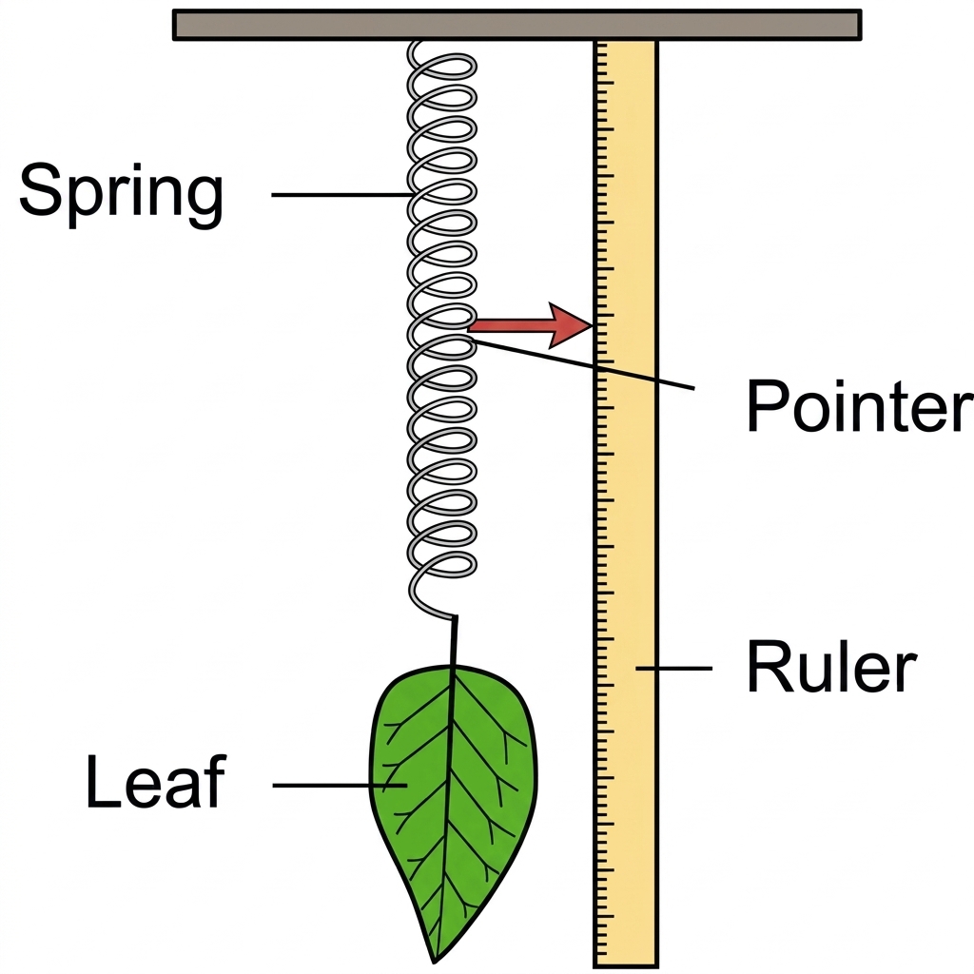
Treatment of the leaf | Change in weight
Leaf without vaseline | 1.9 g
Upper surface smeared with vaseline | 1.7 g
Lower surface smeared with vaseline | 0.3 g
Both surfaces smeared with vaseline | 0 g

10. From these results, the stomata are
A. present in equal numbers on both surfaces.
B. more numerous on the upper surface.
C. more numerous on the lower surface.
D. present on the upper surface only.
Questions 11 and 12 refer to the potometer below.
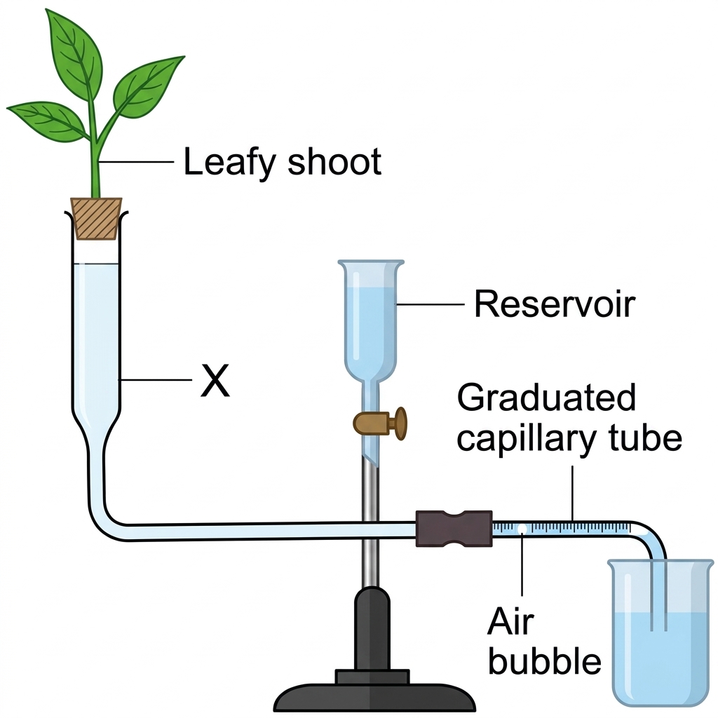
11. The shoot is cut under water in order to
A. let the plant absorb more water so that the experiment lasts longer.
B. stop the plant drying in the air.
C. prevent the xylem vessels from being blocked by air bubbles.
D. speed up water absorption.
12. Which precaution should be taken so that the apparatus works properly?
A. Cover the leaves with vaseline.
B. Cover the bottle with black cloth.
C. Destarch the shoot before the experiment.
D. Cut the shoot under water and insert it into the apparatus under water.
13. Which statement correctly explains why the circumference of a tree trunk is larger at night than in the middle of the day?
A. At night the stomata are closed, so water builds up in the xylem.
B. At night there is less tension in the xylem vessels because the rate of transpiration is reduced.
C. At night the roots absorb less water because mineral uptake by root hairs is reduced.
D. At night the phloem is full of dissolved solutes because translocation has slowed.
Question 14 refers to the set-up below.
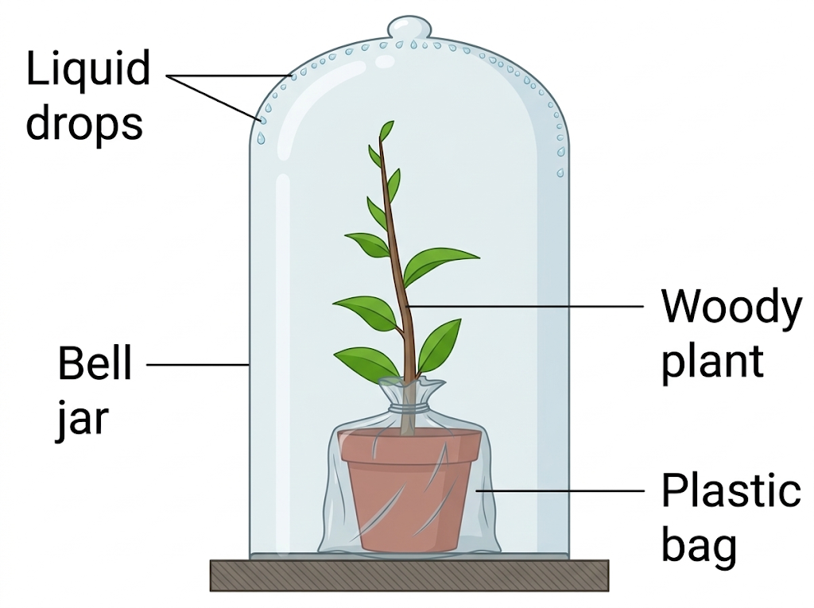
14. The liquid drops on the inner surface of the bell jar are shown to be water. Which reagents can be used for that test?
(1) Anhydrous copper sulphate
(2) Anhydrous potassium hydroxide
(3) Anhydrous calcium chloride
(4) Cobalt chloride paper
A. (1) only
B. (2) only
C. (1) and (3) only
D. (1) and (4) only
15. In a bubble potometer, the distance moved by the air bubble in a given time is a measure of
A. the rate of transpiration of the shoot.
B. the rate of water uptake by the shoot.
C. the rate of photosynthesis.
D. the rate of mineral absorption.
16. Which statement about transpiration is correct?
A. Evaporation of water from the mesophyll uses heat, so the leaf is cooled.
B. Transpiration heats the leaf so that enzymes work faster.
C. The only role of transpiration is to get rid of waste water.
D. Transpiration occurs only at night.
Practice 2
Questions 17 to 32. Absorption, xylem, phloem and support.
Question 17 refers to the photomicrograph below.
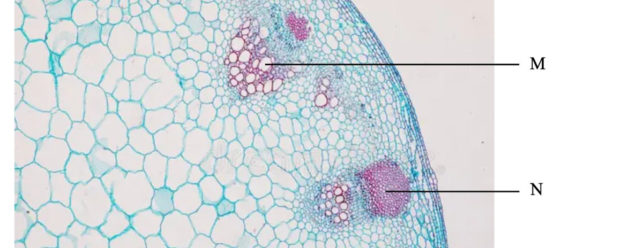
17. Which statements about the structures shown are correct?
(1) The section is from a herbaceous plant.
(2) Structure M provides mechanical support even when the plant is short of water.
(3) Structure N is responsible for the translocation of sucrose.
A. (1) and (2) only
B. (1) and (3) only
C. (2) and (3) only
D. (1), (2) and (3)
Question 18 refers to the photomicrograph below. The double-headed arrow labelled D is the diameter of the section, not an answer option.
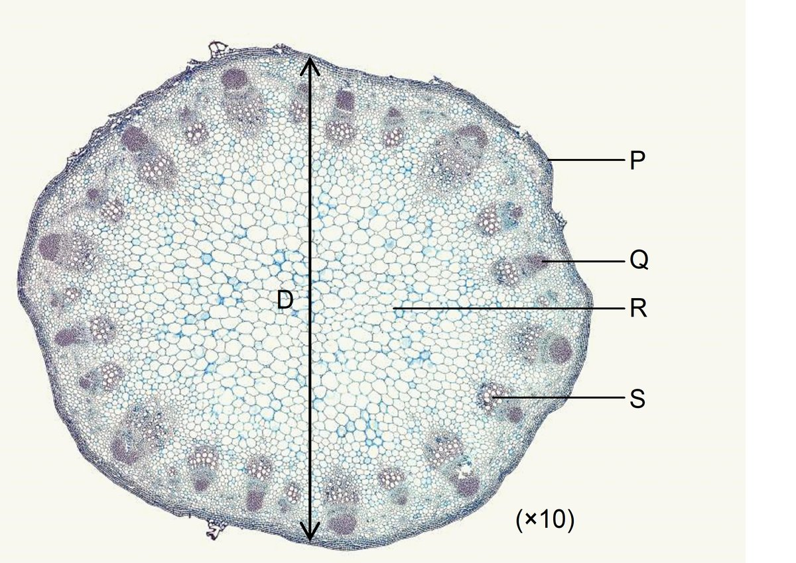
18. Which of the labelled structures are involved in the support of this dicotyledonous stem?
A. P and Q only
B. R and S only
C. P, Q and S only
D. Q, R and S only
Question 19 refers to the experiment below.

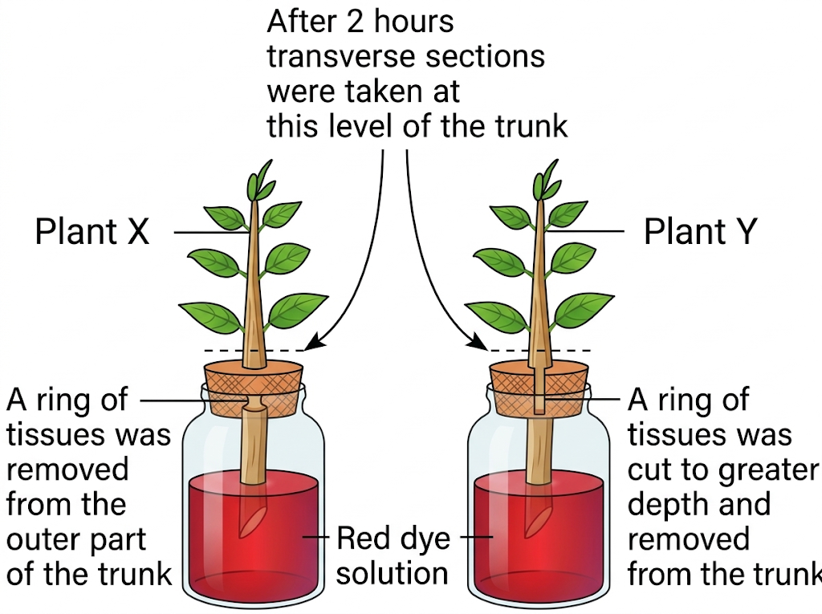
19. After two hours the leaves of plant X remained turgid while those of plant Y wilted. Which conclusion follows from this observation?
A. Phloem transports the food made in the leaves.
B. Water is transported through the xylem throughout the plant.
C. The leaves are supported only by the turgidity of their cells.
D. The rate of transpiration is higher than the rate of absorption by the roots.
Questions 20 and 21 refer to the leafy branch below. A ring of bark containing phloem has been removed.

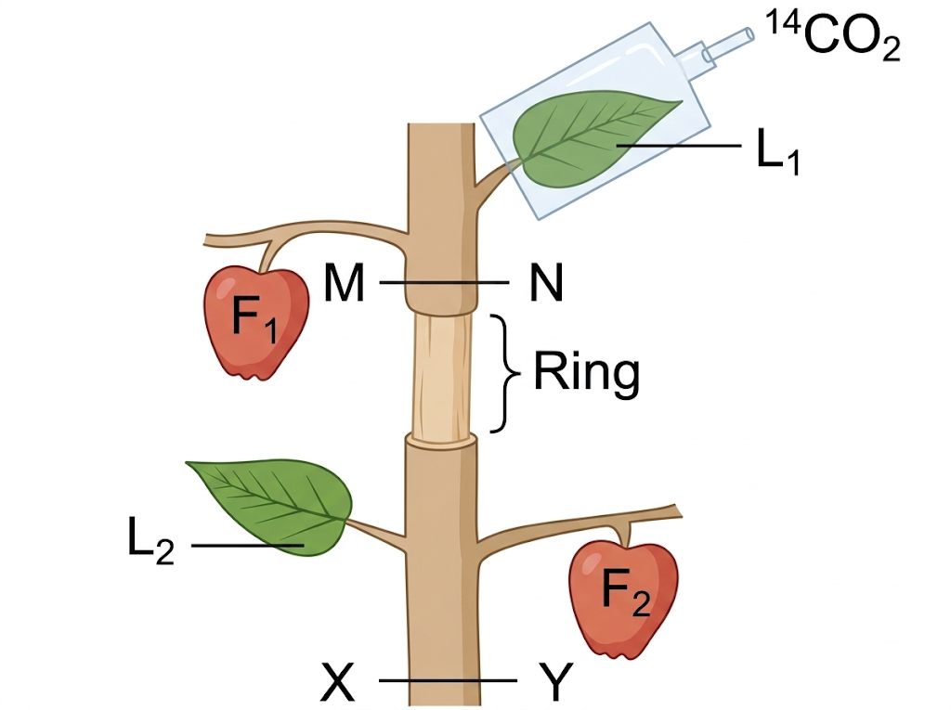
20. Several days after the ring was cut, what would be the difference in size between fruits F1 and F2?
A. F1 became smaller because no more water was transported to it.
B. F1 became bigger because it could receive enough water.
C. F2 became bigger because it was nearer the root, so more water reached it.
D. There is no big difference in size between F1 and F2.
21. If the ring is cut deeper, so that both xylem and phloem are removed, what happens to leaves L1 and L2 after two days?
A. Both leaves die, because neither can obtain water.
B. Leaf L1 remains healthy because it still receives water from the root.
C. Leaf L2 remains turgid because it can still receive water from the root.
D. Leaf L2 wilts because it cannot receive water from the root.
Questions 22 and 23 refer to the experiment below. A herbaceous stem and a woody stem are clamped horizontally in concentrated sugar solution.

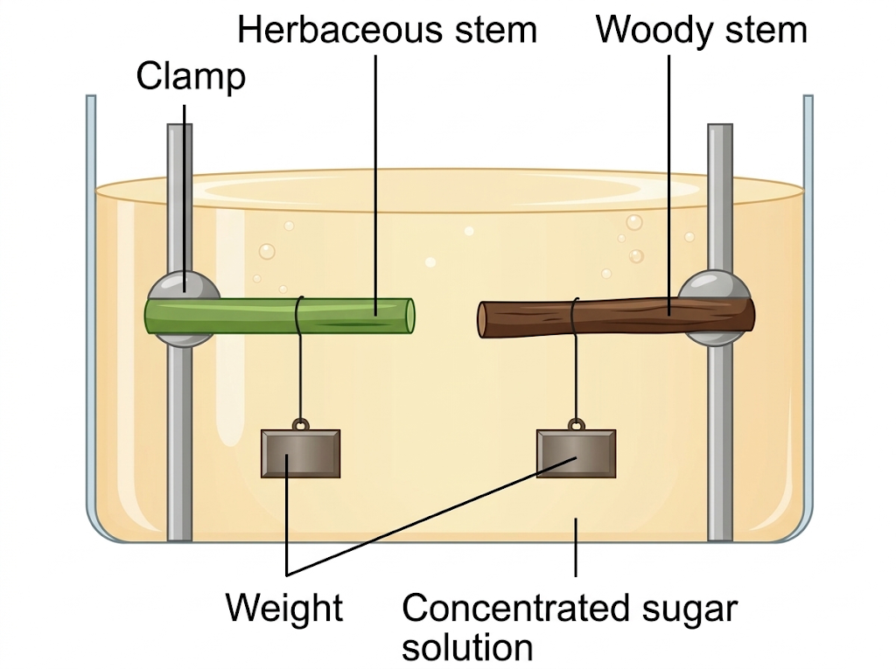
22. What is the appearance of the stems after two hours?
A. Both stems bend downwards.
B. Both stems bend upwards.
C. The herbaceous stem bends downwards while the woody stem remains straight.
D. The woody stem bends downwards while the herbaceous stem remains straight.
23. The concentrated sugar solution is then replaced by distilled water. What is the appearance of the stems?
A. Both stems bend upwards.
B. Both stems stay as they were in the sugar solution.
C. The herbaceous stem bends upwards, back to the straight position, while the woody stem remains unchanged.
D. The herbaceous stem stays unchanged while the woody stem bends upwards.
24. The vascular bundles of a dicotyledonous stem usually lie towards the periphery. This distribution
A. increases the capacity for transporting substances through the plant.
B. gives a stronger effect against the bending stress of wind.
C. leaves more space for cells that divide to lengthen the stem.
D. protects the pith at the centre.
Question 25 refers to the photomicrographs below.
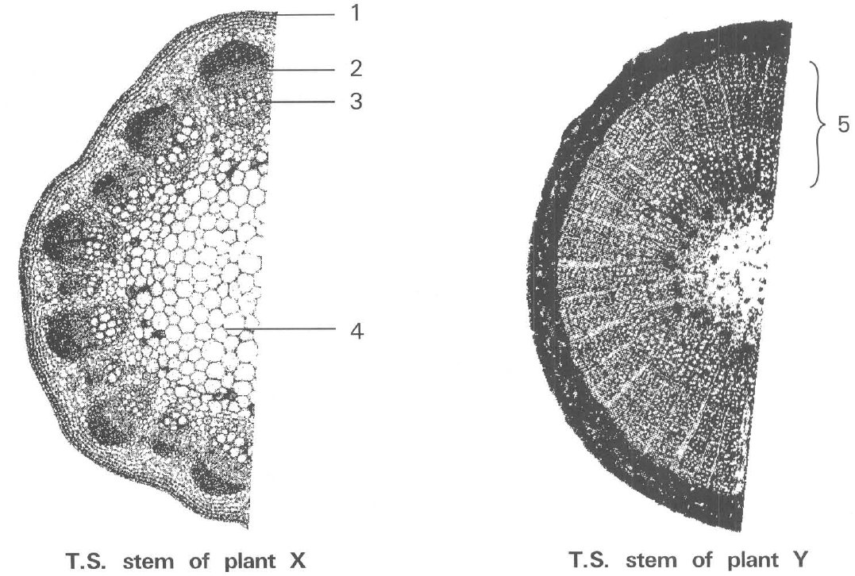
25. Which labelled tissue in plant X has the same function as the tissue labelled 5 in plant Y?
A. 1
B. 2
C. 3
D. 4
Question 26 refers to the drawing of a young root.

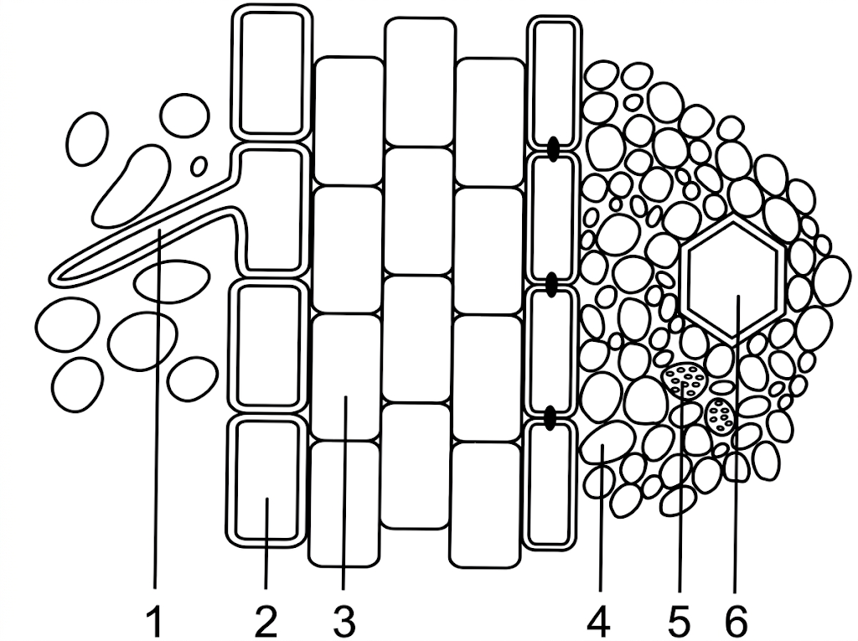
26. Which comparison of water and mineral uptake by a root hair is correct?
A. Water enters by osmosis. Mineral ions may enter by active transport.
B. Water is pumped in by active transport. Minerals enter by osmosis.
C. Both water and minerals enter only by diffusion down a concentration gradient.
D. Nitrogen gas from the soil air enters the root hair and is used to make protein.
27. Farmers are warned not to add too much chemical fertiliser. Which reason is correct?
A. Weeds then grow faster than the crop.
B. The minerals poison the cytoplasm as soon as they enter.
C. The water potential of the soil solution falls, so water may leave the roots.
D. Oxygen becomes insoluble, so the leaves cannot transpire.
28. Which comparison of xylem vessels and sieve tubes is correct?
A. Xylem vessels are dead and carry water upwards only. Sieve tubes are living and can carry sucrose up or down.
B. Both tissues are dead at maturity.
C. Phloem carries water from the roots to the leaves. Xylem carries sucrose.
D. Transport in xylem needs living cytoplasm. Transport in phloem does not.
29. If an air bubble enters a xylem vessel of a transpiring shoot,
A. the continuous water column is broken, so the transpiration pull cannot act through that vessel.
B. the bubble is a source of oxygen that speeds transpiration.
C. root pressure immediately pushes the bubble out through the stomata.
D. the vessel becomes a phloem tube.
30. After heavy rain the soil is waterlogged and a land plant wilts. The best explanation is
A. the roots take in so much water that the leaves burst.
B. root cells lack oxygen for respiration, so they cannot absorb enough water and minerals to replace what the shoot loses.
C. rain washes chlorophyll out of the leaves.
D. stomata stay fully open in rain, so transpiration is faster than in dry air.
Question 31 refers to the ringing experiment below.

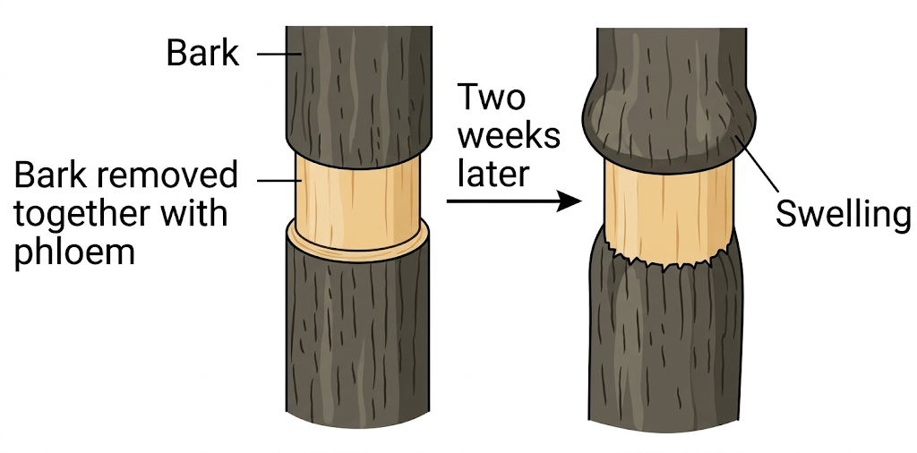
31. A swelling forms above the ring because
A. xylem above the cut grows faster.
B. sugars moving down in the phloem cannot pass the ring, so they accumulate.
C. the cut absorbs water vapour from the air.
D. water cannot pass the ring, so it collects above it.
32. A submerged stem needs little lignified xylem for support because
A. the stem does not transport water.
B. the surrounding water provides buoyancy.
C. submerged plants have no xylem, because they do not transpire.
D. photosynthesis in water produces enough lignin.
Answers
The keyed option is printed in red on the questions. A percentage is given only where the original class or exam key is unchanged. Items at 80% were omitted. New items and rewritten distractors have no percentage. Grey notes are for the teacher.
1. B exam 10.4% n=67 slip D From the table, raising humidity at high light cuts the drop in the water column from 10.1 cm to 3.9 cm. That is a larger reduction than the other three changes. Usual slip D. Exam 2526 F4 mid, 10.4% (n=67).
2. D class 76.6% n=303 slip C Warm, dry, moving air steepens the water-vapour gradient. Cold or still or humid air slows transpiration. Usual slip C. Class 76.6% (n=303).
3. D class 79.9% n=303 At about 1400 hours on a hot day the guard cells lose water and the stomata partly close. The graph shows that dip. Usual slip D listed as the same letter as the key in the dump; the biology is the midday closure. Class 79.9% (n=303).
4. D class 51.9% n=231 slip A After about 1600 hours absorption (dashed) is above transpiration (solid). Water is gained faster than it is lost, so turgor returns. Usual slip A. Class 51.9% (n=231).
5. C class 60.0% n=160 slip A Stomatal area has already levelled. Stronger light raises leaf temperature, so the water-vapour gradient still increases and more water is pulled in. Usual slip A. Class 60.0% (n=160).
6. A exam 75.9% n=129 slip B Uptake = 20 − 14.5 = 5.5 cm³ = 5.5 g. Loss of mass of the whole potometer = 5 g. Retained = 5.5 − 5 = 0.5 g. Usual slip B (the 5 g lost). Exam 2324 F5 final, 75.9% (n=129).
7. B exam 52.2% n=46 slip A High humidity in the bag slows further evaporation, so the volume collected is too low. The leaves do not reabsorb the trapped vapour as the first taught reason, and not every stoma is forced shut. Usual slip A. Exam 2324 F5 mid, 52.2% (n=46).
8. A exam 65.2% n=46 slip B Leaf S (black bag) still collected 1.57 cm³, close to the untreated leaf T. Vaseline on the lower surface cut the volume much more. Usual slip B. Exam 2324 F5 mid, 65.2% (n=46).
9. D class 55.7% n=88 slip A Pink cobalt chloride shows a faster loss of water vapour from the lower surface. It does not, by itself, prove that there are more stomata. Usual slip A. Class 55.7% (n=88).
10. C class 48.9% n=88 slip B Blocking the lower surface almost stops the weight loss. Blocking the upper surface hardly changes it. Usual slip B. Class 48.9% (n=88).
11. C class 56.8% n=88 slip B Air in the xylem breaks the water column. Cutting under water keeps the vessels full of water. Usual slip B. Class 56.8% (n=88).
12. D class 73.9% n=46 slip A The shoot must be cut and fitted under water. Black cloth, destarching and vaseline are not the working precaution for a potometer. Usual slip A. Class 73.9% (n=46).
13. B exam 38.1% n=42 slip A By day, transpiration pull tenses the xylem walls inwards, so the trunk is thinner. At night the tension falls. Water does not simply pile up because stomata are shut. Usual slip A. Exam 2425 F6 final, 38.1% (n=42).
14. D class 61.8% n=157 slip A Anhydrous copper sulphate turns blue, and cobalt chloride paper turns pink, with water. Potassium hydroxide and calcium chloride can dry air but are not the colour tests. Usual slip A. Class 61.8% (n=157).
15. B difficult extra Difficult extra. Some of the water taken up is used in photosynthesis and in the cells. The bubble records uptake, not transpiration.
16. A difficult extra Difficult extra. Evaporation uses latent heat, so the leaf is cooled. Transpiration is not a way of dumping waste water, and it is faster in the light.
17. A exam 14.8% n=54 slip D M is xylem: lignified, so it still supports when the plant is short of water. N is the fibre cap, not the sieve tubes, so it does not translocate sucrose. The section has no thick wood, so it is herbaceous. Usual slip D. Exam 2526 F5 final, 14.8% (n=54).
18. D exam 23.1% n=52 slip B Q and S are vascular bundles (xylem and fibres). R is pith, which supports by turgor. P is epidermis and is not a supporting tissue. The arrow D is the diameter of the section. Usual slip B. Exam 2324 F6 final, 23.1% (n=52).
19. B class 57.9% n=38 slip C Plant X still has xylem, so red dye and water reach the leaves. Plant Y had xylem cut away, so the leaves wilt. Usual slip C. Class 57.9% (n=38).
20. D class 60.5% n=38 slip A The ring removes phloem only. Water in the xylem still reaches both fruits. F1 still receives sucrose from L1; F2 still receives sucrose from L2. Usual slip A. Class 60.5% (n=38).
21. C class 78.9% n=38 slip B L2 is below the ring, so its xylem from the root is intact. L1 is above a cut xylem, so it cannot obtain water. Usual slip B. Class 78.9% (n=38).
22. C class 52.6% n=38 slip A The herbaceous stem is supported by turgor. Concentrated sugar solution has a lower water potential, so the stem loses water and bends down. The woody stem is supported by xylem and stays straight. Usual slip A. Class 52.6% (n=38).
23. C class 62.5% n=32 slip B Distilled water has a higher water potential, so the flaccid herbaceous stem takes up water and straightens. The woody stem does not depend on turgor. Usual slip B. Class 62.5% (n=32).
24. B class 62.5% n=32 slip A A ring of bundles towards the outside resists bending, as in a tube. It is not mainly a way of protecting pith or of lengthening the stem. The printed answer line in the under-80 file had been glued to a leaf-vein distractor. Class 62.5% (n=32), slip A.
25. C class 59.4% n=32 slip D Tissue 3 in X is xylem. Tissue 5 in Y is wood, also xylem. Both give mechanical support. Tissue 4 is pith (turgor). Usual slip D. Class 59.4% (n=32).
26. A difficult extra Difficult extra. Water follows the water-potential gradient. Ions are often taken up against their gradient, so respiration is needed. Leaves do not absorb nitrogen gas; that point belongs with mineral nutrition, not with a nitrogen-cycle item.
27. C difficult extra Difficult extra. This item was removed from the nutrition paper because it is root water uptake. A concentrated soil solution can draw water out of the roots.
28. A difficult extra Difficult extra. Xylem is unidirectional and dead. Phloem is living and bidirectional. Students swap the two tissues.
29. A difficult extra Difficult extra. Cohesion-tension needs an unbroken water column. That is why the shoot is cut under water.
30. B difficult extra Difficult extra. Waterlogged soil has little oxygen. Root respiration slows, so active uptake and then water uptake fail, and the shoot wilts even though the soil is wet.
31. B difficult extra Difficult extra. Phloem is removed, so sucrose cannot pass down. It accumulates and the tissues above the ring swell. Water still passes in the xylem.
32. B difficult extra Difficult extra. Water buoys the stem. Submerged plants still have xylem for transport, but they do not need thick lignified xylem for support.
Not used from the source files
Omitted at 80.1%: the advantage of the 1400-hour drop (to avoid water loss). Dropped as another chapter: the oxygen-exchange graph (area A vs B, gaining weight) and the human blood-vessel item that had been glued into the exam under-80 file. Not used because the printed key was biologically wrong: stomata largest at midnight (correct is noon); dendrograph change due to contraction of the metal ring (correct is xylem tension); leaf veins attract insects (correct is mechanical support). Do not name RuBP, rubisco or GP. Do not use NaHCO₃, NaCl or CaCO₃ as option names. Transport in humans, mineral nutrition, and photosynthesis starch tests are separate papers.
Q | Key | Source
1 | B | exam 10.4% n=67 slip D
2 | D | class 76.6% n=303 slip C
3 | D | class 79.9% n=303
4 | D | class 51.9% n=231 slip A
5 | C | class 60.0% n=160 slip A
6 | A | exam 75.9% n=129 slip B
7 | B | exam 52.2% n=46 slip A
8 | A | exam 65.2% n=46 slip B
9 | D | class 55.7% n=88 slip A
10 | C | class 48.9% n=88 slip B
11 | C | class 56.8% n=88 slip B
12 | D | class 73.9% n=46 slip A
13 | B | exam 38.1% n=42 slip A
14 | D | class 61.8% n=157 slip A
15 | B | difficult extra
16 | A | difficult extra
17 | A | exam 14.8% n=54 slip D
18 | D | exam 23.1% n=52 slip B
19 | B | class 57.9% n=38 slip C
20 | D | class 60.5% n=38 slip A
21 | C | class 78.9% n=38 slip B
22 | C | class 52.6% n=38 slip A
23 | C | class 62.5% n=32 slip B
24 | B | class 62.5% n=32 slip A
25 | C | class 59.4% n=32 slip D
26 | A | difficult extra
27 | C | difficult extra
28 | A | difficult extra
29 | A | difficult extra
30 | B | difficult extra
31 | B | difficult extra
32 | B | difficult extra

