Reproduction in flowering plants
Multiple-choice practice · 32 items · class <80% plus difficult uncovered items
Name: ________________________ Class: ____________ Class no.: ______
Questions 1–20 were answered correctly by fewer than 80% of students in SSGC school examinations or class Google Forms (plant items only; human-reproduction items from the mixed Reproduction bank are not used). Questions 21–32 cover HKDSE Ch.12.1–12.3 and seed germination (Ch.14.3) that those items leave thin, using distractors that match the usual slips. Choose the one best answer.
Teacher check only — not yet posted to the student web. Original under-80 files and review v1 were not overwritten. Improved drawings from the Hollywood folder are used. The avocado photograph is unlabeled so labels can be added in Photoshop. The word endosperm is not used. Double fertilisation is asked at HKDSE level (two male gametes).
Part A — School exam and class items under 80%
1. [exam 2425 F5 final Q6, 29% correct] Potato plants can be reproduced by seeds or by stem tubers. Stem tubers are organs for vegetative propagation. Which comparison between these two methods of reproduction is incorrect?
 | Seeds | Stem tubers
A. Genetic variation in offspring | more | less
B. Chromosome number of the cells of offspring | haploid | diploid
C. Chance of dispersal of offspring | greater | smaller
D. Chance of passing infectious diseases to offspring | smaller | greater

2. [class 72% correct] Which matching about asexual reproduction is incorrect?
 | Asexual reproduction | Organism involved
A. | binary fission | bacteria
B. | budding | Mucor
C. | spore formation | Rhizopus
D. | vegetative propagation | flowering plants

3. [class 80% correct] Which of the following statements about sexual reproduction is/are correct?
(1) It always involves two parents.
(2) It always involves the fusion of gametes.
(3) Offspring are genetically different from their parents.
A. (1) and (2) only
B. (1) and (3) only
C. (2) and (3) only
D. (1), (2) and (3)
Directions: Questions 4 and 5 refer to the photograph of a vegetative organ.
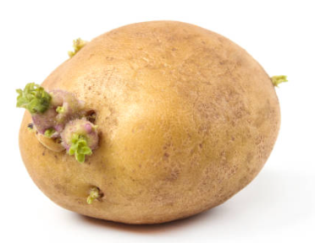
4. [class 60% correct] The vegetative organ is a
A. corm.
B. bulb.
C. rhizome.
D. tuber.
5. [class 77% correct] What happens to this organ when it is developing into a new plant?
A. It becomes bigger to store excess food for the next season.
B. It remains unchanged.
C. It is pulled deeper into the soil by contractile roots.
D. It becomes smaller because stored food is used for growth of the shoot.
6. [class 73% correct] The vegetative organ in the photograph below is a
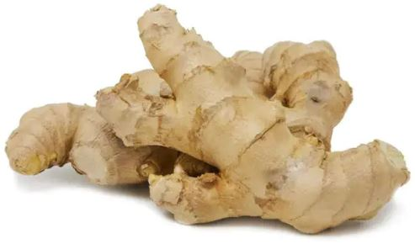
A. corm.
B. bulb.
C. rhizome.
D. tuber.
7. [class 79% correct] Compared with the parent plant, the daughter plant developed from a corm
(1) has the same chromosome number.
(2) is genetically identical to the parent plant.
(3) can reproduce by vegetative propagation only.
A. (1) and (2) only
B. (1) and (3) only
C. (2) and (3) only
D. (1), (2) and (3)
8. [class 71% correct] Which of the following are implications of seed dispersal?
(1) It may reduce competition between parents and offspring.
(2) It may reduce competition among offspring.
(3) It may increase the chance of survival of the species.
A. (1) and (2) only
B. (1) and (3) only
C. (2) and (3) only
D. (1), (2) and (3)
9. [class 52% correct] Which of the following is/are not an advantage of fruit or seed dispersal?
(1) Reduce transmission of diseases within the species.
(2) Enable the species to have more genetic variation.
(3) Make the individuals become fitter for a changing environment.
A. (1) only
B. (1) and (2) only
C. (1) and (3) only
D. (2) and (3) only
10. [class 72% correct] Which sequence of events in sexual reproduction of a flowering plant is correct?
(1) meiosis in gamete formation
(2) growth of the pollen tube through the style
(3) fertilisation
(4) pollination
(5) seed dispersal
(6) mitosis in growth of the embryo
A. (1), (4), (6), (3), (2), (5)
B. (1), (4), (2), (3), (6), (5)
C. (4), (1), (3), (2), (5), (6)
D. (4), (1), (2), (3), (5), (6)
11. [class 51% correct] Which is/are (a) function(s) of the style?
(1) To act as a reservoir for storing pollen grains.
(2) To act as the place where fertilisation takes place.
(3) To provide a passage and nutrients for growth of pollen tubes to the ovules.
(4) To hold the anthers out so that they trap pollen from the air.
A. (1) only
B. (3) only
C. (1) and (2) only
D. (3) and (4) only
Directions: Questions 12 and 13 refer to the carpel below.
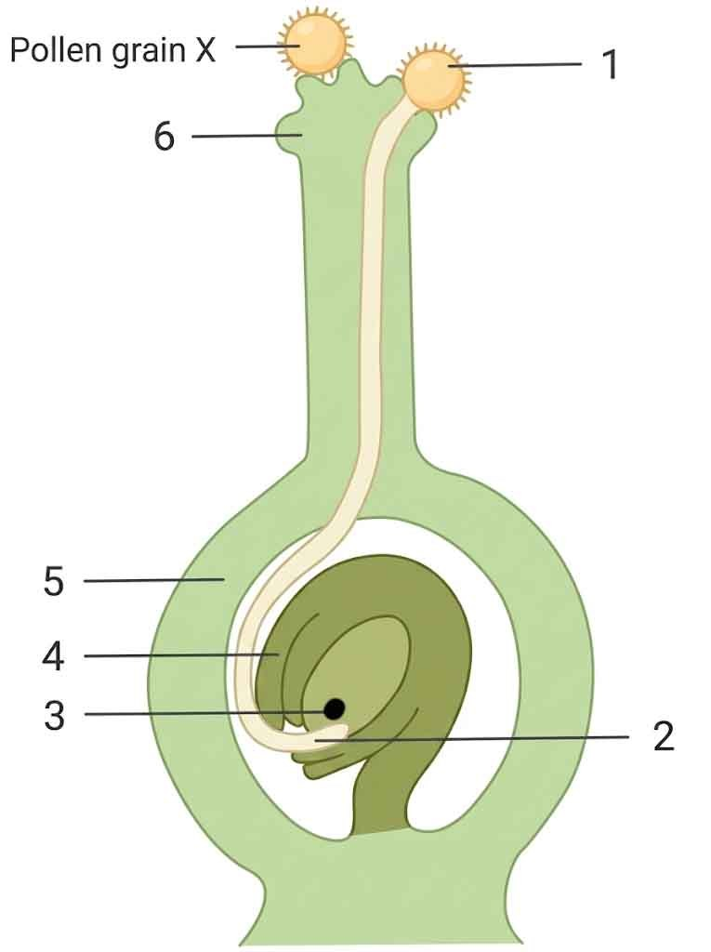
12. [class 70% correct] Pollen grain X fails to develop a pollen tube on this stigma. The most probable explanation is that
A. it is too big to enter the style.
B. it does not belong to the same species as this carpel.
C. it has no male gametes inside.
D. it has died by the time it reaches the stigma.
13. [class 62% correct] After fertilisation, which labelled parts develop into the seed and the fruit?
 | Seed | Fruit
A. | 4 | 5
B. | 3 | 4
C. | 5 | 4
D. | 4 | 3

14. [class 75% correct] Which of the following structures are genetically different?
(1) The pollen grains and the egg cells of the same flower.
(2) The petals and the sepals of the same flower.
(3) Seeds in the same orange.
(4) A corm and the petals of the Gladiolus flower that develops from it.
A. (1) and (3) only
B. (2) and (3) only
C. (3) and (4) only
D. (1) and (4) only
15. [class 24% correct] Which matching of the labelled parts of the broad bean seed is correct?
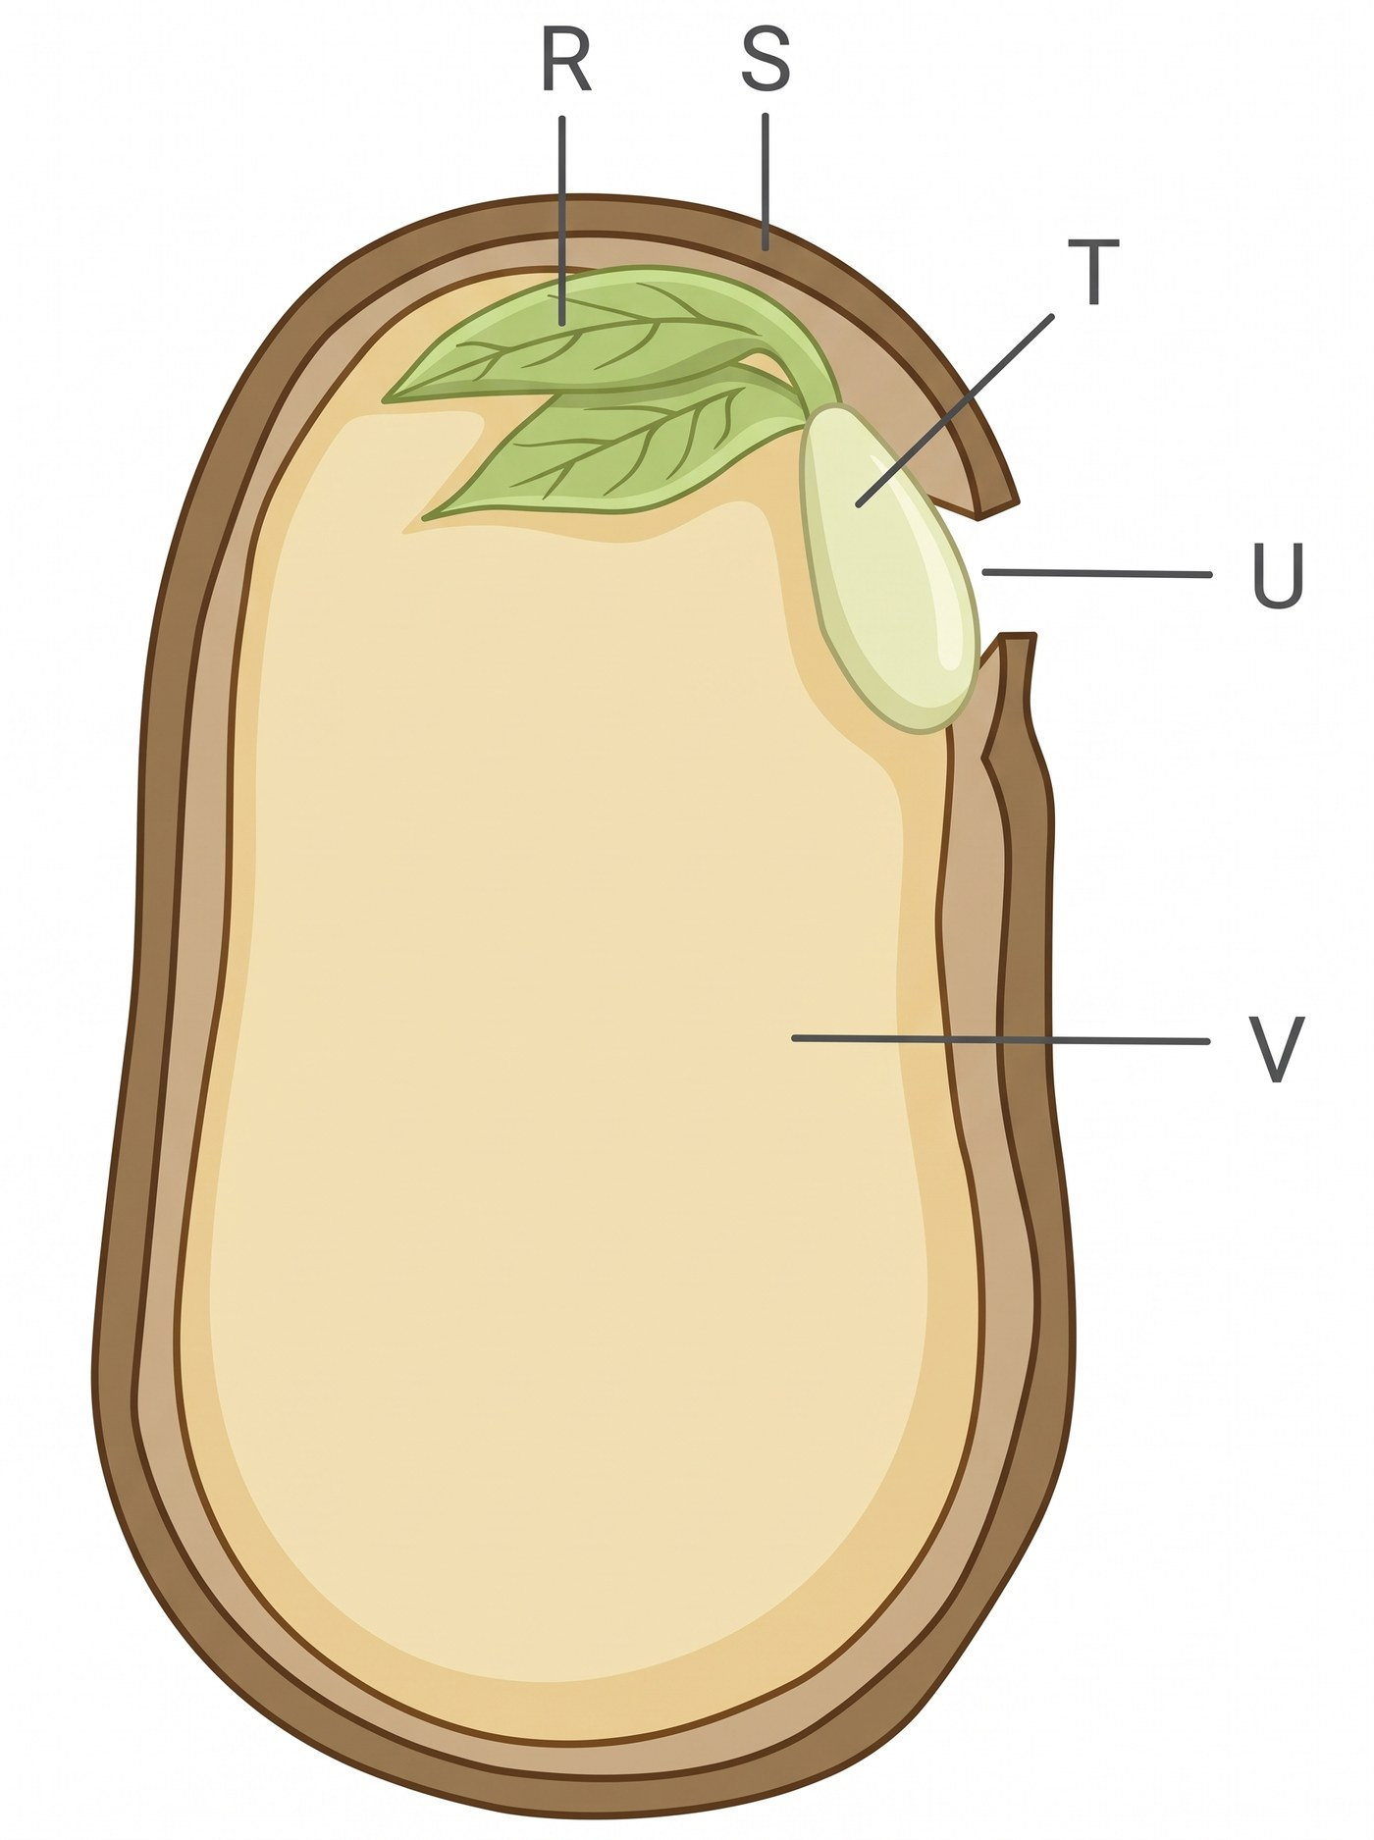
 | S | R | T | V
A. | fruit wall | plumule | radicle | ovary
B. | testa / seed coat | plumule | radicle | cotyledon
C. | testa / seed coat | radicle | plumule | ovary
D. | fruit wall | plumule | radicle | cotyledon

16. [exam 2324 F5 mid Q20, 61% correct] The diagram shows a pod from a pea plant. Which line correctly shows the path taken by a pollen tube to an ovule?
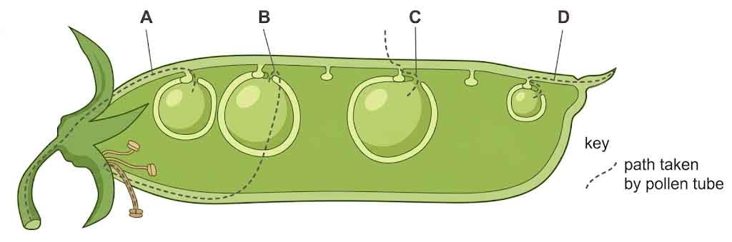
A. A
B. B
C. C
D. D
17. [class 22% correct] Which combination truly represents features of a wind-pollinated flower?

 | Petals | Anthers and stigma | Nectary
A. | large and colourful | enclosed by the petals | present
B. | small or absent | held out of the flower | absent
C. | large and colourful | held out of the flower | present
D. | small or absent | enclosed by the petals | absent

Directions: Question 18 refers to the flower below. 1 petal; 2 stigma; 3 anther; 4 filament; 5 sepal; 6 ovary; 7 ovule; 8 receptacle; 9 nectary; 10 style.
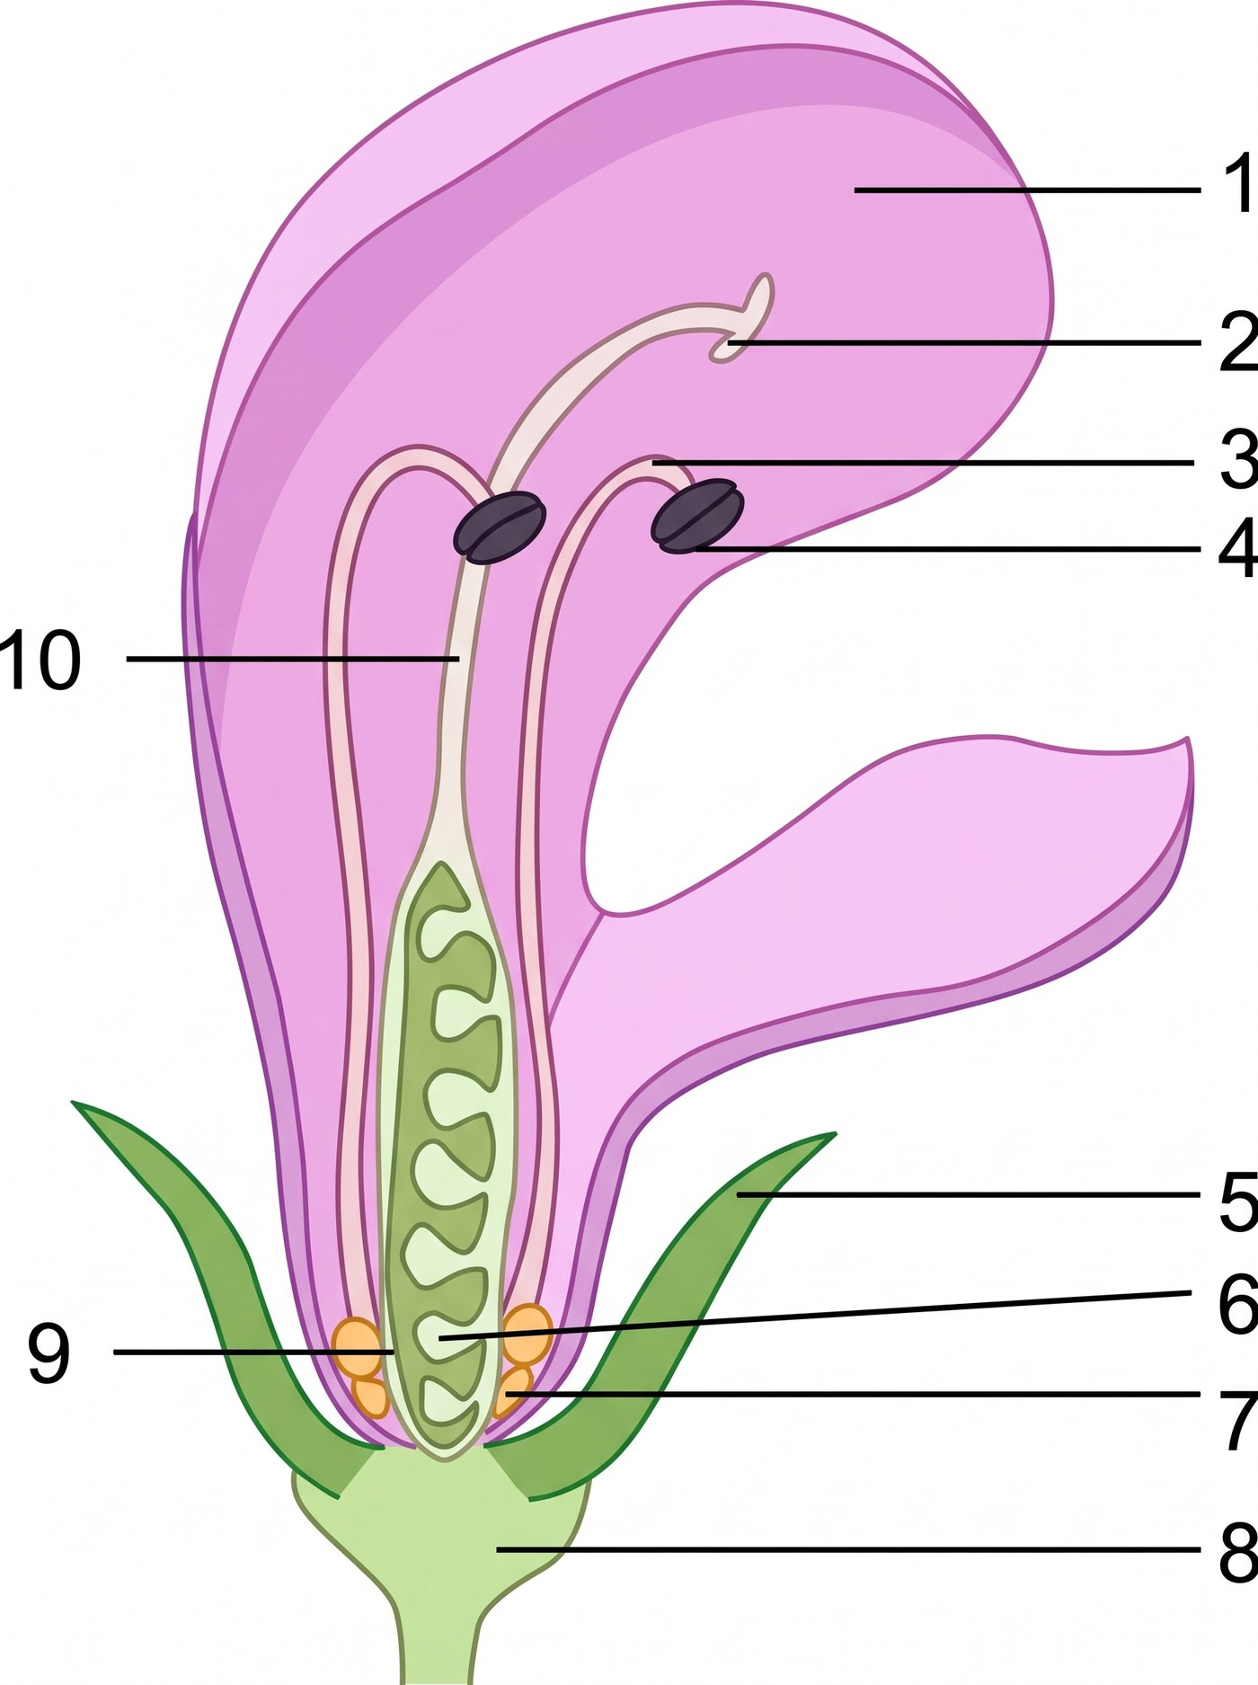
18. [class 59% correct] If cross-fertilisation has occurred, the pollen grains on the stigma of this flower came from
A. structure 3 of this flower.
B. structure 4 of this flower.
C. structure 8 of this flower.
D. none of the labelled structures of this flower.
19. [class 62% correct] The diagram shows carrot tissue grown on a culture medium. Which are advantages of using this method to produce a large number of plants?
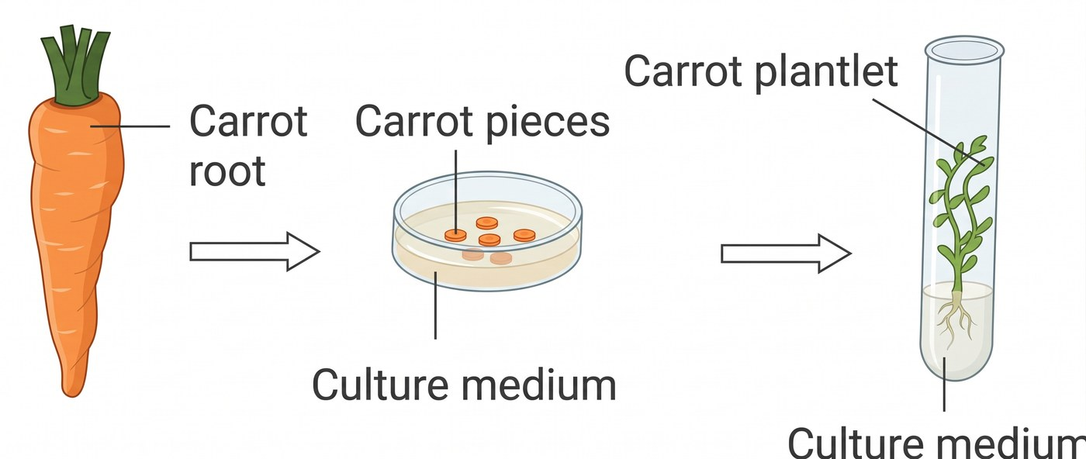
(1) It does not depend on external agents of pollination.
(2) All desirable characteristics of the parent can be transmitted to the offspring.
(3) It produces genetic variation.
(4) It saves space so as to reduce overcrowding in the habitat.
A. (1) and (2) only
B. (2) and (3) only
C. (3) and (4) only
D. (1) and (4) only
20. [exam 2526 F6 final Q33, 55% correct] The photograph shows a longitudinal section of an avocado fruit. Labels (i) to (iv) are to be added on the photograph. Which row correctly gives the function of the labelled part and the floral structure from which it developed?
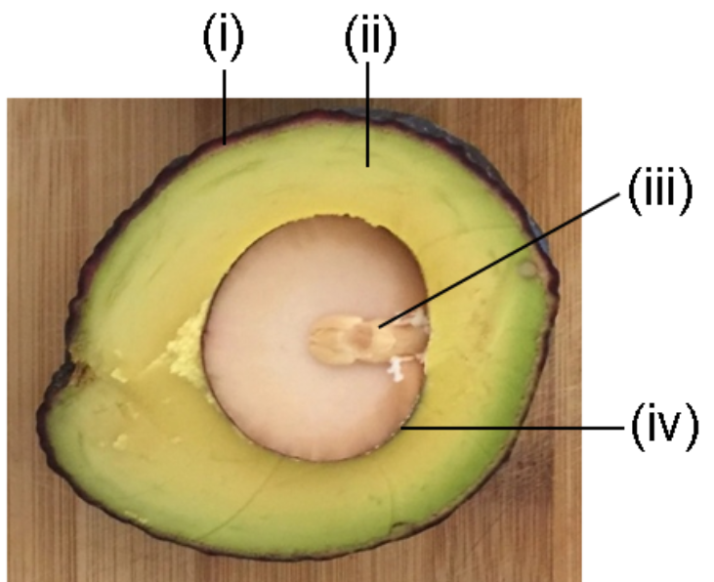
 | Part | Function | Floral part before fertilisation
A. | (i) | attracting insects for pollination | ovary wall
B. | (ii) | protecting the fruit | style
C. | (iii) | producing food for plant growth | ovule
D. | (iv) | protecting the seed | integument

Part B — Difficult items on uncovered HKDSE ground
21. Many insect-pollinated flowers are brightly coloured. Which of the following actually ensures cross-pollination rather than merely making insect visits more likely?
(1) Petals are large and brightly coloured.
(2) Nectar is produced.
(3) The stamens and carpels of one flower mature at different times, or the plant has unisexual flowers.
A. (1) only
B. (1) and (2) only
C. (3) only
D. (1), (2) and (3)
22. Which changes take place after fertilisation in a typical flower?
 | Petals and stamens | Ovary | Ovule
A. | enlarge | withers | becomes the fruit
B. | wither | becomes the fruit | becomes the seed
C. | wither | becomes the seed | becomes the fruit
D. | enlarge | becomes the seed | becomes the fruit

23. The stigma of an isolated bisexual flower is covered with a small bag before the anthers open, and the bag stays on until the flower dies. No pollen can land on the stigma. Which result is expected?
A. No seed is formed, because pollination does not occur.
B. Seeds form by self-pollination inside the bag.
C. Seeds form because the ovules are already haploid gametes.
D. A fruit forms from the petals.

24. The anthers of a bisexual flower are removed before they open. The flower is left uncovered in a garden where other plants of the same species are in flower. Which of the following is/are correct?
(1) Self-pollination of this flower cannot occur.
(2) Cross-pollination of this flower cannot occur.
(3) Seeds can still form if pollen from another plant of the same species lands on the stigma.
A. (1) only
B. (1) and (2) only
C. (1) and (3) only
D. (1), (2) and (3)
Directions: Question 25 refers to the two pollen grains below..

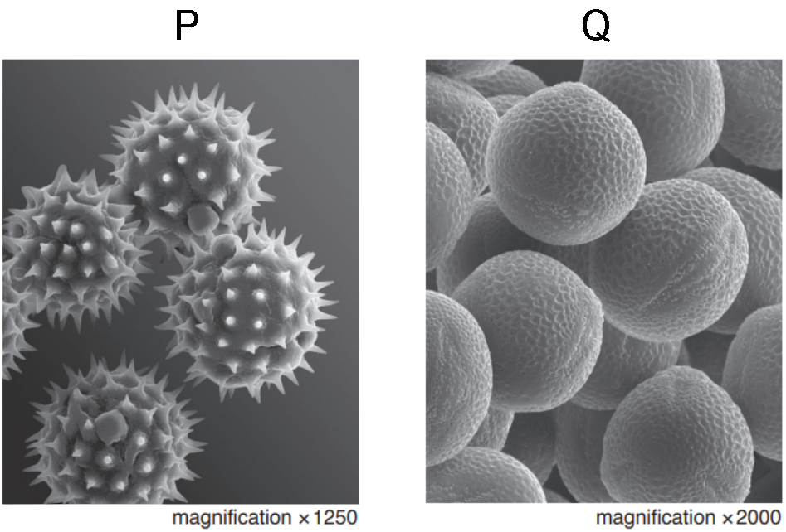
25. Which comparison is correct?
 | P | Q
A. | light, smooth, produced in huge numbers | sticky or sculptured, fewer
B. | sticky or sculptured, carried by insects | light, smooth, carried by wind
C. | contains the ovum | contains two male gametes
D. | diploid | haploid

26. In a flowering plant, meiosis takes place in
(1) the anther.
(2) the ovule.
(3) the petal cells as the bud opens.
A. (1) only
B. (2) only
C. (1) and (2) only
D. (1), (2) and (3)
Directions: Question 27 refers to the flower diagram used in Question 18 (1 petal; 2 stigma; 3 anther; 4 filament; 5 sepal; 6 ovary; 7 ovule; 8 receptacle; 9 nectary; 10 style).
27. Which labelled structure becomes the seed after fertilisation?
A. 2 only
B. 6 only
C. 7 only
D. 9 only
28. The diagram shows a maize grain. Which matching is correct?
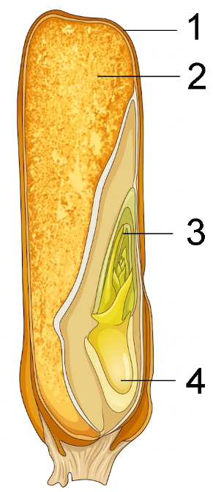
 | 1 | 2 | 3 | 4
A. | seed coat only | cotyledon | radicle | plumule
B. | fruit wall only | cotyledon | plumule | radicle
C. | fruit wall fused with seed coat | stored food | plumule | radicle
D. | fruit wall fused with seed coat | stored food | radicle | plumule

29. The diagrams show five fruits or seeds (not to the same scale). Which pairing of dispersal agent is correct?
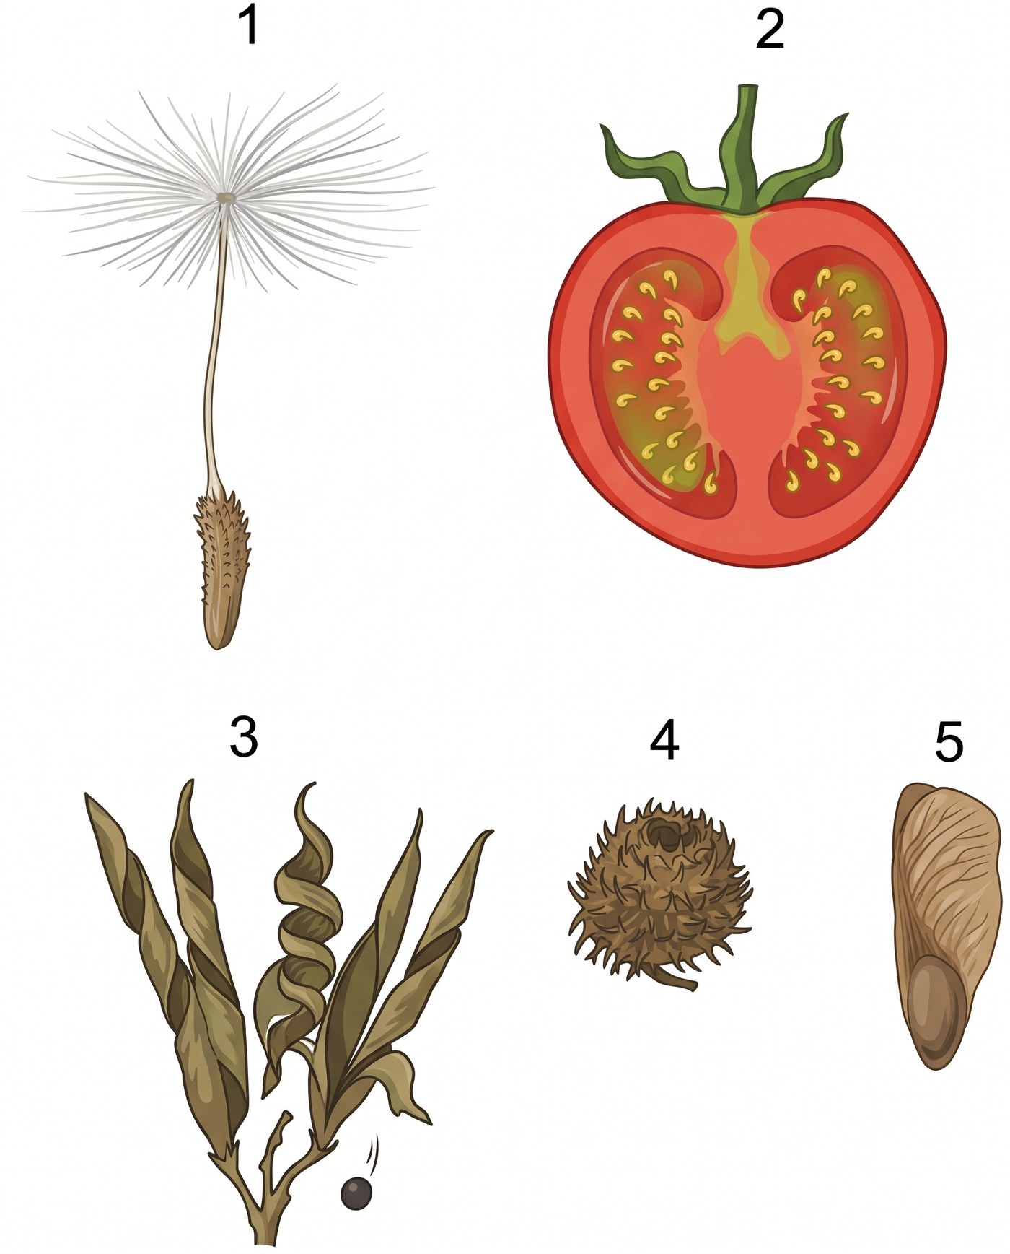
 | Wind | Animal (eaten) | Animal (carried on the body)
A. | 1 and 5 | 2 | 3
B. | 1 and 5 | 2 | 4
C. | 3 | 2 and 4 | 1
D. | 1 and 4 | 5 | 2

30. A pollen tube enters an ovule. Two male gametes are released. Which description is correct?
A. Both male gametes fuse with the egg cell, so two embryos form in every seed.
B. One male gamete fuses with the egg cell; the other is not used.
C. One male gamete fuses with the egg cell to form a zygote; the other fuses with other haploid nuclei in the ovule to form a food-storage tissue.
D. Both male gametes fuse with ovary-wall cells to form the fruit.
31. Immediately before fertilisation, which of the following is/are haploid?
(1) a pollen grain
(2) an egg cell
(3) the integument of an ovule
A. (1) and (2) only
B. (1) and (3) only
C. (2) and (3) only
D. (1), (2) and (3)
32. Which of the following comparisons of vegetative propagation and reproduction by seeds under natural conditions is/are correct?
(1) Vegetative offspring are genetically identical to the parent; seeds are not necessarily so.
(2) Vegetative organs usually form while the plant is growing actively, not as a response to drought.
(3) A plant that forms stem tubers cannot produce flowers and seeds.
A. (1) only
B. (1) and (2) only
C. (2) and (3) only
D. (1), (2) and (3)

Answers
Answers are printed in red. Class percentages are from OMR or Google Forms, matched by wording. Part B has no class percentage.
1. B Class: 29.3% correct (n=58) usual slip C exam 2425 F5 final Q6 Seeds are diploid. C is written as the biologically correct comparison (seeds disperse more). The 2425 paper had C as smaller | greater, which is also incorrect, so that paper had two wrong rows.
2. B Class: 72.2% correct (n=97) usual slip D class YKTo/Longman Mucor reproduces by spores, not budding.
3. C Class: 79.7% correct (n=172) usual slip D class YKTo/Longman Self-fertilisation uses one parent. Usual slip D.
4. D Class: 60.3% correct (n=126) usual slip B class photo
5. D Class: 76.8% correct (n=69) usual slip B class
6. C Class: 72.9% correct (n=199) usual slip A class photo
7. A Class: 79.2% correct (n=130) usual slip D class
8. D Class: 70.9% correct (n=55) usual slip A class
9. D Class: 51.8% correct (n=83) usual slip A class Dispersal does not create genetic variation; sexual reproduction does.
10. B Class: 71.6% correct (n=67) usual slip D class YKTo
11. B Class: 50.7% correct (n=67) usual slip A class YKTo
12. B Class: 69.9% correct (n=83) usual slip A class YKTo
13. A Class: 62.2% correct (n=37) usual slip C class YKTo
14. A Class: 75.0% correct (n=28) usual slip C class YKTo
15. B Class: 24.3% correct (n=37) usual slip D class YKTo
16. D Class: 60.9% correct (n=46) usual slip B exam 2324 F5 mid Q20 The tube grows through stigma and style, then along the placenta to the micropyle — not through the pod wall.
17. B Class: 22.0% correct (n=41) usual slip D class YKTo, figure redrawn Usual slip D shuts anthers inside reduced petals.
18. D Class: 58.8% correct (n=34) usual slip A class YKTo Cross pollen is from another flower, not from anther 3 of this flower.
19. A Class: 61.8% correct (n=110) usual slip B class YKTo tissue culture Tissue culture is asexual. (3) variation and (4) overcrowding belong to sexual reproduction / dispersal.
20. D Class: 55.4% correct (n=56) usual slip C exam 2526 F6 final Q33 Photograph unlabeled for Photoshop: (i) outer skin (ii) fleshy wall (iii) embryo / cotyledon (iv) seed coat. Key D: seed coat from integument.
21. C uncovered · colour does not ensure cross-pollination Colour and nectar attract insects but do not stop self-pollination.
22. B uncovered · after fertilisation
23. A uncovered · bagged stigma Covering the stigma before anthers open prevents both self- and cross-pollination. Ovules are not already seeds.
24. C uncovered · anthers removed, flower left open. (1) and (3) only. Removing anthers stops self-pollination of this flower; cross-pollination from other plants can still occur. Usual trap: (2) / D.
25. B uncovered · pollen
26. C uncovered · meiosis site
27. C uncovered · ovule → seed Ovule → seed; ovary 6 → fruit. Do not reuse the polluted YKTo bank key that marked 6 as seed.
28. C uncovered · maize grain · no endosperm Do not use the word endosperm (out of syllabus). 2 is stored food, not a cotyledon. 3 plumule, 4 radicle. 1 is fruit wall fused with testa.
29. B uncovered · dispersal agents 1 pappus and 5 winged fruit = wind; 2 fleshy = eaten; 4 hooks = carried; 3 explosive pods = self, so 3 is not in the keyed row.
30. C uncovered · two male gametes HKDSE: two male gametes; food-storage tissue, not the name endosperm.
31. A uncovered · haploid structures. Pollen and egg are haploid; the integument is diploid and becomes the testa. Usual slip D.
32. B uncovered · vegetative vs seeds. (1) and (2) only. Potato plants can still flower. Vegetative organs form in the growing season, not as a drought response.
Answer summary
Q | Answer | % correct | n | Usual slip | Source
1 | B | 29.3% | 58 | C | exam 2425 F5 final Q6
2 | B | 72.2% | 97 | D | class YKTo/Longman
3 | C | 79.7% | 172 | D | class YKTo/Longman
4 | D | 60.3% | 126 | B | class photo
5 | D | 76.8% | 69 | B | class
6 | C | 72.9% | 199 | A | class photo
7 | A | 79.2% | 130 | D | class
8 | D | 70.9% | 55 | A | class
9 | D | 51.8% | 83 | A | class
10 | B | 71.6% | 67 | D | class YKTo
11 | B | 50.7% | 67 | A | class YKTo
12 | B | 69.9% | 83 | A | class YKTo
13 | A | 62.2% | 37 | C | class YKTo
14 | A | 75.0% | 28 | C | class YKTo
15 | B | 24.3% | 37 | D | class YKTo
16 | D | 60.9% | 46 | B | exam 2324 F5 mid Q20
17 | B | 22.0% | 41 | D | class YKTo, figure redrawn
18 | D | 58.8% | 34 | A | class YKTo
19 | A | 61.8% | 110 | B | class YKTo tissue culture
20 | D | 55.4% | 56 | C | exam 2526 F6 final Q33
21 | C | — | — | D | uncovered · colour does not ensure cross-pollination
22 | B | — | — | C | uncovered · after fertilisation
23 | A | — | — | B | uncovered · bagged stigma
24 | C | — | — | D | uncovered · anthers removed, flower left open
25 | B | — | — | A | uncovered · pollen
26 | C | — | — | D | uncovered · meiosis site
27 | C | — | — | B | uncovered · ovule → seed
28 | C | — | — | D | uncovered · maize grain · no endosperm
29 | B | — | — | A | uncovered · dispersal agents
30 | C | — | — | A | uncovered · two male gametes
31 | A | — | — | D | uncovered · haploid structures
32 | B | — | — | D | uncovered · vegetative vs seeds

