Transport in humans
Multiple-choice practice · 32 items · class/exam <80% plus difficult uncovered items
Name: ________________________ Class: ____________ Class no.: ______
Practice 1 (Q1–16) focuses on tissue fluid, lymph and capillary exchange (F.4 Ch.8.3). Practice 2 (Q17–32) is heart, vessels and circulation. Teacher check only — not yet posted to the student web. Original under-80 files were not overwritten. Correct option is in red.
Practice 1 — Tissue fluid, lymph and capillary exchange (F.4)
Directions: Question 1 refers to the capillary bed below.
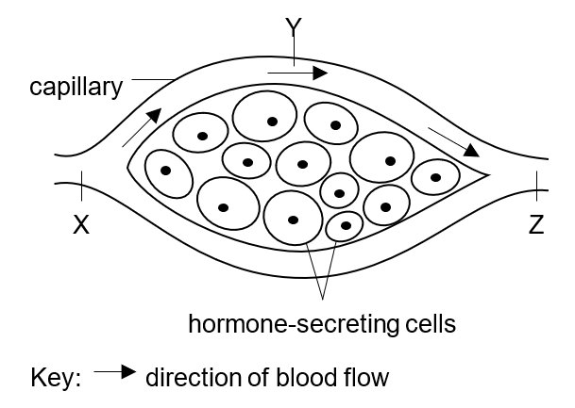
1. [exam 2425 F6 final Q19, 19% correct] The diagram shows a capillary bed in the pancreas of a healthy person. The cells are a mixture of insulin-secreting and glucagon-secreting cells. The person has fasted for 12 hours. Which of the following comparisons are correct?
(1) The concentration of plasma protein at Y is the same as that at X.
(2) The concentration of glucose at Y is higher than that at Z.
(3) The concentration of insulin at Z is higher than that at X.
A. (1) and (2) only
B. (1) and (3) only
C. (2) and (3) only
D. (1), (2) and (3)
Directions: Question 2 refers to the diagram below. Arrows P, Q, R and S represent the transport of different substances.

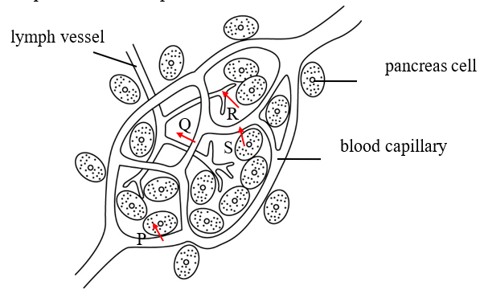
2. [exam 2324 F4 mid Q7, 62% correct] Which of the following incorrectly identifies the transport of substances?
Which of the following incorrectly identifies the transport of substances?
Arrow Transport
A. P transport of protein into pancreas cells
B. Q release of white blood cell from the capillary
C. R transport of tissue fluid into lymph vessel
D. S secretion of insulin from pancreas cells

3. [exam 2526 F4 mid Q14, 61% correct] From the list below, select the appropriate structures and arrange them to show how tissue fluid is formed in the legs and how the excess returns to the heart:
(1) heart
(2) blood capillary in the legs
(3) lymph vessels in the legs
(4) veins in the legs
(5) vena cava
A. (2) (3) (1)
B. (2) (3) (5) (1)
C. (2) (4) (5) (1)
D. (3) (4) (5) (1)
Directions: Questions 4 to 8 refer to the diagram of a capillary bed and a lymph vessel.
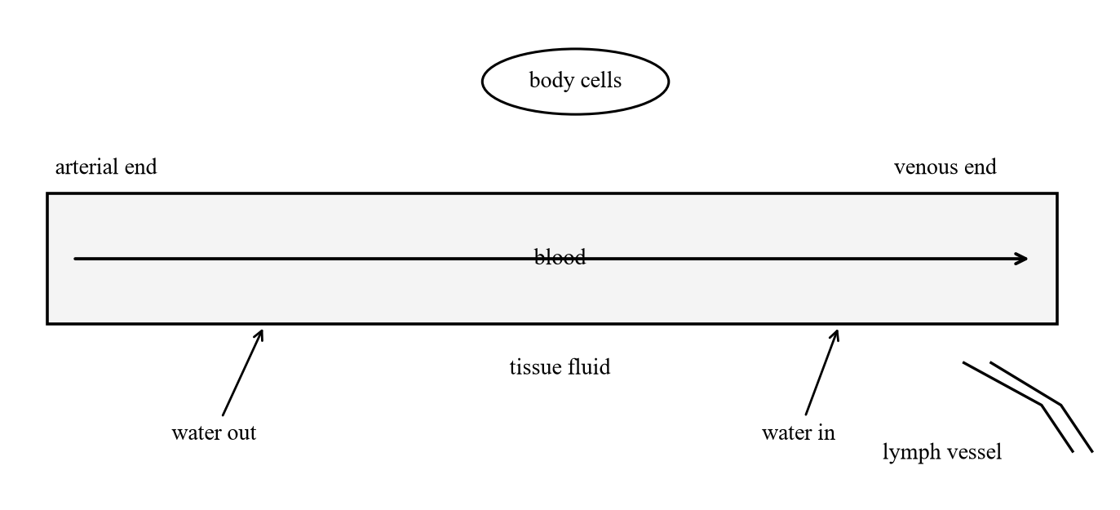
4. [difficult extra] Which matching of water movement with its main driving force is/are correct?
(1) Water leaves the capillary at the arterial end because the hydrostatic pressure of the blood is higher than that of the tissue fluid.
(2) Water returns to the capillary at the venous end by osmosis, because plasma proteins lower the water potential of the blood.
(3) Excess tissue fluid enters the lymph vessel by active transport.
A. (1) and (2) only
B. (1) and (3) only
C. (2) and (3) only
D. (1), (2) and (3)
5. [difficult extra] Which comparison of plasma and tissue fluid is correct?
 | Plasma proteins | Red blood cells | Water potential (relative to the other fluid)
A. | same in both | present in both | plasma higher
B. | much higher in plasma | absent from tissue fluid | plasma lower
C. | much higher in tissue fluid | absent from plasma | tissue fluid lower
D. | absent from both | present only in tissue fluid | the same

6. [difficult extra] A diet very low in protein lowers the concentration of plasma proteins. Which of the following follow from this?
(1) The water potential of the blood plasma rises.
(2) Less water returns to the blood at the venous end of the capillary bed.
(3) Hydrostatic pressure at the arterial end of the capillary bed increases, so more plasma protein is forced out.
A. (1) and (2) only
B. (1) and (3) only
C. (2) and (3) only
D. (1), (2) and (3)
7. [difficult extra] Which fluid is directly in contact with the body cells?
A. Blood in capillaries
B. Plasma only
C. Tissue fluid
D. Lymph in the vena cava
8. [difficult extra] What happens to excess tissue fluid around the capillary bed?
(1) Some is reabsorbed into the capillary at the venous end.
(2) Some enters lymph vessels and becomes lymph.
(3) It is pumped back to the heart by the lymph nodes.
A. (1) and (2) only
B. (1) and (3) only
C. (2) and (3) only
D. (1), (2) and (3)
Directions: Questions 9 to fluids X, Y and Z in the diagram below.
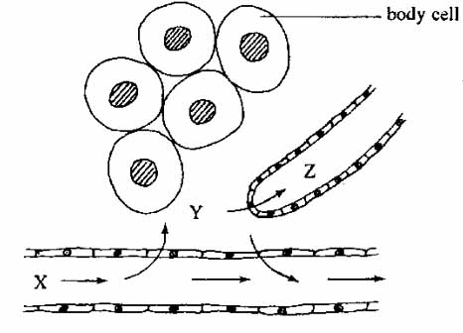
9. [difficult extra] Fluids X, Y and Z are respectively
 | X | Y | Z
A. | tissue fluid | blood | lymph
B. | lymph | tissue fluid | blood
C. | blood | tissue fluid | lymph
D. | blood | lymph | tissue fluid

10. [difficult extra] Which is/are (a) function(s) of the lymphatic system?
(1) It houses white blood cells involved in body defence.
(2) It transfers absorbed fats from the small intestine to the blood.
(3) It returns excess tissue fluid to the blood.
(4) It transports oxygen to body cells.
A. (1) and (2) only
B. (1) and (3) only
C. (2), (3) and (4) only
D. (1), (2) and (3) only
11. [difficult extra] Which comparison of the blood circulatory system and the lymphatic system is correct?
 | Blood circulatory system | Lymphatic system
A. | valves are absent from all vessels | valves are present in lymph vessels
B. | contains phagocytes | contains no white blood cells
C. | blood is driven only by gravity | lymph is pumped by lymph nodes
D. | contains red blood cells | contains no red blood cells

12. [difficult extra] People sitting for a long flight may have swollen feet. Stretching the legs can reduce the discomfort mainly because it
A. increases the heart rate so that more blood is pumped out of the legs.
B. raises arterial blood pressure, which forces more plasma protein into the tissue fluid.
C. squeezes lymph vessels, so more lymph is moved away from the feet.
D. causes vasoconstriction of arterioles, which stops tissue-fluid formation.
13. [difficult extra] Which cell can leave a blood capillary and enter the tissue fluid?
(1) a red blood cell
(2) a phagocyte
(3) a platelet as a complete cell that carries oxygen
A. (1) only
B. (1) and (2) only
C. (2) and (3) only
D. (2) only
14. [exam 2425 F5 final Q26, 38% correct] Which of the following substances is/are not normally found in the blood plasma?
(1) antibodies
(2) haemoglobin
(3) glucagon
A. (1) only
B. (2) only
C. (3) only
D. (2) and (3) only
15. [difficult extra] Some therapists claim that pressing along the limbs towards the trunk improves lymph flow and therefore reduces body weight. Which of the following is/are scientifically valid?
(1) Squeezing lymph vessels that have valves can help lymph move towards the heart.
(2) Lymph is removed from the body by this treatment, so body mass falls.
(3) The treatment increases energy output, so fat stores are used up.
A. (1) only
B. (1) and (2) only
C. (2) and (3) only
D. (1), (2) and (3)
16. [difficult extra] Which row correctly compares the two ends of a capillary bed in a healthy person?
 | Arterial end | Venous end
A. | water enters by osmosis | water is forced out by hydrostatic pressure
B. | hydrostatic pressure of blood is higher than that of tissue fluid | water potential of blood is lower than that of tissue fluid, so water returns by osmosis
C. | plasma proteins leave the blood | plasma proteins return by active transport
D. | red blood cells leave the capillary | red blood cells return through lymph vessels

Practice 2 — Heart, vessels and circulation
Directions: Question 17 refers to the diagram of the human circulatory system.
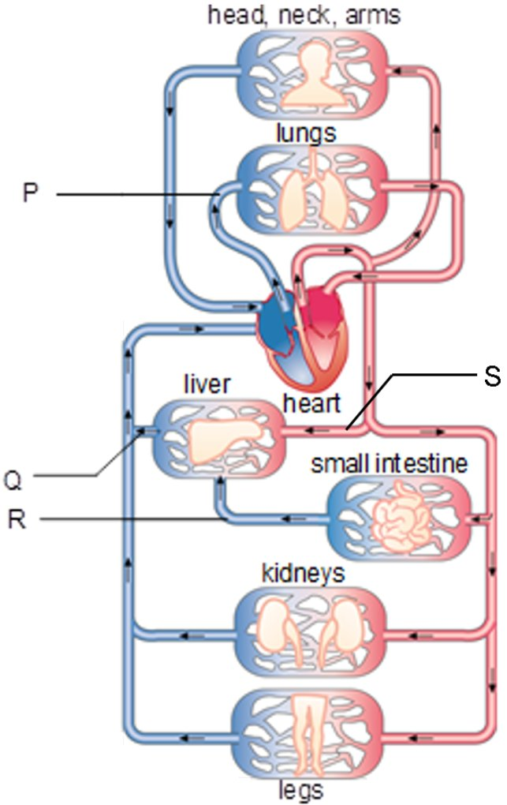
17. [exam 2425 F3 final Q6, 25% correct] Which of the following descriptions about blood vessel R are correct?
(1) It transports antibodies.
(2) It carries deoxygenated blood.
(3) It has capillary networks at both ends.
A. (1) and (2) only
B. (1) and (3) only
C. (2) and (3) only
D. (1), (2) and (3)
Directions: Question 18 refers to the diagram of a heart with a blockage in a coronary vessel.
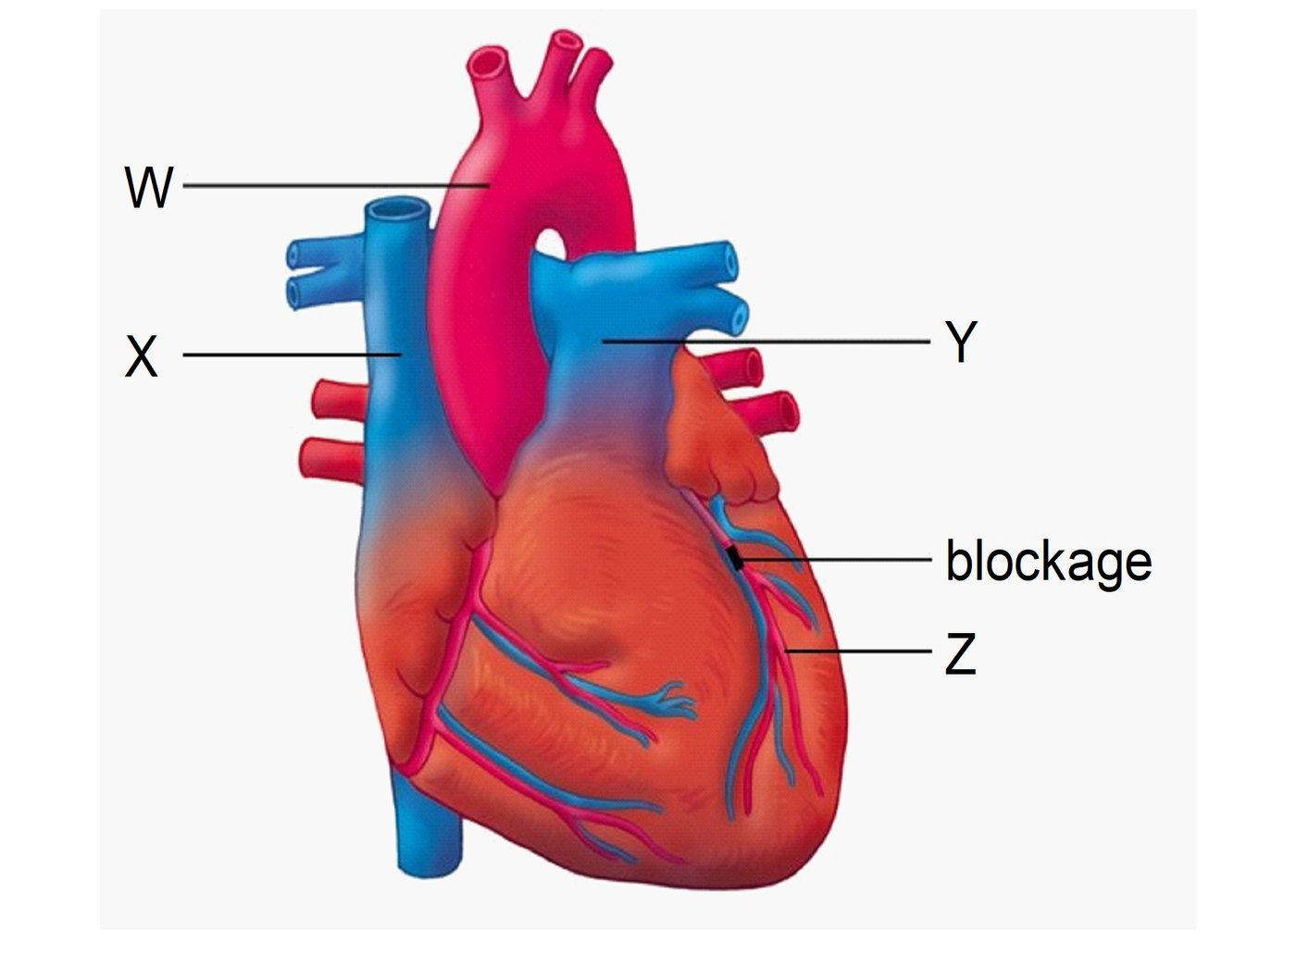
18. [exam 2425 F3 final Q8, 40% correct] A blockage in the coronary artery can be treated by attaching a section of a healthy blood vessel to bypass the blockage. The two blood vessels which should be joined by the new blood vessel are
A. W and X.
B. W and Z.
C. X and Z.
D. Y and Z.
Directions: Question 19 refers to Diagram I below.
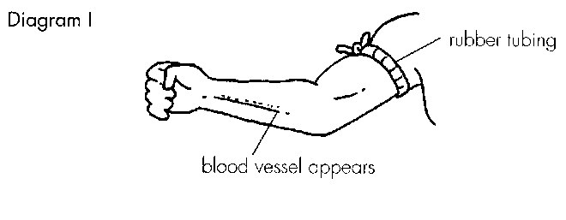
19. [exam 2425 F3 final Q2, 41% correct] The purpose of tying the arm with a rubber tubing is
A. to stop the blood supply to the arm.
B. to make the blood vessel more conspicuous.
C. to prevent the arm from moving.
D. to facilitate the return of blood to the heart.
Directions: Question 20 refers to the heart with parts removed to show valves.
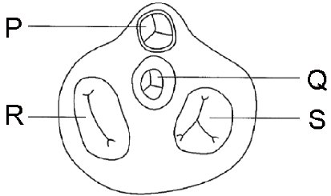
20. [exam 2526 F3 final Q15, 42% correct] Which labelled structure contains valves that prevent the backflow of blood into the ventricles?
A. P only
B. Q only
C. R and S
D. P and Q
Directions: Question 21 refers to the graph of blood pressure along three types of vessel.
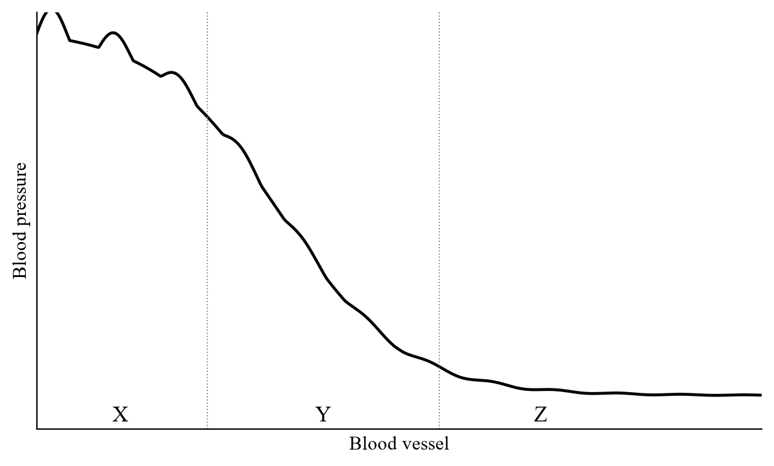
21. [exam 2324 F3 final Q9, 42% correct] Which feature accounts for the appearance of a pulse in blood vessel X?
A. thick wall
B. large lumen
C. wall with elastic fibres
D. presence of valves at intervals
Directions: Questions 22 and 23 refer to the vessel cross-sections and the schematic circulation.
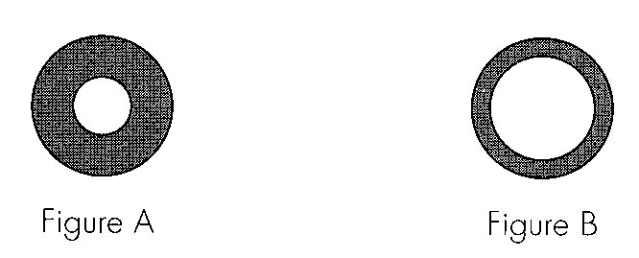
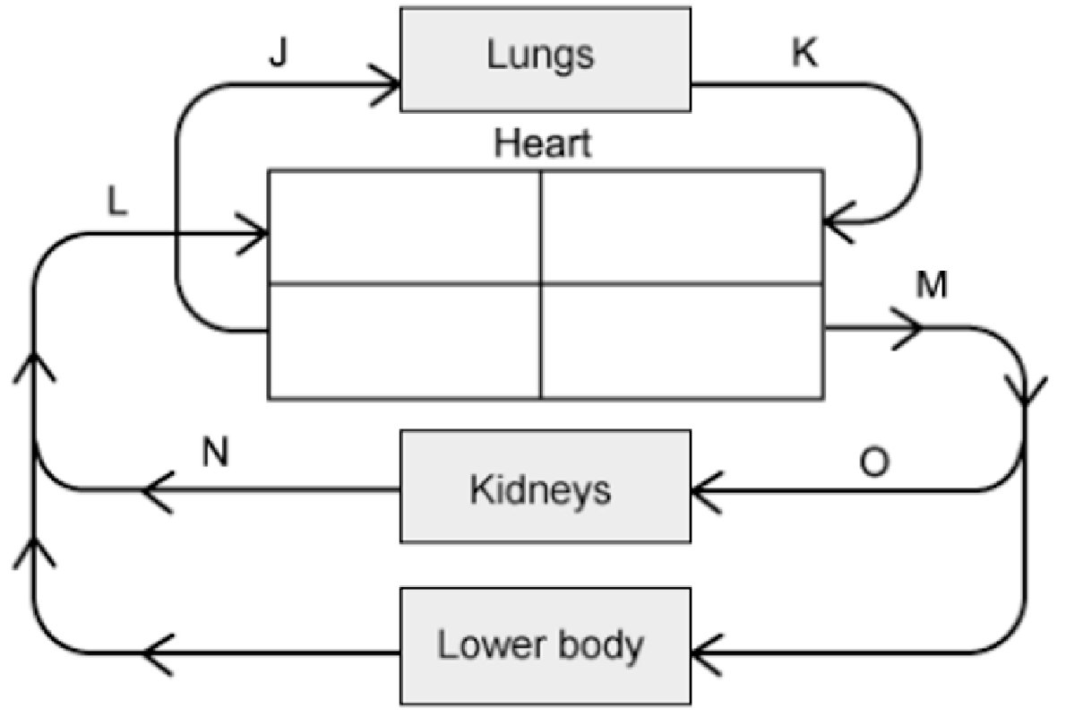
22. [exam 2526 F3 final Q18, 50% correct] The two blood vessels represented by the cross-sections in figures A and B respectively are
A. O and N.
B. N and O.
C. M and J.
D. K and L.
23. [exam 2526 F3 final Q20, 52% correct] Consider the blood in vessels J and K. Which statements are correct?
(1) Blood in J has a higher carbon dioxide concentration than blood in K.
(2) Blood in K flows into the left atrium of the heart.
(3) Blood pressure in J is higher than blood pressure in K.
A. (1) and (2) only
B. (1) and (3) only
C. (2) and (3) only
D. (1), (2) and (3)
24. [exam 2324 F3 final Q10, 52% correct] Which combination correctly states the type of blood vessel from which a routine blood sample was taken, and the reason?
 | Blood vessel | Reason
A. | artery | the blood sample can be collected more quickly
B. | artery | the blood is oxygenated
C. | vein | there are valves to prevent backflow of blood
D. | vein | the blood pressure is low

Directions: Question 25 refers to part of the blood-vessel network in a human leg.
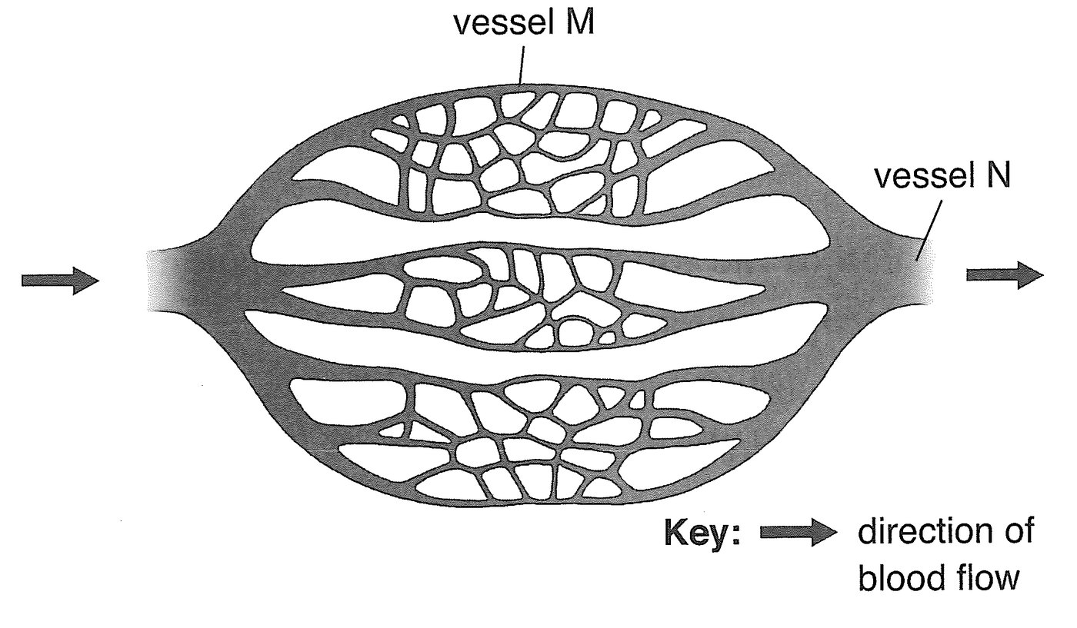
25. [exam 2425 F5 mid Q2, 54% correct] Which comparison between M and N is correct?
 | Vessel M | Vessel N
A. | contains more carbon dioxide | contains less carbon dioxide
B. | blood flows at a higher speed | blood flows at a lower speed
C. | no muscle layer in the wall | has a muscle layer in the wall
D. | lower blood pressure | higher blood pressure

Directions: Question 26 refers to the heart and associated vessels.
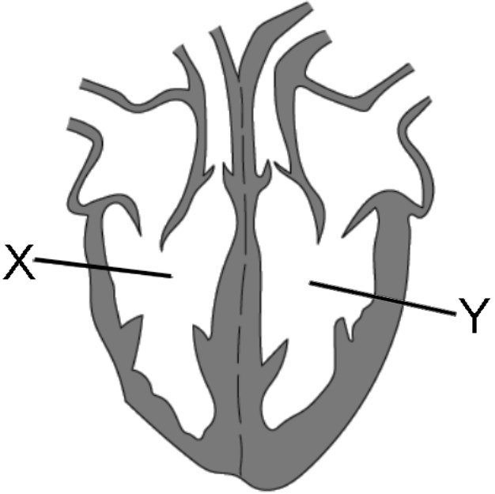
26. [exam 2324 F3 final Q6, 59% correct] Before blood in X reaches Y, what must it do?
A. Absorb glucose
B. Pass through capillaries
C. Transport oxygen to the whole body
D. Travel to the head
Directions: Question 27 refers to a small part of a vein and neighbouring skeletal muscles.
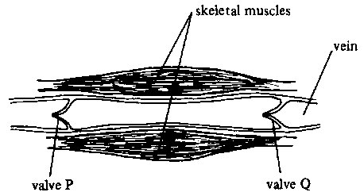
27. [exam 2324 F3 final Q7, 61% correct] Which matching of the state of the muscles with valves P and Q is correct?
 | skeletal muscles | valve P | valve Q
A. | contracting | open | closed
B. | contracting | closed | open
C. | relaxing | open | closed
D. | relaxing | open | open

Directions: Question 28 refers to the photograph of a heart valve (‘gate’).
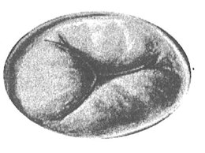
28. [exam 2324 F4 mid Q4, 64% correct] Imagine you were a red blood cell that had reached the heart. After passing through the ‘gate’ shown, there was another ‘gate’ ahead. Which heart chamber were you in now?
A. Left atrium
B. Left ventricle
C. Right atrium
D. Right ventricle
Directions: Question 29 refers to the dissected pig heart.
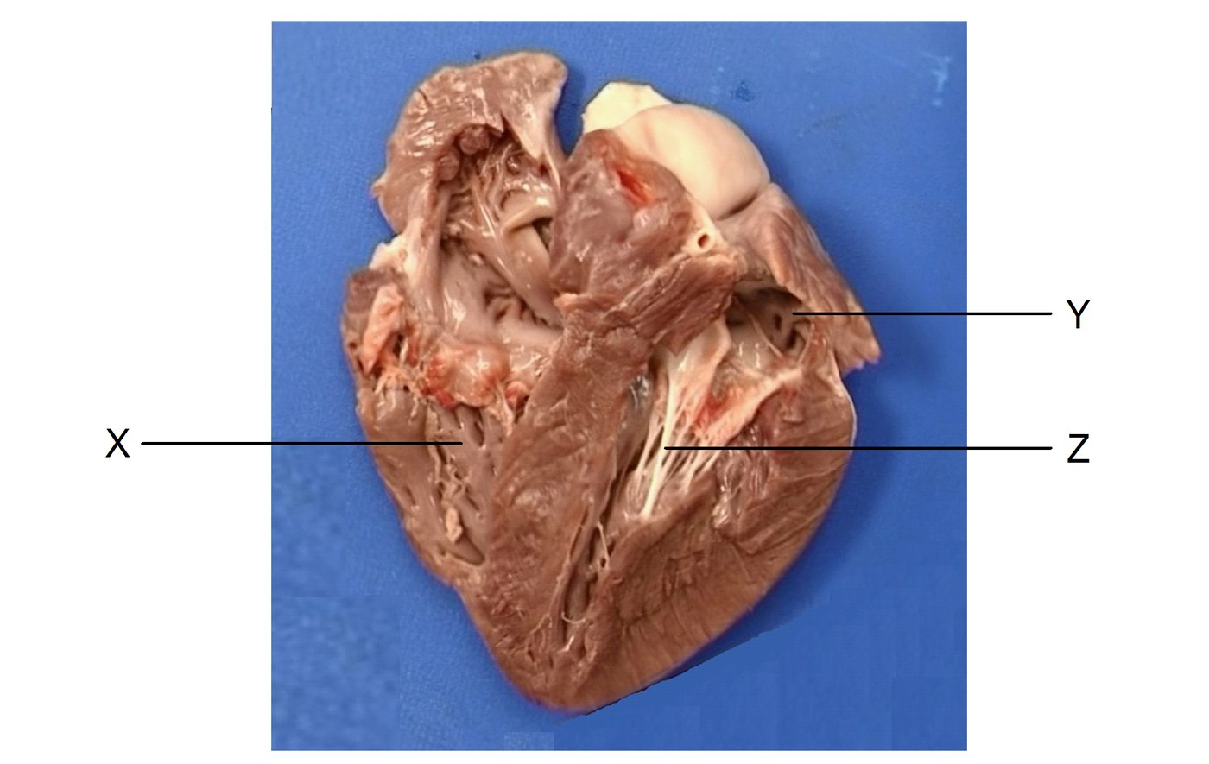
29. [exam 2526 F4 mid Q15, 64% correct] Which of the following statements about structures X, Y and Z is/are correct?
(1) X contracts to pump blood to various parts of the body except the lungs.
(2) Y receives blood from the pulmonary veins.
(3) Z prevents the backflow of blood into the ventricles.
A. (1) only
B. (2) only
C. (1) and (3) only
D. (2) and (3) only
Directions: Questions 30 and 31 refer to blood vessels connected to the liver.
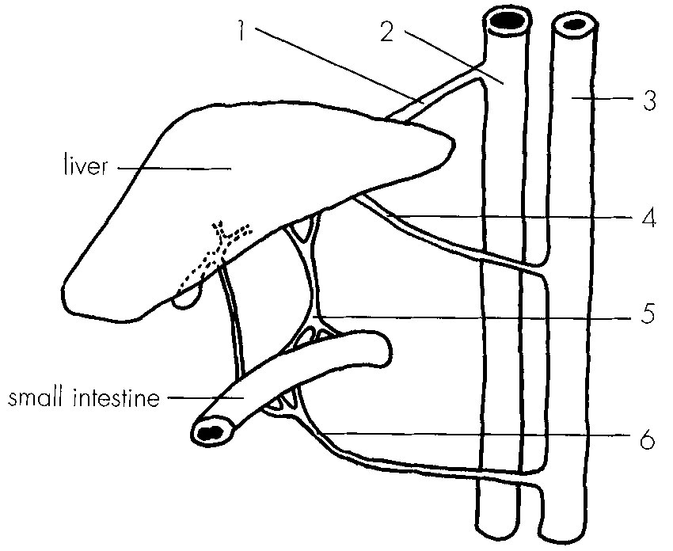
30. [exam 2324 F6 final Q14, 73% correct] Which labelled blood vessel carries blood with the highest concentration of urea?
A. 1
B. 4
C. 5
D. 6
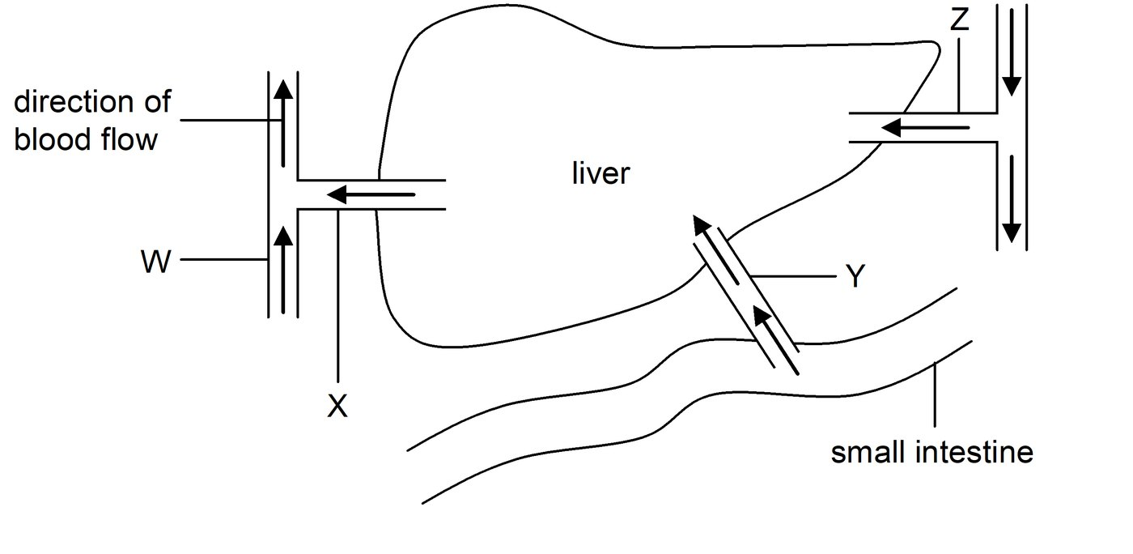
31. [exam 2324 F4 mid Q11, 75% correct] Which of the labelled blood vessels has the smallest lumen?
A. W
B. X
C. Y
D. Z
32. [difficult extra] Which of the following statements about arteries is/are correct?
(1) The pulmonary artery carries deoxygenated blood.
(2) Arteries carry blood away from the heart.
(3) All arteries carry oxygenated blood.
A. (1) only
B. (1) and (2) only
C. (2) and (3) only
D. (1), (2) and (3)
Answers
Correct options are also printed in red on the question paper. Exam percentages are whole-cohort OMR. Extra items have no class percentage.
1. C Plasma protein does not leave at Y. Usual slip A includes (1).
2. A Plasma proteins do not enter pancreas cells along P. Usual slip B.
3. B Formation at the capillary, then lymph → vena cava → heart. Slip D skips the capillary.
4. A Venous return is osmosis, not active transport. Lymph entry is not active transport.
5. B Plasma proteins stay in the blood, so plasma water potential is lower.
6. A (3) is the usual slip: hydrostatic pressure does not rise, and proteins do not leave.
7. C Difficult extra. Distractor = the usual misconception.
8. A Lymph nodes are not pumps.
9. C X blood, Y tissue fluid, Z lymph.
10. D Lymph does not carry oxygen. Usual slip A drops fat transport.
11. D Difficult extra. Distractor = the usual misconception.
12. C Usual slip A (heart rate).
13. D Difficult extra. Distractor = the usual misconception.
14. B Haemoglobin is inside red blood cells, not dissolved in plasma.
15. A Lymph returns to the blood; mass is not lost. Usual slip D.
16. B Difficult extra. Distractor = the usual misconception.
17. D R is the hepatic portal vein. All three. Usual slip C.
18. B Join the aorta (W) to the coronary vessel beyond the blockage (Z).
19. B Difficult extra. Distractor = the usual misconception.
20. D Semilunar valves P and Q. Slip C = atrioventricular valves R and S.
21. C Pulse is elastic recoil, not valves.
22. A Difficult extra. Distractor = the usual misconception.
23. D Difficult extra. Distractor = the usual misconception.
24. D Difficult extra. Distractor = the usual misconception.
25. C M is a capillary (no muscle). Slip B treats M as an artery.
26. B Difficult extra. Distractor = the usual misconception.
27. A Heart is towards P. Contracting: P open, Q closed.
28. D After the tricuspid gate: right ventricle.
29. B X is not the left ventricle; Z is not a semilunar valve. Only (2).
30. A 1 is the hepatic vein.
31. D Difficult extra. Distractor = the usual misconception.
32. B (3) is the usual slip (forgets the pulmonary artery).
Answer summary
Q | Answer | Source / % | Usual slip
1 | C | exam 19% | A
2 | A | exam 62% | B
3 | B | exam 61% | D
4 | A | extra | D
5 | B | extra | A
6 | A | extra | D
7 | C | extra | A
8 | A | extra | D
9 | C | extra | B
10 | D | extra | A
11 | D | extra | A
12 | C | extra | A
13 | D | extra | A
14 | B | exam 38% | C
15 | A | extra | D
16 | B | extra | C
17 | D | exam 25% | C
18 | B | exam 40% | D
19 | B | exam 41% | A
20 | D | exam 42% | C
21 | C | exam 42% | A
22 | A | exam 50% | C
23 | D | exam 52% | A
24 | D | exam 52% | C
25 | C | exam 54% | B
26 | B | exam 59% | A
27 | A | exam 61% | C
28 | D | exam 64% | C
29 | B | exam 64% | D
30 | A | exam 73% | B
31 | D | exam 75% | C
32 | B | extra | D

Do not overwrite Transport in humans MC under80.docx or Transport in humans MC exam under80.docx. Plant-microscope, nitrogen-atoms, airtight-bag, dialysis-tubing osmosis, and teeth items from the exam under80 file were omitted. Duplicate pancreas-capillary and duplicate pig-heart items were used once only. Class Ch.8.3 Google Form items (Q3 45%, Q6 43%, Q8 24.5%, Q9 47%, Q10 43%, n=49) were not copied because only paper numbers, not stems, were in the spreadsheet.

