St. Stephen’s Girls’ College
Biology
Gas exchange in humans
32 multiple-choice items · teacher check
Name: ________________________ Class: ________ Class no.: ________
Setter: Miss Lai K.F.
Practice 1 (Questions 1 to 16). Airways, mucus, and the composition of inspired and expired air.
Practice 2 (Questions 17 to 32). Ventilation, gas exchange at the air sac, exercise and smoking.
Directions: Questions 1 and 2 refer to the diagram below, which shows part of the human breathing system.
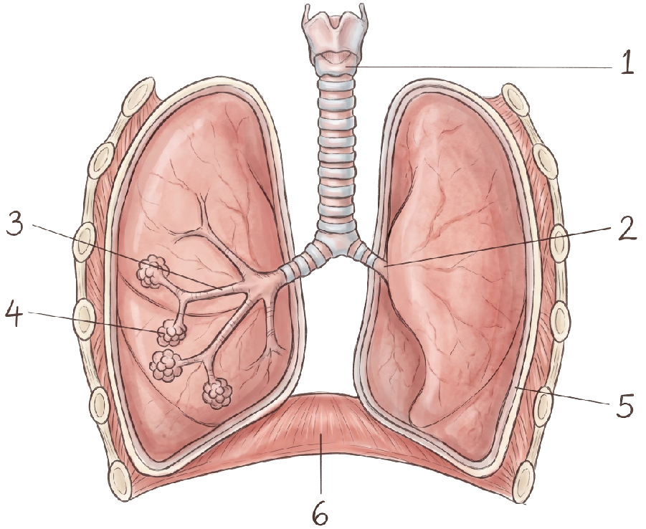
1. Food is prevented from entering structure 1 during swallowing because
A. structure 1 constricts.
B. the oesophagus dilates, and this closes the entrance to structure 1.
C. the glottis is opened wider.
D. the larynx is raised, so the entrance to structure 1 is covered.
2. Which of the numbered structures recoils by its own elasticity during a quiet expiration?
A. 3
B. 4
C. 5
D. 6
3. Which of the following organs are protected by the rib cage?
(1) Lungs
(2) Liver
(3) Heart
(4) Stomach
A. (1) and (3) only
B. (2) and (3) only
C. (2) and (4) only
D. (3) and (4) only
4. Which of the following is a possible route by which inhaled asbestos particles reach an air sac?
A. larynx → pharynx → trachea → bronchus → bronchiole → air sac
B. pharynx → larynx → trachea → bronchus → bronchiole → air sac
C. pharynx → larynx → trachea → bronchiole → bronchus → air sac
D. larynx → pharynx → trachea → bronchiole → bronchus → air sac
5. Which of the following are roles of the mucus secreted in the human breathing system?
(1) It moistens the inspired air.
(2) It warms the inspired air.
(3) It traps dust and dirt.
A. (1) and (2) only
B. (1) and (3) only
C. (2) and (3) only
D. (1), (2) and (3)
6. Which of the following describes the role of the cilia in the human breathing system?
(1) They draw air into the lungs by beating downwards.
(2) They move phlegm upwards, towards the throat.
(3) They trap dust from the inspired air.
A. (1) only
B. (2) only
C. (3) only
D. (1), (2) and (3)
Directions: Question 7 refers to the bar chart below. The shaded bars are inspired air. The white bars are expired air.
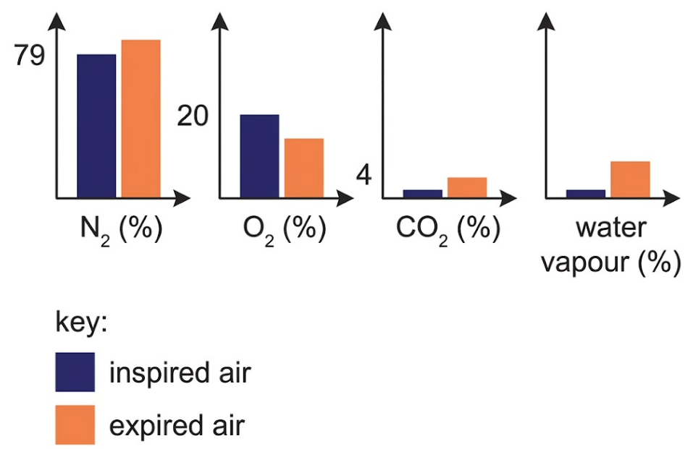
7. Which row could be the percentages of oxygen and carbon dioxide in the expired air?
 | Oxygen | Carbon dioxide
A. | 19.74% | 0.06%
B. | 16.23% | 0.82%
C. | 21.38% | 4.05%
D. | 17.01% | 3.32%

Directions: Question 8 refers to the apparatus below. It is used to compare one gas in inhaled air and exhaled air.

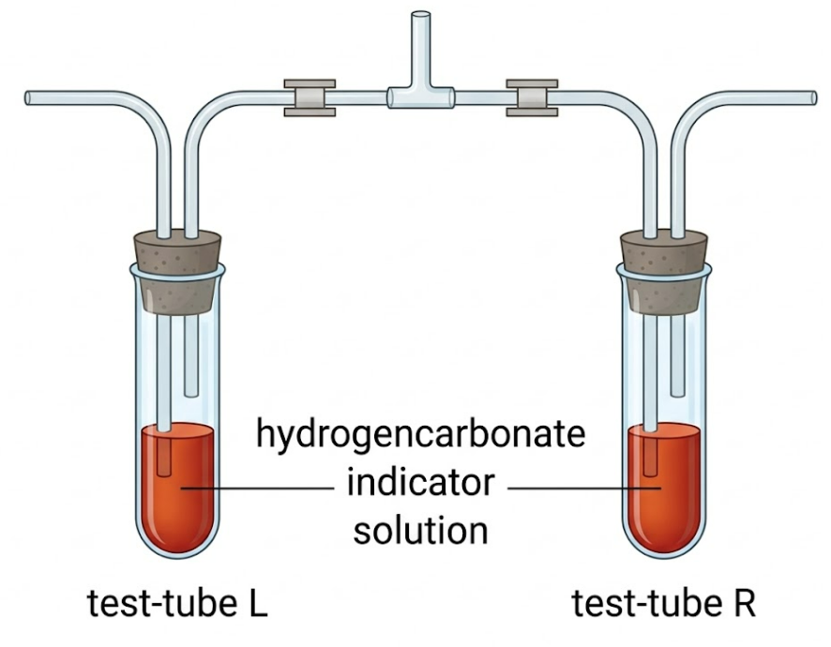
8. Which gas is being compared?
A. Oxygen
B. Carbon dioxide
C. Water vapour
D. Nitrogen
9. The alimentary canal and the respiratory tract meet at the
A. epiglottis.
B. larynx.
C. glottis.
D. pharynx.
10. It is better to breathe in through the nose than through the mouth because
A. the nasal cavity is part of the breathing system, while the mouth is part of the alimentary canal.
B. the nose lets only oxygen in, and the cilia trap carbon dioxide.
C. the nose is nearer the brain, so it controls how much air the lungs take in.
D. the ciliated mucous lining of the nose traps dust and germs.
Directions: Questions 11 and 12 refer to the diagram below, which shows an air sac and a blood capillary. The arrow at H1 shows blood leaving the capillary. The arrow at H2 shows blood entering the capillary.
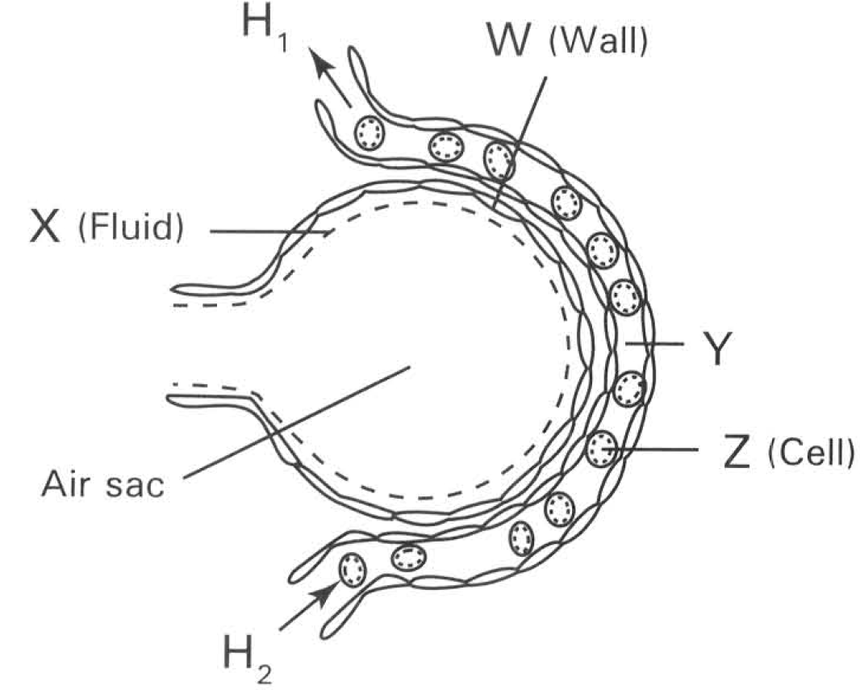
11. Which heart chambers are connected to H1 and H2?
 | H1 | H2
A. | Left atrium | Right ventricle
B. | Left ventricle | Right atrium
C. | Right atrium | Left ventricle
D. | Right ventricle | Left atrium

12. The air sac is densely covered with blood capillaries in order to
A. make the lung more spongy, so that ventilation is easier.
B. provide the large surface area of the air sac.
C. keep a steep concentration gradient of gases between the air in the air sac and the blood.
D. supply nutrients to the cells of the air-sac wall.
Directions: Question 13 refers again to the breathing system in question 1.
13. The rings on structure 1
A. make structure 1 the main site of gas exchange.
B. keep the airway open when the air pressure inside it falls.
C. trap dust particles.
D. force air down into the air sacs.
14. Which comparison of inspired air and expired air is incorrect?
 | Inspired air | Expired air
A. | Higher percentage of oxygen | Lower percentage of oxygen
B. | Lower percentage of carbon dioxide | Higher percentage of carbon dioxide
C. | Lower percentage of oxygen | Higher percentage of oxygen
D. | Lower percentage of water vapour | Higher percentage of water vapour

15. Which features of an air sac help gas exchange?
(1) The wall is one cell thick.
(2) The inner surface is moist.
(3) The wall contains cartilage rings that keep the air sac open.
A. (1) and (2) only
B. (1) and (3) only
C. (2) and (3) only
D. (1), (2) and (3)
16. Which statement is correct?
A. Breathing is the breakdown of glucose to release energy inside cells.
B. Gas exchange at the air sac is the same process as respiration.
C. Breathing moves air into and out of the lungs. Gas exchange is the diffusion of gases between the air in the air sac and the blood.
D. Respiration takes place only in the air sacs.
Practice 2
Questions 17 to 32. Ventilation, gas exchange at the air sac, exercise and smoking.
17. Which statement about breathing is correct?
A. The lungs expand and push the ribs upwards.
B. Air entering the lungs causes the lungs to expand.
C. Contraction of the diaphragm muscles causes the lungs to expand.
D. The air pressure inside the lungs keeps decreasing throughout inhalation.
Directions: Question 18 refers to the graph below, which shows the change in lung volume during two breaths.

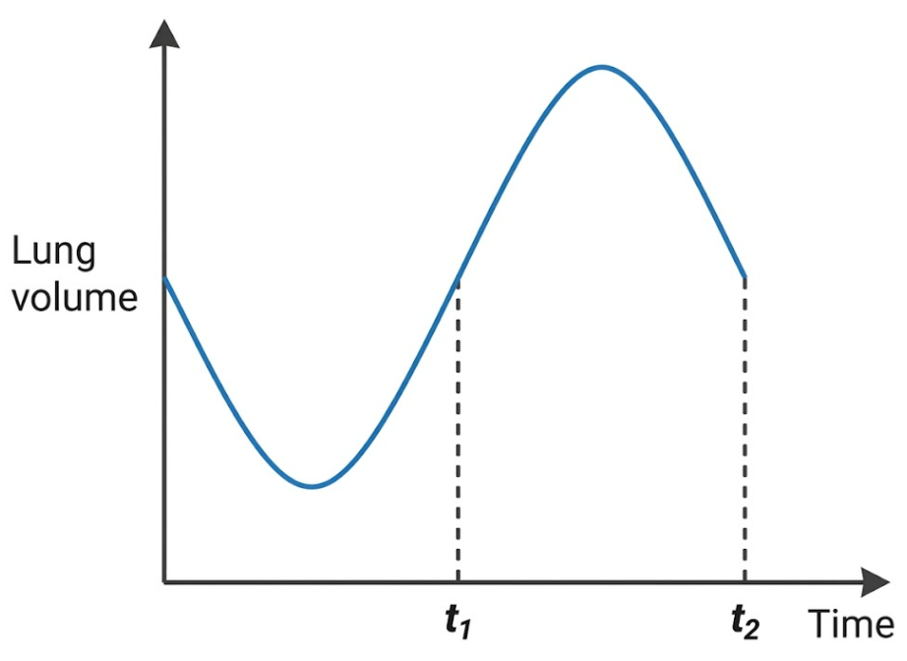
18. Which description is correct at t1?
A. The intercostal muscles are relaxing.
B. There is no flow of air between the lungs and the outside.
C. The rib cage is moving downwards and inwards.
D. The diaphragm muscle is contracting.
Directions: Question 19 refers to the graph below. Atmospheric pressure is 760 mmHg.

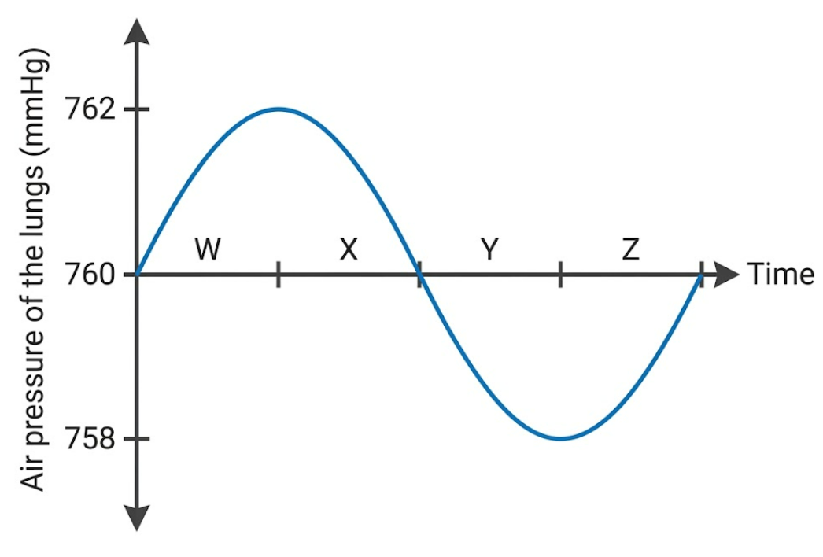
19. Which row correctly describes one period on the graph?
 | Period | Diaphragm muscle | Movement of air
A. | W | Contracting | Into the lungs
B. | X | Relaxing | Out of the lungs
C. | Y | Contracting | Out of the lungs
D. | Z | Relaxing | Into the lungs

Directions: Question 20 refers to the diagram below, which shows a change in the thorax during breathing. The dashed line shows the earlier position of the body wall.

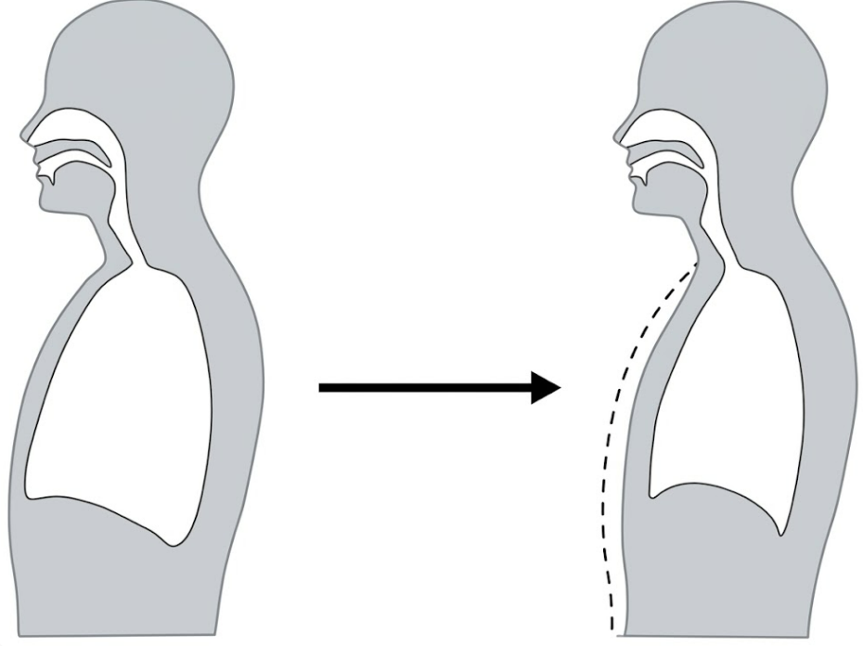
20. Which of the following happened during the change shown?
(1) Air rushed into the lungs because the air pressure inside the lungs was lower than atmospheric pressure.
(2) The diaphragm muscles contracted and pulled the diaphragm upwards.
(3) The intercostal muscles relaxed, and the rib cage moved downwards and inwards.
A. (1) only
B. (3) only
C. (2) and (3) only
D. (1), (2) and (3)
Directions: Question 21 refers to the graph below. It shows the rate of ventilation, and the concentrations of oxygen and carbon dioxide in the blood, while a healthy person exercises.
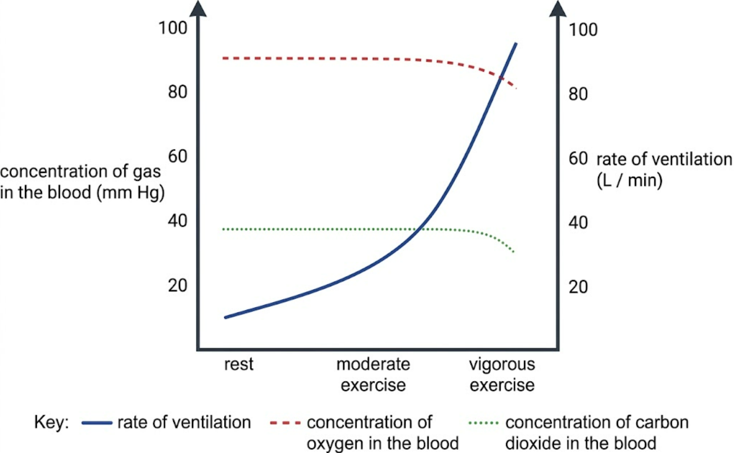
21. Which statements agree with the graph?
(1) The rate of ventilation increases markedly from rest to vigorous exercise.
(2) The carbon dioxide concentration in the blood rises sharply during vigorous exercise.
(3) The oxygen concentration in the blood remains high from rest to vigorous exercise.
A. (1) and (2) only
B. (1) and (3) only
C. (2) and (3) only
D. (1), (2) and (3)
22. Two statements about a quiet expiration are given below.
I The volume of the lungs decreases.
II Air flows from the lungs to the outside.
Which description of the two statements is correct?
A. Both I and II are correct, and II explains I.
B. Both I and II are correct, but II does not explain I.
C. I is correct but II is incorrect.
D. I is incorrect but II is correct.
23. A wound opens the pleural cavity on the right side to the outside air. The left pleural cavity is not opened. Which result is likely?
A. Both lungs collapse, and the person can never breathe again.
B. The right lung collapses. The left lung can still be ventilated.
C. The right lung inflates further, because air from the wound enters its air sacs.
D. Air leaks out of the right lung, through the air sacs, into the wound.
24. The breathing centre increases the rate and depth of breathing mainly in response to
A. a large fall in the oxygen concentration of the blood.
B. a small rise in the carbon dioxide concentration of the blood.
C. a rise in the nitrogen concentration of the blood.
D. a fall in the blood temperature.
25. In a quiet expiration, the first air to leave the nose
A. has already exchanged gases while it was in the trachea.
B. is similar to inspired air, because it was sitting in the trachea and bronchi.
C. contains a higher percentage of oxygen than inspired air.
D. is undiluted air that has just left the air sacs.
26. A quiet expiration takes place because
A. the diaphragm contracts and flattens.
B. the breathing muscles relax and the lungs recoil.
C. the air sacs pump air out.
D. the intercostal muscles contract more strongly than they do during inspiration.
27. Which statements about gas exchange at an air sac are correct?
(1) The oxygen concentration is higher in the air sac than in the blood arriving from the heart.
(2) The wall of the air sac pumps oxygen into the blood.
(3) The carbon dioxide concentration is higher in the blood arriving from the heart than in the air in the air sac.
A. (1) only
B. (1) and (3) only
C. (2) and (3) only
D. (1), (2) and (3)
28. Which effects of cigarette smoking make gas exchange less effective?
(1) Tar stops the cilia beating, so mucus and the dust trapped in it are not cleared.
(2) Breakdown of the air-sac walls reduces the surface area for gas exchange.
(3) A thicker air-sac wall exchanges gases faster.
A. (1) and (2) only
B. (1) and (3) only
C. (2) and (3) only
D. (1), (2) and (3)
29. Cigarette smoke contains carbon monoxide. Which effect most directly reduces the oxygen supply to body cells?
A. Carbon monoxide binds to haemoglobin.
B. The warm smoke raises the temperature of the air in the trachea.
C. Nicotine raises the percentage of oxygen in the air sacs.
D. The filter of the cigarette removes oxygen from the inhaled air.
Directions: Question 30 refers again to the breathing system in question 1. Structure 1 has cartilage rings. Structure 3 does not.

30. Which comparison is correct?
A. Structure 3 is held open by cartilage rings, as structure 1 is.
B. Structure 3 has no cartilage, so its diameter can change.
C. Gas exchange takes place in structure 1, but not in structure 3.
D. Structure 3 pumps air into the lungs.
31. At rest a person breathes 12 times a minute, and each breath takes in 0.5 L of air. During vigorous exercise the same person breathes 30 times a minute, and each breath takes in 2.0 L of air. The volume of air breathed per minute changes from
A. 6 L to 15 L.
B. 6 L to 32 L.
C. 6 L to 60 L.
D. 24 L to 60 L.
32. Which statement about the moist inner surface of an air sac is correct?
A. If the surface dried, gas exchange would slow down, because the gases dissolve before they diffuse.
B. Gas exchange is faster when the surface is dry.
C. Water vapour in expired air shows that the moisture has no role in gas exchange.
D. Oxygen enters the blood through the mucus in the trachea, not across the air sac.
Answers
The keyed option is printed in red on the questions. A percentage is given only where the original class or exam key is unchanged. Corrected items and the new items have no percentage. Grey notes are for the teacher.
1. D corrected; do not quote 75% Structure 1 is the trachea. The larynx is raised and the entrance is covered. The printed key said the oesophagus dilates. The original option C, “the glottis constricts”, overlaps the correct mechanism, so that option is now “opened wider”. Do not quote 75%.
2. B corrected; do not quote 64% On this diagram, 3 is a bronchiole and 4 is the air-sac cluster. Quiet expiration is the elastic recoil of the air sacs, so the key is B. 6 is the diaphragm: it relaxes, it does not recoil. 5 is the lung outline, not a rib. The class form keyed 3, which does not match these pointers. Do not quote 64.2%.
3. A class 71% n=148 slip D The rib cage protects the lungs and the heart. Usual slip D, the heart and the stomach. Class 70.9% (n=148).
4. B corrected; do not quote 76% The route is pharynx, then larynx, then trachea, bronchus, bronchiole, air sac. The printed key ran larynx before pharynx and bronchiole before bronchus. Do not quote 76.4%.
5. B corrected; do not quote 65% Mucus moistens the air and traps dust. Warming is done by the blood in the lining, not by the mucus. The printed key included warming. Do not quote 64.9%.
6. B corrected; do not quote 64% Cilia beat upwards and move the mucus. They do not draw air in, and they do not trap dust. The printed key marked all three correct. Do not quote 64.2%.
7. D corrected; do not quote 69% Expired air is about 16–17% oxygen and about 4% carbon dioxide. Row C has more oxygen than inspired air. Row B has too little carbon dioxide to match the white bar. The printed key was C. Do not quote 68.9%.
8. B corrected; do not quote 74% The solution in the test-tubes is a hydrogencarbonate indicator. It compares carbon dioxide. The printed key was nitrogen. Do not quote 73.6%. The candle-jar figure that was glued onto this item is not used.
9. D class 62% n=148 slip B The two tracts meet at the pharynx. The larynx is below that junction. Usual slip B. Class 62.2% (n=148).
10. D class 14% n=49 slip B The nose filters dust and germs. It does not let only oxygen in, and it does not set the volume of air breathed. Usual slip B. Class 14.3% (n=49).
11. A class 49% n=49 slip C H1 leaves the capillary towards the heart, in the pulmonary vein, so the left atrium. H2 arrives from the pulmonary artery, so the right ventricle. Usual slip C reverses the circuit. Class 49.0% (n=49).
12. C class 70% n=50 slip D The capillaries carry blood away and bring new blood, so the gradient stays steep. The large surface is the air sac itself. Usual slip D, nutrients for the wall. Class 70.0% (n=50).
13. B difficult extra Difficult extra. The rings are cartilage. They stop the trachea collapsing when the pressure inside falls during inspiration. They are not a gas-exchange surface.
14. C difficult extra Difficult extra. Row C reverses oxygen. Expired air has less oxygen, more carbon dioxide and more water vapour than inspired air. Nitrogen stays about the same, which is why question 7 does not treat nitrogen as “much higher”.
15. A difficult extra Difficult extra. The air-sac wall is thin and moist. Cartilage rings belong to the trachea and bronchi, not to the air sac.
16. C difficult extra Difficult extra. Breathing is ventilation. Gas exchange is diffusion at the air sac. Respiration is the release of energy in cells, and it is not confined to the air sacs. Do not set mitochondrial detail on this paper.
17. C exam 33% n=67 slip D The diaphragm contracts and flattens, the thorax enlarges, and the lungs expand. Air does not inflate the lungs first. Pressure does not keep falling for the whole inhalation: it falls, then air enters and the pressure returns towards atmospheric. Usual slip D. Exam 2526 F4 mid, 32.8% (n=67).
18. D corrected; do not quote 29% t1 is on the rising limb, so this is inhalation. The diaphragm is contracting. There is a flow of air inwards. The printed option D said the diaphragm is dome-shaped, which is the end of expiration, at the trough before t1. Do not quote 28.8%. The plant oxygen graph that was glued to this item is not used.
19. B exam 72% n=60 slip A In period X the pressure in the lungs is still above atmospheric pressure, so air is moving out and the diaphragm is relaxed. Period Y is inhalation: the diaphragm is contracting and air is moving in, so row C has the direction wrong. Usual slip A. Exam 2425 F4 final, 71.7% (n=60).
20. B exam 76% n=63 slip C The thorax becomes smaller. This is expiration. Only (3) is correct. Contraction of the diaphragm pulls it downwards, not upwards. Usual slip C. Exam 2526 F4 final, 76.2% (n=63).
21. B graph rebuilt; do not quote 43% Difficult item rebuilt from the exercise graph. Ventilation rises sharply, while blood oxygen stays high and blood carbon dioxide does not rise sharply. The original stem was cut off and its printed key belonged to question 22. Do not quote 42.9%.
22. B corrected; do not quote 43% Both statements are true. The fall in volume raises the pressure in the lungs, and that pressure difference causes the outflow. The outflow does not explain the fall in volume. The printed key said II is incorrect. Do not quote 42.9%.
23. B difficult extra Difficult extra. Each lung has its own pleural cavity. Air entering the right cavity removes the pressure difference, so the right lung collapses. The left lung can still be ventilated. Air does not have to leak out through the air sacs.
24. B difficult extra Difficult extra. A small rise in blood carbon dioxide is the main stimulus. A large fall in oxygen is the usual slip. The rise in ventilation then keeps the blood gases nearly steady, which is what the graph in question 21 shows.
25. B difficult extra Difficult extra. The first air out was sitting in the trachea and bronchi. It has not been to the air sacs, so it is still like inspired air. Later air, from the air sacs, is diluted by this dead-space air.
26. B difficult extra Difficult extra. Quiet expiration is passive: the muscles relax and the lungs recoil. Contraction of the diaphragm is inhalation.
27. B difficult extra Difficult extra. Both gases diffuse down their concentration gradients. The air-sac wall does not pump oxygen.
28. A difficult extra Difficult extra. Tar stops the cilia, and loss of air-sac walls reduces the surface area. A thicker wall slows exchange.
29. A difficult extra Difficult extra. Carbon monoxide binds to haemoglobin, so less oxygen is carried. This is the smoking effect. It is not a question on the structure of the red cell.
30. B difficult extra Difficult extra. Structure 3 is a bronchiole. It has no cartilage, so its diameter can change. Structure 4 is the air-sac cluster: it recoils, but its diameter is not regulated as a bronchiole’s is. Structure 1 is the trachea. Neither 1 nor 3 is the gas-exchange surface.
31. C difficult extra Difficult extra. Volume per minute = rate × volume of one breath. 12 × 0.5 L = 6 L. 30 × 2.0 L = 60 L. 15 L uses the resting depth at the exercise rate. 32 L adds 30 and 2. 24 L uses the exercise depth at the resting rate.
32. A difficult extra Difficult extra. Gases dissolve in the moisture on the air sac before they diffuse. A dry surface would slow exchange. The trachea is not the exchange surface.
Not used from the source files
The exam item “largest lung volume at P, Q, R or S” was dropped. Its attached figures were a plant experiment and a pressure graph on which P is not the largest lung volume. The lung photomicrograph labelled X, Y and Z was not an under-80 item. The bell-jar model, the two-bag breathing experiment and the named site of the breathing centre were already practised in the full bank, so they are not copied here. Cellular respiration and the carriage of oxygen inside red blood cells belong to the papers already set on those topics.
Q | Key | Source
1 | D | corrected; do not quote 75%
2 | B | corrected; do not quote 64%
3 | A | class 71% n=148 slip D
4 | B | corrected; do not quote 76%
5 | B | corrected; do not quote 65%
6 | B | corrected; do not quote 64%
7 | D | corrected; do not quote 69%
8 | B | corrected; do not quote 74%
9 | D | class 62% n=148 slip B
10 | D | class 14% n=49 slip B
11 | A | class 49% n=49 slip C
12 | C | class 70% n=50 slip D
13 | B | difficult extra
14 | C | difficult extra
15 | A | difficult extra
16 | C | difficult extra
17 | C | exam 33% n=67 slip D
18 | D | corrected; do not quote 29%
19 | B | exam 72% n=60 slip A
20 | B | exam 76% n=63 slip C
21 | B | graph rebuilt; do not quote 43%
22 | B | corrected; do not quote 43%
23 | B | difficult extra
24 | B | difficult extra
25 | B | difficult extra
26 | B | difficult extra
27 | B | difficult extra
28 | A | difficult extra
29 | A | difficult extra
30 | B | difficult extra
31 | C | difficult extra
32 | A | difficult extra

Gas Exchange in Humans — Answer Key & Explanations
- D — Structure 1 is the trachea. During swallowing, the larynx rises and the epiglottis covers the entrance to prevent food from entering the airway.

- B — Structure 4 represents the air-sac cluster (alveoli), which recoils elastically during quiet expiration. Structure 3 is a bronchiole, 5 is the pleural membrane/lung outline, and 6 is the diaphragm (which relaxes rather than recoils).

- A — The rib cage protects organs within the thoracic cavity, specifically the lungs (1) and heart (3). The stomach and liver are located lower in the abdominal cavity.

- B — Inhaled air travels sequentially through: pharynx $\rightarrow$ larynx $\rightarrow$ trachea $\rightarrow$ bronchus $\rightarrow$ bronchiole $\rightarrow$ air sac.

- B — Mucus secreted along the respiratory tract moistens incoming air (1) and traps dust and foreign particles (3). Warming is carried out by the dense capillary blood network in the lining, not by mucus.

- B — Cilia beat in coordinated upward waves to move mucus and trapped particles away from the lungs toward the throat. They do not draw air in or trap dust themselves.

- D — Expired air typically contains about 16–17% oxygen and about 4% carbon dioxide.

- B — Hydrogencarbonate indicator is sensitive to pH changes caused by carbon dioxide levels.

- D — The digestive tract and respiratory tract intersect at the pharynx. The larynx is located inferior to this junction.

- D — The nasal cavity has a ciliated, mucus-secreting lining that filters and traps inhaled dust and microorganisms.

- A — $H_1$ carries oxygenated blood away from the capillary bed via the pulmonary vein to the left atrium. $H_2$ delivers deoxygenated blood arriving from the pulmonary artery (originating from the right ventricle).

- C — Continuous capillary blood flow sweeps oxygen away and delivers carbon dioxide, maintaining a steep concentration gradient across the respiratory membrane.

- B — The C-shaped cartilage rings in the trachea prevent the airway from collapsing when internal air pressure drops during inhalation.

- C — Expired air has a lower percentage of oxygen and a higher percentage of carbon dioxide than inspired air; row C incorrectly claims inspired air has less oxygen.

- A — Gas exchange is facilitated by a very thin wall (one cell thick) (1) and a moist inner surface that allows gases to dissolve (2). Cartilage rings are absent in alveoli.

- C — Breathing (ventilation) is the mechanical movement of air in and out of the lungs, whereas gas exchange is the passive diffusion of gases across the alveolar membrane. Respiration is cellular energy release occurring in all living cells.

- C — During inhalation, the diaphragm contracts and flattens, expanding thoracic cavity volume and causing lung expansion. Intrapulmonary pressure drops initially and then rises back toward atmospheric pressure as air enters.

- D — Point $t_1$ is on the rising phase of lung volume, representing active inhalation; the diaphragm muscle is contracting to draw air inward.

- B — During period X, pressure inside the lungs exceeds atmospheric pressure (760 mmHg), meaning air is flowing out of the lungs and the diaphragm is relaxing.

- B — The reduction in thoracic volume indicates expiration; the intercostal muscles relax, allowing the rib cage to move downward and inward.

- B — The graph shows ventilation rate increasing steeply during exercise (1), while blood oxygen concentration remains high and steady (3). Carbon dioxide concentration does not rise steeply.

- B — Both statements are correct: lung volume decreases, and air flows out. However, the decrease in volume causes pressure to rise, driving the airflow outward (II is the consequence of I, not the explanation).

- B — Each lung is sealed in its own separate pleural cavity. Puncturing the right cavity breaks the negative pleural pressure and collapses the right lung, but the left lung remains functional.

- B — The respiratory control centre is primarily stimulated by a small increase in blood carbon dioxide concentration (and the resulting fall in pH).

- B — The initial portion of expired air comes from anatomical dead space (trachea and bronchi) where no gas exchange occurs, so its composition matches inspired air.

- B — Quiet expiration is largely passive, driven by relaxation of inspiratory muscles and elastic recoil of the lungs.

- B — Diffusion occurs down concentration gradients: $O_2$ is higher in the alveoli than in incoming pulmonary blood (1), and $CO_2$ is higher in arriving blood than in the alveoli (3). Exchange is passive diffusion, not active pumping.

- A — Cigarette tar paralyses cilia, inhibiting mucus clearance (1), while destruction of alveolar walls (emphysema) decreases total surface area for diffusion (2). Thicker walls would hinder diffusion, not speed it up.

- A — Carbon monoxide binds tightly to haemoglobin with higher affinity than oxygen, forming carboxyhaemoglobin and drastically lowering oxygen-carrying capacity.

- B — Bronchioles (3) lack cartilage rings, containing smooth muscle that allows their diameter to constrict or dilate.

- C — Minute ventilation equals breathing rate $\times$ tidal volume:

- Rest: $12 \text{ breaths/min} \times 0.5\text{ L} = 6\text{ L/min}$

- Exercise: $30 \text{ breaths/min} \times 2.0\text{ L} = 60\text{ L/min}$

- A — Oxygen and carbon dioxide must dissolve in the thin water film lining the alveoli before diffusing across the epithelial cells into the blood; drying out severely impairs diffusion.

