St. Stephen’s Girls’ College
Biology
Nutrition and gas exchange in plants
17 multiple-choice items · one practice · teacher check
Name: ________________________ Class: ________ Class no.: ________
Setter: Miss Lai K.F.
One practice. Minerals, water culture, and gas exchange in the leaf and the root.
1. Which of the following about photosynthesis is correct?
A. A greenhouse is made of green glass so that photosynthesis inside it is faster.
B. The primary product of photosynthesis can be converted to lipids for storage.
C. Aquatic plants obtain carbon dioxide directly from the atmosphere.
D. The raw materials for photosynthesis include chlorophyll and water.
2. Which of the following are needed for a flowering plant to make enzymes?
(1) Absorption of nitrogen gas through the leaves.
(2) Absorption of nitrates from the soil by the roots.
(3) Production of glucose by photosynthesis.
A. (2) only
B. (3) only
C. (1) and (3) only
D. (2) and (3) only
3. Nitrates absorbed by a plant are used to make
(1) carbohydrates.
(2) lipids.
(3) proteins.
(4) enzymes.
A. (3) only
B. (4) only
C. (1) and (2) only
D. (3) and (4) only
4. Which steps are needed in a water-culture experiment that tests whether a mineral is essential?
(1) Air is blown into the culture solution daily.
(2) The culture solution is renewed regularly.
(3) The bottle of culture solution is covered with black paper.
A. (1) and (2) only
B. (1) and (3) only
C. (2) and (3) only
D. (1), (2) and (3)
5. In a water-culture experiment the jar of culture solution is covered with black paper in order to
A. destarch the seedling.
B. discourage the growth of algae in the jar.
C. increase the carbon dioxide content of the solution.
D. warm the solution to the optimum temperature for growth.
6. Air is blown into the culture solution each day in order to
A. give the roots extra carbon dioxide so that the seedling photosynthesises faster.
B. let the seedling obtain nitrogen from the air for protein synthesis.
C. provide oxygen for respiration in the roots.
D. raise the air pressure so that more water is forced into the roots.
7. A culture solution contains no magnesium. Which symptoms appear in the seedling?
(1) Yellow leaves.
(2) Poor, stunted growth.
(3) Failure to form roots.
A. (1) only
B. (2) only
C. (3) only
D. (1) and (2) only
8. Most green plants, other than those with nitrogen-fixing bacteria in their roots, obtain nitrogen
A. as nitrogen gas from the air, through the leaves.
B. as nitrogen gas from the soil.
C. as nitrates or ammonium compounds from the soil.
D. by eating small animals in the soil.
9. Which statement about an organic fertiliser is NOT true?
A. It can improve the texture of the soil.
B. Its minerals can be absorbed by the roots as soon as it is added.
C. Its minerals are released slowly and can remain available for longer.
D. It returns nutrients from plant or animal remains to the soil.
10. Which of the following is NOT an adaptation of a leaf for gas exchange?
A. Xylem vessels branch through the leaf.
B. A film of water is present on the surface of the mesophyll cells.
C. Air spaces lie between the spongy mesophyll cells.
D. The leaf is thin and flat.
11. Which statements about gas exchange in a flowering plant are INCORRECT?
(1) It takes place only at the leaf surface, and only in daylight.
(2) It takes place at the root hairs, and only at night.
(3) It takes place over the plant throughout the day and the night.
A. (1) only
B. (2) only
C. (3) only
D. (1) and (2) only
Question 12 refers to the drawing below. The numbered arrows are pathways of gas exchange.

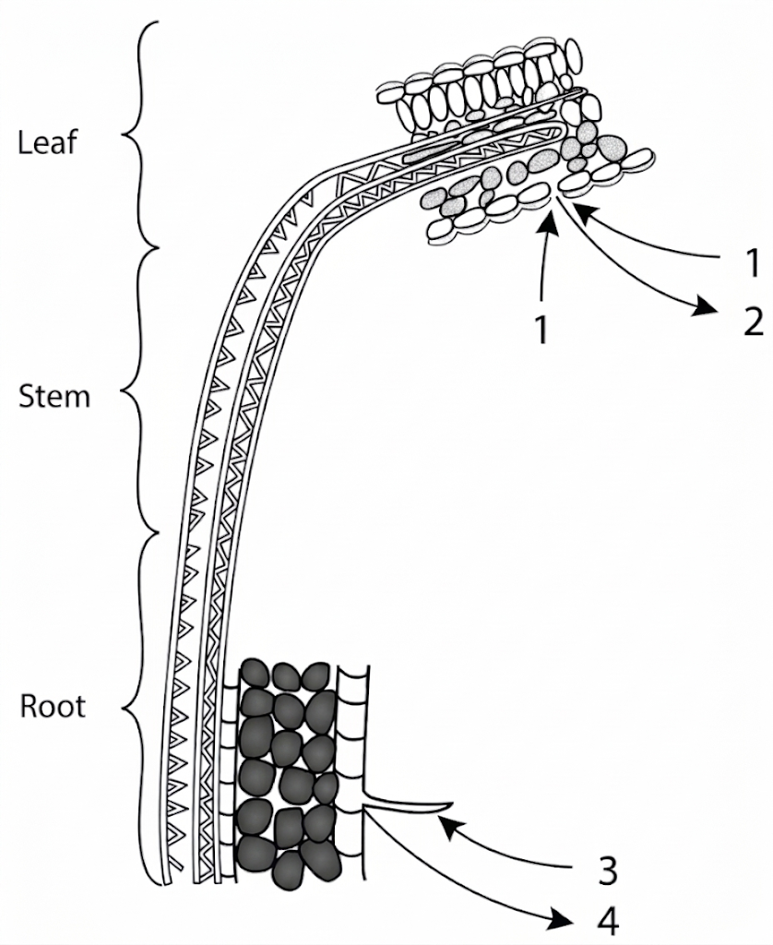
12. At noon, when the light intensity and the temperature are both very high, through which labelled pathways will gas exchange be affected?
A. 1 only
B. 2 only
C. 3 only
D. 1 and 2 only
13. A water plant is sealed in a tube of distilled water and left outdoors for 24 hours. The pH of the water is measured through the day and the night. Which result is the most likely?
A. The pH is lowest just before sunrise.
B. The pH is highest just before sunrise.
C. The pH is lowest at midday.
D. The pH is lowest just before sunset.
Questions 14 and 15 refer to the graph below.

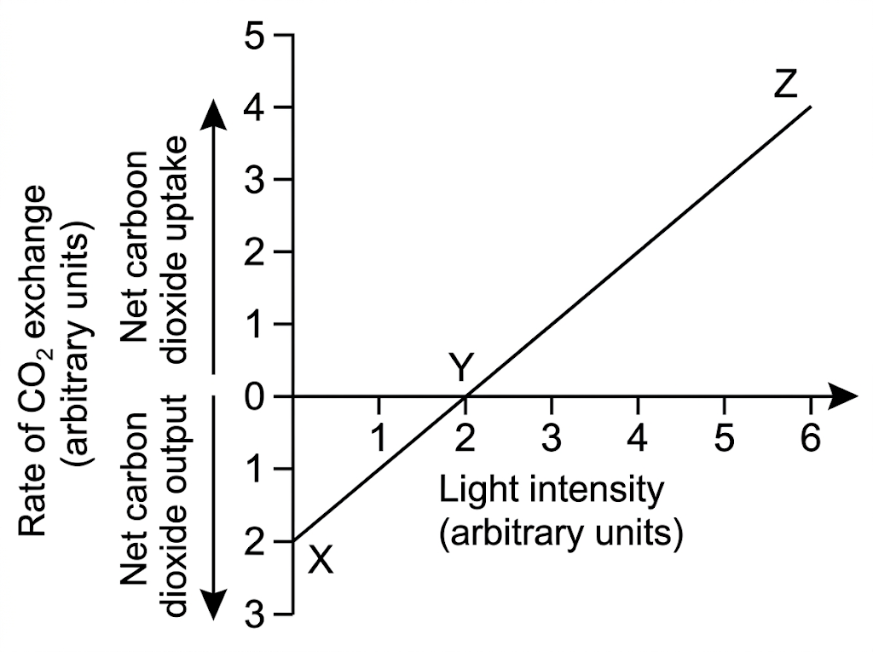
14. What is the rate of respiration, in carbon dioxide units, at X?
A. 1
B. 2
C. 3
D. 4
15. How many units of carbon dioxide are fixed in photosynthesis when the light intensity is 4 units?
A. 1
B. 2
C. 3
D. 4
Questions 16 and 17 refer to the diagram below. At the start, the hydrogencarbonate indicator in every tube is red.
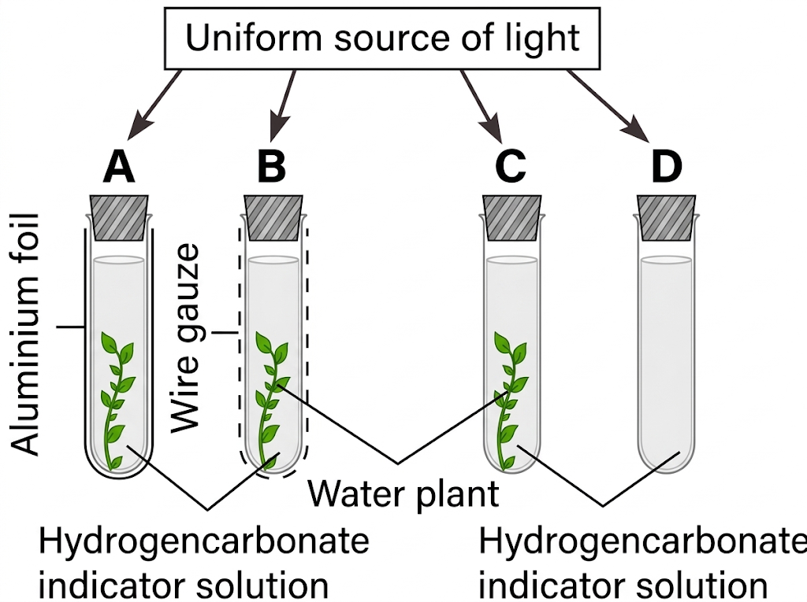
Colour of the indicator
Carbon dioxide concentration | Colour
Less than 0.03% | Purple
0.03% | Red
More than 0.03% | Yellow

16. Which statement about the tubes in the light is correct?
A. In tube A the photosynthetic rate is higher than the respiratory rate.
B. In tube B the respiratory rate and the photosynthetic rate are roughly the same.
C. In tube C the photosynthetic rate is lower than the respiratory rate.
D. In tube D the photosynthetic rate and the respiratory rate are roughly the same.
17. Equal masses of midge larvae are then put into each tube, and all four tubes are kept in darkness. Which row shows the final colour of the indicator?
A. Tube A yellow, tube B red, tube C purple, tube D red.
B. Tube A yellow, tube B red, tube C purple, tube D purple.
C. Tube A yellow, tube B yellow, tube C yellow, tube D yellow.
D. Tube A red, tube B purple, tube C purple, tube D red.
Answers
The keyed option is printed in red on the questions. A percentage is given only where the original class or exam key is unchanged. Corrected items, and the two graph readings, have no percentage. Grey notes are for the teacher.
1. B class 64.9% n=205 slip D Glucose from photosynthesis can be changed into lipid for storage. Chlorophyll is not a raw material that is used up. Usual slip D. Class 64.9% (n=205). The same stem is also on the photosynthesis quiz.
2. D class 70% n=10 slip A Enzymes are proteins. The plant needs nitrate, and a carbon skeleton from glucose. Leaves do not absorb nitrogen gas. Usual slip A. Class 70% (n=10). Also on the photosynthesis quiz. Small n.
3. D class 70% n=10 slip A Carbohydrates and lipids do not contain nitrogen. Proteins do, and enzymes are proteins. Usual slip A. Class 70% (n=10). Also on the photosynthesis quiz. Small n.
4. D class 60% n=10 slip B Air supplies oxygen to the roots. Renewing the solution replaces minerals the seedling has used. Black paper stops algae using those minerals. Usual slip B. Class 60% (n=10).
5. B class 78.5% n=205 slip A The black cover is on the culture jar, not on the shoot. It is not a destarching treatment. Usual slip A. Class 78.5% (n=205).
6. C class 60.5% n=205 slip D Roots need oxygen for respiration. The air does not feed them nitrogen or carbon dioxide, and it does not force water in. Usual slip D. Class 60.5% (n=205).
7. D class 66.8% n=205 slip B Magnesium is used to make chlorophyll. Without it the leaves yellow and growth is poor. Failure to form roots is not the magnesium symptom. Usual slip B. Class 66.8% (n=205).
8. C class 58.5% n=205 slip B The form absorbed is nitrate or ammonium, not nitrogen gas. Usual slip B. Class 58.5% (n=205). Kept as mineral nutrition. The nitrogen-cycle item (nitrifying bacteria) was removed.
9. B corrected; do not quote 71.4% Organic fertiliser must be decomposed before its minerals can be absorbed. It does improve texture, and it releases minerals slowly. The printed key treated “stay longer” as the untrue statement. Do not quote 71.4%.
10. A exam 68.9% n=151 slip D Xylem carries water. It is not an adaptation for gas exchange. The water film, the air spaces and the thin leaf are. Usual slip D. Exam 2526 F3 final, 68.9% (n=151). Kept because the demand is gas exchange.
11. D class 49.2% n=130 slip B Gas exchange continues by day and by night, over the whole plant. Statements (1) and (2) are the incorrect ones. Usual slip B. Class 49.2% (n=130).
12. D class 77.7% n=130 slip C Pathways 1 and 2 are the leaf pathways. At noon, high light and high temperature close the stomata, so those pathways are affected. Pathway 3 is at the root. Usual slip C. Class 77.7% (n=130).
13. A corrected; do not quote 67.7% Overnight respiration adds carbon dioxide, so the water is most acidic just before sunrise. Through the day, photosynthesis removes carbon dioxide and the pH rises. The printed key said the pH is lowest just before sunset. Do not quote 67.7%.
14. B graph reading; percentage not recovered At X the light intensity is zero, so there is no photosynthesis. The net output of 2 units is the rate of respiration. The class answer line for this graph was glued to another stem, so no percentage is quoted. The reading follows the graph.
15. D graph reading; percentage not recovered At 4 units of light the graph shows a net uptake of 2 units. Respiration is still 2 units, so the carbon dioxide fixed is 4 units. No percentage is quoted, for the same reason as question 14. The option 2 is the net reading only.
16. D class 75.9% n=58 slip B Tube D has no plant, so both rates are zero and they are equal. Tube A is in the dark. Tubes B and C are in the light, so photosynthesis is faster than respiration there. Usual slip B. Class 75.9% (n=58).
17. C class 63.8% n=58 slip A In darkness every tube has respiring larvae, and the plants respire as well. Carbon dioxide rises in all four tubes, so the indicator turns yellow. Usual slip A. Class 63.8% (n=58).
Left out of this practice
Removed: every difficult extra; the nitrifying-bacteria item and the nodule item (nitrogen cycle); the warning about too much fertiliser drawing water out of the roots (transport in plants). Two items at 80% stay omitted: chemical fertiliser is not a pesticide, and the colour-change table for tubes W, X and Y. The leaf-disc dry-mass items were not used. Their printed answer line was unusable, so no percentage could be kept. Do not name RuBP, rubisco or GP. Do not use NaHCO₃, NaCl or CaCO₃ as option names.
Q | Key | Source
1 | B | class 64.9% n=205 slip D
2 | D | class 70% n=10 slip A
3 | D | class 70% n=10 slip A
4 | D | class 60% n=10 slip B
5 | B | class 78.5% n=205 slip A
6 | C | class 60.5% n=205 slip D
7 | D | class 66.8% n=205 slip B
8 | C | class 58.5% n=205 slip B
9 | B | corrected; do not quote 71.4%
10 | A | exam 68.9% n=151 slip D
11 | D | class 49.2% n=130 slip B
12 | D | class 77.7% n=130 slip C
13 | A | corrected; do not quote 67.7%
14 | B | graph reading; percentage not recovered
15 | D | graph reading; percentage not recovered
16 | D | class 75.9% n=58 slip B
17 | C | class 63.8% n=58 slip A

