246COM Computer simulation

Individual Project

Student: U Siu Ki (57170430)

File Link: <https://github.com/HKEdwardU/246COM>

This report will describe and interpret the findings from using Simul8 to simulate the Hong Kong Bank's services and abstract the possible problems in the scenario. First, to accurately analyze and find out usable data, a basic model for the bank's services has been made and shown in this flow chart and the model in Simul8:

Then, with this model, we can start the simulation and get graphs and critical data:

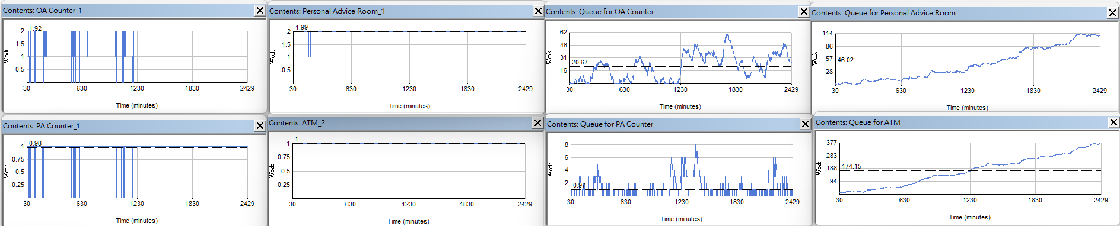

The graphs show that all the services are full of people queuing and staff are working nonstop, showing that the current design has various issues like hours of waiting for many services in the high season periods and overworked staff. For example, for the average queuing time of different services, the queue for OAC is 66.17 minutes, the queue for PA is 340.87 minutes, and the queue for ATM is 591.36 minutes. It means that customers need hours of staying to get their money and all the staff cannot rest until their lunch or tea break. It degrades the bank's service quality, customer satisfaction, and staff healthiness.

For this situation, the main objective of this simulation is to lower the waiting time to less than 30 mins for any customer that visits the cashier services. Meanwhile, improve the queuing problem in other services like personal advice and ATMs. To test the effect of different designs, the Key Performance Indicators (KPI) are the maximum waiting time of the queue of the Ordinary and Premier Account counter (OAC & PAC), the average value of the waiting time of the queue of the ATM user, the maximum waiting time of the queue of the Personal Adviser, and the utilization of all staffs. In this original configuration, The numbers of those KPIs are 162.49 minutes for the maximum queuing time of OAC, 46.08 minutes for the maximum queuing time of PAC, 591.36 minutes for the average Queuing Time of ATM, 714.23 minutes for the maximum Queuing Time of PA, 90.02% of Cashiers, 82% for the personal advisors. Most of those data are recorded when the bank is in the high season period. With all those data and the basic model, many alternative designs can be made to find the best possible result with the lowest cost increasing. There are two alternative scenarios. One is to build all possibles installation, including one OA counter, one personal advice room, and one ATM. The second option is only building one new personal advice room and one ATM; the last option is to increase the facilities to over the given possibility, with one more personal advisor, one extra OA counter, and two more ATMs. It is to try if there is a way to keep most of the improvement and use lower cost.

First, there are the graphs for the first alternative systems:

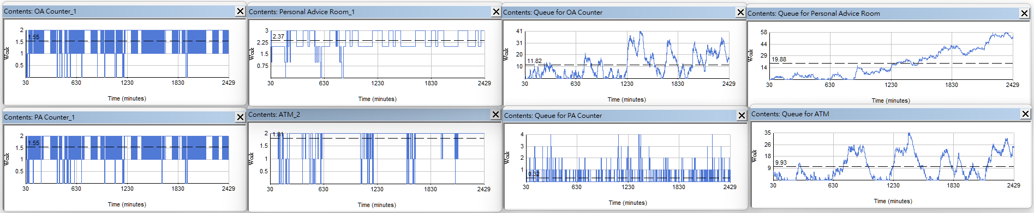

As we can see from the data from the graphs, the queuing situation is hugely eased, and the working pressure is much lower than in the original configuration. The KPI in this simulation also proves this appearance, 110.6 minutes for the maximum queuing time of OAC, 16.1 minutes for the maximum queuing time of PAC, 63.28 minutes for the average Queuing Time of ATM, 182.5 minutes for the maximum Queuing Time of PA, 96.33% for the utilization of the Cashiers, 99.62% for the personal advisors. All those numbers decreased, and the queuing time of PAC met the requirement of lower than 30 minutes. In the meantime, the queuing time of the personal advisors and ATMs also hugely decreased by 46.46% and 89.3%. Hughly solve the crowded problem in every banking service.

On the other hand, there are graphs for the second scenario:

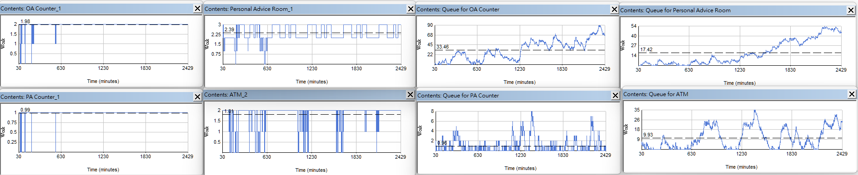

In this circumstance, fewer people queue for the PA and the ATM, just like in the last scenarios, but the counter number is the same as in the original situation, causing the queue of the PAC and OAC to increase. The KPI in this method is 238.33 minutes for the maximum queuing time for the OAC, 42.51 minutes for the maximum queuing time for the PAC, 172.05 minutes for the average queuing time, 63.28 minutes for the average queuing time, 91.52% for the utilization of the cashier, and 99.85% for the utilization of the personal advisors. Most of those queuing times are decreased, but the OAC and PAC queuing times are increased to more than 30 minutes. It will fail to meet the requirement and is not recommended to use.

In the last situation, this is the graph for it:

Without the limit of the possibility, the bank can increase the facilities as much as needed to fit the postulate. The KPI in the approach is 122.6 minutes for the maximum queuing time for the OAC, 42.37 minutes for the maximum queuing time for the PAC, 179.59 minutes for the average queuing time of the personal advisors, 1.61 minutes for the average queuing time of the ATM, 96.71% for the utilization of the cashier, and 99.85% for the utilization of the personal advisors. With this simulation, the need to make the waiting time of ATMs become less than 15 minutes and also decrease the waiting time of the personal advisor room. Although this option is out of the customer's funding, it is one of the few ways to deliver most requirements with the lowest cost.

For the recommendation to fulfil all the customer's requirements, all the options still need to be improved. For example, increase the cashier's number to five people. Also, the advisor may need to increase to five people. At least the number of ATMs has to increase to four systems. With all these upgrades, the queuing problem will be solved.

To handle the difference between the high and low seasons, there is a timetable to arrange each personal advisor's and cashier's tea time and lunchtime. The personal advisors will have their first tea time between 09:45 to 10:30. After that. There will be two advisors to have their lunch break between 10:30 to 12:30. To service the wave of customers; no advisors are on break during the high season from 12:30 to 14:15. Then, the last advisor with have his lunch break from 14:15 to 15:15, and let one of the advisors to have his second tea time at 15:15. Than all of the advisors will be at the bank in the second high season in 15:30 - 16:15. After that, the last two advisors will have their second tea time at 16:15 - 16:45.

For the timetable of the cashier, all of them will get their first tea time at 09:00 - 10:00. Then three of them will get their lunchtime one by one at 10:00 -13:00. After the high season between 13:00 - 14:15, the last cashier will get his lunchtime at 14:15 - 15:15. And one of the cashiers will get his second tea time at 15:15- 15:30. After the second high season at 15:30 - 16:15. All of the cashiers can get their tea time between 16:15 - 17:00.

After that, three of the possible problems that may meet in this improvement need to be considered. First, with this amount of upgrades, the workforce and computer system costs can be very high, and the time needed to recover the cost can be very long. The bank may need to collect enough funding before continuing the improvement plan. Also, with many new pieces of equipment, there may need more space to place all those items. They should be considered moving to a bigger office for further business operations. Lastly, the bank may need help with educating the new staff. They need to be taught by the manager to familiarise themselves with his position; before the completion, they may not serve the customer the best they can.

In conclusion, the possibility provided by the branch manager is hard to fulfil his requirements of lower all of the queuing issue.

(word:1312 words)