http://blog.trustgo.com/k-9-mail-client-is-vulnerable-to-privacy-leak/

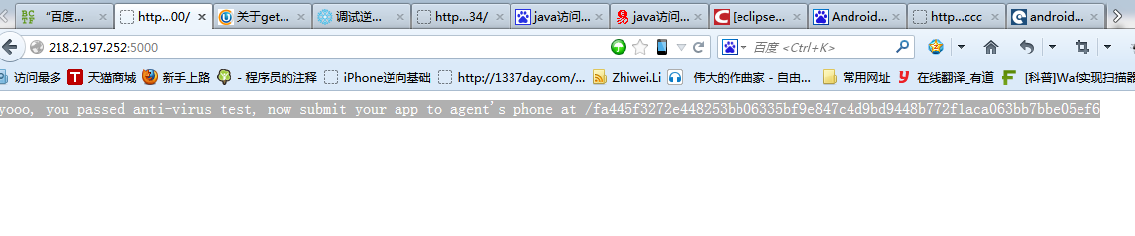

yooo, you passed anti-virus test, now submit your app to agent's phone at /fa445f3272e448253bb06335bf9e847c4d9bd9448b772f1aca063bb7bbe05ef6

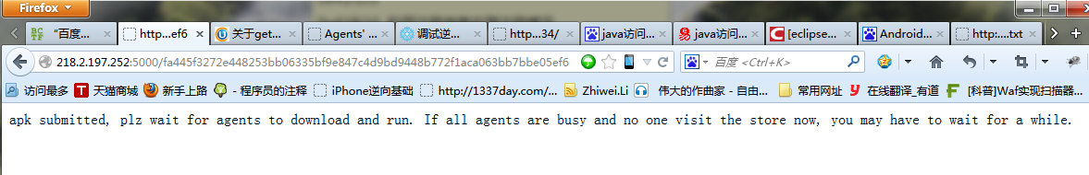

apk submitted, plz wait for agents to download and run. If all agents are busy and no one visit the store now, you may have to wait for a while.

