Engineering Notes No. 4.1

## INFORMATION

**NAME:** William Reimer

**DATE:** 10/29/24 – 11/04/24

**Sprint:** 4

## JIRA BACKLOG

**Responsible for:**

* ERPOLYV39: Complete Sections 2.1-2.3 of SRS document

**Contributed to:**

* Miscellaneous trouble shooting of PolyVerif (elaborated on in notes)

## RESOURCES & DOCUMENTS CONTRIBUTED TO

***Table 1 - Contributions***

|  |  |  |  |
| --- | --- | --- | --- |
| **Date** | **Resource/Document** | **Location** | **Contribution Description** |
| 11/04/24 | EPOLYV-39 | N/A | I completed Sections 2.1-2.3 of the SRS document. |
|  |  |  |  |

## COMPONENTS TESTED

***Table 2 - Testing***

|  |  |  |  |
| --- | --- | --- | --- |
| **Date Tested** | **Component** | **Result** | **Comments** |
| 10/29/24 | Scenario creation and testing are postponed due to issues with running PolyVerif. | After uninstalling and reinstalling PolyVerif, Docker, and Drivers, PolyVerif still will not run | N/A |
|  |  |  |  |

## PROBLEMS SOLVED

***Table 3 - Solutions***

|  |  |  |
| --- | --- | --- |
| **Date** | **Problem** | **Solution & Notes** |
| 10/29 | PolyVerif is not starting | After several attempts of troubleshooting, uninstalling and reinstalling docker and nvidia drivers, PolyVerif still is not running. Emails will be sent to contributors of PolyVerif in the near future to ask for guidance. |
|  |  |  |

## PROBLEMS TO ADDRESS NEXT

***Table 4 – Future Problems***

|  |  |
| --- | --- |
| **Problem** | **Description** |
| PolyVerif not starting | As previously alluded to, without the ability to successfully run PolyVerif, the tasks we can work on become fairly limited. As a result, our focus has primarily shifted to completing documentation, and reaching out to others to assist with this issue. |
|  |  |

## MEETING NARRATIVE NOTES:

***Table 5 – Meeting 1***

|  |  |  |
| --- | --- | --- |
| **10/29/24** | **Meeting Type:** StandUp/Class/ETC | |
| Met with Product Owner(s): Y/N | | |
| **Problems Brought Up: Assistance with environment creation** | | |
| **Problem** | | **Proposed Solution** |
| No complete comprehensive walkthrough exists on how to create a scenario and/or simulation in PolyVerif. | | Send an email to Acclivis for scene / environment creation.   * Ask the Acclivis guys what their next steps are. |
|  | |  |
|  | |  |
| **Other Items Updated on:** | | |
|  | | |
| **Additional Notes:** | | |
| Meeting took place before noticing that PolyVerif was not starting properly. Priorities shifted heavily after meeting | | |

***Table 6 – Meeting 2***

|  |  |  |
| --- | --- | --- |
| **10/31/24** | **Meeting Type:** StandUp/Class/ETC | |
| Met with Product Owner(s): Y/N | | |
| **Problems Brought Up:** | | |
| **Problem** | | **Proposed Solution** |
| Continued issues with PolyVerif    Possibly an issue with our computer, currently investigating issues | | Reached out to Kunal, Quentin, Akbas for PolyVerif guidance. |
|  | |  |
|  | |  |
| **Other Items Updated on:** | | |
|  | | |
| **Additional Notes:** | | |
|  | | |

## NOTES:

* Create Scrum Backlog
* Complete the System Requirement Specification.
* Send an email to Acclivis for scene / environment creation.
  + Ask the Acclivis guys what their next steps are.
* Create a guide for environment creation.
* Create a simple scenario that can simulated, log and display the results.
* Scenarios: (0) stop at red light or  (1) run a red light.
* Improve efficiency of simulation, discussing noise.
* Autoware is looking to implement and merge with PolyVerif.
* Sections for SRS were assigned
  + Section 1 -> Isabella & Hannah
  + Section 2 -> William & Isabella
  + Section 3 -> Hannah, Isabella, and Davian
  + Section 4 -> Davian
  + Section 5 -> Davian
  + Section 6 -> Serena
  + Section 7 -> Serena
  + Section 8 -> Davian & Isabella
  + Hannah and Serena will do diagrams
* Get recording of simulation
* Polyverif stopped working on tuesday, had to revert to Ubuntu 20.02
* Docker and Nvidia Drivers were reinstalled <- Jackson Baker came to save our butts
  + Docker is giving us errors.

Check Python subrelease (3.8.?). Sometimes default packages for a python subrelease introduce breaking changes even in the same minor version (I.e. 3.8.1 vs 3.8.2)

Micaplex Meeting

Continued issues with PolyVerif

Possibly an issue with our computer, currently investigating issues

LGSVL -> Error

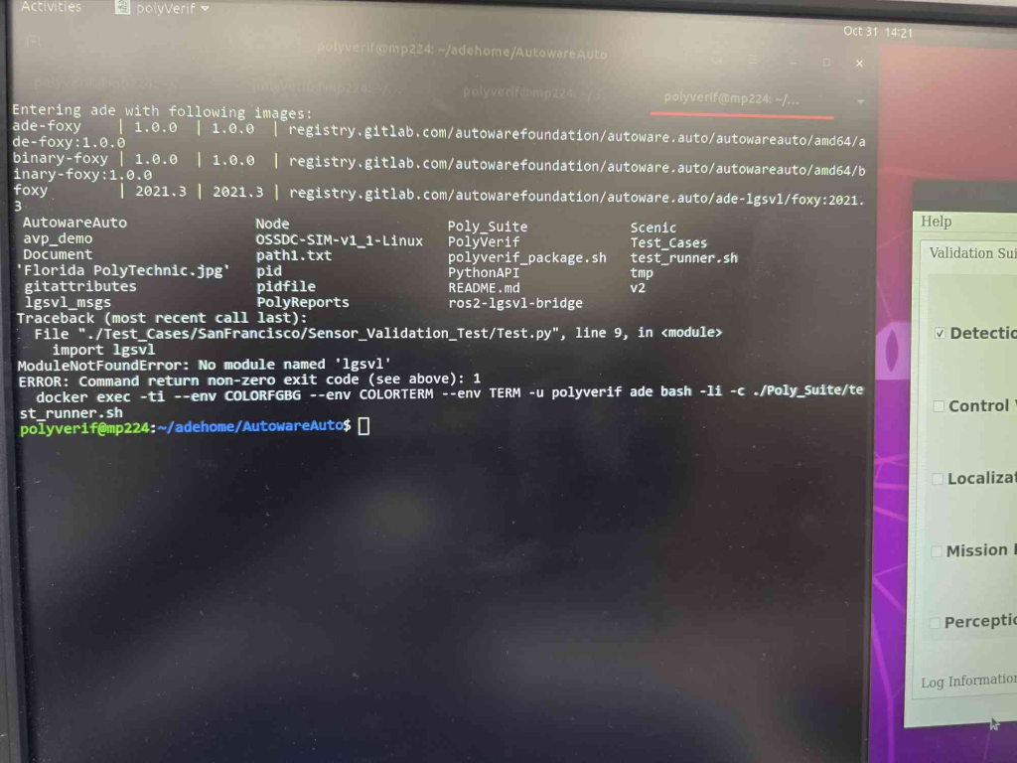

No longer having NVIDIA Docker 2 issues on Ubuntu 20.04.

Computer uses NVIDIA Quadro RTX5000 graphics card

Confirmed Docker was installed properly

Confirmed NVIDIA-Docker was installed properly

Found CUDA version 12.2

Reached out to Kunal, Quentin, Akbas, Serena/Hannah for PolyVerif guidance.