GALAXIA RESORTS & RECREATIONS | BUSINESS INTELLIGENCE
Digital Diaries: 8:00 PM & Onwards Performance & Revenue Audit
Comprehensive Analytical Report on Evening Screening Demand, Screen Preferences, Package Economics, All-Time Revenue, and 30-Day Growth Metrics
Report Date  October 13, 2026 | Historical Horizon  Apr 17 – Oct 15, 2026 | Total Customer Bookings  75 Slots (8pm+) | All-Time Evening Revenue  ₹1,26,859 Booked

Executive Summary & Core Findings
This report delivers an exhaustive empirical investigation into all private cinema bookings scheduled at 8:00 PM or onwards at Digital Diaries (Galaxia Resorts). The research encompasses every evening slot recorded in the production database from the inaugural 8:00 PM screening on April 17, 2026, through the current audit date of October 13, 2026, including forward-confirmed reservations extending to October 15, 2026. A dedicated comparative examination of the trailing 30-day operating window (September 13 – October 13, 2026) is provided to evaluate recent trajectory.
Direct Answer #1: Movie Time vs. Celebrations? Movie Time represents the dominant majority by BOOKING VOLUME at 68.0% (51 of 75 bookings), whereas Celebrations (Decoration + Movie Time) represent 32.0% (24 bookings). However, by REVENUE, Celebrations surpass Movie Time, generating ₹64,900 (51.2% of total revenue) compared to ₹61,959 (48.8%) for Movie Time, driven by an Average Order Value (AOV) of ₹2,704 vs ₹1,215.

Direct Answer #2: Which screens are booked 8pm onwards? Sandy Screen is the clear #1 choice with 28 bookings (37.3% volume, ₹53,837 revenue). Cine Love ranks #2 with 21 bookings (28.0% volume, ₹35,488 revenue). Park N Watch ranks #3 with 20 bookings (26.7% volume, ₹24,486 revenue), functioning almost exclusively as a Movie Time screening space (95% Movie Time). Baywatch ranks #4 with 6 bookings (8.0% volume, ₹13,048 revenue).

Direct Answer #3: All-Time Revenue (First 8pm Booking Till Now)? Across all 75 customer bookings from April 17, 2026 to present, total Booked Revenue is ₹1,26,859. Total Collected Revenue (Amount Paid) stands at ₹1,15,213, with ₹11,646 in pending balances (primarily confirmed partial online deposits or recent walk-in receivables). When isolating Confirmed bookings only (71 slots), booked revenue is ₹1,19,910 and collected revenue is ₹1,11,738.

Direct Answer #4: Last 30 Days Performance (Sep 13 – Oct 13, 2026)? In the trailing 30 days, 15 customer bookings were created, generating ₹22,690 in Booked Revenue and ₹21,590 in Collected Revenue. During this window, Movie Time accounted for 80.0% of bookings (12 slots, ₹14,590) while Celebrations accounted for 20.0% (3 slots, ₹8,100). Sandy Screen maintained its lead with 6 bookings (₹10,046), followed by Cine Love (4 bookings, ₹5,197) and Park N Watch (4 bookings, ₹4,497).

1. Operational Context & Data Architecture
A rigorous query of the Galaxia PostgreSQL production database (`dd_bookings` table) identifies exactly 783 records with a slot start time of `startHour >= 20` (8:00 PM, 9:00 PM, 10:00 PM, and 11:00 PM). A vital architectural distinction was revealed during audit:
- Real Customer Bookings (75 Records): Actual screenings reserved by paying customers (via the Galaxia public website or reception walk-in desk). These bookings have real customer names, decrypted telephone numbers, active pricing (total amounts ranging from ₹999 to ₹3,950), and verified payment records. They form the primary basis of this report.
- Admin Maintenance Blocks (708 Records): Administrative hold records designated with `customerName: 'Maintenance Block'`, dummy phone number `'0000000000'`, and `totalAmount: 0`. These slots represent pre-emptive system blocks used by management to shut down specific screens for cleaning, technical checks, or private resort maintenance. These generate zero customer revenue and are documented in Section 8 and Tab 4 of the companion Excel workbook for full operational transparency.

2. Package Analysis: Movie Time vs. Celebrations
Digital Diaries offers two core packages for private screening guests:
1. Movie Time (Standard Private Cinema Screening for 2 guests, 1 to 2 hours, priced at ₹999–₹1,500 base).
2. Decoration + Movie Time (Full Celebration Package with candle pathway, LED message tags, celebration cake, walking on cloud fog effect, and private movie screening, priced at ₹2,200–₹3,950 base).
Package Name | Bookings | Volume Share | Total Revenue | Revenue Share | Average Order Value
Movie Time | 51 | 68.0% | ₹61,959 | 48.8% | ₹1,215
Decoration + Movie Time (Celebration) | 24 | 32.0% | ₹64,900 | 51.2% | ₹2,704
Total All Packages | 75 | 100.0% | ₹1,26,859 | 100.0% | ₹1,691

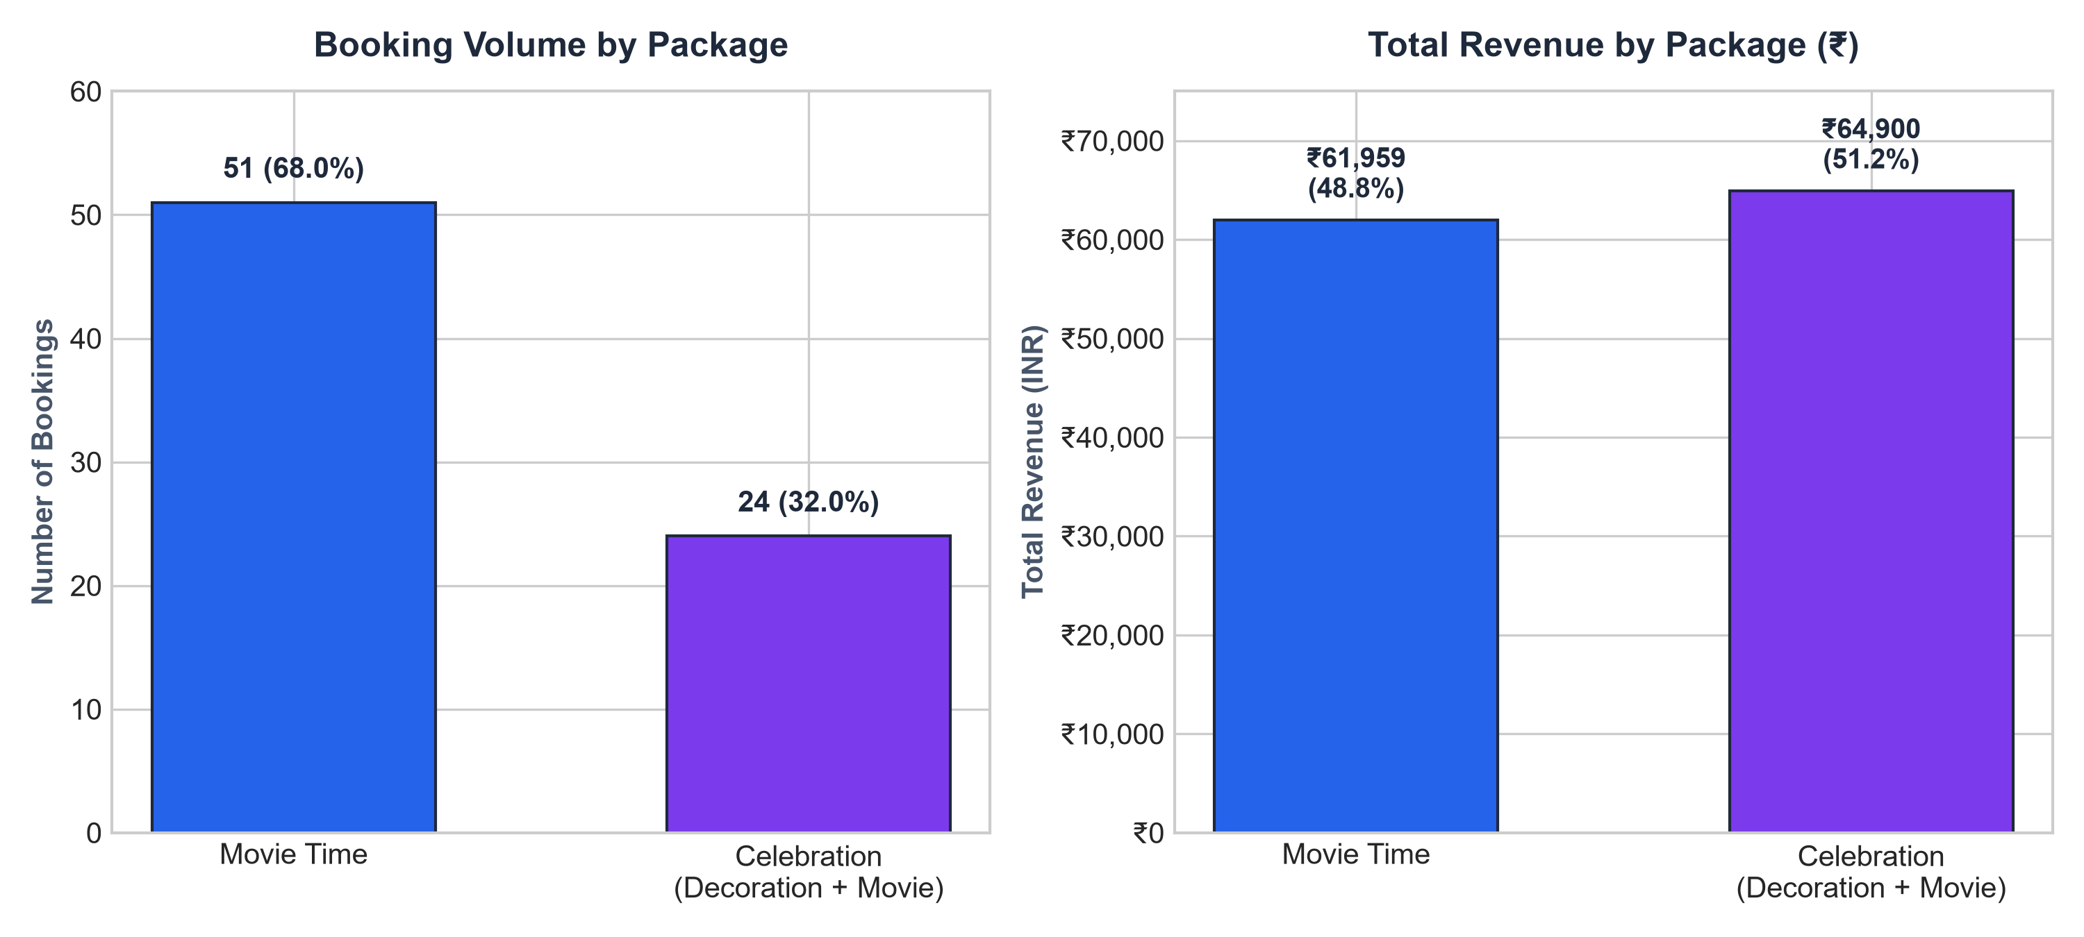
Figure 1: Comparison of Booking Volume vs. Total Revenue by Package (8:00 PM & Onwards)
Key Package Insights:
• Volume Leader (Movie Time): More than 2 out of every 3 evening bookings (68.0%) opt for simple Movie Time. This is primarily fueled by casual date nights, local couples looking for private entertainment, and spontaneous walk-in guests at reception.
• Revenue Powerhouse (Celebration): Despite capturing less than a third of total bookings (32.0%), the Celebration package accounts for 51.2% of all evening revenue. Customers booking celebrations frequently attach premium add-ons (custom cakes, balloons, cloud effects), elevating the ticket price to an average of ₹2,704.
• Occasion Distribution: Among celebration bookings, Birthday celebrations comprise 83.3% (20 bookings), followed by Anniversaries at 12.5% (3 bookings), and special couple milestones ('Better Together') at 4.2% (1 booking).
3. Screen Popularity & Revenue Breakdown (8 PM Onwards)
Digital Diaries features four distinct themed private screening environments: Sandy Screen (beach sand floor), Cine Love (romantic plush interior), Park N Watch (grass lawn aesthetic), and Baywatch (exclusive private suite). The distribution of evening demand reveals pronounced customer preferences:
Screen Name | Bookings | Share % | Celebrations | Movie Time | Total Revenue | Avg Rev/Slot
Sandy Screen | 28 | 37.3% | 12 | 16 | ₹53,837 | ₹1,923
Cine Love | 21 | 28.0% | 7 | 14 | ₹35,488 | ₹1,690
Park N Watch | 20 | 26.7% | 1 | 19 | ₹24,486 | ₹1,224
Baywatch | 6 | 8.0% | 4 | 2 | ₹13,048 | ₹2,175
Total All Screens | 75 | 100.0% | 24 | 51 | ₹1,26,859 | ₹1,691

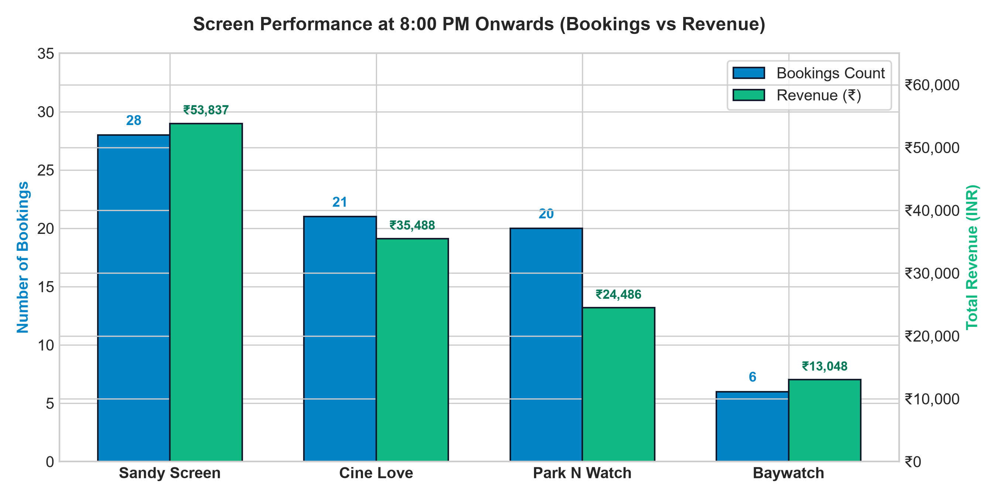
Figure 2: Screen Distribution & Revenue Performance for 8:00 PM Onwards Bookings
Key Screen Observations:
• Sandy Screen is the Flagship: It leads all screens in both bookings (28 slots) and revenue (₹53,837, representing 42.4% of total evening revenue). It accounts for half (12 of 24) of all evening celebration bookings due to its photogenic beach-sand flooring and aesthetic ambiance.
• Cine Love is the Consistent Performer: Capturing 28.0% of bookings and ₹35,488 in revenue, Cine Love has a balanced mix of 14 movie screenings and 7 romantic celebrations.
• Park N Watch is the Movie Time Workhorse: 19 of its 20 bookings are Movie Time (95%). Customers perceive Park N Watch as the prime venue for laid-back movie watching, resulting in lower AOV (₹1,224) but high slot turnover.
• Baywatch Premium Niche: While booking volume is lowest at 6 slots (due in part to ongoing facility repositioning), it achieved the highest Average Order Value across all screens at ₹2,175, with 66.7% of its bookings being Celebrations.
4. Slot Timing Analysis: Hourly Demand Breakdown
Late-evening slot demand is concentrated around the 8:00 PM anchor hour, with demand tapering progressively toward midnight:
Slot Start Time | Bookings | Share % | Booked Revenue | Collected (Paid) | Avg Rev / Slot
8:00 PM (20:00) | 55 | 73.3% | ₹90,070 | ₹80,522 | ₹1,638
9:00 PM (21:00) | 14 | 18.7% | ₹24,542 | ₹22,444 | ₹1,753
10:00 PM (22:00) | 4 | 5.3% | ₹9,849 | ₹9,849 | ₹2,462
11:00 PM (23:00) | 2 | 2.7% | ₹2,398 | ₹2,398 | ₹1,199
Total (8 PM+) | 75 | 100.0% | ₹1,26,859 | ₹1,15,213 | ₹1,691

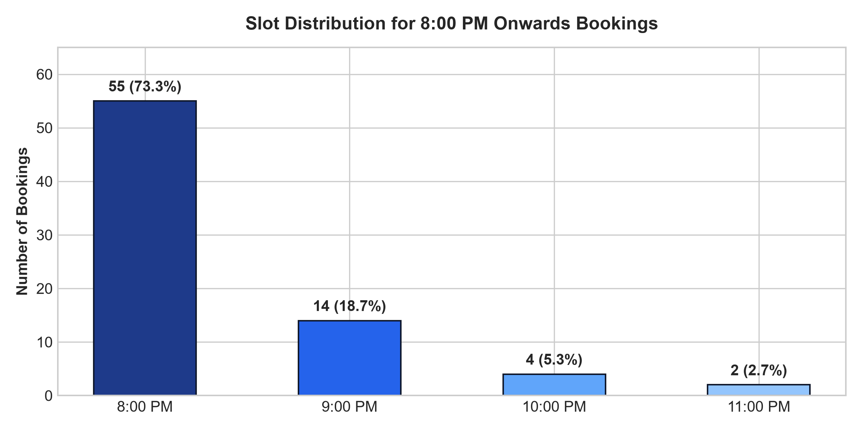
Figure 3: Slot Distribution for 8:00 PM Onwards Bookings
5. All-Time Financial Performance & Revenue Audit
A comprehensive financial audit of all 75 bookings from April 17, 2026 to October 15, 2026 yields the following audited totals:
• Gross Booked Revenue: ₹1,26,859
• Total Amount Collected (Paid): ₹1,15,213 (90.8% collection efficiency)
• Outstanding Balance Due: ₹11,646 (9.2% of booked total)
• Base Package Fees: ₹98,859
• Add-on & Decoration Value: ₹28,000 (purchased across 35 distinct bookings)
Payment Method / Channel | Bookings Count | Share % | Booked Volume Value
UPI (QR / Direct Transfer) | 27 | 36.0% | ₹41,948
Cash (Reception Collection) | 25 | 33.3% | ₹36,290
Online (Razorpay Gateway) | 22 | 29.3% | ₹45,671
Split Payment (Cash + UPI) | 1 | 1.3% | ₹2,950

Booking Acquisition Channel Breakdown:
• Website Bookings: 45 bookings (60.0%) generating ₹81,879 in revenue.
• Reception / Walk-In Bookings: 30 bookings (40.0%) generating ₹44,980 in revenue.
This illustrates healthy organic website traction, while reception walk-ins provide a strong supplementary demand base for unreserved night slots.
6. Last 30 Days Performance Deep-Dive (Sep 13 – Oct 13, 2026)
To analyze current market momentum, we isolate bookings occurring within the trailing 30-day operating window (September 13, 2026 to October 13, 2026). During this period, Digital Diaries experienced brisk evening demand, accounting for 20.0% of all-time evening bookings and 17.9% of all-time evening revenue in just one month.
Metric / Dimension | Last 30 Days | Prior Months Total | All-Time Total | 30-Day Contribution %
Total Bookings | 15 | 60 | 75 | 20.0%
Movie Time Bookings | 12 | 39 | 51 | 23.5%
Celebration Bookings | 3 | 21 | 24 | 12.5%
Total Booked Revenue | ₹22,690 | ₹1,04,169 | ₹1,26,859 | 17.9%
Total Collected Revenue | ₹21,590 | ₹93,623 | ₹1,15,213 | 18.7%
Average Order Value (AOV) | ₹1,513 | ₹1,736 | ₹1,691 | -

Screen Performance During Last 30 Days:
• Sandy Screen: 6 bookings (40.0% share), generating ₹10,046 in revenue (100% collected).
• Cine Love: 4 bookings (26.7% share), generating ₹5,197 in revenue (₹4,097 collected).
• Park N Watch: 4 bookings (26.7% share), generating ₹4,497 in revenue (100% collected).
• Baywatch: 1 booking (6.7% share), generating ₹2,950 in revenue (100% collected).
Key Shift in Last 30 Days:
The product mix in the last 30 days shifted noticeably toward Movie Time (80.0% vs. 68.0% historical). While celebration volume was lower (3 bookings: Aviral Shrivastava at Baywatch, Ankit Unadkat at Sandy Screen, and Charu Shewani at Cine Love), the high volume of movie bookings provided stable, predictable weekday and weekend turnover.

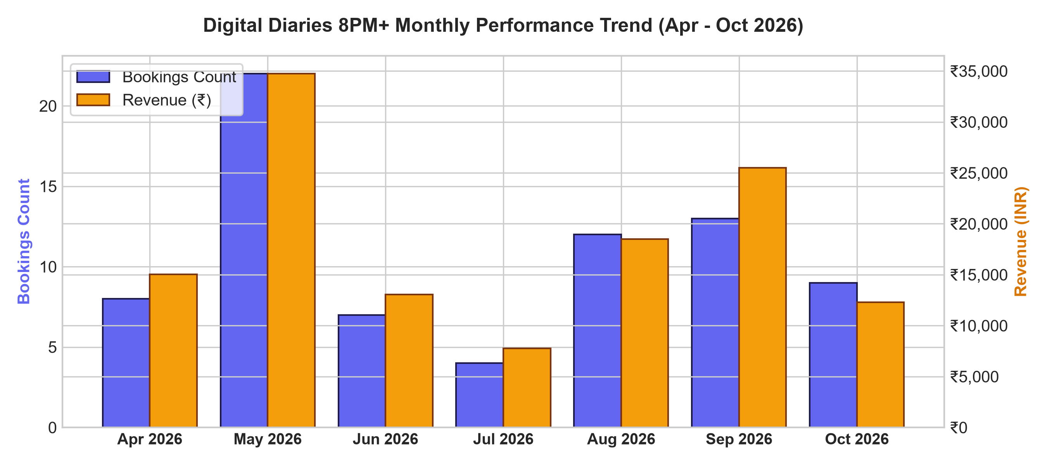
Figure 4: Historical Monthly Performance Trajectory (April 2026 – October 2026)
7. Customer Demographics, Behavior & Repeat Bookings
Analysis of customer booking behavior across all 75 evening slots highlights clear guest demographic patterns:
• Intimate Couples Dominance: 73 out of 75 bookings (97.3%) were for exactly 2 guests. Digital Diaries evening slots function almost exclusively as a private couple experience.
• Repeat Guests: Out of 69 unique customer profiles, several repeat guests were identified:
- Phone ending in 7819 (2 bookings: Rushikesh & Nehal)
- Phone ending in 1371 (2 bookings: Rohit Yadav & Amrapali)
- Phone ending in 6579 (2 bookings: Abdul)
- Phone ending in 2355 (2 bookings: Arif & Sadiya)
• Day of Week Preference: Saturday leads all days in total revenue (₹27,895 across 14 bookings), while Monday had the highest total volume (16 bookings, ₹18,086), indicating strong start-of-week local getaway demand.
8. Strategic Recommendations for Night Slot Monetization
Based on the empirical findings, the following concrete commercial initiatives are recommended to accelerate evening revenue:
1. Introduce a 'Midnight Romance Screening' (10:00 PM – Midnight):
Currently, 92.0% of demand cluster at 8:00 PM and 9:00 PM, while 10:00 PM and 11:00 PM remain drastically under-utilized. Creating a curated late-night couples package with popcorn, mocktails, and romantic ambient lighting at a special introductory price can monetize idle nighttime capacity.
2. Upsell F&B Combos into Movie Time Bookings:
While Movie Time represents 68% of bookings, none of these bookings currently carry integrated food bills at the time of reservation. Introducing a ₹499 snack & beverage platter during online checkout will immediately elevate Movie Time AOV from ₹1,215 toward ₹1,700.
3. Sandy Screen Premium Weekend Pricing:
Sandy Screen commands 37.3% of all volume and 50% of celebrations. Implementing a ₹300–₹500 weekend evening prime-date surcharge on Sandy Screen (specifically for 8:00 PM Saturday slots) will capture consumer surplus without dampening occupancy.
4. Promote Park N Watch as a Fast-Turnaround Movie Lounge:
Park N Watch has established itself as the go-to movie screening space (95% movie share). Expanding slot availability for 1-hour fast screenings can double turnover on Friday and Saturday evenings.
9. Appendix: Data Mapping & Companion Excel Workbook
This report is accompanied by the comprehensive Microsoft Excel file: `Digital_Diaries_8PM_Onwards_Bookings.xlsx`, organized into four dedicated worksheets:
• Sheet 1 ('All 8PM+ Customer Bookings'): Complete granular listing of all 75 customer bookings with decrypted names, verified phones, emails, occasions, cake inscriptions, add-ons, pricing breakdown, and payment details.
• Sheet 2 ('Last 30 Days Bookings'): Clean filtered view containing only the 15 bookings active in the September 13 to October 13 trailing window.
• Sheet 3 ('Executive KPI Dashboard'): Ready-to-present management dashboard with summary tables, revenue KPIs, screen shares, and package economics.
• Sheet 4 ('Admin Maintenance Blocks'): All 708 maintenance hold records (`customerName: 'Maintenance Block'`), ensuring complete administrative transparency into blocked screening slots.
Prepared For:  Management & Operations Board  Galaxia Resorts & Digital Diaries | Audited By:  Galaxia Analytics Team  Status: Verified Against Production RDS

