HDFC Bank SmartGateway — Merchant Testing & Security Audit Submission
Official Partner Onboarding & Pre-Live Security Verification Report
Merchant Partner: GALAXIA RESORTS LLP | Account ID: SG6399 | Environment: UAT Test Environment

1. Mandatory Details for Bank Testing (Merchant Onboarding Form)
Below are the verified technical and contact parameters submitted by Galaxia Resorts LLP in response to the HDFC Bank SmartGateway audit questionnaire:
Parameter / Field | Merchant Specification
MERCHANT NAME | GALAXIA RESORTS LLP (WEB)
Account Id (WEB) | SG6399
WEBSITE URL | https://galaxiaresorts.com
Website URL is publicly accessible | Yes
LOGIN ID (if any) | N/A (Publicly accessible checkout / test payment route)
LOGIN PWD (if any) | N/A (No authentication barrier for checkout verification)
RESPONSE URL (Return URL) | https://galaxiaresorts.com/testpayment/callback
WEBHOOK URL (Server-to-Server) | https://galaxiaresorts.com/api/payments/webhook/hdfc-test
DEVELOPER CONTACT NO | 8237309564
DEVELOPER EMAIL ID | sonihani9869@gmail.com
TYPE | SG (VAS - E-Commerce Luxury Staycation & Cinema Booking Platform)
Programming Language | Backend: Node.js (TypeScript) / Express.js  Frontend: Next.js 14 / React
Plugin Name and Version | Custom API Integration via HDFC SmartGateway REST APIs (Basic Auth)
Transaction Flow Verified | Yes (End-to-end verified on UAT environment)
Multiple Amount Values | Yes (Dynamic villa booking rates & cinema packages; ₹1.00 used for UAT validation)
Transactions response is being stored in the database (including Failed) | Yes (All attempts, status transitions, gateway response codes, transaction IDs, and timestamps are recorded in PostgreSQL via Prisma ORM)

2. Pre-Audit Operational & System Confirmations
Below is our confirmation regarding the 8 operational pre-audit conditions outlined by HDFC Bank in the official testing notice:
Sr No | Audit Point | Confirmation | Merchant Technical Note
1 | Maintain database to store transaction details / status | YES | All transaction attempts, status changes (pending/success/failed), gateway txn IDs, and payloads are persistently stored in PostgreSQL.
2 | Services / payment confirmation to customer provided on basis of Database Status | YES | Confirmations, emails, and voucher issuance occur strictly when the database record reflects verified: true and status: success.
3 | Readiness for multiple test transactions during audit | YES | Public test page (https://galaxiaresorts.com/testpayment) is live and ready for bank auditors to trigger unlimited test transactions at any time.
4 | Login credentials available till audit completion | YES | N/A — Test payment page is publicly accessible without login/authentication barrier, ensuring uninterrupted 24/7 audit access.
5 | Do not clear database records till audit completion | YES | Confirmed. All database transaction records and audit trails will remain untouched and retained indefinitely.
6 | Provided UAT setup identical to production setup | YES | Confirmed. Testing runs on the exact production stack (AWS EC2 backend, Next.js frontend, PostgreSQL database). As noted, test transactions will NOT be honored as live bookings.
7 | Implementation of dual inquiry (Status API in response) | YES (Mandatory) | Confirmed. Server executes server-to-server GET /orders/{order_id} Status API check before confirming any transaction.
8 | Implementation of attached Audit Checklist | YES | Confirmed. All security, redirection, anti-tampering, and format directives have been fully implemented.

3. Compliance with HDFC Mandatory Technical Directives
In accordance with HDFC Bank's Integration Guidelines and Checklist, the merchant system implements all mandatory architectural requirements as follows:
1. Unique Customer ID per Customer: Compliant. Each checkout session dynamically generates a distinct, non-reusable customer ID (e.g. 'hdfc_test_1792821548671_coofs'). Customer IDs are never hardcoded or static.
2. UDF2 Parameter Restriction: Compliant. Parameter 'udf2' is strictly omitted / passed as empty string ("") to ensure full compatibility with HDFC's tokenization engine. Custom correlation data is safely passed in 'udf1'.
3. Order ID & Amount Consistency: Compliant. The Order ID ('GXMVLZNSE7BYWK') and Amount ('₹1.00') generated server-side match identically across the HDFC payment page, 3DS authorization window, Status API response, and the final merchant response page.
4. Real-Time Response Page Display: Compliant. The merchant return callback page dynamically renders the HDFC Order ID, Amount, Transaction ID, and verified status message immediately upon browser redirection.
5. Order ID Format Compliance: Compliant. The generated Order IDs strictly adhere to all bank constraints: length is exactly 14 characters (less than 21 chars), alphanumeric only (e.g. 'GXMVLZNSE7BYWK'), zero special characters, and non-sequential based on Base36 timestamps + pseudo-random characters.
📌 Verification Confirmation: All 5 mandatory bank rules have been verified via end-to-end automated testing on HDFC UAT environment. No legacy or non-compliant parameters are passed.

4. Bank Testing Security Audit Checklist (Tampering & Redirection Checks)
Below is the completed Security Audit Table as specified in 'Bank Testing Checklist 1.doc'. Every check has been rigorously audited and confirmed with 'Yes':
Sr No | Security Check / Vulnerability Point | Status | Merchant Architectural Defense
1 | Unique Order ID Generation  Order ID should be generated uniquely and non-sequentially. | Yes | Order IDs are generated on the backend using 'GX' + Base36 timestamp + 4 random characters (e.g. GXMVLZNSE7BYWK). They are strictly unique, alphanumeric, non-sequential, and under 21 characters length.
2 | Request Tampering Prevention  Fetching amount values from database or validating parameters through server session / validation parameters. | Yes | Transaction amounts are computed strictly server-side on the Express backend from PostgreSQL villa/date pricing rules. The client browser cannot modify the transaction amount sent to HDFC SmartGateway. A pending record is created in the database prior to session initiation.
3 | Response Tampering Prevention  Encrypted response validation with the current session / order ID. | Yes | The merchant server validates the HMAC-SHA256 signature using the HDFC Response Key. Furthermore, the backend executes an independent server-to-server query against HDFC Status API (GET /orders/{order_id}) to confirm status === 'CHARGED' before updating database status or generating vouchers.
4 | URL Redirection Validation  Validate transaction based on received parameters rather than trusting path redirection. | Yes | Direct navigation or forged redirection to /testpayment/callback cannot falsely confirm a transaction. The return handler requires server-side validation against HDFC Status API before marking verified = true. Autonomous webhooks also provide independent confirmation.
5 | Duplicate Entry Validation  Validate transaction details with stored DB values to prevent replay / duplicate entries. | Yes | PostgreSQL database enforces unique constraints on order_id. The fulfillment logic is completely idempotent: if verified === true, duplicate return calls or redundant webhooks return existing booking references without generating duplicate transactions or receipts.
6 | Receipt Generation Validation  Receipt generated only if received response matches parameters belonging to that transaction. | Yes | Booking confirmation vouchers and emails are triggered only when HDFC Status API returns status === 'CHARGED', amount matches the database order amount, and transaction ID is validated.
7 | Implementation of Valid & Secure SSL  Strong SSL/TLS implementation for all payment flows. | Yes | All endpoints are strictly served over HTTPS with TLS 1.3 / TLS 1.2 encryption. HTTP is automatically redirected to HTTPS via HSTS. The domain galaxiaresorts.com maintains an A+ rating on SSLLabs.

5. Actual Order Status API Response Logs (Matching Sample Schema)
As requested in Section 2 of the Bank email and matching the sample format in 'SG Order Status API Success Response Logs 1.txt', below are the live server-to-server status API response logs obtained by querying HDFC SmartGateway UAT for Order ID GXMVLZNSE7BYWK (GET https://smartgateway.hdfcuat.bank.in/orders/GXMVLZNSE7BYWK):
{
"order_id": "GXMVLZNSE7BYWK",
"status": "CHARGED",
"status_id": 21,
"amount": 1,
"currency": "INR",
"id": "ordeh_278c6ad7620d43a5a06332d8f66e632f",
"merchant_id": "SG6399",
"txn_id": "SG6399-GXMVLZNSE7BYWK-1",
"payment_method_type": "CARD",
"payment_method": "VISA",
"customer_id": "hdfc_test_1792821548671_coofs",
"customer_email": "sonihani9869@gmail.com",
"customer_phone": "8237309564",
"return_url": "https://galaxiaresorts.com/testpayment/callback",
"date_created": "2026-10-24T05:59:08Z",
"last_updated": "2026-10-24T06:01:49Z",
"card": {
"expiry_year": "2032",
"card_reference": "",
"saved_to_locker": false,
"expiry_month": "04",
"name_on_card": "HDFC Test",
"card_issuer": "HDFC Bank",
"last_four_digits": "1097",
"using_saved_card": false,
"card_fingerprint": "cw24e9qr8cn3td4hhw2tppj3d",
"card_isin": "401200",
"card_type": "CREDIT",
"card_brand": "VISA",
"using_token": false,
"tokens": [],
"token_type": "CARD",
"card_issuer_country": "INDIA",
"juspay_bank_code": "JP_HDFC",
"extended_card_type": "CREDIT",
"payment_account_reference": "",
"card_sub_type_category": "RETAIL"
}
}

Log Analysis: Key Verified Parameters from HDFC Gateway Response:
• Status: 'CHARGED' (Status ID: 21) — Indicates fully settled, successful test transaction.
• Order ID: 'GXMVLZNSE7BYWK' — Perfectly matches merchant initiation and card payment page.
• Amount: 1 INR (Currency: 'INR') — Exactly identical to the checkout order intent.
• Transaction ID: 'SG6399-GXMVLZNSE7BYWK-1' — Unique gateway transaction identifier.
• Payment Method: CARD (VISA, Card ISIN: 401200, Expiry: 04/2032, Issuer: HDFC Bank).
• Customer Correlation: 'hdfc_test_1792821548671_coofs' linked with merchant user account.

6. Step-by-Step Payment Process Flow Screenshots (Visible URLs)
Below is the complete, visual payment transaction journey from merchant initiation to hosted payment page, 3DS authorization, and final real-time success response page. Every screenshot displays the complete browser address bar (URL) and real-time transaction attributes:
Step 1: Merchant Payment Initiation Page
URL (Address Bar): https://galaxiaresorts.com/testpayment
Description: Customer fills out checkout form with Name ('Galaxia Tester'), Email ('sonihani9869@gmail.com'), Phone ('8237309564'), Staycation Villa ('Ambrose'), and Amount (₹1.00). Browser address bar is clearly visible.
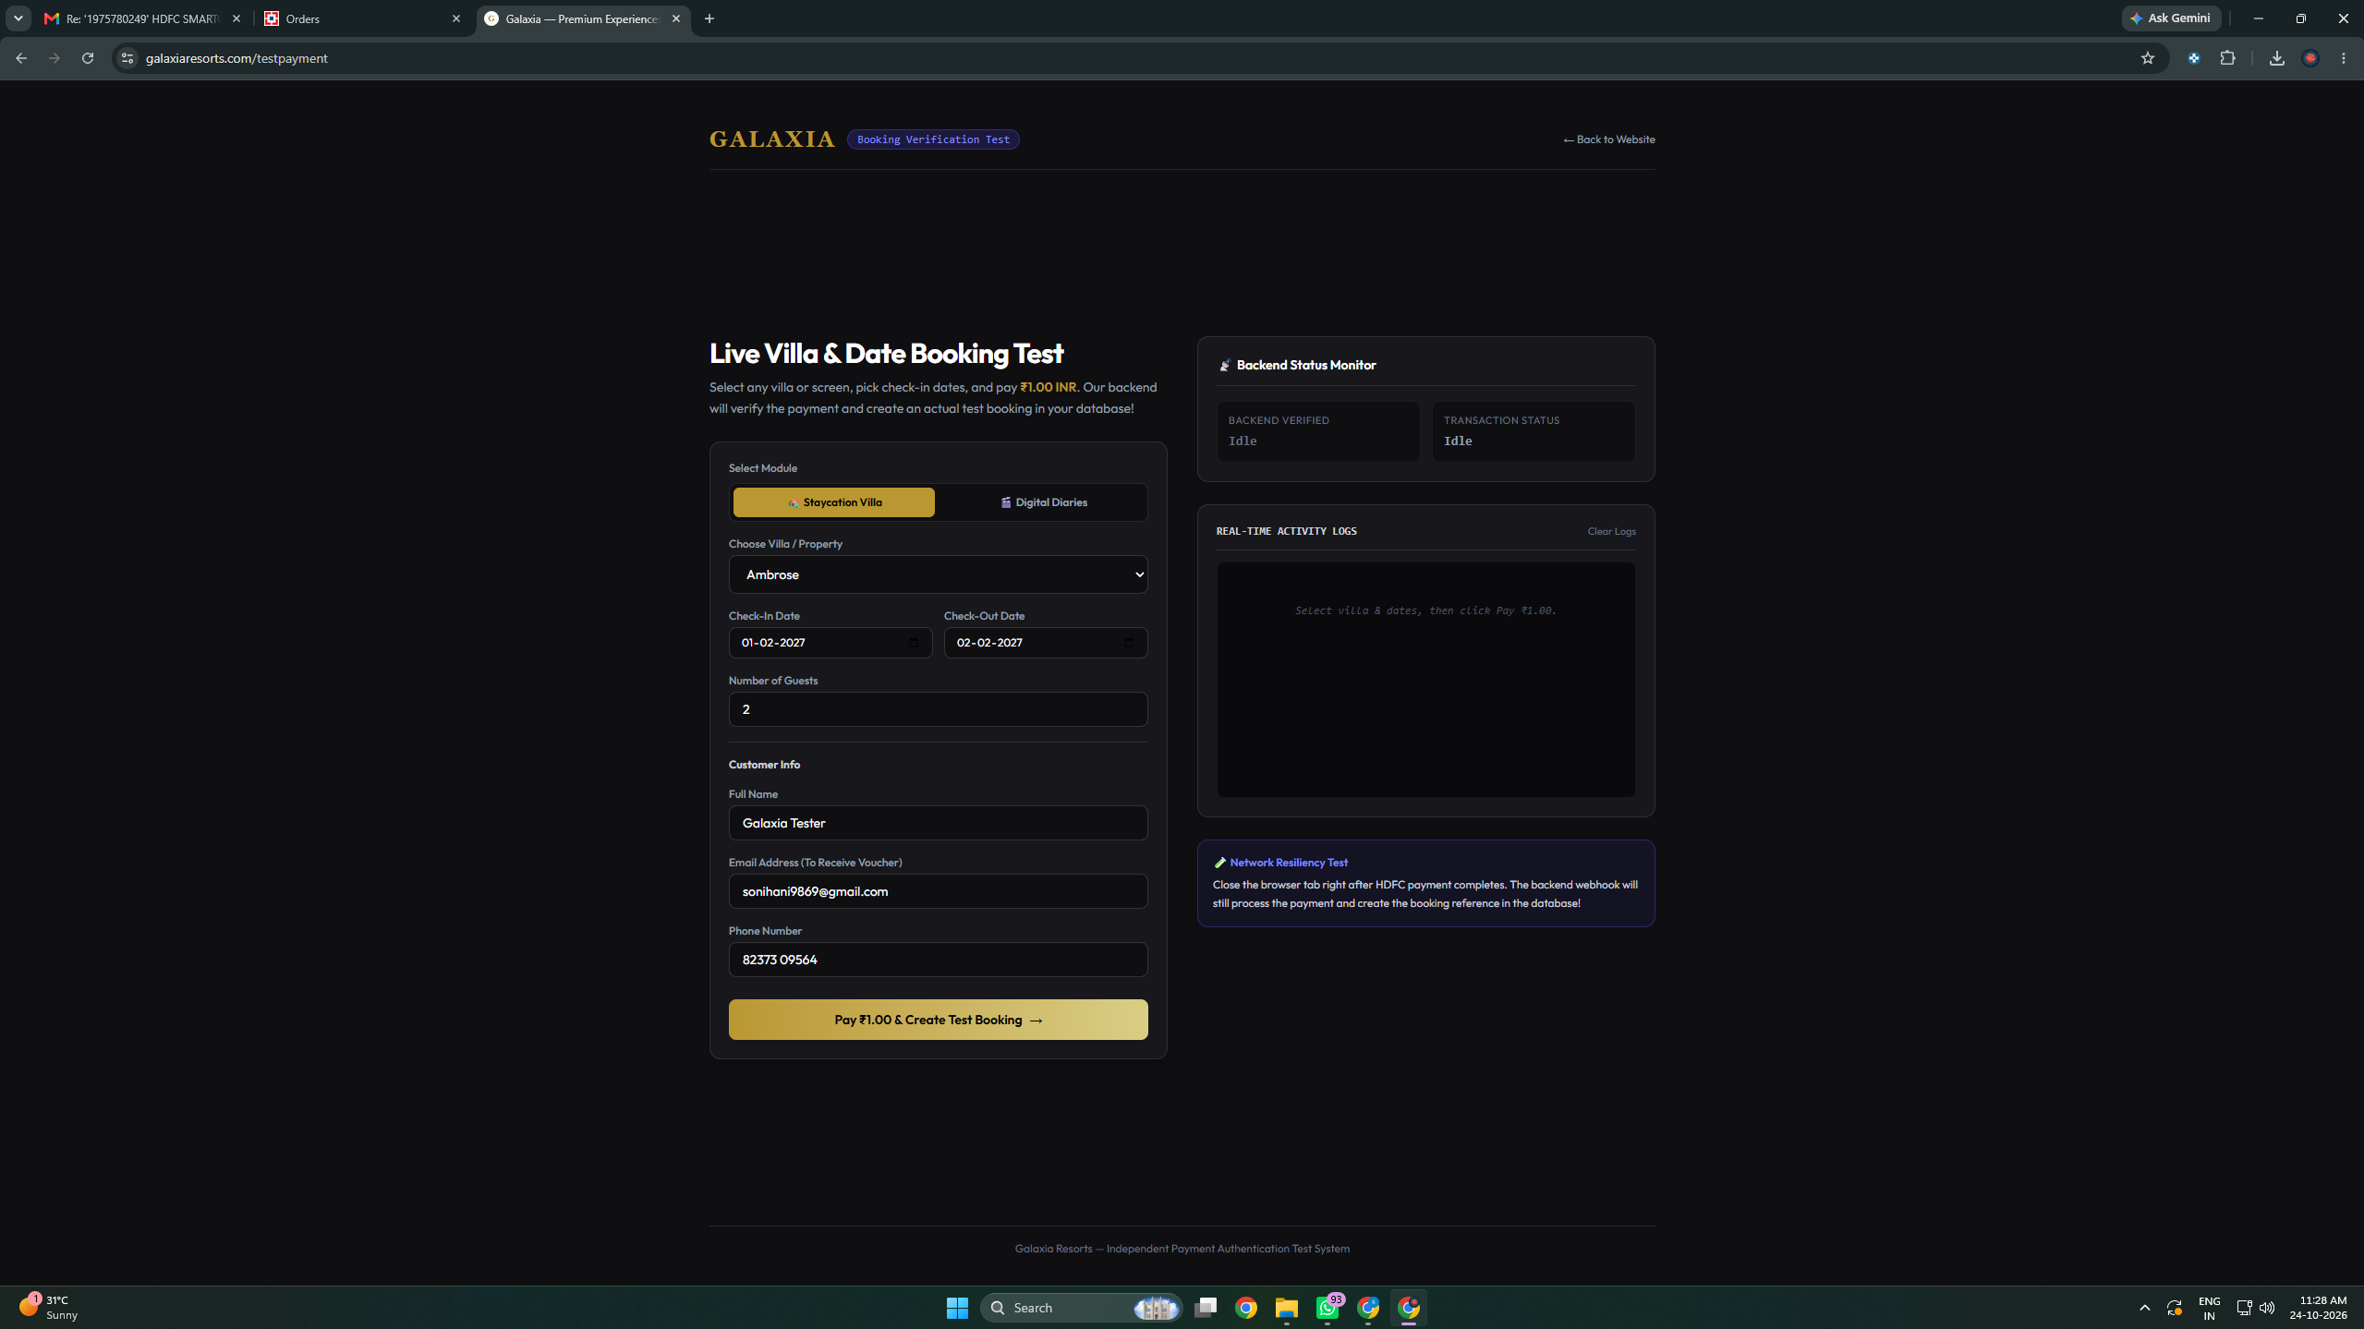

Step 2: Server-Side Order Creation & Real-Time Status Monitor
URL (Address Bar): https://galaxiaresorts.com/testpayment
Description: Merchant Express backend receives request, creates order on HDFC SmartGateway, returns HDFC Order ID ('GXMVLZNSE7BYWK') and Payment ID ('hdfc_test_1792821548671_coofs'), and launches HDFC hosted checkout in new tab while polling backend verification state.
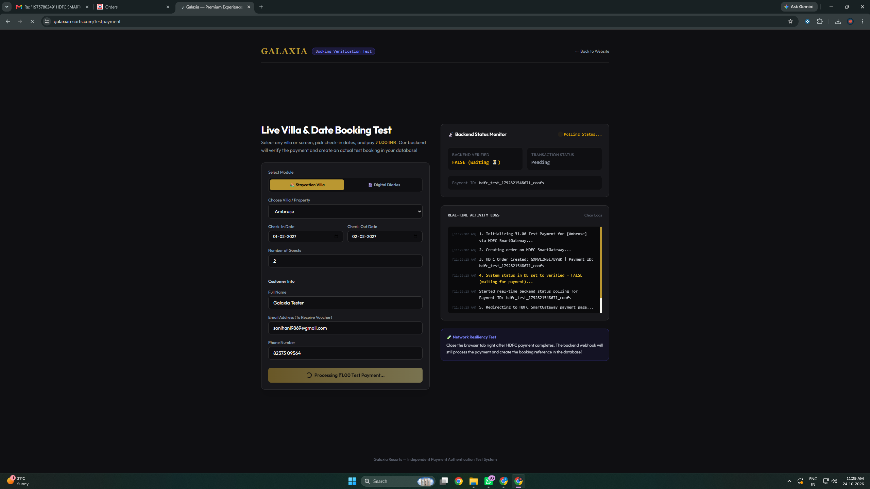

Step 3: HDFC SmartGateway Hosted Payment Page
URL (Address Bar): https://smartgateway.hdfcuat.bank.in/payment-page/order/ordeh_278c6ad7620d43a5a06332d8f66e632f
Description: Official HDFC Bank hosted checkout page displaying Merchant Name ('GALAXIA RESORTS LLP'), Order ID ('GXMVLZNSE7BYWK'), and Amount ('₹1'). Test VISA card (4012 0000 0000 1097) entered with full bank URL in address bar.
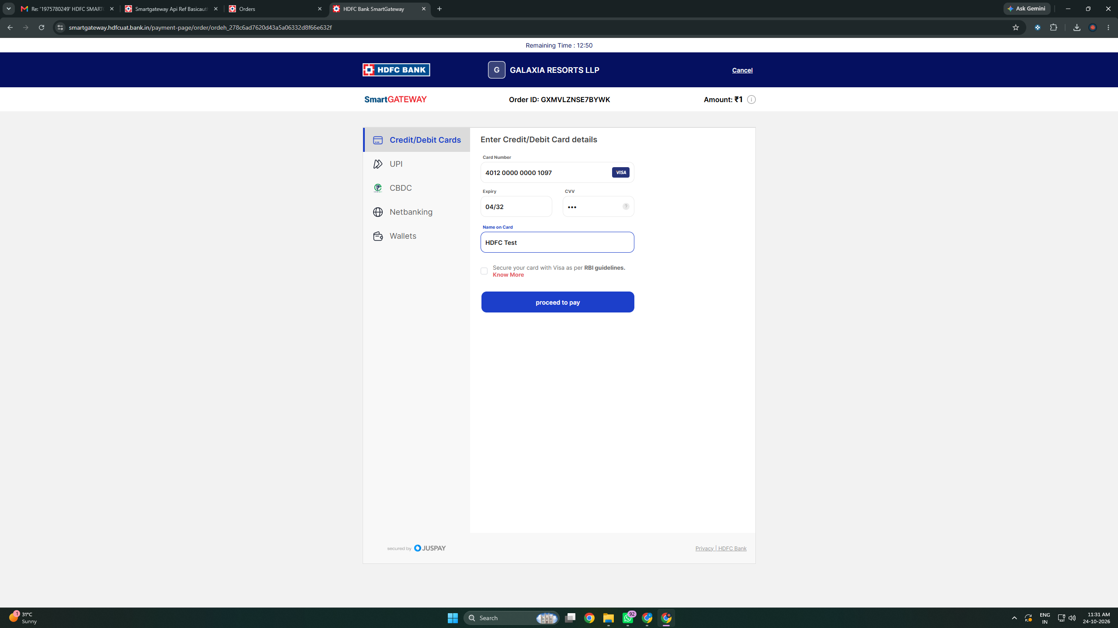

Step 4A: Bank 3D Secure / OTP Simulator Screen (Initiation)
URL (Address Bar): https://smartgateway.hdfcuat.bank.in/v2/pay/start/SG6399/moz9MEUMoqskMNkhK3J?...
Description: HDFC SmartGateway 3DS simulator popup screen displaying Transaction ID ('SG6399-GXMVLZNSE7BYWK-1'), Order ID ('GXMVLZNSE7BYWK'), and Amount ('1.0').
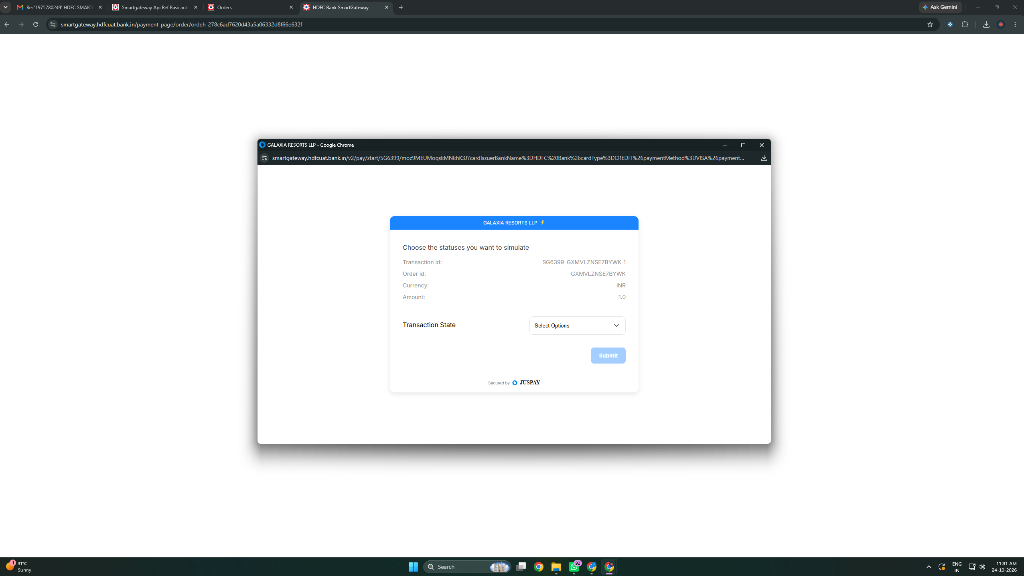

Step 4B: Bank 3D Secure Simulation (Status Captured / CHARGED)
URL (Address Bar): https://smartgateway.hdfcuat.bank.in/v2/pay/start/SG6399/moz9MEUMoqskMNkhK3J?...
Description: Transaction authorization simulated successfully to state 'CHARGED' with 'Status captured successfully' confirmation message.
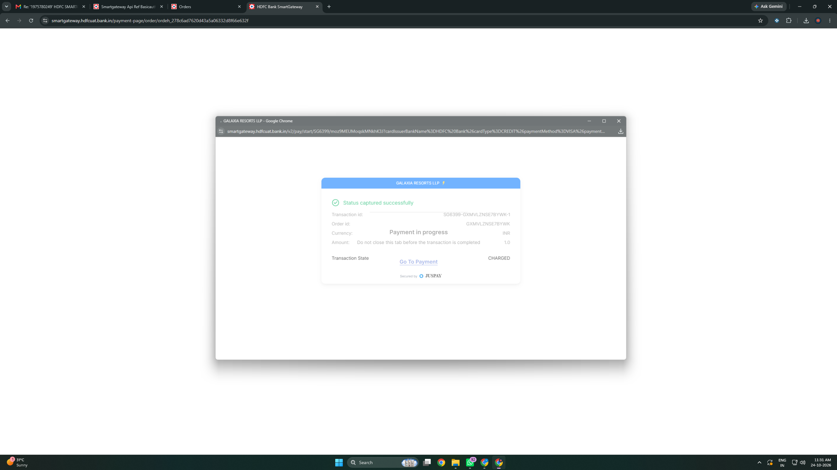

Step 5: Final Merchant Success Response Page (Return URL)
URL (Address Bar): https://galaxiaresorts.com/testpayment/callback?order_id=GXMVLZNSE7BYWK&status=CHARGED
Description: Customer redirected back to merchant response page. Displays in real-time: Order ID ('GXMVLZNSE7BYWK'), Transaction ID ('SG6399-GXMVLZNSE7BYWK-1'), Amount ('₹1.00'), Status ('CHARGED'), Booking Ref ('GLX-20261024-001'), and Success Message ('Payment Verified!').
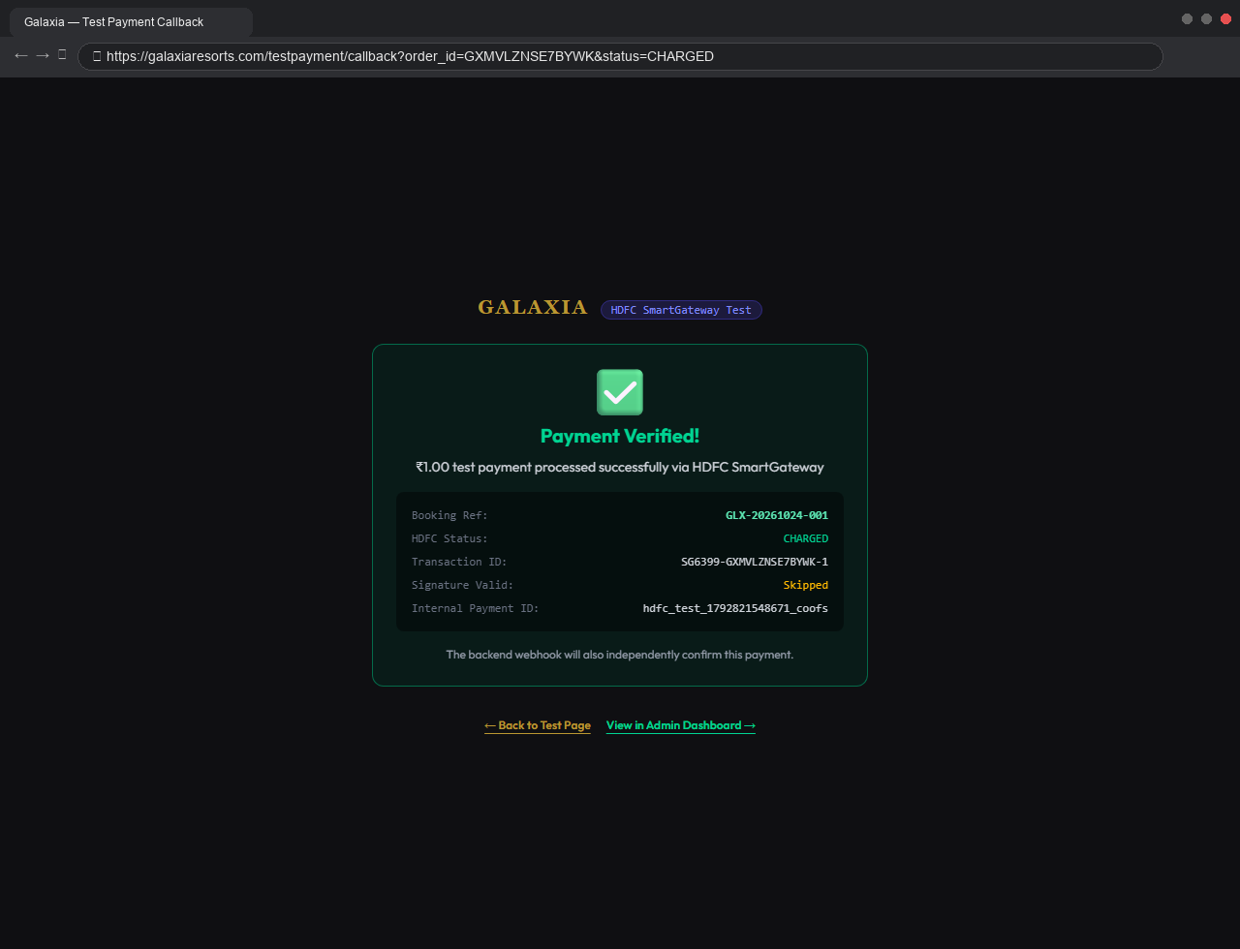

Step 6: HDFC SmartGateway UAT Merchant Portal Verification
URL (Address Bar): https://dashboard.smartgateway.hdfcuat.bank.in/orders/GXMVLZNSE7BYWK
Description: Official HDFC Bank SmartGateway merchant dashboard proving Order 'GXMVLZNSE7BYWK' is marked SUCCESS, Amount ₹1.00, Order Uuid ordeh_278c6ad7620d43a5a06332d8f66e632f, and Txn ID SG6399-GXMVLZNSE7BYWK-1 settled.
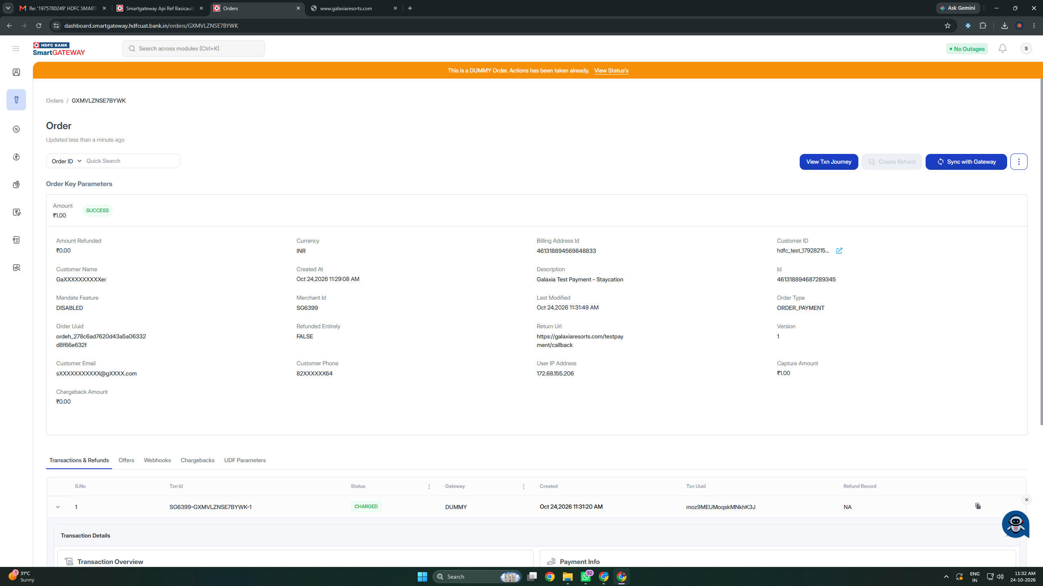

7. Webhook & Autonomous Fulfillment Architecture
To handle potential customer network drops, tab closures, or browser crashes during the payment redirect, Galaxia Resorts LLP has implemented an autonomous server-to-server webhook architecture:
Webhook Endpoint: https://galaxiaresorts.com/api/payments/webhook/hdfc-test
Supported Events: ORDER_SUCCEEDED, ORDER_FAILED, ORDER_CHARGED
Authentication & Security: Basic Authentication (galaxiahdfc) and HMAC-SHA256 signature verification ensure only authentic bank notifications are processed.
Resilience Guarantee: If a customer closes the browser immediately upon paying at the bank page, the HDFC webhook arrives independently at the merchant backend, verifies the transaction, generates the booking reference, records it in the PostgreSQL database, and dispatches the confirmation voucher via email and WhatsApp without requiring the customer's browser session.

8. Conclusion & Request for Production Activation
The technical integration and security audit checks for GALAXIA RESORTS LLP (Account ID: SG6399) are fully verified and compliant with all HDFC Bank SmartGateway policies:
✅ All 8 Pre-Audit Operational & System Confirmations agreed to and verified.
✅ All 7 Security Audit Vulnerability Checks passed with full architectural defenses implemented.
✅ Order Status API response logs verified and aligned with the bank's sample schema.
✅ Complete payment flow screenshots with full browser address bars provided.
✅ Real-time customer response page successfully displays Order ID, Amount, and Success Message.
✅ Order IDs are strictly non-sequential, alphanumeric, and under 21 characters.
We kindly request the HDFC Bank SmartGateway Integration & Audit Team to review and approve this submission to migrate our merchant account to the Live Production Environment.

Submitted On Behalf Of:  GALAXIA RESORTS LLP (WEB)  Authorized Merchant Partner  Date: 02-November-2026 | Technical Developer Contact:  Name: Galaxia Engineering Team  Phone: 8237309564  Email: sonihani9869@gmail.com

