

Spark-H Product Sheet

NXROBO(SHENZHEN NXROBO Co., LTD)

Http://www.nxrobo.com

# Product Introduction

The Spark-H robot is developed by NXROBO(SHENZHEN NXROBO Co., LTD), based on openharmony's intelligent robot development practice platform, and its hardware includes advanced equipment commonly used in the field of robotics, such as openharmony development boards, mobile chassis, depth cameras, lidars, robotic arms, Intel NUC, display screens, etc. The platform structure is flexible and expandable, and the required modules can be added and adjusted according to different applications. It supports mobile phones above harmonyos 3.0, which is convenient for the development of learning and course practice.

Intel NUC master controller for mapping, motion control, obstacle avoidance, and artificial intelligence algorithms; The openharmony development board is used to send control instructions to the Intel NUC and communicate with other harmonyos devices, and the development board comes with an NFC module for communicating with the harmonyos mobile terminal and pulling robot control applications, meeting the needs of openharmony system learning and openharmony smart robot development.

**Product Structure**

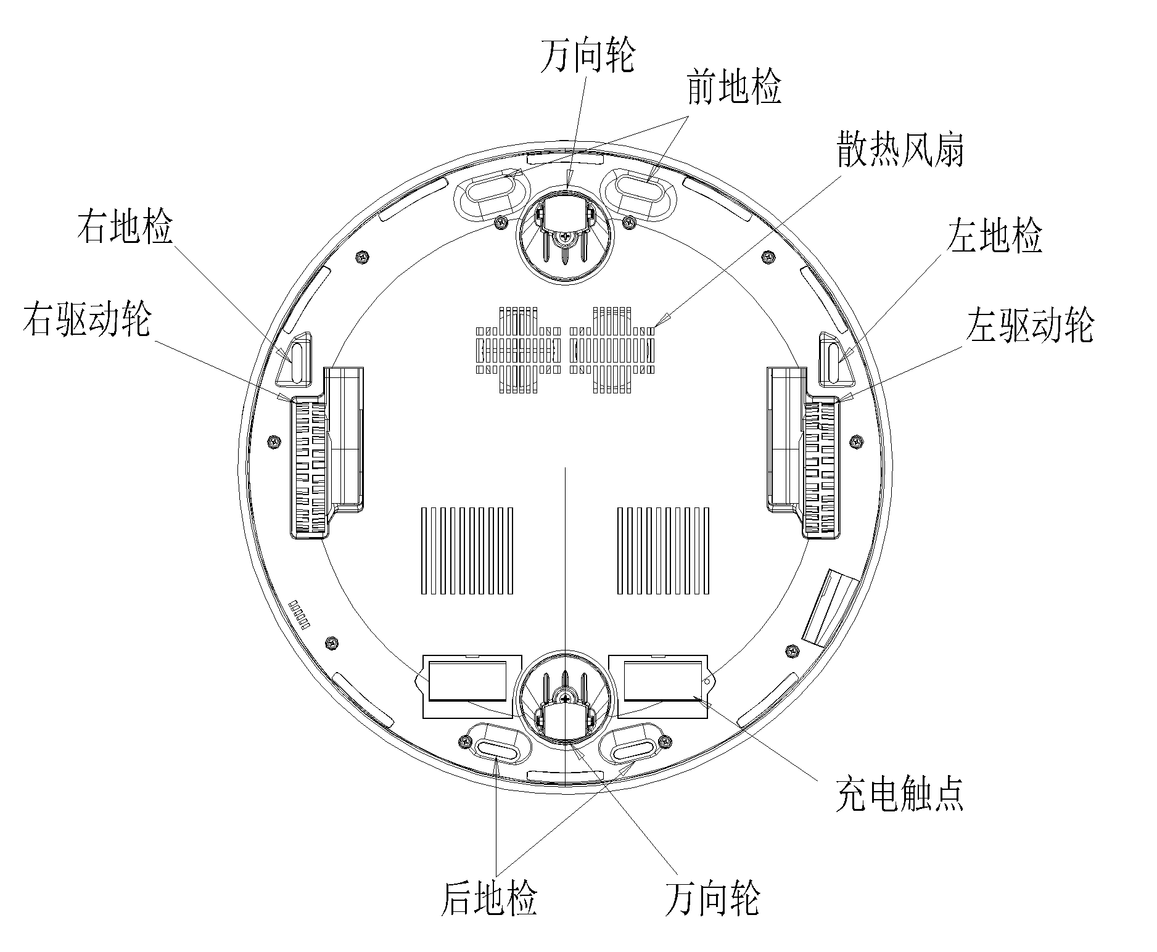

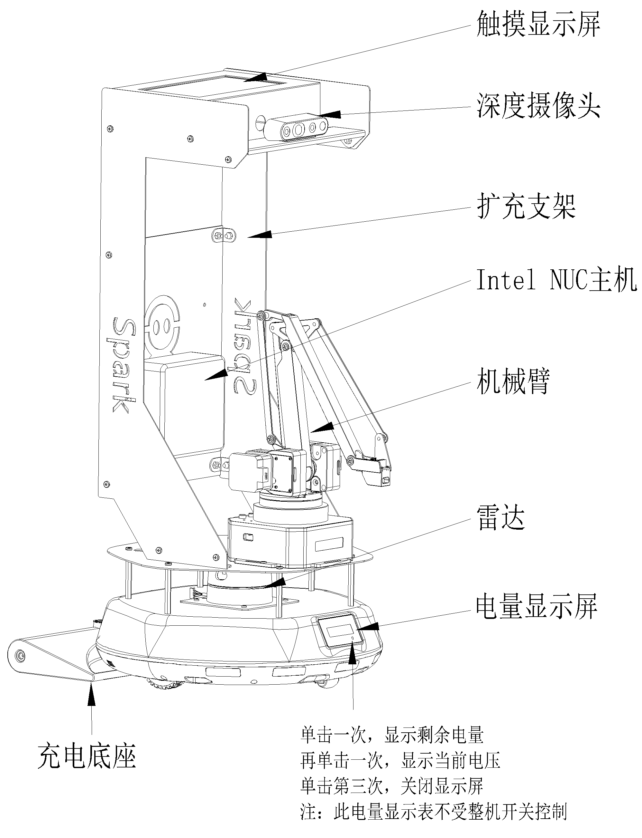

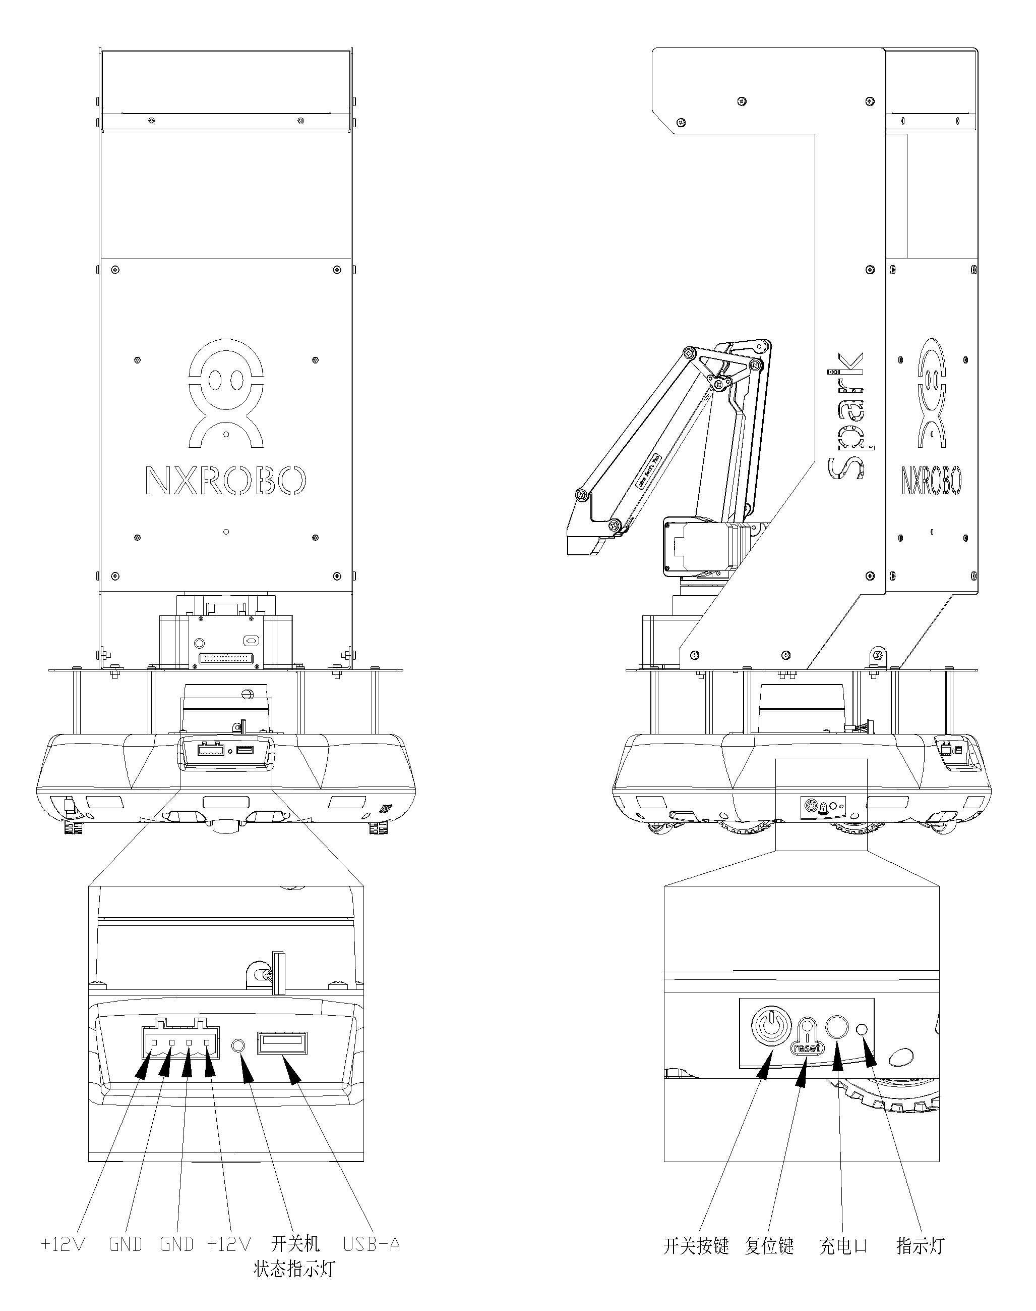

Power on: Click the switch button, the power on and off status indicator will be on, and the SPARK-H will be powered on.

Power off: Press and hold the switch button for 5 seconds, the power on and off status indicator will turn off, and the SPARK-H will power off.

**Fitting installation**

* **Intel NUC installation**

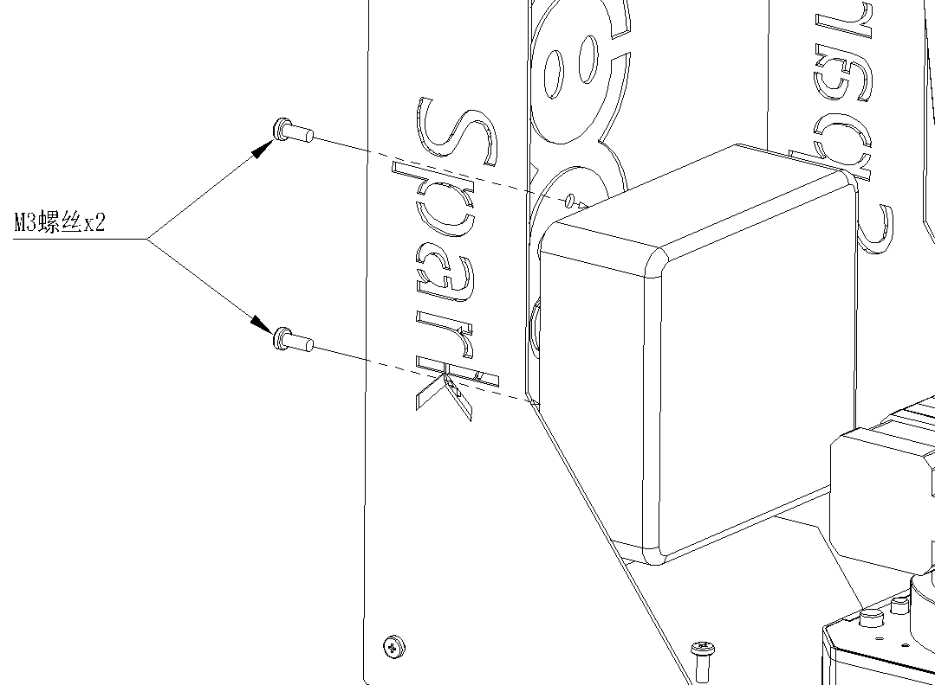

* **Realsense D435 installation**

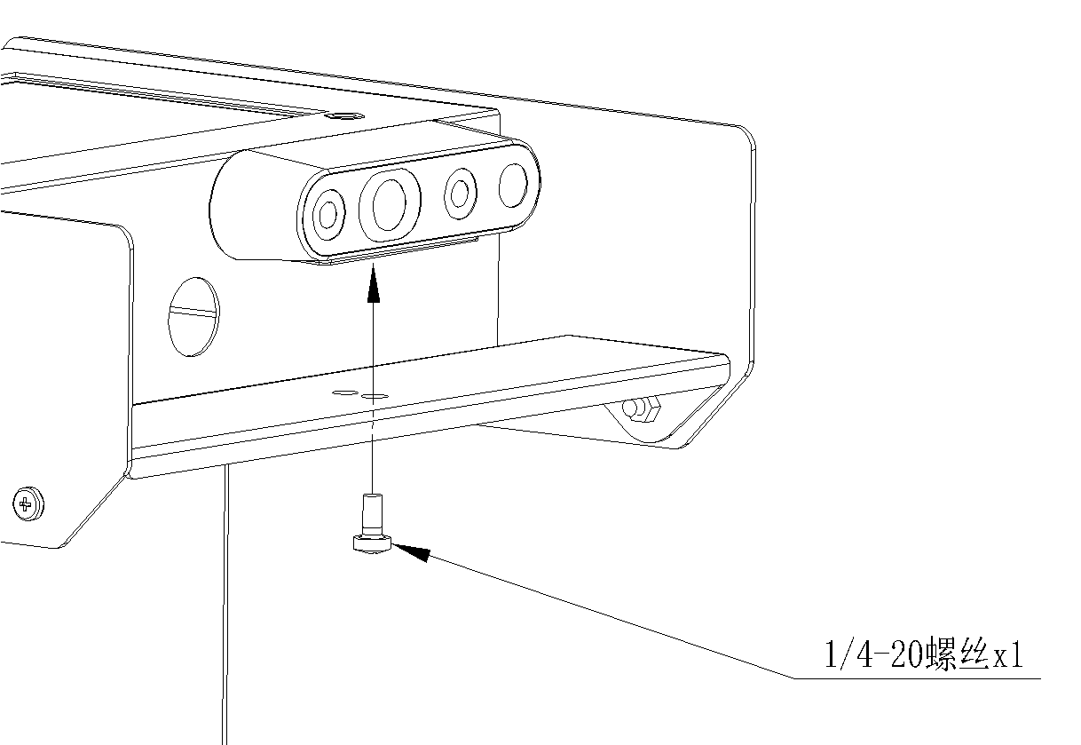

* **Robotic arm mounting**

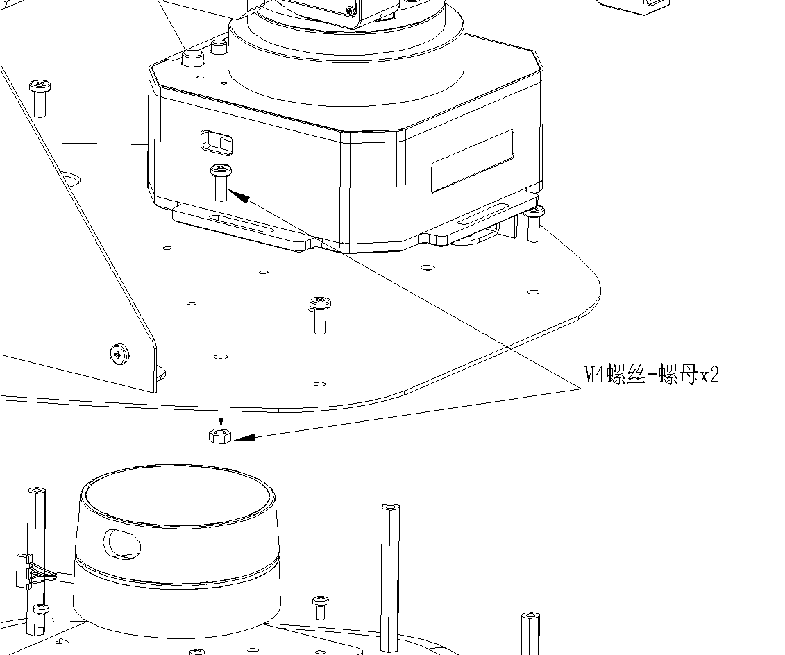

* **Lidar installation**

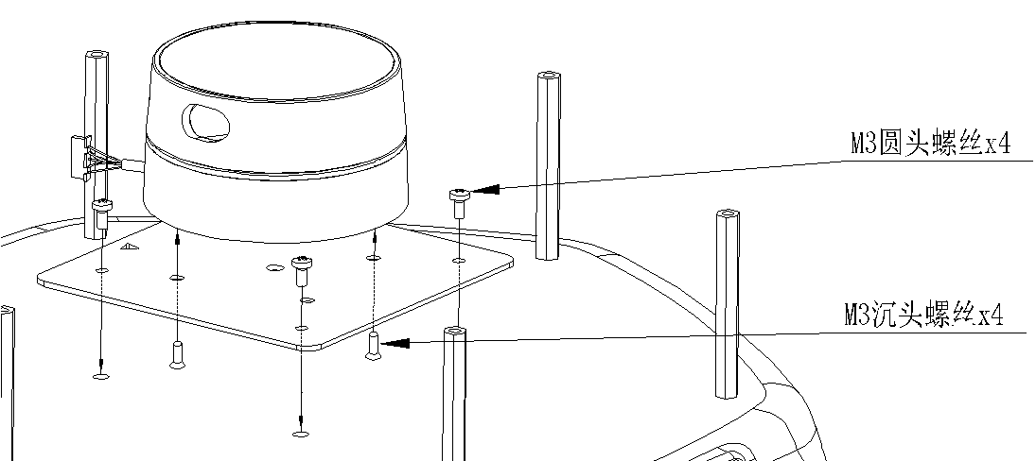

* **Expansion bracket mounting**

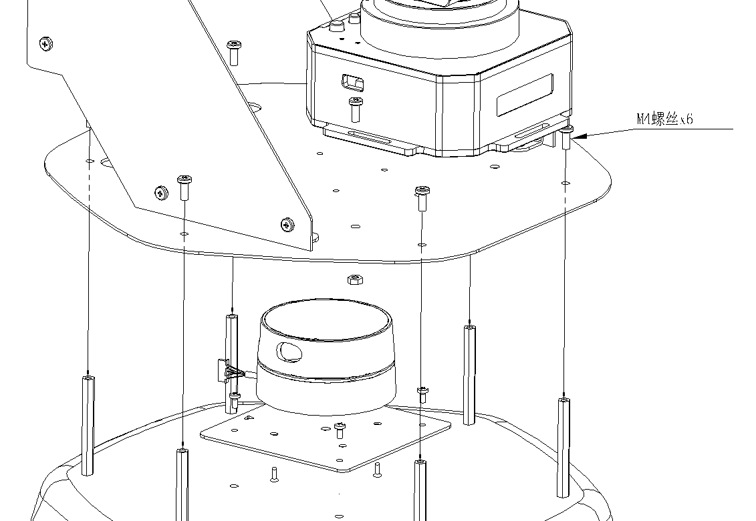

**Basic Information**

|  |  |  |
| --- | --- | --- |
| Product name | | Spark-H |
| Hardware parameters | Drive mode | Differential drive of two driving wheels |
| Drive wheel diameter | 68mm |
| Maximum speed | 0.4m/s |
| Encoder | Bidirectional 12-bit magnetic encoder |
| Load weight | 5kg |
| Obstacle crossing height | 5mm |
| Battery capacity | 18,000mah |
| Battery level display | Digital battery level display, charging flashing light prompt |
| Ingress protection | IP54 |
| Sensor | Wall inspection × 8, ground inspection × 6 |
| Power output interface | Two 12V/3A power outputs |
| Charging voltage | DC 19V |
| Communication interface | USB2.0 |
| Operating ambient temperature | 0°C-45°C, humidity <90% |

**Accessory information**

|  |  |  |
| --- | --- | --- |
| Product name | | Depth camera |
| Hardware parameters | Model | Realsense D435 |
| Use environment | Indoor/Outdoor |
| Deep technology | Active IR stereo |
| Camera | Intel Realsense processor D435 |
| Depth Field of View (hxvd) | 91.2x+65.5x100.6 |
| RGB camera resolution and frame count | 1080P@30fps |
| RGB Camera Field of View (hxvd) | 69.4x42.5x77 |
| Depth output resolution and number of frames | 1280x720&90fps |
| Minimum depth distance | 0.2m |
| Maximum depth distance | 10 meters and more (varies depending on the environment) |
| Size | 90x25x25mm |
| Perimeter connections | USB 3.0 Type-C |

|  |  |  |
| --- | --- | --- |
| Product name | | Robotic arm |
| Hardware parameters | Weight | 2.2kg |
| Fuselage material | Aluminum alloy |
| Fuselage size (length, width and height) | 150mm*140mm*281mm |
| Degree of freedom | 4 |
| Precision | 0.2mm |
| Load | 500g |
| Reach | 50mm~320mm |
| Maximum end movement speed | 500mm/s |
| Connection | Micro USB, Bluetooth 4.0 |
| Operating voltage | DC 12V |
| Power adapter | Input：100~240V 50/60Hz |
| Output：12V5A 60W |
| Operating ambient temperature | 0~40℃ |
| Drive mode | Stepper motor + reducer |
| Actuators | Suction cup |
| Feedback mechanisms | 12-bit magnetic encoder |
| Control the motherboard | Arduino MEGA 2560 |

|  |  |  |
| --- | --- | --- |
| Product name | | Lidar |
| Hardware parameters | Range | 0.12~16m (reflectivity 80%) |
| Sample rate | 8K/s |
| Frequency of scans | 5~12Hz |
| Laser wavelength | 775~800nm |
| Laser power | 3mw (max. 5mw) |
| Precision | <1%@16m |
| Measure resolution | 0.25mm |
| Communication interface | UART (3.3.V TTL) |
| Rated power consumption | 2.25W |
| Operating voltage | Ranging part: DC 5V |
| Starting current | 450ma |
| Operating current | 500ma |
| Volume | Φ72.3mm*41.2mm |
| Weight | 214g |
| Operating temperature | 0~50℃ |
| Ambient light intensity | <2000lux |
| Ambient humidity | <90% |

|  |  |  |
| --- | --- | --- |
| Product name | | NUC host |
| Hardware parameters | Processor | Intel Core 12th Gen i5-1250P 2.4ghz-4.2ghz 12-core 16-thread 12Mb cache |
| Memory | 8GB DDR4 |
| Hard disk | 128G SSD |
| Size | 117×112×37/51mm |
| Interface | HDMI2.0b×2 |
| Front USB3.2×2 |
| After USB3.2×1+USB2.0×1 |
| Rear Thunderbolt 4 interface × 2 |
| RJ45 Gigabit Ethernet port |
| Power supply | 120W |
| Communication | Intel WIFI 6E AX211 wireless card |
| Operating system | Pre-installed Ubuntu 20.04 + ROS Kinetic+ Contest Program |
| Pre-installed VNC remote connection server. Windows, Linux and macos can be controlled by wireless access to the robot system through the network.  Pre-installed ROS application examples and source code, and provide onekey menu to execute applications, such as   * + - The keyboard controls the chassis movement     - The mobile terminal APP remotely controls the chassis to move     - Wechat remote recognition controls chassis movement     - Object tracking and movement through the depth camera |
| * + - Opencv image recognition and interactive control of the robotic arm     - Tensorflow deep learning visual object recognition     - Pocketsphinx English voice recognition controls the mobile chassis     - SLAM (gmapping, hector, karto, rtab_map, frontier_exploration) algorithm synchronous localization and mapping     - Move_base algorithmic path planning and navigation |

|  |  |  |
| --- | --- | --- |
| Product name | | Openharmony development board |
| Hardware parameters | Power supply interface | USB type-C power supply/XH-2P |
| Operating voltage | DC 5V |
| Main control chip | Hi3861V100 |
| CPU frequency | 160mhz |
| Wifi standard | IEEE802.11b/g/n |
| NFC protocol | NFC Forum Type2 Tag |
| Storing Information | SRAM352KB、ROM288KB、  2M Flash |
| Extended interfaces | Microbit interfaces (UART, SPI, IIC,  GPIO,ADC,PWM/I2S/SDIO）  Plug-in expansion is supported |

|  |  |  |
| --- | --- | --- |
| Product name | | Touch the monitor |
| Hardware parameters | Size | 7in |
| Resolution | 1024*600 |
| Types of LCD screens | LCD screen |
| Touch points | 5-point capacitive touch |
| Interface | HDMI、USB-A |
| Viewable area | 154.08x85.92mm |
| Touch area | 154.08x85.92mm |
| Operating temperature | -20℃-70℃ |
| Storage temperature | -30℃-80℃ |

**Accessories list**

* Adapter ×1
* Product Sheet ×1
* Robotic Arm ×1 (Installed)
* Lidar ×1 (installed)
* NUC Host ×1 (Installed)
* Openharmony Development Board ×1 (Installed)
* Touch Monitor ×1 (Installed)
* Harmonyos mobile phone × 1

**Precautions**

* Non-professionals should not use non-original adapters to charge the robot to avoid danger.
* For application developers, please read the Spark manual.
* Intel NUC, the main control system of laptops and robots, will be pre-installed with Linux operating system, if the operating system is destroyed by man, our company can provide paid after-sales service.
* The servo arm will lock when it is powered on, and do not forcibly break the robot arm when it is powered on.
* Download the source code of Spark from https://github.com/NXROBO/spark
* All pictures are for reference only, and the final product is subject to the actual situation.

**Spark Manual**

**Download the source code of Spark from** [https://github.com/NXROBO/Spark](%20https://github.com/NXROBO/Spark)

* Remote interface settings

1. **Windows version AP mode connection**

**Device to be prepared before connecting:**

1. **A Windows laptop (hereinafter referred to as a Windows computer)**
2. **A Spark**
3. Download the tightvnc remote control software for your Windows computer

Download address:<https://www.tightvnc.com/download.php>(installation process, omitted).

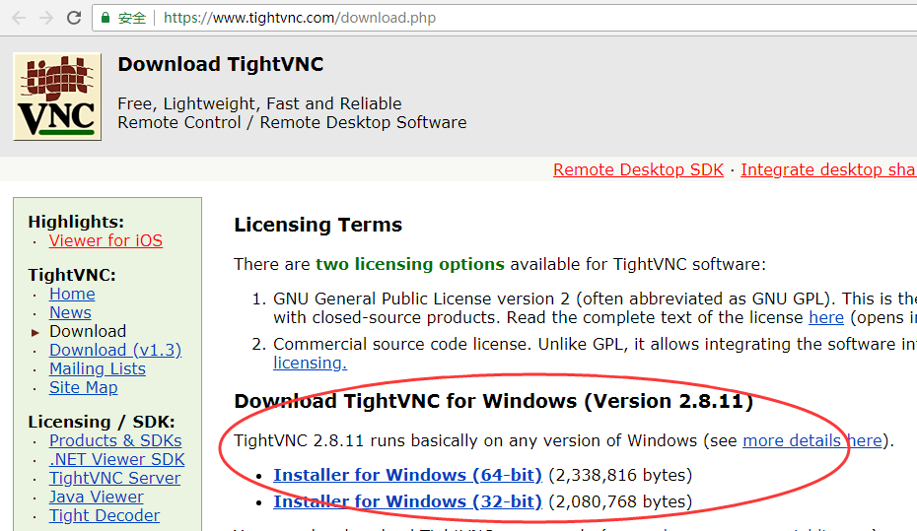

Open the software after installation as follows:

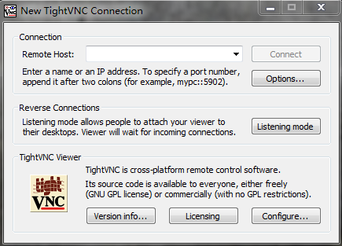

1. Click the Spark trolley boot button, the power indicator will be red light, wait for about 2 minutes, Spark will voice announce "正在启动网络" (the playback mode is only applicable to the SPARK version with speakers, such as SPARK-T), until the "网络标志" in the upper left corner shows a normal connection, indicating that the startup is complete. (as shown below):

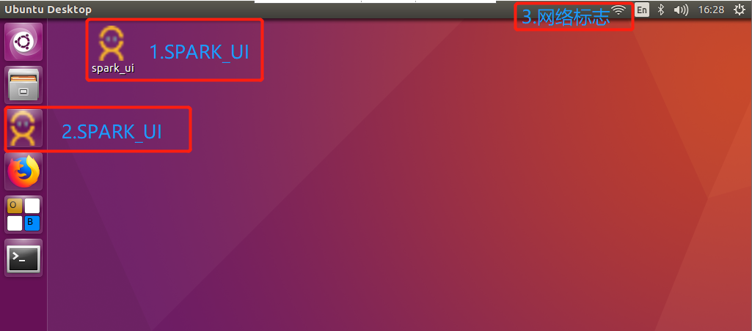

When Spark leaves the factory, it defaults to AP connection mode (Spark's built-in wireless network card transmits wifi hotspots).

This step is applicable to the SPARK version with physical buttons: Windows computer finds the Spark hotspot and connects it (double-click the AP button, Spark will voice announce the wifi name.) Default wifi password: 12345678), as shown in the figure:

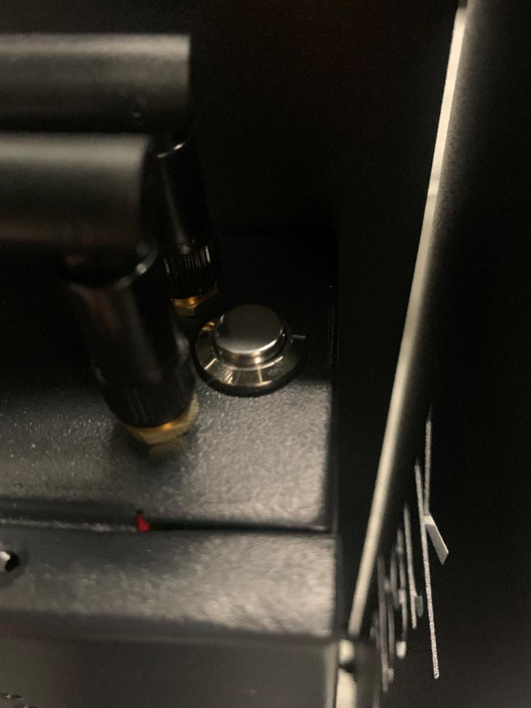

AP按键

Or click on the left menu bar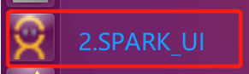 or double-click on the desktop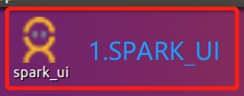, the following interface will pop up, in AP mode, the SSID and IP address of the current hotspot will be displayed, and the default wifi password: 12345678.

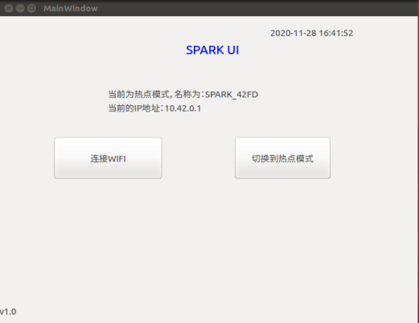

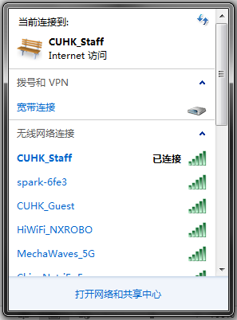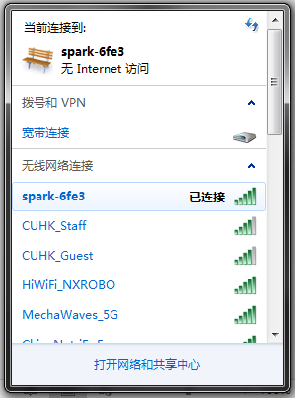

1. Open the tightvnc remote control software and enter the IP address (Spark will voice announce the IP address when you click the AP button once).

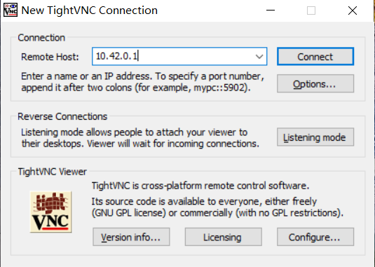

Click connect, when the connection is normal, a new window will pop up, as shown in the figure

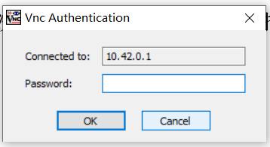

Enter the password: Spark and click OK to enter the remote desktop.

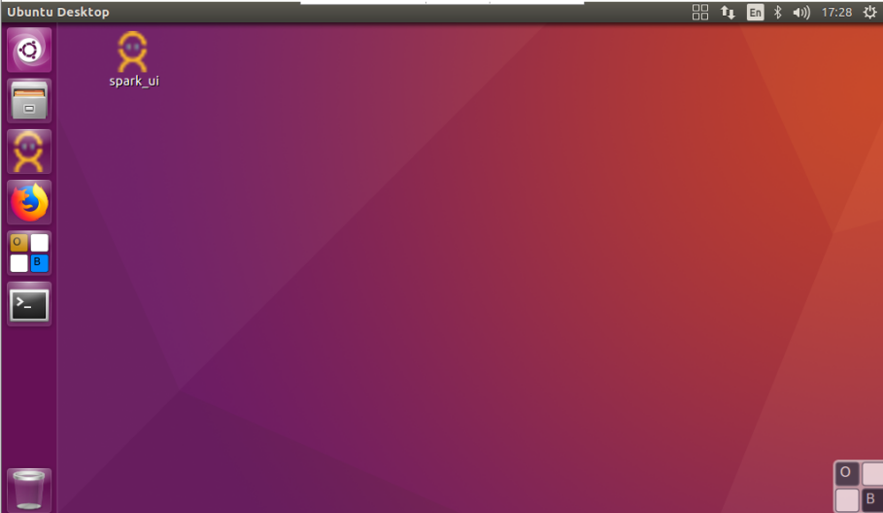

In this case, the Windows computer is connected to the spark AP connection mode. If you want to switch to Wi-Fi connection mode, you can follow the steps below.

1. **Switch to wifi mode**

**Device to be prepared before connecting:**

1. **A Windows laptop (hereinafter referred to as a Windows computer)**
2. **A Spark**
3. **A wifi environment (can be Internet or LAN, can be a wireless router or mobile phone hotspot)**

1. Click on the left menu bar or double-click on the desktop in the ubuntu system of SPARK to display an interface similar to the following figure, please follow the prompts.

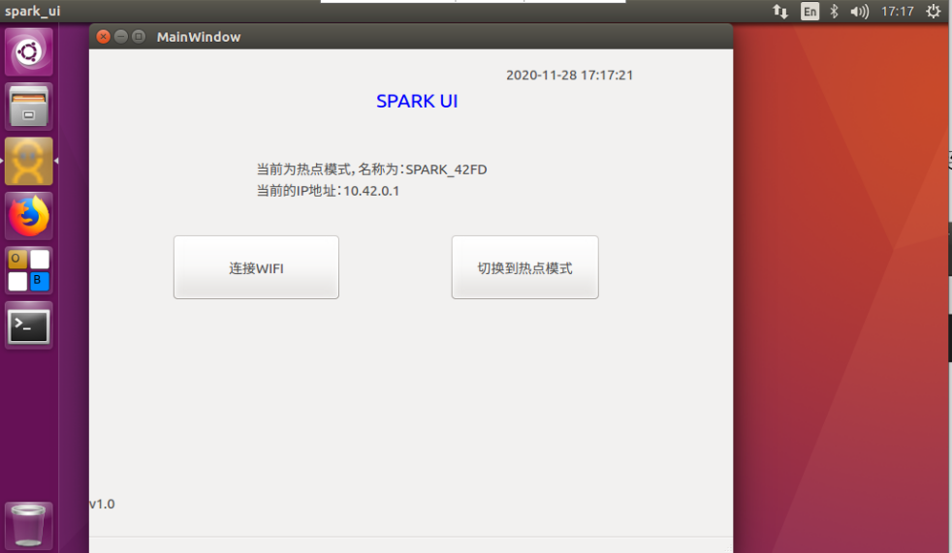

If you want to connect to the designated WIFI, please first determine that the current mode is "热点模式" in the interface (it will be prompted in the interface), if it is not the hotspot mode, please click "切换到热点模式" first, wait for about half a minute, switch to the mode of the hotspot, and then click "连接WIFI ", a WEB interface will pop up for WIFI selection and password entry. Then click "连接" to make a WIFI connection. As shown below:

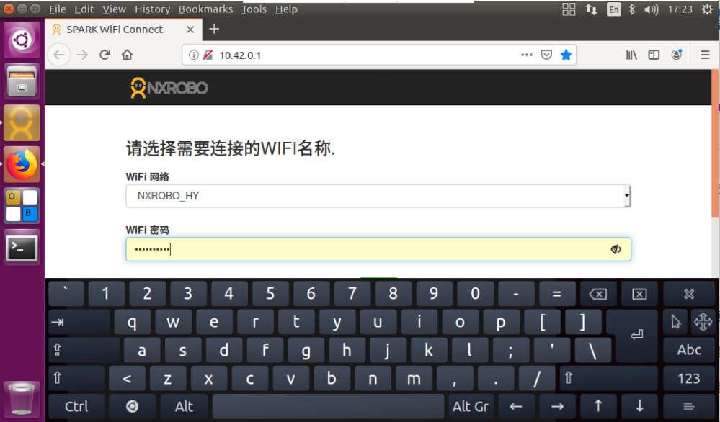

After the connection is successful, the SPARK_ UI interface will display relevant information, as shown in the following figure

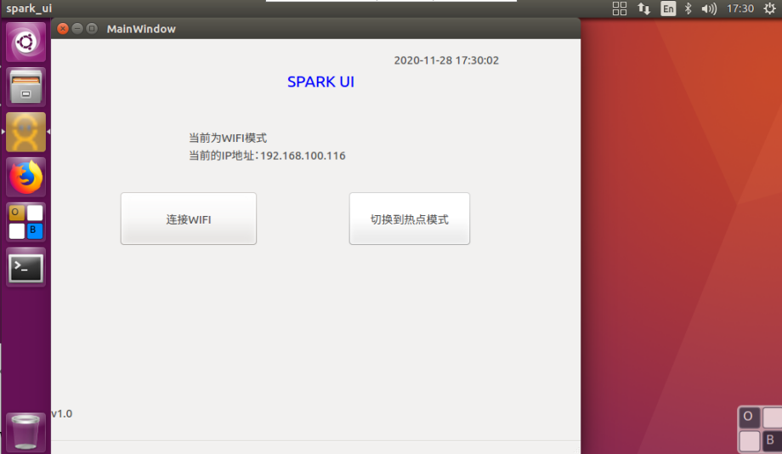

1. The windows computer is connected to the same wifi network as Spark, as shown in the figure

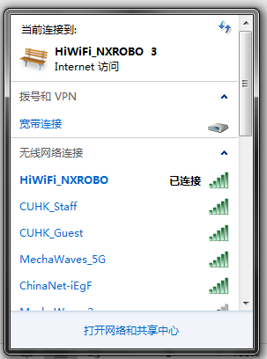

1. Open the tightvnc software on your Windows computer and enter the IP address (check the relevant information on the SPARK_UI)

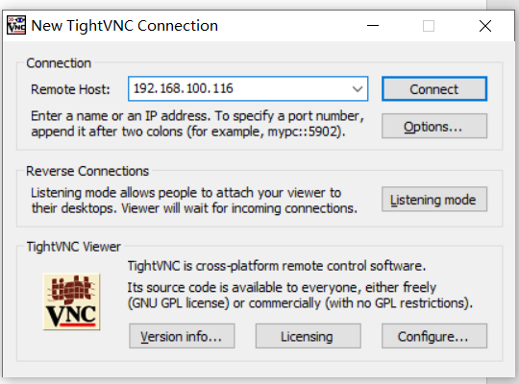

Click connect, when the connection is normal, a new window will pop up, as shown in the figure

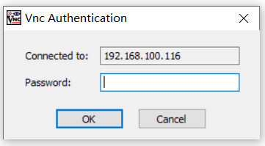

Enter the password: Spark and click OK to enter the remote desktop.

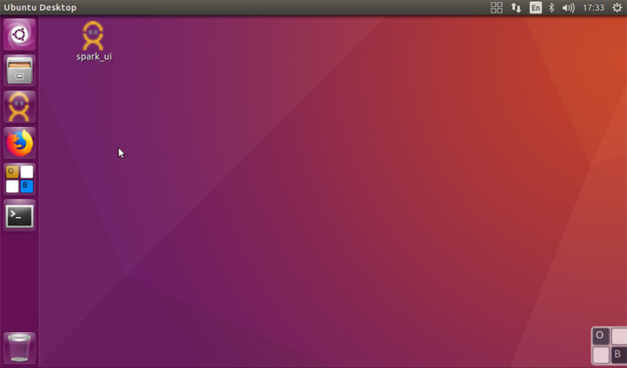

At this time, the wifi mode connection is realized. At this time, both the computer and the robot can use the Internet (the premise of the network).

If you want to return to AP mode, you can press the AP button four times (no more than 1 second between each press), and Spark will announce "正在启动热点，IP地址为XXX ", or click "切换到热点模式" on the SPARK_UI interface. In this case, switch back to AP mode (it is recommended to restart Spark each time you switch back).

* **Enter the one-click function menu**

1. Click the remote terminal, as shown in the following figure

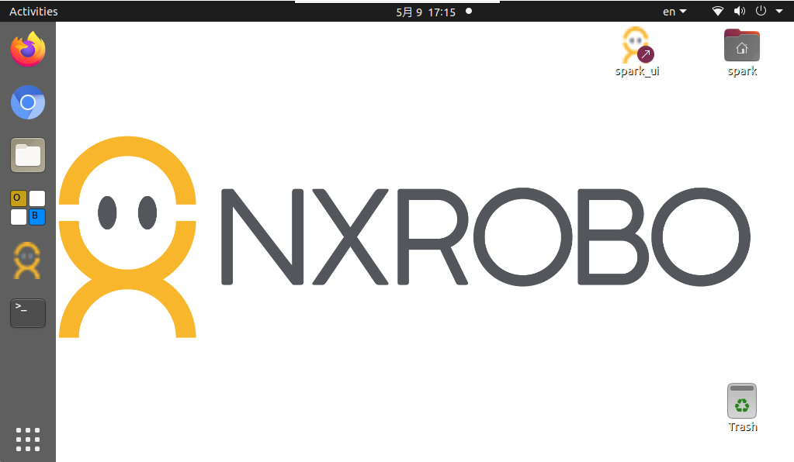

1. In the pop-up window, type: "cd spark_noetic/" and press Enter

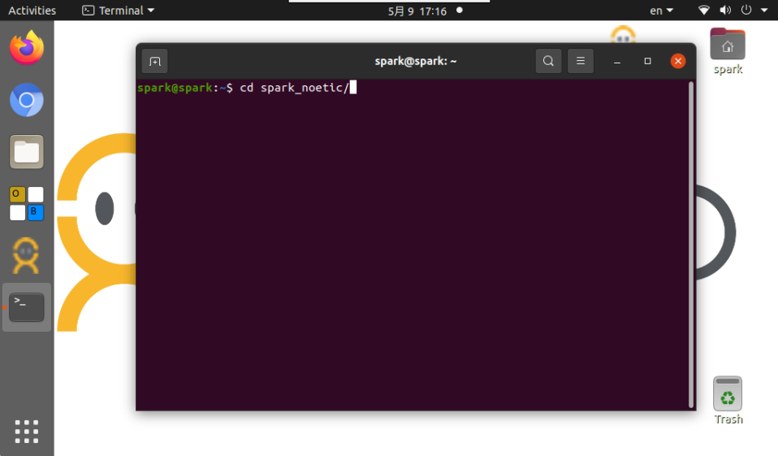

1. Enter: "ls", press enter

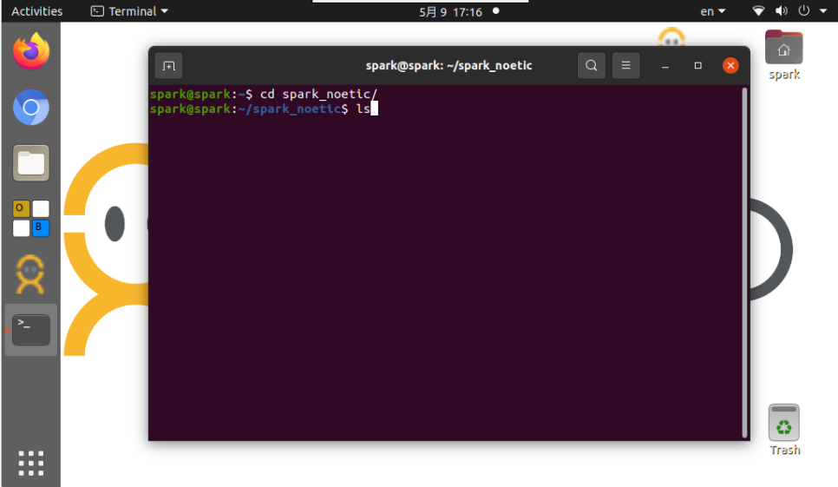

1. Enter: "./menu.sh" and press enter

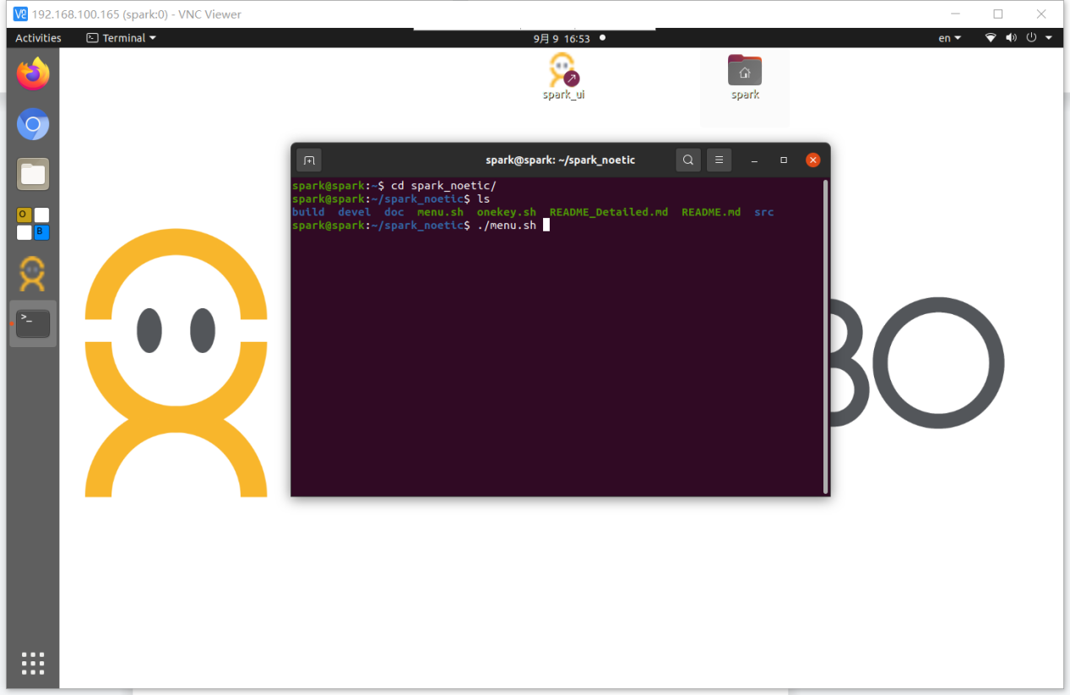

1. At this point, the Spark one-click function interface appears, and you can follow the instructions

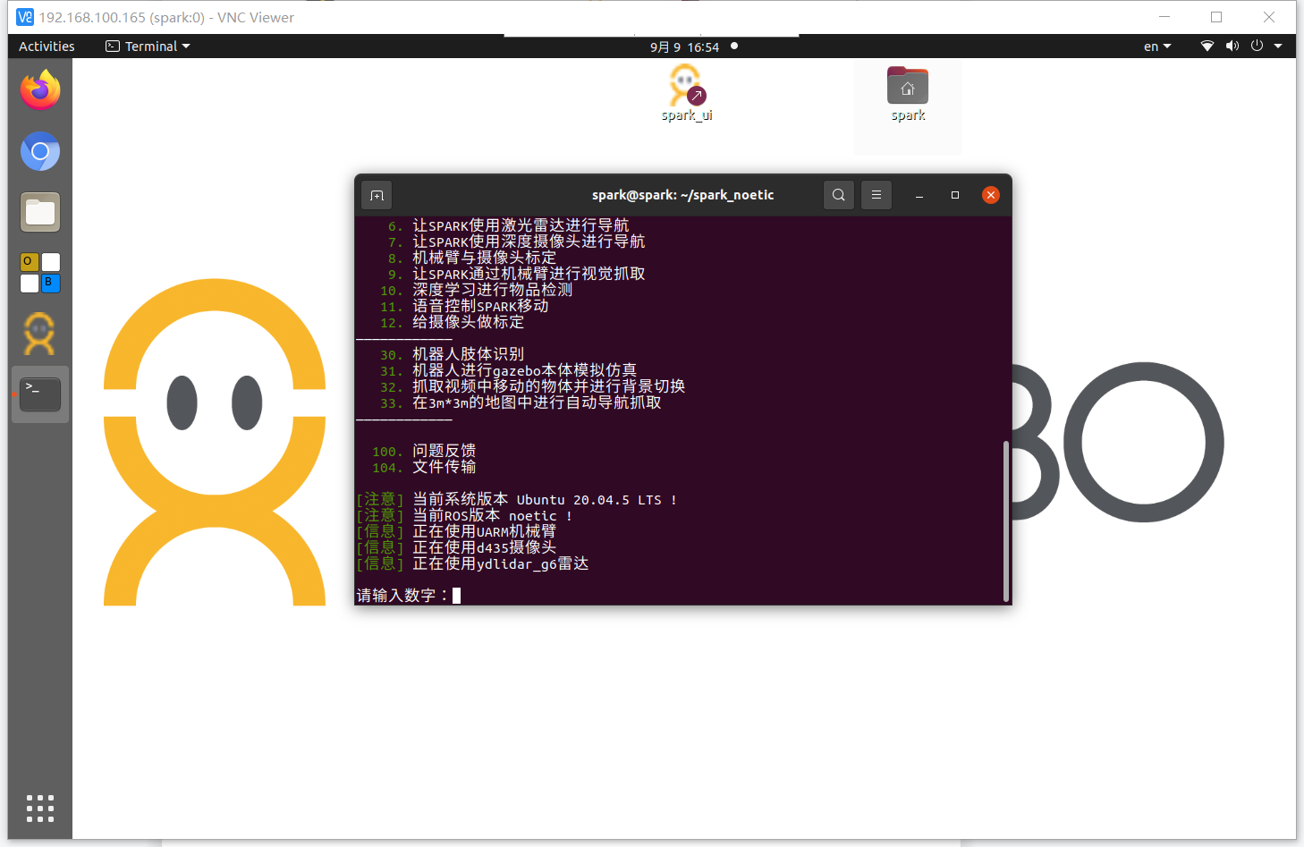

# Warranty

1. Consumers should read the product manual carefully before using the product.

2. The **warranty service is limited to the failure of non-man-made damage caused by the quality of the product itself during the effective warranty period under normal use, and the following services will be enjoyed with the invoice and valid warranty card**

2.1 Within 7 days from the date of purchase, consumers can enjoy free return or replacement services at the original place of purchase, or free warranty services;

2.2 Within 15 days from the date of purchase, consumers can enjoy free replacement service or free warranty service at the original place of purchase;

2.3 During the effective warranty period after 15 days from the date of purchase, consumers can enjoy free warranty services, and the effective warranty period of the host and accessories in the box is one year;

2.4 The calculation of the effective warranty period shall be calculated from the date of invoice, and if the last day of the validity period is a statutory holiday, the next day of the holiday day shall be the last day of the validity period. After the product fails, the user should send it for repair in time to avoid exceeding the warranty period and affecting the normal warranty.

3. If a valid purchase invoice and warranty card cannot be presented, NXROBO will provide the consumer with the 3-Warranty service on the 90th day after the factory date as the starting date of the validity period of the 3-Guarantee.

4. For the same fault, the repaired product will still be warranted for 90 days from the date of repair for the remainder of the original warranty period, whichever is longer.

5. When NXROBO provides free replacement or warranty service, all replaced hosts, parts, parts and accessories, etc. Are owned by NXROBO.

6. The **following situations are not within the scope of the Three Guarantees service:**

6.1 Failures, defects or defects of the Product caused by reasons not attributable to NXROBO (including but not limited to the Consumer not using, maintaining and caring for the Product in accordance with the User Manual, dismantling or repairing the Product by themselves or without NXROBO's authorized service, using parts or accessories not authorized by NXROBO, using them in a manner other than those for which they were designed, infiltration of liquids or food, use in high temperatures or harsh environments, or damage caused by human causes such as crushing or dropping or human error);

6.2 Periodic inspection, maintenance, repair or replacement of parts caused by natural wear and tear of the product and others;

6.3 The contents of the valid invoice and warranty card are inconsistent with the actual product or have been altered;

6.4 The body number of the main engine of the product is unclear, altered, damaged, removed or illegible, and the main machine tamper-evident label or waterproof label is damaged or removed;

6.5 Damage caused by force majeure.

7. After the expiration of the three-guarantee service, or during the three-guarantee period but not within the scope of the service, NXROBO or its authorized service outlets will provide paid maintenance services.

8. When a product fails, the consumer can take action:

8.1 Call the NXROBO Customer Service Hotline for correct service information;

8.2 Send the product to an authorized service outlet or express back to NXROBO for testing and repair services.

9. NXROBO's warranty obligations with respect to the Product, whether implied or implied by this warranty or other written instructions, shall be construed as being included in the warranty coverage and warranty period set forth in the warranty terms.

10. Neither NXROBO's dealer nor its authorized service outlets have the authority to acknowledge or assume any rights on behalf of NXROBO beyond those set forth in this warranty.

11. To the fullest extent permitted by applicable law, NXROBO shall not be liable for any loss of profit, loss of anticipated costs, or damage resulting from the use of this product. In the event that losses arising from the liability of NXROBO or its suppliers are subject to these Terms, compensation shall be based on direct losses incurred, and in no event shall the total amount of compensation be exceeded by the total amount paid by the Customer for the purchase of the Product.

12. NXOROB reserves the right to adjust product features and specifications without prior notice.

**After-sales service card**

Username________ Contact Number_________

Address______________________________________

Postal Code________ After-sales reasons_________

|  |  |  |
| --- | --- | --- |
| Repair time: | | Time of purchase: |
| A description of the cause of the failure or the reason for the return |  | |
| Diagnostic results |  | |
| Proof of repair |  | |

Diagnostic results and repair certificates do not need to be filled out and will be completed after the overhaul has been completed.

If you have other after-sales questions, please call 0755-86022100 for further information.