THE HONG KONG UNIVERSITY OF SCIENCE AND TECHNOLOGY ISDN 2602

Laboratory 5: Routing (5%)

Answer Sheet

Please write down your answer here and submit your answer on GitHub by Wednesday (Nov 5th) 23:59

Part I: Simulation of Dijkstra’s Algorithm by MATLAB

Task 1 – Find the shortest path by Dijkstra’s Algorithm

In this task, we will use the graph shown in figure.
Figure: Example of a weighted graph

Open the file "Task1.m" in the MATLAB editor window and run the code.

There is an n x n array Graph(i,j) of weight/cost where n is equal to the number of nodes in the graph. The cost between nodes i and j is given by Graph(i,j). Graph(i,j) = 0 for i = j . When nodes i and j are not adjacent, Graph(i,j) is set to infinity (inf).

Function fun_dijkstra() is used to find the shortest path by the Dijkstra Algorithm and calculate the cost with the three inputs, i.e., the Graph array, the source node (source), and the destination node (dest).

The code finds the shortest path from node 1 to node 3 as (1 > 4 > 5 > 3) where the cost is 4.

Check Point:

- Modify the code to find the shortest path from node 1 to node 6 and the associated cost. Please Write down your answer in the blank below.
- path =
1
4
5
3
6
cost =
6

Fill in the answers and Show your result to the TA.

Task 2 – Create the Graph

According to the traffic situation of Hong Kong as shown in figure, create the weighted graph by yourself.
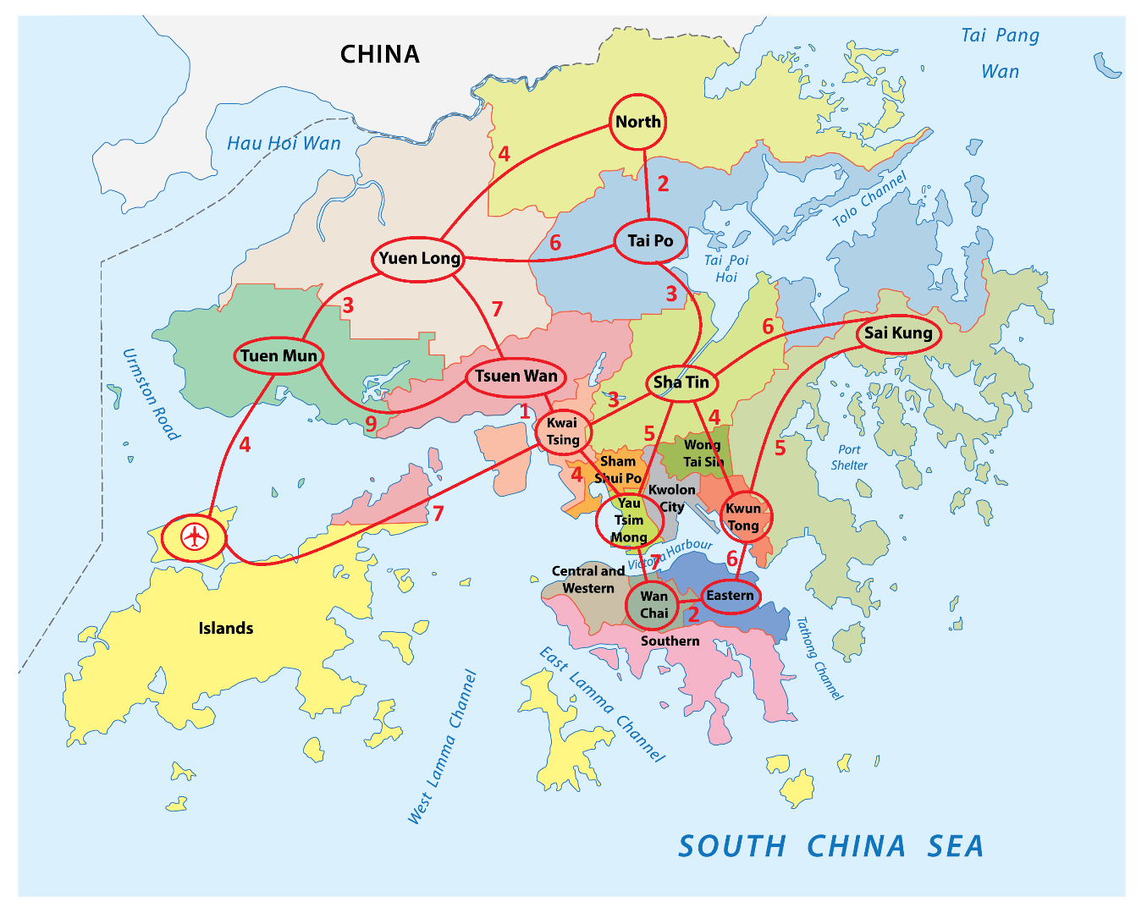
Figure: Traffic situation of Hong Kong

Denote the districts of Hong Kong by the nodes below:
- Node 1: North
- Node 2: Tai Po
- Node 3: Yuen Long
- Node 4: Tuen Mun
- Node 5: Tsuen Wan
- Node 6: Sha Tin
- Node 7: Sai Kung
- Node 8: Kwai Tsing
- Node 9: Yau Tsim Mong
- Node 10: Kwun Tong
- Node 11: Wan Chai
- Node 12: Eastern
- Node 13: Airport

The traffic cost between any two nodes is labelled by the red integer number.
Open the file "Task2.m" in the MATLAB editor window. Then, modify the code to create the weighted graph for the traffic situation in HK.

Check point:

- Copy the array you created to represent the weighted graph here.

Graph = [0 2 4 inf inf inf inf inf inf inf inf inf inf ; % 1
2 0 6 inf 3 inf inf inf inf inf inf inf inf ; % 2
4 6 0 3 7 inf inf inf inf inf inf inf inf ; % 3
inf inf 3 0 9 inf inf inf inf inf inf inf 4 ; % 4
inf inf 7 9 0 inf inf 1 inf inf inf inf inf ; % 5
inf 3 inf inf inf 0 6 3 5 4 inf inf inf ; % 6
inf inf inf inf inf 6 0 inf inf 5 inf inf inf ; % 7
inf inf inf inf 1 3 inf 0 4 inf inf inf 7 ; % 8
inf inf inf inf inf inf inf 4 0 inf inf 7 inf ; % 9
inf inf inf inf inf 4 5 inf inf 0 6 inf inf ; % 10
inf inf inf inf inf inf inf inf inf 6 0 2 inf ; % 11
inf inf inf inf inf inf inf inf 7 inf 2 0 inf ; % 12
inf inf inf 4 inf inf inf 7 inf inf inf inf inf]; % 13

- Find the shortest path from Yuen Long to Eastern and determine the associated cost.

path =
3
5
8
9
12
cost =
19

Fill in the answers, commit the revised codes to GitHub
and Show your result to the TA.

----------------------------------End-----------------------------------

