Stu 1.ID:21152399 Name 1:Li, Kaile
Stu 2.ID:21169718 Name 2:Ng Chui Yiu

Answer Sheet
Lab 5: Motor Speed and 2 DC Motors Direction Control
Task 1 – Control the speed of rotation in one DC motor

Screenshot of A and B plot with PWM duty cycle 0% :
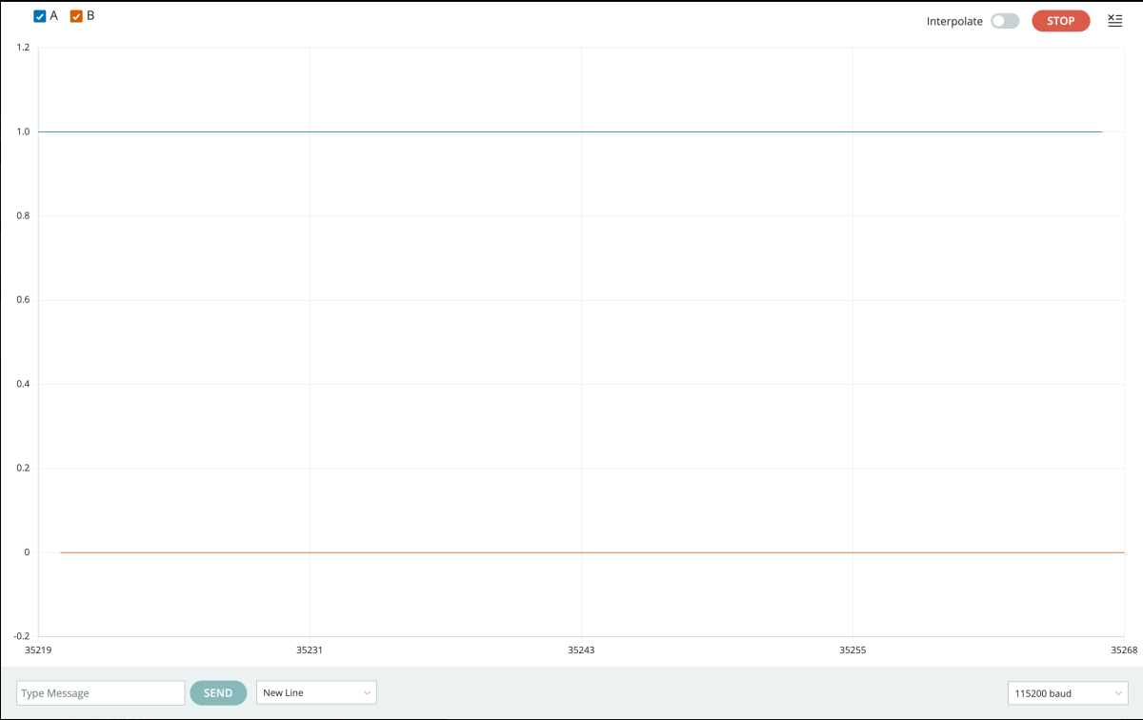

Screenshot of A and B plot with PWM duty cycle 25% : 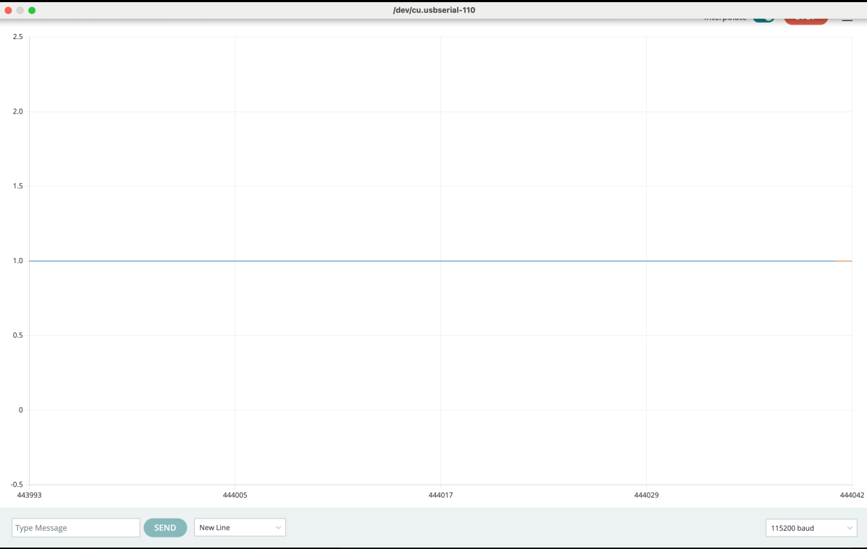

For small duty cycles, the motors might not spin, and make a continuous buzz sound.

Screenshot of A and B plot with PWM duty cycle 50% : 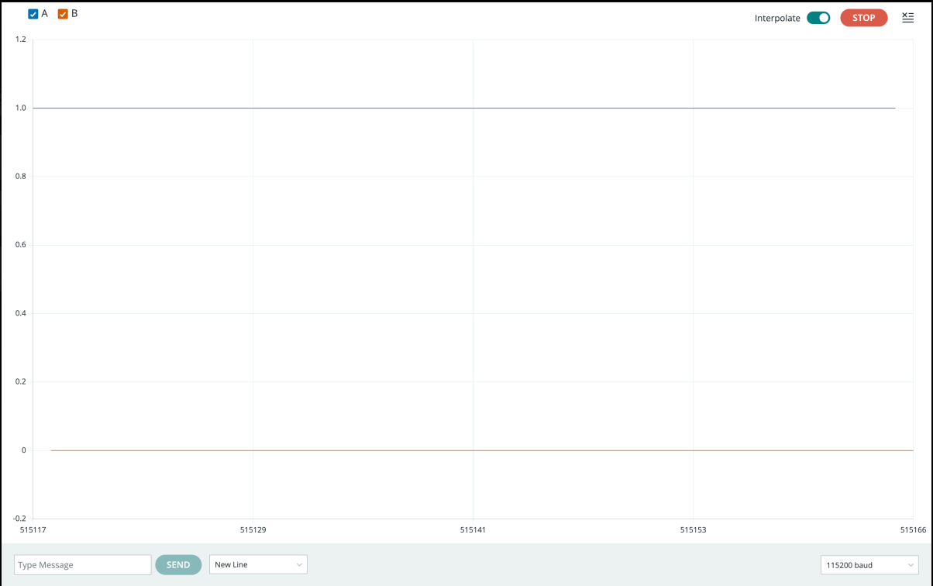

Screenshot of A and B plot with PWM duty cycle 75% : 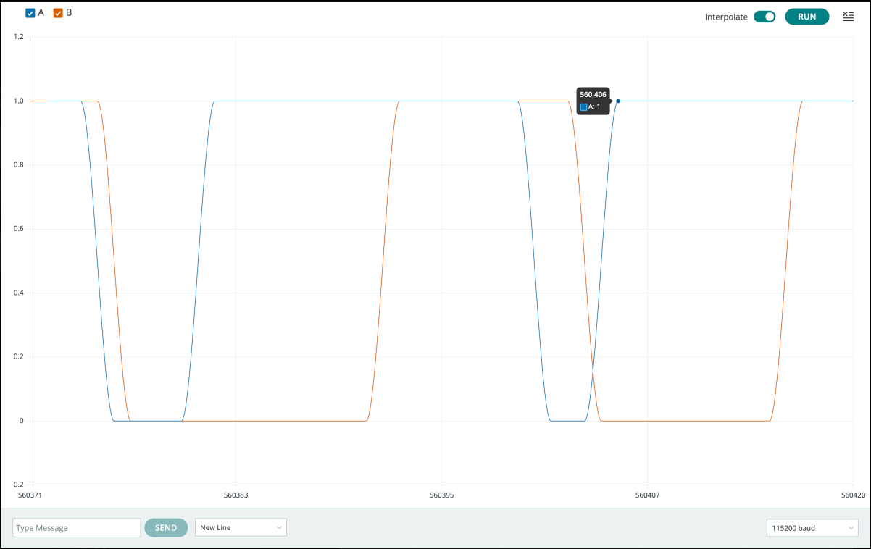

Screenshot of A and B plot with PWM duty cycle 100% : 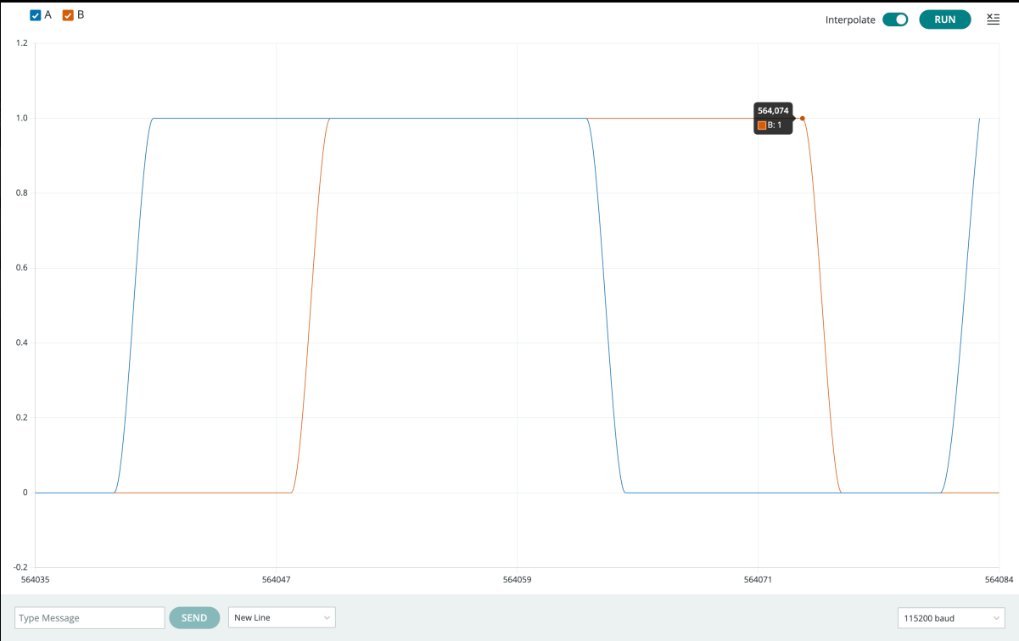

The motor model you used is GM 25-370 DC 12 V 140 rpm

Please paste the code you wrote to set a rotation direction below.
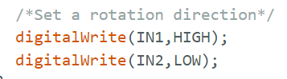

Your motor resulting rotation direction is A
- 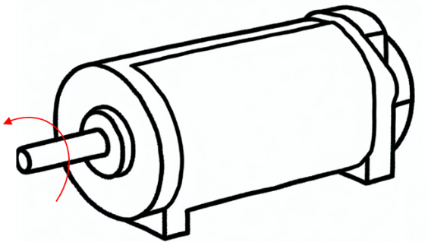 B. 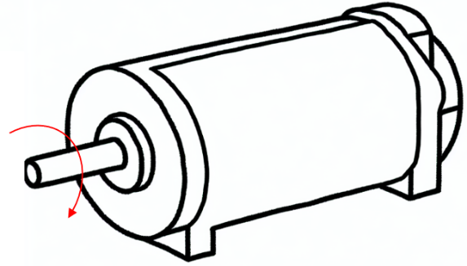

BONUS:
Screenshot of A and B plot with PWM duty cycle 0% :
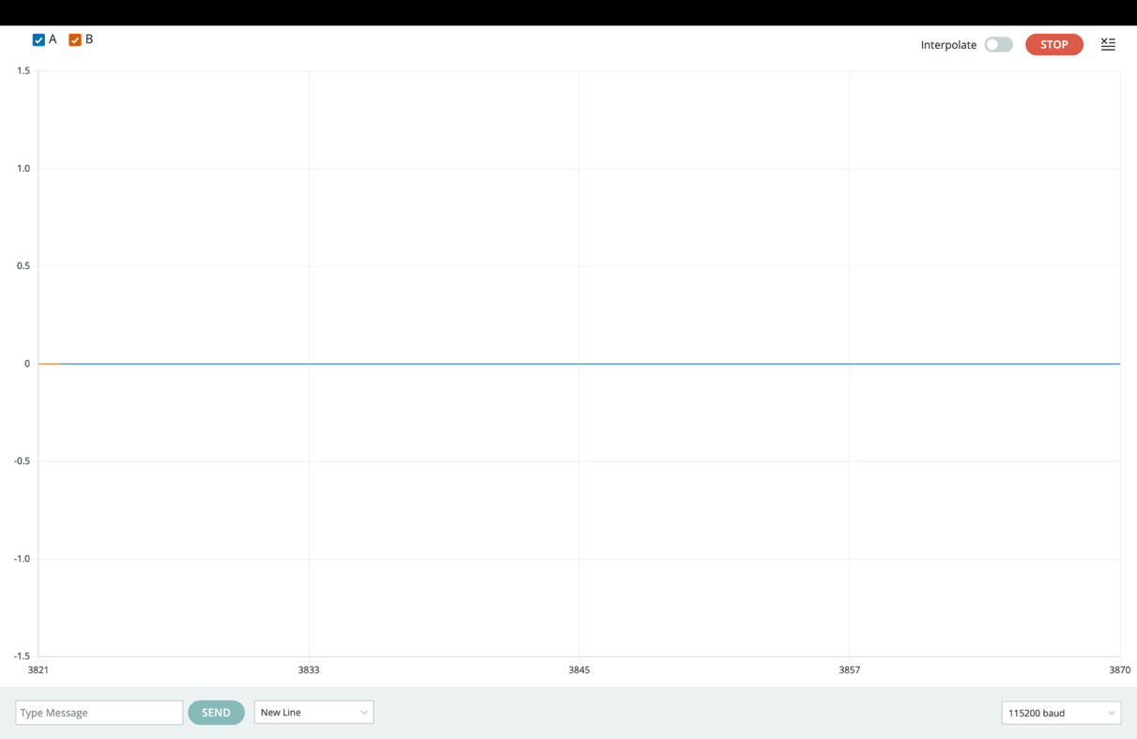

Screenshot of A and B plot with PWM duty cycle 25% :
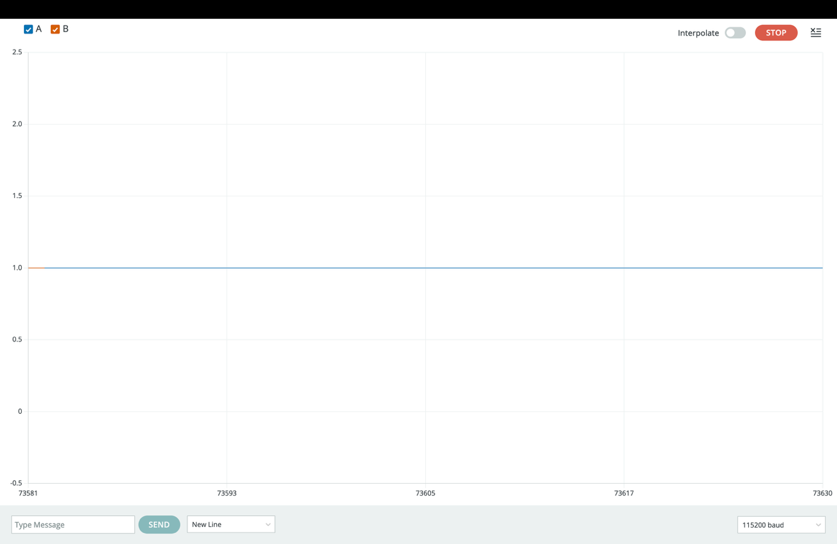

Screenshot of A and B plot with PWM duty cycle 50% :

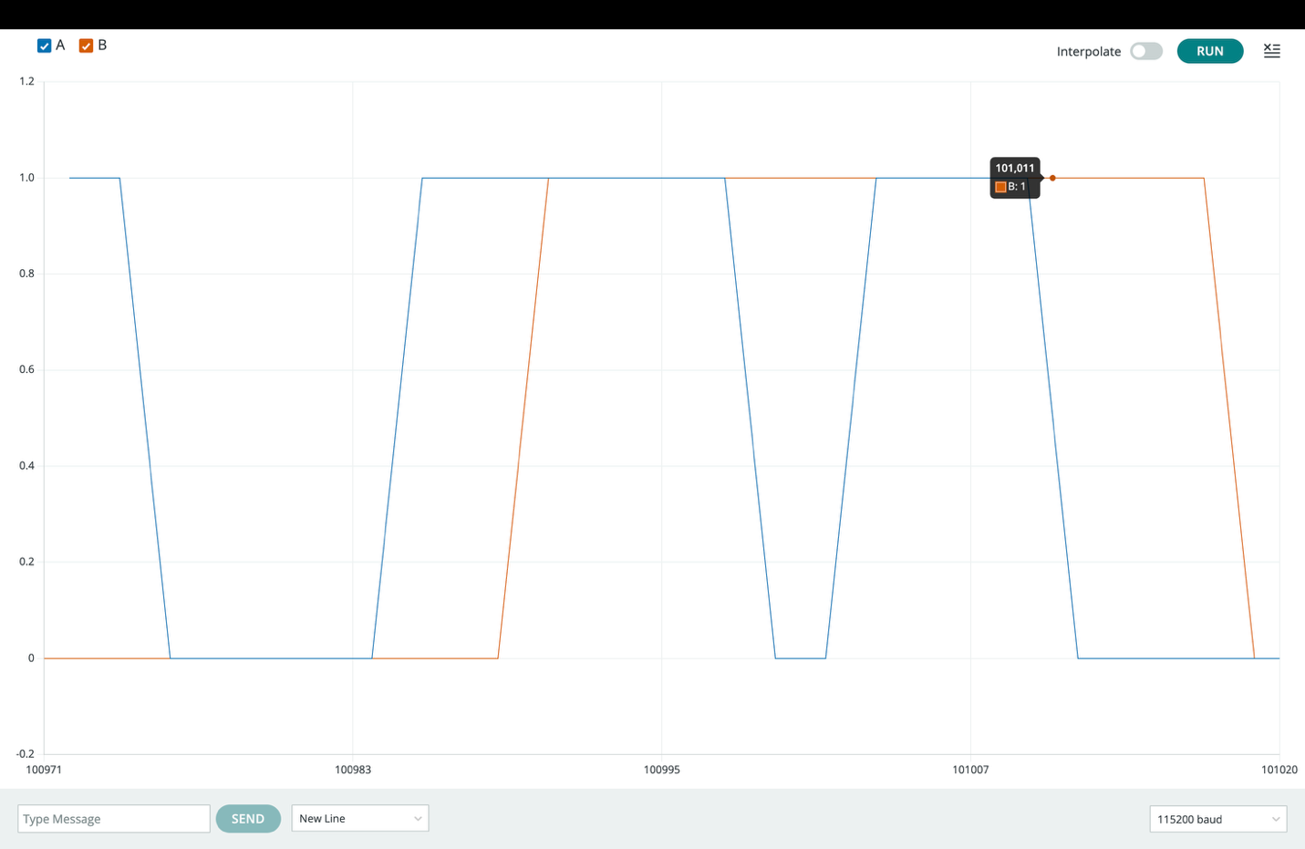

Screenshot of A and B plot with PWM duty cycle 75% :

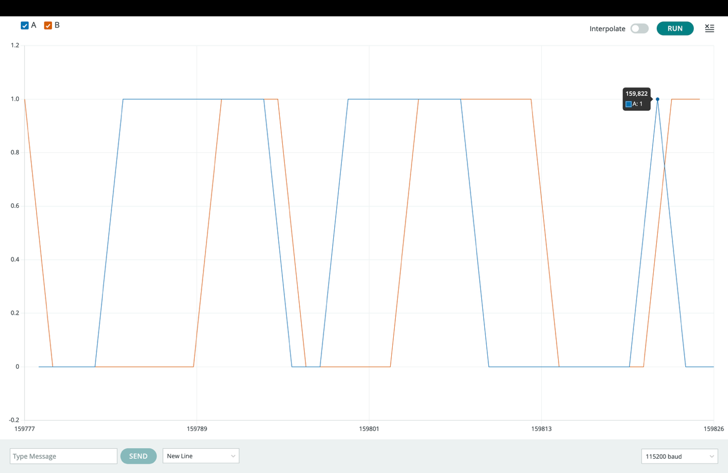

Screenshot of A and B plot with PWM duty cycle 100% :

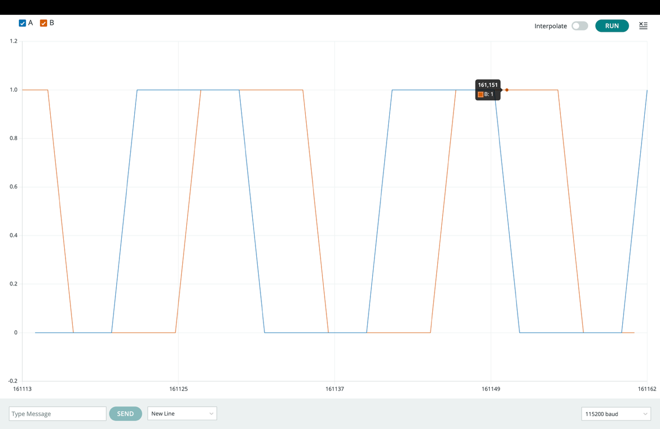

The motor model you used is ____CHR-GM25-370____________

Please paste the code you wrote to set a rotation direction below.

/*Set a rotation direction*/
digitalWrite(IN1,HIGH);
digitalWrite(IN2,LOW);

Your motor resulting rotation direction is __Forward_
- B.

Task 2 – Control the direction of 2 DC motors
Please complete the following Table. 2 in the answer sheet that outlines the state combinations for IN1, IN2, IN3, and IN4 corresponding to the robot's movements, based on Table 1. Motor L is positioned on the left and is connected to IN1 and IN2, while Motor R is positioned on the right and connected to IN3 and IN4.
Table. 2 The state combinations for IN1, IN2, IN3, and IN4 corresponding to the robot's movements
 | IN1 | IN2 | IN3 | IN4
Forward | High | Low | High | Low
Backward | Low | High | Low | High
Right | Low | High | Low | High
Left | High | Low | High | Low
Stop | Low | Low | Low | Low

Screenshot of plots of moving Forward:

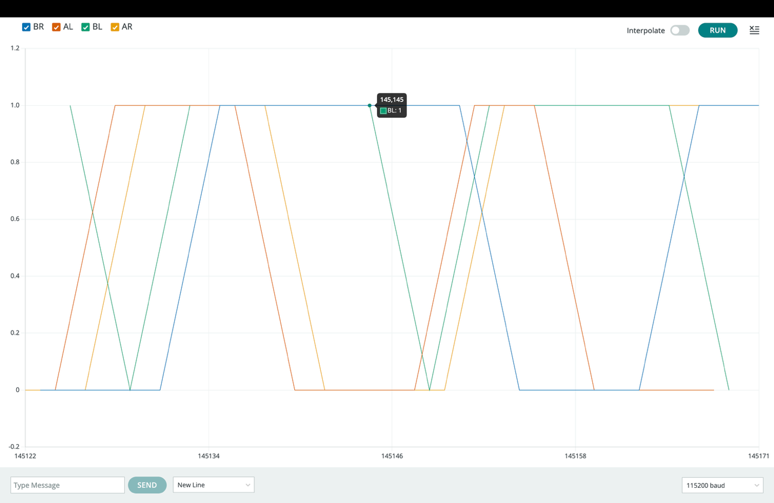

Screenshot of plots of moving backward:

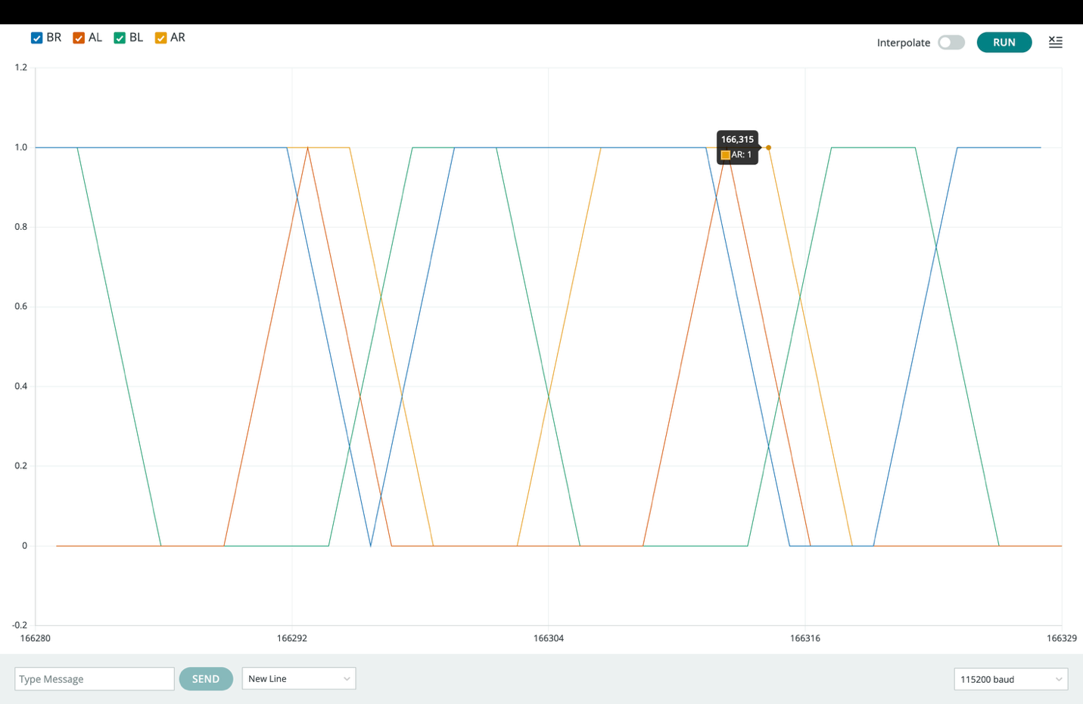

Screenshot of plots of turning right:

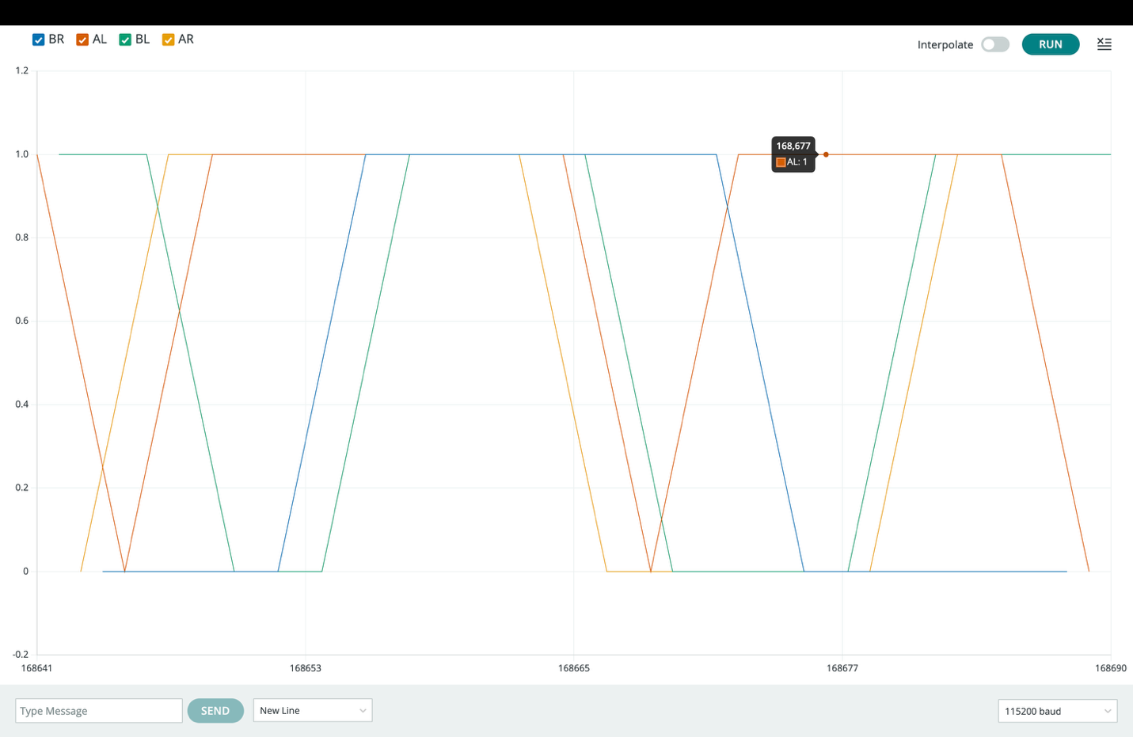

Screenshot of plots of turning left:

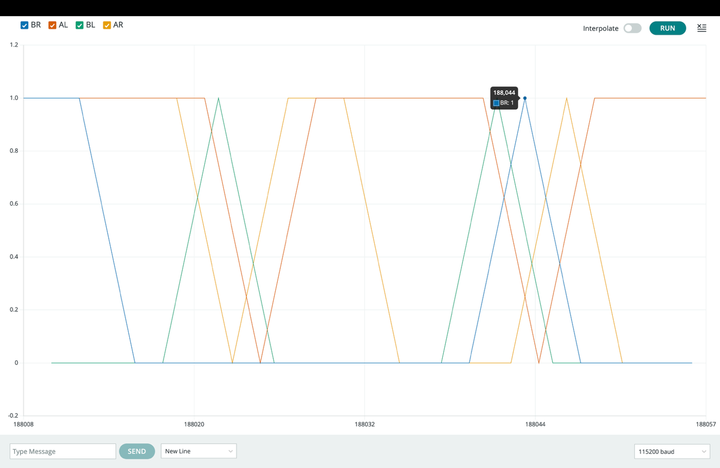

Screenshot of plots of stopping:

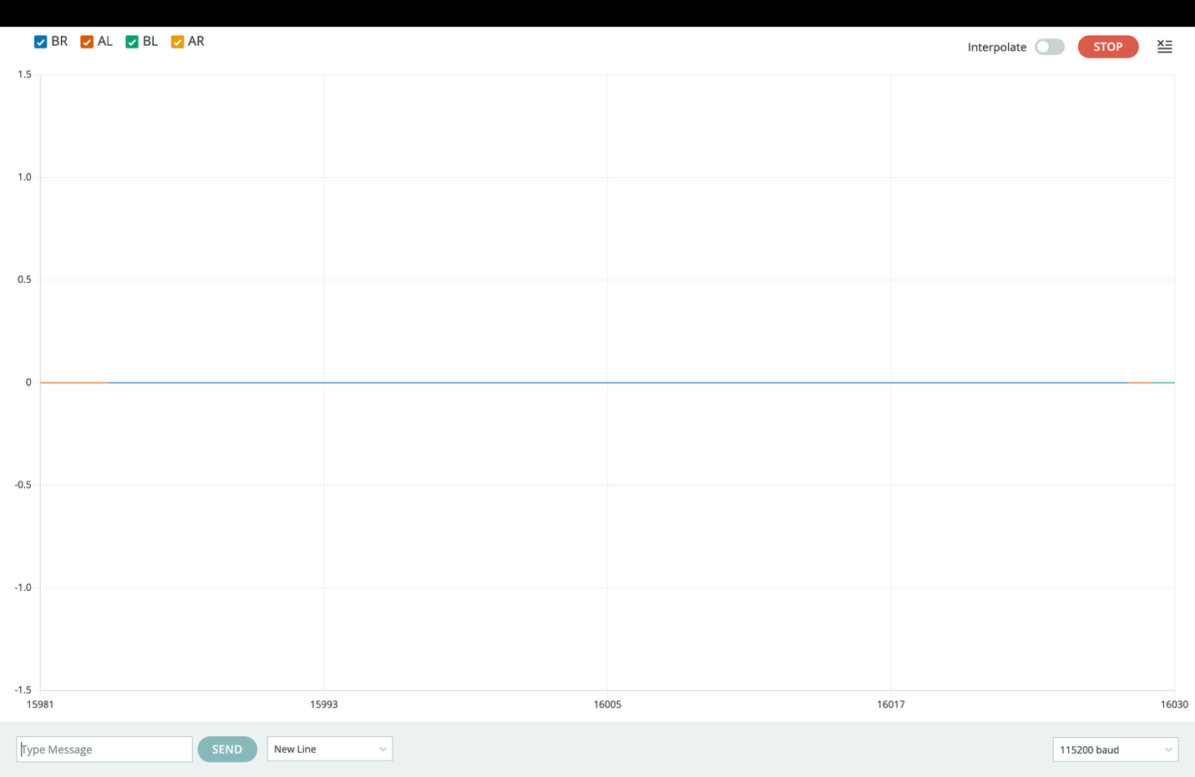

Please commit and push the modified codes to GitHub.
Fill the answer sheet and submit to Canvas/Assignments/Lab5_Answer sheet.

