SOSC 4300 Computational Social Science
Technical Report - How Social Media Data Captures the Evolvement of Social Movement
Group: idk-lol (Leung Man Choi 20521189, Tin Man Sing 20521256, Au Yeung Tsz Wai 20520460, Lam Hoi San 20506775)
Background & Aim
Studies have been using social media to understand how protestors mobilize, share information, and create online community in a specific social movement for around a decade. Literature proposed that social media can facilitates collective action by having easier and immediate communication; attract international attention and form multinational alliances; act as a platform for protestors to share grievances that can be transformed into motivation in joining mass movement; information disseminate channel for activist to promote the movement and allow individual to have a “cost-benefit analysis” to evaluate whether it is worth to join a movement based on the information he/she gathered; and formation of an online community created a shared identity that encourage protestors to participate into social movement (Lynch, 2011; Howards & Hussain, 2011; Jost, et al, 2018; Saunder, 2007). The abundance of literature regarding this relationship shows that social media indeed facilitates many social movements and through many ways. Especially since 2011, two major social movement Arab Spring and Occupy wall street also utilized social media such as Facebook, which have taken a more prominent role in facilitating social movement and shown the power of social media in contributing to mass movement. However, compared to computational methods, the traditional method of studying social movement only focuses on the post-social movement attitude and cannot explain how the social movement evolves through the use of social media. Due to such limitations, the use of computational method in studying the relationship have become more appealing to academia as if there is a suitable dataset, it enables researcher to visualize the dynamics and the network evolvement throughout the movement. Researchers can have a deeper understanding as they can form clusters, directed networks etc to see the formation of the movement network. Researchers will also be able to detect whether countermovement / astroturfing on social media was started by the regime. It also allows researchers to look beyond the network and examine the other aspects of the movement, such as sentiments, frequent words etc to understand the overall atmosphere among the protestors in the online community. Overall, the computational method can help to strengthen the weaknesses and negate criticism of the current social media-movement studies by offering more concrete, detailed, and more information.
This technical report aims to study how social media can facilitate the evolvement of social movement with the example of Hong Kong 2019 Anti-Elab movement and the use of computational approach. Due to the limitation of the dataset, we will focus the scope of social media into Twitter and study more on the international attention and share grievance perspective on the usage of social media through text and sentiment analysis, network analysis, and qualitative analysis on certain Twitter account.
Literature Review
- Conventional and Traditional study of social media and social movement
Numerous studies have been conducted in the past decade regarding the relationship between social media and social movement, and it can be summarized into 4 ways: 1) Mobilization; 2) Seek international support; 3) Share information; and 4) Online community-building.
Firstly, social media has been theorized to facilitate the mobilization process of social movement as it enables the mass to communicate immediately and neglect the physical boundary. As social media is free, spontaneous, and immediate, activists and social movement organization (SMOs) can connect many individuals in a short period of time with a low transactional cost (Lynch, 2011). The primary function of social media of sharing and connecting also helps SMOs by reaching out to a large scale of participants through keywords, hashtags, and various groups and pages, which also help the movement to gain popularity and support (Xiao, et al, 2019). Moreover, if there are more people on social media that is discussing the movement, it can create an atmosphere that urges and motivates other to join the collective action (Lynch, 2011; Wolfsfeld, et al, 2013).
Secondly, as social media does not constrain by any physical distances, any messages and posts on social media can be transnational to the other side of the world and gain support from overseas. As demonstrated by Li, et al (2013), social media help to disseminate information to various geographical locations that protestors can gain oversea support that share ideological proximity but not necessarily geographical closeness. Moreover, as proposed by Keck & Sikkink (1999), social movement under authoritarian regime usually follows a “boomerang pattern” that allows inter-governmental organization and NGOs act as a bridge for two countries. In a real-life context, these organizations such as amnesty international usually uses social media to reveal the cases of police misconduct and unhumanitarian treatment done by the regime, thus gaining international attentions, supports, and sympathy towards the protestors (Mazzucelli, 2014).
Thirdly, social media can be utilized for information sharing. As social media not only limited to text, but also allows photos, audios or even videos to be shared online, it can create a moral shock to non-participants by showing how protestors being mistreated or how determined they are (Howard & Hussain, 2011). This also echoes with the aforementioned mobilizing and gaining public support of a movement as the information diffused by social media can reach many non-participants that can evoke their empathy and motivate them to join the movement. In addition, social media itself can also be an information sharing platform within a movement due to its anonymous nature. For example, in Tunisia’s movement, many protestors shared news and police’s action that helped SMOs to formulate strategies to counteract the police (Marzouki, et al, 2012). The information sharing process can also be useful for outsiders to gain any information they may found relevant, which they can later use it to conduct a “Cost-Benefit Analysis” to decide whether they would like to participate, where the participants can take this opportunity to demonstrate anything that can evoke sympathy and have a better persuasion (Josh, et al, 2007).
Fourthly, social media provides a platform for any dissatisfied individuals to form an online community that can be used for sharing grievances and create an identity. The sense of grievances can act as a fuel for participants to continues the movement, and as social media can connect multiple individuals with the same feeling, it helps to bring individuals together and have emotional motivation that can translate into collective actions (Howards & Hussain, 2011). Similarly, a collective identity will be born in the process of online community building. Such collective identity will bring solidarity among protestors thus strengthen the collective actions (Saunder, 2007)
However, numerous studies have pointed out the issues of the vast research of social media-social movement literature in the past decades. As most of the literature have either only taken a cultural perspective in explaining the relationship or focus on the post-social movement attitude towards the use of social media, such as how people feel the importance of social media in a particular movement, how often do you use social media during social movement etc. These approach have a few limitations: first, as social movement is a spontaneous and ever-changing, understanding post-social movement attitude may not be able to fully captures how exactly social media mobilize the participants; second, conventional survey and data collection process have always been restricted by the sample collection, if a social movement occur under an authoritarian regime, it will be very difficult to collect sample as many participants would rather stay anonymous to avoid reveal their true identity as it may causes them being incarcerated, thus creating biases or non-representative sample; third, while social media can be a useful estimator in explaining many social movement’s occurrence, many current studies have presumed that social media is a strong explanation of movement or held an oversimplification perspective on the social media-induced movement mechanism while neglected the internet can also be used by regime for counter-movement and demobilize the mass (Lynch, 2011; Kidd & Mclntosh, 2016; Wolfsfeld, et al, 2013).
- Computational Approach
The current computational approach can mainly be divided into three different categories: 1) Network Analysis; 2) Text Analysis and 3) Additional Information.
2.1 Network Analysis
Network analysis has been widely adopted since its debut. It helps to visualize how different actors connect with each other, and how they can be grouped into different groups through clustering at a given movement. For example, Tinati, Halford, Carr, Pope (2016) have plotted the twitter account network for over a 6-day period and observed how different nodes emerges and join the existing group. Stewart, Arif, Nied, Spiro & Starbird (2017) also adopted network analysis, with specification on the share-audience and retweet network. They first calculated a shared audience matric, which reflects the friend-following ties and retweet-mentioned ties of for every pair of users by using formula of Jaccard similarity. As there are 25M edges in total, they selected 5M edges by weighting strong overlapping audience. Then, they built the graph of the social network by using Gephi and clustered them by Louvain modularity. The overall utilization of network analysis can help to answer the mechanism of social media and social movement relationships. Through studying how new nodes being included into the existing network, it can help to explain the information flow and identity which certain nodes is the “advertiser” of the movement, thus explaining the role of social media in gaining international support and facilitates information sharing, and the cluster can help to understand how different groups being formed in a given movement thus knowing more about the online community building and identity building mechanism.
2.2 Text Analysis
By conducting text analysis, several different results can be produced to understand the movement. First, the frequency of words can be obtained to understand the general topic being discussed within a movement. Cho, Xiao & Boatweight (2019) took a step further by constructing a keyword network to look for the centrality of keywords, thus enable to identify what kind of keywords being frequently employed by the participants. Second, sentiment analysis is also often adopted to understand the emotion behind each tweet and the overall network, as well as the determining individual’s political affiliation (Tinati, Halford, Carr & Pope, 2016). Text analysis can help to determine whether a specific emotion being conveyed, how participants feel towards the movement, and how often they use the word to frame the movement. For example, if text analysis revealed the sentiment in tweets is negative, it might help explain how share grievances can be one of the mechanisms in motivating movement to occur. Word frequency and centrality also enable outsiders to grasp the main topic of a movement which can understand the context quickly.
2.3 Additional Information
Social media can also reveal other information that is not limited to network and text. For example, location of users can be found, which can be used to examine how “international” or world-wide did the movement go. Li, et al (2013) have attempted to visualize the location to reveal to supporters of occupy wall street movement and show how location can used as a proxy of ideological differences. Another piece of information, the count of posts and accounts, can also indicate the outburst of an event in a certain movement. Stewart, Arif, Nied, Spiro & Starbird (2017) plotted the usage of # over time and was able to link the intensity of social media activity with events, suggesting that participants do utilize social media for social movement.
However, despite the computation approach that can supply more concrete and detailed evidence, there are still flaws that need to be addressed. First, text analysis, namely sentiment analysis, was criticized for its oversimplification. Social Movement usually contains different frames, advocacy, and emotions that lies beyond the algorithm, which makes sentiment analysis a less effect approach to understand the atmosphere among protestors than qualitative analysis (Tinati, Halford, Carr & Pope, 2016). Moreover, social media’s anonymous nature also put the validity and reliability of computational approach into question. As many protestors may want to hide their identity for safety concern, the activity may out of the ordinary that causes concern for researchers to actually observe the interaction through social media (Tinati, Halford, Carr & Pope, 2016).
- Social movement in Hong Kong
The use of social media for social movement in Hong Kong stems from the 2014 Umbrella movement and continued its way to the 2019 Anti-Elab movement (Lee, 2020). The existing research in Hong Kong mostly focuses on the post-social movement attitude and in the form of a survey to collect the data. Xia, Shen & Skoric (2020) conducted survey among university students during the late-occupy movement period and discovered that social media as a political information receiver enhance the online political participation as well as shaping a more distinct attitude towards the movement. It is also revealed that frequent exposure of social media also motivates more active offline(in-person) participation as people resonate with the information and viewpoint they found online. Lee, Chan & Chen (2020) also found similar result that if individual use social media as the main way to receive political information will hold a stable political attitude and more willing to participate collective actions.
However, there is still little study concerning the formation and evolvement within the movement. Lee (2020) took the initiative and used keyword frequency to understand the solidarity of the Anti-ELAB movement and mainly uses cultural perspective to understand the movement. It shows there is still a lack of computational approach in studying the anti-elab movement which has contained a lot more elements, such as seeking international help, framing, and mobilizing the movement. The Anti-Elab movement have led to a lot of new organization and social media page specifically to persuade and attract international attentions, such as “Fight for freedom, stand with Hong Kong; @stand_with_hk”, “Hong Kong Watch; @hk_watch” etc. The interactions and effectiveness of these pages still remain unclear, offering an unexplored area for future research.

The overall literature review has discussed the role and mechanism of social media has on social movement, the importance of computational approach and the context of Hong Kong, which have led us to feel the need to understand the 2019 Anti-ELAB movement due to the important role social media was involved in the movement and the lack of research in this area.

Dataset
First, we are going to take reference to an existing project on GitHub and analyze the dataset “tweets_analysis_hkprotests_2019” (leowgriffin, 2020). It contains 270,000 tweets data posted in November 2019. Those data included the information of Tweets, hashtag, username, date created etc.
For the analysis on the follower network, we also tried to use Twitter API to track for List of followers on the datasets above. There are a total of 54976 unique users involved in the study, in which 49255 having at least 1 follower. The number of followers of those users ranges from 1 to 26193629, with the most followed accounts being international news account like BBC news. In this study, we limited to scope to users with at least 300 followers. The population consists of 12890 users. We then constructed a 1500 users sample, and got the user name of their most recent 300 followers.
For analyzing retweet network, we use the Twitter API to random search for 1000 tweets that contain hashtag #HongKongProtests. Among the 973 tweets we have collected, we selected 883 tweets which are retweet posts. Those data contain retweets from Aug 2019 to Nov 2020.

Methodology
Retweet Network Analysis
For the retweet network analysis, we first built the retweet network using the entire 883 samples we have collected. We match the user id and retweet user id to build a direct retweet network which the target vertex with a pointer is the original tweets. By signaling users with strong influence, we highlighted 38 yellow users with the number of followers larger than 3000. This network can give us a sense of how the retweet network looks like in a micro level and observe how influential users play the role in the retweet network.
As there are too many users in the plot and the influence (number of followers) varies among users (mean= 674 and S.D.= 2301), we subset the 38 influential users to have a more in-depth analysis on the retweet relationship between them. We calculate the vertex size based on the out degree, which calculates the number of times the user's retweets.
Share Audience Matrix
For shared audience matrix, the most important part is to get the list of followers, which unfortunately was not included in the Leowgriffin data set. Therefore, we had to get out own list using the Twitter API. But first, a sample must be created. Due to limitations like the Twitter API flowrate for the get_follower function (follower list of 15 users/15 minutes), our target was set to a sample size of 1000 users, 5% of the number of total users studied this project. We also limit our sample to users with more than 300 followers and above with the hope to have a high average of number of common audiences between the users. There is a total of 12890 users with more than 300 users, with this we created a random sample with 1500 users that we tried to get their follower lists through the Twitter API. We collected a larger number of samples than our target, as we could not obtain the follower users that either have deleted their accounts or did not authorize the action. There are around 1/3 of users with the said characteristics, according to the preliminary run of this analysis. For the actual data scraping, we use the rtweet package in R. The get_followers function has the ability to stop the program from running for 15 minutes after getting the follower list of 15 users to avoid exceeding the rate limit of twitter API. After getting follower list for the 1500 users in the sample, we first eliminate the columns with no results (as we could not get their follower list, with reason mentioned above). With this, the number of users in the analysis went down to 1200, we further lowered the number by having a sample of 300. The shared audience matrix between each user is generated using the intersect function. The number of common audiences became the edges of the cluster. In this analysis, we use the Louvain Community Detection method, and clusters were formed. We then study the number of communities and the number of members within which community.
Sentiment Analysis
The Github dataset is a large dataset which contains more than 240 thousand tweets from Twitter. As we have stated in our literature review before, one of the methods we adopt to do the analysis would be sentiment classification. Sentiment classification is a common method to measure public feeling, which uses text mining to identify the subjective message from the material. In our case, the source of our dataset is collected from Twitter, so sentiment classification can show us the attitude of the Twitter user based on the tweets. The library we apply in the analysis is NLTK Vader_Lexicon Library. The library will return us four scores in total, which are positive, negative, neutral, and compound score and each of the scores would be within -1 to 1. We will only use compound score to do the classification. Initially we planned to divide the compound score into 3 sections only, as the compound score can show the general picture of the user sentiment and we thought that would be adequately shown the Twitter user emotion toward the social movement. The resulting chart of the 3 sections compound score did not show the ideal and meaningful result for us, the majority of the tweets were classified as neutral, we could not do the further elaboration based on those result, so we decided to divide the compound score in 4 sections. The advantage of using 4 clusters is easier for us to determine the sentiment of the Twitter user clearly, as it did not contain a neutral group in it. To visualize the sentiment group, we may conduct a stacked bar chart to show the sentiment of the Twitter user by date. Rather than using quantity to show the number of positive or negative sentiment of the user of that day, our group decide to use the percentage of the user sentiment instead of acute number as the goal of this graph is showing the proportion of the sentiment of different days, but the number of tweets might be different on every day and showing it would influence the perception of the graph. At the end, we might relate the social incidents to some of the dates to explain why the sentiment score tended to a particular side by using that graph.

Word embedding is also one of the methods the measure the sentiment of the Twitter user. Word embedding is a machine learning and modelling technique which uses vector to represent how likely the word in a text would appear near another word. Word2Vec is a popular technique to study word embedding and Word2Vec derivative two variants, Continuous Bag-of-Words model (CBOW) and Skip-Gram model, CBOW is combining the context of the text to predict the word, but Skip-Gram model is using the word to predict a whole context. In the first instance, we adopted CBOW model to train our model, as theoretically Skip-Gram model requires more advanced machines and more time to do the calculation, and we believe that our computers are not capable. However, Skip-gram model can also be compiled within a few minutes by using our laptops indeed, so we adopted Skip-Gram model to make our model to be more precise. We test the sentiment of the Twitter user by testing the similarity of a particular neutral word in the movement. For instance, we input “police”, “government”, “student” in the model to check what other words were more likely to appear near the neutral word, so that we can obtain the top words with high probability. Among those high probability words, we can see whether there is any sentiment word, if yes, it indicated the Twitter user did not consider that word as a neutral word anymore. To visualize the word embedding model, we can also apply t-SNE plot to show the similarity among the words. The idea of t-SNE is similar to the function “similarity” but it uses a scatter plot to present how likely a word would appear near the other words, and inside the plot, if two words are physically closed together, it means the probability of they will appear near each other also higher. It is necessary to do subset as it is impossible to include all the words in the text in one graph. The t-SNE plot can easily show a bunch of words of the text in one graph and visualization, but not only a particular word, so it would be easier to read and understand.

As the Github dataset is generated from Twitter, so the user might use hashtag to connect the same topic in Twitter that they are concerned about. Therefore, using word cloud to find the most popular words at that time can denote the hottest topics in that period. The dataset was sorted out the tweets which were related to the AEB movement, so we just need to data cleaning, such as eliminate the stop words, emoji, and punctuation, etc. After that, we can generate a word cloud, but we still need to do the cleaning steps for several time because only clean out stop word in the python stop word list is not enough to eliminate all the irrelevant words. For instance, the words "the", "of", "e.g.", "have", "an", "also", "like", "text" also are the most common word in the dataset, and those are the meaningless word but not included in the stop word list, so we need do it repeatedly to eliminate them.

Research Result
When we try to analysis the tweets data in “tweets_analysis_hkprotests_2019”, one interesting fact is that there are 54.6% of the users are created after June, which is the beginning of the protest. There could be several explanations of this phenomenon, one is that those users never used twitter before, and they created a twitter because of the protest, second is that they may already have one, but just created another account to express their view related to the protest. For the line graph below, there are several peaks creating accounts, which can be explained by different incidents in the protest. For the first peak in mid-August, it may be due to the “Occupy Airport Movement” which aimed at raising international awareness on what is happening in Hong Kong. For the second peak in late-August, it may be due to the “831” incident happened ion the Prince Edward Railway Station. For the third peak, it may be due to the demonstration on National Day. For the fourth peak, it may be due to the demonstration on National Day and the forth peak may be due to Sieged PolyU & CUHK Incident. The above phenomenon concludes that there are a lot of twitter users creating Twitter especially because of the protest happening in Hong Kong.
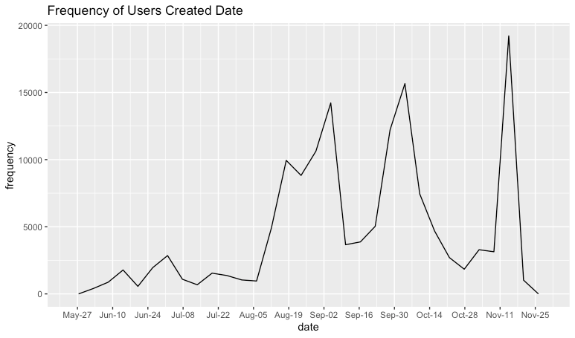

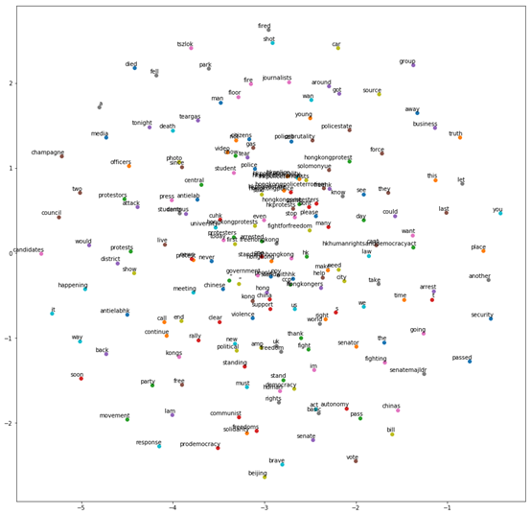
This is a t-SNE graph, which is showing the most common word of the text and the min_count is 4000. We can see that hkpoliceterrorism and standwithhongkong are very close, that indicates they appear near each other frequently. Other examples are hkprotest, stop and soshk.

Using the code “most_similar", we found that the following words have the highest probability with hkpoliceterrorism:
('hkpolicebrutality', 0.7589132785797119), ('hkpolicestate', 0.7112683653831482), ('helpus', 0.6904658675193787), ('hkpolicebrutalitiy', 0.6783536076545715),('hkpolicemurder', 0.668451189994812), ('protecthongkong', 0.6683769822120667)
The following words are the most similar with “standwithhongkong ":
('standwithhk', 0.56546950340271), ('ushongkongprostests', 0.5632084608078003),('fivedemandsnotoneless', 0.5478800535202026), ('fightforfreedom', 0.5474215745925903), ('postcards', 0.546220064163208), ('fightforfreedomstandwithhongkong', 0.537034809589386), ('standwithhong', 0.5357679128646851)

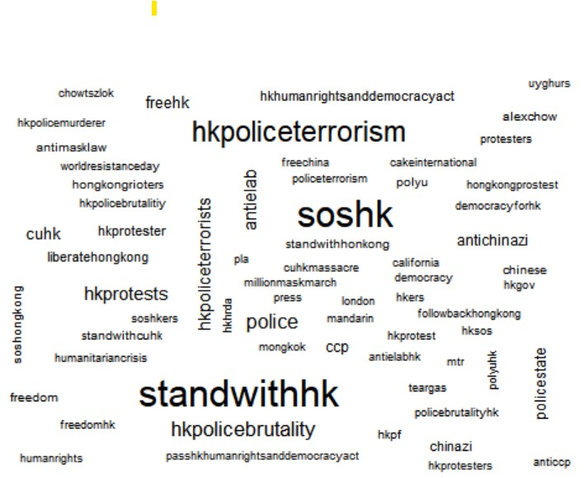
The word cloud shows the most common word of the hashtag, the result corresponds to t-SNE graph. The most common word of the hashtag is hkpoliceterrorism, standwithhk and soshk.

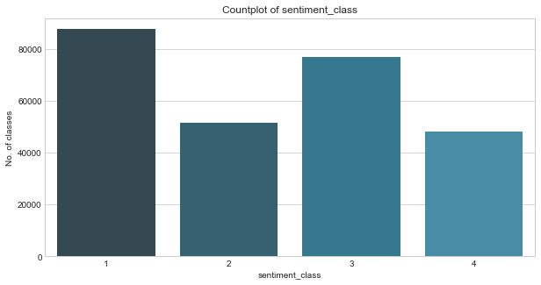
We divide the sentiment into 4 classes, level 1 is the most negative, and level 4 is the most positive.
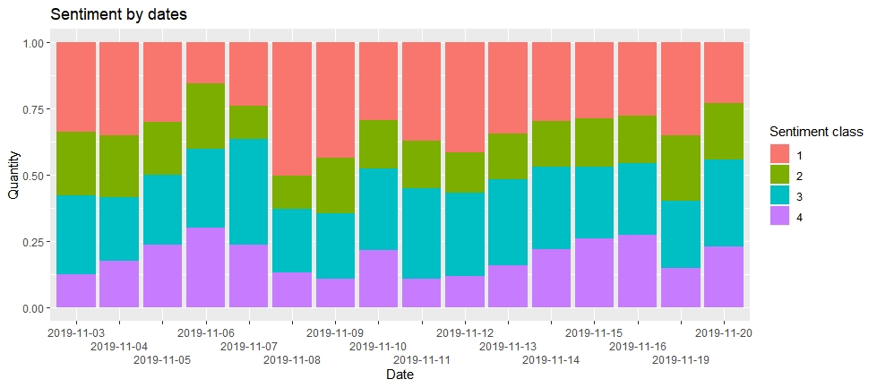
Network Analysis (Gephi- Keyword)
To understand the overall interaction of the 2019 Anti-ELAB movement through Twitter, we have attempted to utilize the Twitter Streaming Importer plugin for Gephi, and construct a user network through specifying the keyword in the tweets to replicate the interaction that was once appeared during the actual movement take place. The networks below used the “fruchterman reingold” layout in gephi with area set as 500 for better visualization.
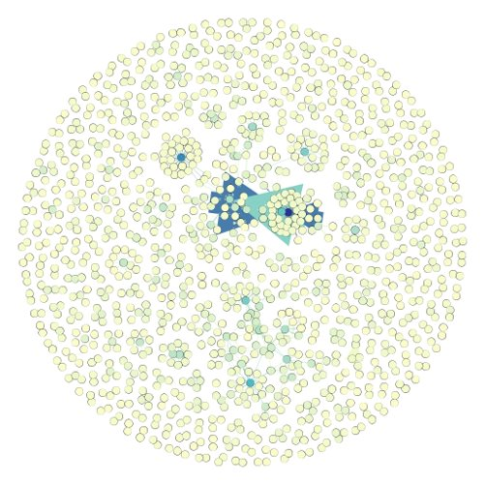
The figure below is the network using keywords such as ”China”, ”Hong Kong”, ”Hong Kong Protest”, ”AntiElab” etc. It is found that the word ”China” is too often used by non-Hong Kong protesters that the middle nodes are @llinwood and @realdonaldtrump, which have been mentioning China in a lot of occasion that does not directly related to the Anti-Elab protest.
On the other hand, the figure below is the network constructed by new keywords such as “721”, “831”, “polyusiege”, “cuhksiege”, “hkpolice” and removed “China”. This colors of this network’s edges have different meanings: Purple means mention; Orange means retweet and Green means quote.
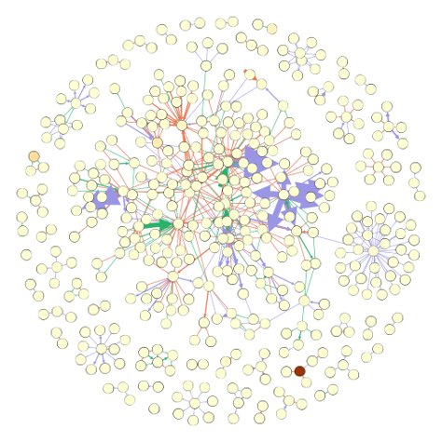
The new network resembles more of the actual network during the peak of the movement as many of the main actors are Hong Kong related. For example, @studioIncendo & @eileenechang are included in the network, which have over 30K followers and 10K followers respectively and they have taken in a more central position of the network. From their profile description, it is clearer that they are Hong Kong movement related.
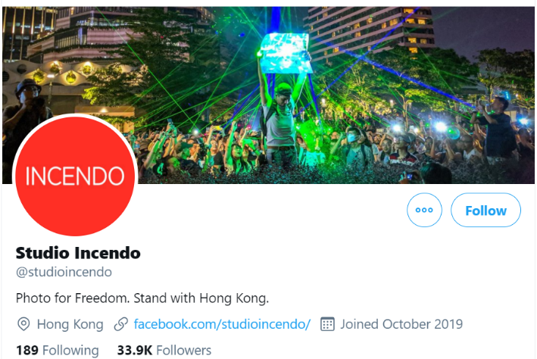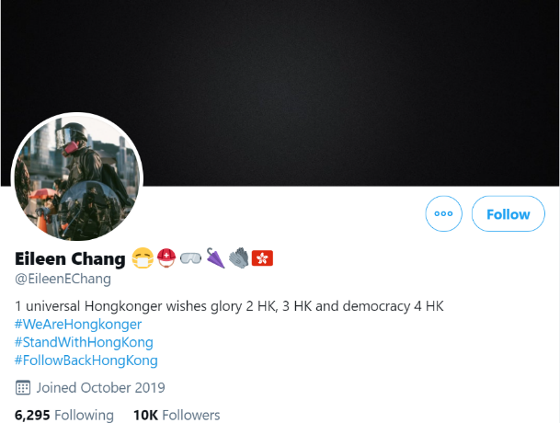
(Screenshot of the 2 major accounts in the new network)
From the result above, we can see that even though “China” itself is the indirect subject that protestors are against, the network shows that Hong Kong protestors are focusing more on incidents, slogans, and direct hatred rather than China.

Shared Audience graph
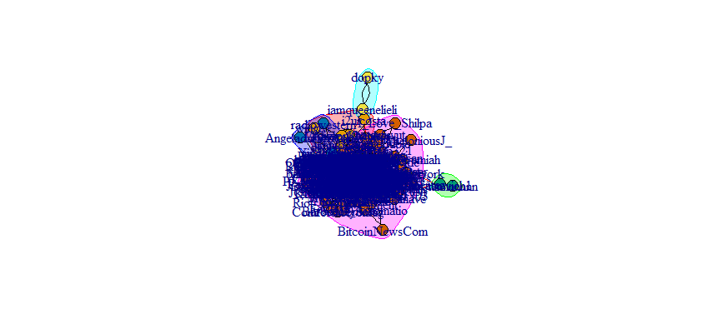
Here is the graph of shared audience graph, there exist 6 distinct communities within the 300 users in our sample. The number of members in the communities varies, with the largest group being group 6, having 176 members. Using the “community” function, we can see they list of members within this community.
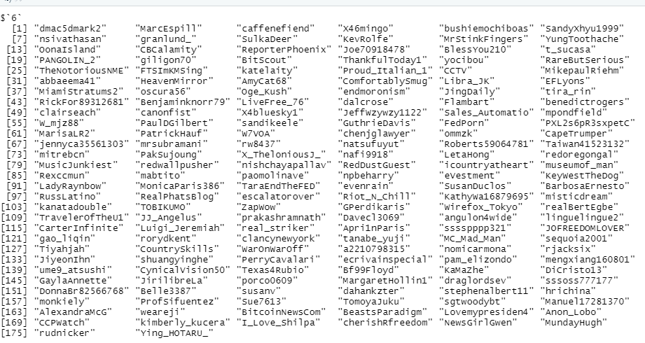

Retweet Network Analysis
For the general retweet among all users, the graph below shows that the retweet network is very concentrated and there are also stong relationships among clusters, meaning that the retweet network is concentrated and united, and users are also likely to retweet posts that do not belong to their cluster. However, there are also some users who are quite far away from the major cluster, the tweets they retweets are not actively retweeted by others.
The result below can also be found that users with more followers have played two major roles in the retweet network. For some of them, they are in the center of the cluster, who strengthens the cluster and becomes the major discussion in the cluster. Besides, there are also some influential users who are trying to retweet posts from other clusters and become the bridge between clusters that members from different clusters would also retweet their posts.
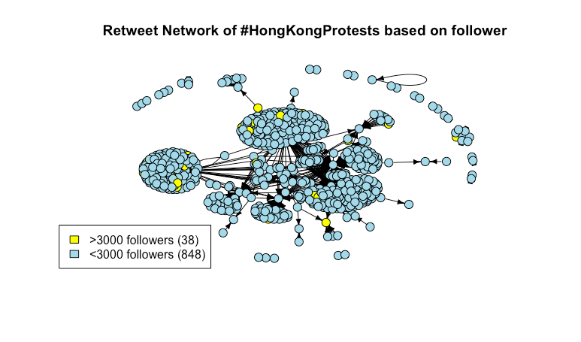
By going in-depth to the retweet network among those influential users, those 38 users can be classified into 8 clusters and the out-degree is not as high as expected (ranging from 0 to 3), which means that there is not much relationship among them in terms of retweeting with each other. However, the result shows that there are some users are at the center of the cluster but with a low out degree, meaning that they are just producing tweets for major discussion in the retweet network, but they are other users in the cluster are more responsible in retweeting those tweets and connecting with other clusters.

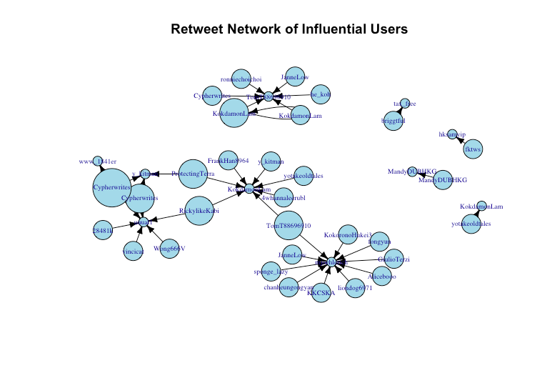

Discussion
We have attempted to use Text analysis and Network Analysis to study the dynamics and interaction of the Anti-ELAB movement based on the dataset we found. Even though the time period of the dataset is rather short, the date of the data gathered was at the peak of the Anti-Elab, during the siege of Polytechnic and Chinese university of Hong Kong (Hong Kong Free Press, 2020).
The shared audience network shows that there are a few distinct communities exist in this group of twitter users, even if many of the users here are having similar view on the issue. In the way forward, we can extract the users names of members belonging to the same community, and by retrieving their tweets, and doing by topic analysis, it is possible to know which topic numbers in this particular community are interested in. If we can retrieve their demographic data, we can know which demographic attributes are the most important in community forming, which would be useful for social movement leaders to know which kind of people are most easily influenced by them and easiest to mobilize.
Through sentiment analysis, we discovered that negative sentiment is the most common sentiment contained in the tweets. This aligns with the wordcount result that the most frequent words in the tweets are “soshk”, “hkpoliceterrorism”, “standwithhk”, which can be understand as the sign of asking for help and hope to gain international empathy through framing the Hong Kong police as brutal and representing terrorist. Such results demonstrated how social media can act as a platform for sharing grievances and seeking international support, which also aligns with the mechanism proposed before.
The result from word embedding suggested how the two most frequently used keywords: “hkpoliceterrorism” and “standwithhk” were associated with other words. It shows that the tweets from protestors may go in the either direction: framing and demonstrating how brutal Hong Kong polices were or gaining support from overseas, which also aligns with the previous findings.
The results from the overall network and the retweet network showed the interaction of twitter users, it is found that clusters are easily observable in any of the network, and that the interaction among the network is that main/influential actors provide information and other smaller users more engaging in retweeting.

Limitations
There are several limitations to the proposed methods and need further refinement.
Firstly, the networks constructed were only able to capture the current interactions of the accounts. It is due to the limitation of Twitter that it is not able to trace back in time and build the exact network that was appeared one year ago. A lot of the twitter account got deleted/ deleted by the owner as the fear of the national security law that was established in the summer of 2020. Nevertheless, the network above can be used as a proxy to understand interactions and key features of the network at that time, given that some of the accounts still remain to this day.
Secondly, this technical report only focuses on twitter but did not discuss other widely used social media such as online forum “LIHKG”, Facebook, instagram, and instant messaging app such as telegram which also gained huge popularity and more frequently used by the protestors than Twitter. This may cause biased and inaccurate results and not be able to fully explain the role of social media in the 2019 Anti-Elab movement. Such constraints meaning that future research is needed to fully explain the mechanism that social media brought to the movement.
Thirdly, the tweets mainly concerned English and neglected other languages. As Chinese is the mother tongue of most Hong Kong people, only analysing results from English tweets cannot capture the full picture. Especially in sentiment analysis, many of the users may express their grievances in Chinese and fail to fully capture in the current sentiment analysis, which may also skew the result. However, as many protestors only see Twitter as the channel to the outside (Wetzstein, 2017), they may not use Twitter frequently for information exchange and community building and instead use LIHKG and other platforms for these functions, which makes examining English alone still be able to capture part of the movement by analysing Twitter.
Last but not least, regarding shared audience network analysis, due to the limited time and man power we have, and also due to the fact that we would like the averages weights of edges to be higher, we have set the target population of this particular analysis to be twitter users with more than 300 followers. With this setting, we have screened out a large number of users in our list. The mean number of followers of the users whose tweets are scrapped by us, is 2654, but in fact this data is highly skewed. The median of no. Of followers is only 41, while the first quartile and third quartile being 4 and 269 respectively, which are both lower than the 300 threshold we have set. If time allows, lowering the threshold will make the result much more representative.

Reference
Chu, D.S. (2019). Media use and protest mobilization: A case study of umbrella movement within Hong Kong schools. Social Media + Society, 2018, 1 –11. doi: 10.1177/2056305118763350

Harlow, S. (2011). Social media and social movements: Facebook and an online Guatemalan justice movement that moved offline. New media & Society, 1 -19. Doi: 10.1177/1461444811410408

Hong Kong Free Press (28th November, 2020). One year on, the memory of Hong Kong PolyU’s protest battle is now under siege. Retrieved at 23rd December, 2020, from: https://hongkongfp.com/2020/11/28/one-year-on-the-memory-of-hong-kong-polyus-protest-battle-is-now-under-siege/

Hussain, M. M. & Howard, P. N. (2013). Information Technologies and the Fuzzy Causes of the Arab Spring. In Democracy’s Fourth Wave? Digital Media and the Arab Spring. (pp 47 - 68). New York City, NY: Oxford University Press.

Jost, J. T., Barbera, P., Bonneau, R., Langer, M., Metzger, M., Nagler, J., Sterling, J. & Tucker, J. A. (2019). How social media facilitates political protests: information, motivation, and social networks. Advances in Political Psychology, 39(1), 85 –117. doi: 10.1111/pops.12478

Keck, M.E. and Sikkink, K. (1999). Transnational advocacy networks in international and regional politics. International Social Science Journal, 51, 89-101. Doi: 10.1111/1468-2451.00179

Kidd, D. & Mclntosh, K. (2016). Social Media and Social Movements. Sociology Compass, 10(9), 785-794. doi: 10.1111/soc4.12399

Lee, F. (2020). Solidarity in the Anti-Extradition Bill Movement in Hong Kong. Critical Asian Studies, 52(1), 18 - 32. Doi: 10.1080/14672715.2020.1700629.
Lee, F., Chen, H.T. & Chan, M. (2017). Social media use and university students’ participation in a large-scale protest campaign: The case of Hong Kong’s Umbrella Movement. Telematics and Informatics, 34(2017), 457 – 469. Doi: 10.1016/j.tele.2016.08.005

Lee, F., Chen, H.T. & Chan, M. (2020). Social Media and Protest Attitudes During Movement Abeyance: A Study of Hong Kong University Students. International Journal of Communication, 14(2020), 4932–4951. Retrieved from: https://www.researchgate.net/publication/344298127_Social_Media_and_Protest_Attitudes_During_Movement_Abeyance_A_Study_of_Hong_Kong_University_Students.

Li, T., Ponnam, S., Gillham, P., Edwards, B. & Johnson, E. (2013, August 25th ). Analyzing the impact of social media on social movements: a computational study on Twitter and the Occupy Wall Street movement. Paper presented at the 2013 IEEE/ACM International Conference on advances in social networks analysis and mining, 1259-1266. Doi: 10.1145/2492517.2500262

Lynch, M. (2011). After Egypt: the limits and promise of online challenges to the authoritarian Arab state. Perspectives on Politics, 9(2), 301 – 310. doi:10.1017/S1537592711000910

Marzouki, Y., Hammoudi, H., Bejaoul, M. & Bellaj, T. (2012). The contribution of Facebook to the 2011 Tunisian revolution: a cyberpsychological insight. Cyberpsychology, Behavior, and Social Networking, 15(5), 237 – 244. doi: 10.1089/cyber.2011.0177

Mazzucelli, C. (2014). Humanitarian technologies and genocide prevention: a critical inquiry. Genocide Studies and Prevention: An International Journal, 8 (3), 87 - 99. Doi: 10.5038/1911-9933.8.3.8

Saunders, C. (2007). Using Social Network Analysis to explore social movements: a relational approach. Social Movement Studies, 6(3), 227 – 243. doi: 10.1080/14742830701777769
Shen, F., Xia, C. & Skoric, M. (2020). Examining the roles of social media and alternative media in social movement participation: A study of Hong Kong’s Umbrella Movement. Telematics and Informatics, 47(2020), 101303. Doi: 10.1016/j.tele.2019.101303

Stewart, L.G., Arif, A., Nied A. C.,Spiro E. S. & Starbird, K.(2017). Drawing the Lines of Contention: Networked Frame Contests Within #BlackLivesMatter Discourse. Proceedings of the ACM on Human-Computer Interaction, 1, 96. Doi: 10.1145/3134920

Tinata, R., Halford S., Carr L., Pope C. (2014) Big Data: Methodological Challenges and Approaches for Sociological Analysis. Sociology, 48(4), 663-681. doi: 10.1177/0038038513511561

Wetzstein, I. (2017). The Visual Discourse of Protest Movements on Twitter: The Case of Hong Kong 2014. Media and Communication, 5(4), 26 – 36. Doi: 10.17645/mac.v5i4.1020

Wolfsfeld, G., Segev, E. & Sheafer, T. (2013). Social Media and the Arab Spring: Politics Comes First. The international journal of Press/Politics, 18(2), 115 – 137. Doi: 10.1177/1940161212471716

Xiong, Y., Cho, M. & Boatwright, B. (2019). Hashtag activism and message frames among social movement organizations: Semantic network analysis and thematic analysis of Twitter during the #MeToo movement. Public Relations Review, 45, 10 –23. Doi: 10.1016/j.pubrev.2018.10.014.

