**Competitive Adsorption of Nitrogen and Hydrogen on Catalyst Surfaces: Implications for Optimizing Ammonia Synthesis**

Honghyun Kim

1. **Introduction**

The Haber-Bosch process is an important industrial method for ammonia synthesis, utilizing the high-pressure catalytic reaction of nitrogen and hydrogen gases1. Central to optimizing this reaction is understanding the competitive adsorption behavior of nitrogen and hydrogen on the catalyst surface2. Adsorption dynamics directly impact the rate and efficiency of ammonia formation, with nitrogen and hydrogen competing for active sites on the catalyst. This competitive behavior, influenced by chemical potentials and interatomic interactions, plays a significant role in determining the overall efficacy of the ammonia synthesis process.

Catalytic surfaces display a complex interaction landscape, where adsorption energies and interaction forces between adsorbates shape the coverage patterns and reactivity3. To optimize the conditions for ammonia synthesis, it is essential to systematically study the adsorption and interaction behavior of nitrogen and hydrogen under various conditions including temperature and pressure4. In addition, examining how adsorption behaviors change with variations in chemical potential and interaction energies can reveal critical insights into maximizing surface availability for ammonia production.

Therefore, in this report, we employed a grand canonical Monte Carlo (GCMC) simulation to model the competitive adsorption of nitrogen and hydrogen on a 2D square lattice, mimicking the catalyst surface in a controlled and systematic manner. We changed the chemical potential of hydrogen, keeping nitrogen in excess, to investigate a range of chemical environments. A series of parameter sets is tested, representing ideal mixing, repulsive interactions, attractive interactions, immiscibility, and a scenario where "like dissolves unlike." By exploring these interaction conditions, we aimed to elucidate how the property of adsorbate interactions impacts coverage patterns. Based on the results, we assumed the ammonia synthesis efficiency through constructing phase diagrams that highlight the coverage states of nitrogen and hydrogen under each interaction scenario. We further interpret the lattice configurations to discuss how competitive adsorption behaviors influence catalyst performance and ammonia synthesis rates. These findings provide practical insights for adjusting reaction conditions to favor optimal coverage, ultimately informing strategies to enhance the efficiency of the Haber-Bosch process.

1. **Methodology**

We modeled the competitive adsorption behavior of nitrogen and hydrogen on a two-dimensional lattice to simulate different interaction conditions relevant to the ammonia synthesis process. To examine diverse adsorption behaviors, we investigated five interaction scenarios. Specifically, the ideal mixture scenario modeled nitrogen and hydrogen as non-interacting particles, serving as a baseline for comparison. The repulsive interactions scenario introduced an energetic penalty when adjacent particles were of the same type, thereby discouraging clustering. For attractive interactions, the configuration was set to favor aggregation, encouraging clusters of like particles. In the immiscible scenario, phase separation was promoted, resulting in distinct domains of nitrogen and hydrogen on the lattice. Finally, the “like dissolves unlike” condition represented selective adsorption, with differential affinities between nitrogen and hydrogen to mimic heterogeneous adsorption tendencies. The detailed values of parameters are shown in **Table 1**.

**Table 1**. Five interaction scenarios for investigating competitive adsorption

|  |  |  |  |  |  |
| --- | --- | --- | --- | --- | --- |
| **Cases** |  |  |  |  |  |
| Ideal Mixture of Nitrogen and Hydrogens | -0.1 eV | -0.1 eV | 0 eV | 0 eV | 0 eV |
| Repulsive Interactions between Nitrogen and Hydrogen | -0.1 eV | -0.1 eV | 0.05 eV | 0.05 eV | 0.05 eV |
| Attractive Interactions between Nitrogen and Hydrogen | -0.1 eV | -0.1 eV | -0.05 eV | -0.05 eV | -0.05 eV |
| Immiscible Nitrogen and Hydrogen | -0.1 eV | -0.1 eV | -0.05 eV | -0.05 eV | 0.05 eV |
| Like Dissolves Unlike | -0.1 eV | -0.1 eV | 0.05 eV | 0.05 eV | -0.05 eV |

Simulations were conducted over a temperature range of 0 to 300 K to capture the effects of thermal fluctuations on adsorption patterns. The chemical potential of adsorbate A (μA​) was varied from -0.2 eV to 0 eV to explore its influence on the adsorption affinities of nitrogen and hydrogen. The lattice size was set as 20 x 20 to fully understand the competitive adsorption behavior. The phase diagrams generated for each set of interaction conditions quantified adsorption occupancy fractions, while lattice configurations visually demonstrated the spatial adsorption patterns on the catalyst surface.

1. **Results and discussion**
   1. **Ideal Mixture Scenario**

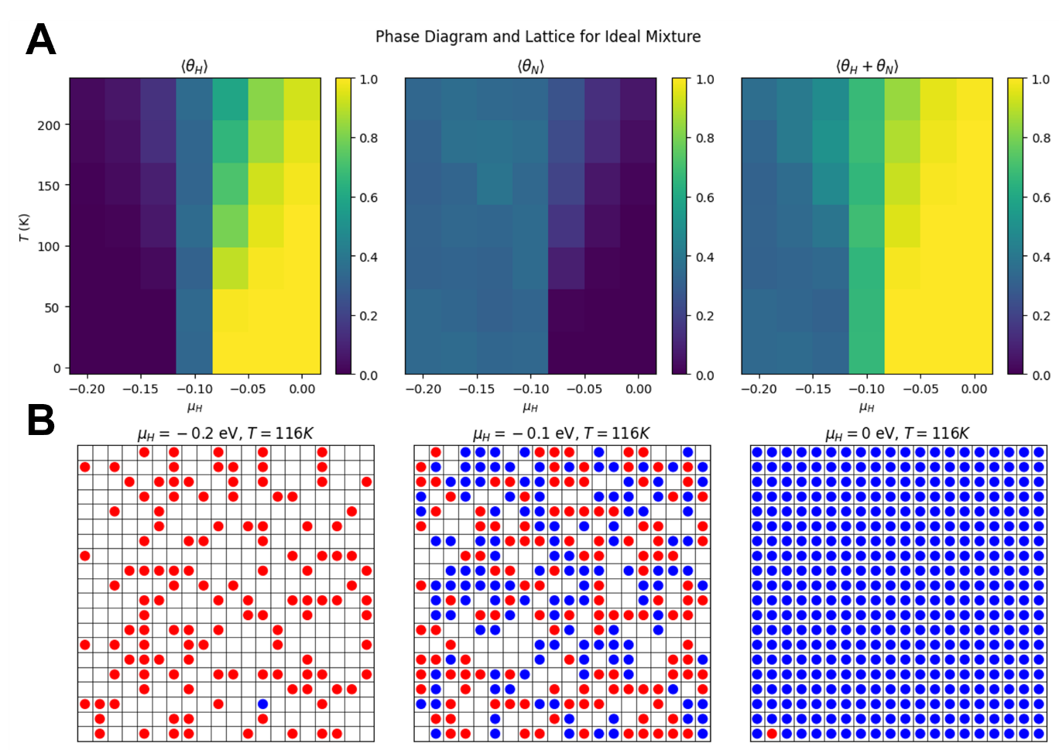

**Figure 1**. (A) Phase diagram and (B) lattice for ideal mixture. The red circle denotes nitrogen and blue circle denotes hydrogen.

The result of the ideal mixture scenario is shown in **Figure 1**. As a result of simulation, the hydrogen adsorption increases as the chemical potential (μH) becomes more positive. High adsorption is observed when μH approaches 0 eV, indicating that hydrogen is highly responsive to increases in chemical potential (**Figure 1A**). This suggests that hydrogen’s affinity for the lattice rises because its chemical potential becomes more favorable. However, as temperature rises, hydrogen adsorption decreases due to thermal desorption. The added thermal energy promotes desorption, reducing hydrogen coverage. In contrast, nitrogen adsorption remains relatively low compared to hydrogen across the range of μH values. As μH becomes more positive, hydrogen adsorption outcompetes nitrogen for lattice sites (**Figure 1B**). Nitrogen coverage only increases when μH is lower, reflecting nitrogen's preference for the lattice in the absence of competitive hydrogen adsorption.

* 1. **Repulsive Interactions Scenario**

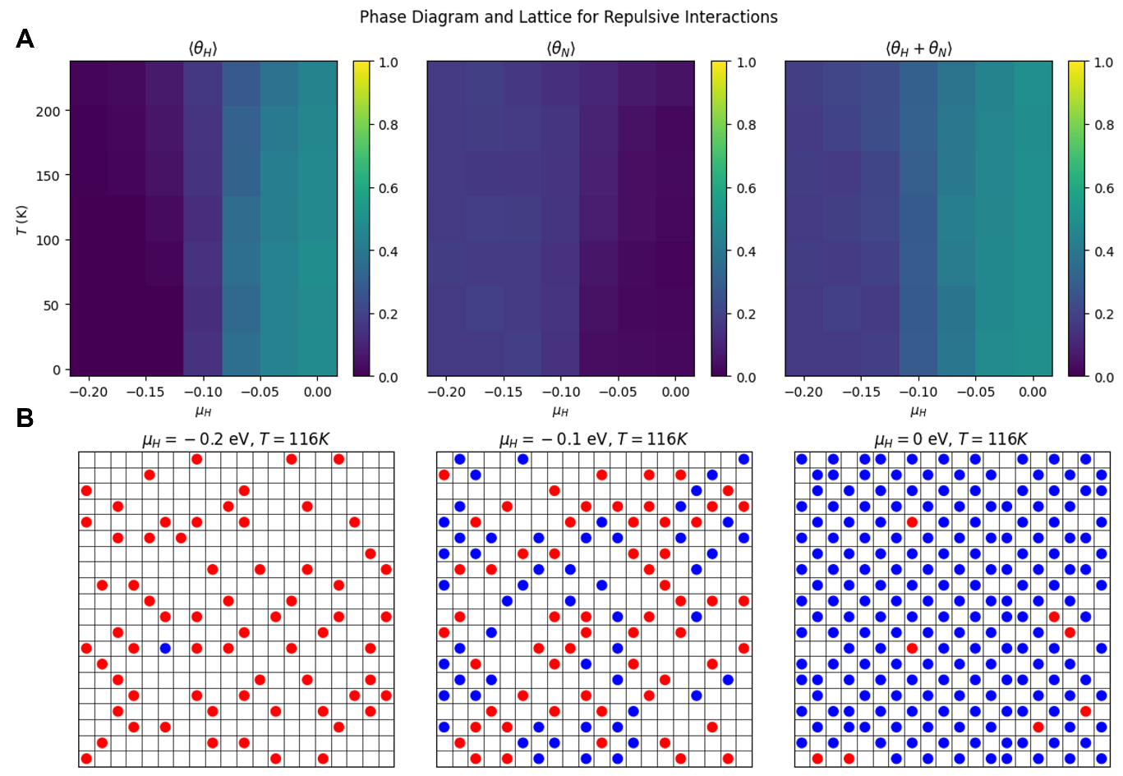

**Figure 2**. (A) Phase diagram and (B) lattice for repulsive interactions. The red circle denotes nitrogen and blue circle denotes hydrogen.

The results in **Figure 2** shows hydrogen and nitrogen adsorption behavior on a lattice with repulsive interactions between the adsorbates. The top row presents phase diagrams for hydrogen ⟨θH⟩, nitrogen ⟨θN⟩, and their combined coverage ⟨θH+θN⟩ across a range of hydrogen chemical potentials (μH) and temperatures (T). The bottom row displays the lattice configurations at specific values of μH​ and T, providing a visual representation of how the adsorbates distribute on the lattice under different conditions.

The hydrogen, nitrogen, and combined coverage diagrams are shown in **Figure 2A.** The phase diagram of hydrogen coverage ⟨θH⟩ increases as μH​ becomes more positive, especially at low temperatures, indicating that hydrogen adsorption is highly sensitive to changes in chemical potential. As temperature rises, the hydrogen coverage decreases, showing the effect of thermal desorption. Nitrogen coverage ⟨θN⟩ remains low across the range of μH​ values, reflecting its lower affinity for the lattice compared to hydrogen. Only at very low μH ​and low temperatures does nitrogen adsorption slightly increase, as hydrogen becomes less competitive for adsorption sites. The combined coverage ⟨θH+θN⟩ shows that hydrogen tends to dominate the lattice, particularly when μH​ is closer to 0 eV, outcompeting nitrogen for adsorption sites.

The lattice configurations provide further insight into these trends (**Figure 2B**). At μH = −0.2 eV and T=116 K, nitrogen atoms are sparsely distributed, with one hydrogen atom appearing in isolated positions. As μH increases to -0.1 eV, more hydrogen atoms appear on the lattice and the availability of sites for nitrogen was reduced. Finally, at μH=0 at the same temperature, the lattice becomes densely populated with hydrogen, leaving very few sites for nitrogen.

These results highlight that, under repulsive interactions, hydrogen shows a strong preference for adsorption at more favorable chemical potentials. Nitrogen only adsorbs significantly when hydrogen’s chemical potential is low. The competition between hydrogen and nitrogen for lattice sites becomes evident, especially as temperature rises and promotes thermal desorption. This combination of competitive adsorption and thermal effects shapes the adsorption landscape for both species.

* 1. **Attractive Interactions Scenario**

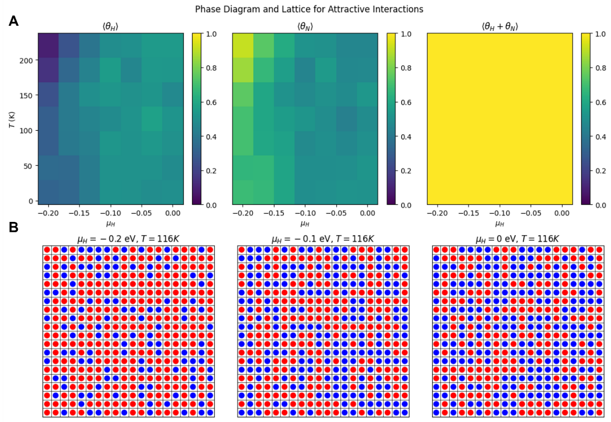

**Figure 3**. (A) Phase diagram and (B) lattice for attractive interactions. The red circle denotes nitrogen and blue circle denotes hydrogen.

In the case of attractive interactions, the results reveal different adsorption behavior for hydrogen and nitrogen on the lattice. The top row shows phase diagrams and the bottom row presents lattice configurations at specific values of μH and T=116 K.

The hydrogen, nitrogen, and combined coverage diagrams are shown in **Figure 3A**. In the phase diagram for hydrogen coverage ⟨θH⟩, the adsorption is moderate across a range of μH values at low temperatures (**Figure 3A**). This suggests that hydrogen adsorbs well due to attractive interactions, filling available sites more effectively. As temperature increases, hydrogen adsorption decreases slightly, indicating the onset of desorption. The nitrogen coverage phase diagram ⟨θN⟩ shows similar behavior. Nitrogen adsorption is also moderate at low temperatures across various μH values. It reflects a strong tendency to adsorb due to attractive interactions. However, in the attractive interaction case, both hydrogen and nitrogen have an inherent tendency to adsorb and stabilize on the lattice. When hydrogen adsorption is less favorable due to the low μH​, nitrogen can take advantage of the available sites and adsorb more readily. Thus, the attractive interactions allow nitrogen to increase its coverage on the lattice in conditions where hydrogen is not as competitive.

The combined coverage phase diagram ⟨θH+θN⟩ support this phenomenon. It is saturated at high values across all μH​ and T ranges. This high combined coverage suggests that both hydrogen and nitrogen can coexist on the lattice without significant competition due to the attractive interactions, which promote full lattice occupancy.

The lattice configurations further support these observations (**Figure 3B**). At μH=−0.2 eV and T=116 K, the lattice shows a balanced distribution of nitrogen and hydrogen, indicating high adsorption for both species. As μH increases to -0.1 eV, both gases remain highly adsorbed, maintaining nearly full lattice coverage. At μH=0 eV, the lattice is densely occupied by both gases, showing a mixed but stable pattern due to the attractive forces.

To sum up, the attractive interactions enable both hydrogen and nitrogen to adsorb efficiently at low and moderate μH​ values. The high coverage across the lattice, even at elevated temperatures, demonstrates the impact of attractive interactions in stabilizing both gases on the lattice.

* 1. **Immiscible Scenario**

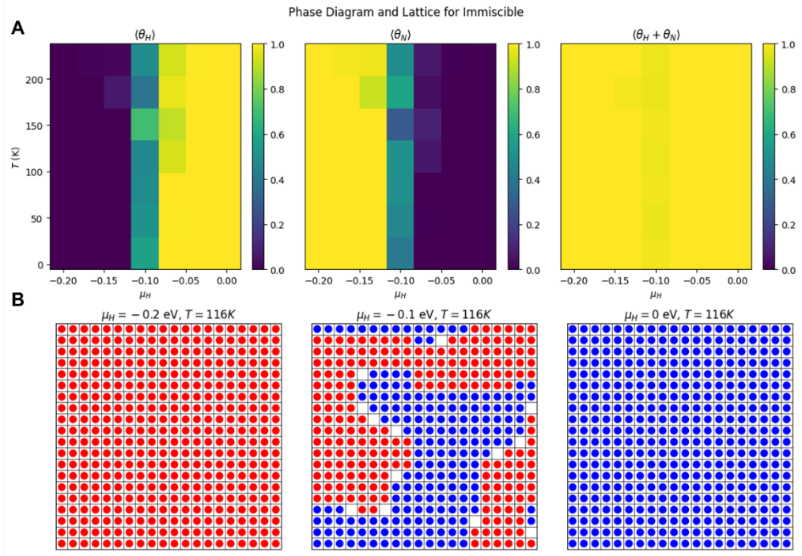

**Figure 4**. (A) Phase diagram and (B) lattice for immiscible case. The red circle denotes nitrogen and blue circle denotes hydrogen.

In the immiscible case, the results show distinct adsorption behavior for hydrogen and nitrogen, with minimal mixing on the lattice. The top row displays phase diagrams and the bottom row presents the lattice configurations at specific values of μH and T=116 K.

The hydrogen, nitrogen, and combined coverage diagrams are shown in **Figure 4A.** In the phase diagram for hydrogen coverage ⟨θH⟩, adsorption increases as μH becomes more positive, especially at low temperatures. Hydrogen coverage reaches high levels when μH​ is closer to 0 eV, indicating that hydrogen adsorbs strongly when its chemical potential is favorable. As temperature rises, hydrogen adsorption decreases due to thermal desorption. The nitrogen coverage phase diagram ⟨θN⟩ shows a similar trend, with high nitrogen coverage at lower μH​ values and low temperatures. As μH​ increases, hydrogen begins to outcompete nitrogen, reducing nitrogen coverage on the lattice. At μH = −0.1 eV, the coverage values of hydrogen and nitrogen become nearly equal, leading to direct competition for lattice sites. This balance reflects the tendency of both gases to adsorb at similar levels when neither has a significant chemical potential advantage. The combined coverage phase diagram ⟨θH+θN⟩ reveals that the lattice is fully occupied across all μH​ and T values. However, the lattice configurations in the bottom row show that hydrogen and nitrogen do not mix. Instead, they form distinct clusters, reflecting their immiscible behavior.

In the lattice configurations, at μH=−0.2 eV, nitrogen occupies most of the lattice, while hydrogen appears in isolated clusters. As μH increases to -0.1 eV, hydrogen coverage expands, leading to more clustering and a decrease in nitrogen coverage. By μH=0 eV, hydrogen dominates the lattice (**Figure 4B**).

These results highlight the immiscibility of hydrogen and nitrogen on the lattice. Each gas prefers to cluster with its own kind rather than mix. This behavior is driven by the repulsive interactions between hydrogen and nitrogen, causing them to form distinct domains even when both adsorb on the lattice.

* 1. **Like Dissolves Unlike Scenario**

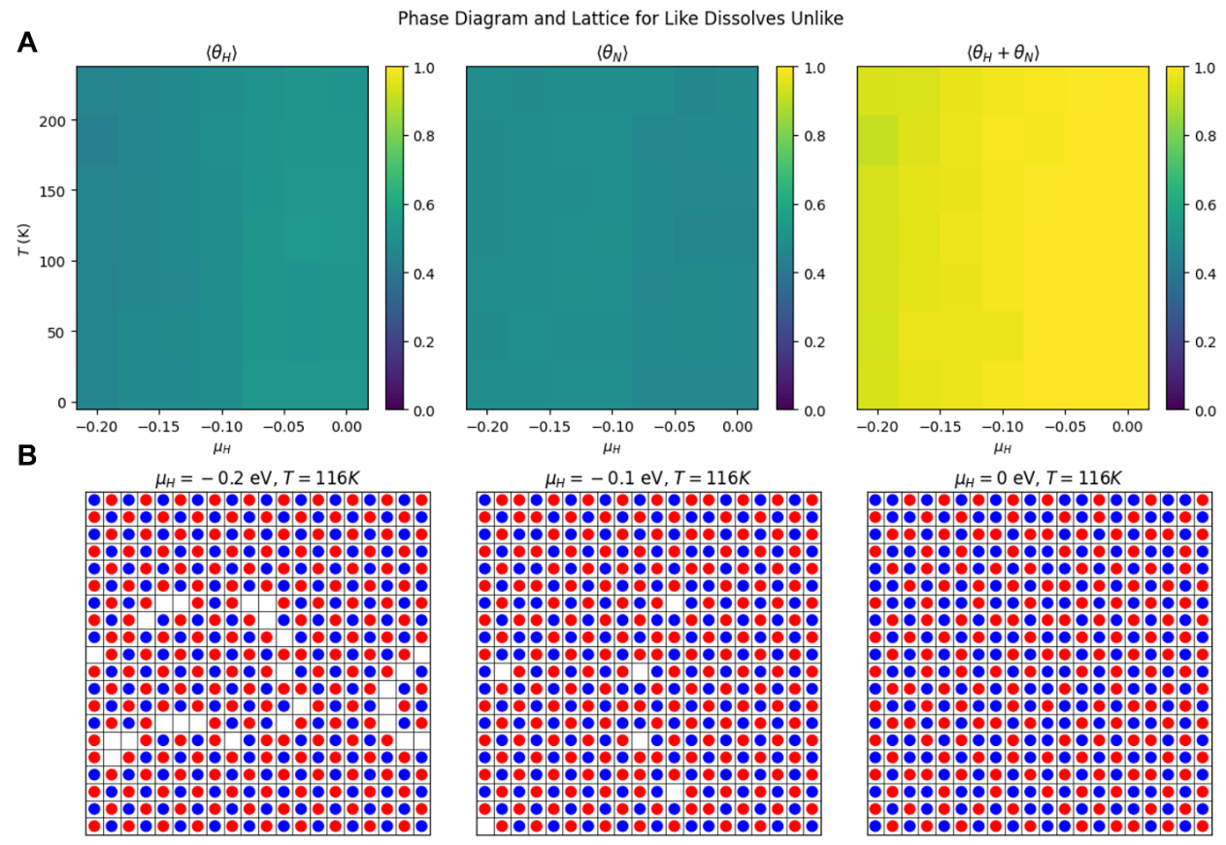

**Figure 5**. (A) Phase diagram and (B) lattice for “Like Dissolves Unlike” case. The red circle denotes nitrogen and blue circle denotes hydrogen.

In the "like dissolves unlike" case, the results show distinct adsorption patterns for hydrogen and nitrogen with a tendency for each species to avoid clustering with itself. The top row displays phase diagrams and the bottom row presents the lattice configurations at specific values of μH and T=116 K.

The hydrogen, nitrogen, and combined coverage diagrams are shown in **Figure 5A.** In the hydrogen coverage phase diagram ⟨θH⟩, hydrogen adsorption increases slightly as μH becomes more positive. This indicates that hydrogen coverage responds to favorable chemical potentials, but not to the extent seen in previous cases. The coverage remains relatively consistent, showing moderate adsorption levels at low temperature condition. The nitrogen coverage phase diagram ⟨θN⟩ shows a similar trend. Nitrogen adsorbs across the lattice and is only moderately affected by changes in μH​. Both gases maintain a steady presence on the lattice as temperature remains low. The combined coverage phase diagram ⟨θH+θN⟩ is nearly saturated across all μH​ values at low temperatures, indicating that both gases are adsorbing to nearly fill the lattice. However, unlike in previous cases, hydrogen and nitrogen do not cluster with themselves; instead, they mix more evenly, consistent with the "like dissolves unlike" interaction.

The lattice configurations reveal this behavior (**Figure 5B**). At μH=−0.2 eV, hydrogen and nitrogen are interspersed rather than forming clusters. This pattern suggests that each gas prefers to avoid neighboring atoms of the same type, resulting in a more mixed distribution. As μH increases to -0.1 eV and 0 eV both gases maintain an even distribution across the lattice.

Overall, the "like dissolves unlike" interaction promotes a dispersed, mixed adsorption pattern for hydrogen and nitrogen. Both gases achieve high coverage but avoid clustering with their own kind, leading to a more homogeneous distribution across the lattice.

* 1. **Comparison Among Parameter Sets**

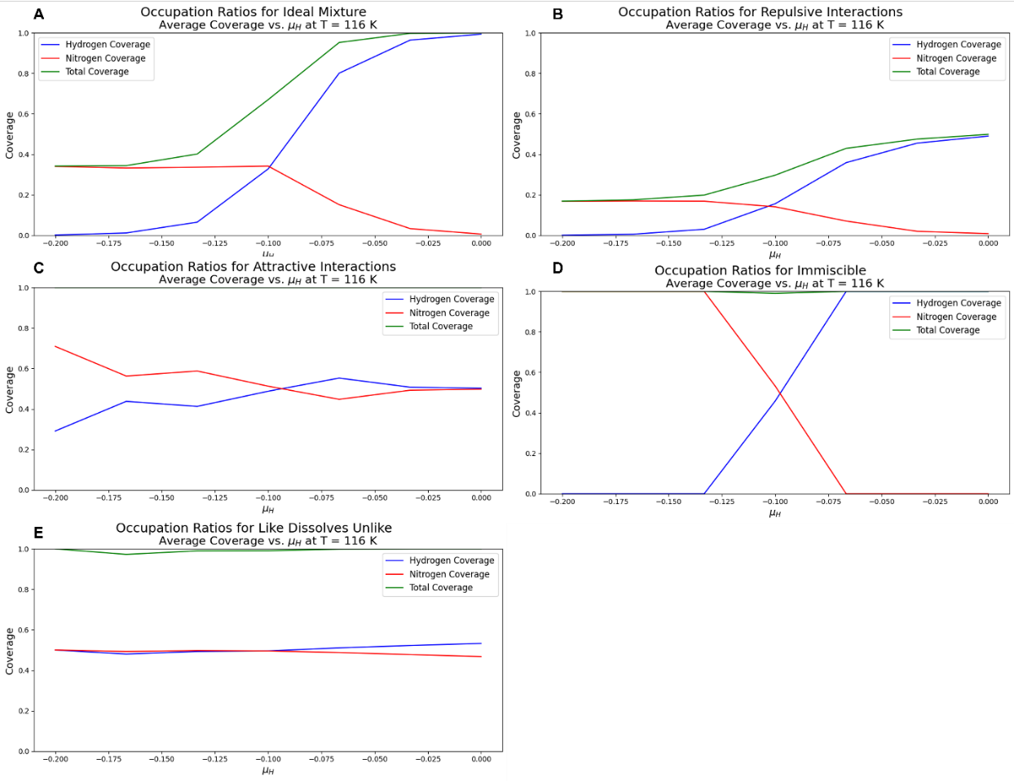

**Figure 6**. Occupation ratios for (A) ideal mixture (B) repulsive interaction (C) attractive interaction (D) immiscible case, and (E) like dissolves unlike case.

**Figure 6** shows the occupation ratios for each scenario and how interaction energies change the adsorption behavior of hydrogen and nitrogen on the surface, with each parameter set showing distinct coverage trends. In the Ideal Mixture case (**Figure 6A**), the graph shows that as μH increases from -0.2 to 0, hydrogen coverage rises sharply, eventually reaching nearly full coverage (~1.0). However, the nitrogen coverage declines to near zero. This pattern indicates independent adsorption behavior, with hydrogen fully occupying the surface at high μH values due to the absence of interaction energies affecting response of each gas. In the Repulsive Interactions scenario (**Figure 6B**), hydrogen coverage increases more gradually, peaking at around 0.4. However, the nitrogen coverage declines steadily, maintaining a presence on the surface even as μH rises. This gradual change reflects the influence of repulsive forces, which limit hydrogen’s ability to fully dominate the surface, resulting in a lower total coverage compared to the Ideal Mixture case. For Attractive Interactions **(Figure 6C)**, the graph shows that hydrogen and nitrogen coverage levels converge around μH = -0.1, with each species stabilizing at roughly 0.5 coverage as μH increases. This behavior results from attractive forces between hydrogen and nitrogen, which stabilize their co-adsorption and prevent either gas from fully displacing the other, leading to a balanced total coverage close to 1.0. The Immiscible case exhibits a clear phase separation (**Figure 6D**), as seen in the sharp transition in coverage. Hydrogen coverage rises rapidly to 1.0 as μH increases from -0.15, while nitrogen coverage drops to zero, indicating that one gas completely displaces the other on the surface at certain μH values. This behavior aligns with phase-separation principles, with strong immiscibility leading to full coverage by a single species depending on μH. In the Like Dissolves Unlike scenario (**Figure 6E**), the graph shows that hydrogen and nitrogen maintain nearly equal coverage (~0.5 each) across the entire μH range. This stable coexistence reflects similar affinities for the surface, creating a balanced adsorption environment that promotes consistent co-coverage. The total coverage remains around 1.0, indicating that both gases share the surface without significant displacement.

* 1. **Implications for Ammonia Synthesis**

The results offer valuable insights for optimizing ammonia synthesis, particularly for the Haber-Bosch process, where efficient adsorption of nitrogen and hydrogen on catalyst surfaces is crucial. The **Ideal Mixture** scenario shows that excessive hydrogen adsorption at high μH can prevent the adsorption of nitrogen to the surface, potentially slowing the reaction. In contrast, **Repulsive Interactions** can limit hydrogen coverage, preventing hydrogen poisoning and maintaining available sites for nitrogen. The **Attractive Interactions** case, where hydrogen and nitrogen co-adsorb at balanced levels, represents an ideal condition for ammonia synthesis, ensuring both gases are available on the catalyst surface in sufficient quantities for efficient reaction rates. The **Immiscible** scenario, with phase separation and complete displacement of nitrogen by hydrogen, would be detrimental, leading to a shortage of nitrogen on the surface. Finally, the **Like Dissolves Unlike** case, where both gases maintain stable and similar coverage, provides another optimal condition by supporting steady reaction rates and consistent catalyst utilization.

To enhance ammonia synthesis, several optimization strategies can be applied. Controlled hydrogen coverage can prevent hydrogen from dominating adsorption sites. This could be achieved by modifying the catalyst surface. Specifically, promoters for balanced co-adsorption can improve reaction efficiency. These promoters, inspired by the Attractive Interactions scenario, enhance the affinity between nitrogen and hydrogen on the surface. For example, Ye et al. advanced their research with the Ni–CeN catalyst, achieving an activity of 6500 μmol g⁻¹ h⁻¹ at 400°C and 0.9 MPa, with a WHSV of 36,000 mL g⁻¹ h⁻¹. In this system, nitrogen vacancies in CeN activate N₂, while Ni facilitates H₂ activation. Unlike conventional catalysts with a promoter, this cocatalyst system allows each component to perform a distinct role, with strong hydrogen adsorption energy of Ni (1.30 eV compared to CeN’s 0.62 eV) enabling efficient H₂ dissociation5. In addition, minimizing phase separation effects can be also achieved by adjusting catalyst properties. This adjustment ensures that both gases remain accessible without one displacing the other. Finally, modifying the catalyst surface for stable coexistence can ensure balanced adsorption of both gases. This can be achieved through alloying or specific surface treatments, as shown in the Like Dissolves Unlike scenario. These strategies provide insights for enhancing ammonia production efficiency in industrial settings, potentially maximizing yield and reducing energy consumption in the Haber-Bosch process.

1. **Conclusion**

In conclusion, the adsorption behaviors observed across different interaction scenarios provide critical insights for optimizing ammonia synthesis. The Ideal Mixture and Immiscible scenarios highlight the risks of unbalanced adsorption, where excessive hydrogen coverage or phase separation can hinder nitrogen availability on the catalyst surface. In contrast, the Attractive Interactions and Like Dissolves Unlike scenarios reveal conditions where both gases achieve stable co-adsorption, supporting efficient reaction rates essential for the Haber-Bosch process.

To leverage these findings, practical optimization strategies include controlling hydrogen coverage, promoting balanced co-adsorption, minimizing phase separation, and ensuring stable coexistence through surface modifications or alloying. These approaches could enhance catalyst efficiency, sustain balanced adsorption, and ultimately improve ammonia production rates. Implementing these strategies in industrial settings offers a pathway to maximizing yield and energy efficiency in ammonia synthesis.

1. **References**

(1) Liu, H. *Ammonia synthesis catalysts: innovation and practice*; World Scientific, 2013.

(2) Liu, H.; Li, Y.; Wu, H.; Liu, J.; He, D. Cuihua Xuebao/Chinese J. *Catal* **2014**, *35*, 1619-1640.

(3) Liu, H. Ammonia synthesis catalyst 100 years: Practice, enlightenment and challenge. *Chinese journal of catalysis* **2014**, *35* (10), 1619-1640.

(4) Elvers, B. *Ullmann's encyclopedia of industrial chemistry*; Verlag Chemie Hoboken, NJ, 1991.

(5) Ye, T.-N.; Park, S.-W.; Lu, Y.; Li, J.; Sasase, M.; Kitano, M.; Hosono, H. Contribution of nitrogen vacancies to ammonia synthesis over metal nitride catalysts. *Journal of the American Chemical Society* **2020**, *142* (33), 14374-14383.