**Achieving Maximum Photothermal Membrane Distillation Efficiency by Controlling Convective Heat Transfer Coefficient**

Honghyun Kim

1. **Introduction**

As the world's population continues to grow, economic development, and quality of life increase, people's water use is rapidly increasing [1]. For this reason, we are developing technologies that can supply a lot of fresh water, and seawater desalination technology such as reverse osmosis (RO) is being widely used. However, the problem of brine release after seawater desalination and treatment and energy use for fresh water production are still problems in terms of sustainable development potential. To overcome these limitations, membrane distillation (MD) technology using solar energy has been proposed as an alternative to RO. Interfacial photothermal desalination, which uses abundant sunlight to produce potable water, has received increased attention as a sustainable technique [2]. Unlike conventional desalination, it harnesses a photothermally-active membrane to localize photothermally generated heat at the membrane’s surface. One of the interfacial photothermal desalination method is the photothermal membrane distillation (PMD). PMD involves a hydrophobic membrane that is only vapor-permeable and is integrated with a vapor trapping system [3,4]. The temperature gradient created by photothermal heating creates a vapor pressure difference, driving vapor transport through the membrane to the permeate side, where it condenses (Figure 1).

**PMD**

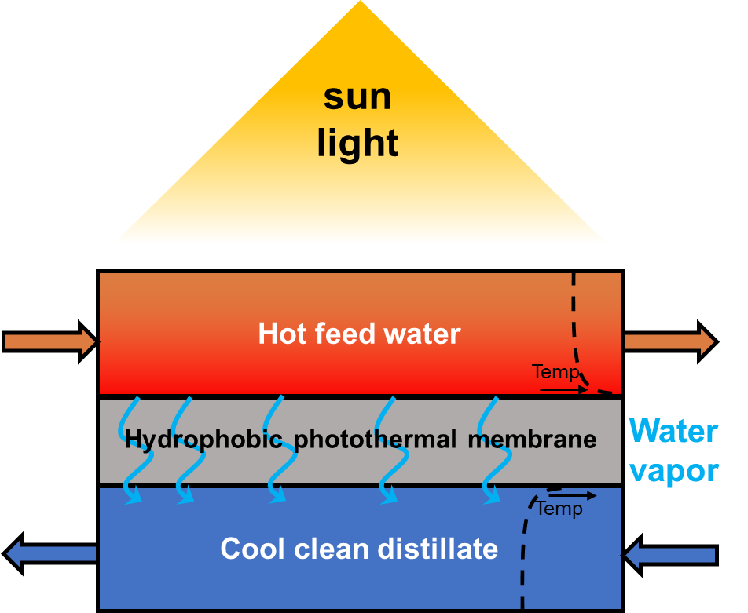

Figure 1. Schematic diagram of photothermal membrane distillation system

In PMD system, bulk feedwater is typically pumped to the photothermal membrane, so PMD can treat the saline water on a larger scale than other interfacial photothermal desalination methods (solar steam generation and interfacial solar still). In addition, it can be operated under relative low temperature feed water (30-90℃) by utilizing solar energy and it needs lower pressures than conventional reverse osmosis system. It means the low consumption of electricity and economical benefit. To evaluate the efficiency of various PMD conditions, thermal efficiency in a PMD system is defined as [5]:

$η=\frac{\dot{m}H_{vap}}{I}$ (Eq. 1)

Where $\dot{m}$ is the permeate flux (kg/ m2h), Hvap is the evaporation enthalpy change of water (2454 kJ/kg), and I is the total energy input by solar irradiation (kJ/m2h). The permeate flux can be obtained by dividing the pure water weight obtained during operating the PMD system by the area of ​​the surface area through which the feedwater passes and the elapsed time. To enhance the thermal efficiency of PMD system, it is important to increase the permeate flux $\dot{m}$ by reducing the temperature polarization (Figure 2).

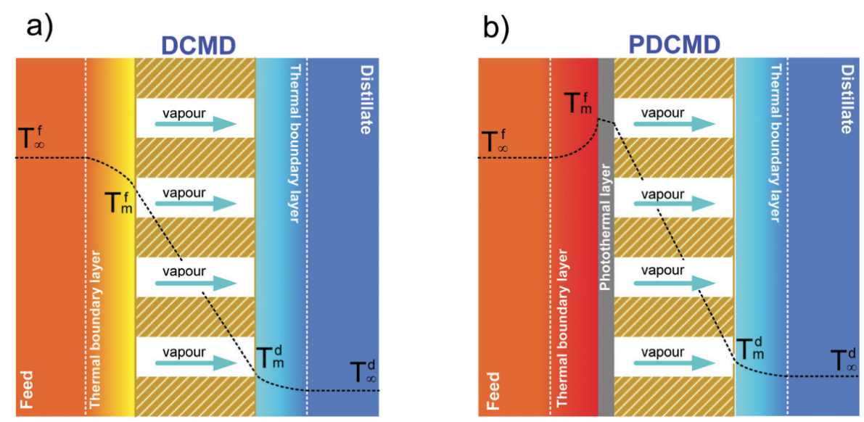

**Figure 2.** Temperature polarization in (a) conventional MD and (b) PMD [6]

Temperature polarization in photothermal membrane distillation refers to the phenomenon where there is a temperature difference across the membrane during the distillation process. It typically occurs because of variations in temperature along the membrane surface. This can affect the efficiency and performance of PMD, potentially leading to reduced productivity or lower quality of the distilled product. One of the factors affecting the temperature polarization is the heat transfer (or heat loss) from the membrane surface to the bulk feedwater. At the surface of the photothermal membrane, the heat is convectively transferred to the bulk feedwater can be expressed as

${Q_{1}}^{i}={h_{conv, ms}}^{i}\left({T_{hm}}^{i}-{T_{hb}}^{i}\right),$ (Eq. 2)

where $h_{conv, ms}$ is the convective coefficient from the membrane surface to the bulk feedwater, and ${T_{hm}}^{i}$ is the surface temperature of the membrane. The heat convective coefficient ($h_{conv, ms}$) can be calculated through the Nusselt correlation:

${h_{conv, ms}}^{i}=\frac{{Nu}^{i}×k^{i}}{D_{h}}$, (Eq. 3)

Where ${Nu}^{i}$ and $k^{i}$ are the Nusselt number and the thermal conductivity of the feedwater of slice I, and $D_{h}$ is the hydraulic diameter. The Nusselt number is a function of the salinity and temperature of the feedwater, and this can be obtained with a series of equations found in [7]:

${Nu}^{i}=0.332×{{Re}_{x}}^{1/2}×{Pr}^{1/3}$, (Eq. 4)

$Re=\frac{{ρ_{s}}^{i}{V_{∞}}^{i}D_{h}}{μ^{i}}$, and (Eq. 5)

$Pr=\frac{{Cp}^{i}×μ^{i}}{k^{i}}$, (Eq. 6)

where $Re$ is the Reynolds number, $Pr$ is the Prandtl number, and ${V_{∞}}^{i}$ is the velocity of the feedwater. Therefore, if we can reduce the heat transfer by convection from the membrane surface to bulk feed water, we can reduce the temperature polarization and achieve higher permeate flux and thermal efficiency of PMD system. In this study, we focused on reducing the value of convective coefficient as a dependent variable, $h_{conv, ms}$ by controlling feed water velocity and the diameter of module (independent variables).

1. **Materials and methods**
   1. **Preparing polypyrrole (ppy)-FTCS-PVDF membrane**

In PMD system, synthesizing black membrane for absorbing the solar energy is important. In this study, ppy-FTCS-PVDF membrane was used to conduct PMD experiment because its synthesis method is simple and fast [8]. First, prepare 100 ml of 0.2 M iron chloride solution using 190 proof ethanol. Afterwards, add the PVDF membrane and mix slowly for 1 hour to ensure that the iron chloride is evenly coated on the surface. After drying in an oven at 70 ℃ for about 30 minutes, 0.05 ml of ppy is coated on the surface of the membrane. At this time, polymerization is done using the vapor phase of ppy rather than direct coating. After the ppy coating was performed in an oven at 70 ℃ for about 6 hours, it was washed three times over two days using deionized water and dried in the air. Afterwards, for hydrophobic treatment, the membrane surface was coated using 0.05 ml of FTCS. In this case, as with ppy coating, the vapor phase was used. Coating is performed in an oven at 70 ℃ for about 24 h to complete the ppy-FTCS-PVDF membrane.

* 1. **PMD operating system and detailed experimental parameters**

The PMD system was designed as an air-gap membrane distillation system (AMD) and the overall configuration is shown in Figure 3.

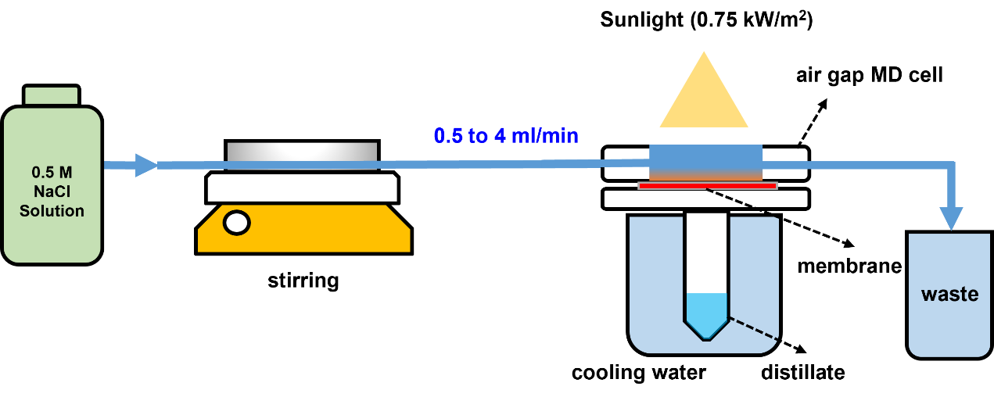

Figure 3. Schematic diagram of experimental set up applying AMD model

AMD has less conductive heat loss than other configuration of PMD system, resulting in higher thermal efficiency, but the longer diffusion distance in AMD slows the vapor diffusion to the permeate. Although AMD has disadvantages, such as low packing density and high resistance to vapor diffusion, AMD with optimized parameters, such as optimally thick airgaps and water channels, can achieve the highest water flux without requiring an additional energy input for vapor trapping. The deionized water (20 ℃) was filled in large beaker as a role of cold side condenser. quantify the amount of collected water. To test the MD performance within 60 minutes at different feed water flowrate, 0.5, 2, and 4 ml/min of flow rate conditions were created. In addition, we manufactured PMD modules with different diameters of 1, 2, and 4 cm using a 3D printer for making different diameter conditions. In all experimental conditions except flow rate and module diameter, the solar intensity was maintained at 0.75 kW/m2 using a solar chamber, and the temperature of the feed water was maintained at room temperature (25℃). In all experimental conditions except flow rate and module diameter, the solar intensity was maintained at 0.75 kW/m2 using a solar chamber. Also, the feed water was applied as a 0.5 M NaCl solution, considering that the PMD system is generally used for seawater treatment. The specific information about parameter conditions is presented in Table 1.

**Table 1**. Dependent and independent parameters applied in this study

|  |  |  |
| --- | --- | --- |
| Dependent parameters | | Independent parameters |
|  |  |  |
|  |  |  |

* 1. **Limitations for experimental set-up**

To objectively evaluate the performance of PMD, testing conditions should be carefully controlled. The ambient temperature directly contributes to the heat transfer from the heated water at the top to the surroundings. Therefore, in this study, the PMD performance was evaluated at ambient temperature (20–25 ºC) in windless conditions. If PMD is performed in an open system, the humidity at the test site can also affect the test results because permeate flux is related to the vaporized water. In addition, to minimize external influences, testing modules should be made of thermally insulating materials that do not supply heat or radiation to the tested system. In this study, we applied the testing module as plastic to avoid the effect. Also, the illuminated light area should cover the entire surface of the membrane to avoid unaccounted for distillation at the unilluminated membrane area, driven by the heated feed water.

1. **Predicted Results and discussion**
   1. **The effect of flow rate of feed water**

In this experimental condition, it was confirmed how the flux can be changed depends on the flow rate of feed water. As a result of increasing the flow rate from 0.5 ml/min to 4 ml/min, it was confirmed that the permeate flux decreased from 0.8 kg/m2h to 0.2 kg/m2h (Figure 4).

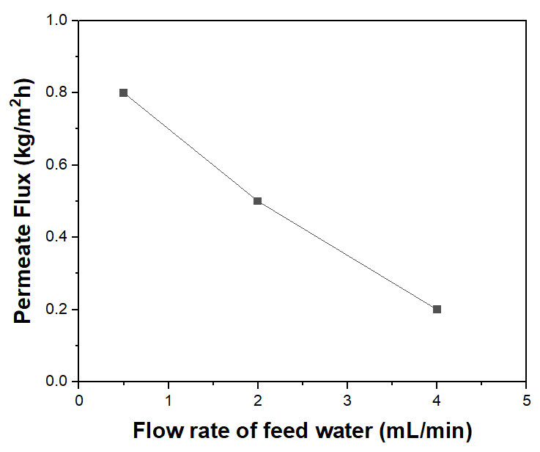

**Figure 4.** Permeate flux depends on different flow rate of feed water

This showed that as the flow rate increased, the temperature polarization formed on the membrane surface decreased, allowing more flux can be achieved. As the flow rate increases by 4 and 8 times, the $Re$ value also increases by 4 and 8 times, which causes an increase of 2 and 2.8 times in the $Nu$ value. As a result, as the convective heat transfer coefficient value increased, heat loss from the membrane surface increased, resulting in a flux value with a decreasing trend.

* 1. **The effect of diameter of PMD module**

In this experimental condition, we observed how the flux changed as the diameter of the PMD module was changed. As a result of conducting the experiment while increasing the diameter of the cylindrical module from 1 cm to 4 cm, it was possible to obtain the permeate flux trend that increases as the diameter of the module increases from 0.3 kg/m2h to 0.9 kg/m2h (Figure 5).

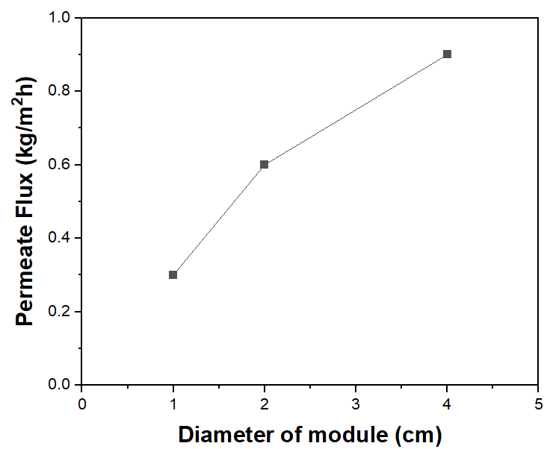

**Figure 5.** Permeate flux depends on different diameter of module

Through this, it was shown that increasing the diameter of the PMD module is effective in reducing temperature polarization. As the diameter increases, the convective heat transfer coefficient decreases because the denominator in Eq.3 increases. This means that heat loss due to convection from the membrane surface is reduced and can lead to an increase in flux. Increase in diameter can also lead to an increase in the $Re$ value, so it actually will cause an increase in the convective heat transport coefficient. However, when comparing the degree of decrease in the ${h_{conv, ms}}^{i}$ value as the diameter increases in Eq.3 and the degree of increase in the $Re$ value as the diameter increases in Eq.5, it can be seen that the degree of decrease in Eq.3 is greater. As a result, it was confirmed that when increasing the diameter, the heat loss occurring on the membrane surface decreases despite the increase in $Re$ value, resulting in higher flux.

Based on the results, we could find that the efficiency of PMD can be enhanced by decreasing flow rate of feed water and increasing diameter of module because it can control the convective heat transfer coefficient. By decreasing the convective heat transfer coefficient, we can reduce the heat loss from the membrane surface.

1. **References**

[1] He, C., Liu, Z., Wu, J., Pan, X., Fang, Z., Li, J., & Bryan, B. A. (2021). Future global urban water scarcity and potential solutions. Nature Communications, 12(1), 4667.

[2] Tao, P., Ni, G., Song, C., Shang, W., Wu, J., Zhu, J., ... & Deng, T. (2018). Solar-driven interfacial evaporation. Nature energy, 3(12), 1031-1041.

[3] Chiavazzo, E., Morciano, M., Viglino, F., Fasano, M., & Asinari, P. (2018). Passive solar high-yield seawater desalination by modular and low-cost distillation. Nature sustainability, 1(12), 763-772.

[4] Wu, X., Jiang, Q., Ghim, D., Singamaneni, S., & Jun, Y. S. (2018). Localized heating with a photothermal polydopamine coating facilitates a novel membrane distillation process. Journal of Materials Chemistry A, 6(39), 18799-18807.

[5] Dongare, P. D., Alabastri, A., Pedersen, S., Zodrow, K. R., Hogan, N. J., Neumann, O., ... & Halas, N. J. (2017). Nanophotonics-enabled solar membrane distillation for off-grid water purification. Proceedings of the National Academy of Sciences, 114(27), 6936-6941.

[6] Santoro, S., Avci, A. H., Politano, A., & Curcio, E. (2022). The advent of thermoplasmonic membrane distillation. Chemical Society Reviews, 51(14), 6087-6125.

[7] Bergman, T. L. (2011). Fundamentals of heat and mass transfer. John Wiley & Sons.

[8] Cao, S. (2021). Novel Photothermal Materials and Thermally Engineered Membranes for Solar Desalination (Doctoral dissertation, Washington University in St. Louis).